6/21/2020
Gavin Clarkson (1809104)
BEng mechanical and maunfacturing engineering
Advanced Processes Report
M6X00414
Advanced Processes and Materials

Table of Contents
Table of Contents 1
Introduction 2
Project Definition 3
Scope 3
Aim 3
Objective 3
Material Review 4
Current material 4
Cold Working Tool Steels 4
Alternative Material Options 6
Manganese Steel (Hadfield Steel) 6
Titanium Aluminium Nitride Coating 7
Conclusions 8
Recommendations 9
References 10
Bibliography 12
Appendices 14
Appendix 1.1 14
Appendix 1.2 1
Appendix 1.3 2
Appendix 2 3

Introduction
In Europe, TATA Steel is one of the biggest steel producers and produces 9.8 million tonnes per year. The primary steel making sites are in Ijmuiden, Netherlands and Port Talbot, Wales and downstream sites are located across Europe (TATA Steel, 2020). TATA Trostre Works is a cold rolling and coating steel site. Currently producing tin plate, electrolytic chromium coated steel and Protact laminated sheets.

Figure 1 - Trostre Works

The Pickle Line is the first process in Trostre works. The Pickling process removes any scale, rust or surface impurities from the coil before it is cold rolled. This process involves washing the steel in tanks of heated sulphuric acid.
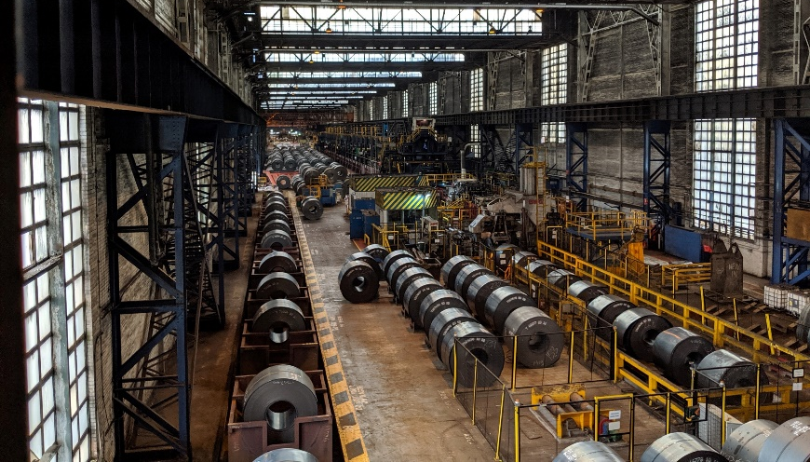
Figure 2 - Pickle Line

Project Definition

Scope
As part of the Pickling process, the steel strip needs to be trimmed down to a certain size determined by the customer. This trim is in a constant run which needs to be chopped or cut up into small manageable pieces before being recycled back into the steel making process.
This scrap chopping process involves four rotation barrel (two on each side of the strip) and four cutting blades per barrel, totalling sixteen blades (appendix 1). There is also a standby unit to alleviate line stoppages.

TATA Steel currently pays £262.65 per blade. In previous years, the total cost of purchasing new blades averages nearly £37,000. This is without other associated costs such as; purchasing new and repairing old wedges (these hold the blades in place) costing in excess of £3,000 per year, manpower to replace these blades, manpower to regrind these blades and line stoppages due to process jams. The blades suffer primarily from chipped edges as well as wear on the cut edge.

Aim
The aim and focus of this report is to review the material used in the manufacture of these blades and to potentially find a more suitable material.

Objective
This report gives an opportunity to analyse the current material used in the blades and look at alternative materials or processes that can be used. The material of the blades have been used for approximately 20 years with no documentation or reports on the change. The primary objective of the report would be cost saving in the scrap chopping process.

Material Review

Current material
The blades that are currently in use are supplied by ASKO, who specialise in metal processing and cutting. The material used is known as Askodyne-C, it is a, (ASKO, 2020) “high alloy cold working tool steel”. It has high levels of carbide and 8.5% of chrome, it comes hardened to 56-58 Hardness Rockwell C (HRC) and offers “higher impact resistance, higher wear resistance…higher compressive strength” when compared to regular tool steel. These knives can be reground and used again. The high level of carbon and chromium increases its strength, hardness and wear resistance (Havel, 2017).

Cold Working Tool Steels
Cold worked tool steels (CWTS) have been developed for use in many applications such as shearing, drilling and grinding. They have been in use for more than a century. These tools are subjected to high levels of stress and are required to have high toughness, high hardness and good wear resistance (Sarkar, et al., 2014) (Viale, et al., 2002) (Meurling, et al., 2001) (Roberts, et al., 1998).
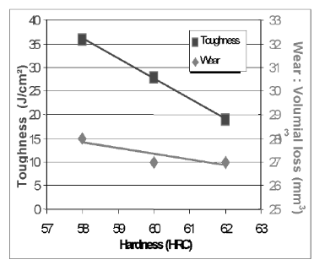
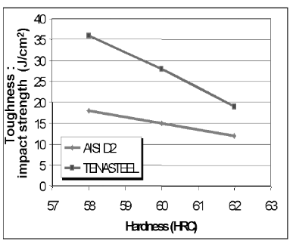
The standard choice for CWTS tends to be a steel known as AISI-D2, it has a composition of approximately 1.5% Carbon (C) and 12% Chromium (Cr). Due to its high levels of C and Cr it contains large fractions of hard carbides which gives it excellent wear resistance. It does however have quite poor toughness due to brittle carbides (Son, et al., 2017) (Kim, et al., 2015) (Sarkar, et al., 2014) (Viale, et al., 2002) (Algarni, 2019). By reducing the C to 0.8 - 1.2% and Cr to 8% this can reduce the brittle carbide in the steel and thus improve the toughness (Viale, et al., 2002) (Kim, et al., 2015). It is shown in the work of (Viale, et al., 2002) that when they compared D2 with a steel called Tenasteel (an 8% Cr steel) the toughness was greater across the different hardness measured (Fig 3). It is worth noting that as the hardness increases, the toughness decrease. (Fig 4) shows that as the hardness increases the wear rate decreases.
Figure 3 - Viale, et al (2002)
Figure 4 - Viale, et al (2002)

(Arieta, et al., 2011) recorded both the hardness and toughness of 12% Cr steel and compared them with various 8% Cr steel. The C content in the 8% Cr steel varied between 0.85% - 1.25%. For each steel three austenitizing temperatures were chosen. As shown in Fig 5, the average hardness was greater in each of the 8% Cr steels across all hardness’.
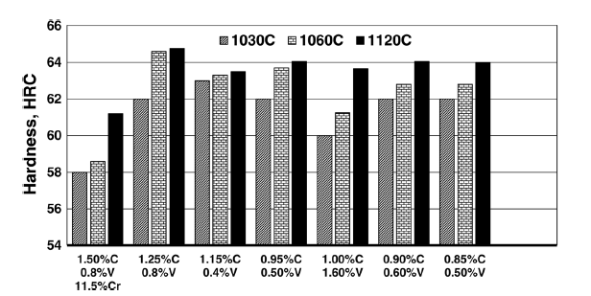
Figure 5 - Arieta, et al (2011)

The toughness was also measured across the different temperatures, as shown in Fig 6. There is a big drop in toughness when the heat treatment process reaches 1120˚C.

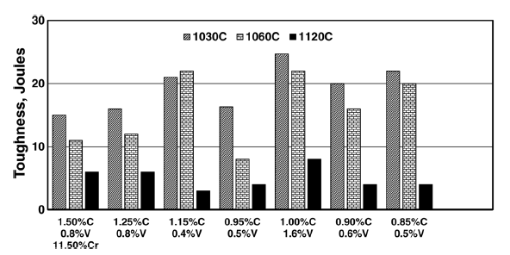
Figure 6 - Arieta, et al (2011)

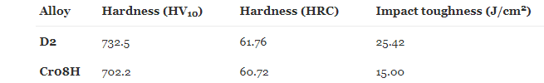
However, in another study, D2 was again compared to an 8% Cr steel in a shear cutting test (Son, et al., 2017). This test set up is very similar to the operation currently used in TATA. The hardness and impact toughness were compared before the test, Fig 5.
Figure 5 - Son, et al (2017)
Fig 7 shows the blades after the test. The 8% Cr steel shows a great deal more scratches, which indicates the wear resistance to be inferior.


Figure 7 - Son, et al (2017)
In Fig 8, the chips that are present on the 8% Cr steel can be seen. These are not visible on D2. The cut edge can be seen in Fig 9 and shows that D2 has a flatter cut edge when compare against 8% Cr steel.
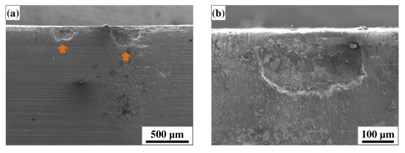
Figure 8 - Son, et al (2017)

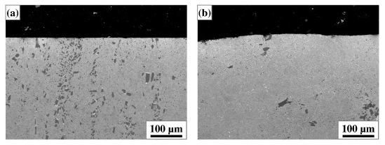
Figure 9 - Son, et al (2017). a = D2. b = 8% Cr steel.

It was concluded that the 8% Cr steel was more susceptible to chipping, scratches and roundness of the cut edge. To potentially improve the performance of the 8% Cr steel, it was recommended to temper the steel at a higher temperature.

Alternative Material Options

Manganese Steel (Hadfield Steel)
Manganese steel (MS) is a steel with high content of manganese, approx. 11 to 14%, and carbon, approx. 1.1 to 1.4%. It is known for its very high resistance to wear and work hardening ability. This type of steel can be exposed to high levels of repeated impacts or abrasions which in turn will work harden the steel (Ellis, 2020) (Hashmi, et al., 2017). The steel can be work hardened to over 550 Brinell (56 HRC) which is of a similar specification to Askodyne-C (Titus Steel, 2020) (Tasker, 2001) (Ellis, 2020). Although, manganese steel starts at around 220 Brinell (20HRC) until it gets work hardened (Havel, 2017) (Cakir, 2016) (Titus Steel, 2020) (Ellis, 2020).
The two points of its wear resistance and work hardening would make it an ideal candidate for the blade material. However, MS is extremely difficult to machine as when it gets machined the surface gets work hardened (Ellis, 2020) (A.J. Marshall, 2020). It is however possible to machine MS by selecting the correct cutting tools and speeds while making sure that the cutting tool is constantly cutting and chatter marks occurring (Havel, 2017) (Cakir, 2016). When work hardening MS only the outer layer of the steel gets hardened and the layers underneath “remains ductile and Tough” (Titus Steel, 2020).
MS had recently been design for use in additive manufacturing by using laser metal deposition and selective laser melting and varied results of work hardening depending on the level on aluminium used in the mixture (Kies, et al., 2018).

Titanium Aluminium Nitride Coating
Titanium aluminium nitride (TiAlN) is a coating usually applied by using physical vapor disposition. It is known to be very hard and have excellent resistance to wear (Wallwork, 2020) (Chauhan & Rawal, 2014) (Prengel, et al., 1998) (Premanond, et al., 2018).
TiAlN was used to coat D2 steel disks to measure the wear resistance improvements, the coating process also used fine shot peening (FSP) (Premanond, et al., 2018). Before the steel was coated, it was first FSP. The wear resistance was checked after each process and recorded, Fig 10.

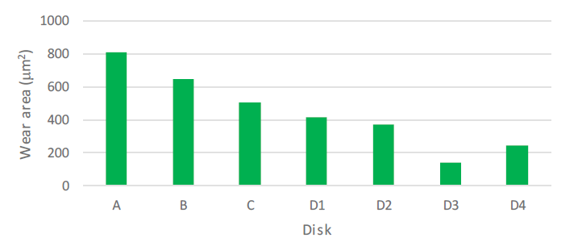
Figure 10 - Premanond, et al (2018)

Process | Surface Modification Process
A | Hardened D2
B | FSP
C | PVD - HiAlN
D1 - D4 | Different levels of FSP and coating

The results show that FSP on D2 steel helps to improve wear resistance. TiAlN – PVD coating also helps to improve on this reading. It was also found that FSP before coatings helps to improve the bond strength between the coating and substructure.

Conclusions
Cold work tool steels are designed for use in shearing and scrap cutting operations so should be the obvious choice when deciding on a material to use. Both D2 and 8% Cr steel have excellent hardness and wear resistance. Although, there are counter arguments in the toughness of these materials. With (Viale, et al., 2002) and (Arieta, et al., 2011) concluding that 8% Cr steel can have a higher level of toughness and it can be twice the level of D2 when tempered up to 575˚C with the same hardness. Whereas, (Son, et al., 2017) concluded that even though 8% Cr steel had a higher impact resistance it was more prone to chipping and the cut edge rounded quicker. However, the steel in this test was only tempered to 180˚C which is considerably less than the previous experiment. All these experiments austenitized the steel to 1030˚C.
Using a different material on these blades does not look to be a suitable option. Manganese steel work hardens up to 56 HRC but as it start at around 20 HRC (Titus Steel, 2020) (Tasker, 2001) (Ellis, 2020) it may well chip before the top end hardness is reached. There are also question marks on the ability to machine manganese steel. Using TiAlN to coat a blade is another option looked at. It was shown to improve the wear resistance of D2 steel while being fine shot peened (Premanond, et al., 2018). Although, this test was not carried out for shearing or chopping but on two faces rubbing together. There is also not much information on the hardness or toughness.

Recommendations
It would be beneficial to obtain the material composition and the temperatures used when austenitizing and tempering for Askodyne-C. After these are obtained and reviewed, a trial using 8% Cr steel with 1.15% C and 0.4% V austenitized to either 1030˚C or1060˚C should be completed. This composition gave the best mix of toughness and hardness in (Arieta, et al., 2011) study. It could however be found that the best material is currently being used.

References
A.J. Marshall, 2020. Manganese Steel – 6 Things You Need to Know. [Online]
Available at: https://ajmarshall.com/manganese-steel-6-things-you-need-to-know/
[Accessed 12 05 2020].
Algarni, M., 2019. Mechanical Properties and Microstructure Characterization of AISI “D2” and “O1” Cold Work Tool Steels. Metals, 9(11), p. 1169.
Arieta, F., Netto, E. B. M., Reguly, A. & Pannes, W. K., 2011. Impact Properties of Vacuum Heat Treated AISI D2 and 8% Cr Cold Work Tool Steels. Journal of ASTM International , 8(9).
ASKO, I., 2020. Askodyne-C Metallurgical-Refined tool steel for shear knives, Homestead, PA, USA: ASKO, Inc.
Cakir, O., 2016. Machining of Hadfield Steel: An Overview. Conference on Advances in Mechanical Engineering, pp. 227 - 232.
Chauhan, K. V. & Rawal, S. K., 2014. A Review Paper on Tribological and Mechanical Properties of Ternary Nitride Baed Coatings. 2nd Internalional Conference on Innovations in Automation and Mechatronics Engineering, Volume 14, pp. 430 - 437.
Ellis, R., 2020. Manganese Steel. [Online]
Available at: https://www.westyorkssteel.com/blog/manganese-steel/
Hashmi, S., Choudhury, I. A., Mridha, S. & Yilbas, B. S., 2017. Comprehensive Materials Finishing Volume 2: Surface and Heat Teatment Processes. Oxford: Oliver Walter.
Havel, D., 2017. Austenitic Manganese Steel, s.l.: Columbia Steel Casting Co, Inc..
Kies, F., Kohnen, P., Wilms, M. B. & Brasche, F., 2018. Design of High-Manganese Steels for Additive Manufacturing Applications with Energy-Absorption Functionality. Materials & Design, Volume 160, pp. 1250 - 1264.
Kim, H., Kang, J.-Y., Son, D. & Lee, T.-H., 2015. Evolution of Carbides in Cold-Work Tool Steels. Materials Characterization, Volume 107, pp. 376 - 385.
Meurling, F., Melander, A., Tidesten, M. & Wetsin, L., 2001. Influence of Carbide and Inclusion Contents on the Fatigue Properties of High Speed Steels and Tool Steels. International Journal of Fatigue, 23(3), pp. 201 - 224.
Pittari, J. j., Murdoch, H. A., Kilczewski, S. m. & Hornbuckle, B. C., 2018. Sintering of Tungsten Carbide Cermets With an Iron-Based Ternary Alloy Binder: Processing and Thermodynamic Considerations. International Journal of Refractory Metals and Hard Materials, Volume 76, pp. 1-11.
Premanond, V., Hato, R. & Sripraserd, J., 2018. Wear Resistance Improvement of Cold Work Tool Steel by Fine Shot Peening. Materials Science Forum, Volume 939, pp. 3 - 8.
Prengel, H. G., Pfouts, W. R. & Santhanam, A. T., 1998. State of the Art in Hard Coatings for Carbide Cutting Tools. Surface and Coating Technology, Volume 102, pp. 183 - 190.
Roberts, G., Krauss, G. & Kennedy, R., 1998. Tool Steels. Fifth ed. Ohio: ASM International.
Sarkar, P. P., Dhua, S. K., Thakur, S. K. & Ghosh, B., 2014. Metallurgical Investigation into the Failure of a Chopper Blade Used for Cutting of Hot-Rolled Steel Coils. Engineering Failure Analysis, Volume 46, pp. 196 - 207.
Son, D., Kim, H., Kang, J.-Y. & Yun Yun, H., 2017. Analyses of the Failures on Shear Cutting Blades After Trimming of Ultra High-Strength Steel. Engineering Failure Analysis, Volume 71, pp. 148 - 156.
Tasker, J., 2001. Austenitic Steels: Non-Stainless. Encyclopedia of Materials: Science and Technology, pp. 411 - 415.
Titus Steel, 2020. Titus Manganese Steel. [Online]
Available at: https://titussteel.com/our-products/wear-and-impact-steel/titus-manganese/
[Accessed 12 05 2020].
T. S., 2020. At A Glance. [Online]
Available at: https://www.tatasteeleurope.com/en/about%E2%80%93us/at-a-glance
[Accessed 17 06 2020].
Viale, D., Beguinot, J., Chenou, F. & Baron, G., 2002. Optimising Microstructure for High Toughness Cold Worked Tool Steel. Proceedings of the 6Th International Tooling Conference, pp. 229 - 318.
Wallwork, 2020. Titanium Aluminium Nitride (TiAlN). [Online]
Available at: https://www.wallworkht.co.uk/content/tialn/
[Accessed 26 05 2020].

Bibliography
A.J. Marshall, 2020. Manganese Steel – 6 Things You Need to Know. [Online]
Available at: https://ajmarshall.com/manganese-steel-6-things-you-need-to-know/
[Accessed 12 05 2020].
Algarni, M., 2019. Mechanical Properties and Microstructure Characterization of AISI “D2” and “O1” Cold Work Tool Steels. Metals, 9(11), p. 1169.
Arieta, F., Netto, E. B. M., Reguly, A. & Pannes, W. K., 2011. Impact Properties of Vacuum Heat Treated AISI D2 and 8% Cr Cold Work Tool Steels. Journal of ASTM International , 8(9).
ASKO, I., 2020. Askodyne-C Metallurgical-Refined tool steel for shear knives, Homestead, PA, USA: ASKO, Inc.
Cakir, O., 2016. Machining of Hadfield Steel: An Overview. Conference on Advances in Mechanical Engineering, pp. 227 - 232.
Chauhan, K. V. & Rawal, S. K., 2014. A Review Paper on Tribological and Mechanical Properties of Ternary Nitride Baed Coatings. 2nd Internalional Conference on Innovations in Automation and Mechatronics Engineering, Volume 14, pp. 430 - 437.
Ellis, R., 2020. Manganese Steel. [Online]
Available at: https://www.westyorkssteel.com/blog/manganese-steel/
Hashmi, S., Choudhury, I. A., Mridha, S. & Yilbas, B. S., 2017. Comprehensive Materials Finishing Volume 2: Surface and Heat Teatment Processes. Oxford: Oliver Walter.
Havel, D., 2017. Austenitic Manganese Steel, s.l.: Columbia Steel Casting Co, Inc..
Jacob, R., Sankaranarayanan, S. R. & Babu, S. P. K., 2020. Recent Advancements in Manganese Steels – A Review. Materials Today: Proceedings.
Kies, F., Kohnen, P., Wilms, M. B. & Brasche, F., 2018. Design of High-Manganese Steels for Additive Manufacturing Applications with Energy-Absorption Functionality. Materials & Design, Volume 160, pp. 1250 - 1264.
Kim, H., Kang, J.-Y., Son, D. & Lee, T.-H., 2015. Evolution of Carbides in Cold-Work Tool Steels. Materials Characterization, Volume 107, pp. 376 - 385.
Meurling, F., Melander, A., Tidesten, M. & Wetsin, L., 2001. Influence of Carbide and Inclusion Contents on the Fatigue Properties of High Speed Steels and Tool Steels. International Journal of Fatigue, 23(3), pp. 201 - 224.
Pittari, J. j., Murdoch, H. A., Kilczewski, S. m. & Hornbuckle, B. C., 2018. Sintering of Tungsten Carbide Cermets With an Iron-Based Ternary Alloy Binder: Processing and Thermodynamic Considerations. International Journal of Refractory Metals and Hard Materials, Volume 76, pp. 1-11.
Premanond, V., Hato, R. & Sripraserd, J., 2018. Wear Resistance Improvement of Cold Work Tool Steel by Fine Shot Peening. Materials Science Forum, Volume 939, pp. 3 - 8.
Prengel, H. G., Pfouts, W. R. & Santhanam, A. T., 1998. State of the Art in Hard Coatings for Carbide Cutting Tools. Surface and Coating Technology, Volume 102, pp. 183 - 190.
Roberts, G., Krauss, G. & Kennedy, R., 1998. Tool Steels. Fifth ed. Ohio: ASM International.
Sarkar, P. P., Dhua, S. K., Thakur, S. K. & Ghosh, B., 2014. Metallurgical Investigation into the Failure of a Chopper Blade Used for Cutting of Hot-Rolled Steel Coils. Engineering Failure Analysis, Volume 46, pp. 196 - 207.
Son, D., Kim, H., Kang, J.-Y. & Yun Yun, H., 2017. Analyses of the Failures on Shear Cutting Blades After Trimming of Ultra High-Strength Steel. Engineering Failure Analysis, Volume 71, pp. 148 - 156.
Tasker, J., 2001. Austenitic Steels: Non-Stainless. Encyclopedia of Materials: Science and Technology, pp. 411 - 415.
Titus Steel, 2020. Titus Manganese Steel. [Online]
Available at: https://titussteel.com/our-products/wear-and-impact-steel/titus-manganese/
[Accessed 12 05 2020].
T. S., 2020. At A Glance. [Online]
Available at: https://www.tatasteeleurope.com/en/about%E2%80%93us/at-a-glance
[Accessed 17 06 2020].
Viale, D., Beguinot, J., Chenou, F. & Baron, G., 2002. Optimising Microstructure for High Toughness Cold Worked Tool Steel. Proceedings of the 6Th International Tooling Conference, pp. 229 - 318.
Vojtech, P. et al., 2017. Characterization of Microstructure of Hadfield Steel. Solid State Phenomena, Volume 270, pp. 265 - 270.
Wallwork, 2020. Titanium Aluminium Nitride (TiAlN). [Online]
Available at: https://www.wallworkht.co.uk/content/tialn/
[Accessed 26 05 2020].

Appendices

Appendix 1.1
Scrap chopper drawing
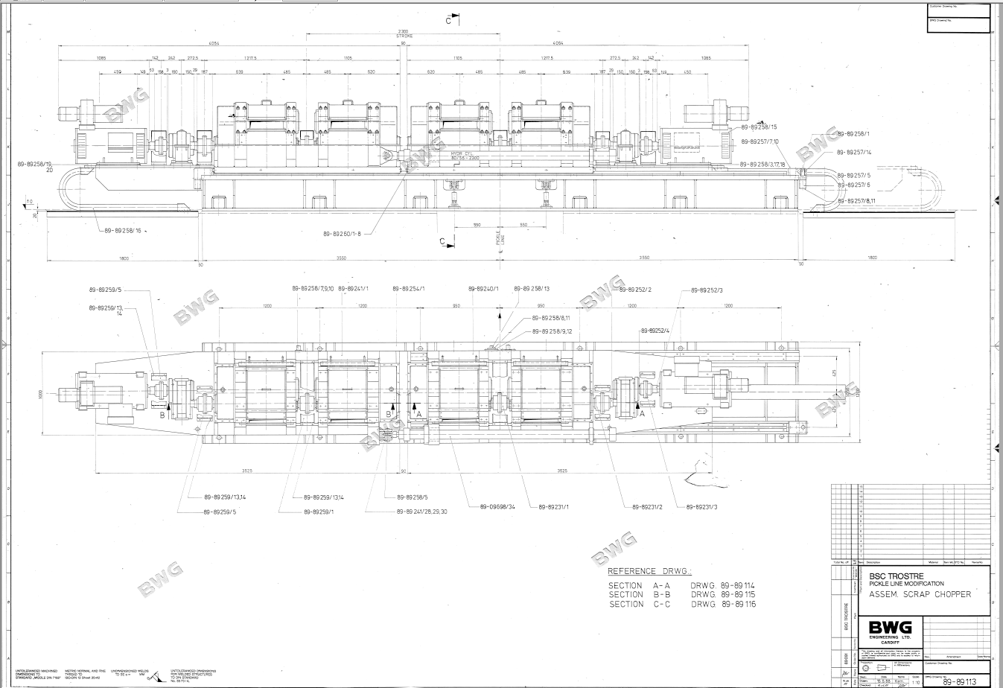

Appendix 1.2
Section view of one scrap chopper.
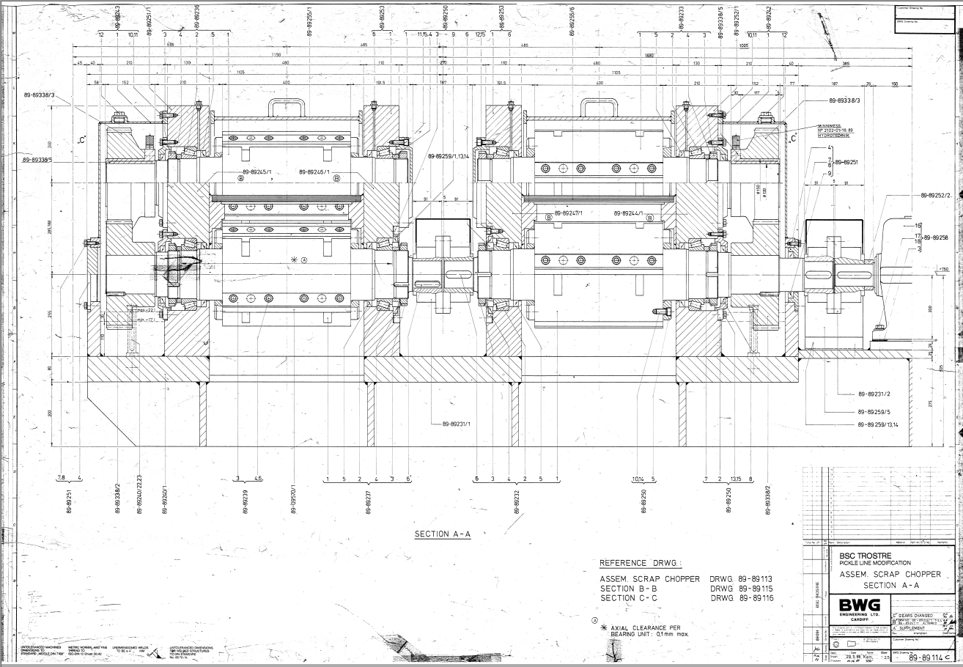

Appendix 1.3
Section view of upper and lower barrels.
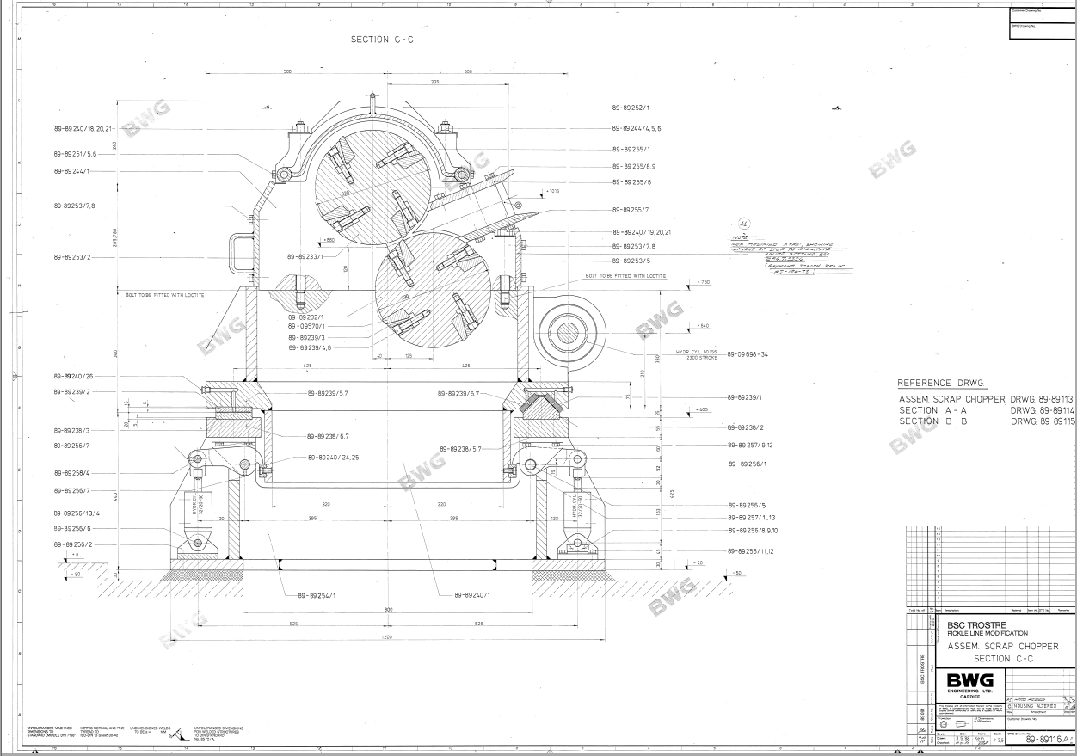

Appendix 2
Scrap chopper blade costs


