Hand rendered draft - 5 x spot drop repeat tile. This is a useful way to layout/ compose a tile (technically repeating as a block, but could be worked as a drop, brick or other repeat system). This example has been worked as a drop repeat (block drops by 1/5 as it is repeated out)
Draft: the first version of a design (not finished, but has the bones to become a finished outcome)

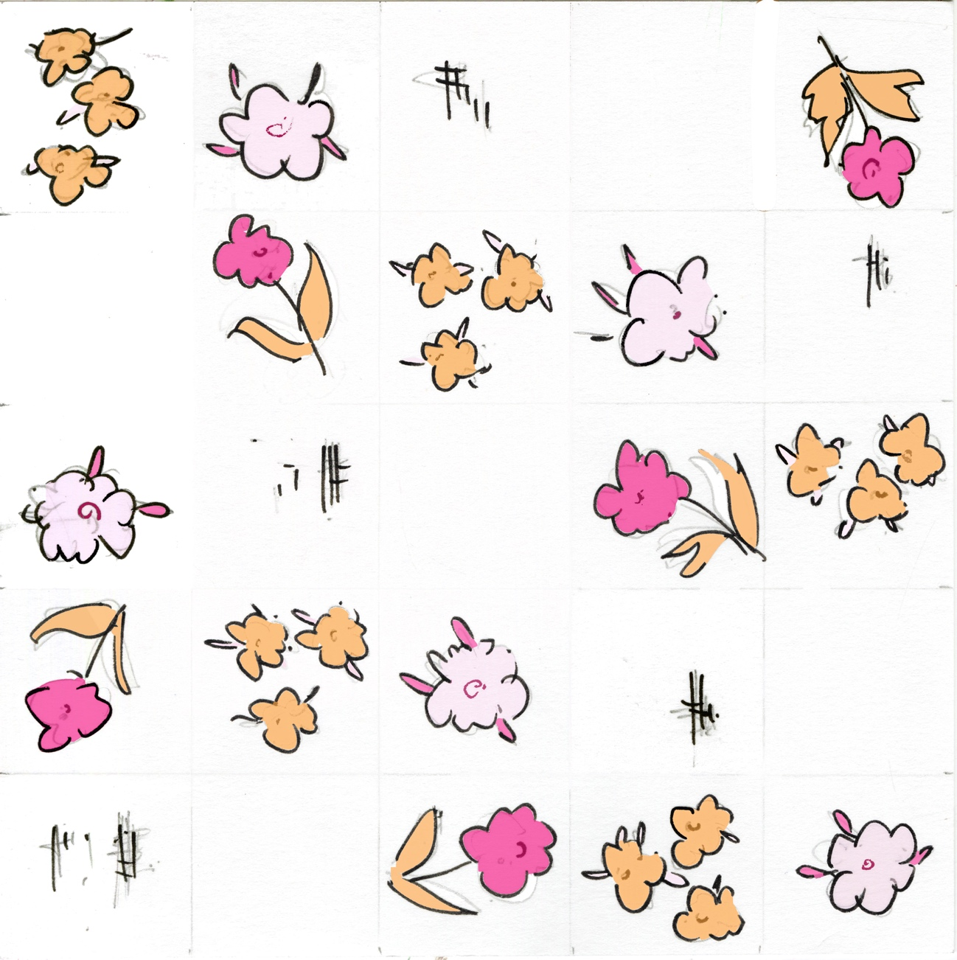
Digitally recoloured from original artwork

These pattern types can work well in a spot repeat layout, but are not limited to this method of repeat. Abstract, Fauna, Floral, Foliage, Geometric, Paisley, Scattered, Spot, Stripe, Toile de Jouy.

You can draft out a 5 spot repeat within the framework of a square or rectangle, something like this…

5 x spot tile layout (arrows indicate direction/ rotation of motif but can be used without)

5 x spot tile layout repeated out with a 1/5 drop

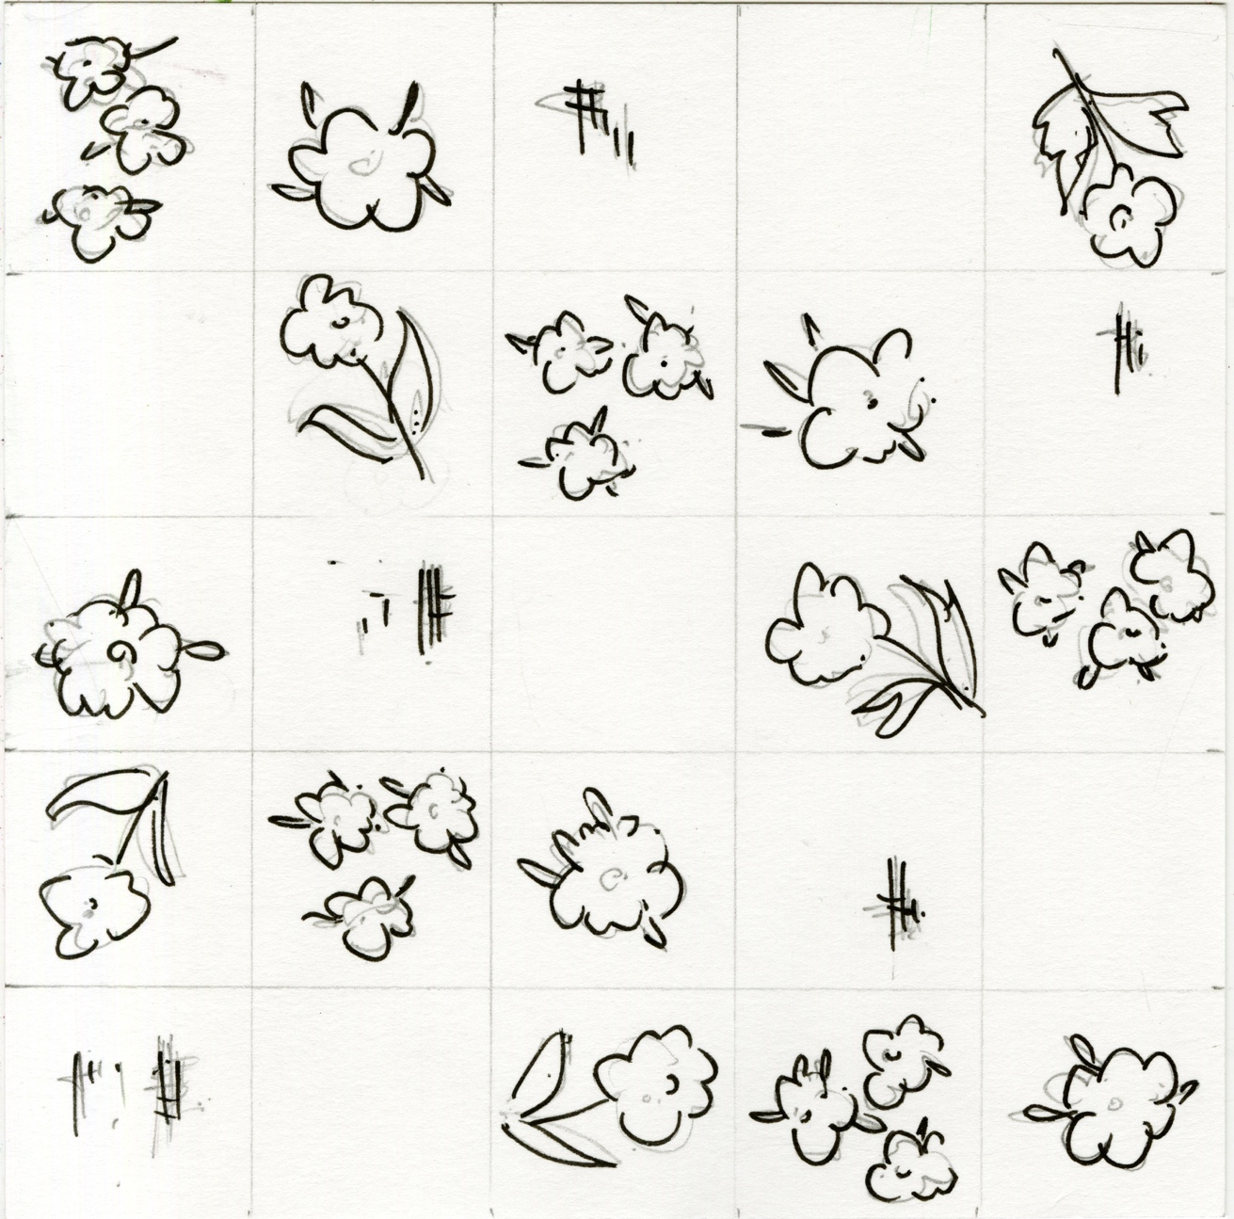

Hand rendered 5 x spot tile (draft) Worked in a spot layout with one motif, before being rotated and worked again in a 5 x spot layout with a different motif. This has been done 4 time.

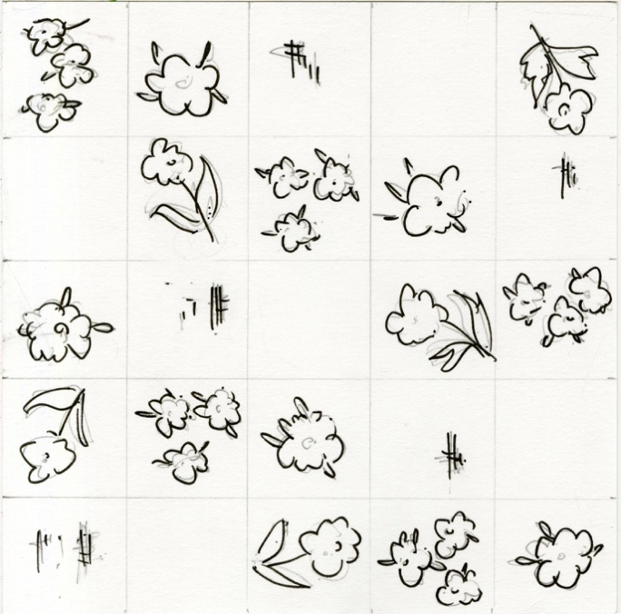
Hand rendered 5 x spot (draft) repeated out with a drop of 1/5. You could drop the tile by other fractions such as 2/5 etc or play around with tile rotations

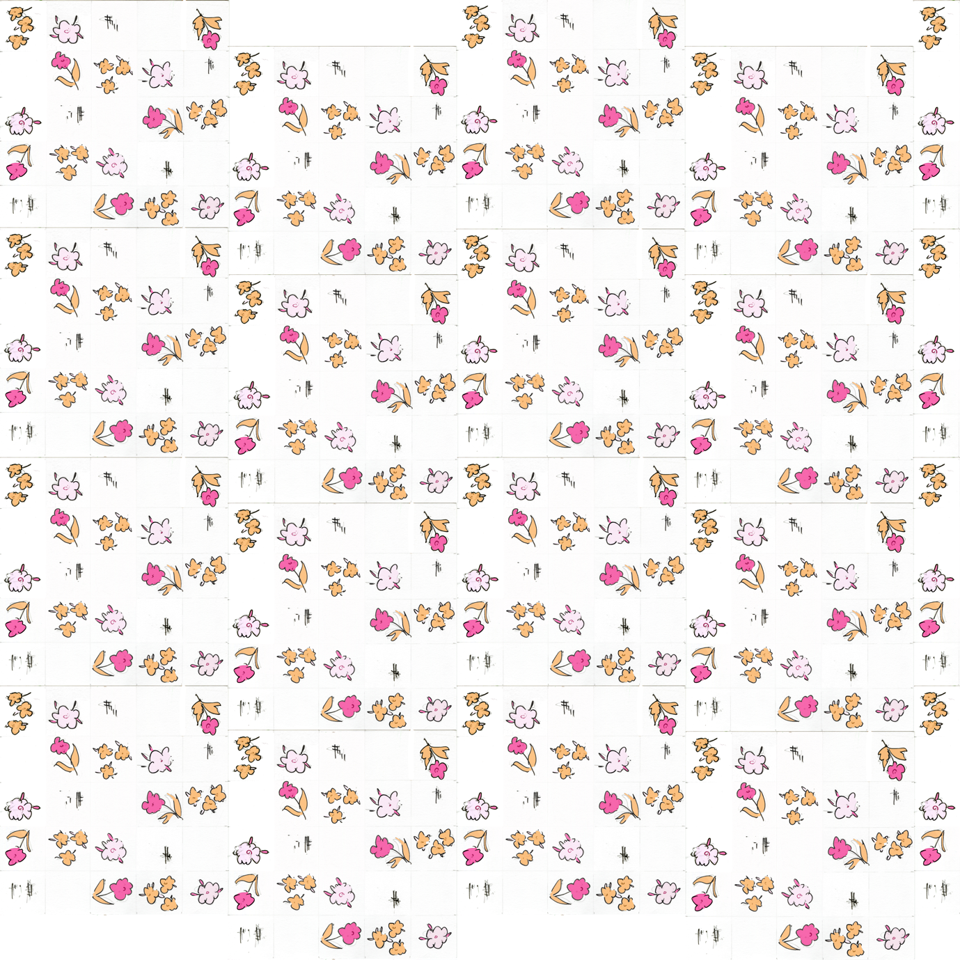

Hand rendered 5 x spot (draft) … digitally placed as a 1/5 drop. Could be recoloured by hand or digitally.

