How can Youth Work in Youth Clubs be made accessible to Neurodivergent Young People?

Leo Smith
2302380

01/05/26

ECGE6003Q
Yr Athrofa: Education and Humanities

Declaration Form

Independent Project/Dissertation Declaration Form.

1. This work has not previously been accepted in substance for any degree and is not being concurrently submitted in candidature for any degree.
Signed: L SMITH
Date 01/05/26

2. This Independent Project/Dissertation is being submitted in partial fulfilment of the requirements for the degree of Youth Work, Young people and Communities
Signed L SMITH
Date 01/05/26

3. This Independent Project/Dissertation is the result of my own independent work/investigation, except where otherwise stated.
Other sources are acknowledged by footnotes giving explicit references.
A reference list is appended.
Signed candidate: L SMITH
Date: 01/05/26

4. I hereby give consent for my Independent Project/Dissertation, if accepted, to be available for photocopying, inter- library loan, and for deposit in the University’s digital repository
Signed (candidate) L SMITH
Date 01/05/26

Supervisor’s Declaration.
I am satisfied that this work is the result of the student’s own efforts.
Signed: …………………………………………………………………………..
Date: ……………………………………………………………………………...

AI Declaration

I confirm that I have not used any AI tools in the research and creation of this assignment. I confirm that I have not presented any AI generated materials as my own work. I confirm I have copies of my drafts, notes, and other resources I used, which I may be asked to provide in evidence.

CONTENTS
Declaration Form and AI declaration.............................................. P. 2-3
Contents............................................................................................. P. 4
Acknowledgments............................................................................. P. 5
Abstract.............................................................................................. P. 5
Acronyms........................................................................................... P. 6

- Introduction............................................................................. P. 7-9
- Literature Review.................................................................... P. 10-18
- Methodology / Methods.......................................................... P. 19-26
- Presentation of Data............................................................... P. 27-32
- Discussion.............................................................................. P. 33-38
- Conclusion and Recommendations..................................... P. 39-43
- References.............................................................................. P. 44-49
- Appendices.............................................................................
8.1 Appendix 1: Ethics Form............................................................... P. 50-66
8.2 Appendix 2: Research Preparation................................................. P. 67- 72
8.3 Appendix 3: Examples of how the research was conducted .............. P. 73- 78

Acknowledgments

I’d like to thank the following people for helping with this dissertation. The young people of the focus group, for your enthusiasm. The youth work lecturer team, especially my supervisor Anghard Lewis who's insight and knowledge steered me through the research. A special thank you to my Learning Support Specialist Ian Showell for reading this so many times! A big thank you to my friends and family for supporting me and listening to my many crazy ideas! Your support meant everything.

Abstract

This is an undergraduate dissertation completed for the Young People, Communities and Youth Work course at University of Wales Trinity St David. The main purpose of this dissertation is to find out whether youth work in youth clubs is accessible to Neurodivergent young people. It also aims to find out: what stops Neurodivergent Young People from accessing main groups and what would make them more likely to access the space alongside Neurotypical young people, as well as researching what aspects affect Neurodivergent people and their experiences. It will also investigate existing research and what changes Neurodivergent specific
organisations make to their spaces to make them more accessible. The research conducted utilised a focus group with young people in a youth club in Southwest Wales and asked them what they think a ‘perfect’ youth club for Neurodivergent young people would look like and asked them if they thought youth work is accessible to Neurodivergent young people. They were also asked what they wanted youth workers to know about Neurodivergence. They were also asked if they attend main groups, as the group asked was part of a smaller sub-group in the youth centre. The results found that the young people wanted calm, sensory friendly youth centres with free “safe foods” and smaller groups to reduce noise. It also found that the young people thought that while youth workers are well informed about Neurodivergence, but this does not show in practice.

Acronyms

- ADHD- Attention Deficit Hyperactivity Disorder
- BERA- British Educational Research Association
- CLDSCS- CLD Standards Council Scotland
- EGER- Ethical Guidelines for Educational Research
- LGBTQ+- Lesbian, Gay, Bisexual, Transgender, Queer + Others
- ND- Neurodivergent
- NDS- Neurodiverse
- NT- Neurotypical
- NYA- National Youth Agency
- NYSSW- National Youth Service Strategy for Wales
- UNCRC- United Convention of the Rights of the Child
- WG- Welsh Government
- YEPF- Youth Engagement and Progression Framework
- YW NOS- Youth Work National Occupational Standards
- YWWRG- Youth Work in Wales Review Group

Chapter 1.
INTRODUCTION

This Independent Project will explore How can Youth Work be made more accessible for Neurodivergent Young People? According to North Wales Regional Partnership Board (2023), there is no way of gaining information on all children and young people who are NDS. However, in North Wales the number of children with additional learning needs related to autism in schools has “risen from about 1,485 in 2017 to about 2,135 in 2023” (North Wales Regional Partnership Board, 2023, p.6). This figure does not include those suspected to have other neurodevelopmental conditions such as dyslexia; however, it shows the significant increase in children and young people who are NDS. This shows that there is more need for provisions that support those who are NDS.

From looking into current organisations that support ND young people, the researcher has found that many of these programmes are not long-term, and often only support parents (Neurodivergence Wales, AP Cymru). Additionally, many only assist those with a diagnosis, therefore they are not accessible to those who are waiting to be diagnosed or who do not want a diagnosis. Currently, from the researcher’s observations and their practice, they have found that ND young people often have their own separate time and day to the main groups that attend youth clubs. These sessions are often shorter and less frequent than main youth club provisions, meaning that ND young people have less time to experience youth work and its benefits. Additionally, the researcher has found that many of these groups rely on outside funding (Workplace Colleague, 2024), meaning they are more likely to stop when funding runs out. This is why the researcher aims to influence main youth work provisions to become more accessible for ND young people.

According to the NYSSW (WG, 2019, p.15) “Youth work is accessible and inclusive”. To achieve this aim, youth work must reflect the diverse backgrounds, identities, experiences and needs of young people in Wales. It also must pro-actively remove any barriers to engagement and participation, ensuring it is accessible to all. This is especially true for those young people who may have more need, for example those from marginalised backgrounds who may be discriminated against, those who have been exploited, and those who experience isolation. While youth work does support those listed above through its range of provisions, the researcher still feels there is a gap in provision for ND young people.

The researcher hopes that ND young people will benefit from this research so they will be more comfortable to attend main youth provisions. The aim of this research is not to make youth provisions NDS specific, but instead to adjust certain aspects of youth clubs that may be triggering or make ND young people uncomfortable. The research relates to aims from the Wellbeing of Future Generations (Wales) Act 2015 (WG, 2015). For example, it meets the aim to create a “More equal Wales” (WG, 2015) as it aims to assist neurodivergent young people to access informal education through youth work, enabling them to fulfil their potential. It also meets the aim to create “A Wales of cohesive communities” (WG, 2015) as due to the community aspect of youth work, involvement in youth work practice will allow ND young people to build their own community and work within the communities that they live in.

The researcher will collect data with ND and NT young people in a youth club in Southwest Wales, utilising a focus group. Because the researcher will be working with young people, there is a limitation on what questions they can ask, due to potentially bringing up past trauma. They are also limited in participant numbers, as they will need to specifically ask ND young people. The researcher will not ask them to disclose whether they are diagnosed or not.

The main aim of the research is to find out if Youth Work is accessible to ND young people, the researcher will also aim to find out if the young people think youth workers are well educated about NDS, and what they want youth workers to know. Another aim is to find out what aspects of an environment affect ND young people and how this can affect their behaviour. The purpose is to look at ways to create a safe environment for ND young people, whether they are diagnosed or not, to thrive and experience youth work. According to the NYA (ND) and BBC Children in Need (ND) youth work is important because it supports young people’s development through informal education, it empowers young people by teaching them essential life skills, builds trusting, voluntary relationships, reduces violence and anti-social behaviour and positively impacts the outcomes of young people’s lives. This is why the researcher believes it is important for ND young people to access youth work. Therefore, the purpose of this Independent Project is to explore how this can be done and what changes need to be made to youth provisions to do this.

Chapter 2.
REVIEW OF LITERATURE

This chapter discusses the literature and research around Neurodivergence and discusses how youth work practice currently operates. The terms ‘Neurodivergent’ and ‘Neurodiverse’ are used widely to describe those who work differently. According to NeuroLaunch (2024), the term ‘Neurodiversity’ was originally coined in the 1990’s and has since gained traction, particularly with those in the autistic community, to describe themselves. According to Grant, Pearson and Leigh (2025), the term ‘Neurodiversity’ includes those who are ND, but also those who are NT, and covers everyone. The term ‘Neurodivergent’ refers to those individuals whose brains work ‘differently’ than others, for example, those with ADHD or Autism. Thus, it is important to use the correct language during this literature review (Milton et al, 2020). Additionally, Grant, Pearson and Leigh (2025) found that using the term ‘Neurodivergent’, helps individuals who do not want to list their diagnosis, and those who are waiting for or do not want a formal diagnosis. However, some find the word too broad and unhelpful, as it does not communicate their day-to-day and support needs. Additionally, many people are still unfamiliar with the term Neurodivergent, and do not understand what it means, making it an ineffective way to explain who they are. There is much controversy about the word neurodivergent, however the researcher has found it is the best word to use to describe the board range of differences people face.

Previous research
Many ND people struggle in social settings (Pavopoulou et al. 2025) due to environmental factors such as noise sensitivity, social anxiety and difficulty to communicate. Additionally, Pavopoulou (et al. 2025, para 6) found that young people diagnosed with ADHD face social isolation, alienation and conflict, self-doubt, loathing and embarrassment because of their diagnosis, and for autistic young people, they related to the feelings of ‘not belonging’ and ‘alienation’. Both groups stated that they felt the need to ‘mask’, a term most ND people use to describe, intentionally or unintentionally, hiding aspects of themselves to avoid harm. For example, suppressing stims (repeated movement or behaviour which helps ND people keep calm or express joy) (National Autistic Society, ND).

Fielding, Streeter and Hanley (2025) argue that ND pupils are more likely to experience emotional distress while in school than their NT peers which affects their attendance record. This is important as research (GOV.UK, 2023) has shown that missing school can be related to poorer social, emotional and academic outcomes. However, they also argue that attendance rates alone do not identify all pupils who struggle in school and argue that many pupils attend school in emotional distress and often display this by ‘acting out’ in classrooms. They state that when looking at what causes emotional distress, most research has been conducted with autistic individuals. Their research suggests that autistic students have lower social motivation and greater school withdrawal, which can result in bullying. Additionally, sensory differences also play a vital role in creating emotional distress for autistic young people in school (Fielding et al, 2025).

Much research has been conducted on helping support ND young people in schools, including Fotheringham, Cebula and Crompton (2023) who co-designed a ND student-led peer support programme for ND young people in mainstream secondary schools. They found that there was a need for a facilitator who was a good fit for the group. They also wanted to make inclusiveness essential and have no need for a formal diagnosis to participate in the group. Finally, the group wanted to directly address negative perceptions of others and focus on the strengths of being ND, rather than the weaknesses. This was flagged as being important as most people view being ND as a weakness, often using deficit models to describe being ND, rather than promoting the idea that doing things differently is not bad, and often helps many people with workplace skills such as creativity and independence.

Focusing on strengths rather than weaknesses is an important factor when discussing neurodiversity. Donaldson, Krejcha and McMillin (2017) argue that focusing on strengths is important as most disability approaches aim toward normalisation and ‘curing’ symptoms. They state that autism and other neurological differences are natural variants of the human brain, and are a natural difference, rather than a disorder. They argue that when dealing with neurodiversity, practitioners should utilise the person’s strengths to support their challenges, while respecting their uniqueness. They state that this idea shifts research towards focusing on improving the quality of life for those who are ND and helping them view their difference as a positive part of their identity, rather than focusing on making them a ‘normal’ part of society.

Peer support groups are a key theme in research previously conducted, including Coyle, Hare and Ramey (2025) who focused their research on co-designing ND support groups in a higher education setting. The key themes of their research were similar to Fotheringham, Cebula and Crompton (2023). They found that the groups were interested in connectedness and having a sense of community and belonging, knowledge and awareness of NDS, and empowerment to advocate for ND students across the whole culture of the university and to provide a voice for ND students. The main aim of these groups was to improve the social connectiveness between ND students in the University, rather than focusing on improving academic skills. Additionally, empowerment and staff training on NDS was another key theme. Empowerment is also a key theme in youth work (YWWRG, 2019), so empowerment and empowering ND young people is a key theme in youth work practice.

While peer support groups are used widely, Shore (ND, cited in Flannery and Wisner-Carlson, 2020, para 1) states that “if you’ve met one person with autism, you’ve met one person with autism”. Shore (ND, cited in Dev, 2018, para 3) states that this “emphasises that there is great diversity within the autism spectrum”, therefore, there cannot be a one size fits all approach when helping ND people. This idea is seconded by Busby (2024) who argues that a one size fits all approach ignores the diverse backgrounds, needs and abilities of ND students. This deprives them of the necessary support and accommodations which in turn hinders their academic, emotional and social development.

Purpose of Youth Work and Youth Clubs
Hine and Wood (2009, p. 249) describe ‘youth’ as “the stage of transition between childhood and adults” and argue that this transition has undergone “significant change”. One of the main markers of achievement in adulthood is being in employment. Research by Valentine (2003, cited in Hine and Wood, 2009) shows that young people are now older when they achieve many of the markers of adulthood, such as employment. Webster et al. (2004, cited in Hine and Wood, 2009) argue that those who come from a more affluent background are more likely to reach the markers of adulthood earlier than those who come from a less affluent background.

Gharabaghi et al. (2014) discuss the difference between ‘practice’ and ‘purpose’ when discussing youth work. They argue that ‘practice’, is what child and youth workers do when working face-to-face with children and young people. ‘Purpose’ relates to what they are trying to do, for example, helping a young person learn about their rights. They also state that the ‘purpose’ of youth work is often outlined within its core concepts, values and principles, and they argue that these are “challenging behaviour, preparing young people for independence, strengthening resilience, exploring identity, imposing containment and promoting safety, increasing performance and advocating for social change” (Gharabaghi et al. 2014, p. 5).

Forkby and Kiilkoski (2014, cited in Eriksen and Seland, 2020, para. 1) argue that the main purpose of youth clubs is to “keep young people occupied and off the streets”, preventing them from participating in antisocial behaviour. The Ministry of Health and Care Services (2015, cited in Eriksen and Seland, 2020) and Norwegian Directorate of Health, (2017, cited in Eriksen and Seland, 2020) argue that youth clubs are also possible areas for the prevention of possible mental health issues among young people as they provide social support and prevent loneliness. This proves the importance of a youth work setting while working with ND young people.

Importance of Neurodivergent-specific Youth Clubs
The researcher argues that a NDS specific youth club is needed as ND young people face many issues which in turn create a barrier to accessing provision. For example, Attwood (2007, p.271) highlights that people with autism face various sensory sensitivities, such as being sensitive to “specific sounds, tactile experiences, light intensity, the taste and texture of food and specific aromas”. Attwood (2007) also states that many adults with autism suggest that their sensory sensitivity has a greater impact on their lives than other problems, such as making friends, managing emotions and finding appropriate employment.

According to the National Youth Council of Ireland (NYCI) (ND) youth clubs are very noisy spaces, which often contain fluorescent lights and different smells from cooking activities. Therefore, they can be a very overwhelming space for ND young people to enter. NYCI (ND) suggests that to make a youth club inclusive, practitioners should consider providing a dedicated group for ND young people, as they may benefit from having a smaller group of people to interact with. Additionally, practitioners should be well informed about NDS and get to know the young people in terms of how they interact, what they enjoy, and what makes them comfortable and uncomfortable. NYCI (ND) also states that the more information provided to the young people the better and suggest using social media to update young people on activities and creating 360-degree videos of the space that they can view before joining the group. Mackenzie (2008) suggests having a carpeted room can reduce noise reverberation. Additionally, neutral colours and natural lighting should also be included; if natural lighting is not achievable, they suggest non-fluorescent lighting.

From researching current organisations that support ND young people, the researcher has found that most provisions take place online. Cossins (2025), a CEO of a ND specific organisation, explained via email to the researcher that when meeting up in person, the young people found the group difficult, both socially and sensory. However, when accessing a Minecraft server, they found it much easier to talk. Cossins explained that after accessing the server, parents would find that their normally quiet and anxious child had become more talkative and able to open-up to them. This shows that having a community and group of friends online worked the same way as it would physically in a youth club. However, many young people do not have access to a device that would be able to run a Minecraft server or other similar sites. A report on digital poverty by Nominet (2023, p.3) found that up to two million young people in the UK are facing digital poverty and 15% of all young people are without access to the internet at home. While social media may have a negative impact on young people as outlined by Nominet (2023, p.7), who reports that many are viewing distressing content on social media, 40% of young people with access to social media believe that it can be a force for good, as it allows them to be connected to others.

Barriers Faced by ND Young People.
Many provisions that support ND young people require a formal diagnosis before the young person can receive help. This creates a barrier to them accessing the services they need. Montague-Cardoso, Beardon and Kirby (2025), Maciver et al. (2025) and Milton et al (2020) argue that historically, most research on neurodiversity has been male-dominated, meaning that a person’s sex may affect whether they receive a diagnosis. Therefore, this creates a barrier to accessing services to those whose sex is female because they are less likely to receive a diagnosis. Additionally, Newton et al. (2025) highlight the fact that a formal diagnosis first requires an appointment with a general practitioner (GP). However, as Doherty et al. (2022, cited by Newton et al, 2025) point out, 80% of autistic adults in their study found it difficult to attend and make GP appointments. Additionally, Doherty et al. (2022) found that 39.4% of GP’s reported receiving no formal training around autism, and many felt that they could not confidently identify and support autistic patients. Newton et al (2025) suggest that the barrier to formal diagnosis is why the rate of young people self-diagnosing has increased.

Vazquez (2024), Armstrong et al (2025) and Romann (2025) argue that social media has a massive effect on young people self-diagnosing. Armstrong et al (2025) note how young people are using social media to self-diagnose mental health issues. However, Vazquez (2024) points out that young people are also diagnosing themselves with ADHD and autism. Vazquez (2024) highlights that while social media can destigmatise mental health and NDS, this is not always a good thing, as they can get mental health conditions confused with NDS resulting in misdiagnosis.

Because many mental health symptoms overlap with neurodevelopmental conditions, ND people are known to struggle with their mental health. Kroll et al. (2025, para 4) argue that this may be because ND people are more likely to be a minority. For example, more sexual and gender minority participants reported that they identified as ND compared to their straight cisgender counterparts, and the complex interconnection between being ND and additional marginalised identities has a significant impact on how mental health symptoms are experienced (Kroll et al. 2025, para 12). NeuroBridge (2025) argues that it is important to state that NDS does not directly cause mental health issues, rather it is certain factors associated with NDS, such as stigma and social isolation, that increases the risk of developing mental health issues.

Having examined the key theoretical perspectives and existing research in this chapter, the following chapter outlines the methodological approach and research methods used to investigate How can Youth Work be made more accessible for Neurodivergent Young People?

Chapter 3.
METHODOLOGY/ METHODS

This chapter will discuss the methodology and methods chosen for this piece of research looking into How Youth Work in Youth Clubs can be made more accessible for Neurodivergent Young People, and will include a discussion on research considerations, ethical considerations and the limitations of the research. To begin, the researcher will outline their methodological approach.

Methodological Approach
The methodological approach to this research is qualitative as according to National University (2023) qualitative data explores meanings and experiences through non-numerical methods such as interviews and focus groups. Additionally, according to Oranga and Matere (2023) by using open-ended questions as qualitative research does, it allows for the participants to give explanatory and personalised answers that may have not been anticipated by the researcher. It also allows the researcher to observe non-verbal cues that participants are making when answering their questions, allowing the researcher to further probe the participants and explain anything if needed. This methodological approach also aligns well with Youth Work’s principles and values (YWWRG, 2022) as it is participatory and empowers young people to share their opinions and values.

Methods
To collect the data to achieve the aims and objectives of this research, the researcher plans to facilitate a focus group in a youth club in Southwest Wales. The researcher understands that this research could have been made more inclusive and youth work based by being completely participatory. However, due to time limitations, the researcher has decided against using purely participatory methods, such as the group directing the research (Duea et al., 2022). However, on the scale of Hart’s Ladder of Participation (1969) the research reaches the second rung because it is adult-initiated, with shared decisions with the users. The process of this focus group will begin with the researcher creating a code of conduct for the research with the young people (for example they agree not to share others’ opinions). The researcher will ask if any participant has any problems with how their data will be kept and presented, they will ask them to either disclose that during the debrief or approach the researcher individually. They will also make sure the participants understand their right to withdraw, and how the research will ensure their confidentiality unless there is a risk of harm. (Tisdall, Davis and Gallagher, 2009)
A focus group is a qualitative data producing methodology which fits into the informal educational aspect of youth work as it is a collaborative and interactive process (Bagnoli and Clark, 2010). Being a participatory method of research, it also meets one of the Five Pillars of Youth Work (Youth Work in Wales Review Group, 2022). Acocella (2011) argues that a focus group highlights unexpected aspects of a social phenomenon and provides detailed information in a short amount of time and at a low cost. However, Acocella (2011) and Stokes and Bergin (2006) argue that researchers may choose to use a focus group without considering whether it is a suitable research technique because it is easy to organise and inexpensive. The researcher has chosen a focus group for this research as they believe it would be the best method to acquire more in-depth and thought-out answers than if, for example, they did a questionnaire. Additionally, when working with young people, a focus group is more likely to make them comfortable than one-on-one interviews as Bagnoli and Clark (2010) argue that when in a group, young people are more likely to open-up. Additionally, Kitzinger (1994, quoted by Bagnoli and Clark, 2010, p.104) argues that “it is the interaction between participants, rather than between participant and researcher, that generates data, as participants are able to question one another.”
Bagnoli and Clark (2010) argue that participatory research is gaining steady popularity. Kindon et al. (2007, cited by Bagnoli and Clark, 2010) states that what makes research ‘participatory’ is not the methodology being used, but rather, is the depth of involvement the participants have in the research process. Although the research will not be completely participatory, participatory research methods will be used to ensure it fits in with the Principles and Purposes of Youth Work (YWWRG, 2022). Lim (2024 p.199) argues that using qualitative methods allows a researcher to investigate human perspectives, capturing opinions and ideas that are often lost using quantitative methods. However, due to qualitative methods utilising a more personal approach, Lim (2024 p.200) argues that it cannot be used to generalise to the wider population. Lim (2024, p.206) also argues that because qualitative research includes people's personal opinions, it cannot be completely objective or detached, and therefore, cannot be used to generalise.

Participants, Sample Size + Research Questions
To choose the participants of the focus group, the researcher has used the purposive sampling strategy. Battaglia (2008, para 1) describes purposive sampling as a “type of non-probability sample”. They explain that rather than using a random selective procedure for participants, purposive sampling used subjective methods to decide what elements should be included in the sample of participants; for example, for this research, most of the participants will need to identify as ND. The anticipated sample size will be 7-10 young people. The researcher has worked with these young people for a long time and therefore has built a trusted professional relationship with them. The researcher is aware that because they know the participants, the participants may want to please the researcher by taking part in the research or altering their results. The researcher will make it clear that they are conducting this research as a university student, not as their youth worker, and will ask the participants to be truthful as this will be more helpful to the research.

Many of these young people identify as ND, which is why they have been chosen to take part in this research. However, because the researcher has used the purposive sampling strategy, they have therefore limited their research participants to those in the LGBTQ+ community. This is due to the targeted nature of the research and needing participants who identify as ND. The researcher is aware that because all the participants are LGBTQ+ it will not be a true reflection of all ND young people, despite the high overlap between ND and being LGBTQ+ (Milton et al, 2020). Andrade (2020) states that research using purposive sampling strategies does not allow for generalisation to the general population as the sample is a sub-population. However, Stratton (2024, p.221) argues that purposive sampling is “advantageous because it requires less resources and time than most traditional research methods”. Additionally, Campbell et al. (2020) argues that purpose sampling methods allow for more in-depth and relevant answers to the research from the perspective of people the research is meant to help. This is why the researcher has chosen to use the purposive sampling strategy.

The focus group will consist of the researcher asking the young people to design a ‘perfect’ youth club for them, or what they believe ND young people would like. After this activity, the researcher will be asking them to respond to questions such as:

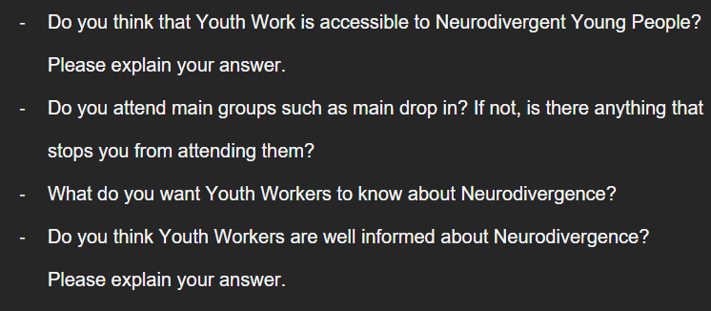
The researcher will provide A3 paper with a mind map for each question and ask the young people to write down their responses around the mind map using the colours assigned to them at the start of the research; this will make it easier for the researcher to record the responses.

Data Analysis Method
Once the results have been collected, the researcher will analyse themes in both the drawings of a ‘perfect’ youth club and the answers to the mind map questions. The data will be presented in a matrix table. Thematic analysis will be adopted which is a method that analyses themes in a data set and is one of the most widely used methods to analyse qualitative data (Ahmed et al., 2025). Jowsey, Deng and Weller (2021) state that thematic analysis allows for a refined understanding of what people say and do in their particular social contexts. Thematic analysis can be used with interviews, focus groups, and documents or images. However, Javadi and Zarea (2016) argue that thematic analysis paraphrases data and does not give room to explain personal opinions and perspectives. They also argue that to conduct thematic analysis, the researcher must remain unbiased because there is a high possibility of the results becoming desired as the researcher chooses the themes.

Research and Ethical Considerations
Another aspect the researcher must consider is the limited time they have to conduct the research, and how big the project can be due to the limitations of their own skills and experience. The researcher has never conducted research using a focus group before. However, they have previously ran focus groups in a non-research environment. The researcher has looked at previous focus group research by Hunt and Hilton (2011) and Pavopolou et al (2025), to investigate how focus groups have been previously conducted. One limitation of the researcher's own focus group is the small sample size, because the researcher needs to reach ND young people, the sample size will be smaller than previous focus group research. However, because of the researcher's limited experience of focus group research, and the time constraints, a smaller participant number will benefit the researcher in terms of transcribing the results of the research. This is also the reason why the researcher has chosen to ask the young people to write down their answers in mind map format rather than recording verbal discussion.

Before the research could go ahead, the researcher had to obtain ethical approval. During this process, the researcher investigated potential ethical issues with the research, for example: participant bias, risk of creating emotional distress and the researcher's own bias due to being passionate about the subject matter. To make sure the research was ethical, the researcher used guidance documents such as: UWTSD Research Ethics & Integrity Code of Practice (ND), the EGER Guidelines (BERA, 2025), UNCRC, (UNICEF, 1990) and the YW NOS (CLDSCS, 2019). To facilitate ethical research, the researcher made sure the participants were aware of their right to withdraw, the fact that participation was voluntary, and how they were going to be kept anonymous. To counter participant bias, the researcher made sure the participants knew they were conducting the research as a university student and all truthful answers were helpful. If there are any issues raised for further concern, the researcher will point them towards support organisations such as: The Donaldson Trust, Papyrus, The Society for Neurodiversity and The Samaritans.

Research limitations
Because the focus group only have six attendants, the researcher gained limited results, however, because the young people who attended were passionate about the topic, the focus group has enough discussion for the researcher to analyse. Some of the young people struggled with understanding the questions or thinking of aspects to add to their ‘perfect’ youth club designs. The researcher did try to help and prompt them, but this may have influenced their decision, and they may have simply written what the researcher suggested.

In this chapter the researcher discussed the methodology and methods they used to approach this research. In the next chapter, they will be presenting the results that occurred from this research.

Chapter 4.
PRESENTATION OF THE DATA

This chapter will discuss the results of the research, including summaries and direct quotes from the focus group activities in which the researcher had six participants, less than their original estimated number. The research was conducted with a small LGBTQ+ centred focus group in Southwest Wales, so it is likely that the research cannot be generalised. The responses from the mind map questions and the participants’ designs of a ‘perfect’ youth club identified four themes through thematic analysis. These themes are Sensory Needs, Biological Needs, Support Needs and The Need for Escape. As such, the data presented within this chapter will be presented against these four themes. To maintain anonymity, each participant will be named after a colour.

Theme 1: Sensory Needs
One of the themes identified in the focus group was sensory needs, and the need for sensory items. For example, Green, Purple and Pink identified in their ‘perfect’ youth club designs that they would like boxes of sensory toys around the centre. Purple used examples such as, “soft stuffed animals”, “putty/clay” and “fidget cubes”. Pink also suggested that having comfort items may be useful to create a calming environment. Purple explained that sensory items can help soothe young people when they get overwhelmed. Purple also suggested to have “mini fans” to cool young people down when they get overwhelmed or overstimulated and are feeling very warm.
Under the umbrella of sensory needs, there are many sub-categories, such as visual needs, auditory needs and touch sensitivity. These were also all identified in the focus group.

- Visual Needs – Every young person in the focus group identified lighting as one of their main aspects of a ‘perfect’ youth centre. Most mentioned not having overhead lighting and instead having low mood lighting such as fairy lights, dim lamps and non-fluorescent lighting were important. Additionally, in terms of the designs of the space, Pink mentioned having no “overly bright colours on the walls” and Dark Blue mentioned that contributing to the design of the space may help them feel more at ease.

- Auditory Needs – Four out of six of the young people mentioned that they wanted fun or calm music in the background of their ‘perfect’ youth club. Pink also mentioned having noise-cancelling headphones available upon request to block out loud sounds would also be helpful. Many of the young people also identified loudness as an issue that prevents them from accessing the main drop-in and making their experiences of other youth clubs overwhelming, so they emphasised the importance of not having loud noises in the space.

- Touch sensitivity – Many of the young people mentioned having comfortable seating, bean bags and specifically “no velvate” [sic] or “scratchy” furniture in their space. Some also mentioned having lots of pillows and blankets to make the space comfortable.
Theme 2: Biological Needs
Three of the young people included, water stations, “safe” food and drink and having different free foods in their space as key components in their ‘perfect’ youth club. Purple explained that their idea of water stations was because “neurodivergent people can very easily forget to feed and hydrate themselves, so having regular reminders and handy, easy to access water stations will prevent members from getting dehydrated”.

Theme 3: Support Needs
In the answers to the question “What would you want Youth Workers to know about Neurodivergence?” many support needs were identified. Many of the young people mentioned wanting youth workers to know not every ND person is the same or has the same needs. Green mentioned wanting youth workers to have more awareness when speaking to non-verbal people and to “not try and get them to speak” and “not get mad when they aren’t responding”. Purple also mentioned wanting youth workers to know that “physical touch is not always good and can make a neurodivergent member with sensory issues really uncomfortable and may trigger a meltdown”. In their design of a ‘perfect’ youth club, Pink mentioned having self-help posters, cue cards for non-verbal members, having a no-judgement policy and youth workers having regular check-ins with members for extra needs. They also wanted everyone that attended the youth centre to have formal education on mental health and neurodiversity. Training, and youth workers having more training on ND young people, was a prominent theme in this category.

Another prominent area that arose when considering support needs was communication aids. Green mentioned youth workers having more training for NT people who go non-verbal, and Pink mentioned “non-verbal cue cards, pins or stickers being available for different needs, and for each member of staff to introduce themselves well to the young people.”

Theme 4: Need for Space / Need for Escape
The final theme identified from the focus group was the need for space or escape. As for need for escape, five of the young people had individual rooms functioning as a ‘quiet’ room for young people to access when they got overwhelmed as part of their ‘perfect’ youth club. However, Pink suggested that instead of having a separate room, a quiet corner where people could go when feeling overwhelmed may be useful to help them still feel included. Pink, Light Blue and Green included tables where people could participate in arts and craft activities on their own. Light Blue specified this as the “doing stuff quiet table” and included a separate “loud table” in their design. The need for space was mostly identified by the young people wanting their youth club to have smaller groups, so the space is “less busy and loud”. Dark Blue also mentioned having an “open space to not feel claustrophobic” and an “outside area for fresh air”.

The pie chart in Figure 1 below is a summary of the young people's answers to mind map question four. In their explanations of their answers in the pie chart below, most participants suggested that in their experience the youth workers in the club they all attend are well informed. However, most of the young people also suggest that some youth workers are under-educated in their practice. For example, Pink suggested that some youth workers “lack updated knowledge and believe in harmful stereotypes”. This was seconded by Purple who suggested that “in some youth groups, the language youth workers use towards and about neurodivergent people can be really condescending”.

Figure 1
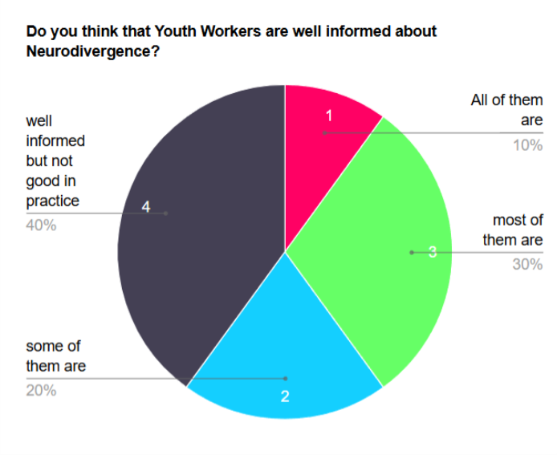

These results show that the young people believe that while youth workers are well informed about NDS, they are not good in practice, and only one young person believes that all youth workers are well informed about NDS.

In this chapter, the researcher has presented the data obtained from the focus group activity. What follows next in Chapter 5 will be the researcher’s discussion, interpretation and analysis of these findings, alongside a reflection on how they relate to the literature reviewed in Chapter 2

Chapter 5.
DISCUSSION, & INTERPRETATION OF THE DATA

This chapter will discuss and analyse the findings of the research, how they are similar/dissimilar to research previously conducted and how the findings may have changed the researcher's perspective and opinions on the topic of How Youth Work in Youth Clubs can be made more accessible to Neurodivergent Young People.

Interpretation of findings

Theme 1 - Sensory Needs
As discussed in the previous chapter, the findings of the research can be linked with sensory needs, something that Pavopoulou et al. (2025) and Attwood (2007) point out to be significant in a ND person’s livelihood. They point to specific areas such as sound, touch, lighting, and taste and texture, many of which were also pointed out by all the young people in the focus group. Fielding, Streeter and Hanley (2025) argue that sensory issues are important as it affects a ND person’s behaviour. They state that this can be measured by a person’s attendance record, or ‘acting out’ in the classroom. NYCI (ND) also highlights the fact that youth clubs are very noisy spaces often containing fluorescent lighting which often means they are inaccessible for ND young people.

Theme 2 - Biological Needs
Because, as Attwood (2007) and MacKenzie (2008) point out, sensory issues have a great impact on ND people’s lives, they are an important aspect to consider. Green, Purple and Pink all mentioned ‘safe food’ or drink in their designs of a ‘perfect’ youth club, and this highlights the importance of considering food sensitivity when designing a safe space. As Purple points out, many ND young people forget to hydrate, which is affirmed by NHS (ND) who suggest that ND young people forget to eat or drink water as they do not understand the signals their body sends them when they are hungry or thirsty. Milton et al (2020) suggests that ND people are sensitive to different foods because they are sensitive to change. They suggest introducing new foods to children and young people by using fun touch and taste sessions, where they can explore food through texture and smell as well as taste, reducing the stress and anxiety of trying new things.

Theme 3 - Support & Communication Needs
The research results also indicate the possible need for PECS (Picture Exchange Communication System) (Bondy and Frost, 2011), as Pink mentioned having non-verbal cue cards in their ‘perfect’ youth club design. Bondy and Frost (2011) explain that PECS can allow autistic children and others that struggle to verbally communicate their needs to others, lowering the possibility of meltdowns and miscommunication. Additionally, five out of the six participants indicated that they believed that youth workers and youth work itself is not fully accessible to ND young people. Many suggested that youth workers should have more training and re-educate themselves about ND young people and educate themselves. The education and training of facilitators was also suggested in research conducted by Fotheringham, Cebula and Crompton (2023) and Coyle, Hare and Ramey (2023). This indicates the importance of having well informed facilitators and NDS specific training for practitioners who work with young people. Milton et al (2020, p.309) point out the importance of interventions for autistic people understanding “real authentic autistic lived experiences”. This indicates that as well as benefitting from training, facilitators may also benefit from learning from listening to the living experience of ND people.

Theme 4 - Need for Space / Escape
Half of the focus group suggested having spaces for arts and crafts in their designs of a ‘perfect’ youth club. This reflects the views of Haywood (2024) who advocates for the importance of art therapy for ND people. They suggest that because art therapy has no need for words, it is a more suited practice for ND people. Haywood (2024) also states that arts and crafts have proven to be relaxing and help many with mental health issues, and as mentioned by Kroll et al (2025), ND people face many challenges that can impact on their mental health. This indicates the importance of including activities that can help them relax in a safe space. In previous research by Frothingham, Cebula and Crompton (2023), a separate room to be used as a ‘quiet’ space was suggested by the young people. This was also suggested by many of the young people who participated in the researcher’s focus group. However, two of the young people, Pink and Light Blue, suggested having a space inside their perfect youth club as a ‘quiet space’. Pink explained that this would mean that ND young people could still be a part of the activity but still have a space of calm to access when they are feeling overwhelmed.

Difference in the findings of other researchers
The main difference between the researcher’s findings and the findings of others is that their research was conducted in a youth club, whereas other research was conducted in schools, therefore most findings in previously conducted research were focused on education and making classrooms more accessible. Research previously conducted (Frothingham, Cebula and Crompton, 2023) also assumes that every ND young person requires the same thing. However, as pointed out by Shore (2020) and Busby (2024) a ‘one size fits all approach’ does not work for ND young people as they all face different issues and have different needs. This was in fact a point raised by Purple in the focus group as one of the things they would like youth workers to know.

There were also differences in relation to the research methods used. Previous research by Frothingham, Cebula and Crompton (2023) used participatory methods. However, they used co-designs, working alongside ND young people and the adults who work with them. They recorded the transcripts of the meetings and thematically analysed them. This approach was more participatory than the researcher’s own study, as young people were involved in the design of their support groups. Coyle, Hare and Ramey (2025) used logic modelling workshop methodology and included ND and NT university students, researchers and disability service staff as participants. Both studies included facilitators that worked with the ND students, whereas the research conducted by the researcher did not.

Another difference between the previously mentioned studies and the current research was in relation to the outcomes of the research. For example, specific programmes were put into place after the previously mentioned research had concluded, whereas for this research, the task was for purely research purposes only. The researcher did inform the young people that it was unlikely that they would get NDS specific changes in their youth centre, however, the researcher does aim to share the results with youth centres, so they are aware of what is needed to make their centres more accessible. The researcher hopes that the results will allow more youth cubs to become accessible spaces.

Due to the time constraints, wordcount and the researcher’s own knowledge, only one focus group could take place. Additionally, it was a small focus group and was LGBTQ+ specific, and therefore it is unlikely that the results can be generalised to the wider range of ND young people in bigger areas.

Change in perspective
The researcher had anticipated most of the findings from the focus group activity. This is in part since they themselves are ND, and because of the research they did before running the focus group. One unexpected finding for the researcher was the fact that while the young people believe that youth workers are well informed about NDS, they do not believe that they are good at putting this knowledge into practice. An example of this was an observation made by Pink who explains that many youth workers still believe in “harmful stereotypes”. The young people made it clear that they did not mean the researcher and their colleagues when they discussed this, but that this instead reflected their experiences of other youth centres. This made it clear to the researcher that more NDS specific training was needed, and potentially current training was outdated and misinformative. Additionally, it may be useful for youth workers to learn from each other. For example, NT youth workers could learn from ND youth workers in terms of how they interact with ND young people. This may help NT youth workers understand it from the ND young people's perspective.

Another surprising aspect was the fact that the young people mentioned having non-verbal cue cards (PECS) (Bondy and Frost, 2011). The researcher has limited knowledge on PECS and how they can be adapted in a youth club setting, however they believe it would be a good idea and will allow more young people who are non-verbal to access the space without feeling the need to speak. Bondy and Frost (2011) highlight the importance of PECS to non-verbal, autistic children. They suggest that PECS gives children a choice, rather than adults guessing what they need. It allows them to communicate differently and still convey what they want. PECS are often used for children to communicate what foods or drinks they want, and therefore they link to the need for ‘safe food and drink’ pointed out by Pink, Green and Purple. It gives the young people the option to not have to verbally communicate but still participate.

In this chapter, the researcher discussed the theoretical implications of the results of their research and how the limitations may have affected their results. In the next chapter, they will conclude on the research results and make recommendations for further research and youth work practice.

Chapter 6.
CONCLUSIONS and RECOMMENDATIONS

Summary of main findings
This dissertation set out to investigate whether youth clubs are accessible to ND young people, and if not, how they could be made more accessible. The main findings of the study are that ND young people want smaller groups to reduce noise, they would like their spaces to consider sensory issues by changing their lighting, furniture and providing a space for people to go when they are overwhelmed. Additionally, this researcher’s findings highlight that while youth workers may be well informed about NDS, ND young people believe that they are not good in practice and still believe in common misconceptions and negative ideas about NDS.

Because most previous research around this topic was conducted in a school environment (Coyle, Hare and Ramey, 2025), it is difficult to compare this research to others. However, it does support previous findings in research by Frothingham, Cebula and Crompton (2023) and Coyle Hare and Ramey (2025) as they all pointed out the need for a facilitator who is well trained in NDS, who is empathetic and understanding to problems ND young people may face. Additionally, the findings of this research do extend what researchers have previously known about sensory needs and how important they are to ND young people when designing a safe space. For example, previous research by NYCI (ND) and Mackenzie (2008) point out the need for non-fluorescent lighting and smaller groups, however, the focus group for this dissertation pointed out additional needs such as: comfortable seating, comfort items, fidget toys and an outdoor space for fresh air. This indicated that ND young people require more to make a space fully inclusive.

The findings of this research link to most of the researcher’s objectives for this dissertation; however, one objective that the research results does not link to is ‘to find out what training already exists for those who work with young people’ as this was not part of the research conducted. However, the research can be linked to the rest of the objectives. For example, one objective that came under the first dissertation aim was ‘to find out what stops Neurodivergent Young People from accessing main groups’, which can be linked to the findings of the focus group. Another objective that can be linked, which was under aim two, is ‘to find out from Young People what they want Youth Workers to know about Neurodivergence.’’ Finally, the results can also be linked to an objective from the third aim, ‘to investigate existing research and what changes Neurodivergent specific organisations make to their spaces to make them more accessible’.

The research concluded that youth centres should consider sensory issues when designing their space, including lighting, furniture and a quiet room. Additionally, Youth Work practitioners may be well informed about ND, but findings showed they were not good in practice, this means that NT youth workers must learn from ND youth workers and young people and change their mindset about NDS. The researcher believes that the research question How Youth Work in Youth Clubs can be made more accessible for Neurodivergent Young People, has been answered as it has indicated that youth clubs can be made accessible, if sensory needs are considered when designing them. The implications of this research are, the fact that youth workers need more training on NDS, and how to interact properly with ND young people. Plus, youth clubs can be very overwhelming for ND young people, so including aspects such as low lighting, comfortable furniture and safe foods can make it less overwhelming for ND young people to attend.

Directions for Further Research
Because of the time limitations on the project the researcher was only able to conduct one focus group, which was with an LGBTQ+ specific group. The researcher would suggest that if this research was re-created, that a second focus group with non-LGBTQ+ participants should take place to widen the scope so the results can be generalised to all ND young people. Additionally, because the research was conducted in a youth club in Southwest Wales, it is limited on its geographical scope as there may be more ND specific centres in a city.

However, despite its limitations, the research did meet most of the aims and objectives. The research uncovered what stops ND young people from accessing main groups, what ND young people think about youth workers’ knowledge of NDS, and what they want them to know. One aim which was not achieved was to look at strategies to make youth clubs more accessible; whilst this was discussed with the young people in their ‘perfect’ youth club designs, the researcher would have liked to have shared this with local youth centres to make real change, the researcher still hopes to do this, but at the moment of writing, this has not been completed.

Another aspect that may be interesting for further research is to interview ND youth workers to gain their experiences of youth clubs and what they would suggest would make the spaces more ND friendly. If possible, it may also be interesting to interview more ND specific youth provisions to gain insight into why they were created, and how they think their young people feel in the space. This may allow further research to investigate other changes that youth clubs could make to make their spaces more accessible to ND young people. The researcher would suggest recording the focus group, even if the results are being written down as they were in this project. This is because the researcher found that many in-person discussions happened and some of these discussions were lost because the participants did not write them down.

Recommendations for Practice

From this research, the researcher would like to recommend that:

- All youth clubs and provisions should investigate sensory needs and adapt their centre if needed.
- Youth workers should take the time to reflect upon their opinions and ideas about NDS, and research whether these are misconceptions.
- Youth workers should talk to ND young people and ask what they want, as not every ND young person requires the same thing.
- Further research should investigate Youth Work as a whole and how all Youth Work contexts can be made accessible for ND young people.

In summary, this study provides new insights into a ND young person’s experience of youth work in a youth club and suggests ways in which youth clubs can be made more accessible. By implementing these recommendations youth clubs can be more accessible for ND young people. This would foster a more inclusive environment in which young people feel empowered to participate (YWWRG, 2022), enabling them to benefit from the wide range of positive outcomes associated with youth work.

Reference list

Acocella, I. (2012) “The focus groups in social research: advantages and disadvantages,” Quality & Quantity, 46(4), pp. 1125–1136. Available at: https://doi.org/10.1007/s11135-011-9600-4. (Accessed January 21, 2025)

Ahmed, S.K., Mohammad. A., Nashwan, a., Ibrahim, R.H., Abdalla, A. Q., Ameen, B. M., Khadir R.M (2025) “Using thematic analysis in qualitative research,” Journal of Medicine, Surgery, and Public Health, 6, p. 100198. Available at: https://doi.org/10.1016/j.glmedi.2025.100198. (Accessed January 26, 2026)

Andrade, C (2020), “The Inconvenient Truth About Convenance and Purposive sampling”. Indian Journal of Psychology and Medicine. Available at: https://journals.sagepub.com/doi/full/10.1177/0253717620977000 (Accessed January 20, 2026)

Armstrong, S., Osuch, E., Wammes, M., Chevalier, O., Kieffer, S.,Meddaoui, M., Rice, L. (2025) “Self-diagnosis in the age of social media: A pilot study of youth entering mental health treatment for mood and anxiety disorders,” Acta Psychologica, 256, p. 105015. Available at: https://doi.org/10.1016/j.actpsy.2025.105015. (Accessed January 15, 2026)

Attwood, T (2007) The Complete Guide to Asperger’s Syndrome. Jessica Kingsley Publishers

Bagnoli, A. and Clark, A. (2010) “Focus groups with young people: a participatory approach to research planning,” Journal of Youth Studies. Available at: https://doi.org/10.1080/13676260903173504. (Accessed November 8, 2025)

Battaglia, M.P. (2008) “Purposive Sample,” in Encyclopedia of Survey Research Methods. Sage Publications, Inc., pp. 645–647. Available at: https://doi.org/10.4135/9781412963947. (Accessed January 20, 2026)

BBC Children in Need (ND): Exploring youth work. Available at: https://www.bbcchildreninneed.co.uk/exploring-youth-work/ (Accessed: November 7, 2025).

Bondy, A., Frost, F (2011). A Picture’s Worth. PECS and Other Visual Communication Strategies in Autism. Woodbine Houe INC

British Educational Research Association (2024) Ethical Guidelines for Educational Research

Busby, E (2024) Neurodiverse Classrooms: Why One-Size-Fits-All Fails – Chronicle Insight. Available at: https://www.chronicleinsight.com/education/neurodiverse-classrooms-why-one-size-fits-all-fails/ (Accessed: December 23, 2025).

Campbell, S. Greenwood, M., Prior, S., Shearer, T., Walkem, K., Young, S., Bywaters, D., Walker, K. (2020) “Purposive sampling: complex or simple? Research case examples,” Journal of Research in Nursing: JRN, 25(8), pp. 652–661. Available at: https://doi.org/10.1177/1744987120927206. (Accessed January 20, 2026)

CLD Standards Council Scotland (2019) National Occupational Standards for Youth Work

Cossins, M (2025) Email to Leo Smith, October 2025

Coyle, A., O’Hare, L. and Ramey, D. (2025) “Synapse: A co-designed neurodivergent peer support programme for higher education settings,” Autism, 29(7), pp. 1711–1726. Available at: https://doi.org/10.1177/13623613251320448. (Accessed December 18, 2025)

Dev, I.R. (2018) “Interview with Dr. Stephen Shore: Autism Advocate & on the Spectrum,” IBCCES, 23 March. Available at: https://ibcces.org/blog/2018/03/23/12748/ (Accessed: December 18, 2025).

Doherty, M. Nelson, S., O’Sullivan,J., Carravallah, L., Johnson, M., Cullen, W., Shaw, S. (2022) “Barriers to healthcare and self-reported adverse outcomes for autistic adults: a cross-sectional study,” BMJ Open, 12(2), p. e056904. Available at: https://doi.org/10.1136/bmjopen-2021-056904. (Accessed: January 15, 2026)

Donaldson, A., Krejcha, K. and McMillin, A. (2017) “A Strengths-Based Approach to Autism: Neurodiversity and Partnering With the Autism Community,” Perspectives of the ASHA Special Interest Groups, pp. 56–68. Available at: https://doi.org/10.1044/persp2.SIG1.56. (Accessed December 18, 2025)

Duea, S., Zimmerman, E., Vaugn, L., Dias, S., Harris, J. (2022) “A Guide to Selecting Participatory Research Methods Based on Project and Partnership Goals,” Journal of participatory research methods, 3(1), p. 10.35844/001c.32605. Available at: https://doi.org/10.35844/001c.32605. (Accessed: February 27, 2026)

Eriksen, I.M. and Seland, I. (2021) “Conceptualizing Well-being in Youth: The Potential of Youth Clubs,” YOUNG, 29(2), pp. 175–190. Available at: https://doi.org/10.1177/1103308820937571. (Accessed, December 17, 2025)

Fergie, G., Hunt, K. and Hilton, S. (2013) “What young people want from health-related online resources: a focus group study,” Journal of Youth Studies, 16(5), pp. 579–596. Available at: https://doi.org/10.1080/13676261.2012.744811. (Accessed February 27, 2026)

Fielding, C. Streeter, A., Hanley, M. (2025) “Neurodivergent Pupils’ Experiences of School Distress and Attendance Difficulties,” Neurodiversity, 3, p. 27546330251327056. Available at: https://doi.org/10.1177/27546330251327056. (Accessed December 23, 2025)

Flannery, K.A. and Wisner-Carlson, R. (2020) “Autism and Education,” Child and Adolescent Psychiatric Clinics of North America, 29(2), pp. 319–343. Available at: https://doi.org/10.1016/j.chc.2019.12.005. (Accessed December 18, 2025)

Fotheringham, F. Cebula, K. Crompton, C . (2023) “Co-designing a neurodivergent student-led peer support programme for neurodivergent young people in mainstream high schools,” Neurodiversity, 1, p. 27546330231205770. Available at: https://doi.org/10.1177/27546330231205770. (Accessed December 17, 2025)

Gharabaghi, K., Skott-Myhre, H.A. and Krueger, M. (2014) With Children and Youth: Emerging Theories and Practices in Child and Youth Care Work. Wilfrid Laurier Univ. Press.

GOV.UK (2023) Why is school attendance so important and what are the risks of missing a day? Available at: Why is school attendance so important and what are the risks of missing a day? – The Education Hub (Accessed March 19, 2026)

Grant, A., Pearson, A. and Leigh, J. (2025) What autistic people – and those with ADHD and dyslexia – really think about the word ‘neurodiversity,’ The Conversation. Available at: https://doi.org/10.64628/AB.knm5q93n6. (Accessed December 17, 2025)

Haywood, S (2024) Neurodiversity and art therapy. Available at: Neurodiversity and art therapy - The British Association Of Art Therapists (Accessed March 12, 2026)

Javadi, M. and Zarea, K. (2016) “Understanding Thematic Analysis and its Pitfall,” Journal of Client Care, 1. Available at: https://doi.org/10.15412/J.JCC.02010107. (Accessed January 26, 2026)

Jowsey, T., Deng, C. and Weller, J. (2021) “General-purpose thematic analysis: a useful qualitative method for anaesthesia research,” BJA Education, 21(12), pp. 472–478. Available at: https://doi.org/10.1016/j.bjae.2021.07.006. (Accessed January 26, 2026)

Kroll, E. Lederman, M., Kohlmeier, J., Ballard, J., Zant, I., Fenkel, C. (2025) “Examining the mental health symptoms of neurodivergent individuals across demographic and identity factors: a quantitative analysis,” Frontiers in Psychology, 16, p. 1499390. Available at: https://doi.org/10.3389/fpsyg.2025.1499390. (Accessed: January 16, 2026)

Lim, W.M. (2025) “What Is Qualitative Research? An Overview and Guidelines,” Australasian Marketing Journal, 33(2), pp. 199–229. Available at: https://doi.org/10.1177/14413582241264619. (Accessed November 9, 2025)

Maciver, D., Singh- Roy, A., Johnston, L., Boilson, M., Curnow, E., Johnstone-Cooke, V., Rutherford, M (2025) Are we getting better at identifying and diagnosing neurodivergent girls and women? Insights into sex ratios and age of diagnosis from clinical population data in Scotland . Available at: https://journals-sagepub-com.ezproxy.uwtsd.ac.uk/doi/full/10.1177/13623613251383343 (Accessed: January 15, 2026).

Mackenzie, H (2008) Reaching and Teaching the Child with Autism Spectrum
Disorder. Using Learning Preferences and Strengths. Jessica Kingsley Publishers

Milton, D., Ridout, S., Martin, N., Mills, R., Murray, D (2020). The Neurodiversity Reader. Exploring concepts, lived experience and implications for practice. Pavilion Publishing and Media LTD

Montague-Cardoso, K., Beardon, L. and Kirby, A. (2025) “Neurodivergence and mental health—Recognising what needs championing and challenging,” PLOS Mental Health, 2(3), p. e0000271. Available at: https://doi.org/10.1371/journal.pmen.0000271. (Accessed: January 15, 2026)

National Autistic Society (ND) Repeated movements and behaviour (stimming). Available at: https://www.autism.org.uk/advice-and-guidance/topics/about-autism/repeated-movements-and-behaviour-stimming (Accessed: December 23, 2025).

National University (2022) What is Qualitative vs Quantitative Study? Available at:What Is Qualitative vs. Quantitative Study? | National University (Accessed: February 27, 2026)

National Youth Agency (ND): What is youth work? Available at: https://nya.org.uk/what-is-youth-work/ (Accessed: November 7, 2025).
National Youth Council of Ireland (ND) Guidance on Working with Young People Who are Neurodivergent. Available at: https://www.youth.ie/wp-content/uploads/2025/02/NYCI_Guidance-Notes_NeurodivergentYouth.pdf (Accessed: January 9, 2026).

NeuroBridge (2025) Exploring The Connection Between Mental Health Issues and Neurodiversity. Available at: https://neurobridge.co.uk/blog/mental-health-and-neurodiversity/ (Accessed: January 16, 2026).

NeuroLaunch team, N. (2024) “Neurodivergent Explained: Exploring Neurodiversity and Its Spectrum,” NeuroLaunch.com, 11 August. Available at: https://neurolaunch.com/what-is-neurodivergent/ (Accessed: December 18, 2025).

Newton, A. Flinn, A., Downs, J., Richmond, R. (2025) “Rethinking self-identification in neurodivergent communities: barriers, harms, and the need for change,” Frontiers in Child and Adolescent Psychiatry, 4. Available at: https://doi.org/10.3389/frcha.2025.1682129. (Accessed: January 15, 2026)

NHS (ND) Eating, drinking and diet for neurodivergent children and young people. Available at: Eating, drinking and diet for neurodivergent children and young people (Accessed March 12, 2026)

North Wales Regional Partnership Board (2023): Statistics about neurodevelopmental conditions in children and young people in North Wales - December 2023. Available at: https://www.northwalescollaborative.wales/wp-content/uploads/2024/02/Neurodevelopmental-conditions-in-children-and-young-people-in-North-Wales-202312.pdf (Accessed: November 7, 2025).

Office for Health Improvement & Disparities (2024) Children and young people’s substance misuse treatment statistics 2023 to 2024: report. Available at: https://www.gov.uk/government/statistics/substance-misuse-treatment-for-young-people-2023-to-2024/children-and-young-peoples-substance-misuse-treatment-statistics-2023-to-2024-report (Accessed: December 23, 2025).

Oranga, J. and Matere, A. (2023) Qualitative Research: Essence, Types and Advantages. Open Access Library Journal, 10: e11001. https://doi.org/10.4236/oalib.1111001 (Accessed February 27, 2026)

Pavlopoulou, G. Chandler, S., Lukito, S., Kakoulidou, M., Jackson, I., Matejko, E L,. Balwani, B., Boyens, T., Poulton, D., Harvey, Nguyen, L., Baker Edmand, S. (2025) “Upsetting experiences in the lives of neurodivergent young people: A qualitative analysis of accounts of adolescents diagnosed with attention-deficit/hyperactivity disorder and/or autism,” JCPP Advances, n/a(n/a), p. e70038. Available at: https://doi.org/10.1002/jcv2.70038. (Accessed December 23, 2025)

Stokes, D., Bergin, R. (2006) Methodology or “methodolatry”? An evaluation of focus groups and depth inter views. Qual. Mark. Res.

Stratton, S.J. (2024) “Purposeful Sampling: Advantages and Pitfalls,” Prehospital and Disaster Medicine, 39(2), pp. 121–122. Available at: https://doi.org/10.1017/S1049023X24000281. (Accessed January 20, 2026)

Tidsall, E., Davis, J., Gallagher, M (2009) Researching with Children & Young People. Research Design, Methods and Analysis. Sage

UNICEF (1990) United Nations Conventions on the Rights of the Child

UWTSD (ND) UWTSD Research Ethics & Integrity Code of Practice
Vazquez, E (2024) The Danger of Self-Diagnosis Through Social Media. Available at: Medens Health (Accessed: January 15, 2026)

Welsh Government (2015) The Well-being of Future Generations (Wales) Act 2015: the essentials. Available at: Well-being of Future Generations (Wales) Act 2015: the essentials [HTML] | GOV.WALES (Accessed January 21, 2026)

Welsh Government (2019). Youth Work Strategy for Wales. Available at: Youth work strategy 2019 | GOV.WALES (Accessed November 28, 2025)

Welsh Government (2019). Youth Work Strategy for Wales. Available at: Youth work strategy 2019 | GOV.WALES (Accessed November 28, 2025)

Wood, J.J. and Hine, J. (2009) Work with Young People: Theory and Policy for Practice. SAGE.

Workplace College (2024) in conversation with Leo Smith
Youth Work in Wales Review Group (2022). Youth Work in Wales: Principles and Purposes

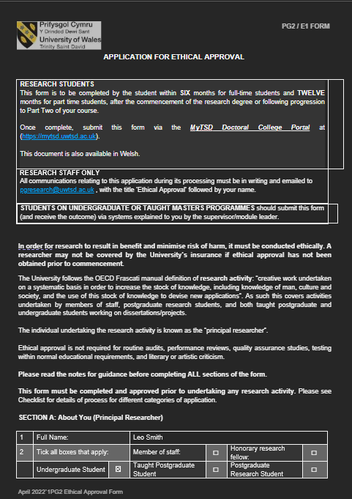
Appendix 1- Ethics Form

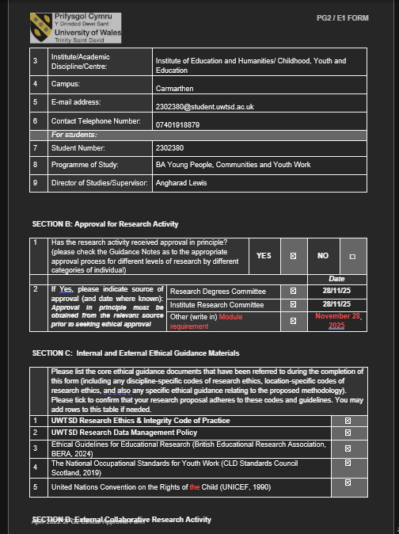
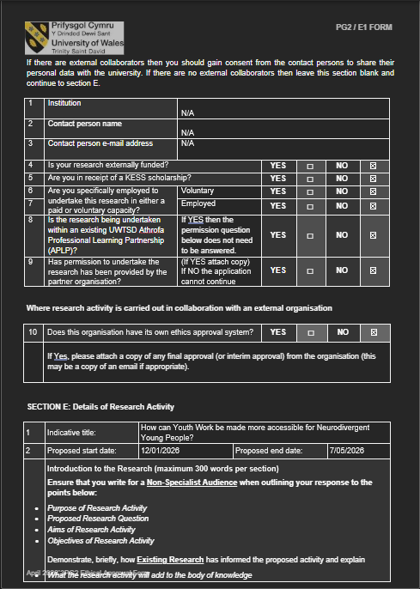
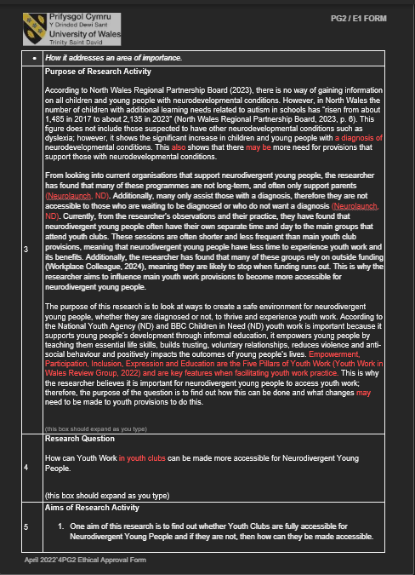
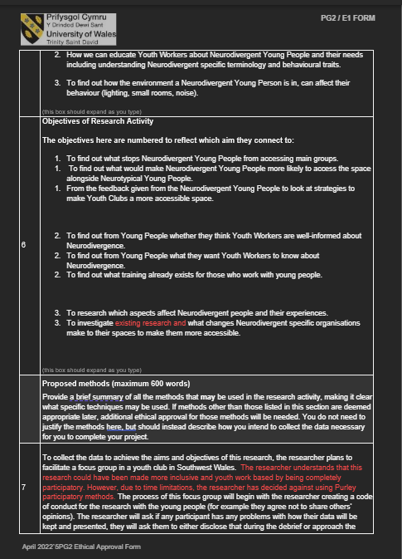
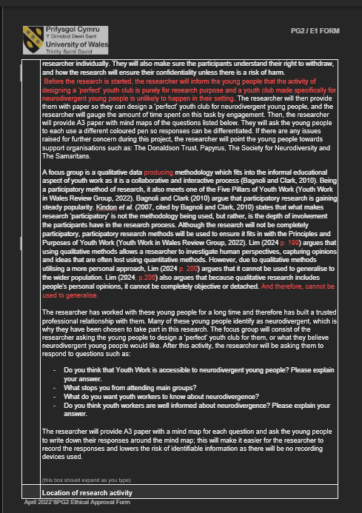
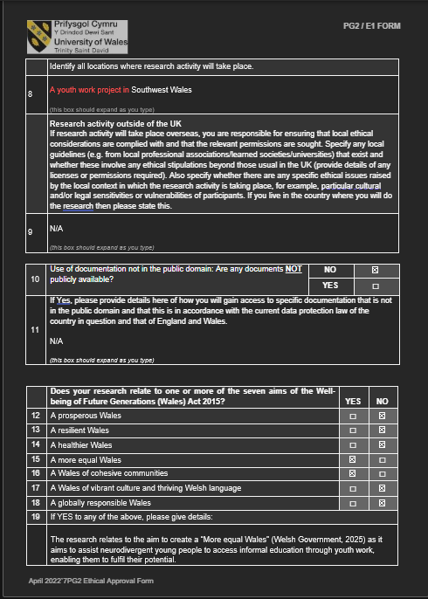
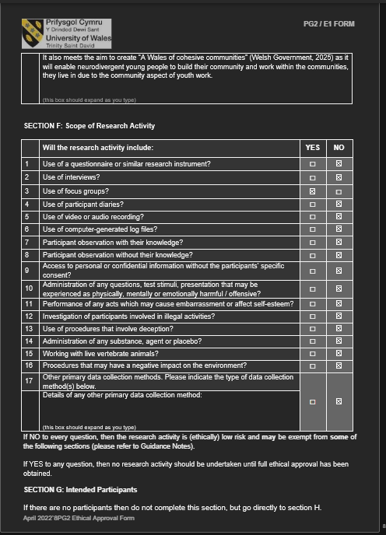
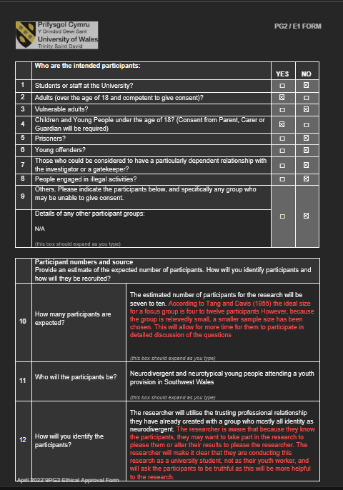
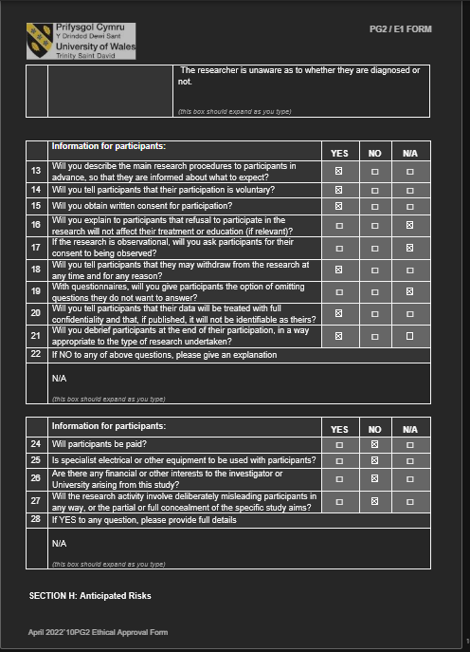
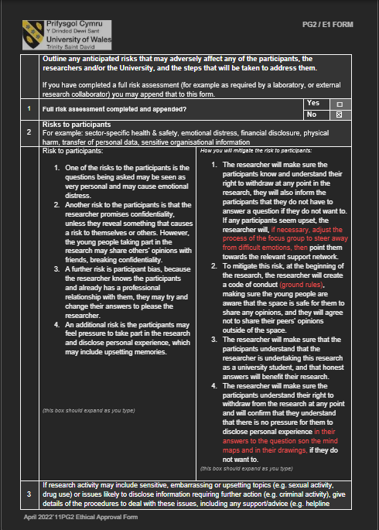
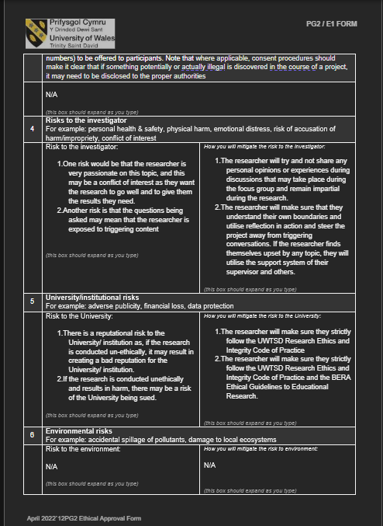
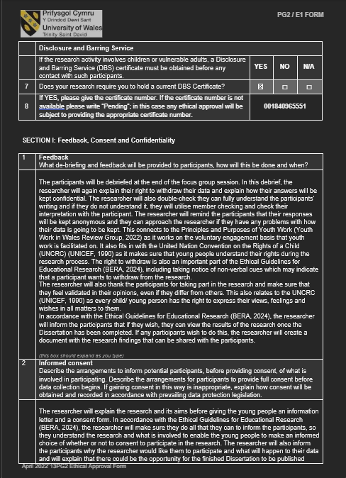
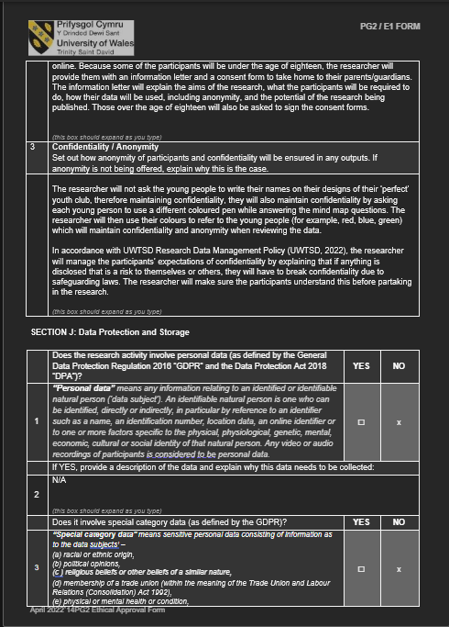
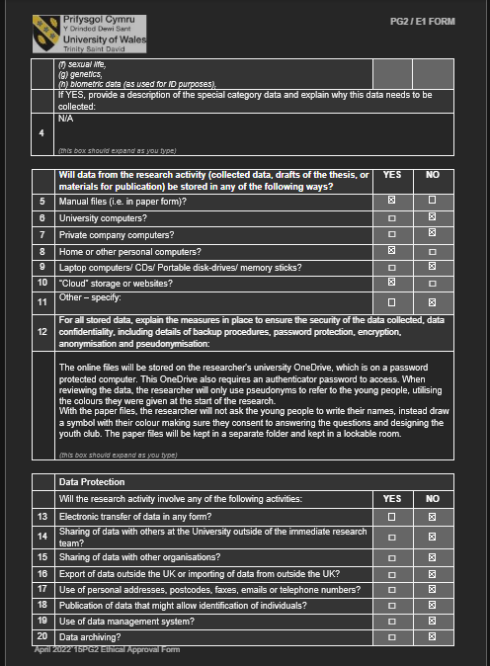
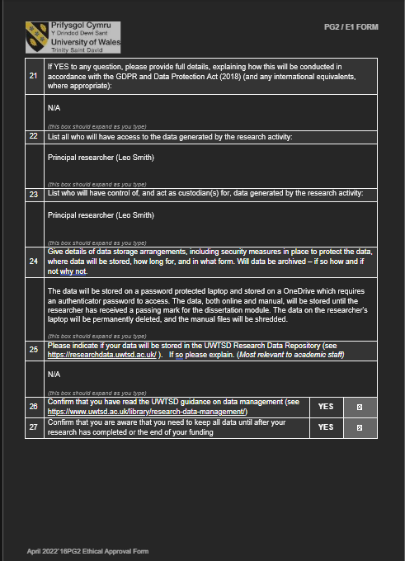
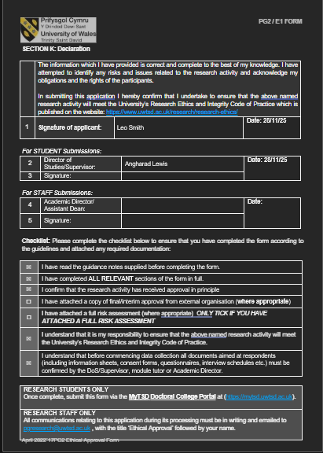

Appendix two- Research Preparation
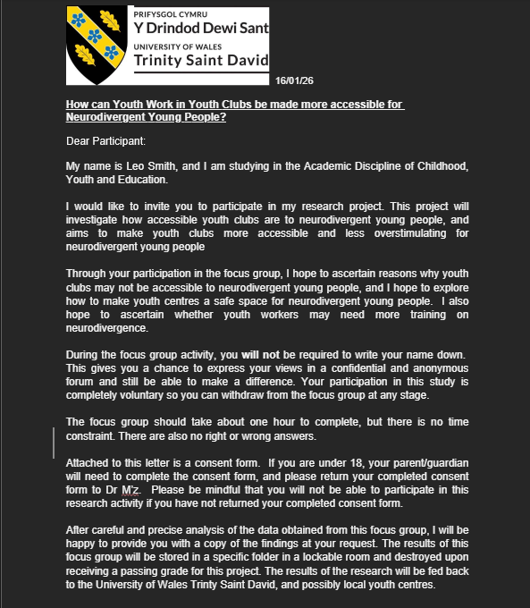
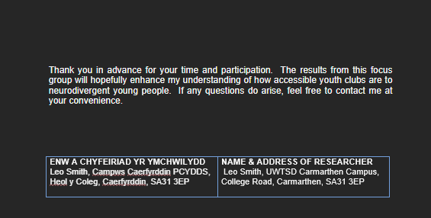
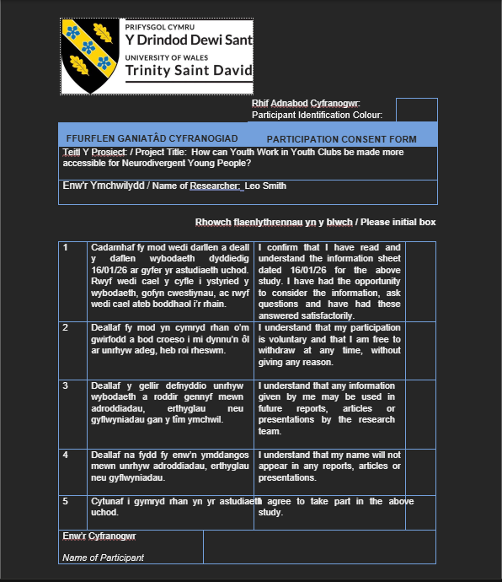
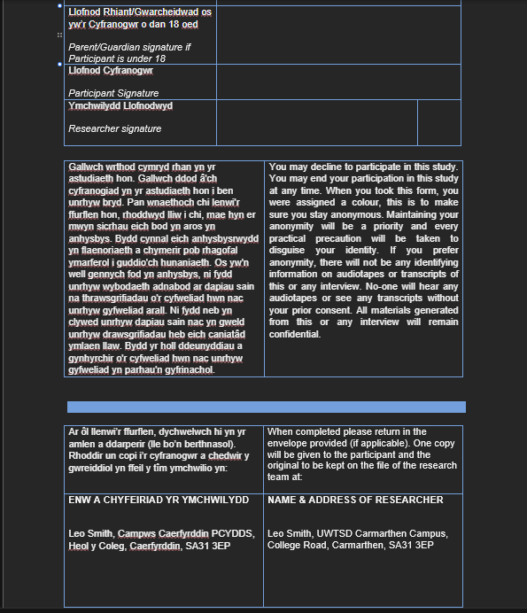
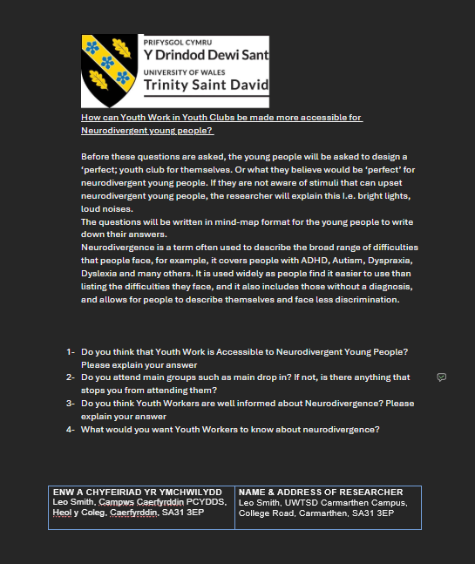
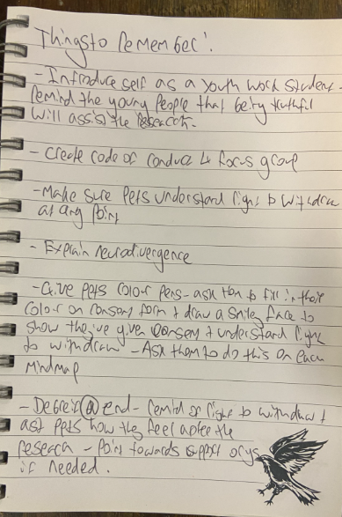
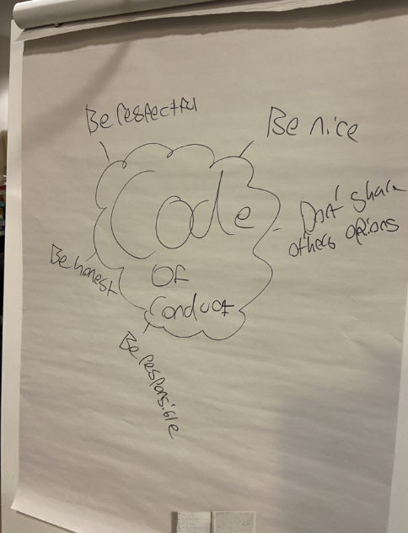

Appendix three – Examples of how the research was conducted


