DS 1 Template

My Screenshots/Photos
- Please add 4–6 screenshots or photos of your digital life.
- You can use your phone or laptop.
- For each screenshot, write one or two sentences explaining what it shows.

Screenshot/Photo 1

I use Snapchat to communicate with my friends and to upload things I am doing in my life.

Screenshot/Photo 2
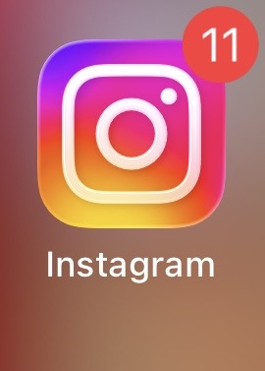
I use Instagram to upload images of myself.

Screenshot/Photo 3

I use YouTube to upload my music videos and to listen to music.

Screenshot/Photo 4

I use chat GPT as a search engine to find information if I need an answer to a question I ask myself.

Screenshot/Photo 5
[Insert Photo/Screenshot below]

[Write what this shows of your digital life]

Screenshot/Photo 6
[Insert Photo/Screenshot below]
[Write what this shows of your digital life]

My Short Reflection
- Write 5–8 simple sentences about your digital life.
- You can use the sentence starters below if helpful.

Sentence starters
- I use digital tools to …
- I feel confident when I …
- I want to improve …
- I often use these tools: …
- I sometimes feel nervous about …
- I hope this module will help me …
- Digital skills are important for me because …
You can write more if you want.

Submission Checklist
Before you submit, please check:
​​​ ☐ I added 4–6 screenshots
☐ I wrote short sentences for each screenshot
☐ I wrote my short reflection
☐ My work is my own
☐ My file opens correctly
​​☐ My file opens correctly

