Engine Performance Characteristics

Date Submitted:
22/03/2023

Motorcycle/Motorsport/Vehicle Technology
ACHA4003/4004/4012

Koa Brook
2203480

Andrew Harrison

Contents
1. Introduction 3
2. Equipment and Method Used 4
2.1. Equipment 4
2.2 Method 4
3. Data and Equations 5
3.1 Graphs 5
SFC: 5
Tourque: 5
Break power: 6
3.2 Equations 6
Corrected power: 6
Thermal efficiency: 6
4. Analysis 7
4.1. Specific Fuel Consumption (figure 2) 7
4.2. Torque (figure 3) 7
4.3. Break power (BP) (figure 4) 7
5. Evaluation 8
6. Conclusion 9
7. Reference List 10

1. Introduction

This paper is analysing the engine dynamometer results of a 1988 1.6 litre Honda Civic Coupe CRX petrol engine. The data given from the dynamometer results will be used to calculate the corrected power, torque, BMEP, SFC, and overall thermal efficiency. These values will be used to create graphs against engine speed so the performance of the engine can be analysed and discussed. The equipment used will also be considered when analysing the data as the equipment/setup used could affect the performance of the engine. A conclusion will be made from the data and analysis about the performance and efficiency of the engine.

2. Equipment and Method Used

2.1. Equipment
The dynamometer used is a SCHENK WS230 Eddie current dynamometer and is limited to 10,000 RPM. The engine turns freely, connected to the dynamometer via the drive shaft. This current created from the dynamometer puts a load on the shaft and therefore the engine. The voltage of the dynamometer corresponds to a load. The outer casing, which puts a load on the engine, is connected to two strain gauges (one on each side). The strain gauge sends a signal to the computer between 5-10 volts, this informs the computer of load that is being applied upon the engine. The air filter attached to the intake is not the original air filter from the vehicle, so could cause variations with the performance and efficiency within the engine. The exhaust pipe of the engine is connected to flexible tubing which connects to the muffler then an extraction vent. The fuel for the engine comes from a separate pump mounted on a wall and supplies the petrol via tubing to the injection system. The engine and dynamometer can be connected to many monitors, in this test there will be monitors measuring the lambda, fuel flow rate load, and load.

2.2 Method
The dynamometer was automated and set to start at 1000 RPM. The system records the values from the sensors and then increases the speed of the engine by 50 RPM. The system continues to record values and then increase the engine speed of the engine by 50 RPM until the engine speed reaches 5,500 RPM. This is called a step test; this is because the controlled variable of the test is increased constantly by the same rate to observe how the data changes. At each engine speed the system records the lambda, fuel flow rate and load of the engine. Then the data recorded is used in calculations with the constants to find the corrected power, torque, BMEP, SFC, and overall thermal efficiency to analyse the performance of the engine.

3. Data and Equations

This section contains the data, graphs and values collected and calculated from the experiment. Figure 1 is a table containing constants from the test some of which were calculated. Figures 2,3, & 4 are graphs that show the performance of the engine using data collected and calculated from the test.
Figure 1
Baro | Humidity | Ambient temp | pivot distance | BMEP | MEȠt | Ƞm
mBar | % | Deg C | metres | w | % | %
1018.9 | 46 | 27 | 0.815776 | 31455.38885 | 26.69714 | 99.3775

3.1 Graphs

SFC:
Figure 2
$$SFC= \frac{V × 0.75 × 3600}{t ×1000 ×P}$$
$$\frac{v}{t}= \frac{volume of fuel}{time taken to use fuel}=fuel flow rate$$
$×$1000 on the denominator converts cc to litres, and $×$3600 on the numirator converts hours to seconds. However the fuel flow rate is should be converted in to litres per second.
$×$0.75 converts litres of fuel to kilo grams.
P is power in kilo watts.
$$∴SFC= \frac{fuel flow rate ×0.75}{P}$$

Tourque:
$$T=Load ×distance from center$$

Figure 3

Break power:
$$BP=T ×2π × \frac{RPM}{60}$$

Figure 4

3.2 Equations

Corrected power:
$$P_{s}=P × \frac{1.01325}{P_{a}} × \sqrt{\frac{T_{a}}{293}}$$
P = the measured/break power (W)
Ps = the corrected power (W)
Pa = the ambient pressure (bar)
Ta = the ambient temperature (Kelvin)
1.01325 = standard pressure (bar)
293 = standard temperature (Kelvin)

Thermal efficiency:

$$η_{t}= \frac{BP}{SFC ×CV}$$
$η_{t}$= thermal efficiency (%)
BP = break power (kW)
SFC = specific fuel consumption (kg/sec)
CV = calorific value of fuel (kJ/kg)

4. Analysis
Figure 5

4.1. Specific Fuel Consumption (figure 2)
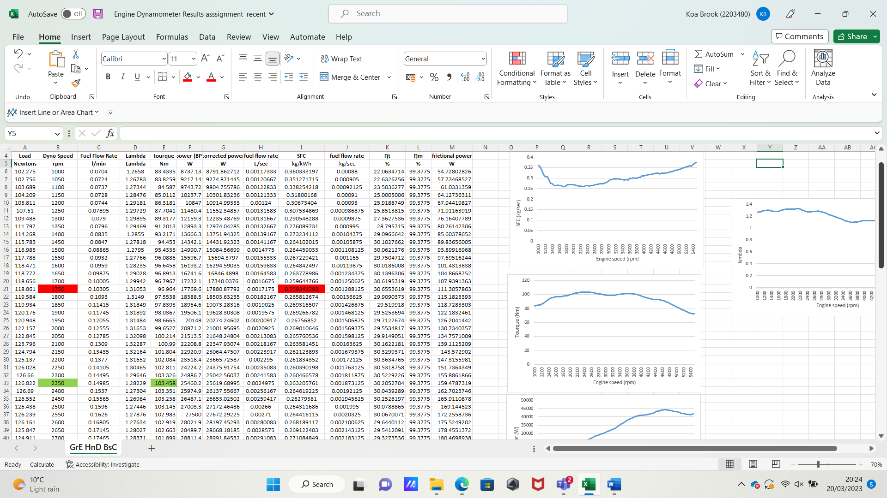
“Consider two engines, call them A and B. If engine A requires less fuel to generate a given power (or thrust for jet engines) than engine B, then we say it is the more efficient of the two. This would place engine B at a competitive disadvantage.” (Snorri Gudmundsson, 2014). even though this section is based on efficiency, the comparison made is due to the difference in SFC values. Engines with a lower SFC use less fuel per kilowatt hour produced from the engine. The SFC graph against RPM begins relatively high this could be because the thermal efficiency (Ƞt) begins relatively low. The engines power and torque do not start at zero this is because when running the engine would stall due to frictional forces if the power and torque started at zero with a linear property. This means that the engine consumes more fuel that can be used for power so that the engine does not fail/stall. At the point where SFC has a minimum value thermal efficiency has a maximum, the two values show inverse proportionality. This can be seen in figure 5 which is a section of the SFC and thermal efficiency data calculated (from 1000-2600 RPM). The increase in thermal efficiency can be linked to the SFC value as when the efficiency increases the engine does not require as much fuel due to more energy being produced per unit of fuel. After 1750 RPM (highlighted in red in the SFC values of figure 5) the SFC value begins to increase and the thermal efficiency decreases, this is because the engine requires more fuel to sustain the increase in power shown in figure 4. After 2200 RPM the SFC graph begins to take on a linear shape as RPM increases.

4.2. Torque (figure 3)
The torque reaches a maximum at 2350 RPM, this is also a point where thermal efficiency reaches a value similar to its maximum value before decreasing. The graph of fuel low rate against torque is shown in figure 6. This graph highlights the linear relation of the two values. As more fuel flows through the engine the higher the turning force. The torque of the engine peaks when the SFC of the engine is at its lowest value. This is because even though the flow rate increases steadily the amount fuel needed to create a unit of power drops, this will produce a larger turning force (torque). As the SFC increases the torque drops as more fuel is needed per unit of power which lowers the turning force as less energy is being produced.
Figure 6

4.3. Brake power (BP) (figure 4)
“… friction losses inherent in mechanizing a heat engine cycle” (J.R. Senft, 1997). The brake power is the power produced by the engine at the drive shaft, this value is lower than the corrected power. The corrected power is the power produced by the engine but due to friction some is lost resulting in the brake power. The brake power graph displays a linear relationship with engine speed. This is as the speed of the engine itself increases the turning speed and therefore brake power of the drive shaft. At 4700 RPM the brake power peaks and the linear aspect of the graph changes, the graph and the values can be seen to decrease steadily at this point at a similar rate to which they climbed. The power may have come to its maximum point then due to the increase in SFC the power declines, as more fuel is required at this rev range to produce the same amount of power.

5. Evaluation

The experiment itself can be improved in many aspects. The air filter used in the experiment was nor made for the engine and did not fit precisely. The experiment would have yielded more accurate results if the engine had an original or aftermarket air filter made specifically for the engine itself. This may have contributed to the high lambda value. As the air filter could have increased the air flow into the injector increasing the air to fuel ration being injected into the engine increasing the SFC as well as the lambda values. The muffler is connected to the engine through flexible tubing, there could have been gaps where the tubing connects allowing the exhaust gasses to escape. This would have an increasing effect on the lambda value. The engine itself could have had wear issues. This can alter results as it can have an effect on power due to frictional wear, and SFC as the volume of the cylinder could have been altered due to damage over time. To make sure this doesn’t affect the test, either a newer engine or new parts would reduce this issue.

6. Conclusion

The experiment itself is precise and accurate in terms of recording the data produced by the engine. The step test method used allows for data that shows easily visible patters when graphed, displaying obvious correlations between different values. However, there are many ways the test itself can be improved upon. These areas for improvement can be seen within the graphs, as even though they show the relationships between data sets they have some variance. This variance cannot be fully removed but, can be limited by improvements that can be made to the setup of the test. There is a possibility of errors within the calculations made, one of these could be with the thermal efficiency as the calorific value of fuel is needed. The value used was a general calorific value as the fuel used was not measured for its exact calorific value. “Errors in the calibration arm. Dynamometers are always supplied with a calibration arm which bolts on to the machine carcase and carries dead weights, usually applied through a knife edge. It is very difficult to check the radius of the knife edge from the trunnion axis; in practice one must rely upon the manufacturer.” (Michael Plint & Anthony Martyr, 1995). This extract emphasises the errors that can be found within the equipment itself, this could cause inconsistencies within the results both calculated and measured. If there are errors within the measured data, then the error will increase as the values are used in calculations.

7. Reference List

- Specific Fuel Consumption - an overview | ScienceDirect Topics. (n.d.) / chapter 7 - selecting the power plant (Snorri Gudmundsson, 2014). www.sciencedirect.com. https://doi.org/10.1016/B978-0-323-90040-9.00026-6

- Engine Testing: Theory and Practice, Chapter 9, Measurement of torque, power, speed, and fuel consumption (Michael Plint & Anthony Martyr, 1995)

- Brake power maxima of engines with limited heat transfer. (J.R. Senft, 1997). IEEE Conference Publication | IEEE Xplore. https://ieeexplore.ieee.org/abstract/document/661901?casa_token=EWIo7cwcPnIAAAAA:rLqakRsZJsJ0VaDl1pBPE3UTX06hDIWQo_OqZeUAkEtWVc1EDKWcl0k4mv-uKKqC4Vr-IgEWh02k

