An investigation of the holocaust through the eyes of a schoolboy

Abstract
This paper will look at the holocaust. What happened during the holocaust and how it made the individuals living through that period feel. It will look at literature around this subject and also contain a diary extract written by a sixteen year old school boy which provides a first-hand viewpoint. The extract will be studied for any themes that arise giving light to how the writer of the extract thought and felt throughout this period. A table will be provided with subordinate and superordinate themes with quotes from the extract and page/line numbers. Through the dissection of the extract it appeared that certain events arose giving the writer conflicting opinions and feelings of both the Germans and the Jewish people. This paper concluded with the viewpoint that the period in which the holocaust occurred was a terrible time to live. This period was rife with fear and death, with anyone who the Nazi’s deemed inferior being segregated and sentenced to terrible fates.
Introduction

This report will view into the period of the Second World War. It will be focusing on the occurrence of the holocaust. It will detail the happenings of the holocaust with brief overviews of the event both before and after. It will provide information on concentration camps and what happened within them. It will also provide details of an individual’s thoughts and feelings during this period. To find this information, historic information along with a first-hand viewpoint of a sixteen year old Ukrainian schoolboy’s diary extract will be used.

Between 1930 and 1945 the Second World War took place between Nazi Germany and the surrounding areas. Within this time frame the holocaust began and many concentration camps and death camps were erected for prisoners of war and other individuals that Nazi Germany deemed inferior to themselves. These included people such as Jews, homosexuals and foreigners to Germany that were not in alliance with Germany at that time (Snyder, 2009). The individuals sent to these camps where either shot in mass shootings or sent to gas chambers where exhaust fumes were used in order to take their lives (Snyder, 2009). One of the most popular camps occupied by the Nazis was Auschwitz. This camp (situated in Poland) witnessed the deaths of one and a half million Jews alone (Mayer, 2007).
Individuals who were deemed inferior by the Nazis where hunted down and taken to these camps. Within these camp the men were split from their families and sent to work while the women and children were often slaughtered by either shootings or gas chambers. Jews were among the most hunted and comprise the greatest numbers of deaths. Overall around six million Jews were hunted down and killed over this period. While these camps were in operation, Nazi scientists conducted experiments on prisoners alive or dead.
Individuals living through this period and who were deemed inferior had a sense of danger everywhere they turned. The fear of being captured and taken to one of these concentration camps was felt by all, with the Jew population feeling it most. Individuals lost their jobs, beaten in the streets and/or went into hiding. It was a dangerous time for anyone who was not Nazi or allied with them (Connolly, 2015).
The holocaust is an important part of history. What happened during this time was awful for many, not only for the prisoners or the survivors but their generational families. People still visit these sites to view and feel a connection with the history of these places. They also pay homage to their families or countrymen who died in those places. It is important to remember what happened in this time so as not to forget the brave men and women who put their lives in danger to hold back the Nazi forces from advancing. The holocaust is also important to remember, to know what happened and to try and not let it happen again.
The aim of this study is to present information of the holocaust, what happened and how individuals living in that period felt with the aid of research and an extract of first-hand experience living in this period.

Methodology
- Design
The design of this study was an Interpretative Phenomenological Analysis. This study consisted of one diary extract written by a sixteen year old schoolboy from Ukraine. The extract was studied by the researcher for similarities in thought and feelings through the language was used. The study took place at the researcher’s leisure as there were no interviews needed. The extract was found within a public domain on the internet.

- Participants
For this study there was a single participant. This participant did not choose nor was asked to participate as the extract used was on the internet within a public domain. The participant who had written the extract was as sixteen years old and from Ukraine. The extract found was in the medium of English, however it may have been translated into English. The participant is not aware that the extract will be used for this study, however if he became aware that it had been used, a consent and debrief form may be needed.

- Materials

- Internet – The diary extract and further research was found via the internet.
- Paper – The extract was printed out in order to analyse and collect notes.
- Pen – A pen was used to collect notes.
- Highlighter – A highlighter was used to colour code similarities within the extract for analysing.
- Microsoft Word – The report was written using a Microsoft word document.

- Procedure
For this study an extract was located via an internet URL link. The extract was then printed in order to take notes and to find any similarities within the extract regarding thoughts and feelings. Once the extract had been read and all notes were in order, thoughts and feeling were then categorised into themes and clusters. This process links all similar thought and feelings into sections to gather information and understand what the writer of the passage felt like. Once this process had been completed they were then put into a table for use in this report. The writer of this passage did not know that the extract would be used, however, because the extract was found within a public domain (the general public can access it) it was presumptive that the writer did not mind the extract being used. The passage used was written in the medium of English and has been presumed to have been translated beforehand by an unknown participant.
- Ethical consideration
Ethical considerations are minimal as this passage was found within a public domain, however if the writer or their family wished the passage to be taken down and to not be used, the researcher may have to supply a consent or debrief form, or negate any work done.

Results/discussion
While reading the diary extract it appears that the writer has some conflicting feelings. At the start of the passage, it appears that he overlooks the Jewish retaliation with some doubt and un-satisfaction. The writer also appears to be a Christian, as he becomes quite angry at the thought of the German soldiers calling themselves Christians and asking for God to be with them. It appears that the writer thinks the Jewish retaliation is futile or a ‘Fairy-tale’ and does not seem to want to be part of the rebellion. The writer does not seem to want to identify himself with the Jewish people but he does however, have some feelings of sadness towards the dead Jews. Further along the passage, the writer seems to conflict with the previous statement about the retaliation being futile and, almost pleads with the Jews to fight back. The writer seems to have a love interest with a female, which he names F. F seems to be a Jewish girl, this however, he seems to put justification to this by saying she is better than everyone in every way. He praises her and almost lifts her onto a pedestal by suggesting how brave she is and that she won’t cower at the thought of death. The writer then goes on to say (which the researcher thinks is F) that she tried to save someone. It seems F was killed by this action, and even though to try and save someone is a very honourable thing, the writer justifies her actions, as if trying to save a Jew was beneath her. It also seems that because he had lifted F onto this pedestal, he could not imagine her in the horrible state like that of the other dead Jews, and so he describes her as ‘nothing’. Because of her death it seems the writer loses faith, as so does not give her any ‘fancy words’ as he puts it.it also seems that in the result of F’s death, the writer become outraged and wants to take revenge. This feeling conflicts with previous feelings about not wanting to take part in any retaliation. Following F’s death, it seems the writer disengages himself, becomes colder towards the Jewish people dyeing and become less concerned with the gunfire. Further along the passage the writer seems to pick up his attitude towards the Jewish people, when the ‘Ghetto’ become inflamed. He seems excited with this, so excited he says that ‘it’s enough to discuss for a whole week’. The writer also seems to be please that the pump carrying water to extinguish the flames doesn’t seem to be powerful enough to put out the flames. This furthers his excitement. From there on he seems to start connecting to the Jewish people again. He also seems to want the Jews to set a fire again and become excited at the idea. His connection towards the Jews become stronger as the passage goes on and at one stage he even starts to call some of the Jews ‘Heroes’ and has admiration for them as they won’t give up the fight. The final paragraph of the passage explains a sale that consisted of clothes worn by dead Jews, it seems this made him unhappy not only that he had to miss work, but that people were queuing to get these clothes.

Table 1
This table shows the superordinate themes and subordinate themes gathered from the extract, along with quotes and page/line numbers.
Superordinate Themes | Subordinate Themes | Quote Keyword | Page/Line Number
Psychological States | Psychopathology  Strong feelings  Love interest  Strong language  Analogies | I will go mad  These bastards dare to call themselves Christians  My first love  Sheep to the slaughter  ‘Pow’ ‘Tra-ta-ta’ | 2/Line 12  1/Line 10  3/Line 5  1/Line 30  4/Line 32-33
Identification | Faith  Identification | If I were a believer  Look at those heroes | 3/Line 25  4/Line 27
Justification | Willingness to fight  Justification | Maybe one day I’ll get revenge  She paid because she dared to want to live | 3/Line 5  3/Line 12-13

This table shows the themes the researcher perceives occurs within this extract. This table also has a quote to support these themes with page and line numbers for easy reader access. This table shows that the researcher perceived much emotion throughout this passage with conflicted thoughts and feelings along the way. There are variables which seem to change the writer’s viewpoint of the Jews, such as his perceived love interest with ‘F’ and the fire which is caused by the Jews. His feeling and viewpoints seem to proceed with an ‘up and down’ motion rather than a ‘consistent line’ throughout the extract. The writer seems to bring to light the general fear within the Jewish community who reside in his surrounding area and the anger towards the German soldiers, within that time, similar to that of the writing of Connolly (2015).
As this was an extract by a single individual, and no other extracts from the same area as this writer has been found, nor the time period of the holocaust be revisited the happenings of this extract cannot be proven, however many books and papers which discuss what happened during the holocaust are similar to those stated in this extract, (Young, 1997), (Finkelstein, 2000), (Mayer, 2007), to name a few.
Conclusion
This paper has looked at the holocaust. It has described what happened during the holocaust, who the German Nazi targeted and how these individuals were killed. It has also looked at a diary extract by a sixteen year old schoolboy who witnessed the holocaust for himself. He provided a detailed log of his feeling and thoughts toward both the Jewish people and the Germans. The diary extract coincided with previous literature describing a time that many lived in fear. From this, it can be said that the holocaust was a horrible time in which to live, with mass genocides and families being separated. It is important to learn history, to see what went wrong, to learn from mankind’s mistakes, and to make sure events like this do not happen again.

References

- Bergmann, M. S., & Jucovy, M. E. (1982). Generations of the Holocaust. Columbia University Press.
- Connolly, K. (Jan 2015). Tales from Auschwitz: survivor stories. The Guardian, Retrieved from: https://www.theguardian.com/world/2015/jan/26/tales-from-auschwitz-survivor-stories

- Finkelstein, N. (2000). The Holocaust industry. Index on Censorship., 29(2), 120-129.

- Harran, M., Kuntz, D., Lemons, R., Michael, R. A., Pickus, K., & Roth, J. K. (2000). The Holocaust Chronicle. Publications International, Ltd..
- Haydn, T. (2000). Teaching the Holocaust through history. Teaching the Holocaust: Educational dimensions, principles and practice, 135-149.

- Herf, J. (2006). The Jewish enemy: Nazi propaganda during world war II and the holocaust (p. 23). Cambridge, MA: Belknap Press of Harvard University Press.
- Katz, S. (1992). The ethic of expediency: Classical rhetoric, technology, and the Holocaust. College English : An Official Journal of the National Council of Teachers of English., 54(3), 255.

- LaCapra, D. (1996). Representing the Holocaust: History, theory, trauma. Cornell University Press.
- Mayer, M. A. (2007). History and the Holocaust.
- Novick, P. (2000). The Holocaust and collective memory: the American experience (pp. 133-4). London: Bloomsbury.
- Snyder, T. (2009). Holocaust: The ignored reality. The New York Review of Books, 56(12), 14-16.

- Young, J. (1997). Toward a Received History of the Holocaust. History and Theory., 36(4), 21-43.

Appendix 1
Diary extract original

Excerpts From the Diary of 16-year Old Schoolboy Roman Kravchenko (Town of Kremenets, 1942)
July 27.
...Now to local events. Recently they have all been about the Jewish question. Persecution of Jews is becoming more and more intense. People in the ghetto are panicking and expect a pogrom any day now. Last night two Jews were shot – they were trying to make their way back to ghetto, probably left it to find food somewhere.
It’s evening. They say the Jews are armed, they are shooting back; they say a gendarme was killed. If this is true (which I strongly doubt), I am only sorry that they only got one of them. The firing stopped during the day but now it’s escalating again; we’ll see what will happen at night. These bastards dare to call themselves Christians; it’s written on their belt buckles: "Gott mit uns" (God with us). So if that’s how it is, how great is this God if he can look down calmly on what is going on. I am sitting on my porch and hear gunfire. I wonder what these people doomed to death feel, hiding in their houses. What a sinister silence, and then the sound of revolvers, a string of machine-gun fire and the heavy blows of schutzmann rifles are all that I can hear. The night is going to be hard. Still, it was their decision to protect themselves, to fight. The whole thing may as well last for a week – it’s not that easy to take them out of all the cellars in their dirty block, all the lanes and corners.
August 11.
The last anti-Jewish action in our town is coming to its end.
I’m writing today about what happened yesterday. I couldn’t write yesterday since I was exhausted. It was just a fairytale that the Jews were going to protect themselves. They were all humble, walking to meet their death as sheep to slaughter. About 5,000 people were shot yesterday. There is an old trench outside the town, made by a Yakut regiment that stayed in town. The execution took place there. They started to cart Jews from the ghetto about 3 am and didn’t finish till late at night. What a horrible sight! The ghetto gates are wide open, and a queue of doomed people is behind them. They are waiting, two in a row. A car pulls up, and the queue moves slowly: the first pair is put on the bottom of the van, the next row lies on top of them, and so on, in several layers. There is complete silence, not a word, a cry, a groan. Policemen, drunk as a fiddler, hurry those who move slowly with their gun-butts; they also use their gun-butts to tamp down the people lying in the van. The van pulls off, speeds up and races to the suburbs, meeting similar vans with high wooden barriers – they are filled with clothes. A policeman is sitting on top, looking all happy and hiding under a lady’s umbrella. No wonder he is so glad – he’s got his pockets full of watches, five fountain pens are stuck in his pocket, and one can only imagine how many suits and astrakhan coats he has hidden along the way in a safe place. Besides, he has already drunk at least a liter. The van rushes out of town. Every now and again the four policemen standing at its corners curse and hit the lying people on the back with their guns. So here is the destination. The van stops. The victims get out and start undressing right away – everyone, men and women – and move, one by one, to the trench. The trench is filled with dead bodies powdered with chloride. Two Gestapo soldiers are sitting on the embankment, their torsos naked, guns in their hands. People step into the trench, lie down on the dead bodies, and a shot is fired. It’s over. Next!
I have no idea what a human being can feel at the last minute, and I don’t want to think about it, or I will go mad. There were those who tried to resist, they didn’t want to undress, they didn’t want to step into the trench. They were killed on spot and thrown into the trench. So now the trench is full and the policeman covers it with soil. The queue moves to another trench – there is room for everyone! One man, already naked, is running along the field, crouching to the ground. The Gestapo soldiers are watching him and grinning. He is already about 200 meters away. Now the soldiers aim carefully and start the fire. In a few minutes the dead body is thrown into the trench. One man, heading towards the trench, was eating bread. The policemen, the only eyewitnesses of the whole thing, sober up in a few minutes after staying there. So then they get their next dose of alcohol and once again lose every semblance of a humanity. Until they sober up again. The Gestapo soldiers don’t need to get wasted – it’s not their first time after all. They threw grenades at people in Rovno, they saw the soil moving under the pressure of living bodies – and it didn’t have any effect on them; they shot endless lines of people standing over the ravines in Kyiv. Finally, when they brought out all the specialists from Dubno before the pogrom, they offered to let them each choose one of their children to save. They were outraged, absolutely incensed, when the desperate creatures refused to work and begged to be shot with their families.
The vans move one by one. It is evening already, and the vans are overcrowded. There are women, girls, children sitting on the bottom. One of the girls is smiling senselessly; another one is fixing the shawl on her head. You all are going to be killed in ten minutes, do you realize that? So go fight for yourself! But no. People have lapsed into apathy, all they want is to put an end to their sufferings, to be put to death as soon as possible. That is the result of starvation and constant beatings.
The 1,500 people who were moved to Belokritsa yesterday were shot as well. They were shot because they dared to set out their demands.
August 19.
They took F. today. I can’t understand my feelings, but it’s so hard, so shameful. I’m not ashamed of myself. I’m ashamed of the people who watch all this indifferently or with a ghoulish joy. They wouldn’t understand me. What’s wrong with him – does he feel sorry for Yids (Jews)? What an idiot! Why is F. any worse than you or anybody else? She is ten times better than you in every respect. She is the only girl I have been quite sincere with in everything, and it’s so wonderful and encouraging to have a friend who understands you and agrees with you. She was a good girl and a very brave one. She was standing in the van with her head held high. It was half an hour ago, at 6.35 on August 19, 1942. I’m sure that she won’t bow her head even when dying.
F., please know that I remember you, and I’ll never forget you, and maybe one day I’ll get revenge. You are my first love, and I have the sweetest and purest memories of you. You were my ideal, and I’m sure I will never find anyone like you. Take this last salute from Romka!
Several vans go to the prison each day. The carry the people found in cellars. I don’t know when they will be executed. Today a dead Jewish woman was lying on Shirokaya (name of the street). She tried to save her life – thus bringing her end closer. She paid because she dared to want to live! As I am writing, I can hear the shots from the prison. So here it goes again. Maybe that shot was for F.? If so, she is better off now. No, “better” is the word for “religious old ladies.” I say that now she is nothing. I can’t imagine F. naked, chlorine all over her body… Deep wounds, and her body is under a pile of another bodies. What a horror!
August 21
I’m writing in bed, so this will be short. Yesterday all the Jews who were gathered in the prison were shot. I’m not sure about the number, but after the execution was over, a five-tonne van left the prison, fully loaded with shoes. As I estimate, that’s about 700-800 people. So, F. died yesterday. If I were a believer, I would commemorate her with fancy sounding words. Today I heard only several random shots.
August 31 {…}
After the Jews were executed for the last time, 600 more people were caught and sent to prison. So it started today at 5 in the morning. Pow! Tra-ta-ta! I listened to these sounds for two hours non-stop, until it was time for me to go to work. If someone survives after all this, it will definitely be a miracle. By the way, the order making robbery in ghetto a death penalty offence was not enough. Now they’ve hung out another order saying that every person found in the ghetto without permission to stay there will be shot on the spot.
I went to the river. The path runs by the trenches where most of the Jews were buried. Now this place is a flat white area because of all the chalk. It’s hot, the corpses are decaying, swelling, so hands and feet appear at the surface, and dogs pull them off and run around the neighborhood with them. The stink is awful and it has spread to half a kilometer away.
September 2.
One more event, and what an event! It’s enough to discuss for the whole week. Someone set the ghetto on fire today. Now it is half past five. About 400 houses were burned by three. Now, I think, less than a quarter of them remain! A motor pump has been working since morning, supplying water from the stream.
But what can one motor pump do, anyway?
There is no doubt that the Jews committed the arson, and they must have thought it through. The weather was perfect for it. An unexpectedly strong wind came up from the east in the evening.
The ghetto went up in flames all of a sudden. The fire ran along in a strip, engulfing the houses on the eastern side. It appears that fuel was spilled, since a shootout erupted near the fire. The police must have noticed movement in the ghetto and opened fire. It was about 1 in the morning. I was awaken by the shooting and was very surprised, as the nights had been more or less calm for a week.
Immediately after that – at about half past one – the fire started, but I was already sleeping. When the shots awoke me, the sky was glowing and thick smoke was rising. I realized what had happened at once, rejoiced and fell asleep again.
… About 300 Jews were led through the burnt gates. Some of them were wearing red bands around their waists. Some say that’s how the Nazis marked the people who are supposed to clean the ghetto, others say it was a demonstration. The motor pump is roaring, and here comes more smoke again. Let’s see more!
September 18.
Organized looting is going on in the ghetto. Women with bags are on watch in front of the ghetto the whole day, to say nothing of the night. What people! Look at those heroes! They are shot, they are caught, they are beaten, but they won’t give up. When they smell gain, there is no stopping them. Peasants from distant villages come to the ghetto, and very few of them don’t have a watch these days. A gold five-piece that cost 1,200-1,400 rubles before the fire and the executions now costs just 200-500 rubles. The police give 3 fives for a liter of vodka. I’m not in the mood to day, so that’s it for today.
September 21.
The Jewish massacre has been going on for more than a month and a half, and there is no end to it. Starting in the early morning today, I could hear the rattling of rifles and gunshots from the prison. They say there are about 200 Jews left in the prison – they are craftsmen who will be relocated to the part of the ghetto that was not burnt and has already been fenced in. I have already seen the fence, as to the rest – we’ll see
October 26
There was a junk sale for the workers today – they sold the clothes of the dead Jews. And there are people who can buy them! There are a lot of them, a whole queue. We didn’t work at the factory today because of the junk sale – everyone was in the queue.
Copyrighted material of the owners of http://holocaust.ioso.ru

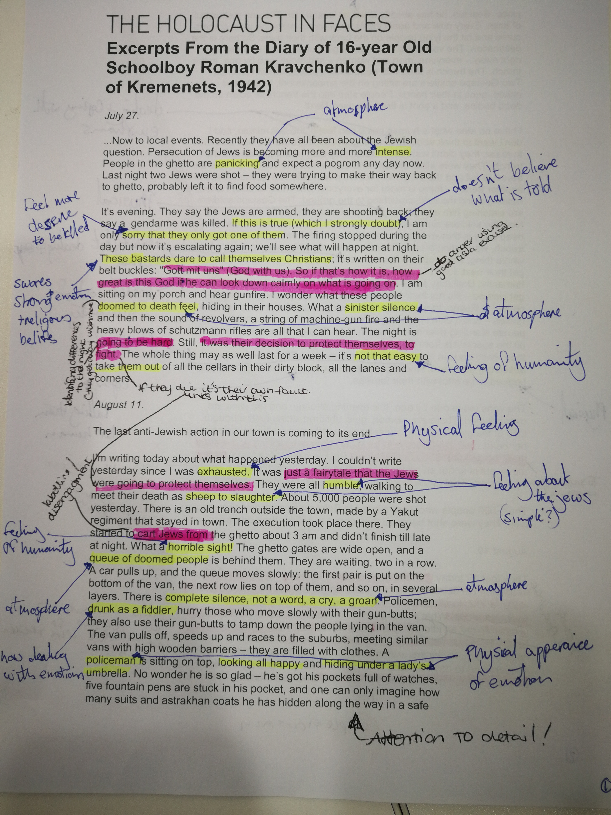
Appendix 2
Extract with notes

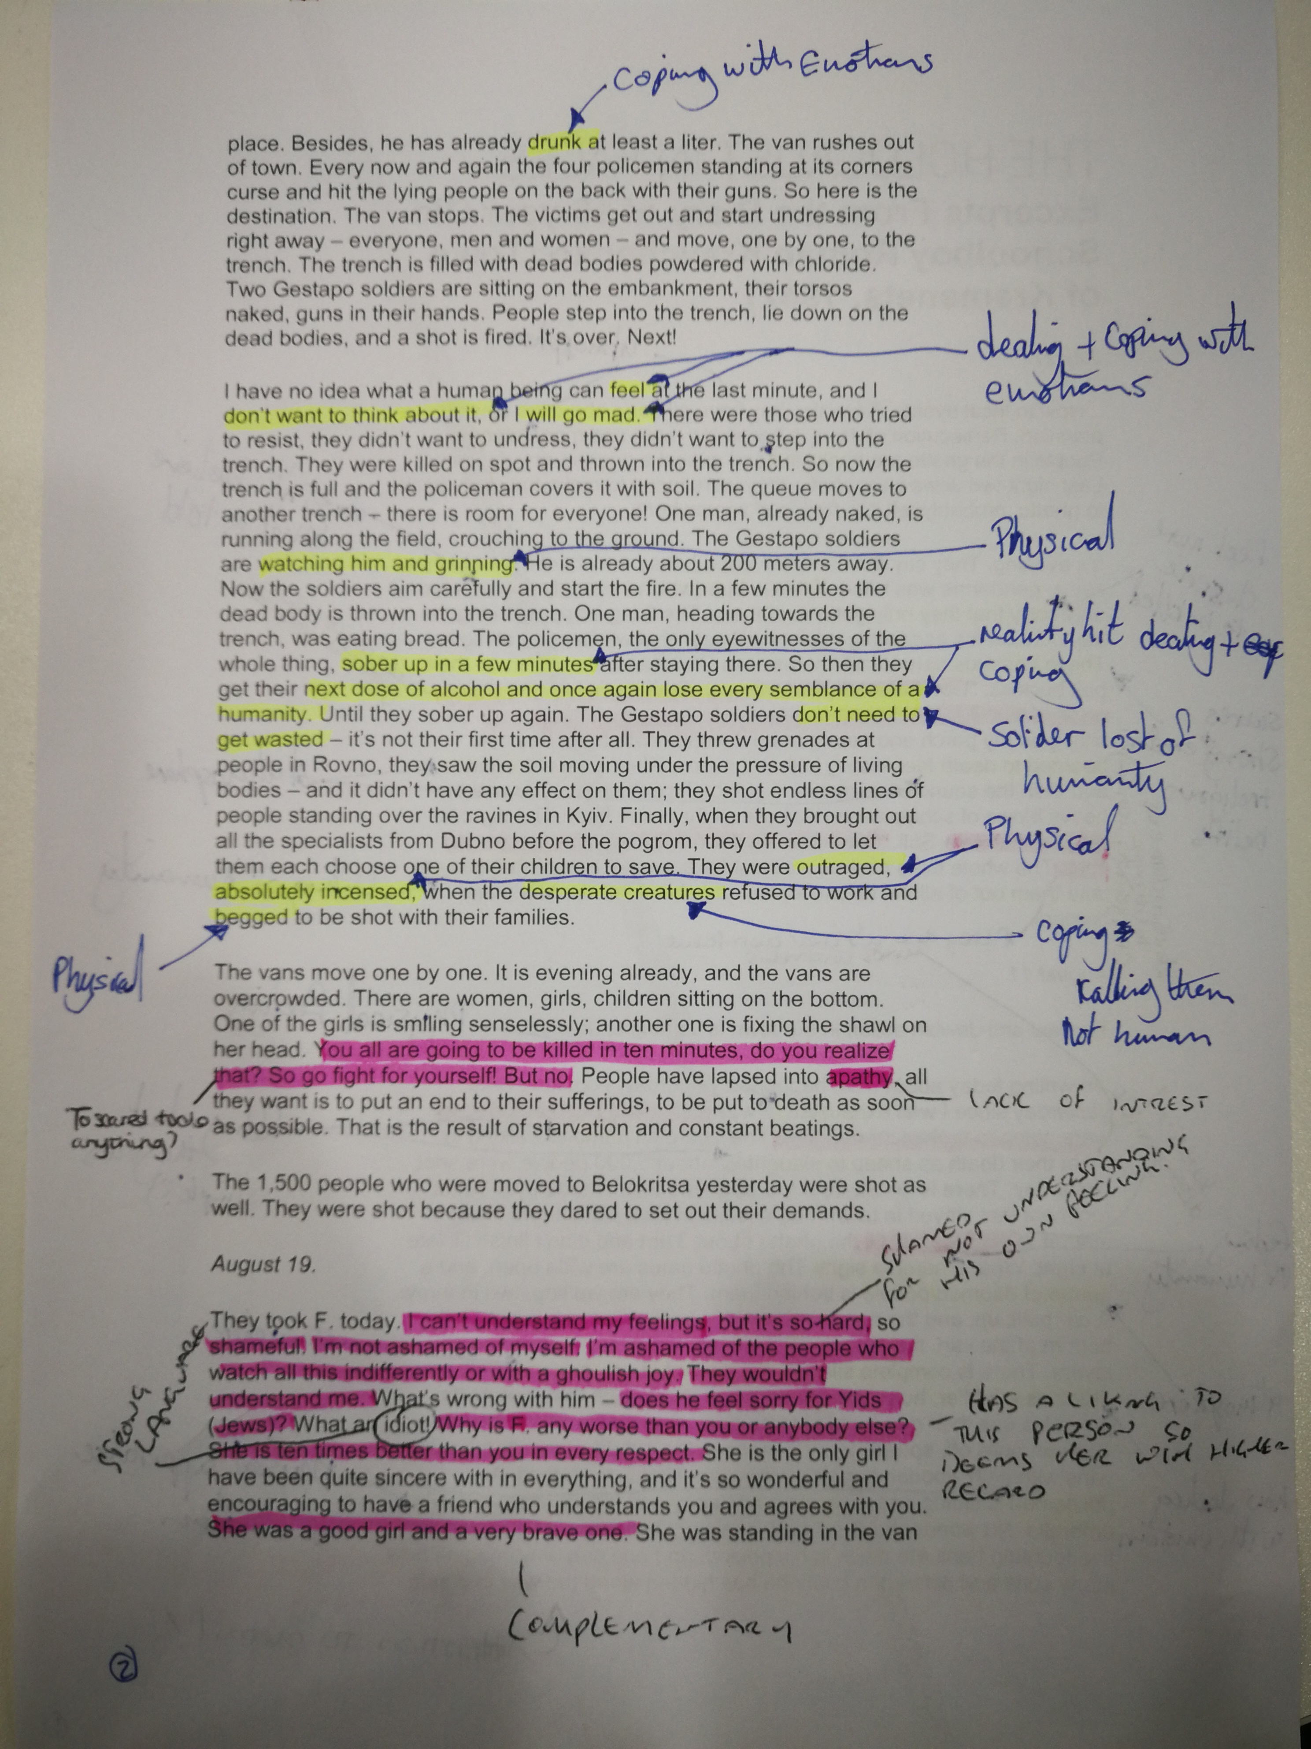

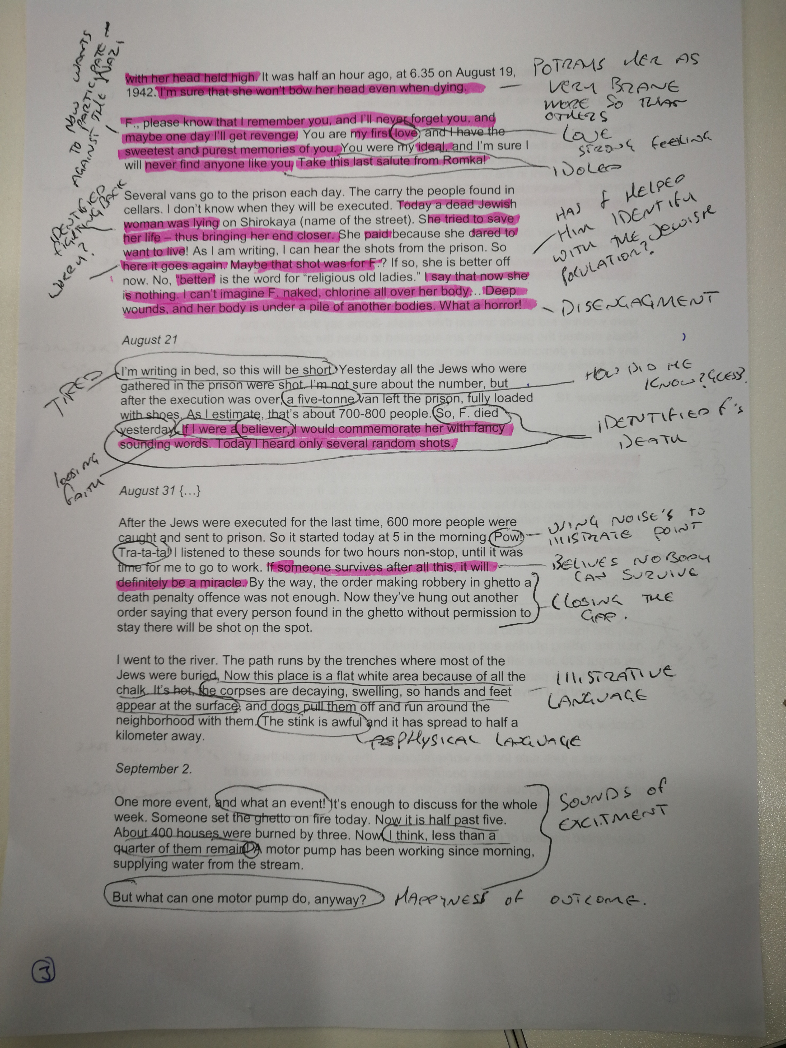

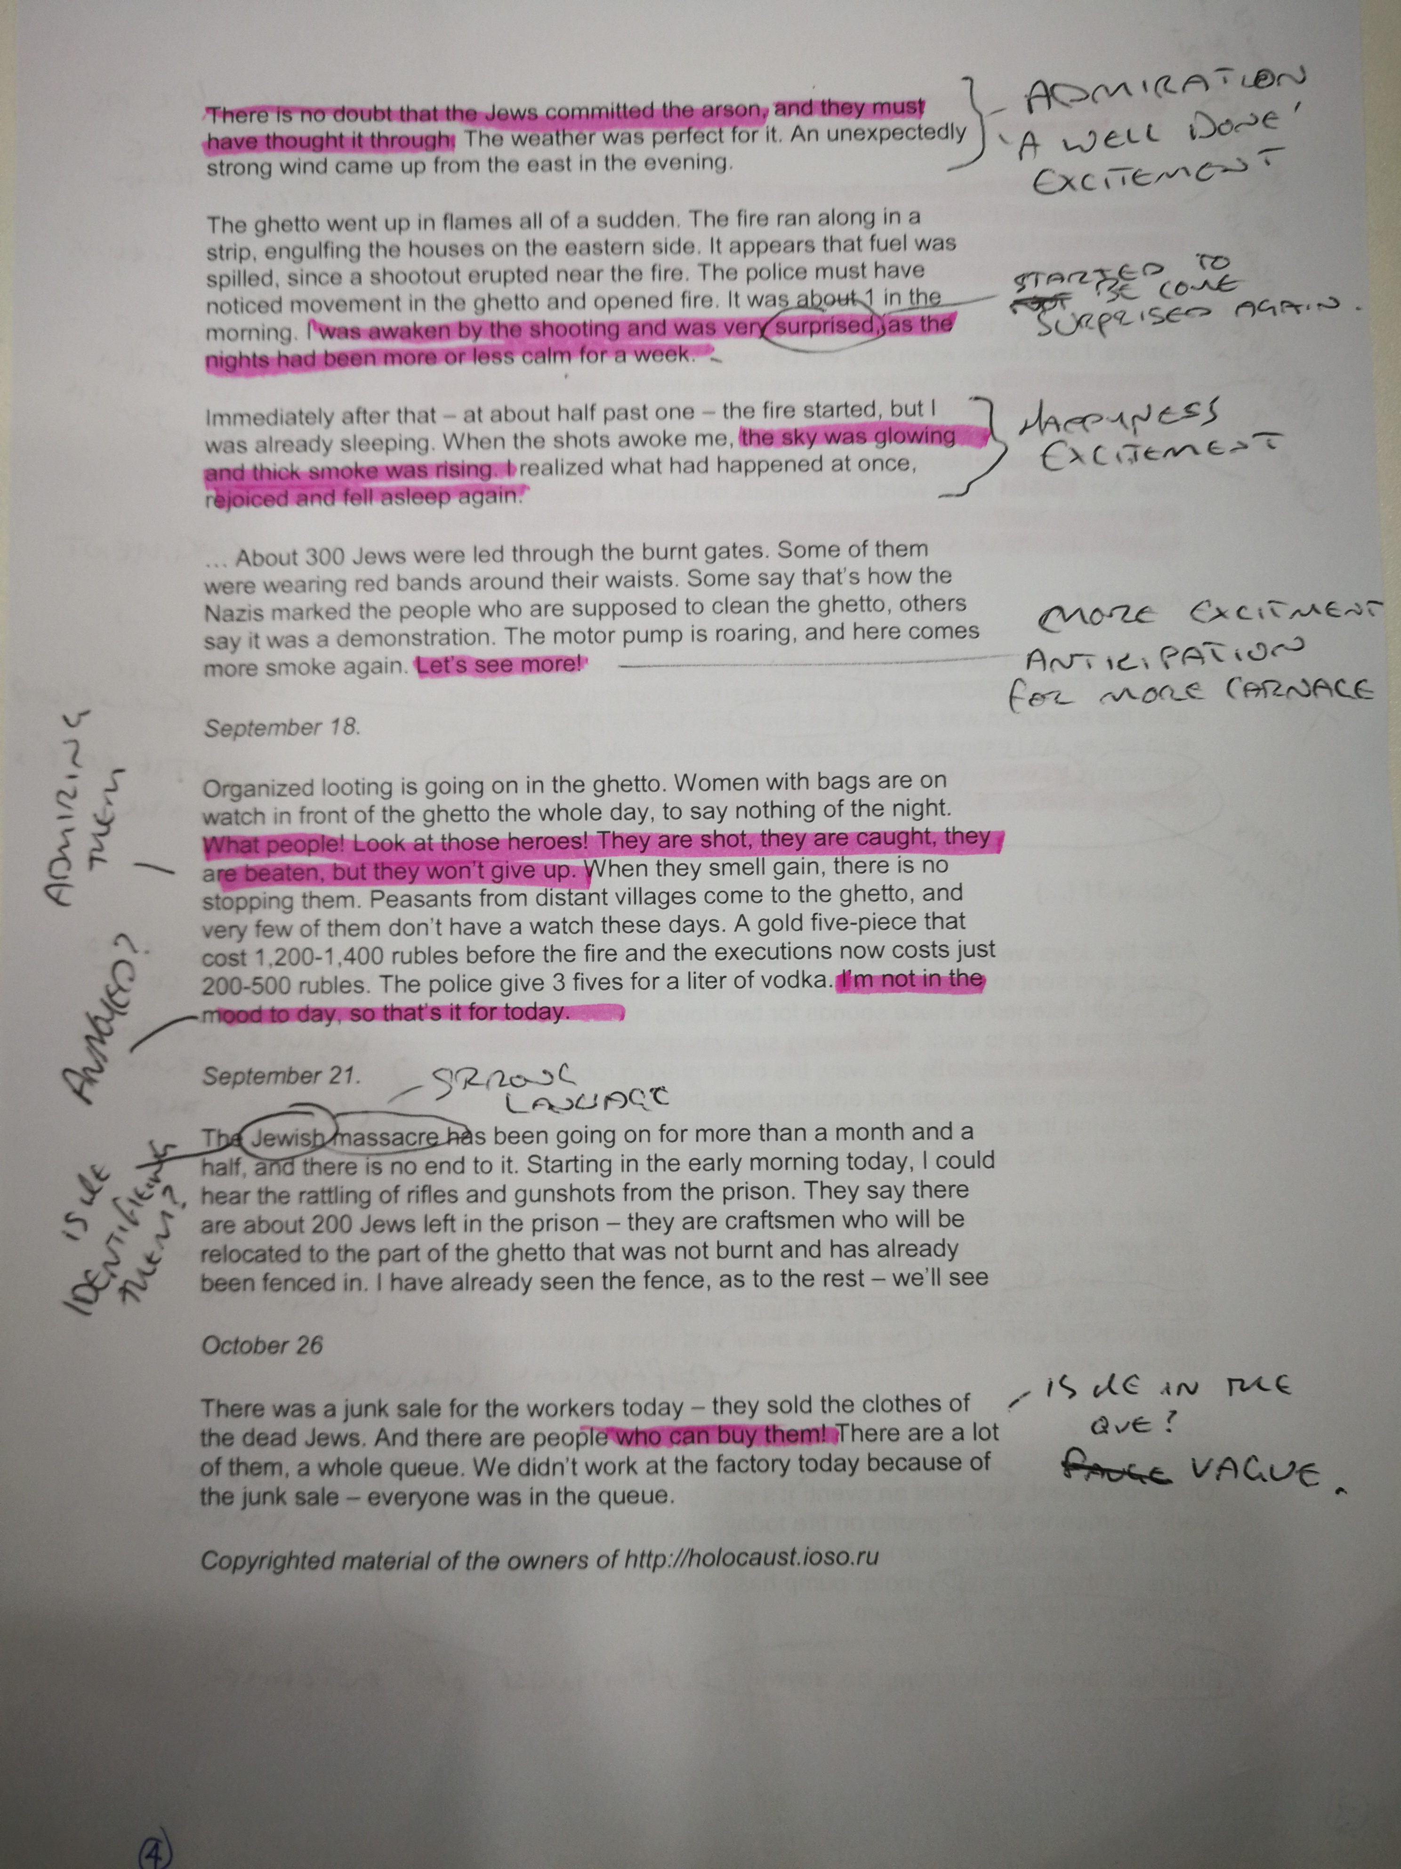

Appendix 3
Ethics form

APPLICATION FOR ETHICAL APPROVAL

In order for research to result in benefit and minimise risk of harm, it must be conducted ethically. A researcher may not be covered by the University’s insurance if ethical approval has not been obtained prior to commencement.

The University follows the OECD Frascati manual definition of research activity: “creative work undertaken on a systematic basis in order to increase the stock of knowledge, including knowledge of man, culture and society, and the use of this stock of knowledge to devise new applications”. As such this covers activities undertaken by members of staff, postgraduate research students, and both taught postgraduate and undergraduate students working on dissertations/projects.

The individual undertaking the research activity is known as the “principal researcher”.

Ethical approval is not required for routine audits, performance reviews, quality assurance studies, testing within normal educational requirements, and literary or artistic criticism.

Please read the notes for guidance before completing ALL sections of the form.

This form must be completed and approved prior to undertaking any research activity. Please see Checklist for details of process for different categories of application.

SECTION A: About You (Principal Researcher)

Full Name: |  |  | Jason Morgan
Tick all boxes which apply:
Member of staff: | ☐ | Student: |  | ☒ | Honorary research fellow: | ☐

Faculty/School/Centre: | Psychology
Campus: | Carmarthen
E-mail address: | 1702538@student.uwtsd.ac.uk
Contact Telephone Number:
For students:
Student Number: | 1702538 | Undergraduate | ☒
Programme of Study: | Applied psychology | Taught Postgraduate | ☐
Director of Studies/Supervisor: | Charlotte greenway | Research | ☐

SECTION B: Approval for Research Activity

Has the research activity received approval in principle?  (please check the Guidance Notes as to the appropriate approval process for different levels of research by different categories of individual) |  | YES | ☒ | NO | ☐
 |  |  |  | Date
If Yes, please indicate source of approval (and date where known): | Research Degrees Committee |  | ☐
 | Faculty Research Committee |  | ☐
 | Other (write in)  School ethics board |  | ☒ | 25.09.18
Approval in principle must be obtained from the relevant source prior to seeking ethical approval.

SECTION C: External Ethical Guidance Materials

Please list the core ethical guidance documents that have been referred to during the completion of this form (including any discipline-specific codes of research ethics, and also any specific ethical guidance relating to the proposed methodology). Please tick to confirm that your research proposal adheres to these codes and guidelines.
Code of Ethics and Conduct (2018) | ☒
BPS Code of Human Research Ethics (2nd edition, 2014) | ☒
The General Data Protection Regulation (GDPR) | ☒

SECTION D: External Collaborative Research Activity

Does the research activity involve collaborators outside of the University? |  | YES | ☐ | NO | ☒
If Yes, please provide the name of the external organisation and name and contact details for the main contact person:
Institution
Contact person name
Contact person e-mail address

Where research activity is carried out in collaboration with an external organisation
Does this organisation have its own ethics approval system? | YES | ☐ | NO | ☐
If Yes, please attach a copy of any final approval (or interim approval) from the organisation

SECTION E: Details of Research Activity

Indicative title: | An investigation of the holocaust through the eyes of a schoolboy
Proposed start date: | 25.09.18 | Proposed end date: | 25.01.19
Purpose of research activity (including aims and objectives)
Outline the purpose, aims and objectives of the research activity, including key research questions. Show briefly how existing research has informed the proposed activity and explain what the research activity will add and how it addresses an area of importance. (Maximum 300 words)
The purpose for this study is to examine how individuals felt during the holocaust. It can be important to study the holocaust, what happened and how we can prevent the happenings within this time from coming again.
There have been many writings on the subject of the holocaust
Marrus, M. R. (1987). The Holocaust in history.
Bauer, Y. (1978). The Holocaust in historical perspective. Canberra: Australian National University Press.
To name a few.
For this study a diary extract from an individual who was living in the time of the holocaust will be used, providing a first-hand experience on some of the events that went on during this period.
The aim for this study is to provide a report on this extract, to break it down and provide some insight to thought, feeling and experiences during the time of the holocaust.

(this box should expand as you type)
Proposed methods
Provide a brief summary of all the methods that may be used in the research activity, making it clear what specific techniques may be used. If methods other than those listed in this section are deemed appropriate later, additional ethical approval for those methods will be needed. (Maximum 600 words)
For this study a diary extract will be used which can be found here:
http://www.worldholocaustforum.org/eng/persons/3/

This extract will be the basis of this study. Throughout this study the extract will be broken down, providing the feelings, thought and experiences the individual went through. This is however through the perception of the researcher.
The study will look at a single extract form an individual experiencing this time period.
The extract was found on the internet, in a public domain.
All information will be gathered through the researcher computer, and will be protected by a password.
All information will be presented through a word document in the medium of English.

(this box should expand as you type)

Location of research activity
Identify all locations where research activity will take place.
The extract that will be used is from the internet

(this box should expand as you type)
Research activity outside of the UK
If research activity will take place overseas, you are responsible for ensuring that local ethical considerations are complied with and that the relevant permissions are sought. Specify any local guidelines (e.g. from local professional associations/learned societies/universities) that exist and whether these involve any ethical stipulations beyond those usual in the UK (provide details of any licenses or permissions required). Also specify whether there are any specific ethical issues raised by the local context in which the research activity is taking place, for example, particular cultural sensitivities or vulnerabilities of participants.
N/A

(this box should expand as you type)

SECTION F: Scope of Research Activity

Will the research activity include: | YES | NO
Use of a questionnaire or similar research instrument? | ☐ | ☒
Use of interviews? | ☐ | ☒
Use of diaries? | ☒ | ☐
Participant observation with their knowledge? | ☐ | ☒
Participant observation without their knowledge? | ☐ | ☒
Use of video or audio recording? | ☐ | ☒
Access to personal or confidential information without the participants’ specific consent? | ☐ | ☒
Administration of any questions, test stimuli, presentation that may be experienced as physically, mentally or emotionally harmful / offensive? | ☐ | ☒
Performance of any acts which may cause embarrassment or affect self-esteem? | ☐ | ☒
Investigation of participants involved in illegal activities? | ☐ | ☒
Use of procedures that involve deception? | ☐ | ☒
Administration of any substance, agent or placebo? | ☐ | ☒
Working with live vertebrate animals? | ☐ | ☒
Other primary data collection methods, please explain in this box | ☐ | ☒

If NO to every question, then the research activity is (ethically) low risk and may be exempt from some of the following sections (please refer to Guidance Notes).

If YES to any question, then no research activity should be undertaken until full ethical approval has been obtained.
SECTION G: Intended Participants

Who are the intended participants: | YES | NO
Students or staff at the University | ☐ | ☒
Adults (over the age of 18 and competent to give consent)? | ☐ | ☒
Vulnerable adults? | ☐ | ☒
Children under 18? | ☐ | ☒
Prisoners? | ☐ | ☒
Young offenders? | ☐ | ☒
Those who could be considered to have a particularly dependent relationship with the investigator or a gatekeeper? | ☐ | ☒
People engaged in illegal activities? | ☐ | ☒
Others (please identify): | ☐ | ☒

Participant numbers and source
Provide an estimate of the expected number of participants. How will you identify participants and how will they be recruited?
There will be no participants as resource used will be a diary extract from the internet.
this box should expand as you type)

Information for participants: | YES | NO | N/A
Will you describe the main research procedures to participants in advance, so that they are informed about what to expect? | ☐ | ☐ | ☒
Will you tell participants that their participation is voluntary? | ☐ | ☐ | ☒
Will you obtain written consent for participation? | ☐ | ☐ | ☒
Will you explain to participants that refusal to participate in the research will not affect their treatment or education (if relevant)? | ☐ | ☐ | ☒
If the research is observational, will you ask participants for their consent to being observed? | ☐ | ☐ | ☒
Will you tell participants that they may withdraw from the research at any time and for any reason? | ☐ | ☐ | ☒
With questionnaires, will you give participants the option of omitting questions they do not want to answer? | ☐ | ☐ | ☒
Will you tell participants that their data will be treated with full confidentiality and that, if published, it will not be identifiable as theirs? | ☐ | ☐ | ☒
Will you debrief participants at the end of their participation, in a way appropriate to the type of research undertaken? | ☐ | ☐ | ☒
If NO to any of above questions, please give an explanation
The source used is from the internet, which the general public can access.

Information for participants: | YES | NO | N/A
Will participants be paid? | ☐ | ☒ | ☐
Is specialist electrical or other equipment to be used with participants? | ☐ | ☒ | ☐
Are there any financial or other interests to the investigator or University arising from this study? | ☐ | ☒ | ☐
Will the research activity involve deliberately misleading participants in any way, or the partial or full concealment of the specific study aims? | ☐ | ☒ | ☐
If YES to any question, please provide full details
(this box should expand as you type)

SECTION H: Anticipated Risks

Outline any anticipated risks that may adversely affect any of the participants, the researchers and/or the University, and the steps that will be taken to address them.

If you have completed a full risk assessment (for example as required by a laboratory, or external research collaborator) you may append that to this form.

Full risk assessment completed and appended?

Yes ☐
No ☒

Risks to participants
For example: emotional distress, financial disclosure, physical harm, transfer of personal data, sensitive organisational information
There is minimal risk to the participant as the resource that will be used is from the internet where the general public can access. However if at any point the individual or the individual’s family wants the extract taken down from the internet, the extract will not be used. (this box should expand as you type)
If research activity may include sensitive, embarrassing or upsetting topics (e.g. sexual activity, drug use) or issues likely to disclose information requiring further action (e.g. criminal activity), give details of the procedures to deal with these issues, including any support/advice (e.g. helpline numbers) to be offered to participants. Note that where applicable, consent procedures should make it clear that if something potentially or actually illegal is discovered in the course of a project, it may need to be disclosed to the proper authorities
N/A
(this box should expand as you type)
Risks to investigator
For example: personal safety, physical harm, emotional distress, risk of accusation of harm/impropriety, conflict of interest
The risks to the investigator are minimal as the source has been taken from a public domain from the internet and will have no contact with the individual who wrote it. If the is any emotional distress because of the content of the extract the investigator can go see their supervisor for support, or any information regarding support. If there is any accusations or conflict of interest complaints made about the researcher the supervisor will be informed for information regarding where to proceed.
University/institutional risks
For example: adverse publicity, financial loss, data protection
Minimal as I will follow BPS and University guidelines. If there is any complaints about the researcher using the extract the study supervisors email address will be stated on the report for any reader to contact. The researcher will be professional, courteous and polite. Data protection will be followed as all data/information regarding the extract will be secured on the researcher’s computer behind a password, and will not be shared to anyone outside of the study. If there are any complaints regarding the researcher, a complaint form will be sent. The complaint form can be found here:
https://www.uwtsd.ac.uk/media/uwtsd-website/content-assets/documents/strategies-policies/uwtsd-external-complaints-procedure.pdf

(this box should expand as you type)
Adverse outcomes
List measures put in place to limit any adverse effects or outcomes of research activity where appropriate. Include any emergency protocols.
N/A
(this box should expand as you type)

Disclosure and Barring Service
If the research activity involves children or vulnerable adults, a Disclosure and Barring Service (DBS) certificate must be obtained before any contact with such participants. | YES | NO | N/A
Has a DBS certificate been obtained? | ☐ | ☐ | ☒
SECTION I: Feedback, Consent and Confidentiality

Feedback
What feedback will be provided to participants, how will this be done and when?
N/A
(this box should expand as you type)
Informed consent
Describe the arrangements to inform potential participants, before providing consent, of what is involved in participating. Describe the arrangements for participants to provide full consent before data collection begins. If gaining consent in this way is inappropriate, explain how consent will be obtained and recorded.
N/A as the extract is on the internet in a public domain
(this box should expand as you type)
Confidentiality / Anonymity
Set out how anonymity of participants and confidentiality will be ensured in any outputs. If anonymity is not being offered, explain why this is the case.
No names/personal information will be attached to this study. The extract will also not be names throughout this study. The researcher will also not be looking for any names tied to this extract.(this box should expand as you type)

SECTION J: Data Protection and Storage

In completing this section refer to the University’s Research Data Management Policy and the extensive resources on the University’s Research Data Management web pages (http://uwtsd.ac.uk/library/research-data-management/).
 | YES | NO
Does the research activity involve personal data (as defined by the Data Protection Act)?  “personal data” means data which relate to a living individual who can be identified—  (a) from those data, or  (b) from those data and other information which is in the possession of, or is likely to come into the possession of, the data controller, and includes any expression of opinion about the individual and any indication of the intentions of the data controller or any other person in respect of the individual. | ☐ | ☒
If YES, provide a description of the data and explain why this data needs to be collected:
Family/marital status and economic status will be asked for as this information is needed for this study.
(this box should expand as you type)
Does it involve sensitive personal data (as defined by the Data Protection Act)?  “Sensitive personal data” means personal data consisting of information as to –  (a) the racial or ethnic origin of the data subject,  (b) his political opinions,  (c ) his religious beliefs or other beliefs of a similar nature,  (d) whether he is a member of a trade union (within the meaning of the Trade Union and Labour Relations (Consolidation) Act 1992),  (e) his physical or mental health or condition,  (f) his sexual life,  (g) the commission or alleged commission by him of any offence, or  (h) any proceedings for any offence committed or alleged to have been committed by him, the disposal of such proceedings or the sentence of any court in such proceedings. | ☐ | ☒
If YES, provide a description of the data and explain why this data needs to be collected:
(this box should expand as you type)

Will the research activity involve storing personal data on one of the following: | YES | NO
Manual files (i.e. in paper form)? | ☐ | ☒
University computers? | ☐ | ☒
Private company computers? | ☐ | ☒
Home or other personal computers? | ☒ | ☐
Laptop computers/ CDs/ Portable disk-drives/ memory sticks? | ☒ | ☐
“Cloud” storage or websites? | ☐ | ☒
Other – specify: | ☐ | ☒
For all stored data, explain the measures in place to ensure data confidentiality, including details of password protection, encryption and anonymization:
All data is anonymous and will be stored on a laptop which is password protected

(this box should expand as you type)

Will the research activity involve any of the following activities: | YES | NO
Electronic transfer of data in any form? | ☐ | ☒
Sharing of data with others at the University? | ☐ | ☒
Sharing of data with other organisations? | ☐ | ☒
Export of data outside the European Union or importing of data from outside the UK? | ☐ | ☒
Use of personal addresses, postcodes, faxes, emails or telephone numbers? | ☐ | ☒
Publication of data that might allow identification of individuals? | ☐ | ☒
Use of data management system? | ☐ | ☒
Data archiving? | ☐ | ☒
If YES to any question, please provide full details, explaining how this will be conducted in accordance with the Data Protection Act (and/or any international equivalent):
(this box should expand as you type)

List all who will have access to the data generated by the research activity:
The principal researcher

(this box should expand as you type)
List who will have control of, and act as custodian(s) for, data generated by the research activity:
The principal researcher

(this box should expand as you type)
Give details of data storage arrangements, including where data will be stored, how long for, and in what form. Will data be archived – if so how and if not why not.
All information regarding this study will be saved upon the researchers computer behind a password.
(this box should expand as you type)

SECTION K: Declaration

The information which I have provided is correct and complete to the best of my knowledge. I have attempted to identify any risks and issues related to the research activity and acknowledge my obligations and the rights of the participants.

In submitting this application I hereby confirm that I undertake to ensure that the above named research activity will meet the University’s Research Ethics and Integrity Code of Practice
Signature of applicant: | Jason Morgan | Date:21.01.2019

For students:
Director of Studies/Supervisor: | Dr Charlotte Greenway
Signature:
Date: | 15.10.18

For staff:
Head of School/Assistant Dean:
Signature:
Date:

Checklist: Please complete the checklist below to ensure that you have completed the form according to the guidelines and attached any required documentation:
☒ | I have read the guidance notes supplied before completing the form.
☒ | I have completed ALL RELEVANT sections of the form in full.
☒ | I confirm that the research activity has received approval in principle
☒ | I have attached a copy of final/interim approval from external organisation (where appropriate)
☐ | I have attached a full risk assessment (and have NOT completed Section H of this form) (where appropriate)
☒ | I understand that it is my responsibility to ensure that the above named research activity will meet the University’s Research Ethics and Integrity Code of Practice.
☒ | I understand that before commencing data collection all documents aimed at respondents (including information sheets, consent forms, questionnaires, interview schedules etc.) must be confirmed by the DoS/Supervisor, module tutor or Head of School.

RESEARCH STUDENTS AND STAFF ONLY
All communications relating to this application during its processing must be in writing and emailed to pgresearch@uwtsd.ac.uk , with the title ‘Ethical Approval’ followed by your name.
You will be informed of the outcome of your claim by email; therefore it is important that you check your University and personal email accounts regularly.

STUDENTS ON UNDERGRADUATE OR TAUGHT MASTERS PROGRAMMES should submit this form (and receive the outcome) via systems explained to you by the supervisor/module leader.

This form is available electronically from the Academic Office web pages: http://www.uwtsd.ac.uk/academic-office/

Application Process

All staff research projects and all research students must submit the Ethical Approval Form to the University Ethics Committee via the Academic Office (pgresearch@uwtsd.ac.uk). Staff research directly in relation to personal study for taught undergraduate or Masters programmes should be submitted via the Faculty procedures explained below.

Taught masters and taught undergraduate research Ethical Approval Forms are considered within Faculties. Faculties will provide details of the specific processes for this. Where the Ethical issues within any single ethical application are of particular concern the Faculty will refer these to the University Ethics Committee. Any student activity that involves the collection of primary data needs to undergo Ethical approval, this includes assignment work as well as dissertations.

Notes for guidance in completion of this form

Section A: About You
Please complete all relevant sections

Section B: Approval for research activity
Research proposals must be approved in principle before applying for Ethical Approval. The proposal approval only becomes final when the ethical approval is received.

The process for proposal approval varies according the individual and programme of study:
- Research students, by application on form PG1 to the Research Degrees Committee
- Taught students by review of research proposal within Faculties (Faculties provide specific details of these processes)
- Staff, by agreement by the Head of School/Assistant Dean

Section C: External Ethical Guidance materials
Many discipline areas are required to operate with the discipline specific codes of research ethics (for example health, psychology, education etc.), any such codes must be listed and you must tick to confirm that you have consulted with these.

Section D: External Collaborative Research Activity
Provide details of the external collaborative partners, where appropriate you might want to submit a copy of the external collaboration agreement with the Ethical Approval Form. If the partner requires the research to be subject to its own internal Ethical approval process then please provide details of that process and a copy of any final (or interim) approvals received from the organisation.

Section E: Details of Research Activity
Remember that the individuals reviewing this Ethical Approval Form may not have seen your research proposal, and also may not be experts in the specific area of your research. The information provided should therefore be jargon free and clearly stated.
Indicative Title: please use the same title as used on the research proposal.
Purpose: the Ethical approval process will want to ensure that the methods you propose are adequate and appropriate to address the research aims and objectives. Excessive additional data collection can be seen as unethical.
Proposed Methods: the Ethical approval process seeks to ensure that you understand the methods that are intended, and that the implementation of those methods will be appropriate and without unnecessary impact on respondents. Please be specific.
Location: this needs to mention geographical location and also local situation (for example, within Local Authority Offices in Cardiff, using a private room but close to other individuals). If you are collecting data within an organisational setting then you need to explain the permissions that you have obtained to do this.
Research Activity outside of the UK: please complete this section in detail, and note any guidance you have received. Also describe your own familiarity (or not) with the location that you will be utilising.

Section F: Scope of Research Activity
Please tick ALL of the research activities that might be undertaken. If any additional types of activity are intended then please add an extra box and describe these.
If you have answered no to all questions in F then sections G and J do not need to be completed. Section H should be considered, and may be completed. Signatures are still required in section K.

Section G: Intended Participants
Please tick all categories that might apply.
Numbers & Source: if you are using a series of different methods or research activities please list numbers for each stage/phase. Be clear about how you will find respondents. Will you use intermediaries, and if so how? How will you ensure compliance with your sampling strategy?
Information for participants: all participants should be appropriately informed about the research, what is expected of them and what will happen to the information that they provide. The Ethical review process does not ask to see this documentation, but requires this to be reviewed and approved by the Director of Studies in the case of research students, the supervisor/module tutor in relation to students on taught programmes and the Head of School/Assistant Dean in relation to staff research.

Section H: Anticipate Risks
All research carries some level of risk. The answers you provide to questions in this section will be reviewed to ensure that you have an appropriate understanding of the type of risks involved and how you can mitigate against these risks. If you have completed a full risk assessment, as required for example for laboratory work, field work, clinical tests, diving operations, or by a collaborative partner, you may append that to this form. In that case, please tick the box indicating this has been provided. You will not then be required to complete Section H.
Risk to participants Think very carefully about how your actions/questions/discussions might affect the people you are involving as participants. You might identify the risk as small but it would still be a risk. Many types of question have the potential to make respondents less content with their life / job; you need to recognise and try to ameliorate any such effects
If these are business owners, time with you may reduce profit.
In some locations physical risk is very real to both participants and yourself, please consider this.
Risk to you, the researcher Think about where you will meet people, if there are any dangers involved in the location. If you are meeting people as individuals think about using a public place. In general do not visit people in their own homes or remote locations. If you are talking to individuals about certain issues think about how their responses might affect you emotionally. What about the risk of collecting insufficient data?
Risk to the University When undertaking your research, you are acting as a member of the University (student or staff). Professionalism is important, so it is important to be well organised and well prepared. Punctuality, clarity etc. are all part of this. What will you do to ensure this? You must ensure you do not harm the good name of the University in any way and do nothing to undermine the reputation of the research it conducts and sponsors. Upholding high standards of conduct and integrity are vital in this regard. You must also conduct the research in such a way to minimise the potential for claims of negligence made against the University, its researchers and any collaborating individual or organisation. In this respect you should always comply with ethical, legal and professional frameworks, obligations and standards as required by statutory and regulatory authorities, as well as the university’s Research Integrity and Ethics Code of Practice. Research misconduct in this respect can take many forms, including:
- fabrication: making up results or other outputs (eg, artefacts) and presenting them as if they were real
- falsification: manipulating research processes or changing or omitting data without good cause
- plagiarism: using other people’s material without giving proper credit
- failure to meet ethical, legal and professional obligations: for example failure to declare competing interests; misrepresentation of involvement or authorship; misrepresentation of interests; breach of confidentiality; lack of informed consent; misuse of personal data; and abuse of research subjects or material
- improper dealing with allegations of misconduct: failing to address possible infringements such as attempts to cover up misconduct and reprisals against whistle-blowers

Adverse Outcomes. Think carefully about the possibilities, and cover here

Section I: Feedback, Consent and Confidentiality
Feedback to participants: outline your approach. Will interview transcripts be shared with respondents to check accuracy? Will summaries of questionnaire analysis be made available to respondents in some way? Will an overview report be provided? How and when?
Informed consent: Draft letter / e-mail / or heading (or footer) section of questionnaire must be approved by DoS/supervisor (if research student), supervisor/module tutor if taught student, or Head of School / Assistant Dean if a member of staff.
Confidentiality/Anonymity. Explain clearly how you will ensure confidentiality and anonymity.

Section J: Data Protection and Storage
Before completing this section it is necessary to read the University’s Research Data Management information. The questions that follow are designed to ensure compliance with the Data Protection Act as well as established research protocols.

Many research activities will involve electronic transfer of data and use of data management systems in the summarisation and analysis of data. You will need to explain these in relation to compliance with the Data Protection Act.
Think carefully about who will have access to your data, this will include supervisors and examiners. Also that a thesis will be made available via the University library and the British Library system. If you are seeking an access bar for a period of time after completion then mention it here. If you will provide a copy of your findings, or intend to give a presentation, to a facilitating/ supporting/accessing organisation then explain that in this section. But also think about the general principle of data sharing, as explained in the Research Data Management information.
In terms of storage of data please ensure security, and also mitigate against loss of data.

Section K: Declaration
Ensure the appropriate countersignatures have been provided
Look carefully at the checklist and ensure that you comply with and tick all that are relevant to your research.

