PORTFOLIO-TWO TASKS

Name: Saiqa Munir
Student ID: 2330363
Programme: Certificate of Higher Education Skills for the Workplace (Health and Social Care)
Module: Introduction to Health and Social Care
Module Code: LCHS4003

Task 1
Poster on Dentistry Services

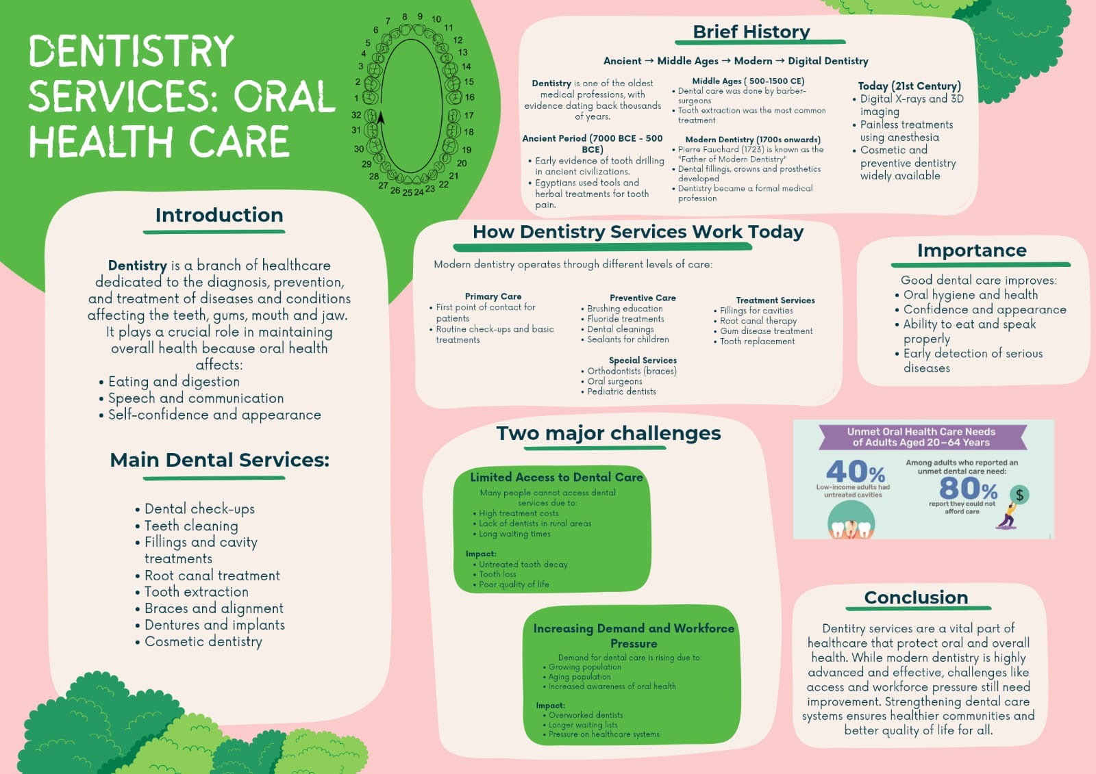

Task 2
Essay on Community Disability Services

Introduction
Community disability services in the United Kingdom are a key component in helping people with physical and learning disabilities, sensory impairments and long-term health conditions to live independently and to take part in society. These are social care services, rehabilitation, supported housing, advocacy, employment and healthcare services offered by local authorities, the National Health Services (NHS), charities and volunteering organisations. Community disability services have developed as a result of the changing social attitudes and government policies and legislation with emphasis on equality and inclusion.

Historical Development of Community Disability Services
Since the end of the Second World War, social reform has resulted in the NHC and welfare state, providing better access to health services and social care (UK Parliament, 2024). But a large number of disabled people continue to be discriminated against and excluded from education, work and community life.
The disability rights movement of the 1970s and 1980s made bold statements and fought against the traditional ideology and promoted the social model of disability. This model was that disability was caused by barriers in society, not by impairments. This in turn resulted in the UK Government having adopted policies to encourage community care and independent living. The Chronically Sick and Disabled Persons Act was passed in 1970 and was one of the first of the major pieces of legislation to recognise the rights of disabled people to receive services in their community—“The community”. (UK Parliament, 2015).
One of the big milestones and changes was the NHS and Community Care Act 1990 which resulted in a shift from institutional care to community based care (The Health Foundation, 2024). Also, the Disability Discrimination Act 1995 provided a further boost to the rights of disabled people as they look for jobs, are in education, use transport and are in public services (House of Lords Library, 2020).
The Equality Act 2010 and the Care Act 2014 have also given a further push in the right direction to disability services, encouraging equality, safeguarding, person centred care and well-being more recently. The legal duty on local councils to support individual well being and to prevent and integrate health and social care services (Care Act 2014) was added to councils' duties.

The Community Disability Services (CDS) are still provided to their respective communities.
In the UK, community disability services are provided in conjunction with NHS, community nurses, charities/voluntary organisations, local authorities/social workers and occupational therapists. Typically, services are provided in response to evaluations made by local councils or health care workers. After assessment, an individual may be given a personalised care plan, addressing their physical, emotional and social needs.
Community disability services aim to help people with disability to live and participate in the community. Home care, mobility aids, supported housing, physiotherapy, educational support, employment support and mental health services are examples of support. There is also an increase in service users' choice in the way services are arranged due to community care policies like personal budgets and direct payments (Rescare, 2015).
The service has been enhanced but there are some areas that need to be addressed. Funding pressures as a result of escalating demand and constrained social care budgets are one of the main concerns. There are many local authorities that have problems to be able to offer services that are adequate to meet the demands and as a result, there are longer waiting lists and fewer amount of support packages. Another difficulty is the lack of staff in health and social care, impacting on the quality and continuity of care.

Significance in Improving Quality of Life
By supporting disabled people to live independently, with dignity and in society, community disability services make a significant contribution to the quality of life of disabled people. Many people can live safely in their communities, rather than in long-term institutional settings, thanks to access to health care services, rehabilitation services, housing, and employment services.
These services also support to decrease social isolation and discrimination. The Equality Act 2010 ensures differently abled people have equal rights and protection from foul treatment in education, employment and public services (GOV.UK, 2010). Furthermore, community-based support helps people to keep in touch with others, attend school, find work, and engage in social life, which helps them feel better physically and mentally.
Moreover, person-centred approaches in contemporary disability services ensure that people are actively participating in decision making around their care. This enhances autonomy, satisfaction and human rights and social inclusion.

Conclusion
To summarise, community disability services have grown and changed a great deal since the time of institutional care, becoming community based and person-centred. Disability services have been influenced by historical legislation, including the NHS Act 1946, the National Health Service and Community Care Act 1990, the Equality Act 2010 and the Care Act 2014. Community disability services are vital to improving the independence, equality and quality of life of people with disabilities in the UK despite current challenges to access, such as funding, and lack of staff.

References

GOV.UK (2010) Equality Act 2010 guidance
https://www.gov.uk/equality-act-2010-guidance

House of Lords Library (2020) Disability Discrimination Act: 1995 and now.
https://lordslibrary.parliament.uk/disability-discrimination-act-1995-and-now

Local Government Association (2024) The Care Act 2014: Ten years on from Royal Assent.
https://www.local.gov.uk/publications/care-act-2014-ten-years-royal-assent

Rescare (2015) History of legislation on disability
https://www.rescare.org.uk/history-of-legislation-on-disability-2/

The Health Foundation (2024) National Health Service and Community Care Act 1990
https://navigator.health.org.uk/theme/national-health-service-and-community-care-act-1990

UK Parliament (2015) 1995 Disability Discrimination Act
https://www.parliament.uk/about/living-heritage/evolutionofparliament/2015-parliament-in-the-making/get-involved1/2015-banners-exhibition/jason-wilsher-mills/1995-disability-discrimination-act-gallery/

UK Parliament (2024) 1946 NHS Act
https://www.parliament.uk/about/living-heritage/transformingsociety/livinglearning/coll-9-health1/health-01/nhs-act-page-2/

