Environmental Analysis of Automobile Industry

Margarita Mandulova
Student ID: 2119899
Module code: LCBB4005
Lecturer: Alfred Mensah

Table of Contents

Environmental Analysis of Automobile Industry 1
Abstract 3
Introduction 3
PESTEL Analysis 3
SWAT analysis 7
Porter’s Five Forces 9
Recommendations 10
Conclusion 11
Reference list 12

Abstract

This report will explore the connection between all factors, both internal and external and will accentuate on few of the strategies used for analysis, such as PESTLE, SWAT, Porter’s five forces etc. The aim of this paper is to provide comprehensive and accurate description, engaging different literature and examples, discussing the strengths and the weaknesses of the modern-day business survival techniques. Specifically, this article will be focused on one of the world leading brands - Toyota, and company business analysis will be discussed.

Introduction

Over the last few years, the evolution of production and management systems has revolutionised the automobile industry. Globalization, intensifying competition in the market and digitalization, are changing the face of the industry. The size of the company is no longer enough to promise success, hence the constant progress in adopting new strategies and tools for survival are inevitable. A company's operating status is affected or influenced by a combination of numbers of factors. The term "business environment" refers to all the external and internal variables that influence how an industry operates, such as employees, customers, supply, demand, and business legislation management. Environmental analysis is used as a strategic tool, recognising and evaluating these external and internal forces affecting a company’s performance, thus aligning and altering strategies and decisions within the organisation constantly.

PESTEL Analysis

1.Political
With globalization, political factors have become increasingly important. The level of political stability in a country decides whether the atmosphere is suitable for business. The government and its polices determines the ability of foreign brands to conduct business.
Political stability, the role of domestic lobbying groups, significant geopolitical trends, are among the few that influence the global automobile sector. In several situations, political issues have had a direct impact on Toyota Motor Corporation. As an example of an impact of political factor on Toyota performance relates to poor relationships between Japan and China. Specifically, “anything related to Japan — and the products it peddles – is off-the-charts out of favour. This is because the two countries are in dispute over the possession of a of small, uninhabited, privately owned islands in East China Seas” Volkman, E. (2012). Back in 2014 Toyota was about to open a plant in Thailand, investing 69 million USD, until some political troubles begun, and the company decided to call it off.

2. Economical

Toyota revenues are affected by the rate of inflation, currency exchange rate, labour costs, macroeconomic climate in the country and in the industry, and tax rates. Variations in the currency exchange rate are a major macroeconomic issue that has a direct impact on Toyota's reported revenues. Better economic position means more people are employed, ergo customers have more spending power. The greater the people's purchasing power, the better the sales and profits of multinational companies like Toyota. Better economic activity also suggests more consumers disposable income, which leads to the purchase of more costly and luxury items. In order to withstand the effect of economic forces, brands like Toyota have focused on building small cars that come for lower prices.

3. Social
Putting emphasis on electric and hybrid cars is Toyota’s answer to the increased consumer concern about the environmental impact.
Changes in family values, consumer attitudes and views about automobiles and travel, media portrayal of the brand, and the health and wellbeing of the prospective customer all have an influence on Toyota. “Toyota hybrid vehicles’ cumulative global sales have reached 8.90 million units as of March 31, 2016 since the sales launch of the Prius—the world’s first mass-produced hybrid passenger vehicle— in December 1997”. Toyota Global Sustainability Report, (2016).

4. Technological

In the last century, technology has played a vital role in all aspects of business. Businesses across the world utilise IT to help them develop and run their operations more effectively. The more innovative a brand's technology is, the more sales it makes. From passenger safety and convenience point, technology plays a critical role and has a significant impact on a brand's reputation. Consumers also like to buy from technologically sophisticated companies, therefore automobiles with minimal fuel consumption and environmental effect are regarded as advanced and have gained popularity. Social media is being used to connect with and engage customers, which has increased the importance of technology in marketing.

5. Environmental

Environmental concerns are becoming very important, as the customers are looking for environmentally responsible brands. Governments are encouraging the use of such brands and rewarding those who have done a better job of mitigating their environmental impact. Toyota has set a goal to reduce vehicle CO2 emissions by 90% by 2050 in compared to 2010 levels, as part of the "New Vehicle Zero CO2 Challenge”. To accomplish this, Toyota will promote the development of next-generation cars with low or zero CO2 emissions, such as hybrid vehicles, plug-in hybrid vehicles, electric vehicles, and fuel cell vehicles, as well as speed the implementation of these vehicles. Toyota Global Sustainability Report (2016).
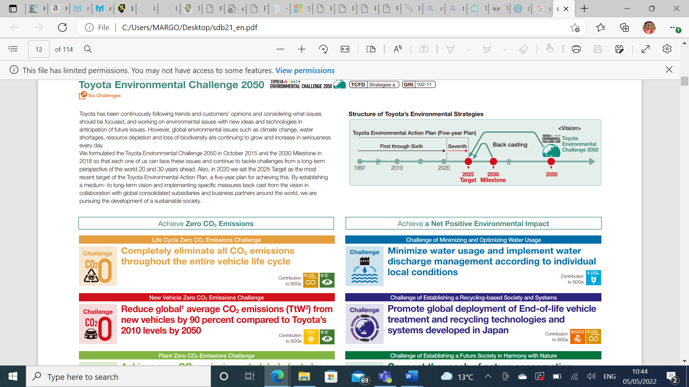

6. Legal

Legal compliance guarantees that businesses can continue to operate smoothly and problem-free. Legal issues may cause firms to lose money in a variety of ways, ranging from labour rules to quality-related legislation and other laws that vary from country to country and market to market. Legal wrangling can be troublesome in areas such as passenger safety and environmental effect. Toyota continues to emphasise passenger safety and has issued recalls as a result of the company's 2016 problems with faulty passenger safety air bags. Internal controls have been put into effect throughout the company to ensure compliance. It has taken care to ensure legal compliance at all levels of the firm, from training and education programs to anti-corruption actions, and should boost commercial value.
The Guiding Principles at Toyota states that Toyota will “honour the language and spirit of the law of every nation and undertake open and fair corporate activities to be a good citizen of the world.”

SWAT analysis

1.Strengths

The Toyota way is a principle that constantly works to help boost productivity, innovations and to ensure respect for their workers and customers. Following these principles formed the strength of the brand, creating image of solid and reliable partner.
Toyota holds over 5,600 global patents related to hydrogen fuel sells, thus putting the company in the top position of the zero-emission vehicle market.
In 2021 Toyota released their new Solid-state battery pack, four years ahead of schedule, reaching charging time 0%-100% in just 10 min, and all-electric range of 500km.
Toyota showed strong stock performance, even during the pandemic, companies such as General Motor’s struggled where their stocks fell with 64% and Toyota’s only with 15%

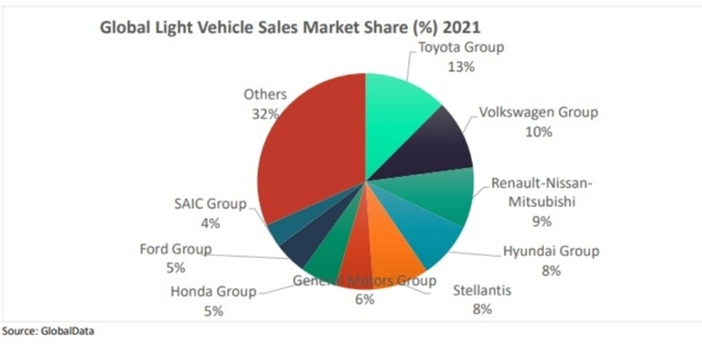

2. Weaknesses

Recalls are one of the biggest problems for the brand. Although Toyota sets the standards for excellent quality, its design and products are not flowless.
Strikes are quite common within the company, thus creating tension between workers and management and putting the company at risk of meeting the market demand.
Rigid Hierarchy- Toyota follows a tight hierarchy in which commands go in one way only - from top to bottom. Although the strict hierarchy allows for greater control, it also obstructs creativity and adaptability.
Nowadays Toyota plays catchup with Tesla, which technology is said to be six years ahead of Toyota’s.
Another minus for the brand is its weak presence in vast new emerging markets such as Africa and South America opposite its very strong presence in North America, Asia and Europe.

3. Opportunities

Some of the opportunities are the company’s very innovative technologies, such as:
Flying car project- Toyota is one of the companies backing up the startup Skydive where they had conducted the first unmanned test flight of its flying car.
Smart cars- working on a self-driving system called The Guardian and the Chauffeur.
Nanomaterials, Cloud and AI Technologies are amongst the other new opportunities that the company has active investment in.
Following variable innovations and the constant thirst for improvement is one of the most significant strengths of Toyota.

4. Threats

One of the biggest threats for Toyota is the competition, especially with Tesla. Tesla’s innovative and creative politics alongside the huge investments makes it extremely difficult for Toyota to follow suit.
Another big issue was Covid-19 pandemic, disrupting the supply chain, restrictions in the work force, creating new challenges and for them to find the best coping mechanism. Overall, Toyota did very well during the last two years, managing to come out of this crisis with minimal losses.

Porter’s Five Forces

1. Bargaining power of buyers
The revenue of the organization is directly connected to the customers. Low switching costs are something affecting every company. Consumers have unlimited information, and they can easily decide to switch to another provider. What is beneficial for Toyota in this case is that there are not many other manufacturers of hybrid cars, hence the competition is limited. Fernfort (2019)

2. Bargaining power of suppliers
Key role in the success of a company is played by the suppliers. Creating good supply chain takes time and effort and always comes with multiple challenges. For Toyota because of its Just in Time politics and lean supply chain policy, suppliers are mostly located close to the manufacturing units, and usually have high bargaining powers.

3. Threats of new entrants
Threats of new entrants is low due to the high barrier for entering the automobile industry, high capitalization, and access to distribution networks. Toyota’s market size and its global market presence is beneficial for the customers in terms of competitive product prices, great distribution channels and solid brand name. Government rules and regulations are also one of the factors which restricts new entrants in the industry. Ferguson (2017)

4. Threats from substitute products
Toyota’s threat for substitute is moderate, despite the ever-changing trends in the vehicle business, buyers continue to rely on Toyota's well-known cars. The demand for these cars has increased, and Toyota has taken full advantage of the situation. However, in places where many different car produsers are operating, and the market is oversaturated the threat is higher.

5. Rivalry of existing players
In the automobile industry, there has been intense and widespread competition for market share. Consumers' needs and expectations for lower prices on vehicle items have been spurred by this. Despite having a solid cost-cutting strategy, Toyota has faced cost challenges on its products. Toyota has the advantage of differentiated products, and new product design in the industry, which is not easy to beat. Fernfort University (2019)

Recommendations

Toyota should continue to make concerted efforts to strengthen its management platform and boost business value, and it should emphasise on business and cost structure changes in order to establish a stable management platform capable of responding quickly to changing market circumstances. It will also benefit from keeping its structure simple by cutting fixed costs and extending its operations in existing markets in developed countries. The corporation should also accelerate its commercial growth into rapidly growing emerging markets by continuously monitoring market circumstances in each part of the world and introducing items that are matched to the features and demands of the market. Another suggestion is to construct production and supply structures in order to obtain the best retail price and delivery while also improving the value chain.

Conclusion

Toyota has continued to develop its management platform and raise its corporate worth, as every firm that aspires to enjoy high profit margins should. It has also concentrated on creating and manufacturing environmentally responsible products that are simple to use and satisfy customers' needs. In essence, Toyota has excelled the sector for years, gaining unrivalled high market share, and the automaker has more to offer. To maintain its market position, the firm must properly address both problems and opportunities. Some of the firm's procedures are in direct reaction to identified dangers. However, further work is necessary to capitalise on present prospects. When paired with efforts to mitigate risks, such initiatives for opportunities can enhance the strategic and long business operation.

Reference list
TheGrowthoftheAutomobileIndustry-ToyotasDominanceinUnitedStates.pdf - See discussions, stats, and author profiles for this publication at: | Course Hero
TICOReport2020_E_full.pdf (toyota-industries.com)
Toyota’s Five Forces Analysis (Porter’s Model) - Panmore Institute
Toyota Motor Corporation Porter Five (5) Forces & Industry Analysis [Strategy] (fernfortuniversity.com)
Toyota SWOT Analysis 2021: Quick Reference Guide (pestleanalysis.com)
Sustainability Data Book | Report Library | Sustainability | Toyota Motor Corporation Official Global Website
Volkman, E. (2012). The Daily Finance. Available at: http://www.dailyfinance.com/2012/10/12/toyotas-got-bigger-problems-than-the-recall/ - Google Search

