ECAD6007 – The learner: who am I teaching?
A critical evaluation and the identification of next teaching and learning steps focusing on a case study of an individual learner or a group of learners, based on an observed critical incident.
Introduction:
Within this assignment, a critical evaluation will be conducted, focusing on a critical incident observed within a school environment. Mohammed (2016, p.25) defines a critical incident as a situation which impacts a person or group of people. Therefore, suggesting that a critical incident can be defined as an unplanned event that has/is happening creates a reaction that Brookfield (1990, p. 84) described as being ‘vividly remembered’. The incidents can be seen in everyday life, and therefore, suggests is not always a negative situation, but also could be positive. Tripp (1993) emphasises the importance of teachers and others within the education profession being able to reflect on these incidences effectively. Griffiths (2000) agrees, acknowledging Tripps’ Critical Incident Methodology, stating that being able to critically reflect effectively is a useful tool for those within the teaching profession to have. This can suggest that those within the education profession are developing on their own experiences and development, both personal and professional, including teaching strategies and supporting individuals in the classroom. For example, ensuring that if a similar incident occurred again, an approach or plan would be put in place to support those involved – whether it is positive or negative (Joshi, 2018, p.82).
In terms of the assignment, it will demonstrate the use of key theories, policies and research which are relevant and reliable to the critical incident within the school environment and the development of the children and young people. Throughout, it will consider and acknowledge the Four Purposes within the Curriculum for Wales (Welsh Government, 2021) while evaluating approaches and strategies supporting equality, diversity including challenging beliefs and assumptions.

The role of critical reflection
Cottrell (2013, p. 188) defines critical reflection as ‘more than just thinking’ which Lishman (2015) acknowledges, stating it is when an individual focuses their attention back to a previous experience/incident. Therefore, suggesting that critical reflection is when strategies, attitudes and effectiveness of a previous experience/incident has been considered and used to challenge the individual (Reynolds, 2013). As a teacher, knowing the individual/child is important in all aspects, allowing them to understand what works for the child when learning; are they auditory, kinaesthetic, reading/writing learners? (Brown, Roediger and Mcdaniel, 2014) Is there a certain subject which they are anxious about? (Mazzone, et al, p.347) Is the sitting plan suited to all of the children? These questions may seem small to some, but could make a great impact, positively, on the childs’ learning and school experience.
There are many reflective models which can be used to allow these questions to be answered and reflected effectively within a school and classroom environment. Brookfield (1990) defines a reflective model as a continuous cycle of self-observation. An example is Gibbs’ Reflective Cycle (Gibbs, 1998), developed by Graham Gibbs, which would allow the questions above previously to be answered. Many argue that Gibbs’ Reflective Cycle (Gibbs, 1998) is one of the most famous cyclical models of reflection. It could suggest due to the amount the six stages within the model allows one to explore and experience to a deeper level and understanding compared to other models (The University of Edinburgh, 2022). Within this reflective cycle, the six stages are; description, feelings, evaluation, analysis, conclusion and action plan. Miller, Ford and Yang (2020, p.357) agree, stating that Gibbs’ (1998) model is ‘more comprehensive’ than Kolb, whose reflective model has four stages; concrete, reflective observation, abstract conceptualisation and active experimentation. However, it is important to acknowledge that different reflective models will work better than one or the other depending on personal preference and also the area in which is being reflected upon.
Within the Professional Standards for Teaching and Leadership, under one of the five sections; pedagogy, and subheading of ‘Reflection on Learning’ it is highlighted that being ‘on track’ it states, ‘in planning, the student-teacher demonstrates awareness of the importance of encouraging learners’ reflection around behaviours and outlooks for learning’ (University of Wales Trinity Saint David, 2022, p.7). Brookfield, Mandzuk and Clifton (1998, p.116) stated that when colleagues/staff members work together, critical conversations will be had. Therefore, if done correctly Badia, Becerril and Gómez (2021, p.123) adds that it creates a positive environment for all within the school environment. This could one of many reasons as to why Bruster and Peterson (2013, p.170) stressed the importance of ensuring student teachers become reflective practitioners. It was identified that when teachers do reflect effectively, students acknowledge them as ‘good teachers’ (Johns, 2000). Therefore, can suggest even from a critical, but reflective conversation being had within the staff room with another member of staff, it demonstrates the overall positive effect it can have on others.
From a wider aspect of critical reflection, the new Curriculum for Wales (Welsh Government, 2021) is a relevant change occurring in schools across Wales. Professor Graham Donaldson reviewed and made recommendations to the old curriculum (Daugherty and Elfed-Owens, 2010, p. 233) explaining that world we live in is forever changing. This can suggest that the first curriculum introduced in 1988, does not allow children to develop to their full potential in todays’ world as Bethane (2018, p.1) believes the education system was ‘outdated’ and ‘not fit for purpose’. Identifying that the book written was published in 2018, suggesting the Curriculum for Wales had not yet been implemented into schools yet.
The United Nations Convention on the Rights of the Child (UNCRC) (Unicef, 2020, p.1) identify that in article twenty-seven, children have the right to ‘reach their full potential’, suggesting the new Curriculum for Wales (Welsh Government, 2021) will allow children to develop to their own individual levels. Within the Curriculum for Wales (Welsh Government, 2021), children will have the opportunity to become ‘ambitious, capable learners’, identifying as one of the four purposes (Dauncey, 2021) through a curriculum which can be viewed as a ‘child-centred’ approach. Power et al, 2018, p.570) have emphasised the importance of the child being at the centre of the learning within the six Areas of Learning and Experiences (AoLE), including assessing. This suggests, a critical reflection on the Curriculum in Wales has been made through Professor Donaldsons’ (Donaldson, 2015) recommendations, as the outcome has created a new curriculum which will focus more on the individual and their personal development which they will participate in. It will allow children to take responsibility of their own learning, rather than a certain level all children must be reaching in terms of their age (Welsh Government, 2021).
Observation School and Class Context –
The literature review will comply with the British Educational Research Association guidelines (BERA, 2018) which states that ‘confidential and anonymous treatment of participants’ data is considered the norm for the conduct of the research’ (BERA, 2018, p.21). To ensure ethical considerations are acknowledged and followed accordingly, the school or the name of the child/children shall not be named. The BERA (2018) guidelines stated those involved in the research as ‘participants’, which within this particular review they are identified as the children. This is to ensure that the research conducted is ethically correct.
The school is located in a small village within the county of Rhondda Cynon Taf, supporting children between the ages of 3-19, identifying as an ‘all-age school’ (Estyn, 2022, p.3). Within the schools’ primary department, the most recent Estyn report stated that over a hundred pupils were attending (Estyn, 2017). However, on arriving at the school, an introduction and discussion occurred with the headteacher who mentioned that the school overall is at seven hundred pupils and at full capacity with two hundred pupils within the primary department. The most recent Estyn (2017) report shows that the school is within a socioeconomically affluent area, with 8% of pupils eligible for free school meals from the most recent report. This is significantly lower than the average in the year of 2017, which has been calculated at an average of 18% (Welsh Government, 2017).
Within the classroom, there were twenty children aged six to seven within year two, identifying as Progression Step 2 within the new curriculum (Welsh Government, 2020) with one teacher and one teaching assistant. The teacher had mentioned there are some pupils who attend ELSA sessions (Emotional Literacy Support Assistants) who provide emotional and social support to those needed (Supporting Service Children in Education Wales, 2022).
Four purposes
Donaldson (2017) stated that the four purposes are the vision and aspiration for every child and young person. The reasoning behind the four purposes if for it is to promote the individual – this can be identified as the child (Welsh Government, 2020). This can suggest that the children is to be at the centre of the curriculum, as the four purposes in based on supporting individual to development into the world we live in today (Donaldson, 2015).
The four purposes are to support the individuals to become –
- Ambitious, capable learners, ready to learn throughout their lives
- Enterprising, creative contributors, ready to play a full part in life and work
- Ethical, informed citizens of Wales and the world
- Healthy, confident individuals, ready to lead fulfilling lives as valued members of society.
Throughout the classroom, there were many resources being used and displayed demonstrating an awareness of the new curriculum and four purposes within (Welsh Government, 2021). Throughout the morning of the critical incident, all of four purposes had been observed as stated below.
The theme within the class was ‘Fy Nghorff Arbenning’, as explained in (appendix 1) where children will be having the opportunity to discuss what is a part of the body, what the body needs to keep healthy. This can demonstrate as encouraging children to develop as ‘healthy, confident individuals’ within the Four Purposes by Professor Graham Donaldson (2015).
The classroom had a ‘lloches lles’ where children were able to have time to themselves. The area was made to feel safe, with cushions, mirrors, and books for children to use and relax. Many of the books emphasised individuals being different and the importance of treating others equally. This corner of the classroom is supported by ‘respecting others and myself’, encouraging individuals to become ethical, informed citizens of Wales and the world (Welsh Government, 2015, p.30). The child which was included within the critical observation used this area at the beginning of the day before morning session.
Reflecting on the observation sheet, view (appendix 1), children were excited and motivated to learn about the new theme. This can suggest that under one of the four purposes of Ambitious capable learners (Welsh Government, 2021), pupils are to enjoy new challenges. Steinmayr and Spinath (2008) acknowledges this stating the importance of pupils having different learning opportunities. It has been identified that when children are given the opportunity, it develops on their social, emotional and intellectual skills which creates an overall positive effect on the individuals’ development (WJEC, 2019). This activity supports Article 29 within the UNCRC (Unicef, 2020) as it states that education must develop individuals’ talents, abilities and personality.
Following on within the classroom, there were many different areas where children had the opportunity to learn and develop. One of the areas included a painting and gluing, cutting and colouring station. This can be identified as developing the pupils in becoming enterprising, creative contributors (Welsh Government, 2021).
Within these stations, it demonstrated children using their own ideas of what they/friends/family members and creating it into their own way – such as painting their picture, or drawing, gluing and colouring in their picture. Professor Graham Donaldson (Donaldson, 2015) stated that creativity should be prominent in education. It can suggest why there was such an emphasis on the 12 recommendations in Professor Dai Smiths’ report (Welsh Government, 2015, p.1) where he stated that schools are to become a ‘creative society, of a creative economy and a creative culture’. This can suggest that allowing pupils to become creative, encourages new innovative skills and knowledge such as building on their confidence. Using creativity within the curriculum engages pupils and motivates them to learn (Ahmad and Shaheen, 2011). Fisher and Williams (2012) stated that engaging creativity raises the standards in literacy and numeracy, which can support the National Literacy and Numeracy Framework (Welsh Government, 2019).

Literature Review
The aim of this section is to critically evaluate the existing and current literature based on two areas of the study which is linked to the critical incident. The critical incident emphasises on the area of ‘assessment for learning’ and ‘group work within primary education’. Including in this literature review, it will also focus on elements of teaching and learning.
Working in groups within primary education
As a part of the new curriculum for Wales (Donaldson, 2015), collaboration is a part of one of the four purposes as ‘enterprising and creative contributors’, which is emphasised within the report of ‘Successful Futures’ by Professor Graham Donaldson (Welsh Government, 2015). Hattie (2016) acknowledges and states that collaborative learning is effective and beneficial for learners which Donaldson (2015) adds creates a safe environment for children to explore their ideas and test them. Slee and Shute (2015) study identified that half of a primary school class believed that when working in small groups or as pairs, they achieve more than if they were working independently.
Vygotsky’s ‘Zone of Proximal development’ can support the previous point (Mooney, 2013). The sociocultural theory identifies that learning is an essential social process which should be supported by parents/guardians, caregivers, peers and the society (Vygotsky, 1978). Mooney (2013, p.101) explains that the name of assistance used to support the child can be recognised as ‘scaffolding’. Vygotsky (1978) defined his theory as the distance between the most difficult task a child can do alone compared to the most difficult task a child can do with help.
It is important to highlight that Vygotsky believed that the ‘scaffolding’ does not have to be only from a teacher/adult but also from other children. He emphasised on the importance of the child’s peers who have already learned the desired skill, allowing them to learn from each other. Soto-Icaza, Aboitiz and Billeke (2015, p.1) explains that interaction between the children while working, not only develops their social skills but also cognitive. Mooney (2013) agrees, stating that the two skills work together, to support the child in their development. This can suggest that within the critical incident, Vygotsky’s theory was observed, following from appendix 1, child (1) quickly finished their work to move onto the next area of painting. It can suggest the child did not quite understand the task while not wanting to take their time in completing as there were many other areas set up in the classroom which the child had noticed.
Obaki (2017, p. 1) explains that when there are too many activities and learning areas prepared, it can impact the childs’ cognitive and social behaviour. However, Barth, et al (2004, p.115) believes that it is important to allow individuals to explore the classroom where they are able to create their own social interactions which will influence learning engagement and motivation. The classroom itself was set out to allow children the freedom of choosing which area they wish to work in which Olds, (2001) has explained that it can be viewed as a positive as when children feel comfortable they tend to explore their surroundings to help support their learning. Department of Education (2022) have acknowledged that through freedom within the classroom, children and young people’s wellbeing has improved, supporting the point made by Olds (2001) that children feel comfortable and secure within their classroom environment. It suggests that the findings from Department for Education (2022) can suggest due to the recent Covid-19 Pandemic, freedom within the classroom and school is vital for individuals to improve their wellbeing, due to the lack of ‘freedom’, for example in ‘lockdowns’ (Organisation for Economic Cooperation and Development, 2020).
As the child came back to the area, it can be seen as ‘imitating’ in what child (2) had done. Mooney (2013) explained that children learn from each other every day and Vygotsky strongly believed this develops on individuals’ new concepts and skills. Therefore, by being able to complete the task again with more knowledge, it can be identified that child (2) can be seen as the ‘scaffold’ within the critical incident (Vygotsky, 1978).

Assessment for learning
Within the new curriculum for Wales, assessing now involves the children, where they have the opportunity to voice their opinion to ensure they are challenged and supported as individuals and are progressing at their own level (Welsh Government, 2015). It is important to acknowledge that children have different learning styles and learn at different paces. To support this, Romanelli, Bird and Ryan (2009, p.1) identified that pupils who understand their own preferences and techniques when learning, has an overall positive effect on their education.
Within the critical incident, reading from appendix (1), child (1) is seen to move around the classroom and unable to concentrate on the one activity. The class can be seen as ‘rotation learning’ where individuals move around each table which have different activities to complete throughout the day. Kim, et al (2020, p.2) identified that around 83% of children were engaged in new friendships when working within smaller groups. However, Cilleseen and Marks (2017) believes children should work in a whole classroom approach, by learning through the teacher. It can suggest that Cilleseen and Marks (2017) believes that the teacher is identifying as a focal point, where they are the centre point of learning. While Slee and Shute (2015) argues previously children achieve more when working in smalls groups. If the classroom was set up in how Cilleseen and Marks (2017) believed it should, there would be a small chance that child (1) and child (2) would had communicated with one another, as observed on the playground that are not within the same ‘friendship group’.
Hattie (2012) describes Assessment for Learning as ‘more visible’ where it supports individuals on how they can develop their own work to reach their own individual development level. From appendix (1), the activity can be seen as formative assessment which Wiliam, Lee, Harrison and Black (2004, p. 105) describes as ‘guided student learning’. This can suggest that the small groups within the class have been planned to shape and guide learning activities by the teacher. Sol (2020) adds that formative assessment allows teachers to know how individuals are progressing and can use the learning activities to make necessary adjustments to ensure all understand and are developing.
Many have argued that using that questioning the pupils is a method which helps understand what children understand already and what they possibly need support in. Hall (2016) explained that the gap in between what a child understands and what they need support in is known as the learning targets. It was identified that questioning is one of the main methods of formative assessment, as it allows children to develop their thinking skills (Education, 2008) . However, Hattie (2012) does explain that although it is a quick an effective method to use, it does work for all, such as those will low self-confidence in their learning and development. Donaldson (2015) adds that assessment is an effective way to double the speed of learning. He suggested that when done correctly, learners can do ‘what could take up to a year, can be done in six months’ (Donaldson, 2015, p.68).
It can suggest that child (1) can be seen as to questioning themselves when observing that child (2) had completed their work. Possible questions could had been asked is ‘what do I have to do?’, ‘how can I complete this?’ while also asking child (2) how they had created theirs (Hattie, 2012). The child had the opportunity to observe child (2), with an indication that they are a visual learner which is defined as people who find it easier to learn through seeing things (Raiyn, 2016).
Before this, child (1) did not want to participate in the activity, which reflecting on, that there were no examples for the child to understand what is expected within the activity. Once child (1) had seen child (2) work and received positive reinforcement, they were able sit and complete the activity to a high level. This demonstrates that although the positive reinforcement was not aimed at child (1), it still had an impact on them. Skinner’s theory positive reinforcement from Skinner’s theory (Ferguson and O’Donohue, 2001) allowed the child to understand that when child (2) had completed their work, they were seen as being ‘rewarded’ through being praised. Lucero and Chen (2020) explains that those who are reinforced positively, their self-confidence develops. This can suggest that although the child was unsure what they had to do within the activity, through positive reinforcement and observation, they were able to complete their work to the best of their ability, identifying as Article 29 within the UNCRC (Unicef, 2020, p.1) where ‘education must develop every child’s personality, talents and abilities to the full’. Donaldson (2015) can suggest that child (1) is identifying as an ambitious, capable learner through communicating with others such as the child (2) to help them develop and complete their task and by the end trying their hardest with their work (Welsh Government, 2015).

Reflection –
Using the reflective model by Gibbs (1988) as shown below, I will be discussing the critical incident through the six stages of; description, feelings, evaluation, analysis and conclusion.

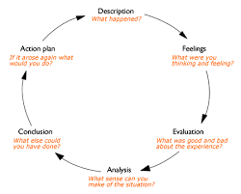

Figure 1: Reflective Model by Gibbs (1998)
Description: During my time within the school, I had the opportunity to observe a morning session in year two. Three critical incidences were observed throughout the school, however, I believed that the incident that occurred within year two demonstrated as the most interesting one to evaluate and discuss. Within (appendix 1) gives an idea of the incident which occurred in year two, with a positive outcome.
Feelings: Throughout my observations, all had positive outcomes allowing me to learn from the teachers within the classes which will support my professional practice now and in the future. All teachers used different strategies which reassured me that not everyone teaches the same, in the same way that not all children learn the same (Solvik and Glenna, 2022). Although I had been in the class for the morning, I did not feel as though my presence disturbed the observation in a negative way. I had communicated and discussed with the children what they had been doing but I did not feel as though the ‘Hawthorne effect’ had occurred (Oswald, Sherratt and Smith, 2014, p.53).
Evaluation: As discussed previously, the incident focused on an individual who through positive reinforcement, scaffolding and observing others, completed their work to a high level. This demonstrated the use of Vygotsky (1978) and B.F Skinner (Ferguson and O’Donohue, 2001) theories being used within the practice by the children themselves. The first time the individual completed their task, it was quickly finished, identifying that they were not engaged. By communicating with child (2), it demonstrated the importance of collaboration which encourages individuals’ social skills and learning to continue developing (Donaldson, 2015).
Analysis: It is important to remember that this was only one session in a day, which is not a considerable amount of time when in a school and classroom environment. After further reading, I have developed my understanding on theories being used within the classroom and the impact they have on the children.
Conclusion: Overall, it demonstrated that child (1) learns best within a smaller group, using visual aids to support and also positive reinforcement – such as encouragement and praise. The class had clearly been designed and structured to support individuals such as child (1), allowing to move around the class/activities freely (Olds, 2001). It demonstrated that the teacher is well aware of the individuals and their needs as the children have been involved in the set out of the classroom and the strategies that have been used are there to support them as individuals to reach their full potential – article 6 within the UNCRC (Unicef, 2020).
Action plan: By observing and researching this critical incident, it has encouraged me to think about the professional next steps to take in my learning and education to become a teacher in the near future. Strategies such as rotation learning which the teacher had used to support children and their learning encouraged collaborative work. It allowed children with mixed abilities and personalities to work together encouraging one of the four purposes; ethical, informed citizens (Donaldson, 2015).

Conclusion –
Throughout this assignment, it has acknowledged relevant theories to the critical incident, which has been supported by a variety of literature research, the UNCRC (Unicef, 2020) and the new Curriculum for Wales (Welsh Government, 2015). The critical incident has given me opportunities to understand the importance of the role of reflection. This will help to continue to develop my role as a teacher in the near future. Using observation within the critical incident has encouraged me to not be afraid of changing the structure of the classroom or how lessons are to be taught, as Solvik and Glenna (2022) emphasised that not all teachers teach the same, in the same way as not all children learn in the same way.

Appendices –
Observation/Field Notes
Appendix 1
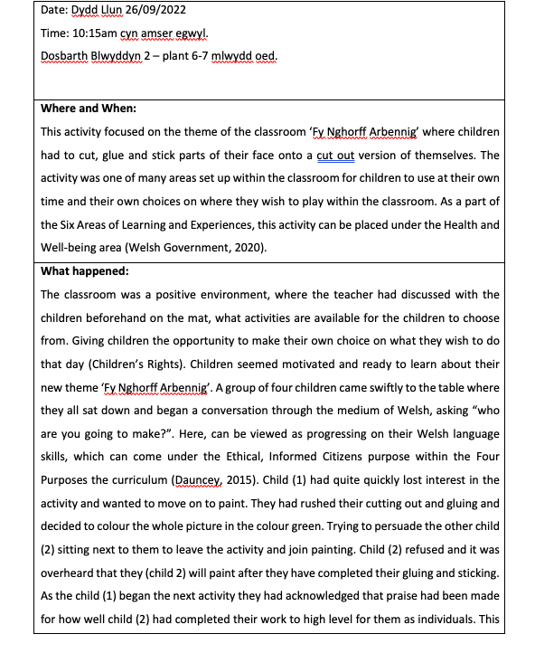
Record 1

Record 1

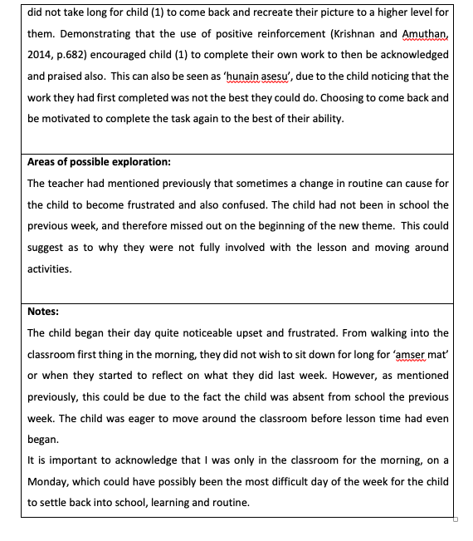

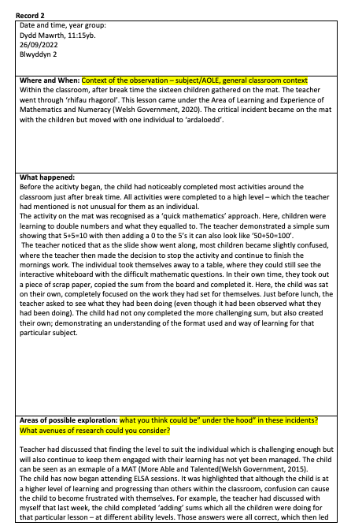
Appendix 2

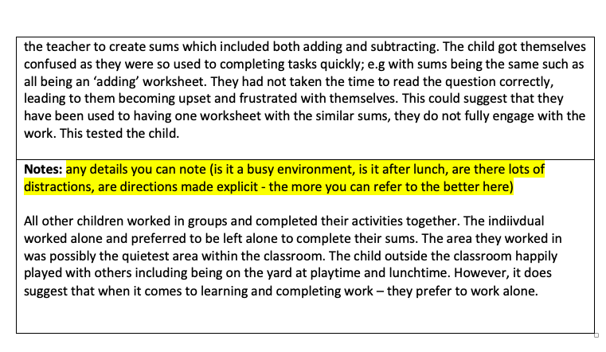

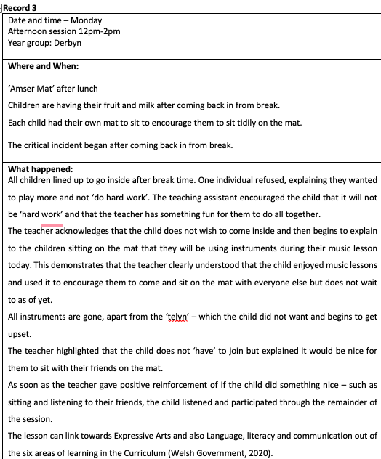
Appendix 3
Record 3

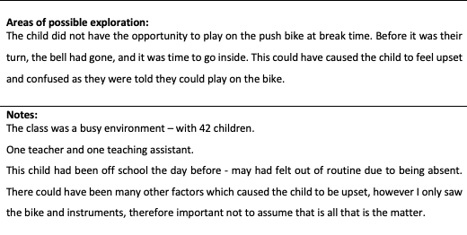

Reference list -
Ahamad, M., and Shaheen, S. (2011) ‘Encouraging Creativity an Innovation In Education’, Indian Journal of Applied Research, 3(2), pp. 114-117. DOI: 10.15373/2249555X/FEB2013/39
Badia, A., Bercerril, L. and Gómez, M. (2021) ‘Four types of teachers’ voices on critical incidents in teaching’, Teacher Development, 25(2), pp. 120-135. DOI: 10.1080/13664530.2021.1882549
Barth, J.M., Dunlap, S.T. et al. (2004) ‘Classroom environment influences on aggression, peer relations, and academic focus’, Journal of School Psychology, 42(2), PP. 115-133. DOI: doi.org/10.1016/j.jsp.2003.11.004.
British Educational Research Association. (2018) Ethical Guidelines for Educational Research. London: BERA.
Brookfield, S.D. (1990) The Skillful teacher. San Francisco: Jossey Bass.
Brookfield, S., Mandzuk, D. and Clifton, R. (1998) ‘Becoming a critically reflective teacher’, Interchange, pp. 115-118. Available at: https://librarysearch.uwtsd.ac.uk/discovery/fulldisplay?docid=cdi_proquest_miscellaneous_839126481&context=PC&vid=44WHELF_UWTSD:44WHELF_UWTSD_VU1&lang=en&search_scope=Search_ELEC&adaptor=Primo%20Central&tab=Everything&query=any,contains,Brookfield,%20S.D.,%202017.%20Becoming%20a%20critically%20reflective%20teacher.%20John%20Wiley%20%26%20Sons.&offset=0.
Brown, P.C., Roediger, H.L. and Mcdaniel, M.A. (2014) Make It Stick: The Science of Successful Learning. Massachusetts: The Belknap Press of Harvard University Press.
Bruster, B.G. and Peterson, B.R. (2013) ‘Using critical incidents in teaching to promote reflective practice’, Reflective Practice, 14(1), pp. 170-182. DOI: 10.1080/14623943.2012.732945.

Cillessen, A. H., and Marks, P. E. (2017). ‘Methodological choices in peer nomination research’ in New Dir. Child Adolescence Development. Pp. 21–44. DOI: 10.1002/ cad.20206
Cottrell, S. (2013) Critical Thinking Skills: Effective analysis, argument and reflection. 3rd Ed. London: Palgrave.
Dauncey, M. (2021) Donaldson Review: The ‘purposes’ and content of a Curriculum for Wales. Available at: https://research.senedd.wales/research-articles/donaldson-review-the-purposes-and-content-of-a-curriculum-for-wales/ (Accessed: 10th of October 2022).
Daugherty, R. and Elfed-Owens, P. (2003) ‘A National Curriculum for Wales: A Case Study of Education Policy-Making in the Era of Administrative Devolution’, British Journal of Educational Studies, 51(3), pp. 233-253. DOI: 10.1111/1467-8527.t01-2-00237.

Department for Education. (2022) State of the nation 2021: children and young people’s wellbeing. Available at: https://assets.publishing.service.gov.uk/government/uploads/system/uploads/attachment_data/file/1053302/State_of_the_Nation_CYP_Wellbeing_2022.pdf (Accessed: 24th of October 2022).

Donaldson, G. (2015) Successful Futures – Independent Review of Curriculum and Assessment Arrangements in Wales. Available at: https://gov.wales/sites/default/files/publications/2018-03/succesful-futures-a-summary-of-professor-graham-donaldsons-report.pdf (Accessed: 10th of October 2022).

Estyn. (2017) An Estyn Inspection. Available at: https://www.estyn.gov.wales/system/files/2020-08/Ysgol%2520Llanhari%2520en.pdf (Accessed: 23rd of October 2022).

Estyn. (2022) All-Age schools in Wales – A report on the challenges and successes of establishing all-age schools. Available at: https://www.estyn.gov.wales/document-page/20884/contents/document-details/introduction (Accessed: 21st of October 2022).
Ferguson, K.E. and O’Donohue, W.T (2001) The psychology of B.F Skinner. California: Sage.

Fisher, R. and Williams, M., 2012. Unlocking Creativity: A teacher's guide to creativity across the curriculum. Routledge.

Gibbs, G. (1998). Learning by Doing: A Guide to Teaching and Learning. London: Further Educational Unit.
Hattie, J., (2012). Visible Learning For Teachers: Maximising The Impact On Learning. New York: Routledge.
Johns, C. (2000). Becoming a reflective practitioner. Oxford: Blackwell Science
Jones, P., Judge, B., McCreery, E. and Eales-Reynolds, L. (2013) Critical thinking skills for education students. 2nd Ed. London: Sage Publications.
Joshi, K.R. (2016) ‘Critical Incidents for Teachers’ Professional Development’, Journal of NELTA Surkhet, 5(1), pp. 82-88. DOI:
10.3126/jns.v5i0.19493.

Kim, S., et al. (2020) ‘Experiences in Early Elementary Classrooms’, Frontiers in Psychology, 11(1), PP. 1-14. DOI: 10.3389/fpsyg.2020.587170.
Lishman, J. (2015) Handbook for Practice Learning in Social Work, and Social Care. 3rd Ed. London: Jessica Kingsley Publishers.
Lucero, K.S. and Chen, P. (2020) ‘What Do Reinforcement and Confidence Have to do with it? A systematic pathway analysis of knowledge, competence, confidence and intention to change’, Journal of European CME, 9(1). PP. 1-6. DOI: 10.1080/21614083.2020.1834759

Mazzone, L., Ducci, F., Scoto, M,C., Passaniti, E., D’Arrigo, V.G and Vitiello, B. (2007) ‘The role of anxiety symptoms in school performance in a community sample of children and adolescents’, BioMed Central Public Health, 7(1), DOI: 10.1186/1471-2458-7-347.

Miller, J.M., Ford, S.F. and Yang, A. (2020) ‘Elevation through reflection: closing the circle to improve librarianship’ Journal of the Medical Library Association, Pp. 353-363. DOI: 10.5195/jmla.2020.938

Mohammed, R. (2016) ‘Critical incident analysis: reflections of a teacher educator’, Research in Teacher Education, 6(1), pp. 25-29. DOI: 10.15123/PUB.5093.
Mooney, C. (2013) Theories of Childhood: An introduction to Dewey, Montessori, Erikson, Piaget and Vygotsky. 2nd Ed. St Paul: Redleaf Press.
Olds, A.R. (2001) Childcare: Design guide. New York: McGraw-Hill.
Organisation for Education Cooperation and Development. (2020) Youth and COVID-19: Response, recovery and resilience. Available at: https://www.oecd.org/coronavirus/policy-responses/youth-and-covid-19-response-recovery-and-resilience-c40e61c6/ (Accessed: 24th of October 2022).
Oswald, D., Sherratt, F. and Smith, S. (2014) ‘Handling the Hawthorne effect: The challenges surroundings a participant observer’, Review of Social Studies, 1(1), Pp. 53- 73. Available at: https://www.research.ed.ac.uk/en/publications/handling-the-hawthorne-effect-the-challenges-surrounding-a-partic (Accessed: 25th of October 2022).
Power, S., Rhys, M., Taylor, C. and Waldron, S. (2018) ‘How child-centred education favours some learners more than others’, Review of Education, 7(3), pp. 570-592. DOI: https://doi.org/10.1002/rev3.3137.

Raiyn, J. (2016) ‘The Role of Visual Learning in Improving Students’ Hight-Order Thinking Skill’, Journal of Education and Practice, 7(24), PP. 115-121. Available at: https://files.eric.ed.gov/fulltext/EJ1112894.pdf (Accessed: 24th of October 2022).

Romanelli, F., Bird, E. and Ryan, M. (2009) ‘Learning Styles: A Review of Theory, Application, and Best Practices’, American Journal of pharmaceutical Education, 73(1), PP. 1-5. DOI: 10.5688/aj730109.

Slee, P.T. and Shute, R.H. (2015) Child development: Theories and Critical perspectives. 2nd Ed. Oxfordshire: Routledge.

Solvi, R.M. and Glenna, A,E.H. (2022) ‘Teachers’ potential to promote students’ deeper learning in whole-class teaching: An observation study in Norwegian classrooms’, Journal of Educational Change, 23(1), Pp. 343-369. DOI: 10.1007/s10833-021-09420-8.

Soto-Icaza, P., Aboitiz, F. and Billeke, P. (2015) ‘Development of social skills in children: neutral and behavioural evidence for the elaboration of cognitive models’, Frontiers in Neuroscience, 9(333), pp. 1-16. DOI: 10.3389/fnins.2015.00333.

Steinmayr, R. and Spinath, B. (2008) ‘The importance of motivation as a predictor of school achievement’, Learning and Individuals Differences, 19(1), pp. 80-90 DOI: 10.1016/j.lindif.2008.05.004

Sol, K. (2020) Formative assessment: Using feedback to improve student learning. Cambodian Education Forum: Cambodia.

The University of Edinburgh. (2020) Gibbs’ Reflective Cycle. Available at: https://www.ed.ac.uk/reflection/reflectors-toolkit/reflecting-on-experience/gibbs-reflective-cycle (Accessed: 23rd of October 2022).

Tripp, D. (2012) Critical incidents in teaching: developing professional judgement. Oxfordshire: Routledge.
Unicef. (2020) A Summary of the UN Convention on the Rights of the Child. Available at: https://www.unicef.org.uk/wp-content/uploads/2019/10/UNCRC_summary-1_1.pdf (Accessed: 11th of October 2022).
University of Wales Trinity Saint David. (2022) Professional Standards for Teaching and Leadership. Internal Yr Athrofa report. Unpublished.
Vygotsky, L., (1978). Mind In Society. Cambridge: Harvard University Press.
Welsh Government. (2015) Creative learning through the art an action plan for Wales. Available at: https://gov.wales/sites/default/files/publications/2018-02/creative-learning-through-the-arts-an-action-plan-for-wales-2015-2020.pdf (Accessed: 23rd of October 2022).
Welsh Government. (2017) Pupils eligible for free school meals by the local authority, region and year. Available at: https://statswales.gov.wales/Catalogue/Education-and-Skills/Schools-and-Teachers/Schools-Census/Pupil-Level-Annual-School-Census/Provision-of-Meals-and-Milk/pupilseligibleforfreeschoolmeals-by-localauthorityregion-year (Accessed: 22nd of October 2022).
Welsh Government. (2019) Cross-curricular skills framework. Available at: https://hwb.gov.wales/curriculum-for-wales/cross-curricular-skills-frameworks (Accessed: 23rd of October 2022).
Welsh Government. (2020) Supporting learner progression: assessment guidance. Available at: https://hwb.gov.wales/curriculum-for-wales/assessment-arrangements/supporting-learner-progression-assessment-guidance (Accessed: 23rd of October 2022).
Welsh Government (2021) Introduction to Curriculum for Wales guidance. Available at: https://hwb.gov.wales/curriculum-for-wales/introduction/ (Accessed: 5th of October 2022).
Wiliam, D., Lee, C., Harrison, C. and Black, P. J. (2004). Teachers developing assessment for learning: impact on student achievement. Assessment in Education: Principles Policy and Practice, 11(1), 49-65. DOI: 10.1080/0969594042000208994.

WJEC. (2019) Positive environment. Available at: http://resource.download.wjec.co.uk.s3.amazonaws.com/vtc/2018-19/hsc18-19_3-2/_multi-lang/unit02/02-feature-of-a-positive-environment-that-takes-account-of-childrens-needs.html (Accessed 23rd of October 2022).

