Intercultural competence report

Student Name: Sarda-Anu-Stefania Kumar
Student ID: 2230813
Module Title: Foreign Languages & Cultural Awareness
Module Code: BMIH5003
Lecturer: Lisa Bassler

Executive summary
Why is intercultural competence important?
The answer is simple. It facilitates better communication, mutual respect, and understanding, things that are highly important in the hospitality industry.
Intercultural competence refers to capability to operate effectively within diverse cultural settings, behave appropriately, and collaborate with individuals from varied cultural origins, domestically or internationally.
In today's world, intercultural competence is a key skill. Simply put, it's the ability to interact effectively with people from different cultures; it involves understanding, appreciating, and respecting cultural differences.
Intercultural competence is crucial in today's globalised world. It involves understanding, communicating, and effectively interacting with people across different cultures. In this report, we will explore the intercultural competencies required when dealing with two distinct cultures - England and Spain.
The communication styles in England and Spain exhibit distinct differences. English people often employ a subtle, indirect approach. They value politeness and avoid confrontational conversations. Conversely, Spaniards are openly expressive. They communicate their thoughts and feelings directly, without hesitation.
Also the attitudes towards work also vary. In England, promptness and punctuality are highly valued in contrast with Spain.
Both countries have rich histories, unique cultures, and distinct social norms. Recognising these differences is the first step towards achieving intercultural competence.
England, on one hand, values understatement and indirectness. They often use polite language and may come off as reserved to outsiders. In contrast, Spain is characterised by expressive and direct communication. Spaniards typically speak their minds and are comfortable expressing their emotions openly.
In England, the use of irony, sarcasm, and self-deprecating humour is common. This can be confusing for foreigners, especially those from cultures that value directness like Spain. While the English use of language is subtle and nuanced, the Spanish are straightforward and literal.
Furthermore, in England, punctuality is highly valued. In Spain, there's a more relaxed approach to time. This dichotomy may cause misunderstandings. For instance, an English businessperson may view a late Spanish counterpart as disrespectful, while the latter might see the former's punctuality as rigidity.
Moreover, social norms vary greatly. English people traditionally value privacy and personal space. Spaniards, conversely, are known to be communal and open. These contrasting social norms can lead to discomfort if not adequately managed.
Recognising and appreciating the cultural differences between England and Spain is crucial. By understanding these differences, we can foster intercultural competence. This competence is not only beneficial in personal interactions but also vital in the business world. It promotes respect, minimises misunderstandings, and paves the way for productive and harmonious interactions between different cultures.

Content Table
Executive summary 2
Introduction 5
Culture overview 6
Key differences between England and Spain 6
Challenges of intercultural leadership 7
Culture and leadership visualisation for England and Spain 8
Conclusions 10
Recommendations 11
References 12

Introduction
This report is about the key differences and potential challenges that can occur between England and Spain – they are both European countries, but they differ in cultures, languages, and ways of life.
In the context of England-Spain interactions, the intercultural competence can greatly aid in overcoming challenges and effectively navigating cultural differences.
For instance, understanding cultural differences between England and Spain can significantly enhance communication and collaboration. In this report, we delve into the nuances of these two vibrant cultures.
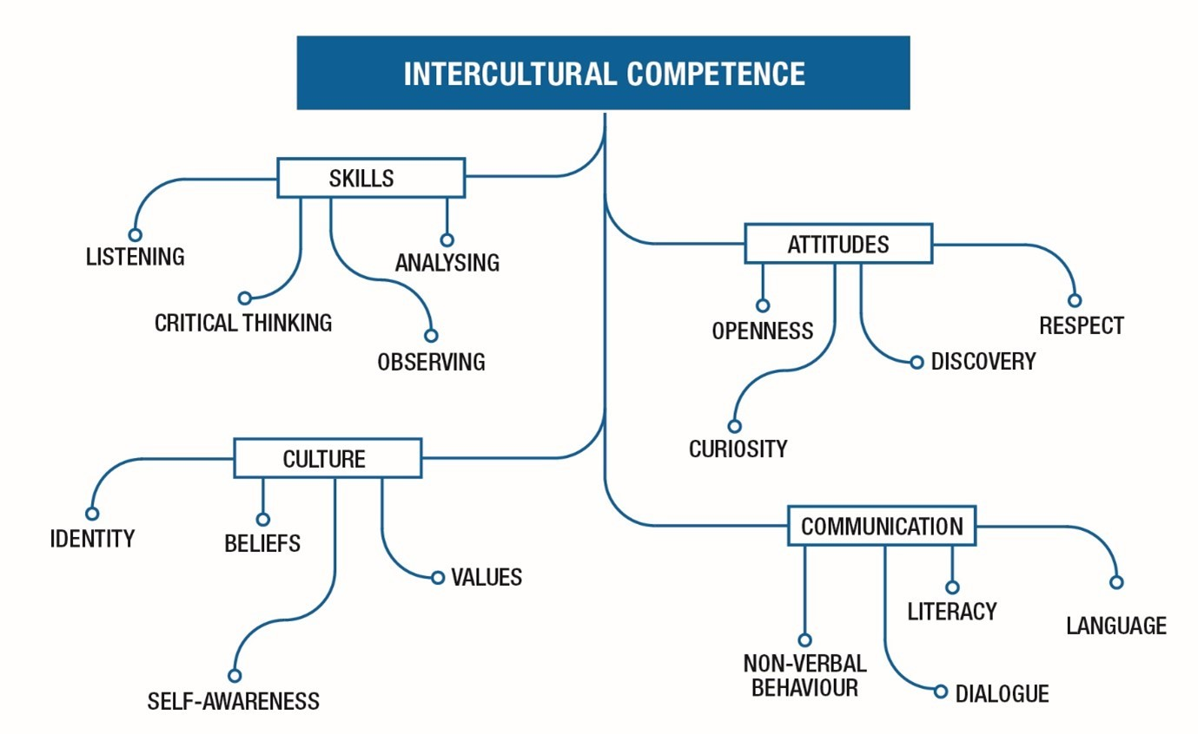
Figure 1 Intercultural competence Source: Monash University, 2013, What is intercultural competence, and why is it important? – (online) available at What is intercultural competence? - Monash Intercultural Lab accessed on 4th February 2024
A comparison of the culture and leadership visualisation of both countries from GLOBE Project will help to better understand the differences between England and Spain.

Culture overview
The abundant customs and traditions of England are renowned worldwide. Often, English culture is linked to excessive tea consumption, the British Royal family, and impeccable etiquette and a delightful sense of humour. (Boag-Wyllie, A., 2023)
In the realm of Spanish culture, individuals embrace life with verve and vitality, not in a frantic or rushed manner. Spaniards prefer a more leisurely pace, taking care to soak up the beauty of their surroundings and the company of those around them. (AFS, 2023)
In the Spanish culture, the act of maintaining eye contact holds significant importance and tends to be more prolonged compared to other societies. (Godoy, S., 2021)

Key differences between England and Spain
- The English tend to be indirect in their communication, often using euphemisms and understatement. Expressing disagreement too directly can be seen as rude. In contrast, in Spain, people tend to be more direct and expressive in their communication. (Lengyel-Marosi, R., 2021) (Boag-Wyllie, A., 2023)
- English people might find the Spanish custom of interrupting during conversations rude, as for them politeness and listening is very important, but for the Spanish people it is not a sign of disrespect to interrupt, but a way to communicate actively. (Godoy, S., 2021)
- The British take a lunchbreak of between 30 minutes to one hour. In Spain, on the other hand, they often take a break of up to two hours to sit quietly and enjoy some downtime or siestas. (Villarroya, A., et al, 2019)
- The English often talk about the weather as a conversation starter and they use humour, particularly self-deprecating humour, in their communication and punctuality is highly valued. Tardiness can be seen as disrespectful.
Spaniards usually have dinner late, often after 9 pm and they often take a siesta, a short nap, in the afternoon. (Ibanez, F., 2022)

Challenges of intercultural leadership
All of the above can be seen as challenges for the intercultural leadership in the hospitality industry as very few people might know about the differences between the two countries.
For example, if one of the new Spanish employees will try to have a break that is normal for him, then the British employees will not be happy with this as they only take a max 1hour break.
Another example is the interruption of a discussion – as specified before, for the people from Spain is normal to interrupt, but for the English is rude – so this could lead to conflicts between employees.

Culture and leadership visualisation for England and Spain
The GLOBE project initiative is a global research focused on developing, examining, and confirming hypotheses related to the correlation between societal norms and the effectiveness of society, organizations, and leadership.
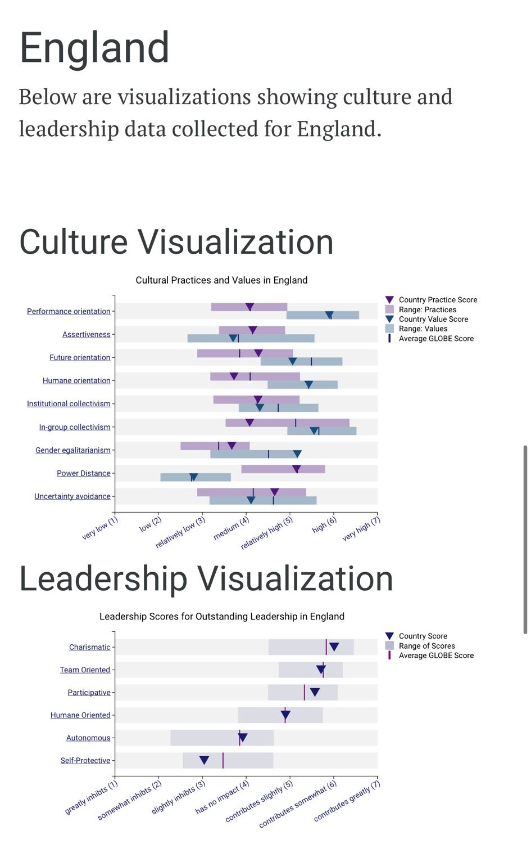
Figure 2 England culture visualisation – Source : GLOBE PROJECT 2020 – ONLINE AVAILABLE AT https://globeproject.com/results/countries/GBR%3Fmenu=list.html#list ACCESSED ON 15TH FEBRUARY 2024
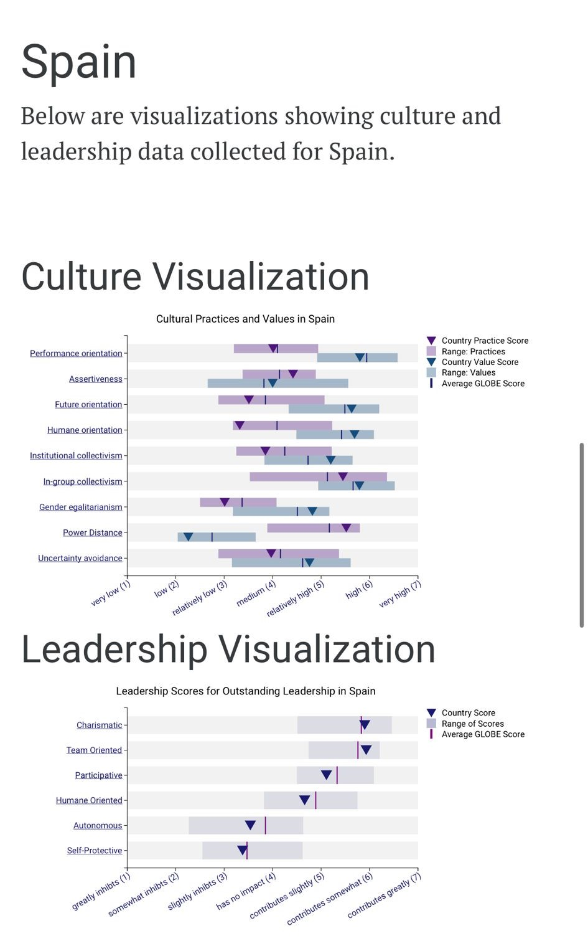
Figure 3 Spain culture visualisation – Source : GLOBE PROJECT 2020 – ONLINE AVAILABLE AT https://globeproject.com/results/countries/ESP%3Fmenu=list.html#list ACCESSED ON 15TH FEBRUARY 2024
The culture visualisation:
- Both England and Spain have a score almost on the average for the values and practices of the performance orientation, which means that they both supports and recognises the individuals for their excellence and progress in performance.
- England has scores of 4.15 and 3.7, in contrast with Spain that has 4.42 and 4 in the assertiveness; which means that Spain is a country where people interact with others in a more confrontational, aggressive, and assertive manner.
- As for the future orientation, the Spanish populace prefers to cherish the present, rather than excessively worrying about the future compared to England where the people leans towards a pragmatic culture.
- With a rating of 5.52 in Power Distance, the Spanish society accepts that every individual has a designated position, eliminating the need for any additional justification, although this is not necessarily what they value as a country, compared to England which has a score in practices of 5.15.
The leadership visualisation:
- England’s score for the team oriented is slightly below the average 5.71 – while the Spain’s is above 5.93, meaning that Spanish people are more effective at building teams and following a common goal.
- Participative scores show that England’s managers tend to involve others more in the decision making process than Spain’s managers.
- The self-protective indicator is below average for both countries with scores of 3.04 England and 3.38 Spain – meaning that Spain leaders are more likely to ensure the security and safety of a group or individual.

Conclusions
Understanding cultural nuances is a cornerstone of intercultural competence. It involves recognising cultural differences and similarities and managing the potential misunderstandings that may arise.
England, offers a complex cultural landscape. The English are known for their politeness, punctuality, and reserve. These cultural norms play a significant role in shaping communication styles and expectations.
Spain, on the other hand, is characterised by its vibrant culture and warm, expressive people. They tend to be more relaxed about time and more open in their communication.
The cultural differences between England and Spain provide excellent opportunities for developing intercultural competence.

Recommendations
- The management must understand that interruption is a part of the Spanish culture and not a sign of impoliteness, so the hotel from London needs to train its employees prior the arrival of the Spanish colleagues.
- The hotel in London will have to explain to the stuff the difference about the punctuality between England and Spain, in this way the English employees will not get annoyed when a Spanish person is late.
- About the lunchbreak – the hotel must explain to all the Spanish employees that it will not be possible for them to take much time off for lunch and maybe try to make an hour long break for everyone – instead of 30 minutes, in this way any potential conflict between the employees will be avoided.

References
- AFS (2023) Exploring Spanish Culture – (online) available at Spain: Exploring Spanish Culture | Learn with AFS-USA (afsusa.org) – accessed on 4th February 2024
- Alex Boag-Wyllie (2023) All Things English – (online) available at English Culture and Traditions - An Essential Guide | Wilderness England
- Bai, R., (2006) Foreign Language Teachers and Intercultural Competence: An International Investigation. Teachers College Record, 108(8), 1589-1592 – (online) available at https://doi-org.ezproxy.uwtsd.ac.uk/10.1177/016146810610800820 accessed on 4th February 2024
- Bamford Alex (2014) What are the cultural differences between Spain and the UK? – (online) available at What are the cultural differences between Spain and the UK? by Alex Bamford on Prezi – accessed on 21st February 2024
- Globe Project (2020) – (online) available at Spain Results - GLOBE Project accessed on 15th February 2024
- Globe Project (2020) – (online) available at United Kingdom Results - GLOBE Project accessed on 15th February 2024
- Godoy Sofia (2021), A Brief Introduction to Spanish Culture, Traditions, and Beliefs – (online) available at A Brief Introduction to Spanish Culture, Traditions, and Beliefs – accessed on 4th February 2024
- Ibanez, Frédéric (2022) 10 cultural differences between Spain and the UK – (online) available at Cultural differences between Spain and the UK (alphatrad.co.uk) accessed on 4th February 2024
- Jason Gordon (2023) GLOBE Project0020- explained – (online) available at GLOBE Project - Explained - The Business Professor, LLC – accessed on 21st February 2024
- LeapScholar (2023) Culture in The UK: Tradition, Language, Etiquettes, Beliefs, and Practices – (online) available at Culture in The UK: Tradition, Language, Etiquettes, Beliefs, and Practices - Leap Scholar – accessed on 4th February 2024
- Liu, Y., Liu, J. and King, B. (2022) Intercultural communicative competence: Hospitality industry and education perspectives, The journal of hospitality, leisure, sport & tourism education, 30, pp. 100371 - (online) available at https://doi.org/10.1016/j.jhlste.2022.100371 - accessed on 4th February 2024
- Monash University (2013) What is intercultural competence, and why is it important? - Adapted from Leung, K., Ang, S. and Tan, M.L. (2014), 'Intercultural Competence', Annual Review of Organizational Psychology and Organizational Behaviour, 1:4889-519. – (online) available at What is intercultural competence? - Monash Intercultural Lab – accessed on 4th February 2024
- Nardon, Luciara (2017) Working in a Multicultural World : A Guide to Developing Intercultural Competence, University of Toronto Press, ProQuest Ebook Central – (online) available at https://ebookcentral.proquest.com/lib/trinity/detail.action?docID=5110567 – accessed on 4th February 2024
- Renáta Lengyel-Marosi (2021) Culture and History of Great Britain, pg 86-101 – (online) available at https://pf.ujs.sk/documents/books/02_2021_Lengyel-Marosi_Culture_and_2_NYOMDAKESZ.pdf - accessed on 6th February 2024
- Villarroya Anna, et al., (2019) Country profile Spain, pg 22-40 – (online) available at https://www.culturalpolicies.net/wp-content/uploads/pdf_full/spain/Full-country-profile_Spain.pdf - accessed on 6th February 2024

