Tom Walters - 0652274

ACCA5034 – Data Security and Compliance
Assignment

Task 1
The following document addresses Task 1 of the Assignment

Security Technologies
Tom Walters 0652274
Student University of Wales Trinity St David, Swansea, Wales
0652274@student.uwtsd.ac.uk

Abstract- In the modern world, organisations need to establish and maintain a solid posture on cyber security. The reason for this is that there an increasing need to understand the Information Technology landscape. Since the COVID-19 pandemic, a larger number of workers are now working from home in a hybrid/remote role style. This has moved a large number of networks from being internal to endpoints outside the physical domain of the organisation.
This document is primarily aimed at Security Technologies, but in order to cover this topic, additional understanding will be required of Intrusion Detection and Prevention Systems (IDPS) and other Security Tooling, also how each part of this relates to Security Frameworks and audit points.
The topic is "Peeling the Onion: What is defence in depth, how important is it and how to increase buy in to it!".

There are a number of components to achieving defence in depth, most commonly this comprises of overlapping protective technology rather than relying on one specific 'golden bullet' to treat everything:
- Physical Security - measures to protect physical access to systems and facilities
- Network Security - Tools and techniques to secure the network installation
- Endpoint Security - Protecting devices that connect to the network.
- Application Security - Ensuring security during the Software Development Life Cycle.
- Data Security - Safeguarding data through encryption and access controls
- Identity and Access Management (IAM) - Controlling and managing user access to systems and facilities.
- Security Awareness Training - Educating users about cyber security best practice.

All the above require both strong processes and utilise a Zero Trust approach. This is a strategy that removes implicit trust and works on a never trust always verify approach. This can be found in NIST Special Publication 800-207.

The overlapping nature of the tools and techniques above are often referred to as 'defence in depth'. While there isn't one specific guideline on how to achieve this, there are a number of frameworks and reference points which can be utilised in specific sections. It is important to note that there are nuances to each framework which will affect how an organisation will choose to utilise it. Forbes [1] - identifies that aligning with a framework allows identification of gaps within tooling, processes and organisational policies. The article also cautions that ongoing reviews of the frameworks being utilised allows a self-critique of the frameworks in place against the appropriate tooling and practices.

It is important to note that there is a hierarchy of items that are generated as a result of aligning with a security framework or framework that allows reporting. There are a number of hierarchical components:
- Policies
- Controls
- Procedures

A Policy is a high level management intent. For example; ”we will maintain our network and assets in a proper manner ” The control would be “The patches are applied in a timely manner”. The Standard would define patching cadence for each type of device and document clearly how high priority patches would be addressed.

A number of the titles above depend on the categorisation of the device and utilising a zero trust policy, reviewing the devices below as follows. :
- Endpoints - Mobiles
- Endpoints - Laptops
- Servers - Cloud
- Servers - On Premise
- Physical Security
Physical security is a crucial aspect of cybersecurity as it involes the protection of the physical network components, such as servers, routers and other hardware from unauthorised access thus potentially restricting the chance of damage.
Data centres where servers/hosts are stored (either as private company devices or as larger components within Virtual Private Clouds with service providers such as AWS or Microsoft Azure/Entra). Many Data Centres will comply with several audit standards - ISO regulations such as 27001 or ISAE (International Standard on Assurance Engagement) 3402 [link]. Any pre-existing audit accreditation assists a company in providing due diligence in supply chain management, and assists in future audits by reducing 3rd party supplier queries.
Data centres will have physical controls starting at the perimeter fence with vehicle barriers, then card access to the data hall, and finally key access to the specific cabinet in which a server resides. At each control point the zero-trust method applies - the work order raised by an authorised signatory of the company, with a pass being issued on condition of the individual being authorised to access specific rooms and areas. Then the keys for the cabinet being issued. In addition to this, during the time within the premises, there is continual monitoring via CCTV and also access control systems to list where users of the facility are. As part of the site certification process the centre would establish climate control, fire suppression systems, power redundancy such as separate power networks, as well as redundant generators and uninterruptible power supplies

Moving away from the core network to laptops, robust procedures in both staff training regarding what process to follow should a laptop or company mobile device be stolen is essential. This allows the service desk to both be able to isolate and restrict access to the device as well as the user account. In order to create a bigger challenge for an unauthorised party to login to the system, the use of multi factor authentication can act as a 'trip wire'. Should a 3rd party attempt to use a legitimate account to login, the account owner would receive a prompt on their mobile device to enter a randomly generated number and approve the sign in. Thus increasing the complexity of imitating an authorised user significantly. Training would also cover points such as where to store a laptop when not in use, transporting the laptop in less conspicuous bags. Also ensuring that essential users such as C-Level Executives have regular backups of the laptop done by a snapshot of the device, this would be over and above the protection provided by cloud stored document files such as One Drive and SharePoint within the Microsoft Office Suite.
- Network Security
Network security is essential for maintaining the CIA Triad of data and resources held on a network.. The components that can include this are items such as:
- Firewalls which are placed on the edge of the network, and act as a gatekeeper for network traffic into the corporate estate.
- Intrusion Detection and Prevention Systems (IDPS) - the majority of security tooling can establish a baseline, IE what is normal and then react to what is not. For example it would not be expected that the CEO of a firm would be logging on to another laptop or server at 3am. Especially when their normal behaviour would show them accessing office documentation during core business hours. Tools such as Microsoft Defender, DarkTrace which are designed to assess out of the ordinary events and report in into a tool-set such as Microsoft Sentinel,
Further to the above it should be pointed out that both endpoint and network security are integral to the overall approach to security but they do focus on different aspects of protection.
With regards to scope, Endpoints security will target individual devices, whereas the whole network is covered by the network security remit. In the arena of threat detection, networks would monitor and control traffic to prevent threats from entering the network, while endpoint security would respond to a threat after detection.

In a nutshell - Network Security tooling can stop threats before they get to the endpoints/core infrastructure. Endpoint Security is designed to detect and mitigate threats should they get through the first layer of protection.

- Endpoint Security
Implementing robust endpoint security measures comprise a range of tooling, some of which are also regularly encouraged for use on home PC's by institutions such as banks or utilities companies. Security for Endpoints is also known as EDR - Endpoint Detection and Response.
EDR is designed to continuously monitor and respond to threats such as Malware, Ransomware, and also Advanced Persistent Threat on endpoints, such as desktops, laptops, mobile devices. In addition to the protection, EDR extends from the Protect and Defend phases of NIST framework into the Respond phase allowing advanced threat hunting. This occurs using URL and IP checks as well as comparing downloaded file hashes. Often these systems allow administrators to blacklist or whitelist items in addition to gaining from using the vendor supplied definitions - for example, a sales employee may ask for an exemption to WilliamHill being accessed, this is due to a lead being generated, however the EDR software would block the URL as a gambling categorised site.

- Application Security
Programming securely is complex and there are specific models on how to develop an application securely. [link].
The security of applications starts with a security first approach, integrating requirements into the SDLC - Software Development Life Cycle or SDLC for short. [link]. The SDLC is an industry accepted method of creating defined stages to Plan, Design, Implement, Test, Deploy and Maintain an application. As explained by the AWS guidance there are a number of different ways to develop software, Some of which, have become a management function within their own right, an example of this would be Agile Scrum Masters.

There has been a recent drive within the development community to 'shift left'. A reference to integrating critical development activities such as testing, security measures and considerations and quality assurance (QA) earlier in the process.

Using the SDLC, applications that connect across multiple networks and often to the cloud are exposed to a number of threats, following the SDLC helps to prevent cyber-attacks and reduce the attack surface radius.

While as a software development function the holistic approach of application security is extremely important. As a consumer of applications, any individual or company should also remember other considerations, such as regular updates/patching for operating systems and applications on the network.

Testing the security of an application can be done using a number of different tool-sets which are all used at different points in the SDLC. Static Application Security Testing (SAST) would usually be done prior to implementation, ensuring clean coding utilising a tool such as SonarQube. Dynamic Application Security Testing (DAST) tests application in their running state to identify security issues. Tools such as BurpSuite which are industry recognised and can be integrated into the Continuous Integration/Continuous Delivery (CI/CD) pipeline to provide ongoing testing on each iteration of development and also scheduled to scan existing applications.

To use an analogy - A house is no good without a solid foundation, so the architect will base the design on the requirements, and then the builders will be given the specification and expected to apply their knowledge of building code to provide a solid well-built house.

- Data Security
The process of safeguarding digital information throughout its entire life cycle to maintain the CIA Triad, (Protect from corruption, unauthorised access ). With the increase in remote workers, the responsibility for restriction doesn't just lie on the server/core infrastructure.

It should be noted that often Data Security and Data Privacy are two separate definitions, While they share certain principles, they are not interchangeable.

Data security focuses on protecting data while data privacy relates to what others can do with information once it is accessed.
Michael Parent [link] suggests that since the COVID pandemic the pressure on companies to create a model for work that is supporting and accessible for remote workers. This means due to the change in design that more emphasis is being put on ingress routes to company devices - many of which now sit within home networks, whereas previously, often it was travelling sales teams and management only that worked from remote locations (home/hotels etc), the effect of this is to have to cast the effective virtual shield further.
Protecting an endpoint (laptop) sitting on a network that is not owned by the company requires additional considerations such as a regularly updated Operating System and Office program. Potentially a secure network tunnel (Virtual Private Network - VPN) to allow access to on premises servers and resources. Anti Virus, often all emails are filtered prior to reaching user mailboxes for both potential phishing and also malware utilising mail appliances and also Exchange Online Protection if run through the office suite.

- Identity and Access Management (IAM)
Identity and Access Management is often referred to as IAM and is a framework of technologies and policies to ensure that the correct person has the correct level of access to the correct resource at the right time for the right reason. As can be seen below, the principles of the CIA Triad are upheld when IAM best practices are followed.

IAM consists of Identity Management, Access Management, Authentication, Authorisation and User Life-Cycle Management.

The two main sections of Identity Management are User Identification and Authentication. Identification relates to the creation and management of the user account, each account is given a unique identifier, such as a username or email address.
Authentication relates to the verification of the identity of the user. An initial step would be to use a password, with additional factors such as biometrics or Multi-factor Authentication(MFA), also known as two factor authentication (2FA).

Access Management deals with Authorisation and Access Control. There is a close relationship between these two points as a Access control based on Zero Trust would mean that a user is not authorised to access anything unless appropriate. Taking this a step further would be the implementation of Role Based Access Control - predefined configuration based on the job role and location.

Life Cycle Management is related to regular user reviews ensuring that individuals who are no longer working for the company have their accounts disabled on the last day of work etc. Another important part of this is when software is licensed per user, so even if a user has left, the account is still present and could be charged for - such as backups or scanning within the active directory.

- Security Awareness Training
Training is a process designed to provide employees with the ability add to the overall strategy of Defence In Depth, this allows them to not only prevent in some cases but to respond in the correct fashion - escalating to Service Desk who would triage and pass to the Security Operations Centre as an example. Or reporting phishing using dedicated tool-sets which integrate with email clients to allow a single button click to report phishing emails but also are part of a further training on identifying phishing emails.
In addition to this, topics such as Password Management, Safe Browsing Practices, recognising Data types (confidential, company only, restricted), Understanding Social Engineering,

- Summary
As has been discussed above, security now covers a much wider area than five years ago, and the technologies now exist to complement each other, rather than being a standalone firewall and a standalone anti virus, while there is sometimes a failure of one part, the overlapping layers of protection and detection make it easier for a business to identify issues quicker and become more resilient. Which gives brand confidence and maintains brand reputation.

Task 2

Introduction
The purpose of the strategy is to give assurance to the owners, partners and stakeholders that every effort is being made to render our systems safe and to protect our data and networks safe from attack or interference.
Cyber Security is an organisation wide responsibility due to the nature of the risk and misconception that security is solely an information technology function. Due to the expansion of IT systems across the business, the responsibility of maintaining the Confidentiality, Integrity and Availability (CIA) Triad.

Background and Context
The company ("MarketSafe") is a medium to large scale enterprise based across a number of continents. The Group IT team are based within Cardiff with sales offices around the world. The company utilises both Amazon Web Services (AWS) and Microsoft Entra/Azure for cloud processing as well as a number of physical and virtual servers within a datacentre site at Newport, South Wales.

The Approach So Far
Our framework is aligned with the NCSC guidance for hybrid working within Large Scale organisations. The entire estate is subject to external penetration testing annually and is subject to a regular patching regime, servers are patched on a sixty day cycle, meaning that our user environment is patched every month, with test and production environments being patched on alternating months ensuring patches do not affect the production environment.

Our current stance comprises of a traditional on premises virtualised estate connected to both Amazon Web Services via Virtual Private Cloud and Microsoft Azure Portal, this affords a high level of protection and assurance.

Our current user base have been migrated from Windows 2016 Active Directory to Azure Active Directory, within the next 12 months the intent is to migrate all local office Virtual Hosted servers to Azure - leaving the offices with networking only devices. All user devices are 802.x Wifi Enabled Laptops, printing will be handled via Microsoft Azure Print Services to on site printers. All of this is thanks to Microsoft 365, a software as a service (SaaS).
The use of M365 is empowering staff to collaborate and potentially share documents without the traditional intervention of the IT Department. This flexibility does raise additional challenges and with the security of data and information systems being foremost we do need to ensure both the organisation and staff members are being protected.
At the end of this document is a table showing the current state of NIST controls against our roadmap – divided into the specific sections of the NIST domains.

Stakeholder Support
Our key stakeholders are comprised of our customers, suppliers, employees, regulators and senior leaders within the organisation. HOwever, we also have a responsibility to ensure that any data that may be shared by third parties is accurate and appropriate.
Our approach is to encourage collaboration with open and honest dialogue with clearly defined escalation paths.

Clear processes and training are needed to ensure that all employees are security aware and this is fundamental to effective prevention, detection and response.

External Influences
During recent years cyber attacks have become more commonplace due to the pandemic. As a result a lot of new technologies were implemented without complete consideration being given to configuration, resulting in threat actors being able to exploit weaknesses in order to gain access to organisations.

No organisation is immune to the threat of cyber attack and several large organisations have fallen victim to service disruption, data loss and ransomware over the past 24 months.

The Importance of Collaboration
Cyber threats are now the most effective way to attack an organisation and threat actors are finding ever more sophisticated ways of carrying out their activities with malicious intent.

While phishing attacks, cloning Wi-Fi networks, obtaining passwords, adversary in the middle (man in the middle) attacks are all widely, and successfully, used to compromise information and processes, cyber security can also be undermined by the human threat.

Effective cyber security technology is critical but is only effective when processes are in place and employees have an awareness of the risks, a silo-based approach to cyber security significantly increases the risk of an organisation’s vulnerability to data loss.

It is important that systems and processes are reviewed regularly and assessed by the organisation, not only for efficiency but the potential to leak data to unintended recipients.

The Information Management (IM) project, launched in January 2022 as an operational improvement initiative, is anticipated to deliver a corporate framework defining how data is to be managed, categorised, and used throughout the organisation.

This project will be key in establishing a framework which will be the catalyst to build the foundational blocks, drive change and increase awareness on how we can use data and processes to their best advantage. This framework will support both the Cyber Security and Digital strategies enabling us to automate and monitor many of the manual labour-intensive tasks we do today.

Effective and regular communication and training also ensure that employees have a good awareness of cyber security and can act as an additional set of eyes and ears giving early warning affording us the opportunity to isolate and contain any issue quickly.

In addition, the use of regular simulation of real-world attacks allows us to test the effectiveness of our training and technologies and continue to evolve our approach within the organisation to cyber security.

This collaborative approach to raising awareness of cyber security within the organisation ensures the topic is always current and using different simulations in addition to awareness and training allows us to evaluate and plan for the “what if” scenarios and how to deal with them effectively.

Organisation Structure
The creation of a new Information Security Team (InfoSec Team) will be broken down into stages over the course of two years. As can be seen from the organisational chart below, the Information Security Team will fall under the remit of the Chief Information Security Officer. Working in two discrete functions - Operations(Sec Ops) and Enterprise Risk Management (ERM) with a manager to lead each function.

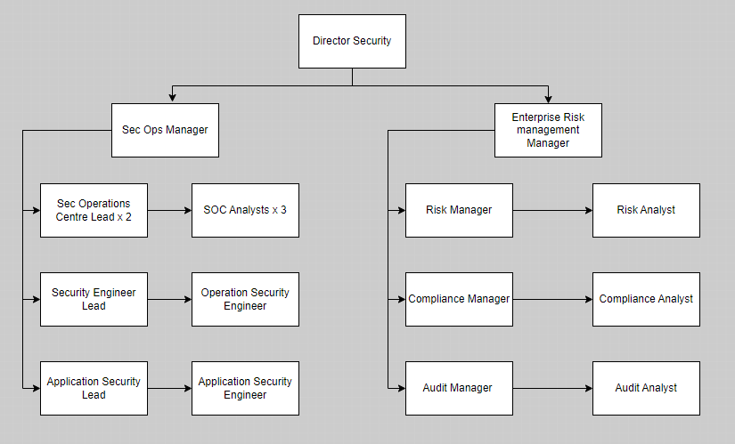
The intent would be to start Sec Ops at 50% staffing, and Enterprise Risk Management with the Lead roles filled, as the team establishes stability, develops and implement the necessary tooling. ERM expansion to work in conjunction with the rhythm of audit and findings.

Policies and Procedures
The current approach to cyber security will be modelled on the 10 Steps to Cyber Security issued by the National Cyber Security Centre. Further information can be found here
The Cyber Security Strategy sits alongside the ICT Strategy and is supported by a suite of policies.

Department Priorities
The current company IT position is in transition from on premises to cloud utilising both Azure and Amazon Web Services. Staff are all using Windows 10/11 laptops with software delivered via Intune Company Portal.

Priority 1 - Zero Trust
Zero Trust is a cyber-security Paradigm that shifts the focus from traditional, perimeter-based defence to a model where trust is never assumed and always verified. It requires continuous authentication and authorisation for every access attempt. This is regardless of whether it originates from inside or outside the network further info can be found at https://nvlpubs.nist.gov/nistpubs/SpecialPublications/NIST.SP.800-207A.pdf and a simplified explanation from Microsoft Learn
- Never Trust, Always Verify
- Assume Breach
- Least-Privilege Access

This applies at three levels:
- Users - Require Strong authentication of user identity, application of 'least access' principles and verification of user device integrity.
- Applications - Removal of implicit trust with various components of applications when they talk to each other. A fundamental concept of Zero Trust is that applications cannot be trusted and continuous monitoring during runtime is necessary to validate their behaviour.
- Infrastructure - All components which comprise the enterprise estate such as routers, switches, servers, storage, cloud etc, are built with a zero-trust approach.

Priority 2 - Strong Process
As an established organisation working towards ISO27001, the framework directs that organisations should establish, implement, operate, monitor, review and continuously improve in Information security management systems (ISMS). As one of the commitments to development, ITIL training will ensure that Strategy, Design, Transition, Operation and Continuous Improvement are given due respect by the team and the enhanced understanding that this will proved allows them to integrate better with other parts of the business.

Priority 3 - Enterprise Technology
All tooling will be reviewed against Gartner Magic Quadrant, with the tooling selected from the 'top-right' Leaders quadrant. The tooling review process will include integration requirements such as Single Sign On, SIEM connectors as part of the Supplier on-boarding process

Priority 4 - Central Management
All solutions must be centrally managed and controlled with single sign on which links back to the master list. This means that should an employee leave the organisation, or a contractor reach the end of tenure then all hardware and systems access can be instantly revoked.

Priority 5 - Staff Awareness Training
Technology alone can no longer mitigate our organisation against cyber-attacks. It is important that regular training, that the staff can relate to, It is important that the staff are trained to understand cyber threats such as phishing, malware, ransomware and social engineering.

Commitments
The primary commitment is to provide assurance to the organisation that every effort is being made to render the systems safe and to protect the data, network and infrastructure from attack of interference while maintaining the CIA Triad.

This will be achieved by:
- Investing in internal processes to modernise, defend and secure the assets by introducing ISO27001 within the UK business group, this audit to be completed within 18 months of stand-up of the ERM function. Further to this, a gap analysis to assist in mapping controls from the 27001 audit to controls required to be documented for a SOC2 Type 1 audit at 24 months. and submission for Type 2 at 30 months. Type 1 being a suitability verification, with Type 2 assessing the operational effectiveness of the documented systems.
- Continued investment in appropriate technology to protect infrastructure, networks and data, utilising both Intrusion Detection and Prevention Systems (IDPS) and also an appropriate Security Incident Event Management (SIEM) system.
- Ongoing Continuous Professional Development of staff, to address skills training gaps and ongoing training systems. All team members to be qualified in ITIL v4 foundation within 12 months to advocate for strong process management,
- Continue to collaborate with the departments within the organisation to accelerate technical awareness, automate processes to reduce manual intervention and potential resulting errors.
- Facilitation and implementation of data categorisation policies in line with the organisations policies.
- Utilising tooling to monitoring inappropriate data sharing with external parties.
- Integration of pipeline scanning utilising and feedback to developers.

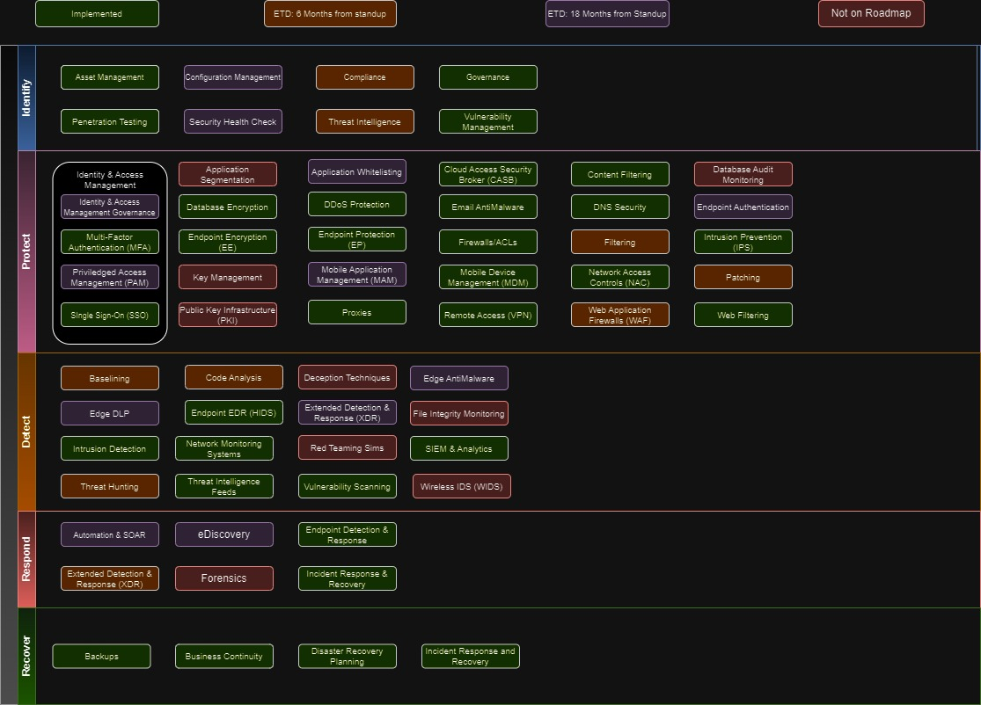

References
Amazzon. (n.d.). AWS . Retrieved from What is SDLC: https://aws.amazon.com/what-is/sdlc/
Dulaney, E., & Easttom, C. (2018). CompTIA Security+ STudy Guide (7th Edition). Sybex.
Magowan, K. (2020, Nov 30). BMC Blogs. Retrieved from BMC Blogs: https://www.bmc.com/blogs/what-is-shift-left-shift-left-testing-explained/
Microsoft. (2024, April 12). What is Zero Trust. Retrieved from Learn Microsoft: https://learn.microsoft.com/en-us/security/zero-trust/zero-trust-overview
Price Waterhouse Cooper. (n.d.). www.pwc.com. Retrieved from Service Organization Controls Report - International Standard on Assurance Engagements (ISAE) 3402: https://www.pwc.com/ph/en/risk-assurance/trust-transparency/service-organization-controls-report-isae-3402.html
Rose, S., Borchert, O., Mitchell, S., & Connelly, S. (2020, August). NIST Special Publication 800-207. Retrieved from NIST: https://nvlpubs.nist.gov/nistpubs/SpecialPublications/NIST.SP.800-207.pdf
Watkins, R. (2024, Feb 13). Benefits And Cautions Of Aligning With Cybersecurity Frameworks. Retrieved from Forbes.com: https://www.forbes.com/sites/forbestechcouncil/2024/02/13/benefits-and-cautions-of-aligning-with-cybersecurity-frameworks/

