

Maldiva Ltd. – Overcoming Operational Challenges
Proposal for Information Systems Improvements
Programme | BA (Hons) Leadership and Management Skills for the Workplace
Module | Managing Business Information
Module code | LCLM 5004
Assignment title | Component 2 - Individual Report - Information Systems Improvements
Student Name | Samuel Stoican
Student ID Number | 2420306
Word Count | 2002 Words

Contents
1. Introduction 3
1.1 Overview of the business case 3
1.2 Key challenges 3
2. Evaluation of Existing Systems 4
2.1 Current systems and process weaknesses 4
2.2 Inefficiencies and gaps 4
2.3 Effect on business performance 5
3. Recommended Solution 5
3.1 Proposed information system 5
3.2 Justification based on business needs, efficiency, cost and scalability 6
3.3 How the system will improve operations 6
3.4 Data management and decision-making benefits 6
3.5 Why this option is better than separate systems 7
4. Implementation Plan 7
4.1 Implementation steps 7
4.2 Training and change management 8
4.3 Integration, security and potential challenges 8
5. Conclusion 9
References 10

1. Introduction

1.1 Overview of the business case
Maldiva Ltd is a growing consumer electronics retailer with 30 physical stores and an e-commerce platform. There has been rapid growth in sales, and therefore the company requires faster and more reliable information systems at the moment. The business case indicates that the company is no smaller, to rely on manual records of stocks, individual customer files and spreadsheet reporting. These procedures might have performed well at a smaller level guiding the business however they now cause delay, mistakes and bad customer experience. An information system must not just process data from a business viewpoint.

1.2 Key challenges
The key issue is that systems in the Maldives are not integrated. The online availability does not correspond with the store's inventory. This results in the acceptance of online orders when stock is not available. This is followed by cancellations, refunds, and frustration for customers. Store managers also do not have the chance of seeing what is overstocked or understocked. The second issue is the poor customer relations management. The information on customers, complaints and purchase history is stored in various locations, hence the inability to target customers strategically and the inability to address problems on time by the support staff. The third difficulty is tardy reporting. Managers use manually prepared spreadsheets, which sometimes may be late and inaccurate. The fourth obstacle is the protection of data. The existing mechanism has poor access controls, audit trails, as well as security procedures. The last issue is the separation of departments.
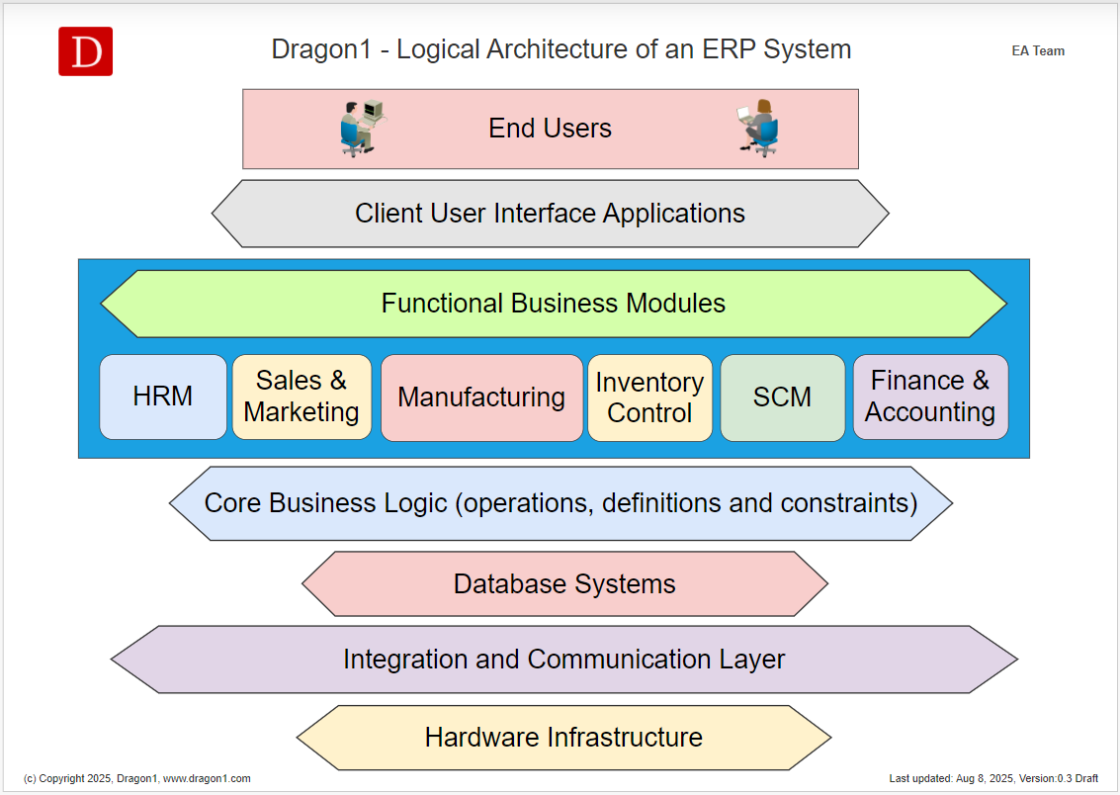
Figure 1: Logical ERP architecture showing integrated business modules.
Source/reference: Dragon1 Software (2025).

2. Evaluation of Existing Systems

2.1 Current systems and process weaknesses
The current system consists primarily of tools that are disconnected and manual. The manual tracking of inventory is done by using basic local files or manual tracking. CRM records are divided into separate records. Spreadsheets are made to generate sales reports. Other applications are used in finance, stock and sales teams. This implies that there are multiple small systems in the company which lack a reliable business system. Practically, every department invents its own version of the truth.

2.2 Inefficiencies and gaps
The largest gap is the absence of real-time inventory visibility. The contemporary ERP solutions are structured in such a manner that they can integrate the major business processes like finance, sales, supply chain and procurement into a single source of business information (SAP, 2026). Maldives lacks this single source of truth at the moment. The second weakness is the bad customer data management. A CRM ought to oversee relations with both existing and future customers and assist the organisation become better in relationships and profitability ( Salesforce, 2026). The CRM position of Maldiva is unstable as the support workers are unable to access purchase history, records of complaints or customer preferences faster. The third weakness is the lack of business intelligence. Quick decisions cannot be made with Spreadsheet reports during a time of increasing sales volumes. Security and compliance are the fourth gap.

2.3 Effect on business performance
These gaps affect performance in several ways. To begin with, stock mistakes decrease sales since the company will be unable to deliver confirmed orders. Second, excess stock restrains cash and stocks. Third, a stock-out leads to lost sales and a ruined reputation. Fourth, poor CRM minimises customer loyalty as customers are offered generic promotions and respond to complaints with slowness. The studies on CRM and big data have indicated that improved customer data can assist with personalisation and customer experience over data that is inaccurate and unusable. Fifth, manual reporting slows management action.

3. Recommended Solution

3.1 Proposed information system
The recommended solution is a cloud-based integrated retail ERP system with CRM, inventory management, e-commerce integration, finance, reporting and security modules. An appropriate practical alternative would be Microsoft Dynamics 365 Business Central as the ERP core with the assistance of Dynamics 365 Customer Insights or Sales as CRM and Power BI as dashboards. The reason why business central is fitting is that finance, sales, service and operations are integrated in a single solution which aligns with what Maldiva needs since it eliminates departmental silos (Microsoft, 2026a). The system will also integrate with its existing e-commerce and store point-of-sale terminals using common APIs.

3.2 Justification based on business needs, efficiency, cost and scalability
This recommendation fits Maldiva’s business needs because the company is a multi-store retailer with online sales. It requires a single system, capable of serving stock control, customer service, finance and management reporting simultaneously. Cloud ERP is more appropriate than an on-premises system in the sense that it does not require a heavy investment in servers, it has remote access abilities and can add users/ modules as a company grows. Scalability, availability and reduced infrastructure burden are other benefits of cloud ERP studies, but implementation has to be handled with care (Abd Elmonem, Nasr and Geith, 2016). This will involve the cost of licences, implementation support, data migration, training and integration work. Nevertheless, such expenditures are worth the existing system leads to refunds, restocked items, duplications, and compliance streamlining.

3.3 How the system will improve operations
The proposed system will improve operations by giving staff one updated view of products, customers and orders. Upon a customer making an online purchase, the stock will be on hold. In the case of selling an item through a store, the online stock level will also vary. Reorder alerts can be based on sales history, lead times and minimum stock levels. The finance department will automatically receive the sales and inventory information, and therefore, the staff will not have to enter the same data. Customer service will be capable of searching individual customer records and viewing purchases, returns, complaints and past communication. Based on the kind of purchases made by customers, marketing can develop tailored campaigns for these customers.

3.4 Data management and decision-making benefits
It will develop improved data management since most of the key transactions will be stored in a central database. Each product, customer and order will have a consistent record. Managers will not have to wait and receive weekly spreadsheet reports before they can take action. They are able to benchmark the performance of stores, monitor the demand and modify promotions online in fast moving electronic. Forecasting will also be based on better data. To illustrate, where phone accessories are selling off fast following a new phone launch, the system will be in a position to display this trend earlier.

3.5 Why this option is better than separate systems
Maldiva could choose several separate systems, such as a stock application, a CRM package and a reporting tool. This alternative might initially appear cheaper, but that would still be propagating the same issue in a new form. Connectors, manual checks and duplicate records would still be needed by the staff. A third alternative is to create a completely bespoke system. It would be an ideal fit for the company, but it would prove to be quite costly, time-consuming, and risky in a company that needs to recover quickly. CRM and BI are more balanced in a cloud ERP.
It also enables the management to implement controls without the years-long process of an exclusive platform. The system also needs to be structured according to the processes of the Maldives, yet the company cannot make a lot of modifications to the software. High customisation is costly, causes difficulties with upgrades and presents more difficulties in staff training. A standardised solution will prove easier to uphold in 30 stores and the online channel. The suggested solution is not just a purchase of technology, then. It is a business enhancement programme. It alters the way customers accept orders, manage stock, the way customers are served and how managers make use of evidence.

4. Implementation Plan

4.1 Implementation steps
Implementation should be completed in planned phases to reduce disruption. Discovery is the initial stage. Project team is expected to have mapping of current processes of ordering, stock control, online sales, returns, complaints, finance and reporting. The second step is the system design. Maldiva, when developing the workflow, must not be over-customised, but only use some of the typical workflows. The third one is data preparation. The product codes, customer records, supplier records and past sales should be purged prior to migration. There has to be a combination of two or more customer records. Wrong records of stock should be checked by a physical count. Configuration and integration are the fourth step. ERP, CRM, e-commerce portal, POS terminals and finance files should be interrelated. Testing is the fifth stage. Some of the tasks that should be tested by the staff include common tasks like online ordering, stock transfer, processing refunds, recording complaints and generating reports, just to mention a few.

4.2 Training and change management
The importance of training lies in the fact that the success of the system will rely on how they have been adopted. The store employees ought to be provided with training on how to check in stock on live basis, transfers, and how to do returns. The protocol on updating the records on purchase history and complaints will require the customer care department to come into force. The marketing staff should be educated on how to segment customers and use campaign tools. Automated reports and reconciliation procedures should be learned by finance personnel. Managers should be informed with regard to dashboards and exception reports. Training should be part of short role practices, minimised user manuals and guided practice. Reasons should be presented as to why the system is needed by change management. Employees may be resisting the new system in case they believe that the system is aimed at enhancing espionage or even an increase in workload.

4.3 Integration, security and potential challenges
The APIs should be integrated using secure APIs and tested thoroughly. Errors may come about by having inconsistencies in product codes or customer identities. This is why data cleansing is one of the crucial tasks when a material is to be migrated. The implementation must be made secure. The system component ought to utilise role-based access, multi-factor authentication, encryption, audit trail and regular backups. NIST Cybersecurity Framework 2.0 puts much importance on identity management, authentication, access control, data security, awareness training and resilience as key protection outcomes (NIST, 2024). The GDPR also requires legal, fair and straightforward treatment of personal data, and Maldiva must know the type of personal information they gather, why they use it and to which individuals (European Union, 2016). The likely pitfalls will be the cost increases, rollout disruption, bad data quality, employee resistance and reliance on outside consultants. These risks can be reduced with the help of a clear budget, the backing of senior management, gradual implementation, realistic timeframes, and effective communication. Regular progress reviews and stakeholder collaboration will further support successful implementation while minimizing potential challenges and ensuring sustainable long-term outcomes.

Figure 3: Data protection and cybersecurity network concept.
Source/reference: Soyio (2026).

5. Conclusion
Maldiva Ltd requires a modern information system due to the inability of its existing systems to stay with a manual system, which is disconnected and cannot serve a growing retailer. The challenges faced by the business include inaccuracy of inventory, poor management of customer relationships, slow reporting, weak compliance and silo departments. These issues hurt sales and customer confidence, employee output and decision-making. The most appropriate solution is a well-supported and integrated cloud ERP system that may be a retail system available and supported by CRM, inventory management, e-commerce integration, business intelligence and powerful security systems. This system will introduce a single source of the product, customer, order and financial information. It will improve the accuracy of stocks, reduce the refunds, assist in the creation of personalised marketing, speed up reporting and improve the adoption of the GDPR. This must be done in steps where the process mapping and data cleansing have to be first rolled out and lastly process mapping, data cleansing and roll out of pilots and overall deployment.

References
Abd Elmonem, M.A., Nasr, E.S. and Geith, M.H. (2016) ‘Benefits and challenges of cloud ERP systems: A systematic literature review’, Future Computing and Informatics Journal, 1(1-2), pp. 1-9. Available at: https://doi.org/10.1016/j.fcij.2017.03.003 (Accessed: 8 July 2026).
Dragon1 Software (2025) Enterprise Resource Planning ERP. Available at: https://www.dragon1.com/solutions/enterprise-resource-planning-system (Accessed: 8 July 2026).
European Union (2016) Regulation (EU) 2016/679, General Data Protection Regulation. Available at: https://eur-lex.europa.eu/eli/reg/2016/679/oj/eng (Accessed: 8 July 2026).
Microsoft (2026a) Dynamics 365 Business Central. Available at: https://www.microsoft.com/en-us/dynamics-365/products/business-central (Accessed: 8 July 2026).
Microsoft (2026b) Power BI: Data Visualisation. Available at: https://www.microsoft.com/en-us/power-platform/products/power-bi (Accessed: 8 July 2026).
NIST (2024). The NIST Cybersecurity Framework (CSF) 2.0. Gaithersburg, MD: National Institute of Standards and Technology. Available at: https://nvlpubs.nist.gov/nistpubs/CSWP/NIST.CSWP.29.pdf (Accessed: 8 July 2026).
Salesforce (2026) What is CRM? Available at: https://www.salesforce.com/ap/crm/what-is-crm/ (Accessed: 8 July 2026).
SAP (2026) What is ERP? Available at: https://www.sap.com/mena/resources/what-is-erp (Accessed: 8 July 2026).
Soyio (2026) ¿Protección de datos personales y ciberseguridad son lo mismo? Available at: https://soyio.id/blog/proteccion-de-datos-personales-y-ciberseguridad-es-lo-mismo (Accessed: 8 July 2026).

