Iwan Jones
1803154
Application Development
ACCA5012

Contents
Abstract 2
Requirements 2
The Application 2
Features 2
Design & Implementations 3
Design Features 3
Implementation 3
Controller, View & Models 3
Evaluation 8
Testing 8
Conclusion 9
Bibliography 9

Abstract
The following report will be discussing the topic of this report and the application that has been created for the purpose of this assignment. There will be an overview given of the application and why it has been created, the design and implementation of said application will be discussed following on from the overview. This will discuss the main scripts, methods or classes that have been implemented into the app which create the functionality of the application that has been created. The report will be concluded by the evaluation of application which will include in-depth testing of the functions and features that allow the application to function.

Requirements

The Application
The application that has been created is based off an excising company called Trifit which is the name of the company that the application has been created for in this case. Trifit is a triathlon training centre for all athletes that are based in South Wales. Trifit offers training sessions for all disciplines in triathlon, from swimming sessions, indoor biking session to run training. The target audience for the application is that of any athletes in the local area looking for somewhere to train and improve. The application that has been created allows all athletes in the area to be able to check the time of any and all sessions that TriFit is running, they time the start and end, the type of sport and session that will be covered and finally the member of staff that will be in charge of said session.

Features
There are many features and functional requirements to the application that has been designed for this project. The main features of the application that has been created is the classes page of the site where it accesses the session table to display all the sessions that are available along with the data that goes with them. This page can be viewed by any user that views the website. However, not every has access to the CRUD functions. All users visiting the site will be able to use the details button and view the details of the selected session on a separate page but only the admin user can access the CRUD functions. The two pages regarding staff and customer details can only be accessed by the admin account that has been created any customer cannot access these details. This prevents data being stolen and keeps all sensitive data in the protection of TriFit. The admin account can access all features on the site and has the power to be able to add, edit and delete any records on the database. Customers without an account can register on the register page. On the classes page there is a searching option which allows the user to either search for any specific details for a session they are looking for without trolling through every session. There is also a paging feature where the amount of results on a page can be changed and limited to 10, 20 and 50 if there are enough pieces of data on the page. Likewise, on the back-office page where the customer details are stored, there is also a search/filter feature implemented. This will allow to search for any customer and find them instantly from searching their first name or surname. To recap the points discusses in this section the list below shows the main features of the application created.;
- Admin Login
- Admin rights
- Customer rights
- CRUD functionality
- Page Searching
- Paging

Design & Implementations
In the following section both the design features and the actual implementation of these features will be discussed and the role that the features play in functionality of the application that has been created.

Design Features
To begin with, the application follows industry development standard by keeping to the three-colour rule. Following on from this, to address the admin features that have been implemented the methods that were chosen to use this feature, was to create a class called “SeedUsers” which contains the information on the admin login. In this file the class contains the information on the two different roles within the application, them being the admin role and a customer role. The user’s login credentials are stored within this file and then stored in the ASPusers table. For the CRUD functions which are located in the views for each of the controllers that were created (sessions, customer and staff). Within these scripts and line of code has been added for the authentication for the admin account to use the functions and not to allow the customer to be able to access any of these functions and to mess with the data stored in the tables of the application. The scrips that have been created for the paging and the searching have multiple scrips and multiple locations. In the enum’s folder the two controllers that have searching and paging added to it (sessions and customers) have filter files and sort option classes this is where the data from the tables in the database a referenced and how the filter on the application page itself functions. The filter script provides the html page in reference to the pages it is used on with drop down menus for the specific columns in the tables with the data that is being searched for. These classes are then referenced to in the views for each of the spoken about tables where the scripts for the search bars and paging bar are stored and reference back to the previous scripts to fetch the data and display the correct information.

Implementation
In the following section the controllers, views and models that have been created to allow the application to function and use the information from the database that have been created. Controllers are responsible for the order in which the data executes, when a page on the website is requested and MVC framework controller will respond and return the correct data for the page that has been requested by the user. A quote from the tutorialspoint website on the subject [1], “The Controller is responsible for controlling the application logic and acts as the coordinator between the View and the Model”. A model’s main job is to manage the data within the application and responds to requests the view might send and any instructions that the controller send it then the view updates, “the component ‘Model’ is responsible for managing the data of the application. It responds to the request from the view and it also responds to instructions from the controller to update itself”[1]. Finally, the view is the result of the model and the view and works on the user side functionality, “As seen in the initial introductory chapters, View is the component involved with the application's User Interface. These Views are generally bind from the model data and have extensions such as html, aspx, cshtml, vbhtml, etc”[1]. The list below recaps the previous section and show a list of the main controllers, views and models being used in this application.

Controller, View & Models
- Customers
- Sessions
- Staff

  - Navbar

  - Standard Header
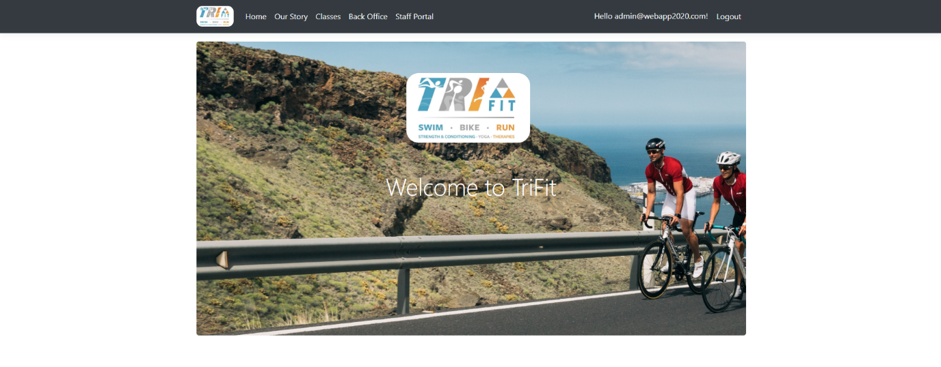
  - Standard Footer


  - Home page
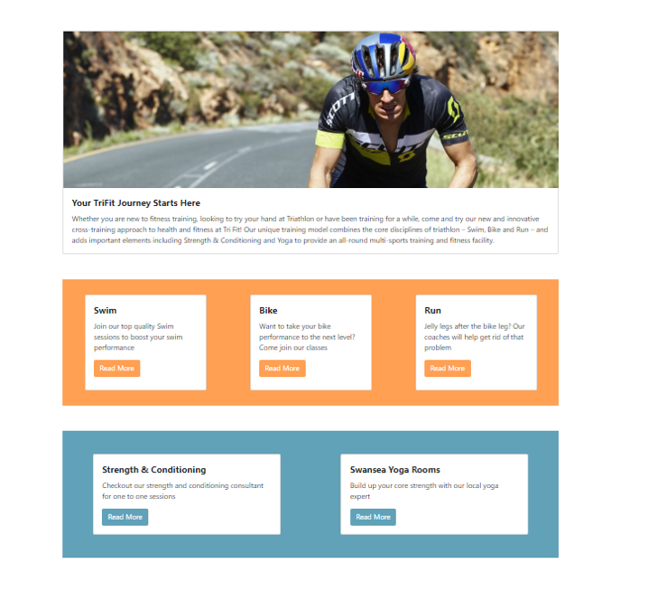

  - Our Story page
  - 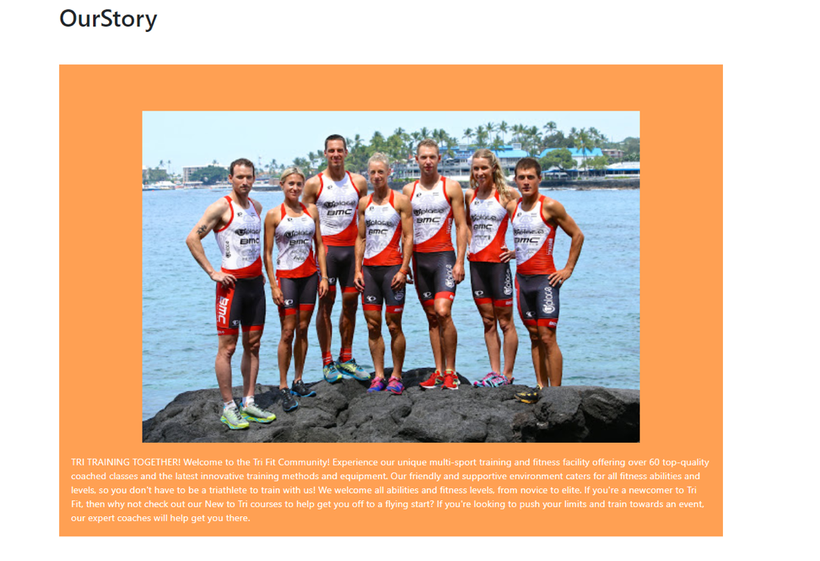
  - Classes
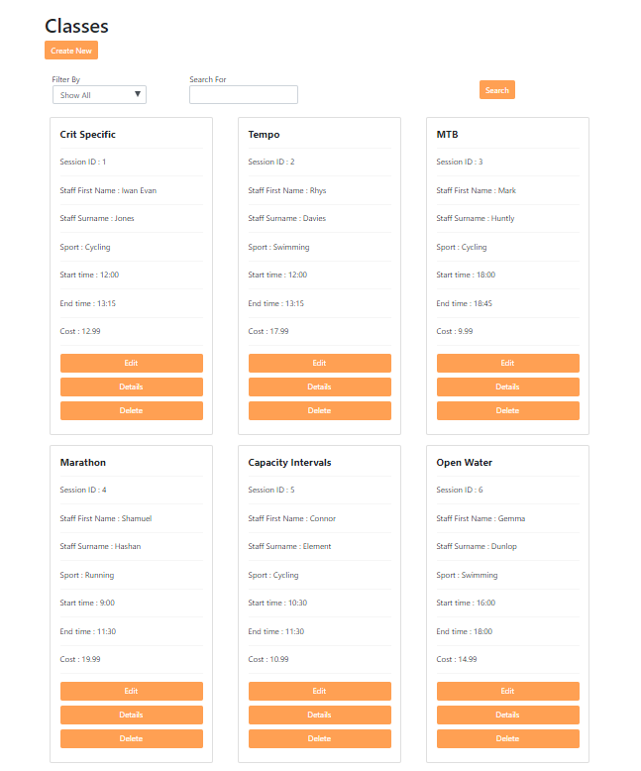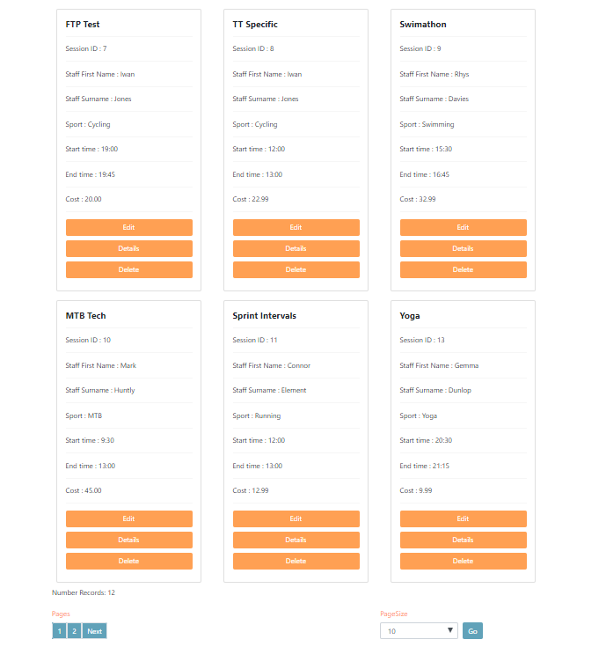

  - CRUD Function Pages
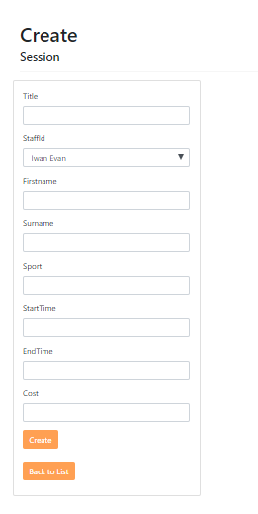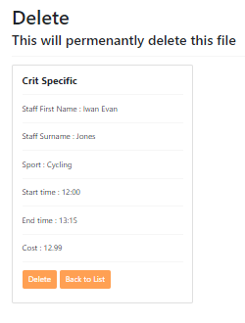
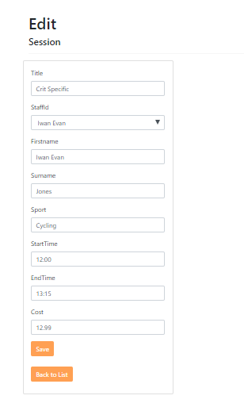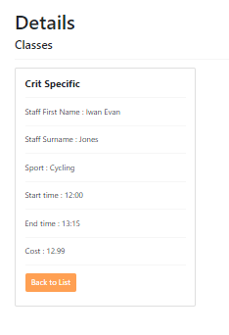

  - Back Office page
  - 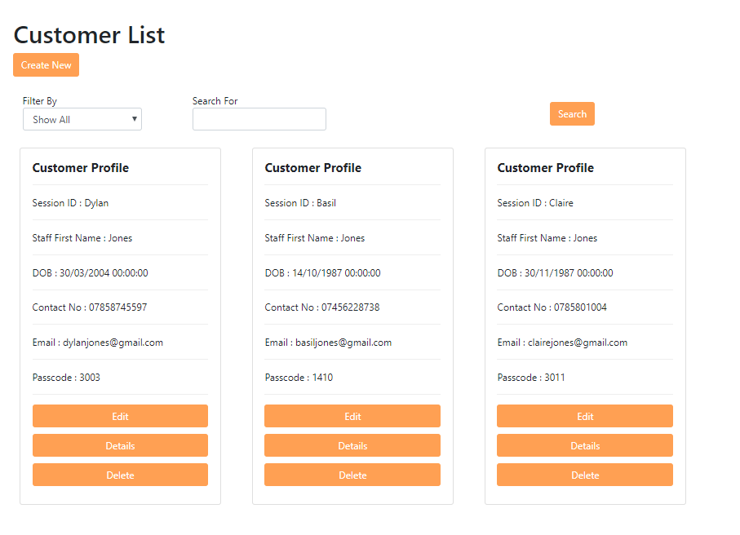

  - Staff Portal
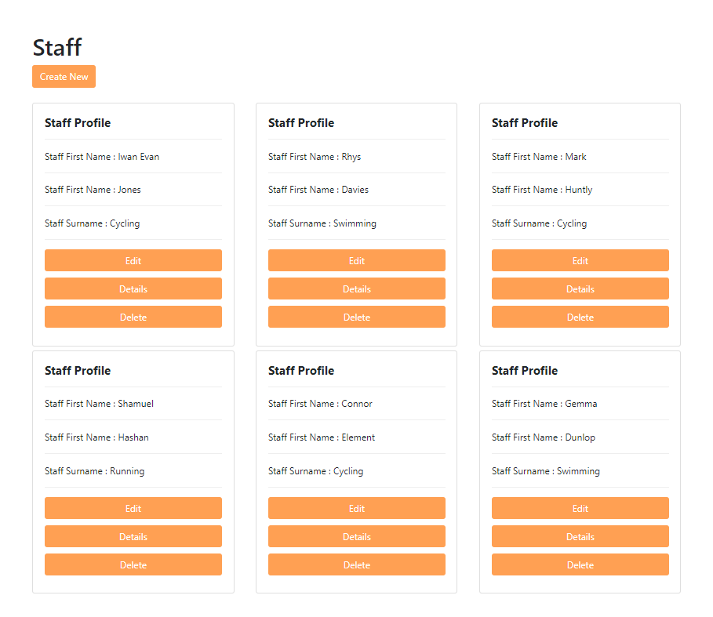

Evaluation
In the following section, tests on the main core functions of the application will be tested against the requirements of the assignment to ensure software verification and validation. The tests will also be used to check that the features that have been implemented do indeed function correctly and to document any features that may fail the test in order to identify what needs to be done on the application to improve it taking into consideration the functionality and the usability of the app.

Testing

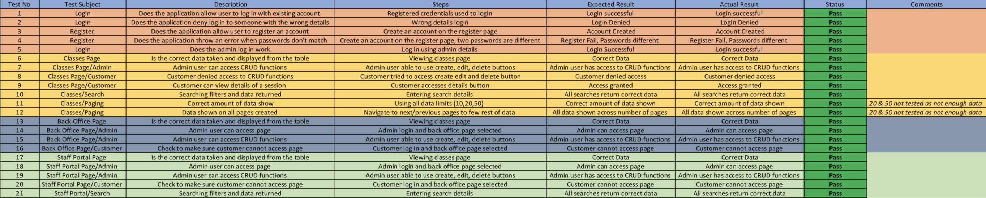

Conclusion
To conclude this report, overall, I am happy with the application that I have designed and developed with the features that have been asked for in the assignment. I feel that I have gained a sound knowledge of creating an application with ASP.NET. Regarding the usability of the application I feel that the application that I have created is fairly straightforward to use and isn’t difficult to navigate around to access all the features that are required by the user. The design off the application follows the three-colour rule, again adding to the usability of the application. The functionality of the application is very easy to use; however, this is the section of the application if I was able to re-create the application in question again I would add a couple of extra features to improve the functionality of it. I would add a booking system to the application to allow user to be able to book themselves into a session online. The second extra feature that I would add would be to have all data that my be stored in the booking table deleted at a set time so that all booking slots for the coming days classes are clear and not booked up by people from the previous days sessions. I would also add an admin navigation page that would be accessed when logged in by the admin user which would allow them to use the CRUD functions on all pages which would then allow all CRUD buttons to be deleted from the pages customers can view. These additions would add to the overall functionality of the application. However, as stated previously I am happy with the work I have produced.

Bibliography

[1] | tutorialspoint, “MVC Framework,” [Online]. Available: https://www.tutorialspoint.com/mvc_framework/mvc_framework_controllers.htm. [Accessed 27 April 2020].

