Micheal Bennett 2027283
BMSW 4006 – MANAGEMENT ENTERPRISE IN THE 21ST CENTURY

Introduction
My proposed business plan is of a driving tuition school called Take the Leap Driving School based predominantly in the area of Swansea but also including Port Talbot and Neath. The business will be run from my home in Swansea. I will be fully qualified as outlined by the UK government to after successfully completing 3 separate exams to hold the title of an A.D.I (Approved Driving Instructor)
The business will be a sole trader meaning that the business will be run solely by myself, Micheal Bennett and its success or failure being my full responsibility along with any financial implications. As a sole trader I will inform HMRC and register as self-employed by filling in an online form, self-assessments will be submitted once I have earnt more than £1,000 from 6th April to 5th April (Gov.uk, 2022)
I will have unlimited liability and will be personally liable for the firm’s debts and may have to pay for losses made by the business (BBC Bitesize,2020).The advantages of being a sole trader are that I will be my own boss, keep any profits made, easy to set the business up with lower costs, however it does come with disadvantages, the risk to being a sole trader is that personal finances are not protected with unlimited liability, may not be tax efficient, no one to share decision making and making it harder to take time off.
Lessons will be offered as frequently as I can accommodate and charged at 30.00GBP per hour. Discount rates will be offered if a student bulk buys hours in which I will offer at varying scales depending on how many hours are purchased. I will also offer gift cards for friends and family members to purchase hours on behalf of a student.
Company Logo
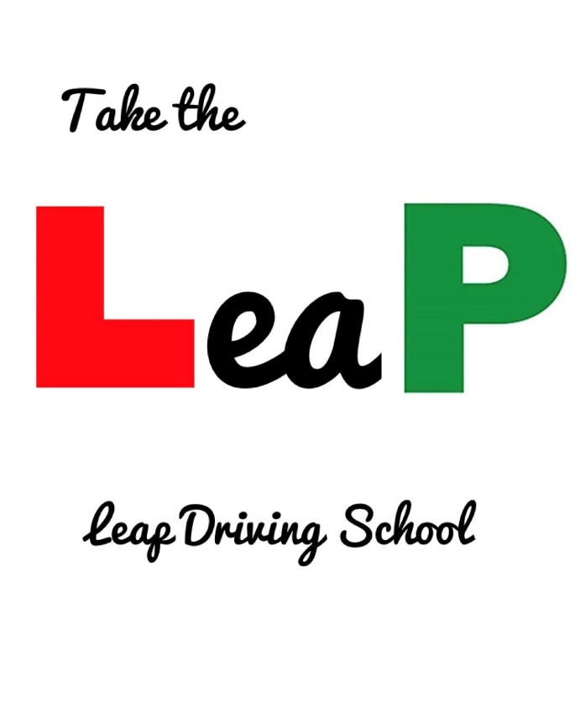
Contents
- Introduction
- Contents
- Mission Statement, Aims and Objectives, Why become a driving instructor?
- SWOT Analysis
- Marketing, How will the business be marketed and promoted and who is the business’ target market?
- Human Resource
- Cashflow and Physical Resources
- Appendices
14. Reference List

Mission Statement
Lee (2021) explains that a mission statement is a broad overview of a company’s aims and objectives and how they will strive to achieve these.
Bart (2002) explains that a mission statement is required to create focus in a business. If everyone associated with the business is aware of the mission statement, understands it and strives to achieve it, everybody is able to contribute positively to it.
Leap Driving School is committed to providing comprehensive driver tuition, excellent customer service individually tailored to each customer in order to give confidence in learning a skill that lasts a lifetime.
Aims and objectives
- Provide a high quality of driving tuition
- Provide a high level of customer service
- Have sustainable profits
- Exceed customers expectations
- Give customers confidence during their learning journey
The business’ unique selling point is providing varying lesson durations to best suit the students needs. Most driving schools offer 2 hour lessons whereas I will offer anywhere between 1-2 hour lessons. A Student’s concentration levels dwindle the longer a lesson goes on which can lead to errors and also leave the student feeling disheartened and potentially stop learning to drive.

Why become a driving instructor?
During my working life, I have always enjoyed the training element of the role of sharing my skill and knowledge. Ive also coached a junior football team and really enjoyed the coaching side of the role. Also, it is coming away from being employed and working for myself.
Due to the Covid pandemic, there is a backlog of students. h Sunday Times Driving reports months of backlogs and the ripple effect that will have on students who turn 17 in 2021 and 2022. There are not enough instuctors for students with waitlists reported by Uplands School of Motoring of 45 students (2022) CITE Uplands.
With this situation, there has never been a better time to start a driving school.

SWOT Analysis – Please see appendix D
Using conversion strategies, focusing on competition as the market is saturated with potential students and not enough instructors to deal with the current backlog, this initially will not pose any major issues to income initially. Sharma (2021) and The RAC (2022) report delays in driving tests of between 6 – 10 months approx. due the Covid pandemic. This will in turn have a knock on effect to students turning 17 in 2022 and even into 2023. By the time the backlog is back under control, I will be able to evolve my business to utilise the opportunities within my SWOT analysis by providing a more robust service which includes providing a new student with information and assistance with every step in their journey, starting with applying for their provisional licence as legally required by the UK government (2022). I will offer a personalised students page within my website which, once a student is registered will offer a checklist facility. This will be a step by step by step guide of what to do to become fully qualified. I will include within this website a mock test section and upload a variety of test questions which can be randomised upon each attempt as well as uploading video clips for the hazard perception section of the theory test. This will be my unique selling point and differentiate myself from my competitors who will mainly focus on the driving side.

Marketing
Effective marketing is the key to success. It is a method to communicate who you are, what your business can provide and gives an opportunity to explain why a customer should choose you over a competitor. Fifield (1998, p. XV) explains that marketing also helps organise the company. A company’s advertising dictates to a degree how it operates. The products and/or services it operates is outlined in it’s marketing. Offering services outside of what is marketed can be detrimental to your business and vice versa, offering services/products within your marketing that you cannot achieve, affects your reputation.
Adopting Borden (1965) 4 Ps of the marketing mix to help promote my school, Will help focus my marketing.
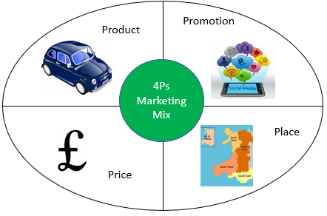

Product – Providing Driving tuition and associated services to encompass the learning journey from start to finish.
Price – Ensuring I am competitively price in comparison to competing driving schools
Place – Ensure I am able to provide lessons within a wide enough radius to attract more customers but also not over extend myself by providing lessons in an area that is not economical to travel to and also not familiar with as it could compromise the service.
Promotion – What types of advertising will I take advantage of to promote myself and my driving school.
How will the business be marketed and promoted and who is the business’ target market?
Market segmentation is combining potential purchasers into groups or segments with comparable demands and responses to a marketing action. (Tarver, 2021) The target market will be essentially anyone aged 17 and above without a full driving licence but to refine this, students aged 17 and over.
As with most large towns and cities, Swansea has a number of colleges and universities. Therefore sourcing students is not solely reliant on residents within my operating radius. I will target students with flyers offering student discount and referral discounts. Referral discounts will assist with word of mouth promotion. Hayes (2022) explains that word of mouth advertising is a method of advertising when experiences are shared during everyday conversations. The conversation will include emotional and influential characteristics. Tedx Talks (2016) highlight a beneficial trait of word of mouth advertising. Social Media can be viewed as intrusive to the point of annoyance which leads to potentially ignoring any adverts or promotion of a company’s website and/or service. With word of mouth, it bares a lot of relevance when it is discussed. Reliability to this advertising is emphasised depending on the relationship between the 2 or more participants in the conversation. To try and emphasise this reliability, I will include testimonials from existing and previous students on my website to add credence to my driving school.
The business will be promoted with the mission statement at the forefront of the business’ marketing and promotion. I want to promote reliability and reassurance in my advertising encouraging people to get in touch or arrange a call back via my advertising mediums. Creating a free business page on Facebook will attract local customers. Swansea Online Facebook group (2022) have over 98,000 people following their official page and therefore active users on Facebook, not including Neath and Port Talbot. I will create pages on various social media and free sites that allow promotion of services – LinkedIn, Instagram, and Gumtree.
- Marketing my service, The client will receive a personalised, high-quality service delivered in a professional manner. The challenge facing the business is to ensure the customer receives a higher quality service than what competitors offer.
- Promotion of my business will include reductions in costs for students and initial lesson. I will also include a promotion for word of mouth referrals, subject to certain conditions.
- Prices will be competitive with an hourly fee, bulk purchase or hours fee and intensive course prices.
- Place of business will be internet based at my home address with my tuition car being mobile.
I conducted market research for my business. The market research was not overly beneficial as the majority of respondents already had driving licences. One question that was beneficial was price for tuition and I have factored this in to my pricing. Questionnaire results – See appendix E

Human Resource
Due to the nature of the company, it will be operated as a sole trader. The UK Government (2022) deem a Sole Trader as someone earning over £1,000 between the 2021 – 2022 Tax year. I will be solely responsible for the business’ loses. I will also be entirely responsible for the running of the company there no human resource is required initially.
I will be required to register the business and business name and will be required to complete annual self-assessments (gov.uk, 2022)
Looking to the future of the business, once the business is sustaining, I can look to expand the business by incorporating franchisees. Hayes (2021) explains that a franchise is allowing a person or business in which the owner licences his or her operations, as well as its products, branding, and knowledge, in exchange for a monetary fee. This will allow driving instructors to operate under the company name but on a self-employed basis. FranchiseBusiness.com.au (2016) explain the main benefit of being a franchisee is the support you will be provided in areas as a driving instructor a franchisee is not as strong in. Furthermore, you will be operating under a established company who has experience in the industry whilst still being in control to a degree in regards to how you operate and being self-employed.
With enrolling a number of franchisees, it would mean, I would not be responsible for the Human Resource side as franchisees will have responsibility in this respect. An issue that will arise will be the organisation of the franchisees and their students. I would potentially look to recruit a secretary on a part time basis. Data Barring service (Gov.uk, 2022) check will need to be undertaken to ensure any appointment is safe and secure. A contract of employment is required so both the employer and employee are aware of what is required of both parties, this will include information such as rate of pay, hours of work, salary, holiday entitlement and a job description. Employees must have full training on fire evacuation and legal requirements for Fire Safety along with all Health and Safety guidance. Wage for a secretary will be £20,070 pro rata for part time (Payscale, 2022) based on similar roles and the experience required in the local area. Should this wage equate to earnings over £10,000 a year and the person I employ is 22 years of age and below state pension age, it is a legal requirement to provide a workplace pension (Gov.uk, 2022).
Recruiting an already established driving instructors may prove difficult as they are already operating and are happy to be independent or are operating under a competitor. Undercutting competitors is an option but one I would not be happy to engage in to entice driving instructors to become a franchisee. Recruiting an Ordit trainer may become an option. Ordit trainers are recognised by Gov.uk as a trainer of driving instructors (2022). Their role would be to recruit drivers and train them to become an approved driving instructor. The training would be free under the premise that they become franchisees for a set time period. This will open up another income stream for the business as it evolves.

Cashflow and Physical resources
The physical resources required to initially launch my driving school will be:
- A learning car - £10,995
- Dashcam and installation - £140
- Dual Control pedals and installation - £400
- Instructor’s mirror - £7.99
- Blind spot mirrors – £4.99
- Stationary and driver’s demonstrator - £60.00
- Car Tax - £155.00
The source of finance will come from my redundancy severance package from my previous employment in which most costs will be paid up front therefore minimising payments during the initial year and earnings from driving tuition recouping this initial outlay.
Other cost considerations
- National insurance and tax - £2,800.00 based on £400.00 weekly profit for the 21/22 tax year (HM Revenue & Customs, 2022)
- Driving instructor training - £1,000.00
- Fuel – Estimated annual cost £3,640.00 p.a based on £70 per week.
- Specialist Driving instructor insurance - £755.00 p.a
There are other cost considerations which cannot be factored as it is impossible to see into the future. Fuel costs may rise, mechanical failure of the vehicle and inflation pay a part. I will be required to set aside earnings to cover ongoing costs therefor I will dedicate a budget to cover tax and national insurance as well as cost to repair any mechanical failures.
I will charge students £29 per hour for tuition and offer discount for increasing amount of hours purchased to incentivise to bulk purchase lessons.
Hours purchased | Cost
1 hour | £29
1.5 hours | £41
2 hours | £52
15 hours | £375
30 hours | £700
45 hours | £1,000

According to Payle (2018), DVSA advise that an average amount of hours to be at test standard is 45 hours but this can fluctuate depending on proficiency of each student. I will project that I will provide 4 lessons a day at 1.5 hours each lesson between the hours of 08:00 till 17:00 for 5 days per calendar week.

Cashflow – See Appendix A, B & C
Appendices
Appendix A
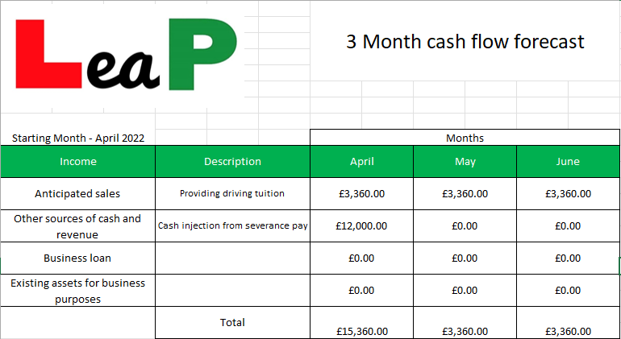

Appenix B
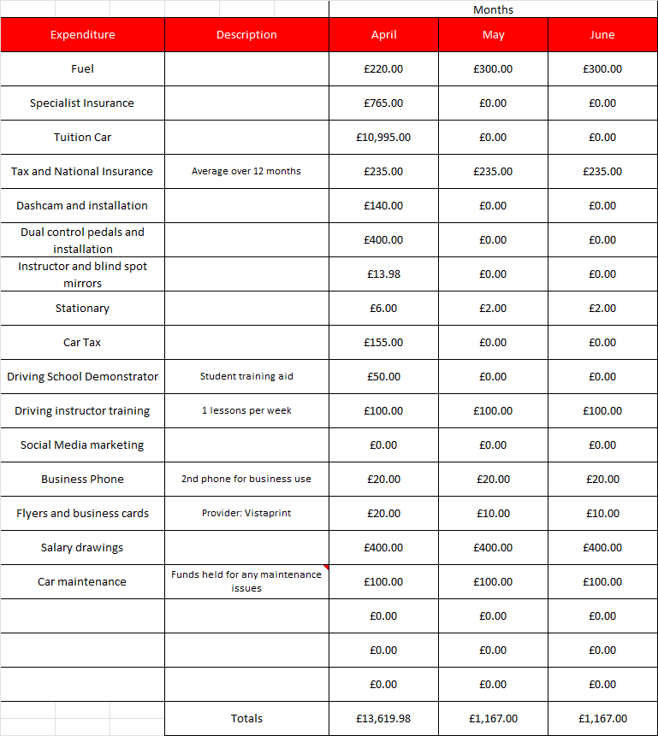

Appendix C
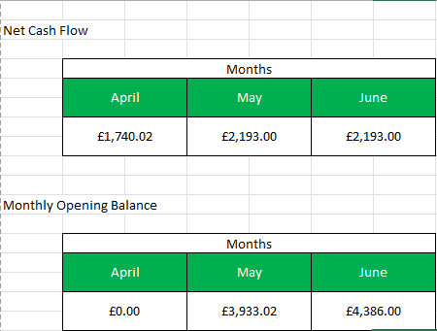

Appendix D

Strengths  Backlog of students due to Covid Lockdown  Driving Experience  Coaching/Teaching Experience  Costs minimised | Weaknesses  Lack of experience  Cost  Threat to income
Opportunities  Lack of instructors  Train to earn higher qualifications  Expand to recruit franchisees  Create an app for Theory revision | Threats  Recession  Competition  Mechanical issues

Appendix E
Timestamp | What is your age category? | Have you attempted driving tuition with other companies? | Do you hold a full driving licence? | If you do not hold a driving licence, what is the main reason for this? | What hourly rate would you expect to pay for driving lessons? | What communication methods would you prefer when interacting with a business? | Would you prefer...? | What information would you like to know when learning to drive? | What time would you prefer to undertake driving lessons? | How long is you preferred driving lesson duration? | Please describe the key attributes you would expect from a driving instructor?
21/02/2022 09:24 | 26-30 | No | I have not had any driving classes in the UK |  | £20 - £35 | Email | Discount on hourly rates for bulk booking lessons?, Discount on hourly rates for referring a family member or friend? | What to expect on your driving test | 08:00 - 12:00 | 2 hours | Calm, Encouraging, Experienced
01/03/2022 10:19 | 31+ | No | None |  | 15 | Face to face | Discount on hourly rates for bulk booking lessons? | Highway Code | 12:00 - 16:00 | 90 minutes | Good listener , patient, understanding
01/03/2022 10:41 | 31+ | Yes | Yes |  | 20£/h | Email | Discount on hourly rates for referring a family member or friend? | Highway Code | 08:00 - 12:00 | 1 hour | Punctuality, to be honest
01/03/2022 10:46 | 31+ | Yes | Yes |  | £25 | Email, Whatsapp | Discount on hourly rates for bulk booking lessons? | Highway Code, How to book your driving test, What to expect on your driving test, How to book your theory test, Theory Test revision | 12:00 - 16:00 | 90 minutes | Honest and friendly feedback
01/03/2022 13:26 | 31+ | Yes | Yes |  | 100 | Email | Discount on hourly rates for bulk booking lessons? | How to apply for your provisional driving licence | 08:00 - 12:00 | 1 hour | Kind person
01/03/2022 13:26 | 26-30 | Yes | Yes |  | £35 an hour | Facebook, Instagram, Facebook Messenger, Email, Whatsapp, Telephone | Discount on hourly rates for bulk booking lessons? | Highway Code, What to expect on your driving test, Theory Test revision, Individual lesson recap material | 16:00 - 20:00 | 1 hour | firm but friendly
02/03/2022 15:03 | 26-30 | No | Yes |  | £10 | Email | Discount on hourly rates for bulk booking lessons? | What to expect on your driving test | 08:00 - 12:00 | 1 hour | Punctual

Reference List
BART, C.K., 2002. Creating effective mission statements: Recapturing the power and glory of mission is possible with careful planning and implementation. Health Progress, 83(5), pp. 41-4, 55.
Fifield, P. (1998) Marketing Strategy. London: Routledge 2nd Edition
Gov.uk (2022) Become a driving instructor (ORDIT) trainer. Available at: https://www.gov.uk/guidance/become-a-driving-instructor-ordit-trainer (Accessed: 15 March 2022)
Gov.uk (2022) Independent review of the disclosure and barring regime. Available at: https://www.gov.uk/government/news/independent-review-of-the-disclosure-and-barring-regime (Accessed: 8 March 2022)
Gov.uk (2022) The Highway Code. Available at: https://www.gov.uk/guidance/the-highway-code/annex-3-motor-vehicle-documentation-and-learner-driver-requirements (Accessed: 8 March 2022)
Gov.uk (2022) Workplace Pensions. Available at: https://www.gov.uk/workplace-pensions/joining-a-workplace-pension (Accessed: 9 March 2022)
Hayes, A (2021) Franchise. Available at https://www.investopedia.com/terms/f/franchise.asp (Accessed: 07 March 2022)
Hayes, A (2021) Market Segmentation. Available at: https://www.investopedia.com/terms/m/marketsegmentation.asp (Accessed: 07 March 2022)
HM Revenue & Customs (No date) Budget for your Self Assessment tax bill if you're self-employed. Available at: https://www.gov.uk/self-assessment-ready-reckoner (Accessed: 16 February 2022)
https://www.facebook.com/SwanseaOnline1/
https://www.youtube.com/watch?v=fjY9ByzNtS4
https://www.youtube.com/watch?v=Z_EERL2hSrg
Lee, E (2021) What is a mission statement? Available at: //cpdonline.co.uk/knowledge-base/business/what-is-a-mission-statement/ (Accessed: 15 March 2022)
Payscale (2022) Available at: https://www.payscale.com/mypayscale.aspx?surveyId=534702c0-2f24-44f1-bf96-f40bd17e4fda&tab=business (Accessed: 8 March 2022)
Playle, T (2018) How may driving lessons will it take to pass my driving test?. Available at: https://www.insurelearnerdriver.co.uk/how-many-driving-lessons-does-it-take-to-pass-my-driving-test/ (Accessed: 8 March 2022)
RAC (2022) Driving Test Backlog leaves learners facing 10-month wait. Available at: https://www.rac.co.uk/drive/news/infrastructure/driving-test-backlog-leaves-learners-facing-10-month-wait/ (Accessed: 7 March 2022)
Sharma, R (2021) Driving Test Backlogs leaves learners waiting up to 24 weeks for a slot in some areas of the UK. Available at: https://inews.co.uk/news/driving-test-book-backlog-learners-waiting-24-weeks-slot-areas-uk-1256542 (Accessed: 7 March 2022)

