Changemakers: Building Your Personal Brand for Sustainable Employment Assignment 2 Written Document
Module Code: BMHP5015_BIRM
Student: Sadeka Khatun Lecturer: Chloe Harries

Table of Contents
Introduction 2
Unit 1: Topic 1 – Ambition is Critical 3
Unit 2: Topic 2 – Variety is the Spice of Life 4
My Network Map 5
Unit 3: Topic 2 - Identifying Career Opportunities 6
Unit 4: Topic 2 – Passion and Perseverance 7
Personal Development Plan 8
Conclusion 10
References 11

Introduction
What a challenging journey it has been for me so far, thankfully another term nearly coming to an end, I am excited to break up and have a short break before I return in January 2022. I am looking forward to working through my last term in the new year, hopefully bringing my level 5 academic year in Health and Social Care to an end. I have enjoyed learning and working through another term of e- learning and have experienced some great learning from using different tools which was made available to me.
This written document contains learning outcomes and evidence from all the four different Units which I managed to complete to the best of my ability, also this document will contain a ‘Personal Development Plan’ (PDP) a template which was obtained from High-Speed website and according to them a PDP is something that allows you to be able to make clearer decisions and plan for future goals efficiently and effectively (High Speed Training, 2021).

Unit 1: Topic 1 – Ambition is Critical
In this Unit I was introduced to the various aspects of how to achieve the best out of gaining experience and skills for my future aspirations. Topic 1 within this unit was enjoyable to work through as it resonates with me more. I have recently been ambitious with my own approach in life, I am currently now working towards a career change and in a field that I love and that interest me, I have a passion about working in the Health and Social Care sector and desire to want to achieve the best possible outcomes. According to Kapoor, (2015) with ambition comes drive, and what drives someone to achieve more is repeated failure rather than success (Kapoor, 2015). According to Roy, (2008) It is about using your energy, feelings, needs, and positive or negative factors in life to reach your goals. (Roy, 2008)
According to The Knowledge Society, (2019) On YouTube, I watched a video that showed ambition means different things to different people. It is what makes us different and unique individuals at the end of the day. The way we perceive, and process information is different. Some just want to wake up and enjoy life. Some are persistent they keep on going to achieve their path to success regardless of countless failures. For other’s ambition creates curiosity to achieve a purpose in life, The key is to be genuine to yourself whatever you do (TKS, 2019).
The key learning outcome I will be taking away is that now I have a much better understanding of the benefits of self-management. How being self-aware plays a part in developing my own skills and abilities to increase chances of success. According to Duneier, (2019) he presented a talk on TEDx Talks, which really has taught me a new approach to any task going forward, even if I devote ten minutes at a time to what needs my attention, it will be better than doing nothing at all. Everything I do will be beneficial to me in the long run. A change in mindset and approach will give me the best chance to succeed in the future. (TEDx Talks, 2019).

Unit 2: Topic 2 – Variety is the Spice of Life
In this Unit working through all the topics have been interesting, however in particular Topic 2 has indeed shown me the importance of having variety and diversity in my network. According to McColgan, (2013) he presented in his TEDx Talks video that we should be mixing our networks up, this means have a variety and a diversity of links and connections. He further concludes that we always tend to as humans connect with people, we have things in common with, meaning too many similarities (TEDx Talks, 2013). I have since identified that opportunities need to be created by meeting people who I might not normally interact with due to our differences, I further developed a deeper understanding around how everything is connected to everything (Finno Lux, 2019). On the website it further states that humans play a key role to society, one most critical is that of survival and evolution of everything else around them.
According to Harvard Business Review, (2021) Networks can lead to new ways of thinking by connecting you to people whose viewpoints, insights, resources, and lived experiences are different from your own (Harvard Business Review, 2021).
I was able to reflect on my own network map. Mapping networks and how to identify stronger contacts to those that are weaker. Working through this unit also highlighted to me that I need to step out of my comfort zone. Please refer to the next page and see example network map on the next page for an insight of how my connection interact.
The key learning points I have taken away from this is understanding networks and how they function, how they interlink with one another, being able to recognize the positive links and potential collaboration is key. To Consider variety and diversity within my networks can improve my network. After reading an article by Carson Kohler, (2021) on Top Resume website I was able to also access a quiz and find out if I was an introvert or an extrovert (Kohler, 2021). According to the quiz, I have an ambivert personality type and fall just beneath the introvert/extrovert line

My Network Map

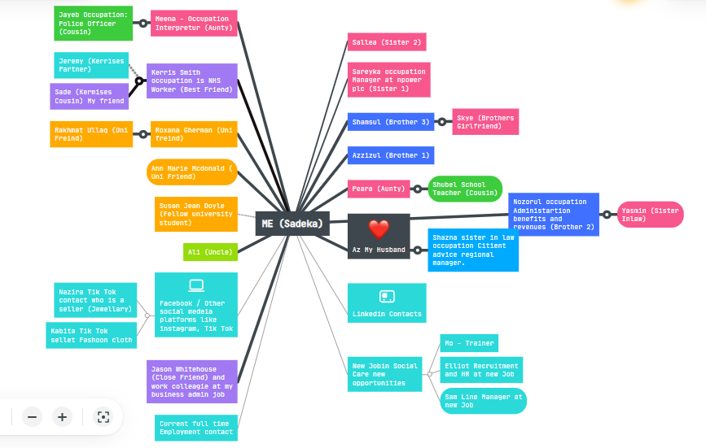
(Mindmeister.com 2021)
Black Lines = Stronger connections
Grey Lines = Weaker connections

Unit 3: Topic 2 - Identifying Career Opportunities
From all the topics in this unit, I would say I was most engaged with Topic 2 and the learning that was involved, mainly because it resonated with my current professional life, as I am currently seeking suitable job roles, and further wanting to communicate with potential employers, and was considering where to begin. This provided me with important insights into how I can prepare and move forward.
According to Dalton, (2020) According to the author of 'The 2-hour Job Search', the way we search for jobs has changed considerably from what it used to be a few decades ago, and how we search plays a major role in the new way we live in this new era; we must embrace the new changes by adapting to them (Dalton, 2020, pp. 2-3). Changing our approaches using planning strategies is a factor to consider for instance, technology today is a major factor in the way we search for ideal roles, everything is pretty much done online, which makes the process quite efficient, yet less effective for the inundation of online applications (Dalton. 2020, p.3). Reading into a Journal review by Auxier, (2013) stated that he agrees with Pink, (2012) “Healthcare and educational services are one of the fastest growing industries around the globe” (Auxier, 2012, p.109).
The key learning points I have taken away from this is that I need to be willing to initiate those first communications and ensure that I make conversations with employers regarding possible roles in the future. Also, as part of this Unit I was directed to watch a film via ClickView, (2021) ‘The Devil Wears Prada’ (2018) highlighted to me after watching the film, "If you can realize that you have the right to decide what you do in life, then you can achieve anything in life." (The Devil Wears Prada, 2018).
I have a LinkedIn account which I will update and start connecting with various types of professionals. According to LinkedIn, (2020) their platform is the largest online professional network in the world. LinkedIn may help individuals in the similar situations to me find the best job or internship, connect with others to strengthen your professional network, and develop the skills you need to succeed (LinkedIn, 2020).

Unit 4: Topic 2 – Passion and Perseverance
The topic of Topic 2 in this unit was my favourite, because I can relate to it in terms of Passion and Perseverance. When the topic arose, I had to reflect. For me to be happy, I cannot just earn a good salary. I want to be able to enjoy my successes in life. It has been my commitment to make a career change, and no matter what obstacles get in my way I will remain committed to the cause. So, reflecting on this I started to think about the support pillars I have around me. I am one of the lucky individuals who do have loved ones around me to support and give me a boost of energy to keep ongoing.
According to Duckworth, (2013) presented an eye-opening TEDx lecture talk she explained how the key to success was identified down to one characteristic, which was grit which meaning having power of passion and perseverance (Duckworth, 2013). It is about sticking to your plan’s day in day out however long it takes until you make your dreams a reality. According to a quiz by Angela Duckworth, (2021) my results show as per screen capture provided below.
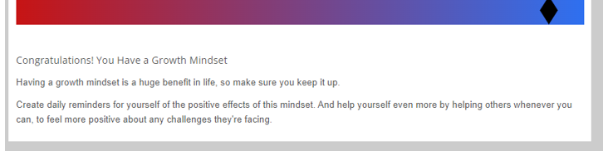
(AngelaDuckworth.com, 2021)
Some of the key learning points I have taken away from this Unit would be that to learn the power of self-belief rather than limiting beliefs, after watching a video ‘Learning from Failure’ (2018). I have recognised that realising my full potential will contribute to a healthy mindset for me to successfully achieve what I want to in life. Dealing with failure will require some positive psychological approaches, undoubtedly failure can bring anyone down, however having an approach where you make a positive out of a negative you can go and try again. Stay open to self-improvement (GCFLearFree.Org, 2018).
Sagacity was another learning outcome for me. It was a word I had never heard before, and to find out what it means was interesting. It symbolizes the sense of wisdom you acquire after going through adversity. I do believe Intelligence can provide long-term understanding of prospects, not just in the short term.

Personal Development Plan

 | What are my big  goals? | Which goals need to  happen first? | When do I want,  to achieve this? | What obstacles  might get in the  way? | How can I improve  my chances of  meeting my goal? | Where can I go  for support? | Review:  How  I am doing?
1st Priority | Achieve my Bachelor of Science in Health and Social Care Level 5 qualification successfully. | This is my 1st priority, as I am already currently at the end of my 2nd term, and in Jan 2022 I will be working to finish my last term. | I aim to successfully complete my level 5 certificate by April 2022. So that I can go on to enrol onto level 6 in May 2022. | A failure or poor mark will delay the achievement of my goal. As an example, if I am unable to resist a particular module, this may lead to performance and productivity issues due to workload. It will also affect my confidence and stress levels. | Seeking the relevant support, and feedback from my lecturers.  Always proof reading and double checking my work for grammar and spelling mistakes before submitting will help me improve my work. Always aim to work at gaining the highest marks possible. | The university is my point of contact with regards to any support this will help me achieve the best possible outcome. I am aware that there is student services and many individuals whom I can request for support. | The progress I have made will need to be reviewed on a regular basis every 6 months, but for this 1st priority, I would like to revisit once my results are due in April/May 2022 so that I may check and evaluate my position once I receive my results from the previous academic year.
2nd Priority | Achieve my Bachelor of Science in Health and Social Care Level 6 qualification successfully. Work on gaining various works experience through work placements. | This is my 2nd priority and based on my results on previous academic year 2021 I hoping to get through all my 3 terms successfully in level 6 | By the end of 2022 academic year which takes me into 2023. I will look at re-evaluating my position based on my results. I can then move on and start to plan for suitable postgraduate course. | Obstacles I may be faced with is the challenges of managing education and work life, however, based on previous arrangements this can be planned again. | Remain focused to my end goal, set my expectations reasonably, bearing in mind setbacks are predictable. Will seek the appropriate feedback for draft work where possible. | I am confident that I will have the support I need made available to me by my university like I have previously received, there will be Lecturer’s and student services I can approach to get the guidance and support as and when I need. | The progress on my 2nd priority will need to be re-evaluated in May 2023. When I receive my results, I will be better able to determine the next steps I need to take to accomplish my next priority.  .
3rd Priority | Will apply for a postgraduate course in Counselling and gain various work experience throughout my studies. | In addition to my studies, I intend to work full-time during those years. However, my goal is to be employed in my dream position by 2023 and have the ability to advance from there. | I desire by 2024 I should be on a postgraduate course, as  work is essential to me. I work now so regardless of studies progression is what I would aim to do start of 2023 | Obstacles I will encounter is the changes when applying for different job roles, I need to be flexible and resilient in my ways so that I can achieve the experience that I most need to progress | Guidance and career support will help me make informed career decisions in the future. By seeking support and feedback from my lecturers I can stay on track. | I can check and manage my progress by referring to my Personal Development Plan. | I will regularly check my progress and time frames I have set myself by frequent updates being made to my development plan.

Conclusion
Everyone does have some sort of ambition within them it means various things to different people. Learning how the benefits of self-management and how self-awareness can enhance your skills and abilities to increase your chances of success is a skill. Although networking seems like it's for extroverts only, that isn't the case, anyone can take advantage of the opportunities available to them. (Kohler, 2021).
Adapting and adjusting to new changes can open opportunities. The right to choose means that change is sometimes a good thing but not always suited for everyone. (The Devil Wears Prada, 2018).
Keeping an open mind about your approach will help diversify your network, opening lots of opportunities in the future (McColgan, 2013).
If you fail, that's okay. Make the negative experience a positive one by reflecting on how you can improve. The negative emotions will eventually disappear, allowing time for you to improve yourself and remain focused on your goal.

References

- Auxier, W.R. (2013) To Sell is Human: The Surprising Truth About Moving Others [review], Pink, Daniel H. Journal of Applied Christian Leadership, 7(2), pp.108-110.

- Angela Duckworth, (2021) Angela Duckworth. Available at: https://angeladuckworth.com/grit-scale/ (Accessed 9 December 2021).

- Dalton, S. (2020) The 2-hour job search: Using technology to get the right job faster. 2nd edn. United States: Ten Speed Press Book.

- Harvard Business Review, (2021) How to Diversify Your Professional Network. Available at: https://hbr.org/2018/08/how-to-diversify-your-professional-network (Accessed 9 December 2021).

- Hight Speed Training, (2021) A Personal Development Plan (PDP) Guide & Template, Available at: https://www.highspeedtraining.co.uk/hub/personal-development-plan-template/ (Accessed: 3 December 2021).

- Kapoor, I. (2015) ‘What “Drives” capitalist development?’, Human Geography, 8(3). pp.66-78.

- Linno Lux, (2019) Everything is Connected to Everything Else. Available at: https://finnolux.com/everything-is-connected-to-everything-else/ (Accessed 9 December 2021).
- Mindmeister.com, (2021) Mind Map. Available at: https://www.mindmeister.com/map/2060754197 (Accessed 9 December 2021).

- Roy, S. (2008) ‘The psychology of ambition’, Ezine Articles. Available at: https://ezinearticles.com/?The-Psychology-of-Ambition&id=1393654 (Accessed 5 December 2021).

- TEDx Talks, (2013) Networking is not working: Doug McColgin at TEDx Indianapolis. [Video], Available at: https://www.youtube.com/watch?v=reCX9LDQVKw (Accessed 8 December 2021).

- TEDX Talks, (2019) How to Achieve Your Most Ambitious Goals. [Video], Available at: https://www.youtube.com/watch?v=TQMbvJNRpLE&t=107s (Accessed 6 December).

- The Knowledge Society, (2019) What Does Ambition Mean to You? [Video], Available at: https://www.youtube.com/watch?v=zSW6HRkS-NA (Accessed 5 December 2021).

- ‘The Devil Wears Prada’ (2006) ClickView, Broadcast Channel: Channel 4, 19th August 2018. Available at: https://online.clickview.co.uk/share?sharecode=9470d0b (Accessed 8 December 2021)

- Kohler, C. (2021) What Type of Networking Fits Your Personality Best? (Quiz). Available at: https://www.topresume.com/career-advice/career-quiz-networking-type-personality (Accessed 9 December 2021).

- Duckworth, L.A. (2013) Grit: the power of passion and perseverance | Angela Lee Duckworth. [video], Available at: https://www.youtube.com/watch?v=H14bBuluwB8 (Accessed 9 December 2021).

- GCFLearFree.Org, (2018) Learning from Failure. [video], Available at: https://www.youtube.com/watch?v=MQx39z99_Js (Accessed 9 December 2021).

