
UNIVERSITY OF WALES TRINITY SAINT DAVID
School of Business
London Campus
DIGITAL SKILLS AND RESEARCH METHODS
BMSW4003_LON
Mr. Balendran Kandasamy

IMPACT AND USE OF VIRTUAL LEARNING ENVIRONMENT (MOODLE)
SAMANTHA ESTEFANIA MONCAYO CASANOVA
1907363

EXECUTIVE SUMMARY
The following report is about the use and impact of MOODLE in students of our university and all around the world. Moodle is a platform that helps students in their studies and complement all the topics seen in class. The objective of this writing is to identify how useful is this platform and compare the differences of the students that use it. To achieve results, I applied a survey for the students and I made research of similar reports in other universities. What I obtain is that people usually use mobile phone to access MOODLE and the majority said that is an effective and useful platform for complement their studies in this time of concerns. The use of this platform means that the students of our university do not have problems in the learning of each module and may be able to educate themselves despite the current situation in the world.

INTRODUCTION
The following report is about the impact of virtual learning environment (MOODLE) in the students of University of Wales Trinity Saint David London Campus and how useful is this platform in the university life. It also describes how students of the group nine, second term makes use of Moodle and if in this time of pandemic, this is useful is in their continuous learning.
Moodle is an education platform considered to offer professors, administrators and students with an only strong, safe and unified scheme to generate adapted education atmospheres.
(Moodle, n.d.)

OBJECTIVES
This report has the next objectives:
- Identify how useful is Moodle for the students in University of Wales Trinity Saint David London campus.
- Comparing the differences in the use of Moodle between students in London Campus.

LITERATURE REVIEW
In this part of the report, I will talk about the use of MOODLE platform in a University in Portugal. This investigation was written by Carolina Costa, Helena Alvelos and Leonor Teixeira for the University of Aveiro.
They start an investigation to examine functionalities and tools of the MOODLE platform and their use by the students. For do this, the applied a survey to 278 students of the university and the obtain the next results.
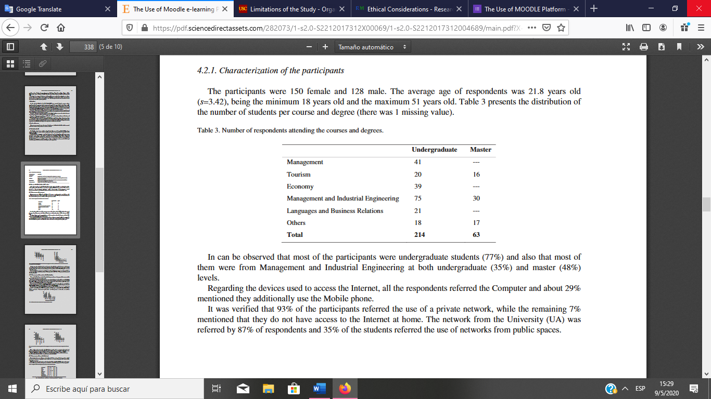
Table 1: Number of respondents attending the courses and degrees
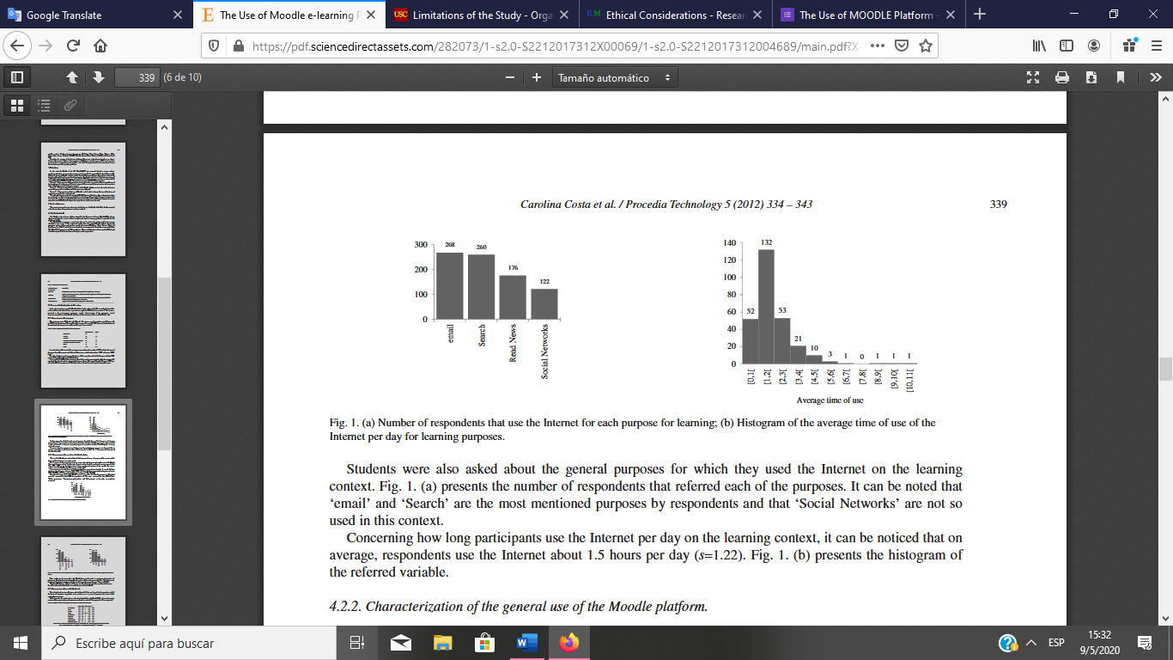
Table 2: Number of respondents that use the Internet for each purpose for learning
Table 3: Histogram of the average time of use of the Internet per day for learning purposes.
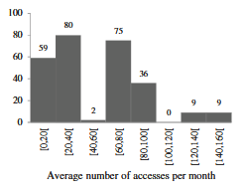
Table 4: Histogram of the average number of accesses per month to the Moodle.
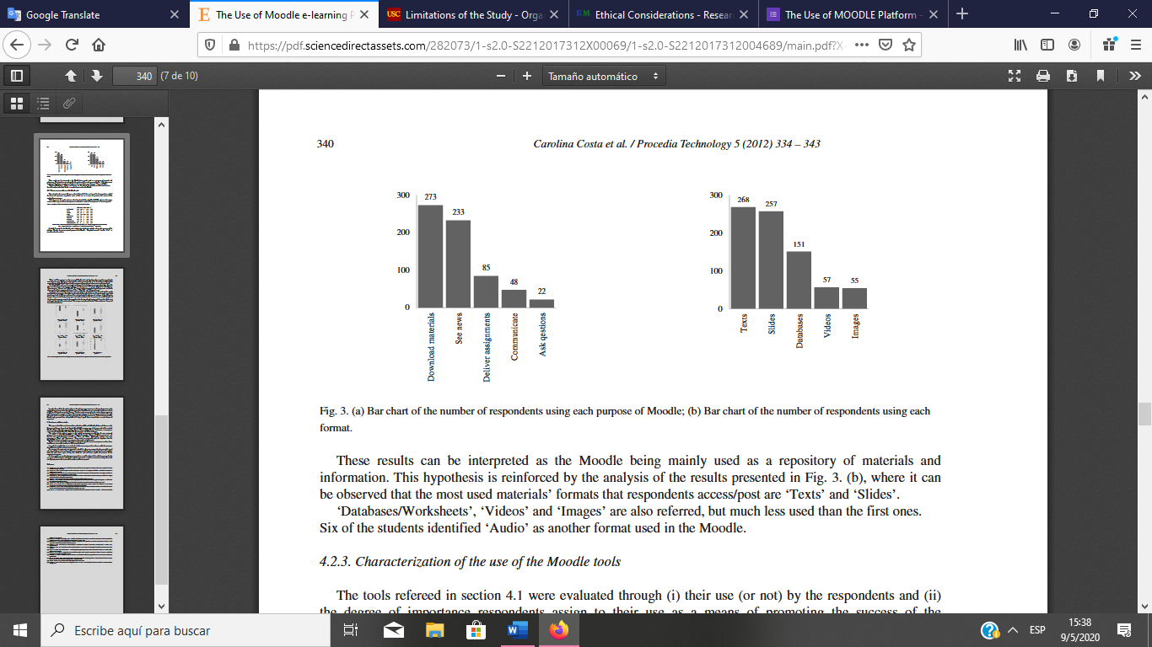
Table 5: Bar chart of the number of respondents using each purpose of Moodle.
Table 6: Bar chart of the number of respondents using each format.
When I finished the reading of this investigation, I was able to see that they use a good methodology to complete this report. They applied a survey to a lot of student that honestly gives answers to the important question and this permit the writers to reach the conclusions of the use of MOODLE. Also, I like the way the summarise the answers the charts. This are simple but concise and precise and with a simple view of them, we can see that the results are accurate.

PRIMARY RESEARCH

METHODOLOGY
For the writing of the following report, I apply a survey to my classmates in university to find out the information I need.
A Survey is an instrument that is used often to collect research statistics. Surveys accumulate statistics straight from themes, and are managed in a written format (email, post, Internet) or vocally (face-to-face, video-link, telephone). They regularly use general interrogations (items), which offer self-reported data. This fact may be intermission information (e.g. Oldness, height), ordinal or nominal definite information using pre-hooked up recognised groups (e.g. Yes/No, or None/Some/Many, or us of a of birth), or free text wherein respondents write about reviews in their personal words.
(Grimmer & Bialocerkowski, 2005)
For the survey, I ask the next questions:
- Gender.
- Range of Age.
- In what type of device do you usually use MOODLE?
- How often do you open MOODLE?
- How much time do you spend in MOODLE?
- In a 1 to 5 scale, how useful is Moodle for you?
- What is the main reason why you make use of MOODLE?
- In a scale from 1 to 5, rate how is the difficulty of using MOODLE
- What is the main benefit that you find when using the MOODLE platform?
- How would you rate this new virtual tool?
- Have you had any kind of problem when presenting any type of homework or report?
- If your answer in question 11 was YES, please specify the problem.
- How would you rate the knowledge and domain you have of the Moodle Platform?

ETHICAL CONSIDERATIONS
To carry out the following report, a total of 40 people was surveyed. All participated voluntarily and were not forced to do so if they don’t wish to. In case they no longer want to be part of the investigation, they can withdraw. In addition, all respondents have knowledge of what the study is about and the results obtained once the report is completed. I, as the writer of the investigation, can assure that in the questions asked, there hasn’t been, under no circumstances, the use of offensive or discriminatory language. It should be noted that the privacy and anonymity of people is fully guaranteed and that any source of information use will be duly referenced with the Harvard referencing system. Finally, everything that has been written is under the data protection act, in order that all the information given is true and the privacy of the respondents is guaranteed.

RESULTS
In the surveys carry out, I applied qualitative and quantitative questions. The mean of this is that I obtain written and numeric data for my investigation. With this I guaranteed that I obtain all the information that I need and I can summarise the answers with the following charts.
The results of the questionnaire are the following:
- In the first question I obtain that 60% of the people are female while the 37.5% are male and 2.5% of the people prefer not to give an answer.
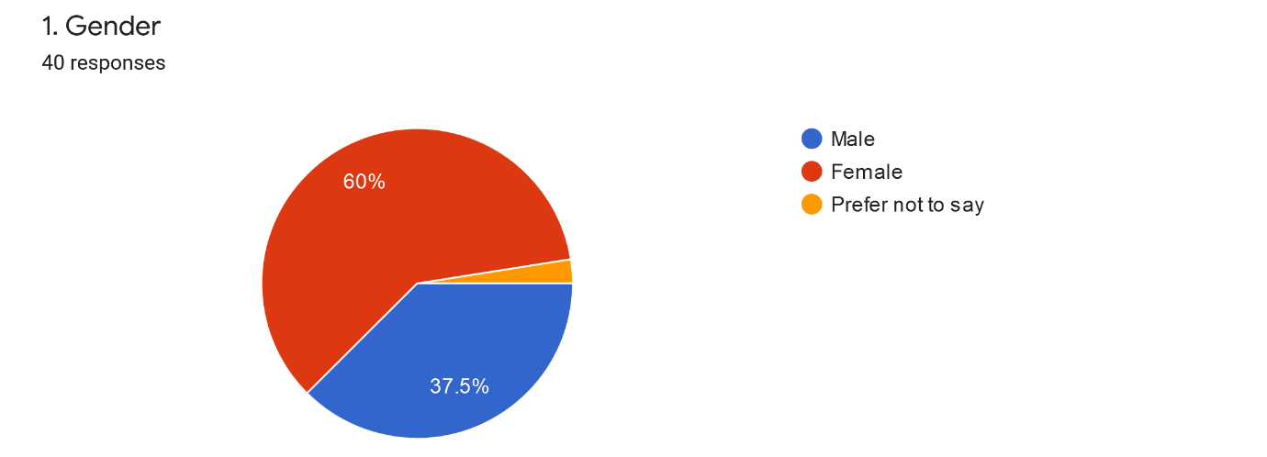
- In the second question I obtain that the 65% of the people are between 15 and 25 years old, the 15% of the people are between 36 and 45 years old, 12.5% of the people are between 26 and 35 years old, 5% of the people are between 46 and 55 years old and a 2.5% of the people are 56 or more years old.
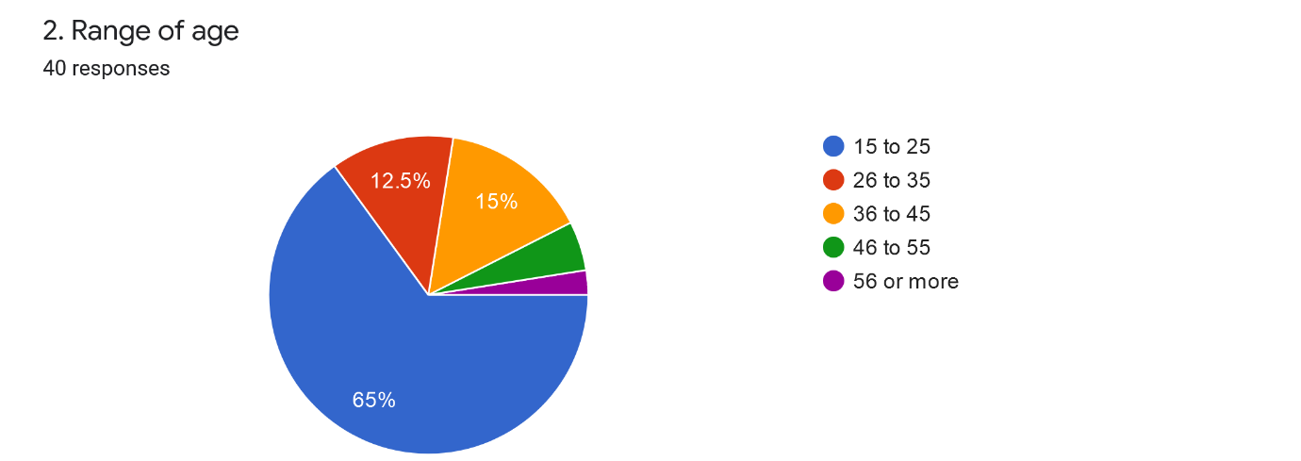
- In the third I obtain that the 60% of people uses MOODLE via mobile phone and the 40% of students’ login via laptop.
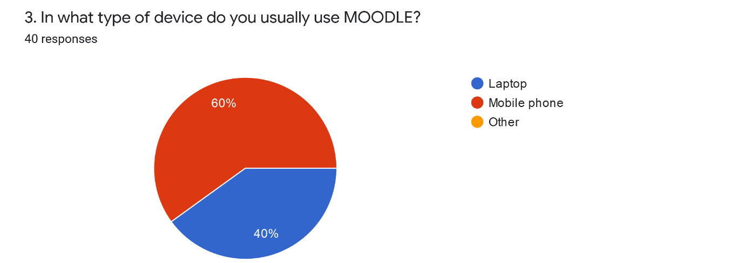
- In the fourth question I obtain that the 37.5% of students open MOODLE four or more times a week, the 32.5% of the people, uses the platform twice a week, 20% of the students uses MOODLE three times a week and the last 10% of people, uses the platform once a week.
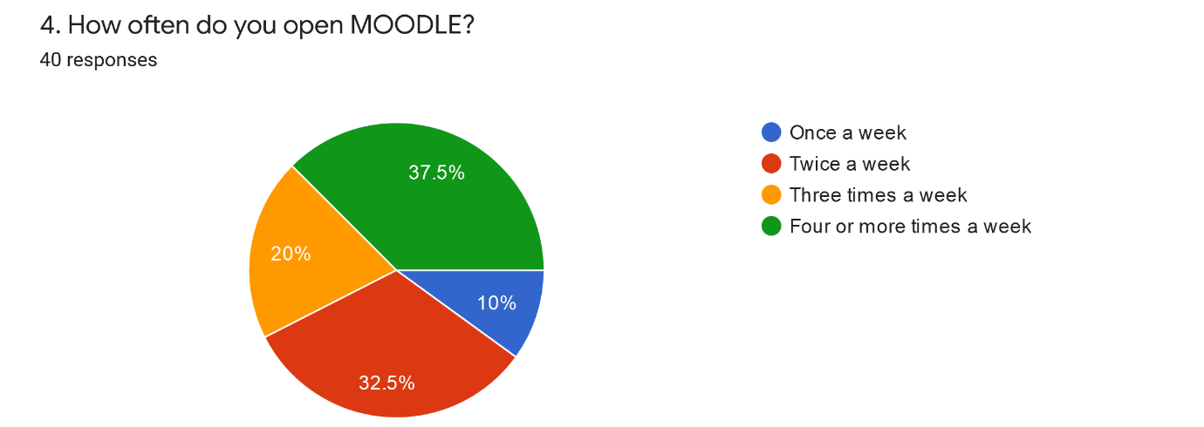
- In the fifth question I obtain that the 62.5% of the students spend 1or 2 hours in MOODLE, the 25% of people, use the platform for 3 or 4 hours and the 12.5% of students, use it for 5 or more hours.
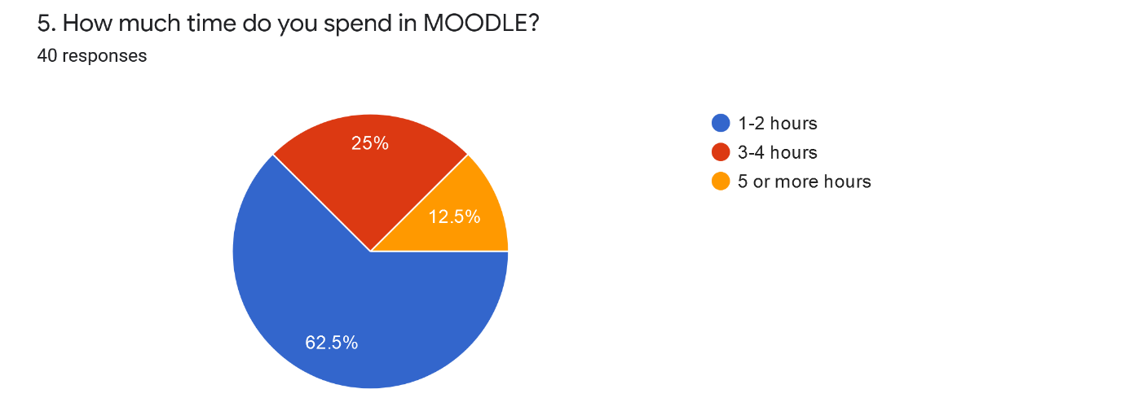
- In the sixth question the 42.5% of students say that the platform is a 4 in a scale of five, 30% of people say that is a 3 in a scale of 5 and the 27.5% of students say that 5 in a scale of 5.
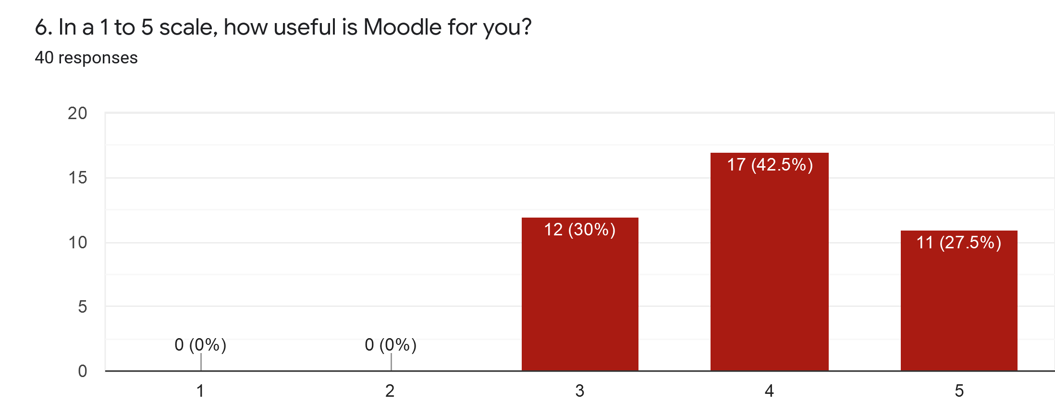
- In the seventh question the 50% of the people said that they used it because the study the topics seen in class, the 32.5% of students, say that they use it because they want to know the future topics of the module and be prepared for the next classes and the last 17.5% of people say that they use it for deliver reports.
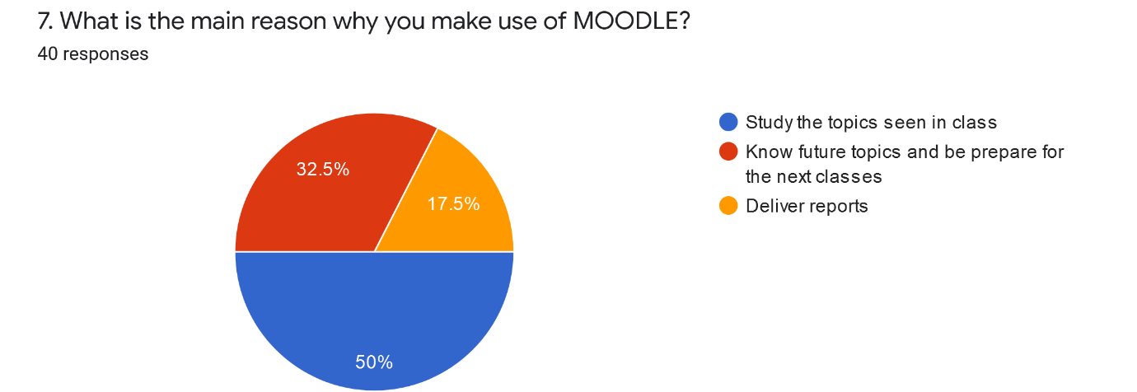
- In the eighth question the 37.5% of the people said that is a 4 of 5 in a scale of difficulty, a 27.5% of students said that is a 5 of 5 in the scale, another 27.5% of people said that is a 3 of 5 in the scale, 5% of students said that is a 1 of 5 in the scale and the last 2.5% of people said that is a 2 of 5 in the scale of difficulty.
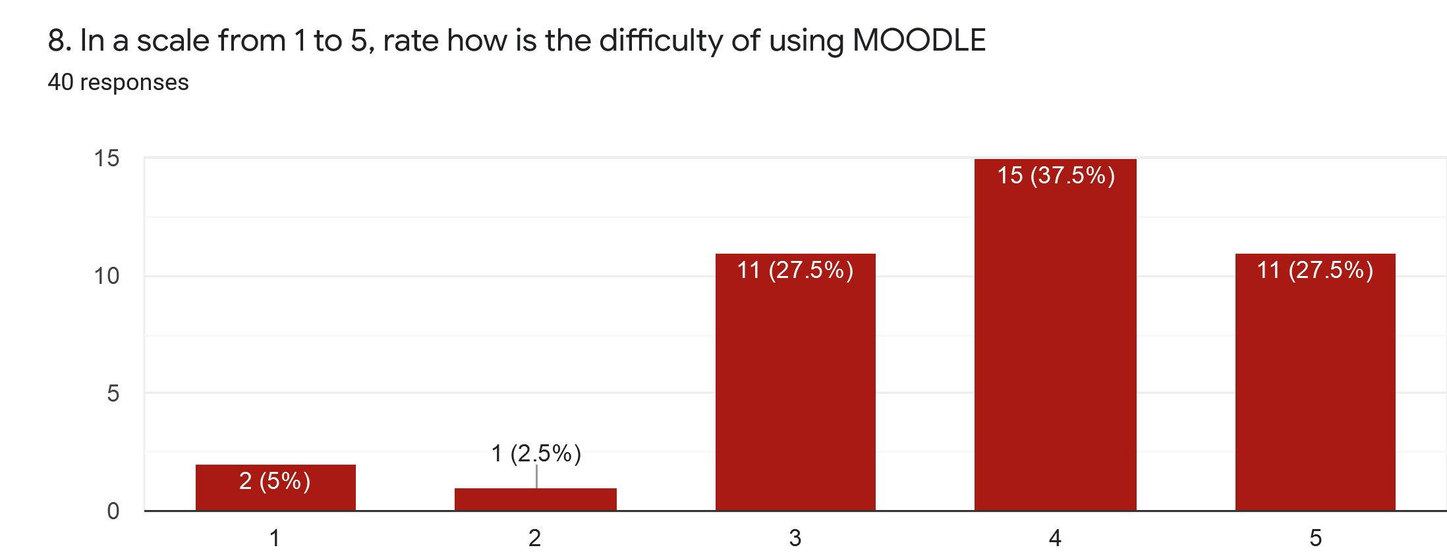
- In the ninth question the 45% of students said that the benefit is facility for study, the 22.5% of people said that they use it because of the speed when they send a report, the 20%of students said that they use it because of the effective learn MOODLE gives, and the 12.5% of students said that the benefit is the facility for receiving grades or feedback.
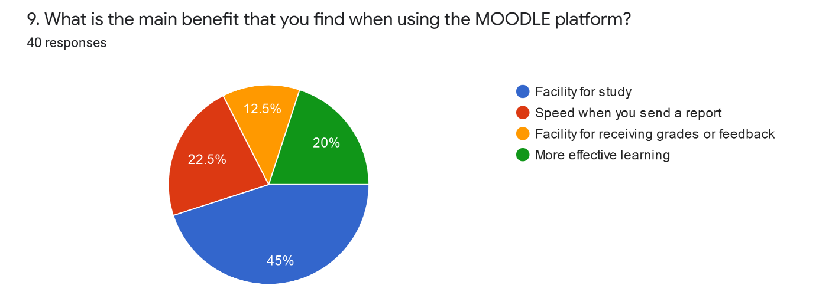
- In the tenth question the 32.5% of people rated the platform with an eight, the 20% of students said is a 10 of 10 in the scale, the 15% of students rate MOODLE with a nine and another 15% of people said is 6 of 10 in the scale, the 12.5% of students said that is a 7 of 10 in the scale, the 2.5% of people rate the platform with a five and the last 2.5% of students said that is a 4 of 10 in the scale.
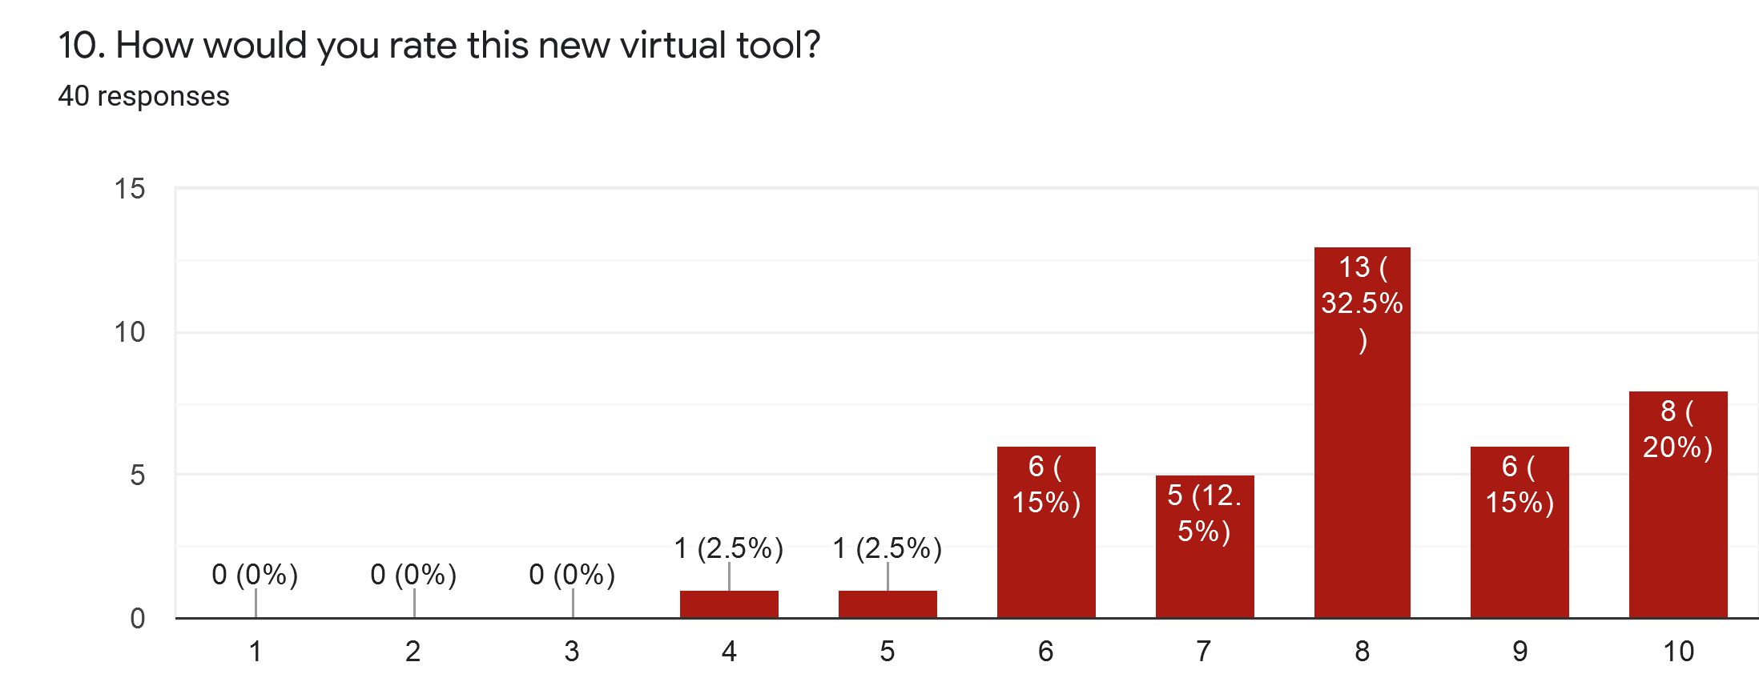
- In the eleventh question the 82.5% of students said that the haven’t experience any kind of problem, the 15% of people said that maybe have problems and the 2.5% of student said that they have problems presenting reports or homework in MOODLE.
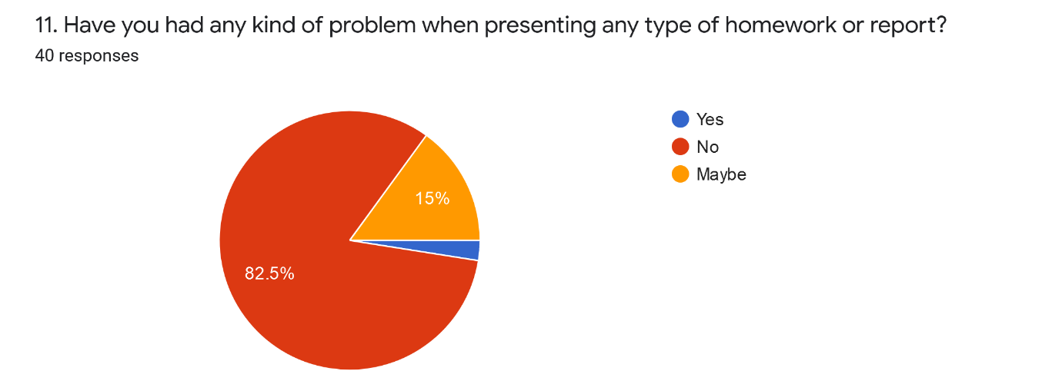
- In the twelfth question one student said that the problem was when he/she was sending a work to the teacher, and the other person said a very confusing answer, he/she only write yes.
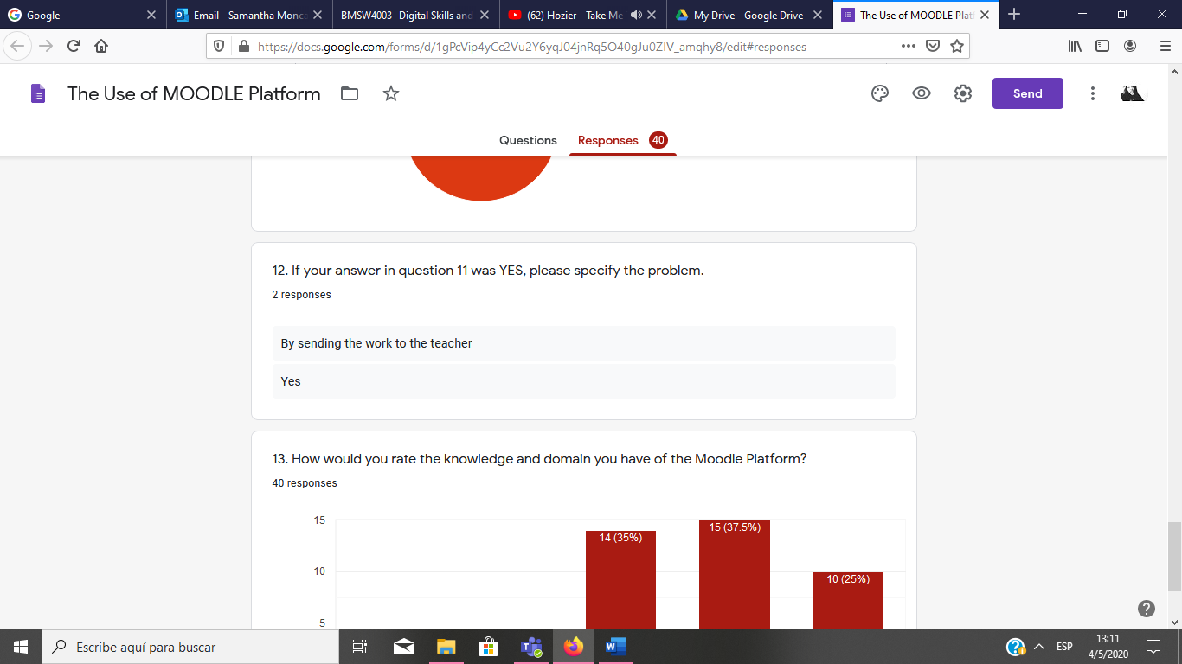
- In the last question 1 is for no knowledge and domain and 5 is for excellent knowledge and domain. The 37.5% of students said that they have a 4 of 5 in the scale, the 35% of people said that they have a 3 of 5 in the scale, the 25% of students said that they have a 5 of 5 in the scale and the last 2.5% of students said that they have a 2 of 5 in the scale of knowledge and domain. The results are shown in the chart below.
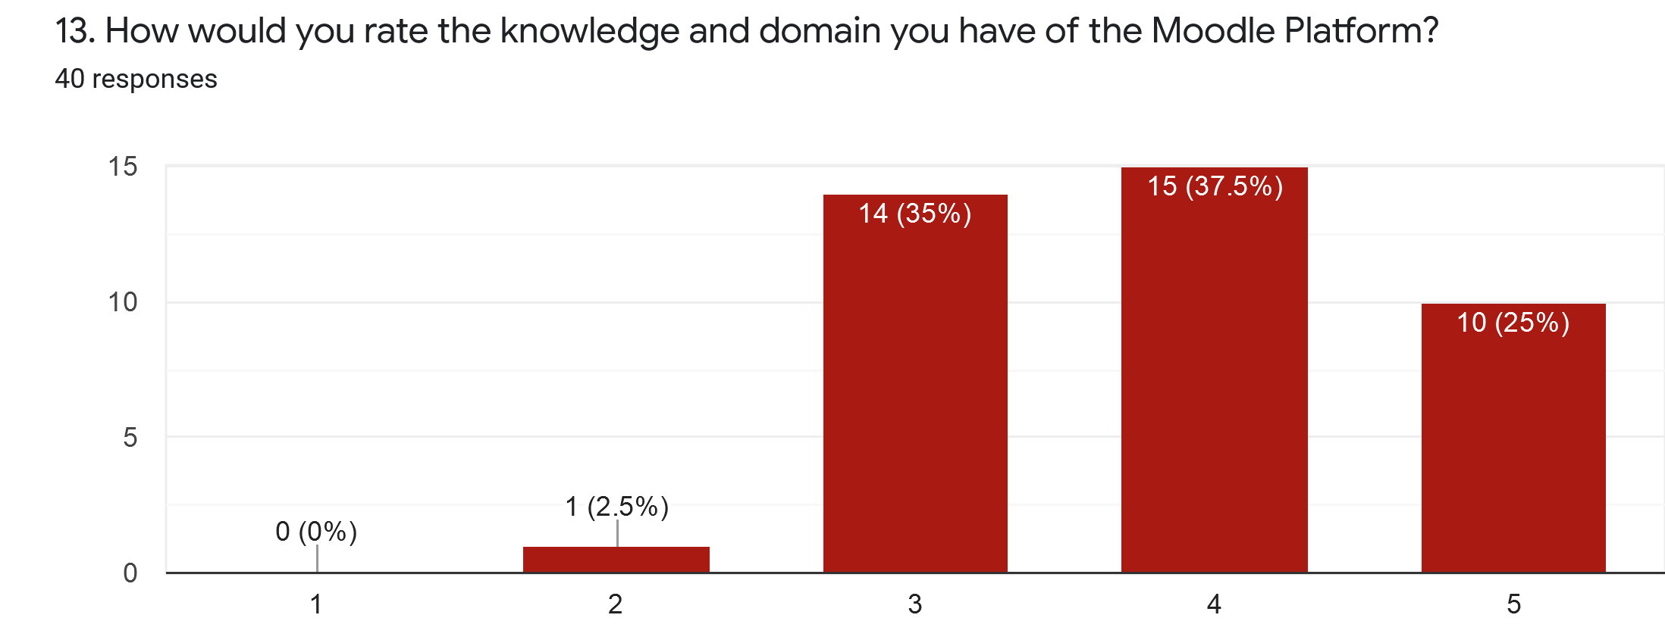

LIMITATIONS OF STUDY
When writing this report, I had a few limitations that initially affected me a little with the research, but that later, I was able to solve. At the beginning, I had very few people surveyed, so I had to enlarge the number to 40, which although it is not a high number, was much better than having almost no information. Another limitation was the lack of reliable sources on internet, so I made use of Google scholar and the library of our university to obtain truthful information. The last limitation I had was that, being a speaker of the Spanish language, and although I have a good domain of English language, there are words that I do not understand perfectly. What I did was translate and find out the meaning of the words I didn't know.

CONCLUSION
I can conclude that this platform is designed to monitor student learning and the good continuation of studies, guaranteeing that all the accesses that MOODLE has are to continue acquiring new knowledge. The use of this platform means that the students of our university do not have problems in terms of the themes of each module and may be able to educate themselves despite the current situation in the world. With due investigation, I was able to achieve my proposed objectives and thus, make it known that the students of our university have access to this platform, where most of them use it to study the topics seen in class as well as being an easy way to learn.

REFERENCES

- Costa, C., Alvelos, H. & Teixeira, L. (2012). The use of Moodle e-learning platform: a study in a Portuguese University, Aveiro: Elsevier Ltd. Selection.
- Grimmer, K. & Bialocerkowski, A. (2005). 'Surveys', Australian Journal of Physiotherapy. 51(3), pp. 185-187.
- Moodle, (n.d.), MoodleDocs. [Online]
Available at: https://docs.moodle.org/38/en/About_Moodle#Easy_to_use
[Accessed: 26 April 2020].

APPENDIX

