Assignment title

Managing Projects in the Organisation

Name: Kazi Ahsanul Haque
Student Number: 1605418
Module Code: BMSK-5004
Module Lecturer’s Name: Dr Rexon Nting

Introduction
Project management contains the usage of numerous values, actions, and strategies that are recognised to guide a project from its beginning phase all the method along until its conclusion. Each project organisation specialised will acknowledge that planning, as well as organisation, are main portions of project management and the application of shaped strategies. This assignment will discuss a project management stage by stage guide. Work itself is defined as a precise start accepted with considerations intended to be followed with the intention to produce a definite result (Pedler, 2011). A project grasps its individual alongside ongoing procedures because of the statement that it has an exact start as well as finish date where procedures can be continuing for an unknown dated of time.

Contents
Introduction 2
Provide a critical assessment of the usefulness of project management tools and techniques 3
Plan the implementation of a project within the workplace. Communicate the project plans with appropriate colleagues and stakeholders. Implement the project plan. 9
Critically evaluate your ability to manage a project. Use feedback from others to evaluate your own ability to plan and implement a project, identifying strengths and weaknesses. Create a self-development plan to improve your own performance in managing projects. 14
Conclusion 18
Reference 19

Provide a critical assessment of the usefulness of project management tools and techniques
Project management tools and techniques and usefulness for managing a project
There are several techniques that today’s businesses are used to manage their project. Project management methods or techniques helps the business to utilize the resources, allocate tasks, and so on. Agile method, Waterfall method, Prince2, Scrum, Critical Chain Methodology all are the most famous type of project management techniques.

Agile
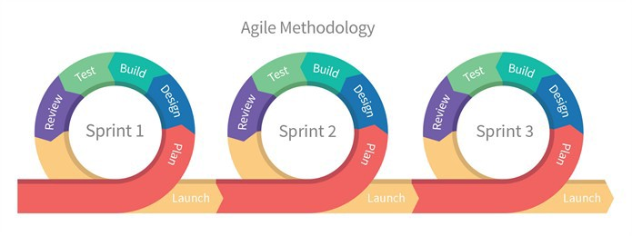
Source: (Pedler, 2011)
Agile techniques are one of the most suitable and famous project management methodologies that today's organizations are used. ‘Sprint Approach’ is one of the common use of agile methodology. In this method, a business can break a project in the method of sprints. The word agile itself define to move quickly or response quickly toward any kind of changes. Hence this methodology actually very flexible and dynamic. It is widely used in software improvement besides is greatest suitable for minor software projects that necessitate frequent communication and work with groups (Pedler, 2011).

Waterfall
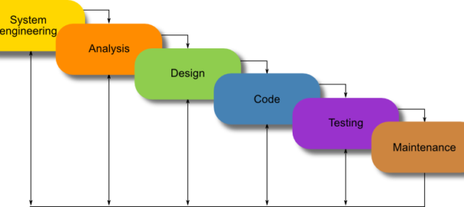
Source: (Pedler, 2011)
Waterfall project management technique is one of the easiest and oldest forms of project management techniques. This methodology can also be recognized as an SDLC or software development life cycle that emphasis on creating a firm strategy and operative execution. The Waterfall method is progressive that means one job needs to be finished before the following starts in the pipeline.
Project Management Tools
There are several types of tools are available in the business to manage their project effectively as well as quickly. Liquid Planner, Proof Hub, Zoho Projects, Basecamp, and so on all are the most famous types of project management tools (Nicholls, 2014).
Proof Hub is a multipurpose project management tool used by leading businesses like Taco Bell, NASA, Disney, and so on. This multifunction tool that derives filled with influential structures to remove the essential of having excessively numerous diverse tools toward run the commercial. There are several features of these tools such as it saves time as this tool can save time at the time of the feedback-sharing procedure. This tools also make task accomplishment less stressful. Now a day all famous and well-known organization in the UK use this tools to project management.

How projects are carried out
There are numerous kinds of business structures that are used for managing projects in Tesco PLC. There are numerous issues that are measured while selecting the business structure intended for a project. Inside a business, the key issues that play an important character are the authority as well as accountability that the upper management delivers to the minor level administrators. The upper management of a business plays a significant role to frame an appropriate administrative structure for the business that would be helpful toward managing projects. There are numerous kinds of business structures that are used for managing any kind of project within the business, for example, project-based structure, programmatic based arrangement, Matrix-based structure, and so on.
Programmatic based organization is one of the easiest and famous organization structure for managing projects within the business. Tesco PLC also prefers this method to manage their project effectively. This type of structure also called a conventional organizational structure. The projects that be possessed by a program division besides don’t necessitate persons be appropriate to diverse program segments with expanded knowledge need programmatic based business structure. Under this structure or method, the groups that are shaped for the determination of the development are operated through the employees that be owned by a similar area. For instance, a project about manufacture would comprise the obligatory workforce and assets from the manufacturing segment. The final advantage extended through the programmatically based assignment is that a structure like this is shaped with a solitary organisation besides the lines of expert are similarly perfect. This is a very effective method for project management as the staffs of the projects are performing together in the same unit. Hence, the goals of the staffs those are involved within the same department or the same project are same besides they save a similar understanding about the project (Nicholls, 2014).
The duties involving the employees under this method as well as their responsibility are obviously specified besides they are responsible to report their activity toward the project managers of the organization. The role and responsibility of the project manager’s would be functioning performance assessment of the staffs and likewise, observe the improvement of the employees functioning in an assignment. The project groups accomplishment within this method the accountability toward developing an understanding connecting to project documentation as well as ownership. The employees belonging to the task plays the character of managing the actions of the task in an accurate method do that they can accomplish the aims of the project proficiently.
Evaluate several project management approaches
PM approaches | Ease of understanding | Fit with requirements of project | Fit with organization culture | Accessibility to other members
Agile | This method helps the business to complete a project in a dynamic and rapid way. Tesco PLC uses this method for completing their all type of projects (Loucks-Horsley.et.al. 2009). | Agile methodology really fit with several projects of the Tesco PLC as it encourages to do a project in an agile way. Every project needs to be done quickly. So this method is most appropriate for the business | It is necessary for the business to feet their project management method with the organization culture for better efficiency. | Agile method always encourages to work or perform in a group way rather than individual way. This method always fits well with other members of the organization.
Waterfall | Waterfall is a project management method where a mission is finished in separate phases and moved gradually toward final release to customers. | Fixed pricing and timeframes help create certainty for the customer. | This is not a flexible method as a list of requirement are being listed before starting the project. | Everyone can use this method but this not easy process for any kind of changes.

Understanding of PM tools and techniques
Agile project management is a method related to delivering necessities iteratively as well as incrementally through the project life cycle. This type of project management techniques is the necessity to display principal standards and behaviors of faith, flexibility,authorisation and teamwork.
Agile PM techniques are beneficial for Tesco PLC also as this approach to ensure the effectiveness of the project. Agile methods authorise those involved; build responsibility; inspire assortment of ideas; permitting the initial release of benefits, and elevation of constant development (Loucks-Horsley.et.al. 2009).
Agile aids build customer as well as user engagement as fluctuations are evolutionary and incremental instead of revolutionary: it can consequently be in effect in secondary cultural alteration that is serious to the achievement of greatest revolution projects.
Waterfall is a project management method where a mission is finished in separate phases and moved gradually toward final release to customers. An individual can create a big strategy upfront and then perform in a direct way, hoping there will not be any variations in the proposal.
All responsibilities on waterfall projects are gathered through a kind of action besides each plan follows the same phases:
Requirements – this is the step of analysing business needs and find out the software need to accomplish the project.
Design – in this stage Tesco PLC find out the technology, make diagram and policy to start a project.
Testing – this is the stage of examining or evaluate the process of execute the project.
Operations - where the business arranges the code to a manufacture situation and offer support.

Plan the implementation of a project within the workplace. Communicate the project plans with appropriate colleagues and stakeholders. Implement the project plan.
It is necessary to have skills and knowledge to manage a project. An individual need to develop communication, leadership, team management, negotiation, personal organization, and risk management skills to manage a project within the business. I always use PRINCE2 approaches to plan a project within the business as this process ensure to complete a project within a specific time period and cost-effective process. PRINCE2 is the most appropriate management tools for the Tesco PLC (Kop and Fournier, 2011).
This project management technique is likewise categorised through merchandises that are transported on time besides well within cost estimations. The characters are prearranged before the kick-off of the scheme besides all associate of the assignment is well conscious of their accountabilities towards to effective implementation of the assignment.
A business might essentially help with realising PRINCE2 if, for instance:
- PRINCE2 has previously been applied into the business but commercial welfares are not being completely recognised.
- The commercial wants to confirm they are PRINCE2 obedient
- The commercial is interested in gaining an acknowledged authorisation for its project management procedures
Now a day many organizations treated their all project through PRINCE2 process. Full transference of skills of the individuals can be transferred into the workplace by PRINCE2 approaches. Several steps are necessary to implement a project by this method such as starting up a project, initiating a project, directing a project, controlling a stage, managing state boundaries, managing product delivery, closing a project.
PRINCE2 mentors specialise in supporting businesses with the organisation of alteration that is essential to implement PRINCE2 effectively. They be able to offer supervision and support throughout the application of PRINCE2 through an arrangement of training, mentoring and teaching and safeguarding the suitable abilities are encouraged. They likewise offer one-to-one terms with persons to support them in their novel or improved character, give conferences or workspaces for minor groups with definite characters or tasks, and/or remote support through telephone or email.
Identify a project
The first step in the organisation procedure involves classifying precisely what an individual going to do, the scope of the project. In this phase, members of project management team classify main essentials of work besides then break them down methodically into lesser and smaller pieces, in anticipation of each part develops a comfortable size to evaluation, perform, and observe.
One of the project that needs to carry out in my area is to arrange meetings with foreign stakeholders. For this process, I have to complete several tasks in sequence way and it is a great work for completing my tasks. As maximum persons would incline to do instinctively, I begin by knowing that there are numerous large “chunks” of effort to be completed. I will have to do some development. I will essential to take care I correctly welcome everybody. I am sure I will need provisions of a certain sort, for example, benches and chairs, conference room, and so on. I will likewise need to arrange for the gathering and cleaning afterward the conference is over. I have by this time begun subdividing the project to be done.
The important at this stage is to verify, in addition to conceivable, that I have recognised all main types of effort that establish the project. In addition, all part of effort compulsory for my gathering will fit into one of these five subcategories. Meanwhile, I trust this is the circumstance, I can continue toward the following level of aspect (Kop and Fournier, 2011).
I begin through seeing the whole thing I will essential to do on the subject of Setup. I understand that I will have to send mail to all of the higher management about the conference time and ensure a better facility to them. I will also have to create a conference place presentable. I will arrange a hotel room for all the guest those are coming from a foreign country. It happens toward me that there appear to be regular groupings of actions here, connected to sports and entertainment, and so on.
A correctly settled work breakdown assembly permits me to classify each solitary element of project obligatory to complete the task. Once I have completed this, I am now able to move quickly forward in the scheduling procedure. For each of those actions, I will now essential to reflect significant features, which can be called as scopes. I would use these scopes as response for upcoming forecasting stages:
Time: here time indicates the number of days or weeks are required to accomplish the project
Cost: this is spending of money for involving workforce and buy necessary equipment to accomplishing the project.
Scope: The project that would be completed, in what way it would be completed, and what would be produced
Accountability: The individual responsible for its effective achievement.
Resources: Subsidiary labour, resources, or materials required (Jarvis, 2009).
Quality: How well the effort should be completed; how well any productivities should complete.
Relationship to Other Actions: Actions that essential to be finished before this one can start.
4D methodology for managing a project
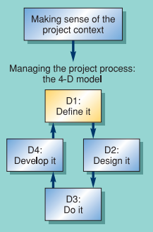
The circumstance of the Tesco PLC exemplifies a remarkable challenge for project leaders – in what way to realise achievement in manifold zones. In this circumstance, the definitive achievement will be the attainment of the radical, ecological, financial and social purposes, in the short-term, medium-term and long-term, to the gratification of all troubled. Such an obligation signifies the final state of excellence for a scheme. The 4D method is the most appropriate way to manage a project as this method divided the project into four segments.
Stakeholders- The challenge toward attaining entire achievement originates from the difficulty of the purposes and the necessities of numerous diverse assemblies of stakeholders for the assignment, not least since there would be engagements among the necessities of each. We express these necessities as actions.
‘Begin with the end in mind.’ Whether a scheme is an achievement or failure is hardly generally decided at the conclusion of a project. Though, a decided declaration of what is obligatory delivers a decent beginning point. The perfect consequence brought the past and at no price, is for optimists (Jarvis, 2009).
Initial planning- the principal of the initial planning stages are described in this section. The method of planning defines the nature, character and eventually the efficacy of the strategy. It is just as significant to recognise in what way besides why to end a assignment as to start one. Creating a sense of a compound project can be supported by inspiring a high degree of reflectivity in the procedure.
Time planning- The first principle of planning is deconstruction: breakdown the creation as well as the effort into responsibilities. Time management needs the preparation of the responsibilities into an arrangement for the determination of investigation. The greatest known method to communicate time management is as a Gantt Chart.
Rethinking time planning: The critical chain approach
If an individual plan by means of the serious path time, the individual plan to fail. The accepting of limitations in a task is vigorous to continuing project efficiently. It is very crucial and beneficial approaches for all type of organizations.
Stakeholders and quality- the principle of this stage are accomplishing a definite degree of quality is one of the main purposes of most tasks, and there are budgets related to this. Quality is an individual asset besides is judged through all of the task stakeholders. The consequence has a significant influence on client retention besides forthcoming trust in plans.
Certain basics of value will need conformance, others offer the chance for actual enactment to be established, while others offer the chance for commercial development.
Risk and opportunities
Management-the principle of this management Risk and uncertainty are basics of schemes. There are powerful methods that can be functional toward the organisation of risk. Though there is continuously disadvantage possible for a scheme, there is continuously advantage too. Opportunities of the businesses are important as risk.
The communication needs of appropriate colleagues and identified project stakeholders
There are three overall classes of communication that are required in operative shareholder management;
- public relations
- reporting, and
- Purposeful communication
Reporting accomplishes two valuable purposes: initially, it reveals an individual is running his or her project correctly; Furthermore, copying a task to an individual keeps staffs in touch with them for when more important communications are required.
Public affairs besides advertising are undervalued besides underused statement procedures. PR comprises all of the recording transportations desirable to deliver info about the project to the broader shareholder community to marketplace the worth of the task besides to stop info ‘black holes' increasing that breed misrepresentation besides rumor.
Purposeful communication is firm effort and essentials to be engrossed on the significant investors with whom an individual essential to reason an exact result. This comprises providing a way to the group members besides dealers and manipulating the approach or prospects of other important shareholders.
A project can be accomplished in several ways. It would be better to evaluate the progress from time to time. The Gantt Chart helps me to evaluate the progress of my activities (Jarvis, 2009).
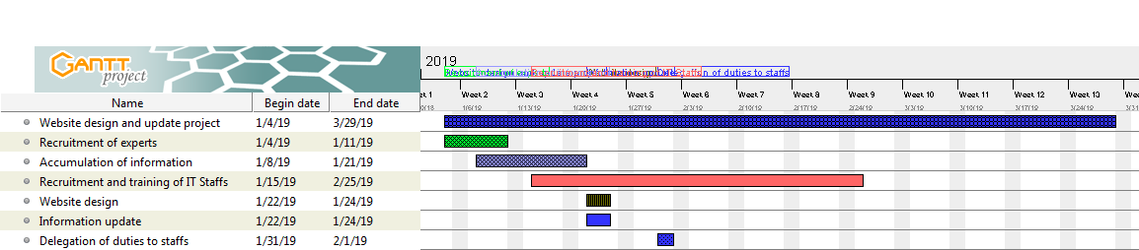

Figure: Gantt Chart detailing roles and responsibilities (Jarvis, 2009).

Critically evaluate your ability to manage a project. Use feedback from others to evaluate your own ability to plan and implement a project, identifying strengths and weaknesses. Create a self-development plan to improve your own performance in managing projects.

A person can seek feedback from his or her colleagues in a different way. Feedback is really crucial to find out the strength and weakness of an individual. It would better to create a chart and mark them from the colleagues about the performance. By this way, an individual can get positive as well as negative feedback from colleagues.
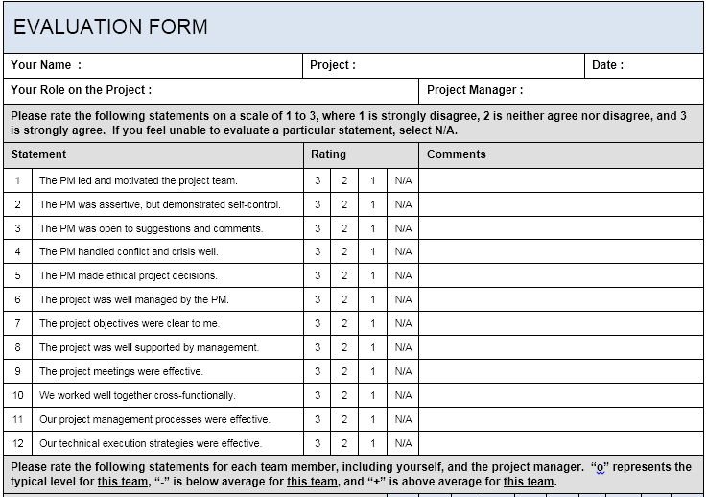
Feedback helps the individual to find out the weakness as well as strength of the persons who are involved in the project management process (Calderhead.et.al. 2012). SWOT investigation for project management is a simple, yet operative procedure. It permits me to recognize zones that essentials development. By executing the precise methods for the investigation, it is likely to confirm that a project would be finished promptly as well as within financial plan.

Strengths | Weaknesses
I am very excited about my project and I have finished my trainings from a reputed university in the UK. My operational profile is likewise very solid as I have finished several projects while performing in Tesco PLC. This experienced help me to gain some experience and learn how to manage a project in an effective way. | From the experience that I have found that there are several weakness that needs to be improved. I find it difficult to work with group members. I also have a disability to work under tremendous pressure. It would better to develop communication skills for completing a project in an effective way (Calderhead.et.al. 2012).
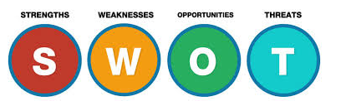
Source: (Pedler, 2011)
A member of staff must be quite honest with the truths given in strength and weakness as it aids the person to withstand in administration in the long term. By observance in the judgments of specialised standard of establishment I have exposed potential asset and weakness of my profile.
Development plan: - It consists of the current as well as upcoming demands and its capability at both stages. I being a member of staff have to measure capability in the operational organization. Development strategy of staff must reflect subsequent issues for example -present enactment goals and purposes; attainment dates, appraisal dates, learning programme actions, achievement tactics, and individual growth strategy. Being a worker I discover several actions however the greatest suitable measure is classifying our individual essential intent and in what way we respond with the project assigned to us. So as to measure these facts I first note down my abilities, asset, weakness and other essential physical things (Calderhead.et.al. 2012).

Identify and plan relevant training and development activities
Training Objective | Learning outcome | Methods / activities | Documentation/evidence of learning process | Evaluation of data obtain
By this way can develop management skills to manage a project in an effective way. | 1. Exhibition of essential abilities in problem-solving and decision making  2. Exhibition of essential skills in delegation | This section helps me to find out my goals and targets.  1. Complete a course in basic supervision  2. Address a main problem that comprises creating major decisions  3. Delegate to a definite worker for one month | Evidence produced during my learning activities -- these are consequences that someone can see, hear, feel, read, smell,  Assessment of my problem solves and decision making methods. | Understand and judgment on the quality of evidence in order to conclude whether I achieved the learning purposes or not.

Action Plan for the next 6 / 9 / 12 months (Circle the appropriate timescale?
Development Goal | SMART Objectives | Resources Required | Action Steps | Obstacles/ Solutions | Complete by (Date) | Review Date | Methods of Evaluation
Complete my studies | Main aim of completing my degree is to get my desire job after complete the courses. | It is necessary to have huge financial support and motivation to complete the courses. | I have to study hard with full determination and research more. | It is very difficult to complete the courses within time bound. | 2020 | In starting 2019 | Cross check of individual abilities
JOB | Receiving a promotion | It is necessary to evaluate by myself and perform in a dedicated way. | Need to have collaboration with professional and personal level. | Organisation of time besides no faults at any period | 2021 | 2019 | Need to have strong mindset and full determination.
Set up of commercial | Commercial set up | With the alteration in awareness besides economical mind state | Commercial support | Link between learning, occupation and commercial | 2019 | 2018 | With money oriented and successful

Conclusion
Managing a project more frequently than not needs a group of persons with abilities and capacities that accompaniment each other as well as aid to effort towards attaining the objective of the task. The group, accompanied by its project administrator are accountable for the development, classifying and observing project development. Any project organisation expert will indicate that all project tracks a project life cycle as well as definite project organization stages that carry it from beginning to conclusion.

Reference
Bunderson, J.S. and Boumgarden, P., (2010). Structure and learning in self-managed teams: Why “bureaucratic” teams can be better learners.Organization Science, 21(3), pp.609-624.
Busse, H., Aboneh, E.A. and Tefera, G., (2014). Learning from developing countries in strengthening health systems: an evaluation of personal and professional impact among global health volunteers at Addis
Ababa University’s Tikur Anbessa Specialized Hospital (Ethiopia). Globalization and health, 10(1), p.1.
Calderhead, J., Denicolo, P. and Day, C. (2012). Research on Teacher Thinking (RLE Edu N): Understanding Professional Development. Routledge.
Cummings, T. and Worley, C., (2014). Organization development and change. Cengage learning.
Fink, L.D., (2013). Creating significant learning experiences: An integrated approach to designing college courses. John Wiley & Sons.
Ho, L.A., (2011). Meditation, learning, organizational innovation and performance. Industrial Management & Data Systems, 111(1), pp.113-131.
Hopkinson, C. 2014. Personal and professional development: A Textbook for Professional Practice. 383.
Jarvis, P. 2009. The Routledge international handbook of lifelong learning. Routledge.
Kop, R. and Fournier, H. (2011). New dimensions to self-directed learning in an open networked learning environment. International Journal of Self-Directed Learning. 7(2). Pp. 2-20.
Larson, E.W. and Gray, C.F., (2011). Project management : The managerial process
Alexandra, D. & Britton, A. (2014). International Financial Reporting and Analysis. Andover: South-Western Cengage Learning. Retrieved from http://lib.myilibrary.com/ProductDetail.aspx?id=549474
Berry, A. & Jarvis, R. (2011). Accounting in a Business Context. South-Western Cengage Learning. Retrieved from http:// http://lib.myilibrary.com/ProductDetail.aspx?id=328474
Walton, P. & Walter, A. (2013). Global Financial Accounting and Reporting: Principles and Analysis. Andover: South-Western Cengage Learning. Retrieved from http://lib.myilibrary.com/ProductDetail.aspx?id=458683

