

MODULE CODE: BMSP 6012

INDEPENDENT STUDY (DISSERTATION)
WORD COUNT: 10,000 WORDS
Overall Word Count: 10,622 Words
TITLE: Dyslexia in the workplace: The role of Human Resources (HR) in recruitment, employment, and further support.

MODULE TUTORS:
Dr Alex Bell (Lecturer)
Dr Roisin Mullins (supervisor)

Student:

Caitlin Faye Innes

1900689

Submission Date: 25th Apr 2022

Declaration form


Name of the Programme of Study: BA Business and Management

Name of Student (Capital Letters): CAITLIN FAYE INNES

DECLARATION

I certify that the whole of this work is the result of my individual effort, and that all sources have been acknowledged.

Signed: CFInnes.

Date: 20th of April 2022

DECLARATION

I am satisfied that this work is the result of the student’s effort.

Signed .............................................................. (Lecturer)

Date ..............................................................

Title
Dyslexia in the workplace: The role of Human Resources (HR) in recruitment, employment, and further support.

Acknowledgements
I would like to thank my supervisor, Dr Roisin Mullins, for her guidance through the process, and to lecturer Dr Alex Bell for his advice and guidance. I would like to acknowledge Glenn Behenna for inspiring my interest in the intercultural workplace. My dear friend, Sara John-Davies, was instrumental in supporting me and keeping me motivated to work with long hours on facetime daily. For this, I am extremely grateful. I would also like to thank my learning support Sara Hill for all her help, I will forever be grateful for her support. I would like to give a general thank you to my family and friends for checking up on me and making sure I was not too stressed during the writing proses. And a last thank you to my two cats for the companionship or comfort during the research and writing process.

Abstract
The aim of this research study is to analyse and discover how and in what way can dyslexia be dealt with in the workplace from the employees’ point of view, with the addition of role does human resources play within this process, looking at recruitment, employment, and further support. A mixed methods approach was taken for this research study with a structured interview that was conducted with one participant as a case study, and a structured questionnaire on surveymonkey.com that 71 participants took part in. The analysis shows a strong correlation between the lack of workplace understanding on how dyslexia affect individuals and an unconscious bias that comes with dyslexia. The study concludes that further research on dyslexia in the workplace is needed to fully understand the reasoning behind the lack of understanding and the support that is out there for the dyslexic employees.

Key words
Dyslexia; Learning difference; Disclosure; Stigma; Reasonable adjustments; Wellbeing.

Table of Contents

Declaration form 2
Title 3
Acknowledgements 4
Abstract 5
Key words 5
Table of Contents 6
Table of Tables 8
Table of Figures 8
Introduction 9
Chapter 1 - Background 10
Research Questions 12
Aims and objectives 12
Chapter 2 – Literature Review 13
Dyslexia in the workplace 13
Wellbeing – anxiety and stress 14
Disclosure and stigma 15
Support and reasonable adjustments 16
Methodology 17
Sampling 17
Method 18
Participants 18
Design 18
Materials 18
Procedure 19
Results 20
Quantitative research studies 20
Results - Thematic analysis 26
Qualitative research studies 26
Chapter 3 – The Conclusion 29
Analysis 29
Quantitative research studies 29
Discussion 32
Qualitative research studies 32
Summary of the key findings 32
Interpretations 33
The implications 34
The limitations 34
Recommendations and Conclusions 35
Recommendations 35
Conclusion 35
References 37
Appendices 42
Appendix A – Participant Agreement form Template 42
Appendix B – Questionnaire questions 43
Appendix C – Interview questions 45

Table of Tables
Table 1 Answers Yes to Question 7 23
Table 2 Questionnaire Question 9 25
Table 3 Thematic Analysis Theme Tabel 26

Table of Figures
Figure 1 Questionnaire Question 1 20
Figure 2 Questionnaire Question 2 20
Figure 3 Questionnaire Question 3 21
Figure 4 Questionnaire Question 4 21
Figure 5 Questionnaire Question 5 22
Figure 6 Questionnaire Question 6 22
Figure 7 Questionnaire Question 7 23
Figure 9 Questionnaire Question 8 24

Introduction
This research dissertation will be discussing dyslexia in the workplace focusing on three key areas that involve the human resources department these are recruitment, employment, and any further support. This topic was selected due to being relevant in the business as it is important for the sustainability of the company and of the employment of the staff, as it is important to keep the employees work life positive. To conclude this study will be looking at dyslexia in the workplace and the role that Human Resources play in it during recruitment, employment, and further support that is offered or not offered. To be able to do this the study will be referring to the theories, the different policies that are in place, and what happens in practice.
Overview of the structure
Chapter 1 – Background
In chapter one we will be disguising the background of dyslexia by looking at what is dyslexia, explain the key words that are related to dyslexia, stating the UK facts and figures, dyslexia and workplace changes, trends, practices, and policies. Followed by the research question, and the aims and objectives of the research dissertation.
Chapter 2 – Literature review
Chapter two will be looking at the current literature on dyslexia focusing on dyslexia in the workplace the employee and business perspective, wellbeing focusing on stress and anxiety, disclosure, and stigma, and finally support and reasonable adjustments. After the literature review the chapter moves on to the Methodology where the research methods are discussed followed by an explanation of the sampling of the different participants and how they were grouped. The last thing that is covered in chapter two is the findings of the quantitative and qualitative research giving the results of the questionnaires and a thematic analysis of the case study interview.
Chapter 3 - The conclusion chapter.
The third and final chapter or as known the conclusion chapter starts with the discussion an analysis of the findings of the quantitative and qualitative results. This chapter then moves on to the Recommendations and conclusions, where 2 recommendations to organisations will be made and then to conclude and summarise the research dissertation.

Chapter 1 - Background
Dyslexia is something that occurs along a spectrum, for example, from mild to severe (Harriss & Cooper, 2005). Dyslexia is a learning difficulty that affects how the individual’s process information (OHC, 2013). Following this dyslexia is also a specific learning difference or is sometimes known as a processing difference with it being known that it can co-occur with other differences such as dyspraxia, ADHD, and ADD to name a few, leaving dyslexic individuals to display characteristics of one or more condition (Beetham & Okhai, 2017). Because dyslexia is a hidden disability it can cause a lack of awareness and this leaves dyslexia to be believed to only affect the dyslexic individual’s ability to read and write (Beetham & Okhai, 2017). In correlation to what has been said not all dyslexic individuals have the same strengths and weaknesses (DyslexiaHelp, 2022).
When we look at dyslexia there are some key words that need to be considered and understood. Firstly disclosure- disclosure is when an individual shares with their place of work their disability. Disclosing a disability to an individual’s potential or even current employer can be a very personal decision to make, with some potential consequences for both the employer and the employee (von Schrader et al., 2014). A disability disclosure such as dyslexia can assure that the individual receives the appropriate workplace accommodations, and additionally the disclosure could help the employers respond in a more effective way to diversity and inclusion initiatives by the government that is aimed at increasing the hiring of those individuals with disabilities (von Schrader et al., 2014). However, we may say good comes from disclosure, but disclosure may also bring some negative aspects to the individuals employment, for example lower supervisor expectations, isolation coming from their co-workers, and lastly an increased likelihood of termination from the position or job completely (Rutigliano & O’Connell, 2013).
Another important word in relation to dyslexia is neurodiversity and following neurodiversity is the term neurotypical. Neurodiversity is the diversity within the human mind and this will include the minds of neurodivergent and neurotypical people, in short it is a group of people where some may be neurotypical and the others are neurodivergent (Authentically Emily, 2022). Neurodivergent is then when an individual’s brain differs from what the normal is, in contrast to this neurotypical is those individuals who then have a brain that is considered typical (Authentically Emily, 2022).
Researching dyslexia in the United Kingdom it has given some facts and figures, for instance to start with a definition of dyslexia given to us by the British Psychological Society (1999) is dyslexia occurs when accurate and fluent reading and spelling has developed incorrectly or with some great difficulty. Following this in the United Kingdom diagnostics of dyslexia may include a variation of different symptoms when defining the individuals dyslexia this is due to the accuracy in the screening process used in the United Kingdom to diagnose dyslexia (Harriss & Cooper, 2005). The Occupational Health (2013) estimate that 1 in 10 people in the United Kingdom have a variation of dyslexia.
When looking at the actual figures from 2012 onwards they roughly say the same thing but they also contradict each other, for example according to Brunswick (2012) roughly 5% to 15% of the people that can speak alphabetic languages such as English, Spanish, and French are dyslexic. Hagan (2014) explained that the British dyslexia association estimates that 10% of the population is dyslexic this is equalling 2.9 million individuals of the working world may be dyslexic. Additionally, in 2017 Beetham and Okhai said that dyslexia affect around 10% to 15% of the population. But in contrast to this Cullen et al. (2019) tells us a different story- that dyslexia is a common learning difficulty, and it affects roughly 6% of the general population.
Dyslexia in the workplace involves individual employees that have dyslexia maybe struggling to read text-dense emails or paperwork, they may also slip up with the same spelling mistakes, and it may even be possible for them to find the acronyms of the company hard to decipher (Headstart, 2021). On the other hand, the individual employees with dyslexia could be struggling with their dyslexia impacting all aspects of their professional life and it might not even be noticed by employers or co-workers (Headstart, 2021). To help, workplace changes can include firstly to understand what dyslexia is as it can be difficult to address dyslexia in the workplace. Some ways to support dyslexia within the workplace may include- offering advice with planning, providing both written and verbal instructions, allowing the individuals more time for tasks, providing access to appropriate technology, and lastly giving reasonable adjustments (HR Dept, 2018).
Author Dr.W.Pringle Morgan gave the first description of dyslexia in 1896 in England (Bates, 2020). When trying to understand dyslexia there are a few possible trends but overall we can see looking back that the understanding of dyslexia has bettered over the years (Beetham & Okhai, 2017). Following this some dyslexic individuals may have gone at least the last 30 years in education and the workplace without being diagnosed or any of their issues being noticed (Alexander-Passe, 2015). In today’s world we understand that dyslexia is a brain-based issue that is a hereditary difficulty in manipulating the sounds and letters of language (Bates, 2020).
When looking at dyslexia in the workplace there have been some policies put in place and some practice recommendations, to start it is not commonly known that dyslexia is a disability that is recognised by the DDA or the Disability Discrimination Act 1995 (Harriss & Cooper, 2005). Another Act that came into effect on the 1st of October 2010 is the Equality Act 2010 and this Act covers dyslexia in the workplace making the employers have the duty to give individuals with dyslexia ‘reasonable adjustment’ ( The Dyslexia Association, 2016; British Dyslexia Association, 2020). The public sector equality duty in Section 149 of the Equality Act 2010 came into force in April 2011 and this then applies to any public bodies that carries out public functions (British Dyslexia Association, 2020).

There is a legal responsibility on the employers to make reasonable adjustments for the individuals with dyslexia so that the individuals can carry out their roles (British Dyslexia Association, 2022). Reasonable adjustments are put in place as a change to the individuals working environment and the way of working (British Dyslexia Association, 2022). What will be classed as reasonable will be depending on the individuals difficulties, the resources available to the employer, and also how practical it is for them to make the changes in the workplace (British Dyslexia Association, 2022).

Research Questions
The research questions for this research dissertation are:
- Is there still a stigma around hiring individuals with dyslexia?
- What support is there for dyslexia in the workplace?
- What are the reasonable adjustments a workplace can make to support an employee with dyslexia?

Aims and objectives
The study aims to uncover issues pertaining to the questions and propose suggestions for improvements of unsupported/uneducated workplaces on learning differences such as dyslexia, and potentially show that individuals with a disability can work alongside others and should not be afraid to disclose. Additionally, this study is a research dissertation, with the intention to research what is known and highlight what is unknown, and why these things are important for organisations to recognise the changes that need to be put in place to accommodate diverse individuals to ensure equality and diversity. These would be followed along by the implementation of policies in practice equalling in the workplace. This study will also build on existing literature and research into the area of dyslexia in the workplace, but also addresses the gap in the literature of how human resources play a role within the support and employment of those individuals with dyslexia. Hopefully this study will provide a new understanding, or point of view, of disabilities such as dyslexia co-existing in the workplace and how these individuals can be supported, but also how they can benefit an organisation too.

The aim of the study is to analyse and discover how dyslexia is being dealt with in the workplace from the employees’ point of view and what role human resources plays within this process of recruitment, employment, and further support. The objectives that would be used to meet the aim of the study include:
- To review the current literature to help develop a broader awareness of the body of literature that currently exists
- To determine the influence of theory and policy on what happens in practice
- To examine the literature in detail, as this will help inform the direction of the proposed primary research
- To determine the types of issues people with dyslexia in the workplace encounter/experience, and lastly
- To propose a set of guidelines that companies could follow to assess the 3 areas of the study, namely recruitment, employment, and further support.

Chapter 2 – Literature Review

Dyslexia in the workplace
With having dyslexia in the workplace, they key perspectives to look at it from would be the employees and the business for example the employers.

Employee perspective
From the perspective of the employee who has dyslexia, it is important to consider them and the challenges they face, for example, Malpas (2012) said that it can take up to 6 months for individuals with dyslexia to learn how to work with new strategies as it is not something that can happen overnight. Despite their difficulties, after education most dyslexic individuals may enter the labour workforce (de Beer et al., 2014). Differently Hagan (2014) discusses how individuals with dyslexia in employment may face disciplinary and or misconduct actions that tend to be because of issues related to their disabilities, and due to the limited understanding of dyslexia reasonable adjustments can be limited, however, workplace negotiations could resolve any issues caused by their dyslexia. A study by Moody (2015) discovered that dyslexia in the workplace has shown some challenges to the individuals in areas including- task performance, interpersonal relationships, and organisation.

Beetham and Okhai (2017) explain that workplace challenges for dyslexic individuals will depend on the individuals’ unique challenges, and the role and the environment that they work within. Additionally, Beetham and Okhai (2017) list the most common challenges in the workplace that individuals with dyslexia face, including- time management, planning, presenting information, organisation, and structuring written communication. The obstacles that individuals with dyslexia may have faced during their education can be something that is continued into their work life (Hećimović, 2019) and because it is most likely that there are plenty of individuals with dyslexia in every organisation, they could be working and coping without any support (Beetham & Okhai, 2017).

Business perspective
Looking at dyslexia in the workplace from the organisation’s point of view, many factors need to be taken into account, for example, dyslexia can cause issues for employers but only when it starts to affect work (OHC, 2013). This could be prevented because disability awareness training is considered crucial, not only to the workplace but to also improve education on disabilities to be able to support staff (Morris & Turnbull, 2007). Therefore to understand and recognise dyslexia as part of their role as an employer is not only good in a commercial sense, but it has been a legal obligation since 2010 (Kirby, 2014). This then allows employers to be able to help their employees achieve success by giving them the appropriate accommodations (Moody, 2015).

On the other hand, unfortunately, sometimes when support is given in the workplace to dyslexic individuals it could potentially fade away despite any of the possible changes in the landscape of the workplace leading to the need for the organisation to do regular reviews (Bewley & George, 2016). From the business point of view, it means that without support individuals are likely not to perform to their full potential with a likely impact being lacking confidence and reduced engagement (Beetham & Okhai, 2017). But there is an advantage to dyslexic individuals in a workplace as they can think outside the box allowing them to gain a different point of view to solve problems (Beetham & Okhai, 2017). In order for individuals with dyslexia to work to their full potential organisations need to make the process for individuals to access support a clear and accessible one, and to make it available to all who work in the organisation (Beetham & Okhai, 2017). Additionally, because of the Equality Act 2010 organisations are encouraged to implement a plan for disabled individuals allowing them to be ready for when the organisation does have individuals with disabilities (Beetham & Okhai, 2017).

Wellbeing – anxiety and stress
When looking at wellbeing in the workplace, for those with dyslexia there is a bigger focus on stress and anxiety. The theory that is visible when looking at dyslexia and the stress those individuals face would be the stress theory particularly looking at the individual stress theory (Weber, 2010). This theory looks at the different levels of stress leading that can lead to chronic stress (Weber, 2010).
Dyslexia can affect the individual’s ability to work due to more than just the common dyslexic traits for example the individual’s wellbeing such as issues related to anxiety and stress, these need to be considered because dyslexia can be worse due to stress or change, with ill health and tiredness affecting dyslexia too (OHC, 2013). When thinking about stress in small amounts stress can be positive due to the fact stress releases adrenaline, but chronic stress can take a toll on both physical and psychological well-being causing a range of problems such as insomnia, a weakened immune system, muscle pain, and high blood pressure (APA, 2013). If individuals with dyslexia are unsupported they could potentially experience higher than normal levels of negative stress and anxiety (Beetham & Okhai, 2017).
On the topic of wellbeing, mental wellbeing and stress is a big topic for all individuals, not only those with dyslexia but everyone in employment, but there are benefits to being in work, for instance, good supervision at work can lead to a positive difference in wellbeing (Modini et al., 2016). As being dyslexic is stressful, in stressful situations it could impact on and increase the dyslexic-related challenges that individuals face in their day to day life (Beetham & Okhai, 2017). It could be increasingly more stressful to the individuals that do not realise they have dyslexia and they may experience difficulties that they cannot seem to explain because of this they may feel more pressure on them than normal leading them to working longer hours to complete tasks, with the addition of experiencing some difficulties interacting with their co-workers taking a negative toll on the individual’s health physically and mentally (Beetham & Okhai, 2017).

Disclosure and stigma
In this section it will look at the disclosure and stigma that is involved with dyslexia, in that the stigma from dyslexia can influence the self-image and self-awareness of the individuals, even though they could become goal driven and persevering (Shaywitz, 2003). The unwarranted stigma that dyslexia attracts can have a negative effect on the person (Morris & Turnbull, 2007). Furthermore, dyslexic individuals may experience discrimination because of their disability whether the individual sees their dyslexia as a disability or not (Alexander-Passe, 2015). The stigma around dyslexia may cause individuals to camouflage any difficulties at work with positive attributes such as their quirkiness, rather than the negative of being disabled (Alexander-Passe, 2015). For a long time dyslexia was associated with difficulties linked with low a IQ (or a low global ability) leaving some stigma and prejudice, and this has made individuals with dyslexia afraid to seek the support they need (Beetham & Okhai, 2017). There is a stigma around being dyslexic, but it is uncertain as to why this stigma persists as being dyslexic is not associated with the individual's IQ or global ability, but the challenges that are impacting the individuals based on the underlying challenges that are completely unique to the individual (Beetham & Okhai, 2017). In conclusion the stigma associated with dyslexia leaves individuals reluctant to seek help because they fear any negative outcomes (Beetham & Okhai, 2017).

Talking about the disclosure of dyslexia in the workplace is important because there is no legal requirement to disclose dyslexia in the workplace and this is completely up to the individual (Morris & Turnbull, 2007). But when it comes to concerns about whether to disclose dyslexia, the things that might be considered are mainly confidentiality issues and potential discrimination from others in the workplace (Morris & Turnbull, 2007). Additionally, for individuals with a hidden disability or illness, when they are deciding whether to disclose it or not in the workplace, it can be a very stressful and a mentally taxing thing as it requires a large amount of calculated consideration (Greene, 2009). The biggest thing that individuals with dyslexia fear because of disclosure is the fear of being victimised by their employers and potential bullying from their workmates (Hagan, 2014).

On the other hand dyslexia can be perceived as a good thing as it gives the individuals unique skills, but it can also make the individuals feel different (Alexander-Passe, 2015). The feeling of feeling different may have come from needing to work harder than their neurotypical peers, as dyslexia affects so many aspects of their daily life (Alexander-Passe, 2015). When it comes to actually disclosing dyslexia, for individuals who want to disclose their disabilities at work, it can be a difficult process (Tomas et al., 2022). Therefore, a fundamental step towards the disclosure of dyslexia in the workplace is to raise awareness among staff about how dyslexia can present itself and to discourage any judgement and stigma (Cullen et al., 2019).

Support and reasonable adjustments
When looking at support and reasonable adjustments that Human Resources can give to individuals with dyslexia there are theories we could apply for example the organizational adaption theory (Burgelman, 1991). The organizational adaption theory is how a business can change their operation and function to keep up with changing conditions and the shifting factors of employing individuals with dyslexia (Burgelman, 1991). A business will need to be seen as changing and adapting to suit the needs of those individuals with dyslexia.
There are many laws and regulations across the world for disabilities like dyslexia, such as in America where they have the Americans with Disabilities Act 1990 (ADA 1990) which requires reasonable adjustments to be made for individuals with disabilities (Sauter & McPeek, 1993). To be able to support dyslexia in the workplace the ones who are supplying the support will need to understand dyslexia (Harriss & Cooper, 2005). To do this a diagnostics agency can make recommendations for support to allow employers to make adjustments in compliance with the DDA 1995 (Harriss & Cooper, 2005). A diagnosis agency may be better because the occupational health can only provide a limited amount of support for dyslexia (OHC, 2013). On the other hand, organisations can seek specialist help to provide reasonable adjustments from companies such as Lexxic (OHC, 2013). It is important to not only support differences, but embrace them (Beetham & Okhai, 2017).
Because dyslexia support is not yet widespread or consistent (Beetham & Okhai, 2017), making any adjustments on a practical level can include adjustments during the recruitment process, alternative ways of doing tasks, new equipment, training, recreation, and refreshment facilities (Kirby & Gibbon, 2018). As part of the Equality Act 2010 organisations are required to give those with disabilities reasonable adjustments (Cullen et al., 2019). Reasonable adjustments are the steps that are taken to be able to help individuals gain the most they can from their strengths and to then minimise any challenges that may appear due to their dyslexia (DyslexiaHelp, 2022). Any adjustments would vary person to person in accordance with their job role (DyslexiaHelp, 2022).
There does not need to be a diagnosis to give reasonable adjustments to employees, the workplace needs assessment is only taken to be able to know what appropriate adjustments individuals need (DyslexiaHelp, 2022). When implementing reasonable adjustments, it will not solve anything overnight as it could take months to see results of the impact any adjustments made because of the nature of the dyslexia and the job role (DyslexiaHelp, 2022). When communicating, organisations should consider things such as giving verbal and written instructions, and using assistive technologies such as screen readers and text to speech (DyslexiaHelp, 2022).

Methodology
This section is going to be discussing the methodology used for this research dissertation, this research is following a research approach because the correct approach will have an impact on the success and quality of the research dissertation.
There are generally only 2 options for the research approach for collecting data these research choices include quantitative and qualitative. For this study, the research approach chosen was a mixed method this is means that this research is carries out using both approaches because it will allow an in-depth detail on the area, and it will be possible to analyse the quantitative data using SPSS and analyse the qualitative interview data using thematic analysis.

Sampling
When sampling for this part of the research dissertation it was done for both the case study interview and the questionnaire. For the case study the sampling was purposive, the case study was selected with the criteria of no age but with the preference of a working age participant, from this the participant was selected due to being in employment and had experience in the interview and working process, knowledge of dyslexia and potentially having it were also important in the criteria. In selecting the case study participant, ethical considerations were followed by having the participant complete a consent form and giving them a copy of the ethics form, a template of the participant agreement form is in Appendix A. In terms of the reliability of the responses of the case study participant, due to it being an interview setting they could be nervous, and this could make them think up something quickly, or on the other side it may lead to better quality answers, as it gives them time to answer the questions in detail. The validity of the case study participant is that the participant may not fully understand the questions as they may have a disability, but they may just give a response anyway. The potential bias from the case study participant can include bias against a workplace that may have discriminated against them, or they may not have had enough information to give for answers.

Differently, the sampling for the questionnaire was more a convenience sample rather than a purposive sample like the case study, because this way it was felt that it may gain more responses. This part of the sampling also followed ethical considerations giving the participants time to read the ethics form and to also consent to doing the questionnaire with the participant agreement form additionally. For the questionnaire none of the questions were marked as required, meaning that the participants did not have to complete a question if they did not feel comfortable doing so. Therefore, the criteria for the questionnaire were not chosen just that it had to be people with jobs, as the questionnaire was distributed on social media, including Facebook, and Instagram, there may be some question in terms of the reliability, validity, and the bias from the participants. To begin with the reliability of these participants is much lower that the case study as there is no telling who is completing the questionnaire. Additionally, the participants may give answers that they believe that the researcher wants to see. The validity of the participants is like their reliability as they may not have experience in the topic area meaning they potentially will give answers that they do not really understand. And lastly the bias from the participants can include a lack of knowledge and understanding of the topic area leading to skipped or guessed questions and answers.

Method
To begin, the first step was to send out the 9-question questionnaire via surveymonkey.com and it was then distributed via social media and text to friends and family. Whilst waiting for at least 50 responses to the questionnaire a case study interview was conducted the interview lasted roughly 20 minutes and was made up of 10 questions. After the interview was conducted it was then transcribed and the themes where noted. Once the questionnaire had come back with 71 responses, graphs and charts were taken from the results along with some of the quotes in the open questions, these where then analysed and interpreted in the results section of the quantitative research. Once they were analysed in the discussion section for the quantitative data, the results and findings of the qualitative data was then discussed in relation to the literature review and additionally relating the findings back to the results found in the quantitative data.

Participants
The people involved in the study will always be referred to as ‘participants’. The participants for the data collection through questionnaires were recruited via LinkedIn, email, and social media such as Facebook, age and gender was looked at but is not a key factor, there was a preference for participants that have a hidden disability such as dyslexia, but neurotypical participants were not excluded. For the interview 1 case study was conducted and this was done in a semi-structured way through a recorded Google Teams meeting. The participant chosen for the case study interview would be either a HR member of staff or an employee who has a learning disability, for example dyslexia. With the data collected from the interview a thematic analysis was conducted and from these themes drawn out. Additionally, the data from the interview was compared to the similar themes and responses from the questionnaires, and lastly all the data was analysed and compared to the existing body of literature. All participants reside in the UK.

Design
The design that was used is as follows. In this study there are two groups of participants one group is an interview case study with 1 participant and the other group consists of those who filled out the questionnaire. In this study the participants’ tasks for group one was to answer the interview questions and give their opinion and or experience in relation to the question asked, this was then analysed in a thematic analysis format. Group two had to answer a set of 10 online questions being analysed using primarily SPSS, but Excel was also used to transfer the data to SPSS.

Materials
The materials used and created for the study include a list of questions for the case study interview, the questions were designed to lead the interview and to gain knowledge on the participant’s experience of having dyslexia in the workplace. The interview questions where 9 open-ended questions allowing the participant to elaborate on their responses in detail. Additionally, a questionnaire was created and used, this questionnaire was made up of 9 questions- two multiple choices, five 5-point Likert Scale questions, one yes/no question with an explanation area if yes, and one open-ended question. For the 5-point Likert Scale, the 5 points are: strongly disagree; disagree; neither agree nor disagree; agree; and strongly agree. To make the questionnaire, an online program called Surveymonkey.com was used. This program helps distribute the questionnaires to be completed, easier for participants to complete. To see the questionnaire questions, see Appendix B, and for the interview questions see Appendix C.

Procedure
The precise procedure that the interview participant went through when participating in the research study was to firstly read the ethics form and then sign a participant agreement form before then conducting the interview of 10 questions planning on lasting half hour maximum, but potentially more depending on the participant. The interview was recorded with the participants’ consent and knowledge additionally notes where taken during the interview. The precise procedure that the questionnaire participants went through when participating in the research study was for them to firstly open the link to the questionnaire, then they were welcomed by a brief introduction about the researcher, the research dissertation, and the purpose of the questionnaire, then they had the chance to read the ethics form and to give consent on a participant agreement form. Once on the questionnaire, there was a series of 9 questions ranging from open-ended, yes/no, multiple choice, and Likert Scale, all the questions were optional. Once completed, participants would just click ‘submit with no contact’, keeping it all anonymous.

Results

Quantitative research studies
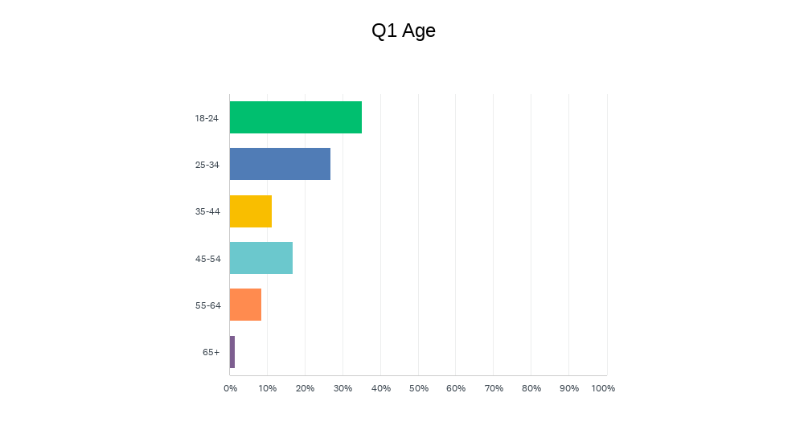
Figure 1 Questionnaire Question 1
The graph above shows that the willingness to do a questionnaire for someone is in the age group 18 to 24. Additionally, the age question was asked to get a range of responses from the different generations. As shown, there were responses from every age group allowing a comparison of the responses from all age ranges.

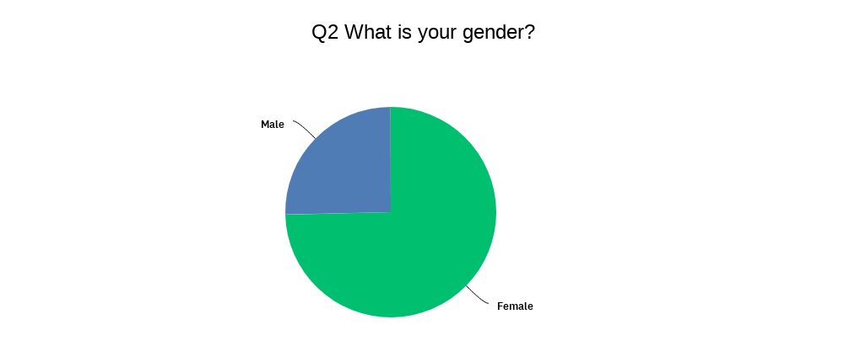
Figure 2 Questionnaire Question 2
In addition to the age question the majority of those who completed the questionnaire were female. Even with this factor, just over a quarter of the participants were male giving the researcher enough to be able to compare the responses of both genders (no other gender was selected).
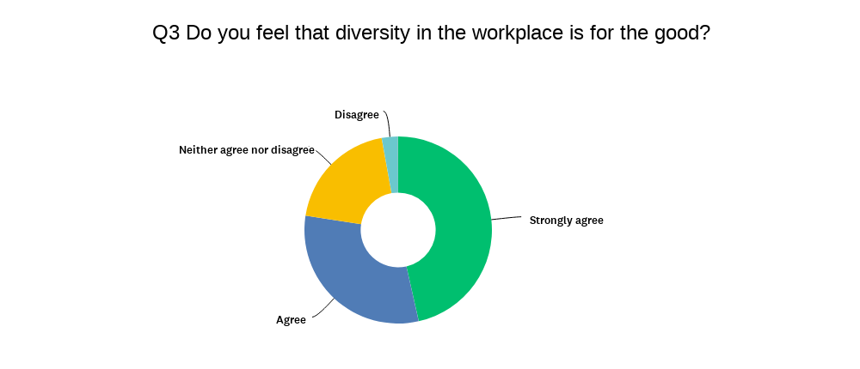
Figure 3 Questionnaire Question 3
This graph above shows us a variation of answers on if diversity in the workplace is for the good or not, the majority have said that they strongly agree that diversity in the workplace is for the good and over a quarter agreed with this statement too. On the other hand, we can see that there were some participants who did not agree or disagree that diversity in the workplace is for the good.
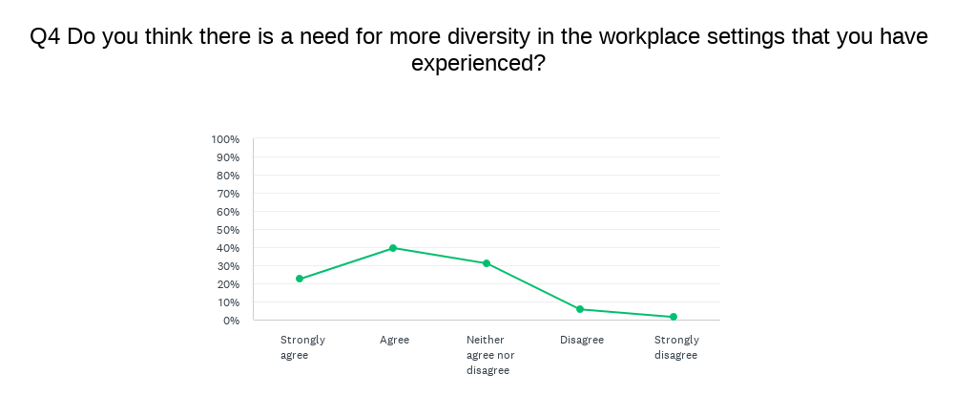
Figure 4 Questionnaire Question 4
This graph above shows the participants’ experience with diversity in the workplace and if more is needed. From the graph above we can see that there is a large group who agree that there is a need for more diversity in the workplace setting that they have experienced. But there is only a small amount who neither agree nor disagree with this.
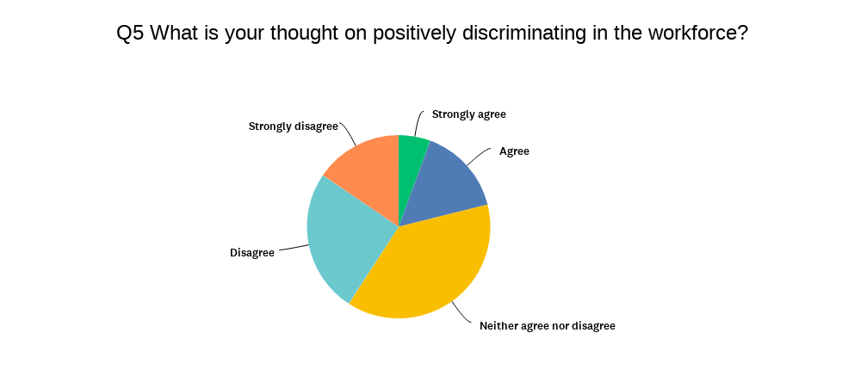
Figure 5 Questionnaire Question 5
When looking at the participants thoughts on positively discriminating in the workforce, from the graph above we can see that nearly half of the participants either disagree or strongly disagree with positively discriminating in the workforce but there are also nearly equal amounts of participants who say they neither agree nor disagree with positively discriminating in the workplace.
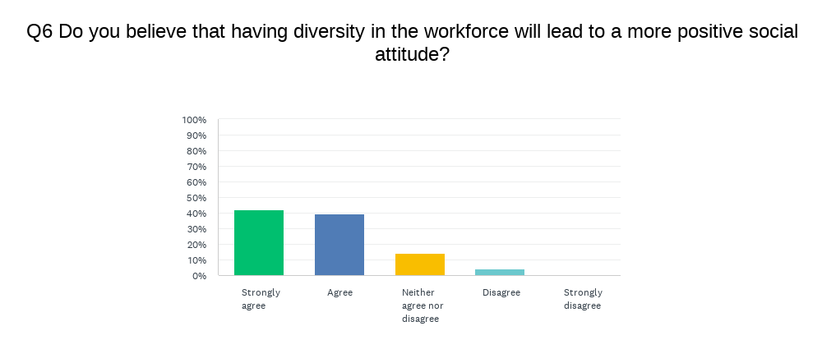
Figure 6 Questionnaire Question 6
From the chart above we can clearly see that most of the participants either agreed or strongly agreed that having diversity in the workfare leads to a more positive social attitude.
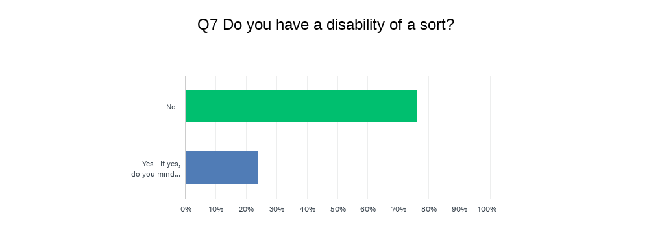
Figure 7 Questionnaire Question 7
When asking the participants if they have any disability of a sort only 17 responded yes as shown in the graph above and the table below. As shown in the table below the 17 that did respond that they had a disability 2 of the participants were not prepared to share their disability the question was optional. For the others who did disclose it shows a range of disabilities.

# YES - IF YES, DO YOU MIND DISCLOSING WHAT DISABILITY (FOR EXAMPLE LEARNING DIFFERENCE, HEARING IMPAIRMENT, ATTENTION SPAN ETC…).
# | Response
1 | Mental Health
2 | Hearing impaired both ears. Use hearing aids.
3 | Dyslexia
4 | Not prepared to share.
5 | Severe mental health
6 | Social anxiety
7 | If it’s counted - I have an intention tremor
8 | ADHD
9 | Panic disorder
10 | Dyslexia
11 | None
12 | Dyslexia
13 | Can’t stand for a long time because of a bad back
14 | Mental health
15 | Epilepsy
16 | Dyslexic and hearing impairments
17 | Dyslexia
Table 1 Answers Yes to Question 7
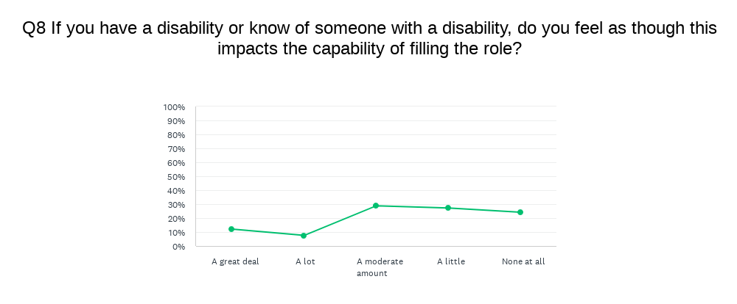
Figure 9 Questionnaire Question 8
From the graph above there is a little discrepancy between those who believe that theirs or someone else’s disability impacts their capability to fulfil their job role a moderate amount, a little, and none. There are some participants who noted that the disability impacts a great deal and a lot. The hope for this is to compare it against those who noted none and see how their opinions and experiences differ.

Q9, do you have anything else to add for example any feelings about dyslexia in the workplace?

24 people answered this question and 47 people skipped the question. Those 24 that answered this question the responses are listed in the table below with two being a no and one N/A.

# | Response
1 | Put all support there if its needed
2 | People need to know more about it and how it effects people.
3 | No, just that it's important for them to get any additional support they need
4 | No one should be discriminated
5 | Workplaces are better at supporting now than they were before.
6 | No
7 | I think people with Dyslexia should be given the most amount of support which is necessary to them, and not to tar all dyslexic people the same way as not all people need the same amount of support.
8 | being dyslexic myself i don't really find that there are many policies on it, would be good to know they are finally recognising it
9 | Everyone has a part to play and with aids put in place if needed (whether it’s a mentor, laptop, special technology) this can make it a level playing field. It just needs flexibility on the side of the company
10 | We have a person with both dyslexia and dysmnesia, no problem at all
11 | It’s difficult for me but a dyslexic “can” cause serious harm/death in the role that I train people for: aircraft engineer. Instructions are specific and must be completed in a tight timescale without any errors or omissions as it a mistake can result in the death of a lot of people
12 | No
13 | With the right support there is no reason someone with dyslexia cannot fulfil a job role like any other employee.
14 | No
15 | I have worked closely with people that have dyslexia. I feel there is sometimes prejudice placed against them. And I feel that sometimes they are not often given the support they may need. Whether that be directly from their employer or the fellow colleagues. But with positive support they can flourish, function, and perform as valued team member.
16 | Same as any other disability in the workplace
17 | My boss is dyslexic however he is still able to run a very successful business with employees around that are there for proofreading his emails and work should it be required but it has not stopped him from becoming a chartered surveyor with several employees and businesses with solid turnovers
18 | N/A
19 | I work with a dyslexic colleague, and he is one of the best at dealing with customers. All that a workplace needs to ensure is support from colleagues and managers and encouraging diversity and inclusiveness.
20 | No, I feel like everyone should be given a fair chance regardless of what disability said person has. I have worked with many disabled people in various roles, and they are honestly the hardest working people I have ever met!
21 | I run a business but have never had anyone work for me so I cannot comment on diversity as I have never worked with anyone else
22 | Depends on the situation. You'd expect to be told so you can provide extra training rather than pick up on slight aspects of poor quality of work.
23 | People with Dyslexia should be given equal opportunities no matter what. As a HR Manager, when it comes to Talent Acquisition this is something we witness first hand. For example, prehire assessments. These should be taken into consideration, but a new hire should never be based solely on the ability to carry out a task that will only relate to a small percentage of their duties. In addition, dyslexia may fail someone with regards to their ability to process information, however, it has been known to enhance different areas of someone’s personality, including enhanced creativity and problem solving.
24 | People shouldnt be labelled but if they can be supported that’s much better
Table 2 Questionnaire Question 9

Results - Thematic analysis

Qualitative research studies
The primary aim of the research was to analysis and discover how dyslexia is being dealt with in the workplace. A thematic analysis was used to explore the specific research questions and these questions include: Is there still a stigma around hiring individuals with dyslexia? What support is there for dyslexia in the workplace? and What are the reasonable adjustments a workplace can make to support an employee with dyslexia? From the transcript seven themes were drawn out, the main theme found was workplace understanding, this is then followed by six sub themes, these sub themes are: lack of understanding; self-ambition; support; job roles; equality; and work impacts.
Theme | Supporting quotes
Workplace understanding | The workplace is not that knowledgeable on the difficulties of having dyslexia.  Colleagues may start to think that they are better than you.  Workplace knows about their dyslexia, but they are unsure if the workplace took any notice of it.  The participant felt that everyone was the same as they are if anything the participant feels better about themselves that they were chosen for the position over all the other candidates to fill the only open position.  The participant believes that it should be more accessible to individuals who must live and work every day with dyslexia.  Notes that the education circumstances treat dyslexia better in the participants experience in the workplace you are made to get on with your work as if you haven’t got dyslexia.  Job interviews should be done on the individuals’ abilities and not their disabilities nor to please the minorities.  The participant does not see how someone with a disability should not be treated the same.  Doing write ups and tests it can take the participant longer than others to do.  It sometimes takes participant longer than others to read and write information down.
Sub-Theme
- Lack of understanding
- Self-Ambition
- Support
- Job roles
- Equality
- Work impact
Table 3 Thematic Analysis Theme Tabel
The theme of workplace understanding is the main theme as it links the sub-themes together. The sub-theme of lack of understanding, support, equality, and work impact are all linked to the understanding of the workplace. The sub-theme of lack of understanding became a sub-theme because the participant noted a few times about this lack of knowledge on dyslexia in the workplace. The sub-theme self-ambition or ambition come to be a sub-theme due to the feeling of achievement that the participant felt in their response to question two. Support or workplace support came to be one of the sub-themes by interpreting what the participant said we can notice that the key word support appears where support may be better in other areas and not so good in some. Next the sub-theme job roles or appropriate job types was found to be a sub theme as it was felt it was important to note a comment that the participant made about the person needing to be suitable for the role and not the business trying to tick a box. As we know everyone has the right to be treated as an equal and this comes through in the participants responses leading us to the sub-theme of equality. Lastly the sub-theme work impact or the impact on work was found in the participants responses also where they tell us how their dyslexia personally affect their ability in the workplace.

Following the thematic analysis on the case study interview, 6 sub-themes were found relating to the participants responses, a list of the questions asked to the case study participant can be found in appendix B.
To begin with, the lack of workplace understanding, this theme appeared in 3 of the participant’s responses to questions 1, 3, and 9. The interpretation to the participants response of ‘Yes, but the workplace is not that knowledgeable on the difficulties of having dyslexia’ is that the workplace has a lack of understanding of dyslexia showing the theme of a lack of workplace understanding. Following this was question 3 and 9, where the participants responded to question 3 by saying ‘Yes, because the colleagues may start to think that they are better than you and that you are a lower level than they are as the participant has dyslexia and spells phonetically meaning when they need to write it may get noticed that they have trouble spelling’, and the participant’s response to question 9 was ‘The participant thinks that their workplace knows about their dyslexia, but they are unsure if the workplace took any notice of it.’ The interpretation taken from the response for question 3 was that the participant felt that the issues are with the co-workers and not their disability. Similarly, the interpretation taken from the participant’s question 9 response was that the workplace may not know what dyslexia is, or that they do not mind the participant having dyslexia.
The second theme found was ambition. This theme showed up in only one of the question responses, this being the response to question 2. The response to question two was ‘No as the participant felt that everyone was the same as they are if anything the participant feels better about themselves that they were chosen for the position over all the other candidates to fill the only open position.’ This was then interpreted that having a disability has not discouraged the participant and they have a feeling of achievement. This interpretation shows us that the participant has ambitions even with a disability like dyslexia.
The third theme found was workplace support, this theme showed up in the participant’s responses to question 4 and question 10. The participant’s response to question four was that they believe in other organisations or sectors yes, but in the participant’s role it was a no. This may be because the participant’s role is very number orientated, and they do not find this side of work difficult. Regarding the tools that are out there to support dyslexia in the workplace the participant believes that it should be more accessible to individuals who must live and work every day with dyslexia. To interpret this would be to say that the participant believes that workplace support for dyslexia should be more accessible even though they personally do not need the additional support. Following this the other response that had the theme of workplace support was in question 10, but differently the participant notes that the education circumstances treat dyslexia better in the participant’s experience than in the workplace where you are made to get on with your work as if you have not got dyslexia. The interpretation of this response is that disability is treated better in education than the workplace, showing us that the workplace support needs to be worked on.
The fourth theme is appropriate job type. The theme of appropriate job type only came up in one of the participant’s responses and this was to the fifth question asked. The response that the participant gave to indicate the theme appropriate job type was in certain job roles it is a bad thing, for example a wheelchair user can not be a scaffolding person as they will not be able to fulfil their job role. Job interviews should be based on individuals’ abilities and not their disabilities, nor to please the minorities. When interpreting this some jobs just are not suitable for some people, and interviews should be based on a person’s abilities and not the disclosure of a disability.
Fifth theme of equality was also only found in one response. This one was found in the participant’s response to question six. The response to question six from the participant was that the participant does not think it would impact. The participant does not see how someone with a disability should not be treated the same. The interpretation from the participant’s response is that everyone should be treated equally.
Lastly the sixth theme found was the impact on the work, this theme showed up in two of the participant’s responses. These where the responses to questions seven and eight. The participant’s response to question seven and eight where similar where seven was yes, when it comes to doing write ups and tests it can take the participant longer than others to do the activities. The interpretation to the question seven response is that by having a disability it may cause some activities to take longer to complete. Like question seven the participant’s response to question eight is yes, like what the participant said to answer question 7, it sometimes takes them longer than others to read and write information down as part of their job. For the interpretation of the question eight response, it is slightly like that of question seven but also different because the interpretation to the participant’s question eight response is that writing and reading information can take longer than normal to complete.
During the case study interview the most dominant threads have been about the impact that the participants’ dyslexia have on their working life and the lack of support that they feel the workplace has to offer due the lack of understanding in the workplace, compared to the participants educational experiences with support and understanding.

Chapter 3 – The Conclusion

Analysis

Quantitative research studies
When comparing some of the results against each other it is noticeable that there are some patterns, for example, from question 7 and looking at just the ones who disclosed that they have a disability like dyslexia and looking at the rest of their responses we can see that from the 5 that state they are dyslexic only one is male but interestingly they are from a range of age groups 18-24, 25-34, 35-44, and 45-54. Still looking at this group of participants none have noted the same response indicating that their dyslexia affect them all differently, from ‘none’ to a ‘great deal’. Only one of these participants notes any other comments- they said that they feel as though workplaces are better now than before for supporting dyslexia in the workplace.

When looking at the other participants that noted that they have a disability not including dyslexia, most of these participants are in the 45-54 age group showing that disabilities may form with age, but there are also ones from 35-55, 25-34, and 18-24. Most of these participants believe that their disability only impacts their capability to complete their job role a little. Some of these participants left comments on their thoughts on dyslexia in the workplace ranging from that no one should be discriminated, to they should be given equal opportunities and finally that they believe that a dyslexic co-worker of theirs is the best person they know at dealing with customers and that workplace just need to make sure the support encourages diversity and inclusiveness.

For the next part the participants will be put into 2 groups- participant group A and participant group B. Group A will be those who disclosed that they have a disability and group B will be those who selected ‘No’.

Now we can compare these results with those of the ones who said that they did not have a disability. Starting with question 3, participant group A, most participants strongly agreed that they feel that diversity in the workplace is for the good. Similarly, most of the participants in group B also said that they strongly agree with diversity in the workplace being for the good. These show that overall, everyone feels that diversity in the workplace is for the good no matter if the participant has a disability or not.

Next, we have the comparison to the results of the participant’s responses to question 4 in groups A and B. For those who are in group A the majority said that they agree that there is a need for more diversity in the workplace setting that they have experienced. Similarly, those participants in group B also said that they agree that there is a need for more diversity in the workplaces that they have experienced. This shows us that overall no matter who you are we see the need for more inclusivity and diversity in workplaces.

Following this for the participants in group A their response to question 5 was different to most of this group’s responses. So far, instead of agreeing, they disagree with positively discriminating in the workplace. In comparison to the participants in group B who also disagree, but there is a big part who neither agree nor disagree with positively discriminating in the workforce. This shows us that most people do not agree with positively discriminating in the workplace, but there are a few that are not sure on their thoughts on the situation.

When looking at the participants’ responses to question 6, in group A we can see that this group of people agree that having diversity in the workplace will lead to a more positive social attitude. In the same way nearly all the participants in group B agree and strongly agree that having diversity in the workplace will lead to a more positive social attitude, the handful that did not agree said that they neither agree nor disagree, showing us that they believe that it should not have an impact. Overall, the results of the responses for question six by both groups we can see that most people agree that diversity leads to a better social attitude.

For question eight the responses given by group A is a mixture of all, showing us that the impact of someone’s disability varies from person to person, even with the impacts on their capabilities of fulfilling their job role. It may be controversial to look at this question from the perspective of individuals without a disability, but their responses hint at how those without a disability perceive those with a disability, even if they do not mean to. To start with only 4 participants from group B said that they believe that a disability like dyslexia will impact an individual ability to fulfil their job role a great deal, similarly only 4 of the participants in group B selected a lot for the impact. This shows that these participants feel as though dyslexia may cause trouble for those in employment. On the other hand, sixteen of the participants in group B selected a moderate amount as the amount of impact on the individual’s job, this shows us that they understand that disabilities do impact on the job but there are ways to handle it from impacting the individuals job role. Lastly the rest of the participants in group B selected a little impact or none and this shows that these individuals may feel that dyslexia that is supported does not impact that individual’s ability to do their job.

Lastly the responses for question nine from the participant group A gave us some themes, these themes include support, discrimination, equality, abilities, and danger to others. To start with, support this theme only shows up in 2 of the responses from participants in group A, these being ‘workplaces are better at supporting now than they were before’ and ‘All that a workplace needs to ensure is support from managers and colleagues.’ Following this in participant group B, 7 of the responses were seen with the theme of support, this could be because there were 8 more responses or possibly even due to the fact people without dyslexia expect those individuals with it to be supported, for example ‘I think people with dyslexia should be given the most amount of support’ and ‘with positive support they can flourish.’

The theme discrimination appeared in the responses from the participants in group A once and in participant group B once. For the response in group A, it was as simple as just saying ‘No one should be discriminated’. In the response from the participant in group B, the participant said that they felt as though there is a prejudice against people with dyslexia. These participants show us that even though we all say we do not want to discriminate we know it is there, and even those without the disability can see and feel it.

Equality is the most prominent theme in both sets of participant group responses. In group A the theme equality showed up in 2 of the responses, and in group B it showed up in 5 of the responses. Starting with the participants in group A, they tell us that ‘workplaces need to encourage diversity and inclusivity in the workforce and that dyslexic individual should be given equal opportunities.’ Next, the participants from group B tell us that individuals with dyslexia are not a problem, and that recognising dyslexia is the biggest step towards workplace equality with disabilities. Additionally, when dealing with dyslexia in the workplace, support needs to be given to allow those with dyslexia to have a fair playing field alongside everyone else, and this then gives the individuals with dyslexia a fair chance in the workplace. It could be poor work quality if no extra training is provided, and that individual would need to rely on trying to pick up on aspects for development on their own.

The theme abilities only showed up in 2 of the responses overall from both groups. Firstly, to look at group B’s response, the participant tells us that the effects of dyslexia on individuals needs to be recognised more, following this the participant from group A is from a Human Resources perspective where this participant tells us that an individual should never be based only on their abilities to carry out tasks and that there is so much more to an individual, for example their personality whether that is being creative, or having the ability to solve problems.

Lastly the theme danger to others only presents in 1 response which is in participant group A. This participant just explains to us that it could potentially cause danger to others by having disabilities in certain workplaces, the example they give is the role of aircraft engineers.

Discussion

Qualitative research studies
The objectives that are mentioned in chapter one under aims and objectives, were achieved by doing an in-depth literature review on four key aspects of dyslexia these being dyslexia in the workplace and the perspective of the employee and the business, wellbeing, disclosure and stigma, and support and reasonable adjustments. From the literature review we can see what happens in theory and policy but the research from the qualitative and quantitative data is where we see what happens in practice. From the qualitative and quantitative data, we can determine what the types of issues that individuals with dyslexia face in the workplace. Following these two recommendations will be made as a set of guidelines for businesses to follow for the key areas of this research study namely recruitment, and employment and further support.

With the qualitative research study part of this research dissertation, it is important to say as this was case study research there are many limitations for example it is not a big sample size as it is only one participant, but this has been backed up with 71 participants in the questionnaire research. The age of this participant is not relevant, but they were of working age and had been diagnose whilst in education meaning thieve had plenty of experience with dyslexia and how its discriminated against and how its supported. Lastly the major findings from the study were in the research it shows us that there are plenty of options for giving individuals with dyslexia support and reasonable adjustments, but in the study, it shows us that more support is needed in the workplace.

Summary of the key findings
To summarise the key findings, we would start with the problem statement of the study which is to try and understand how dyslexia in the workplace having can affect individuals and what support is available to these individuals and to also find out the experiences of those individuals with dyslexia and to see what recommendations need to be made to businesses. Following this we have the three research questions that the study answers what is the stigma around dyslexia in the workplace? What support is out there for dyslexia in the workplace, and lastly what reasonable adjustments that can be made?
The results from the study indicate a few different points for example a lack of understanding from peers and employers. Additionally, another point that the study indicates is that unconsciously we discriminate against those with dyslexia. This is our unconscious bias even though we do not mean to, or we do not think that we are, it still may be there for example in the analysis of the quantitative when looking at the theme of discrimination in question ten it told us that discrimination may be there if we want it to be or not and that we may be the cause of the discrimination ourselves. The study then demonstrates a correlation between a lack of understanding of dyslexia in the workplace and the wellbeing of those individual with dyslexia in the workplace such as stress. An example of this is that the participant in the case study tells us that some workplaces may treat dyslexic individuals as if they don’t have dyslexia and are left unsupported. From this we see the unsupported effects in the research from Beetham and Okhai (2017) when they discussed the affects of unsupported dyslexia in the workplace where the individuals would experience a higher level of stress and anxiety.
The analysis confirms that support is the biggest theme that comes across in the study in both the findings of the questionnaire and the results of the thematic analysis. We know this as the case study tells us that a more accessible way of accessing support for dyslexia in the workplace is needed. Following this the number of times that the theme of support appeared in the findings and analysis of the questionnaire were high, especially those who say that more support is needed. Yet on the other hand the research tells us that there is plenty of support out there for individuals with dyslexia in the workplace such as reasonable adjustments that Kirby and Gibbon (2018) gives such as on a practical level adjustments can be made during requirment, some alternative ways of doing tasks, supplying new equipment, giving training, and a refreshment and recreation facility.
The data from the study suggests that most of the participants believe that no one should be discriminated and that everyone should be treated equally no matter their disability. On the other hand, the research explains that even if support is given there is a possibility of it fading away (Bewley & George, 2016). In support of this Cullen et al. (2019) explains the only way forward to disclosure and equality in the workplace for those with dyslexia, awareness on how dyslexia can present and affect a person is needed in addition to the discouragement of judgement and stigma.

Interpretations
In line with the study a correlation that can be made between the analysis of the data, the thematic analysis, and the research is that individuals with dyslexia all have unique challenges and that their dyslexia will affect them differently even with the same diagnosis. To further explain this the data show us this with the responses from question eight where it shows us the different levels of participant understanding but the majority show us that ther is a understand that dyslexia does impact on the dyslexic individual’s job, and that there are ways to handle it from impacting the individuals job role as it affects them all differently. The studies thematic analysis shows it when the participant said in their response to question four that their dyslexia dose not affect them in the numerical sense and only with reading and spelling, whereas from the research by (Moody, 2015) we see that dyslexia can affect more than just their reading and writing, for example memory, processing, and motor skills. Additionally, the research by (Beetham & Okhai, 2017) tells us that challenges that individuals face in the workplace depend on the dyslexic individuals’ unique challenges, their role, and the environment they work in.
Contrary to the correlation between the analysis of the data, the thematic analysis, and the research a related difference that is shown is that education is a big factor in an individuals dyslexia moving forward into the workplace. Education was not brought up in the data part of the study, but it can be found in the thematic analysis of the case study where they explained to us that from their experience of the treatment of dyslexia in the workplace that they believe that dyslexia is treated better in education, support wise. The research from Hećimović (2019) that explained that obstacles that dyslexic individuals faced in education are continued into the workplace does however go on to tell us that the biggest challenge that dyslexic individuals faced in education was uneducated teachers, this is similar to the key findings of a lack of understanding of dyslexia.

The implications
These results of more support is needed in the workplace both seen in the thematic analysis and the data, build on the existing evidence from Harriss and Cooper (2005) where we are told that to be able to support dyslexia properly the ones who are supplying the support such as the employer needs to have a full understanding of how dyslexia can affect an individual. The results from the data of participants disagreeing with positively discriminating against dyslexia in the workplace does not fit with the organizational adaption theory (Burgelman, 1991). This is because it shows us that organizations arent adapting they may simply be purposely trying to tick a box by having diversity in the workplace.
The study provides a new insight into the relationship between the stress theory and the theory of self-determination. This is shown through the results of the study such as in the research we learn that the stress theory is expressed in the research by the APA (2013) where they a explain a little bit of stress can be good but if you let it develop into chronic stress it can cause physical and mental problems. This leads us to the insight of a self-determination because instead of stress we can see determination instead. An example of self-determination is from the study participant from the case study who tells us after getting offered a job out of a selection of people they had a sense of achievement. The results from the study show that theres a willingness to disclose a disability like dyslexia now, should be considered when considering how to make recommendations in the conclusion section.

The limitations
The generalisability of the results is limited by the sample size because the qualitative study as this was only a one participant case study, but the results are then backed up by the quantitative study as 71 participants participated with the questionnaire. The reliability of this data is impacted by the questionnaire participants, this is because they were not selected meaning they may not be that knowledgeable and could give answers they believe you are looking for and not what they believe. Due to the lack of available data, the results cannot confirm most of the research that was conducted before the study. If a follow-up research question was to be considered for if this study was to be picked up the next question that would need to be addressed the theme of support and workplace understanding further, as I feel that further knowledge and explanation to why there is a lack of knowledge and support in the workplace for dyslexia is important.

Recommendations and Conclusions

Recommendations
For this study 2 recommendations will be given but it will differ person to person as every individual’s needs are different as proven in the study even if 2 individuals have the same diagnosis, they will not always have the same difficulties, jobs, or environments.

The first recommendation that will be made to organisations at the recruitment stage is if the disability such as dyslexia is disclosed, to not to only focus on that factor. An example of this would be to ask about their experiences in dealing with situations where something like dyslexia may usually cause issues in the workplace but they were able to overcome it. This is because it is important because it allows the employers to learn before employment what support and strategies that the individual needs to have in place to be able to complete their role to the best of their ability.

Lastly the second recommendation that will be made to the organisations is for the employment stage and further support. This recommendation is to make weekly or even daily check in meetings to see how the individuals are coping in their position and to also see if there is anything additional, they may need to fulfil their role. This is important because there are five main benefits to weekly check ins not check-ups. These benefits being the ability to build trust and loyalty, access for faster resolutions of issues, boost the productivity of everyone, give staff motivation, and the ability to improve everyone’s skills (Ainomugisha, 2019).

Conclusion
The research aimed to identify the stigma around dyslexia in the workplace, what reasonable adjustments and support is available to those individuals with dyslexia. Based on the quantitative and qualitative analysis of dyslexia in the workplace and the individuals’ experiences, it can be concluded that support and understanding are important factors to consider when having dyslexic individuals in the workplace. The results indicate that there is a willingness to accept and support dyslexia in the workplace but more education on the disability is needed to make that step forward.
This research took the mixed methods approach to gain a deeper knowledge by having an in-depth interview with a case study participant and having the ability to back it up and compare it to the 71 participants from the questionnaire and their knowledgeable but simplified responses. It was expected to find that even with more knowledge on dyslexia that there would still be some discrepancies with it when it comes to the workplace. The research matched the expectations well as we could see from the case study, they explain this lack of knowledge in the workplace but the education sector where more supportive. In the process some questions raised such as those on support, as seen throughout the research support was a key theme with participants saying more was needed, but why is this? In the literature we are shown that our knowledge and understanding of dyslexia has improved yet theres a lack of support in the workplace.
To conclude this study on dyslexia in the workplace and how human resources have a role in supporting those individuals through recruitment, employment, and any further support that’s needed. From the literature review it is clear to see that there are gaps in the research as there isn’t much recent research out there and where there is plenty of research there are big gaps in the years the research was conducted.

References

Ainomugisha, G. (2019, September 25). The Weekly Check-In: How to Do It and Why They Are So Effective. The 6Q Blog. https://inside.6q.io/the-weekly-check-in/
Alexander-Passe, N. (2015). The Dyslexia Experience: Difference, Disclosure, Labelling, Discrimination and Stigma. Asia Pacific Journal of Developmental Differences, 2(2), 202–233. https://doi.org/10.3850/S2345734115000290
APA. (2013). How stress affects your health. Https://Www.Apa.Org. https://www.apa.org/topics/stress/health
Authentically Emily. (2022, March 27). A Day in the Life of a Neurodivergent vs a Neurotypical. Authentically Emily. https://www.authenticallyemily.uk/blog/a-day-in-the-life-of-a-neurodivergent-vs-a-neurotypical
Bates, M. (2020). Dyslexia Statistics, Facts and Figures. Dyslexia Reading Well. https://www.dyslexia-reading-well.com/dyslexia-statistics.html
Beetham, J., & Okhai, L. (2017). Workplace Dyslexia & Specific Learning Difficulties—Productivity, Engagement and Well-Being. Open Journal of Social Sciences, 05, 56–78. https://doi.org/10.4236/jss.2017.56007
Bewley, H., & George, A. (2016). Neurodiversity at work | Acas. https://www.acas.org.uk/neurodiversity-at-work-report
British Dyslexia Association. (2020). Legislation. British Dyslexia Association. https://www.bdadyslexia.org.uk/advice/employers/how-can-i-support-my-dyslexic-employees/legislation
British Dyslexia Association. (2022). Reasonable Adjustments in the workplace. British Dyslexia Association. https://www.bdadyslexia.org.uk/advice/adults/in-the-workplace/reasonable-adjustments-in-the-workplace
Brunswick, N. (2012). Dyslexia: A Beginner’s Guide. Simon and Schuster.
Burgelman, R. A. (1991). Intraorganizational Ecology of Strategy Making and Organizational Adaptation: Theory and Field Research. Organization Science, 2(3), 239–262. https://doi.org/10.1287/orsc.2.3.239
Cullen, J., Darby, L., & Rahmani, M. (2019). Dyslexia: An invisible disability. British Journal of Hospital Medicine, 80(8), 426–427. https://doi.org/10.12968/hmed.2019.80.8.426
de Beer, J., Engels, J., Heerkens, Y., & van der Klink, J. (2014). Factors influencing work participation of adults with developmental dyslexia: A systematic review. BMC Public Health, 14(1), 77. https://doi.org/10.1186/1471-2458-14-77
DyslexiaHelp. (2022). The Many Strengths of Dyslexics. http://dyslexiahelp.umich.edu/dyslexics/learn-about-dyslexia/what-is-dyslexia/the-many-strengths-of-dyslexics
Greene, K. (2009). An integrated model of health disclosure decision-making. Uncertainty and information regulation in interpersonal contexts: Theories and applications. Routledge.
Hagan, B. (2014). Dyslexia in the workplace—A TUC guide (third edition). Trades Union Congress.
Harriss, A., & Cooper, R. (2005, March). Dyslexia in the workplace. Occupational Health, 57(3), 25–28.
Headstart. (2021, January 12). Supporting dyslexia at work: What can HR do? Headstart. https://www.headstart.io/insights/supporting-dyslexia-at-work/
Hećimović, E. (2019). Understanding People with Dyslexia Support Strategies for Students and Employees [Info:eu-repo/semantics/bachelorThesis, RIT Croatia]. https://urn.nsk.hr/urn:nbn:hr:229:723539
HR Dept. (2018). Dyslexia in the workplace. The HR Dept. https://www.hrdept.co.uk/blog/dyslexia-in-the-workplace/
Kirby, A. (2014). How to Succeed in Employment with Specific Learning Difficulties: A Guide ... - Amanda Kirby—Google Books. https://books.google.co.uk/books/about/How_to_Succeed_in_Employment_with_Specif.html?id=nVXTBQAAQBAJ&redir_esc=y
Kirby, A., & Gibbon, H. (2018). Dyslexia and Employment. Perspectives on Language and Literacy, 44(Winter), 27–31.
Malpas, M. (2012). Dyslexia in the Workplace. British Dyslexia Association. - References—Scientific Research Publishing. https://www.scirp.org/%28S%28351jmbntvnsjt1aadkposzje%29%29/reference/referencespapers.aspx?referenceid=2054740
Modini, M., Joyce, S., Mykletun, A., Christensen, H., Bryant, R. A., Mitchell, P. B., & Harvey, S. B. (2016). The mental health benefits of employment: Results of a systematic meta-review. Australasian Psychiatry, 24(4), 331–336. https://doi.org/10.1177/1039856215618523
Moody, S. (2015). DYSLEXIA, DYSPRAXIA and ADHD in EMPLOYMENT: A View from the United Kingdom. Career Planning & Adult Development Journal, 31(4), 142–150.
Morris, D. K., & Turnbull, P. A. (2007). The disclosure of dyslexia in clinical practice: Experiences of student nurses in the United Kingdom. Nurse Education Today, 27(1), 35–42. https://doi.org/10.1016/j.nedt.2006.01.017
OHC. (2013, April 30). Adult Dyslexia & Neuro-Differences in the Workplace. Occupational Health. https://www.occupationalhealthltd.co.uk/blog/dyslexia-in-the-workplace/
Rutigliano, P., & O’Connell, M. (2013). Employees with disabilities the forgotten diversity segment: Tracking trends. New Yourk: Sirota/NOD.
Sauter, D. L., & McPeek, D. (1993). Dyslexia in the workplace: Implications of the Americans with disabilities act. Annals of Dyslexia, 43(1), 271–277. https://doi.org/10.1007/BF02928186
Shaywitz, S. E. (2003). Overcoming dyslexia: A new and complete science-based program for reading problems at any level. New York: Alfred A. Knopf., 26.
the British psychological society. (1999). The dyslexia debate continues | The Psychologist. https://thepsychologist.bps.org.uk/volume-18/edition-12/dyslexia-debate-continues
The Dyslexia Association. (2016, September 9). Equality Act and Dyslexia—The Dyslexia Association—The Dyslexia Association. https://www.dyslexia.uk.net/employers/equality-act/
Tomas, V., Ahmed, H., & Lindsay, S. (2022). Unravelling the Complexities of Workplace Disclosure Among Persons with Non-Visible Disabilities and Illnesses: A Qualitative Meta-Ethnography. Journal of Occupational Rehabilitation. https://doi.org/10.1007/s10926-022-10023-0
von Schrader, S., Malzer, V., & Bruyère, S. (2014). Perspectives on Disability Disclosure: The Importance of Employer Practices and Workplace Climate. Employee Responsibilities and Rights Journal, 26(4), 237–255. https://doi.org/10.1007/s10672-013-9227-9
Weber, J. G. (2010). Individual and Family Stress and Crises—Janice Gauthier Weber—Google Books. https://books.google.co.uk/books?hl=en&lr=&id=F3FxYyjo4a4C&oi=fnd&pg=PP1&dq=individual+stress+theory&ots=Y03YtilzDN&sig=KpHrjpky_Ye2P6cMeb1ppplRCmw#v=onepage&q=individual%20stress%20theory&f=false

Appendices

Appendix A – Participant Agreement form Template

Participant Name ________________________
Interviewer Name - Caitlin Faye Innes.
Interviewer Programme of Study - BA Business and Management
Research Learning Tutor - Dr Roisin Mullins & Dr Alex Bell, UWTSD
Participation Agreement to be interviewed:
I agree to participate in the research concerning a research dissertations qualitative data on dyslexia in the workplace. I understand that the purpose of this study is to examine my experiences about diversity and dyslexia in the workplace and what has been experienced personally. I understand that this will involve me in a short 20 to 45-minute interview.
I understand that this interview will be recorded and transcribed for use only in Caitlin Faye Innes’ undergraduate research methods course and dissertation at the University of Wales Trinity Saint David.
I understand that my name or any reference to my identity will be kept anonymous in this study and for any subsequent publications I will be asked again for my consent. I understand that use storage of the recordings and transcriptions relating to this interview will be anonymous; not be used for any other purpose than this study and will be subsequently destroyed after the use intended here.
I understand that I may withdraw from the study at any point with all records of my contribution removed without having to provide a reason.
Interviewee Signature:
Interviewer Signature: CGFInnes.
Date of Interview: 25.03.2022
A copy of this agreement should be retained by both interviewer and interviewee.

Appendix B – Questionnaire questions
Questionnaire –
- Age
- 18-24 (1)
- 25-34 (2)
- 35-44 (3)
- 45-54 (4)
- 55-64
- 65>

- Gender
- Female
- Male
- Non-binary
- Other
____________________________

- Do you feel that diversity in the workplace is for the good?
- Strongly Disagree (1)
- Disagree (2)
- Neither agree nor disagree (3)
- Agree (4)
- Strongly agree (5)

- Do you think there is a need for more diversity in the workplace settings that you have experienced?
- Strongly Disagree (1)
- Disagree (2)
- Neither agree nor disagree (3)
- Agree (4)
- Strongly agree (5)

- What is your thought on positively discriminating in the workforce?
- Strongly Disagree (1)
- Disagree (2)
- Neither agree nor disagree (3)
- Agree (4)
- Strongly agree (5)

- Do you believe that by having diversity in the workforce that it will lead towards a more positive social attitude?
- Strongly Disagree (1)
- Disagree (2)
- Neither agree nor disagree (3)
- Agree (4)
- Strongly agree (5)

- Do you have a disability of a sort?
- Yes
- No
If yes, do you mind disclosing what disability (for example learning difference, hearing impairment, attention span etc…)
___________________________________________________________________

- If you have a disability or know of someone with a disability, do you feel as though it affects their ability to do yours or their job?
- Strongly Disagree (1)
- Disagree (2)
- Neither agree nor disagree (3)
- Agree (4)
- Strongly agree (5)

- Do you have anything else to add for example any feelings on dyslexia in the workplace?
___________________________________________________________________

Appendix C – Interview questions
- Do you feel that your workplace is giving you enough relevant support to help you with your dyslexia whilst doing your job?

- Do you believe that you were seen to be at a disadvantage to others at the recruiting stage?

- Do you feel that there is a stigma around being dyslexic in the workplace?

- Do you think that business know about what support to give for dyslexia and what tools are out there to do this?

- What is your thought on positively discriminating disabilities in the workforce?

- Do you believe that by having diversity in the workforce that it will lead towards a more positive social attitude?

- Do you feel that your dyslexia influence your ability to do your job?

- Have you personally come across any challenges caused by your dyslexia whilst at work?

- Does your workplace know of your dyslexia if you don’t mind me asking?

- Do you have any other comments that you would like to make?

