Reflective
Portfolio

Abdi Rahman
Professional and Career Development
BMSW 4005
Shahida Yasmin – 1813926
31 January 2020

CONTENTS
Contents……………………………………………………………………………..  Introduction – Part A………………………………………………………….........  What is KNOWLEDGE?...................................................................................  What are SKILLS?...........................................................................................  What is means to work effectively………………………………………………...  Time Management………………………………………………………………….  Readiness for employability………………………………………………………..  Personal advancement……………………………………………………………..  Personal Development Plan……………………………………………………….  What is a S.W.O.T Analysis?……………………………………………………  My S.W.O.T Analysis……………………………………………………………….  What is a Johari Window?….……………………………………………………...  My Johari Window – Shahida Yasmin.……………………. …………………….  My Personal Development Plan…………………………………………………..  Conclusion…………………………………………………………………………..  Introduction – Part B……………………………………………………………….  Finding a Job………………………………………………………………………..  Importance of Job Advertisement…………………………………………………  Definition of Recruitment and Selection………………………………………….  Employment Law……………………………………………………………………  Importance of a CV…………………………………………………………………  My Journey to getting a Job……………………………………………………….  Appendix  C.V…………………………………………………………………………..  .  Feedback……………………………………………………………………  .  References………………………………………………………………………… | Page  2  3  4  4-5  5  5-6  7  7  8  8-9  10  11-12  13  14  15  16  17-19  19  20  20-21  21-22  22-24  25-29  30  31-34
INTRODUCTION

PART A
In this report I will be finding out what Skills and Knowledge are and why they are needed for working effectively. Another very importance factor to look at was Time management and how best to use this to be more productive.

I will also be finding out about the various theories of self-awareness and applying these theories to myself to help me improve myself in my personal and professional life.

WHAT IS KNOWLEDGE?
Knowledge is like a key. It is all about “information, facts, awareness, understanding something or someone”, and appreciation. To gain all this knowledge, it would have come from various sources such as “experience, education, discovering or learning”. (En.wikipedia.org, 2020)
Having the knowledge about how to cook a dish, how to play golf or how to change a car tyre is not the same as having practical skills. (Open.edu, 2020)
Knowledge is gained by a lot of things around us, such as “reading, watching, listening, touching”, and studying to name but a few. Skills on the other hand, “refer to the ability to apply knowledge to specific situations”. You can have all the knowledge of a sport, but this does not mean that you will be able to play. In order to play, you need to develop the skills through practise.
“Practice is the only way to develop skills: The more you do something, the better you get at doing it”. (eLearning Industry, 2020)

(Lifetechbrussels.com, 2020)
What are SKILLS?
“Skills are the knowledge and the ability that enables you to do something well”. (Dictionary.cambridge.org, 2020)
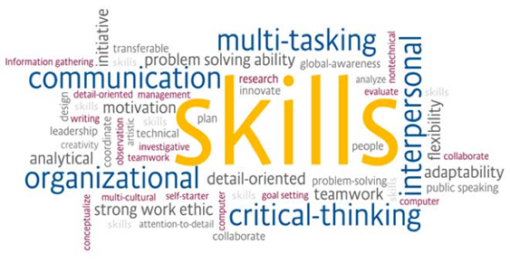
(http://ijobs.rutgers.edu/wordpress, 2020)

“A great example would be that of a parent, where you have to develop a lot of skills such as childcare skills, organizing, cooking, life skills, stress management, time management, budgeting, behaviour management and many more”. (Open.edu, 2020)

WHAT IS MEANS TO WORK EFFECTIVELY
To be able to work effectively, you must able to make the most out of your time and use it to your advantage to get the most out of your workload. This eliminates the risk of distractions yet improves communication and helps with keeping stress levels down. (Mindtools.com, 2020)
The biggest issue of all is Time Management. Once you can manage your time effectively, then your working day will most definitely be productive.

TIME MANAGEMENT
It is very important to be able to manage your time well as this will help you the most in making your working day effective. You need to be organised plan ahead and prioritise your work, set yourself targets, delegate if you must and learn to say no to any extra work from colleagues, if required.
Below are the 4D’s of Time Management broken down to briefly explain how to manage your workload effectively.

- DO
This is the most important of the four sections. Here are jobs that are important as well as urgent, so these need to be attended to first. These tasks cannot be deferred, delegated or delete.
- DEFER
This is not as important as the DO section, and they are also the non-urgent jobs and therefore can wait but still need attending to.
- DELEGATE
This section is not important, and therefore can be delegated. These are jobs like meetings or checking e-mails or any other interruptions that might crop up.
- DELETE
This is the least important and the least urgent section of all four D’s. These are things that can be deleted as they are not necessary.
By arranging your workload using the 4 D’s, it would make your day a lot more productive.

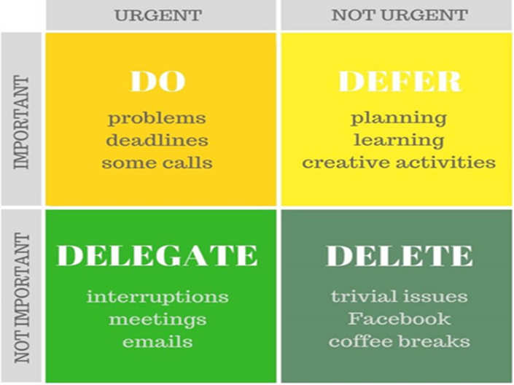
(Stepshot,2020)

READINESS FOR EMPLOYABILITY
This simply mean having the skills that are required by employers.
Employers want better productivity with jobs completed on time and to be able to reach their goals and achieve their targets. Therefore, having employability skills is very important in order to be hired, as you will not be the only one who is applying for that vacancy. To be hired you must have skills that no one else has and to be able to stand out amongst so many other candidates. (Smallbusiness.chron.com, 2020)

PERSONAL ADVANCEMENT
Personal development is an ongoing process. “It is a way for people to assess their skills and qualities and consider their aims in life and set goals in order to realise and maximise their potential.” (2011-2020, 2020)
Personal development is a crucial part of growing and improving yourself. This helps you to become more confident, and happy within yourself by improving your own identity along with improving your skills and knowledge.
The way to keep track of your personal development is by making a Personal Development Plan, a PDP.
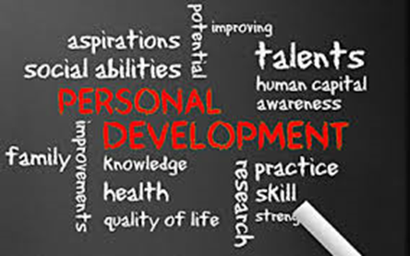
(Intelligenthq.com, 2020)
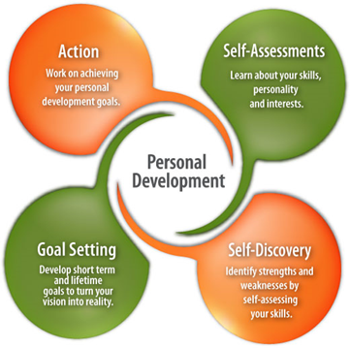 | 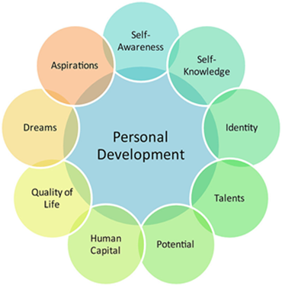
(Connect.supplysideshow.com, 2020) (Flickr, 2020)

These diagrams above are also highlighting key points of Personal Development to improve yourself and achieve more.

PERSONAL DEVELOPMENT PLAN
It is a very good idea to get to know yourself and your future plans by drawing up a PDP using different types of analysis and assessments. Below are a few I did for my personal development.
- S.W.O.T Analysis
- Jo Hari Window
- Belbin Test 123 (see Appendix)

WHAT IS A S.W.O.T ANALYSIS?
The main purpose of the S.W.O.T analysis is to find out your strengths, weaknesses, opportunities and threats in order to help you understand yourself better.
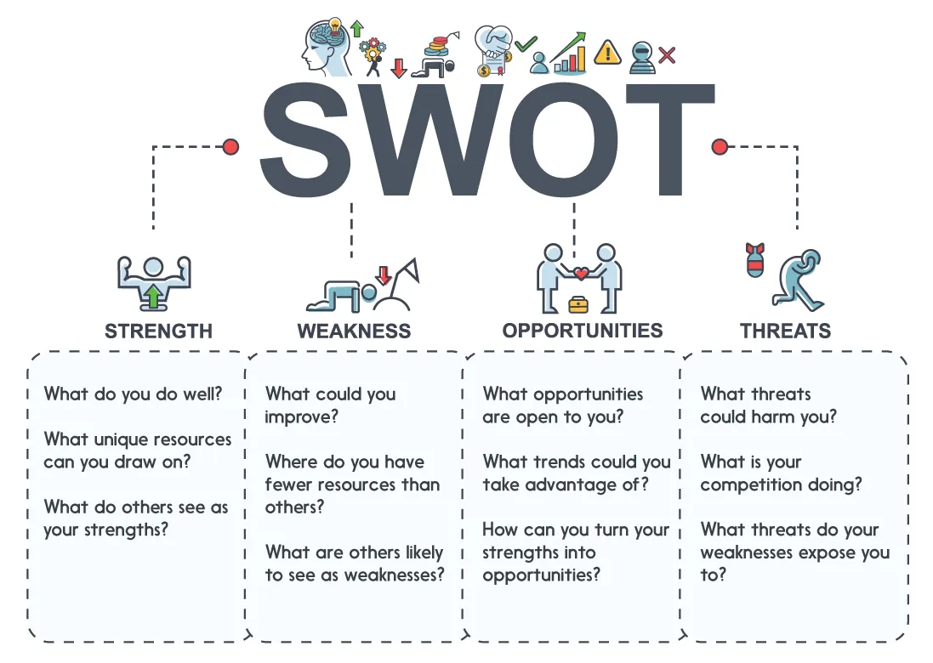
(Saraswat, 2020)
This is a S.W.O.T analysis done on myself. I found this a bit difficult to do at first, as I was not habit of talking about myself or pin-pointing various facts all in one go.
However, I found this analysis very good, as it made me see my strengths, weaknesses, opportunities and threats all in one grid in-front of me. I have never done anything like this before, so this was all new and impressive to me. With this analysis I was able to view my own S.W.O.T right in-front of me rather than just think about what them.

STRENGTHS | WEAKNESSES
- Passionate and self-taught Make-up Artist  - Knowledge of social media  - Helpful and always available  - Self-taught Hair Stylist  - Friendly and cheerful  - Self-taught Henna Artist  - 8 years of secretarial experience  - Achieved NVQ Business  - Administration Level 1 and 2  - Achieved CLAIT (Computer Literacy And Information Technology)  - Achieved RSA Word Processing 1, 2.1, 2.2 & 3.1  - Very patient  - Creative  - Worked in big firms  - Enjoy learning  - Very good PA skills  - Very good communication skills  - University student  - Fluently in English and Patwari | - Shy and afraid to speak up  - Public speaking/debating  - Always busy running around my parents and children  - Lack of family support  - Lack of confidence  - Need to brush up my office skills  - Not able to express myself  - Lack of time  - Fear of Failure  - Fear of wasting my time  - Not able to give family enough time  - Not able to finish University if a good job is offered
OPPORTUNITIES | THREATS
- More money  - More opportunities  - 8 years of secretarial experience  - Self-employed Makeup Artist (MUA)  - New career and new start will bring fresh opportunities  - If self-employed, my own hours  - Get more MUA training | - My family commitments take up most of my time  - Competition from other candidates  - Competition from other MUA’s  - Difficult clients  - Investment required to be self-employed
What is a Johari Window?
A Johari window is a method of communication and a way of improving self-awareness within yourself. It was developed by Joseph Luft and Harry Ingham in 1955 to help people learn more about themselves and each other through the ‘Johari window’.
The theory behind this is very simple. As mentioned in the (Educational Business Articles, 2020), “the more others understand you and the more you open up to each other, the more rapport, and trust is developed and as a result, relationships can strengthen”.
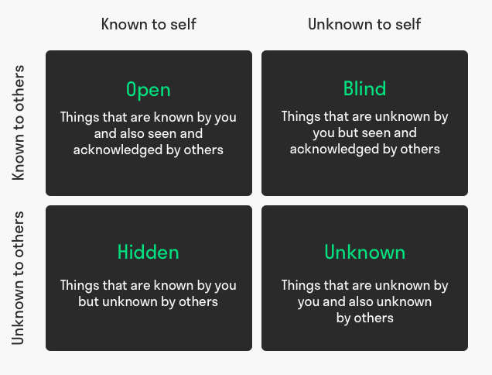
(Mulder, 2020)
The Johari theory of consists of 4 windows, the open area, the blind area, the hidden area and the unknown area, and this is what they mean.
- Open area
This window holds information such as feelings, emotions, behaviour, skills and attitudes, which are known to the individual person and by others.
- Blind area
This area is small as it holds information about you, which is only known to others, but you are unaware of them.
- Hidden area
This information is about yourself which will be kept hidden from others, such as secrets, feelings, past relationships, fears. These are mainly personal and private information
- Unknown area
Information in this area are the ones you are unaware of and so are others. This could include deep feelings, past experiences that are better forgotten, or even traumatic events in the past which could remain unknown for a lifetime.
(Communication Theory, 2020)
This theory was also very interesting as I found out about myself from fellow students.

JOHARI WINDOW – SHAHIDA YASMIN
OPEN AREA | BLIND AREA
- Happy/Cheerful/Bubbly  - Get on well with everyone  - Outgoing  - Enjoy working alone and with others  - Trustworthy and honest  - Hardworking  - Quite shy  - Friendly and nice  - Happy  - Able  - Well organised  - Dignified  - Calm | - Too sensitive  - Let people get to me too much  - Not confident enough  - Scared of speaking up/debating
HIDDEN AREA | UNKNOWN AREA
- Fear of failure  - Fear of rejection  - Scared of meeting new people  - Petrified of presentations and public speaking/debating  - Lack of confidence  - I don’t make my hidden area obvious, as I hide all these points well | ?

MY PERSONAL DEVELOPMENT PLAN – SHAHIDA YASMIN
What are my Goals? | How to achieve this? | What are the obstacles? | How to overcome my obstacles? | Where can I get support from?
To complete University and get a Degree | Attend UWTSD regularly | Family commitments  Traveling  Lack of family support  Getting back into studying  Fear of failure  Lack of confidence  Scared of presentations, debating, speaking out | Set up a better routine at home  Find shortest routes to travel  Try to convince family to support me  Think positive to overcome fear of failure and lack of confidence  Do my very best to achieve the best I can | The University – UWTSD  Lecturers  Fellow students  Moodle  Supportive friends  Google
Become a self-employed Make-up Artist (MUA) | Get training  Attend Hair and Make-up classes  Enrol in 1-2-1 Academy, Studio classes  Practise at home | Family commitments  Lack of funds – need to pay to get trained up  Travelling  Lack of confidence  Fear of failure | Set up a better routine at home  Find a part-time job  Save the UWTSD student loan  Find shorter routes to travel  Think positive to overcome fear of failure and lack of confidence. Do my very best | Naeem Khan Academy – Bradford  ZBridal Studio – Bradford
Get a better paid job | Get a Degree  Update my administrative skills  Learn new skills and jobs by doing voluntary work | Family commitments  Lack of family support  Getting back into work after a long break  Fear of failure  Lack of confidence  Travelling | Set up a better routine at home  Try to convince family to support me  Think positive to overcome fear of failure and lack of confidence. Do my very best  Find shortest routes to travel | UWTSD  Job centres  LinkedIn  Google  Job Agencies

CONCLUSION
I have found this section to be very interesting. This has given me a new and improved way of thinking about my personal strengths, weaknesses, opportunities and threats. I had never looked at all these in this manner.

The Johari window has also allowed me to get feedback from fellow students and made me realise what I almost knew about myself and also what I did not know about myself.

I strongly believe that the knowledge I have gained from the S.W.O.T analysis and the Johari window will help me greatly and stay with me for along time coming.

INTRODUCTION

PART B

This is a report to see what employers are looking for, when they advertise for a job vacancy. When jobs are advertised, there are certain skills and knowledge that an employee must have in order to firstly, get that vacancy and secondly to be successful in his/her job.

This is a Reflective report focusing on the elements of recruitment. I will be looking at the importance of job adverts including job descriptions to finding the right job and applying for it using a Curriculum Vitae.

FINDING A JOB
Finding a job can be a scary and long process. From knowing where to look for a job to being interviewed, you need to go through the whole process of perfecting your Curriculum Vitae (CV) and making sure that it is up to date and, also preparing for your interview.

Here, I will be looking at the whole process of finding a job to updating your C.V to getting to that interview, and the importance of each stage.

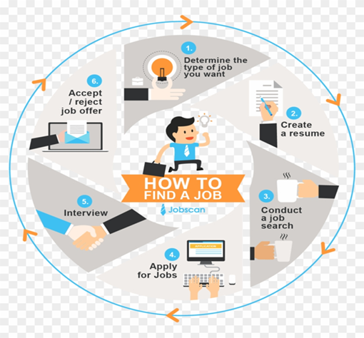
(PikPng.com, 2020)

There are many places where jobs are advertised these days, not just at the Job Centre like back in the days. Below is a list of places to help you find the right job for you.
• Networking
Networking in simple terms means exchanging or sharing information between people. As many jobs are not advertised, it is best to get talking to people to find out. You may not know someone who knows directly, but that person might know someone who does.
• Job Fairs
Job fairs are opportunities to meet employers and the workshops and seminars set out for job seekers and to network with people who could help you.
• Company Websites
You could keep an eye on the desired organisations, websites for possible job opportunities or events that they may hold for recruiting new employees.
• Cold calling
You could just be frank and consider making cold calls to companies you wish to work for. This can be done by telephone or by e-mail.
• Recruitment Agencies
Some organisations only employee people through recruitment agencies to help with the lengthy process of finding and interviewing candidates.
• Go Online
Since so much is happening online, searching for jobs using the internet would give you so many options. There are so many websites and so many jobs advertised online.
• Using LinkedIn
LinkedIn is a social network that can connect you to so many professional people. You can use this network to display your CV, look for jobs and networking to help you find the job you want.
• Social Media
Social networking is probably the best way to get a good job. Many employers and recruitment agencies use using social media to find the right candidates.
(Investopedia, 2020)

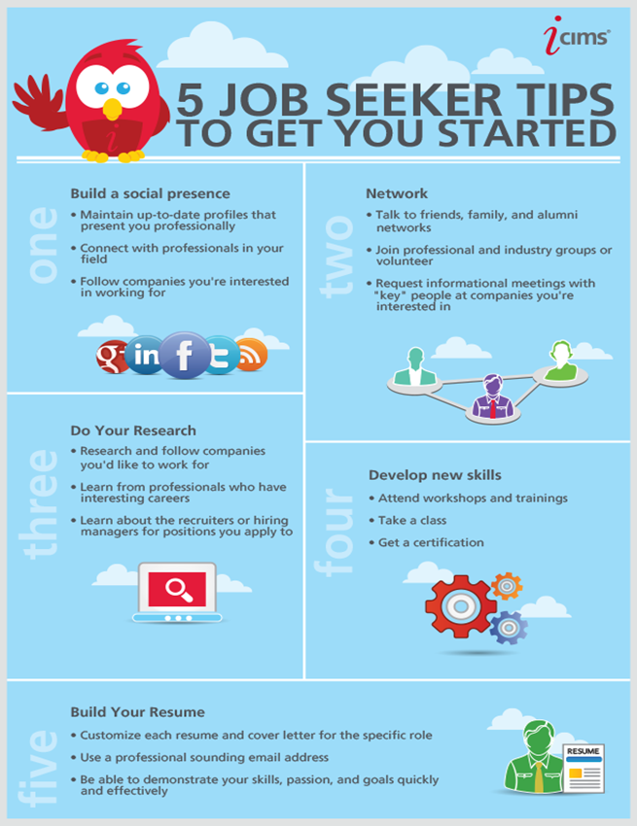
(Pinterest, 2020)

IMPORTANCE OF JOB ADVERTISEMENTS
Advertising for jobs is very important as it is the best way employers can spread the word that they have a vacancy available. The main purpose for advertising is to hire someone new to join them organisation.
Adverts can come in so many different forms such as, newspaper ads, billboards and posts on LinkedIn. This way the wider the message goes, “the more talented and skilful the potential employees will be”. (Us et al., 2020)
DEFINITION OF RECRUITMENT AND SELECTION
The meaning of Recruitment refers to the process of searching for potential employees to fill the vacancy within their organisation.
• The first stage is defining the job itself, the job description & the job specification.
• The second stage is to attract the potential employees by advertising the job to attract the best skilled and talented people out there.
• The third stage is to select the right candidate by interviewing.
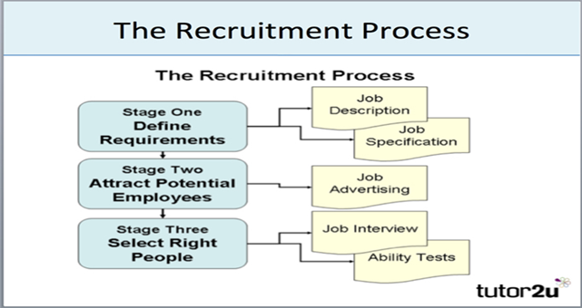
(tutor2u, 2020)

EMPLOYMENT LAW
Employment law builds a rapport between the employer and the employee.
Employment law basically focuses on everything to do with work. This includes hiring, advertising, recruiting, promotions, new starters, benefits and perks available and voluntary exits and litigation. (Anon, 2020)
Below are two diagrams which outline the different types of employment laws, we could come across in our employment.
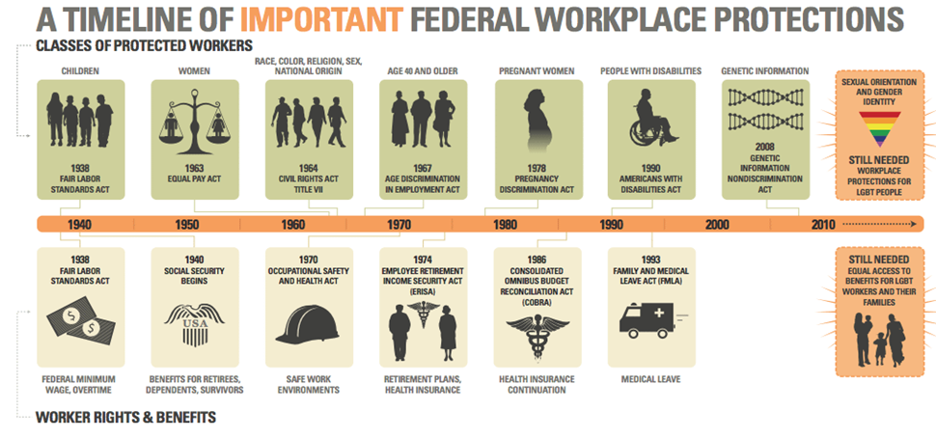
(Graves, 2020)

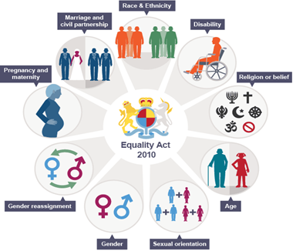
(Keepinghrsimple.co.uk, 2020)

IMPORTANCE OF A CV
A Curriculum Vitae (CV) also known as a job resume, is a brief summary of the applicant including their past education and employment history.
CVs are used to create an impression on the future employer. This is a first impression the employers have of you and therefore it is the most importance step during a job search.
A CV is like marketing yourself and putting yourself out on the market to be hired. It is by no means just a document, but your professional life outlined for a potential employer to quickly see what you have achieved and how your skills could contribute to their organisation. (Ginger Pages, 2020)

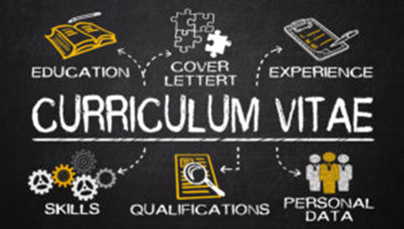
(Rowben Consulting, 2020)
The Diagram below is a quick glance at the process of finding a job and the steps to getting the job.
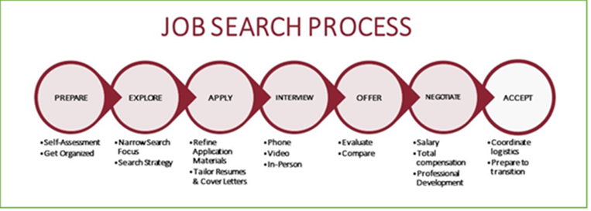
(Career & Professional Development | University of Denver, 2020)

MY JOURNEY TO GETTING THE JOB

Job Search
My journey started with trying to find the right job by looking online for office jobs and started searching for an Office Administrator job.
This was the type of job I wanted as I have qualified in this field and had previous experience in this position and would be able to fit in well and do justice to the job vacancy. I searched for job locally as I did not want to travel too far out and had a decent salary to match.

Creating my CV
Creating my CV was a bit of a nightmare, as I had been out of work for 17years and had to try to either remember what my old CV contained or to locate my old CV. It took some time before I found my, nearly 20year old CV, as trying to remember the contents was impossible.
A lot had changed since I last updated my CV. I managed to get a CV Template on Microsoft Word which was a great help and easier to update my CV. After a bit of struggle trying to update my CV, I eventually got there along with my covering letter to accompany it. After one problem came another, I could not print it as the printer started to play up, so I had fun with updating my CV.
I made 2 copies of my CV’s and my job description, one for Dr Olu and one for Abdi, our 2 interviewers.

Interview Preparation
Once the CV was ready, the preparation started for the interview. I was getting so nervous that I could not prepare much as that was making me even more nervous. I did manage to choose a plain black long dress to wear to the interview to look smart and formal.
Interview Day – WHAT HAPPENED? and MY FEELINGS
The day of the interview was here, and I was so nervous and petrified. It has been a very long time since I last attended a job interview and could not think straight.
We all knew we would be interviewed by 2 interviewers, but this did not help. We found out that we will all be interviewed according to the class register. I was towards the end of our class register, so I was going to be the penultimate one to be interviewed and the wait worsened. At this stage my mind was going blank. A few trips to the toilet was not helping.
Eventually and much later, it was my time to be interviewed. My mind went blank and I almost froze outside the interview room. I quickly took a few deep breaths and told myself ‘I can do this’ and entered the interview room.

The interview - WHAT HAPPENED? and MY FEELINGS
As I entered the interview room, I was very nervous, but I was greeted with a big reassuring smile from our Lecturer Abdi which made me feel a lot better and reassured. However, I have never seen or been taught by Dr Olu, I did not know what to expect from him. Dr Olu looked a bit strict and he didn’t smile so I was a little on edge about that.
I handed one copy of the CV and job description to Abdi and one to Dr Olu and waited until they told me to sit down.
I took a seat and sat with my back straight, ready to be interviewed. I got questioned about the employer and their background and why I should get the job along with many more questions. The more I got questioned, the more and more nervous I got. However, since I had done my research on the employer and had my questions ready to ask, I was feeling like the interview was going quite well. I did not feel like I struggled at all, but I felt like I did put Dr Olu on the spot, when I asked a question about the training that would be given to the successful candidate, as it felt like he struggled to answer that question but he did well in the end. I was asked my Abdi, why I did not stay with previous my employer’s for longer than 2year, so I replied saying because there were no career prospects, no upward ladder and I wanted to achieve more. All throughout my interview, I maintained eye contact and smiled where possible.
All in all, I felt the interview went really well and I could tell that Dr Olu and Abdi both seemed happy too. At the end I was told by Dr Olu to write something on the white board. I almost wrote ’something’ on the board but I realised that most of my fellow students must have written that on the board, so I chose to write ‘Smile Always’, which Dr Olu and Abdi were happy with.
I was very happy after my interview as I felt I did my very best in the interview. And off the record, the best part was when Dr Olu and Abdi made some lovely comments that gave me tears of happiness.
The good and bad – What was good and bad about the experience? (Evaluation) & Analysis
The best thing about the interview was the fact that both Dr Olu and Abdi made me feel comfortable and not on edge. Another thing I was happy about was the fact that I had done my research about the employer and was able to answer questions about them and ask questions too. I believe being prepared helps a lot and can get you through the interview smoothly.
From this experience, I have learned that you must be prepared for everything from being asked questions and having answers ready, to being able to present yourself as confident and the best there is to be hired. I have also learned that you are one amongst so many other candidates fighting for that job, so unless you go out there and really market yourself, you might lose that job and opportunity to someone else.

The wait was the only bad thing as it adds on extra stress and worry.

The FEEEDBACK – Conclusion
After the interview, I felt that it went really well. But once I had received the result of my feedback I was overwhelmed with happiness. I honestly did not expect 96% or even imagined that I would be able to score such a high percentage.
I remember Abdi saying that anyone who receives 90% or more gets the job, and I thought all along that there is no way I could achieve that. I guess I really underestimated myself.
Along with impressing the interviewers, I think I have impressed myself too. This has given me the extra push to do even better in future and given me more confidence in myself.
I do not know how I could have done any better apart from maybe ask more questions that I already did.
I must stress that it also helps to have someone who teaches you well. Someone like Abdi for definite, because he teaches you with a passion and he keeps you focused and interested all the way through our module. I can honestly say that I have enjoyed this module the most out of all other modules taught in the last year, and that too with Abdi.
Abdi keep up the good work, you are too good!!
APPENDIX
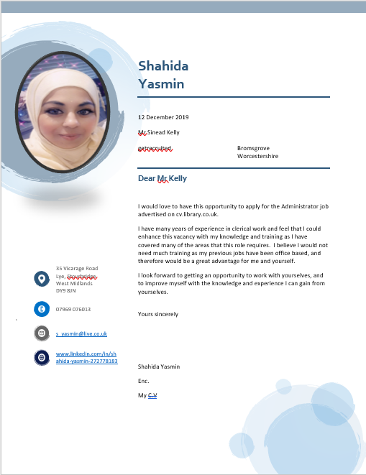

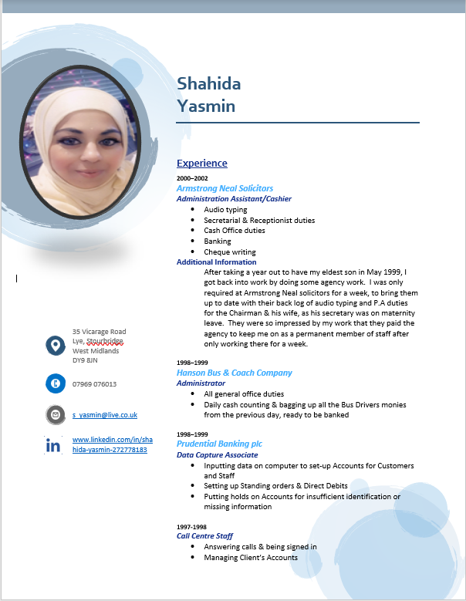
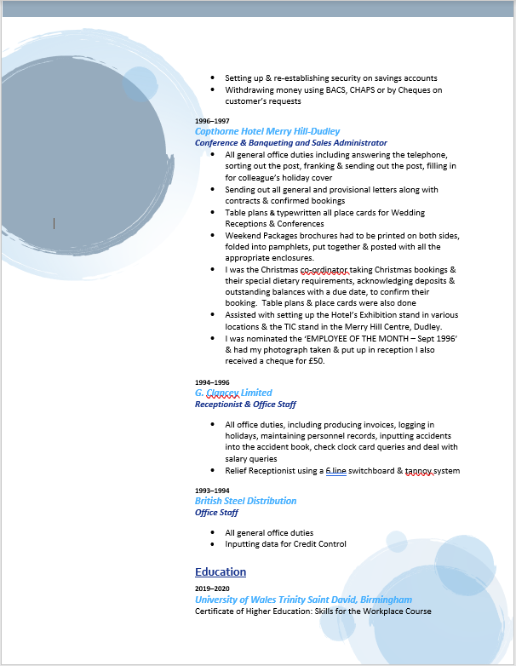

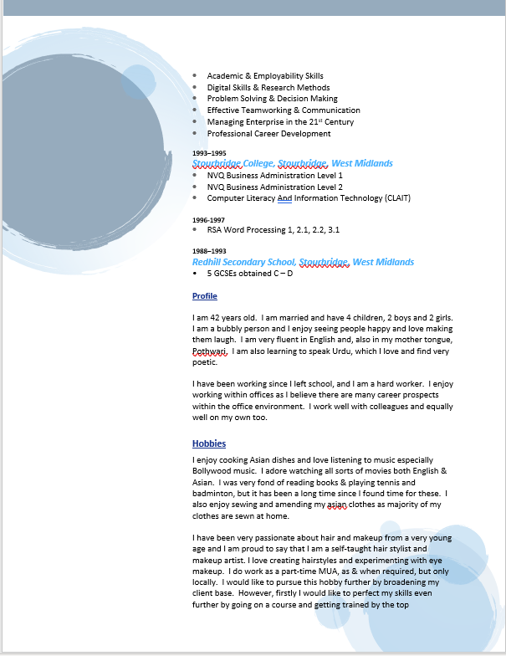

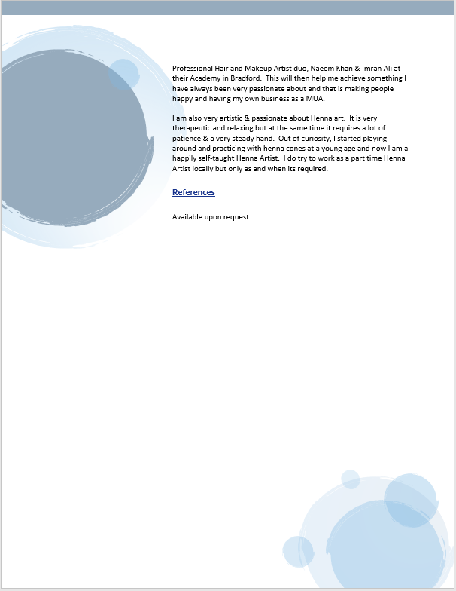

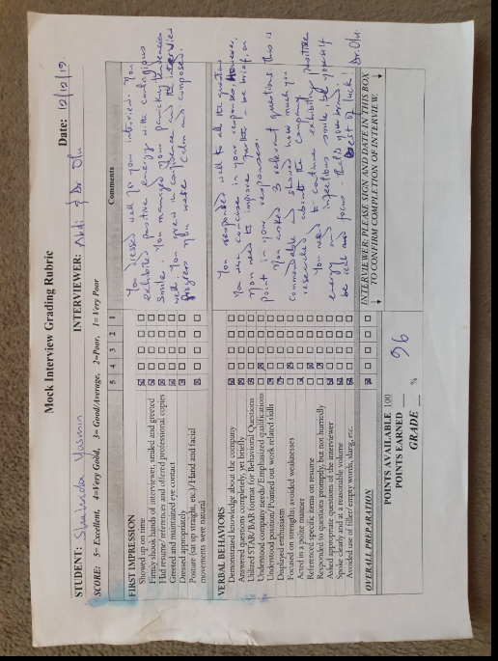

REFERENCES
2011-2020, (. (2020). Personal Development | SkillsYouNeed. [online] Skillsyouneed.com. Available at: https://www.skillsyouneed.com/ps/personal-development.html [Accessed 23 Jan. 2020].
Anon, (2020). [online] Available at: https://www.allaboutlaw.co.uk/stage/areas-of-law/employment-law [Accessed 30 Jan. 2020].
Career & Professional Development | University of Denver. (2020). 7 Practical Steps to Follow in Your Job Search. [online] Available at: https://career.du.edu/blog/2018/05/29/7jobsearchsteps/ [Accessed 28 Jan. 2020].
Communication Theory. (2020). The Johari Window Model. [online] Available at: https://www.communicationtheory.org/the-johari-window-model/ [Accessed 27 Jan. 2020].
Connect.supplysideshow.com. (2020). Personal Development | Natural Product by CareersInFood.com. [online] Available at: https://connect.supplysideshow.com/product/personal-development [Accessed 23 Jan. 2020].
Dictionary.cambridge.org. (2020). SKILL | meaning in the Cambridge English Dictionary. [online] Available at: https://dictionary.cambridge.org/dictionary/english/skill [Accessed 18 Jan. 2020].
Educational Business Articles. (2020). Understanding The Johari Window to improve team work, communication and trust. [online] Available at: https://www.educational-business-articles.com/johari-window/ [Accessed 25 Jan. 2020].
eLearning Industry. (2020). The Difference Between Knowledge And Skills: Knowing Does Not Make You Skilled - eLearning Industry. [online] Available at: https://elearningindustry.com/difference-between-knowledge-and-skills-knowing-not-make-skilled [Accessed 17 Jan. 2020].
En.wikipedia.org. (2020). Knowledge. [online] Available at: https://en.wikipedia.org/wiki/Knowledge [Accessed 17 Jan. 2020].
Flickr. (2020). Flickr. [online] Available at: https://www.flickr.com/photos/62311671@N02/with/40655833603/ [Accessed 24 Jan. 2020].
Ginger Pages. (2020). What is a Resume and Why is It Important? | Ginger. [online] Available at: https://www.gingersoftware.com/content/writing-center/resume/ [Accessed 28 Jan. 2020].
Graves, L. (2020). Issue at a Glance: LGBTQ Employment Discrimination - LGBTQ Victory Institute. [online] LGBTQ Victory Institute. Available at: https://victoryinstitute.org/issue-at-a-glance-lgbtq-employment-discrimination/ [Accessed 28 Jan. 2020].
http://ijobs.rutgers.edu/wordpress. (2020). Discover the Transferable Ph.D. Skills that Make You Employable | The Rutgers iJOBS Blog. [online] Available at: http://ijobs.rutgers.edu/wordpress/2016/06/09/discover-the-transferable-ph-d-skills-that-makes-you-employable/#sthash.PJr5MVzR.dpbs [Accessed 18 Jan. 2020].
Intelligenthq.com. (2020). 25 Personal Development / Self Development Skills To Learn Free Online. [online] Available at: https://www.intelligenthq.com/25-self-development-skills-to-learn-for-free-online-this-year/ [Accessed 23 Jan. 2020].
Investopedia. (2020). 9 Different Ways to Find a New Job. [online] Available at: https://www.investopedia.com/financial-edge/0711/9-different-ways-to-find-a-new-job.aspx [Accessed 27 Jan. 2020].
Keepinghrsimple.co.uk. (2020). Protected Characteristics -. [online] Available at: https://keepinghrsimple.co.uk/protected-characteristics/ [Accessed 28 Jan. 2020].
Lifetechbrussels.com. (2020). [online] Available at: http://lifetechbrussels.com/wp-content/uploads/2015/02/knowledge-management.jpg [Accessed 17 Jan. 2020].
Mindtools.com. (2020). Being Effective at Work: Essential Traits and Skills. [online] Available at: https://www.mindtools.com/pages/article/being-effective.htm [Accessed 18 Jan. 2020].
Mulder, P. (2020). What is the Johari Window Model? Definition, example, template | toolshero. [online] toolshero. Available at: https://www.toolshero.com/communication-skills/johari-window-model/ [Accessed 26 Jan. 2020].
Open.edu. (2020). Week 2: Understanding your skills and abilities: View as single page. [online] Available at: https://www.open.edu/openlearn/ocw/mod/oucontent/view.php?id=20017&printable=1 [Accessed 17 Jan. 2020].
Open.edu. (2020). Week 2: Understanding your skills and abilities: View as single page. [online] Available at: https://www.open.edu/openlearn/ocw/mod/oucontent/view.php?id=20017&printable=1 [Accessed 17 Jan. 2020].
PikPng.com. (2020). How To Find A Job - Circle Clipart (#106473) - PikPng. [online] Available at: https://www.pikpng.com/pngvi/JThiT_how-to-find-a-job-circle-clipart/ [Accessed 27 Jan. 2020].
Pinterest. (2020). 5 Jobseeker Tips | Job search tips, Job info, Job hunting tips. [online] Available at: https://www.pinterest.co.uk/pin/538672805402069114/ [Accessed 27 Jan. 2020].
Rowben Consulting. (2020). The importance of a stellar CV - Rowben Consulting. [online] Available at: https://www.rowben.com.au/news/importance-stellar-cv/ [Accessed 29 Jan. 2020].
Saraswat, A. (2020). What Is SWOT Analysis? - Template, Examples, & How-To guide | Feedough. [online] Feedough. Available at: https://www.feedough.com/swot-analysis/ Accessed 25 Jan. 2020].
SelfDelvy. (2020). What is Self-Development? A Study on Human Potential - SelfDelvy. [online] Available at: https://selfdelvy.com/what-is-self-development/ [Accessed 24 Jan. 2020].
Sheffield, U. (2020). Reflective Practice - University Study - Study Skills - 301 - SSiD - The University of Sheffield. [online] Sheffield.ac.uk. Available at: https://www.sheffield.ac.uk/ssid/301/study-skills/university-study/reflective-practice [Accessed 30 Jan. 2020]
Slideplayer.com. (2020). Ch. 2 Personality, Self-Esteem & Emotions Section 2- Achieving Your Potential. - ppt download. [online] Available at: https://slideplayer.com/slide/8328635/ [Accessed 24 Jan. 2020].
Smallbusiness.chron.com. (2020). Most Important Employee Skills in the Workplace. [online] Available at: https://smallbusiness.chron.com/important-employee-skills-workplace-999999924708.html [Accessed 20 Jan. 2020].
Stepshot. (2020). Effective Time Management: How to Manage Your Work Time. [online] Available at: https://stepshot.net/effective-time-management/ Accessed 18 Jan. 2020].
tutor2u. (2020). Recruitment & Selection - Overview | Business | tutor2u. [online] Available at: https://www.tutor2u.net/business/reference/recruitment-selection-overview [Accessed 28 Jan. 2020].
Us, A., Marketing, R., Advertising, P., Management, V., Services, P., Dallas, P., Us, A., Marketing, R., Advertising, P., Management, V., Services, P. and Dallas, P. (2020). Why Job Advertisements Are Important | Ad Club - Recruitment Advertising, Immigration Ads and Job Posting. [online] Ad Club - Recruitment Advertising, Immigration Ads and Job Posting. Available at: https://adclub.com/why-job-advertisements-are-important/ [Accessed 27 Jan. 2020].

