PROBLEM SOLVING AND DECISION MAKING .
Martin William Cadogan.
Student 2025891.
Terms of reference: A report submitted of the requirements for course BMSW 4004, Task 2. University of Wales, Trinity Saint David.
Lecturer : Yohan Mendis .

How stress is affecting workers in the United Kingdom, what causes it and possible ways of reducing it.
Stress problems in the UK are an increasing fact of everyday life and can lead to health problems. 4 out of 5 people claimed in a test carried out in 2020 that work-related stress and its economic impact on households were the main cause of stress related illnesses.

TABLE OF CONTENT :

- INTRODUCTION.
- DEFINING THE PROBLEM.
- ANALYZING THE PROBLEM.
- ENVIRONMENTAL ANALYSIS.
- EVAULATION OF SOLUTIONS .
- PLAN FOR IMPLEMENTING POSSIBLE SOLUTIONS.
- CONCLUSION.
- REFERENCES.

1 INTRODUCTION.
This report is about how stress is affecting workers in the United Kingdom, what causes it and possible ways of reducing it. Stress problems in the UK are an increasing fact of everyday life and can lead to health problems. 4 out of 5 people claimed in a test carried out in 2020 that work-related stress and its economic impact on households were the main cause of stress.
How to solve problems using the Pestle method and how to make decisions following on from these results using the Pestle method applied to the Fishbone theory.

2 DEFINING THE PROBLEM.
To define the problem of stress caused by workers in the United Kingdom we can use different tools to analyse the problems.
Problem solving tools can help us make choices to solve problematic situations.
Can the problem be solved, is it worth solving, what are the solutions to this or these problems? Decisions need to be taken and the best outcome is a positive solution, a problem solved, or a negative solution which means that the problem has not been solved, and a stalemate solution whereby nothing has been solved. Trying to solve problems and deciding about the best way to go about solving the problem could be left to those that are our managers. Sometimes they don’t always make the right decision when it relates to the benefit of a team.
What is a problem: “A perceived gap between the existing state and the desired status, or a deviation from a norm, standard, or status quo “( Business dictionary, 2020)
Stress is a very real cause of health problems in the UK that affects those most involved in the basic functions of modern society, being teachers and nurses in the frontline, in a country that has a large elderly population and an underfunded health system. Perhaps the politicians could spend less money on submarines and more on education and healthcare.

3 ANALYZING THE PROBLEM.
In the modern world, many people suffer from stress related illnesses caused directly or indirectly by the working environment. In the UK about 80% of respondents to a poll claimed that the common signs of stress are caused by or related to the workplace, job insecurity, commuting, and the uncertainty of their future, family and home. To work is in itself a risk :
“Most of us agree that risk essentially dealswith uncertainty.We characterize
risky decisions as those that entail greater amounts of uncertainty”
“ (Amit & Wernerfelt,
1990).
In a working environment in the United Kingdom, all workers might suffer from stress at any level regardless of their hierarchal position in a company. The people at the top, the bosses have a very stressful job of dealing with the political climate, especially in these times of a world pandemic. They will have to make decisions that also affect their positions in a company, the money and investments placed by and owned by shareholders and investors. The decisions will then affect workers further down the pyramid and the bosses have to make a choice between which workers have to go to keep a company floating in times of a serious financial crisis caused by covid and its knock-on effect in society. The workers further down the scale will become to feel this more as their job security is very much threatened, and as their job security affects all other areas in their lives, mortgages, rent, children's schooling, health insurance, etc, the stress levels can become overwhelming.

4 ENVIRONMENTAL ANALYSIS.
Using a diagram based on the fishbone method, then applying the results to the Pestel method :
Included here is a slide of fishbone analysis for this course’s project, using references from what are the real problems that workers are suffering from regarding stress in the united kingdom :

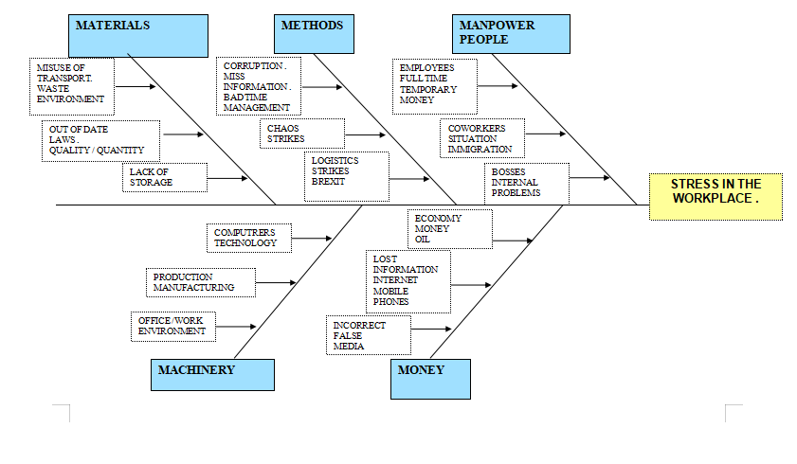

How to use the Pestle method:

As it is a method to use to analyse the common effects of improvement in this scenario, if conclusions are drawn from materials or statistics that are not properly clarified results from this information may not be genuine. If one cause of possible solution does not take into account the results of other solutions the result would not be positive and as these cause and effect diagrams are based on honesty, if thinking of a way to solve a problem is based on a ‘ brainstorm ‘, the structure might not be able to find the real cause of its problem. If people are given a specific time work or framework to study these problems, other team members can also contribute to the solutions and talk to the rest of the organization.

The PESTLE Method, created by Francis Aguilar in1967 :
Developed by him to assist American corporations, analysing their productivity problems in the early 1970s during the end of Nixon’s reign, thus P, E, S, T, E, L.
Political: The present situation in any given scenario in any country, in this case, the United Kingdom.
Economics: Connected to external and internal politics, as above also below, all economies are affected by their internal and external political policies.
Society: Age groups, ethnic groups, political status, religion, economic status. Therefore, all of society can be included in this method.
Technology: Electricity supply, internet, resources. Energy, from what resources are available.
Environment.: Home, city or country, water, or desert.
Law: Depends on all the above.
If solutions are not identified the problems could be more problematic in the future, all of the above are interconnected in most societies.

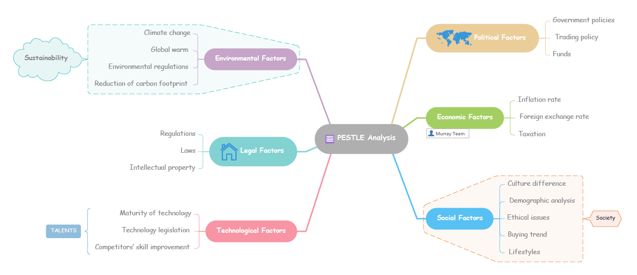

5 EVALUATION OF SOLUTIONS:
The 5'm s, 5 ways to recognise the cause of problems causing stress in a business environment:
Manpower, or surely human power. People and their effectiveness, their contribution and efficiency.
Machinery: Man-made tools to improve production and manufacturing, the oldest tool known to man being the two sticks our ancestors used to rub together to make fire.
Money: Measurements of profit and loss, Investors, Shareholders, and again Banks and politics.
Materials: From where, Quality and Quantity, logistics.
Methods: Machines and humans, Time management; whose time and at what time, when can the above 4 m’s be solved to integrate into the larger solution of 5 ‘m s?
“Based on self-determination theory (Deci & Ryan, 1985, 1987, 1991), we assessed the effect of controlling strategies and restricted choice options on students' performance on analytic reason problems. Subjects in the controlling-directives condition were told by their “teacher” that a given strategy was the way students “should” solve a set of analytical problems.”
( Boggiano et al,1993 )

The PMI test:
Using the PMI test, which is an acronym for Positive, Negative and the ‘Interesting ‘. In this case interesting can be read as neutral or measured as the gain and loss between the positive and the negative.
Below is an example of a PMI test:

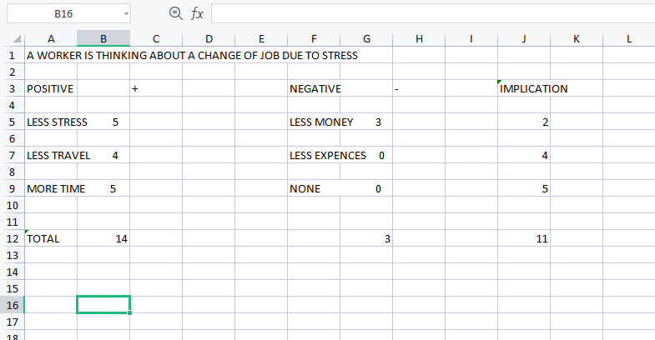

A WORKER IS THINKING ABOUT A CHANGE OF JOB IN THE FUTURE……..
From the statistics measured and the conclusion above, this said worker should perhaps consider a change of job as the implication is in favour of this decision, out of a total of 14, Positive wins against Negative 11 to 3.

The GRID test :
Here is a GRID analysis of a similar situation :
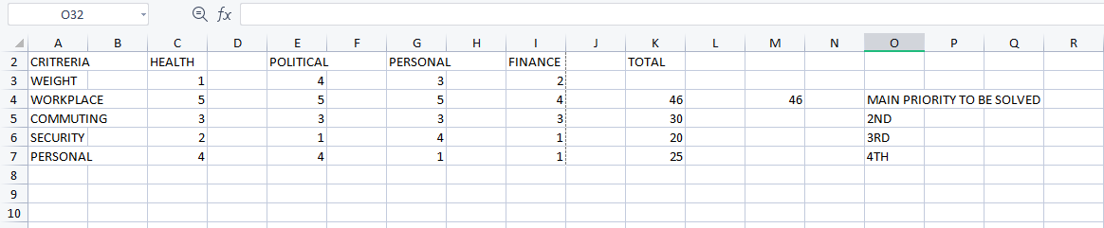
From this Grid analysis, the worker could also lower their stress levels by realizing what are the high levels of stress caused in the workplace, which according to this GRID analysis is caused by the workplace environment and could be the main priority to resolve and fix.

6 IMPLEMENTATION PLAN:
1: More laws to allow workers better flexibility, especially for people working in large towns and cities:
“Debates around the benefits of flexible work arrangements for employee well-being are limited by a lack of empirical analyses on whether flexible working enables employees with work or family stressors to cope with their levels of stress. This study examines whether the availability and use of different flexible work arrangements are associated with lower allostatic load (an index of chronic stress-related biomarkers) in a large representative study of UK adults.” (Chandola et al .,2019)
2: Develop more bicycle paths, more public transport as in done in many European countries, seen as an individual right by the EU :
“Cycling Cities is a richly illustrated volume analyzing 100 years of urban cycling‒policy, use, and practice in 14 European cities in 9 countries. Why did some capitals and business centers became real cycling cities and others not? The book has gained traction in the news. Cycling Cities traces how policymakers, engineers, cyclists, or community groups campaigned—and made a difference since the early twentieth century” Oldenziel, R, Emanuel, M, Albert de la Bruheze, AA & Veraart, F 2016, Cycling Cities: The European Experience: Hundred Years of Policy and Practice. Foundation for the History of Technology, Eindhoven.
“The European Union (EU) is a "composite' democracy which features diverse forms of democratic legitimation: vertical legitimation through parliamentary representation in the European Parliament; executive representation through delegates of democratically elected governments in the Council of Ministers; horizontal mutual control among member states; associative and expert representation (delegation) in policy networks; and, finally, individual rights-based legitimacy.”

3: Job security, for all, public taxes to be transparent so we know where our money is being spent.
Adrienne Héritier (2003) Composite democracy in Europe: the role of transparency and access to information, Journal of European Public Policy, 10:5, 814-833, DOI: 10.1080/1350176032000124104

7 CONCLUSION
To avoid the complications in general of stress in our daily lives, the workplace must be safe and workers need to be happy. They need guarantees of job security and laws protecting their homes from the banks that caused the decade-old economic crisis, free health care that works for everyone not only during this present pandemic. Transparent evidence of where workers taxes are being spent.
Happy workers produce more if they are paid better and respected by all their fellow workers in a stress-free environment. This type of working environment could be achieved if the government implements new laws safeguarding all workers, unfortunately, this doesn’t work out in a country that to many outsiders still seems to be stuck in the 19th century.
The U.K needs to improve its basic infrastructure, unlike Japan, it has a high population density whose major cities have not been connected. With the internet, some of us do not have to travel to work, even for lower pay it could be more attractive to many people who work in offices to work at home, to attempt to be happier.
Obviously, for the people who do other types of work, it is irrelevant where they work from if they have to be at their physical place of work.
“Rapidly changing conditions of work and employment have brought the topic of work organization and health to the forefront of concern in occupational safety and health.” ( Sauter and Hurrell, 1999)
“Studies on mental health and academic performance have been conducted throughout the world. Thus, this study aims to assess the students' mental health amidst the new normal of education employing 21-item Depression, Anxiety, and Stress Scale or DASS-21, concerning their academic performance. The study's findings showed that almost more than half of the respondents suffered from moderate to extremely severe levels of depression, stress, and anxiety.” https://doi.org/10.17605/OSF.IO/MPTK7

8 REFERENCES :
( Boggiano et al,1993 )
( Business dictionary, 2020)
( Gabel, Sherwood and Enochs,1984 ).
(Amit & Wernerfelt,
(Chandola et al .,2019)
(Cooper and Kelly,1993)
(Davis,1997)
Adrienne Héritier (2003) Composite democracy in Europe: the role of transparency and access to information, Journal of European Public Policy, 10:5, 814-833, DOI: 10.1080/1350176032000124104
https://doi.org/10.1007/978-3-030-03638-6_20 ( Sauter and Hurrell, 1999)
Oldenziel, R, Emanuel, M, Albert de la Bruheze, AA & Veraart, F 2016, Cycling Cities: The European Experience: Hundred Years of Policy and Practice. Foundation for the History of Technology, Eindhoven.https://doi.org/10.17605/OSF.IO/MPTK7

