Qualification: CIPD Diploma in Applied Human Resources
Module Name: Contributing to the Management of Change 5AMOC

Word Count: 3289

Student Name: Catherine Thomas
Student Number: 2012743
CIPD Membership Number: 57612349

By signing below, I confirm that the work/evidence presented is my own, unaided work. I understand the regulations pertaining to candidate malpractice and the action that may be taken as a result.

Signed: C Thomas
Date: 11 November 2021
Contents
Details Page No
Evidence Matrix 5-7
Personal Statement for LO1 including reference list & Evidence 8-45
EV1 Emails re SLE to Hywel Dda Medical Staffing from NWSSP - Programme Board meeting, 12-16
Minutes, Actions, Advisory Review Brief document, operational procedure for the application of
Workforce Policies & Procedures for trainees.
EV2 The Need and the Benefits for the change 16-17
EV3 Examples via email from Nick Meyler confirming transfer of doctors from Hywel Dda to the
Single Lead Employer 17-20

EV4 Doctors in Training Planned Move to Single Lead Employer Timeline 20-21
EV5 Letter from Hywel Dda regarding the transfer to SLE 21
EV5A FAQ’s 22-24
EV6 NWSSP Team involved in change 24
EV7 Minutes of Meeting 25-27
EV7A Finance involvement regarding the SLE for the pay mechanism 27-31
EV8 Termination Form 31-32
Contents

Details Page No
EV9 Showing Deanery Position Number (DPN) for deletion and how to delete it in the ESR Position 33-34
EV10 Guidance on how to Share URPs with a Shared Service Centre (SSC). Health Board URPs to with NWSSP –
URP Matrix Audit - April 2021 35-36
EV11 Change Plan 36-38
EV12 Gantt Chart 39-40
EV13 Stakeholder Map 40-41
EV14 Minutes of Meeting to sign off Change Plan 41-43
EV15 Sign off from Manager, facts established and contribution was effective 43-44
Personal Statement for LO2 including reference list & Evidence 46-65
EV16 Emails to stakeholders implementing the change process 49-52
EV17 Email from payroll requesting access for reports & email confirming access and details provided to SS 52-54
EV18 Details from NWSSP asking to share the VPD, and email from me confirming it has been done. 54-55
EV19 Positive Working Relationships – Unison Rep 55-57
Contents

Details Page No

EV20 Scenarios when to use full OCP and when not to: 57-58
EV21 Email questioning who would carry out Stat and Mand training. 59
EV22 Email ongoing monitoring of the positions. 60-61
EV23 Email advising new codes to be used to accompany the Single Lead Employer 61-62
EV24 Email to NWSSP confirming completion from Hywel Dda’s side and confirmation they’ve gone across to SLE 62-63
EV25 Collaborative meeting details and date 64
Personal Statement for LO3 including reference list & Evidence 66-70
EV26 Email showing objectives met from Hywel Dda to SLE 68
EV27 Email and screenshot to show correspondence between Medical Staffing and Payroll 68
EV28 Confirmation in an email from the Senior Programme Manager – Digital Workforce NWSSP 69
that the change management process was met
EV29 Email from NWSSP advising of change and email to NWSSP confirming completion 69

Candidate name: Catherine Thomas |  |  |  |  |  | CIPD Membership/registration No.:  5762349
Qualification title: CIPD Diploma in Applied Human Resources |  |  |  |  |  | Unique Learner No. (ULN):  2012743
Unit code | Unit title |  | Assessment criteria no. | Evidence description |  | Evidence reference number | Assessor  initials | I/V initials if sampled
5AMOC | Contributing to the Management of Change 5AMOC |  | 1.1, 1.2, 1.3, 1.4, 2.1, 2.2, 2.3, 2.4 & 2.5 | Emails re SLE to HDUHB Medical Staffing from NWSSP - Programme Board meeting, minutes, Actions, Advisory Review Brief document, operational procedure for the application of workforce policies & procedures for trainees |  | EV1
5AMOC | Contributing to the Management of Change 5AMOC |  | 1.1, 1.2, 2.1 | The Need and the Benefits for the change |  | EV2
5AMOC | Contributing to the Management of Change 5AMOC |  | 1.2 | Examples via email from Nick Meyler confirming transfer of doctors from HDUH to the Single Lead Employer |  | EV3
5AMOC | Contributing to the Management of Change 5AMOC |  | - , 3.1, 3.2 & 3.3 | Doctors in Training Planned Move to Single Lead Employer Timeline |  | EV4
5AMOC | Contributing to the Management of Change 5AMOC |  | 1.2 | Letter from Hywel Dda regarding the transfer to SLE |  | EV5
5AMOC | Contributing to the Management of Change 5AMOC |  | 1.2, 2.1 & 2.3 | NWSSP FAQ’s |  | EV5A
5AMOC | Contributing to the Management of Change 5AMOC |  | 1.3 | NWSSP Team involved in change |  | EV6
5AMOC | Contributing to the Management of Change 5AMOC |  | 1.3 | Minutes of Meeting |  | EV7
5AMOC | Contributing to the Management of Change 5AMOC |  | 1.3 | Finance involvement regarding the SLE for the pay mechanism |  | EV7A
5AMOC | Contributing to the Management of Change 5AMOC |  | 1.3 & 2.5 | Termination Form |  | EV8
5AMOC | Contributing to the Management of Change 5AMOC |  | 1.3 | Showing Deanery Position Number for deletion and how to delete it in the ESR Position |  | EV9
5AMOC | Contributing to the Management of Change 5AMOC |  | 1.3 | Guidance on how to Share URPs with a Shared Service Centre (SSC). Health Board URPs to be Shared with NWSSP - URP Matrix Audit - April 2021 |  | EV10
5AMOC | Contributing to the Management of Change 5AMOC |  | 1.4 | Change Plan |  | EV11
5AMOC | Contributing to the Management of Change 5AMOC |  | 1.4 | Gantt Chart |  | EV12
5AMOC | Contributing to the Management of Change 5AMOC |  | 1.4 | Stakeholder Map |  | EV13
5AMOC | Contributing to the Management of Change 5AMOC |  | 1.5 | Minutes of Meeting to sign off Change Plan |  | EV14
5AMOC | Contributing to the Management of Change 5AMOC |  | 1.5 | Sign off from Manager facts established and contribution was effective |  | EV15
5AMOC | Contributing to the Management of Change 5AMOC |  | 2.1, 2.2 , 3.1 & 3.2 | Emails to stakeholders implementing the change process |  | EV16
5AMOC | Contributing to the Management of Change 5AMOC |  | 2.2 | Email from payroll requesting access for reports. Emailing confirming access and details provided to shared services |  | EV17
5AMOC | Contributing to the Management of Change 5AMOC |  | 2.2 | Details from NWSSP asking to share the VPD, and email from me confirming it has been done. |  | EV18
5AMOC | Contributing to the Management of Change 5AMOC |  | 2.3 | Positive Working Relationships – Unison Rep |  | EV19
5AMOC | Contributing to the Management of Change 5AMOC |  | 2.3 | Scenarios when to use full OCP and when not to: |  | EV20
5AMOC | Contributing to the Management of Change 5AMOC |  | 2.4 | Email questioning who would carry out Stat and Mand training. |  | EV21
5AMOC | Contributing to the Management of Change 5AMOC |  | 2.4 | Email ongoing monitoring of the positions. |  | EV22
5AMOC | Contributing to the Management of Change 5AMOC |  | 2.4 | Email advising new codes to be used to accompany the Single Lead Employer |  | EV23
5AMOC | Contributing to the Management of Change 5AMOC |  | 2.4 & 2.5 | Email to NWSSP confirming completion from HDUHB side and for him to confirm that they had gone across to the Single Lead Employer |  | EV24
5AMOC | Contributing to the Management of Change 5AMOC |  | 2.5 | Collaborative meeting details and date |  | EV25
5AMOC | Contributing to the Management of Change 5AMOC |  | 3.1 | Email confirming objectives met and all complete to date |  | EV26
5AMOC | Contributing to the Management of Change 5AMOC |  | 3.1 | Email and screenshot to show correspondence between Medical Staffing and Payroll |  | EV27
5AMOC | Contributing to the Management of Change 5AMOC |  | 3.2 | email from the Senior Programme Manager – Digital Workforce NWSSP that the change management process was met |  | EV28
5AMOC | Contributing to the Management of Change 5AMOC |  | 3.3 | Email from NWSSP advising of change and email to NWSSP confirming completion |  | EV29
- I confirm that the work/evidence presented for assessment is my own unaided work.
- I have read the assessment regulations and understand that if I am found to have ‘copied’ from published work without acknowledgement, or from other candidate’s work, this may be regarded as plagiarism which is an offence against the assessment regulations and leads to failure in the relevant unit and formal disciplinary action.
- I agree to this work being subjected to scrutiny by textual analysis software if required.
- I understand that my work may be used for future academic/quality assurance purposes in accordance with the provisions of the Data Protection Act 1998.
- I understand that the work/evidence submitted for assessment may not be returned to me and that I have retained a copy for my records.
I understand that until such time as the assessment grade has been ratified through internal and external quality assurance processes it is not final.
Signature: C Thomas
Date |  |  |  |  | 11 November 2021

  - Establish the need, Objectives and potential benefits in relation to a specific change requirement.

Beckhard and Harris (1987, p687 explained in Hughes, 2014 p.10) that major organisational change has stages; the future state, the present state, and the transition state. The need for the change LO1, AC1.1 is that all new Medical and Dental training doctors will move to the ‘Single Lead Employer Scheme’ (SLE) at NWSSP (NHS Wales Shared Service Partnership) from Health Boards as a part of the Aug 2020 intake through to May 2022 with full support by the GPC Wales. The business case would have been compiled by the Single Lead Employer which explains details about the Lead Employer and the model encompass. Workforce and OD Directors have agreed signed off for the change by the NWSSP Partnership Group (EV1). Internal drivers were source of the change (Rees and French, 2012, p.110). My role was to co-ordinate the change within Hywel Dda UHB to the Single Lead Employer.

Objectives

- To remove all Junior Doctors from Hywel Dda payroll as advised by NWSSP.
- Termination forms completed by Medical Staffing and sent to Payroll.
- To remove all DPN numbers from positions numbers to enable NWSSP to setup their end as this cannot happen if the DPN number is still in the Hywel Dda position.
- Communicate where necessary with stakeholders
- Communicate with doctors should they need confirmation that they ESR record is now with NWSSP. HDUHB (2021)

Benefits (EV1) NWSSP (2021)
- Junior doctors able to work across a wider geographical area in their substantive post.
- Locum shifts for junior doctors can also be across a wider geographical area.
- One ESR account as paid by Shared Services and one payroll number.
- One ESR login for their personal details via Employee Self Service.
- Due to working across all NHS Wales sites can seek job opportunities within all of the Health Boards as an internal applicant.
- Cut down bureaucracy, provide greater equity and improve the working experience for trainees
- Consistent use of policies and procedures

  - Analyse who will be affected by the changes and their potential information and support needs.

According to (Inside HR, 2018) the change needs to be communicated to those that will be affected, with managers putting systems in place to take it forward. Processes and practices must be re-designed to strengthen the change.

Doctors in Training from NHS Wales Health Boards will be affected by the change (EV2) LO1 AC1.2. However, for Hywel Dda UHB we have to prepare and do background work for the junior doctors to move to the Single Lead Employer (SLE). The SLE are implementing for all Wales Health Boards although each Health Board has to implementation the change their end adherering to actions from the Single Lead Employer. Examples via an email from NWSSP of the junior doctors in their specialities moving across and work to be undertaken. (EV3).

Junior doctors from Hywel Dda are affected from all specialities are as such Rheumatology, Dermatology, Cardiology & Resp Medicine, T & O, General Surgery, Core Psychiatry, Higher Surgery, Geriatric Medicine, Ophthalmology, Pathologies, Higher Psychiatry, F2s, O&G/Sexual Health, Higher Medicine, Core Anaesthetics, Core Medicine, ACCS, Higher Emergency, Higher Anaesthetics & Intensive Care Medicine and Core Surgery. The transfer has been done over a period of months and the intake each month can vary as some specialities have more junior doctors in than others for example Core Anaesthetics, Core Medicine, ACCS have 401 junior doctors as opposed to Rheumatology who only have 10 (EV4) (LO1, AC 1.2).

A letter was compiled by myself and send to the Junior Doctors within Hywel Dda to confirm transfer of staff and advising details that will be changing and where to find FAQ’s. (EV5). There are also FAQ’s on the NWSSP website with questions such as what is the SLE model responsible for? and help with the support needs for those concerned. (EV5A) LO1 AC1.2.

  - Identify the resources required for the change process and how these will be
made available.

Accordingly to (CIPD, 2021) People professionals have a significant role to play in any change management process.
As the implementation is being rolled out via NHS Wales Shared Services Partnership (NWSSP) to all Welsh Health Boards they will have their team structure regarding guidance, equipment etc. (EV6). Nevertheless, each Health Board will have to have their people, equipment and staff to enable the change to go ahead and I co-ordinated these and also setup a meeting for all those involved from Hywel Dda’s perspective and minutes were taken by myself and distributed accordingly. Objectives for each team, materials required and contact details for any queries were all discussed. (EV7).

Resources available required to do the change are people within Payroll, Medical Staffing, Finance and Workforce. Details of Finance’s involved are that they have implemented an SLE pay feed into our ledgers from Velindre’s ESR system, and have set up an SLA where we pay Velindre a forecast amount for the service e.g. the pay feed mechanism. Along with minutes of the meeting for the finance work stream (EV7A).

There is no additional equipment as all work to enable the change will be done electronically via computers. The material will be termination forms (EV8) sent from Medical Staffing to Payroll as they have to terminate junior doctors from the Hywel Dda payroll system. ESR team within Workforce have to do background work on positions by taking out the Deanery Pin Number (DPN) that junior doctors are currently sitting in to enable the interface between Hywel Dda and the new Single Lead Employer to work. (LO1, AC1.2). Guidance on how to do this was produced by me and sent to the ESR team from a Hywel Dda perspective (EV9). The time for doing this has been incorporated within the daily work of the administrator and I co-ordinated one of my team members to undertake this.

Also User Responsibility access had to be provided to the Single Lead Employer 043 and Hywel Dda had to remove the responsibility from 120 Velindre NHS and shared access had to be provided to the new Single Lead Employer 043. LO1 1.3. An email from NWSSP confirming this and details was compiled by me on how to insert the responsibility and delete the old responsibility. This was then shared with the ESR team to do update accordingly with myself being involved in the process too. (EV10).

  - Devise a plan, including objectives, actions and timescales for implementing the
required change.

HR Teams require a transparent remit and objectives in order to deliver expectations. (Sage, 2020). In order to meet the expected criteria from NWSSP for us as a Health Board; a plan comprising of objectives, actions and timescales for implanting the change was required. (The Motley Fool, 2021).

The process for the objectives when doing the change plan were taken into account following (North, 2021). The change plan LO1 AC1.4 (EV11) was devised by me which formed the vision and objectives and a Gantt chart which was also devised by me (EV12). Included in this was timings and milestones to be achieved. The Benefits, issues and risks were also included, along with the people who are affected by the change. Roles and Resources were also identified and finally details regarding measuring success (The Motley Fool, 2021). The Stakeholder map was devised by myself to help decide stakeholder’s grouping for change communications. (EV13). (SHRM, 2019).

The timescales LO1 AC1.4 are deployed by NWSSP who are co-ordinating the change to the Single Lead Employer which is on a monthly basis with individual specialities and the intake numbers for that group. This being from July 2020 to May 2022. (EV4).

Currently junior doctors can be paid by multiple Health Boards e.g. hold a substantive position with Hywel Dda University Health Board. Also have multiple locum bank posts within local hospitals this meaning having multiple payroll numbers, multiple login details for their personal Electronic Staff Record, multiple payslips and multiple email addresses linked to each Health Board.
1.5 Communicate the change plan, and gain agreement for its implementation, from decision makers.

Conveying changes and having precise HR data to hand to know what and how to change and updating processes and policies as necessary is one of the roles of HR. (Sage, 2020).

A meeting was setup by me with the stakeholders to sign off the Change Plan along with the Gantt chart. The meeting took place via teams and the Change Plan and Gantt Chart were shared by me with the members. The minutes of the meeting were noted formally to ensure continuity and expectations of those concerned to enable the change. Comments were such that as one of the objectives for communication of the change and FAQ’s being done via NWSSP who were co-ordinating the change for the Single Lead Employer was that there needed to be evidence seen by the Stakeholders of Hywel Dda that this was happening. (EV14) LO1 AC1.5.

Following on from the meeting discussion took place verbally with the Head of Digital Workforce Solutions, as she catches up daily in the office and the Change Plan and Gantt chart were shown. Due to this being verbal I had emailed for evidence of the approval and confirmation that the details were appropriate, accurate and that it was effectively communicated.(EV15) LO1 AC1.5. (CIPD, 2014) Assess the organisation’s change context and establish aspects of context that hold back desired change.

Evidence for Learning Outcome 1

EV1 LO1 AC1.1. – Emails re SLE Programme Board meeting, minutes, Actions, Advisory Review Brief document, operational procedure for the application of workforce policies & procedures for trainees.

From: Rhys Owen (NWSSP) <Rhys.Owen3@wales.nhs.uk>
Sent: 13 November 2020 14:28
To: Gareth Hardacre (NWSSP - Workforce & Organisational Development) <Gareth.Hardacre2@wales.nhs.uk>; Malcolm Lewis (NWSSP) <Malcolm.Lewis2@wales.nhs.uk>; SarahM Evans (NWSSP) <SarahM.Evans@wales.nhs.uk>; Hywel Jones (Aneurin Bevan UHB - Anaesthetics) <
Subject: SLE: Programme Board agenda - 19 November (3pm)
Dear all,
Please see attached the agenda for next Thursday SLE Programme Board meeting.You will find documents embedded within the agenda.



Single Lead Employer Programme Board
Thursday 19th November 2020 (15.00-16.30) - Via Microsoft Teams
AGENDA
No: | Item | Document | Lead
1. | Welcome and Introduction |  | ML
2. | Actions from meeting 29th September 2020 |  | ML
3. | PID (phase 2)  - Includes phase 2 and phase 3 roll out | To note | RO/SE
6. | Feedback from SLE Trainee Survey | Verbal | IC

From: Jenna Goldsworthy (NWSSP) <Jenna.Goldsworthy@wales.nhs.uk>

Sent: 05 October 2021 12:36
To: Gareth Hardacre (NWSSP – People & OD) <Gareth.Hardacre2@wales.nhs.uk>; Sarah Evans (NWSSP - People & OD) <SarahM.Evans@wales.nhs.uk>; Hywel Jones (Aneurin Bevan UHB - Anaesthetics) <Hywel.Jones3@wales.nhs.uk>; Emma Woolley (BCUHB - Maxillo Facial) <Emma.Woolley@wales.nhs.uk>; JHarris@bma.org.uk; EStamp@bma.org.uk; Sharon Vickery (Swansea Bay UHB - Human Resources) <Sharon.Vickery@wales.nhs.uk>; Sarah Simmonds (Aneurin Bevan UHB - Personnel) <Sarah.Simmonds@wales.nhs.uk>; Simon Cookson (NWSSP - Internal Audit) <Simon.Cookson@wales.nhs.uk>; Helen Baker (HEIW) <Helen.Baker2@wales.nhs.uk>; Ian Collings (HEIW) <Ian.Collings@wales.nhs.uk>; Linsay Payne (NWSSP - Shared Services) <Linsay.Payne@wales.nhs.uk>;
Subject: RE: SLE - Programme Board
Hi All,
Please find the updated agenda for the Single Lead Employer Programme Board Meeting attached. As a reminder, the meeting is scheduled for 10am-11.30am, Wednesday 06-Oct-21.
Single Lead Employer Programme Board Agenda
Wednesday 6th October 2021 (10.00-11.30)
Via Microsoft Teams
No: | Item | Document | Lead
1. | Welcome and apologies | Verbal | RA
6. | Single Lead Employer - Advisory Review - Final Report |  | RA

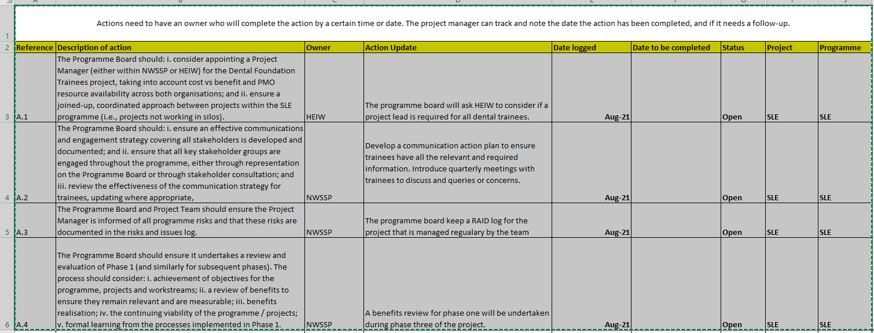
From: Emma Rees (NWSSP - Audit and Assurance Services) <Emma.Rees13@wales.nhs.uk>
Sent: 01 June 2021 14:03
To: Malcolm Lewis (NWSSP) <Malcolm.Lewis2@wales.nhs.uk>; Gareth Hardacre (NWSSP - Workforce & Organisational Development) <Gareth.Hardacre2@wales.nhs.uk>; SarahM Evans (NWSSP) <SarahM.Evans@wales.nhs.uk>; Emma Woolley (BCUHB - Maxillo Facial) <Emma.Woolley@wales.nhs.uk>; Sharon Vickery (Swansea Bay UHB - Human Resources) <Sharon.Vickery@wales.nhs.uk>; Sarah Simmonds (Aneurin Bevan UHB - Personnel) <Sarah.Simmonds@wales.nhs.uk>; Angie Oliver (HEIW) <Angie.Oliver@wales.nhs.uk>; Helen Baker (HEIW) <Helen.Baker2@wales.nhs.uk>; Linsay Payne (NWSSP - Audit) <Simon.Cookson@wales.nhs.uk>; James Quance (NWSSP - Audit and Assurance Services) <James.Quance@wales.nhs.uk>
Subject: NWSSP SLE Phase 1 review
Dear all
Please find attached the final brief for our advisory review of the SLE Phase 1 programme.
The following individuals have been selected by the Programme Board for interview as part of our work:
- SRO: Malcolm Lewis
- Workstream Leads: Sarah Evans, Daniela Mahapatra/Adam Leith. Linsay Payne
- Stakeholder representatives: Helen Baker, Elenor Williams, Hilary Sharp, Jasmine Harris, Milan Makwana
- Project team: Rhys Owen, Louisa Jones, Christine Richards

We have been in touch with these individuals to arrange interviews over the first two weeks of June.
Please let us know if there is anyone else who would like to speak with us as part of the review. We are aiming to complete our work by the end of June.
Emma
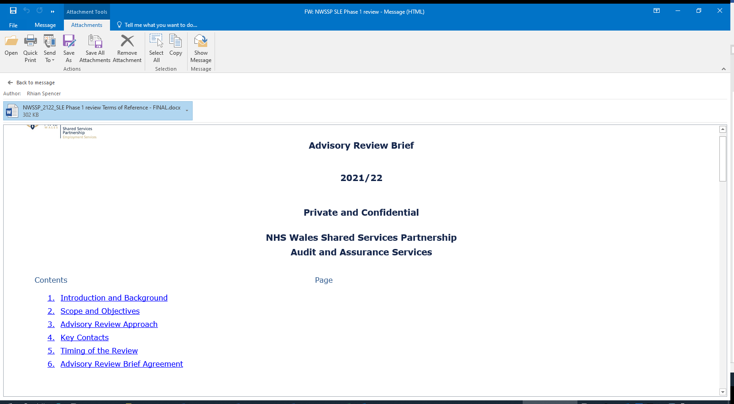
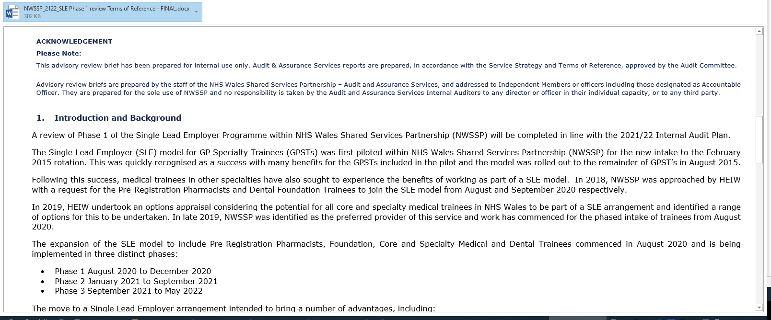
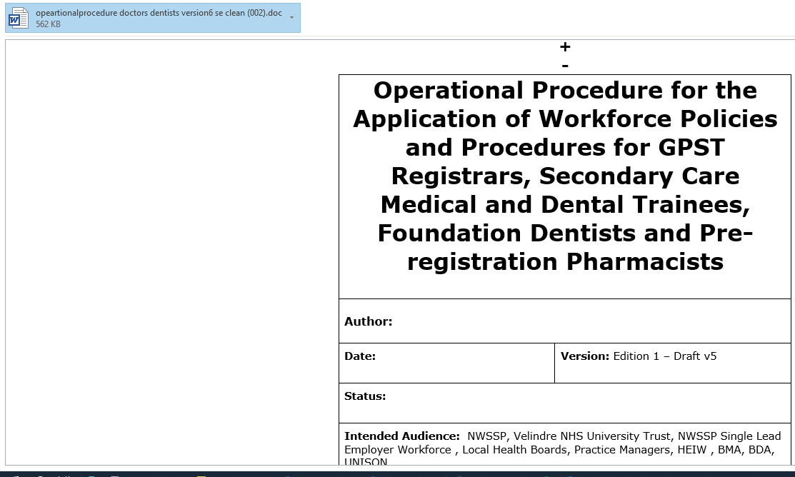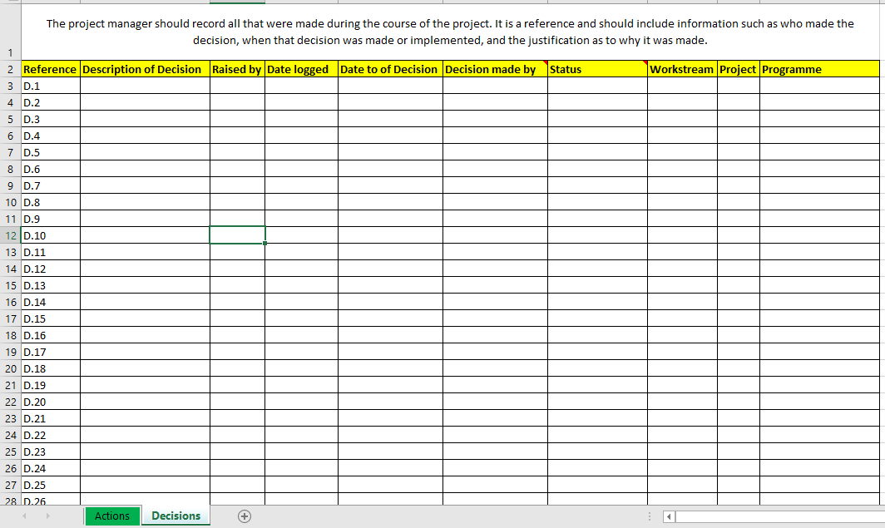
EV2 LO1 ac1.2 The Need and the Benefits for the change
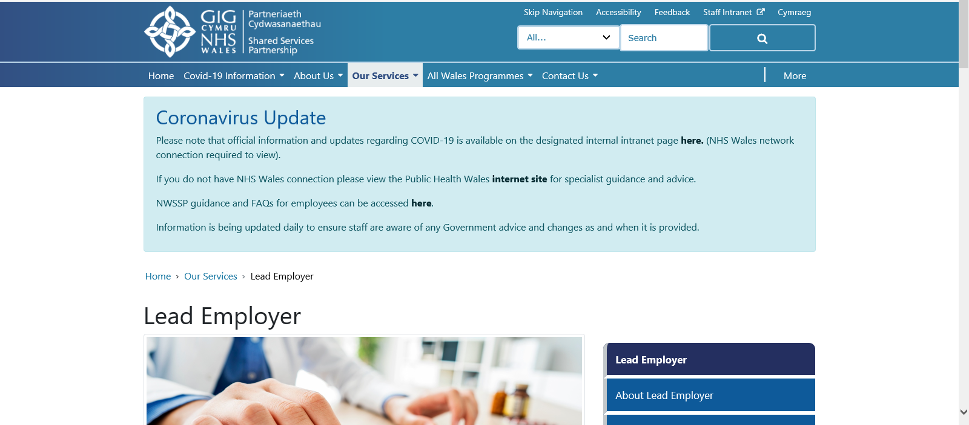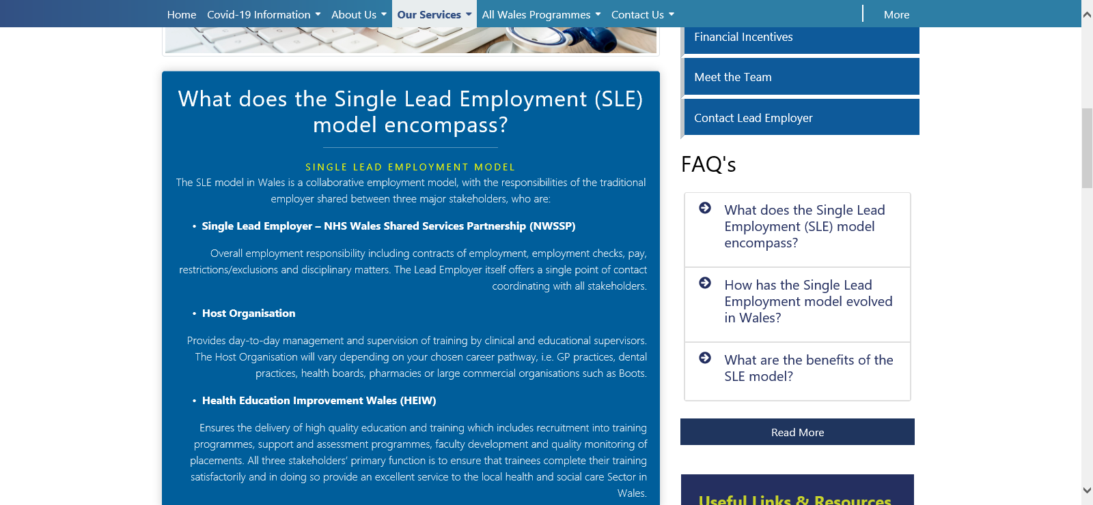

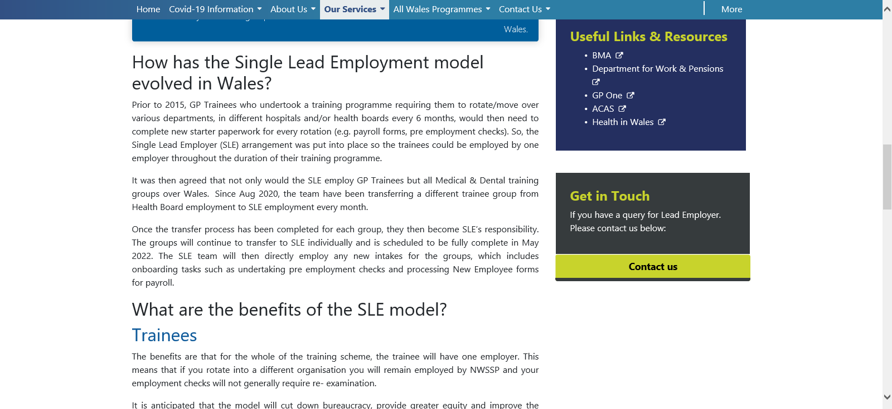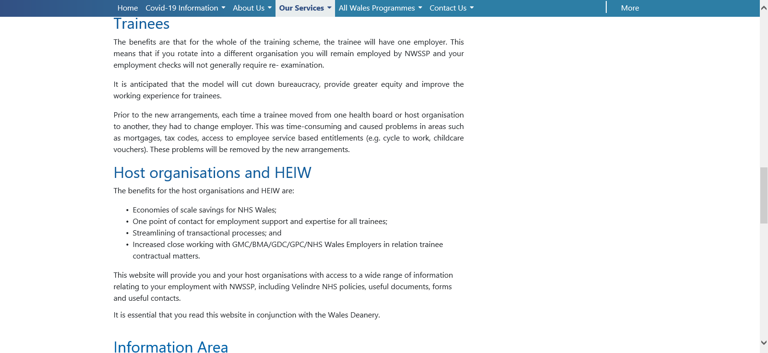
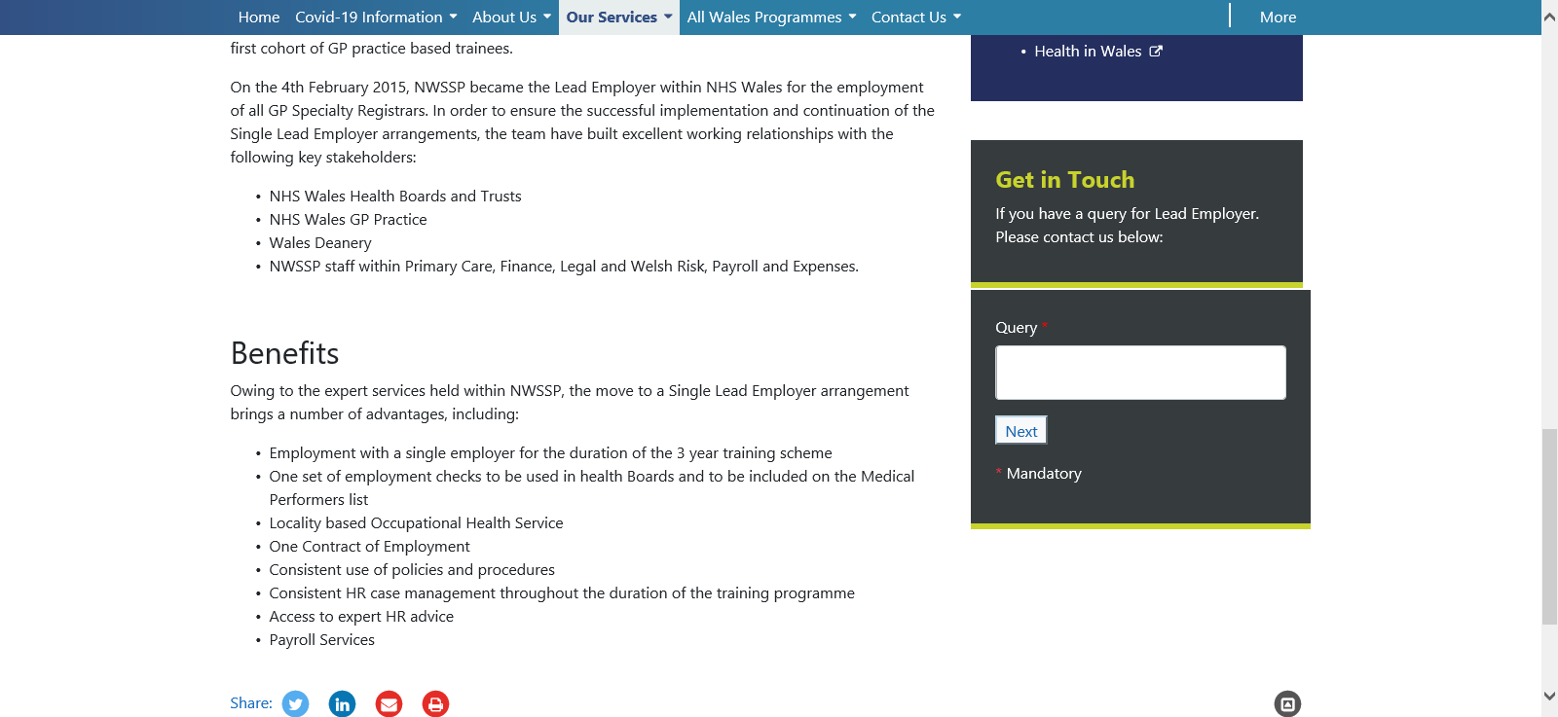

EV3 LO1 AC1.2 Some examples via email from Nick Meyler confirming transfer of doctors from Hywel Dda to the Single Lead Employer

From: Nicholas Meyler (NWSSP - WorkForce & OD) <Nicholas.Meyler@wales.nhs.uk>
Sent: 28 April 2020 13:03
To: Leeann Gardner (Swansea Bay UHB - Finance) <Leeann.Gardner@wales.nhs.uk>; Kate Davies (Aneurin Bevan UHB - Workforce and Organisational Development) <Kate.Davies6@wales.nhs.uk>; Mike Mullan (Cardiff and Vale UHB - Workforce Information) <Mike.Mullan@wales.nhs.uk>; Tanya Challenger (CTUHB - Human Resources) <Tanya.Challenger@wales.nhs.uk>; Michelle James (Hywel Dda UHB - Head of Workforce Intelligence) <Michelle.James@wales.nhs.uk>; Catherine Thomas (Hywel Dda UHB - Project Support Officer (ESR Self Service)) <Catherine.Thomas@wales.nhs.uk>; Louise
Subject: Foundation Year 1 (F1s) Move to NWSSP Single Lead Employer Scheme - Deanery Post Number Closure from HB ESR
Importance: High
Hi All
As you may be aware Workforce and OD Directors have agreed that, all new Medical and Dental Foundation Year 1 (F1s) will move to the Single Lead Employer scheme at NWSSP from Health Boards as a part of the August 2020 intake. This has been signed off by the NWSSP Partnership Group.
The below table summarises the total F1 DPNs which need to be removed from each Health Board’s ESR:
Health Board | Intrepid identified F1 DPNs
ABU | 46
BCU | 58
C&VU | 66
CTMU | 57
HDU | 54
SBU | 46
To ensure the interface between Intrepid and ESR links correctly for F1 Trainees in NWSSP please can you:
- Review the Intrepid Deanery Post Numbers (DPNs) report for your organisation. This will be sent in a separate email.
- Run the NHS Position Analysis Dashboard in Business Intelligence – Medical & Dental tab, default parameters to identify all F1 Positions with a DPN attached, occupied or not
- Look up the DPN between both reports to identify the unique position number
- Use the position number to locate and remove the Deanery Post number from each ESR Foundation Year 1 Position. (Please see attached guide)
Example DPN:
WAL/W042/001/F1/001 – Wales Deanery / Bangor Hospital / General Medicine / F1 / Post Number
This will remove the link from Intrepid to ESR in your Organisation for these DPN Positions, but will not change any data you currently held for the F1 trainees and the Active positions can remain until after the August 2020 rotation.
Please ensure this is completed by Close of Play Friday 8th May 2020 to ensure the interface can link between VPD 043 and Intrepid, and email confirmation to Nicholas.Meyler@wales.nhs.uk
From: Nicholas Meyler (NWSSP - People & OD) <Nicholas.Meyler@wales.nhs.uk>
Sent: 12 August 2021 09:24
To: Leeann Gardner (Swansea Bay UHB - Finance) <Leeann.Gardner@wales.nhs.uk>; Billy Horwood (Swansea Bay UHB - Finance) <Billy.Horwood@wales.nhs.uk>; Kate Davies (Aneurin Bevan UHB - Workforce and Organisational Development) <Kate.Davies6@wales.nhs.uk>; Mike Mullan (Cardiff and Vale UHB - Workforce Information) <Mike.Mullan@wales.nhs.uk>; Tanya Challenger (CTM UHB - Human Resources) <Tanya.Challenger@wales.nhs.uk>; Louise Foulkes (BCUHB -
Subject: O&G Speciality Registrar StRH & StRL transfer to NWSSP Single Lead Employer Scheme Effective 1 October 2021 - Deanery Post Number Closure from HB ESR
Hi All,
Obstetrics & Gynaecology and Sexual Health Speciality Registrar StRH and StRL posts are the next group of doctors in training to move across to the Single Lead Employer scheme at NWSSP from Health Boards on 1st October 2021.
For your organisation please can you:
- Remove the DPN interface link from the Position Extra Detail by 23rd August 2021
- Eliminate the ESR positions following the trainees transfer to the Single Lead Employer after 1 October 2021

Please could you ensure this is completed by close of play Monday 23 August 2021 and email confirmation to Nicholas.Meyler@wales.nhs.uk
If you have any queries regarding this then please do not hesitate to let me know.
Hi All,
Foundation Year 2 (F2s) posts are the next group of doctors in training to move across to the Single Lead Employer scheme at NWSSP from Health Boards on 4 August 2021. The below table summarises the total F2 DPNs which need to be removed from each Health Board’s ESR:
 | Health Board |  |  | Intrepid Identified F2 DPNs
 | Aneurin Bevan University Lhb |  |  | 48
 | Betsi Cadwaladr University Lhb |  |  | 66
 | Cardiff & Vale University Lhb |  |  | 69
 | Cwm Taf Morgannwg University Lhb |  |  | 60
 | Hywel Dda University Lhb |  |  | 57
 | Swansea Bay University Lhb |  |  | 39
 | Grand Total |  |  | 339
 |  | EV4 LO1 AC1.2 Doctors in Training Planned Move to Single Lead Employer Timeline
 |  | Month | Group |  | Intake Numbers
 |  | July 20 | F1’s |  | 54
 |  | Dec-20 | Rheumatology |  | 10
 |  | Dec-20  Jan-21 | Dermatology |  | 17
 |  | Dec-20  Jan-21 | Cardiology & Resp Medicine |  | 67
 |  | Jan-21  Feb-21 | T & O |  | 45
 |  | Jan-21  Feb-21 | General Surgery |  | 55
 |  | Jan-21  Feb-21 | Core Psychiatry |  | 85
 |  | Mar-21 | Higher Surgery |  | 82
 |  | Apr-21 | Geriatric Medicine |  | 52
 |  | Apr-21  May-21 | Ophthalmology |  | 40
 |  | Apr-21  May-21 | Pathologies |  | 41
 |  | May-21  Aug-21 | Higher Psychiatry |  | 63
 |  | May-21  Aug-21 | F2s |  | 57
 |  | Oct-21 | O&G/Sexual Health |  | 95
 |  | Nov-21 | Higher Medicine |  | 128
 |  | Dec-21 | Core Anaesthetics, Core Medicine, ACCS |  | 401
 |  | Dec-21  Mar-22 | Higher Emergency Medicine |  | 49
 |  | Dec-21  Mar-22 | Higher Anaesthetics & Intensive Care |  | 164
 |  | May-22 | Core Surgery |  | 100

EV5 LO1 AC1.2 Letter from Hywel Dda regarding the transfer to SLE
Junior Doctors moving from Hywel Dda to the Single Lead Employer
This letter is to confirm the transfer of all junior doctors across all specialities from Hywel Dda to the Single Lead Health Board. This means that your personal record with Hywel Dda will be terminated and you will be hired by the Singe Lead employer, therefore having a new payroll number and new login details for the ESR Electronic Staff Record.
However, you will still be working in the Hywel Dda hospitals across the counties and your mandatory elearning will be undertaken by Hywel Dda, along with any training relevant to your post.
The transfer will take place depending on the speciality which commenced July 2020 and will end May 2022.
We have been advised that you have also been contacted by the Single Lead Employer regarding transferring details.
We would like to thank you for your continuing work within Hywel Dda UHB.
Any further questions regarding the transfer can be found on the NWSSP website via.
Yours sincerely
Medical Staffing

EV5A LO1 AC1.2 FAQ
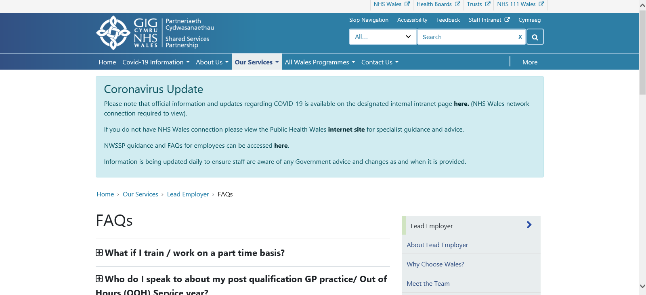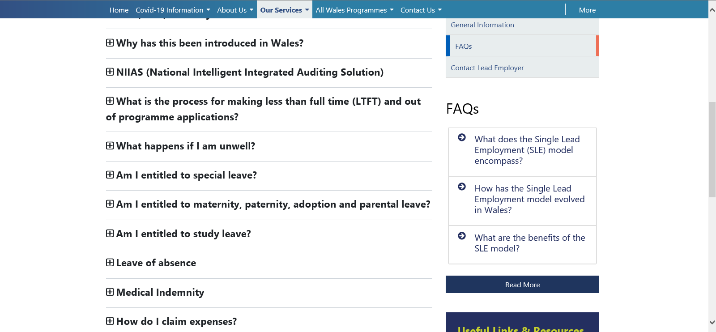

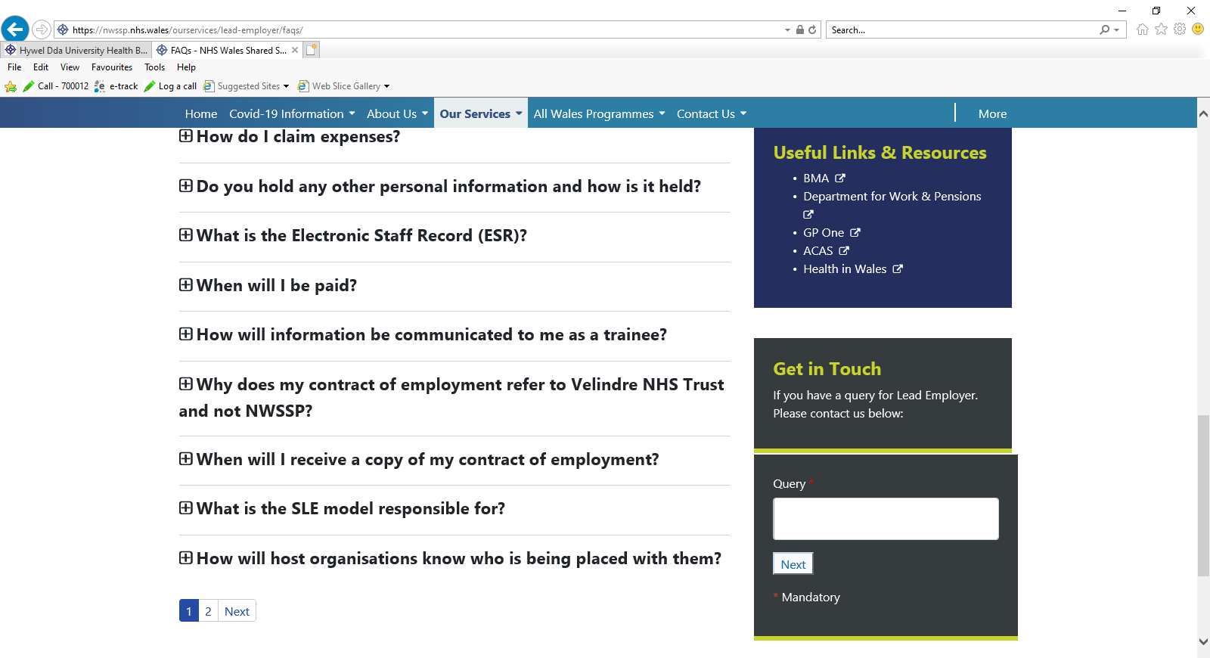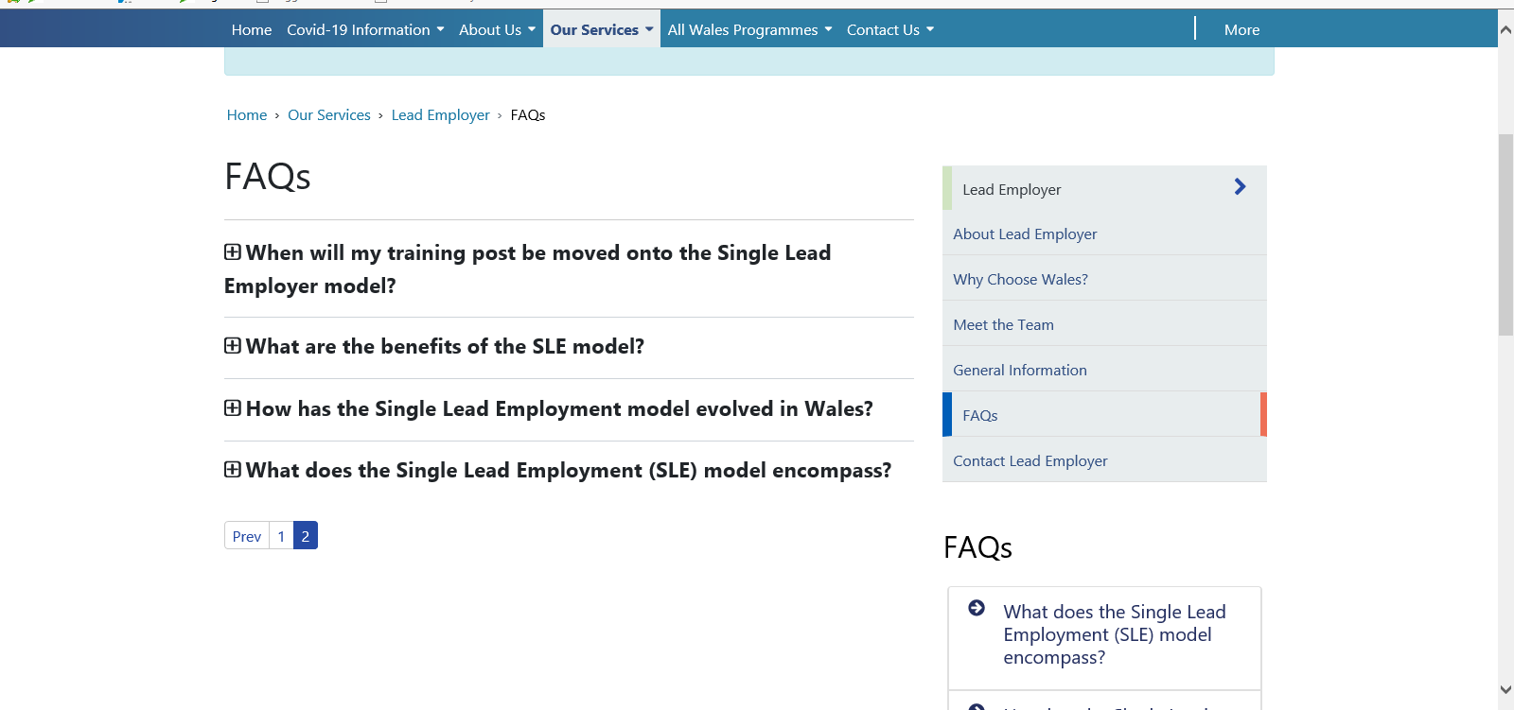

The SLE model in Wales is a collaborative employment model, with the responsibilities of the traditional employer shared between three major stakeholders, who are:
- Single Lead Employer – NHS Wales Shared Services Partnership (NWSSP)
- Host Organisation
- Health Education Improvement Wales (HEIW)
Prior to 2015, GP Trainees who undertook a training programme requiring them to rotate/move over various departments, in different hospitals and/or health boards every 6 months, would then need to complete new starter paperwork for every rotation (e.g. payroll forms, pre employment checks). So, the Single Lead Employer (SLE) arrangement was put into place so the trainees could be employed by one employer throughout the duration of their training programme.
It was then agreed that not only would the SLE employ GP Trainees but all Medical & Dental training groups over Wales. Since Aug 2020, the team have been transferring a different trainee group from Health Board employment to SLE employment every month.
Once the transfer process has been completed for each group, they then become SLE’s responsibility. The groups will continue to transfer to SLE individually and is scheduled to be fully complete in May 2022. The SLE team will then directly employ any new intakes for the groups, which includes onboarding tasks such as undertaking pre employment checks and processing New Employee forms for payroll.
Trainees
The benefits are that for the whole of the training scheme, the trainee will have one employer. This means that if you rotate into a different organisation you will remain employed by NWSSP and your employment checks will not generally require re- examination.
It is anticipated that the model will cut down bureaucracy, provide greater equity and improve the working experience for trainees.
Prior to the new arrangements, each time a trainee moved from one health board or host organisation to another, they had to change employer. This was time-consuming and caused problems in areas such as mortgages, tax codes, access to employee service based entitlements (e.g. cycle to work, childcare vouchers). These problems will be removed by the new arrangements.
Host organisations and HEIW
The benefits for the host organisations and HEIW are:
- Ecoomies of scale savings for NHS Wales;
- One point of contact for employment support and expertise for all trainees;
- Streamlining of transactional processes; and
- Increased close working with GMC/BMA/GDC/GPC/NHS Wales Employers in relation trainee contractual matters.

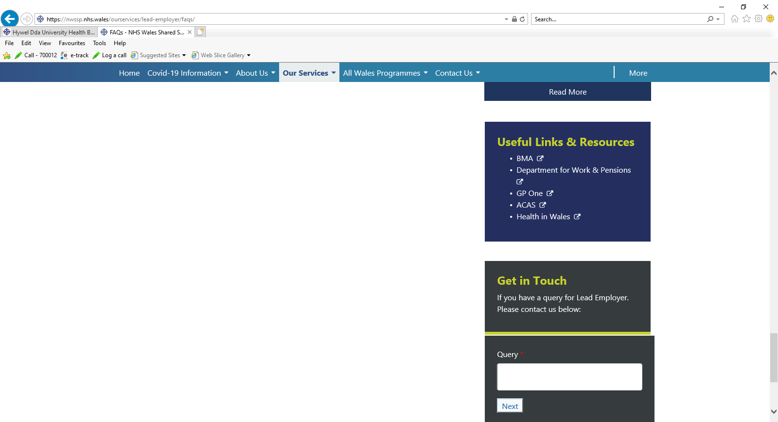
EV6 LO1 AC1.2 NWSSP Team involved in change
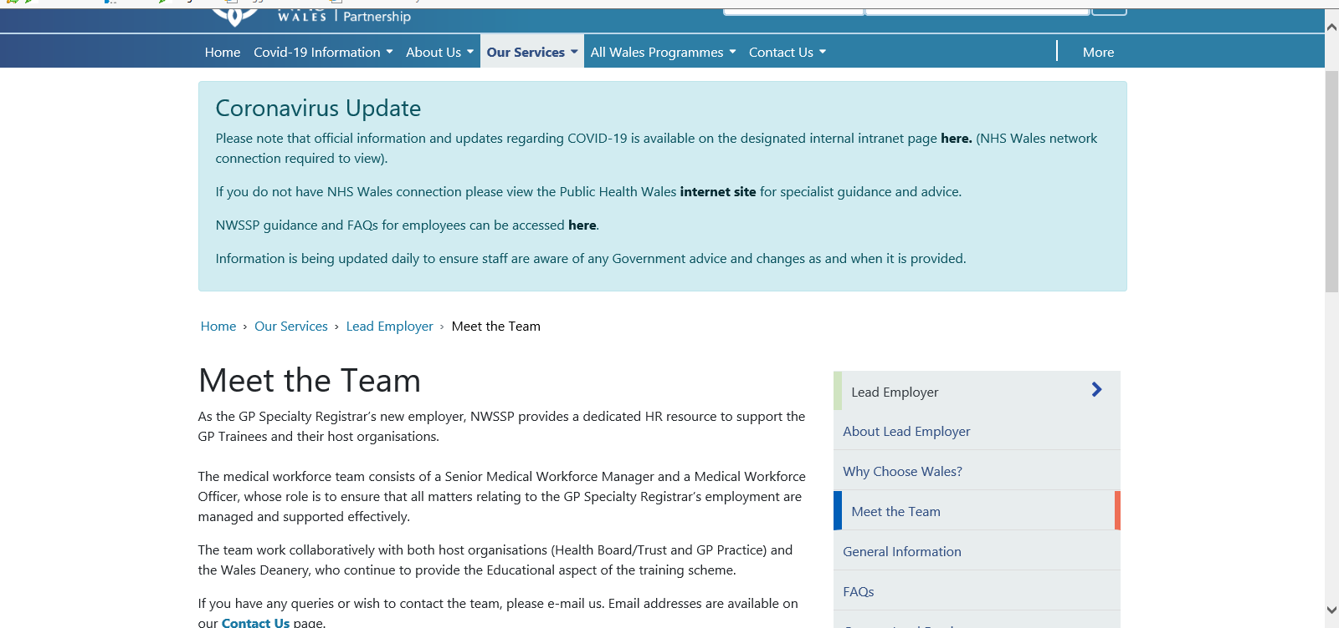

EV7 LO1 AC1.3 Minutes of Meeting

Minutes of Meeting
Doctors in Training Planned Move to Single Lead Employer
Tuesday 1st December 2020 - 9.00am – 12.30am - Via Teams
Name | Role | Attendance
Catherine Thomas | ESR Administrator/Workforce Information Manager (HDUHB) | Present
Bethan Griffiths | Senior Workforce Manager (HDUHB | Present
Bethan Jones | Medical Workforce Assistance (HDUHB) | Present
Dyfrig Davies | Regional Information Officer (HEIW) | Present
Nick Meyler | Senior Information Analyst | Present
Sailaja Ramachandran | ESR Administrator (HDUHB) | Present
David Lewis | Payroll Clerk (NWSSP Employment Services) | Present
Jane Wilkins | Payroll Clerk (NWSSP Employment Services) | Present
Diane Bowen | Finance clerk (HDUHB) | Present

- Introduction & Apologies

A short introduction was given by all who attended. There were no apologies.
- Notes of Previous Meeting and Actions
None as this was the first meeting.
- Discuss ESR Interface & work involved

Discussion took place around how the interface between the Deanery and ESR worked. It was noted that in order for the interface to work the DPN number in ESR had to be removed. This would be done by Hywel Dda for those junior doctors that would be moving across to NWSSP who would then setup a position for the SLE and a deanery number would be inserted.
The guidance on how to do this has to be devised and the ESR Manager would do this.
Action: CT
Any queries/problems when the ESR administrator begins the work there would need to be a conversation to have with Medical Staffing such as e.g. who is sitting in the position, where we have the right position number to correspond with the DPN number. If the problem could not be rectified between Workforce and Medical Staffing then the administrator would need to speak to the Deanery.
Action: SR/BJ/DD
Termination forms for the Junior Doctors that are currently on the Hywel Dda payroll would need to be sent to Payroll from Medical Staffing. Once received payroll will terminate them on the ESR system to enable the new SLE to hire them.
Action: BJ/DL/JW
- Correspondence to Junior Doctors

As this is an All Wales move NWSSP will be relaying the change to the doctors. Advising they will be paid by the SLE and not individual HB’s. However, junior doctors already have login details to individual HB’s there will be a difference as they will have new login details e.g. they currently have 100 Hywel Dda login with the VPD virtual private database but they will have the new SLE e.g. 043.

- Discuss Potential Problems

Junior doctors may contact the current HB for ESR login details to view personal details, payslips etc. and if this is the case they should be pointed in the direction the ESR Wales Support Hub and not individual HB’s. This as the hub have a shared service ESR Support hub for all the Welsh Health Boards meaning they can login and reset password for all the Welsh HB’s including the Single Lead Employer 043.
Action: - All
- AOB
None at present as this is the first meeting.
- Date of Next Meeting
TBC
Action Log
Item Number | Action | Member
3 | Guidance on taking out the DPN number in ESR | CT
3 | Queries/problems | SR/BJ/DD
5 | Jnr Drs login details if they query | All
3 | Termination form sent from Medical Staffing to Payroll | BJ/DL/JW
EV7A LO1 AC1.3 Finance involvement regarding the SLE
From: Ian Roberts (Hywel Dda UHB - Assistant Finance Business Partner (Systems)) <ian.roberts3@wales.nhs.uk>
Sent: 28 October 2021 10:52
To: Catherine Thomas (Hywel Dda UHB - ESR Administrator/Workforce Information Manager) <Catherine.Thomas@wales.nhs.uk>
Cc: Katie Stuart-Robson (Hywel Dda UHB - Assistant Finance Business Partner) <Katie.Stuart-Robson@wales.nhs.uk>
Subject: FW: SLE single lead employer junior doctors
Hello Catherine,
Both Katie Stuart-Robson and myself are the finance leads for the SLE project.
It has been implemented, and is still evolving as more specialties come on board.
We have implemented an SLE pay feed into our ledgers from Velindre’s ESR system, and have set up an SLA where we pay Velindre a forecast amount for the service.
We are also a pilot for adding Locum shifts to the SLE pay feed process.
Happy to share any information with you, and/or have a teams session to discuss etc…
Many thanks

Ian Roberts (Hywel Dda UHB - Assistant Finance Business Partner (Systems))
Sent: 23 July 2020 11:35
To: Diane Bowen (Hywel Dda UHB - Corporate Finance Officer) <Diane.Bowen@wales.nhs.uk>; Lauren Theaker (Hywel Dda UHB - Finance Business Partner) <Lauren.Theaker@wales.nhs.uk>; Ceri Dda UHB - Assistant Finance Business Partner) <Katie.Stuart-Robson@wales.nhs.uk>; Sarah Barnes (Hywel Dda UHB - Finance Analyst (Systems)) <Sarah.AM.Barnes@wales.nhs.uk>
Subject: FW: Single Lead Employer Finance Workstream
Hello All,
Having attended the 2nd Finance Workstream meeting of the Single Lead Employer project for Medical and Foundation Trainees, I thought I would summarise where we are and the forthcoming proposed changes to our processes. I have also attached the Agenda and embedded documents which include timetables and process maps from the meeting for your information.
Summary of what is going to happen in August and planned for the rest of the year:
The existing NWSSP SLE model will go into an expanded phase beginning in August this year with the intake of new Foundation year medical trainees. Medical trainees from other specialities will be joining the scheme on a phased basis as per the timetable below (the timetable is susceptible to slippage due to Covid):
 | Specialty |  | Aug20 |  | Sep20 | Oct20 |  | Nov20 | Feb21 | Aug21
 | F1s
 | Pre-Registration Pharmacists
 | Dental Foundation Trainees
 | Paediatrics
 | Anaesthetics |  |  |  |  | Oct 20 postponed – new date TBC
 | Radiology
 | F2s/additional specialties
 | Remaining specialties
Pay Month |  | Expected Date Payroll feed will be available to Systems to start processing |  | Pay Date |  |  | Expected Date Payroll feed will be available to Systems to start processing |  |  |  | Supp Pay Date
August 2020 |  | Tue 18-Aug-20 |  | Fri 21-Aug-20 |  |  | Wed 26-Aug-20 |  |  |  | Fri 28-Aug-20
September 2020 |  | Wed 16-Sep-20 |  | Mon 21-Sep-20 |  |  | Thu 24-Sep-20 |  |  |  | Wed 30-Sep-20
October 2020 |  | Fri 16-Oct-20 |  | Wed 21-Oct-20 |  |  | Mon 26-Oct-20 |  |  |  | Fri 30-Oct-20
November 2020 |  | Tue 17-Nov-20 |  | Fri 20-Nov-20 |  |  | Wed 25-Nov-20 |  |  |  | Mon 30-Nov-20

In order to populate the NWSSP’s ESR we have provided them with Hywel Dda’s relevant cost centres for each specialty intake.
We have also provided them with a Balance sheet contra-entry code for the feed – which can be used for the recharge mechanism. (This code will also be used for invoice payments).
It was envisaged that we would have had a test file from NWSSP in mid-July so that we could test the processing of the feeds, however they are having issues producing a test feed due to there being no “test” environment in ESR. (In order to produce a feed - you have to run a payroll). NWSSP are looking for a workaround however it may be the case that we do not receive a test file, and will receive the first Actual payfeed in mid August.
As a fall back if the payfeeds from ESR, for any reason cannot be produced – they will revert to the existing process used for GP Rotation.
Process Maps – Primary care payments and Feeds:
The process maps embedded in the agenda highlight the changes that will occur with regard to DFT dental trainees, Pre reg Pharmacists and Core & Specialty trainees – pay costs. Grants etc.
Currently these costs are input into our ledger via Primary Care feeds/journals received from NWSSP, and reconcile back to the payments made on our behalf by Primary Care Services.
Some aspects of this will now be included in the proposed pay feeds going forward – please see process maps for details.
Future Potential:
Once the SLE model is up and running future potential developments could include:
Study Leave – potential for this to be centrally managed, recorded and paid by one employer
Locum work –potential for any locum hours worked anywhere in NHS Wales to be paid as part of the SLE model and recharged to the UHB and specialty where the shifts are worked via the automatic recharge process.
Next steps:
The next meeting of the SLE Project Finance workstream will not be until September, although minutes and action points will be distributed from last Tuesday’s meeting.
However it was decided that an Emergency meeting would be scheduled if difficulties were encountered producing the feeds.
We will also be liaising with Workforce, as they have a separate project workstream to explore any issues they may have, and also to gather information on salary sacrifice and the Apprenticeship Levy to feed back to the group.
Please can you review the contents of the embedded documents and make note if this effects your area.
There may be the need to review existing internal processes within your departments to accommodate the new procedures, and also the need to put various mechanisms into place before the procedure goes live.
If you have any points to raise, issues, concerns or observations – please can you communicate them to myself and Katie Stuart-Robson so that we can progress them either internally or take them to the project finance workstream?
Many thanks


SINGLE LEAD EMPLOYER FINANCE WORKSTREAM
Tuesday 21st July 2020 via Microsoft Team
 | Agenda Item | Lead | Documents
1 | Welcome and apologies for absence | LP
2 | Meeting Notes and Action Log from 17th June 2020 | LP
3 | Agreement of Terms of Reference and Finance sections of Roles & Responsibilities document | LP
4 | Project update and updates from other workstreams | RO | Verbal
5 | Review of SLE Financial Arrangements and actions identified:  - Updated paper per comments at last meeting  - Finance Process Maps (DRAFT)  - Monthly Timetable  - Salary Sacrifice  - Apprenticeship Levy  - Testing | LP  RM  RM  LP/RM | Verbal
EV8 LO1 AC1.3 Copy of Termination form
Termination Form To be completed when: Employee is leaving the Health Board AND/OR retiring and coming back. (If moving dept, a change form is required and NOT a termination form) WAVE ……………....If on ESR Self Service, please insert wave number and send to payroll only



Is this the employee’s only job within the Health Board: If No please indicate job title and department: Yes / No

Is member of staff currently paying for a Salary Sacrifice Scheme eg Bike, Computer, Childcare, phone etc. Yes / No
Does the member of staff have a Lease Car: Yes / No
Is the employee available for bank work: Yes / No
Title | Full Name | Job Title | Department | Base | Staff No
NOTIFICATION |  |  | REASON FOR LEAVING
Final Termination Date: |  |  | Dismissal  ۝ Conduct  ۝ Capability  ۝ Some other substantial reason  ۝ Statutory reason  Redundancy  ۝ Voluntary Early release scheme  ۝ Voluntary  ۝ Compulsory  Retirement  ۝ Age  ۝ Ill Health  ۝ Voluntary Early Retirement  End of Temporary / Fixed Term Contract  ۝ End of Temporary / Fixed Term Contract  ۝ Completion of Training Scheme  ۝ External Rotation  ۝ End of Work Requirement  Voluntary Resignation

EV9 LO1 AC1.3 Showing Deanery (DPN) for deletion and how to delete it in the ESR Position

 | Healthboard: | HDU
 | F2s
 | Post No. | Site
 | WAL/W025/030/F2/001 | Glangwili Hospital
 | WAL/W025/030/F2/003 | Glangwili Hospital
 | WAL/W022/017/F2/003 | Prince Phillip Hospital
 | WAL/W022/001/F2/001 | Prince Phillip Hospital
 | WAL/W025/001/F2/002 | Glangwili Hospital
 | WAL/W025/001/F2/003 | Glangwili Hospital
 | WAL/W00134/800/F2/001 | Llwynhendy Health Centre
 | WAL/W92009/800/F2/001 | Meddygfa Teilo
 | WAL/W92037/800/F2/002 | Avenue Villa Surgery
 | WAL/W025/021/F2/001 | Glangwili Hospital
 | WAL/W021/012/F2/001 | Bronglais General
 | WAL/W091/030/F2/001 | Withybush General Hospital

How to Delete a Deanery Post Number from ESR
This guide will show you:
- How to delete a Deanery Post Number from an ESR position.
- Login to ESR with Username and password.

- Select ESR Navigator link from the navigation menu located on the left-side of the screen.
  - Select xx Local Workstructures Administration >> Position Description.
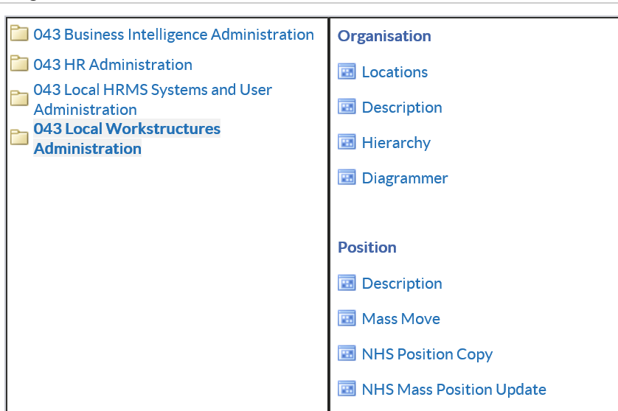

The below Decision window will appear:

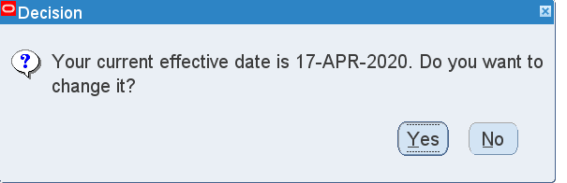

- Click Yes
- Change the date to 01-Mar-2020
- Click OK
The below form will appear:
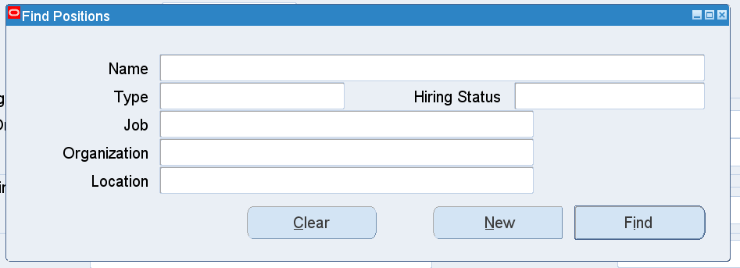

EV10 LO1 AC 1.3 Guidance on how to Share URPs with a Shared Service Centre (SSC)
Use URP: XXX Local Workstructures
NHS ESR
(N) Organisations > Description
Organization
Use the above Organisation Description navigation path which always takes you to the Organization form via a Decision box for Effective Date change and then on to the Find Organisation form.
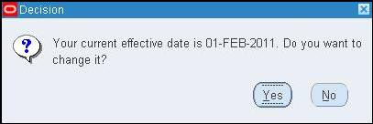
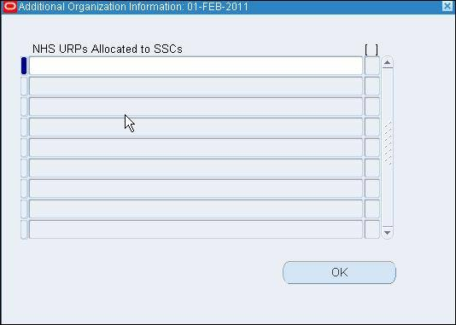
9. Click the first blank row to open the NHS URPs Allocated to SSCs Descriptive Flexfield.
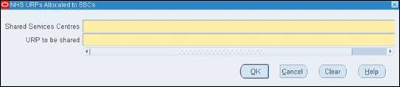
 | EV10 cont… LO1 AC1.3 Health Board URPs to be Shared with NWSSP - URP Matrix Audit - April 2021
 | URP Shared | 100 Hywl Dda
 | Absence Administration | Required
 | Absence Data Entry | Not Required
 | Absence Management (Read only) | Required
 | Business Intelligence Administration | Not Required

EV11 LO1 AC1.4 Change Plan
Created by | Catherine Thomas
Date | October 2021
Version | One

Vision and Objectives
- To remove all Junior Doctors from Hywel Dda payroll as advised by NWSSP.
- Termination forms completed by Medical Staffing and sent to Payroll.
- To remove all DPN numbers from positions numbers to enable NWSSP to setup their end as this cannot happen if the DPN number is still in the Hywel Dda position.
- All Junior Doctors still work within the Health Board under each speciality but paid by the Single Lead Employer 043.
- Vision is that there will be uniformity for all Junior Doctors being paid by one Health Board and have one single login for the (ESR) Electronic Staff Record instead of multiple logins if they work across a number of hospitals in Wales.
- Vision is also that there will be also be the same process for Locum bank doctors in that they are paid for locum work by the Single Lead Employer 043.
- Team to be informed of communication to staff by NWSSP also of any FAQ’s outlined re the change.

Activities to achieve objectives (attach Gantt chart)
See Gantt Chart.

Business case (evidence-based - include data, benefits of change, gap analysis – difference between current and future states, issues and risks)
The Benefits:
- Junior doctors able to work across a wider geographical area in their substantive post.
- Locum shifts for junior doctors can also be across a wider geographical area.
- One ESR account as paid by Shared Services and one payroll number.
- One ESR login for their personal details via Employee Self Service.
- Due to working across all NHS Wales sites can seek job opportunities within all of the Health Boards as an internal applicant.
- Consistent use of policies and procedures
Currently junior doctors can be paid by multiple Health Boards e.g. hold a substantive position with Hywel Dda University Health Board. Also have multiple locum bank posts within local hospitals this meaning having multiple payroll numbers, multiple login details for their personal Electronic Staff Record, multiple payslips and multiple email address linked to each Health Board.
Future state being they are only paid by one Health Board and can work across multiple hospitals having only one payroll number, one payslip, one email address, and one Electronic Staff Record.
Issues could be doctors forget their ESR number and contact the hospital that currently paid them instead of their new employer. Should for any reason a decision be made that the Single Lead Employer is not successful then reverting back to how it was previously would be a lot of background work along with confusion for the doctors. Also that they can become confused as to who they would sit under for their mandatory training needs e.g. eLearning.
People affected (stakeholders – employees, particular employees, customers, shareholders)
- Junior Doctors
Scope of change (eg one site, one product group)
- All Junior Doctors in training posts
Roles (project manager, sponsor, team members)
- Payroll team
- Medical Staffing team
- Finance team
- ESR Team
- NWSSP Administrator
Communication strategy (attach communication plan, list of change champions)
As this is predominately rolled out by NWSSP communication to staff and teams members will be done by them.
Support to be offered (advice, counselling, coaching, mentoring, representation, training - attach, for example, a training plan)
Advice would only be provided by NWSSP. However, with regards to mandatory clinical training this would still have to be done in each individual hospital the junior doctor is working. With regards to mandatory elearning training this would be completed with the Single Lead Employer.
Timings and milestones (see Gantt chart)
See Gantt Chart
Resources required, including cost (equipment, time, people, materials, guidance)
Payroll staff, Medical Staffing staff, Finance staff, ESR team. Time is within the staff’s working day and not overtime. Equipment used is the computer and the ESR system is the package to be used which is already used in the Health Board.
Monitoring activities
Once work has been undertaken by all team’s involved, discussion will take place with NWSSP who are working with the Single Lead Employer as to whether they can take forward the actions once completed by our side.

Any errors that arise will be discussed and fault finding undertaken to be able to take the action forward. Should all avenues fail it is up to the ESR team to raise a Service Request with the provider of the ESR System (IBM) for them to look into the problem and assist with guidance on how to correct.
Success Measures
Success will only be measured once the Single Lead Employer hires staff onto their payroll system.

EV12 LO1 AC1.4 Gantt Chart
 |  |  |  |  |  |  | 2020/2021/2022
Task | Dec | Jan | Feb | Mar | Apr | May | Jun | Jul | Aug | Sep | Oct | Nov | Dec | Mar | May
Project Management Work
Discuss around interface being rolled out & communication
Meetings between relevant departments
Question as to whether need Terms of Reference
Tools required to do task
URP (user responsbility Profile) Review e.g. what access is required
Do necessary background work to enable change
Revisit potential errors preventing roll out
Data Cleanse
Once record has been closed by payroll Workforce to make sure assignment final process date is in record once terminated to enable record to be taken off system
Workforce to make sure position number is closed once the move has taken place so that Recruiment won't advise with the old position number
Payroll to insert Final Process Date if not done once checked by Workforce.
Payroll Data Cleanse
Governance
Continue to monitor through roll out. Noting once rolled out there will be no need for monitoring as will be with new Single Lead Employer. Termination forms need to be sent to payroll on time e.g. the relevant cut off date to ensure there are no overpayments.
Question whether Junior Doctors will come back to HB to do bank work and will then have to be setup with a payroll number and assignment record for HB. Discuss whether SLE will setup and coorindate Bank Locums?
Note:-
Due to the change being implemented by NWSSP for all Wales Healthboards they will have their own correspondence/plans/change plans. However, plans etc will be required for the change being done within each individual HB enabling NWSSP to fully implement the doctors onto their payroll system and within their structure.

Also as the tasks are done month on month the background work/potential errors etc are required to do each month.
EV13 LO1 AC1.4 Stakeholder Map for communicating change

Stakeholder Mapping Worksheet

Stakeholder Influence/Interest Matrix
For each key stakeholder, characterize them using the following stakeholder influence grid.

Influence | High | Keep Satisfied | Key Players
Influence | Low | Minimal Effort | Keep Informed
 |  | Low | High
 |  | Level of Interest

Stakeholder Grouping
Using the Stakeholder Influence/Interest Matrix, complete the table below. This will help determine stakeholder’s grouping for change communications.
Stakeholder Name | Influence Level | Level of Interest | Stakeholder Grouping
Payroll | High | High | Keep informed
Deanery | Low | Low | Keep informed
NWSSP (NHS Wales Shared Service Partnership) | High | High | Key Players
WFiS Workforce Information Systems | High | High | Keep Informed
Medical Staffing | High | High | Keep informed
Postgrad | Low | Low | Keep informed
Finance | High | High | Keep informed

Change Management: Leading Successful Transformations
©2019 Society for Human Resource Management
EV14 LO1 AC1.5 Minutes of Meeting to sign off Change Plan

Minutes of Meeting (2)
Doctors in Training Planned Move to
Single Lead Employer – Sign off Change Plan
Tuesday 15th December 2020 - 9.00am – 12.30am - Via Teams
Name | Role | Attendance
Catherine Thomas | ESR Administrator/Workforce Information Manager (HDUHB) | Present
Bethan Griffiths | Senior Workforce Manager (HDUHB | Present
Bethan Jones | Medical Workforce Assistance (HDUHB) | Present
Dyfrig Davies | Regional Information Officer (HEIW) | Present
Nick Meyler | Senior Information Analyst | Present
Sailaja Ramachandran | ESR Administrator (HDUHB) | Present
David Lewis | Payroll Clerk (NWSSP Employment Services) | Present
Jane Wilkins | Payroll Clerk (NWSSP Employment Services) | Present
Diane Bowen | Finance clerk (HDUHB) | Present

- Apologies

There were no apologies.
- Notes of Previous Meeting and Actions

Minutes of previous meeting noted and all actions were advised as correct and complete.
- Discussion to sign off Change Plan

Whilst on teams the Change plan and Gantt Chart was shared. It was noted that the F1’s had gone across to the Single Lead Employer 043 in August 2020 and that work was undertaken quickly at that point due to there being a lot of them and August usually being the biggest intake. However, moving forward there had to be a change plan which focussed on the other specialities going across.

Rheumatology and Dermatology are the next to go in December however, the intake numbers is relatively small being 27.

All team members were happy with the plan and also the Gantt Chart. After discussion as to any add in’s or errors to the plan it was agreed that no changes were needed, except for it to be noted of the potential overpayment problem. Once this has been updated everyone agreed it could be shared with the Head of Workforce Intelligence for final sign off.
Action: CT

- Discuss Potential Problems

Payroll clerks had reservations about receiving termination forms on time from Medical Staffing to reach payroll cut off, meaning there could potentially be overpayments
Action: - Medical Staffing
- AOB

Medical Staffing commented that a lot of communication had been done by NWSSP as they were the lead. The stakeholders of Hywel Dda wanted confirmation that communication and FAQ’s that had been done by NWSSP were available and where these could be found.
Action: CT
- Date of Next Meeting

TBC
Action Log
Item Number | Action | Member
3 | Send Change Plan and Gantt Chart to Head of Workforce Intelligence for signing off | Catherine Thomas
4 | Payroll clerks had reservations about receiving termination forms on time from Medical Staffing to reach payroll cut off, meaning there could potentially be overpayments. | Medical Staffing
5 | The stakeholders of Hywel Dda wanted confirmation that communication and FAQ’s that had been done by NWSSP were available and where these could be found. | Catherine Thomas
EV15 LO1 AC1.5 MICHELLE EMAIL SIGN OFF
From: Michelle James (Hywel Dda UHB - Head of Digital Workforce Solutions) <Michelle.James@wales.nhs.uk>
Sent: 03 November 2021 19:56
To: Catherine Thomas (Hywel Dda UHB - ESR Administrator/Workforce Information Manager) <Catherine.Thomas@wales.nhs.uk>
Subject: FW: Change Plan & Gantt Chart
Hi,
I confirm that Cath was the lead for developing the attached plan and gantt chart and for implementing the Single Lead Employer for training doctors in Hywel Dda University Health Board.
Regards

From: Catherine Thomas (Hywel Dda UHB - ESR Administrator/Workforce Information Manager) <Catherine.Thomas@wales.nhs.uk>
Sent: 28 October 2021 08:17
To: Michelle James (Hywel Dda UHB - Head of Digital Workforce Solutions) <Michelle.James@wales.nhs.uk>
Subject: Change Plan & Gantt Chart
Hi Michelle
I know we have previously met and discussed verbally the attached regarding sign off for the Change Plan and Gantt Chart by you and you were happy to proceed.
However, could you please confirm this via an email or witness statement please as I need evidence for my assignment re change management.

References for Learning Outcome 1
- CIPD (2021) Change Management. Available at:
https://www.cipd.co.uk/knowledge/strategy/change/management-factsheet#_ga=2.4078646.769207037.1635087311-1206122804.1633545165 (Accessed: 24 October 2021).
- CIPD, (2014) Landing Transformational Change. London. CIPD.
- Gantt Charts (2021) Gantt Charts. Available at: http://www.gantt-chart.co.uk/. (Accessed: 25 October 2021
- Hughes, M. (2014) Managing Change. London. CIPD.
- Inside HR (2018) 5 ways to improve change management through design thinking. Available at: How design thinking can improve change management outcomes. (Accessed: 23 October 2021).
- NHS Wales (2021) About Lead Employer. Available at: https://nwssp.nhs.wales/ourservices/lead-employer/about-lead-employer/ (Accessed: 26 October 2021).

NHS Wales (2021) FAQ. Available at: https://nwssp.nhs.wales/ourservices/lead-employer/faqs/ (Accessed: 26 October 2021).

NHS Wales (2021) Lead Employer. Available at: https://nwssp.nhs.wales/ourservices/lead-employer/#:~:text=Single%20Lead%20Employer%20%E2%80%93%20NHS%20Wales%20Shared%20Services,single%20point%20of%20contact%20coordinating%20with%20all%20stakeholders. (Accessed 26 October 2021).

NHS Wales (2021) Meet the Team. Available at: https://nwssp.nhs.wales/ourservices/lead-employer/meet-the-team/ (Accessed 26 October 2021).

North, J. (2021) The Role of Leadership in Change Management Available at: https://www.redglobepress.com/companion/Hayes-Change-Management-5e/learning-resources/Videos/ (Accessed: 26 September 2021).

Rees, G and Hall, d (2016) Learning, Managing and developing people, 5th Chartered Institute of Personnel and Development.
- SHRM (2019) Stakeholder Mapping Worksheet. Available at:
https://view.officeapps.live.com/op/view.aspx?src=https%3A%2F%2Fwww.shrm.org%2FLearningAndCareer%2Flearning%2FPublishingImages%2FPages%2FForms%2FAllItems%2FStakeholder%2520Mapping%2520Worksheet.docx (Accessed: 24 October 2021).

Sage (2020) Business resilience and agility: How HR leaders can empower change. How to build a stronger, more adaptable workforce. Published.

The Motley Fool (2021) How to Create and Run a Change Management Plan. Available at: 5 Steps to Creating a Change Management Plan |The Blueprint (fool.com) (Accessed: 24 October 2021).

2.1 Follow the agreed plan to implement change processes.

According to (Sage, 2020) organisations must be flexible and agile in order to survive. They need to be responsive and respond quickly to changes and have the ability to adapt and evolve.

Project management skills were followed by the Gantt Chart LO2 AC2.1. Every month details were received from NWSSP to implement each speciality moving over to the Single Lead Employer and as per the Gantt chart this was followed. All stakeholders worked together getting each phase completed. Firstly removing the Deanery Pin Number from the position number, closing the position number, making sure the record is terminated so they can then be hired by the SLE. Emails were sent to make sure the tasks were undertaken by the Stakeholders to implement the change by me. (EV16).

Ongoing communication and promotion of the change would be the responsibility of NWSSP who were co-ordinating the change, showing the need for the change and the benefits (EV2 & EV5A).

According to Kotter (1996, quoted in Hughes, 2010, p.136) describes that management is the backbone of keeping a system of people and technology running effortlessly, and that leadership supports people with the vision to make it happen. Kotter’s Eight Step Change Process was taken into consideration, e.g. establishing the need for the change, communicating the vision and engaging others. (SHRM, 2019).

2.2 Provide information and support to stakeholders in line with their identified requirements.

(Insider HR, 2018) suggests that testing the processes helps to find whether it works, as if no other solutions need to be thought of.

An email was received from payroll asking whether I could provide access to them for the Business Intelligence reporting side so they could see exactly how many junior doctors were involved in the change. I had to provide access to the shared services through Hywel Dda for NWSSP to pick up their end. (EV17).

Regarding support to other Stakeholders; emails were sent advising of the identified requirements with supporting evidence (EV18). Feedback received from NWSSP thanking me for the support provided in testing taking out the DPN to then allow him to check all will work his end. (EV16).

2.3 Apply techniques for maintaining positive working relationships throughout the change processes.

McKinsey & Company (2016) suggest that leaders find it hard to get employees to accept large change programs, they are likely to resist rather than adapt and could land up looking for a new job.

I was not familiar with applying techniques as this is not something I would do for this particular project as it would be the Single Lead Employer. However, I did speak to the Unison Representative for Hywel Dda UHB to find out the process of positive working relationships throughout the change process. The union rep advised that the Organisational Change Policy is used for changes across whole directorates and that manager’s stick to the process rigorously and that it works very well for staff involved in any move. (EV19). I have investigated the techniques used for maintaining positive working relationships throughout change processes within the Health Board. Whether it be on a ward or in a department and my findings are that within Hywel Dda UHB there are processes to follow e.g. Scenarios when to use full OCP and when not to. If it’s a big change i.e. a ward closure, these changes need to be signed off at board level. So a consultation briefing document is completed to outline the change plans and overview of timescales, etc which has to be signed off by the board before it can progress further (EV20).
FAQ are shown on the NWSSP website which helps with the positive working relationship, such as “Why has this been introduced in Wales? And “When will I be paid”?(EV5A). As this was implemented by Shared Services I am not aware of their techniques.

An article by the CIPD ARC Dublin (2020) commissioned by the Henley Forum, of Henley Business School, displays findings of research into the role of workplace relationships supporting engagement and wellbeing in challenging environments.

2.4 Monitor the effectiveness of the implementation, agreeing and making justified adaptations where required.

Research by Deloitte found that 70% of change management programmes fail, from all different causes. Employees’ approval of the change is the stride to success. (Insider HR, 2018).
One aspect of monitoring the effectiveness of the implementation was whether Statutory and Mandatory training for both classroom based learning and e-learning would be completed internally within Health Boards or if this would be completed by NWSSP or a combination of the two? An email was sent by me to NWSSP asking the question LO2 AC2.4 (EV21). Justified adaptions were made to the positions by me as these did not interface across from Hywel Dda to the Single Lead Employer and work had to be adapted to enable the position to interface LO2 AC2.4 (EV22).
Another monitoring process for checking data analysis was subjective codes that are inserted in the position number which the staff member sits in. We received an updated to these codes for ESR and Oracle Financials. As these were agreed by the Finance Technical Advisory Group and were to be used by the Single Lead Employer, these had to be updated with immediate effect by me. LO2 AC2.4 (EV23). Also looking at performance assessments an email was sent to NWSSP by me confirming completion from Hywel Dda’s side and for him to confirm that they had gone across to the Single Lead Employer LO2 AC2.4 (EV24).
There is no definite answer to managing change as it is complicated. Research by the CIPD and University of Bath recognised techniques against topics that could be applied to a selection of change management situations to enhance the effectiveness of change programmes. (CIPD, 2021).

2.5 Maintain records of the change process in line with organisational requirements.

There is a process when storing, using, and gathering data regarding people, and Organisations must adhere to the Data Protection Act 2018, General Data Protection Regulation (GDPR) and other related legislation. (CIPD, 2021).

Through the change process, termination forms (EV8) were sent to payroll to terminate the junior doctors from Hywel Dda UHB to then be hired by the Single Lead Employer. These are paper forms but would have been sent electronically to the generic payroll email account more so since the pandemic as payroll staff are working from home. This helped regarding data protection as they would not be printed out and left in a tray in the office but stored electronically on the generic email account. Obviously this could not be totally audited as staff could print out at home whereby family members could see the data. Recently via the Workforce Collaborative meeting Hybrid/flexible home working was discussed and all aspects such as confidential forms were brought up (EV25). Confirmation from my manager that the process was in line with organisational requirements is in an email (EV15). Also confirmation in an email from the Senior Programme Manager – Digital Workforce NWSSP that the change management process was met. (EV26).

Quantitative data was also considered by me when making the change as to when would be the best time to terminate the staff from Hywel Dda UHB due to the payroll cut-off date. This so that headcount figures did not have an impact in the structure for both Health Boards. (EV24).

Evidence for Learning Outcome 2

EV16 LO2 AC2.1 – Details to staff to implement change

From: Catherine Thomas (Hywel Dda UHB - Project Support Officer (ESR Self Service)) <Catherine.Thomas@wales.nhs.uk>
Sent: 29 April 2020 13:30
To: Bethan Griffiths (Hywel Dda UHB - Senior Medical Workforce Manager) <Bethan.Griffiths101@wales.nhs.uk>; Jason Wills (NWSSP - NWSSP Employment Services) <Jason.Wills@wales.nhs.uk>; Bethan Jones (Hywel Dda UHB - Senior Medical Workforce Advisor) <Bethan.Jones3@wales.nhs.uk>
Cc: Sandra Thomas (Hywel Dda UHB - Medical Workforce Officer) <Sandra.Thomas3@wales.nhs.uk>; Linsey Jones (Hywel Dda UHB - Medical Workforce) <Linsey.Jones3@wales.nhs.uk>; Sailaja Ramachandran (Hywel Dda UHB - ESR Administrator) <Sailaja.Ramachandran@wales.nhs.uk>; Alex Thomas (Hywel Dda UHB - ESR Support Officer) <Alex.Thomas2@wales.nhs.uk>; Helen Rees (Hywel Dda UHB - ESR System Administrator) <Helen.Rees@wales.nhs.uk>; Robert Horsley (Hywel Dda UHB - Hafan Derwen) <Robert.Horsley@wales.nhs.uk>; Michelle James (Hywel Dda UHB - Head of Workforce Intelligence) <Michelle.James@wales.nhs.uk>
Subject: FW: Foundation Year 1 (F1s) Move to NWSSP Single Lead Employer Scheme - Deanery Post Number Closure from HB ESR
Importance: High
Thanks Bethan G for your email just now regarding F1's. Please see email below regarding this also. I will be doing what is required.
In the meantime I have done a report (attached) and would like confirmation that you agree with the staff so that I can take the DPN number from the position so that the interface will work between NWSSP etc.
From: Sailaja Ramachandran (Hywel Dda UHB - ESR Administrator) <Sailaja.Ramachandran@wales.nhs.uk>
Sent: 29 October 2021 14:13
To: Catherine Thomas (Hywel Dda UHB - ESR Administrator/Workforce Information Manager) <Catherine.Thomas@wales.nhs.uk>
Subject: FW: Paediatric Doctors in Training

From: Catherine Thomas (Hywel Dda UHB - Project Support Officer (ESR Self Service)) <Catherine.Thomas@wales.nhs.uk>
Sent: 18 June 2020 13:46
To: Nicholas Meyler (NWSSP - WorkForce & OD) <Nicholas.Meyler@wales.nhs.uk>
Cc: Sailaja Ramachandran (Hywel Dda UHB - ESR Administrator) <Sailaja.Ramachandran@wales.nhs.uk>
Subject: RE: Paediatric Doctors in Training
Ok many thanks

From: Nicholas Meyler (NWSSP - WorkForce & OD) <Nicholas.Meyler@wales.nhs.uk>
Sent: 18 June 2020 13:40
To: Catherine Thomas (Hywel Dda UHB - Project Support Officer (ESR Self Service)) <Catherine.Thomas@wales.nhs.uk>
Cc: Sailaja Ramachandran (Hywel Dda UHB - ESR Administrator) <Sailaja.Ramachandran@wales.nhs.uk>
Subject: RE: Paediatric Doctors in Training
Hi Cath
Many thanks for this. If the positions are currently empty then these can be closed down. If you currently have staff in these positions then the positions will need to be closed down once they have rotated out.
Thanks
Nick

From: Catherine Thomas (Hywel Dda UHB - Project Support Officer (ESR Self Service)) <Catherine.Thomas@wales.nhs.uk>
Sent: 18 June 2020 13:06
To: Nicholas Meyler (NWSSP - WorkForce & OD) <Nicholas.Meyler@wales.nhs.uk>
Cc: Sailaja Ramachandran (Hywel Dda UHB - ESR Administrator) <Sailaja.Ramachandran@wales.nhs.uk>
Subject: RE: Paediatric Doctors in Training
All done our end.
Will you be confirming when all done your end so we can close these and the f1 posts.
As you know you advised to keep the positions open our end until we hear from you to confirm closing.
Thanks
Cath

From: Nicholas Meyler (NWSSP - WorkForce & OD) <Nicholas.Meyler@wales.nhs.uk>
Sent: 17 June 2020 12:52
To: Catherine Thomas (Hywel Dda UHB - Project Support Officer (ESR Self Service)) <Catherine.Thomas@wales.nhs.uk>
Subject: Paediatric Doctors in Training
Hi Cath
How are you?
The DPNs listed in the attached are due to be moving across to NWSSP for September rotation as part of the Single Lead Employer scheme, Please could you review the attached list of DPN’s and remove the DPN from the positions on your ESR (same process which was completed for the Foundation Doctors) prior to the interface opening start of July? This will ensure applicant data isn’t duplicated on ESR from Intrepid.
Any queries please let me know.
I’ll forward the password in a separate email.
Thanks,
From: Nicholas Meyler (NWSSP - WorkForce & OD) <Nicholas.Meyler@wales.nhs.uk>
Sent: 05 May 2020 14:18
To: Catherine Thomas (Hywel Dda UHB - Project Support Officer (ESR Self Service)) <Catherine.Thomas@wales.nhs.uk>
Subject: RE: deanery
Workforce2020

From: Catherine Thomas (Hywel Dda UHB - Project Support Officer (ESR Self Service)) <Catherine.Thomas@wales.nhs.uk>
Sent: 05 May 2020 13:18
To: Nicholas Meyler (NWSSP - WorkForce & OD) <Nicholas.Meyler@wales.nhs.uk>
Subject: deanery
Importance: High
Hi Nick
I just wanted to make sure we captured the list from you re the dpn numbers .
As previously advised we have the dpn number in the job title so it is easy to identify, however, I have tried to do a look up (not my forte to be honest).
Can you please have a look I think I have done it right.
There are a few n/a but I will look at them manually.
We are about to finish deleting them.
Many Thanks
Catherine

From: Catherine Thomas (Hywel Dda UHB - Project Support Officer (ESR Self Service)) <Catherine.Thomas@wales.nhs.uk>
Sent: 24 August 2020 11:07
To: Nicholas Meyler (NWSSP - WorkForce & OD) <Nicholas.Meyler@wales.nhs.uk>
Cc: Sailaja Ramachandran (Hywel Dda UHB - ESR Administrator) <Sailaja.Ramachandran@wales.nhs.uk>; Alex Thomas (Hywel Dda UHB - ESR Support Officer) <Alex.Thomas2@wales.nhs.uk>; Michelle James (Hywel Dda UHB - Head of Workforce Intelligence) <Michelle.James@wales.nhs.uk>
Subject: RE: Clinical Radiology Speciality Registrar StRH and StRL Move to NWSSP Single Lead Employer Scheme - Deanery Post Number Closure from HB ESR
Hi Nick
All done our end. We will close the post number for Hywel Dda in December if they are moving in November.
Thanks
Cath

From: Nicholas Meyler (NWSSP - WorkForce & OD) <Nicholas.Meyler@wales.nhs.uk>
Sent: 21 August 2020 13:05
To: Michelle James (Hywel Dda UHB - Head of Workforce Intelligence) <Michelle.James@wales.nhs.uk>; Catherine Thomas (Hywel Dda UHB - Project Support Officer (ESR Self Service)) <Catherine.Thomas@wales.nhs.uk>
Subject: Clinical Radiology Speciality Registrar StRH and StRL Move to NWSSP Single Lead Employer Scheme - Deanery Post Number Closure from HB ESR
Hi both
In relation to my email sent earlier today, please see attached.
Any queries please let me know
Kind regards
Nick

From: Sailaja Ramachandran (Hywel Dda UHB - ESR Administrator) <Sailaja.Ramachandran@wales.nhs.uk>
Sent: 15 December 2020 15:08
To: Catherine Thomas (Hywel Dda UHB - Project Support Officer (ESR Self Service)) <Catherine.Thomas@wales.nhs.uk>
Subject: RE: Speciality Registrar StRH transfer to NWSSP Single Lead Employer Scheme wef 6 Jan 2021 - Deanery Post Number Closure from HB ESR
Hai Cath
Ok then
I will do it next week on Monday
Thanks
Sailaja

From: Catherine Thomas (Hywel Dda UHB - Project Support Officer (ESR Self Service)) <Catherine.Thomas@wales.nhs.uk>
Sent: 15 December 2020 15:06
To: Sailaja Ramachandran (Hywel Dda UHB - ESR Administrator) <Sailaja.Ramachandran@wales.nhs.uk>
Subject: RE: Speciality Registrar StRH transfer to NWSSP Single Lead Employer Scheme wef 6 Jan 2021 - Deanery Post Number Closure from HB ESR
I think from the email Nicks said to take out dpn but delete on 6th Jan
EV17 LO2 AC2.2 Email from payroll requesting access for reports. Emailing confirming access and details provided to shared services also.
From: Nicholas Meyler (NWSSP - WorkForce & OD) <Nicholas.Meyler@wales.nhs.uk>
Sent: 07 December 2020 11:15
To: Jason Wills (NWSSP - NWSSP Employment Services) <Jason.Wills@wales.nhs.uk>; Catherine Thomas (Hywel Dda UHB - Project Support Officer (ESR Self Service)) <Catherine.Thomas@wales.nhs.uk>
Subject: RE: BI Admin
Hi Jas
I’ve now allocated the 100 Business Intelligence URP to your access. I’ve added an end date of 10th December based on the email trail below but this can be amended if needed.
BW Nick

From: Jason Wills (NWSSP - NWSSP Employment Services) <Jason.Wills@wales.nhs.uk>
Sent: 07 December 2020 10:46
To: Nicholas Meyler (NWSSP - WorkForce & OD) <Nicholas.Meyler@wales.nhs.uk>
Subject: FW: BI Admin
Hi Nick
If Hywel Dda have given me temporary BI Admin access but ‘through Shared Services’ do you then need to give me the access?
Thanks
Jas

From: Catherine Thomas (Hywel Dda UHB - Project Support Officer (ESR Self Service))
Sent: 07 December 2020 08:50
To: Jason Wills (NWSSP - NWSSP Employment Services) <Jason.Wills@wales.nhs.uk>
Cc: Michelle James (Hywel Dda UHB - Head of Workforce Intelligence) <Michelle.James@wales.nhs.uk>
Subject: RE: BI Admin
Hi Jason

I have provided you with BI admin access. I have done it via the shared services, same as I have done for all your other 100 access.
I think you may need to speak to Velindre for them to add it their end.
Thanks
Cath

From: Jason Wills (NWSSP - NWSSP Employment Services) <Jason.Wills@wales.nhs.uk>
Sent: 07 December 2020 07:55
To: Michelle James (Hywel Dda UHB - Head of Workforce Intelligence) <Michelle.James@wales.nhs.uk>; Catherine Thomas (Hywel Dda UHB - Project Support Officer (ESR Self Service)) <Catherine.Thomas@wales.nhs.uk>
Subject: RE: BI Admin
Wouldn’t have thought so, I’ve received the catalog file for the BI report so think I just need to add it using BI admin and think then the URP can be removed but the file should still be available.
jas

From: Jason Wills (NWSSP - NWSSP Employment Services) <Jason.Wills@wales.nhs.uk>
Sent: 05 December 2020 09:12
To: Michelle James (Hywel Dda UHB - Head of Workforce Intelligence) <Michelle.James@wales.nhs.uk>; Catherine Thomas (Hywel Dda UHB - Project Support Officer (ESR Self Service)) <Catherine.Thomas@wales.nhs.uk>
Subject: BI Admin
Hi Both,
A colleague in Cardiff Payroll team has written BI report which he has shared with me, however to access the report I need to have BI Admin URP. Is this something you can allow?
Thanks
Jas
EV18 LO2 AC2.2 Support to staff making the changes
Healthboard: | HDU
Higher Medicine
Post No. | Site
WAL/W022/017/STRH/001 | Prince Philip Hospital
WAL/W025/018/STRH/001 | Glangwili Hospital
WAL/W022/018/STRH/001 | Prince Philip Hospital

Healthboard: | HDU
Obstetrics and Gynaecology
Post No. | Site
WAL/W025/040/STRH/001 | Glangwili Hospital
WAL/W025/040/STRH/002 | Glangwili Hospital
WAL/W025/040/STRH/003 | Glangwili Hospital
WAL/W025/040/STRH/004 | Glangwilif Hospital
WAL/W025/040/STRL/001 | Glangwili Hospital
WAL/W025/040/STRL/002 | Glangwili Hospital

Catherine Thomas (Hywel Dda UHB - ESR Administrator/Workforce Information Manager)
Sent: 13 September 2021 09:53
To: Sailaja Ramachandran (Hywel Dda UHB - ESR Administrator) <Sailaja.Ramachandran@wales.nhs.uk>
Subject: FW: Higher Medicine Speciality Registrar Transfer to NWSSP Single Lead Employer Scheme Effective 1 Nov 2021 - Deanery Post Number Closure from HB ESR
Hi Sailaja
Higher Medicine Speciality Registrar Transfer to NWSSSP SLE.
Please action. I have previously sent you the guide on how to delete the DPN number from the position and to then eliminate the post so it isn’t used again by recruitment.
Thanks
Cath
From: Catherine Thomas (Hywel Dda UHB - ESR Administrator/Workforce Information Manager)
Sent: 23 March 2021 08:18
To: Sailaja Ramachandran (Hywel Dda UHB - ESR Administrator) <Sailaja.Ramachandran@wales.nhs.uk>
Subject: FW: Higher Psychiatry and Pathology Speciality Registrar StRH transfer to NWSSP Single Lead Employer Scheme Effective 1 May 2021 - Deanery Post Number Closure from HB ESR
For actioning please.
Healthboard: | HDU
Higher Psychiatry
Post No. | Site
WAL/W024/053/STRH/001 | Hafan Derwen
WAL/W024/052/STRH/001 | Hafan Derwen
WAL/W024/052/STRH/002 | Hafan Derwen
WAL/W024/056/STRH/001 | Hafan Derwen
EV19 LO2 AC2.3 Positive Working Relationships – Unison Rep
From: Helen Martin (Hywel Dda UHB - Unison Rep) <Helen.Martin2@wales.nhs.uk>
Sent: 01 November 2021 13:56
To: Catherine Thomas (Hywel Dda UHB - ESR Administrator/Workforce Information Manager) <Catherine.Thomas@wales.nhs.uk>
Subject: RE: CIPD
Hi Cath
Happy to try to help.
We have the Organisational Change Policy which is used for changes across whole directorates/depts. This is stuck to rigorously by management and works extremely well for staff involved in any moves as It not only gives management the opportunity to change things around within the dept but also for staff who may be interested, to have the opportunity for career progression.
The only time staff are really upset is when a Manager introduces a change to shifts/processes which may involve things like On Call rota changes. If this involves staff who have young children and they are being asked to work different hours, say during the night, this can cause problems obviously. We then ask management to approach them last. This quite often works as some staff don’t mind working later hours as they get enhancements etc.
I am not sure if I have given you all the information you needed but give me a shout if not as always happy to help
Regards, keep safe
Helen Senior Steward, Carms UNISON

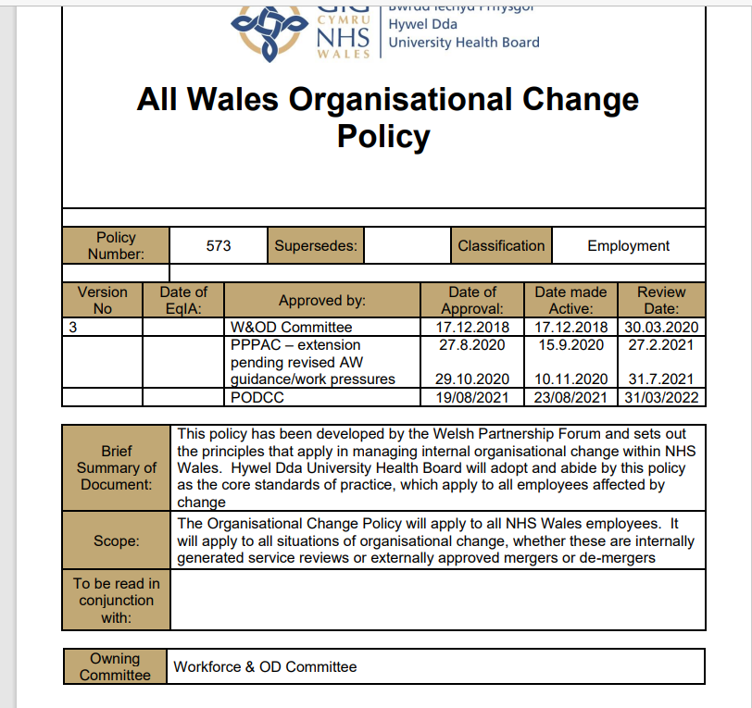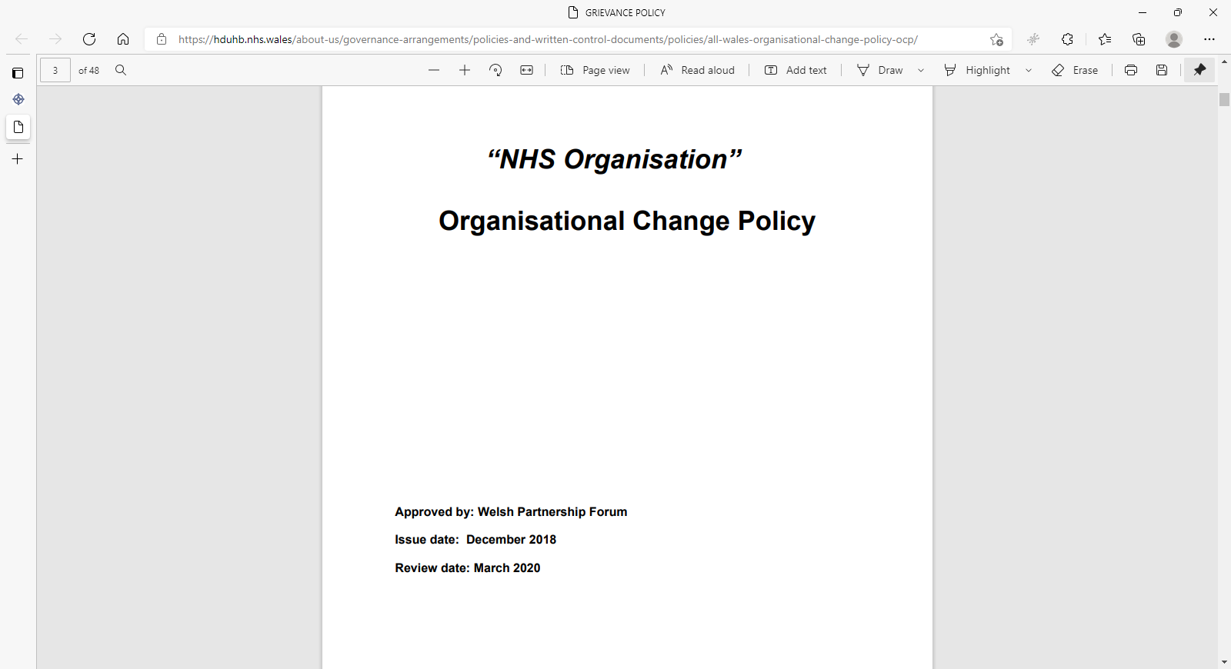

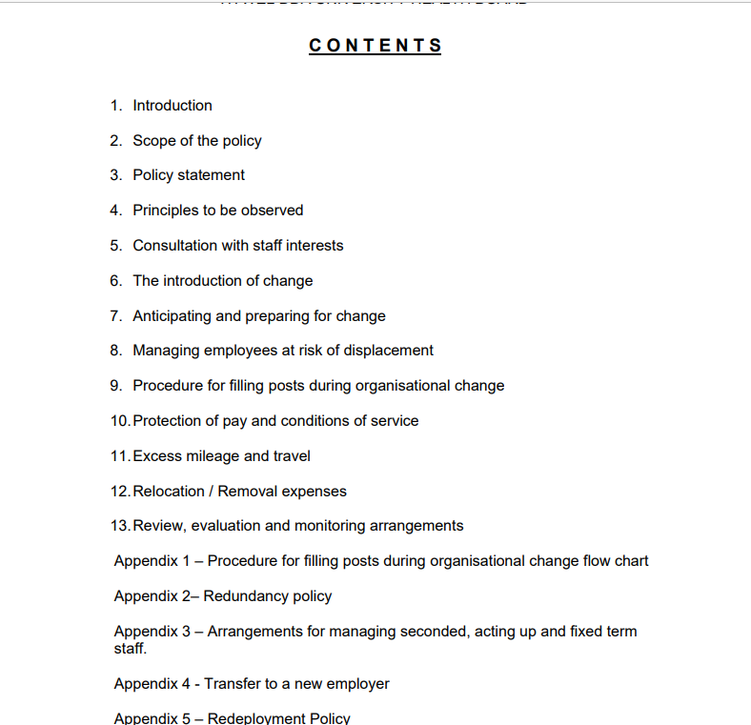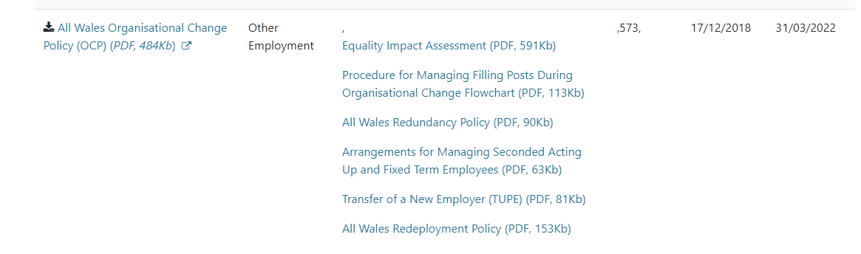
EV20 Scenarios when to use full OCP and when not to:
OCP | Principles of OCP/variation of contract
Where a significant change in service is proposed such as a ward closure, (including temporary closure) the re-location or reduction of a service. | Changes to staff rotas to meet the demands of service. Refer to ACAS guidance re variation of contract: https://www.acas.org.uk/media/316/Advice-leaflet---Varying-a-contract-of-employment/pdf/Varying-a-contract-of-employment-Acas-leaflet.pdf
Service redesign where posts and responsibilities change. | Changes to structure whereby only 1 or 2 members of staff are affected by the changes.
 | When funding (e.g. through LA/service level agreement) for a service/post is no longer available and staff have over 2 yrs service. (Refer to section 5.3 of OCP i.e. redeployment as opposed to redundancy)
 | Where staffing levels pose a risk to health & safety of service users and emergency/immediate measures are required i.e. temporary relocation of service &/ reduced service hours.
 | Changes to staff terms and conditions as non-compliant with A4C e.g. paid/no rest breaks.
 | Changes to management structure where post responsibilities do not change but the management line alters.
 | Where new posts are created to supplement an existing structure but no posts at risk. (New post approval via Workforce panel)
 | Implementation/removal of on-call rota. Refer to ACAS guidance re variation of contract: https://www.acas.org.uk/media/316/Advice-leaflet---Varying-a-contract-of-employment/pdf/Varying-a-contract-of-employment-Acas-leaflet.pdf
We’ve got the organisational change policy which is an All Wales policy so every HB in Wales uses it.
https://hduhb.nhs.wales/about-us/governance-arrangements/policies-and-written-control-documents/policies/all-wales-organisational-change-policy-ocp
With any change managers have to look at the scale of the change, how many are affected and how much will change. I’ve attached a few general principles to consider. If it’s a big change i.e. a ward closure, these changes need to be signed off at board level. So a consultation briefing document is completed to outline the change plans and overview of timescales, etc which has to be signed off by the board before it can progress further. I’d say communication is key – so early discussions with those affected is best to avoid a scenario where staff are surprised that change is happening. If lots of people are affected then consultation meetings with a senior manager, workforce and Trade union rep are arranged at different times, dates etc. to capture everyone and answer any queries/concerns that people have. Depending on the feedback, the plans may change following these meetings as well.
In June this year the dignity at work and grievance policies were replaced by the Respect and Resolution Policy.
https://hduhb.nhs.wales/about-us/governance-arrangements/policies-and-written-control-documents/policies-appendices1/all-wales-respect-and-resolution-policy-pdf-1364-kb/ The approach is much more geared towards resolving things informally where appropriate and early intervention to address things before they get to any formal stages.
https://heiw.nhs.wales/programmes/fair-together-healthy-compassionate-culture/healthier-relationships-work-workplaces/

EV21 LO2 AC2.4 Email questioning who would carry out Stat and Mand training
From: Catherine Thomas (Hywel Dda UHB - Project Support Officer (ESR Self Service))
Sent: 21 August 2020 14:24
To: Nicholas Meyler (NWSSP - WorkForce & OD) <Nicholas.Meyler@wales.nhs.uk>; Louisa Jones (NWSSP – CORP) <Louisa.Jones@wales.nhs.uk>; Julia Denyer (NWSSP - CORP) <Julia.Denyer@wales.nhs.uk>; Nigel Hughes (NWSSP - CORP) <Nigel.Hughes2@wales.nhs.uk>
Subject: RE: SLE Employer Stat and Mandatory Training
Hi all
Any update on this please.
Catherine Thomas
ESR Administrator/Workforce Information Manager/Gweinyddwr ESR/Rheolwr Gwybodaeth Y
From: Nicholas Meyler (NWSSP - WorkForce & OD) <Nicholas.Meyler@wales.nhs.uk>
Sent: 14 August 2020 13:32
To: Louisa Jones (NWSSP – CORP) <Louisa.Jones@wales.nhs.uk>; Julia Denyer (NWSSP - CORP) <Julia.Denyer@wales.nhs.uk>; Nigel Hughes (NWSSP - CORP) <Nigel.Hughes2@wales.nhs.uk>
Cc: Catherine Thomas (Hywel Dda UHB - Project Support Officer (ESR Self Service)) <Catherine.Thomas@wales.nhs.uk>
Subject: SLE Employer Stat and Mandatory Training
Hi all
I hope you are well.
In relation to Cath’s query shown below. For doctors in training on the SLE scheme, please could you advise if statutory and Mandatory training for both classroom based learning and e-learning would be completed internally within Health Boards or if this would be completed by NWSSP or a combination of the two?
Many thanks
Nick

From: Catherine Thomas (Hywel Dda UHB - Project Support Officer (ESR Self Service)) <Catherine.Thomas@wales.nhs.uk>
Sent: 14 August 2020 11:56
To: Nicholas Meyler (NWSSP - WorkForce & OD) <Nicholas.Meyler@wales.nhs.uk>
Subject: FW: Paediatric Doctors in Training
Hi Nick
Sorry to trouble you but at our WfIS meeting last week the question around who would be do the training/elearing and it was confirmed that NWSSP would be doing it.
Is that correct?

EV22 LO2 AC2.4 Email ongoing monitoring of the positions

From: Sailaja Ramachandran (Hywel Dda UHB - ESR Administrator) <Sailaja.Ramachandran@wales.nhs.uk>
Sent: 15 December 2020 13:54
To: Catherine Thomas (Hywel Dda UHB - Project Support Officer (ESR Self Service)) <Catherine.Thomas@wales.nhs.uk>
Subject: RE: Speciality Registrar StRH transfer to NWSSP Single Lead Employer Scheme wef 6 Jan 2021 - Deanery Post Number Closure from HB ESR
Importance: High
Hai Cath
There is staff still sitting in that position
Do you want me to delete it from 6 Jan 2021 or when I am back next Monday ?
Whatever you suggest.
Thanks
Sailaja

From: Nicholas Meyler (NWSSP - WorkForce & OD) <Nicholas.Meyler@wales.nhs.uk>
Sent: 19 January 2021 10:28
To: Catherine Thomas (Hywel Dda UHB - ESR Administrator/Workforce Information Manager) <Catherine.Thomas@wales.nhs.uk>
Cc: Sailaja Ramachandran (Hywel Dda UHB - ESR Administrator) <Sailaja.Ramachandran@wales.nhs.uk>
Subject: RE: Speciality Registrar StRL transfer to NWSSP Single Lead Employer Scheme Effective 3 Feb 2021 - Deanery Post Number Closure from HB ESR
Thanks Cath you are a star!
Thanks for looking into this.
BW
Nick

From: Catherine Thomas (Hywel Dda UHB - ESR Administrator/Workforce Information Manager) <Catherine.Thomas@wales.nhs.uk>
Sent: 19 January 2021 10:17
To: Nicholas Meyler (NWSSP - WorkForce & OD) <Nicholas.Meyler@wales.nhs.uk>
Cc: Sailaja Ramachandran (Hywel Dda UHB - ESR Administrator) <Sailaja.Ramachandran@wales.nhs.uk>
Subject: RE: Speciality Registrar StRL transfer to NWSSP Single Lead Employer Scheme Effective 3 Feb 2021 - Deanery Post Number Closure from HB ESR
Importance: High
Hi Nick
Please see below in red.
Berman, Dr Nikita is in 2 posts as applicant.
As I was in the position I have now taken the deanery number out.
I added this number to the list as it wasn’t on your original list, but then was on the 2nd list you sent WAL/W024/052/STRL/002.
I think we are all done our end now, accept for us closing the position number after the 3rd February.
Thanks
Cath

From: Nicholas Meyler (NWSSP - WorkForce & OD) <Nicholas.Meyler@wales.nhs.uk>
Sent: 19 January 2021 09:07
To: Catherine Thomas (Hywel Dda UHB - ESR Administrator/Workforce Information Manager) <Catherine.Thomas@wales.nhs.uk>
Subject: RE: Speciality Registrar StRL transfer to NWSSP Single Lead Employer Scheme Effective 3 Feb 2021 - Deanery Post Number Closure from HB ESR
Morning Cath,
Can I check, regarding the DPN’s listed below have you received any recent applicant data to positions? They don’t seem to be coming across to the positions I’ve created in December so I wonder if they may be being directed to your ESR?
Deanery Post Number
WAL/W025/052/STRL/002
Radwan, Mohamed Badawy (Mohamed) employee/applicant 3 dec 2020
EV23 LO2 AC2.4 Email advising new codes to be used to accompany the Single Lead Employer
From: Debra Lewis (NWSSP - WfIS, NWSSP) <Debra.Lewis@wales.nhs.uk>
Sent: 01 March 2021 16:38
To: Catherine Thomas (Hywel Dda UHB - ESR Administrator/Workforce Information Manager) <Catherine.Thomas@wales.nhs.uk>
Subject: RE: Subjective Code update - 26 Jan 2021
Yes substantive only. 043 Single Lead Employer will not employ any Locum Appointed for Service (LAS). LAS will continue to be managed by the Health Board / Trust
Diolch
Deb

From: Catherine Thomas (Hywel Dda UHB - ESR Administrator/Workforce Information Manager) <Catherine.Thomas@wales.nhs.uk>
Sent: 24 February 2021 09:17
To: Debra Lewis (NWSSP - WfIS, NWSSP) <Debra.Lewis@wales.nhs.uk>
Subject: FW: Subjective Code update - 26 Jan 2021
Can I check that these subj codes are for substantive only and not locum?

From: Debra Lewis (NWSSP - WfIS, NWSSP) <Debra.Lewis@wales.nhs.uk>
Sent: 26 January 2021 12:33
To: Billy Horwood (Swansea Bay UHB - Finance) <Billy.Horwood@wales.nhs.uk>; Catherine Thomas (Hywel Dda UHB - ESR Administrator/Workforce Information Manager) <Catherine.Thomas@wales.nhs.uk>; Clair Tipton (BCUHB - Workforce & Organisational Development) <Clair.Tipton@wales.nhs.uk>; Deanna Ford Williams (Aneurin Bevan UHB - Workforce Information) <Deanna.FordWilliams@wales.nhs.uk>; Debra Lewis (NWSSP - WfIS, NWSSP) <Debra.Lewis@wales.nhs.uk>; Donna Hill (CTM UHB - Human Resources) < >
Subject: Subjective Code update - 26 Jan 2021
I attach the latest update to the Subjective Codes in ESR and Oracle Financials as at 26 January 2021. These new codes have been agreed by the Finance Technical Advisory Group (TAG) and will be used by Single Lead Employer (SLE) from March 2021, for full IBM Mass Update implementation, and from February 2021 for a small number of new Positions in 120 and 043 VPDs.
NOTE: some of the descriptions have been shortened for Oracle Financials
Please add these new codes to ESR to enable Single Lead Employer costing.
Change | Subj | Description | Comment
New | 21005 | SLE-Consultant retn to trainng (M&D) | SLE - M&D registered with GMC or GDC
New | 23105 | SLE- Specialty Registrar (M&D) | SLE - M&D Training Grade, begining after Foundation year 2
New | 24105 | SLE -F2 Foundation year (M&D) | SLE - M&D Training Grade, Foundation Year 2 on successful completion of the F1 year
New | 24405 | SLE - F1 Foundation year (M&D) | SLE - M&D Training Grade, Foundation Year 1
New | 24905 | SLE - Foundation Dentist (M&D) | SLE - Registered with the GDC. Works in an approved Dentist training practice, for 1 year.
New | 25303 | SLE-GP Retrn to Practice (M&D) | SLE - M&D Return to Practice
New | 2E455 | SLE -Pre Reg Pharmacist Fdn Band 5 | SLE - Band 5 Pre-Registration Foundation Pharmacist

EV24 LO2 AC2.4 email to NWSSP confirming completion from Hywel Dda’s side and for him to confirm that they had gone across to the Single Lead Employer
From: Nicholas Meyler (NWSSP - People & OD) <Nicholas.Meyler@wales.nhs.uk>
Sent: 05 August 2021 10:37
To: Catherine Thomas (Hywel Dda UHB - ESR Administrator/Workforce Information Manager) <Catherine.Thomas@wales.nhs.uk>
Subject: RE: SLE
Hi Cath
No probs, when would you need the data by? It might be best to wait a week or so as I know Payroll are currently in the process of completing the onboarding/changes for the August starters/rotations and so this will impact the headcount figures.
Thanks
Nick

From: Catherine Thomas (Hywel Dda UHB - ESR Administrator/Workforce Information Manager) <Catherine.Thomas@wales.nhs.uk>
Sent: 05 August 2021 10:30
To: Nicholas Meyler (NWSSP - People & OD) <Nicholas.Meyler@wales.nhs.uk>
Subject: SLE
Morning Nick
Can you have a look at details below for me please to confirm that these are all that have come across and I haven’t missed any out on the list.
Group | Date of Transfer | Numbers
SPR GP trainees | Already employed
Foundation year 1 doctors | 30-Jul-20 | 54
Pre-registration pharmacists | 03-Aug-20 | 13
Foundation dentists | 01-Sep-20 | ?
Paediatric trainees | 01-Sep-20 | 4
Radiology trainees | 01-Nov-20 | 2
Cardiology, Respiratory Medicine, T&O Surgery, and General Surgery Speciality Registrar StRH posts | 06-Jan-21 | 6
Core Psychiatry | 03-Feb-21 | 5
Higher Surgery Speciality Registrar StRH | 01-Mar-21 | 2
Geriatric Medicine | 01-Apr-21 | 4
Ophthalmology | 01-Apr-21 | 2
Higher Psychiatry and Pathology Speciality Registrar StRH | 01-May-21 | 4
Foundation Year 2 (F2s) | 01-Aug-21 | 57

EV25 LO2 AC2.5 Date of Hybrid Working meeting
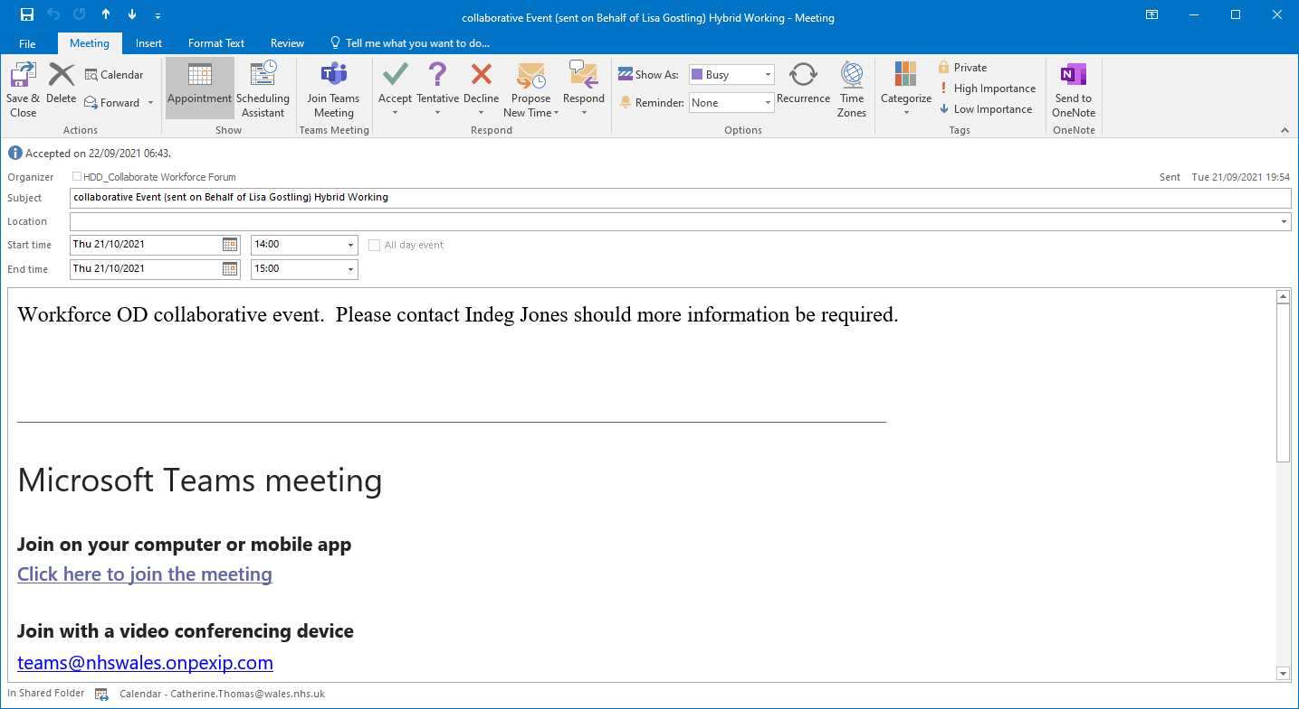
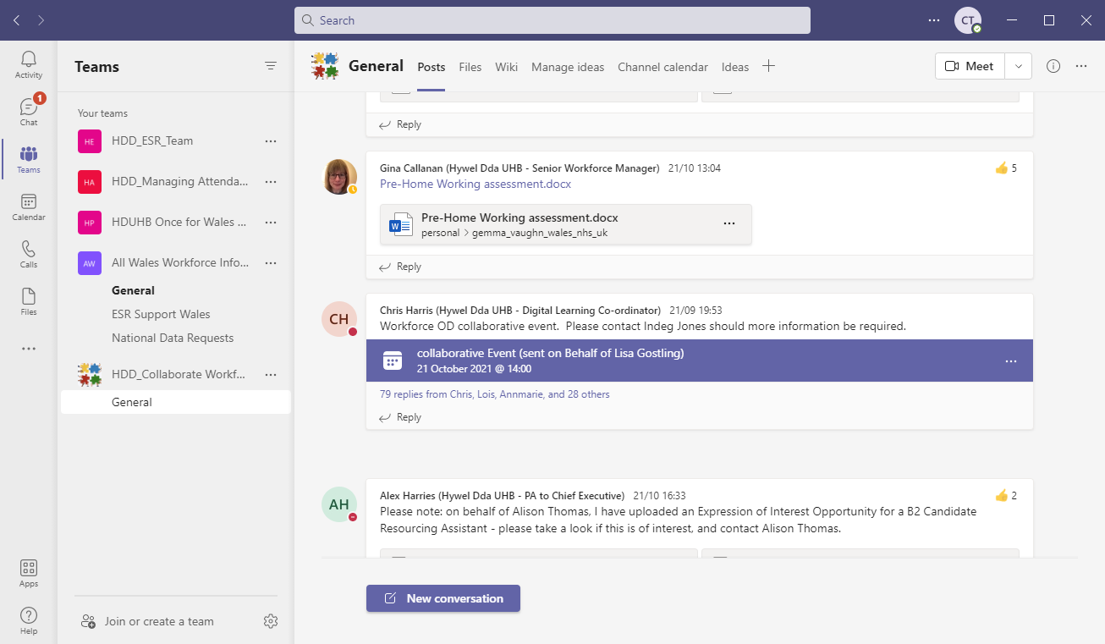
References for Learning Outcome 2
- CIPD ARC Dublin, (2020) Shaping positive work experiences: Workplace relationships in disruptive times. Chartered Institute of Personnel and Development, London, June 2020. Available at: https://www.cipd.co.uk/Images/shaping-positive-work-experiences_tcm18-80030.pdf (Accessed 30 October 2021).
- CIPD (2021) Change Management. Available at:
- https://www.cipd.co.uk/knowledge/strategy/change/management-factsheet#_ga=2.4078646.769207037.1635087311-1206122804.1633545165 (Accessed: 31 October 2021).
- CIPD (2021) Data protection and GDPR in the workplace. Available at:
- https://www.cipd.co.uk/knowledge/fundamentals/emp-law/data-protection/factsheet#:~:text=The%20employer%20must%20ensure%20the%20third%20party%20is,the%20relevant%20requirements%20for%20overseas%20transfers%20of%20data. (Accessed: 1 November 2021).
- Hughes, M. (2014) Managing Change. London. CIPD.
- Inside HR (2018) 5 ways to improve change management through design thinking. Available at: How design thinking can improve change management outcomes. (Accessed: 30 October 2021).
- McKinsey & Company, (2016) Winning hearts and minds in the 21st century. Available at https://www.mckinsey.com/business-functions/people-and-organizational-performance/our-insights/winning-hearts-and-minds-in-the-21st-century. (Accessed: 28 October 2021).
- SHRM (2019) Tips & Tactics for Kotter’s Change Model. Available at: Tips and Tactics for Kotter Change Model (SHRM).pdf (Accessed: 29 October 2021).
- Sage (2020) Business resilience and agility: How HR leaders can empower change. How to build a stronger, more adaptable workforce. Published.

3.1 Measure the effectiveness of the change process in meeting the required objectives.

To date the objectives have been met with all the background work to enable the junior doctors to move from Hywel Dda UHB to the Single Lead Employer has been completed as shown in the email reply from NWSSP. (EV27). Also the DPN numbers were removed from the position numbers to enable the interface with the new system (EV16).

An effect measurement shown in (EV28) is of an email attaching a completed Termination form by Medical Staffing to payroll for payroll to terminate in readiness for the Single Lead Employer Health Board to hire them.

Change is inevitable and adaptable, and managers should help people get through change as soon as possible. Managers developing routines over time during regular episodes of management style are separate during times of change and require adjusting appropriately. (Bain & Company, 2018).

3.2 Identify further work required to embed changes and/or further developments required.

As shown below there are still junior doctors yet to move so work is continuing until May 2022 and once finished there will then be an audit of what went well and what didn’t go well (EV4). Therefore the further work required is the same as the previous months Payroll terminating staff (EV28) and Workforce taking out the Deanery Post Number (DPN) from positions (EV16) enabling the interface to work for the new Single Lead Employer. Accordingly to the (CIPD, 2021) Leaders need to design the transformation.

Nov-21 | Higher Medicine | 128
Dec-21 | Core Anaesthetics, Core Medicine, ACCS | 401
Dec-21  Mar-22 | Higher Emergency Medicine | 49
Dec-21  Mar-22 | Higher Anaesthetics & Intensive Care | 164
May-22 | Core Surgery | 100

3.3 Communicate the key outcomes and the impact of change to stakeholders.

Communication is still ongoing due to the project not completing until May 2022. (EV4). It is difficult to communicate the key outcomes due to the change still ongoing. Although communication every month is key in as much as when the change is done by Hywel Dda UHB this is then communicated to NWSSP who are co-ordinating the change for the Single Lead Employer (EV29). The impact for Medical Staffing is that once the Junior Doctors have moved across from Hywel Dda UHB to the Single Lead Employer they are no longer co-ordinated by them. The impact for payroll is that once the staff have terminated by them hence are no longer on the Hywel Dda payroll they no longer take any pay queries from them.

Stage 3 Refreeze of Lewin’s Change Management Model is when the changes start to develop; with Organisations making sure the changes are used all the time. (Mindtools, 2021).

3.4 Evaluate the effectiveness of own performance in contributing to the management of change.

Looking at the ‘Change’ within the CIPD Professional Map with my manager our discussion was as follows:-
As a manager within Workforce for the Electronic Staff Record system for Hywel Dda University Health Board, change happens often, with new enhancements to the ESR system enabling better working procedures. As a department, we have to grow with change as the system constantly develops new and better ways of working. Enhancements are usually monthly.
My knowledge of change over the 18 years within the Health Board has grown. This due to the organisation growing; as it has gone from Pembs & Derwen NHS Trust to Hywel Dda Trust, to Hywel Dda Health Board and currently Hywel Dda University Health Board (HDUHB, 2021). All of this has happened within my years of service. From these changes, new approaches to Payroll, Recruitment and Workforce systems have evolved.
Upon discussion with my manager of the above knowledge, skills and ability that I have development within my role, we went on to discuss what my current development needs are. My manager advised that I need to expand on developing costings and measures for any enhancements whether it be to the system such as new interfaces from the provider which incurs cost, or whether it be for any change to the team that also require costings e.g. training, equipment etc. Also looking at new ways to approach staff with the enhancements to support the change culture and to continuously innovate and deliver change at pace, to be on top of the change ensuring that it is for the long term and not short lived.

Evidence for Learning Outcome 3
EV26 LO3 AC3.1 Email from NWSSP confirming all those transferred are complete to date
From: Nicholas Meyler (NWSSP - WorkForce & OD) <Nicholas.Meyler@wales.nhs.uk>
Sent: 15 September 2021 16:00
To: Catherine Thomas (Hywel Dda UHB - ESR Administrator/Workforce Information Manager) <Catherine.Thomas@wales.nhs.uk>
Subject: Paediatric Doctors in Training
Hi Cath
Hope you are keeping well in these times.
Just to confirm that to date all junior doctors have transferred correctly from Hywel Dda to the Single Lead Employer. They are now on the SLE payroll and have their new login details for the Employee Staff Record and they are aware of who to contact should they have any login problems.
I will shortly be sending the new details through for the October transfer and just to confirm that the transfer is still on time for May 2022.
Regards Nick.
EV27 LO3 AC3.1 – Email and screenshot to show correspondence between Medical Staffing and Payroll

From: Ffion Evans (Hywel Dda UHB - Medical Workforce Officer)
Sent: 02 November 2021 12:31
To: David Lewis (NWSSP - Employment Services) <David.Lewis5@wales.nhs.uk>
Subject: FW: term form signed
Hi
Please find attached Termination. The Doctor is moving over to SLE.
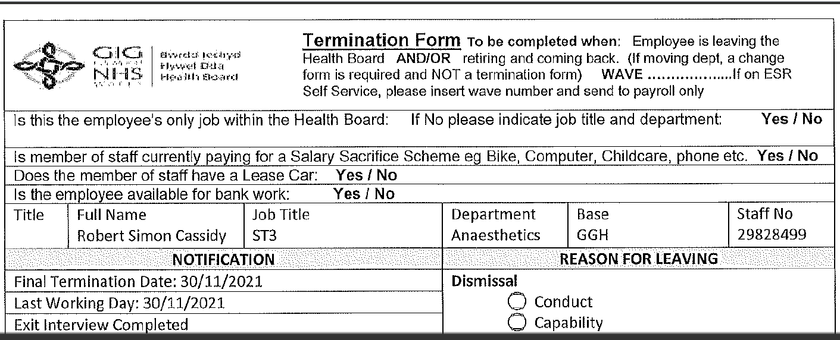

EV28 LO3 AC3.2 Email from NWSSP manager to show my requirements were successful in the SLE change.
From: Rebecca Jarvis (NWSSP - WFIS) <Rebecca.Jarvis@wales.nhs.uk>
Sent: 05 November 2021 12:48
To: Catherine Thomas (Hywel Dda UHB - ESR Administrator/Workforce Information Manager) <Catherine.Thomas@wales.nhs.uk>
Subject: RE: SLE involvement from Hywel Dda UHB
Hi Cath
Yes I am more than happy to confirm that all of the work undertaken by yourself in terms of the SLE process change has met our necessary requirements and has therefore proved effective and valuable.
Thank you so much for your support in this huge piece of change management project.
Kind Regards
Rebecca Jarvis, Senior Programme Manager – Digital Workforce
EV29 LO3 AC3.3 Email from NWSSP advising of change and email to NWSSP confirming completion
From: Catherine Thomas (Hywel Dda UHB - ESR Administrator/Workforce Information Manager) <Catherine.Thomas@wales.nhs.uk>
Sent: 18 June 2020 16:00
To: Nicholas Meyler (NWSSP - WorkForce & OD) <Nicholas.Meyler@wales.nhs.uk>
Subject: SLE Paeds Doctors in Training
Hi Nick
Sailaja has now moved all the DPN’s in readiness for the September rotation for the Paed doctors.
Please can you confirm all okay your end and let us know whether there is anything else we need to do.
It all looks okay our end.
From: Nicholas Meyler (NWSSP - WorkForce & OD) <Nicholas.Meyler@wales.nhs.uk>
Sent: 17 June 2020 12:52
To: Catherine Thomas (Hywel Dda UHB - ESR Administrator/Workforce Information Manager) <Catherine.Thomas@wales.nhs.uk>
Subject: Paediatric Doctors in Training
Hi Cath
The DPNs listed in the attached are due to be moving across to NWSSP for September rotation as part of the Single Lead Employer scheme, Please could you review the attached list of DPN’s and remove the DPN from the positions on your ESR (same process which was completed for the Foundation Doctors) prior to the interface opening start of July? This will ensure applicant data isn’t duplicated on ESR from Intrepid.
Any queries please let me know. I’ll forward the password in a separate email.

References for Learning Outcome 3

- Bain & Company (2018) David Michels: Busting Three Common Myths of Change Management. Available at: https://www.bain.com/insights/david-michels-change-management-video/ (Accessed 4 November 2021).

- CIPD (2021) Change management. Available at: https://www.cipd.co.uk/knowledge/strategy/change/management-factsheet#8090. (Accessed: 5 November 2021).

- MindTools (2021) Lewin's Change Management Model Understanding the Three Stages of Change. Available at: Lewin's Change Management Model - from MindTools.com (Accessed: 5 November 2021).

