Module name: Managing People

Assignment 2
Nursing Industry Report

Module Code: LCBB5004

Name: Valentina Pituscanu
Student ID: 2124861

Lecturer: Piyumika Gamage

Table of Contents
Table of Contents 2
Introduction 3
Cause and Effects of Employee Attrition in the Nursing Industry in the UK 3
Five monetary and Five non-monetary retention schemes used by the NHS for Nursing professionals. 4
Five Monetary Retention Schemes 4
Five Non-Monetary Retention Schemes 6
Recommendations to lower nurse attrition rate in the UK 7
Short-term recommendations 7
Long-term recommendations 8
Conclusion 8
Reference 9

Introduction
Employee attrition, also known as employee turnover, is the process of losing employees over time due to various reasons, such as resignation, retirement, or termination. It is an essential metric that organisations use to measure the rate at which employees leave their jobs and the reasons why. Employee attrition can be voluntary, where employees leave the organisation on their own accord, or involuntary, where employees are terminated or laid off by the organisation. Employee attrition is an important metric for organisations because it affects the productivity, profitability, and overall success of the business. High employee attrition can result in the loss of valuable employees with skills, knowledge, and experience that are difficult to replace. Also constantly replacing employees can be expensive for organisations, as they have to invest in recruitment, training, and onboarding new employees. High employee attrition can lead to a reduction in productivity, as new employees may take some time to get up to speed with their roles and responsibilities. Constant employee turnover can lead to low employee morale, which can have a ripple effect on the rest of the organisation. Therefore, it is essential for organisations to track and manage employee attrition to retain talented employees, reduce costs, and maintain high levels of productivity and employee morale.

Cause and Effects of Employee Attrition in the Nursing Industry in the UK
In the nursing industry in the UK, employee attrition remains a significant challenge affecting both private and public healthcare institutions (Marufu et al., 2021). There are several causes of employee attrition within the nursing industry in the UK. One of the leading causes is burnout resulting from long hours and high workload. According to the Royal College of Nursing (RCN), 38% of nurses and midwives were found to be burnt out in a survey conducted (Dickson et al., 2022). This highlights the need for measures such as job rotation, flexible scheduling and adequate staffing levels to reduce burnout among nursing professionals. Another cause of employee attrition in the nursing industry is low pay, which has led to an increase in nurses seeking employment abroad.
The average pay for nurses in the UK is £17 per hour, which is considerably less than what is paid to nurses in other nations like Australia, Canada, and the US (Drennan and Ross, 2019).
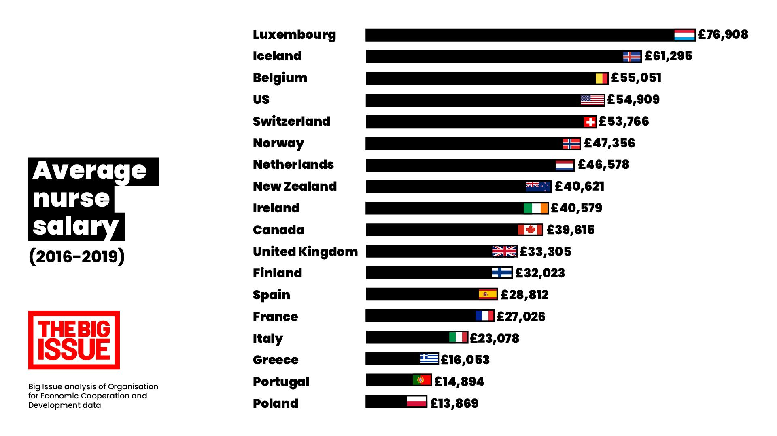
Figure 1 : Average Nurse Salary Globally
(Source : Big Issue, 2021)
As a result, UK nurses have left the industry in search of better opportunities. Lack of internal career progression prospects, bad working conditions, and high levels of stress are other factors influencing employee attrition in the nursing sector. Employee attrition has a number of implications on the nursing sector in the UK. Lack of qualified nursing staff to address patient demands is one of the key consequences. In the UK, there is already thought to be a shortfall of 40,000 nurses, according to a Health Foundation analysis (Lucas et al., 2021). As a result, the responsibilities of the surviving nursing professionals have increased, which has led to burnout, job unhappiness, and lower care quality.
Moreover, healthcare organisations must spend more on recruitment and training as a result of employee attrition. A poll by Nursing Personnel found that replacing a nurse or midwife costs, on average, between £20,000 and £60,000 (Palmer, Rolewicz and Nuffield Trust, 2022). Patient satisfaction may suffer as a result of a high turnover rate since patients may not get the continuity of care they need. According to the statistics, burnout and low compensation are the main causes of staff attrition in the UK nursing business, which poses a serious concern.
One in three nurses in the UK's nursing workforce are over 50, according to a Health Foundation report, raising fears about a potential retirement wave. About 5,000 nurses and midwives left the field in 2019, up 9% from the previous year, according to the Nursing and Midwifery Council (NMC) (Buchan et al., 2019). According to an RCN survey, 35% of nurses intend to leave the field within the next five years due to strain and stress. According to research by the Health Foundation, the NHS spends an estimated £1.5 billion annually on temporary staffing to fill nursing positions. To address this challenge, it is important for healthcare institutions to implement measures such as job rotation, flexible scheduling, competitive compensation and adequate staffing levels to reduce employee burnout, increase job satisfaction and retain skilled nursing professionals.

Five monetary and Five non-monetary retention schemes used by the NHS for Nursing professionals.
In the UK, the National Health Service (NHS) is the main employer of nurses and other medical professionals (NHS, 2023). A stable healthcare workforce and high-quality patient care depend on nursing professionals being retained in the NHS. Below are some retention schemes found during the research.

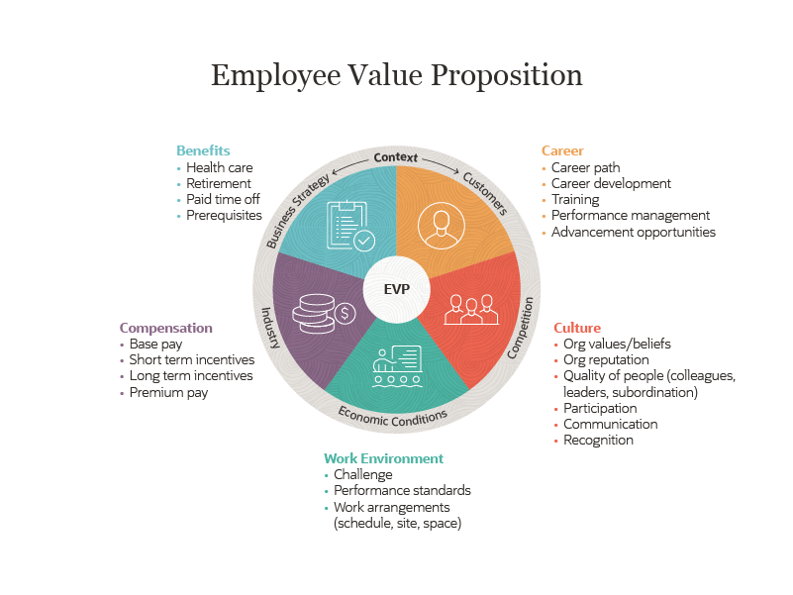
Figure 2 : Retention Schemes
(Source : Oracle NetSuite, 2021)

Five Monetary Retention Schemes
Pay Increases: Pay hikes are one of the most prevalent monetary retention strategies utilised by the NHS (Sayli et al., 2022). For individuals who match the requirements, the NHS offers progressive pay scales that are based on experience and qualifications, with regular salary increases. This program's objective is to provide financial incentives to nursing professionals to keep working in their current positions.
While wage increases can help nursing practitioners stay in the field, they may not always be sufficient to address other problems like workload and stress. In addition, the NHS continues to pay nurses less than other healthcare professionals, which could cause unhappiness and turnover.
Bonuses: Nursing professionals who work in certain positions or places, such as in difficult-to-fill locales or speciality tasks, may also be eligible for incentives from the NHS. This program's objective is to provide cash incentives to nursing professionals in particular locations.
While bonuses can help keep nursing practitioners in certain positions or settings, they might not address more general problems like workload and job satisfaction (Hoff, Carabetta and Collinson, 2019). Also, it might result in wage gaps for nurses, which would breed anger and discontent.
Flexible Working: Nursing practitioners can work remotely, part-time, or in a job sharing arrangement thanks to the NHS. The purpose of this programme is to improve work-life balance and encourage nursing professionals to stay in their positions. Nursing professionals who need more work-life balance may be more likely to stay with their employer with the help of flexible working arrangements (Dousin et al., 2021). It might not be appropriate for all nurse roles, though, and healthcare organisations might have scheduling issues as a result.
Relocation Expenses: Nursing professionals who migrate to fill positions in difficult-to-fill locations are eligible for relocation expenses from the NHS. The purpose of this programme is to encourage nurses to move to places where there is a scarcity of medical experts. Relocation expenditures can be useful in encouraging nursing professionals to move to locations with a shortage of qualified candidates, but they might not solve other problems like workload and job satisfaction. In addition, if the root causes are not resolved, it might not be a long-term remedy.
Career Progression: The NHS provides nursing workers with chances for career advancement such as mentorship, leadership development programmes, and additional education and training (Cabral, Oram and Allum, 2019). This program's objective is to give nursing professionals a defined career path and create incentives for them to stay in their positions. By providing clear objectives and incentives for professional development, career progression possibilities can help retain nursing professionals. Although it might not address other problems like workload and job satisfaction, it might also lead to pay inequalities and limited prospects for nursing professionals.

Five Non-Monetary Retention Schemes
Employee Engagement: Via a variety of employee engagement efforts, including staff surveys, staff councils, and recognition programmes, the NHS engages nursing professionals (Quek et al., 2021). This programme aims to reward nursing professionals' contributions to patient care and to include them in decision-making. Nevertheless, if the underlying problems are not resolved, it might not be sustainable and might not address more general issues like workload and job satisfaction.
Workload Management: The National Health Service (NHS) provides nursing professionals with workload management strategies, which include staffing level evaluations and workload assessments, in order to guarantee that their workloads are feasible and prevent exhaustion. The primary objective of these schemes is to reduce stress levels while increasing job satisfaction as a means of retaining skilled nursing professionals (Rajamohan, Porock and Chang, 2019). Nevertheless, implementing such measures may prove difficult in practice due to the prioritisation of efficiency over employee well-being by certain managers who may exhibit resistance towards this approach.
Health and Wellbeing Support: The National Health Service (NHS) provides nursing professionals with health and wellness assistance, including psychological counselling, mental health care provisions, as well as occupational healthcare services (Cramer et al., 2020). The objective of this initiative is to promote the physical and emotional wellbeing of nursing practitioners while preventing work absence and staff turnover. The provision of health support for both bodily and intellectual welfare may be instrumental in keeping nurses on board by catering to their comprehensive medical requirements. Nevertheless, it might not effectively deal with more general issues such as job satisfaction or workload pressures.
Professional Development Opportunities: The National Health Service (NHS) affords nursing professionals with prospects for professional development, including training initiatives, continuous education programs and conferences. While such opportunities can facilitate the retention of these personnel by facilitating career advancement and individual progress, they may fall short in addressing matters relating to workload management or job satisfaction while potentially engendering discrepancies in remuneration and accessibilities among members of the nursing community.
Work-Life Balance: The NHS provides nursing professionals with a range of work-life balance initiatives, including flexible working hours, part-time employment opportunities, and job sharing arrangements (Dousin et al., 2021). These measures have been designed to improve the flexibility and overall quality of life for nurses. Work-life balance initiatives can serve as effective retention tools for those nursing professionals who require more accommodating schedules due to personal or family obligations; however, they may not be suitable in all instances within the healthcare industry and could potentially create scheduling difficulties for healthcare organisations.
In order to retain nursing professionals within the NHS, a range of financial and non-financial strategies are implemented by the organisation. Despite their potential effectiveness in ensuring staff retention, these schemes may not fully tackle more general concerns surrounding job satisfaction and workload management. Consequently, an all-encompassing approach is required which considers both monetary and non-monetary aspects for successful nursing professional retention.

Recommendations to lower nurse attrition rate in the UK
To improve nurse retention and lower nurse attrition rates in the UK, here are some recommendations that can be implemented in the short term and the long term:

Short-term recommendations
Conduct exit interviews: To enhance staff retention, organisations may conduct exit interviews with nurses who have resigned voluntarily in order to determine the underlying reasons for their departure. The insights gleaned from such inquiries can aid organisational efforts aimed at identifying and addressing factors that negatively impact employee retention.
Improve workload management: To avoid burnout and job discontent, nursing practitioners should have a manageable workload. To lessen workload stress, the NHS should evaluate staffing numbers and offer additional assistance as needed (Quirk et al., 2018).
Offer competitive salaries: To lure and keep nursing experts, competitive remuneration should be provided. To make sure that pay is competitive with those provided by other healthcare organisations, the NHS should perform market research.

Long-term recommendations
Increase training and development opportunities: To increase job satisfaction and help nursing professionals maintain their skills, professional development opportunities should be made available. This can be accomplished by making investments in mentorship, continuing education, and training programmes.
Address workplace culture: Nursing practitioners may be more likely to stay in the field if their contributions are valued by the organisation. To foster a healthy work environment, healthcare organisations should encourage a culture of respect, support, and collaboration.
Increase community involvement: For the purpose of raising public awareness of nursing careers and the beneficial effects they have on society, healthcare organisations should become more active in the neighbourhood (Stanhope and Lancaster, 2019). This may encourage more people to pursue nursing occupations and foster a sense of professionalism.
Provide better career progression opportunities: Clear career routes and chances for promotion should be available to nurses. The NHS should create organised career advancement pathways that encourage nurses to advance their knowledge and assume bigger responsibilities.

Conclusion
In order to lower nurse attrition rates in the UK, nurse retention is a crucial problem that needs to be addressed. The sustainability of the healthcare system and patient outcomes may be negatively impacted by the scarcity of nursing staff. Healthcare companies can employ both short- and long-term measures to retain nursing staff despite the fact that the causes of nurse attrition are multifaceted. They include managing workloads, paying competitive compensation, fostering a positive work environment, promoting work-life balance, fostering a sense of community, and providing improved possibilities for professional advancement. The expenses of implementing these techniques will be high, but the advantages of keeping qualified nursing staff will ultimately surpass them. The healthcare sector needs to prioritize nurse retention to ensure that patients receive high-quality care and that the healthcare system is sustainable in the long term.

Reference
Buchan, J., Charlesworth, A., Gershlick, B. and Seccombe, I., 2019. A critical moment: NHS staffing trends, retention and attrition. London: Health Foundation.
Cabral, A., Oram, C. and Allum, S., 2019. Developing nursing leadership talent—Views from the NHS nursing leadership for south‐east England. Journal of nursing management, 27(1), pp.75-83.
Cramer, R.J., Ireland, J.L., Hartley, V., Long, M.M., Ireland, C.A. and Wilkins, T., 2020. Coping, mental health, and subjective well-being among mental health staff working in secure forensic psychiatric settings: Results from a workplace health assessment. Psychological services, 17(2), p.160.
Dickson, C.A., Davies, C., McCormack, B., Westcott, L., Merrell, J., Mcilfatrick, S. and Dewing, J., 2022. UK nurses' and midwives' experiences of healthful leadership practices during the COVID‐19 pandemic: A rapid realist review. Journal of Nursing Management, 30(8), pp.3942-3957.
Dousin, O., Collins, N., Bartram, T. and Stanton, P., 2021. The relationship between work‐life balance, the need for achievement, and intention to leave: mixed‐method study. Journal of advanced nursing, 77(3), pp.1478-1489.
Drennan, V.M. and Ross, F., 2019. Global nurse shortages: the facts, the impact and action for change. British medical bulletin, 130(1), pp.25-37.
Hoff, T., Carabetta, S. and Collinson, G.E., 2019. Satisfaction, burnout, and turnover among nurse practitioners and physician assistants: a review of the empirical literature. Medical Care Research and Review, 76(1), pp.3-31.
Holiday, M., 2023. 25 Employee Retention Strategies & Tactics to Keep Your Employees. Oracle NetSuite. [Online]. Available at : https://www.netsuite.com/portal/resource/articles/human-resources/employee-retention-strategies.shtml
Lucas, G., Brook, J., Thomas, T., Daniel, D., Ahmet, L. and Salmon, D., 2021. Healthcare professionals' views of a new second‐level nursing associate role: A qualitative study exploring early implementation in an acute setting. Journal of Clinical Nursing, 30(9-10), pp.1312-1324.
Marufu, T.C., Collins, A., Vargas, L., Gillespie, L. and Almghairbi, D., 2021. Factors influencing retention among hospital nurses: systematic review. British Journal of Nursing, 30(5), pp.302-308.
NHS, 2023. [Online]. Available at : https://docs.google.com/document/d/11yvlxTYwAAj43QpXH-8hfbpiAJkkyHyMYNO8JzYnZnE/edit#
Palmer, B., Rolewicz, L. and Nuffield Trust, 2022. Peak leaving? A spotlight on nurse leaver rates in the UK. Nuffield Trust www. nuffieldtrust. org. uk/resource/peak-leaving-a-spotlight-on-nurse-leaver-rates-in-the-uk.
Quek, S.J., Thomson, L., Houghton, R., Bramley, L., Davis, S. and Cooper, J., 2021. Distributed leadership as a predictor of employee engagement, job satisfaction and turnover intention in UK nursing staff. Journal of Nursing Management, 29(6), pp.1544-1553.
Quirk, H., Crank, H., Carter, A., Leahy, H. and Copeland, R.J., 2018. Barriers and facilitators to implementing workplace health and wellbeing services in the NHS from the perspective of senior leaders and wellbeing practitioners: a qualitative study. BMC public health, 18(1), pp.1-14.
Rajamohan, S., Porock, D. and Chang, Y.P., 2019. Understanding the relationship between staff and job satisfaction, stress, turnover, and staff outcomes in the person‐centered care nursing home arena. Journal of Nursing Scholarship, 51(5), pp.560-568.
Sayli, M., Moscelli, G., Blanden, J., Bojke, C. and Mello, M., 2022. Do Non-monetary Interventions Improve Staff Retention? Evidence from English NHS Hospitals.
Stanhope, M. and Lancaster, J., 2019. Public health nursing e-book: Population-centered health care in the community. Elsevier Health Sciences.
Westwater, H., May 2021. UK pays nurses less than France, Ireland, US and more. BigIssue News. [Online]. Available at : https://www.bigissue.com/news/uk-pays-nurses-less-than-france-ireland-us-and-more/ [Accessed 8th April, 2023]

