Community Profile
By Louise Hosking

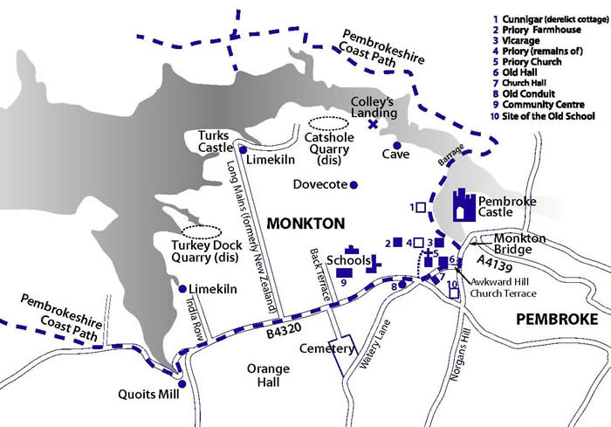

Monkton
By Louise Hosking

About Monkton

History, location and environment
Monkton is a small community situated on the west side of the town of Pembroke, on the southern shore of the Pembroke river. Monkton was a self-sufficient village that had numerous shops selling all that people needed, enabling them to shop locally. This was until the 1960’s when Pembrokeshire borough council decided to “implement a programme of modernisation”. It was then that most of the old village was knocked down and destroyed and replaced with a large council housing estate. Now, in 2020, Monkton’s housing estate houses mainly single parent families, most of which receive benefits. It is a very run-down estate with little to no employment opportunities and almost zero facilities for children and young people to attend.
This once thriving community is now ranked 80 out of 1909 places within Wales suffering from deprivation according to the 2018 Index on Multiple Deprivation (IMD).

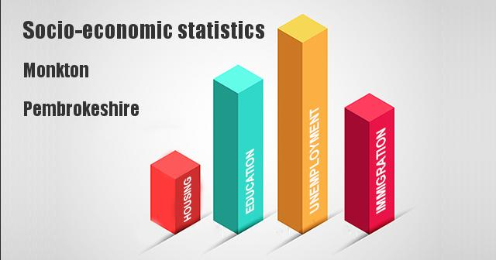

Housing and population

The latest census (2011) provides the statistics of how Monkton is made up. This includes how many males, females and full-time students live in the area. These figures also include how big (hectares) the area is and how many people there are per hectare. The following table shows these figures:

1650 | All usual residents
770 | males
880 | females
1650 | Lives in a household
14 | School child or fulltime student at non-term time address
138 | Area (hectares)
12 | Density (people per hectare)

This table shows the total number of houses within Monkton and how each household is made up:

707 | Total number of houses
214 | One person household
82 | One person household age 65+
455 | One family household
167 | Married or same sex couple
75 | Cohabiting couple
22 | Cohabiting couple no children
45 | Cohabiting couple with children
176 | Lone parent
133 | Lone parent with dependants
43 | Lone parent with no dependants

Although, since this information was published, a large number of houses have been built within Monkton, therefore some of the statistics could be significantly higher. Zoopla website shows that the average house price in Monkton is around £116,556.
According to the I live Here website; the following table shows the percentages of the resident type in Monkton:

Percentage % | Type
42 | Home owner
26.8 | With mortgage
11 | Rented (council)
11.6 | Rented (private)
4.7 | Rented (housing association)
0.3 | Shared
1.9 | Rent free
1.9 | Other

In Monkton there is a small community within a community. This is where most of the gypsy families live. They have their own site named Castle Quarry. It is a very close-knit community and is mostly made up of large families. Only a few years ago only gypsy people would go on to the site and it wasn’t often that you would see gypsy people out of the site. Now, in 2020 it is common for the two communities to mix. More and more gypsies are living in houses and the children are attending the local schools more than they have done in the past, especially the secondary school.

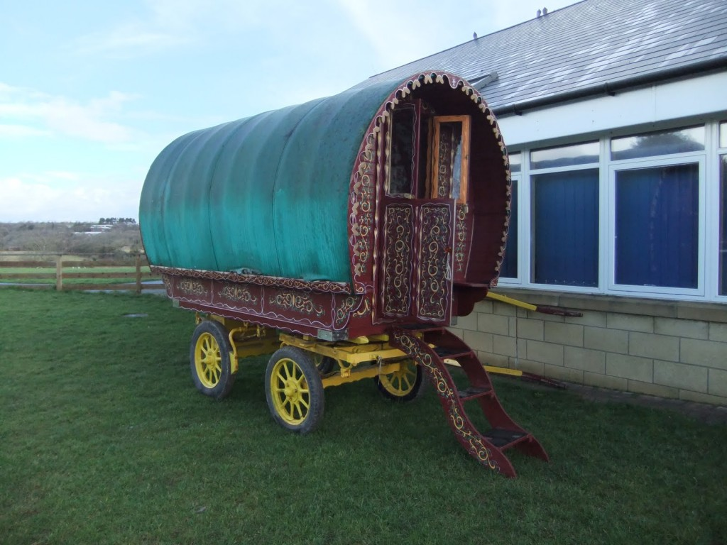

The local school brought in a barrel top wagon to allow the children, including gypsy children, to learn about the culture and see what wagons were like a long time ago.

Ethnicity

Monkton is home to one thousand, six hundred and fifty residents.

According to the census released in 2011, only 86 people within the Monkton community were of gypsy origin. This number could be significantly higher now as the local gypsy site in Monkton is home to more gypsies than ever but no official number is known at the time this community profile was produced.

Employment

According to statistics (census, 2011), the majority of residents that live in Monkton are unemployed and rely on benefits as their only form of income. The following chart shows how the employment statistics are compiled:

Economically active (work) | 649
Full time employed | 275
Part time employed | 176
Self-employed with f/t employees | 7
Self-employed with p/t employees | 2
F/t self-employed without employees | 43
P/t self-employed without employees | 13
Unemployed but seeking work | 112
Full-time student | 21
Economically inactive (not seeking work) | 470
Retired | 157
Inactive student | 48
Looking after home or family | 99
Long-term sick or disabled | 129
Other | 37

There are very few options to gain employment within Monkton. Anybody seeking employment would almost certainly have to travel into neighbouring towns but while doing this research it was noticed that a lot

of the residents of Monkton do not drive and with there being limited public transport in this area, getting to other towns often proves difficult.

There is only one local bus service that runs through Monkton. There are a number of bus stops throughout the area, the main stop being outside the local Spar shop but the buses only run every hour with none running on a Sunday.

The closest train station is Pembroke station which is one mile away from Monkton and takes around 20 minutes to walk.

Places of employment within Monkton

Monkton Swifts Football Club – This is the local football and social club. They have their own community football teams including junior teams from as young as ten years old. There are four teams that play out of the club in total but no local residents are employed by the club.
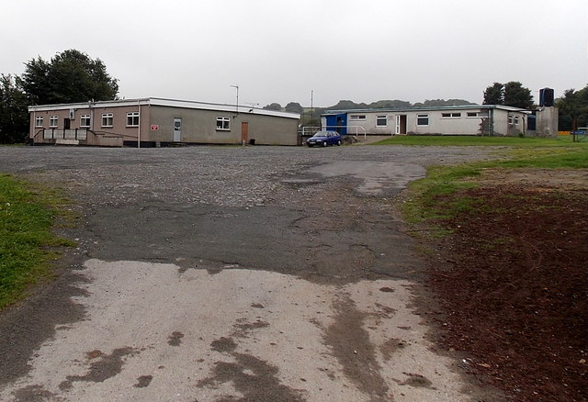

Monkton Community Hall – This was once a very busy building that held almost all the local community events. It had various clubs for all ages and ran courses for young people and adults. It was also a place where community meetings were held but in recent years the building has been used less and less and was left standing empty until January 2018 when three new committee members took over the building and restarted all the clubs and groups that once thrived from the building. The committee members work voluntary at the hall. There are no paid staff.
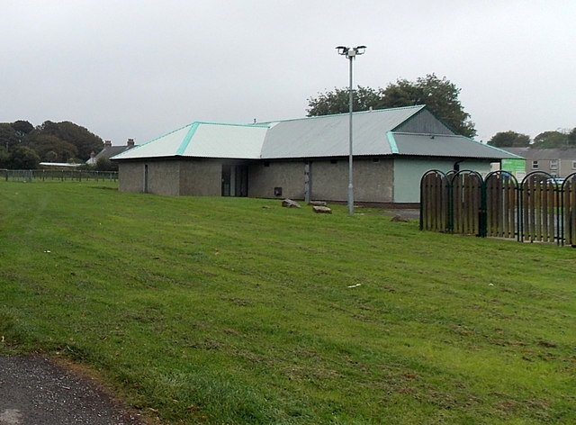

The Tyre Man – This business is owned by a local resident named Clive Kennington. This building was derelict for many years until Clive opened his tyre business in 2017. The garage employs one other local resident who works alongside Clive but since the garage has opened business is growing by the day and Clive is considering giving a local young person the opportunity to start an apprenticeship at the garage.
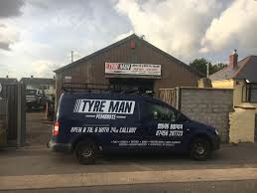

The Spar shop – The manager of the only shop in Monkton is Jane Barton. There is a team of twenty-five people working in the shop, usually on a part-time basis. All employees at the spar are Monkton residents, only three of these are under the age of twenty-five. The spar is the second highest employer in Monkton, only less than Monkton school.
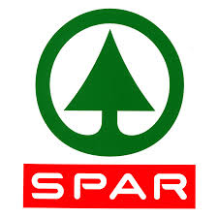

The Munch Box – This is a food establishment that has only opened during 2019. Only two people are employed here and neither of them are local residents. This was formally called Monkton Priory Chippy and employed three local residents.
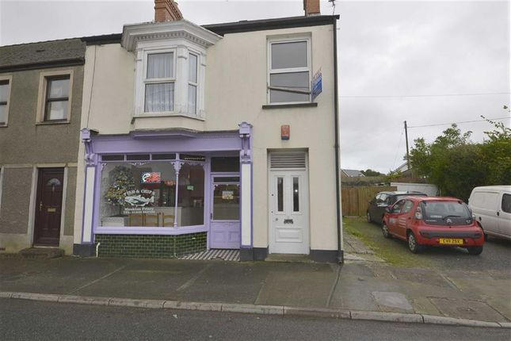

The white door next to the Munch Box entrance is now a nail business called Gemaura Beauty.

Gemarura Beauty – This is a nail and beauty business that has been established since 2018. It is owned by a young lady named Gemma and she is the only person that works there. She is not a local resident.

Monkton Priory C.P school – The local school is the main employer in Monkton. The age of pupils ranges from two years old to sixteen years old as they have a Flying Start centre attached as well as the Priory Learning Centre which is for gypsy children of secondary school age. The school also has two learning resource centres within it, one for infant age children and one for junior age children. The school employs forty-four staff and although the school is the biggest employer within the area only ten members of staff live locally.
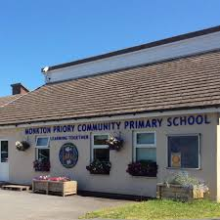

The highest level of education obtained by the residents of Monkton (Uk census, 2011) is as follows:

 | Monkton (%) | Wales (%)
No qualifications | 24.6 | 25.9
Level 1 | 13.6 | 13.3
Level 2 | 16.8 | 15.7
Apprenticeship | 4.3 | 3.9
Level 3 | 11.8 | 12.3
Level 4 | 24.8 | 24.5
Other | 4.1 | 4.3

More and more Monkton residents are able to gain qualifications now as the school also provide adult education where people can take part in courses including degrees, site safety, retaking of GCSEs and many other courses, all held on the school site in the evenings.

Local amenities

There are two churches in Monkton. There is St Joseph’s Catholic Church run by the Rev Patrick Fitzgerald-Lombard, which only opens twice a week. This church no longer offers Sunday school or bible groups and offers no other groups to the young people of Monkton.
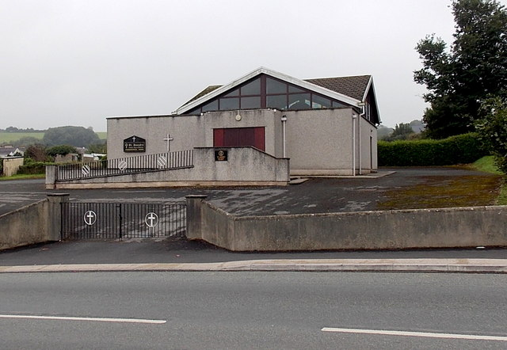

The second church is St Nicolas and St John Church which is run by Rev Peter James. This church is open daily to the public and has a Sunday school which runs directly after Sunday service. This church runs a mother’s union group and helps to support and include the local

community in many different events. Many of the residents of Monkton attend this church, especially for Midnight Mass on Christmas eve.

Monkton Crime Rate

All crimes documented in the following table have been committed within a one-mile radius of Monkton:

The chart shows the most common crime was violent and sexual crimes, amounting to 41.4% of crimes committed. These figures are shown on crime-statistics.co.uk.
There is no assigned youth worker to the Monkton area and when speaking to local residents they feel the young people of Monkton would benefit from one being allocated. People feel that a youth worker would help provide activities and opportunities for young people helping keep them out of trouble therefore reducing the crime rate and increasing qualifications.

Conclusion

According to statistics and national studies, Monkton is one of the most deprived areas within the United Kingdom. Due to these facts, the government has been allocating more money to the local councils to help combat the situation regarding deprivation. Hopefully, with these small changes being made Monkton will again become the thriving community it once was.

