

MODULE NAME:
KNOWLEDGE AND INFORMATION MANAGEMENT SKILLS FOR THE WORKPLACE

MODULE CODE: BMSK5006
STUDENT NAME: SAIFUR RAHMAN
STUDENT NUMBER: 1605226
LECTURER NAME: TANJA NATHAN

Contents
Knowledge and Information Management Skills for the Workplace 1
Introduction 1
Task 1 2
a) Explain the relationship between data information and knowledge 2
b) Relationship between individual knowledge and organisational knowledge 4
c) Apply analysis and modelling techniques to identify knowledge assets. 4
d) Evaluate actual and potential knowledge assets. 6
Task 2 8
a) Explain what is required to create, store, apply and integrate knowledge 8
b) Consider the importance of Intellectual Property rights 10
Task 3 10
a) Explain the contribution knowledge assets have on an organisation 10
b) Evaluate the knowledge requirements for the organisation 12
c) Evaluate the organisation’s framework for enabling knowledge sharing. 13
d) Recommend improvements to the current framework. 14
Conclusion 15
References 16

Introduction
This report is about the knowledge and information skills for Wal-Mart, the largest supermarket chain in the world. The relationship between data information and knowledge and also the relationship between individual and organisational knowledge are discussed in this report. Various models and techniques are used to identify and evaluate potentials knowledge assets. The process of creating, storing, applying and integrating the knowledge assets in Wal-Mart along with the importance of intellectual property rights for Wal-Mart are evaluated in this report. Contribution of knowledge assets in Wal-Mart, knowledge requirement for Wal-Mart, its organisational framework for knowledge sharing and necessary recommendations for improving the current framework for Wal-Mart is discussed and evaluated in this report (Ichijo and Nonaka, 2007).

Task 1

a) Explain the relationship between data information and knowledge
Data, information and knowledge are interrelated and sequential in every aspect of life. This is the age of information revolution and with proper information one can create a knowledge management system with will help to prosper in business and other operations.
Data: Data is the single factor unit of an observation and without processing the data into a meaningful information data has no value. A single data can be effective in many cases for example a tip from the source to the police. But for Organisations like Wal-Mart single data is called unprocessed information and the company collect lots of data to solve various management problems. For Wal-Mart, they will surely organize all the data to find out the perfect information that they are looking for. On the other side, the role of data and information have been very important to understand about the competitors of the Wal-Mart, the market in which they operate and customers. Data can be a series of non-random symbol, colour, number and values, facts and observation from research and a collection of non-random facts. For example 1250 Kg, 5000 Packets of cereals and 200 bottle of juice are random data for Wal-Mart and after processing the data with additional data and information it will have meanings (Sanchez, 2014).
Information: After processing data in a meaningful way we get information. Information has meaning and it can be used and applied in various ways to solve business problems. If the processed data can draw some conclusion or can be interpreted in a meaningful way to solve any problem or to get any results it will be information. For example the balance sheet of Wal-Mart, sales out of a store and the list of addresses of various outlets in the website of Wal-Mart are the information (Ichijo and Nonaka, 2007).
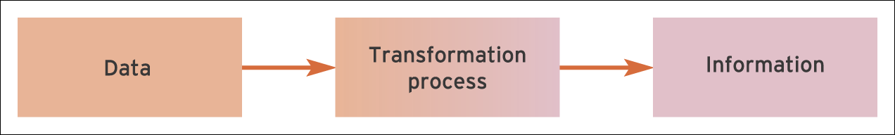
Figure: Transforming data into information
Source: (Collinson and Parcel, 2015)
Knowledge: The combination of our judgement, experience and information is called knowledge. A person can gain knowledge from the information at hand. There are two ways one can describe the knowledge which are explicit and tacit. Explicit knowledge is manual and documented in great details and formal and systematic in nature. Tacit knowledge are the perception, belief, values and experiences of a person. An example of knowledge is after reviewing the sales data Wal-Mart’s marketing manager decides to increase budget in marketing campaigns as the sales drops due to the cutting of budget in marketing campaigns (Ichijo and Nonaka, 2007). In the context of Wal-Mart, there will be a requirement of so many decisions according to the aspects of the system. This is why Wal-Mart will require to gain and analyse the knowledge which will help them to take the decisions and so on. In this way, the whole activities of Wal-Mart will go on and aligned with the proper system.
Relationship among data, information and knowledge
Data and information is sequential and without raw data at first place information cannot be processed. Information of one source can be data for another source. For example the result of income statement is the data for preparing the balance sheet for the organisation. Information helps to form knowledge and based on the knowledge the organisation takes decisions. Relationship among data, information and knowledge can be explained by DIKW model.

Figure: DIKW model
Source: (Hussain and Hussain, 2011).
DIKW is a hierarchy model where gathering data is the first step and gaining wisdom is the final stage by processing data into information and using experience with the information gathering knowledge. By applying the knowledge in a fruitful way one can build wisdom. It depends on how effectively one use the knowledge and what outcome the person or the organisation gets. For example, if Wal-Mart has to apply most effective promotion tool to increase sales and Wal-Mart able to do so than the organisation will reach at the wisdom stage (Sanchez, 2014). As it is said earlier, Wal-Mart will need to make decisions. This is why Wal-Mart will require to gain and analyse the knowledge which will help them to take the decisions and so on. The DKIW model will be very helpful for the Wal-Mart from many consequences and this is how all the roles will be made.

b) Relationship between individual knowledge and organisational knowledge
Individual knowledge is the experiences, skills, values, perceptions and belief of a single person. Individual knowledge is processed and stored in the memory of the person which he or she uses to solve the problems or take decisions of his/her life. All the individual knowledge is not related with organisational knowledge (Collinson and Parcel, 2015). For example one store manager of Wal-Mart knows how to cook food, do laundry and origami and these are the individual knowledge which are not related with the organisational knowledge because these knowledge or skills will not be useful for the organisation.
On the other hand organisational knowledge is vast and can be defined from several perspectives. Organisational knowledge is the assent for the organisation which is the collection of abilities and experiences all the individuals and the management system, organisational structure and culture and decision making process (Sanchez, 2014). Wal-Mart’s organisational structure is an organisational knowledge which helps the company to operate in a systematic ways. Wal-Mart’s R&D team is an organisational knowledge which helps the organisation to design new and creative products and strategies.
When individual knowledge can be applied in the organisational context then it can be said that individual knowledge has relationships with the organisational knowledge. For example marketing manager has various marketing skills and it will be also an organisational knowledge for Wal-Mart if those skills will be used to design marketing strategies for Wal-Mart.
An organisation requires different types of knowledge and for a single individual it is not possible to have all the knowledge and skills. So in the case of organisational knowledge the term ‘collective knowledge’ is used. Here collective means collection of various knowledge and skills from diverse background. For example Wal-Mart requires experts from marketing, HR, IT, Finance and manufacturing and collection of all the skills make Wal-Mart an efficient organisation (Davenport and Prusak, 2012). In Wal-Mart, the individual and organizational understanding are important because they are important for meeting the objectives. In Wal-Mart, there can be several objectives and with the help of the individual knowledge, the organizational knowledge will be increased. The increment will be helpful for the arrangement of the steps of meting goals.

c) Apply analysis and modelling techniques to identify knowledge assets.
Organisations use knowledge management techniques and models to identify the knowledge assists of the organisations. Knowledge management is the process of selecting, processing and storing knowledge and skills to improve the productivity and performances of the employees. Nonaka and Takeuchi (2007) provide a theory of knowledge creation where they suggested how to create explicit knowledge from tacit knowledge in four ways. In the four ways organisations or people can adopt various methods to create or convert knowledge.

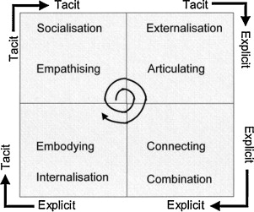
Figure: Knowledge conversion process
Source: (Easterby-Smith and Lyles, 2013)

- Solicitation: The process of obtaining knowledge from someone or something is called solicitation. In knowledge asset identification process one party will try to obtain or extract knowledge from other parties or various sources. Common solicitation methods to identify knowledge assets are face to face meeting, group interview, workshops, seminars and conferences where receivers observe, copy and practise some knowledge and skills. For example workshops for Wal-Mart employees to improve their interpersonal skills.
- Capture: The process of converting tacit knowledge into explicit knowledge is called capture in knowledge creation process. Everybody has its values, perception and belief about the organisation and through some methods like collaboration system, online discussion database and question and answer season one can convert its tacit knowledge into explicit knowledge (Ichijo and Nonaka, 2007). For example employees in Wal-Mart learn about customer persuasion techniques which are in tacit stage and when the employee will write a report or make a document about the persuasion techniques it will be explicit knowledge.
- Dissemination: The process of collecting and distributing the knowledge and skills is called dissemination. This stage is crucial because here the knowledge is transferred from one person to other. Here organisations combine and connect with all the parties to disseminate knowledge though emails, manual documents, collaborations and meeting. For example floor manager in Wal-Mart trains the employees about their duties and responsibilities (Sanchez, 2014).
- Internalisation: The process of identifying and experiencing the knowledge trough an explicit source is called internalisation. In this step tacit knowledge become explicit knowledge. For example employees can read training material and as well as compare the learning from previous experiences. The methods of internalisations are online learning, organisations intranet porters and search and data mining (Ichijo and Nonaka, 2007).
Wal-Mart applies other methods to identify knowledge assets in the organisation and one of the methods is focus group where Wal-Mart invite people from various departments and do brainstorming to identify knowledge. In the focus group meeting one propose new ideas and other people give counter proposal or argue about the pros and cons of the new idea. Wal-Mart has created new roles in the organisation to identify knowledge asset. Knowledge worker is recruited in the organisation to create, use, share and apply knowledge. Knowledge engineers works with the experts to elicit knowledge from them and record and share the knowledge with other in the organisation (Davenport and Prusak, 2012).

d) Evaluate actual and potential knowledge assets.
Knowledge assets are the properties for the organisations which help them to grow and sustain in the market. Actual knowledge assets are the existing knowledge in the organisation and potential knowledge are the skills and knowledge which the organisation will attain in future and currently testing the probability of the knowledge asset. Knowledge assets help to improve the performance of the employees. Knowledge asset are the “know how” process that organisation acquire to create value for its customer and capture value from the customers in return. Wal-Mart has various knowledge assets which includes intellectual resources and other assets (Walmart, 2018).
- Customer data: Wal-Mart has huge customer data which is computerised and updated. From the customer data Wal-Mart can predict customer demand pattern and change in the market trend and Wal-Mart can customise the value proposition by matching with customer’s characteristics (Ebel et al., 2013). Wal-Mart will be able to determine what customers require from the customer data.
- R&D department: Research and development team is another knowledge asset for Wal-Mart and this department is capable of designing new products as the marketing manager wants. There are creative minds working in the R&D team who are highly skilled and know their role very well. Creative teams also have the clear idea of current trends and development and they relate their innovations with the current trends.
- Cognitive skills: The core skills of the brain that are used to create, think, and learn new ideas and process. Wal-Mart recruit employees with high cognitive skills and these employees are contributing in decision making and better strategy creation for the organisation. Cognitive skills help Wal-Mart to respond with the changes in the market, collect and process information and take fast decision (Griseri, 2016).
- Technical skills: major portion of knowledge assets of Wal-Mart are the different technical skills of the employees of different departments. Wal-Mart has recruited employees for different departments with specific technical skills appropriate for those departments. For example IT manager is recruited with minimum two years of job experience in related filed and a bachelor degree in computer science, a marking manager must have bachelor degree in marketing and minimum five years of job experiences in related fields (Hussain and Hussain, 2011).
- Potential knowledge assets: Potential knowledge assets for Wal-Mart are achieving better efficiencies in production and operation process by reducing carbon emission, cost, waste and order cycle time and increasing the profitability in the organisation. Advance technologies like artificial intelligence and robotics are also the potential asset for the organisation and by having those technologies Wal-Mart can reduce manual labour and fasten the operation process and in return the organisation can reduce the cost of operation and improve the accuracy and efficiencies (Ichijo and Nonaka, 2007). The knowledge assets are important for Wal-Mart and this is why they are using the patent, copyright and other assets safety tools in the system.
All these knowledge assets will help the organisation to offer better services to the customers, suppliers and intermediaries. Wal-Mart will be able to control the bargaining power from both buyer and supplier side and Wal-Mart will be able to ensure customer satisfaction and growth opportunities for the organisation (Walmart, 2018).

Task 2

a) Explain what is required to create, store, apply and integrate knowledge
Wal-Mart requires a strategy or framework to create, store, apply and integrate knowledge in the organisation. Knowledge management cycle can be applied in Wal-Mart in this regard.

Figure: Knowledge management cycle
Source: (Collinson and Parcel, 2015).
Knowledge acquisition
The process of knowledge creation and innovation is called knowledge acquisition. KA is the first step in KM cycles that collects and creates new knowledge in the organisation. Wal-Mart can acquire knowledge from various sources. Wal-Mart has to develop strategies to select appropriate sources to collect new knowledge. New employees with dynamic ideas can be a major source of KA as they know the latest concepts and theories which will be useful for the organisation. Existing employees can acquire new knowledge from various external sources like seminars, workshops and training programs (Griseri, 2016). Wal-Mart can recruit consultant and trainers to provide new skills for the employees. The company can achieve new knowledge through Merger and acquisition with other firms. Wal-Mart can invest in research and development programs to create new knowledge
Knowledge retention
Once the organisation acquires some knowledge it has to store it to use later. If the employees forget the knowledge what they have acquire than they will fail to apply it in the work. From the ancient times till now it is observed that people store their knowledge in some physical form for example books and journal. In the digital age organisations are using internet, website and computerised database to store data and retain the data whenever they need. The amount of business data is increasing and the organisations need more effective ways to extract the useful data. Business intelligence is the process of extracting the useful data from the huge database the organisation kept. Organisation like Wal-Mart has data warehouses where they store huge amount current and historical data. Data mart is a more efficient way of managing data where data are stored on departmental based (Hussain and Hussain, 2011).
Knowledge transfer
The process of sharing and exchanging the knowledge is called knowledge transfer. Knowledge can be shared where one party will give and another party will receive, for example training programs. Knowledge exchanging is the process giving and receiving knowledge at the same time. For example in merger agreement one organisation has some skills and resources and it needs some other resources and it exchange with other organisation which does not has the resources that first organisation has but does have the resources which the first organisation does not have. Knowledge can be transferred in many ways and today with the development of technologies it becomes easier to transfer knowledge from one source to another. People can read books, get training, and attend workshops and seminars to transfer and receive knowledge assets (Sanchez, 2014).
Knowledge application
Final stage of knowledge management cycle is knowledge application where the knowledge is applied in real life and integrates with the whole organisation. In this step the organisation prepares various strategies and techniques to apply and integrate knowledge in the organisation.
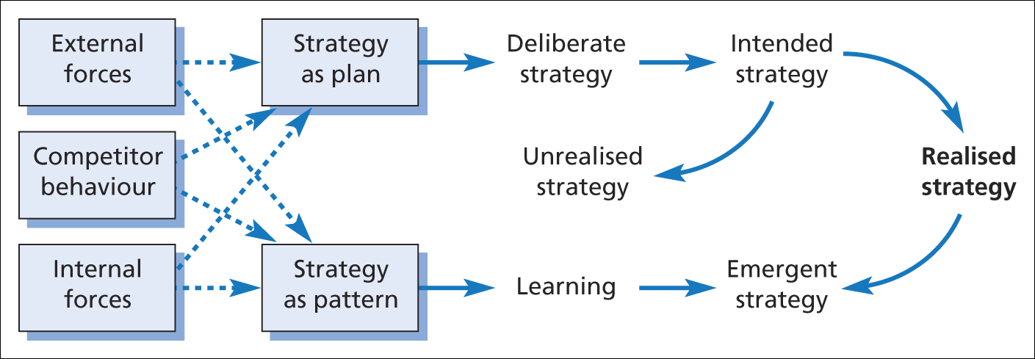
Figure: Strategy as a plan and pattern (adapted from Mintzberg and Waters 1985)
The organisation considers the external and internal forces and competitive behaviour during the strategy creation and implementation. The organisation design strategies to apply the knowledge to achieve its objectives. Strategies can be deliberate which are fully realised or they can be unrealised. Emergent strategies are pattern and actions that are taken one by one. Deliberate, unrealised, intended and emergent strategies together create realised strategies (Ichijo and Nonaka, 2007).

b) Consider the importance of Intellectual Property rights
The creative and intangible properties of an organisation are called intellectual property. For example the brand name of Wal-Mart, it logo design, tag line, trademark and copyrights are the intellectual properties for the company. Intellectual properties are the result of creativity and innovation and managing them can create competitive advantage and brand positioning in the market. Intellectual property rights are the rights that are held by an organisation or company that give the person or the company exclusive authority or power to use those properties for the betterment of the company (Wipo.int, 2018).
There are several acts to protect the intellectual properties like patent, trademark and copyrights. First of all intellectual property right provide safety and protection of intellectual properties. Other individual and organisation cannot claim or copy in intellectual priories. If someone infringes the copyright or patent of others then the person will face legal consequences and the person may have to be jailed for 5 to 20 years based on the level of the crime. It provides the organisation exclusive right to use the intellectual properties. For example the tag line of ‘Wal-Mart is save money, live better’ and any other organisation cannot use this tagline as it is the intellectual property of the company and Wal-Mart has patent for the tag line (Walmart, 2018). And the properties can be used in the promotional campaigns of the organisation. Intellectual properties serve as the tools for brand recognition. A company can differentiate its offerings by using its trademarks and logos. Intellectual properties are the sign of authenticity of the products that helps to gain customer trust and loyalty (Sanchez, 2014).

Task 3
a) Explain the contribution knowledge assets have on an organisation.
Knowledge assets are the intangible properties the organisations own and by using the knowledge assets the organisation create and implement various strategies to sustain in the market and create values for the customers. Information management strategy is a knowledge asset for Wal-Mart and using that strategy Wal-Mart has integrated all the activities of the organisation and quick access the all the information helps Wal-Mart to make effective and quick decisions. The information cycle is a tool that the organisation uses to track, capture and destroy information.
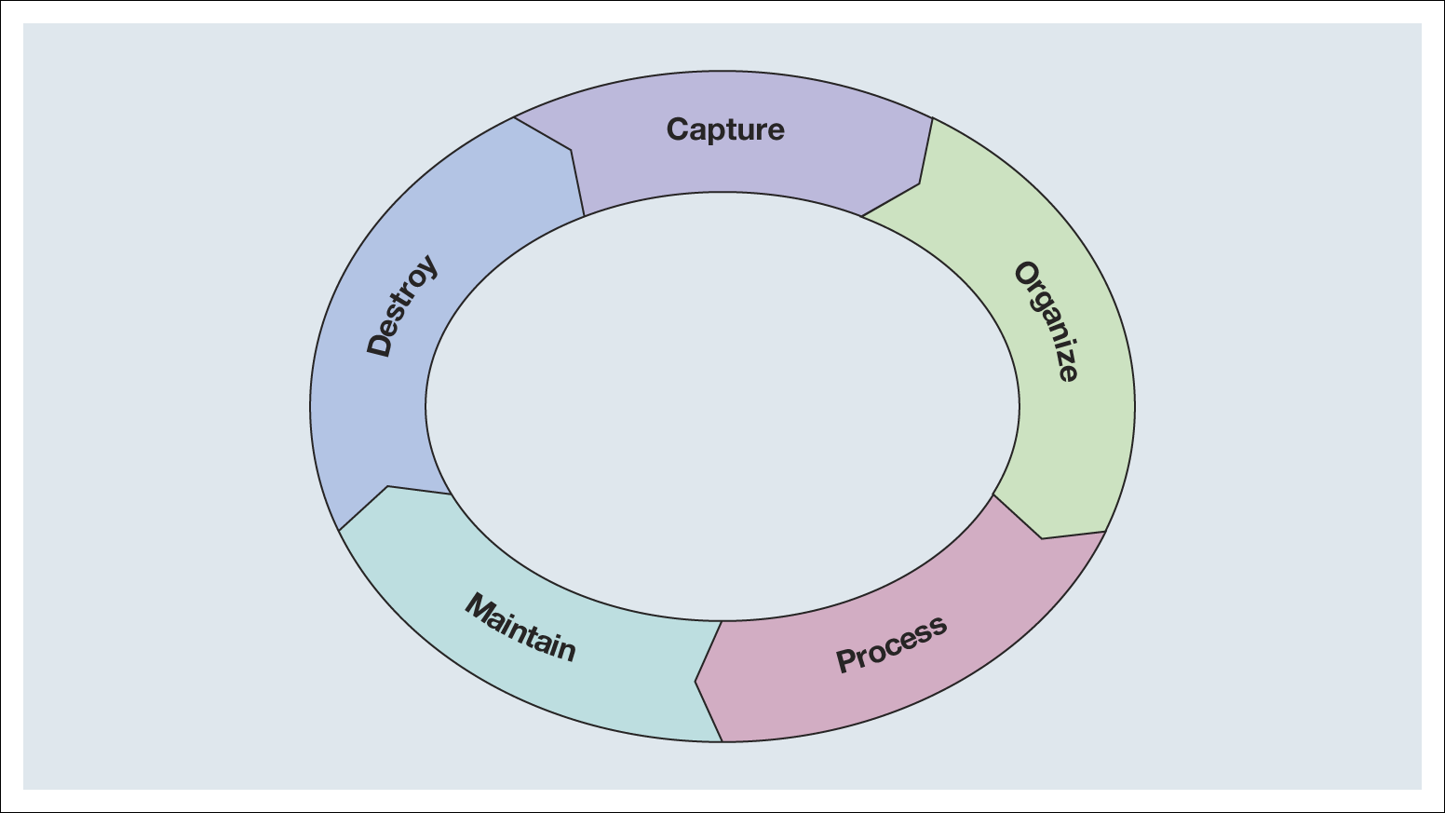
Figure: Information cycle
Source: (Ebel et al., 2013).

By using the cycle Wal-Mart capture necessary information for example collecting customer data through survey and then Wal-Mart organises the data. Then the company process the data to convert them into useful information and use or maintain customer data for future uses. Due to the legal requirement Wal-Mart may have to destroy the data or information. The company may destroy customer data voluntarily because the data may get obsolete (Jones, 2016).
Knowledge assets have contribution in other areas in Wal-Mart and some important contribution of knowledge assets are:
- Gaining competitive advantage: Wal-Mart has built a competitive advantage of being affordable and most convenient supermarket chain in UK due to its knowledge asset like innovation, creativity, research and development (Griseri, 2016).
- Product leadership: Wal-Mart has the most number of product assortments than any other supermarket brands in UK. Besides Wal-Mart has its own private label brands which are popular than many conventional brands and this success is possible because of the knowledge assets like experience, technologies and innovation (Sanchez, 2014).
- Gaining customer intimacy: By using the knowledge assets like brand name, logo, tag line and innovative CRM strategies Wal-Mart has gain customer intimacy. The company issue 5000 loyalty cards every year which means number of intimacy with its customers are increasing day by day. In recent time Wal-Mart has most number of loyal customers in UK (prezi.com, 2018).
- Operational excellence: A Knowledge asset like cognitive and technical skills helps Wal-Mart to increase the productivity and quality of the products. It also helps to reduce order cycle time, lower the mistakes and transferring best practice efficiencies and increases overall operational excellence in the organisation (O'Dell and Hubert, 2013).

b) Evaluate the knowledge requirements for the organisation
Wal-Mart is the largest retailer in UK and moving toward digitalisation it business along with the brick and mortar form. Wal-Mart requires various knowledge assets to achieve its business objectives, to achieve competitive advantage and to create value and differentiate the value from the competitors. Various knowledge assets require for the organisation is evaluated below:
- Patent and trademark: Patent and trademark of for the brand name, log, tagline and other innovation will allow Wal-Mart to protect its unique assets. Customers will identify the uniqueness of Wal-Mart through the patent and trademark and customers will also able to differentiate the offerings of Wal-Mart from the competitors’ offerings (Jones, 2016).
- Technological skills: Wal-Mart require technological skills which will allow the organisation to increase the efficiencies in overall operation. Besides Wal-Mart has the largest online grocery shop and to run the shop efficiency Wal-Mart will need experts from IT and marketing departments. Technological skills will also help to gain competitive advantage If Wal-Mart is the first to use the technology (Bakardjieva, 2010).
- Cognitive and technical skills: Wal-Mart also needs cognitive and Technical skills to be effective in strategy making and achieving operational excellence. Creativity, thinking power, decision making ability and analytical abilities are the required cognitive skills and on the other hand marketing skills, management skills, finance and IT skills are the required technical skills for Wal-Mart (Mosconi, E. and Marie-Christine, 2015).
- CRM system: Wal-Mart has to build an effective customer relationship system in the organisation to make the existing customers loyal and attract new customers. Wal-Mart’s club card is an effective program where the club card holders get some special benefit (prezi.com, 2018). Everyday more and more customers want club cards and having the card means they will hardly go somewhere else to do shopping and will remain loyal to the organisation.
- ERP system: Wal-Mart has to implement enterprise system where the organisation will provide single solution for a single problem by integrating all the resources and activities. Internet technologies are used to instigate and communicate within the system including marketing, HR, manufacturing, finance and distribution (Zeng and Skibniewski, 2013).

c) Evaluate the organisation’s framework for enabling knowledge sharing.
Wal-Mart has the framework for knowledge sharing. The organisation applies various operation information systems to share knowledge which are:
Transaction process system (TPS)
TPS system is used to share knowledge with third parties like customers, suppliers and distributors. Two types of TPS are batch system and real time system. Batch processing is more appropriate the Wal-Mart as it is a large organisation where information are accumulated and processed at the time of lower transaction. In real time knowledge is shared immediately. Example of TPS is when someone checks at Wal-Mart’s, every time one of the purchases is swiped over the barcode reader and that is a transaction (Bakardjieva, 2010).
Office automation system (OAS)
OAS system is used to share knowledge and manage it within the office functions and it helps to create the office environment more effective. Various types of OAS are:
- Groupware: A team of people working together and share knowledge through connectivity such as emails and teleconferencing (Lilley, Lightfoot and Amaral, 2014).
- Document managing process: Knowledge stored in documents is converted in digital format which increase the lifetime and reach of the knowledge.
- Workflow management system: Here the knowledge is shared by right people in right time at right place. The sharing process of knowledge is automated by providing a structured framework to support the process (Ebel et al., 2013).
Process and control system
Here the knowledge is collected, organised and shared though a controlled framework so that quality of the knowledge can be controlled and improved. For example knowledge about material requirements planning (MRP) aims to ensure the right amount of stock is held for the production schedule (Lilley, Lightfoot and Amaral, 2014).

d) Recommend improvements to the current framework.
Current knowledge sharing framework is doing fine for Wal-Mart but with the changing business environment and to sustain in the competitive market Wal-Mart has to make improvement to the current framework. Here is some recommendation for Wal-Mart to improve the current framework.
- Managing information risk: there are lots of risks in knowledge sharing and Wal-Mart has to manage that risk properly. Most common information risks are accidents, natural disaster, vandalism, theft, unauthorised use, and sabotage and virus attack. Wal-Mart has to consider those risks in knowledge sharing framework and has to take steps to protect the frameworks from those risks. Some solutions are having backup in two or three sources, using antivirus software, controlling unauthorised access by using password and recruiting IT professionals (Mosconi, E. and Marie-Christine, 2015).
- Implementing DSS system: Decision support system is a tool that will help Wal-Mart to collect, analyse, store and retrieve necessary information to facilitate strategic and tactical decision making. Artificial intelligence can be used here to increase the efficiencies of computer like a human brain (Ebel et al., 2013).
- Improving ERP system: Enterprise resource planning is the future of knowledge asset development in an integrated way and Wal-Mart should invest more to develop the ERP framework in the organisation (Zeng and Skibniewski, 2013).
- Sharing knowledge through easy and traditional medium: Wal-Mart should arrange workshops, seminars, training programs, coaching, meeting and question and answer season to share knowledge. Wal-Mart can give learning materials and online sources to the employees to increase their work related knowledge. More over modern technologies like teleconferencing, intranet and social networking can be used to improve the knowledge sharing framework of the organisation (Newell, 2015).

Conclusion
Wal-Mart has to build an efficient network of knowledge sharing to improve the knowledge and management skills for its employees. With efficient knowledge sharing Wal-Mart will be able to increase the productivity and overall profitability of the organisation. Wal-Mart can use various tools and models to identify the knowledge assess required for the organisation and take steps to acquire those knowledge assets in the organisation. Wal-Mart has to follow a system to share and exchange knowledge from various internal and external sources. True success of knowledge sharing is depended on how effectively the employees receive the knowledge and skills given by the organisation.

References
Bakardjieva, M. (2010). Internet society. Los Angeles: Sage.
Collinson, C. and Parcel, G. (2015). Learning to Fly: Practical Knowledge Management from Leading and Learning Organizations. Oxford: Capstone.
Davenport, T. and Prusak, L. (2012). Working Knowledge: How Organizations Manage What They Know. Boston, Mass.: Harvard Business School Press.
Easterby-Smith, M. and Lyles, M. (2013). The Blackwell Handbook of Organizational Learning and Knowledge Management. Malden, MA: Blackwell Pub.
Ebel, A., Marchiori, F., Lucarelli, A., Lonzi, G., Fidalgo, D., Pellicer, P. and Iglesias, M. (2013). Knowledge management and decision support with special focus to process and quality optimisation at flat steel production (Knowdec). Luxembourg: Publications Office.
Griseri, P. (2016). Management Knowledge: A Critical View. Houndmills, Basingstoke, Hampshire: Palgrave.
Hussain, D. and Hussain, K. (2011). Information management: organization, management and control of computer processing. New York: Prentice Hall.
Ichijo, K. and Nonaka, I. (2007). Knowledge creation and management. Oxford: Oxford University Press.
Jones, B. (2016). Knowledge Capitalism. Oxford: Oxford University Press.
Lilley, S., Lightfoot, G. and Amaral, P. (2014). Representing organization: knowledge, management and the information age. Oxford: Oxford University Press.
Mosconi, E., E. and Marie-Christine, R. (2015). Linking Management and Organizational Performance. International Business Research. Sep2013, Vol. 6 Issue 9, p68-76. 9.
Newell, S. (2015). Managing Knowledge Work and Innovation. Houndsmillls, Basingstoke, Hampshire: Palgrave.
O'Dell, C. and Hubert, C. (2013). The New Edge in Knowledge: How Knowledge Management Is Changing the Way We Do Business. Hoboken, N.J.: Wiley.
prezi.com. (2018). Wal-Mart's CRM. [Online] Available at: https://prezi.com/pil0303t7gvi/Wal-Marts-crm/ [Accessed 17 Dec. 2018].
Sanchez, R. (2014). Knowledge management and organizational competence.. New York: Oxford University Press.
Wipo.int. (2018). About IP. [Online] Available at: http://www.wipo.int/about-ip/en/ [Accessed 15 Dec. 2018].
Walmart, (2018). About. [Online] Available at: https://www.walmart.com/about/ [Accessed 15 Dec. 2018].
Zeng, Y. and Skibniewski, M. (2013). Risk assessment for enterprise resource planning (ERP) system implementations: a fault tree analysis approach. Enterprise Information Systems, 7(3), pp.332-353.

