Personal Development Portfolio
Professional Career Development in Health and Social Care (LCHS 4009)
Assignment 2 – Component 2
Name of Student: Prince Peter Ojeabulu Okhueidiata
Student Number: 2509560
Module Code and Title: LCHS4009 – Professional Career Development in Health and Social Care
Name of Lecturer: Dilhara Nadeeshani Mampitiya
Assignment Title: Personal Development Portfolio – Support Care Worker Role
Word Count: 1,886 words

AI Acknowledgement Use
I confirm that no generative artificial intelligence (AI) tools were used in the research, writing, or preparation of this report. The content, analysis, and conclusions presented are my own work.

Table of Contents
AI Acknowledgement Use 2
Table of Contents 3
Introduction 4
Task 1: Job Vacancy and CV 4
Job Vacancy – Nottingham City Council 4
Curriculum Vitae 5
Personal Profile 5
Education 5
Work Experience 5
Additional Training and Workshops 6
Skills and Competencies 7
Interests 7
Referees 7
Task 2: Personal Statement 8
Task 3a: SWOT Analysis – Support Care Worker Role 9
Task 3b: Personal Development Plan (PDP) 10
Task 4: Reflective Account Using Gibbs' Reflective Cycle 11
Description 12
Feelings 12
Evaluation 12
Analysis 12
Conclusion 12
Action Plan 13
References 14

Introduction
This portfolio supports my application for the role of Support Care Worker at Cherry Trees, Bestwood (Skills for Care, 2025). It brings together a chosen job vacancy and tailored CV, a personal statement, a SWOT analysis, a Personal Development Plan, and a reflective account of my Component 1 presentation for LCHS4009.
My aim is to show I'm ready for this role by drawing on several years of practical experience in residential and nursing care, alongside my ongoing Health and Social Care studies at the University of Wales Trinity Saint David (UWTSD). Each section also points to where I still need to develop, reflecting the expectation that care workers keep learning throughout their careers (Skills for Care, 2025).
The sections below cover, in order: the job vacancy and CV (Task 1), my personal statement (Task 2), a SWOT analysis and Personal Development Plan (Task 3), and a Gibbs' Reflective Cycle account of a prior presentation (Task 4).

Task 1: Job Vacancy and CV
The vacancy I've chosen is a Care Worker Level 2 post with Nottingham City Council at Cherry Trees, Bestwood Park Estate - the same home where I already work as agency staff. It's the permanent, council-employed role I'm now working towards, and the advertisement below is reproduced in summary form, in the style used on the council's careers site (Nottingham City Council, 2026).

Job Vacancy – Nottingham City Council
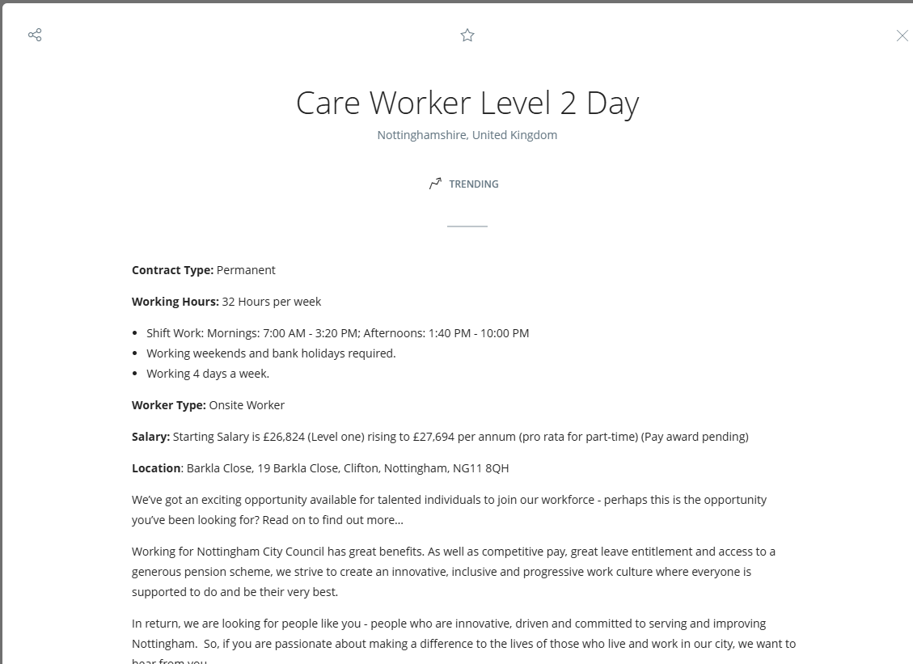.

Curriculum Vitae
Prince Peter Ojeabulu Okhueidiata
Address: Bestwood Street, Notttingham, United Kingdom | Phone: +44 7778 384285 | Email: 2509560@student.uwtsd.ac.uk

Personal Profile
I have worked in health and social care for almost ten years now, mostly in senior residential and nursing roles covering both day and night shifts. In that time I've supported residents with personal care, supervised and mentored junior staff, and helped keep homes running safely day to day. I'm currently partway through a CertHE in Health and Social Care at the University of Wales Trinity Saint David, which I'm fitting in alongside my job, and it's helped me put a stronger theoretical footing under things I already do in practice - safeguarding, communication, and person-centred care in particular.

Education
- CertHE in Health and Social Care– University of Wales Trinity Saint David, Department of Health and Social Care. To be awarded: January 2027.

Work Experience
Senior Night Staff - Cherry Trees Resource Centre (Agency) | February 2024 – Present
- Providing overnight care and supervision to residents and colleagues.
- Ensuring adherence to health and safety regulations.
- Administering medication and supporting residents with their individual needs.
Senior Day Staff - Lacemaker Court, DCC (Agency Worker) | 2022 – Present
- Assisting with personal care and daily living activities.
- Supervising and supporting junior staff members.
- Communicating effectively with families and healthcare professionals.
Senior Day / Acting Duty Manager - Lady Cross, DCC | 2019 – 2021
- Managing the day-to-day operations of the care facility.
- Leading and mentoring a team of caregivers.
- Handling administrative duties, including care plans and documentation.

Senior Days / Acting Duty Manager - Beechcroft, DCC | 2018 – 2019
- Overseeing the provision of high-quality care.
- Handling staffing and scheduling to ensure adequate coverage.
- Assisting residents with personal care and medication administration.
Support Worker - Maple Manor Nursing Home for Learning Disabilities | 2016 – 2018
- Supporting individuals with learning disabilities in daily activities.
- Encouraging independence and social engagement.
- Working closely with multidisciplinary teams to provide holistic care.
Care / Support Worker - Highfield Nursing Home | 2014 – 2016
- Assisting residents with personal care needs.
- Providing emotional and social support to enhance well-being.
- Ensuring a clean and safe living environment.
Healthcare Assistant - Albemarle Court Nursing Home | 2011 – 2014
- Assisting residents with daily personal care, including bathing, dressing, and mobility support.
- Providing emotional support and companionship to enhance residents' well-being.
- Ensuring adherence to health and safety regulations within the care home.
- Supporting residents with dementia and other age-related conditions.

Additional Training and Workshops
- Equality, Diversity, and Human Rights
- Health, Safety, and Welfare
- Infection Prevention and Control
- Safeguarding Adults and Children
- Moving and Handling
- Basic Life Support
- Food Safety and Hygiene
- Medication Administration

Skills and Competencies
- Resident care and support
- Medication administration
- Leadership and team management
- Effective communication with residents, families, and colleagues
- Record keeping and care plan documentation
- Awareness of safeguarding and health and safety procedures

Interests
Prince has a strong interest in staff development and mentoring, having supported and supervised junior colleagues in several of his roles. He also has an interest in continuing professional development within health and social care leadership.

Referees
Available upon request.

Task 2: Personal Statement
I am applying for the Support Care Worker post at Cherry Trees, Bestwood, and I believe I can make a real contribution to the house and the wider organisation. I'm currently studying for a CertHE in Health and Social Care at the University of Wales Trinity Saint David, and I bring almost a decade of practical experience across residential and nursing care, most recently as Senior Night Staff at Cherry Trees Resource Centre.
Over my career, I have built solid, hands-on knowledge of care delivery personal care tasks, helping service users towards maximum independence, applying care plans, and keeping running records and daily monitoring forms up to date. I know how much effective communication matters with residents and colleagues, and I stay alert to health and safety, including recognising and reporting signs of potential abuse.
My experience and training, including certification through Heartland Care Recruitment Ltd, have prepared me well for this role. I have worked across a range of settings, from supporting people with learning disabilities at Maple Manor to acting as Duty Manager at Lady Cross and Beechcroft, where I managed daily operations, mentored staff, and handled care documentation. That range has given me a strong, practical grasp of person-centred care and of how different people's needs vary.
I would describe myself as open-minded, easy-going, and reliable, with good analytical and problem-solving skills. I work well with others, follow policies and procedures carefully, and I'm comfortable sharing ideas with colleagues and managers to help make positive changes. Having worked closely with Cherry Trees over recent months, including night shifts, I have genuinely enjoyed it and remain committed to the team.
I understand the need for confidentiality and for recognising the rights and feelings of vulnerable adults from diverse backgrounds. I am happy to work flexibly to meet the service's needs, to follow policies such as non-smoking requirements, and to stay honest and professional in everything I do.
I am also committed to continuing my development, through both my studies and further workplace training. Combining my practical experience with what I'm learning academically makes me a strong candidate for this role, and I'd welcome the chance to keep contributing to the Cherry Trees team.

Task 3a: SWOT Analysis – Support Care Worker Role
A SWOT analysis helps identify personal strengths, weaknesses, opportunities, and threats in relation to a chosen role, supporting honest self-evaluation (Skills for Care, 2025). Below, I consider my own readiness for the Support Care Worker role at Cherry Trees, which calls for practical care skills, leadership, communication, and a person-centred approach (CQC, 2010; NHS England, 2023).
Strengths | Weaknesses
Almost ten years across residential and nursing care, including personal care, medication administration, and supporting people with learning disabilities and dementia.  Supervisory and Acting Duty Manager experience, building my leadership and administrative skills (Skills for Care, 2001).  Completed training in safeguarding, moving and handling, infection control, and basic life support. | My formal academic study is still in progress, so I'm still building the theory behind practices I already carry out day to day (Skills for Care, 2001).  Coming mainly from hands-on roles, I could develop my written reporting and formal documentation further.
Opportunities | Threats
Continuing my CertHE at UWTSD lets me build the theory behind my practice while gaining a recognised qualification (Skills for Care, 2025).  Clear routes for progression at Cherry Trees, building on my Acting Duty Manager experience, plus specialist training such as dementia care. | Care work can be physically and emotionally demanding, and sector-wide staff shortages add to workload pressure (Skills for Care, 2001).  Balancing full-time study with shift work, including nights, needs careful time management.
Overall, my clearest strength is direct, hands-on care and leadership experience, while my main gaps are academic underpinning and written documentation both addressed in the Personal Development Plan below. Staying organised and reflective should help me manage the pressures noted above.

Task 3b: Personal Development Plan (PDP)
A Personal Development Plan (PDP) identifies clear goals and a plan for developing the knowledge, skills, and confidence needed for a chosen role (Skills for Care, 2025). Building directly on the weaknesses identified in my SWOT analysis, my PDP focuses on three key areas that will support my progress as a Support Care Worker over the next two years.
Development Area | SMART Goal | Actions | Resources | Target Date | Monitoring & Evaluation
Safeguarding and regulatory knowledge | Complete remaining CertHE modules, focusing on safeguarding, the Care Act 2014, and CQC standards, so my practice is more clearly grounded in current guidance (CQC, 2010). | Attend modules and assessments; discuss learning points with my workplace supervisor. | CertHE materials; supervisor; CQC guidance. | 2 years | Track module results each term and discuss progress with my supervisor.
Leadership and management skills | Building on my Acting Duty Manager experience, complete a recognised leadership qualification, such as a Level 5 Diploma in Leadership for Adult Care, within two years. | Research and apply for a course; ask for more leadership responsibility at work to practise as I learn. | Employer training budget; course providers; line manager. | 2 years | Workplace appraisals and direct manager feedback on leadership performance.
Digital record-keeping and reporting | Build confidence with electronic care records and reporting systems used at Cherry Trees, to a consistently high standard (Skills for Care, 2001). | Complete in-house systems training; ask a supervisor to review my records monthly. | Employer induction training; supervisor feedback. | 6 months | Supervisor audits, reviewed at a six-monthly check-in.
Reviewing these three goals regularly will show me where I'm closing the gaps from my SWOT analysis, and let me adjust the plan if my circumstances change.

Task 4: Reflective Account Using Gibbs' Reflective Cycle
This account reflects on my Component 1 presentation for LCHS4009. I'm using Gibbs' Reflective Cycle (Gibbs, 1988) to think through planning and delivering a presentation on Working in Teams, where I used Tuckman's model of team development (Tuckman, 1965) to explain how teams grow more effective over time.

Description
I chose Working in Teams as my topic, drawing on my own experience supervising and mentoring staff as Acting Duty Manager. I explained Tuckman's stages - forming, storming, norming, and performing (Tuckman, 1965) - and linked each one to examples from my own workplace, like inducting new night staff and building trust within a care team.

Feelings
I felt confident about the content, since it reflected my day-to-day experience, but nervous about presenting in an academic format rather than a workplace one. Once I got into examples I knew well, I settled, and afterwards I felt a real sense of achievement at having connected theory to practice.

Evaluation
Using real workplace examples to illustrate Tuckman's model was a clear strength, making the theory easier to relate to practice (Tuckman, 1965). My lecturer's feedback agreed - the practical examples came through well, and so did my understanding of team dynamics in a care setting. The feedback also suggested my presentation would have benefited from clearer academic referencing and a more structured slide layout.

Analysis
This showed me that strong practical knowledge doesn't automatically make a strong academic presentation - the two need different, complementary skills. Tuckman's model helped me see that teams don't become effective immediately, but develop through communication, trust, and shared goals (Tuckman, 1965), which matched my own supervisory experience closely. It also told me that, as I move further into academic study, I need more emphasis on formal referencing and structure alongside my practical insight (NHS England, 2023).

Conclusion
Overall this was a positive experience. I connected an academic model to real workplace practice, which was a genuine strength. At the same time, I need to keep developing my academic presentation skills particularly referencing and slide structure alongside my practical knowledge.

Action Plan
Next time, I will pay closer attention to referencing conventions and plan my slide structure before focusing on content. I will also ask my tutor for feedback earlier in preparation, not just after delivery, so I can adjust in good time. And I will keep drawing on my workplace experience, since that was a genuine strength, while presenting it more rigorously.

References
Care Quality Commission (CQC) (2010) Regulation 9: Person-centred care. Available at: https://www.cqc.org.uk/guidance-providers/regulations-enforcement/regulation-9-person-centred-care (Accessed: 30 July 2026).
Department of Health and Social Care (2014) Care Act 2014. London: The Stationery Office.
Gibbs, G. (1988) Learning by Doing: A Guide to Teaching and Learning Methods. Oxford: Further Education Unit.
NHS England (2023) Good communication with patients waiting for care. Available at: https://www.england.nhs.uk/long-read/good-communication-with-patients-waiting-for-care/ (Accessed: 30 July 2026).
Nottingham City Council (2026) Care Worker Level 2 – Cherry Trees, Bestwood Park Estate. Nottingham City Council Careers. Available at: https://eism.fa.em2.oraclecloud.com/hcmUI/CandidateExperience/en/sites/ncc (Accessed: 30 July 2026).
Skills for Care (2001) A guide to adult safeguarding for social care providers. Available at: https://www.skillsforcare.org.uk/resources/documents/Support-for-leaders-and-managers/Managing-a-service/Safeguarding/A-guide-to-adult-safeguarding-for-social-care-providers.pdf (Accessed: 30 July 2026).
Skills for Care (2025) Statutory and mandatory training guide. Available at: https://www.skillsforcare.org.uk/resources/documents/Developing-your-workforce/Guide-to-developing-your-staff/Statutory-and-mandatory-training-guide-December-2025.pdf (Accessed: 30 July 2026).
Tuckman, B.W. (1965) 'Developmental sequence in small groups', Psychological Bulletin, 63(6), pp. 384–399.

