Shell’s International Marketing Analysis

Student: Marius Ionut Saiz
Student Number: 1605685
Module: International Marketing (LCMB7006)
Lecturer: Tushara Balendran

Table of Content

Table of Figures 4
1.0 Global Marketing 5
2.0 Background of Shell Company 6
2.1 Core Values of Shell 7
2.1 Shell Performance in Greek 8
2.2 Shell Performance in Russia 9
3.0 Shell Global Financial Performance Data 10
3.1 Shell Company Present Financial Status in Russia and Greece 11
4.0 Culture Dimension Model of Hofstede 11
• Power Distance 12
• Uncertainty Avoidance 12
• Individualism 13
• Masculinity 13
• Long Term Orientation 13
• Indulgence 13
5.0 Pestle Analysis of Shell Company 14
• Political Factors 15
• Technological Factors 15
• Economic Factors 15
• Social Factors 15
• Environmental Factors 16
• Legal Forces 16
6.0 Shell Company Porter Five Forces Model 16
• Level of Competition (High) 17
• Threats of New Entrants (Low) 17
• The threat of Substitutes (Low) 17
• Bargaining Power of Buyers (Low) 18
• Bargaining Power of Suppliers (Low) 18
Recommendations 18
5.0 SWOT Analysis of Shell Company 18
• Strength 19
• Weaknesses 19
• Opportunities 19
• Threats 19
SWOT Analysis Shell Russia 20
SWOT Analysis Shell Greece 21
6.0 Shell Company Market Mix Strategy 21
- Product Role in Marketing of Shell Company 22
- Place Role in Marketing of Shell 22
- Price Role in Marketing of Shell 22
- Promotion Role in Marketing of Shell 23
7.0 The ANSOFF Matrix 23
- Market Penetration 24
- Product Development 24
- Market Development 24
- Diversification 24
8.0 Product Life Cycle of Shell 25
• Development Stage 26
• Growth Stage 26
• Maturity Stage 26
• Decline Stage 26
Conclusion 26
References: 28

Table of Figures

Figure 1: Perceptual Map of Shell Positioning
Figure 2: Core Strategy of Shell
Figure 3: Engine Oil Brands in Russia
Figure 4: Annual Percentage GDP Growth Rate of Russia, 2008–2017
Figure 5: Royal Dutch Shell's Revenue 2005-2020
Figure 5: Royal Dutch Shell's Revenue 2005-2020
Figure 6: Culture Dimension Model of Hofstede
Figure 7: Pestle Analysis Figure 8: Porter’s Five Forces Model
Figure 9: 4P’S of Marketing
Figure 10: The ANSOFF Matrix
Figure 11: Shell Major Steps towards Energy Diversification
Figure12: Shell Product Life Cycle

Tables:
Table 1: Shell’s Financial Data
Table 2: SWOT Analysis Shell Russia
Table3: SWOT Analysis Shell Greece

Royal Dutch Shell PLC

1.0 Global Marketing
Global Market gives an approach to gain new customer attention towards product and services effectively and expel the marketing competence to know the market and competitors. It is required to keep under consideration international marketing depends highly upon internal and external forces and involves high risk and challenges. The international market has a great impact and dominancy on multinationals and developed countries. It requires broader competence to meet the international instructions. The global branding principle involves the impact of people, people, place, price, promotion, packing, and position (Seth, 2020).
International Marketing is the multinational process of exchange of ideas, price, promotion to create an exchange to satisfy individual and organizational objection profoundly. It also builds long-term relations with international clients. No doubt, international marketing provides substantial international commitment, focuses on individual countries, and provides a polycentric vision. The benefit of international marketing is the promotion of export activities, foreign direct investment, direct venture, licensing, and franchising. Global marketing fulfils the needs and wants of international customers by using different marketing strategies. The major things to be kept under consideration while doing international marketing are broader market vision, large scale operation, high risk and challenges, and international restrictions.
To improve international marketing research of new territories, excess of market opportunities, an adaption of market strategies, understanding of local norms of different countries, and adjustment of media mix according to the needs and requirement of the product and services expansion. The international market faces certain barriers required to be addressed on time includes tariff barriers, political instability, place constraints, variation in exchange rates, and diversity factors (Rana, 2020).

The international market is although making ways for potential business growth but needs to enhance opportunities and to face threats created by the external or internal environment of the society. This paper will discuss compare and see the difference and the common element of the marketing mix of shell products in Russia and Greece having different economics, policies, the strategy of marketing (Donthu, 2021).

2.0Background of Shell Company
The Royal Dutch Shell is a British company headquartered in Hague. It is a global group of energy and petrochemical. Superior brand working for more than 100 years and the company possess large fuel storage tanks from 1899. The focus of the company is to provide the energy needs of the society in terms of social, economic, and environmentally friendly way at present as well as for future perspective (Katičić, 2020).
The perception map of Shell determines the customer vision regarding the brand in the market place. It is also representative of customer perception regarding the attributes of product and services of an organization (Chevron, 2014).

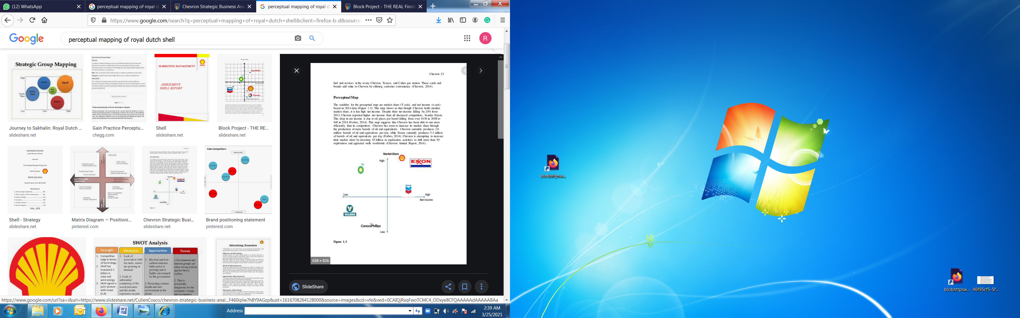
Figure 1: Perceptual Map of Shell Positioning
Source :( Chevron Annual Report 2014)

Among the six largest oil companies in the world, shell is acquiring the 5th position in the market and having a large workforce of about 93,000 people working in 90 countries all over the world. The company is using advanced technology and an innovative approach to build substantial stability for future growth. The logistic partner of shell is Kube and Kubenz, DenHartogh and Dam Gaslog. Shell is working with experienced and Certified DME transport companies to facilitate a reliable logistic chain up the production hub (Andersson, 2020)

2.1 Core Values of Shell
The core values of shell companies are (Foo, 2020):
- Long-term profitability is essential for company growth.
- The company's main motive is honesty, integrity, and fairness in all aspects of a business.
- Shell is also concerned about the environmental impacts on operation, product, and services.
- Regular meetings on different agendas and engagement with stalk holders are needed for the smooth running of a business in the long term.
- The best thing about the shell company is the strict following of rules and regulations of the country's code of conducts and norms in which it is operating.

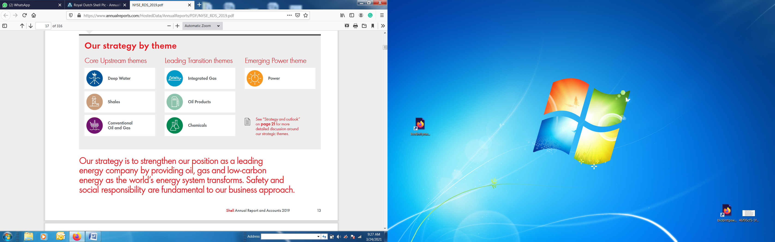
Figure 2: Core Strategy of Shell
Source: (Shell Annual Report and Accounts 2019)
The strategy of the shell is to position itself as a leading energy-producing and supplying company by providing oil, gas, and low-carbon energy as the world energy system transforms effectively. No doubt, the shell gives tremendous importance to safety and social responsibility since it comes in the core business value of the shell.

2.1 Shell Performance in Greece
Shell is operating as a leading fuel company in Greece with 750 retail stations and having a huge market share of 22%. The key role of shell in Greece is the marketing and distribution of crude oil, lubricants, petroleum, and diesel through its retail network. In 2010, Shell completed the sales of its key marketing business in Greece in driving the Motor Oil Corinth Refineries. Shell further signed an agreement with Petros Petropoulos A.E.B.E. in 2010. The Petro’s company took the responsibility of sales and marketing of shell oil and lubricant in Greece and act as a macro distributor over there. Shell Company has also signed a pack with Greece Marine owners in 2016 for providing high-quality marine lubricants. Shell Natural S4 oils and greases are highly recommended for marine operation in Greece due to their quality of meeting both the biodegradability and performance utmost level. Shell has great opportunities and marketing expansion potential in Greece. On the other hand, Russia's car owner considered Shell as the second-highest motor oil brand in 2019 (Tsakas, 2020).

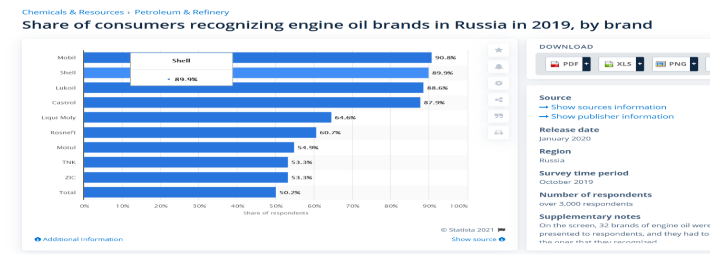
Figure 3: Engine Oil Brands in Russia
Sources :(Statista Research Department, Feb 9, 2021).
According to 2018 by the Greece states controlled DEPA Company of gas will buy 49 percent of stake worth $175 million in domestic gas supply to resist the conflict with domestic gas supply companies.

2.2 Shell Performance in Russia
Russia also invited shell in 2009 to take part in Sakhalin 3 and 4 energy projects of Russia. Sell enjoyed a position of $ 22bn in this project. Shell also introduced its Torzhok oil lubricant plant in Russia in 2012; The Company is expected to produce 200 million oil litres in a year and is estimated to reach this capacity in 2027. At present lubricant, oil plants are producing 90 million litres a year. The sales of the shell are doubled in 2014 on the expectation value and the Russian government-imposed sanctions to reduce sales and limit up to the forecasted value since the company global cost in US dollars. Apart from its lubricant plant facility in Torzhok, the shell also imports 30 million of oil for Russia from its other plants in different countries to fulfil the regional requirements as well (Filimonova, 2020).
The Russian rubble and financial crises occurred in 2014 due to the devaluation of the Russian rubble that occurred in the second half of 2014. The major crude oil export of Russia faces the rubble devaluation in 2014 and its market value decreases to 50% in the same year. The international market US and European group imposed a section on Russia for reduction of the price value of oil to destroy its economy due to its intervention in Ukraine and annexation of Crimea. The decrease in crude oil value in Russia gives a big advantage to shell in terms of production and profitability. The below graph showing the Annual Percentage GDP growth rate of Russia from 2008 to 2017 (Loginova, 2020).

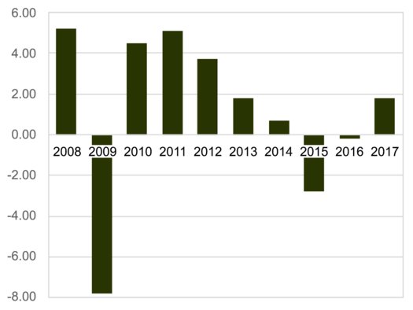
Figure 4: Annual Percentage GDP Growth Rate of Russia, 2008–2017
Sources :(Statista Research Department,2014).
The report will explain in detail the role of Shell Company in Russia and Greece. Further the usage of different marketing strategies to be put under work for future growth of the company concerning geographical location aspects like culture, colour, language, stability. The market potential of shell groups in Russia and Greece will also be visualized in this report

3.0 Shell Global Financial Performance Data

Shell Income Statement 2015-2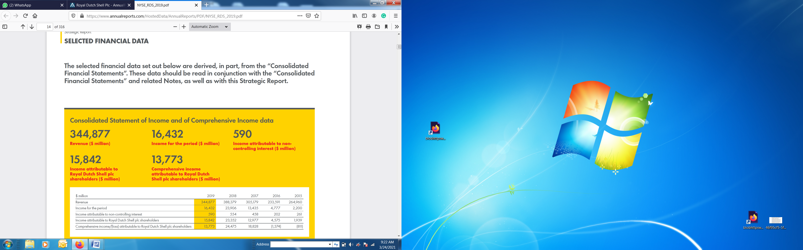

Table 1: Shell’s Financial Data
Source: (Shell Annual Report and Accounts, 2019)
The above table shows the Royal Dutch shell Plc is growing in terms of revenue. The notable decrease of revenue has been seen in 2019 due to oil crises bought on the economy and mobility restriction to avoid Covid-19, which is creating globally economic instability (Ermakova, n.d.).

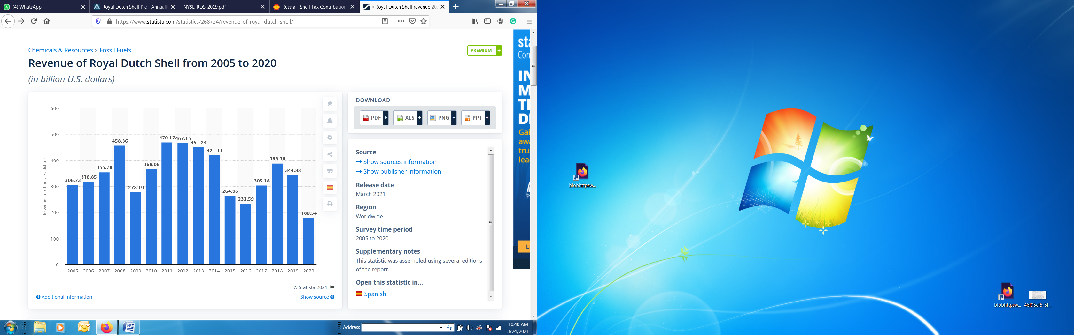Figure 5: Royal Dutch Shell's Revenue 2005-2020
Source :(N. Sonnichsen, Mar 23, 2021)

3.1 Shell Company Present Financial Status in Russia and Greece
According to the Shell tax contribution report 2018, the total earning of the shell in this region is about $16,081,171 annually after deduction of income tax of 20% implemented in Russia. Shell is paying 100% concerning all upstream, downstream, and relating to other trading activities. At present, Shell has suspended all its joint ventures with Russia due to sanctions imposed on Russia by the US and European countries creating hurdles in smooth business running in this region(Provornaya, 2020).
Greece is mostly importing crude oil from other countries, so no such shell revenue data has been found that showing strong relation of Greece with Shell Group. In 2018 Shell just signed a joint venture with one of the domestic gas supply companies. A domestic gas project estimated cost is $175millions.

4.0Culture Dimension Model of Hofstede
The culture is simply defined as the mental programming of the human mind which distinguish one group of people from other due to difference of their social and moral attributes. According to the research of (Michael Minkov, 2010), the cultural dimension is the framework determining the different cultural aspects of the environment. This model is focusing on five-dimension s of cultural values of different countries based on standard define values uploaded in the Hofstede model of cultural dimension (Minkov, 2020).

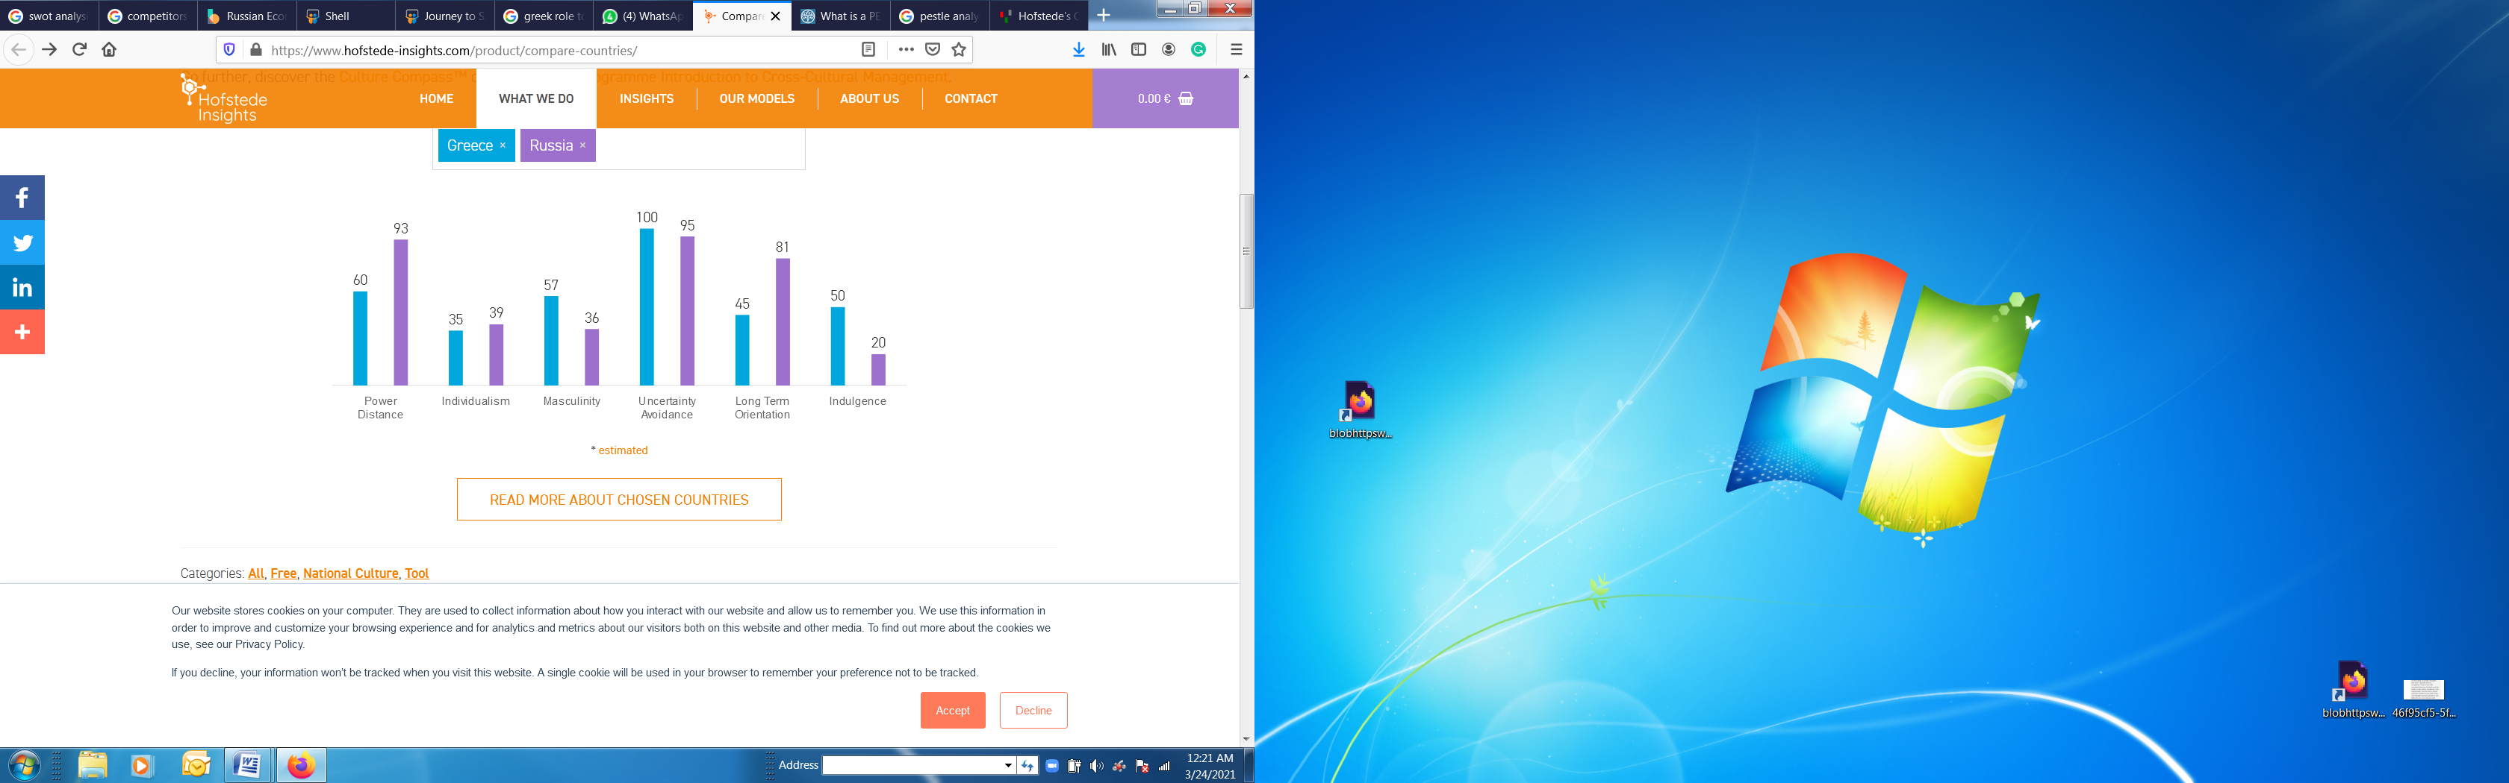
Figure 6: Culture Dimension Model of Hofstede
Source: (Michael Minkov, 2010).

Power Distance

It determines the opportunities difference among the group of people living in the society. The PDI value of power distance in Greece is 60 showing that imbalance is less compared to Russia whose value is 93 comparatively very high. The high PDI value showing the power distance is not equally distributed in Russia. Strong wealthy people residing in Russia are running the authorities as well as activities of the country (Wang, 2020).

Uncertainty Avoidance
The PDI value of uncertainty avoidance of Russia is 95 which is showing no work is going on in the country regarding risk management and the country subjected to a high level of risk factors. Similarly, Greece's PDI value of uncertainty avoidance is high and showing it is also not taking any measures regarding the risk controlling factors of the country. Russia as well as Greece is required to put their concern towards this crucial issue of risk management. In this regard policies and frameworks are required to be designed for the people to prosper living as a society (Watts, 2020).

Individualism
The PDI value of individualism is 39 in Russia showing the liberty of freely working is less present in the state. The governing bodies are authorities' powers in the country and offer restrictions and policies for the well-being of the country. Similarly, the individualism PDI value of Greece is also low and showing the trend of collectivist more than individualism in the society. Both countries are offering less liberty to the individuals residing over there (Bazzi, 2021).

Masculinity
The Masculinity PDI value of Greece 57 and Russia is 36. It shows that more freedom Greece's population has in terms of freedom and leadership compares to Russia. The higher legislative and federal obligations put by the governing bodies are reducing masculinity ability from the individuals living in the society and power is in the hands of governing bodies of the country (Pederson, 2021).

Long Term Orientation
The PDI value of Russia shows that the country looks towards future progress by doing working as per the long-term perspective. To gain future goals Russia is delaying its short-term material, goals, emotional gratitude’s, and social success. The long-term orientation perspective of Russia brings the value of persistence, perseverance, saving, and ability towards adaption in the society. The less PDI value of Greece shows that the people are not long-term oriented and satisfy with, what they are getting at present (He, 2020).

Indulgence
It defines as the individual attributes towards achieving the future targets based on beliefs, handwork, and interest. The indulgence PDI value of Greece is 50 showing that people are more oriented and motivated towards their tasks and future goals. People freely their lives and have fun with freedom whereas the indulgence PDI value of Russia is 20 showing that the people are less oriented towards the assigned goals. People of Russia have no authority to enjoying freedom towards their actions and family life. People are under great pressure due to the restriction of various codes and behavior and must follow the norm's framework designed by the governing bodies of Russia (Purevdorj, 2020).

5.0 Pestle Analysis of Shell Company
It is a framework that determines the macro-external factors such as political, economic, technological, social, environmental affecting the working of an organization. The professional practices and capabilities help in overcoming the impact of external forces in an organization. The macro-environmental analysis must be carried out once in a six month to see the impact of different forces and by using corrective measures should be corrected as soon as possible for the effective working of a workplace. The monitoring and response to changes in the macro-environment can differentiate from the competition and create a competitive advantage(Ferreira, 2020).

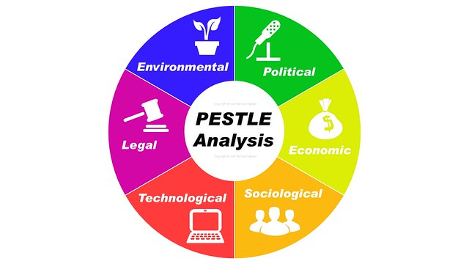
Figure 7: Pestle Analysis
Source: (Eduardo Pérez, 2017).

Political Factors
The government policies' impacts on the organizational working are important to be kept under consideration. These policies include political policies, trade, fiscal, and taxation policies as well.
In Russia, the main problem faced by the substantiation for construction required 50 different approvals by local and federal Russian regulatory agencies. Apart from legal regulations, the risk of military invasions, level of corruption, intellectual property protection, and taxation. Whereas the construction activities are not much sounding in Greece due to lack of resources and the country is highly dependent on import of product and services.

Technological Factors
The rate of technology innovation and development could highly affect the market and business place. Apart from digital technology, innovation must be done in distribution, manufacturing, and logistics. In Russia impact of technology cost structure and value change is very important and under consideration during the run of any business. On the other hand, Greece is not revealing more activation towards technology since the lack of infrastructure development affecting other factors as well.

Economic Factors
It impacts on economic performance at large and directly to the company's progress and profitability. Economic factors include interest rate, employment and unemployment, raw material cost, and foreign exchange rates. Economic factors play a key role in raising the company towards a potential growth rate.

Social Factors
It determines the social environment trend changes and the customer needs and wants according to the changing trend. Factor includes changes in family demographic, educational level, culture changes, attitude and living values changes should be kept under consideration while observing the business progress. Russia people are highly directed towards the defined values whereas in Greece people are divided into communities and less bother about joint working for country development. This is the reason behind the less development and highly imports orientation seen in Greece.

Environmental Factors
It relates the influence of the surrounding environment and impacts of ecological aspects. It’s the co-operate sustainability responsibility to keep the following factors under consideration for future better working and approaches includes carbon footprints, recycle procedure, waste disposal, and sustainability.

Legal Forces
An organization should be profoundly aware of the legal laws of the territory in which it is operating. The change in legislation must be kept in consideration since it will impact the business working and sustainability. A legal law includes employee legislation, consumer laws, health and safety, international, trade regulations, and restrictions.
Transportation is one of the stumbling issues for FDI in the Russian energy sector. Another factor of concern is the foreign investment in oil firms has been limited to a certain extend. The restriction of business introduction to a certain level is another issue shell face while working on a joint venture of whereas crude oil and gas plants in Russia. Although the legislative bodies are not so much rigid in Greece and this is the reason, Shell has also signed certain projects in Greece in 2018 as a joint venture with Deepa Company of gas supply with a projected cost of $175 million. The pestle analysis provides a path to populate the opportunities and threats in SWOT Analysis.

6.0 Shell Company Porter Five Forces Model
This marketing model determines the present scenario of the business and the impact of different competitors present in the market creating resistance to business growth. There are five elements of porter five forces important to be kept under consideration while reviewing the company's progress are the level of competition, the threat of substitutes, the threat of new entrants, the bargaining power of suppliers, and the bargaining power of customers. The level of forces the shell has to deal with while operating its business in Russia and Greece are as follows (Sousa, 2020):

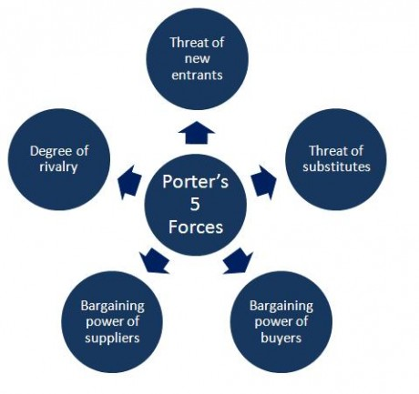
Figure 8: Porter’s Five Forces Model
Source: (Reshan Perera, 2020).

Level of Competition: Russia – High; Greece - High
There is a high level of competition among the oil and gas supply companies for Greece and Russia. The key players are few since Shell holds a good position in the market and reaching the level of success day by day. British Petroleum is the major competitor of Shell and also developing acquisitions, partnerships, and alliances to develop a large framework to meet growing demands in Russia. Facing a high level of competition in Russia, gas and oil company such as Gazprom, Rosneft, Rompetrol, Lukoil fights for supremacy. In Greece, Aegean is among top five direct competitors of Shell, being a state company, along Exxon, Mobil, Chevron, BP and Valero.

Threats of New Entrants (Russia – Low; Greece - Low)

The chances of the entrance of new competitors are low because huge capital investment is required for setting up of plant and usage of advanced technology for the extraction of oil domestically as well as for meeting international demand. Russia detains a huge amount of oil and gas resources and the existing company in the industry already shared the monopole making difficult for new entrants to penetrate the market. The Greek market has also its well-established oil companies and the enormous amount of investment required to penetrate the market, discourage the new entrants.

The threat of Substitutes (Russia – Low; Greece - Medium)
The investigation and research on bio-fuels are going on to put in working for future as a replacement element of crude oil. Many companies are now putting efforts to investigate the importance and proper usage of bio-fuel to overcome social, economic, and political pressure. Shell is thinking to invest a large amount in the research and exploration of biofuels. At present company is not putting great efforts towards these fields. In Russian. The threat of substitutes is low due to the fact that the Russian people are not embracing the new as much as Greeks. For instance, they maintain the old minded thinking, and being nationalists makes them not so interested in new ways of replacing the actual gas and oil resources. Greece limited resources, makes people to look to new ways of replacing the existing methods of using oils, and they show interest to new technologies, more eco-friendly and more sustainable for the environment.

Bargaining Power of Buyers (Russia – Medium; Greece - Low)
The bargaining power of buyers is also low because there are not many fuel supplying companies offering a large variety of conventional, alternative, and bio-mass fuels. Russia benefits for a significant number of competitors, which offer quite same quality for same prices, and the bargain power of buyers is medium, people having the final decision. Only a couple of companies are well established in Greece, and buyers do not have so many options and they have to stick with what the market offers.

Bargaining Power of Suppliers (Russia – Low; Greece - High)
The bargaining power of the supplier is low since there are only a few suppliers available in the broad-spectrum market. Most of the companies are extracted and setting their plants for completing delivery services therefore supplier power is extensively low in the market. Russia natural resources allows companies to choose their suppliers and they can set the rules, having the upper hand. On the other side, Greece bargain power of suppliers is high due to the fact that Greek natural resources regarding oil and gas are limited.

Recommendations
Porter’s five forces model provides a reasonable solution regarding the competitive forces present in the marketplace. In shell case the threat of substitute, a new entrant is low as well as low bargaining power of suppliers and buyers give a great advantage of improving and innovating this field in beating rivals by improving infrastructure and business revenue generation model effectively.

5.0 SWOT Analysis of Shell Company
It is an important marketing strategy to improve the business model by defining the strength, weaknesses, threats, and opportunities profoundly for the company's future success. The improvement areas are required to be focused on perfectly for better progress of the business. Royal Dutch Shell commonly known as shell considered the world one of the largest oils and gas producing company. The SWOT Analysis of the Shell is as follows (Sousa, 2020):

Strength
It is important to have a large size and strong financial resources to sustain in the energy sector. The vertically integrated shell company is expanding slowly and gradually. About 80,000 employees are associated with shell in more than 70 countries of the world. Since the company has strong financial resources and can flexibly pass-through lower profitability. In 2018, Shell has invested $25billion in capital and $ 1 billion in research and development to improve and enhance the company working for future progress. In 2016, the shell holds of BG Group, which is one of the UK best oil and gas firms. Strong financial resources help shell in the potential exploring and usage of M&A activities.

Weaknesses
Shell gas and oil reservoirs are dropping recently and creating the company image down. Another area of concern is the innovation is required in renewable resources. The recent mobility is also changing towards electric vehicle charging. The low prices of oil lead the company to spend less on renewable resources until the market becomes sustainable. The company highly dependent on oil prices since due to the Covid-19 breakthrough the prices of oil decrease which in turn decreases oil prices. Shell must look towards other renewable transitions of energy resources.

Opportunities
The strong driven force for the shell group is economic growth. The discoveries lead to strong business marketing strategies. No doubt, the shell has strong exploration capabilities. The financial capabilities of the shell allow the company to invest more towards renewable resources to increase the presence in green energy sources. The partnership with other companies helps in innovating and exploring renewable energy resources at the utmost level.

Threats
Macro-economic uncertainty and price volatility also impact the assets and resources of the shell group. The oil demand is decreasing due to unstable economic conditions at present leading to low oil pricing. Russia and Greece are increasing their oil reservoir by doing mutual consents with the shell which leads to decrease oil prices by increasing the supply of oil. Shell growth resistance due to competitors Chevron, BP, Saudi Armco, ExxonMobil, Petro China, and Marathon Petroleum.

SWOT Analysis Shell Russia
Strength | Weaknesses
- Competitive edge in terms of technology | - Lack of association with biofuel which is high in demand.
- Shell has invested $1 billion in solar and wind energy. | - Lack of substantial power to overcome the social and media pressure on the company.
- It has signed a joint venture with Cosan (S.A) Company. | - High un-certainty in the society
Opportunities | Threats
- Biofuel and low carbon emission fuel sector is growing, and it’s highly encouraged by the government. | - Political instability resist in earning huge amount of foreign exchange.
- Promote the better health and environmentally friendly atmosphere near the plant. | - The government and interest groups are highly concerned about heavy carbon emission and take active steps towards its reduction.

Table 2: SWOT Analysis Shell Russia

According to 2018, the Russian economy is $4.2 trillion as per its gross domestic products. It is highly dependent on the export of crude oil and gas to different countries of the world. No doubt, Russia is a highly wealthy country that needs to focus on opportunities and improvement towards lacking and weak areas leads the country towards a growth path.

SWOT Analysis Shell Greece
Strength | Weaknesses
- Strategic partnership is increasing with time. | - Highly dependent on oil and gas export
- Technology advancement | - low Presence in renewable
- Exploration capabilities | - Dependency on oil prices
Opportunities | Threats
- Economic Growth | - Uncertainty
- New Discoveries | - Price Volatility
- Partnership and M&S | - Competition

Table 3: SWOT Analysis Shell Greece

Oil is the most important fuel for producing energy in Greece. The domestic production of crude oil is negligible, and the country is highly dependent upon export of crude oil and gas from Iran and Russia. The shell has been working jointly in various new projects of oil reservoirs facilities establishment within the country, since the infrastructure is not built sustainable, so international companies take less interest in investing in Greece. Shell should focus on opportunities and work on Weak areas to establish a strong position in Greece.

6.0 Shell Company Market Mix Strategy

Shell is a global energy provider through crude oil and gas. In 2013, It is ranked first among the largest companies of the world in the Fortune Global 500 list. The marketing strategy of the shell is innovative and expanding gradually with time. The company is targeting segments for increasing its sales in different territories of the world. The company is presently focusing on building customer trust by providing the best customer services, brand image, and quality and quantity up-gradation (Smaliukiene, 2020).

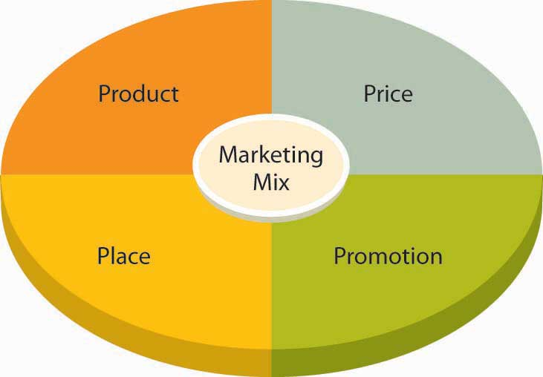
Figure 9: 4P’S of Marketing
Source: ( Marketing mix of Royal Dutch Shell: Hitesh, 2019).

Product Role in Marketing of Shell Company
Shell is highly active in oil and gas activities occurring in different countries and producing about 3.7 million barrels of oil every day. It is the largest company at present for the production of liquefied natural gas in the world. Its large range of products is divided into segmental approaches as upstream, downstream, and integrated gas and new energies. Its business customers are lubricants, Aviation, marine, and various shell global solutions.

Place Role in Marketing of Shell

Royal Dutch Shell Plc has spread its operation in nearly 70 countries of the world. It has successful distribution and supply system that is successfully doing the product distribution in different parts of the global arena. The company has created seven hundred and seventy supply points about one hundred distribution terminals in twenty-five countries. The company is selling fuel by the name of Shell V Power brand in more than sixty countries. Further company is operating forty-four thousand service stations in different countries of the World. The expansion of services in Greece is less due to undeveloped infrastructure. In past years shell expanded its services in Russia, but political issues and sanction imposition on Russia causes the stoppage of shell working in this territory.

Price Role in Marketing of Shell
Shell is considered as sixth position in the world and the largest oil producer in Europe in terms of revenue according to 2016. According to the fiscal year 2017; it reached revenue of 305.1 billion US dollars. The prices of oil and gas are regulated by the government and market trends. The Company is following a variable price policy and adopting prices according to the quality of the product. Shell is facing stiff competition in the domestic market and following the policy of competitive prices compatible with the rivals present in the domestic market.

Promotion Role in Marketing of Shell
Shell is known in various countries of the world due to its brand name. It is using different marketing strategies helping in retaining its position in the consumer market. The unique logo is easily recognized and brings brand awareness among the consumers in an effective way. The brand is aware of advertisement and promotes its products through a digital and visual medium in newspapers, magazines, and television. Shell also promoting its business through social media platforms like Face book, YOUTUBE, and Instagram accounts.
The brand is aware of the social responsibility and working different activities regarding reducing and reusing waste. The scientist of Shell has introduced such lubricants in the market which are resisting the corrosion on the material. Shell also actively participating in community projects by offering its workers as volunteers as well as sponsoring various products like BMW Motorsports, Toro Rosso, and DJR Team Penske as a business advantage.

7.0 The ANSOFF Matrix
The ANSOFF Matrix is a tool used for product and market expansion. It also analyzes and plans strategies for firm growth. Also, calculate the growth rate of a firm by multiply the company retention rate by its return on equity. This matrix helps make marketing strategies by evaluating the risk factors involved (Martins, 2020).
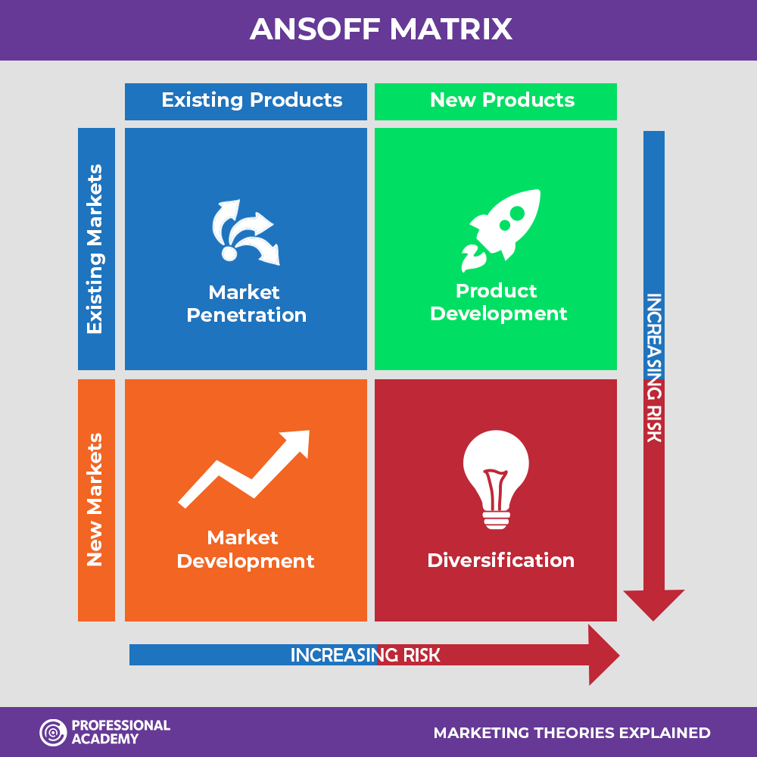
Figure 10: The ANSOFF Matrix
Source: (John Dawes, 2018)

Market Penetration
The shell should expand its marketing network in both Russia and Greece for future strong joint ventures in these regions. The company should also focus on strongly targeted segments by visualizing the geographical, cultural, social, and moral aspects of different regions. The shell should also focus on B2B business territories at the highest level for promoting business growth.

Product Development
The unique innovative products Shell introducing Russia and Greece by understanding the needs and requirements of the place. The Greece infrastructure is not established and needs construction for future trade ease. In such circumstances the movement of vehicles is not an easy task by keeping this point under consideration, Shell introducing high potential crude oil that promotes the vehicle's potential on rough roads.

Market Development
Shell is developing its market by targeting new segments. No doubt shell marketing team is highly skilled and innovative. It is required by a shell to expand its market in Greece by stretching its resources in new segments and target markets. The market expansion is a little difficult at present in Russia due to sanctions imposed by the US and European countries on the territory.

Diversification
Shell Company has shown diversification by introducing new products in the market for fulfilling the needs of the growing economy of the world. The life of the oil and gas industry is measured based on its production. Before 2016, the production capacity of the shell is not fulfilling the requirement effectively. The company introduced new key pillars in 2016 that include integrated gas, new energies free from carbon footprints, and global deep-water plays.

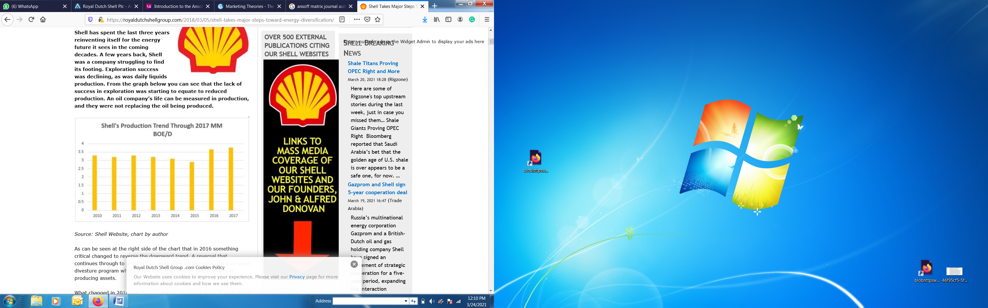
Figure 11: Shell Major Steps towards Energy Diversification
Source: (John Donovan, 2018).

8.0 Product Life Cycle of Shell
The product life cycle defines the changes in the sales volume of the product with time. In this dynamic world, the fluctuation of the market is common, and every product to phase fluctuations by using correct marketing strategies, to sustain for the long term. The development of a product through different stages is known as the product life cycle. The four main parts of the product life cycle are as follows (Sousa, 2020):
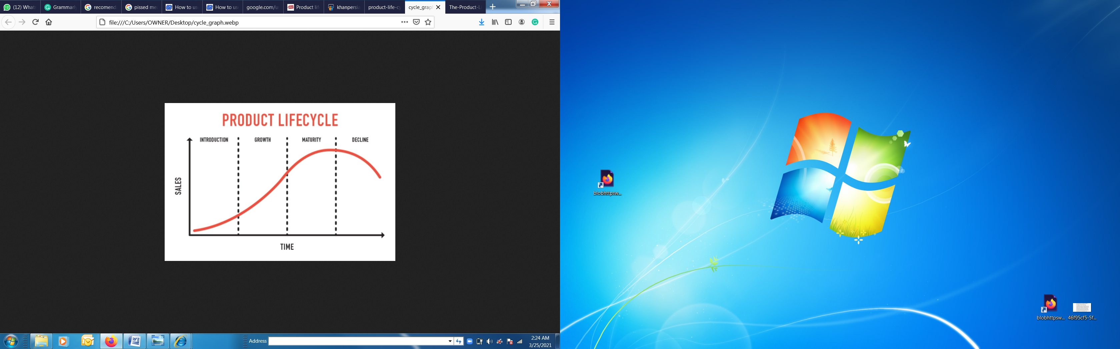
Figure12: Shell Product Life Cycle
Source: (TejvanPetting, 2019).

Development Stage
In this stage the product market and sales are low. The shell company has put potential focus towards this stage by investing huge costs and great efforts in marketing, promotion, and distribution strategies in testing the market, order to enhance business expansion and growth with time.

Growth Stage
In this stage, rapid growth arises in terms of sales and profitability. The companies can earn profit by increasing output and by keeping optimum prices that are attracted by the customer. Shell is international crude oil and Petroleum Company operating in more than 90 countries and having 44,000 service stations worldwide producing about 2% of world oil and 3% of world gas. About 35refineries and chemical plants are operated and run by this giant oil producer and seller.

Maturity Stage
This stage is very important for an international brand. In Maturity Stage Company’s competition become strong and fight to maintain good and secure market share. No doubt at this point marketing and finance is the key to success. Marketing spend has to be monitored carefully since any significant move by a company can be easily copied by competitors. The shell business is strong in Russia and has put in its root in various sectors. While the role of the shell is not much vast in Germany since it is mostly doing import of crude oil and gas from foreign countries and especially Russia.

Decline Stage
At this stage company's market value shrinkage and the profit, the value decreases about the competitors. The declining stage requires the managing of the product or services properly. The shell is an internationally renowned brand and not in the decline stage. No doubt, shell shares are increasing, and company is progressing by introducing different marketing strategies which helps in enhancing the sales value. The Company made a net income of 16.4 billion US dollars.

Conclusion
The report highlights Shell's position and importance in the international market. The brand integration started starting from the exploration and production of crude to refining and manufacturing petroleum products and indulging in best marketing practices. Shell's commitment to technology and innovations continues to be at the core of its strategy. The report further highlights the performance of shell in Greece and Russia by using different marketing strategies and models for better understanding and implementation for future progress. Shell while working as a foreign company needs the confidence of both state and central government for steady cash flow and production. Shell is also exploring the environmental sector for the betterment of mankind since it creates some business risk. Apart from a green environment working the political is necessary for business in emerging markets.

References:
- Andersson, J., 2020. Ghost in a Shell: The Scenario Tool and the World Making of Royal Dutch Shell. Business History Review, 94(4), pp.729-751.. s.l.:s.n.
- Bazzi, S. F. M. a. G. M., 2021. “Rugged individualism” and collective (In) action during the COVID-19 pandemic.. Journal of Public Economics, 195, p.104357.
- Donthu, N. K. S. P. N. &. L. W. M., 2021. An Analytical Retrospective.. Journal of International Marketing, 1069031X211004234..
- Ermakova, E., n.d. Lawsuits against Governments and Private Companies of European Countries over Climate Protection under the Paris Agreement 2015. s.l.:s.n.
- Ferreira, S. A. R. J. G. R. K. C. C. T. E. a. G. N., 2020. DNA from mollusc shell: a valuable and underutilised substrate for genetic analyses. PeerJ, 8, p.e9420.. s.l.:s.n.
- Filimonova, I. K. A. P. I. D. Y. a. L. A., 2020. Efficiency of oil companies in Russia in the context of energy and sustainable development. Energy Reports, 6, pp.498-504. s.l.:s.n.
- Foo, A. M. P. C.-S. N. A. a. C. J., 2020. The Changeless Core in a Changing Business Environment.. Journal of Business Management and Accounting, 10(1), pp.95-107..
- He, J. a. S. L., 2020. Developing a new long-term orientation structure in a cross-cultural context: A study on supply chain relationships. Industrial Marketing Management, 88, pp.186-194..
- Katičić, M., 2020. The acquisition of BG Group by Royal Dutch Shell (Doctoral dissertation, University of Zagreb.. Faculty of Economics and Business. Department of Organization and Management.)..
- Kunz, S., 2020. Royal Dutch Shell and the management of racial capitalism. Transactions of the Institute of British Geographers, 45(2), pp.377-391.. s.l.:s.n.
- Loginova, J. S. T. M. K. a. T. M., 2020. Spatial differentiation of variegated capitalisms: a comparative analysis of Russian and Australian oil and gas corporate city networks. Economic Geography, pp.1-27.. s.l.:s.n.
- Martins, A., 2020. Scenarios and Ansoff Matrix (Doctoral dissertation).. s.l.:s.n.
- Minkov, M. a. K. A., 2020. A test of Hofstede's model of culture following his own approach. Cross Cultural & Strategic Management.. s.l.:s.n.
- Pederson, S., 2021. Beethoven and masculinity. In Beethoven and his world (pp. 313-331). Princeton University Press..
- Provornaya, I. F. I. N. V. K. A. a. D. Y., 2020. Features of the petroleum products pricing in Russia, in the USA, and Saudi Arabia. Energy Reports,. s.l.:s.n.
- Purevdorj, N. B. A. a. K. A., 2020. An Investigation of Mongolian National Cultural Values using the Hofstede 6-D Model.. s.l.:s.n.
- Rana, S. P. S. B. M. a. H. A., 2020. Determinants of international marketing strategy for emerging market multinationals.
- Sheth, J., 2020. Borderless media: Rethinking international marketing.. Journal of International Marketing, 28(1), pp.3-12.
- Smaliukiene, R. a. M. S., 2020. Social responsibility, social marketing role, and societal attitudes. In Energy Transformation Towards Sustainability (pp. 289-308). Elsevier.. s.l.:s.n.
- Smaliukiene, R. a. M. S., 2020. Social responsibility, social marketing role, and societal attitudes. In Energy Transformation Towards Sustainability (pp. 289-308). Elsevier.. s.l.:s.n.
- Sousa, S., 2020. . Equity research-Royal Dutch Shell, PLC (Doctoral dissertation, Instituto Superior de Economia e Gestão).. s.l.:s.n.
- Sousa, S., 2020. Equity research-Royal Dutch Shell, PLC (Doctoral dissertation, Instituto Superior de Economia e Gestão).. s.l.:s.n.
- Sousa, S., 2020. Equity research-Royal Dutch Shell, PLC (Doctoral dissertation, Instituto Superior de Economia e Gestão).. s.l.:s.n.
- Tsakas, C., 2020. Shipping tycoons and authoritarian rulers: doing the oil business with the Greek dictatorship, 1967–1974.. ournal of modern Greek studies, 38(1), pp.185-208..
- Wang, J. T. C. a. L. A., 2020. The interactive effect of power distance belief and consumers’ status on preference for national (vs. private-label) brands.. Journal of Business Research, 107, pp.1-12.
- Watts, L. S. L. a. D. H. D., 2020. Uncertainty avoidance moderates the relationship between transformational leadership and innovation:. A meta-analysis. Journal of International Business Studies, 51(1), pp.138-145..

