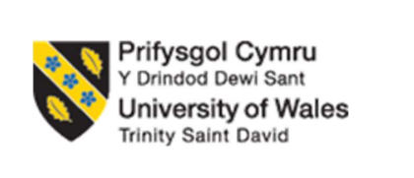

Assignment Title: Portfolio

Programme: Master of Business Administration

Module: Marketing Management

Module code: LCMB7024

Lecturer: Laila Maazouz

Portfolio on Superdry: A New Product Category Development in the UK

Student Name: Sajan Hareshbhai Vekariya

Student ID: 2529464

Words: 2376 (Excluding Poster- 251 words)

Table of Contents
Element 1: Sustainable Brand Extension Poster Presentation 3
Element 2: Develop a Segmentation, Targeting, Differentiation, and Positioning (STDP) 4
2.1 Key market segments 4
2.2 Explanation of chosen target audience 5
2.3 Differentiation 6
2.4 Positioning strategy 7
Element 3: Marketing Mix 8
3.1 Introduction 8
3.2 Critically discussed 4P elements of the marketing mix 8
3.3 Conclusion 12
Element 4: Reflection 13
4.1. Kolb’s reflective model 13
Reference list 15

Element 1: Sustainable Brand Extension Poster Presentation
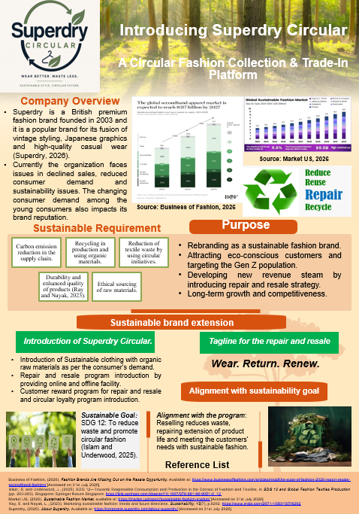

Element 2: Develop a Segmentation, Targeting, Differentiation, and Positioning (STDP)

2.1 Key market segments
Identification of the right market for the organisation is essential. It ensures that the Superdry for its new product category Superdry Circular can successfully strengthen the brand position in the market.
Segmentation | Targeting | Positioning
Geographic  Urban centres  Regions with strong fashion-forward cultures  Regions with high disposable income  Demographic  Age: 22–35  Income: Middle to upper-middle class  Occupation: Tech, finance, creative industries, consulting  Psychographic  Lifestyle: Ambitious, career-driven  Values: Balance between professionalism and individuality.  Personality: seeking authenticity and modernity.  High conscious of market trends  Strong brand and market awareness  Behavioural  Usage: smart casual  Looking for hybrid office wear  Loyalty: attracted to unique identity, high quality, sustainable fashion  Benefits: premium quality, global brand recognition and Stylish yet functional clothing | Young professionals who value versatility  Seek premium casual wear to reflect their individuality and ambition  Digitally tech savvy customer  Engage in social and e-commerce platforms | The go-to brand option for ambitious young professionals who prefer to wear modern style with effortless functionality
Table 1: STP model
The above table identifies that the company segmented the customer into four divisions to generate an effective positioning strategy. The main motto of the company is to target young professionals who live in metropolitan cities and are highly focused on their careers.

2.2 Explanation of chosen target audience
Young professionals have a high interest in the current market trend and stylish fashion segments. The age range of 22-35 typically refers to the early stage of a career, where the customer group creates demand for creative solutions. This group is highly career-driven, ambitious and socially active, which helps to complement social media marketing (Hu et al., 2025). This target audience balances professional responsibility with a vibrant lifestyle, which creates high demand for the premium quality style modern fashion items in the market. This group is highly conscious about current social events, environmental contribution and impact. Middle to upper middle-income group spend on casual to premium wear, which ensures the expansion of the Superdry company.
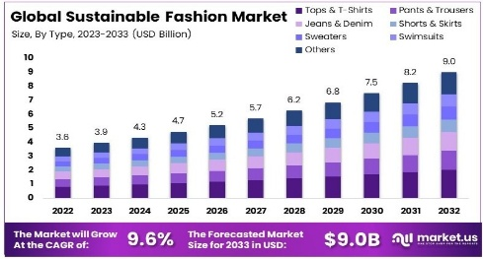
Figure 1: Fashion Market suitability and demand over years among customers
(Source: Market US, 2026)
Rationale - Urban population are the main trendsetter in the global fashion market. Targeting this group helps the organisation to design trendy items which ensure stable sales growth. Middle- to upper-income groups value individuality and create demand for modern items which value their personality. The purchasing power of this group in the city region is high, which ensures that the company can boost the sales stream (Zahran, 2025). Lifestyle patterns of this group demand hybrid fashion which meet the product design of the company.

2.3 Differentiation
Design - The fashion industry is highly competitive in nature; to develop a strong brand position in this market, it is essential for the organisation to prioritise design and quality. Fusion design is currently preferred by young consumers. Considering this point, Superdry can blend product design to create smart casual hybrid items, which are helpful in social and office life. Superdry is mainly criticised for quality and fabrics, which require special attention at this time. Considering the concern raised by the customer regarding fabrics, the company will use high quality fabrics which last long (Li and Tang, 2023). Durability and premium fabrics ensure that it can develop strong brand loyalty in the market.
Sustainability focus – Currently, the target customer is highly conscious about the social and environmental impact. For this reason, it is important for the organisation to engage in sustainable practices. Superdry can differentiate the brand position by investing in Eco friendly collection. As per, Rehman and Al-Ghazali (2022) to add value in the business function, prioritising a sustainable strategy is a highly effective decision. Through a transparent supply chain, Superdry can build trust among the customers. Aligning organisational value with socially conscious activity helps the organisation to maintain healthy relationships with customers. Circular economic practice develops a positive brand image in the market. It will spread that the company follow a responsible consumption pattern to protect the nature.
Digital engagement – Competitors are highly active in the digital platform, which helps the company to connect with customers easily. Based on this factor, Superdry can leverage a personalisation strategy. Influencer collaboration builds a strong digital connection with UK customers compared to traditional luxury branding strategy.
Lifestyle branding – A major number of fashion hub emphasis on the fashion trends. Fashion followers. Instead of this, Superdry can try a lifestyle branding strategy. Developing lifestyle identity in the market makes the company a highly attractive option for the young professional (Castillo-Abdul, Bonilla-del-Río and Núñez-Barriopedro, 2021).

2.4 Positioning strategy
Superdry can position the brand by empathising on casual wear. British tailoring combined with Japanese graphics helps customers to connect with traditional fashions. High quality fusion brand items can help the customer connect with a busy lifestyle. Unique aesthetic products offered by the company highlight the identity of individuals from others. Continued discounts on newly launched fusion products help the company to protect the brand equity and stabilise the gross margin.

Element 3: Marketing Mix

3.1 Introduction
Marketing mix is a marketing strategy where the different elements required for developing the marketing planning of an organisation are considered. In this context, the 4P marketing strategy is used because it covers every aspect, including packaging, for the brand extension of Superdry. The four elements of this strategy are: product, price, place and promotion.

Figure 2: Marketing mix 4P analysis
(Source: self-developed and idea taken from Earley, 2022)

3.2 Critically discussed 4P elements of the marketing mix
Product
Product strategy: Superdry's brand extension strategy, Superdry Circular, is related to the introduction of the resale and repairing strategy and using recycled and organic materials to produce the clothes. This introduction of the circular economy strategy will reduce consumption, and the brand extension promotes circular fashion models (Earley, 2022). The introduction of the repair and reselling strategy will encourage customers to return used clothes and recycle and repair any damaged products for increasing product life cycle.
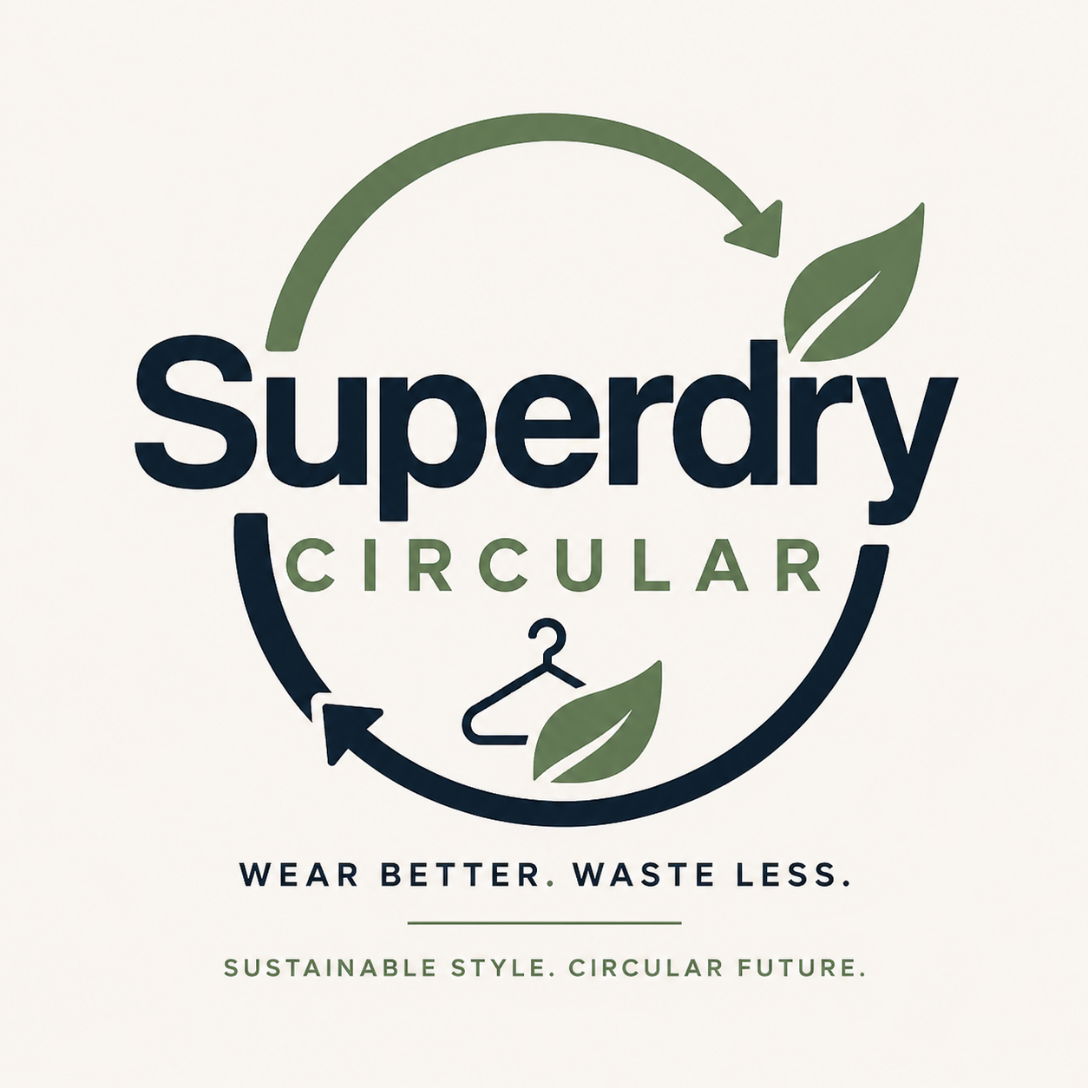
Figure 3: New Logo of the sustainable product line of Superdry
(Source: self-developed)
Aligning with brand extension: The strategy also supports the aim of Superdry to position their brand as a sustainable fashion brand to align with the current demand of the consumers. Among Gen Z customers, the demand for suitable fashion is high, and they can also pay extra for suitable products due to their environmental awareness (Ge, 2024). It also provides competitive advantages for the brand, and the brand extension strategy also provides after-sales service, which adds more value and improves customer relationships.
Justification: The product strategy chosen for the brand extension product development strategy is because the organisation modified its existing products or introduced new services in its existing markets to enhance growth (Bicho et al., 2023). They have a strong customer base, and their target customers are Gen Z customers. The launch of repair and resale, a circular model and using organic material and recycled products to rebrand it as a sustainable brand. However, it will need to invest more in its R&D.
Price
Strategy: The organisation is introducing the value-based pricing strategy, where for the superior and sustainable fashion products, the value is added, which reflects on their pricing. Sustainable products have premium pricing and also receive additional value for the repairing and reselling opportunities (Helmold, 2022). The pricing is also related to loyalty rewards, reduces the membership cost of customers, and attracts repeat customers.
Aligning with branding: The pricing strategy is also aligned with brand extension by showing that the premium pricing for the sustainable products and the circular system can add value to the environment and society. The eco-conscious young customers choose the sustainable, durable and ethical sourced products with the repairing and reselling opportunity with premium pricing.
Justification: Kotler's value-based pricing strategy is used because it focuses on setting a pricing based on the value of the product or service (Iliemena-Ifeanyi et al., 2025). Superdry can use this strategy in their brand extension because it is positioned in the premium casual segment, so through Superdry Circular, they can justify their premium pricing for high-quality sustainable products and improve their sustainable brand identity. However, it may face challenges in developing countries like India, where competition is very high.
Place
Strategy: The organization will be used omnichannel distribution strategy for the new branding and will use retail store distribution as well as e-commerce platforms through their own website for distribution of products. They also have a digital marketplace for repairing and reselling (Li, 2024). Also, their existing stores will be used as a collection point and return point. The omnichannel facility will improve convenience and enable participation in the circular initiative for their customers.
Aligning with branding: The place strategy is aligned with the current brand extension strategy because, through omnichannel distribution, consumers can get the service of recycling, repairing or reselling from the stores as well as online. It also helps to position the brand as a sustainable brand and improve customer engagement. Integration of offline and online facilities also enhances customer experiences and encourages reverse logistics.
Justification: The strategy is justified because the omnichannel strategy integrates the customer touchpoints, and it gives a unique customer experience. It will provide sustainable experiences with convenience by providing flexible use of online and offline channels (Akahome, 2026). The strategy is the most suitable to encourage the circular fashion ecosystem.
Promotion
Strategy: Superdry Circular will be promoted using integrated marketing communications, where sustainability, transparency and community engagement are key to communication. Some of these promotional activities will involve creating social media campaigns, collaborating with influencers and brand advocates, assigning stories to the environment, user-generated content or videos about the care of a garment, reports on sustainability and loyalty programs that offer rewards to customers who recycle or purchase for sustainability (Zhao et al., 2022). Digital campaigns engage consumers, while communicating measurable environmental outcomes to boost their confidence, including a reduction in textile waste and carbon emissions.
Aligning with branding: This will contribute directly to the sustainable brand extension through consumer education on circular fashion and supporting consumers' behaviour to accept responsible use of the brand. Through the social media campaigning, the consumers and also the investors will be aware of the sustainability approach of the organisation.
Justification: Using Integrated Marketing Communications (IMC) is the most suitable for brand extension. Consistent messages are sent over all communication channels through IMC, which helps to build and create stronger brand awareness and credibility (Hayatuki et al., 2026). Superdry can build trust, win trust and build a brand that is considered a sustainable fashion brand by sending one message across all social media, retail stores, digital platforms and PR; it fosters strengthened trust and better customer perception of the brand. However, it will have a huge cost and complexity in marketing.

3.3 Conclusion
The Superdry Circular strategy is the brand extension of the Superdry organisation towards sustainability. In this respect, the sustainable-sourced products development and repairing, reselling and recycling of the products will be adopted. Then, for pricing, value-based pricing will be adopted, and omnichannel distribution will be used. For promotion, social media, digital campaigning, influencer marketing and user-generated content will be used.

Element 4: Reflection

4.1. Kolb’s reflective model
By using Kolb's reflective cycle, I am going to state my personal learning and experience regarding this customer. Selecting this reflective model provides the opportunity to share my ideas stepwise for clarity and relevance.
Concrete experience: This coursework helps me to develop a clear knowledge of sustainable branding procedures. To develop sustainable brand value in the market, it is essential for the organisation to maintain relevance with the current time. Because I have found that the chosen organisation has failed to keep up with current trends, which creates an operational gap. For consistent performance, it is important to prioritise market research and competitor position analysis (Harvey, 2023). It helps the organisation to avoid any kind of negative brand publicity in the market. I learned that to evaluate the current market position, it is important to collect the latest information to set the branding strategy (Lê and Schmid, 2022). Considering the sustainable factor, it is important to develop a branding strategy to add value to business operations.
Reflective observation: I have noticed that strong research skill is highly essential because it helps to collect data from several authentic sources. Selecting a credible source to collect information is highly essential to maintain the quality of information for strategic decisions. Gathering information regarding consumer perception and eco-friendly practices is essential to shape the strategic decisions of the organisation, which helps me to design the presentation conveniently (Lê and Schmid, 2022). This coursework helps me to shape my knowledge and ideas regarding the current trends, which is essential for strategy development for an organisation.
Abstract conceptualisation: I have realised that my current capabilities to make strategic decision is very limited which can create barrier in future project. I do not have the capability to select the right strategic decision to overcome a challenge due to a lack of emotional intelligence. I need practice to shape my strategic choice for better outcomes in presentations. I must improve my problem-solving ability based on real world scenarios to ensure the success of the proposed strategy. I have found that in the current time, digital tools and technology play an important role in presenting a creative solution. Most young professionals prefer to get information and updates from online platforms, which increases the demand for digital knowledge (Gray, 2021). My current capability in digital technology is very limited, which creates a gap in presentation. Developing knowledge of creative solution develop a strong positive impression in a competitive marketplace.
Active experimentation: Further, I have a plan to develop strong knowledge of current digital solutions used in business organisations. Within the next 6 months, I plan to improve my digital knowledge by joining online courses. Additionally, I want to strengthen my strategic thinking ability, which helps me to make rational decisions in any situation to solve an issue. By participating in different group work or projects, I will develop this skill. Developing market-relevant skills and competencies ensures that I can make relevant marketing strategic decisions to work successfully in this field in future.

Reference list
Akahome, J.E., (2026). Omnichannel fashion retail strategies: bridging E-commerce and physical stores for sustainable business growth outcome. Journal of Fashion Marketing and Management: An International Journal, pp.1-17. https://www.emerald.com/jfmm/article/doi/10.1108/JFMM-07-2025-0401/1382066
Bicho, M., Pereira, M., Barata, T.R., Belino, N. and Miguel, R., (2023), September. Sustainable fashion product development: The importance of skills in new materials and processes in the academy and industry context. In International Fashion and Design Congress (pp. 287-301). Cham: Springer Nature Switzerland. https://link.springer.com/content/pdf/10.1007/978-3-031-43937-7_26.pdf
Castillo-Abdul, B., Bonilla-del-Río, M. and Núñez-Barriopedro, E., (2021). Influence and relationship between branded content and the social media consumer interactions of the luxury fashion brand Manolo Blahnik. Publications, 9(1), p.10. https://www.mdpi.com/2304-6775/9/1/10
Earley, R., (2022). Sustainable textiles for fashion. Journal of Physics: Materials, 5(032001), pp.81-84. https://ualresearchonline.arts.ac.uk/id/eprint/19449/1/p81_84_Titirici_2022_J._Phys._Mater._5_032001.pdf
Ge, J., (2024). Influencers marketing and its impacts on sustainable fashion consumption among generation Z. Journal of Soft Computing and Decision Analytics, 2(1), pp.118-143. http://www.jscda-journal.org/index.php/jscda/article/download/38/35
Gray, D.E., (2021). Doing research in the real world. https://www.academia.edu/download/59448622/Gray__Doing_Research_in_the_Real_World20190530-2982-1eo5xiw.pdf
Harvey, S., (2023). Nonfiction matters: Reading, writing, and research in grades 3-8. Routledge. http://www.lexami.com/PDF%20files/0072guid.pdf
Hayatuki, F., Shobrina, R. and Utari, N.P.A.C., (2026). A Systematic Literature Review (SLR) on the Influence of Integrated Marketing Communication Message Consistency on Consumer Trust in Green Products within the Context of Greenwashing Skepticism. (JPAP) Jurnal Praktisi Administrasi Pendidikan, 10(1), pp.160-164. https://jurnalpasca.unram.ac.id/index.php/jpap/article/download/1479/908
Helmold, M., (2022). Value-Based and Cost-Based Pricing Concepts. In Performance Excellence in Marketing, Sales and Pricing: Leveraging Change, Lean and Innovation Management (pp. 75-81). Cham: Springer International Publishing. https://link.springer.com/chapter/10.1007/978-3-031-10097-0_7
Hu, L., Olivieri, M., Giovannetti, M. and Cedrola, E., (2025). The retail strategies of luxury fashion firms in the metaverse: Enhancing brand experiences. Journal of Retailing and Consumer Services, 84, p.104202. https://www.sciencedirect.com/science/article/pii/S0969698924004983
Iliemena-Ifeanyi, R.O., Nloghari, A.A. and Goodluck, H., (2025). Strategic pricing for sustainability: Exploring the effect of pricing decisions on environmental and social outcomes. International Journal of Sustainable Built Environment, 2(1), pp.1-21. https://www.researchgate.net/profile/Rachael-Iliemena-Ifeanyi/publication/393499725_STRATEGIC_PRICING_FOR_SUSTAINABILITY_EXPLORING_THE_EFFECT_OF_PRICING_DECISIONS_ON_ENVIRONMENTAL_AND_SOCIAL_OUTCOMES/links/686d086592697d42903dcc97/STRATEGIC-PRICING-FOR-SUSTAINABILITY-EXPLORING-THE-EFFECT-OF-PRICING-DECISIONS-ON-ENVIRONMENTAL-AND-SOCIAL-OUTCOMES.pdf
Lê, J.K. and Schmid, T., (2022). The practice of innovating research methods. Organizational Research Methods, 25(2), pp.308-336. https://journals.sagepub.com/doi/pdf/10.1177/1094428120935498
Li, C. and Tang, Y., (2023). The Factors of Brand Reputation in Chinese Luxury Fashion Brands. Journal of Integrated Social Sciences and Humanities, pp.1-14. https://ojs.sgsci.org/journals/jissh/article/download/228/221
Li, Y., (2024), May. Optimizing the omni channel marketing strategy of green clothing by integrating artificial intelligence and big data. In Proceedings of the 2024 3rd international symposium on intelligent unmanned systems and artificial intelligence (pp. 227-230). https://dl.acm.org/doi/pdf/10.1145/3669721.3669726
Market US, (2026). Sustainable Fashion Market, available at: https://market.us/report/sustainable-fashion-market/ [Accessed on 31st July 2026]
Rehman, F.U. and Al-Ghazali, B.M., (2022). Evaluating the influence of social advertising, individual factors, and brand image on the buying behavior toward fashion clothing brands. Sage Open, 12(1), p.21582440221088858. https://journals.sagepub.com/doi/pdf/10.1177/21582440221088858
Zahran, A.M., (2025). The impact of marketing strategies on the success of the fast fashion industry: A systematic review. JUMDER: Jurnal Bisnis Digital dan Ekonomi Kreatif, 1(3), pp.1-15. https://journal.dinamikapublika.id/index.php/JUMDER/article/download/25/23
Zhao, L., Lee, S.H., Li, M. and Sun, P., (2022). The use of social media to promote sustainable fashion and benefit communications: A data-mining approach. Sustainability, 14(3), p.1178. https://www.mdpi.com/2071-1050/14/3/1178

