BMSW4001
Academic and employability skills
Assignment Title: ACE Practical Portfolio

Cristina Broasca (1919621)
University of Whales Trinity Saint David
Lecturer: Lloyd Beharry
Table of Contents

1.Introduction………………………………………………………….…………………..…2

2.Reflection method…………………...……………………………………..……….…..3-4

3.Reflection on learning Time Management..…………………………………..……...4-5

4.Reflection on learning Paraphrasing……………………………………..…………...6-7

5.Reflection on learning Public speaking and giving presentations…......................7-8

7.Conclusion…………………………………………………………………………....…..8

8.References…..………………………………………..……………………………….…9

9.Additional Notes…………………………………...…..………………………….....10-12

Reflection on my learning in Academic and Employability Skills

Introduction
In this report, I will analyse my own experiences throughout this whole module of learning which is Academic and Employability Skills (ACE)- (BMSW4001 LON) studied at the University of Wales Trinity Saint David. I am going to apply a reflective method to 4 topics covered previously: time management, paraphrasing, referencing and public speaking and giving presentations. These topics were chosen by me as these have had the biggest impact on my learning and personal development. Reflective learning is highly individual, and each person’s experience is different from others. I will make sure to clarify and focus on my personal development, thoughts, feelings, impressions and difficulties I’ve had. I will make logical connections between the material covered by the teacher along with the usefulness of these topics for my future. Each topic will be reviewed in-depth to indicate if it was or it will be useful for myself.

Reflection Method
Reflection is defined as “serious thought or consideration” (Oxford University Press, 2018). There are several methods of reflection which often have the same scope, to perform an analysis and a consideration on something done before. Some of the reflection methods can be much simple and some can be used as deeper analysis. Often these simpler methods of reflection are not accurate, and they don’t deliver information precisely. However, any method of reflection will help increase learning as individuals can draw on their own experiences.

Thus, in this report, I have chosen Atkins and Murphy’s (1993) cyclical model of reflection. MSC Student (2016) believes that this method of reflection is “good for deeper reflections” and it encourages individuals to deliberate assumptions. Its 5 points of reflection provide students with the choice to display their feelings, actions and even discomfort that there may have occurred in the past. I thought that this method of reflection is appropriated for myself as I like to analyse experiences in complexity. Also, I considered that my reflection on my learning using the Atkins and Murphy’s (1993) reflection method will be more effective as it will allow me to evaluate any obstacles and create alternatives.

To provide a clearer reflection on my learning I am going to follow crucial steps from the reflection method chosen. Zeeman (2019) explains the 5 steps of this meaningful level of reflection. Each of these delivers a different mission.
- 1st is Awareness which is extremely important as it explains what happened in that specific situation and it analyses personal thoughts and feelings that have been felt back then.
- The 2nd step in the development of a reflection is to Describe what? where? and when the event happened?. The key events will realise a better understanding of any discomfort occurred, which will be easier to learn from it.
- In the 3rd step of the model of reflection is to Analyse any knowledge I already knew about the topic also what were the differences between reality and assumptions similarly, what would be my reaction if something else has happened. This step is crucial for determining & examining if the assumptions and the knowledge were correct or wrong.
- 4th step of Atkins and Murphy model of reflection is Evaluate and this is the one that may hugely differ from one to another’s person. For the simple fact that each person’s evaluation is completely personal, and the analysis of scenarios and potential behaviours differ.
- The 5th step is to Identify the leaning as an overall experience and how it may help me in the future.

Reflection on leaning Time management

Cambridge Dictionary (2020) believes that “the practice of using the time that you have available in a useful and effective way, especially in your work” is the definition of time management.
Upon receiving the specific topic in the online lesson, I internally groaned. I was aware of what time management is, what it represents and what does it require to be successful from previous experiences. My thoughts on this specific topic were of boredom as I read before about it in articles such as “What is Time Management?” (Mindtools.com, 2017) and I thought that that was all I had to know about the topic. Looking back at that situation, I was wrong, as I thought that the teacher is going to present the same information I already knew.

This event happened in the first week of this module of Academic and Employability Skills. The professor presented to us at the beginning of the lesson that we are going to learn about time management. He personalised a specific PowerPoint presentation for the lesson with very detailed information about time management. The key observations described how organisation and time management link together which I did not realise before the lesson. The presentation also included ways to improve our time management effectively.

To analyse what I already knew before the lesson was quite limited. I just knew that being on time brings a good impression on myself. Both in school and in a work environment being on time was necessary. However, I have realised that I was wasting time because of the way I was organising my time later on. The tutor provided us with some activities in the lesson that could take time management into a deeper perspective. He made us analyse how we managed time effectively in the past 2 days (Table 1) as in a list format where we should also review our priorities and the use of time. At the start I thought that this was a pretty simple and straight forward task, later on, I have struggled immensely as I realised that besides, sleeping, eating and being on my phone or watching Netflix I don’t comprehend anything else on a day even though I have loads of important things to do. I realised that I rarely achieve my priorities because I don’t manage time well and because I let myself convince my brain that tomorrow is the day that I am going to complete the task.

To evaluate the situation, my knowledge and assumptions about time management were not wrong, but they were limited. On the grounds of this, the teacher once again proved that to me when he asked us to complete the “The Eisenhower Method” (Table 2) where I realised that the “not urgent tasks” were pretty much what I would do in a day and the important tasks would be leftover because of my lack of attention and organisation. I felt upset about the fact that my vision on time management was weak, but I was sure that this could be improved.

One helpful thing that the teacher did was attaching articles about Time Management Techniques (Table 3) for us to look at after lessons. My overall learning was successful in time management. The difficulties met by me were shortly fixed. I started planning my days in a journal, in bullet point formats; I am now completing the priorities of the day first; I achieve what I plan the day before because I wake up earlier; I set reminders and also, I set a limit of time to be on my phone daily, which helps me focus more on studies but not social media. Now that I manage my time effectively I have more time left to spend with my family and friends which is very beneficial for my personal development. The in-depth perspective created by my teacher on time management surely will be used in future situations because time management is one very important skill to be taken into consideration by each individual.
Reflection on leaning Paraphrasing
(Oxford Learners Dictionaries, 2020) believe that paraphrasing (something) is to express what somebody has said or written using different words, especially to make it easier to understand.
The teacher communicated to us that we are going to learn about paraphrasing in week 4 of the study. When I first heard of “paraphrasing” in week 3 when we learned about referencing, I was confused about what could that be as I have never heard of it before and no one has mentioned it to me in the past. As I didn’t know what paraphrasing means, I assumed that it might be a deeper analysis of a phrase. However, I felt confident and I was determined to learn about it. One thing that was clear to me from week 3 was that it links to in-text citation and referencing, so I was feeling quite confident about it. When the importance of the topic and the situation occurred, I approached the topic extremely seriously.
The lecturer once again prepared a detailed PowerPoint presentation on paraphrasing where he clearly explained that paraphrasing is an essential skill where the action of writing someone else’s ideas in my own words occurs. He then made us complete some activities and practice exercises in Paraphrasing (Table 4) where I did good in as my teacher said so. While everyone else was thinking over the answers to the activities I was finished with my task and was just waiting for everyone else to finish which made me feel very proud of myself. It was straight forward, and I understood the topic easily.
To examine the effectiveness of the topic, the lecturer explained the importance of doing paraphrasing and avoiding plagiarism. Then he delivered the techniques of doing paraphrasing: using synonyms, changing word class, and the word order in a sentence. I felt really good about it because this was a simple topic that could be executed by me with no obstacle. On the grounds of this, videos of paraphrasing, and other paraphrasing exercises (Table 5) were attached for us to practice on our own time, which was very useful for me.
The use of knowledge in paraphrasing came in naturally in my experience, I am sure that I have previously done this type of exercise in college, but I didn’t know that the action itself was called paraphrasing. If referring to my assumption I was foolish, because paraphrasing is not a deeper understanding of a phrase but is so much more than that.
This topic was very useful to me, and it will be used by me in the future when writing reports and making references to specific articles or books to give the credits to the authors but at the same time make sure that I do not commit plagiarism which could end up in misconduct and other consequences.

Reflection on leaning Public Speaking and Giving Presentations

Spencer (2018) explains that these 2 links together and are spoken presentations given live to an audience.

I have been always afraid when coming to speaking in public especially to a big audience. When I have been told by the lecturer that we are going to learn about giving presentations and public speaking I felt relaxed and confident. I was thinking that there will be nothing new for me as I’ve done presentations before in college about many topics, some of them with the big emotional impact such as “Suicide” and “Knife Crime”.
The lesson in week 6 aimed to learn how best to prepare ourselves for presentations as one of our assignments was giving an online presentation to the class. I was pretty confident that I already knew everything that I was supposed to know about giving presentations and was just enjoying a nice recap in silence. I thought that my effort in this lesson will be minimal.
I already knew how to overcome fear and anxiety, because every time I would have done a presentation in front of an audience I would start to shiver, my hands would become very sweaty and my voice would crack. It was tough but I understood how to fight with anxiety as time passed and I was gaining more experience in giving presentations therefore, improving myself. I already knew about controlling my tonality of voice, about speaking clearly and body language, but one important thing I was unaware of was “questions”. The mistake I would always do was to allow the public question me while I was doing my presentation and I would never admit that I don’t know the answer or that the answer is in the next upcoming slides. I felt surprised when the teacher told us that it is a very common mistake and is better to ask for questions at the end of the presentation, this was new and helpful to me. What I learned is that lengthy presentations are not entertaining at all.
To better explain how a perfect presentation would look like, the lecturer attached valuable videos and tips (Table 6) in Moodle and showed us some of them so we can understand and differentiate a good presentation from a bad one.
My use of knowledge was helpful throughout the lesson because I knew what works better for me: revising the presentation, exercising in front of the mirror on to my parents so they could give me constructive feedback and always seeking for feedback from teachers. However, I have learned important steps when it comes to length and asking questions. I felt grateful that the teacher mentioned that in the presentation because I will use it in the future to level up my presentations.

Conclusion
Even though online learning sometimes can be though I enjoyed Academic and Employability Skills module. In conclusion, this Module was very entertaining for me as I have learned a lot of academic and employability skills that will be useful in the future to improve myself as an individual and as an academic at University of Wales Trinity Saint David.

References

Cambridge Dictionary (2020). TIME MANAGEMENT | meaning in the Cambridge English Dictionary. [online] Cambridge.org. Available at: https://dictionary.cambridge.org/dictionary/english/time-management [Accessed 22 Nov. 2020].
‌Mindtools.com. (2017). What Is Time Management?: Working Smarter to Enhance Productivity. [online] Available at: https://www.mindtools.com/pages/article/newHTE_00.htm [Accessed 22 Nov. 2020].
‌
MSC Student (2016). Guide to models of reflection – when & why should you use different ones? [online] Available at: https://lifelonglearningwithot.wordpress.com/2016/05/02/different-models-of-reflection-using-them-to-help-me-reflect/ [Accessed 22 Nov. 2020].

‌ Oxfordlearnersdictionaries.com. (2020). paraphrase_1 verb - Definition, pictures, pronunciation and usage notes | Oxford Advanced Learner’s Dictionary at OxfordLearnersDictionaries.com. [online] Available at: https://www.oxfordlearnersdictionaries.com/definition/english/paraphrase_1?q=paraphrasing [Accessed 25 Nov. 2020].
‌
Oxford University Press (2018) Reflection. Available at: https://en.oxforddictionaries.com/definition/reflection [Accessed 22 Nov. 2020].

Spencer, L. (2018). What Is Public Speaking? & Why Is It Important? [online] Available at: https://business.tutsplus.com/tutorials/what-is-public-speaking--cms-31255#:~:text=A%20Public%20Speaking%20Definition,-What%20is%20public&text=Basically%2C%20it’s%20a%20presentation%20that’s,entertain%2C%20or%20influence%20the%20listeners.[Accessed 25 Nov. 2020].
‌
Zeeman, A. (2019). Atkins and Murphy model of reflection. Theory & examples | Available online at: https://www.toolshero.com/personal-development/atkins-murphy-model-of-reflection/ [Accessed 22 Nov. 2020].
‌
Additional notes:

Table 1.
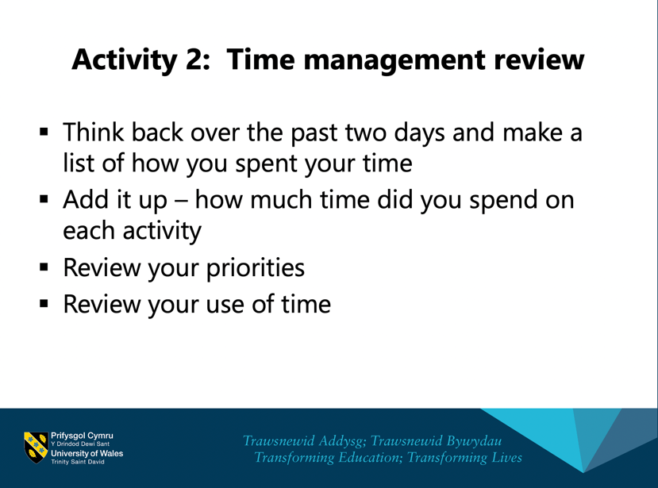
Table 2.
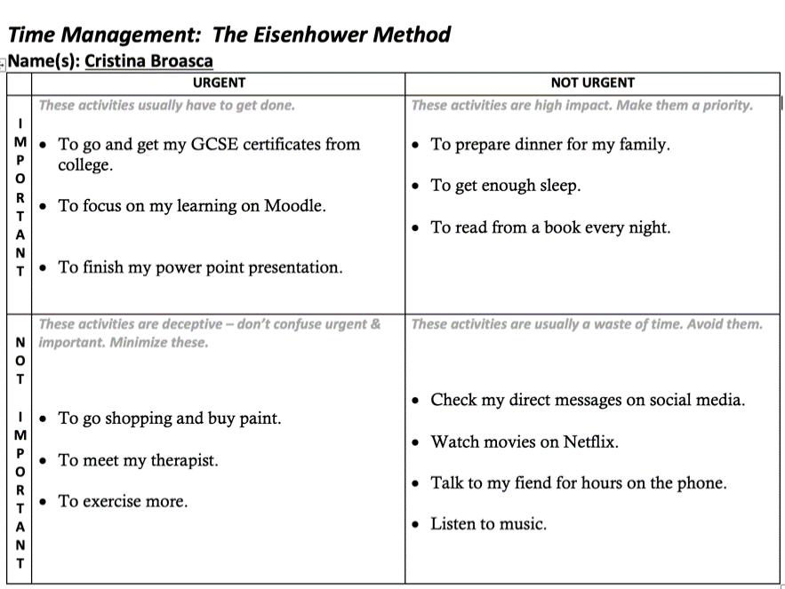
Table 3.
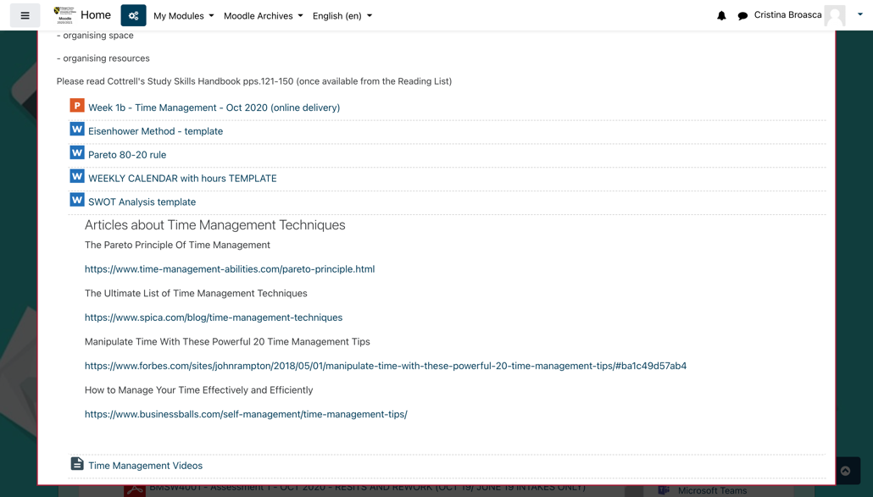
Table 4.
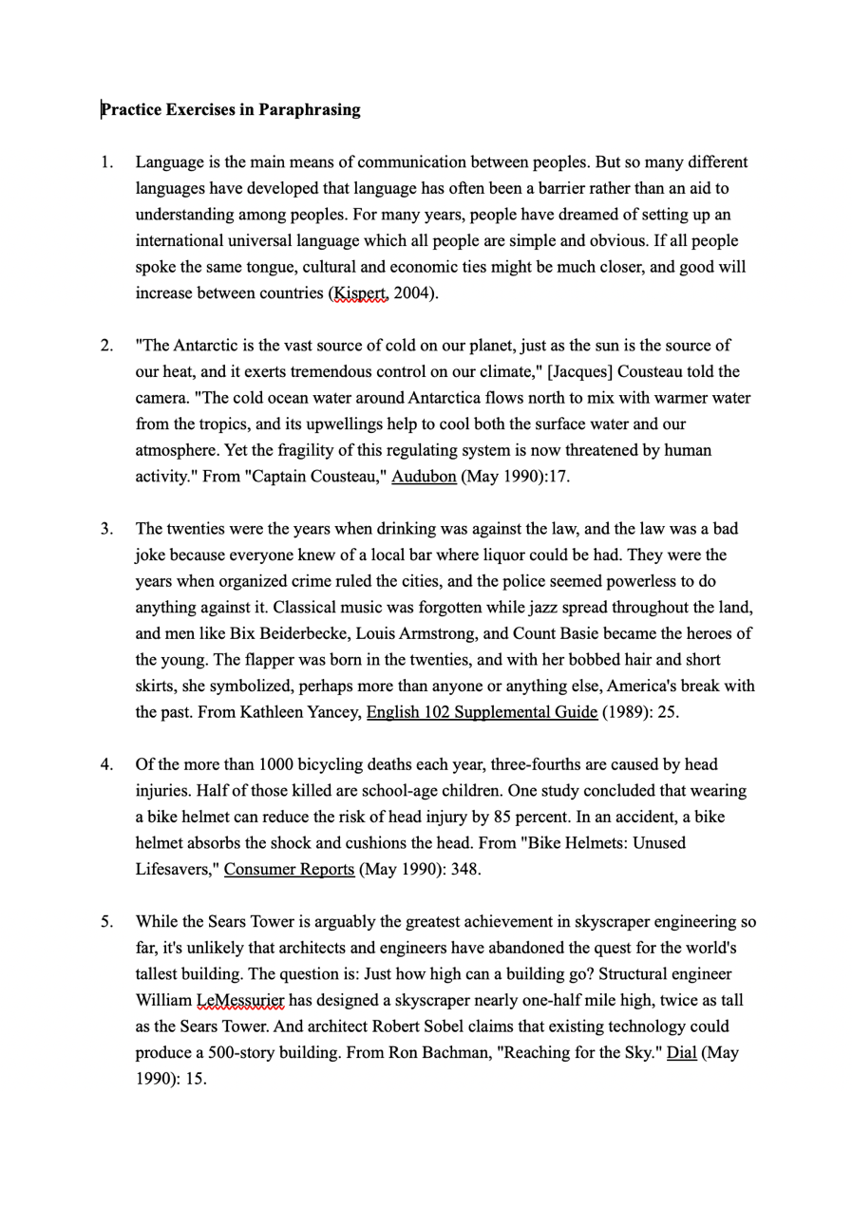
Table 5.
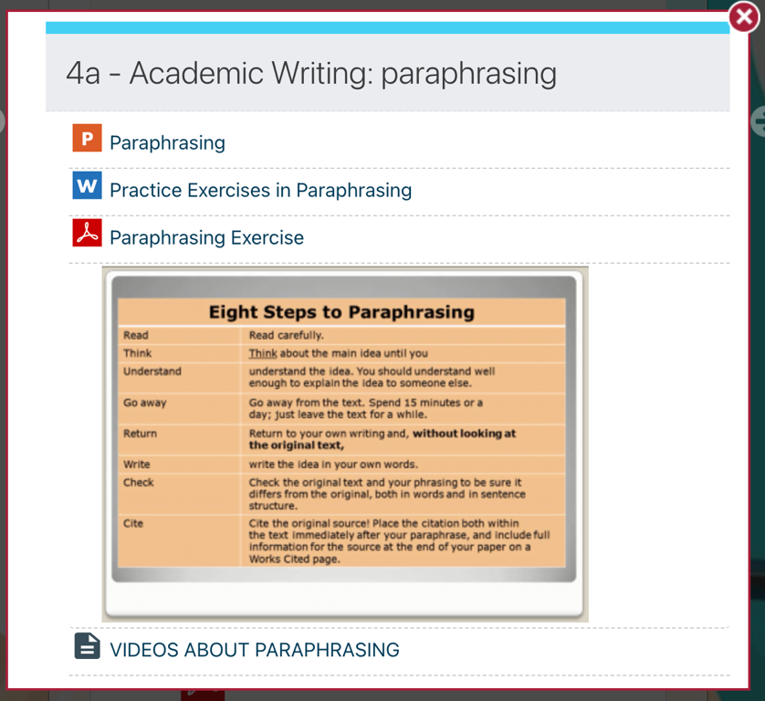
Table 6.


