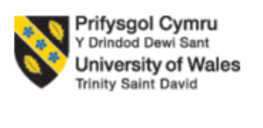
Student name: | Andrei Bargan | Student ID number: | 2429860
Programme: | CertHE Computing Skills for Workplace
Module: | Network and Cybersecurity Essentials
Module code: | ACCA4024
Lecturer: | Amit Naik, Kwame
Assignment Title: | Assessment Component 1: Synthesize a solution to a potential real-life scenario
Submission deadline: | 18-12-2025 14:00 (2PM)

Contents
Introduction 3
Identification of Modern Threats 3
Modern Security Policies 5
Technical Mitigation Measures 6
Proactive Monitoring and Incident responses. 8
Continuous training and awareness: 11
Conclusion: 12
PowerPoint Presentation: 12
Certificate 15
Bibliography 16

Introduction
Cyber security is a critical challenge for modern financial services organisations, as threats continue to increase in scale and sophistication. The shift to hybrid working models, cloud services, and mobile devices has expanded organisational attacks and reduced the effectiveness of traditional security controls. As a result from this, corporations face risks like phishing, ransomware, and supply chain compromise.
Vigilant Trust & Asset Management (VTAM) is a medium-sized financial services company, which has experienced multiple security incidents, which are a sophisticated phishing attempt and ransomware attack. As a response, they tried to develop a modern cyber security framework that is based on Zero Trust principles, where no one is being trusted by default (no system, user, device, etc.)
In this report, I will suggest a Zero Trust-aligned security framework for VTAM, informed by industry best practices and standards such as NIST, CSF, ISO /IEC 27001, and guidance from CISA to identify the cyber threats and improve the organisation’s security.
The Zero Trust model is based on the idea that no user, device, or system should be trusted by default and that continuous verification is required before granting access (NIST, 2020). [1]

Identification of Modern Threats
VTAM faces a lot of cyber threats because of its role as being a financial services company and its use of cloud services and hybrid working. These threats can be both from outside attackers and inside the organisation attacks.

External Threats:
RaaS (Ransomware as a service)- Ransomware can be sold as a service, means that attackers do not require the skills to launch such attacks. This has made them more common. Financial companies like VTAM are targeted because attackers know the data loss and down time of the company cause very serious damage and the companies will be more forced to pay the ransom as soon as possible. According to CISA, ransomware attacks often exploit known vulnerabilities, which is why organisations should prioritise patching vulnerabilities listed in the Known Exploited Vulnerabilities (KEV) catalog (CISA, 2023). [2]

AI powered social engineering (vishing)-Attackers can now use artificial intelligence to create very realistic phone calls (vishing) or phishing emails. They can pretend to be from reputable companies or managers of the company which can be harder to detect. If the employees fall for these attacks, then the attackers can steal login info or trick them into sending money and sensitive data.
Supply chain attacks- VTAM uses third party suppliers such as cloud providers. If one of these suppliers are compromised, attackers can gain access to VTAM’s systems. These attacks can be very dangerous because the organisation may trust the compromised system without knowing it has been attacked.

Internal threats:
Human error- Mistakes made by the staff such as pressing on malicious links are a major risk. These errors can happen because the security training is very weak or employees using personal devices for work.
Insider threats and stolen accounts -Insider threat can come from employees that misuse access or if attackers took over the employee account using a stolen password. Once they are inside the network, the attackers can do anything they want with the sensitive data they access.

Cloud and hybrid work risks- Hybrid working and cloud services increase security risk because employees can access the system when they are in a different location or use a different device. ENISA highlights that phishing, social engineering, and cloud misconfigurations remain some of the most common cyber threats affecting organisations using hybrid working and cloud services (ENISA, 2023) [3].Cloud service system can also be misconfigured, allowing attackers to access the data if security settings are not correctly put. Without strong identity checks and device monitoring, the company will be more exposed to cyber-attacks.

Modern Security Policies
To reduce the risks that were mentioned earlier, VTAM could adopt a set of modern security policies based on the Zero Trust model. The zero-trust model means that no user, device or system is trusted by default, even if they are inside the network in the company. Access will be only given after they verify your information properly and it limits the access to only what is necessary for the employee. These policies are aligned with best practices from NIST CSF and ISO /IEC 27001.

ISO/IEC 27001 provides a structured approach to managing information security through policies, access controls, and continuous risk management (ISO, 2022). [4]

Identity and access control policy- All users will have to verify their identity before they access the company systems. This includes everybody, like employees, contractors, and third-party sellers. After verifying their identity, people will be only able to access the least amount of the system to just do their job which is called the principle of least privilege.
This policy supports Zero Trust by ensuring that access is always checked and aligns with NIST CSF- Protect and ISO 27001 access control requirements.

Multifactor authentication (MFA) Policy- this needs to be used by all systems, including cloud services, vpns, emails and all sort of administrative accounts. MFA will reduce the risk of stolen passwords being used by the attackers.
This policy helps prevent unauthorised access and follows recommendations from NIST and CISA.

Device security and trust policy- Only approved and secured devices should be allowed to access VTAM systems. This means that the devices must meet the basic security requirements such as having an updated os, disk encryption and antivirus. Devices that do not meet such criteria should be blocked or giving them more limited access.
This supports Zero Trust by not automatically trusting devices and aligns with ISO 27001 asset management and security controls.

Data protection and classification policy- Data must be classified and protected based on the importance that it has. This means that financial and personal data should be encrypted both when stored or when its being transmitted. Such access to sensitive data should always be kept an eye on by logging it and always be reviewed.
This policy reduces the impact of data breaches and aligns with NIST CSF-Protect and ISO 27001 information security controls.

Third party and supply chain security policy- Third party suppliers and partners must meet VTAM’s security requirements before being granted access into the system to their data. Security assessments must be done regularly, and they should monitor always the access or limit it.
This policy helps reduce supply chain risks and supports guidance from NIST and ISO 27001.

Continuous monitoring and logging policy- All access to their systems especially the more sensitive information should always be logged and monitored. If any suspicious behaviour is detected it needs to be investigated as soon as possible.
This policy supports Zero Trust by assuming breaches can happen and aligns with NIST CSF- Detect.

Technical Mitigation Measures
To reduce the cyber risks that VTAM are facing, some technical controls and administrative measures should be implemented. These measures should support the zero-trust model by verifying users, devices and activity non-stop rather than relying on a traditional network perimeter.

MFA – Multi factor authentication should be put on all important systems, such as emails, cloud platforms, VPN access, or admin accounts. MFA requires users to not only put their passwords but also a code that is sent to their phone or an authentication app. This will significantly reduce the risk of attackers gaining access to the accounts or passwords they stole even if they successfully did a phishing or vishing attack.

Security information and Event management (SIEM)- a SIEM system should be used to collect and analyse the security logs within the organization, this includes servers, cloud services, firewalls or user accounts. SIEM will help detect a suspicious activity like unusual login locations or multiple failed attempts of logging in.
Using SIEM will allow VTAM to identify threats early and continue monitoring which is a key part of the zero-trust model.

Security Orchestration, Automation and Response (SOAR)-
SOAR tools should be used alongside with SIEM to automate responses to common security issues. For instance, if they detect a phishing email, SOAR will automatically block the sender, isolate the account that has been affected and alert security team.
This will reduce response time and limits the damage caused by attacks like ransomware.

Cloud Security Posture Management (CSPM)- VTAM uses cloud services, which means that a CSPM solution should be implemented to check cloud configurations nonstop. CSPM tools will help identify risks like missing encryption or weak access permissions. This will reduce the risk of data exposure caused by cloud misconfigurations.

Patch Management using CISA KEV
VTAM should maintain a strong patch management process that prioritise vulnerabilities listed in the CISA Known Exploited Vulnerabilities (KEV) catalog. The systems should always be updated regularly and vulnerabilities that are critical should always be patched as soon as possible. This will reduce the risk of attackers exploiting known weaknesses in systems and softwares.

Back up and recovery controls – Regular backups should be done and stored securely. Backups should also be protected from modifications or deletion and tested all the time to be sure that they do work and can be restored. These controls are essential for recovery from things like ransomware and help reduce the downtime or the financial impact that it will have on.

Administrative Controls and procedures.
Clear procedures should be in place for user access reviews, reporting incidents and change management. Employees should be trained enough to know how to report suspicious emails or activity and the access rights should always be reviewed to ensure that they are still required. Administrative controls will help with technical measures and reduce the human errors.

Proactive Monitoring and Incident responses.
VTAM requires a proactive approach to detect and respond to the cyber-attacks and to reduce the impact of such attacks (phishing, ransomware). It needs continuous monitoring and clear incident response will help to identify the threats earlier and respond quick.

Continuous monitoring – VTAM should operate 24/7 security monitoring using SIEM and SOAR tools. The SIEM will keep collecting logs from systems like email, cloud platforms, servers and devices. These logs will then be analysed to determine if any suspicious activity is taking place. This includes unusual login attempts, malware alerts, abnormal data transfers etc. If suspicious activity is detected, the security team will be alerted so they can investigate.

Incident detection and analysis- Once they get the alert, the security team will review it to understand if it’s a real security incident. This includes checking the affected system, the user account or any other type of possible activity. If the alert is confirmed to be really a threat, the process of responding to the incident begins. This step will help reduce false alarms and ensure that resources are focused on the real threats.
Incident response and containment: For confirmed incidents, auto actions through SOAR should be used when it is possible. This can include Isolated infected devices from the company network, blocking malicious Ip addresses or disabling the affected user accounts etc. In the case of a ransomware, the systems that were affected should be instantly isolated to prevent further spread.
Recovery and lessons learned- After the incident has been contained, system can be restored using a clean back-up (if it is required). The security team will review the incident and see what went wrong and how such similar incidents can be prevented in the future. If they find anything useful, it can be used to improve security controls, staff training etc. This continuous improvement approach aligns with Zero Trust and modern security frameworks.

This is a flowchart which will help me illustrate better what I am talking about:
It shows VTAM’s SIEM and SOAR-based incident response process, showing nonstop monitoring, automated containment and improvement for after incident happens.
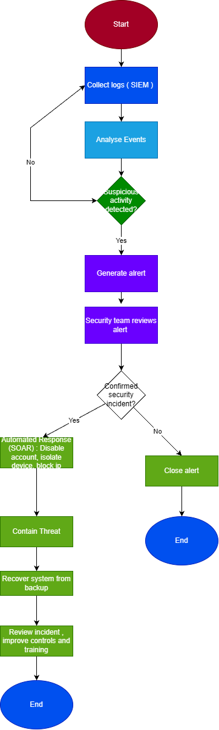

Continuous training and awareness:
Human errors remain one of the biggest reasons for the successful cyber-attacks, especially when it comes to phishing or vishing or any ransomware incidents. This is why VTAM should focus on implementing better security training and awareness programmes. This will help train the employees to recognize modern threats and make them have a better understanding overall.
Phishing and vishing simulations- VTAM should run a lot of phishing and vishing simulations to test employee’s awareness. These simulations should use realistic emails and phone call scenarios that are based on the techniques that are used now by the attackers. These techniques could be fake invoices, messages impersonating staff or password reset requests.
Employees that would fall for such simulated attacks will then be more vigorously trained. This will help them learn from their mistakes in a safe environment which will improve their awareness overtime.
Role based security training: The employees that are working on different sectors must face different risks which is why they will need to be trained on things that they need more than others. Finance staff for example should be trained on vishing attacks and payment fraud. IT staff should receive more training on incident response and system security. Managers should be trained to recognise impersonation and social engineering attempts. This will ensure training is relevant and effective for everybody.

Security awareness in hybrid work: As many employees work from home, they should also get training on secure remote working practices. This includes using strong passwords and mfa, reporting incidents fast, recognising suspicious phone calls or emails and securing their home network.
Encouraging a culture: VTAM should promote a culture where security is seen as everybody’s responsibility. By doing so, it will encourage employees to always report incidents without any fear of punishment. Regular security reminders, reminders or posters, etc would be a really good way to do so.
Measuring effectiveness: Training should be monitored, like using a phishing click rate or incident reporting times. The results should always be reviewed, and the training should always be adapted to the new threats and the lessons they learn from real incidents.

Conclusion:
Cyber threats are growing everyday in complexity, especially with the rise of ransomwares, social engineering and other risks. This report tried to show a modern cyber security framework for VTAM based on Zero trust method while showing the recognised standards such as NIST CSF, ISO/IEC 27001 and guidance from CISA. Combining strong security policies, modern technical controls, nonstop monitoring, and continuous staff training VTAM can reduce the risks of cyber-attacks, improve their incident response and strengthen their overall understanding of cyber security.

Appendix:

PowerPoint Presentation:
Slide 1: Introduction
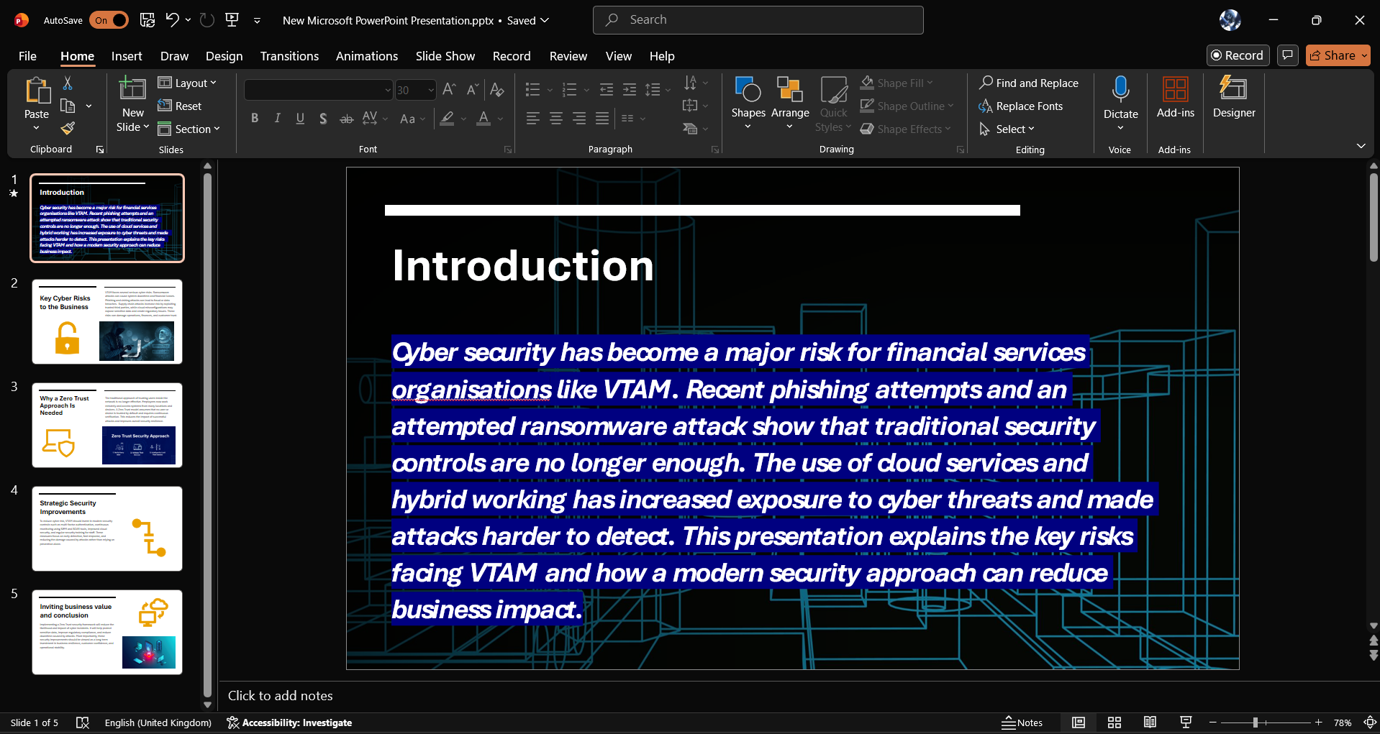

Slide 2: Key Cyber Risks to the Business
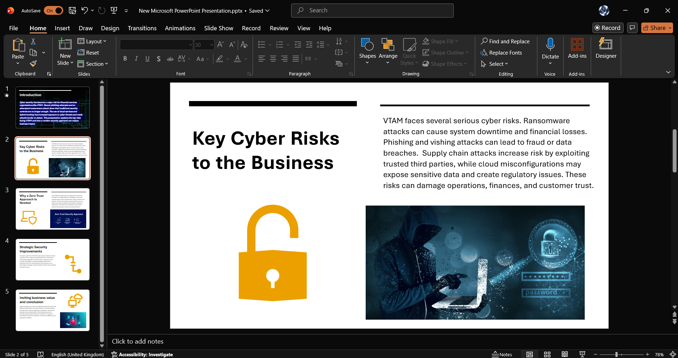

Slide 3: Why a zero-trust approach is needed
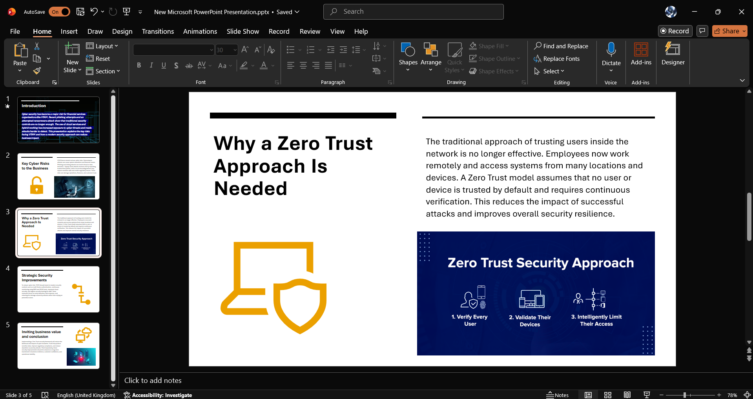

Slide 4 : Strategic Security Improvements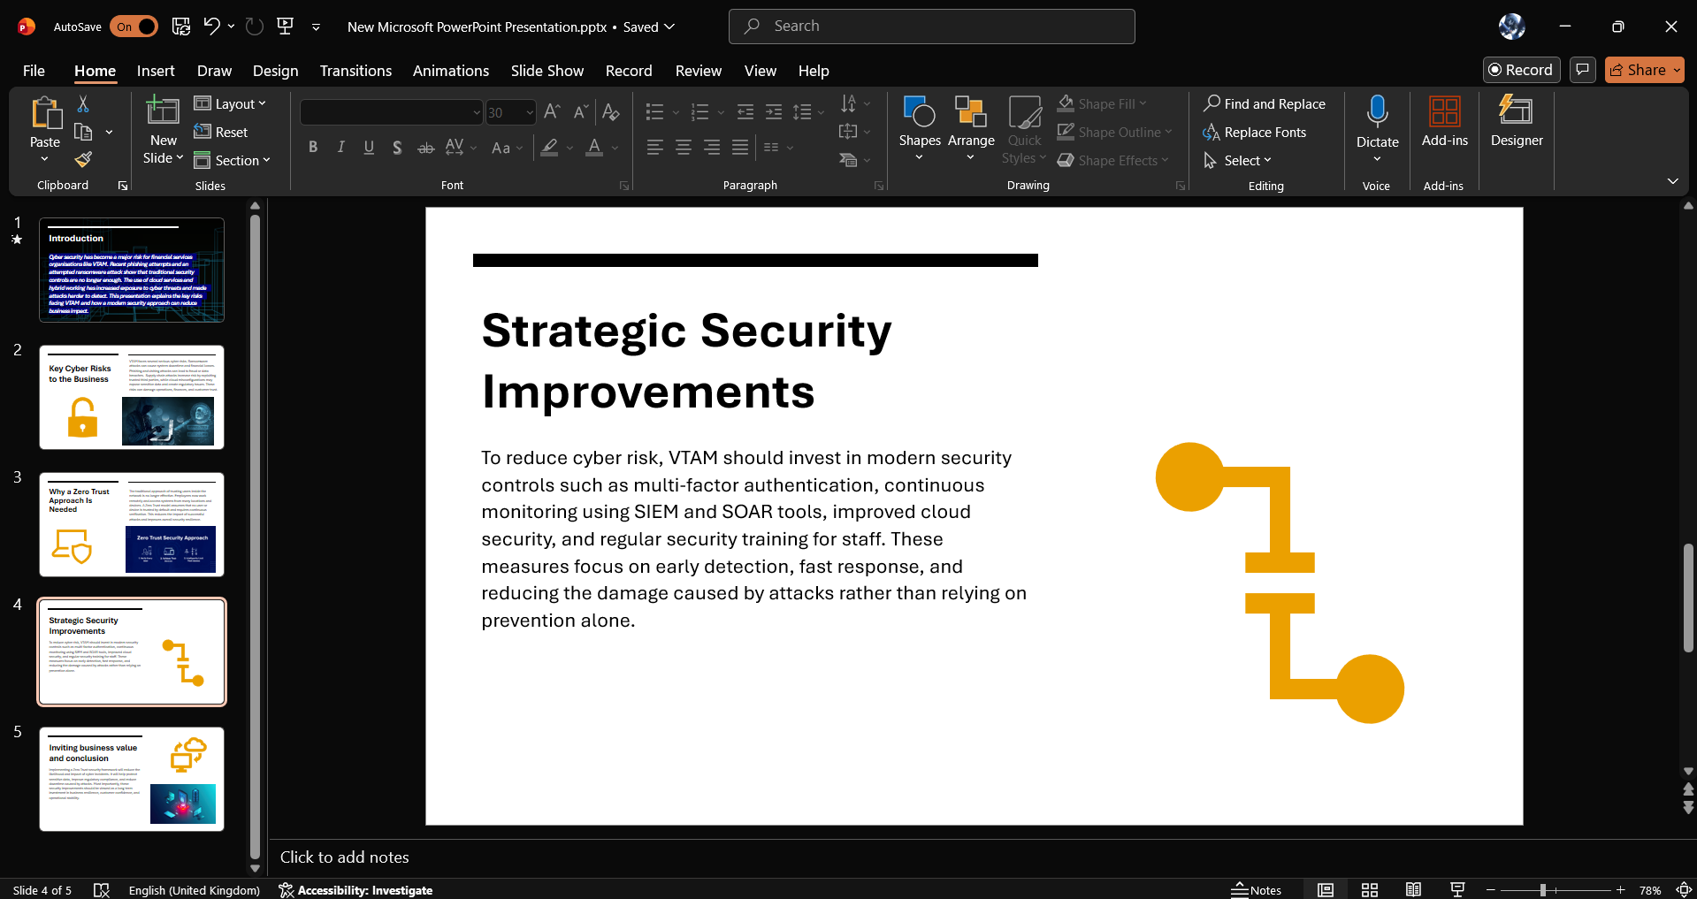

Slide 5: Conclusion
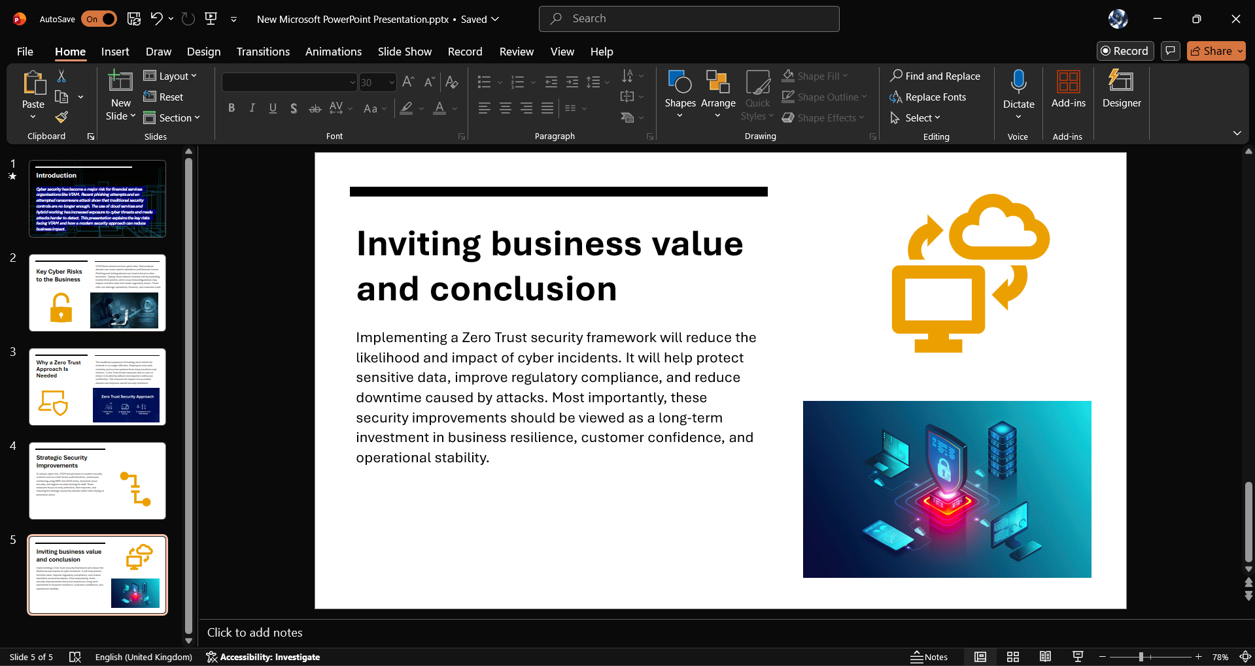

Certificate
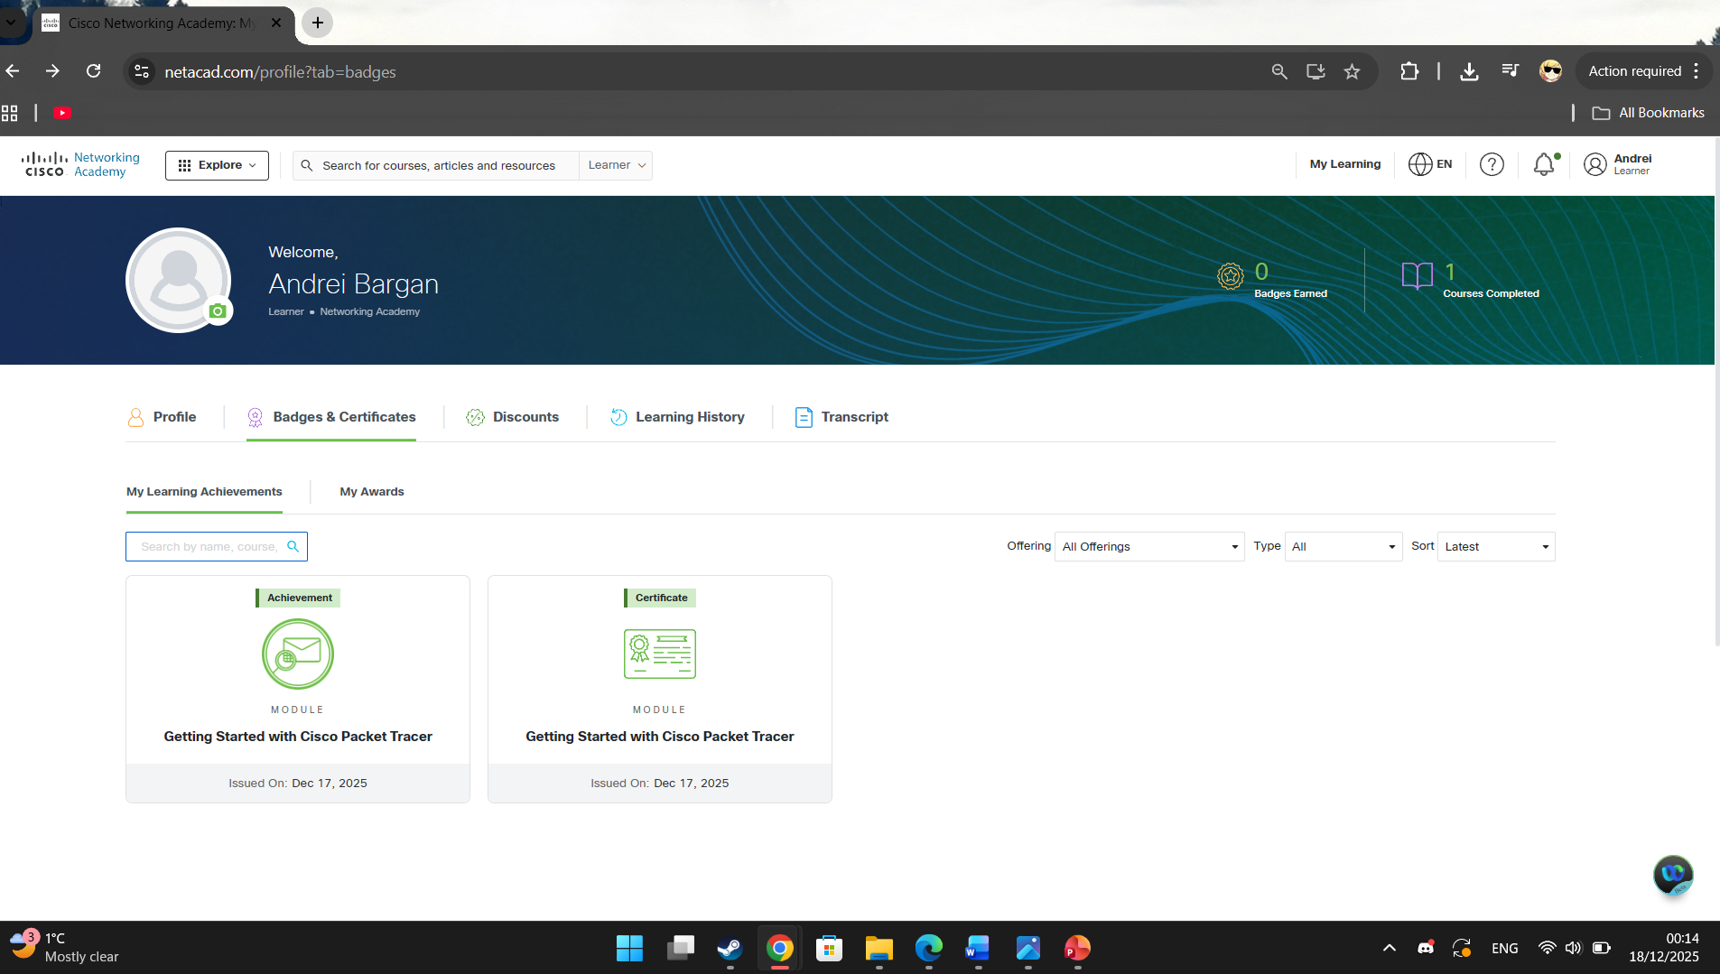
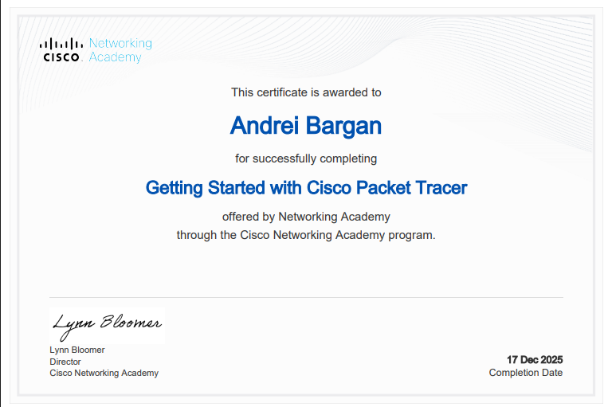

Bibliography

[1] | CISA, “Known Exploited Vulnerabilities Catalog,” CISA, 2023. [Online]. Available: https://www.cisa.gov/known-exploited-vulnerabilities-catalog. [Accessed 17 12 2025].
[2] | ENISA, “Cyber Threats,” 2023. [Online]. Available: https://www.enisa.europa.eu/topics/cyber-threats. [Accessed 17 12 2025].
[3] | ISO, “ISO/IEC 27001 Information Security Management,” ISO, 2022. [Online]. Available: https://www.iso.org/standard/27001. [Accessed 17 12 2025].
[4] | NIST, “Zero Trust Architecture,” 2020. [Online]. Available: https://www.nist.gov/publications/zero-trust-architecture. [Accessed 17 12 2025].

