PROBLEM SOLVING AND DECISION MAKING

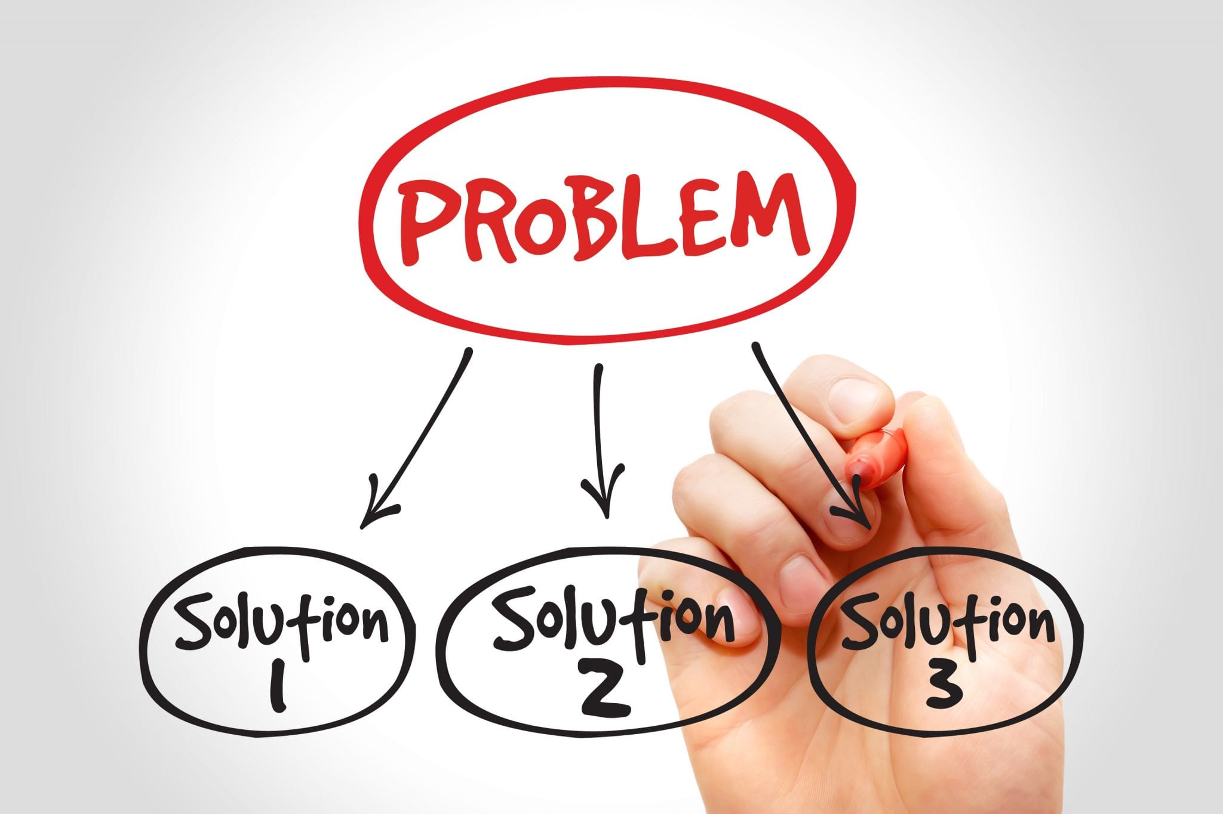

Student Name: Debora Ferreira - 1909895

Lecturer Name: Anupam Mazumdar

Module Name: Problem Solving and Decision Making

Module Code: BMSW4004

Executive Summary
In this report the process of problem solving and decision making has been discussed and which needs to be developed and the use of it should increase. The scientific process which are provided the methods which are widely used for the success in various situations. The process uses many different techniques and solution for any member. The decisions which are made can affect the individuals both weakness and the strength and make solution in order to solve the problems.

Table of Contents

Introduction 4
Complex Problem with impact and scope 4
Analysis of Complex Problems 5
Decision Making Tools and Techniques 6
SWOT Analysis 6
PESTLE Analysis 6
Fishbone 8
Suggestion on Solution 8
Implementation of Solution A 9
Communication Plan with different stakeholder 10
Monitoring and Reviewing Techniques 13
Conclusion 13
Reference List 14
Appendix 1: Fishbone 16

Introduction
Most of the people make initiative in problem solving and making decisions and are stressed in the short period of time. People work and encounter everyday new problems and make decisions accordingly. Many of the problems and the decisions are so small that it cannot be noticed but even small of the decisions can be quite overwhelming and in some cases it is like a dilemma to decide what the steps to be taken are. The company is supposed to set some guidelines in the process of decision making and it might be useful and there is a requirement for something in order to make effective decisions for the company.

Complex Problem with impact and scope
Working with the communities and the families the types of problems that arise have an impact on the communities and the families working together and that could be quite hard to define at certain levels. It is the social complexity instead of the technical complexities that are the reason which makes the complex problems hard to communicate, for example: the change in the climate. All the people in the world are surrounded by complex problems and there are few difficulties in solving the threatening issues. There is a distinction which will be made between the projects that are complicated and problems that are not been able to be specified in early stages. For the successful delivery of the budget, scope and the timescale under the project that is complex total planning is supposed to be done. Most of the problem management approaches take place where some of the projects are considered to be quite complicated one where it has the total impact on the implementation of the project. The complex problem management contrasts with the main findings of the project. The problem management is the knowledge that is incomplete under the approach of bounded planning which is implied in the learning (Ahern et al. 2014). Viewing the problem management as the practice of the organization with the learning implied because of the not specified knowledge which suggests the leadership of the complex project. The finding points out the new direction for the research of the future and determines the effective leadership in the project management area. The main finding of project management that is complex is displayed in two of the organizations and therefore could be understood as the form in solving the complex kind of problems (Ahern, 2014). Problem solving is all about using logic and even use of imagination that make some sense in handling situations and therefore people can come up with the correct solutions. In concern with the business of the UK the company has faced many challenges because of the problems the focus on a project becomes a little harder for the workers.

Analysis of Complex Problems
Problem solving is the central feature of the human intelligence and the Intelligence test that covers all the areas in a proper way. The definition of Buchner stresses on the character of the complex problem solving and the strategies and the discussion on the problem-solving surrounding plays a great role (Simpol et al. 2017). To an extent a perspective that focuses on the solving of the problem is found in the intelligence definition. The perspective which focuses on the process of problem solving has been considered as they key to success in the research of complex problem solving. The complex problem solving is divided into two areas, one is the knowledge application and the other one is the knowledge acquisition. Therefore, in many tests of the complex problem solving the score of the final performances as well as the data on both the processes are taken out separately. The acquisition of knowledge refers to the process of gathering knowledge about the process of dynamic changes which includes the exploration of the spec of problems through the target discussion between the situations of the problem and problem solver (Wu, 2020).
Application of the knowledge refers to the process where the knowledge that has been previously gathered reaches the target state for simply solving the problem. It is well known that in case of real life both of the processes take place (Chiang, 2017). Hence, working on the solutions of the problems then there will be realization that there are few pieces of the structure of the problem that are needed to be discovered and to go back in re exploring the space of problems. When the complex problem solution tests are employed then it may make some sense to divide the two of the processes. First is gathering knowledge and information and instructing the participants all about the issues which can be even termed as knowledge acquisition and then working towards the goal which can be termed as application of knowledge (Lotz, et al. 2017).

Decision Making Tools and Techniques

SWOT Analysis
The SWOT analysis helps in recognizing the external as well as the internal factors where the internal factors are the weakness and the strength, and the external factors are the threats and opportunities. This tool provides the business in guiding them and creating various options that even provide questions and templates to focus on the right areas (Nekrasov and Melnyk, 2017). Presently working in the company of Morrison the techniques used for the problem-solving process accordingly.

Strengths  - It has a strong brand portfolio.  - Has an skilled workforce in the company.  - Free cash flow is quite strong. | Weaknesses  - Not quite good at forecasting the product.  - Investment in technology needs to be increased.  - Financial planning to be done efficiently.
Opportunity  - New environmental policies  - They get new customers from the online source.  - Opening a new market with the approval of the government. | Threats  - Development of new technologies increases competition in the market.  - Laws of liability might expose many claims of liability.

PESTLE Analysis
In order to solve the complex problems the PESTLE analysis can help in giving relevant information and solve the problems.
Factors | Analysis | Impact
Political Factor | The main political factor is the Brexit and a lot of uncertainty arises because of change in regulations and laws.  Multiple government impact on retail food. | Negative
Economic Factor | Fluctuation because of Brexit and increase in inflation in the market.  Rise in the oil price rates which made the budget of the consumer's budget tighter (Sánchez-Cambronero et al. 2020). | Negative
Social Factor | Ageing population increases.  Health and education consumers’ growth. | Positive
Technological Factor | Investing in technology reduces the cost of making the business.  The use of digital equipment has been increased to serve better to the customers.  The research is still on the development of the in-house system and software. | Negative
Legal Factor | Safety of food and the legal standards.  The legal policies of the companies support and guide them. | Positive
Environmental Factor | The emission of carbon gas was reduced  Plastic free on the vegetable and fruits were offered | Positive

Table 1: Pestle Analysis

Fishbone
There are fewer strategies in the analysis of the diagram of fishbone, in order to recognize the root cause. The statement of the problem is to be captured in the head of the fish; the problems are being captured in the fins of the fish. The major problems are being captured in the end of the fins of the fishbone. The approach has produced a visualization of the issues related to the company and helps in the process of finding solutions. It is important to ensure that the major root causes that are proposed are recognized well and are solved properly (Problem solving, 2020).
[Refer to Appendix 1]

Suggestion on Solution
According to the Analysis I think that solution A would be the better option as the problems are the usual and the natural part of life. Making decisions and solving problems are both different things but are closely linked with each other. The solving of the problem will involve creation of more problems, the more the skill is in solving the problem then the decision making becomes easier. While problem solving and making decisions it is important to consult, bring out solutions, decisions should be made for the implementation, evaluation and systematic approach should be used for the process of problem solving.
Solution A: According to the analysis I think the SWOT Analysis looks on the internal as well as the external factors of the company that helps in analysing and making decisions accordingly. If there is weakness, then it can be solved by making decisions.
Solution B: In Solution B the pestle analysis only suggests the external factors, where few of the factors cannot be solved such as weather change etc.
Solution C: According to the solution C that is the analysis of fishbone, the problems are structured in the fishbone in a systematic way where the problem of statement is on the head of the fish and the major problems are on the fins of the fishbone.
According to the above three solutions I think that the solution A is better than the solution B and C because it can analyse the weakness and the strength of the company will help in making decisions well and it would be easy to understand what is coming as a threat to the company and solve the problem (Ince, 2018). Whereas in solution B and C this cannot be justified as it shows the external factors and some of the solutions cannot be made such as the change in law, climate condition etc. All of these are not in the hands in control.

Implementation of Solution A
According to the Solution A some of them are to be implemented in the ADKAR model for the effective change in the management of the company.
ADKAR Model
Awareness: Awareness should be made about the development of new technology in the market and the customers should be aware of the specifications and the use of the product.
Desire: Desire is one of the difficult phases because the individuals will have to make their own decisions and will have to make changes in the management process. The aim of the company is to create a positive benchmark and improve the image of the brand.
Knowledge: The knowledge and training should be given for the effective and skilled labour in the company and development of the company.
Ability: Once they have gained the knowledge then they will have a desire to do new things for the change, activities and time is needed for the development of the new skills.
Reinforce: In many of the companies the changes might be temporary, therefore rewarding to the employment for their work is necessary.

Communication Plan with different stakeholder
Stakeholders | Communication Medium |  |  |  |  | Timeframe  (Immediate/  Weekly/Monthly)
Stakeholders | F2F | Telephone | Huddle | Letter | Email
Employees | X | The employees need to communicate with the employees through telephone. | X | The interaction of the queries of the customers is done through calls. | X | Immediate
Customers | X | Customers communicate with the employees through calls. | Customers communicate with the employee. |  |  | Immediate & Weekly
Managers | X | Managers should be even trained and take the decisions effectively and solve all the problems of the employees through telephone | X | Communication with the customers. | Communication with employees and customers. | Immediate
Suppliers | The supplier’s interaction should be face to face with the managers. | X | The supplier's interaction should be through a huddle. | X | X | Weekly
Third Party IT Organization | The communication with the manager. | X | Communication with the manager and employees. | X | X | Monthly
Table 2: Stakeholder communication plan

Monitoring and Reviewing Techniques
For implementing solutions in the company correct strategies and decisions are to be taken for the solving of the problems. The reviewing of the techniques are to be done after every year and according to the planning for the change is supposed to be done.

Conclusion
It is quite easy to approach them and encounter new issues and the decisions and therefore work beforehand. It becomes easy for the company to stay stuck in solving the problems each time. Hence, it is quite important and is useful to get used to the approach of the organization in decision making and solving the problem. The solving of the problem is resolving the gaps between the desired goals and the present situation. The problems are encountered, and solutions are made from the past experiences. Therefore, there is even a need to develop the use of decision making and the process of problem solving.

Reference List
Ahern, T., Leavy, B. and Byrne, P.J., 2014. Complex project management as complex problem solving: A distributed knowledge management perspective. International Journal of Project Management, 32(8), pp.1371-1381.
Chiang, T.H.C., 2017. Analysis of learning behaviour in a flipped programming classroom adopting problem-solving strategies. Interactive Learning Environments, 25(2), pp.189-202.
Ince, E., 2018. An Overview of Problem-Solving Studies in Physics Education. Journal of Education and Learning, 7(4), pp.191-200.
Lotz, C., Scherer, R., Greiff, S. and Sparfeldt, J.R., 2017. Intelligence in action–Effective strategic behaviours while solving complex problems. Intelligence, 64, pp.98-112.
Nekrasov, V. and Melnyk, V., 2017. Application of SWOT and PESTEL analysis in combating economic crimes and when identifying threats to economic security of the state. Probs. Legality, 136, p.193.
Sánchez-Cambronero, A., González-Cancelas, N. and Serrano, B.M., 2020. Analysis of port sustainability using the PPSC methodology (PESTEL, Porter, SWOT, CAME). World Scientific News, 146, pp.121-138.
Simpol, N.S.H., Shahrill, M., Li, H.C. and Prahmana, R.C.I., 2017, December. Implementing thinking aloud pair and Pólya problem solving strategies in fractions. In Journal of Physics: Conference Series (Vol. 943, No. 1, p. 012013). IOP Publishing.
Wu, Y., 2020, February. The Marketing Strategies of IKEA in China Using Tools of PESTEL, Five Forces Model and SWOT Analysis. In International Academic Conference on Frontiers in Social Sciences and Management Innovation (IAFSM 2019) (pp. 348-355). Paris: Atlantis Press.

Appendix 1: Fishbone


