Dafydd Pett (2405762)
Synthesize a solution to a potential real-life scenario
Dafydd Pett
2405762
Computer Forensics
Synthesize a solution to a potential real-life scenario
Table of Contents
Introduction 3
Forensic Toolkit (FTK) 3
(Sleuth) Autopsy 3
Magnet Forensics AXIOM 4
Cellebrite UFED 4
Paladin 4
MSAB XAMN 5
Comparison Table 5
Comparison 5
Conclusion 6
Task 2 – Case study: Sabotage 7
Introduction 7
Forensic Methodology 7
Investigation Plan 8
Forensic Report 9
Conclusion 18
Appendix 19
Professional Invoice 19
Bibliography 20

Introduction
Digital forensics have become a crucial part of the modern world with technology use rising by 10% between 2024 and 2025 [1]. The more use and advancements of technology, although the core principles of computer forensics remain the same, the greater the need for a strong presence of computer forensics where evidence can be identified, preserved and analysed.
Computer Hacking Forensic Investigator (CHFI) process includes 5 critical steps where tools are required to conduct a successful investigation [2]. These steps include identification, preservation, acquisition, analysis, and reporting [3]. With a wide range of devices being used in the modern world, a range of both paid and free tools are utilised to undertake different role required for a successful forensic investigation on all devices and software’s. Within computer forensics, no single tool covers all aspects and the methods to obtain relevant data changes per device and investigation.

Forensic Toolkit (FTK)
The forensic toolkit (FTK) is an analysis tool within the CHFI process. FTK’s role is to analyse devices, often used within law enforcement forensic investigations as primary role is to create bit-for-bit copies or hard drives, USB drives and other storage without altering the evidence so it can be used in court [4]. A major strength of FTK is that it allows large quantities of data to be searched and analysed producing accurate, court admissible reports allowing prosecution if the evidence is sufficient. FTK is often used alongside FTK Imager which is used for acquisitions in the CHFI process.
FTK uses a power indexing engine which allows quick searching of keywords and supports a range of file formats such as NTFS, FAT, exFAT, HFS+ and EXT [6]. Because of its power indexing engine, it is suitable for processing a large amount of data and it even has password cracking, graphic analysis and email analysis included in the tool [5].
Although FTK has a range of high-level tools making analysis seamless, it is a hight cost tool with the pro version costing $499 per year [7] and it requires a high level of training to utilise all the features that the #
software includes to conduct a successful investigation. On the other hand however, a free version of FTK is also available which includes very basic tools for less complex investigations.

(Sleuth) Autopsy
Autopsy is a free, open-source programme part of the Sleuth Kit Labs [8]. It is used for hard drive, smartphone and media analysis. Autopsy has a range of advanced features such as recovery of deleted items, web activity, timeline and registry analysis allowing data to be found using keyword search [8].
Autopsy is easy to use with a user friendly GUI including case management and reporting. This can be accessed when ingest modules run in the background to filter out the information which is required for the forensic investigation to go ahead. Case management and reporting tools which will organise data accordingly with a full chain of custody timeline are also included in the tool[9]. Autopsy also supports the use of plugins that extend its functionality and can be customised to suit the needs of the investigation.
On the other hand, this tool specialises mainly in the use of hard drive analysis and limited features are available for mobile and cloud investigations as this would entail manual configuration and interpretation which can be time consuming.

Magnet Forensics AXIOM
Magnet Forensics AXIOM is a tool which can be used to analyse multiple data sources, but it is mainly used for cloud and mobile device investigations. This programme has a range of advanced features such as automatic detection of relevant data such as browser history and social media activity [10]. The software can identify and categorise relevant information which reduces the amount of time spent on the software.
One of the main benefits of AXIOM is the ability to analyse data on cloud due to its cloud acquisition and analysis features which is increasingly important as we see a shift to cloud based computing. Reports can then be generated using the evidence which has been found from the acquisition. It also includes a timeline and artifact correlation feature which allows the investigator to review data across different data sources to analyse the behaviour of the user deeper [11].
On the other hand, the tool comes at a great cost, and a high level of training will need to be provided to users. Due to it being primarily used for analysis rather than acquisition, a further cost would be required for a tool which specialises in acquisition.

Cellebrite UFED
Cellebrite UFED’s is used for the acquisition and mobile forensic phase with the purpose is to perform deep extractions on mobile devices, often being able to bypass encrypted data, SMS messages as well as recover data which has been deleted from the device using both logical and physical extraction methods [12]. It is then able to produce court admissible reports showing the extracted data logically [13].
Cellebrite UFED has a broad range of devices which is compatible, with more mainstream devices such as android and apple devices being compatible as well as more niche devices being supported such as legacy Nokia models.
It is however extremely expensive starting at $6,000 [14], and a range of training will need to be provided to the user to utilise the broad range of advanced features available. It has also been found that some encryption advancements are yet to be supported on the programme. When using Cellebrite UFED, legal and ethical considerations need to be looked at when bypassing device security or encryption as this tool is restricted to authorised users such as law enforcement and must comply with legal regulations.

Paladin
Paladin is a free, open-source tool which is used within the acquisition stage of CHFI [15]. It is often used to create forensic images of storage creating bit by bit copies without compromising the original data. The tool has built-in write blockers which don’t change the original data and supports a range of formats like E01 and RAW [16] which are very popular in computer forensics.
On the other hand, Paladin doesn't have advanced integrated analysis capabilities which means further tools are needed for more complex areas of leading to further cost. Some basic training will also be needed to use all the features however it can also be used with minimal training for amateur investigators due to it’s simple GUI.

MSAB XAMN
This programme is used to analyse mobile devices; it does this by transforming raw data into evidence which can be easily investigated and provided to court for prosecution [17]. XAMN can support multiple data formats and using an extraction tool such as MSAB XRY or other 3rd party app can be used and then XAMN automatically organises and categorises data from the mobile such as call logs and SMS messages [18] and supports features such as timelines for easy analysis.
MSAB XAMN has an easy-to-use GUI with data filtering and advanced report capabilities suitable for court. XAMN on the other hand has high licencing costs and will need an additional programme to be purchased for extraction of data as well as it also being limited to mobile analysis.

Comparison Table
 | Forensic Toolkit (FTK) | Autopsy | Magnet Forensics AXIOM | Cellebrite UFED | Paladin | MSAB XAMN
Use | Imaging | Disk analysis | Analysis & Reporting | Data extraction & analysis | Imaging/acquisition | Device searching, filtering & analysis
Hardware Type | Disk | Disk | Mobile & Cloud | Mobile | Disk | Mobile
Type | Commercial | Open Source | Commercial | Commercial | Open Source | Commercial
Cost | Standard: Free  Pro: $499 | Free: Open source | Standard: $5000  Cyber $8000 | $6,000-30,000 | Free: Open Source | Viewer: Free  Pro: £1800
File type | NTFS, FAT, exFAT, EXT. | NTFS, FAT, EXT | NTFS, FAT, exFAT, APFS, EXT | Android & IOS system files | E01, Ex01, RAW, SMART, AFF, VHD, VMDK, and DMG | XRY, XY
Strengths | Reliable,  Low cost,  Easy to use | User friendly GUI  Open source  Free  Plugins available | Advanced recovery  Adaptable to device  Good GUI  Cloud & Mobile Integration | Deep and reliable both logical and physical extraction of mobile devices | User friendly GUI  Open source  Free | Analysis of device logs  Mid-level cost
Weaknesses | Lack of analysis tools | Limited advanced features and reports | Expensive & training required | Expensive  Legal constraints | No built-in analysis or reporting tool | Training required and reliance on proprietary data formats

Tool Comparison
The Computer Hacking Forensic Investigator (CHFI) process has many stages including identification, preservation, acquisition, analysis, and reporting. Each forensic tool plays a different role within these phases.
Acquisition:
Tools such as FTK Imager and Cellebrite UFED are used create copies of the evidence without altering the original.
Analysis:
Autopsy and Magnet AXIOM can be used to interpret and examine extracted data. This can range from deleted files, browser history and all activity on the device.
Mobile Forensics:
Cellebrite UFED and MSAB XAMN perform deep mobile data extraction and analysis.
Cloud Forensics Phase:
Magnet AXIOM has strong cloud acquisition and artifact analysis capabilities.
Reporting Phase:
Tools such as Forensic Toolkit (FTK) provide a complete overview of what has been found during the acquisition phase and then creates court-admissible reports.
The comparison of all different tools backs up the claim that one tool doesn’t cover all the aspects needed to complete a successful computer forensics investigation. In my opinion, I believe that the below tools which specialise in different roles are what is needed to conduct a successful forensic investigation.
FTK - Data processing and reporting
AXIOM - Cloud and multi-device analysis
UFED - Mobile extraction
Paladin - Disk Imaging
XAMN - Mobile data interpretation & analysis
Each application specialises in a particular device which
Disk Evidence: Hard drives and USB devices analysed using tools such as Autopsy and Forensic Toolkit (FTK).
Mobile Data: SMS, call logs, media files as well as app data can be extracted using Cellebrite UFED and analysed with MSAB XAMN.
Cloud: Data from cloud providers such as Google Drive and iCloud analysed using Magnet AXIOM.
Volatile Data: RAM storage data will show active sessions of the devices.
Although each of the tools have their own speciality’s and some cross over with others, it is essential to have a range of these tools on hand in order to conduct a successful investigation when multiple devices need imaging and analysis, one tool doesn’t fit all needs.

Conclusion
In conclusion, digital forensics investigations need a wide range of tools to get accurate results in a timely manner which are suitable for court. While the tools change, the principles of digital forensics don’t change however with the help of advanced features of each tool, all devices can have in-depth investigations conducted against them.
Each tool in this report has a different purpose and a range of positives and negatives yet they each have a particular role within a forensic investigation. Firstly, FTK is the best for analysis and reporting, Autopsy on the other hand is a great analysis tool and is cheaper than FTK however advanced features are limited. With Magnet AXIOM, it supports cloud and multi device investigations whereas Cellebrite UFED & MSAB MAMN support mobile phone investigations. Some tools such as Magnet AXIOM and Cellebrite UFED, are also a lot more expensive than other tools on offer and require specialist training in order to maximise the use of the software.
Overall, the most effective approach is to use a combination of tools dependent on the type of evidence and investigation requirements, reinforcing the principle that there is no one-size-fits-all solution in digital forensics.

Task 2 – Case study: Sabotage

Introduction
Within this case study, an investigation is to be conducted due to theft of intellectual property by a former employee of Cyfusion Mobile Manufacturing Company (CMMC). CMMC is a mobile manufacturer based in London specialising in the graphical user interface (GUI) of highly technical handsets which require a large amount of precision, time and skill to compete with other devices on the open market.
Rich Daley was an employee of CMMC who has been working on the GUI for the new Galaxy Z Flip Phone 6. When Rich had finished his design of the GUI, he had sold the design to a competitor of CMMC, called 360Tech for personal financial gain without notifying CMMC of his actions. A week following the sale of the Galaxy Z Flip Phone 6 to a 360Tech, he resigned from Cyfusion Mobile Manufacturing Company.
Rich Daley was working on a Windows 11 device provided by the company, which was BitLocker encrypted and due to confidentiality, his work was never backed up. Before leaving, Daley used a file wiping tool and synced some of the work to Google Drive. As this sabotage is due to lose CMMC millions, the CEO, Ms Ker Walters, has employed Computer Hacking Forensic Investigator (CHFI) and Certified Ethical Hacker (CEH) Troy Simpson to investigate the sabotage and retrieve the data.

Forensic Methodology
There are two core principles which can be followed for the use of computer forensic investigations, these are called Computer Hacking Forensic Investigator (CHFI) & Association of Chief Police Officers (ACPO). These are both in place to ensure that an investigator is using the correct methods in order to conduct the investigation and for it to be carried out lawfully. Following these principles also ensure that Rich’s personal data is handled correctly, in line with the General Data Protection Act (GDPR) and the Computer Misuse Act 1990.
The Computer Hacking Forensic Investigator (CHFI) certification and principles are put in place to ensure that the investigator is legally requirement while conducting their role [2]. CHFI lifecycle consists of the below:
Forensically Sound Investigation: Bit stream forensic images during acquisition will need to be completed without altering the original data which use of write-blockers can ensure [19].
Chain of Custody: Having a record of the changes and progression within the investigation is important to show the when and how evidence was obtained which will need to be provided for the data to be admissible in court [21].
Methodological Approach: Follow the different stages which are required for the forensic investigation outlined in the CHFI process which consists of identification, preservation, acquisition, analysis, and reporting [19].
Data Acquisition and Duplication: Ensure that data is a direct bit by bit copy of the original evidence that has been acquired.
Anti-Forensics Detection: Bypass methods that hackers may use to delete or make data harder to access such as encryption.
Volatile Data Capture: Ensure that data from volatile data sources such as RAM are used to get reliable evidence.
ACPO have four principles which are to be followed for to handle forensic data correctly, these consist of [20]:
Preservation: Data which is to be used in court must not be changed and an untouched bit by bit image must be created before further analysis.
Competence: Original data should only be available to authorised personnel who can be trusted not to tamper with the evidence and can justify any actions they take.
Audit Trail: Have a strong record of all the steps that have been taken with the aim that if a 3rd party was to do the same, they would receive the same results. This will need to be in the form of a detailed chain of custody.
Accountability: The investigator must follow all laws while conducting the investigation and will claim all accountability for any wrongdoing.

Investigation Plan
Throughout the entirety of the investigation, ACPO principles will need to be followed for it to be lawful and for the evidence to be court admissible. To investigate the misconduct that has taken place, we firstly need to investigate the device in which the incident took place on. Rich Daley’s only device was a Windows 11 workstation which had FDE BitLocker Encryption enabled which means the first step would be to decrypt the drive else we are unable to read the data.
Firstly, during the acquisition stage, a live acquisition will need to be conducted as the device can be powered on to conduct this method. Within this stage, the RAM will need to be captured from the Windows 11 workstation to extract BitLocker keys. As a contingency plan, a dead acquisition could take place where the hard disk would be connected via a hardware write blocker. When the write blocker has been connected, or BitLocker has been bypassed using encryption keys, a full disk image can be created in EO1 format and used within FTK imager. Recovery of BitLocker keys will need to be obtained from System Files such as pagefiles.sys and memory dumps. This will allow lawful access without altering the disk contents by imaging to SHA-256 which ensure that integrity of evidence is continuous. Calculation and validation on the SHA-1 hashes can be found in FTK or alternatively SHA1SUM can be used within a Linux BASH command.
Use of FTK will be used due to its pre-installed tools, strong GUI with data being displayed easily and overall compatibility with devices. Within FTK, the investigator will need to look for anti-forensic activity and to do this, wiping techniques will need to be researched for example, tools such as Eraser and Ccleaner.
To find anti-forensic activity on the device, an index search will need to be ran in FTK to find this activity within the registry and looking through the timestamps to find suspicious blocks of activity such as Eraser.exe and ccleaner64.exe. During the index search, looking out for other pieces of anti-forensic activity such as overwriting files and zeroed suppressors, unallocated file space and recovery file fragments during certain timestamps as these are strong pieces of evidence for anti-forensic tools rather than accidental deletion.
As files have been wiped from the system, advanced carving techniques must be used within FTK to recover deleted data. To do this, searching raw disk space for unallocated space and partial fragments with file types relating to Autodesk such as .mb (Magic Bytes) and .ma Autodesk files will allow reconstruction to take place to combine fragments back into fully launchable files. Alternatively, previous versions of the files can also be used to combine the files back together.
When Rich Daley transferred files from the workstation to his personal computer, he used a cloud storage provider, Google Cloud, which can be traced back using forensic tools. Tools such as Magnet AXIOM can be used to view user account details and file transfer activity while also looking into cached files. Magnet AXIOM has strong cloud capabilities which will allow a deep search of the uploads which Rich Daley had completed on the company device onto his personal devices. This will allow us to prove that confidential company data had been transferred over to Daley’s personal device before being erased with AXIOM being able to input this into a report that adheres to legal standards and is court admissible [22].
To investigate all the information that has then be used from FTK and Magnet AXIOM, Autopsy can be used for a deeper analysis of the data. Autopsy will allow for a visualisation of the timestamps of each event which took place as well as create a report showing all data found as well as a chain of custody throughout the investigation that had been conducted.
Overall, the tools that I believe would be necessary to conduct a successful and lawful investigation would be FTK imager for workstation data and Magnet AXIOM for the acquisition stage as these are reliable and have a range of built in tools to dive into various pieces of data. For Anti-Forensic detection, FTK can be used to find files which have been erased using a range of techniques while Autopsy allows for deeper analysis and a visual timeline of when the events had taken place.

Forensic Report
  - Executive Summary
This executive summary outlines the stages within the forensic investigation taken place relating to the incident that occurred within London-based company, Cyfusion Mobile Manufacturing Company (CMMC) by former employee, Rich Daley.
Intellectual property has been sabotaged from CMMC which led to Chief Executive, Ms Ker Walters, to hire CHFI and CEH certified professional, Troy Simpson to conduct a forensic investigation in line with CHFI and ACPO principles and guidelines.
Rich’s post within CMMC was to develop the design of the GUI for the new Samsung Galaxy Z Flip phone which was highly confidential and high profile. Rich Daley allegedly sold the design upon completion to CMMC’s competitor, 360Tech for financial gain without any consultation with CMMC which as a result of the sabotage, the company stands to lose millions. Following the sabotage, Rich handed in his resigned to CMMC.
The sabotage had taken place on a company owned Windows 11 device with full BitLocker encryption.
Within the investigation, the aims and objectives are:
- Investigate what Rich Daley had aims were (eg financial gain, disgruntled)
- Investigate the deletion of Autodesk project files
- Recover erased data
- Find evidence and a timeline of the events which occurred
Within the investigation, a live acquisition had taken place using volatile memory by extracting the encryption key which was successfully completed. This was then validated using MD5 and SHA256SUM hash verification.
Use of FTK were used to view deletion of Autodesk files where evidence of Ccleaner64.exe and eraser.exe were found in suspicious times leading up to Rich’s resignation.
Erased data was found via data fragments which showed that data had been deleted and could be erased. Access to Google Drive was also found where files had been transferred to his personal device.
A full timeline using Autopsy was then creates as well as a full automatically generated, court admissible report of all the findings from this case while also proving that none of the original evidence was changed. A full chain of custody was followed and ACPO principles were followed throughout the investigation.
Following all stages of the investigation, it is the investigator, Troy Simpson’s conclusion that the evidence shows Rich Daley having purposefully sabotaged the design of the Samsung Galaxy Z Flip Phone which concludes that there was theft of intellectual property from CMMC.
  - Investigation Steps
- Create a case and forensic image using FTK and verify image integrity
- Bypass BitLocker encryption using a RAM capture as a live acquisition can take place
- Hash values verified via md5sum and SHA1SUM bash command
- Examine and analyse all files and a range of paths where data would be stored using FTK
- Index search for keywords such as Erase and Ccleaner to find suspicious blocks where data was deleted from the workstation
- Analyse unallocated space to find potentially recoverable deleted data
- Analyse Recovered file fragments such as Autodesk Maya files which would have been deleted and can be pieced together to restore the file.
- View graphical images relating to the design of the mobile GUI
- Index search browser history anything that may be relevant to the deal which was conducted as well as google drive access
- Confirm google drive upload and view history
- Conduct file carving of fragments to re-merge files
- Upload to Autopsy for further Analysis
- View potential USB’s that were used to transfer data
- View activity in both a count chart and timeline to find out when the incident had taken place
- Generate a full Autopsy General Report which is court admissible
  - Findings
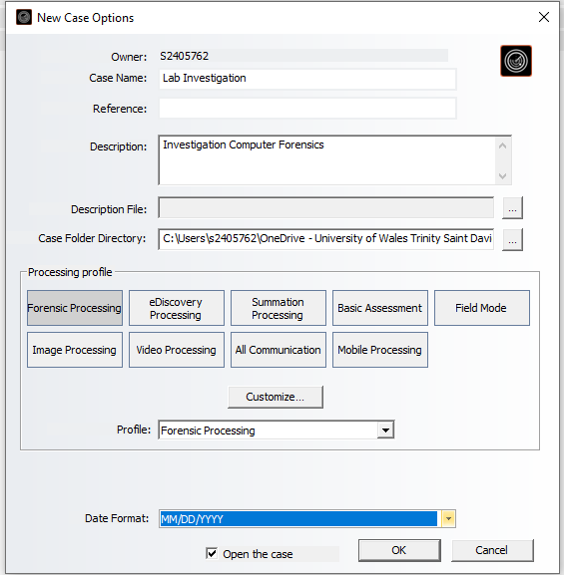
Figure 1 – Create a case on FTK with the processing profile as Forensic Processing and filling in all relevant information such as case name and description.
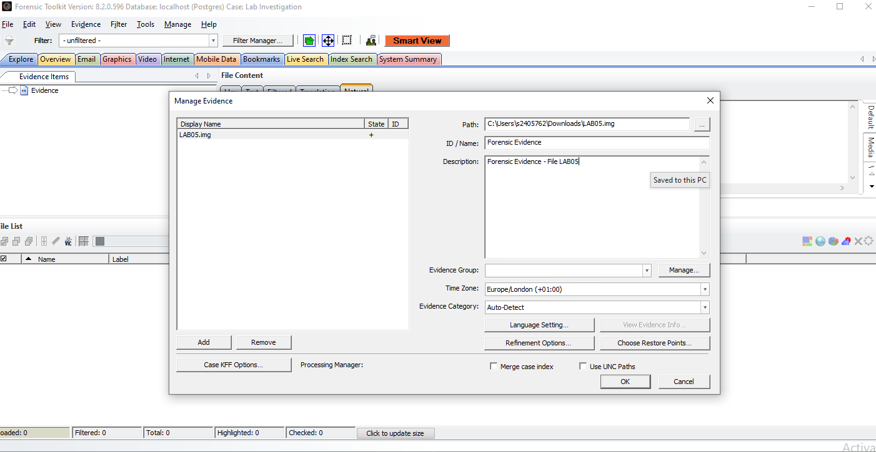
Figure 2 – Upload the forensic image onto FTK so it can load and verify
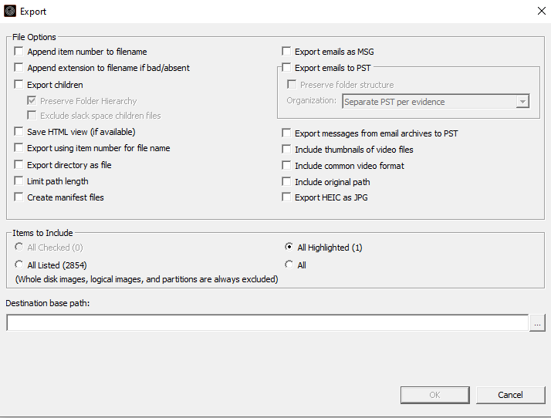
Figure 3 – export and select all the data from the image
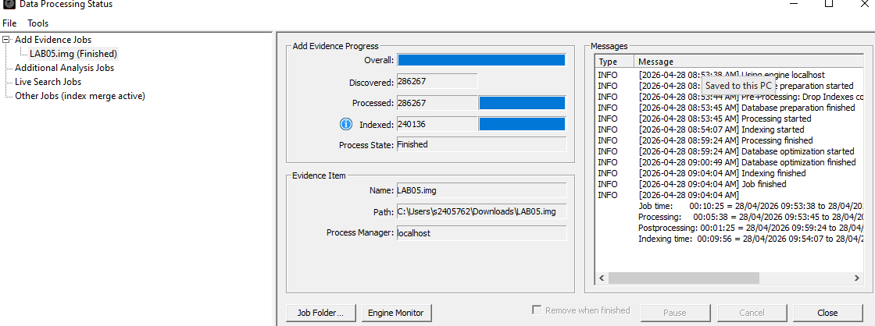
Figure 4 – Complete upload of all data from the image onto the forensic toolkit
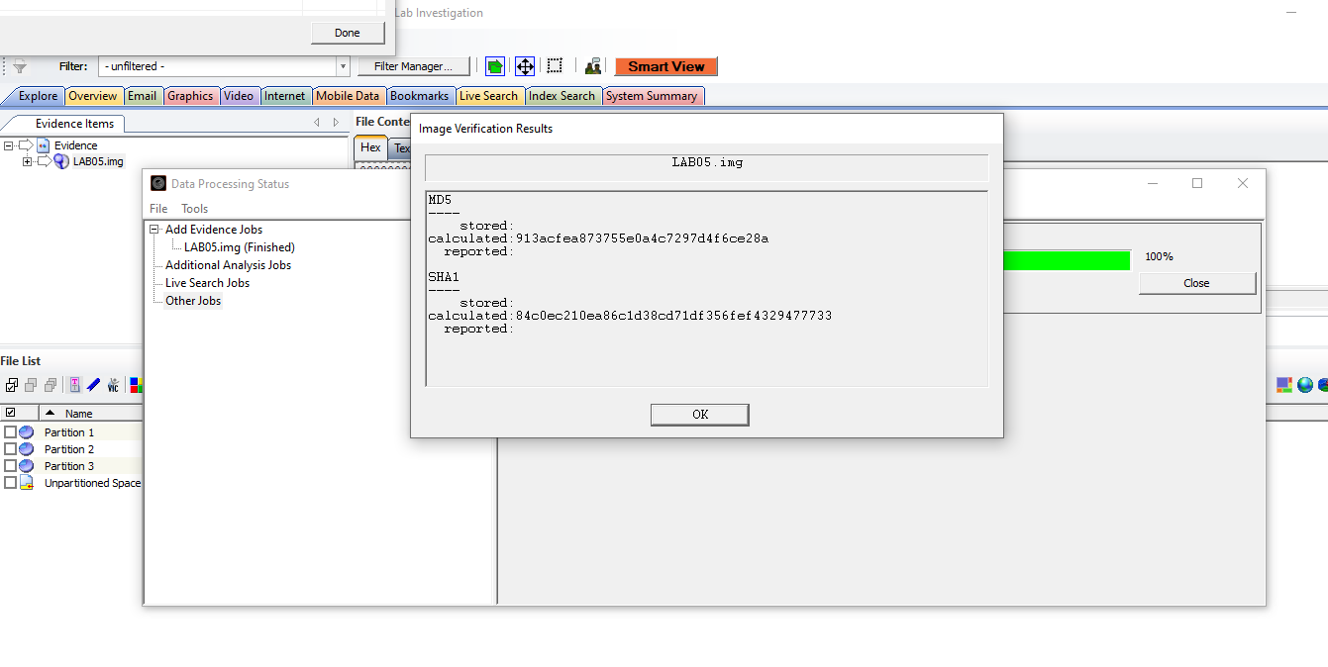
Figure 5 - Get verification of both the MD5 and SHA1 due to the files being encrypted
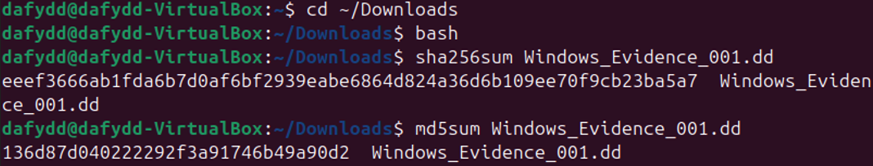
Figure 6 – Double check the integrity of the file by running both a sha256sum and md5sum Linux bash command.

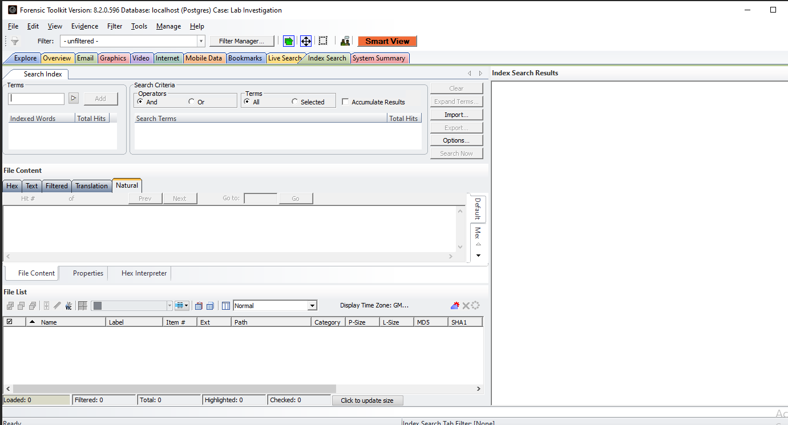
Figure 7 – Use the index searching tool within FTK to find certain events that had taken place on the workstation
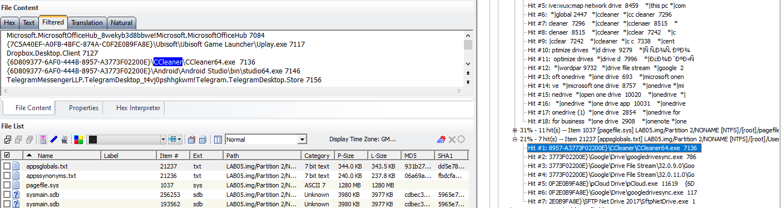
Figure 8 – Search using index searching tools to find deletion of files. In this screenshot, the Ccleaner tool was used to erase files as multiple occurrences of ccleaner64.exe was found.
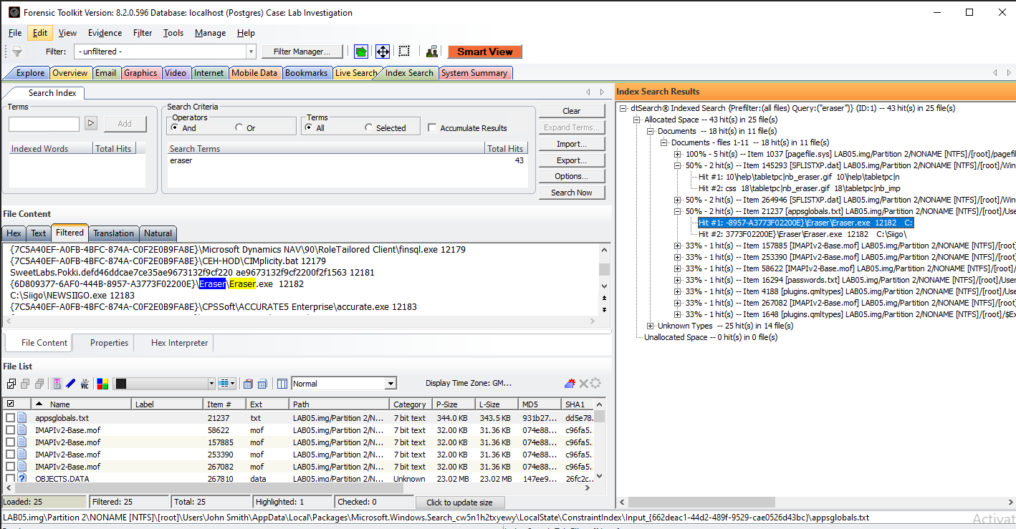
Figure 9 – Index searching also found the use of the use of the eraser.exe tool used for further wiping.
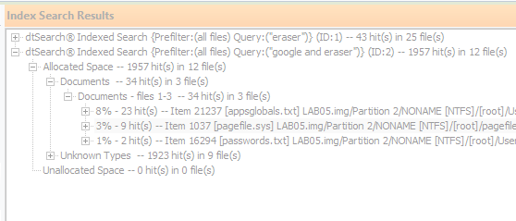
Figure 10 – Proof of over 34 hits in 3 files for key words google and eraser
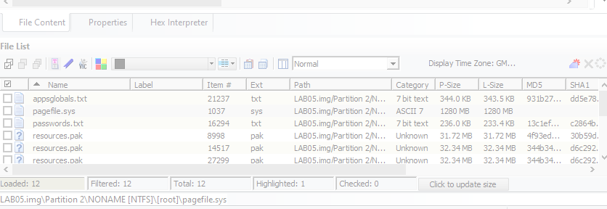
Figure 11 – Browsing further files which are showing within the image
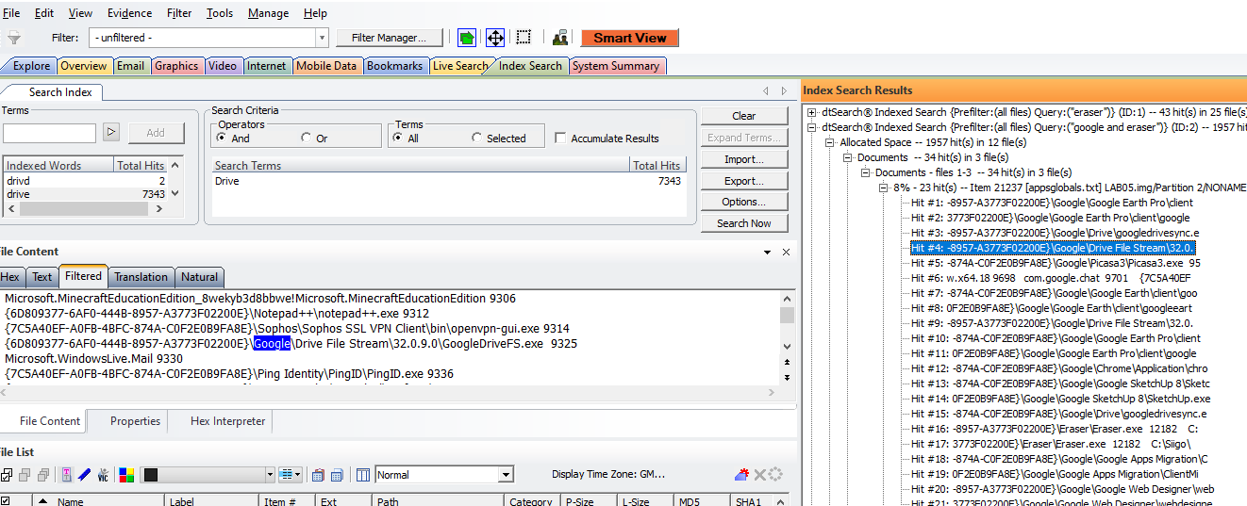
Figure 12 – Index searching revealed that the workstation connected to Sophos VPN client and then accessed Google Drive and a sync was actioned.
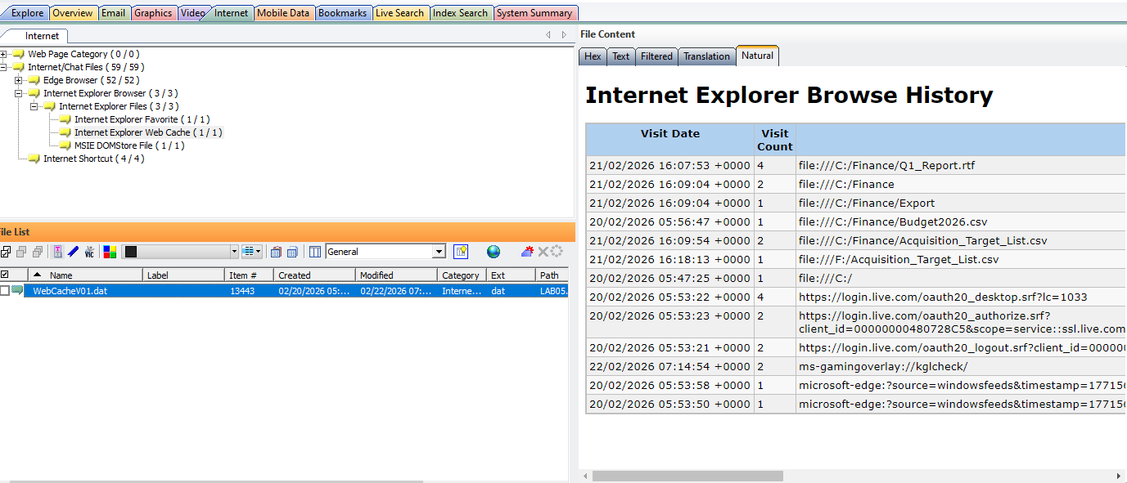
Figure 13 – Analysing the internet explorer browser history on the workstation reveals what the user had been on.
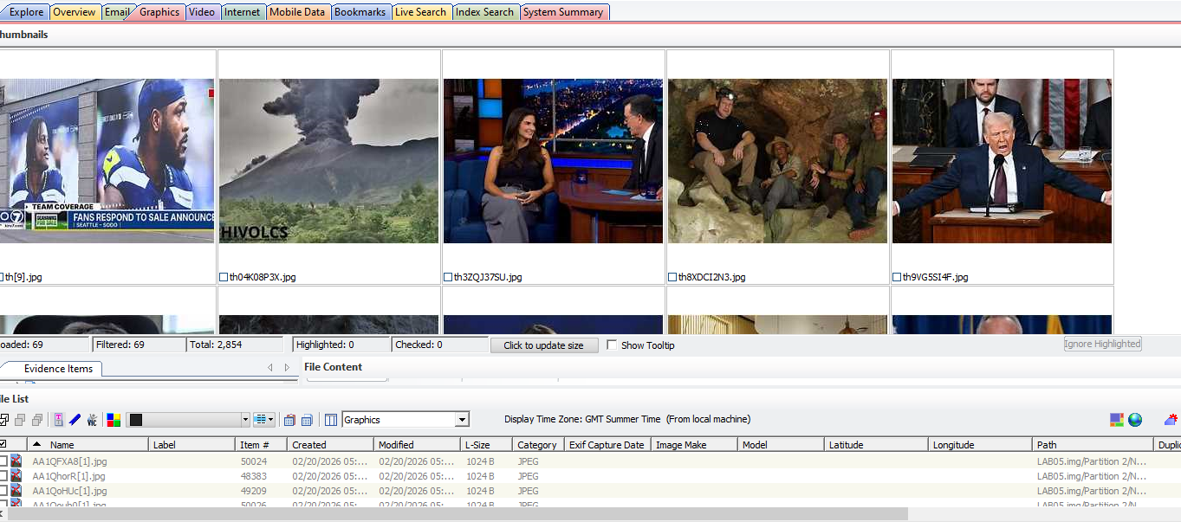
Figure 14 – Analysis of the graphical images that were saved on the workstation.
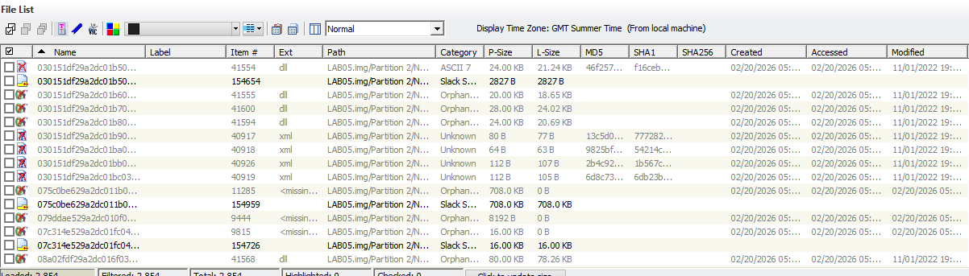
Figure 15 – Recovered file fragments which indicate deleted files within FTK
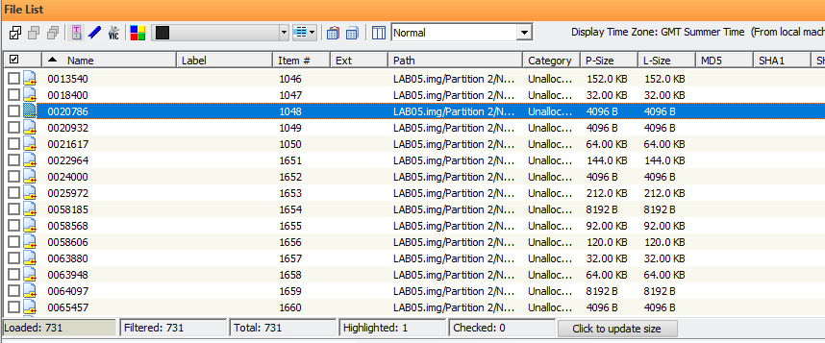
Figure 16 – Unallocated file space found with FTK which shows where deleted files could have been stored
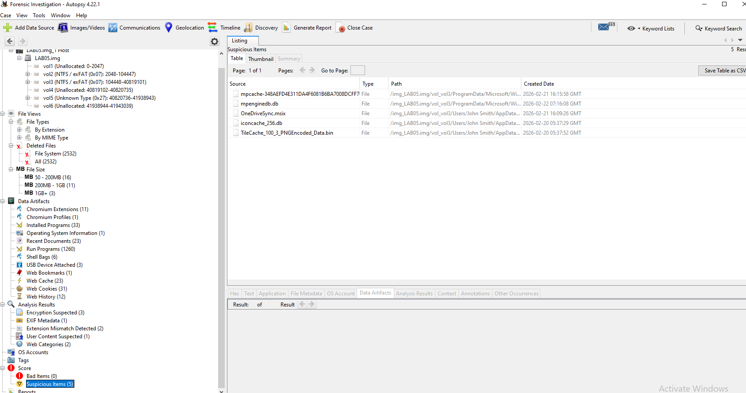
Figure 17 – Launch Autopsy Forensic Investigator for further analysis and upload the image.
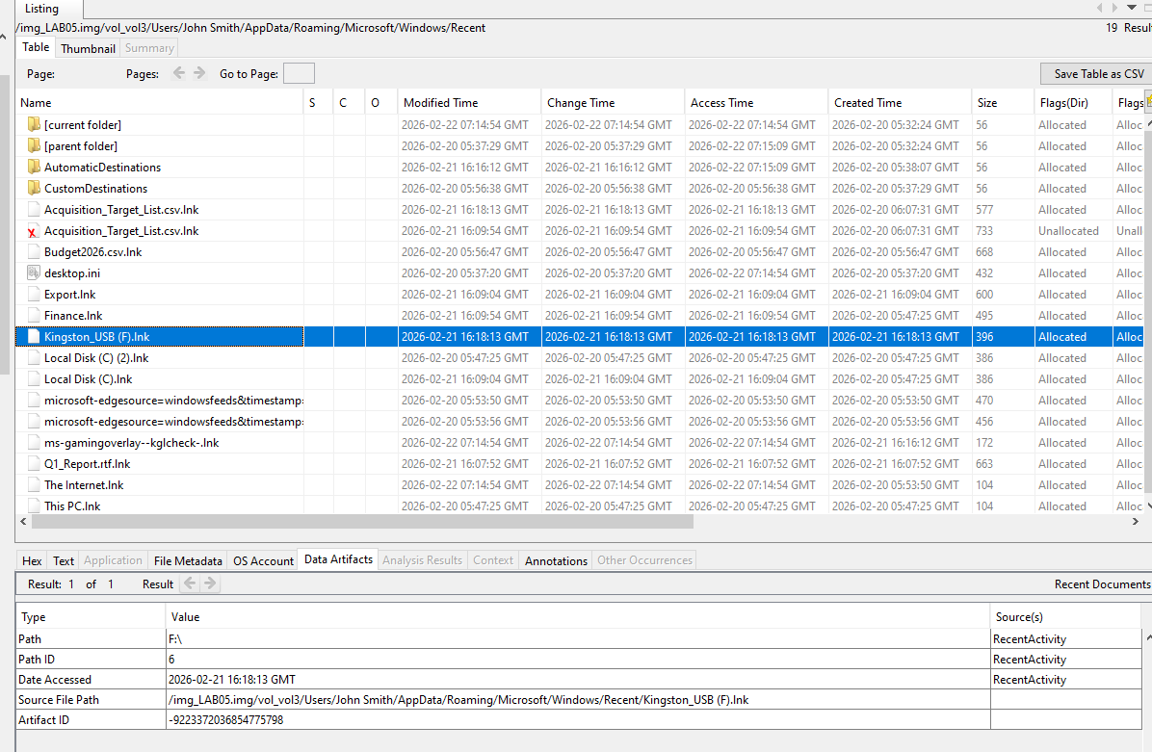
Figure 18 – Upon further analysis on Autopsy, it shows that a Kingston USB stick has been plugged into the workstation.
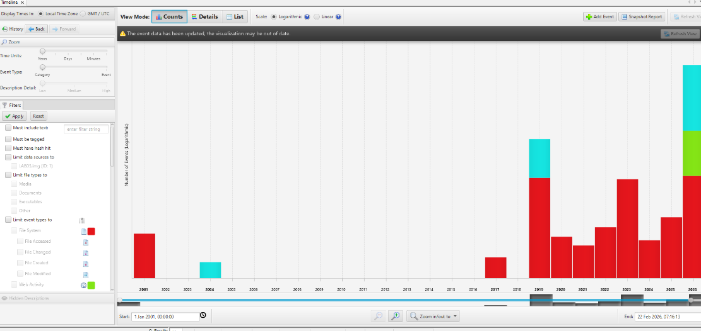
Figure 19 – Dive further into analysis by using the graphic tool within Autopsy which shows when web browser, file or other activity has been recorded and what year it had taken place.
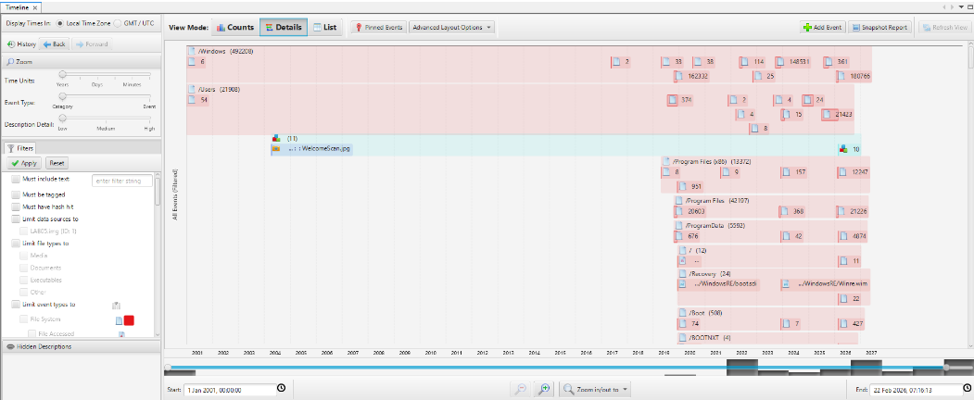
Figure 20 – Viewing when events had occurred in an interactive timeline which allows means blocks of suspicious activity can be analysed.
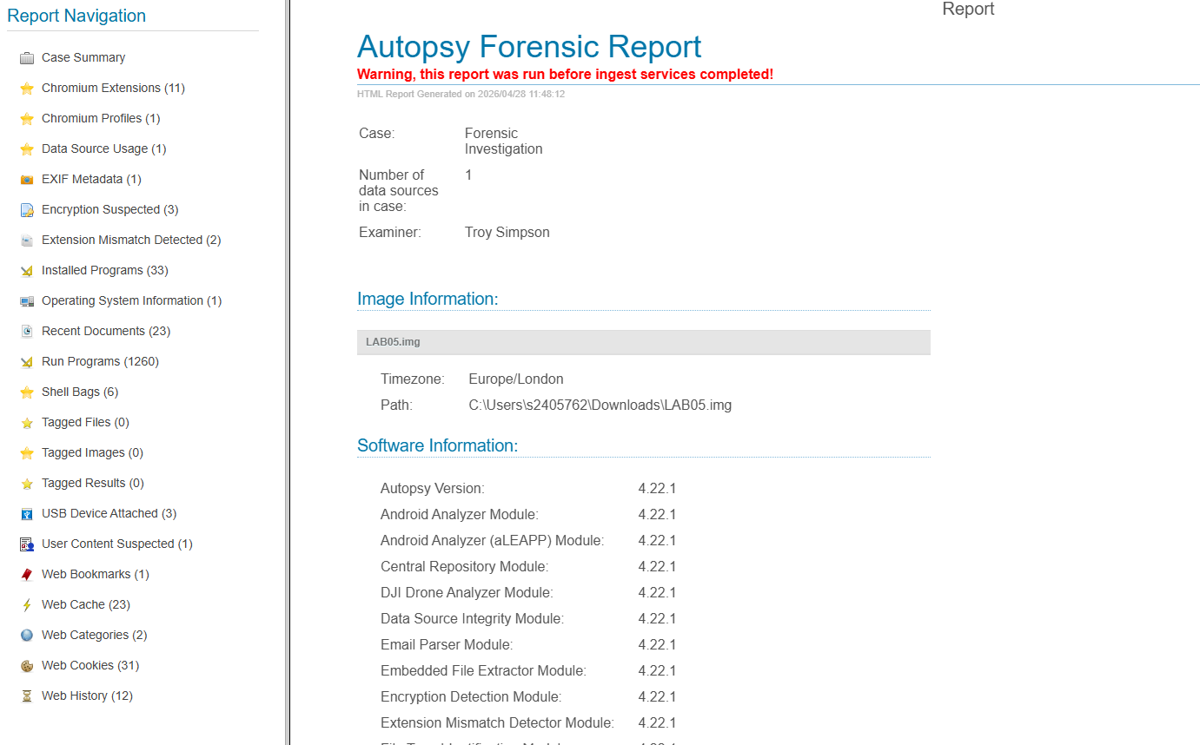
Figure 21 – Using Autopsy, create a full, court admissible forensic report outlining what had been found within the image and what had been researched for continuity and chain of custody.

Conclusion
In conclusion, the forensic investigation which has been conducted against former employee of CMMC Rich Daley, has been completed in a lawful manner following ACPO principles and CHFI methodology along with comprehensive audit such as chain of custody and reporting. Throughout the entire investigation, the Computer Forensics lifecycle was followed to ensure that the investigation was thorough and evidence was collected lawfully.
There were a range of challenges which I had identified, and these were set out in the investigation plan. Firstly, encryption on the Windows 11 workstation had to be bypassed to obtain the image while also having look into anti-forensic techniques which had been used by Rich Daley to erase vital data. A live memory acquisition was completed using FTK as well as verifying using SHA256SUM and MD5SUM Linux Bash commands. Using live acquisition as well as use of tools such as Forensic Toolkit, Magnet AXIOM and Autopsy, a sound investigation was conducted without compromising the data or altering the original data. When the sabotage had taken place, the tools advanced file carving techniques were used which would allow recovery of critical fragments of the deleted Autodesk Maya design files. Using the tools, in-depth browser analysis enables the reconstruction of user activity which will allow investigators to verify that the sensitive company data was transferred via Google Drive.
Overall, the use of forensic technology, tools and forensic techniques allow reconstruction of events, proof of deletion and a timeline of the events which took place all leading to a successful investigation as these allow recovery of file evidence, anti-forensic steps, analysis of cloud activity.
Following these processes and actioning use of these tools ensure that CMMC can progress with legal action against Rich Daley, using credible digital evidence which has been found using the forensic examination tools. This investigation shows and indicates the importance of implementing stronger internal controls, such as BitLocker recovery management, regular backups and monitoring of insider activity to prevent the same thing happening to CMMC in the future.

Appendix
SHA256 - eeef3666ab1fda6b7d0af6bf2939eabe6864d824a36d6b109ee70f9cb23ba5a7
MD5SUM - 136d87d040222292f3a91746b49a90d2

Professional Invoice
Professional invoice from Troy Simpson Forensics
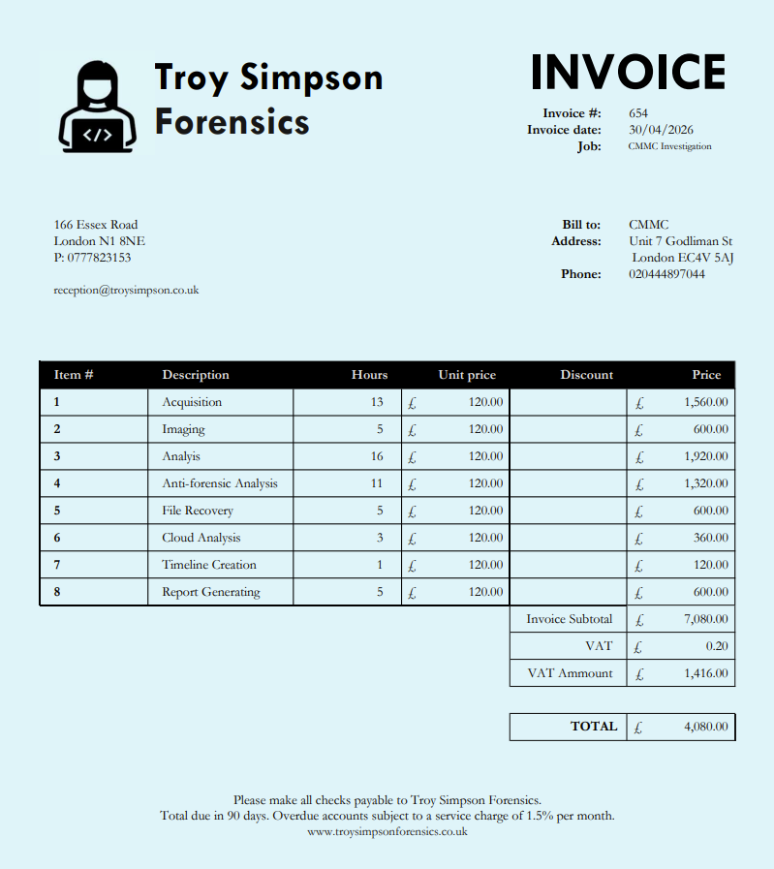

Bibliography
[1]
“100+ Technology Statistics 2025 · AIPRM.” Accessed: Apr. 20, 2026. [Online]. Available: https://www.aiprm.com/en-gb/technology-statistics/
[2]
EC-Council, "Computer Hacking Forensic Investigator (CHFI)," EC-Council, 2025. [Online]. Available: https://www.eccouncil.org/train-certify/computer-hacking-forensic-investigator-chfi/
[3]
S. Admin, “How to Conduct Digital Forensics: Step-by-Step Guide.” Accessed: Apr. 29, 2026. [Online]. Available: https://computerforensicslab.co.uk/how-to-conduct-digital-forensics-guide/
[4]
Exterro, "Law Enforcement Digital Forensics Software - FTK," Exterro, 2025. [Online]. Available: https://www.exterro.com/law-enforcement-market
[5]
C. Dodt, "Computer Forensics: FTK Forensic Toolkit Overview," Infosec Institute, 2019. [Online]. Available: https://www.infosecinstitute.com/resources/digital-forensics/computer-forensics-ftk-forensic-toolkit-overview/
[6]
Forensic Store, "Forensic Toolkit Suite," Forensic Store, 2017. [Online]. Available: https://www.forensicstore.com/product/forensic-toolkit-6-2/
[7]
“FTK Imager Pro | Encryption Detection & iOS Collections.” Accessed: Apr. 29, 2026. [Online]. Available: https://store.exterro.com/products/ftk-imager-pro
[8]
Sleuth Kit Labs, "Autopsy - Digital Forensics," Sleuth Kit Labs, 2025. [Online]. Available: https://www.autopsy.com/
[9]
Sleuth Kit Labs, "Autopsy: Features," Sleuth Kit Labs, 2025. [Online]. Available: https://www.sleuthkit.org/autopsy/features.php
[10]
Cyber Forensics Academy, "Magnet AXIOM: Features, Pricing & Real Investigation Use Cases," Cyber Forensics Academy, Dec. 2025. [Online]. Available: https://www.cyberforensicacademy.com/blog/magnet-axiom-features-pricing-real-investigation-use-cases
[11]
Magnet Forensics, "Introduction to Magnet AXIOM," Magnet Forensics, 2025. [Online]. Available: https://www.magnetforensics.com/resources/introduction-to-magnet-axiom/
[12]
T. Sutikno and I. Busthomi, "Capabilities of Cellebrite Universal Forensics Extraction Device in Mobile Device Forensics," Computer Science and Information Technologies, vol. 5, no. 3, pp. 254–264, Nov. 2024. [Online]. Available: https://csit.iaesprime.org/index.php/csit/article/view/138
[13]
National Institute of Justice, "Cellebrite UFED, Version 1.1.7.6 Evaluation Report," U.S. Department of Justice Office of Justice Programs, 2010. [Online]. Available: https://www.ojp.gov/ncjrs/virtual-library/abstracts/cellebrite-ufed-version-1176-evaluation-report
[14]
Wikipedia, "Cellebrite UFED," Wikipedia, The Free Encyclopedia, 2025. [Online]. Available: https://en.wikipedia.org/wiki/Cellebrite_UFED
[15]
SUMURI PALADIN, “PALADIN Forensic Suite,” SUMURI LLC. [Online]. Available: https://sumuri.com/software/paladin/
[16]
“PALADIN LTS 64 Bit Forensic Imaging Tool.” Accessed: Apr. 30, 2026. [Online]. Available: https://sumuri.com/product/paladin-lts/
[17]
MSAB XAMN, “XAMN – Mobile Forensic Analysis Software,” MSAB. [Online]. Available: https://www.msab.com/products/xamn/
[18]
“How to automate your keyword searching in XAMN Pro?” Accessed: Apr. 30, 2026. [Online]. Available: https://www.msab.com/tutorials/how-to-automate-your-keyword-searching-in-xamn-pro/
[19]
S. Admin, “7 Essential Digital Forensics Best Practices for Success.” Accessed: Apr. 30, 2026. [Online]. Available: https://computerforensicslab.co.uk/digital-forensics-best-practices-success/
[20]
“ACPO guidelines & principles explained.” Accessed: Apr. 30, 2026. [Online]. Available: https://forensiccontrol.com/guides/acpo-guidelines-principles-explained/
[21]
“Understanding Digital Forensics: The Importance of Chain of Custody | Infosec”, Accessed: Apr. 30, 2026. [Online]. Available: https://www.infosecinstitute.com/resources/digital-forensics/computer-forensics-chain-custody/
[22]
D. Hilliard, “Admissible digital evidence | Strengthening prosecutions.” Accessed: Apr. 30, 2026. [Online]. Available: https://www.magnetforensics.com/blog/from-seizure-to-verdict-strengthening-prosecutions-with-clear-admissible-digital-evidence/

