Database Coursework Submission
- Student Details
- Name: Yahya Sugal Jama
- Student ID: 2532858
- Module: Introduction to Web and Database Concepts
- Lecturer: Anum Paracha
2. Table of Contents
(Use automatic table of contents in Word)
3. Introduction
- Overview of MediLink Pharmacy scenario
- Purpose of the database system
4. Scenario Analysis
- Identify entities
- Attributes of each entity
- Relationships between entities
5. Entity Relationship Diagram (ERD)
- Insert ERD diagram here
- Include primary keys, foreign keys, cardinality
6. Data Structure Design
- Tables created
- Field names and data types
- Relationships and constraints
7. Normalisation (Up to 3NF)
- Show steps of normalisation
- Explain decisions
8. Sample Data
- Insert screenshots or tables (minimum 5 records per table)
9. Queries
- List queries created
- Purpose of each query
- Screenshots of results
10. Forms and Reports
- Screenshots of forms
- Screenshots of reports
- Explanation of functionality
11. Validation and Testing
- Testing methods
- Results
- Issues found and fixes
12. Reflection
- Challenges faced
- Improvements for future
13. Conclusion
- Summary of system
14. References
- Use IEEE format
15. Appendices
- Additional screenshots
- Additional queries if needed

Introduction
Auto Park management system, a citywide parking services provider, is currently facing these challenges because it relies on paper records and manual data updates. As the organization expands and operates several parking locations in the city, the disadvantages of manual data management have become obvious. [1]
This aims to design and implement a fully working relational database using Microsoft Access to help solve these problems. We aim for a centralised system that can store, manage, and evaluate operational data in a structured and efficient way. The database solution is designed for key operational areas, including customer registration, vehicle management, parking slot allocation, booking records, and payment processing. [2]
Auto Park can integrate all these components into a single system to increase accuracy, reduce redundancy, and improve day-to-day operations. The project follows a systematic development process that begins with a scenario analysis of the core entities and their relationships. Then, an Entity-Relationship Diagram (ERD) is drawn to visually represent the database's logical framework. Tables are created from the ERD, and primary and foreign keys are defined with referential integrity. [3] After the database structure is in place, sample data is inserted to simulate real-world use cases and illustrate system behaviour under normal operating conditions. [4].

Scenario Explanation
In an effort to solve these problems, Auto Park must establish a centralised database system to store, manage and process all the operational data in an orderly and efficient manner. [5]
To address this problem, I have designed and implemented a relational database using Microsoft Access. This will maintain the key entities such as customers, vehicles, parking sites, parking slots, bookings and payments. [6]. The system will clearly establish relationships among these entities, supporting key features such as slot allocation, booking management, payment tracking, and overall reporting.
The case presents a simplified but realistic framework for the progress of an operational database system. It defines the core operational needs of a parking management organisation. It provides a basis for the design of a solution that increases data accuracy, improves efficiency and enables better decision-making.

Identify entities
The Auto Park Management system is built around a set of core entities that represent the core components of its business. [7] These entities form the backbone of the database, making sure that all the relevant information is organised and meaningful.

Each entity is a concentrate object or process in the parking management context.
From the scenario, the main entities identified are:
Customer:
- This is a person who has a car and uses the services of Auto Park.
Vehicle:
- Refers to vehicles registered by customers for parking.
Parking Site:
- Represents a physical parking spot managed by Auto Park.
Parking Slot:
- Refers to individual parking spaces within each parking area
Booking:
- Indicates the allocation or use of a vehicle parking space
Payment:
Displays financial transactions for reservations.
These entities collaborate to provide the system’s core functions such as customer management, vehicle tracking, slot assignment, booking and payment recording.

Attributes of each entity
The Relationships between entities are as follows:
Each entity possesses a set of attributes that describe the information it holds. These attributes are based on the scenario requirements and tables you created using Microsoft Access.
Customer To Vehicle
One-To-Many
A customer can have more than one vehicle, but each vehicle belongs to one customer.
Vehicle To Booking: One-To-Many
A vehicle can have multiple bookings over time, but each booking can be for only one vehicle.
Parking Site To Parking Slot: One-To-Many
Each parking facility has many parking spaces, but each parking space is associated with only one parking facility.
Parking Slot To Booking: One-To-Many
A Parking slot can be booked multiple times, but the booking is for one slot.
Booking To Payment: One-To-One or One-To-Many
Each booking has one or more payment records, determined by the payment structure.
These Relationships allow the database to support everyday activities such as tracking slot usage, linking customers to vehicles, and linking payments to bookings.

Entity Relationship Diagram (ERD)
- Insert ERD diagram here + Link: https://lucid.app/lucidchart/64feb9c7-a19e-48ba-818c-0f833b60a94a/edit?page=0_0&invitationId=inv_3fe10e35-aaaf-4a65-96a6-70e29dad9afc#
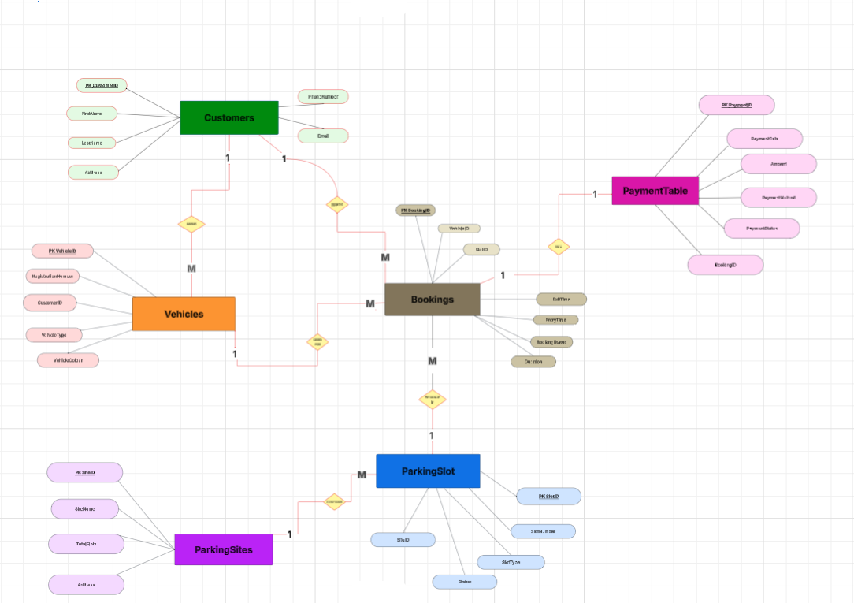
Figure 1: Entity Relationship Diagram (ERD) for Auto Park Management- includes primary keys, foreign keys, and cardinality. [8]

Data Structure Design
- Tables created: Customer Table
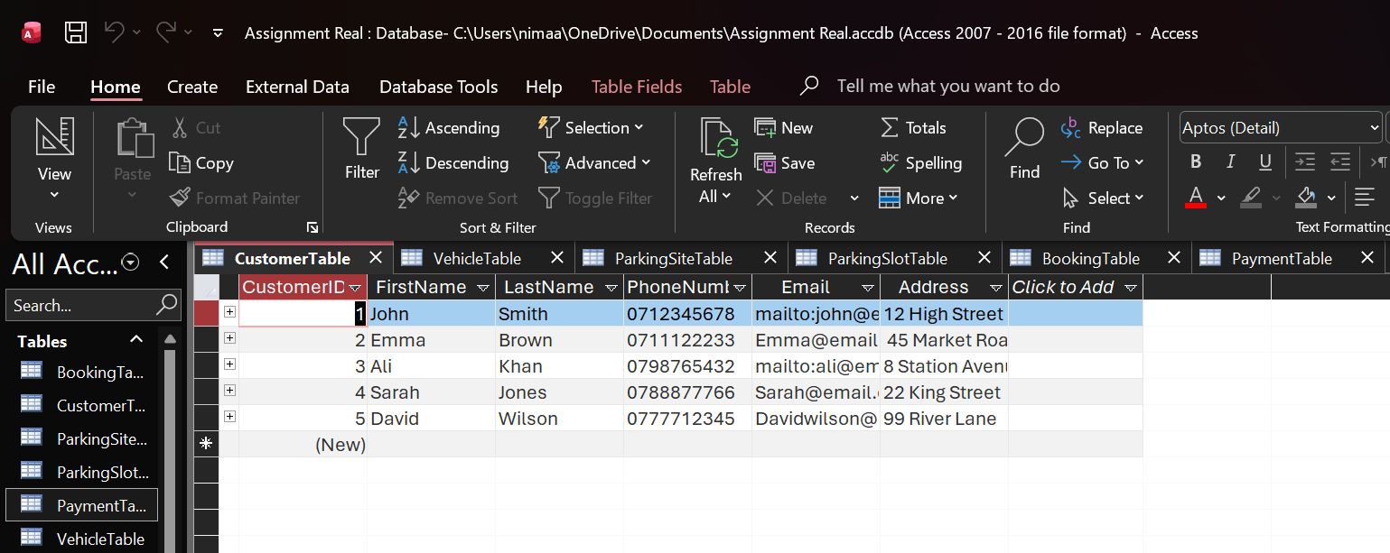
Figure 1: Customer Table – Datasheet View Displaying Customer ID, Personal Details, and Contact Information. [9]

- Vehicle Table
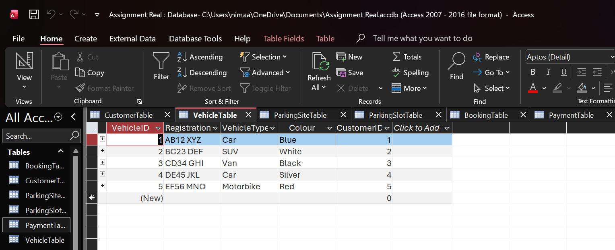
Figure 2: Vehicle Table- Datasheet View Displaying Vehicle Details, Type, Colours, and Customer ID Relationships. [10]

- Parking Site Table
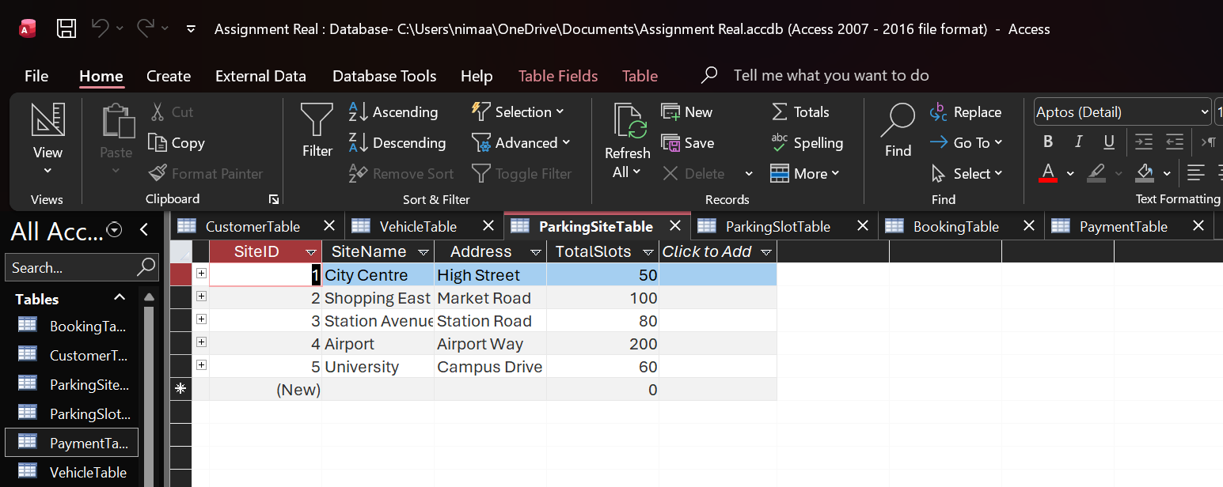
Figure 3: Parking Site Table – Datasheet View Displaying Site ID, Site Names, Addresses and Total Slots. [11]

- Parking Slot Table
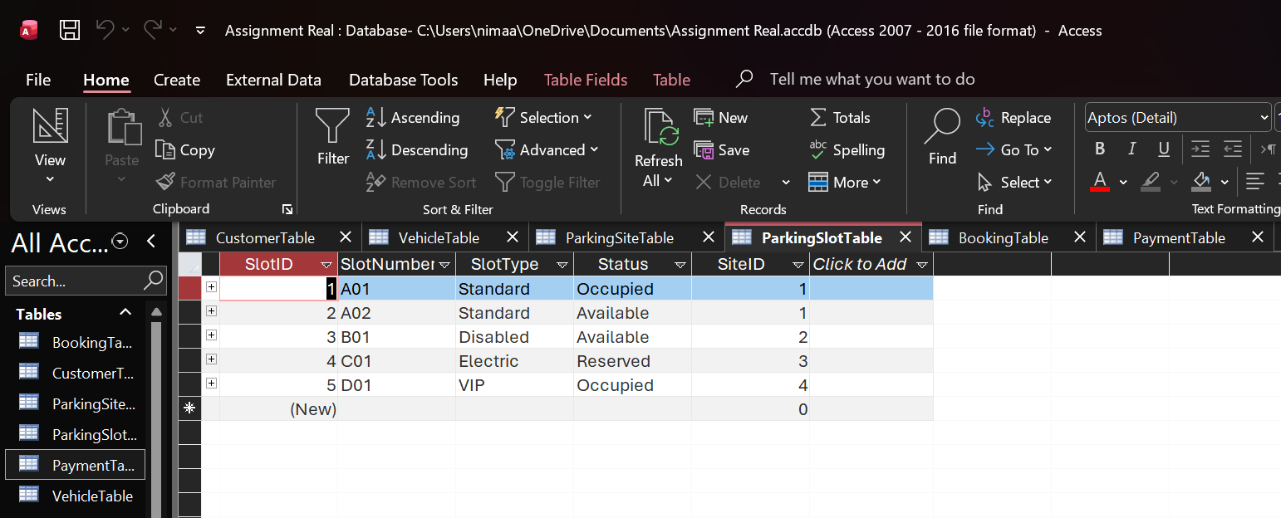
Figure 4: Parking Slot Table – Datasheet View Displaying Slot Numbers, Slot Types, and Availability Status. [12]

- Booking Table
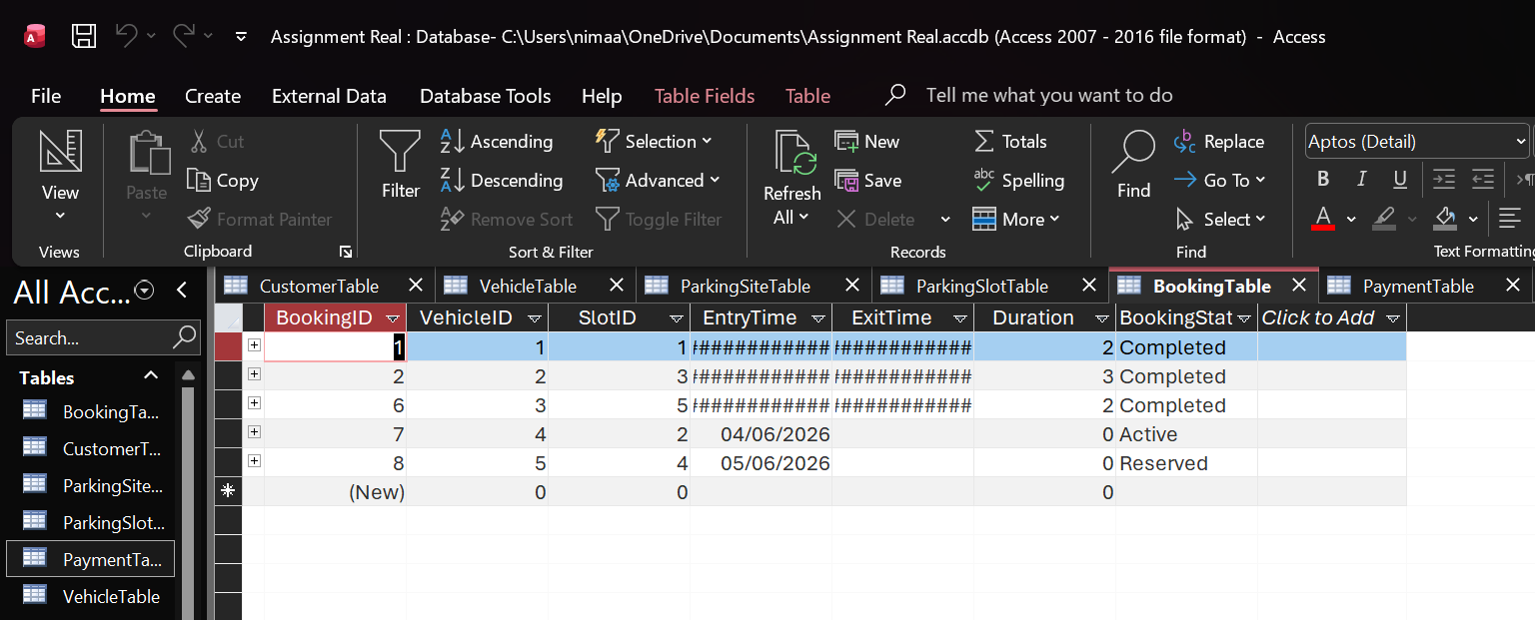
Figure 5: Booking Table- Datasheet View Showing Vehicle Bookings, Slot Assignments, and Booking Status. [13]

- Payment Table Caption
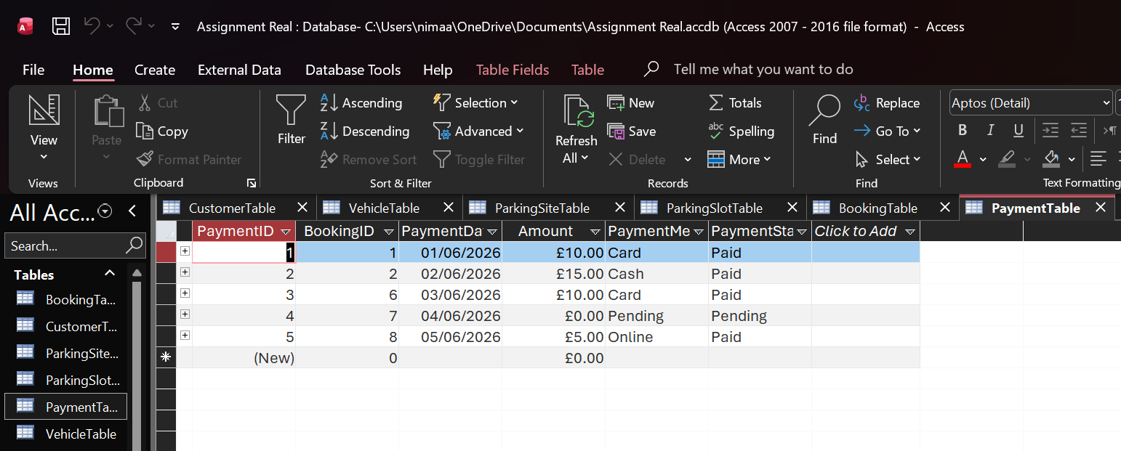
Figure 6: Payment Table – Datasheet View Displaying Payment ID, Booking ID, Payment Method, Amount, and Payment Status. [14]

Normalisation (Up to 3NF)
Normalisation is a process of organising data in a database. [15] It helps to reduce redundancy and improve data integrity.
The Auto Park Management System was normalised to Third Normal Form (3NF) to facilitate precise relationships, effective storage, and ensure data consistency.
The Following steps are performed during the normalisation process
First Step: UNF, which stands for Un-Normalised Form.
In UNF, the data can range from:
- Repeated Clusters
- Multiple Value attributes
- Non-atomic values
-Example (Unnormalised Booking Data)
Imagine booking records set up like this.
Booking ID | Vehicle Details | Slot Details | Times | Status
1 | AB29 XYZ  CAR – BLUE | A01  Standard | 01/07/2026  2 Hours | Completed
2 | BC87 EDS  SUV- WHITE | B01  Disabled | 02/07/2026  3 Hours | Completed

What Problems does this face?
- Vehicle Info is in one field
- Slot Information is in one field
- Total time is combined
- There is a cluster of repetition
- Lastly, there are no specific keys

Second Step: First Normal Form 1NF
A table is in the First Normal Form when :
- All fields consist of atomic values (no multiple values within one cell).
- There are no repeated clusters.
- Every record is unique

- Conversion to 1NF
We divided combined fields into individual fields
Booking ID | Vehicle ID | Slot ID | EntryTime | Duration
1 | 1 | 1 | 01/06/2026 | 2
2 | 2 | 3 | 02/06/2026 | 3

Now:

- Each field stores one value.

- There are no repeating groups.

- The primary key ( Booking ID ) uniquely identifies each record.
- Third Step: Second Normal Form ( 2NF )
A table is in 2NF when:
- It is already in 1NF.
- All non-key attributes depend on the entire primary key.
- This only applies when the primary key is composite.
Check for Partial Dependencies: The Booking table has a primary key, Booking ID, which is not composite. Hence, there are no partial dependencies. If, however, Booking had a composite key such as (Vehicle, Slot ID), attributes such as duration would depend on the entire key.
The outcome is that the Booking Table is already in 2NF.
Fourth Step: Third Normal Form ( 3NF )
A Table is in Third Normal Form ( 3NF ) if:
- This is already in 2nd Normal Form.
- No transitive dependencies.
- Non-key fields are not dependent on other non-key fields.
Verify for Transitive Dependencies: Hypothetical example of a transitive dependency ( if it would exist):
- Payment status is dependent on Payment Method.
- Booking ID depends on Payment Method.
This would violate Third Normal Form (3NF).
Fixing Transitive Dependencies to get to 3rd Normal Form :
- Payment information has been moved to the Payment Table.
- Vehicle data is saved in the Vehicle Table.
- The Parking Slot Table stores the parking slot information.
This ensures :
- Each table deals with one category of data.
- No non-key attribute is dependent upon another non-key attribute.
- Foreign keys are used for all relations.
This Results in all tables in the Auto Park Management System being in the Third Normal Form.

Normal Form | What Was Done | Results
UNF – 1NF | Removed duplicate groups, made fields atomic. | Well-defined, Structured.
1NF – 2NF | All fields are guaranteed to depend on the whole key. | No dependency is partial.
2NF – 3NF | Removed transitive reliance. | Fully standardised tables.

Sample Data
Test data was entered into each table of the Auto Park Management System to enhance the database's functionality and to show how records are stored, linked, and retrieved.
Below, I demonstrate figures showing the sample data entered into each table.

- Customer Table
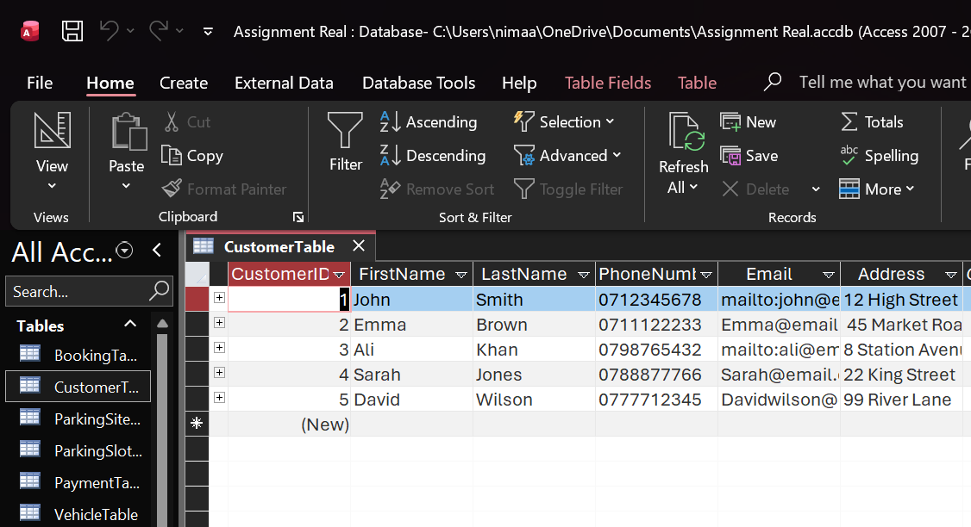 Figure 7: Customer Table showing Customer ID, Names, Contact details, and Addresses. [16]
The Customer Table contains the personal and contact information of the users who use the parking services.

- Vehicle Table
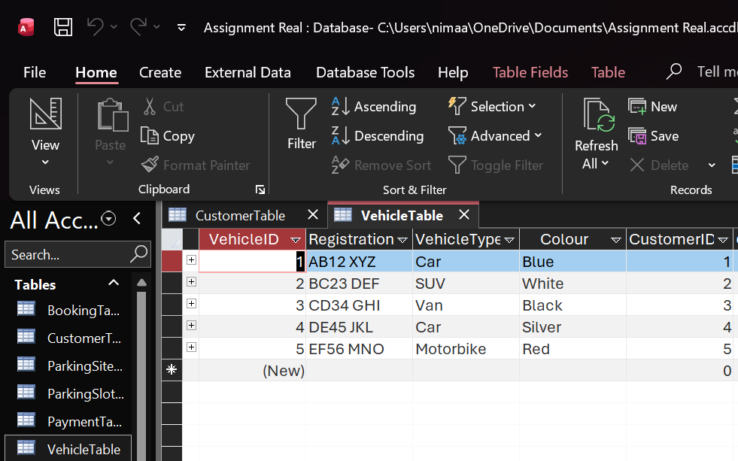 Figure 8: Vehicle Table Showing Vehicle Registration, Colours, and Customer ID Links. [17]
The Vehicle Table contains information about vehicles registered by customers. It stores type, colour and the corresponding Customer ID.

- Parking Site Table
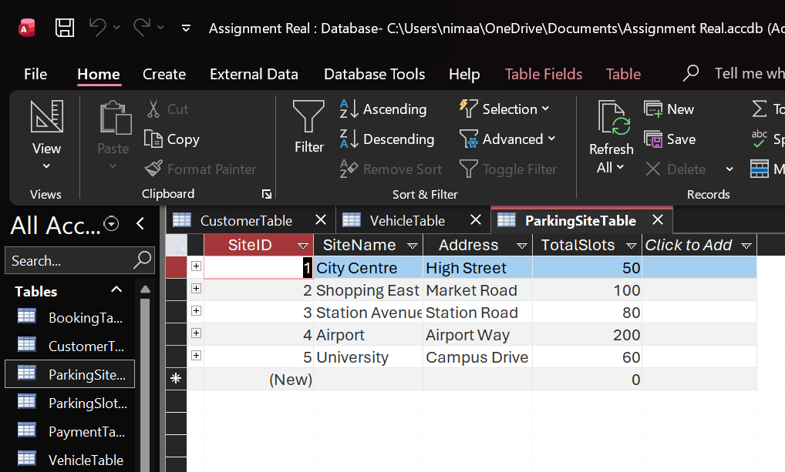 Figure 9: Parking Site Table showing Site Names, Total Slots, and Addresses. [18]
The Parking Site Table contains information about each parking location, including the total number of slots.
- Parking Slot Table
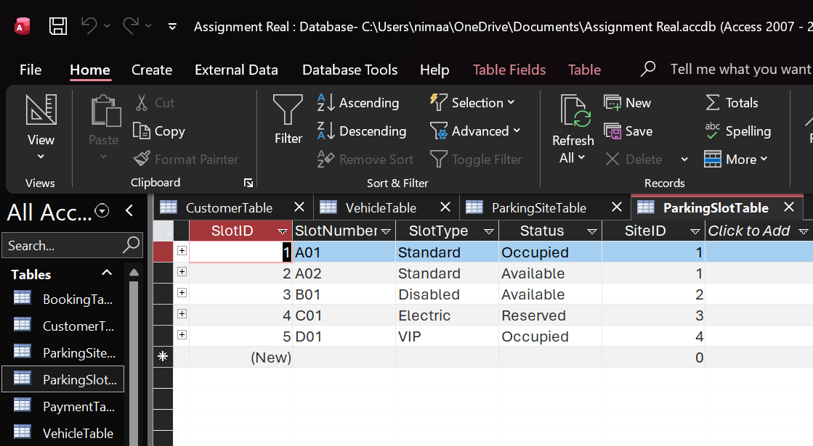Figure 10: Parking Slot Table showing Slot Number, Slot Types, Status and Site ID Associations. [19]
The Parking Slot Table records the number, type, availability status, and associated site for each parking slot.
- Booking Table
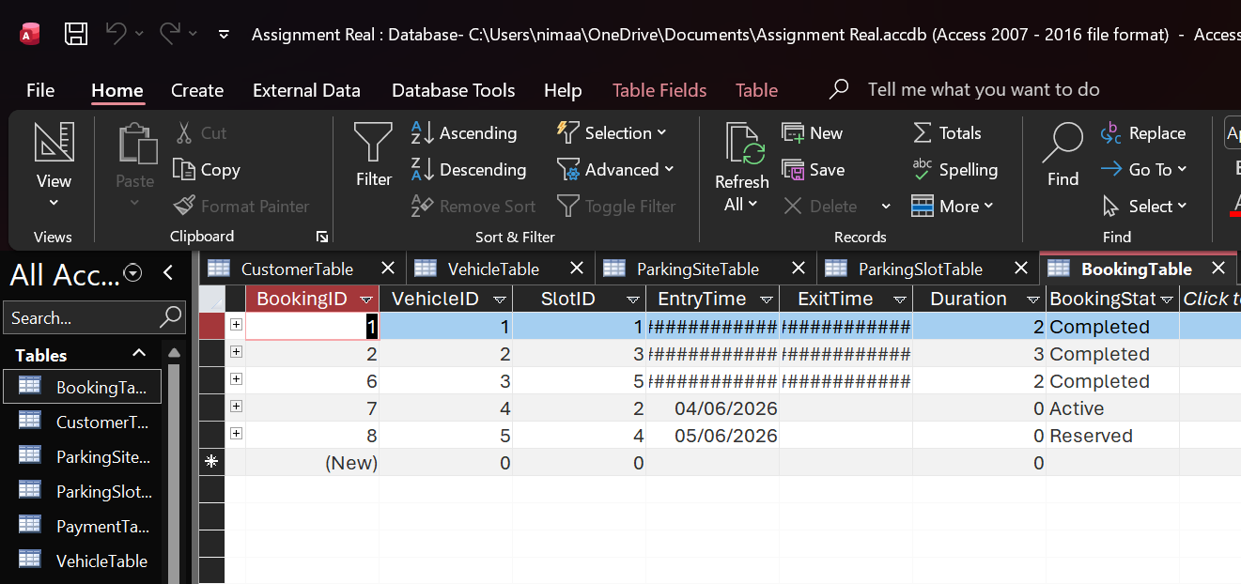Figure 11: Booking Table Showing Vehicle Bookings, Slot Assignments, and Booking Status. [20]
The Booking Table tracks all bookings, recording entry and exit times and the booking status.

- Payment Table
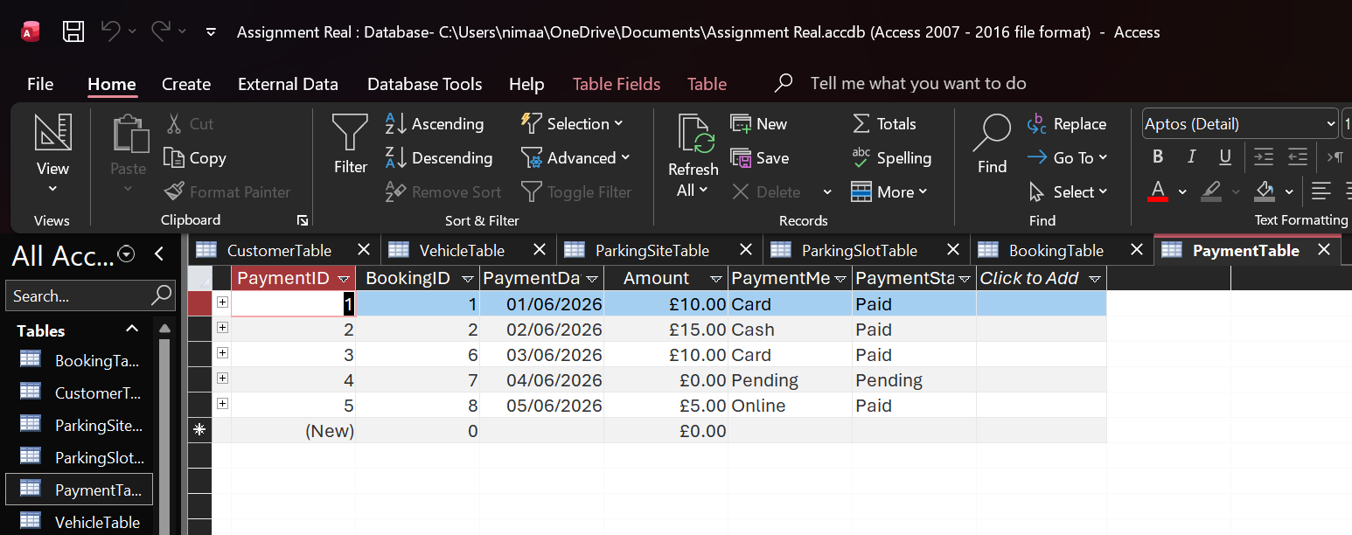Figure 12: Payment Table Showing Payment Dates, Amounts, Methods and Status. [21]
The Payment Table records transactions associated with bookings, detailing the payment method, amount, and status.

Queries
Query 1 – Active Bookings
This Query retrieves all active reservations, allowing staff to see which vehicles remain parked on site.
The Fields Used: Booking ID, Entry Time, Booking Status, Registration ID, Vehicle Type and Customer ID.
The Criteria I applied:
- Booking Status = “Active”
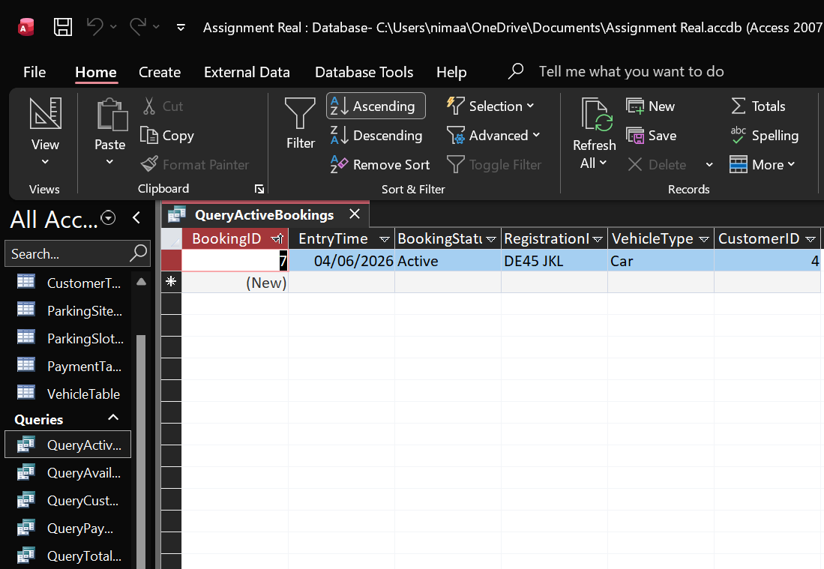 Figure 13: Query Showing All Active Bookings. [22]
This Query filters the Booking Table only to display records with a booking status of Active. It also contains the relevant vehicle and customer information. Making it simple for staff to identify used parking spaces.

Query 2- Available Parking Slots
This Query identifies parking spaces that are available to use at the present moment.
The Fields Used: Slot ID, Slot Number, Slot Type, Status, Site ID.
The Criteria I Applied:
- Status = “ Available ”
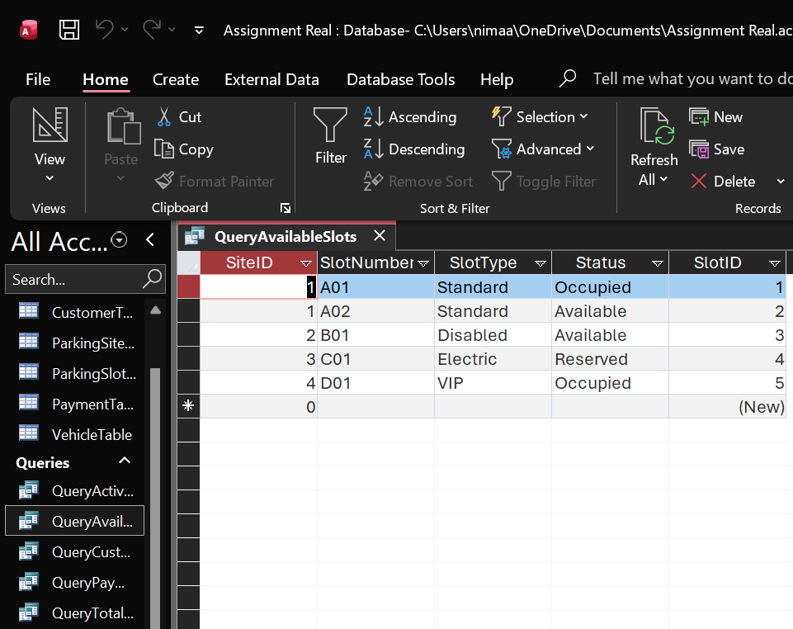 Figure 14: Query Showing All Available Slots. [23]
This query filters the Parking Slot Table to show only slots marked as Available, enabling staff to quickly identify parking spaces for new bookings.

Query 3 - Customer And Vehicle Details
This query lists each customer and their registered vehicle by joining the Customer Table and Vehicle Table.
The Fields Used: First Name, Last Name, Registration, Vehicle Type, Colour.
Join Applied: Customer Table. Customer ID= Vehicle Table.CustomerID.
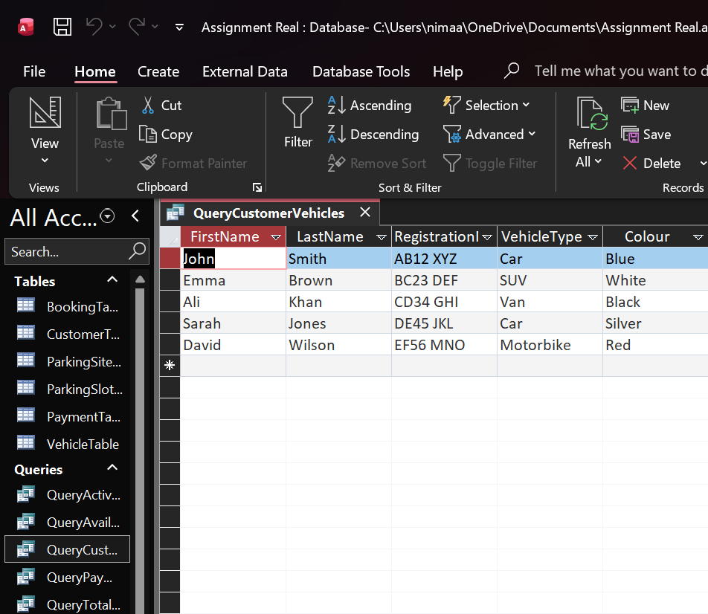 Figure 15: Query Showing Customer Details with Their Registered Vehicles. [24]
This query links customer information to their vehicles, offering a clear overview of vehicle ownership. It supports booking, payment, and operational tasks in the Auto Park Management System.

Query 4 – Payment For Completed Bookings
This query retrieves all recorded payments, enabling staff to review both completed and pending transactions.
The Fields Used: Payment Date, Amount, Payment Status and Booking ID.
The Criteria I Applied: Payment Status = “Paid”
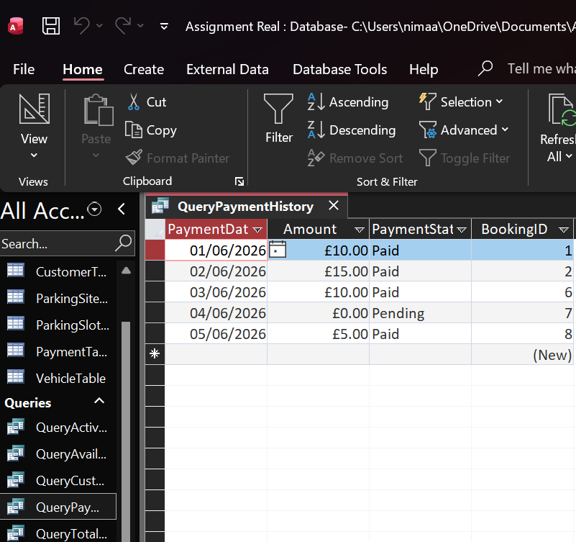 Figure 16: Query Showing All Completed Payments [25]

Query 5 – Total Revenue Generated
The following query calculates the total revenue generated by all completed payments in the Auto Park Management System.
The Fields Used: Amount (Payment Table).
Aggregate Function Applied: SUM ( Amount )
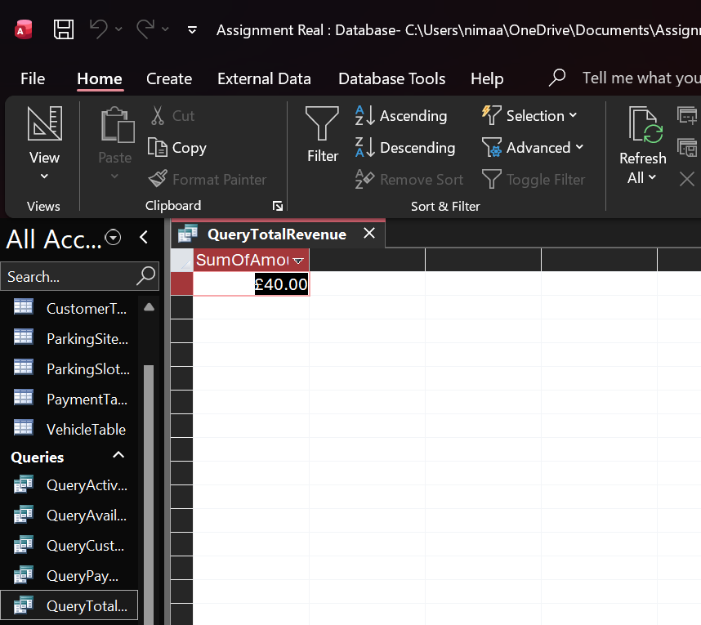 Figure 17: Query Showing Total Revenue [26]

Reports
Reports were created in Microsoft Access to present key information from the Auto Park Management System clearly and in a printable format. Reports
Available Parking Report
The Purpose:
Shows all parking spaces and clearly marks the available ones.
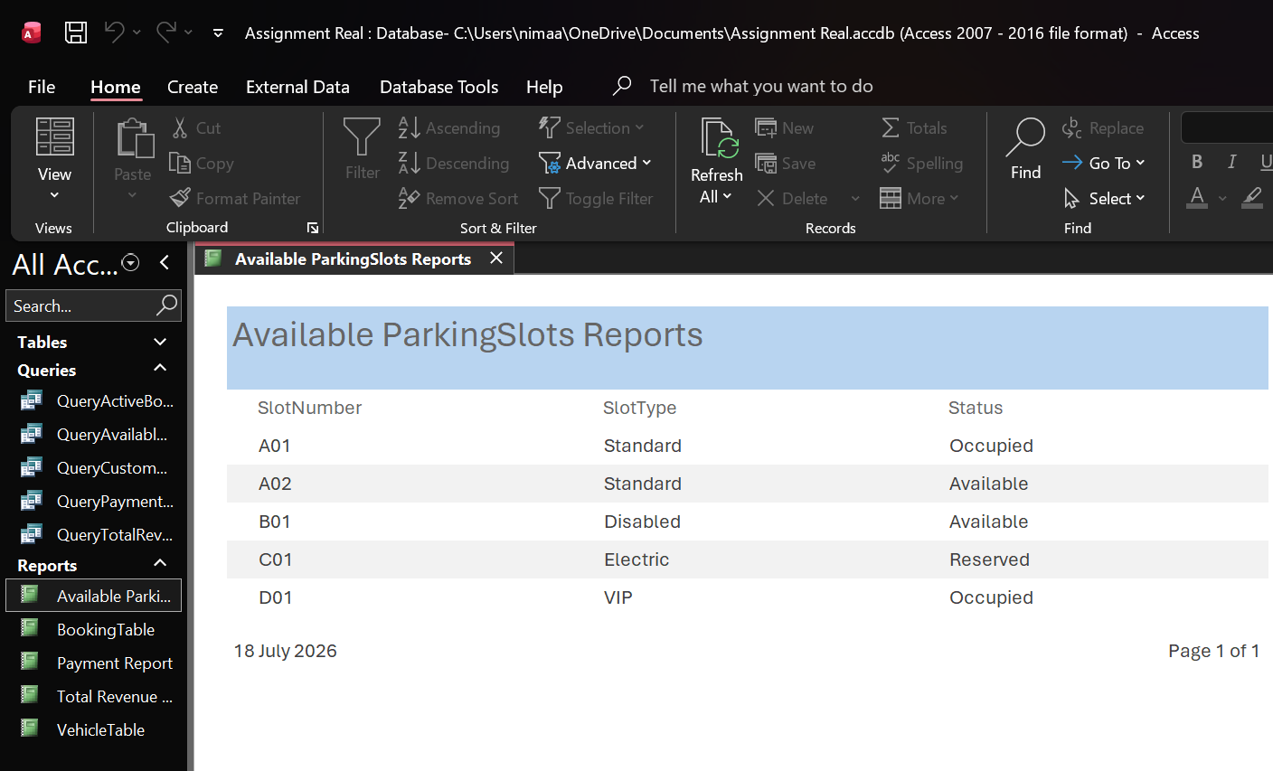 Figure 18: Report Showing Available Parking Slots. ( Source: MS Access )

Booking Report
The Purpose:
This report presents all booking records maintained within the system, detailing entry time, booking identification number, booking status, and vehicle registration number.
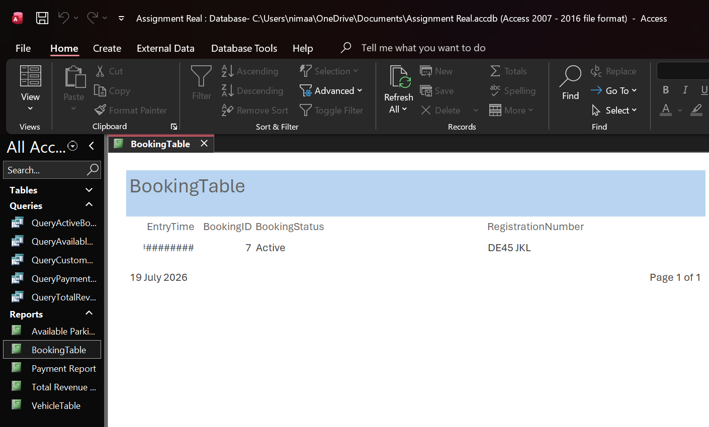 Figure 19: Booking Report Showing Active and Completed Bookings. ( Source: MS Access )
Payment Report
The Purpose:
Shows all payment transactions, along with the amount, payment method, and status.

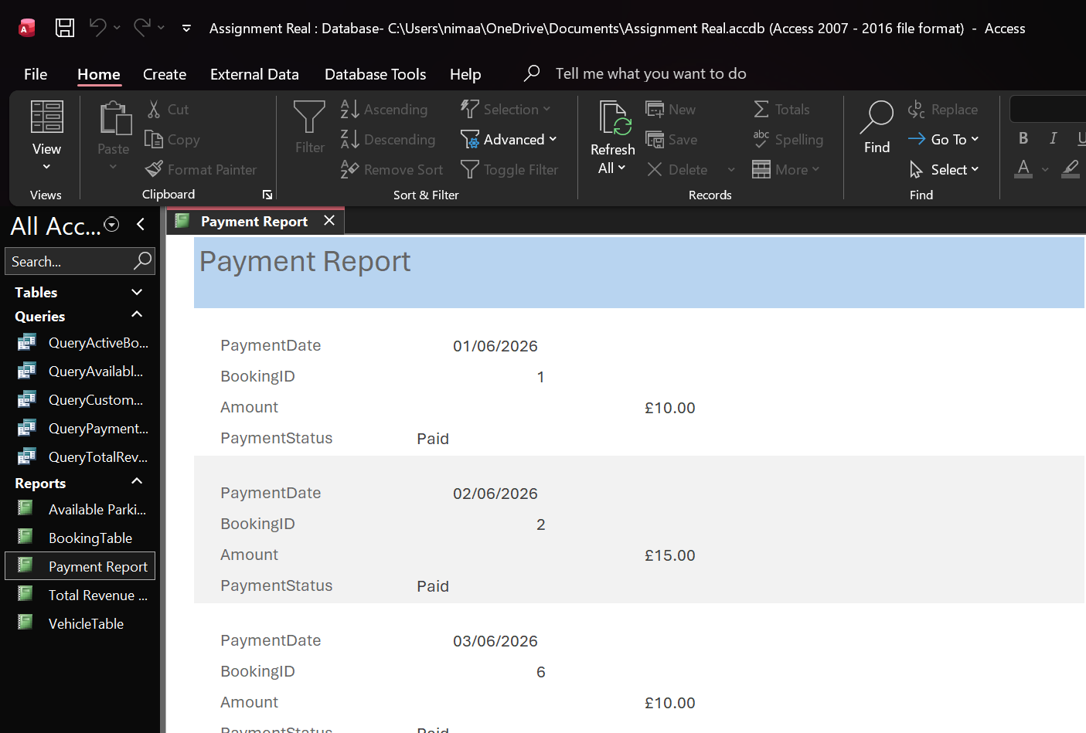 Figure 20: Report Showing Payment History. ( Source: MS Access )

Total Revenue Report
The Purpose:
This calculates the total revenue from all payments.
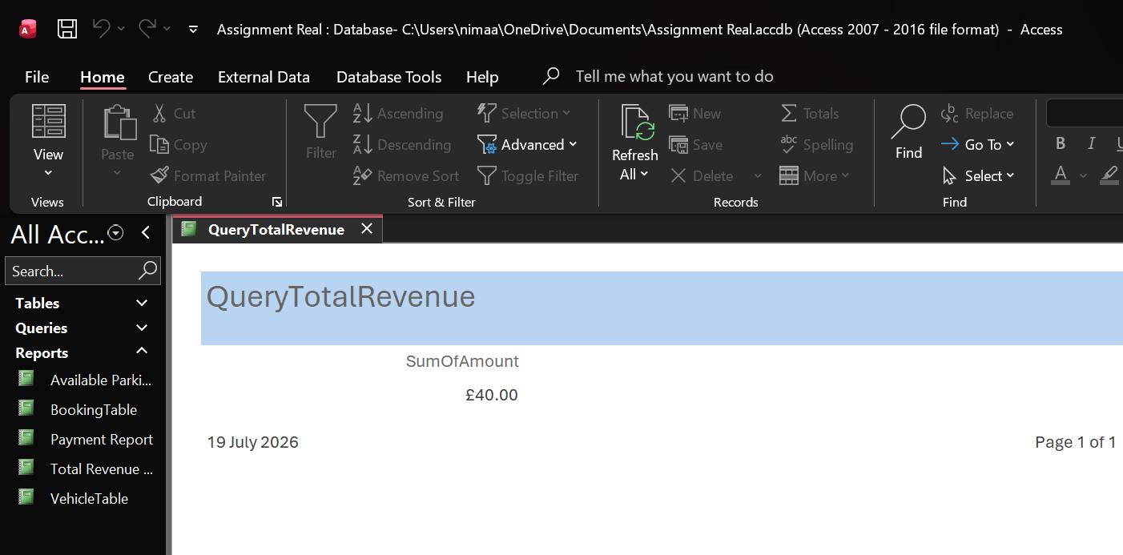 Figure 21: Report Showing Total Revenue. (Source: MS Access)

Vehicle Report
The Purpose:
Displays all vehicles registered in the system, including their type, colour, and associated customer.
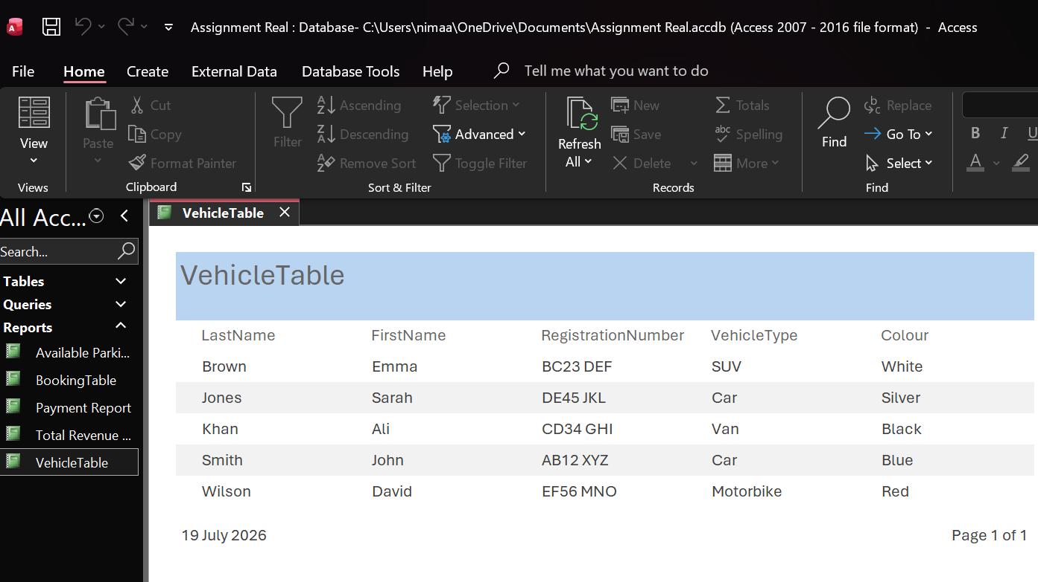 Figure 22: Report Showing Registered Vehicles. ( Source: MS Access )

Validation and Testing
Testing was conducted throughout the development of the Auto Park Management System to verify that all tables, queries, and reports function correctly and deliver accurate results.
Various methods, including normal, abnormal, and boundary data, were used to confirm that the system behaves as expected under different conditions. [27]
Testing Methods Used:
- Normal Data Testing
Normal data refers to valid, expected inputs. It is used to confirm that the system correctly stores, retrieves, and displays information.
- Abnormal Data Testing
Abnormal data refers to incorrect or unexpected inputs. We used such data to verify that the system rejects invalid entries or generates appropriate error messages.
- Boundary Data Testing
Boundary data means using values at the edge of what is allowed. For example, you might test the smallest and largest payment amounts.
The Auto Park Management System has been fully tested and validated. All tables, queries, and reports function correctly, and any issues identified during testing have been resolved. The system meets the assignment’s functional requirements and delivers accurate, reliable outputs for parking management.

Bibliography

[1] | S. P. Ltd, “Why Manual Parking Management Causes Operational Inefficiency,” Smart Parking, [Online]. Available: https://www.smartparking.com/news/manual-parking-management-inefficiency. [Accessed 19 July 2026].
[2] | M. CORP, “Introduction to Database Design,” Microsoft, 5 October 2023. [Online]. Available: https://learn.microsoft.com/en-us/office/access/database-design. [Accessed 19 July 2026].
[3] | M. Corporation, “Database Design Basics,” Microsoft , October 2023. [Online]. Available: https://learn.microsoft.com/en-us/office/access/database-design. [Accessed 19 July 2026].
[4] | Oracle Corporation, “Introduction to Test Data and Sample Data,” Oracle, 14 September 2022. [Online]. Available: https://www.oracle.com/data-management/test-data/. [Accessed 19 July 2026].
[5] | Intact Software, “Page: 10 Benefits of Having a Centralised Single Database,” Intact, [Online]. Available: https://www.intactsoftware.com/blog/centralised-single-database-benefits. [Accessed 20 July 2026].
[6] | RENTALL, “Centralized Reservation System Benefits for Rental,” 11 April 2023. [Online]. Available: https://www.rentallsoftware.com/blog/centralized-reservation-system-benefits. [Accessed 20 July 2026].
[7] | Oracle Corporation, “What Is an Entity in a Database,” Oracle, 2023. [Online]. Available: https://www.oracle.com/database/what-is-an-entity/. [Accessed 20 July 2026].
[8] | Lucid Software Inc., “Online ERD Diagram Tool,” Lucid, 20 January 2024. [Online]. Available: https://www.lucidchart.com/pages/examples/erd-diagram. [Accessed 20 July 2026].
[9] | Microsoft Corporation, “Introduction to Tables,” Microsoft, 5 October 2023. [Online]. Available: https://learn.microsoft.com/en-us/office/access/tables. [Accessed 20 July 2026].
[10] | Microsoft Corporation, “Introduction to Datasheet View,” Microsoft, 5 October 2023. [Online]. Available: https://learn.microsoft.com/en-us/office/access/datasheet-view. [Accessed 20 July 2026].
[11] | Microsoft Corporation, “Create and Modify Tables,” Microsoft, 5 October 2023. [Online]. Available: https://learn.microsoft.com/en-us/office/access/create-modify-tables. [Accessed 20 July 2026].
[12] | Microsoft Corporation, “Working with Fields in Access,” Microsoft, 5 October 2023. [Online]. Available: https://learn.microsoft.com/en-us/office/access/fields. [Accessed 20 July 2026].
[13] | Microsoft Corporation, “ Introduction to Tables and Relationships,” Microsoft, 5 October 2023. [Online]. Available: https://learn.microsoft.com/en-us/office/access/database-design. [Accessed 20 July 2026].
[14] | Microsoft Corporation, “Working with Fields in Access,” Microsoft, 5 October 2023. [Online]. Available: https://learn.microsoft.com/en-us/office/access/fields . [Accessed 20 July 2026].
[15] | Microsoft Corporation, “Database Normalisation Basics,” Microsoft, 5 October 2023. [Online]. Available: https://learn.microsoft.com/en-us/office/access/database-normalisation-basics. [Accessed 20 July 2026].
[16] | Microsoft Corporation, “Introduction to Tables,” Microsoft, 5 October 2023. [Online]. Available: https://learn.microsoft.com/en-us/office/access/tables. [Accessed 20 July 2026].
[17] | Microsoft Corporation, “ Introduction to Datasheet View,” Microsoft, [Online]. Available: https://learn.microsoft.com/en-us/office/access/datasheet-view. [Accessed 20 July 2026].
[18] | Microsoft Corporation, “Create and Modify Tables,” Microsoft, [Online]. Available: https://learn.microsoft.com/en-us/office/access/create-modify-tables. [Accessed 20 July 2026].
[19] | Microsoft Corporation, “Working with Fields in Access,” Microsoft, October 2023. [Online]. Available: https://learn.microsoft.com/en-us/office/access/fields .
[20] | Microsoft Corporation, “ Introduction to Tables and Relationships,” Microsoft, [Online]. Available: https://learn.microsoft.com/en-us/office/access/database-design. [Accessed 20 July 2026].
[21] | Microsoft Corporation, “Working with Fields in Access,” Microsoft, 2023. [Online]. Available: https://learn.microsoft.com/en-us/office/access/fields. [Accessed 20 July 2026].
[22] | Microsoft Corporation, “Introduction to Queries,” Microsoft, 2023. [Online]. Available: https://learn.microsoft.com/en-us/office/access/queries. [Accessed 20 July 2026].
[23] | Microsoft Corporation, “ Create a Simple Select Query,” Microsoft, [Online]. Available: https://learn.microsoft.com/en-us/office/access/create-select-query. [Accessed 20 July 2026].
[24] | Microsoft Corporation, “Create Relationships Between Tables,” Microsoft, [Online]. Available: https://learn.microsoft.com/en-us/office/access/relationships . [Accessed 20 July 2026].
[25] | Microsoft Corporation, “Filter Data in a Query,” Microsoft, [Online]. Available: https://learn.microsoft.com/en-us/office/access/filter-query. [Accessed 20 July 2026].
[26] | Microsoft Corporation, “Use Aggregate Functions in Queries,” Microsoft, [Online]. Available: https://learn.microsoft.com/en-us/office/access/aggregate-functions. [Accessed 20 July 2026].
[27] | Microsoft Corporation, “Types of Test Data,” Microsoft, [Online]. Available: https://learn.microsoft.com/en-us/windows-apps/test/test-data-types. [Accessed 20 July 2026].

