Desk based assessment of the lower portion of the Ystwyth Valley

This report will include information on the known historical presence in the lower Ystwyth Valley. Find below the subject area in which we are looking at for this assessment.
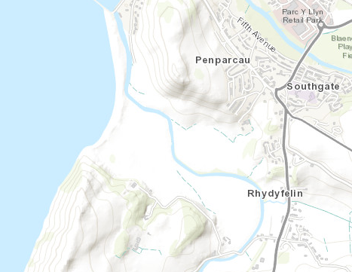
Research area of the Lower Ystwyth Valley. ArcGIS, 2019.

Location:
The location of the site is situated to the south of Aberystwyth and west of Rhydyfelin area of the A487. SN 58491 79522.
Basic visual data from Google maps:
The research area is an open landscape with little construction. There is evidence of field boundaries, date unknown. Looking at the topographical map on ArcGIS, the lower portion of the Ystwyth Valley is a flat plateau leading to St Georges Channel. To the north and south of the research area are the valley edges, these valley edges have fairly high peaks. To the east side of the research area is a tributary to the River Ystwyth, Nant Paith. Looking at a satellite Google maps image of the research area there is a few features immediately visible. Firstly is the River Ystwyth itself, the river meanders through the subject area cutting in half with a north-eastern section and south-western section. The western half on the research area you can see a parched ovular feature in the open grass lands, and to the west on that you can see some more parched grass in a distinctly man made shape (the nature of either of these is unknown with the data I have to hand, field walk would be advisable). To the northern side of the research area sits a hillfort (SN 58500 80300), likely Iron age in date, the hillfort is called Pen Dinas Camp. Pen Dinas Camp is a scheduled monument with CADW, schedule number CD007 (Archwilio, 2019). Another large feature in the research area is Castle Tan y Castell (SN 58510 79000), this castle site is a scheduled monument with CADW schedule number CD096. This site is high to late medieval in date (Archwilio, 2019. This site is ringwork and bailey in nature. When looking at undertaking archaeological excavation of any type in these two areas, caution will need to be taken as to whether you are excavating within the boundary of the scheduled monuments. If excavation is wanted to be done within these boundaries the necessary permission will need to be sought.
The overall area in which the research area is situated is part of a historic landscape, this landscape was surveyed by National Resources Wales on 15th March 2017. The unique ID for the historic landscape is CRDGNHL041. The survey appears to have been done by Dyfed Archaeological Trust (Archwilio, 2019).

National Museum Archaeology Collection
Name | Period | Material | Accession No. | Grid reference
Medieval Lead seal matrix | Medieval | Lead | 2006.2H | SN 58400 79400
Neolithic stone axehead roughout | Neolithic | baked shale | 47.164/94 | SN 58500 80300
Bronze Age flint arrowhead | Bronze Age | flint | 33.409/1 | SN 58500 80300
Undated stone weight | undated | stone | 47.164/149 | SN 58500 80300
Undated stone weight | undated | stone | 47.164/150 | SN 58500 80300
Undated stone weight | undated | stone | 47.164/151 | SN 58500 80300
Copper object | N/A | copper | 33.409/2 | SN 58500 80300
CADW Scheduled Ancient Monuments
Name | Period | Site type | Reference No. | Grid reference
Castle Tan-y-Castell | Medieval | Ringwork and bailey | CD096 | SN 58510 79000
Pen Dinas Camp | Prehistoric | Hillfort | CD007 | SN 58500 80300
CADW Listed Buildings
Name | Grade | Reference No. | Date of Designation | Grid reference
Tanybwlch | II | 20522 | 09/09/1998 | SN 58089 79343
Wellington Monument | II | 10420 | 11/06/1980 | SN 58421 80210
Tanycastell | II | 82513 | 24/02/2004 | SN 58761 78864
Garden wall, gates and railings at Ty'n y Lon | II | 82499 | 24/02/2004 | SN 59028 78904
Ty'n y Lon | II | 82515 | 24/02/2004 | SN 59034 78919
Crugiau | II | 18288 | 17/09/1987 | SN 59138 79406
Welsh Archaeological Trusts' Historic Environments Records
Name | PRN | Status | Site type | Grid reference
TANYBWLCH | 58017 | Listed Building II | POST MEDIEVAL House | SN 58089 79343
TAN-Y-BWLCH | 16100 | N/A | POST MEDIEVAL House | SN 58080 79360
TAN-Y-BWLCH | 31447 | N/A | Medieval Platform | SN 57774 79585
TAN-Y-BWLCH | 31448 | N/A | Medieval Field | SN 57710 79630
Castle Tan-y-Castell | 769 | Scheduled Monument | Medieval Motte | SN 58510 79000
PENDINAS | 11655 | N/A | Medieval Findspot | SN 58000 80000
TYNANT;MELACH | 11851 | N/A | Bronze Age Findspot | SN 58000 80000
PENDINAS | 9983 | N/A | Neolithic Findspot | SN 58000 80000
TANYBWLCH | 30789 | N/A | POST MEDIEVAL Mill Race | SN 58171 80082
MORFA MILL | 16140 | N/A | POST MEDIEVAL Mill | SN 58130 80280
PENDINAS | 8218 | N/A | Bronze Age Finds | SN 58450 80250
PENDINAS | 9982 | N/A | Neolithic Findspot | SN 58000 80000
WELLINGTON MONUMENT | 15268 | Listed Building II | Commemorative Monument | SN 58420 80211
PENDINAS | 8201 | N/A | Bronze Age Findspot | SN 58000 80000
FELIN Y MOR MILL | 4826 | N/A | POST MEDIEVAL Mill | SN 58800 79900
CRUGIAU | 57939 | Listed Building II* | POST MEDIEVAL Country House | SN 59138 79406
RHYD Y FELIN | 12756 | N/A | Medieval Water Mill | SN 59000 79000
CAPEL GOSHEN | 16109 | N/A | POST MEDIEVAL Chapel | SN 59060 78930
TY'N Y LON | 58113 | Listed Building II | POST MEDIEVAL House | SN 59034 78919
GARDEN WALL, GATES AND RAILINGS AT TY'N Y LON | 58097 | Listed Building II | POST MEDIEVAL Garden Wall | SN 59025 78906
National Monuments Record for Wales
Name | NPRN | Type of Site | Period | Grid reference
TECLA CARMEN | 515197 | WRECK | Post Medieval | SN 57417 79489
LAUREL | 515198 | WRECK | Post Medieval | SN 57666 79838
TANYBWLCH FISH TRAP | 518847 | FISH TRAP | Post Medieval | SN 57787 79758
TANYBWLCH SUBMERGED FOREST | 421874 | SUBMERGED FOREST | Mesolithic, Bronze Age, Neolithic | SN 57810 79740
FERRY HOUSE, TANYBWLCH | 518564 | FERRY CROSSING | Post Medieval | SN 57984 79867
MORFA MILL, ABERYSTWYTH | 24775 | CORN MILL | Post Medieval | SN 58100 80250
PEN DINAS SLING STONE FINDS | 301242 | FINDSPOT | Iron Age | SN 58450 80250
THE WELLINGTON MONUMENT ON PEN DINAS | 32637 | COMMEMORATIVE MONUMENT | Post Medieval | SN 58420 80211
PENDINAS HILLFORT | 92236 | HILLFORT | Iron Age | SN 58420 80211
PEN DINAS SUMMIT MOUND, POSSIBLE ROUND BARROW | 421666 | ROUND BARROW | Bronze Age | SN 58440 80180
FELIN-Y-MOR | 24754 | CORN MILL | Post Medieval | SN 58800 79900
PIERCEFIELD FARM, OUTBUILDINGS | 31541 | OUTBUILDING | Post Medieval | SN 58940 79810
PIERCEFIELD FARM | 35100 | DWELLING | Post Medieval | SN 58950 79800
RHYDYFELIN VILLAGE | 402555 | VILLAGE | N/A | SN 59200 79600
CRUGIAU HOUSE, RHYDYFELIN | 5341 | HOUSE | Post Medieval | SN 59130 79400
CHAPEL HOUSE, GOSEN CHAPEL, RHYDYFELIN | 414556 | CHAPEL HOUSE | 19th Century | SN 59047 78928
GOSEN WELSH CALVINISTIC METHODIST CHAPEL, RHYDYFELIN | 7262 | CHAPEL | Post Medieval | SN 59060 78930
CASTELL TAN-Y-CASTELL | 301795 | CASTLE | Medieval | SN 58510 79000
TAN-Y CASTELL COTTAGE | 35274 | HOUSE | Post Medieval | SN 58540 79200
PLAS TANYBWLCH | 407475 | HOUSE, INFECTIOUS DISEASES HOSPITAL | 19th Century, Post Medieval | SN 58091 79327
PLAS TANYBWLCH, GARDEN, ABERYSTWYTH | 265078 | COUNTRY HOUSE GARDEN | Post Medieval | SN 58093 79346
PEN DINAS SWORD FIND | 300249 | FINDSPOT | Medieval | SN 58500 80100

All above data acquired from Historic Wales, 2019.

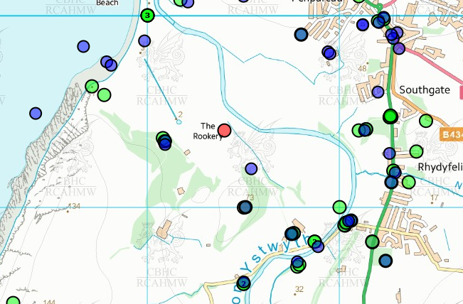
The above data was gathered from the Historic Wales website. The data above is shown on the map below, not all of the data points on the map below are represented in the data above as they are not all in the research area in question.

Historic Wales, 2019
As you can see on the map above there is minimal data for the main plateau area of the research area. This may be due to it not being explored to the extent of the surrounding area, but may also be due to being farm land and from looking at some of the data sets it looks like it has been farm land for quite some time.
However there is a medieval castle on the southern edge of the research area, this could indicate that there has been conflict or battle in the surrounding area. Whilst this is not conclusive evidence, it would be something to look out for during potential excavations in the area. Achwilio does state that there have been a number of battles at the castle in the research area, these battles according to Archwilio commenced in 1136, 1141, 1197 and 1221 (Archwilio, 2019). These put the battles at an interesting point of Norman history within wales. From the data supplied by Archwilio there is only one archaeological find relation to the medieval period, that being the medieval lead seal matrix. There is minimal information on the matrix, the National Museum of Wales’ website states that the seal matrix is of ‘Ithel ap Bleddyn’ from the late 14th century (National Museum of Wales, 2019). This puts the seal matrix after Tan y Castell was apparently destroyed. There is another medieval artefact discovered in the research area. This is a medieval sword find, the sword remains were sent to the National Museum of Wales but the current whereabouts are unknown. The sword find itself was discovered on the Iron Age hillfort, the other side of the valley to the Medieval castle Tan y Castell (Coflein, ND).
In terms of the data from Historic Wales, there seems to be three main time periods represented. Those being Post Medieval, Iron Age and Bronze Age. The majority of the Iron Age and Bronze Age data point seem to be centred around the hillfort, which is to be anticipated. The Post Medieval data points are spread all over the research area.
Not much is known about the fish traps, according to Coflein there are two posts remaining which could have possibly supported a dry stone wall as the construction of the fish traps (Coflein, ND).
For the case of palaeoenvironmental archaeology there is two main points of interest. These are the submerged forest and the fish traps. Depending on the state of preservation of the submerged forest it may be possible to get a dendrochronological assessment of the timber remains completed, as well as if there are peat levels in which the submerged forest is resting in (much like Goldcliff, Newport) palaeoenvironmental samples may be able to be taken to undergo both pollen analysis and mollusc and ostracod analysis. This could potentially provide the information on the environment in which the trees were living in to the point of the death of the trees.
For the completion of any palaeoenvironmental or archaeological excavation it would be suggested to conduct a field walk of the specific areas to be examined. After that has been completed then it could be suggested to undergo test pits, the purpose of these could be dependent on the type of excavation being done. For a palaeoenvironmental extacation then the test pits could be to confirm the ground type and whether the types of palaeoenvironmental remains are likely to survive in the subject area. For an archaeological excavation the test pits would be to determine the possibility of archaeological finds.

Bibliography:
ArcGIS. 2019. ArcGIS. Available from: https://www.arcgis.com/home/webmap/viewer.html?useExisting=1 [Accessed 28/02/2019]
Archwilio. 2019. Historic environments Record for Wales. Available from: https://www.archwilio.org.uk/her/chi1/arch.html?county=Ceredigion&lang=eng [Accessed 28/02/2019]
Coflein. ND. PEN DINAS SWORD FIND. Available from: https://coflein.gov.uk/en/site/300249/details/pen-dinas-sword-find [Accessed 28/02/2019]
Coflein. ND. TANYBWLCH FISH TRAP. Available from: https://coflein.gov.uk/en/site/518847/details/tanybwlch-fish-trap [Accessed 28/02/2019]
Historic Wales. 2019. Historic Wales. Available from: https://historicwales.gov.uk/#zoom=5&lat=279333.59502&lon=258991.71177&layers=BTTTTTTFFTTT [Accessed 28/02/2019]
National Museum of Wales. 2019. Medieval lead seal matrix. Available from: https://museum.wales/collections/online/object/3c89776e-c014-34c6-9084-85d8c6180495/Medieval-lead-seal-matrix/?field0=string&value0=2006.2H&index=0 [Accessed 28/02/2019]

