Winston Richard Morrison (2337238)

Rebuilding the City of Merritt waste water plant after Canada’s 2022 flooding
Project Management
A Project portfolio

Table of Contents
Rebuilding the City of Merritt Wastewater Plant 4
Introduction 4
1. Introduction 4
Project description 5
Project Scope 6
Work breakdown structure 7
5. Quad Chart 8
Project Objectives 8
Key Activities 8
Stakeholders 8
Risks and Constraints 8
Gant Chart 9
Stakeholders’ Involvement 9
Allocation of Resources 10
Human Resources 10
Material and Equipment Resources 10
Financial Resources 10
Risk Analysis 11
Key Risks: 11
Conclusion 11
Bibliography 13

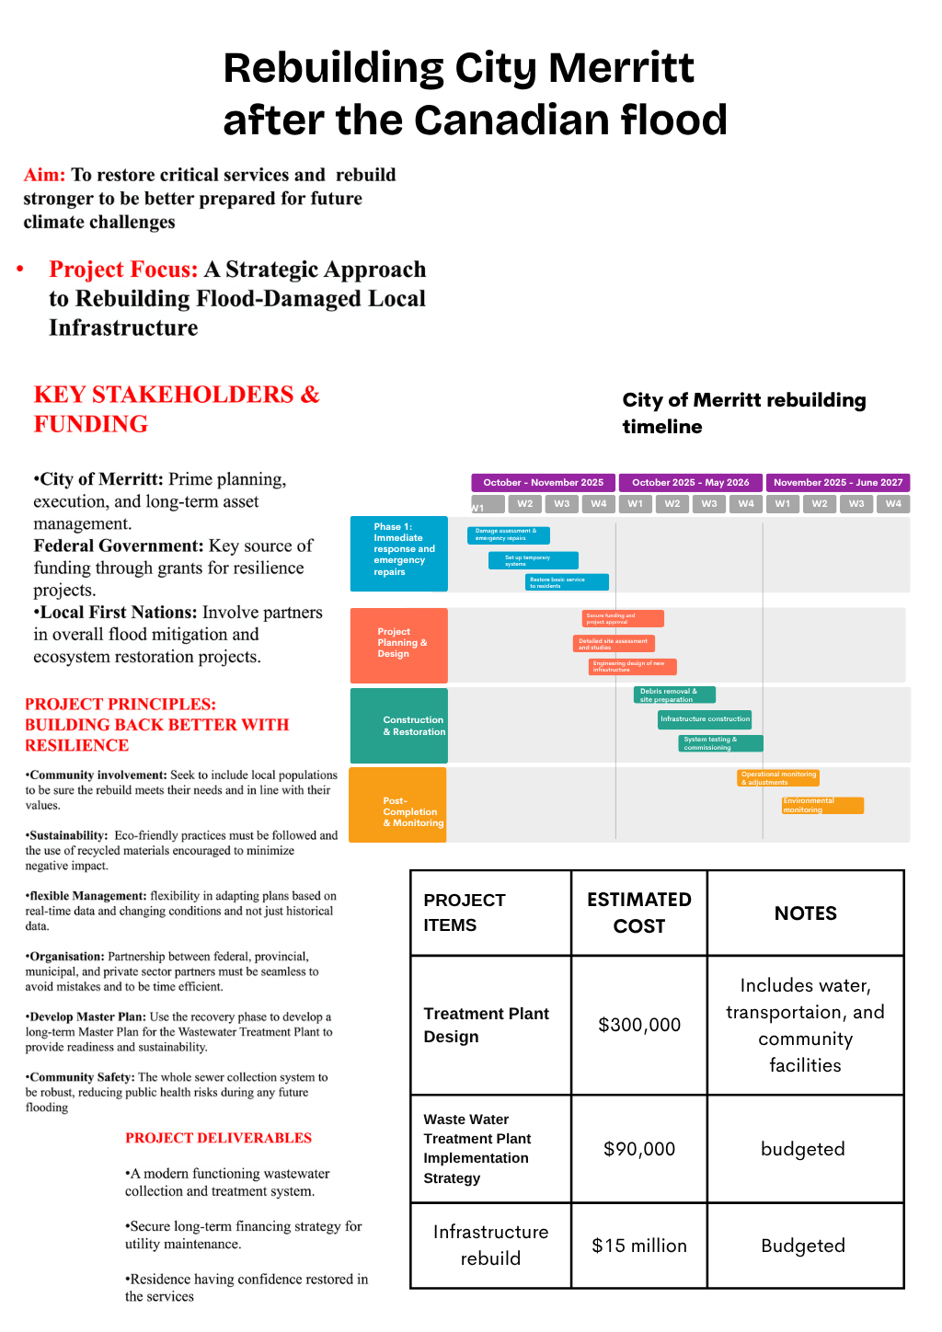

Reflection On Feedback
Reflection Report on Presentation: Rebuilding of the City of Merritt Wastewater Treatment Plant
This reflection evaluates my presentation on the rebuilding of the City of Merritt Wastewater Treatment Plant, focusing on both the strengths of my delivery and areas for future improvement. My presentation aimed to explain the background of the project, the challenges faced after the flooding event, and the importance of rebuilding critical infrastructure in a resilient and sustainable way.
One of the main strengths of my presentation was my understanding of the subject matter. I had researched the project thoroughly, which allowed me to speak confidently about the plant and its importance. The design considerations for the rebuild, and the long-term benefits to the City of Merritt. This preparation helped me answer questions and to demonstrate my engagement with the topic. I also structured the presentation in a way I could understand as well as the people I was presenting to. I started with background information, then moving into the rebuilding process and concluding with future implications. I designed my poster as clear as possible with not too many details and pictures to allow an easy flow which would make the content easier for the audience to follow as well as to help with my delivery.
Another positive aspect was my use of visual support. The poster supported my spoken content by highlighting key points without overwhelming my peers and tutor with too much text. I used Images and diagrams related to wastewater treatment processes and flood impacts helped to reinforce understanding. I also maintained eye contact with the audience as much as I could manage, given that I do not always feel confident in public speaking.
Despite these strengths, there are several areas where I know I can improve on. The most significant feedback from my tutor was that I rushed the presentation and that I needed a little more information on my poster. Although I covered all the required content, I spoke too quickly at times, which may have reduced the audience’s ability to fully absorb the information. This likely occurred because I was focused on fitting all the material within the time limit, and as mentioned before, I do not feel as confident as I should when speaking in public. I realised I didn’t really allow any natural pauses. In future presentations, I should practice pacing more deliberately and time my rehearsals to ensure I can deliver the content calmly without allowing anxiety to swallow my words and how I deliver my content.
Additionally, I could improve my transitions between sections. Taking brief moments to emphasize key points or allow the audience to reflect would improve clarity and professionalism. Slowing down would also help reduce nervousness and make my delivery more confident. I also needed to add more content to make it very clear, what the aim was and how it would be executed.
In conclusion, this presentation highlighted my strong preparation, subject knowledge, and effective use of visual aids. However, it also revealed the importance of pacing and delivery. By practicing more thoroughly, managing my time better, and consciously slowing my speech, I can significantly improve the quality of my future presentations as well as my report on the rebuilding of the wastewater treatment plant.

Rebuilding the City of Merritt Wastewater Plant

Introduction

1. Introduction
British Columbia, Canada, experienced one of the worst and severe flooding disasters Canadia has seen in history. Atmospheric rivers along with record breaking rainfall triggered the flood causing landslides, and infrastructure failures across the province. Main transportation corridors were disconnected, bridges collapsed, and entire communities became remote from the Lower Mainland (The Gaurdian, 2022). City of Merritt were one of the most severely impacted communities which experienced extensive damage to its water supply infrastructure, including the municipal reservoir system.
Wastewater treatment plants are a foundation of public health protection and environmental sustainability. The City of Merritt was no different. Wastewater plants are intended to collect, treat, and safely discharge wastewater, in so preventing contamination of surface and groundwater resources. However, as they are usually located in low-lying areas near receiving water bodies, this makes them especially vulnerable to flooding. Damage to wastewater treatment infrastructure can lead to untreated sewage releases, ecological degradation, and severe public health risks, compounding the impacts of natural disasters.
The City Merritt Wastewater treatment plant significantly compromised drinkable water availability, fire protection capabilities, and public health due to the severe destruction. Because of the undeniable failure of such a critical infrastructure asset, it highlighted the need for a resilient, climate-adaptive reconstruction project urgently.
Wastewater treatment infrastructure is essential for protecting public health, conserving environmental quality, and ensuring economic activity is supported. The failure of Merritt’s WWTP significantly hindered the recovery efforts and highlighted the weakness of existing infrastructure to extreme future weather indiscretions. Given the increasing frequency and severity of climate change that are reflected in more occurring natural disasters, rebuilding the wastewater treatment plant presents an opportunity not only to restore essential services but also to enhance resilience, sustainability, and long-term operational efficiency.
This Project Management Plan will outline the approach, methodology, and governance required to rebuild the Merritt Reservoir in a sustainable, safe, and timely manner, ensuring long-term water security for the city.
This Project management plan will display the application of recognised project management principles, tools, and techniques and provides a structured roadmap for execution of the project, monitoring, and control.

Project description

The City of Merritt relies on a reservoir system for municipal water storage and distribution. During the 2022 flooding, erosion and landslides, the severe damage to the structure, compromised the reservoir embankments, and disrupted water treatment operations. Emergency water advisories had to issued, and extended water shortages were faced by the residents of City of Merritt.
The atmospheric river event caused unprecedented rainfall that made river levels to rise rapidly, overtopping banks and inundating large portions of the city. The wastewater treatment plant, located within the floodplain, was submerged by floodwaters that entered buildings and process areas. Critical systems such as pumps, motors, electrical panels, instrumentation, and supervisory control and data acquisition systems were damaged or destroyed. Biological treatment processes were disrupted due to contamination and loss of operational control. The loss of wastewater treatment capacity posed immediate environmental risks to downstream ecosystems and concerns were raised about waterborne diseases and regulatory non-compliance.
The rebuilding of the City of Merritt wastewater treatment plant will involve multiple phases, including damage assessment, permitting, demolition, engineering design, installation of new equipment, reconstruction, and commissioning. This project will be publicly funded, with financial support from the City of Merritt, the Province of British Columbia through disaster recovery programs, and the Government of Canada through infrastructure funding initiatives. There are a lot of important bodies who will play key roles in this project such as, engineering consultants, construction contractors, and regulatory.
Knowing how important water infrastructure to public safety is, community resilience and economic recovery, rebuilding the reservoir was of a high priority infrastructure project at the municipal, provincial, and federal levels (Team, 2024).
On this project, a heavy focus must be placed on long term flood mitigation strategies to protect critical infrastructure from future events. The city stands at the confluence of two rivers and experienced repeated flooding in the past (Darwish, 2025), so this is a very important step to take.
The purpose of this project is to reconstruct the City of Merritt wastewater treatment plant in a modernised way, making sure to incorporate flood-resilient design standards and climate adaptation strategies that can withstand flooding and any future extreme weather events.
The key objectives of the project are:
- Restore reliable potable water storage and distribution capacity
- Improve resilience to flooding and landslides
- Ensure compliance with Canadian drinking water and environmental regulations
- Minimize service disruptions during construction
- Deliver the project within approved budget and schedule
- Engage stakeholders and Indigenous communities throughout the project lifecycle

Project Scope
The project scope is to outline the totality of outputs, the outcomes and benefits and the work that will be needed to produce this (APM, 2024). The scope on this project will included:
- Demolition and removal of damaged structures
- Construction of reservoir embankments and lining
- Installation of intake, outlet, and overflow systems
- Integration with existing water treatment facilities
- Environmental mitigation and site restoration
- Testing, commissioning, and handover
- Stakeholder consultation and regulatory approvals
- Damage assessment and geotechnical investigations
- Design of a new flood-resilient reservoir system
This project also faces constraints and assumptions such as:
- Project funding depends on federal and provincial disaster recovery programs
- Construction activities are subject to seasonal weather limitations
- Regulatory approval timelines may affect the schedule
- Skilled labour availability may be limited during peak construction periods
A formal Change Control process will manage scope change which will require approval from the Project Steering Committee which will prevent a scope steal.
There are also out of scope elements to maintain control and focus, some activities must be excluded such as
- Expansion of treatment capacity beyond pre-flood population demand
- Major upgrades to upstream sewer collection systems
- Non-essential architectural or aesthetic enhancements not related to functionality or resilience
When the scope is clearly defined, it allows project managers to support stakeholder expectations and ensure efficient use of limited resources.

Work breakdown structure

The Work Breakdown Structure will split the project into manageable sections enabling effective planning, scheduling, and cost control as outlined below:
1 Project Initiation and Management
- Project charter development
- Stakeholder identification and engagement
- Funding approvals and financial management
- Project governance and reporting
2 Assessment and Design
- Flood damage assessment
- Geotechnical and environmental studies
- Hydraulic and flood modelling
- Engineering design and technical specifications
3 Permitting and Regulatory Approvals
- Environmental impact assessments
- Provincial and federal approvals
- Occupational health and safety planning
4 Demolition and Site Preparation
- Removal of damaged equipment and structures
- Waste disposal and environmental protection measures
- Site grading and preparation
5 Construction and Reconstruction
- Civil works (foundations, tanks, buildings)
- Mechanical system installation
- Electrical and control system installation
6 Flood Resilience Enhancements
- Elevation of critical infrastructure
- Installation of flood barriers
- Drainage and erosion control improvements
7 Testing and Commissioning
- System testing and calibration
- Performance validation
- Regulatory inspections
8 Training and Handover
- Operator training programs
- Documentation and manuals
- Final handover and closeout

5. Quad Chart
The quad chart below shows the objective and scope. The schedule we aim to work with in how long we expect to need and finish the rebuilding as well as the estimated budget we need to complete the project

Project Objectives
- Restore wastewater treatment services
- Improve flood resilience and climate adaptability
- Ensure regulatory compliance
- Protect public health and the environment

Key Activities
- Engineering design and assessment
- Construction and equipment installation
- Flood mitigation implementation
- Testing and commissioning

Stakeholders
- City of Merritt
- Provincial Government of British Columbia
- Government of Canada
- Engineering consultants
- Construction contractors
- Indigenous and local community groups

Risks and Constraints
- Funding limitations
- Schedule delays due to weather
- Supply chain disruptions
- Regulatory approval timelines

Gant Chart
The Gant chart will give a summary and show the timeline we intend to work on, and how long each task is expected to take.
Phase | Duration
Project Initiation | 2 months
Planning & Design | 6 months
Procurement | 4 months
Construction | 10 months
Testing & Commissioning | 2 months

Stakeholders’ Involvement
In simple terms, stakeholders are either individuals, groups or an organisation that has an interest in a project, a program or a portfolio. These stakeholders have an interest because they either are involved in the work or will be affected in some way by the outcome (APM, 2025).
The Stakeholder involvement is central to the success of the rebuilding project.
- City of Merritt: Project owner responsible for governance, funding coordination, and community communication.
- Provincial Government (British Columbia): Provides disaster recovery funding and regulatory oversight.
- Federal Government: Supports funding through infrastructure and disaster assistance programs.
- Engineering Consultants: Deliver design, compliance, and quality assurance.
- Construction Contractors: Execute physical rebuilding works.
- Community and Indigenous Groups: Provide local input, ensuring social and environmental considerations are addressed.
Transparent communication and collaboration reduce conflict and improve project outcomes

Effective stakeholder engagement is essential to ensure project acceptance and regulatory compliance. Engagement strategies include:
- Regular stakeholder meetings and briefings
- Public consultations and information sessions
- Indigenous engagement respecting consultation protocols
- Transparent reporting through municipal channels
- Mechanisms for addressing community concerns

Allocation of Resources

Human Resources
- Project Manager
- Civil, environmental, and process engineers
- Construction managers and skilled trades
- Health, safety, and environmental officers
- Quality assurance personnel
- Administrative support staff

Material and Equipment Resources
- Concrete, steel, and piping materials
- Wastewater treatment equipment
- Electrical and control systems
- Heavy construction machinery
- Temporary facilities and utilities

Financial Resources
Project funding sources include:
- Federal disaster assistance programs
- Provincial infrastructure grants
- Municipal contributions
- Contingency allowances for unforeseen conditions

Risk Analysis

The definition of risk management can be explained as the process of identifying, assessing and addressing any financial, legal, strategic and security risks to an organization (McGrath & Jonker, 2024)
Risks in business can stem from many sources, which includes financial uncertainty, legal liabilities, technology use, strategic management errors, accidents and natural disasters. Risk management practices are put in place to anticipate these threats and their potential impact and establish plans to address them when they arise.

Key Risks associated with the rebuilding of the wastewater plant:
- Flood Recurrence: Mitigated by elevated structures and barriers
- Cost Overruns: Managed through contingency budgeting and cost controls
- Schedule Delays: Reduced through phased planning and buffer periods
- Regulatory Delays: Addressed by early engagement with authorities
- Supply Chain Disruptions: Mitigated through diversified suppliers
A risk register is maintained throughout the project lifecycle.

Conclusion
Immediately after the flooding, emergency measures were applied to manage wastewater flows and prevent uncontrolled discharges. These temporary solutions, however, were not sustainable and highlighted the vital need for a permanent rebuilding strategy. The project therefore transitioned from emergency response to long-term recovery and resilience planning.
The rebuilding of the City of Merritt Wastewater Treatment Plant following the 2022 flooding represents a critical infrastructure recovery initiative that underscores the importance of resilient design and effective project management. If structured planning tools such as scope definition, work breakdown structures, scheduling, and risk analysis are applied, the project can address immediate service restoration needs while enhancing long-term sustainability.
The project demonstrates how coordinated stakeholder engagement, strategic resource allocation, and proactive risk management can transform disaster recovery into an opportunity for infrastructure improvement. As climate change continues to increase flood risks, lessons learned from the Merritt WWTP rebuilding project provide valuable insights for future municipal infrastructure resilience efforts across Canada.
The key objectives of the project are multifaceted. The project seeks to restore full wastewater treatment functionality in the City of Merritt to protect public health and the environment. The project also aims to rebuild the facility in a manner that enhances resilience to future flooding and climate-related risks. This includes incorporating flood-resistant materials, elevating critical equipment, and improving site drainage. The project must comply with updated regulatory requirements and best practices in wastewater treatment and environmental protection. Finally, the project aims to improve operational reliability, reduce maintenance requirements, and extend the service life of the facility.
This report has provided a comprehensive project management analysis of the rebuilding of the City of Merritt Wastewater Treatment Plant following the 2022 flooding recovery phase. Established project management principles were used and the report examined the project’s description, scope, work breakdown structure, scheduling, stakeholder involvement, resource allocation, and risk management. The aim is to demonstrate how structured planning and resilient design can support effective disaster recovery while improving long-term infrastructure performance and adaptability.

Bibliography
APM, 2024. Association For Project Management. [Online]
Available at: https://www.apm.org.uk/resources/find-a-resource/major-differences-between-project-scope-and-objectives/
[Accessed 21st November 2025].
APM, 2025. What is stakeholder engagement?. [Online]
Available at: https://www.apm.org.uk/resources/find-a-resource/stakeholder-engagement/#:~:text=In%20general%20terms%2C%20Stakeholders%20are,or%20affected%20by%20the%20outcomes.
[Accessed 03rd December 2025].
Darwish, L., 2025. MERRITT Reducing Flood Risk through Community-Driven Floodplain Naturalization. [Online]
Available at: https://www.iclr.org/wp-content/uploads/2025/11/11_MERRITT.pdf
[Accessed 27 November 2025].
McGrath, A. & Jonker, A., 2024. What is risk management?. [Online]
Available at: https://www.ibm.com/think/topics/risk-management
[Accessed 22nd November 2025].
Team, F. M., 2024. STUWI(x) Project: Funding Received. [Online]
Available at: https://www.merritt.ca/stuwix/
[Accessed 22 November 2025].
The Gaurdian, 2022. Severe flooding. [Online]
Available at: https://www.theguardian.com/world/2022/oct/19/british-columbia-drought-floods-climate-crisis
[Accessed 21 November 2025].

