Programme: MSc Public Health and Social Care in Practice
Module: Population Health and Digital Health Promotion
Module code: LCHS7007
Student Name : Manishaben Rajeshbhai Patel
Student ID : 2406807
Lecturer Name : Dr Ping Wu

Table of Contents
TASK 1 – Blogs 2 entries 3
Blog 1: Telemedicine platform for mental health services 3
Blog 2: Public health problem: Depression and anxiety 5
TASK 2- Poster 7
1. Background 7
2. Health promotion values and principles 8
3. Behavioural change theory 8
4. Expected outcome 9
5. Conclusion 10

TASK 1 – Blogs 2 entries

Blog 1: Telemedicine platform for mental health services
Addressing Depression and Anxiety: A Growing Concern
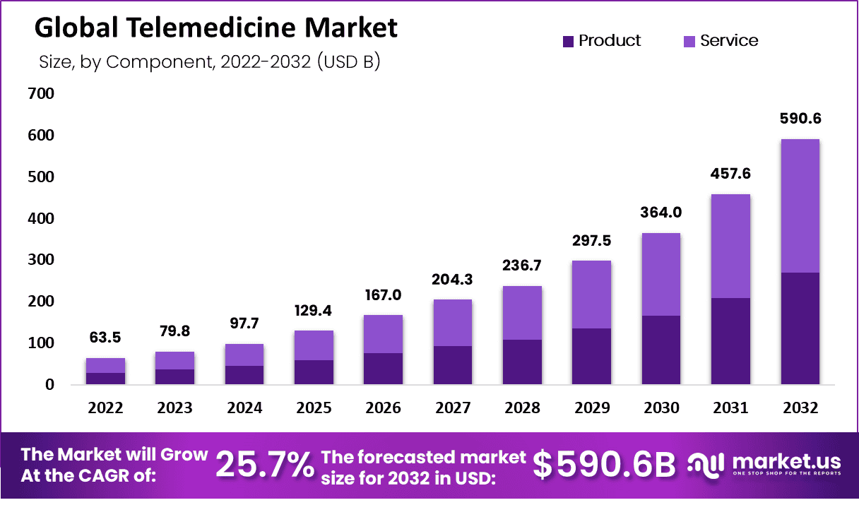
https://market.us/report/telemedicine-market/
Anxiety and depression are some of the most common mental disorders on Earth, with millions affected on every continent. Their economic effects include decreased productivity and overall well-being. Many people opt not to seek help because of stigma. Untreated symptoms and outcomes tend to worsen with time. Traditional therapy is out of reach for many people. But telemedicine offers an easier option (Goodwin et al. 2020). It is quick, private, and helps people whenever and wherever they need it. There are effective digital solutions that can fill this gap.
Using Digital Technology for Mental Health Support
Remote video counseling allows patients to receive professional therapy without leaving home. Supporting care is always available. Mood-tracking applications also provide assistance by scanning users’ emotions and telling their psychological shifts over time. Such technologies identify maintenance needs (Torous et al. 2020). They enable users to take control of their mental health. Telemedicine is part of a growing shift toward patient-centered and personalized care.
Evidence Supporting Digital Mental Health Solutions
Research confirms the claim that telemedicine improves mental health. In one report from 2021, video counseling reduced depression symptoms by 50% (Schueller and Torous, 2020). All patients reported improved self-evaluating emotional awareness due to mood-tracking apps. The research proves these apps will stop them from having severe episodes. Digital solutions increase patients’ adherence to therapeutic regimens. They help to reduce waiting times and other barriers to access care.
Impact of Telemedicine on Mental Health Promotion
Telemedicine captures a wider audience looking for mental health services. It provides anonymity and flexibility. Patients can participate in therapy and mental health services without stigma. But there are still people without internet access (Rutkowska, 2022). Some people find digital tools impersonal. Some people have difficulty with self-monitoring. In-person support cannot be replaced entirely. There are also people's privacy concerns, which is a very caring problem
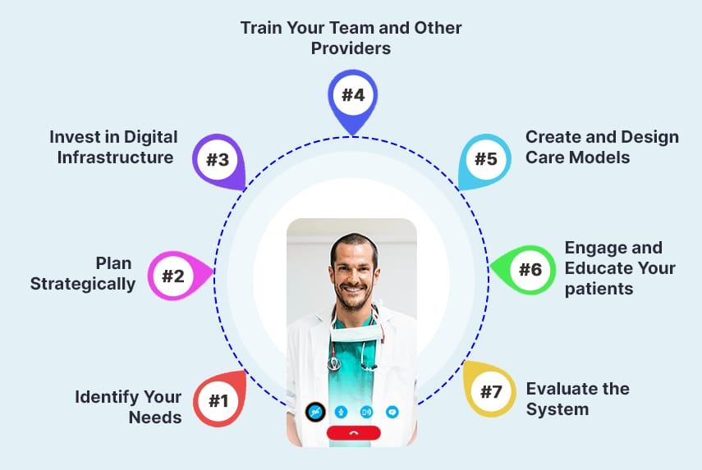
Figure 2 Empowering Healthcare: Telemedicine Solutions for Modern Organizations, source:(Ahmad, 2024)

Addressing Telemedicine Shortfalls
Broadening internet coverage helps solve the limitations of telemedicine. Hybrid therapy is the combination of digital therapy with traditional face-to-face therapy. Enhanced AI support smart personalization is given for basic mental health (Ncube et al. 2022). Privacy issues have been dealt with by the provision of secure systems. Educating people on digital tools increases users engagement. There is always an ongoing study for improvement of telehealth.
Conclusion
Telemedicine is transforming mental health treatment by expanding access to therapy, reducing stigma, and improving outcomes.Technology solutions like video counseling and mood-tracking apps allow individuals to manage their mental health successfully.
Research proves their effectiveness in reducing symptoms of depression and anxiety.However, there are some issues like internet connectivity problems, privacy concerns, and the need for a human touch in therapy.Hybrid models that combine online and offline care and push the boundaries of AI-led personalization are well-placed to surmount such issues.Increased internet availability and training of users will also be contributing factors.
As telemedicine continues to develop, constant research and development will continue to keep online mental well-being services effective, inclusive, and secure, ultimately leading to the improvement of the global feeling of well-being

References
Goodwin, R.D., Weinberger, A.H., Kim, J.H., Wu, M. and Galea, S., 2020. Trends in anxiety among adults in the United States, 2008–2018: Rapid increases among young adults. Journal of psychiatric research, 130, pp.441-446.
Ncube, B., Mars, M. and Scott, R.E., 2022. Telemedicine options to address identified health needs in Botswana. Digital Health, 8, p.20552076221102768.
Rutkowska, A., 2022. Telemedicine interventions as an attempt to improve the mental health of populations during the covid-19 pandemic—a narrative review. International Journal of Environmental Research and Public Health, 19(22), p.14945.
Schueller, S.M. and Torous, J., 2020. Scaling evidence-based treatments through digital mental health. American Psychologist, 75(8), p.1093.
Torous, J., Myrick, K.J., Rauseo-Ricupero, N. and Firth, J., 2020. Digital mental health and COVID-19: using technology today to accelerate the curve on access and quality tomorrow. JMIR mental health, 7(3), p.e18848.
Ahmad, S. (2024). Facilitating Telemedicine for Healthcare Organizations. Mobisoft Infotech. Retrieved from https://mobisoftinfotech.com/resources/blog/facilitating-telemedicine-healthcare-organizations

Blog 2: Public health problem: Depression and anxiety
Understanding Depression and Anxiety as a Public Health Concern
Anxiety and depression are significant health problems which afflict more than 280 million people across the globe. They lead to higher spending on health services, lower productivity, and reduced quality of life. The WHO (World Health Organization) states that depression alone is the primary cause for disability and leaves many people with anxiety disorders undiagnosed (An et al. 2020). With scarce access to therapy sessions and mental health professionals, a greater toll is now placed upon these illnesses requiring novel solutions for effective treatments.
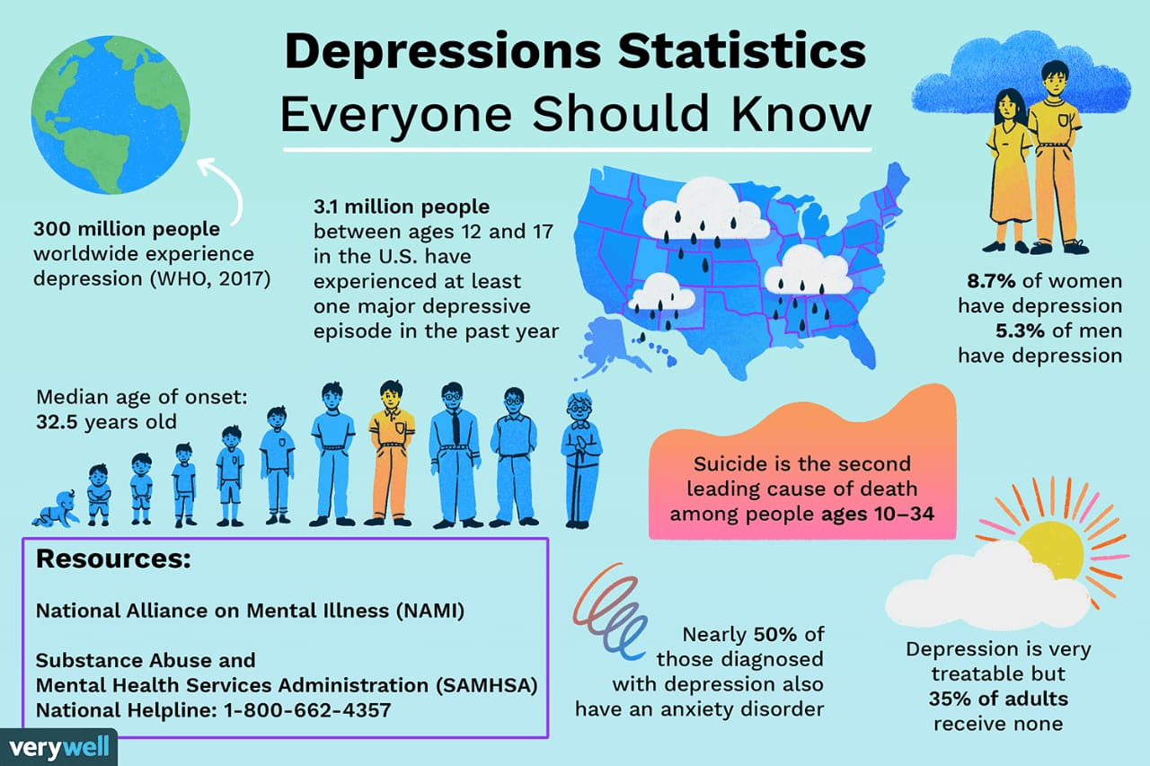
Figure 3 Understanding Depression: Key Statistics and Facts, image source :(Cherry, 2024)

A New Digital Mental Health Solution
With the goal of eliminating the divide in mental health care treatment, “MindBalance” has been introduced as a digital solution. This AI-driven mental health treatment application not only offers video counseling, but also incorporates sophisticated features such as mood tracking. Additionally, it offers self-help apps that when paired with AI chat can analyze emotions in real time (Joshi and Kanoongo, 2022). MindBalance is able to create new opportunities in mental healthcare by providing solutions that personalize health care services based on user activities.

How MindBalance Promotes Mental Health
MindBalance enables patients to track their emotions constantly and assist people in recognizing the need for mood changes through AI. The platform has personalized changes, like anxiety and therapy motivating exercises, embedded in it. Through the video counseling feature, users are able to speak with licensed professionals assuring quality mental health support (Kaywan et al. 2023). The software motivates self-monitoring and early intervention allowing better mental health.
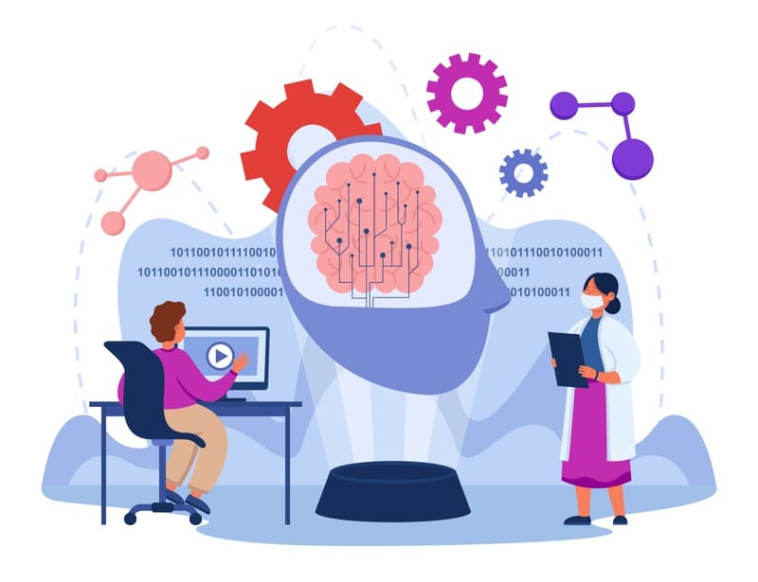
Figure 4 AI and Mental Health: Balancing Technology and Human Connection, source :(Degen, 2024)
Impact of MindBalance on Mental Health Promotion
MindBalance considers the provision of mental health support with a renewed focus on an AI driven model. The software is capable of offering immediate help, while users have the ability to receive therapy from the comfort of their homes. Since the platform allows users to self-monitor their emotions, it enables them to take charge of their mental health proactively. However, there are some issues with it such as insufficient human contact, erroneous AI judgments, and data security concerns (Ren, 2020).
Addressing the Shortfalls of MindBalance
Greater enhancement in emotional AI assessments will improve the effectiveness of MindBalance. Security issues can be alleviated through stronger data encryption and privacy measures. Therapy outcomes can be improved through AI with a human touch. Such digital mental health services can further be broadened with the expansion of internet services and development of digital literacy programs (Klos et al. 2021). Continued research and development is necessary for diverse users in the case of refinement of MindBalance.

References
An, Y., Yang, Y., Wang, A., Li, Y., Zhang, Q., Cheung, T., Ungvari, G.S., Qin, M.Z., An, F.R. and Xiang, Y.T., 2020. Prevalence of depression and its impact on quality of life among frontline nurses in emergency departments during the COVID-19 outbreak. Journal of affective disorders, 276, pp.312-315.
Joshi, M.L. and Kanoongo, N., 2022. Depression detection using emotional artificial intelligence and machine learning: A closer review. Materials Today: Proceedings, 58, pp.217-226.
Kaywan, P., Ahmed, K., Ibaida, A., Miao, Y. and Gu, B., 2023. Early detection of depression using a conversational AI bot: A non-clinical trial. Plos one, 18(2), p.e0279743.
Klos, M.C., Escoredo, M., Joerin, A., Lemos, V.N., Rauws, M. and Bunge, E.L., 2021. Artificial intelligence–based chatbot for anxiety and depression in university students: pilot randomized controlled trial. JMIR formative research, 5(8), p.e20678.
Ren, X., 2020. Artificial intelligence and depression: How AI powered chatbots in virtual reality games may reduce anxiety and depression levels. Journal of Artificial Intelligence Practice, 3(1), pp.48-58.
Cherry, K. (2024). Depression Statistics Everyone Should Know. Verywell Mind. Retrieved from https://www.verywellmind.com/depression-statistics-everyone-should-know-4159056
Degen, C. (2024). Can Machines Heal the Mind? A Dive into the Impact of AI on Mental Health. KrASIA. Retrieved from https://amp.kr-asia.com/can-machines-heal-the-mind-a-dive-into-the-impact-of-ai-on-mental-health

TASK 2- Poster

1. Background
Anxiety and depression pose some of the most important global health problems, with more than 280 million people within their reach (Liana, 2024). Their impact in terms of mental health has been associated with loss of productivity and poor quality of life. According to WHO, depression is the single leading cause of disability in the world. The negative impact of anxiety disorders often remains undetected, which compounds the problem further. The consequences of mental health problems affect individuals within families, communities or supporting healthcare systems. Care has its own obstacles such as stigma and cost. Most traditional therapy approaches have challenges in availability or accessibility. Limited session openings with long leads generally results in severe treatment delay. Therefore, people could compute the worsening symptoms. Digital services bring relief through technology which enhances the ease and convenience of obtaining therapy. The greatest breakthroughs are in video counseling and mood monitoring therapy (Gautam et al. 2020). Through video counseling, those who have physical disabilities can interact with therapists. It allows offering therapy remotely in a convenient way, unlike having to go for the sessions in person which can be difficult. Mood tracking apps help users analyze emotional responses over certain periods of time. These apps can sense the onset of emotional discomfort. They provide users with self-help techniques and feedback (Kuroda et al. 2021).
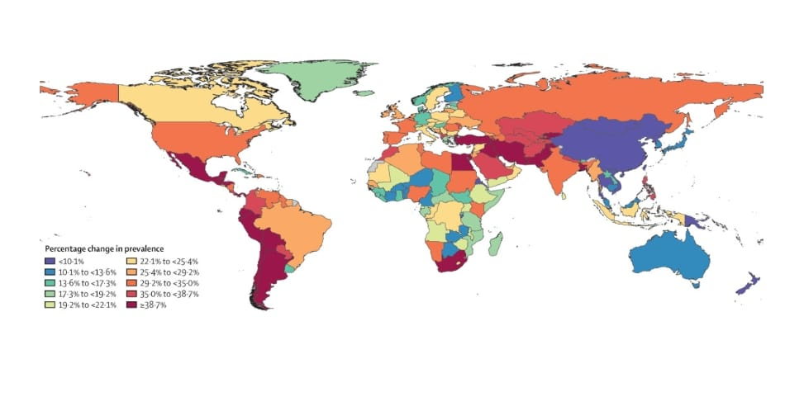
Figure 5 Global prevalence and burden of depressive and anxiety disorders in 204 countries and territories in 2020 , source:
By using both self-help apps, users receive postvention care with great ease because mental health support is available at all times. There is a new way to put mental health care within reach of those pressed for time. It removes geographic barriers and Americans, equipped with smartphones and computers, can have access to therapy at any time and any place.

The tools in question are especially beneficial for users located in remote or neglected regions. These tools help eliminate travel, time, and cost barriers. Moreover, digital tools enable proactive measures to be taken. Regular mood monitoring sheds light on possible emotional triggers and patterns. Noteworthy, symptoms easier to detect often lead to less severe mental health issues developing. The reduction in funds spent on traditional therapy compared to digital health interventions is astounding (Ormel et al. 2022). Their cost efficiency allows for wide distribution amongst the population. People who would often be denied aid due to a lack of resources can now receive it. The rigidness and inflexibility of these digital solutions renders them futile for a diverse population. Previous public health interventions have used similar digital tools with success. Telemedicine has broadened the scope for healthcare access, with more focus shifted to mental healthcare services (Hossain et al. 2022). Digital health coaching applications like Headspace and Calm foster mental well-being through mindfulness exercises, as seen in these examples. These aids showcase the improvement in mental health accessibility caused by digital health interventions. Video counseling and mood tracking apps take it a step further by logically building upon these successful models (de Girolamo et al. 2020). They provide real-time emotional support, monitor emotional wellbeing, and enable timely interventions when necessary. With this technology at hand, a more personalized approach to mental health care becomes not only easier, but more proactive.

2. Health promotion values and principles
Allocating resources towards health promotion aims at empowerment, equity, and health accessibility, which further enables the individual to take control of their own health. Prevention, education, and early intervention are critical components. Digital health services must include the well-being and inclusivity of the users at the forefront of the solution (Shah et al. 2022).
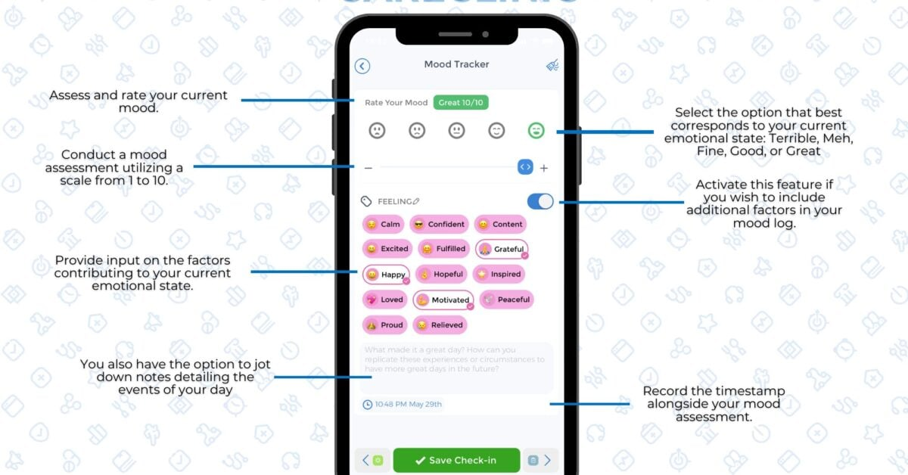
Figure 5 CareClinic Mood Tracker App: Monitoring Mental Wellbeing, source (CareClinic, 2024)

These two-video counseling and mood tracking apps, for example, serve to enable early detection and accessible mental health support. Remote therapy promote equity by serving those who are disadvantaged. Hypothetical self-enabled mood tracking fosters empowerment through self-awareness. Privacy and data security policies guarantee ethical concerns. Guidance of a professional enhances the reliability and predicted efficacy of the tools. These tools enhance the promotion of mental health through prevention, accessibility, and personalized care.

3. Behavioural change theory
The Transtheoretical Model (TTM) describes how a person processes through different stages of change which are: precontemplation, contemplation, preparation, action, and maintenance. This model facilitates gradual behavior changes, making it ideal for adapting mental health interventions (Huang et al. 2022). There is alignment with TTM principles by video counseling and mood tracking apps. Users identify emotion related problems (precontemplation). They begin to think about getting help (contemplation), and digital tools are initiated (preparation). Therapeutic engagement with mood tracking occurs in the action stage. Sustained usage of the app and self-monitoring helps support maintenance. This stage utilizes feedback, reminders, and motivating features. Engagement is enhanced with AI-driven insights. Personalized interventions guide users towards better self-emotional regulation (Meng et al. 2025). Digital technologies have a positive impact on the results of mental health problems by encouraging behavioral modification.

4. Expected outcome
Using the Transtheoretical Model (TTM) for digital interventions like video counseling and mood-tracking apps is likely to be beneficial. The digital tools guide the users through the stages of change: precontemplation, contemplation, preparation, action, and maintenance. In precontemplation, users typically have no clue that they need help (Nusawat and Leelasantitham, 2024). Users are unaware of their moods and are not considering any form of therapy. As they progress into the next stage, which is contemplation, they start to view therapy as a method to help them solve their issues. They are provided with video counseling, so they can get the help they need as they begin to prepare (Gaudreau et al. 2025). At this point, they begin to take part in the therapy and do self-monitoring. Regular action which means most people are participating in self-care and attending counseling sessions are dealing with their issues (Kinnunen, 2020). The mood tracking app compliments this by giving feedback on emotional responses. Users start becoming aware of their emotional triggers. To these emotional triggers, certain coping responses are developed to manage anxiety and depression. During maintenance, users develop a certain degree of emotional stability. Other than these, the tools can continuously track the mental health of users. Over time, users are able to self-manage their mental health (Ali Ahmed and Çerkez, 2020). The users are also empowered by the intervention to regulate their emotions, which improves their coping skills. Long-term improvement of mental health is achieved through increased therapy adherence, as well as self-engagement. The users can expect to work towards well-being on their own with the help of the behavioral change model.
Still, issues in user participation and motivation could pose a challenge. Some people may find it difficult to engage with the digital tools consistently. These users, especially those who are new, would find it difficult to achieve their goals due to sporadic app participation (Meng et al. 2025). Furthermore, some people's ability to engage with the app may be curtailed by lower levels of digital literacy. This problem needs to be solved with the help of digital literacy initiatives accompanying the tools. There is also the possibility that AI-driven insights will not fully account for the absence of human touch needed in therapy. AI does give personal recommendations, but it lacks compassion and genuine care. Bridging the gap between AI and human interaction requires a combination of both approaches (Kaywan et al. 2023). For continued participation, users must feel linked to the professionals. Another challenge is the privacy and data security issue, where hesitancy to share personal information online is the problem. If the platform guarantees protection of the information, trust will be built. In spite of these challenges, the projection is higher self-awareness and better mental health as the results. Video counseling and mood tracking app integration offers an invasive and easy way for intervention (Tan and Ismail, 2023). This strategy helps increase participation, lowers the stigma of mental illnesses, and gives for timely help. As these tools are perfected, they could be placed at the frontline of modern mental healthcare and provide users with the help required for their emotional health.

5. Conclusion
Policies, education, and research are all shaped by digital mental health tools. There needs to be a policy on data safety and relevancy. Digital aids should be assimilated into the health care systems by the governments. These tools can be utilized by institutions for mental health education. AI-supported and therapeutic interventions will be further developed in research. Evaluating the interventions over time helps improve their effectiveness. Mental healthcare gaps are bridged and care is shifted from reactive to proactive due to digital technology.

References
Ali Ahmed, S. and Çerkez, Y., 2020. The impact of anxiety, depression, and stress on emotional stability among the university students from the view of educational aspects. Propositos Y Representaciones, 8(3).
de Girolamo, G., Barattieri di San Pietro, C., Bulgari, V., Dagani, J., Ferrari, C., Hotopf, M., Iannone, G., Macis, A., Matcham, F., Myin‐Germeys, I. and Rintala, A., 2020. The acceptability of real‐time health monitoring among community participants with depression: A systematic review and meta‐analysis of the literature. Depression and Anxiety, 37(9), pp.885-897.
Gaudreau, H., Radziszewski, S., Houle, J., Beaudin, A., Boisvert, L.P., Brouri, S., Charrette, M., Côté, L., Coulombe, S., Labelle, R. and Louka, E., 2025. Self-management strategies in youth with difficulties related to anxiety or depression: What helps them feel better. Journal of Adolescent Research, 40(1), pp.66-98.
Gautam, M., Tripathi, A., Deshmukh, D. and Gaur, M., 2020. Cognitive behavioral therapy for depression. Indian journal of psychiatry, 62(Suppl 2), pp.S223-S229.
Hossain, B., Nagargoje, V.P., Sk, M.I.K. and Das, J., 2022. Social exclusion and mental health among older adults: cross-sectional evidence from a population-based survey in India. Bmc Psychiatry, 22(1), p.409.
Huang, R., Wang, X.Q., Yang, B.X., Liu, Z., Chen, W.C., Jiao, S.F. and Chen, J., 2022. Self‐management of depression among Chinese community individuals: A cross‐sectional study using the transtheoretical model. Perspectives in Psychiatric Care, 58(1), pp.256-265.
Kaywan, P., Ahmed, K., Ibaida, A., Miao, Y. and Gu, B., 2023. Early detection of depression using a conversational AI bot: A non-clinical trial. Plos one, 18(2), p.e0279743.
Kinnunen, P., 2020, October. Dealing with emotions–engineering teachers’ observations of students’ emotional reactions to receiving feedback on their work. In 2020 IEEE Frontiers in Education Conference (FIE) (pp. 1-5). IEEE.
Kuroda, N., Burkey, M.D. and Wissow, L.S., 2021. Discovering common elements of empirically supported self-help interventions for depression in primary care: a systematic review. Journal of General Internal Medicine, 36, pp.869-880.
Liana, S., 2024, March. DEPRESSION IS THE MOST COMMON MENTAL DISORDER OF HUMANITY IN THE GLOBAL WORLD. In The 12th International scientific and practical conference “Modern thoughts on the development of science: ideas, technologies and theories”(March 26–29, 2024) Amsterdam, Netherlands. International Science Group. 2024. 336 p. (p. 198).
Meng, H., Zhang, R., Wang, G., Yang, Y., Qin, P., Lee, J. and Lee, Y.C., 2025. Deconstructing Depression Stigma: Integrating AI-driven Data Collection and Analysis with Causal Knowledge Graphs. arXiv preprint arXiv:2502.06075.
Meng, H., Zhang, R., Wang, G., Yang, Y., Qin, P., Lee, J. and Lee, Y.C., 2025. Deconstructing Depression Stigma: Integrating AI-driven Data Collection and Analysis with Causal Knowledge Graphs. arXiv preprint arXiv:2502.06075.
Nusawat, P. and Leelasantitham, A., 2024. A New Consistent Concept Between the I-change Model and the Transtheoretical Outcome to Imply the Leading Guideline of Depression Behavior Health Change Using Social Media. The Open Public Health Journal, 17(1).
Ormel, J., Hollon, S.D., Kessler, R.C., Cuijpers, P. and Monroe, S.M., 2022. More treatment but no less depression: The treatment-prevalence paradox. Clinical psychology review, 91, p.102111.
Shah, A., Hussain-Shamsy, N., Strudwick, G., Sockalingam, S., Nolan, R.P. and Seto, E., 2022. Digital health interventions for depression and anxiety among people with chronic conditions: scoping review. Journal of medical Internet research, 24(9), p.e38030.
Tan, J.J.Y. and Ismail, M.N., 2023. Therapist: Development of a Mobile Application on Emotional Control Guidance and Mood Charts for University Students. Applied Information Technology And Computer Science, 4(2), pp.573-592.
CareClinic. (2024). CareClinic Mood Tracker App Interface. [Mobile App Screenshot]. Retrieved from https://pplx-res.cloudinary.com/image/upload/v1743595949/user_uploads/daNuOQIaJhvCueL/image.jpg
Bueno-Notivol, J., Pérez-Rodríguez, M. M., González-Blanch, C., Valiente, R. M., Cerda-Uriarte, R., & Moreno-Küstner, B. (2021). Effectiveness of psychological therapies delivered through digital devices for treatment of depression: A systematic review and meta-analysis. The Lancet, 398(10301), 665–678. https://doi.org/10.1016/S0140-6736(21)02143-7
Santomauro, D.F., Herrera, A.M.M., Shadid, J., Zheng, P., Ashbaugh, C., Pigott, D.M., et al., 2021. Global prevalence and burden of depressive and anxiety disorders in 204 countries and territories in 2020 due to the COVID-19 pandemic. The Lancet, 398(10312), pp.1700–1712. Available at: https://www.thelancet.com/article/S0140-6736%2821%2902143-7/fulltext [Accessed 2 Apr. 2025].

