Task 3 – Source Evaluation Template
Student Details
Name and student ID: Mohammad Zubeer and 2538614
Topic chosen: The use of social media to promote businesses
Title of source: Leveraging Social Media for Business Growth and Innovation
Author(s): Gade, S., Krishna Chaitanya, D., Dathatreya Reddy, and Savanam Chandra Sekhar
Year published: 2025
How did you find this source?
This source comes from Google (ResearchGate) when I was looking for articles on social media strategies for business promotion. To choose the best source, I've looked at the abstracts and previews of several sources to find the one that is most relevant and understandable.

Why did you choose this source?
- Relevance: Social media strategies that businesses can employ which closely align with my topic.
- Usefulness: Contains research-based knowledge and examples of innovative applications of social media in business.
- Academic source: Peer-reviewed preprint on a trusted research platform, Google (ResearchGate).

When was it published? Is it recent enough? Why?
Published in 2025 – very recent. Social media tactics change rapidly, and current research keeps content up-to-date and relevant.

Author Credibility
Who is the author? What are their qualifications or expertise?
The authors have extensive expertise in digital marketing and business innovation. It is a reliable source as they have the necessary qualifications and have published multiple works in the field.

Reliability
It is a reliable source as it is a preprint from ResearchGate, written by experts, has references to other studies and offers evidence-based findings.
________________________________________

5-Minute Presentation Structure
- Introduce topic and source
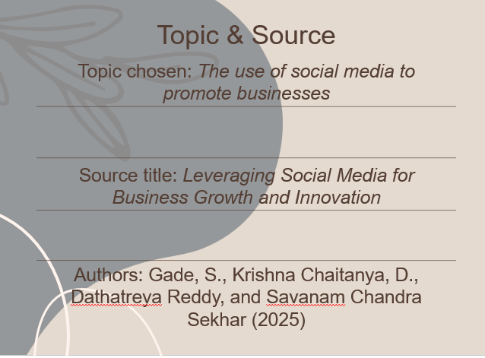
Today, I will discuss about my chosen topic which is about 'Use of Social Media in Promoting Business Growth and Innovation' in the selected source 'Leveraging Social Media for Business Growth and Innovation' by Gade et al. (2025) which directly addresses my topic and provides practical examples and strategies.

- Explain how you found the source
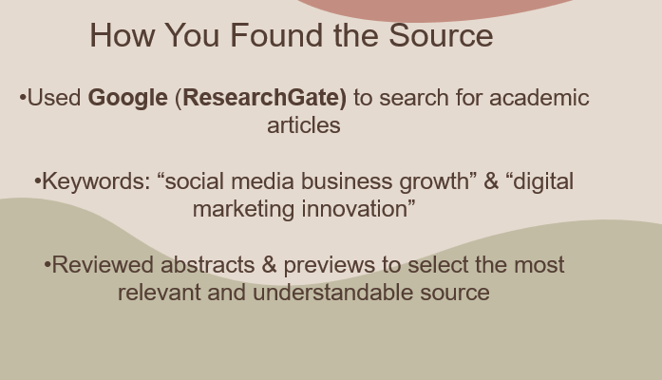
I used keywords to search for sources on ResearchGate, such as "social media business growth" and "digital marketing innovation". I checked a few abstracts and previews to see which one was the most relevant and understandable.

- Evaluate credibility (author, date, reliability) - To do so, you will need to respond to the above questions.
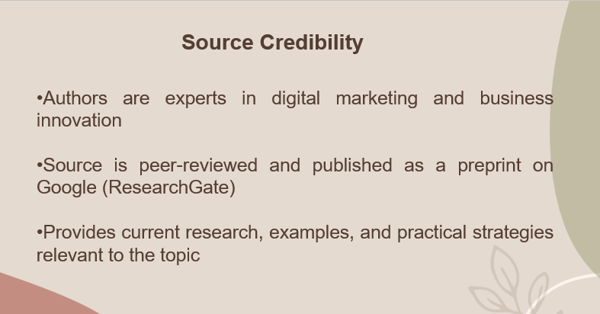
The authors are recognised experts in digital marketing and business innovation; the source is recent (2025), peer-reviewed, and offers evidence-based insights that can be trusted, given that it comes from a reputable research platform and references other academic studies.

- Short reflection – What did you find difficult about this task?
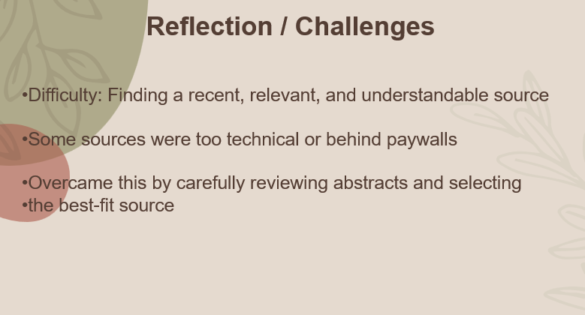
Identifying a recent source that was easily understood was the hard part. At first, some articles were too technical or behind paywalls, but I worked around this by carefully reading the abstracts and choosing a source that presented relevant information.
- What did you learn from this task?
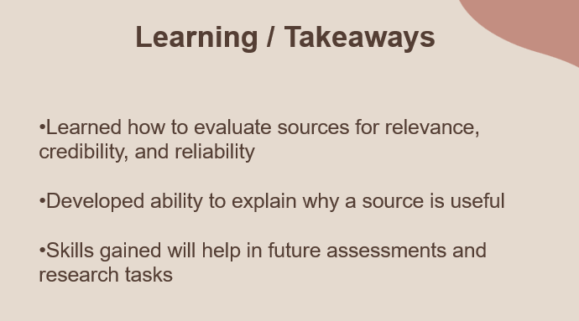
I learned how to critically analyse a source for its relevance, credibility, and reliability and how to explain why a source is useful, and how to reflect on my own research process, which will help in future assessments.

