Name: Labli Begum
Student number: 2121373
Program: BA (Hons) Leadership and Management Skills in the workplace
Module: independent Project
Module code: LCLM6005
Module leaders: Md Kalam, Samuel Ofori
Assignment title: part: Exploring the limitation and challenges experienced by Muslim travelers in the Hospitality Sector.

Content
Chapter 1- introduction 4
1.2. overview 4
1.3. Background 4
1.4. Research aims. 6
1.5. Research aims 6
1.6. Research questions 6
Significance of the research 1.7 7
1.8. Brief Methodology 7
1.9 Conclusion 7
Chapter 2 8
Literature Review – introduction 8
2.1. theoretical framework 17
Chapter 3 Methodology Introduction 19
3.1 Systematic Literature Review (SLR) 20
3.2 Search Strategy 20
3.3 Search terms 20
3.4 Key Words 21
3.5 Databases 21
3.6 Inclusion/Exclusion Criteria brief introduction 21
3.6.1 Inclusion Criteria 22
3.6.2 Exclusion Criteria 22
3.7 Search Results 22
3.8 Ethical Considerations 22
CHAPTER 4: Results and Discussion Introduction 23
CHAPTER 5: introduction 30
5.1 Recommendations 30
Theoretical Recommendation / contribution to theory. 32
5.2 Conclusion 33
5.3 Limitation of research 33
References and Appendices (if needed) 35

Table of figures and table
Figure 1. Lipaka and Hackett (2017) growing religion in the world 5
Figure 2 on website WHICH, Bell (2023) comparing best and worst service providers 9
Figure 3 Fernandes (2025), Website, YouGov 10
Figure 4 AbuKhalifeh et a. (2012) Parasuraman SERVQUAL management framework 12
Figure 5 Yi et al. (2025) Muslim tourist market. source. Authors 13
Figure 6 Yi at al. (2025) muslin market share. source. Authors 14
Figure 7 Yi et al. (2025) challenges implementing Muslim services. Source. Authors 16
Figure 8 Dabholkar et al. (2000) A comprehensive framework for quality service 17
Figure 9 adapted version service quality for Muslim friendly service 17
Figure 10 UK halal food market, And R. (2025) in Research and Markets 27

Table 1. the findings/results and discussion 23

Acknowledgement
I would like to thank my supervisor Eric Osei for the support and guidance.

Chapter 1- introduction

1.2. overview
The UK hospitality sector is renowned for its diversity and global appeal, yet it faces significant gaps in catering to the needs of minority groups—particularly Muslim travelers. One of the most pressing concerns is the limited availability of halal food options in hotels, which restricts the comfort and satisfaction of Muslim guests. This chapter explores the limitations and challenges experienced by Muslim travelers, focusing on the lack of halal menus and its implications for inclusivity in hospitality industry and the challenges. Chapter 1 is an introduction to background; research aims and questions and the significance of the research, brief methodology with an overall conclusion. Chapter 2 is an introduction to literature review and a theatrical framework. Chapter 3 is introduction to methodology with breakdown of data collecting. Chapter 4 is introduction of results and discussion on the views of authors and articles. Finally, Chapter 5 is an introduction to recommendations, conclusions, and limitations to the research.

1.3. Background
According to Fig 1. Lipaka and Hackett (2017) the fastest growing religion in the world in 2010-2020 was Islam in the 2025 analysis and it has been predicted the number of Muslims will grow by large from 2015 to 2060 and graph indicates if the growing number of Muslim are at large then the demand to cater in terms services for those minorities becomes an important factor. According to Clark (2025) Statista data reporting in 2019 1.28 million living in London and other largest Muslim communities live in West Midlands, north wet and Yorkshire. As the growing number of Muslims in UK the demand for halal food will be high. According to Gecsoyler, (2023) in the Guardians article, halal food has become more accepting in food festival, supermarket retail like Tesco, Muslim owned food chain, and restaurants but the problem is there is a limitation for halal food in hospitality industry in UK.
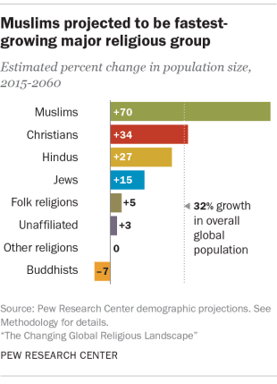
Figure 1. Lipaka and Hackett (2017) are growing religion in the world.

According to Future Market Insights (2025) in UK halal tourism market analysis for 2025-2035 forecasts the seeking demand for travel option that act accordance with the Islamic law of halal, with its growing number of Muslims population and understanding the need to accommodate to Muslim travelers/stayers. Although this is an ambitious project for the future that meets customers but expectations amongst the minorities (it also takes in consideration cultural and religious practices making it more inclusive just for the Muslim communities), at this current situation many top hotels in UK have either failed to meet those standards or do not have capacity to manage in large scale. The lack of inclusiveness in hospitality services indicates the challenges providing diverse dietary needs that can impact on customer satisfaction, reduce trust, and affect market competitiveness.
1.3. Problem statement
Despite hotels across the UK offer limited or no halal-certified food options.
Leading to the events of the problem is their fewer hotels cater to the halal menu in hotels one of UK top hotel for its affordability and situated mostly in town areas is premier Inn. Available on (Premier Inn 2016) this big UK brand hotel with 800 and more hotels across the UK is for leisure and business stayers and budget-conscious travelers but for guests being inclusive means focusing on guests with disabilities or catering for vegan or having all the facilities that many hotels do so according to the website, Premier Inn (2025). Another leading issue is not only Muslims who travel look for hotels for leisure or a getaway, but travel business or work related have preference of religious dietary needs. This problem needs addressing and the aim of this research is important.

1.4. Research aims.
The aim of this research is to find ways how UK Hotel can accommodate for Muslim travelers whether its leisure or business stayers by recognizing customer expectation in halal tourism. To acknowledge the target audience who are from Muslim communities and find suitable package hotel deal. To make inclusiveness more ethically promotes fairness and equity in policy making. understanding the market adapting to a new change to cater exclusively for Muslim stayers will make the company to be, more competitive in innovation. Also, the aim of the research is to see the challenges or barriers that limit the hospitality industry with less to no halal choices in hotels. The aim is also to build customer loyalty and trust.

1.5. Research aims
The research aims:
- To understand religious and cultural expectations of customers, particularly Muslims in their choice of hotel accommodation.
- Investigate whether there is a demand for specific Muslim-based food products and services such as halal food.
- Explore the menu choices available that cater to Muslim customers.
- Analyze policies and strategies targeted at Muslim customers.
- To show challenges faced by the lack of halal menu choices in hotels

1.6. Research questions
The research questions for this study are.
- What are the religious and cultural expectations of customers, particularly Muslims in their choice of hotel accommodation?
- What is the demand for specific Muslim-based food products and services?
- What menu choices are available that cater to Muslim customers in the Hotels?
- What are the policies and strategies targeted at Muslim customers?
- What are the challenges/barriers that may contribute to the lack of halal menu choices in hotels?

Significance of the research 1.7
This problem matters because according to Vargas-Sánchez, and Moral-Moral (2019) it is vital to offer halal services (food, worship facilities, etc.) to attract more Muslim tourists but also cater for those living in UK. According to Vargas-Sánchez and Moral-Moral (2022), the significance of this research is because Muslim travelers who respect their religious values and follow their duties also enjoy leisure activities too and its two segments to considered for companies is challenging. The significance of this research is for more diversity in guest satisfaction. This will build trust and loyalty with customers, and they will feel valued. It will enhance brand reputation business model for being more inclusive. It will create respect in the market and expansion for creativity. According to Ahmed (2024) in The Halal Times, the significance of halal food options with training staff on cultural sensitivity will bring more opportunities for growth and innovation tourism.

1.8. Brief Methodology
The data method is to Investigate a no Halal Menu in UK Hotels. Qualitative data to understand customer expectations, cultural sensitivities, operational feasibility, demand for halal food in hotel industry and hotel strategies and policies. Secondary data used for collecting information. data collected from Statista reports, gov.uk, census, articles or journals or media content about hospitality the aim to find out through graphs, charts, feedback, reviews looking at demographic factors of age, gender, and ethnicity/religion and look at documented data, industry reports, media and travel blogs, statical databases. As it is secondary data, all credits given to all reliable sources and meet ethical consideration and limitation of the research.

1.9 Conclusion
In conclusion the background explains the issues I want to address. It is important for the current market to acknowledge the growing of number of Muslims are at large around the world and there may be demand for certain needs that limited in the hospitality industry in UK e.g., halal food in hotels. The problem statement explains, one of the hotels in UK provide all necessity for being a good hotel but not catering for the Muslim minorities when it comes to food. The aim of the research would be to understand accommodate for Muslim travelers but also to show the challenges behind the lack of less halal choices in hotel industry followed by the research question which will give me idea in terms of my literature review. The significance of this research is respecting customers with cultural sensitivity, meeting customer expectations and understanding faith base policies and strategies, and if they align with policies in hotels. Concluding this research with a secondary data research method.
Chapter summary
CHAPTER 2: Literature Review
CHAPTER 3: Methodology
CHAPTER 4: Results and Discussion
CHAPTER 5: Recommendations, Conclusion, and limitations of the research limitations
References and Appendices (if needed)

Chapter 2

Literature Review – introduction
in chapter 2 the study is looking at the literature review on what customers expectation of service providers in hospitality industry. Then we understand service quality and customers’ expectations. Followed by looking into the demand for halal food in the hospitality industry, policies, and strategies for hotels, and then understanding faith-based attributes and policies. Finally, the study will see how to incorporate a theoretical framework in connecting service quality to customer satisfaction. Ending with critical analysis.
Customer expectations of service providers.
According to Lacalle (2024) service providers in hospitality industry is a service that offers guest experience, comfort of stay, sometimes including all inclusive of services e.g., food, family activities, room facilities/technologies and good customer service and efficient check-in and check-out. Here are top 3 hotel service providers in UK who accommodate the best of services for their guests.
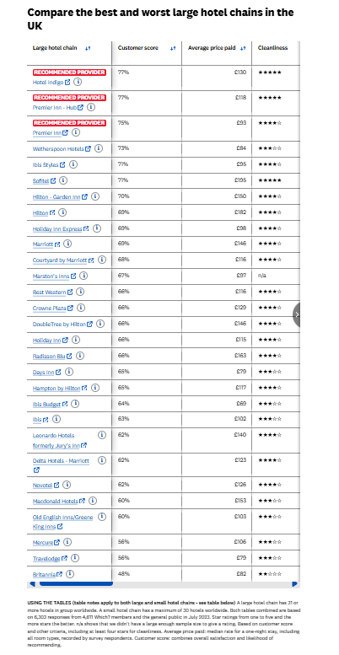
Figure 2 on website WHICH, Bell (2023) comparing best and worst service providers.

According to the website Which, Fig 2. Bell (2023) shows recommended service providers in the UK and what kind of service it provides: Hotel Indigo- customers find this place to be Classy mid-range hotels packed with personality – and at a reasonable price. Guests are happy with customer service as it provides helpful staff and a great breakfast and found near the city center. The décor is old-fashioned with 1930s period look. Customers score 77% Hub by Premier Inn- offers smart stylish rooms across UK. With all room amenities and comfortable stay. Premier Inn- offers super comfortable beds, tasty food and drinks, and family friendliness. Both Hub premier Inn 77% and premier Inn 75%. According to customers, this hotel is value for money and meets expectations of those who are looking for budget friendly stay. The worst According to website Which, Fig 2. Bell (2023) at bottom 3 is Mercure, Travelodge, and Britannia. According to AbuKhalifeh et al. 2012 the service providers should be able to understand the behavior and needs of guests to be able to know how to satisfy them. According to on website Which, Fig 2. Bell (2023) the top 3 hotels are hotel Indigo, Premier Inn, and Premiere Inn Hub and although the Marriott hotel scores 69% but according to the website Halabooking.com. (2025) it shows the London Marriott Hotel Regents Park do provide halal food service but only though halal booking.com but Indigo and premier Inn do not.
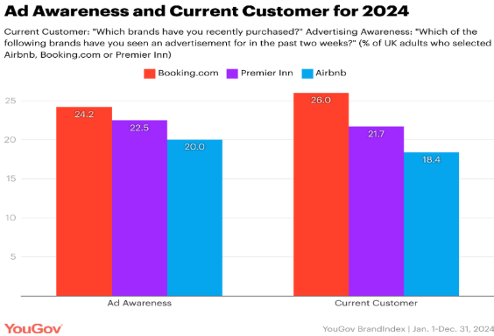
Figure 3 Fernandes (2025), Website, YouGov
According to Fig. 3 Fernandes (2025) indicates how premiere Inn in UK has been consistent meeting customer expectations and market demands. Although might argue that the Booking.com is leading in UK’s Ad for Awareness, but Premier Inn wins on brand Value in 2024 and Airbnb least in the ad awareness and current customers.
Service Quality and Customer Expectations 300
According to Selander (2024) the kind of service customers want in the hospitality industry is good quality of service, cleanliness, all amenities and facilities that hotel provides, value of money, guest experience from feedback/reviews, personalized attention to details, engaging with guests through other channels e.g. social media, offers and events, and staff self-assurance. These are what guest/travelers look for in service providers for guest satisfaction. According to Gebremichael et al. (2019) “customer satisfaction is created through ensuring quality in service delivery, and service quality is connected to customer perceptions and customer expectations” and also mentioned by Gebremichael et al. (2019) “study finally suggested that in an attempt to improve the quality of service provided to customers, managers should improve or renew all physical, facilities, equipment and communication materials used by hotels this means some costumers perception is shaped brand name, price and experience.” This can also mean when choosing a hotel, the following matters e.g., interesting brochures, advertisements, car park facilities, friendly reception desk, to well trained staff and overall, all excellent value in terms of money. According to this author it focuses on high standard of service quality and dimensions. E.g., empathy in how employees behave, tangibility in what service the hotel offers, reliability/responsiveness in how the hotel performs and assurance is how the hotels manage problems. According to Rao and Sahu (2013) “service quality by focusing on the front office staff only and explored the customers’ expectations and perception levels of these services”. This author talks about how the staff are and what makes it wonderful experience for customers in hotels. According to Gebremichael et al. (2019) the result show factors that only four dimensions or factors such as assurance, reliability and responsiveness, tangibility, and empathy were found important for service quality of hotels such as the improving equipment, facilities and communication but Rao and Sahu (2013) the five-dimension results showed that the overall mean of perception was higher than expectation in all dimensions, submitting an optimistic SERVQUAL gap working around staff being the core in building a quality of service. The authors focus on customers’ satisfaction and expectation but using the same dimensions which are tangibility- staff appearance and approach, reliability- how staff provide service, responsiveness- how prompt staff are in providing service, assurance- staff to be trustworthy and last empathy in how staff communicate. According Arasli et al. (2023) Key attributes of Muslim-friendly hotels’ service quality is hotel, staff, food, room, facilities, cleanliness, and Wi-Fi. This is what a most Muslim guests look in customer satisfaction. This data gathered from online website booking.com.

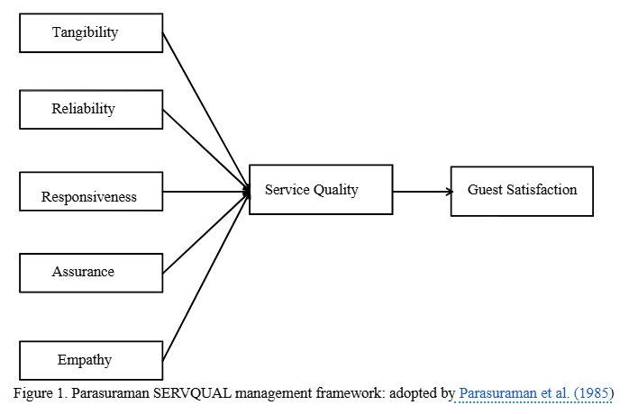
Figure 4 AbuKhalifeh et a. (2012) Parasuraman SERVQUAL management framework.

Fig 4. AbuKhalifeh et al. (2012) Parasuraman SERVQUAL management framework: adopted by Parasuraman et al. (1985), Framework explains how quality of service meets customer expectations and based on the 5 dimensions of performance guests feel satisfied or dissatisfied. Service providers need to understand what guests need in order meet their expectations and that impact on their behavioral intentions.
Demand for Halal Foods in Hospitality Industry 300
According to and, R. (2025) in Research and markets the UK the growing demand halal certification that is ethically source and high quality. According to Adnan (2025) int The Halal times the growth of UK halal industry valued at £1.7 billion in 2025. The halal market is reaching consumer demands as the growing number of Muslim populations is growing at large and it has predicted to reach USD 10 trillion by 2030. According to Ahmed (2024) in The Halal Times, with a worldwide Muslim population 1.9 billion, the demand for Muslim-friendly travel options has been at the highest. For Muslim religious dietary is a requirement and so Muslim tourist more like to choose a destination that is accommodates to their needs as well recreational activities. While countries such as Malaysia, Türkiye, and Indonesia Muslim countries cater for halal tourism that includes food but according to the website Premier Inn (2025) food and drink- one of value for money hotel in UK only offers non halal food services. Only provided by third-party restaurants and only cater vegan/vegetarian and classic British food which means there is a challenge to source halal certified meals that meet religious dietary needs.

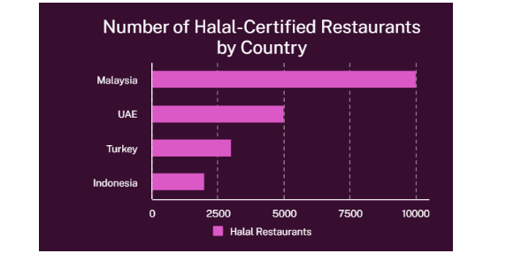
Figure 5 Yi et al. (2025) Muslim tourist market. source. Authors

According to Fig. 4 Yi et al. (2025) the demand for halal certificated restaurants by countries are Malaysia with 10000, then UAE with 5000, Türkiye 2700 and Indonesia 1800. This data indicates popularity of tourism when it comes to halal certified food in international countries where faith-based attributes considered and selling point for Muslim travelers.
Policies and Strategies of Hotels 300
According to Lacalle, (2024) at Mews.com the policies of the hotel are most common rules and regulations that are important in the hospitality industry. They are there to meet guest expectations and regulate a system that manages hotel operation smoothly and accordingly and aligned with the hotel’s policies. Here are the handbook listings of policies: cancellation and refunds- it must state when booking that guests are aware of the terms and conditions of cancellation, refunds and with deadline policies. Safety and security- these are to make sure guests are safe, secure, and assured all measured taken when staying e.g., door entrance, fire exits, fire alarms, and smoke detectors and staff members are to make sure guests know. Smoking policy- hotels have no-smoking policy and guests must abide by that rule. Damage and lost personal items- most hotels are liable if anything happens to guests’ items while they are not there and can be held accountable but also guests need to be mindful of the facilities that they use in the hotel and may hold responsible. Check-in-in and check-out. When booking guests given the choice of arrival time and leave time. Sometimes it acquires ID check. Occupancy- when booking for room size to the number of people it is by rate and for extra people the extra charge applies which guests must accept. Noise and behavior- guests staying must respect other holiday guests and be mindful of not being loud or noisy. Also be respectful towards staff members. This author has explained how the hotel policies in current time matter and guests must follow and agree to the hotels guidelines. According to Dimitrios et al. (2023) digital marketing is most trending for promoting hotel business. Hotels and guests used social media marketing strategy to give feedback or review on high standard hotels. The use of digital tools helps effectively promote and enhance more coverage to interest customers. Online revies helps to better the service or know how well a hotel is doing. It focuses on customers’ satisfaction.
Faith-Based Strategies and Policies 300
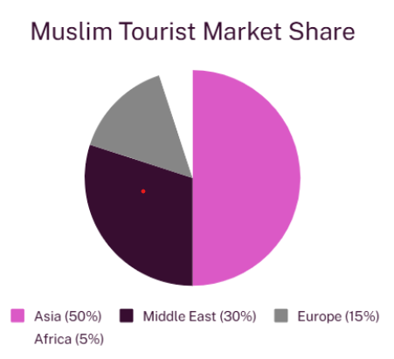
Figure 6 Yi at al. (2025) muslin market share. source. Authors

According to Fig. 4 According to YI et a. (2025) Muslim Market Share Asia has the largest Muslim tourist with 50% and Africa least with 5%. According to Papastathopoulos. Et al. (2021) despite the hospitality industry offers what most customers commonly look at when booking e.g. room size, location, good restaurants within hotels, bars, and other facilities but it explores the faith-based attributes for travel and tourism focusing hotels in located large cities in Singapore, Japan, Thailand which are non- destination. Muslim practice their faith with all honesty and preference to when booking for hotel would be how they can practice their faith and halal food choice. With the growing number Muslim tourist around the world are rising yet the research has not explored how the religious needs of Muslim tourists affect the hospitality. This study also indicates religious beliefs change customers’ behavior, daily activities, or business purpose and this all must align with their practices. According to Papastathopoulos. Et al. (2021) uses hedonic pricing models which is a faith-based attributes for those who are looking exclusively for halal tourism, and this include internal- room size, amenities, halal certified kitchen, prayer facilities and then an external attribute that includes local mosques and halal restaurants. The author defines the importance of faith-based attributes and customer expectations of halal food and practicing their faith comfortably is vital Muslim travelers. Muslim tourists are willing to pay more for internal and external halal related attributes e.g., halal food, certified halal, alcohol free, halal restaurants, payer mat or prayer room, mosques and private pools when choosing destination and hotel. Most used database Tripadvisor mentions how they do not record halal related services, and this information found from Tripfez a website that takes data for hotels that offer halal-friendly service that interest Muslim travelers. This means not using data that explores faith-based attributes could mean lack of understanding of statistics what the demands are for halal friendly tourism. According to YI et a. (2025) a swot analysis conducted for Muslim service for beautiful tourist location in more Muslim friendly countries and to see advantage and disadvantage of halal tourism. The advantage was cultural uniqueness, which is Muslim friendly service, halal food, prayer places, warm hospitality, and this make is Muslim tourist to enjoy their holiday and practice their faith. Another advantage was immense potential for growing market to enhance in halal tourism but the disadvantage implementing Muslim services requires safety and security, cultural tension, or differences or conflict, in non-Muslim locals may lack of halal food, prayer facilities. Another disadvantage is inadequate staff training, or services e.g., the absence of halal certified food or prayer facilities.

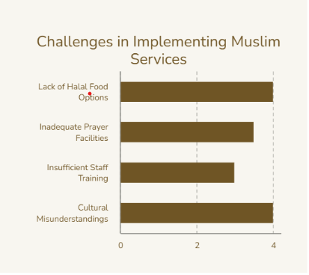
Figure 7 Yi et al. (2025) challenges implementing Muslim services. Source. Authors
Some of the challenges for faith-based policies do lack of halal food for Muslim travelers and cultural misunderstanding which could be a reason for why there less halal option in UK hotels e.g. Mentioned on the website of according to the website Premier Inn (2025) food and drink with no halal option but has vegan and vegetarian.

2.1. theoretical framework
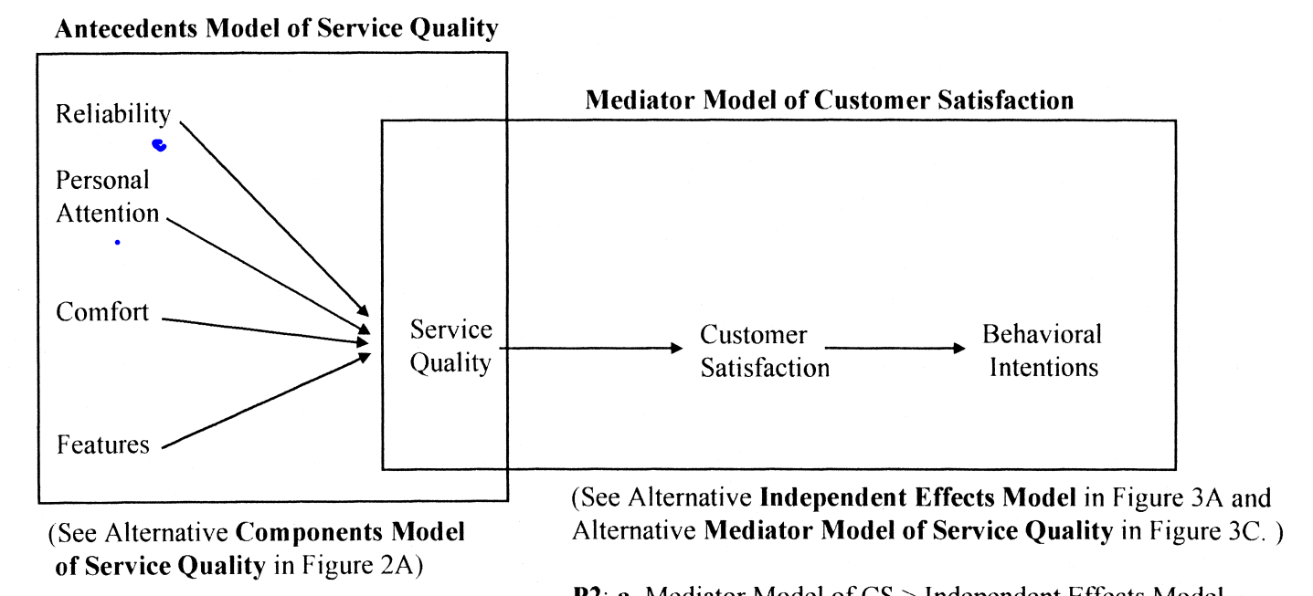
Figure 8 Dabholkar et al. (2000) A comprehensive framework for quality service.

Adapted version.

Service quality
Halal food
Menu/Quality of food
Room amenities
Employee behavior
Behavioral intentions
intention
Customer satisfaction

Figure 9 adapted version service quality for Muslim friendly service.
Adapted version from two different theoretical frameworks Fig 6. Dabholkar et al. (2000) and Fig 3. AbuKhalifeh et al. (2012) Parasuraman SERVQUAL management framework, the following explains how halal food, quality of menu, room amenities, employee behavior that can impact Muslims travelers/guest in a positive way and good quality of service that impacts on customers satisfaction leaving the effects of behavioral intentions which can be overall advantage that hotels benefit from being most inclusive.
Halal food
Crescent Rating (2019) halal food must meet to an Islamic law certified so its permissible for Muslims to consume. Access to halal-certified food is often a priority, so a hotel with an in-house halal restaurant or one close to halal eateries is a major plus. So, it is important to have hotels that take into consideration religious values and the need for a third-party restaurant that can get trained staff, halal desinated kitchen space with cross contamination, and making sure the ingredients are sourced from halal vendor/supplier. Guests also look for alcohol free in restaurants. Halal food must be ethically sourced.
Choice of menu and quality of food
Depending on the package of booking (e.g. breakfast, lunch and dinner) choice of menu should be at least 1-3 options: halal meat and chicken option and the food quality should be as good the rest of non halal option as Muslims look for good food which important for quality of service and customer satisfaction. According to Bano (2022) in The Halal Times fish with garlic, grilled kebabs, butter chicken, chicken biryani, and sponge cake. These are examples of what can be served to guests.
Room amenities
Comfortable stay and room space clean enough to pray for guests who are practicing their faith. With Wi-Fi, TV, and all the necessities of a room. Family friendly accommodation.
Employee behavior
Friendly and accommodating staff makes guest experience enjoyable and most importantly guests that are diverse with cultural sensitivity or religious beliefs or need important staff are respectful, mindful, and helpful and so guests can feel valued. Staff should always be attentive, willingness to help.
Service quality
Halal food choice is included, and the quality of the food is important and should be same standard as non halal options because it will show the measure of how well a service meets or exceed customers’ expectations that includes the minorities of Muslim stayers or guest. The addition of room amenities such comfortable bed, Wi-Fi, individualized touch, and complimentary gifts are what makes guests feel welcomed. Employee behavior makes good customer service and being professional, understanding calm and helpful are the traits stand for good business models. Service quality leads to knowing what customer expectations are.
Customers satisfaction
When a halal choice is considered and the food tastes good, guests will feel happy. When the room amenities to their liking they will get a comfortable night's stay and when staff are very accommodated guests will feel safe and looked after. This shows the service meets customers’ expectations which leads to behavioral intention.
Behavioral intentions
The guests will feel valued and would like to book a hotel that caters for halal food, all room amenities and great customer service and builds customer loyalty and trust.
summary
CHAPTER 3: Methodology
CHAPTER 4: Results and Discussion
CHAPTER 5: Recommendations, Conclusion, and limitations of the research limitations
References and Appendices (if needed)

Chapter 3 Methodology Introduction

In this chapter, the study will show how it is collected. Starting with the literature review used in chapter 1. Defining the search strategy and explaining how it is adopted, the choices of strategy driven by RQs. Defining the search terms and showing the reason for using them. Defining the key words and finding them. Then tell all databases to collect information stored electronically and the reason for the use. Then defining what information is used and excluding what information is not relevant. Then briefly discuss results with a mention of ethical consideration.

3.1 Systematic Literature Review (SLR)
According to Fikriyah et al. (2025) it defines the research question halal friendly hotels. It focuses on customers satisfaction and building customer loyalty and trust for Muslim minorities, but it also identifies gaps in research limitations.

3.2 Search Strategy
The search strategy for secondary data according to O’Leary (2018) is developing the research question, then finding the data to see whether it is accessible or not. Making sure the data is credible and relevant for the research, following data collecting protocol in finding database. The reason for adopting this strategy according to Wickham (2020) saves time avoiding the challenges of primary data collecting. Defining the choice of strategy is driven by the key words in the RQs:
RQS 1. What are the customer expectations in hotels?
RQs 2. What are the policies and strategies targeted at Muslim customers?
RQs 3. What is the demand for halal food in hospitality industry?
RQs 4. What menu choices are available that cater to Muslim customers in the Hotels?
RQs 5. What is the demand for specific Muslim-based food products and services such as halal food?
RQs 7. What are the challenges/barriers that may contribute to the lack of halal menu choices in hotels?

3.3 Search terms
Defining the research terms according to University of Leeds (2022) are key words, keywords and phrases taken from the key idea of a research question, used to find relevant literature in databases for secondary data. E.g., if the RGs question is What are the customer expectations in hotels? Then the focus research will be on customer expectations. Another RQs What menu choices are available that cater to Muslim customers in the Hotels? The research should focus on Menu choices and Muslim customers.

3.4 Key Words
Defining the keys are focused on what the research is on. The key words are Halal, Muslim-friendly, faith-based, Hotel, hospitality in UK and international, accommodation, Tourism, guest satisfaction, service quality. The reason for these key words is because they focus on target audience, the industry and the demand or need to meet expectations that will enhance the business.

3.5 Databases
According to George (2023) Databases in secondary data is information stored electronically through organization, statistics report from primary resource, journals, studies, and other literatures. The relevant databases are Google scholar, Scopus, Elsevier Science Direct, research Gate, ProQuest, UWSTD library, Mews, office of National Statics, Statista, PubMed Central. The reasons for using secondary data information that meets the chosen methodology and is mostly freely accessible online. Saving all important data on google bookmark that will save time looking for relevant articles, journals, website, blogs to not so relevant data.

3.6 Inclusion/Exclusion Criteria brief introduction
According to According to Nikolopoulou (2022). Exclusion criteria are specific characteristics that disqualify individuals from taking part in a research study. For example, if they are minor or have medical conditions. Inclusion criteria are key information that is 3relevant, dependable, and need to be included because it aims to focus on RQs' findings. According to Nikolopoulou (2022), inclusion criteria are population, more observation, and places/location. For example, people meeting inclusion criteria need to be more eligible, and that includes the age factor. Both are important in researching and whether it is needed, and that safeguards information for ethical consideration. Both will still have similar attributes for assessing studies which are time, location, e.g., UK demanding halal menu and international halal tourism, and journals online.

3.6.1 Inclusion Criteria
According to CM Patino et al. (2018), inclusion criteria are based on specific target people, places, and that focus more oriented around researcher questions. This will include statistical reports, journals, and articles that may be qualitative and quantitative secondary data.

3.6.2 Exclusion Criteria
According to CM Patino et al. (2018), exclusion criteria can be inaccurate data, or studies may not be relevant in searching data. Exclusion criteria are information that may not be that valid, but still ethical considerations need to be in place. The things that need to be excluded are age and gender as the research focuses on the Muslim minorities. This is because the research aimed to understand the expectations of Muslims customers and the demand for halal food menu specially In UK which lacks the most.

3.7 Search Results
The expected results would find any gaps in literature or limitations in findings of what aims and goals that concentrate on the research questions. The results that can expected from this study is how the expectation of Muslim consumers perceived that is align with religious or cultural values and follows halal standard. The study will also explore the challenges and barriers in finding out why it is difficult to cater for a halal menu in the hotels in the UK in contrast to Halal friendly countries who do cater for more halal tourism that includes food. The results to be discussed are policies and strategies and comparing faith-based strategies and policies. The study is gaining understanding of the gap in market for halal tourism, especially in the UK.

3.8 Ethical Considerations
Business ethics would be the gathering of information through data protection, GDPR, using reliable sources and excluding sources that cannot be cited, referencing sources with Harvard referencing method.
summary
CHAPTER 4: Results and Discussion
CHAPTER 5: Recommendations, Conclusion, and limitations of the research limitations
References and Appendices (if needed)

CHAPTER 4: Results and Discussion Introduction
The study will result from finding 1-4 findings and discussing similarities in thought or conflicting views or comparing views.
Table 1. the findings/results and discussion
Findings |  |  |  | Theme | Discussion
Author 1  Selander (2024) | Author 2  Gebremichael et al. (2019) | Author 3  Arasli et al. (2023) |  | 1 - What are the customer expectations and service quality in the hospitality industry? | To find ways in how service providers can enhance and improve customer loyalty
Author 1  According to Papastathopoulos. Et al. (2021) | Author 2  YI. Et al. (2025) | Author 3  Lacalle, (2024) |  | 2. What are the policies and strategies targeted at Muslim customers? | Muslim friendly service
Author 1  Adnan (2025 | Author 2  Ahmed (2024) in Halal Times | Article.  UK halal food market, And Research (2025) |  | 3. What is the demand for services in the hospitality industry? | Demand less UK and varies internationally
Author 1  Crescent Rating (2019) | website  and R. (2025) in Research and markets |  |  | 4. What menu choices are available that cater to Muslim customers in the Hotels? | Vegans, vegetarians, and sea food
Author 1  Bano (2022) in The Halal Times | Website  Premier Inn (2025) Food & drink | Website  HalalBooking. (2025) London Marriott Hotel Regents Park |  | RQs 5. What is the demand for specific Muslim-based food products and services such as halal food? | Halal certified and source meat, chicken, and alcohol free
Author 1 Marcelina and Palupiningtyas, (2025) | Author 2  Arasli et al. (2023) | Author 3  Fig 6. Dabholkar et al. (2000) fig. 3 AbuKhalifeh et al. (2012), | Website  website Which, Fig 2. Bell (2023) | 6. What are the religious and cultural expectations of customers, particularly Muslims in their choice of hotel accommodation? | Theatrical framework
Author 1  YI. Et al. (2025) | Author 2 Alserhan et al. (2022) | Website  CFScompliance (2024), |  | 7. What are the challenges/barriers that may contribute to the lack of halal menu choices in hotels? | Gap for faith-based policy and lack of staff training

Themes
1 - What are the customer expectations and service quality in the hospitality industry?
According to Selander (2024) the kind of service customers want in the hospitality industry is one which ensures customers have wonderful experience, explore prioritizing customers satisfaction, and find ways in how service providers can enhance and improve customer loyalty. This author talks about the success behind achieving guest satisfaction, always knowing what guests want, and how to improve their needs that meet and exceed customer expectations in the hospitality industry. According to this author, it focuses on the crucial factors such as quality of service, which is to make sure guests are looked after throughout their stay and the operation of check-in and check-out runs smoothly. Another factor is cleanliness and maintenance, which is to make sure guests have a well-kept environment that meets hygiene standards. Another factor is amenities and facilities which are a comfortable room stay, Wi-Fi, and room essential as well as fitness and spas which make guests happy. Another factor is value for money, which is to make sure guests have the best package deal. Another factor is guest experience with staff, booking and the stay. Another factor is the impact of personalization where guests get special treatment or exclusive to their preference. Another factor to customer expectations is marketing by engaging guests via various comms channels such as social media platforms. Lastly, staff self-assurance is another key factor that makes customer satisfaction when staff are efficient and confident in providing customer service. According to Selander (2024), not only does the article understand the key factors affecting customer satisfaction but it also finds ways to improve guest satisfaction and how to measure guest satisfaction through feedback/review. According to Gebremichael et al. (2019) study suggests that to improve the quality of service provided to customers this means these factors influence a customer opinion, feelings and future purchasing affected by the brand name, price, and guest experience. This author uses the five-dimension service quality data which is empathy, tangibility, reliability/responsiveness, and assurance but shows how it needs improvement on tangible features, which is making latest changes to hotels facilities, how the hotel communicates and how staff presented. This study shows the four star and five stars found in Ethiopian hotel industry. Both authors have one features in common is trying to meet the needs of guest expectations by improving what would better the service and evolve this business to next level but with Selander (2024) the article is more current and the factors for improvement are more highly recommended for competitive hotel industry and so the success measures on investing time and resources. Each article talks about the customers’ expectations of service quality and looking into what Muslim minorities want is similar, According Arasli et al. (2023) which great staff, food, room, facilities, cleanliness, and Wi-Fi but only difference is a more inclusivity in creating a Muslim friendly hotel with halal certified menu and a room that is clean enough to practice their faith and staff that mindful of cultural/religious sensitivity. This is what a most Muslim guests look in customer satisfaction. This data was gathered from the online website booking.com.
2. What are the policies and strategies targeted at Muslim customers?
According to Papastathopoulos. Et al. (2021) provides evidence that offering halal services has a significant and positive effect on hotel prices. The method used to analyze this is a hedonic pricing model that shows the impact of internal and external faith attributes on price. The study focused on hotels found in 3 large non-Muslim destination but catering a halal friendly service with the price dominating the interest of Muslim tourist when it comes to booking. The Hotels provides the internal benefits of halal certified food and prayer room for guests and external benefits of near mosques and local halal restaurants. The prices reflect consumer behavior. While Papastathopoulos. Et al. (2021) has follows the policies and strategies that applies exploring faith-based attributes and how price controls and contribute better to travel and tourism in other hand according to YI et a. (2025) would argue that there is some advantages Muslim tourism is which is when visiting beautiful pictures location there is rich cultural; legacy of Muslim communities, Muslim friendly service, halal food, modest regulations, nearby prayer places. All this makes the experience for Muslim traveler reassuring and enjoyable, but there are challenges too, where some beautiful location may lack of sufficient facilities for Muslims such as prayer room and halal food. This would make an uncomfortable experience and would have a negative impact on consumer behavior. Another challenge would be staff with not enough training who are key players in the hotel industry but lack service quality. another barrier is cultural sensitivity where it may lead conflict between Muslim tourist being in non-Muslim locales. Although these policies and strategies are put in place implementing these services needs the consideration of safety and security and so the author mentions about ways to improve that would facilitate for Muslims in the scenic spots such as increase tourist flow e.g. more halal food, prayer facilities, targeting family group and making cultural experience more inclusive to Muslims and non- tourists and establishing halal certified eating areas and making food preparation complies with halal standard. Both articles have similarities in their strategies and policies when comes provided a halal friendly service for Muslim but- do the strategies and policies meet the same in UK? And to understand the policies and strategies that apply in UK the aim is to explore the limitations of halal menu for Muslim minorities in hospitality sector in UK. According to Lacalle, (2024) at Mews.com the policies that require running a hotel are making sure following policies are put in place: cancellation and refunds, safety and security, no smoking policy, no noise after certain time, damage to property, check-in and check-out, and being respectful to staff and other occupancy. These are basic policies for all guests accommodating all ages, gender or ethnicity and all guests must abide by these rules and regulations of hotel guidelines, and they are most similar around hotels in UK. The author has not made an exception to a policy that caters for any specific group as has the other 2 authors who have aimed the target audience to be Muslims.
3. What is the demand for halal services in the hospitality industry?
According to Adnan (2025) int The Halal times the growth of UK halal industry is valued at £1.7 billion in 2025 According to Ahmed (2024) in The Halal Times, with a worldwide Muslim population 1.9 billion, the demand for Muslim-friendly travel options has been at the highest. For Muslim religious dietary is a requirement and so Muslim tourist more like to choose a destination that is accommodates to their needs as well other facilities like sports, activities and a family friendly environment but according to the website Premier Inn (2025) food and drink there is no halal food or services. Premiere Inn on one of the hotels in second place according to Bell (2023), Best UK hotel chains for 2025). This shows us being the best hotel, but the demand for halal food in this hospitality industry is less, and that also identifies the lack of diversity in being more inclusive. The demand for food is high but not so in the hospitality industry. according to Yi et al. (2024) the study shows the demand for halal service is based on cost/pricing and hotel rates shows all-inclusive the likes of facilities, meals, service attitude, and religious assistance impact positively on quality of service.
4. What is the demand for specific Muslim-based food products and services such as halal food in UK?
Halal meat and chicken, alcohol free that needs to comply under Islamic law and is permissible to consume. Crescent Rating (2019) halal food must meet to an Islamic law certified so its permissible for Muslims to consume. According to and, R. (2025) in Research and markets the UK, the growing demand for halal certification that is ethically sourced and high quality and meets the Halal Monitoring Committee (HMC), Halal Food Authority (HFA). The halal products consumers demand are Meat Poultry and Seafood Fruits and Vegetables and Dairy Products.
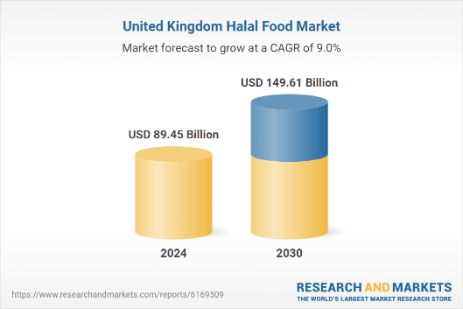
Figure 10 UK halal food market, And R. (2025) in Research and Markets

According to fig. 10 UK halal food market, And R. (2025) and Adnan (2025) The Halal times, both agree that the demand for halal is high with reports shows the USD is 89.45 billion in 2024 and is predicted USD 14.61 billion by 2030 so that indicates the demand for halal market is high as the growing number Muslims are at large too and the growth of UK halal industry is valued at £1.7 billion in 2025.
5. What menu choices are available that cater to Muslim customers in the Hotels?
Customer demand and choice: To understand religious and cultural expectations in how the food is prepared and certified for customers’ reassurance. Looking at choices on the menu e.g., breakfast, lunch, dinner, and snack choice. According to Bano (2022) in The Halal Times fish with garlic, grilled kebabs, butter chicken, chicken biryani, and sponge cake. These are examples of what can be served to guests but looking at Premier Inn (2025) Food & drink website one in hotels in UK (who work with third party restaurants providing different menus) do not serve halal food but alternative to this vegan and vegetarian. While premiere Inn does not have a policy that allows halal in menu, it is according to HalalBooking. (2025) London Marriott Hotel Regents Park do have halal choice in their restaurant menu but only if customers book through halabooking.com. this shows the limitation for Muslim minorities.
6. What are the religious and cultural expectations of customers, particularly Muslims in their choice of hotel accommodation?
According to Marcelina and Palupiningtyas, (2025) the preference and expectation of Muslim guest are Muslim friendly hotel facilities and services that align with Islamic law. Specific preferences would be halal food and prayer place. The author had done a qualitative study understand Muslim guest needs and consideration for the importance of marketing strategies that interest consumers behavioral interest. The author has mentioned that in terms of dietary needs, guests feel satisfied if they have assurance of meat and chicken is halal and no alcohol. The main expectation is that guests give importance and halal food is one of the key attributes that draw customers into booking the hotel. Finding prayer facilities is the second choice, and the staff's attentiveness is the third choice. According Arasli et al. (2023) the expectation for Muslim guest they want staff with good customers service, room, facilities, cleanliness, and Wi-Fi but also the inclusivity of a halal menu and clean room where they can prayer and staff that are also mindful toward cultural sensitivity. These are service qualities that build customer loyalty, trust, and satisfaction. Both authors had similar views although one emphasized halal service more e.g., food and prayer place and other authors more on halal food but more amenities and a clean room where they can pray. Adapted version from two different theoretical frameworks fig 6. Dabholkar et al. (2000) and Fig 3. AbuKhalifeh et al. (2012) Parasuraman SERVQUAL management framework, it shows how to be perceived service quality of halal food, quality of menu, room amenities, and employee behavior can have a beneficial impact on customer satisfaction if it meets customer expectations for the Muslim minorities. A choice of hotel would be Premier Inn UK, being one of the best hotels according to website Which, Fig 2. Bell (2023)
RQs 7. What are the challenges/barriers of non-halal menu choices in hotels?
Hotels offering non-halal menu choices face challenges related to cultural sensitivity, guest satisfaction, and operational complexity, especially in regions with significant Muslim populations. According to YI. Et al. (2025) the challenges in implementing Muslim services are: lack of halal food options, inadequate prayer facilities, insufficient staff training. and cultural misunderstandings. With a swot analysis this author has highlighted that even when Muslim consumer looks for beautiful, picturesque location they may not have services catering for Muslims such as restaurants that serve halal food or other facilities that prioritize practicing their faith. This can affect the travel experience Muslim tourist, meaning they are less likely to book for hotels that do not facilitate for their needs. the missing requirement for halal certified food and other services results to an uncomfortable experience for Muslim visitors. While this author can oversee the challenges of halal food choice, even in international countries, the challenges in meeting halal standards may be similar. According to CFScompliance (2024), the challenges shown despite growing demand for halal products are the risk of cross-contamination and making sure they are ethically sourced and certified. This important to ensure Muslim consumers can feel trust in service they provided with. Cross contamination and not ethically sourced food can be a risk in the kitchen restaurant department of any hotel that serves food to guests with religious needs. The need for Halal certification through the HFA (halal Food Authority) follows the health and safety standards. Another challenge in cooperating with a halal menu in hotels is the lack of trained staff. According Alserhan et al. (2022) to manage the demand of halal services and skills, the need for qualified Muslim workers is necessary but the hospitality is unfamiliar with the principles and not meet the standard of compliance. Without proper training, staff may not understand the importance of halal food to Muslim guests, affecting service quality. The different reliable sources have similar views, which lack of halal food, insufficient training of staff and the difficulty of integrating a halal certification for food standard policy are the barriers/challenges of why there is limitation to halal menu in hotels, especially in UK. Another challenge is affordability according to Ahmed, H.M. (2023) Halal-certified products are often more expensive than non-halal options due to the cost of certification and the limited supply of halal products in non-Muslim countries. Halal certified products are more expensive, and the cost of non-halal food is easier to access than halal produce that requires halal slaughtering. There is also the challenge of availability of halal products, and food retailers struggle to have halal options in big named supermarkets. Another challenge is trust in making a show that the halal produce is ethically sourced. This author has emphasized how on how the challenges of halal consumerism effects on halal products and services in many non-Muslim countries and there for could be the reason UK struggles to cater for halal menu in UK hotels.
Chapter Summary
CHAPTER 5: Recommendations, Conclusion, and limitations of the research limitations
References and Appendices (if needed)

CHAPTER 5: introduction
Introducing practical recommendations for managers, policy recommendations for policy makers, and theoretical recommendations for running hotels. Then a conclusion to understand the overall perspective of the research and ending with limitation of

5.1 Recommendations
Practical Recommendations for the Manager 100
Hotel managers aiming to deliver high halal service quality should focus on staff training, halal compliance, and culturally sensitive guest experiences Here are practical recommendations for managers aiming to implement halal catering successfully:
Managers need to plan and action staff training and awareness: In the running of the hotel managers should make sure staff are mindful, respectful towards religious needs and helpful toward guests in the minorities. Empower frontline staff with knowledge in dealing with diversity and understanding cultural sensitivity.
Halal Food & Beverage Management. Arranging training, especially kitchen staff managing Understand halal requirements. Making sure food is complies to Islamic law, no alcohol, no pork, halal certified meat, and chicken. Avoid cross contamination where there is a designated kitchen space that prepares food. Create a menu that includes a few chicken and meat options as well as the vegetarian and vegan ones that guests allowed to eat Sourced certified food suppliers. Food labelling or clear menu that writes down halal signs and no alcohol. Vendors that supply ethically soured ingredients.
Facilities & Service: although helping prayer room may be difficult but good and through housing keeping of the room guests staying should be acceptable enough for practicing their faith. It needs to be clean and should include other facilities with a gym (separate for adults).
Policy Recommendation
To enhance halal service quality in hotels, policy recommendations should focus on certification, staff training, infrastructure, and transparent halal governance.
Halal certification and compliance: Certification that meets (Halal Food Authority) or HMC (Halal Monitoring Committee). Include halal catering in hospitality guidelines. Cost/financial means: Looking at the budget and affordability of this change depending on the third-party restaurant hired in hotels in the UK, access to kitchen space and staff training following halal food and hygiene will need to be put in place.
Halal food supply chain: food preparation and storage needs align with health and safety. Promote local halal suppliers. According to Shari et al. (2022) The halal food supply chain sector emphasizes risk management, integrity, coordination, and warehousing to ensure compliance with Islamic law and consumer trust.

Theoretical Recommendation / contribution to theory.
According to Noor (2025), the theoretical framework recommended for service quality in halal industries is the SERVQUAL model. Culture, technology, and faith-related are key components of halal service quality, meeting consumer expectations, and business practices across halal industries. Adapted version from two different theoretical frameworks Fig 6. Dabholkar et al. (2000) and Fig 3. AbuKhalifeh et al. (2012) Parasuraman SERVQUAL management framework here is a version that could work in UK if they adopted the following for halal service in UK hotels like E.g., premiere Inn:

The key dimensions are halal food, menu/quality of food, room amenities, and employee behavior. Making sure the food certified from halal vendor that holds Certification that meets (Halal Food Authority) or HMC (Halal Monitoring Committee) and ethically sourced produce. This would mean that the hotel looking into the stakeholders, e.g., suppliers. The quality of menu needs to be taken into consideration. There should be 2-3 halal chicken and meat choice. There should be an option depending on the guest who booked what package deal, breakfast, lunch, and dinner. With the room amenities it needs to be clean enough so the guest can practice their faith comfortably and staff need to be attentive and respectful, but staff need to train in kitchen when serving halal food to guests and have full knowledge and understanding of what they are serving. This service quality will decide customers' satisfaction performance and from the behavioral intention will come honest feedback or reviews that allow managers to make strategic decisions. This will open new market and competitive market that would allow hotels to adopt this model for halal service. Using this model on a choice of hotel would be Premier Inn UK being one of the best hotels according to website Which, Fig 2. Bell (2023).

5.2 Conclusion
Overall, I have come to understand that the possibilities of creating a market that is serves halal menu Uk hotels will be difficult. Studies show the number of Muslim are growing in large and the hospitality industry in UK in booming meeting the expectation of consumers but lacking in providing a niche market for the minorities. This is because learning from the research there a limited halal hotels and restaurants lack halal-certified menus, forcing Muslim guests to make choices of alternatives or compromise on choices e.g., Vegan, vegetarian, or specific seafood. I have come to understand another difficulty of having a halal service is cultural sensitivity and staff training. Especially in the kitchen where food will be prepared and served, the need for staff training is vital but a challenge too. The food needs halal certified and ethically sourced from halal vendors, and so the hotel would need to integrate a faith-based policy. with the hospitality staff lacking awareness of Muslim customs, the studies show how insufficient training can lead to poor customer service specially with cultural sensitivity. Although the demand for the halal food industry is high in general but the need for the halal menu in restaurants and in hotels has low demand. This shows the gap in the market and not enough qualitative research on halal tourism.

5.3 Limitation of research
I was limited to this data because: be honest and reflective. Discuss how data influenced the results and how it could be changed.
Time and cost: time is a key factor in doing the research, so choosing secondary data was a better choice. Not choosing to do primary data was better choice as it would cost time looking for a company, then contacting the company through phone call or email would mean waiting for response from the right person and their willingness to art in any survey or interview. To get permission, an ethical consideration needs to be put forward where and if the participants want to take part and make sure all research is signed through the consent of whether participants want to be anonymous. This would take time to contact a chosen company (e.g. maybe Premiere Inn UK) not just one hotel but maybe 2 other premier Inn, so my research allows a thorough investigation of consumer needs, staff perfective and understanding the business operation in how it copes without the availability of being too inclusive for specific groups of consumers. Another challenge of trying to do primary data is the sensitivity of the matter targeting or prioritizing around one ethnic minority may spark conflicting views or it may be relevant yet for the business to consider so they may decline any research methods.
Data access, sample size: accessing some data was relevant to my research but it was not reliable source, so I had excluded but any that was reliable I checked Harvard referencing guide. All research has been saved in google bookmark for easy access. Using google scholar and searching articles and journals on website. There were key elements taken out for chapter 2 literature review and then used in chapter 4 for discussion while adding new authors. This was crucial to get more perspective to make critical analysis. Accessing Statista was difficult as it was only for subscription but managed to access some information. The data and sample size only varies and covers some of the research questions, but the rest is my critical judgment in understanding similar views or conflicting views.

Theoretical (framework constraint):
One of the frameworks is from two different theoretical frameworks Fig 6. Dabholkar et al. (2000) and Fig 3. AbuKhalifeh et al. (2012) Parasuraman SERVQUAL management framework both are service quality works for hospitality industry but the adapted version many not necessary works as it’s an assumption it hasn’t establish policy of creating halal services especially in UK and targeting a hotel ad whether it meets that requirement. That leads not to enough data on Premiere Inn which could be examples of chosen hotel for making any changes in how theory could work. These constraints can show and sometimes restrict how my research can analyze data, frame questions, and draw conclusions.

References and Appendices (if needed)

Adnan, L. (2025). UK Halal Industry Expands with Changing Demographics and New Ideas - The Halal Times. [online] The Halal Times. Available at: https://www.halaltimes.com/uk-halal-industry-expands-with-changing-demographics-and-new-ideas/ accessed online 06/11/25
Ahmed, H.M. (2023). Top 4 Challenges of Halal Consumerism in Non-Muslim Countries. [online] The Halal Times. Available at: https://www.halaltimes.com/top-4-challenges-of-halal-consumerism-in-non-muslim-countries/. Accessed online: 12/11/25
Ahmed, H.M. (2024). Hospitality Industry Needs to Understand Muslim Tourists` Psyche - The Halal Times. [online] The Halal Times. Available at: https://www.halaltimes.com/hospitality-industry-needs-understand-muslim-tourists-psyche/. Accessed online: 15/10/25
Arasli, H., Saydam, M.B., Gunay, T. and Jafari, K., 2023. Key attributes of Muslim-friendly hotels’ service quality: voices from booking. com. Journal of Islamic Marketing, 14(1), pp.106-127.
Bano, S. (2022). 5 Halal Meal Ideas for Muslim Guests. [online] The Halal Times. Available at: https://www.halaltimes.com/5-halal-meal-ideas-for-muslim-guests/. Accessed online 07/11/25
cfscompliance (2024). Halal food identification. [online] Complete Food Safety Ltd. Available at: https://cfscompliance.co.uk/blog/halal-food-identification/. Accessed online 09/11/25
Clark, D. (2025). Muslim population of England and Wales, by region. [online] Statista. Available at: https://www.statista.com/statistics/868696/muslim-population-in-england-and-wales/. Accessed online: 07/10/25.
CrescentRating (2019). What is Halal Food? [online] CrescentRating. Available at: https://www.crescentrating.com/magazine/muslim-travel/4020/what-is-halal-food.html. Accessed online: 19/10/25
Dimitrios, B., Ioannis, R., Angelos, N. and Nikolaos, T., 2023. Digital marketing: The case of digital marketing strategies in luxurious hotels. Procedia Computer Science, 219, pp.688-696.
Fielding, C. (2025). Premier Inn to open one of their biggest hotels in the UK with 400 rooms... [online] The Sun. Available at: https://www.thesun.co.uk/travel/34834670/premier-inn-new-hotel-uk-biggest/ accessed online 09/10/25
Fig. 1 Lipka, M. and Hackett, C. (2017). Why Muslims are the world’s fastest-growing religious group. [online] Pew Research Center. Available at: https://www.pewresearch.org/short-reads/2017/04/06/why-muslims-are-the-worlds-fastest-growing-religious-group/. Accessed online 07/10/25.
Fig. 2 Bell, L. (2023). Best UK hotel chains for 2025. [online] Which? Available at: https://www.which.co.uk/reviews/uk-hotel-chains/article/best-and-worst-uk-hotel-chains-aaVVF4u1jZpe#the-best-uk-hotel-chains-according-to-customers accessed online: 14/10/25.
Fig. 3 Fernandes, J. (2025). Booking.com leads UK in Ad Awareness, but Premier Inn wins brand Value in 2024. [online] Yougov.com. Available at: https://business.yougov.com/content/51632-bookingcom-leads-uk-in-ad-awareness-but-premier-inn-wins-on-brand-value-in-2024 accessed online: 23/ 10/25
Fig. 4 Abu Khalifeh, A.A.N. and Som, A.P.M., 2012. Service quality management in hotel industry: a conceptual framework for food and beverage departments. International Journal of Business and Management, 7(14), p.135.
Fig. 5, 6, 7 YI, Z., TONGQIAN, Z. and ALBATTAT, A., 2025. The Impact of Muslim Services on the Economic Returns of Scenic Spots Based on SWOT Analysis. Journal of Southwest Jiaotong University, 60(1), pp.213-241.
Fig. 8 Dabholkar, P.A., Shepherd, C.D., and Thorpe, D.I., 2000. A comprehensive framework for service quality: an investigation of critical conceptual and measurement issues through a longitudinal study. Journal of retailing, 76(2), pp.139-173.
Fig. 10 and R. (2025). United Kingdom Halal Food Market Size & Forecast to 2030. [online] Researchandmarkets.com. Available at: https://www.researchandmarkets.com/report/united-kingdom-halal-food-market. Accessed online 07/11/25
Fikriyah, A., Hidayat, K. and Kusumawati, A., 2025. Halal-Friendly Experiences in Hotel: A Systematic Literature Review. Wacana Journal of Social and Humanity Studies, 28(2).
Gebremichael, G.B. and Singh, A.I., 2019. Customers’ expectations and beliefs of service quality dimensions: A study of the hotel industry in selected cities of Tigray Region, Ethiopia. African Journal of Hospitality, Tourism and Leisure, 8(5), pp.1-15.
Gecsoyler, S. (2023). Halal rising: Muslim food marks its UK embrace with a stadium celebration. The Guardian. [online] 24 Sep. Available at: https://www.theguardian.com/food/2023/sep/24/halal-rising-muslim-food-marks-its-uk-embrace-with-a-stadium-celebration. Accessed online 15/10/25
George, T. (2023). What is Secondary Research? | Definition, Types, & Examples. [online] Scribbr. Available at: https://www.scribbr.co.uk/research-methods/secondary-research-explained/. Accessed online: 29/10/25
Halalbooking. (2025). London Marriott Hotel Regents Park. [online] Available at: https://halalbooking.com/en/london-marriott-hotel-regents-park/p/5592 accessed online 31/10/25
Hope, M. (2024). Which cities are the UK’s tourist hot spots? - Centre for Cities. [online] Centre for Cities. Available at: https://www.centreforcities.org/blog/which-cities-are-the-uks-tourist-hot-spots/. Accessed online 09/10/25.
Lacalle, E. (2024). What is a night audit in the hotel industry? Mews.com. [online] Doi: https://doi.org/108784468/1705331011579/module_148108784468_share-global. Accessed online 17/10/25
Lacalle, E. (2024). 10 best services in the hotel industry. [online] Mews.com. Available at: https://www.mews.com/en/blog/hotelier-services. Accessed online 15/10/25
Marcelina, M. and Palupiningtyas, D. (2025). Exploration of Muslim Guests’ Preferences and Expectations towards Muslim-Friendly Hotel Facilities and Services at Horison Aziza Solo. Journal of Business Management and Economic Development, 3(01), pp.336–347. Doi: https://doi.org/10.59653/jbmed.v3i01.1450.
Nikolopoulou, K. (2022). Inclusion and Exclusion Criteria | Examples & Definition. [online] Scribbr. Available at: https://www.scribbr.com/methodology/inclusion-exclusion-criteria/. Accessed online: 30/10/25
Noor, N., 2025. Halal service quality: systematic review, conceptual model, and future research. Journal of Islamic Accounting and Business Research
O’Leary, Z. (2018). Steps in Secondary Data Analysis | SAGE Companion. [online] Sagepub.com. Available at: https://study.sagepub.com/oleary3e/student-resources/analysing-data/steps-in-secondary-data-analysis. Accessed online: 27/10/25
Papastathopoulos, A., Koritos, C. and Mertzanis, C., 2021. Effects of faith-based attributes on hotel prices: the case of halal services. International Journal of Contemporary Hospitality Management, 33(8), pp.2839-2861.
Patino, C. and Ferreira, J. (2018). Inclusion and Exclusion Criteria in Research studies: Definitions and Why They Matter. Jornal Brasileiro De Pneumologia, [online] 44(2), p.84. Doi: HTTPs://doi.org/10.1590/s1806-37562018000000088. Accessed online: 29/10/25
Premier Inn (2016). History of Premier Inn. [online] Premier Inn. Available at: https://www.premierinn.com/gb/en/why/history-of-premier-inn.html. Accessed online 07/10/25
Premier Inn (2025). Food & drink. [online] www.premierinn.com. Available at: https://www.premierinn.com/gb/en/why/food.html accessed online 07/11/25.
Premier Inn (2025). Food and drinks. [online] www.premierinn.com. Available at: https://www.premierinn.com/gb/en/why/food.html. Accessed online 08/10/25.
Premier Inn (2025). Why We’re Premier. [online] www.premierinn.com. Available at: https://www.premierinn.com/gb/en/why.html. Accessed online: 07/10/25.
Rao, P.S. and Sahu, P.C., 2013. Impact of service quality on customer satisfaction in hotel industry. IOSR Journal of Humanities and Social Science, 18(5), pp.39-44.
Selander, F. (2024). How to improve customer satisfaction in the hospitality industry. [online] www.lingio.com. Available at: https://www.lingio.com/blog/how-to-improve-satisfaction-in-hospitality. Accessed online 04/11/25
Shari, S.S., Muzairihana Md Moid, Kamisah Supian and Hirman, N.S. (2022). Transparency And Halal Procurement in The Hotel Industry. European Proceedings of Multidisciplinary Sciences, 3, pp.12–23. Doi: HTTPs://doi.org/10.15405/epms.2022.10.2. Accessed online: 12/11/25.
University of Leeds (2022). Literature searching explained. [online] Leeds.ac.uk. Available at: https://library.leeds.ac.uk/info/1404/literature_searching/14/literature_searching_explained/4. Accessed online: 29/10/25
Vargas-Sánchez, A. and Moral-Moral, M. (2019). Halal tourism: literature review and experts’ view. Journal of Islamic Marketing. Doi: HTTPs://doi.org/10.1108/jima-04-2017-0039. Accessed online 08/10/25.
Vargas-Sánchez, A. and Moral-Moral, M., 2022. Halal tourism experiences: the challenge of diversity and innovation. In Handbook on the Tourist Experience (pp. 246-262). Edward Elgar Publishing. DOI: https://doi.org/10.4337/9781839109393.00024
Wickham, R. (2020). Secondary Analysis research. Journal of the Advanced Practitioner in Oncology, [online] 10(4), pp.395–400. Doi: https://doi.org/10.6004/jadpro.2019.10.4.7 accessed online 27/10/25.
Yi, Z., Zou Tongqian and Albattat, A. (2024). The Relationship Between Halal Service Quality Evaluation and Hotel Price. Library Progress (International), [online] 44(3), pp. 24951–24965. Available at: https://www.researchgate.net/publication/386026014_The_Relationship_Between_Halal_Service_Quality_Evaluation_and_Hotel_Price. Accessed online 12/11/25

