

]Cloud Computing Administration ACCA6025
Name: Robert-Mihaita Radu
Student Id:2029778
Assignment Title: Aspire Retailers Cloud Management with Azure

Table of Contents
Guidance for Cloud Solution for Aspire Retailers 3
Comparison Among Cloud Service Providers 4
TCO Calculations 6
Azure Active Directory Usage 16
Cloud Governance Strategy 18
Cloud Disaster Recovery Plan for Aspire Retailers 20
References 22

Guidance for Cloud Solution for Aspire Retailers
Aspire Retailer is a growing name in the section home improvement retail business, and they are currently using an on-premises data center to manage their all-business-related operations. But in recent times the company is have issues in the process of their process of computing services, after assessing the problems and going through the proper understanding of the changing dynamics of the market, the company has decided to go for cloud adoption so that they can better manage their operations. As IT administrator, it is recommended to Aspire Relaters that they can adopt the cloud solution, this can help the company to meet the criteria of their business where they are lacking behind [13]. Some of the major benefits that cloud adoption can provide to Aspire Retailer are listed here.
- Disaster recovery: One of the greatest advantages of cloud adoption is that it provides its users a greater advantage in the process of disaster recovery. As the cloud comes with the feature of providing unlimited space for storing their valuable data, this can help Aspire Retailers to store their data online. And if any incident related to data theft or data breach may affect the workability of the company then the data which Aspire Retailers has stored in the cloud will act as a backup.
- Pay-as-you-go model: Cloud providers have a habit of working in a Pay-as-you-go model where the users of the cloud services will only need to pay for the resources which they are using. This will help a lot to Aspire Retailers to save their valuable money, the company will not have to make any upfront payment for expensive hardware and software resources for management of their computing services [12].
- Data security and compliance: Cloud services providers keep their special focus on the factors like data security and compliance. These companies made their huge investments in maintaining the security of their platforms and obtaining the relevant certifications. Aspire Retailers can take advantage of features like encryption, detection against threats, management of identity and access, and data recovery provided by cloud service providers to keep their valuable data safe [14].
Load balancing is a computer networking technique that allows the distribution of excessive incoming network traffic load from a single network to different resources. It works on the principles of proper optimization of resources, helps to enhance performance, and promotes flexibility in cloud services [8]. Some of the main features of load balancing are mentioned here.
- Traffic distribution: Traffic distribution is one of the major features of load balancing, it helps to make even distribution of the incoming traffic or requests over a network to spread across multiple servers and resources. This helps to protect a single server from getting overloaded with requests and will help enhance the cloud’s performance.
- SSL termination: Load balancers are also very useful in the process of handling encryption and decryption of the SSL/TLS protocols. Which helps to provide relief to the backend servers from getting bumped into the overhead computation. This helps the company to enhance the overall performance of its servers and will contribute to make safe communication between the client and server [15].
- Scalability: It is another major benefit the load balancers provide in cloud adoption. As the load balancers have the capability in them that by analyzing the incoming traffic they can optime the number of resources are being in use. They have the ability to add or remove any server, this helps to ensure the perfect use of cloud resources. This feature of load balancing will play a big role for Aspire Retailers in the process of management of sudden increases in traffic and will help the company to run its business without any hindrance.

Comparison Among Cloud Service Providers
As Aspire Retailers are planning for adoption so that they can enhance their computing services, it becomes very important for the company to make a proper assessment of the different cloud service providers which are available in the market. This section of the report is going to conduct a thorough comparison of the services and features of three major cloud services providing companies. For this the report is going to assess the features of Google Cloud Platform (GCP), Amazon Web Services (AWS), and Microsoft Azure [5].
Google Cloud Platform (GCP)
Computer Engine: In terms of computer engine, GPC permits its users to create virtual machines as per the requirement, these virtual machines are built with the specific configuration of the user, and also come with the feature of making customization in the future as per the changing needs. This feature of GPC delivers greater flexibility to its users, this can help organizations to choose the resources as per their requirements [9].
Cloud storage: The storage solution provided by GPC is very durable and scalable. GPC provides its storage facilities in different classes of storage, which includes, the Standard class, Nearline class, Coldline class, and Archive class. Users have the freedom to choose any of these classes based on the pattern of their data access, which further contributes to better optimization of both costs as well as performance for the user.
Cloud spanner: The cloud spanner of GPC provides scalable as well as distributed relational database services to its clients. It has the ability, that it can combine the most suitable features of traditional relational databases with the fault-tolerance features of a NoSQL system and scalability [10].
Amazon Web Services (AWS)
Elastic Compute Cloud (EC2): The EC2 services of AWS provide its users with various of options to choose any virtual server, these virtual servers are very easy to maintain and set up so the users can easily use these servers for the efficient management of their cloud resources. AWS allows its users to choose any of the EC2 servers as per the workload of the functions for the organization. Which is flexible and scalable according to the user’s needs [7].
Simple Storage Service (S3): The storage services of AWS is also known as S3 services. It allows its users to store and retrieve any amount of data. The users of AWS can store any type of data over the cloud such as backup files, static data, or even multimedia content. AWS promises its users to give high durability over the data which they have stored in the cloud.
Elastic Load Balancing (ELB): The ELB feature of AWS plays a major role in the process of distributing the incoming traffic from the application over the various EC2 instances. This helps to make improvements in the process of fault tolerance. One this is special about the load balancing feature of AWS is that it provides three types of load balancers to its users [11].
Microsoft Azure
Computing system: Azure provides more than one option to its users for solving the computing needs of its users. First, it includes Virtual machines which are very helpful in running different types of applications, second one is Azure functions which help its users to get enabled with serverless computing systems. And the next one is Azure batch which comes with the capability to deliver high performance to its user and also provides the service of parallel computing. Users can choose any one of these as per their requirements.
Storage: Like computing, Azure also provides multiple options to its users in the storing process also. Where users can use Azure Blob Storage for storing data which is in an unstructured manner, for the purpose of storage and transfer of big files users can use the Azure file storage services, Azure Table Storage contributes to storing NoSQL data, and along with all of these there is still a long list of a storage facility which azure provide to its users [6].
Networking: Azure delivers its users a strong and secure networking solution to its users for the efficient run of applications. It allows its users to create a virtual network for their specific use of the user, it also comes with an enhanced seven-layer load-balancing feature for its users [16].

TCO Calculations
In association with the detailed analysis of the case study here, it had been determined that the Aspire Retailers had been acquainted with running 5 different VMs on their system, for which they had been required to determine proper cost management for taking care of their VMs. Since the organization had been found to attracted to use Microsoft Azure over their existing on-premises solution. For their requirement to operate both Linux as well as Windows OS, the TCO calculation for each VM had been specified below:
VM 1
The image being provided below had been foreshowing the TCO cost calculation over 3-years of time gap for the VM 1:
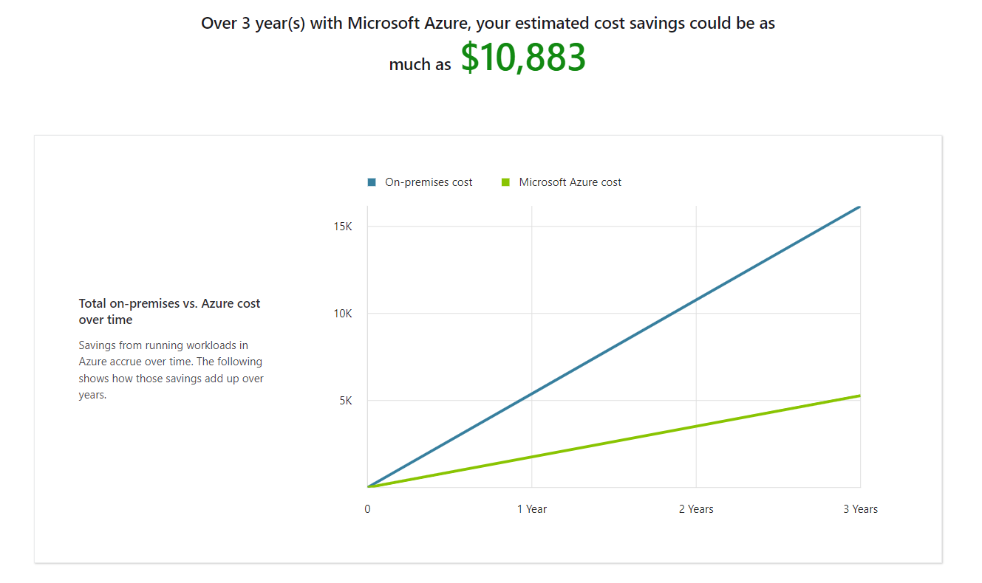
The image above had been determining that with the implementation of VM1, with 2-core CPU and 14 GB of RAM, the Aspire Retailers would easily save a sum of around $10,883 if they go with Microsoft Azure.
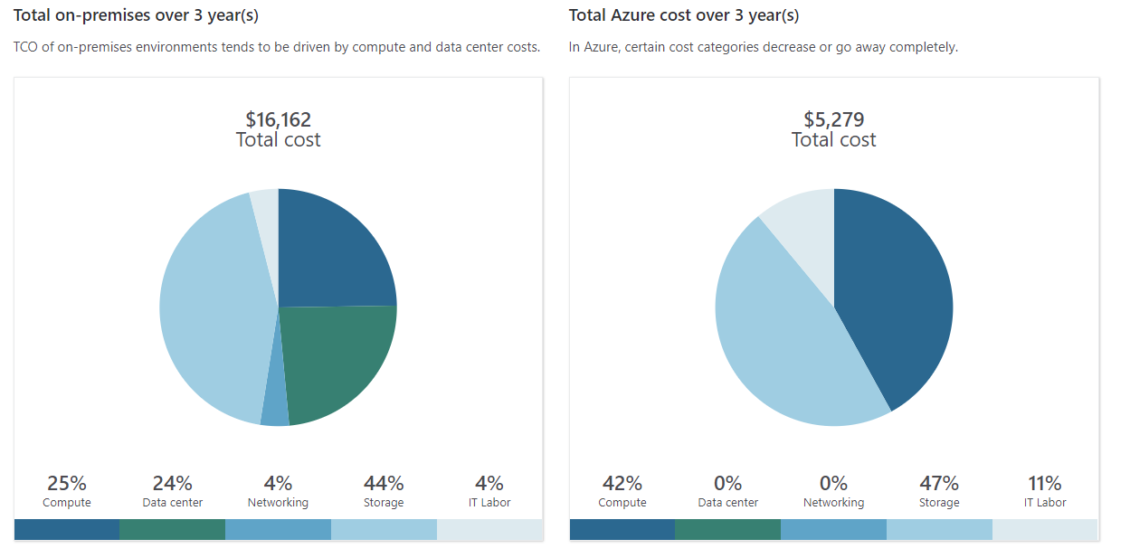
The image obtained above had been representing a brief comparison of the total cost that the Aspire Retailers would have to face, if they choose to go with either of the solutions here for their organization.
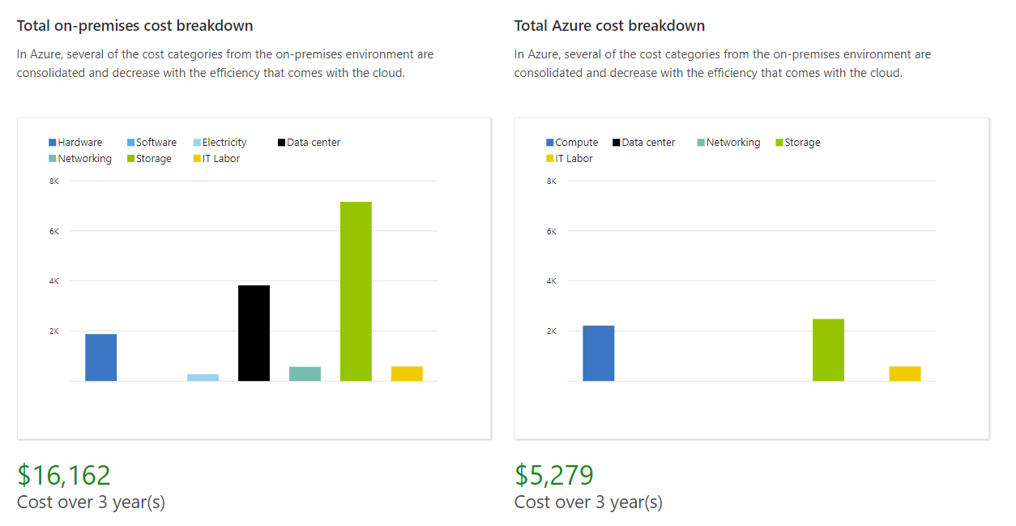
The image obtained above had been representing the total cost breakdown for both, On-premises as well as Azure solution, thus determining that how the organization would be at benefit they select Azure over their existing infrastructure.
VM 2
The image being provided below had been foreshowing the TCO cost calculation over 3-years of time gap for the VM 2:
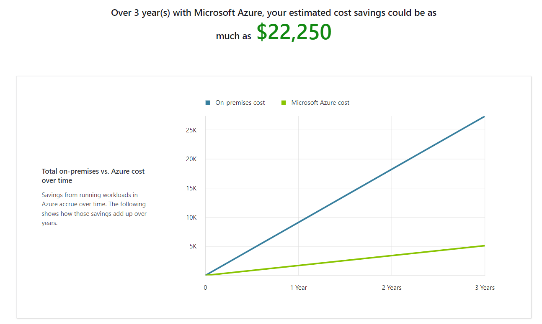
The image obtained above foreshows the total savings of $ 22,250, that the Aspire Retailers could acquires while using VM 2 with 4-core CPU and 16 GB RAM, of they tend to choose Azure over their existing On-premises datacenter.
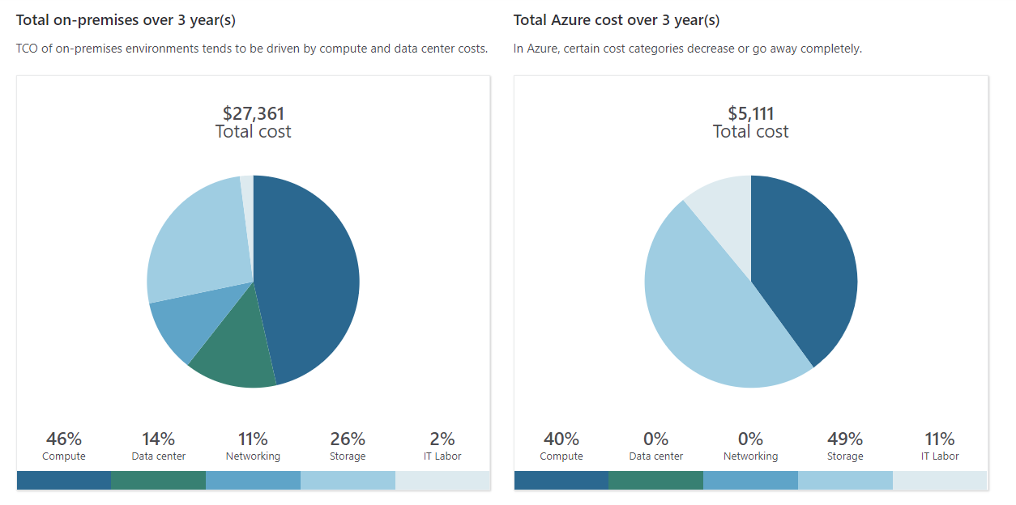
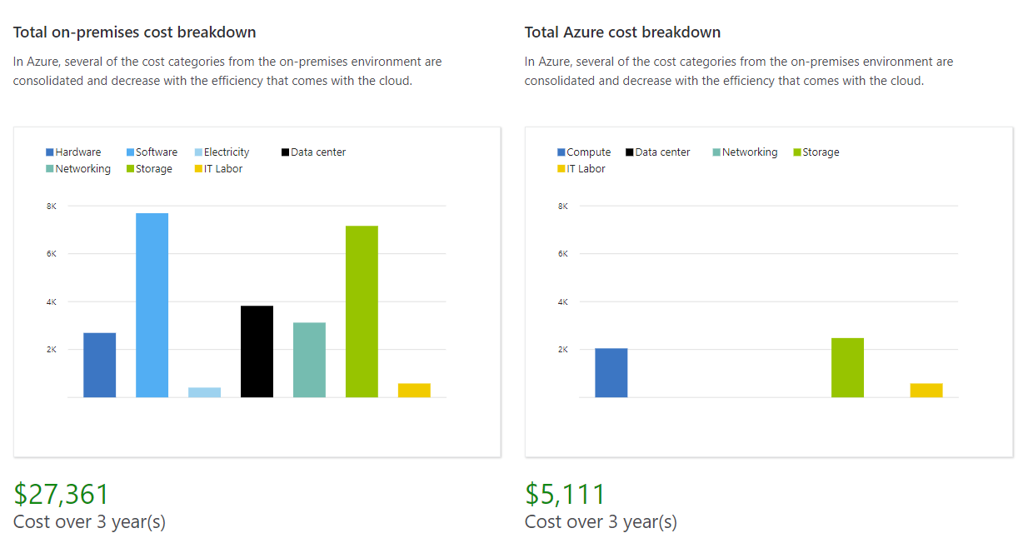
The image being obtained above had been representing a brief differentiation among the costs that would be incurred if Aspire Retailers tends to select either of the solutions here. This simply determines that the implementation of Microsoft Azure would be beneficial for Aspire Retailers rather than sticking to their existing On-premises datacenter.
VM 3
The image being provided below had been foreshowing the TCO cost calculation over 3-years of time gap for the VM 3:
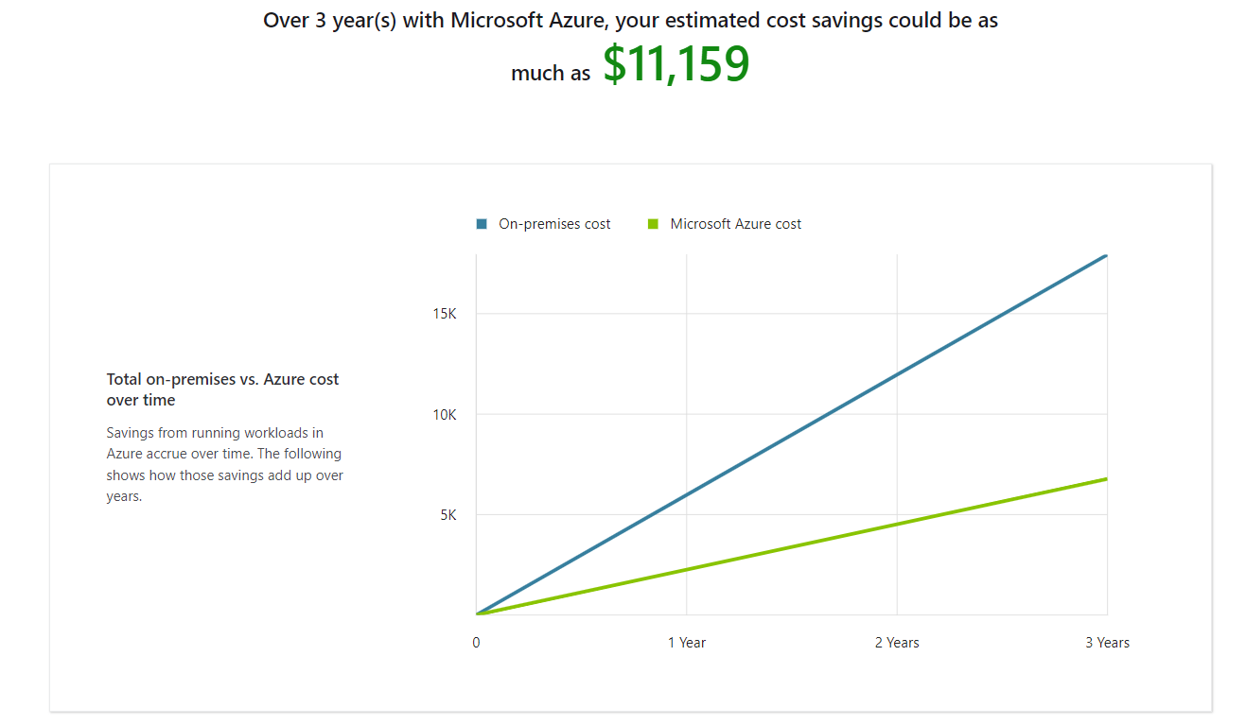
The associated image obtained above had been foreshowing the cost saving of $11,159, for the VM 3, with 8-Core CPU and 32 GB RAM, which Aspire Retailers tends to utilize while using Azure cloud platform, rather than their existing On-premises Datacenter.
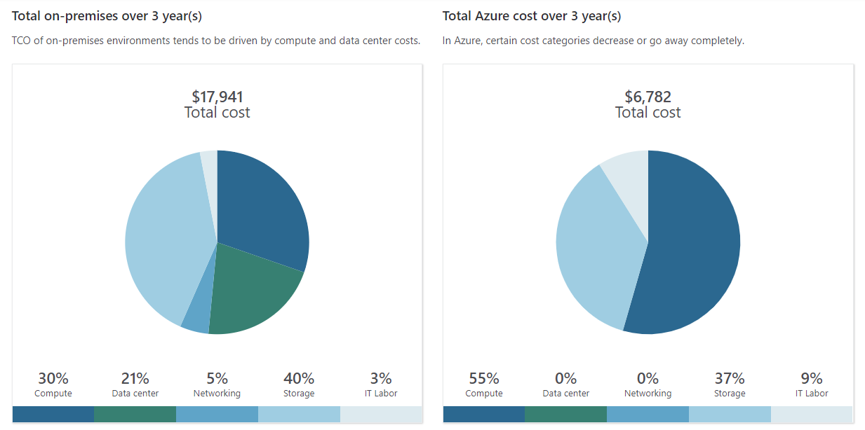
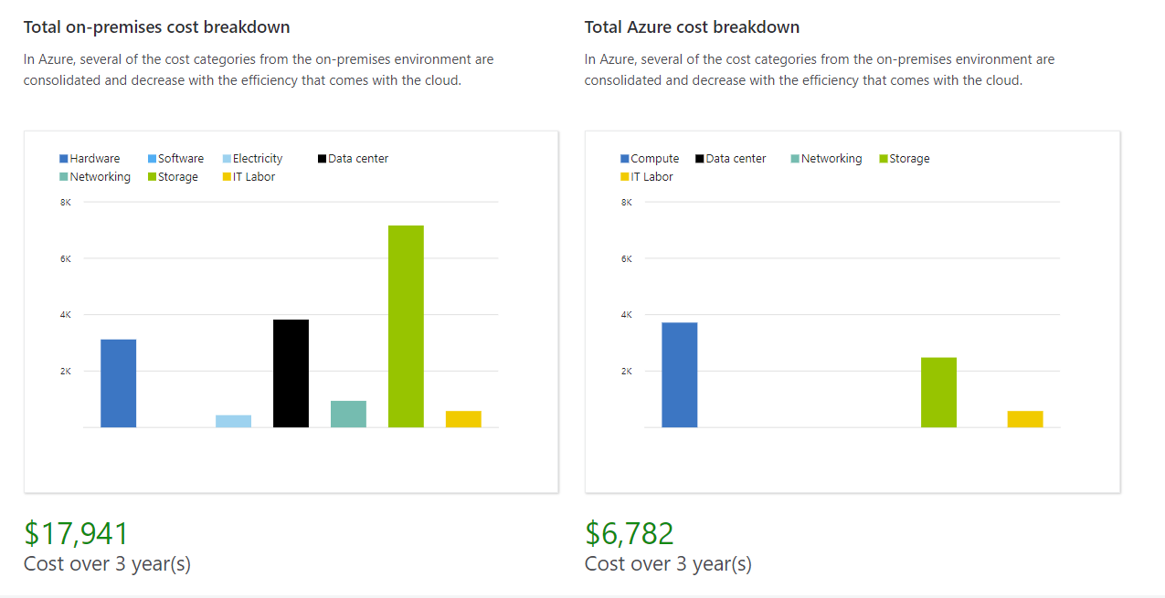
The images obtained above had been representing a brief differentiation among the costs that would be incurred if Aspire Retailers tends to select either of the solutions here.
VM 4
The image being provided below had been foreshowing the TCO cost calculation over 3-years of time gap for the VM 4
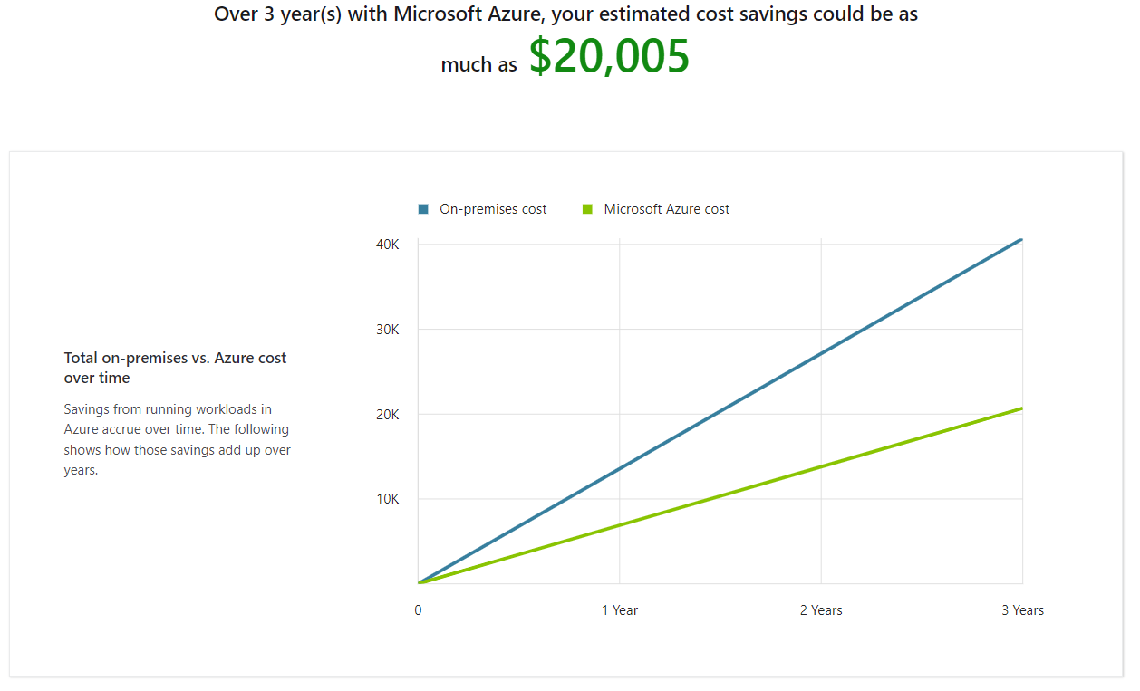
The image being obtained above had been representing the total cost saving, worth $20,005, which Aspire Retailers would avail with their implementation of VM4, with 16-core CPU and 112 GB RAM on Microsoft Azure.
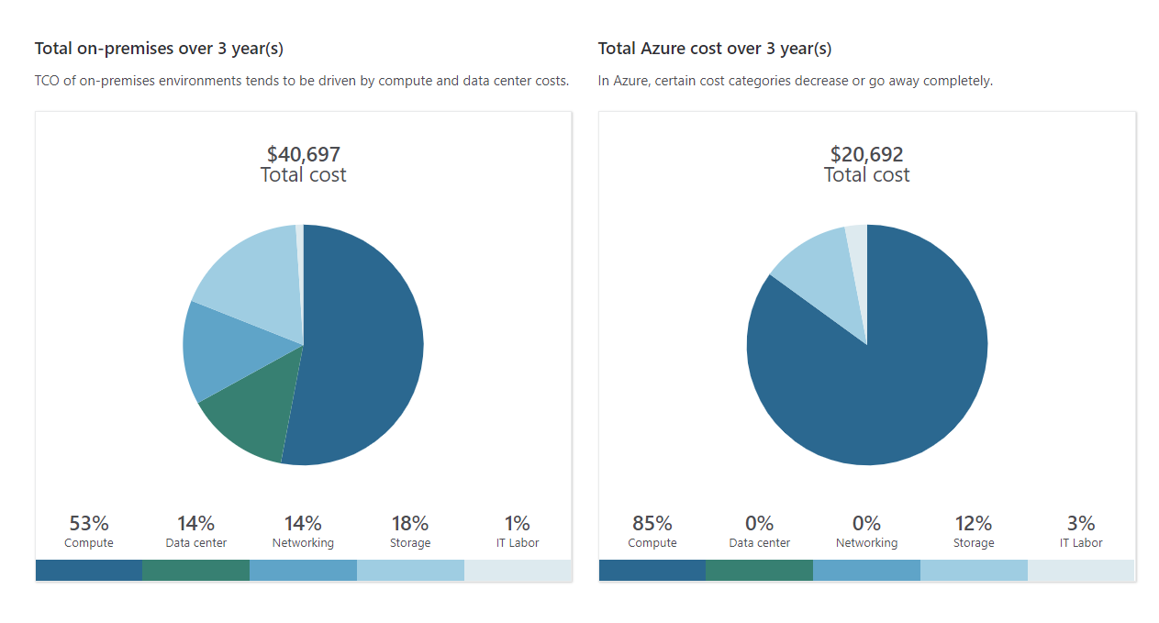
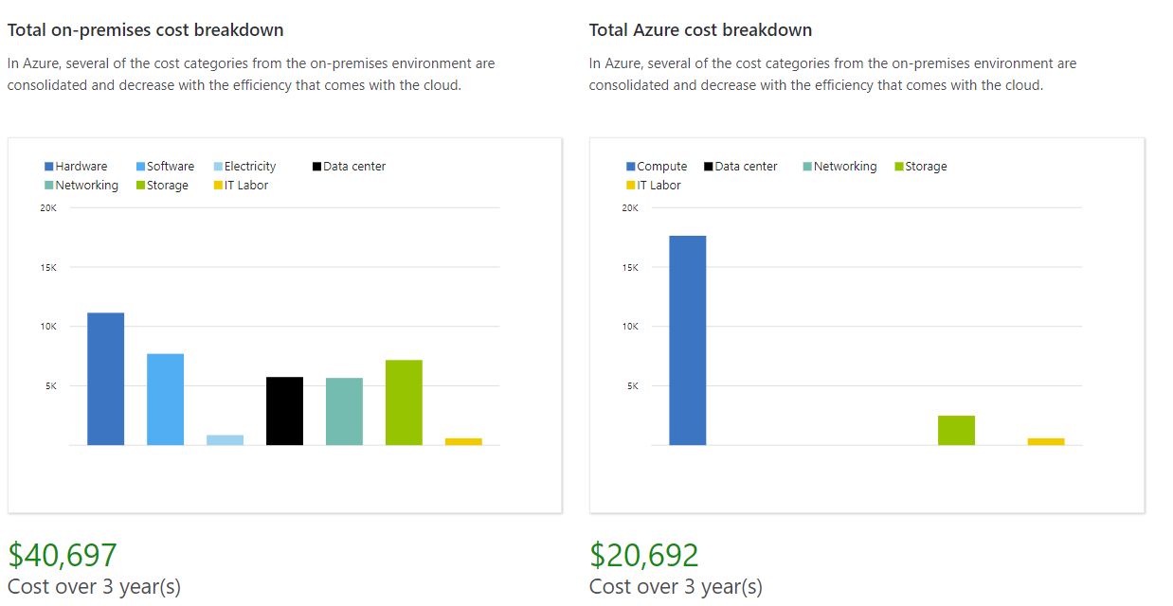
The image that had been obtained above had been representing the detailed analysis in between the difference of total cost that would incur for Aspire Retailers if they tend to go with either of the solution for managing their data.
VM 5
The image being provided below had been foreshowing the TCO cost calculation over 3-years of time gap for the VM 5:
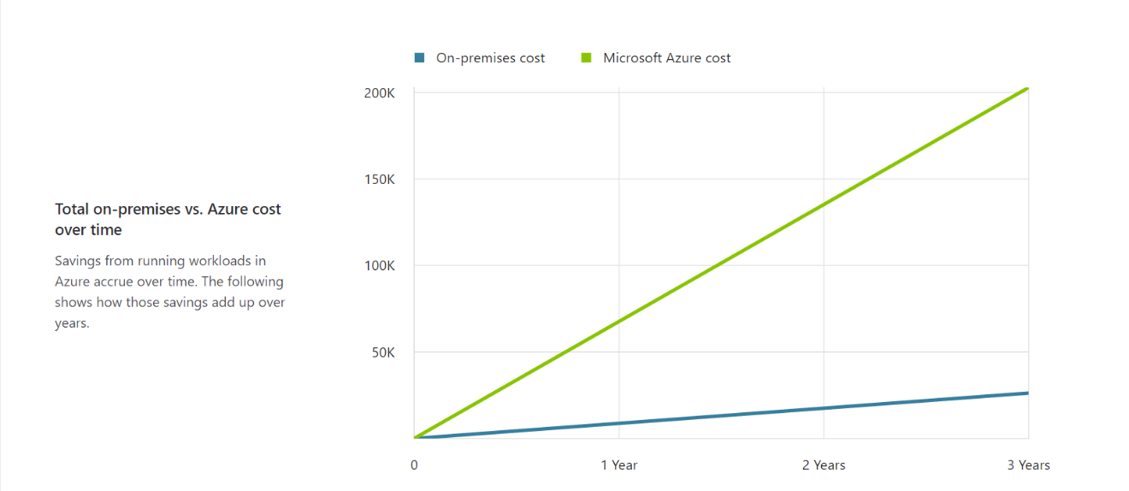
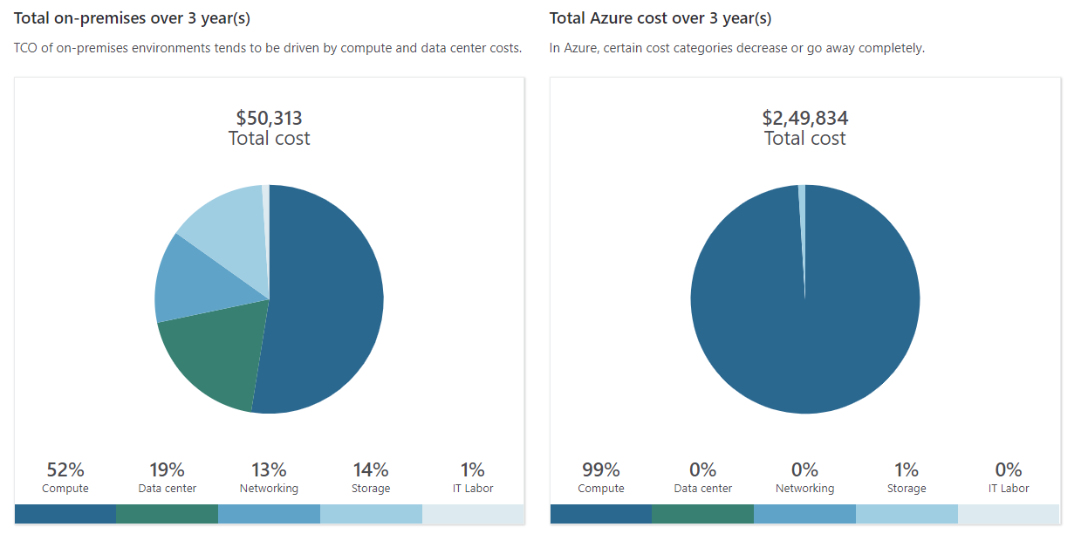
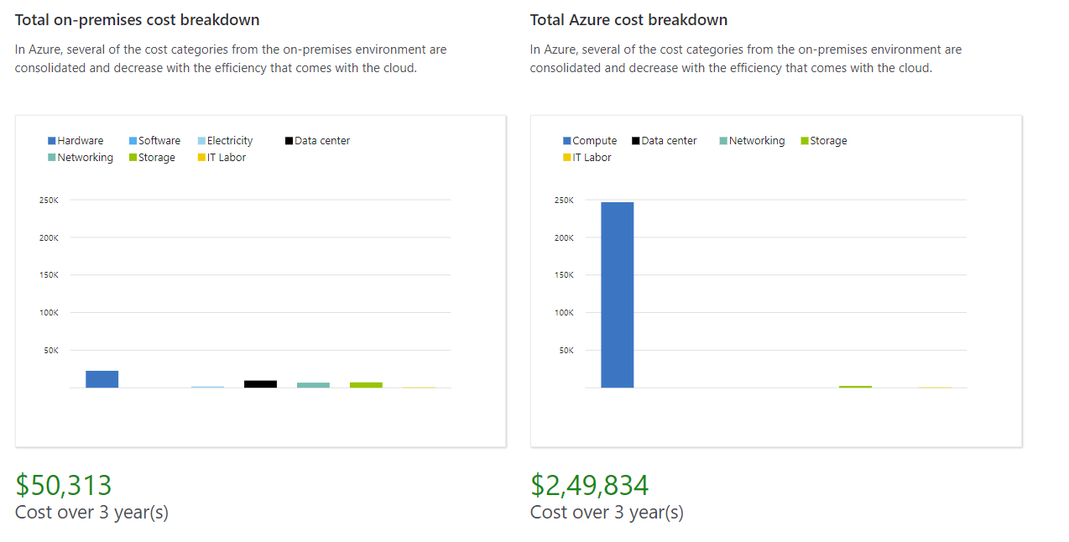
Since the TCO Calculator here had been limited to only 448 GB of RAM, thus no exact cost could be determined here that would incur over Aspire Retailers while implementing VM 5 with 32-cores CPU and 512 GB RAM. Thus, it could only be concluded that the total estimated cost for implementing VM 5 at Aspire Retailers would cost them about $2,49,834 over 3 years. For further summarization, a detailed computing plan for each VM had been provided below:
s | Cost for 3-years
VM 1 | $ 5,279
VM 2 | $ 5,111
VM 3 | $ 6,782
VM 4 | $ 20,629
VM 5 | $ 2,49,834
Total Overall Cost | $ 2,87,635

In association with the detailed analysis being conducted at the table obtained above, it can be seen that the Aspire Retailers would be required to invest a total of $ 2,87,635 over 3-years for their configuring their cloud computing with 5 VMs, apart from which they would be saving a huge sum of money regarding the implementation of external hardware, software and electricity, since they had been required here to pay for their computational costs only.

Azure Active Directory Usage
Azure Active Directory (Azure AD) is a commonly used solution that helps in generating identity and access management solutions provided by Microsoft Azure [17]. It enables organizations to operate over accounts, access controls, and security policies centrally. Retailers can use Azure for enhancing the security level within the cloud environment.
Configuration of User Account
With the help of Azure AD, multiple accounts of various user can be created and managed at the same time. By following the below-mentioned steps the user accounts can be configured:
- Create User Accounts: by the usage of PowerShell commands, administrators can create user accounts within Azure AD. These accounts can be associated with the organization domain or created as a guest accounts for external users.
- Assigning User Priorities: properties of the user such as name, contract, and job title can be set for each of the user accounts. Such kind of information can help in managing the user account properly.
- Configuring Authentication Method: There is a large variety while considering authentication in AD as it provides to choose multiple varieties to choose between, such as multi-factor authentication and password-based authentication and also it has integration with several authentication providers [18]. The administrator can choose from the vast authentications available and can select one as per the requirement.
- Define User Roles and Permissions: Azure AD also provides user-based access control for user permissions. By assigning different roles to different users the administrator can build a strong security concern that can ensure no disruption to the resources within the organization. Setting roles such some to be Global Administrator and User Administrator [20].
Setting roles to Global users and Normal users
Normally in terms of Azure AD Global users are the seniors of the organization who are responsible is decision-making and overseeing the total workflow inside the organization, they have more power and they can directly access the resources of the organization whereas while speaking about the normal users they have less power as compared to the Global users and they cannot even access the resources of the organization, therefore the normal users are basically the workers or the members of the organization [19].
Implementations of the below-discussed points are necessary for setting the global and normal users in Azure AD, including:
- Assigning Global Administrator Role: The Global Administrator role is full of responsibilities and it also enables the individuals to access to all the administrative features and controls in Azure AD [28]. Moving forward Aspire Retailers can assigning individuals to relatable tasks and by assigning individuals for managing and performing administrative task of the organization.
- Defining Custom Roles: In Azure AD custom roles can also be assigned with specific powers and limitations to take care of specific organizational requirements. In circumstances such as retailers can define a custom role through which users can perform specific tasks and can access to some of the organizational resources for successful completion of the task.
- Assigning User Administrator Role: The User Administrator performs the role of granting permissions for accessing to the user accounts and passwords and other important details and also other jobs related to user [23]. In such cases, Aspire Retailers can take the help of IT professionals, who can assist them in user management.
- Group-Based Access Control: Usage of Group-Based Access Control Technique in Azure AD enhances the process of assigning users to predefined or custom groups. Administrators can manage the user right at a group level by assigning roes to these groups at the same point of time with streamless access management.
Centralized user management along with accurate security and at the same time streamlined access control within the cloud environment can be achieved by the Aspire Retailers by adhering to appropriate roles in Azure AD and by configuring user accounts

Cloud Governance Strategy
According to the current digital space, including Bring Your Own Device (BYOD), mobile application, and cloud-based solution, the main focus has been shifted from traditional methods to modern identity-based measures. It is important to have an idea of who is accessing the system from time to time and what safety measures are important to be ensured by them relating to the safety of the user’s data [24]. A robust governance strategy is important for successfully achieving organizational objectives and goals, which is a combined package of maintaining cost along with maintaining the organizational structure.
For managing cloud-based assets efficiently a set of policies or measures has been introduced which has to be implemented and this set of policies is commonly termed as cloud governance. Proper and accurate cloud governance will help in maintaining data integrity and enhance the security of data, optimize resource utilization etc.
Being one of the giants of the business industry of cloud platforms, Microsoft Azure has a variety of services for supporting governance along with enhancing access security. Listed below are some of the aspects in which Azure can assist Aspire Retailers in a relatable context:
- Identity Access Management (IAM)
Proper user identification, access restriction and authentication procedures can be set and overlooked and these facilities are enabled through the efficient Identity Access Management (IAM) of Azure AD. Adding upon AD can even be used by Aspire Retailers for building multi-factor authentication with a motive to establish proper user access control over the cloud resources [26]. It is the role of the administrator to make sure that correct access is provided to users based on their roles and responsibility and for ensuring this the implementation of role-based access control (RBAC) and granting appropriate permissions are necessary.
- Conditional access policies
Azure holds the capability to define the terms and policies that enables an organization for enforcing access requirements based on specific needs that connects with the factors like user’s current location, device health along with the risk involved [25]. Aspire Retailers can add on an extra layer of security towards the preservation of available resources by approving limited access policies for devices that are operating from unauthorized locations and can safeguard the cloud environment.
- Azure security center
An impressive threat protection policy and security management is provided by Azure at Azure security center. The procedure involves continuous detection of un identified activities along with the continuous recommendation of steps to be implemented for overcoming any unauthorized or unsafe circumstances, which play a vital role in improving the security posture of the cloud resources [22]. Through the help of such policy Aspire Retailers can gain a proper idea of any vulnerability’s ability and characteristics, and implementing best possible security measures for countering such vulnerabilities.
- Compliance and regulatory support
Along with aligning with the industry’s norms and policies, Azure also provides a variety in terms of compliance certification [27]. Adapting Azure will enable the Aspire Retailers to address the regulatory requirements as per their cloud deployments like HIPAA and ISO 27001.
Suggested Policy: Regular access policy should be implemented by Aspire Retailers. This ensures the reviewing of access controls on a periodical basis and accounts of the employees who has left the organization or their respective and post and position in the organization has changed their accounts have to be deactivated or deleted at times. This will also reduce the chances of unauthorized access within the organization strengthening the security posture and the record will be available [21].
Aspire Retailers can make sure that users have secure access to cloud resources by implementing Azure's cloud governance policy. A well-regulated and secure cloud environment is made possible by Azure's identity and access management, conditional access controls, security monitoring, and compliance assistance.
In order to demonstrate how cloud governance strategy worked, policy lab will be performed from Skillable Azure. Here, by using the Azure policy, cloud governance will be managed.
The architecture of the lab is provided below:
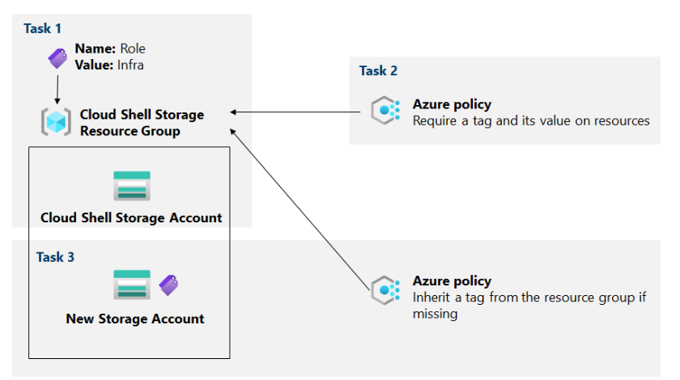
The lab comprises three parts which are shown below:
Task 1: Creation and assigning of tags in Azure portal
Starting the PowerShell within the Cloud Shell
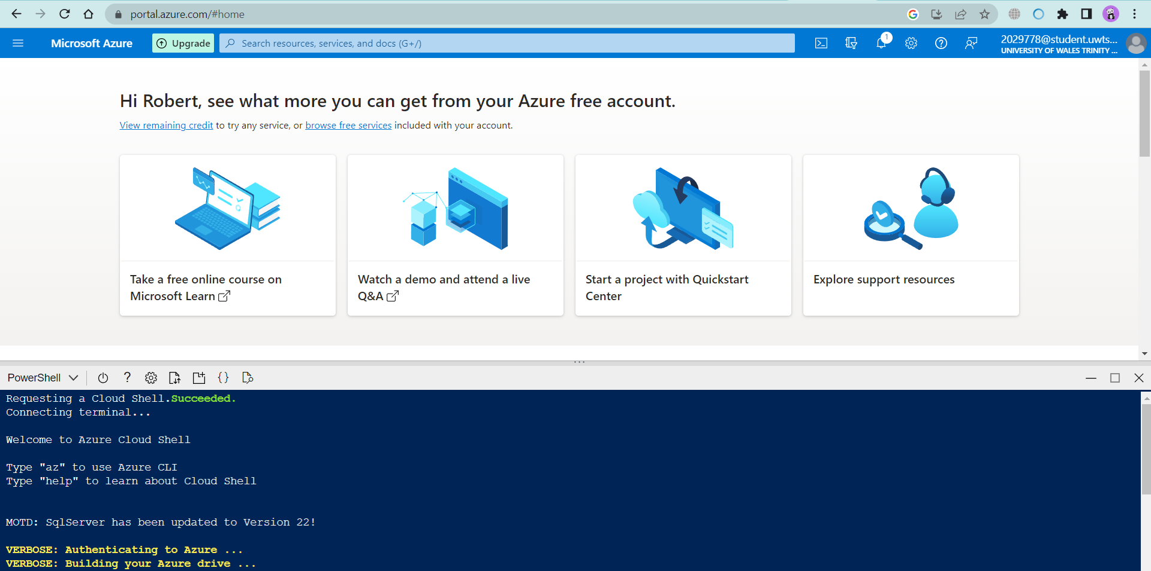
Checking the storage account name
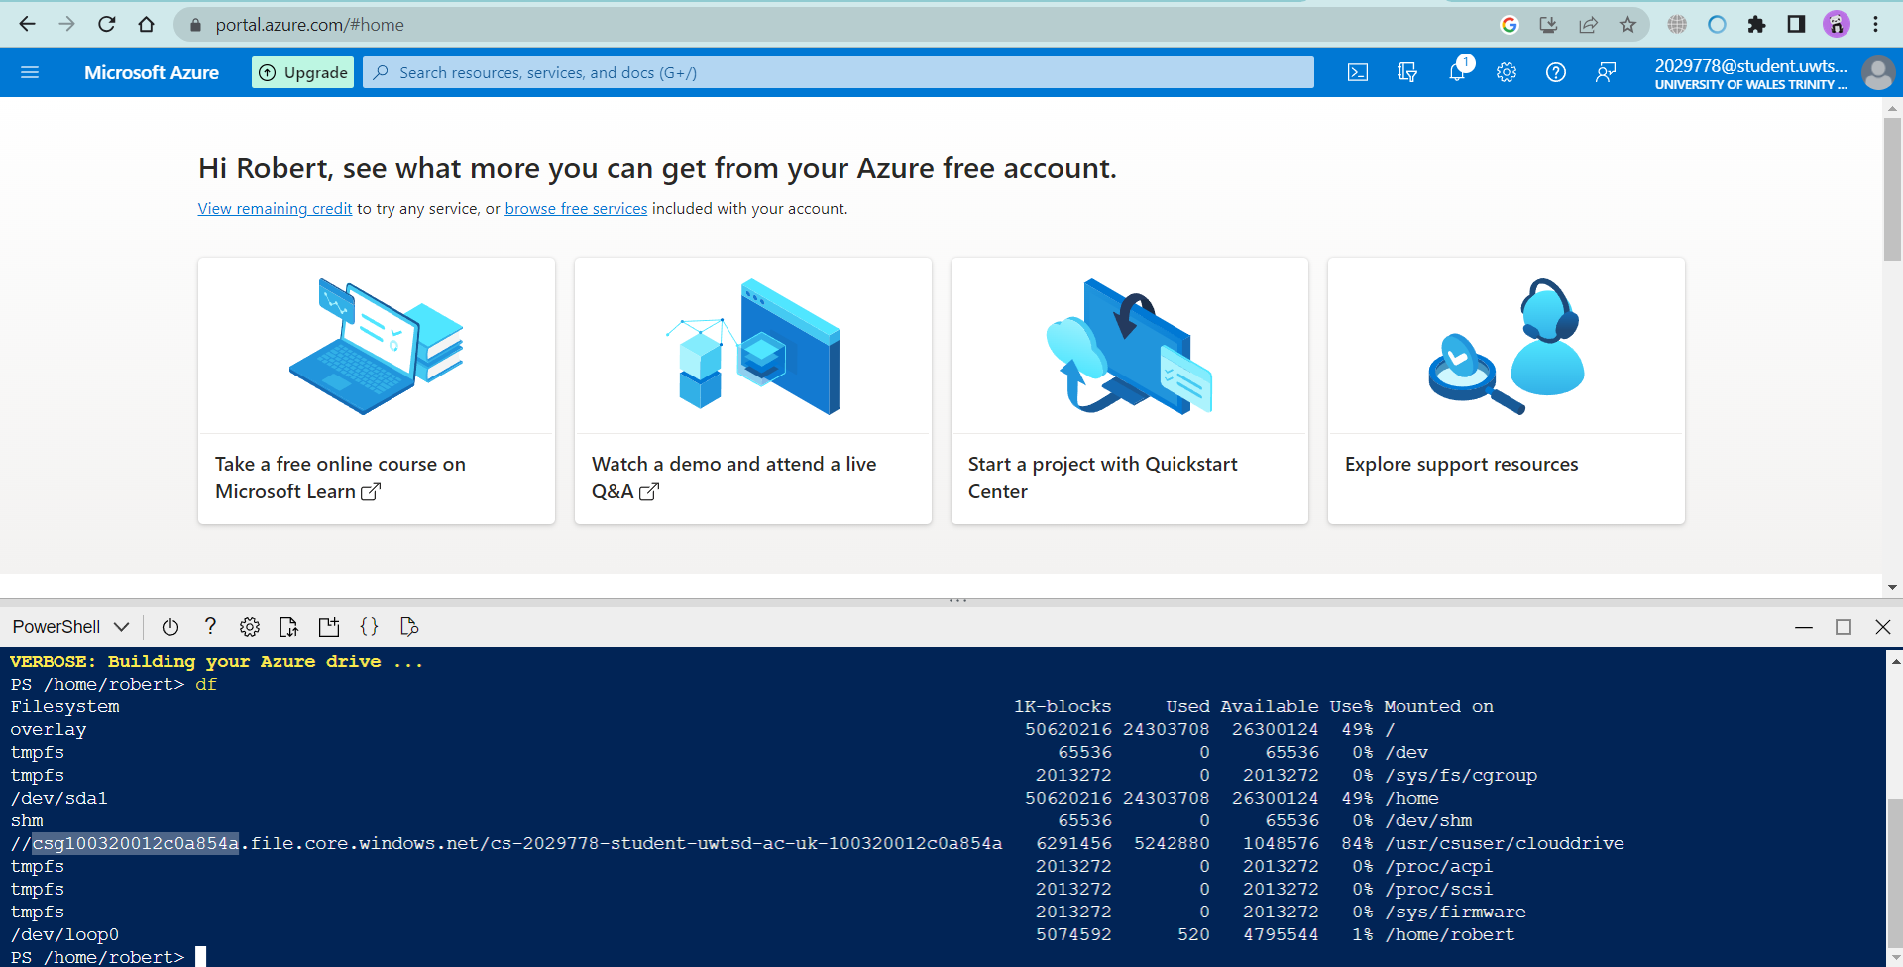
Opening the resource group associated with Storage account
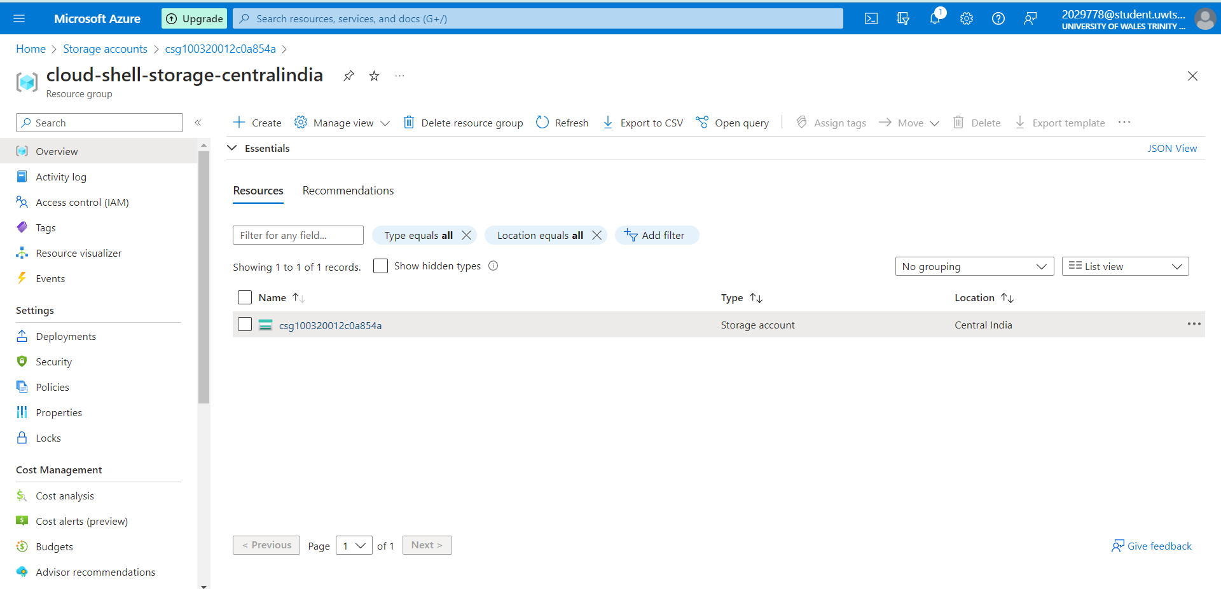
New tag creation
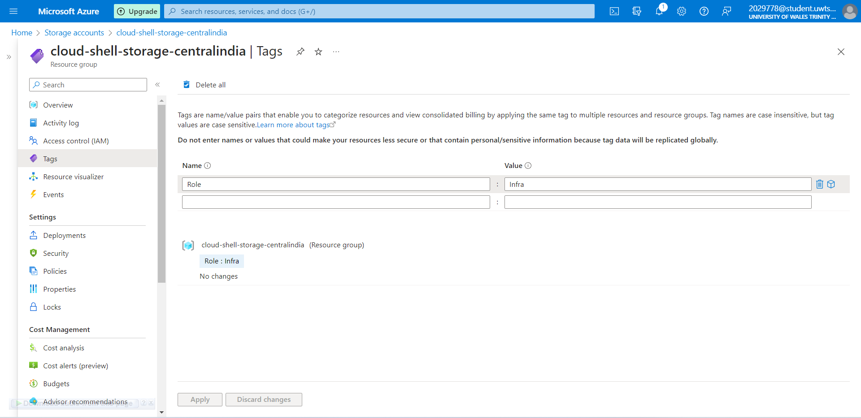
Checking the new tag is storage account
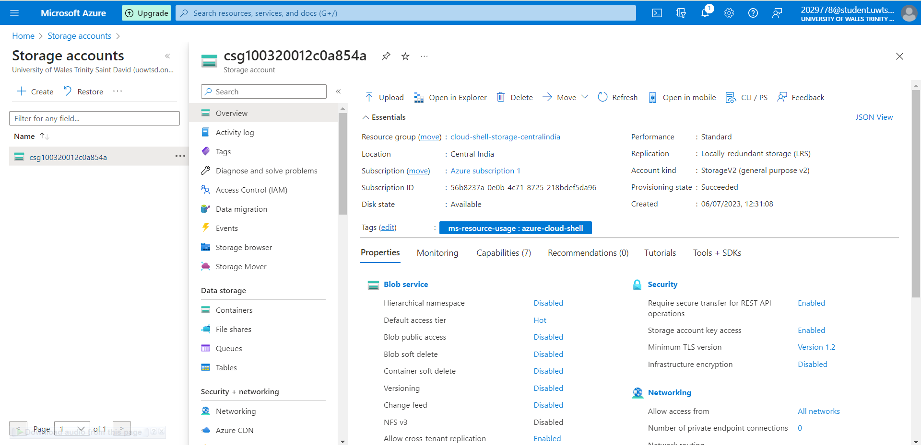
The above figure illustrates that the newly created has not been automatically assigned within the storage account.
Task 2: Tagging enforcement through Azure policy
Setting policy in Azure
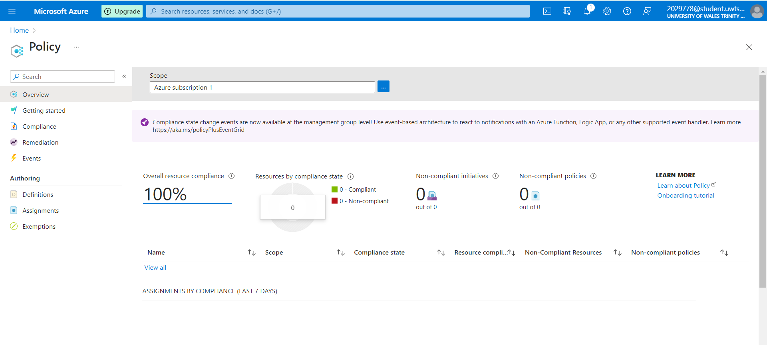
Checking all built-in policy associated with Tags
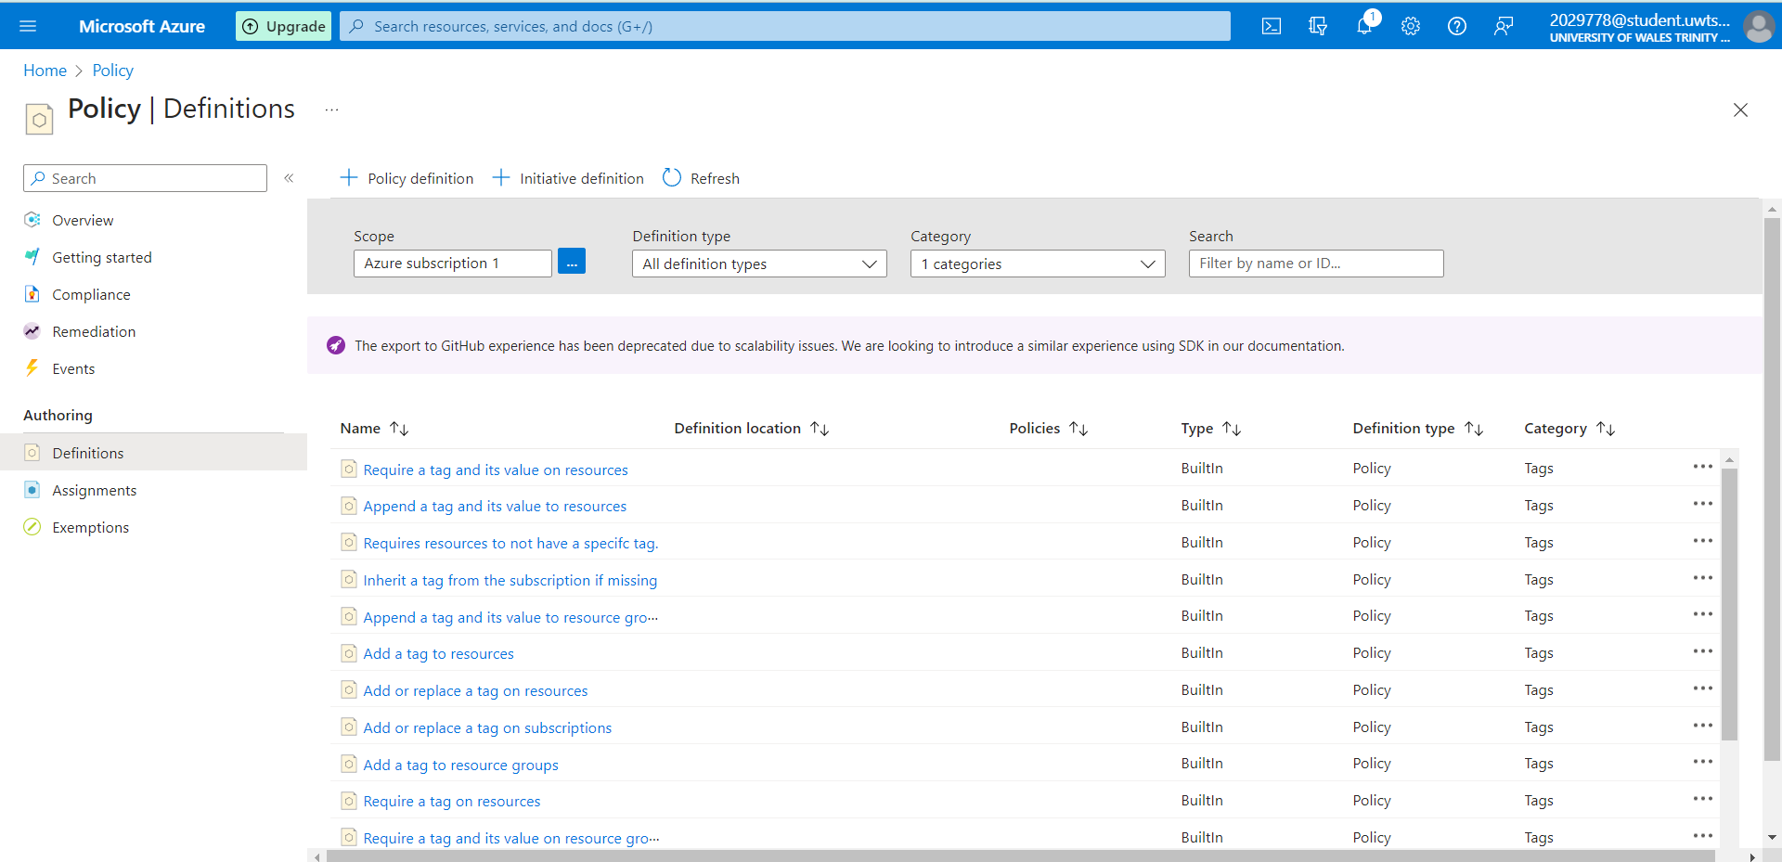
Opening a policy named “Require a tag and its value on resources”
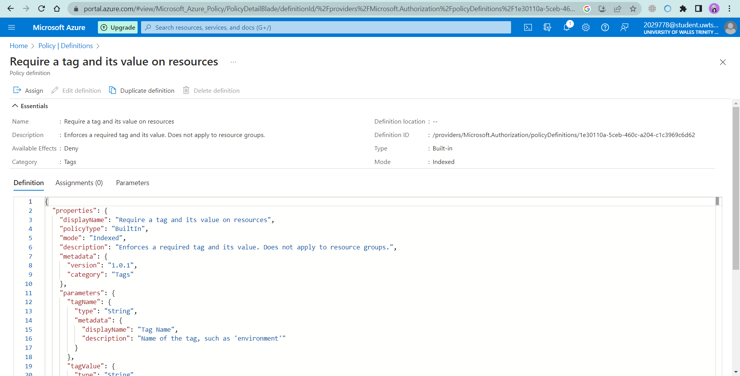
Assigning the policy
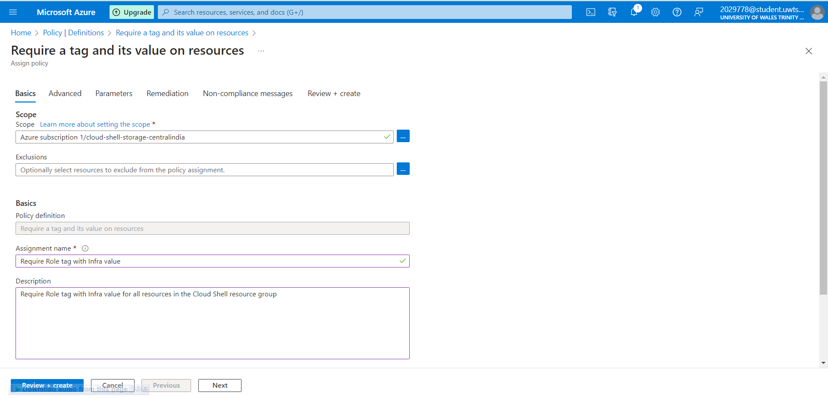
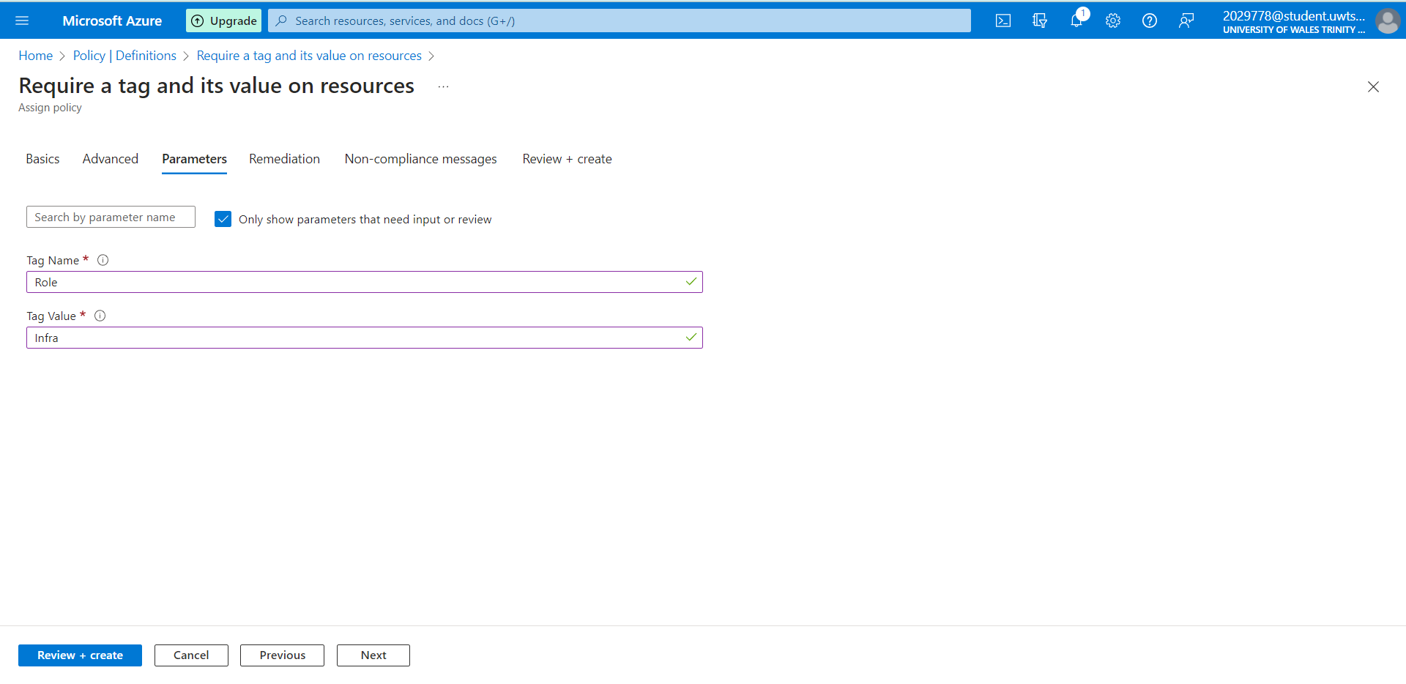
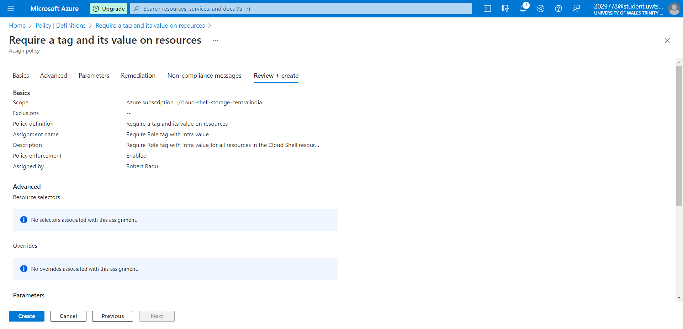
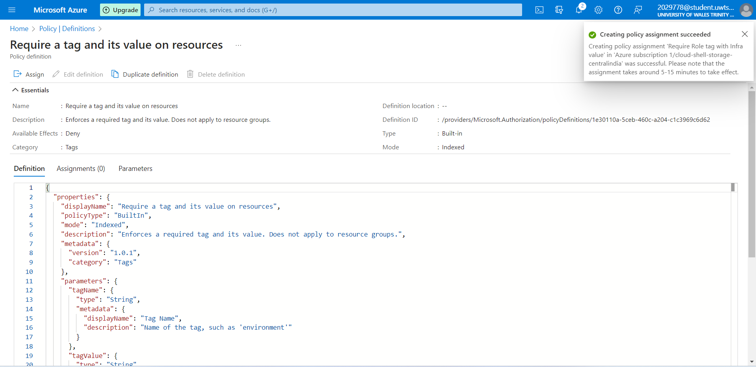
Creating a storage account for testing
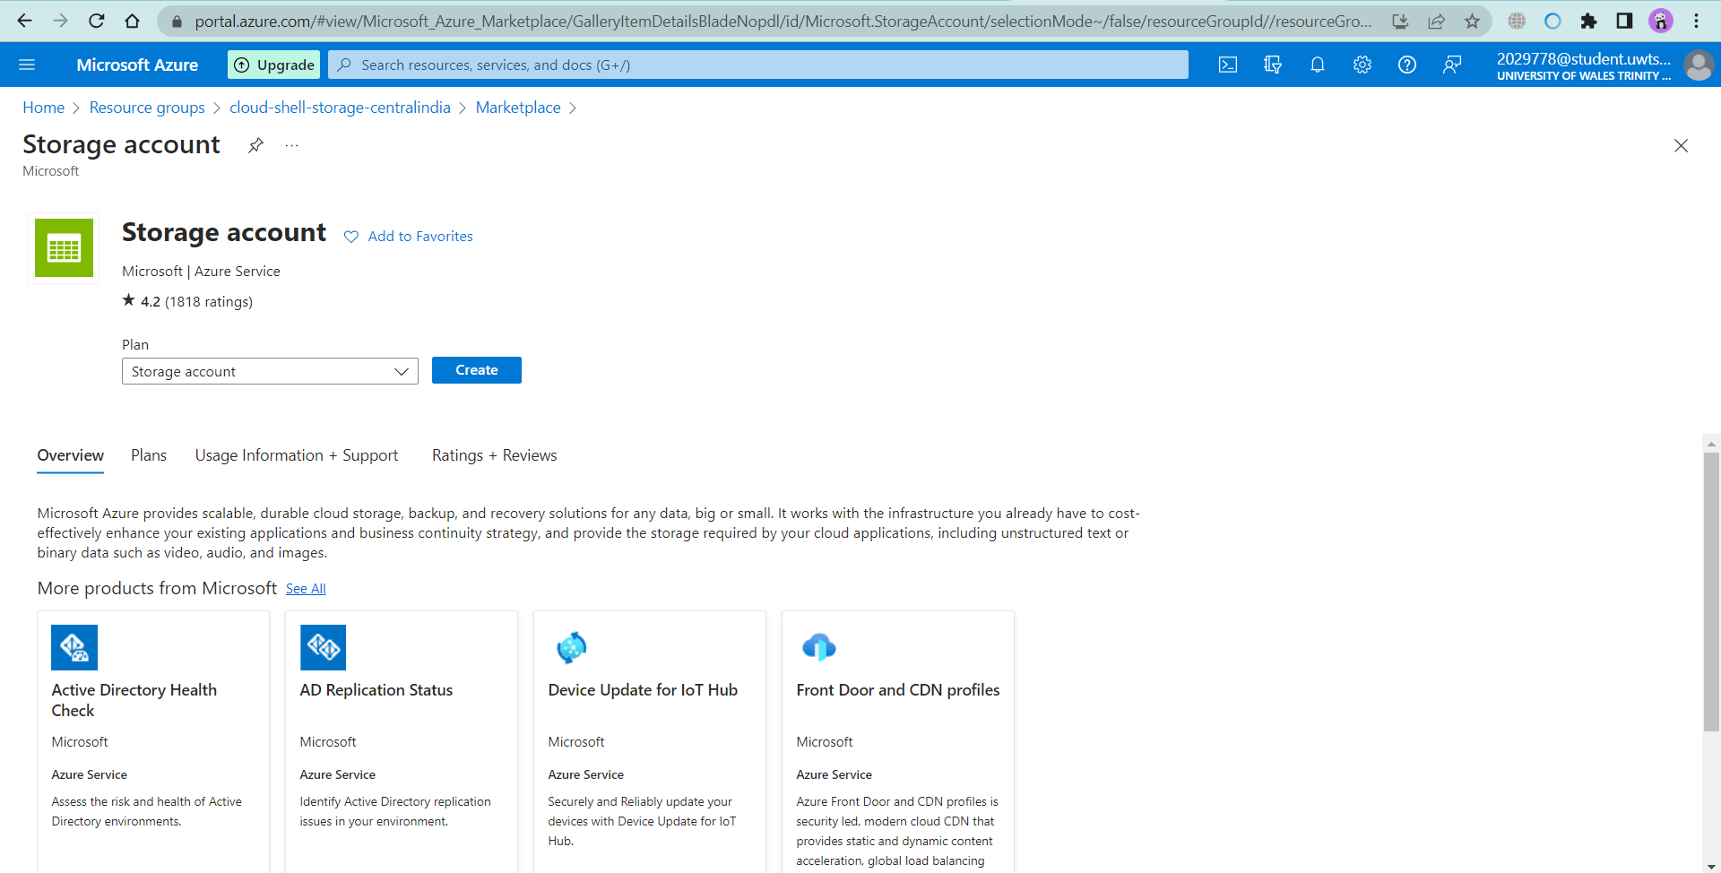
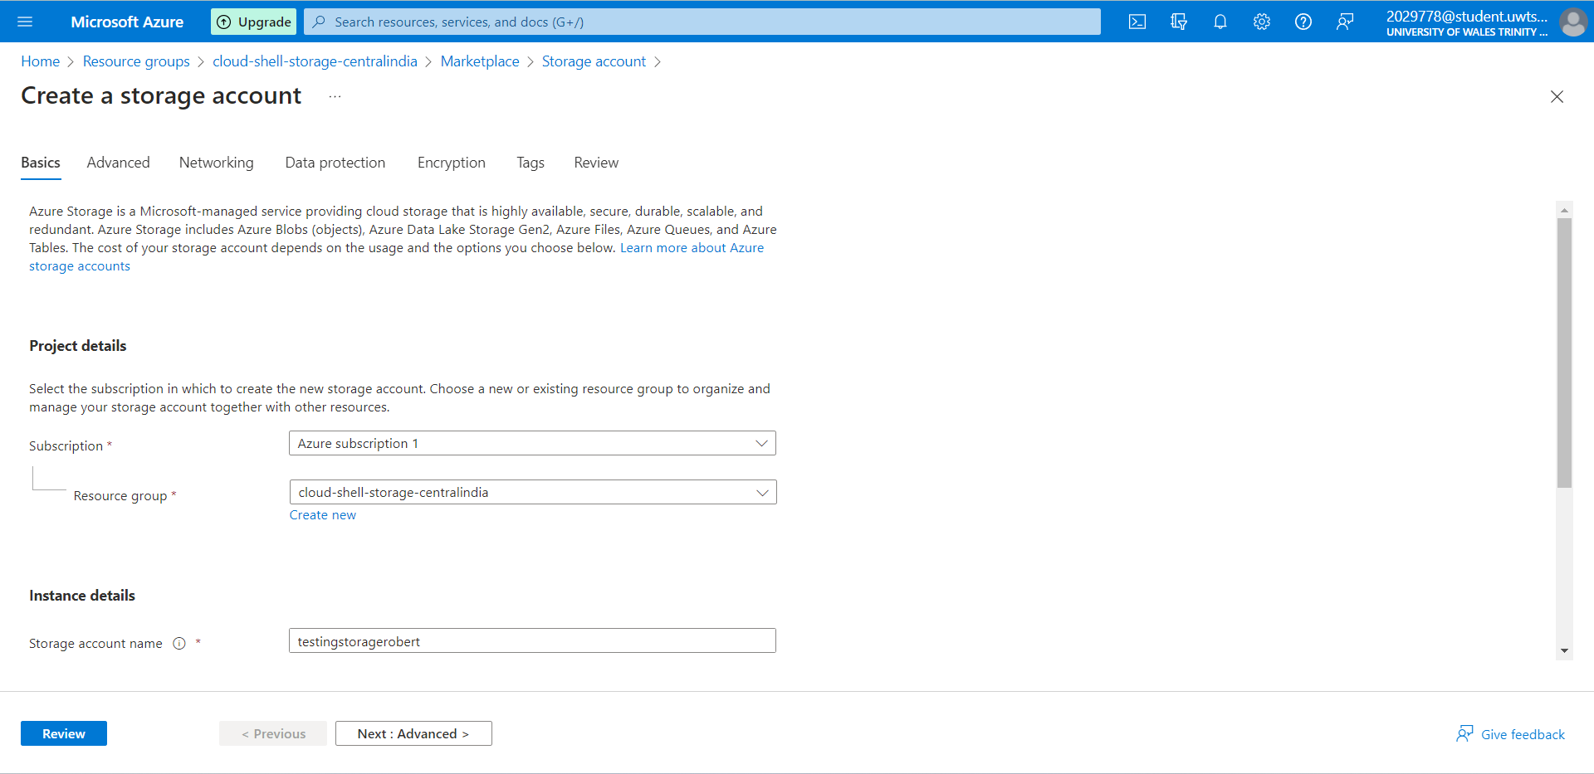
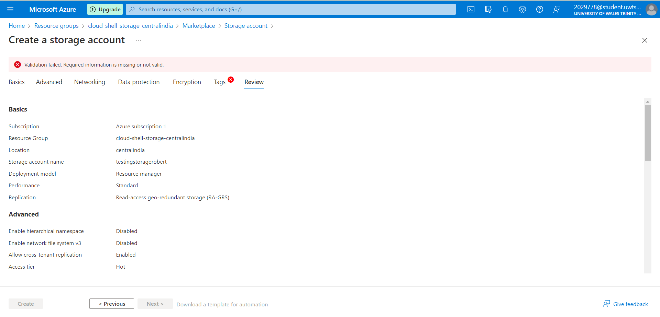
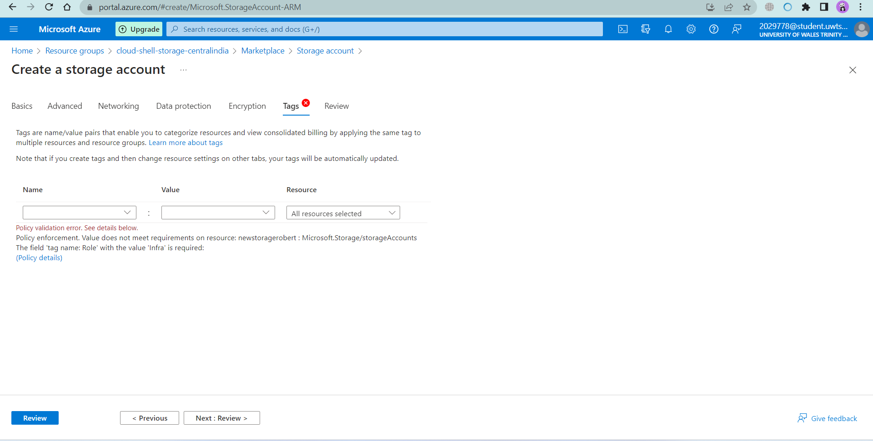
Due to the created policy, new storage account is not created as that tag name and value is not matched.
Task 3: Applying tagging through Azure policy
Deleting an assignment named “Require Role tag with Infra value”
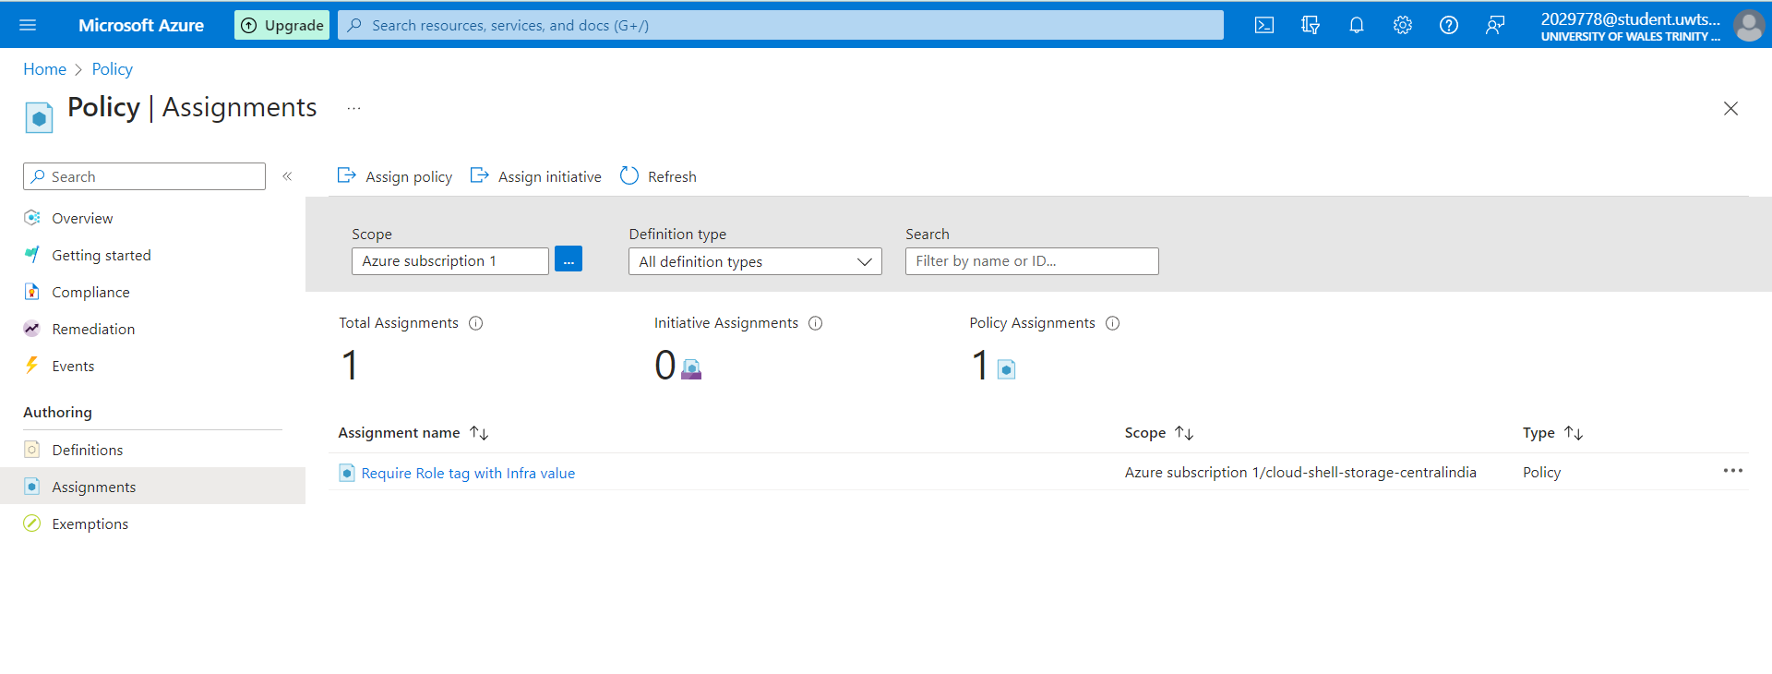
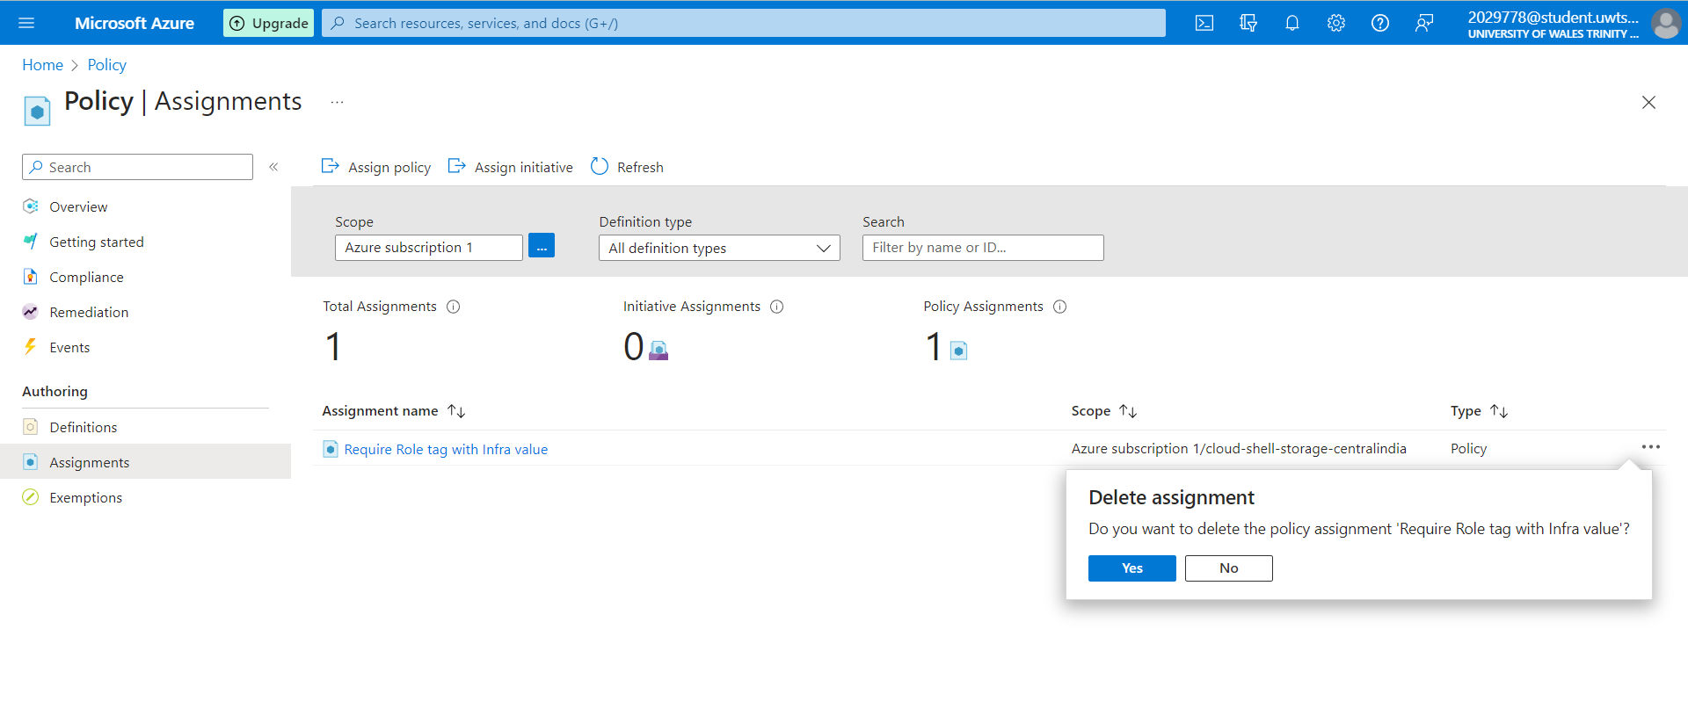
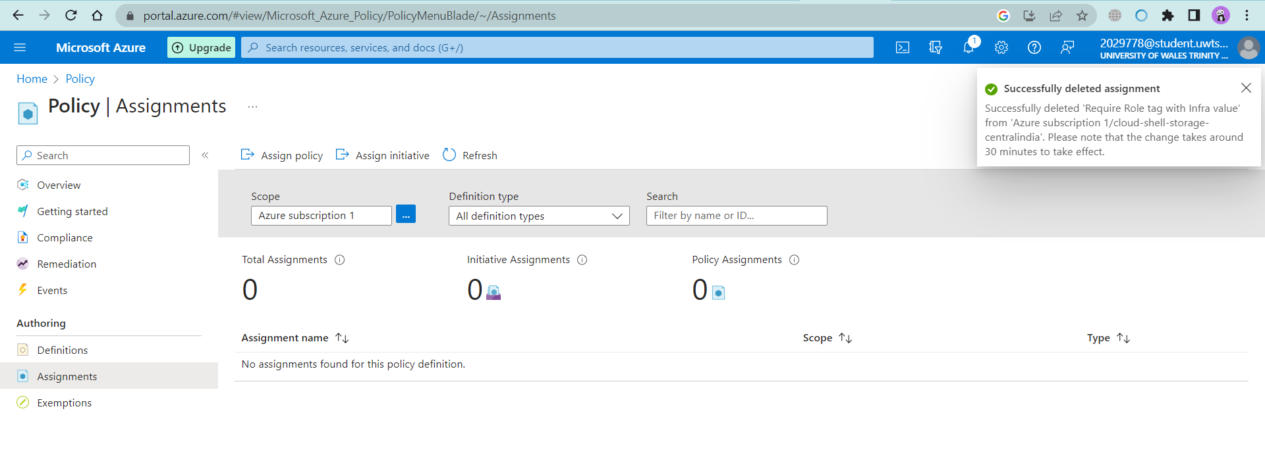
Assigning a policy
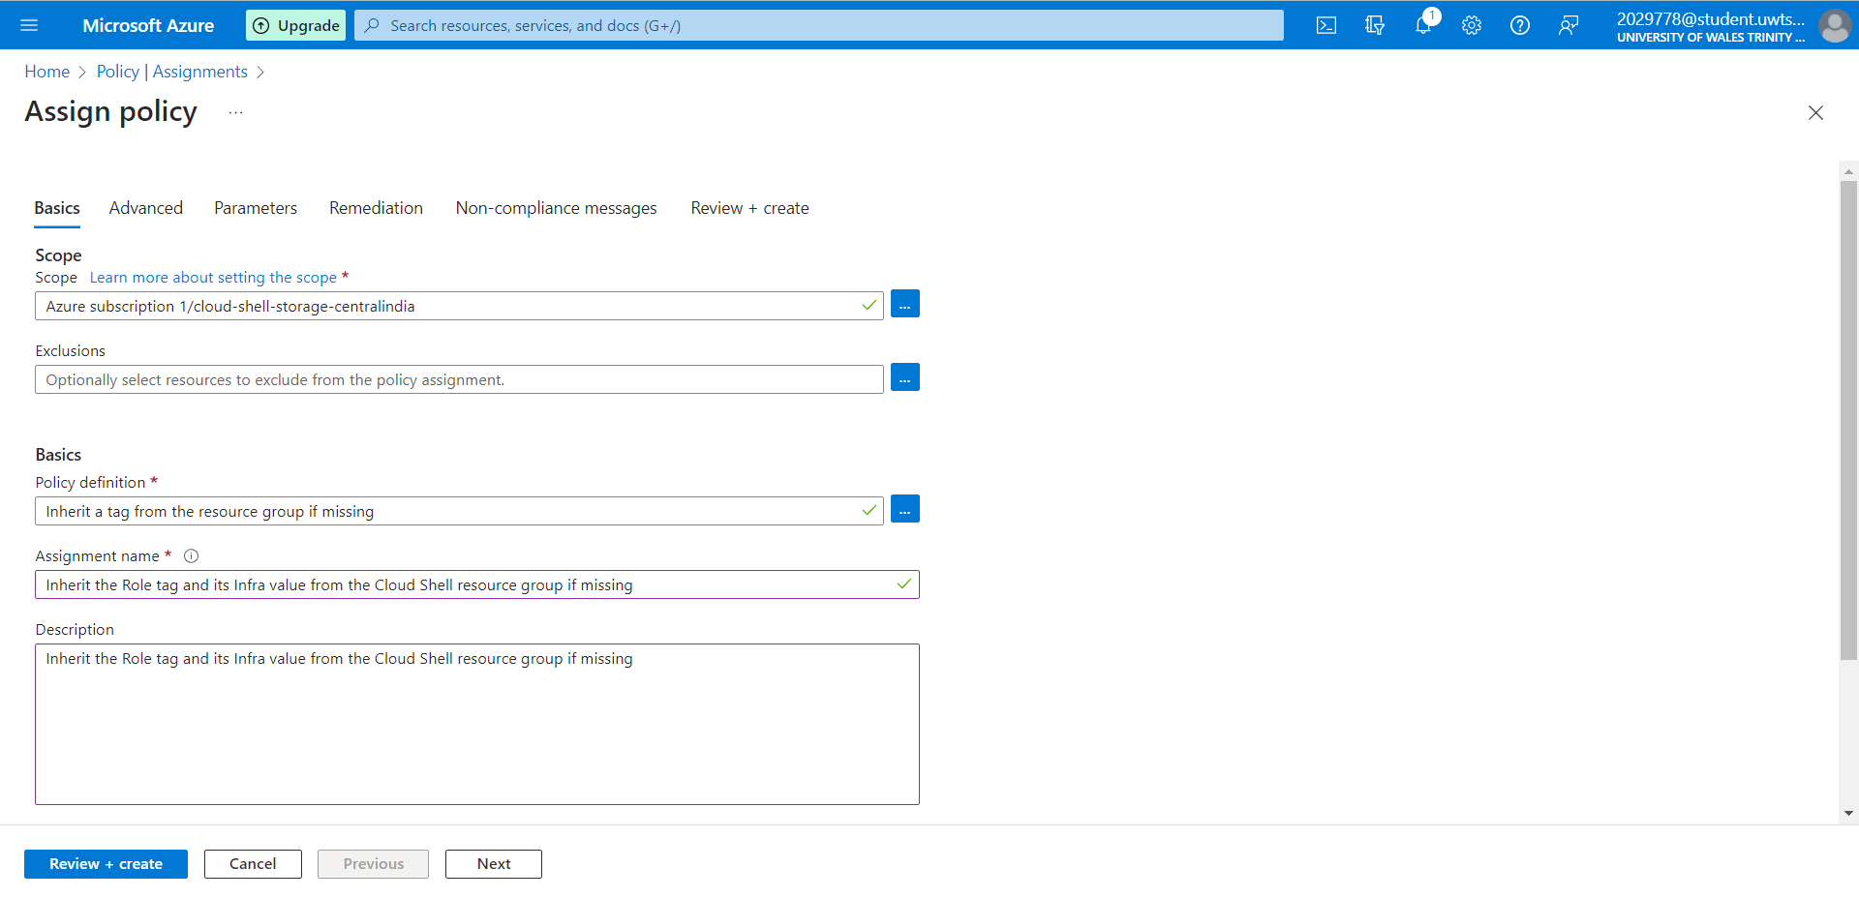
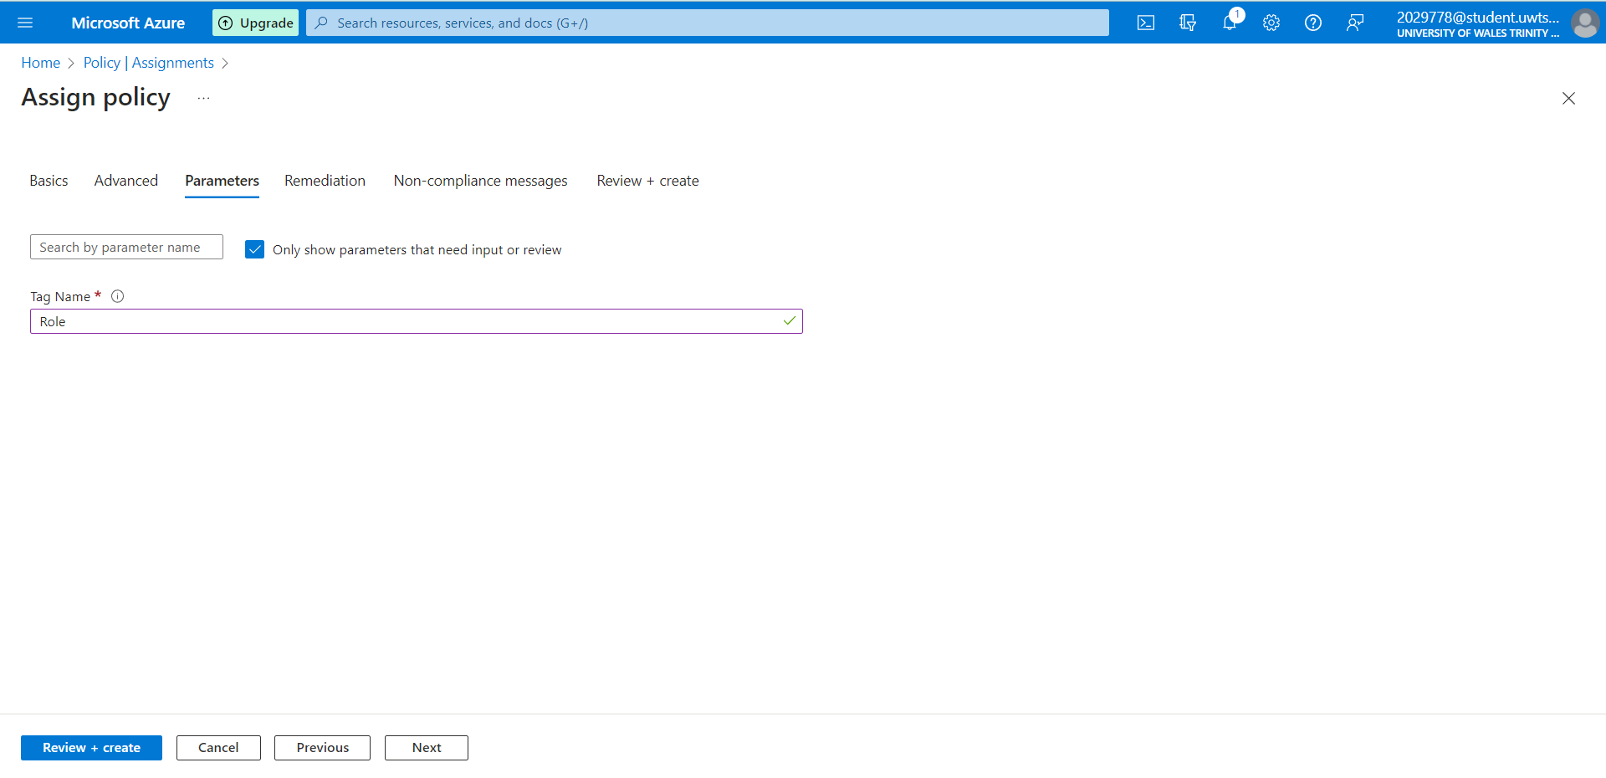
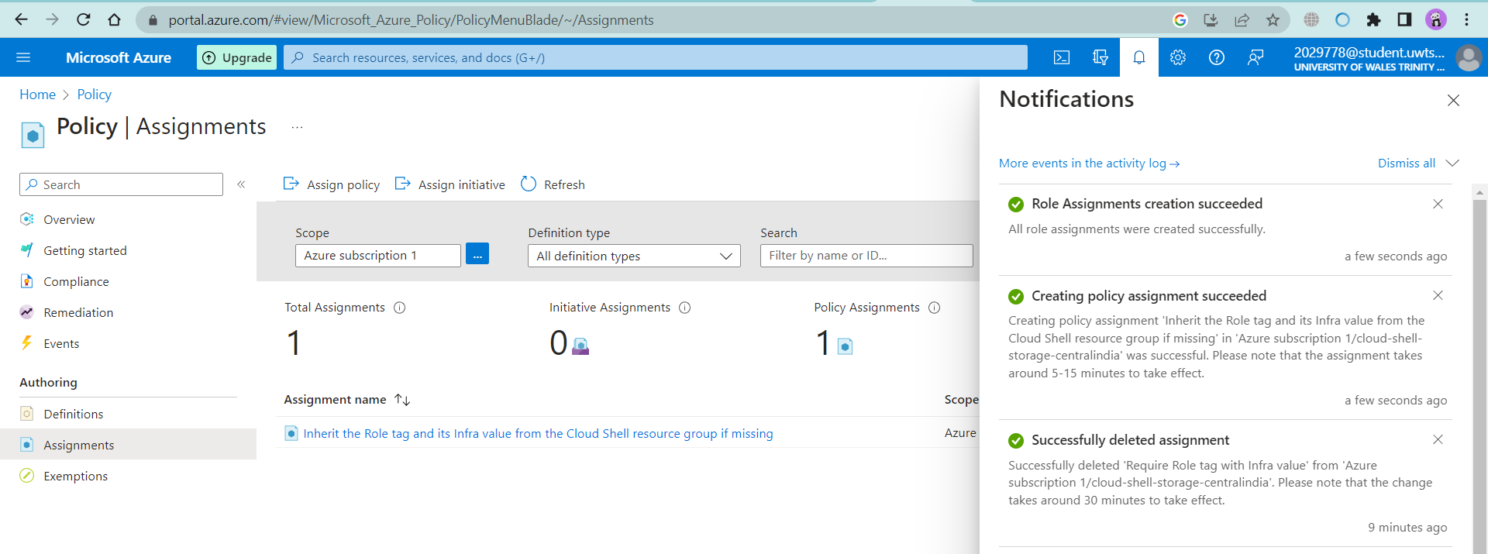
Creating a new storage account
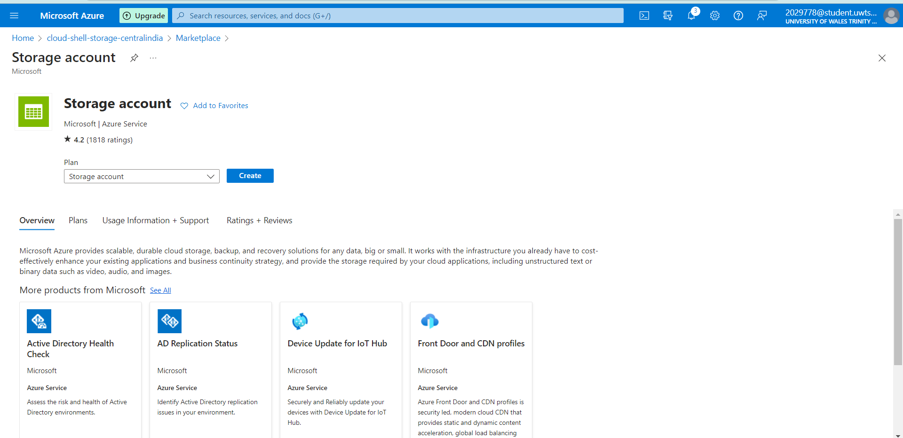
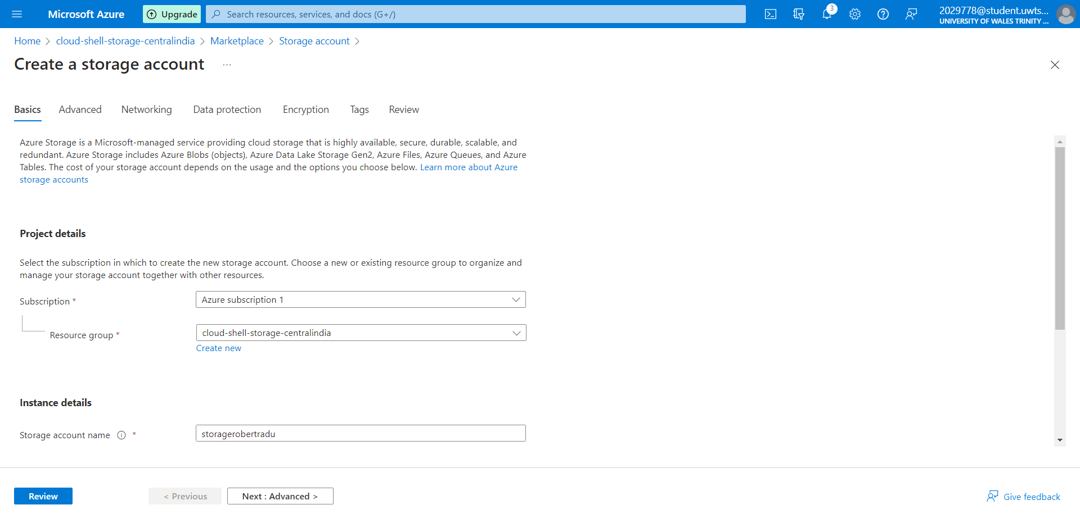
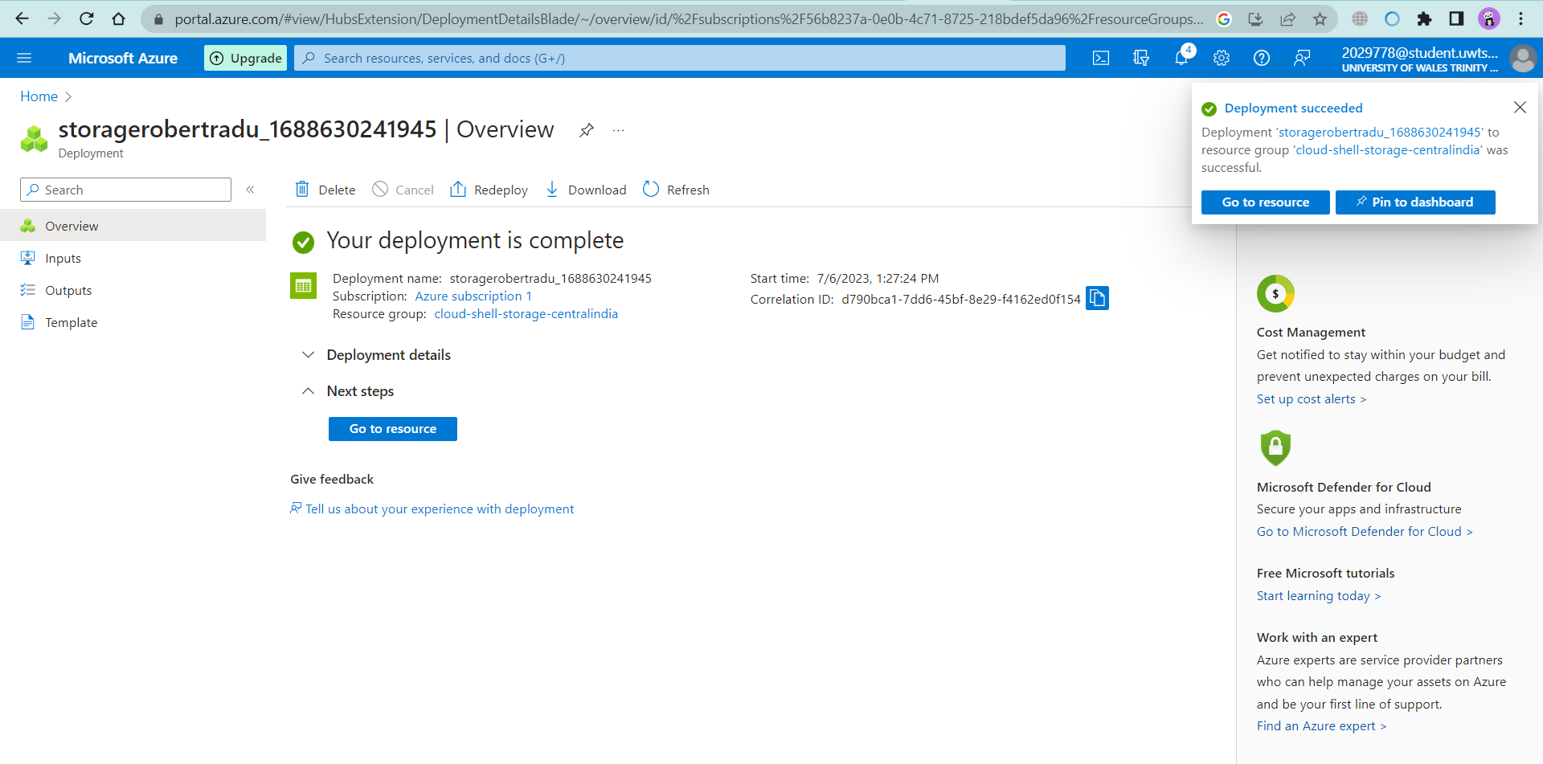
This time the deployment was succeeded the created policy inherited that the tag name and its value from the cloud shell resource group.
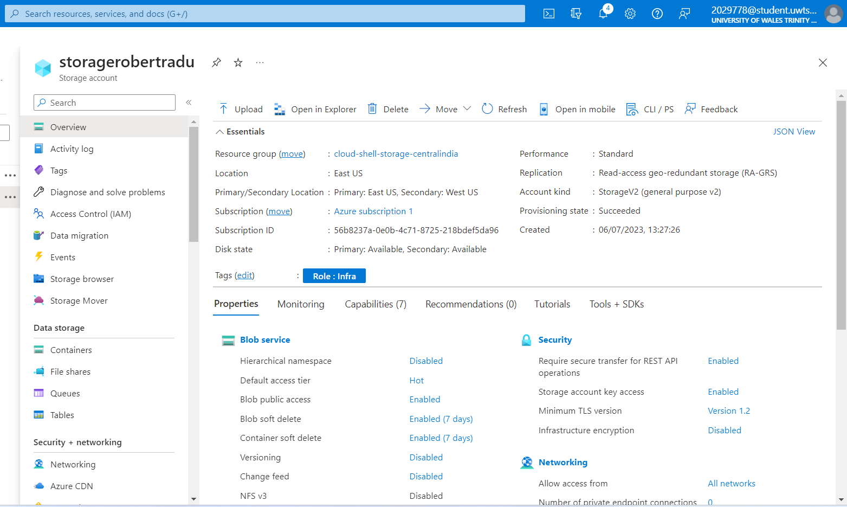
The above figure illustrates that the Role:Infra tag has been automatically assigned to the newly created storage account.

Cloud Disaster Recovery Plan for Aspire Retailers
For providing with a detailed support over the data as well as each application available or being used by Aspire Retailers on the cloud, a brief and robust Disaster Recovery Plan, which seems to be crucial here for providing with data integrity and security, while maintaining data availability, the following ideas that had been required to be considered here:
- Critical Workloads and Recovery object identification: - The Azure Cloud Disaster Recovery plan here had been determined to be beneficial for successively identifying all kinds of critical workloads, which would be utilized for prioritizing the major works that needed to be addressed for preventing any issues during data breach [2].
- Regular Testing and Monitoring: - Apart from identifying and marking the critical workloads, it also had been determined beneficial here for conducting a frequent testing of the Azure Cloud platform, so as to detect any malicious activities. This would include monitoring the status of every VM replications that had been made here at the organization, while tracking their data backup health [4].
- Azure Site Recovery: - The Cloud Disaster recovery plan here should also be equipped with a feature called Azure Site Recovery, responsible for providing a sufficient amount of server replications, so as to execute their work on both physical as well as virtual environment with more efficiency.
- Azure Traffic Manager: - The Cloud Disaster Recovery Plan here should also be implementing a feature of Azure Traffic Manager, responsible for distributing the entire network traffic all across the replicas of servers at Aspire Retailers. This would further be beneficial for maintaining a proper record of what kind of network data had been utilized here by the organization [3].
- Azure Backups: - Last, but not least, the Cloud Disaster Recovery plan here for Aspire Retailers should also include Azure Backups, which would be responsible for providing with an additional level of protection and storage for allowing Aspire Retailers to keep their data safe, which could be utilized during any data breach [1].

References
[1] A. B. Carter, “Considerations for genomic data privacy and security when working in the cloud,” The Journal of Molecular Diagnostics, vol. 21, no. 4, pp. 542–552, 2019. doi:10.1016/j.jmoldx.2018.07.009
[2] R. Al-Mahrouqi, K. Al Siyabi, A. Al Nabhani, S. Al-Hashemi, and S. Ali Muhammed, “E-commerce web app in Azure cloud: Considerations, components of implementation and schematic design,” Computer and Information Science, vol. 14, no. 4, p. 32, 2021. doi:10.5539/cis.v14n4p32
[3] A. Rashid and A. Chaturvedi, “Cloud computing characteristics and services a brief review,” International Journal of Computer Sciences and Engineering, vol. 7, no. 2, pp. 421–426, 2019. doi:10.26438/ijcse/v7i2.421426
[4] P. Kaushik, A. M. Rao, D. P. Singh, S. Vashisht, and S. Gupta, “Cloud computing and comparison based on service and performance between Amazon AWS, Microsoft Azure, and google cloud,” 2021 International Conference on Technological Advancements and Innovations (ICTAI), 2021. doi:10.1109/ictai53825.2021.9673425
[5] A. S. Muhammed and D. Ucuz, “Comparison of the IOT platform vendors, Microsoft Azure, Amazon Web Services, and google cloud, from users’ perspectives,” 2020 8th International Symposium on Digital Forensics and Security (ISDFS), 2020. doi:10.1109/isdfs49300.2020.9116254
[6] J. Soh, M. Copeland, A. Puca, and M. Harris, “Microsoft Azure and cloud computing,” Microsoft Azure, pp. 3–20, 2020. doi:10.1007/978-1-4842-5958-0_1
[7] I. Pelle, J. Czentye, J. Doka, and B. Sonkoly, “Towards latency sensitive cloud native applications: A performance study on AWS,” 2019 IEEE 12th International Conference on Cloud Computing (CLOUD), 2019. doi:10.1109/cloud.2019.00054
[8] Zhang, W.Z., Elgendy, I.A., Hammad, M., Iliyasu, A.M., Du, X., Guizani, M. and Abd El-Latif, A.A., 2020. Secure and optimized load balancing for multitier IoT and edge-cloud computing systems. IEEE Internet of Things Journal, doi: 8(10), pp.8119-8132.
[9] E. Bisong, “An overview of Google Cloud Platform Services,” Building Machine Learning and Deep Learning Models on Google Cloud Platform, pp. 7–10, 2019. doi:10.1007/978-1-4842-4470-8_2
[10] N. J. Mitchell and K. Zunnurhain, “Google Cloud Platform Security,” Proceedings of the 4th ACM/IEEE Symposium on Edge Computing, 2019. doi:10.1145/3318216.3363371
[11] S. Hashemipour and M. Ali, “Amazon Web Services (AWS) – an overview of the on-demand cloud computing platform,” Lecture Notes of the Institute for Computer Sciences, Social Informatics and Telecommunications Engineering, pp. 40–47, 2020. doi:10.1007/978-3-030-60036-5_3
[12] S. Zhao, J. Miao, J. Zhao, and N. Naghshbandi, “A comprehensive and systematic review of the banking systems based on pay-as-you-go payment fashion and cloud computing in the pandemic era,” Information Systems and e-Business Management, 2023. doi:10.1007/s10257-022-00617-9
[13] X. Yao et al., “Enabling the big earth observation data via cloud computing and DGGS: Opportunities and challenges,” Remote Sensing, vol. 12, no. 1, p. 62, 2019. doi:10.3390/rs12010062
[14] S. El Kafhali, I. El Mir, and M. Hanini, “Security threats, defense mechanisms, challenges, and future directions in cloud computing,” Archives of Computational Methods in Engineering, vol. 29, no. 1, pp. 223–246, 2021. doi:10.1007/s11831-021-09573-y
[15] D. Cabianca, “Configuring load balancing,” Google Cloud Platform (GCP) Professional Cloud Network Engineer Certification Companion, pp. 215–290, 2023. doi:10.1007/978-1-4842-9354-6_5
[16] J. Soh, M. Copeland, A. Puca, and M. Harris, “Implementing azure networking,” Microsoft Azure, pp. 137–163, 2020. doi:10.1007/978-1-4842-5958-0_9
[17] M. Banisakher, D. Mohammed, and M. Omar, “A cloud-based computing architecture model of Post-Disaster Management System,” International journal of simulation: systems, science &amp; technology, 2019. doi:10.5013/ijssst.a.19.05.19
[18] H. Tabrizchi and M. Kuchaki Rafsanjani, “A survey on security challenges in cloud computing: Issues, threats, and solutions,” The Journal of Supercomputing, vol. 76, no. 12, pp. 9493–9532, 2020. doi:10.1007/s11227-020-03213-1
[19] A. Saini et al., “A smart-contract-based Access Control Framework for Cloud Smart Healthcare System,” IEEE Internet of Things Journal, vol. 8, no. 7, pp. 5914–5925, 2021. doi:10.1109/jiot.2020.3032997
[20] W. Ahmad, A. Rasool, A. R. Javed, T. Baker, and Z. Jalil, “Cyber security in IOT-based Cloud computing: A comprehensive survey,” Electronics, vol. 11, no. 1, p. 16, 2021. doi:10.3390/electronics11010016
[21] R. S. M, S. Pattar, P. R, and M. S. H, “An overview of blockchain technology for identity and access management in the IOT ecosystem,” 2022 14th International Conference on COMmunication Systems &amp; NETworkS (COMSNETS), 2022. doi:10.1109/comsnets53615.2022.9668412
[22] U. Amah, J. Mart, and A. Oyetoro, Cloud security governance guidelines, 2023. doi:10.14293/pr2199.000062.v1
[23] T. Weil, “Risk assessment methods for cloud computing platforms,” 2019 IEEE 43rd Annual Computer Software and Applications Conference (COMPSAC), 2019. doi:10.1109/compsac.2019.00083
[24] A. Badirova, S. Dabbaghi, F. F. Moghaddam, P. Wieder, and R. Yahyapour, “A survey on identity and access management for cross-domain dynamic users: Issues, solutions, and challenges,” IEEE Access, vol. 11, pp. 61660–61679, 2023. doi:10.1109/access.2023.3279492
[25] M. Copeland and M. Jacobs, “Security Governance Operations,” Cyber Security on Azure, pp. 227–272, 2020. doi:10.1007/978-1-4842-6531-4_7
[26] A. Rath, B. Spasic, N. Boucart, and P. Thiran, “Security pattern for cloud SAAS: From system and data security to privacy case study in AWS and Azure,” Computers, vol. 8, no. 2, p. 34, 2019. doi:10.3390/computers8020034
[27] R. S. M, S. Pattar, P. R, and M. S. H, “An overview of blockchain technology for identity and access management in the IOT ecosystem,” 2022 14th International Conference on COMmunication Systems &amp; NETworkS (COMSNETS), 2022. doi:10.1109/comsnets53615.2022.9668412
[28] J. Bolannavar, “CSPM- Cloud Security Posture Management (comprehensive security for cloud environment),” International Journal of Scientific Research in Computer Science, Engineering and Information Technology, pp. 251–257, 2020. doi:10.32628/cseit206268

