

BMDB7006

Portfolio

Student name: Mengjun Chen
Student ID number: 1905034
Programme: DBA
Module: Resilience, Talent and Technology
Module code: BMDB7006
Contribution to Overall Module Assessment (%): 50%
Lecturer: Dr. David Griffiths
Internal Verifier:

Content

1.PESTLE analysis on talent attraction in Cisco 1
References 4
2. Labor market trends affecting the organisation 6
References 9
3. Ted talk -- technology impacting on human resource planning 11
References 12
4. HRM policy comparison in Liberal economy and Coordinated economy 14
References 17
5. Presentation -- the future of work 19
References 39
6. Critical analysis of Atkinson’s Model in open talent economy 41
References 45
7. Organisational resilience model and application 47
References 50

1.PESTLE analysis on talent attraction in Cisco

Attracting high-quality people is the external policy implementation in talent resourcing which is the outcome of talent planning (Armstrong, 2017). In order to be competitive, it is important and challenging to obtain people from outside and within the organization (Armstrong and Taylor, 2014; Deloitte, 2019). The international recruitment and selection criteria may be varied widely in terms of the what kind of candidate the organisation need, the candidate characteristics, the company role, the assignment nature, the talent needs and legal issues (Edwards & Rees, 2011).
As a multinational corporation, founded in USA in 1984, Cisco System Inc. is a high-technology product and service company across collaboration, networking and the cloud. It is ranked 63rd on the Fortune 500 (Fortune, 2020) through decades of development with over 75,900 employees worldwide and it entered in China in 1994 (Cisco, 2020).
A PESTLE analysis is a framework impacting the organisation by analyzing six key external factors (Political, Economic, Sociological, Technological, Legal and Environment) (CIPD, 2020). There are many external factors may affect talent attraction, thus it is useful to conduct a PESLE analysis critically evaluate how the factors influence the talent acquisition for an organization in the global context. Take Cisco for an example, due to the word limitation, the analysis is mainly focused on political and technological part.
Figure 1: PESTLE analysis
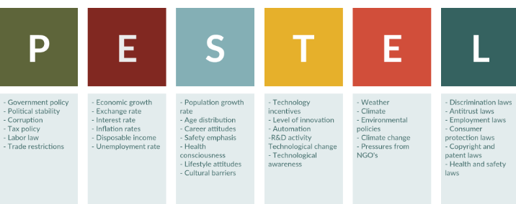
Political analysis:
Government legislation and policy would influence the talent attraction.
- US-China trade war is negatively impact talent attraction as an “host-country” effect (Edwards and Rees, 2011). Both China and USA have signed a preliminary deal, but there are some issues remained unsolved. China increased the tariff from 5% to 25% on American goods (BBC, 2020), which will impact talents in Cisco as well.
- On the other hand, as Chinese researchers are difficult to get the visa and scrutiny is tighter in US, many researchers leave the country. Hence, it has being seen a big talent loss in Cisco in USA (Huang & Lo, 2019).
Technological analysis:
- AI and automation bring a lot of benefit to the mankind. For example, 52% of employers who invested in AI and automation saw the quality of goods and service is improved; 37% of employers who invested in AI and automation saw cost reduced; 34% of employers who invested in AI saw revenue increased (CIPD, 2019).
- According to the World Economic Forum (2018), 50% of companies expect that automation will lead to some reduction in their full-time workforce, based on the job profiles of their employee base today.
- Technology is greatly adopted by industry, such as cloud computing, encryption (World Economic Forum, 2018).
- Technology helps human make decisions in the workforce, thus unique human traits become more valuable, such as emotional intelligence, creativity and innovation (PWC, 2020). As technology becomes more powerful and capable, it is the rise in demand for “human skills” that ultimately helps define the transition to the 2027 labor market. Human skills embody workers’ ability to make the best use of technological innovations on a large scale (Yoo, 2020).
Thus, as an external factor, technology impact a lot on Cisco HR function. Cisco attract and retain talents by using WebEx system which is the ubiquitous one. By using the employees’ voice with the employer brand, Cisco is more accessible to talent, which is much more different from other organization (Randstad, 2020). New digitized technology provides Cisco an advanced recruitment platform and both technique and human skills are emphasized as talent requirement in the competitive era (Cisco, 2020).
Environmental analysis:
According to the Cisco (2019), it can be seen Cisco makes effort on green issues such as friendly environmental materials, energy efficiency and renewable projects (Cisco, 2019). The sustainable development helps Cisco to acquire talents in the long term.
Social analysis:
As for the eastern and western culture are different, the candidate’s characteristics and needs may vary a lot in USA and China. Lifestyle and work-balance factors could be social factors impact the talent attraction.
Legal analysis:
Both in USA and China, there is Employment Law, Labor Law and Health and safety regulation to protect the employee’s right, which helps Cisco to attract the talent.
Economic analysis:
Exchange rate, employment rates, labor cost, inflation and consumer spending habits could be economical factors influence talent attraction in Cisco.

References
Armstrong, M., and Taylor, S. (2014) Armstrong's handbook of human resource
management practice. Kogan Page Publishers.
BBC. (2020) A quick guide to the US-China trade war. Available at: https://www.bbc.com/news/business-45899310 (Accessed: 19 October 2020).
Cisco. (2019) Corporate social responsibility report. Available at: https://www.bbc.com/news/business-45899310 (Accessed: 19 October 2020).
Cisco. (2020) Our People Deal. Available at: https://www.cisco.com/c/en/us/about/careers/we-are-cisco/people-deal.html (Accessed: 19 October 2020)
CIPD. (2019) People and machines: from hype to reality. Available at: https://www.cipd.co.uk/Images/people-and-machines-exec-summary_tcm18-56971.pdf (Accessed: 14 September 2020)
CIPD. (2020) PESTLE analysis. Available at: https://www.cipd.co.uk/knowledge/strategy/organisational-development/pestle-analysis-factsheet (Accessed: 19 October 2020).
Deloitte. (2019) Leading the social enterprise: Reinvent with a human focus.
Available at: https://www2.deloitte.com/content/dam/insights/us/articles/5136_HC-Trends-2019/DI_HC-Trends-2019.pdf (Accessed: 19 October 2020).
Edwards, T. and Rees, C. (2011) International Human Resource Management: globalisation, national systems and multinational companies. 2nd ed. Essex: Palgrave.
Forture. (2020) Cisco system company profile. Available at: https://fortune.com/company/cisco-systems/fortune500/ (Accessed: 19 October 2020).
Randstad. (2020) Cisco reinvents talent acquisition using the voice of employees. Available at: https://www.randstad.com/workforce-insights/employer-branding/cisco-reinvents-talent-acquisition-using-voice-employees/ (Accessed: 19 October 2020).
Huang, K. & Lo, K. (2019) As China and US spar over tech, scientist would rather not talk about their talent awards. Available at: https://www.scmp.com/news/china/diplomacy/article/2180752/china-and-us-spar-over-tech-scientists-would-rather-not-talk (Accessed: 19 October 2020).
World Economic Forum. (2018) The future of job reports. Available at: http://www3.weforum.org/docs/WEF_Future_of_Jobs_2018.pdf (Accessed: 19 October 2020).
Yoo, T., (2020) Research: Modeling to inform the future of work. Oxford Economics & Cisco CSR research. Available at: https://www.cisco.com/c/dam/assets/csr/pdf/modeling-inform-future-work.pdf (Accessed on 15 Sep 2020).

2. Labor market trends affecting the organisation

PESTLE analysis would be more effective to understand the labor market trends affecting the organisation, though Mogan (2016) points out globalization, mobility, millennials and change demographics, new behaviors and technology are the five trends which is a little bit broad to shape the organisation future work.
Technology analysis:
- The unprecedented pace and scale of change brought about by Industry 4.0 has led technology is increasingly outpacing individuals’ and organisations’ ability to adapt (Deloitte, 2017). New technologies are the vital tools for people to shape the future work together (World Economy Forum, 2016; 2018)
- AI and automation bring the power and the threat (CIPD, 2019). While AI and automation has more potential to remove jobs, it also has greater potential to create them (CIPD, 2019). 50% of companies expect that automation will lead to some reduction in their full-time workforce, based on the job profiles of their employee base today (World Economic Forum, 2018)
- Human collaborates machines to make decisions in the workforce. Unique human traits become more valuable, such as emotional intelligence, creativity, persuasion and innovation (PWC, 2020).
Economic analysis:
Unemployment rate may hit 10% in 2020 (The economist, 2020), however it may just influence the private sector rather than the public sector. How to improve the student enrollment rate need to be considered in the higher education due to the economics declined.
Political analysis:
US-China trade war (BBC, 2020) results that the Chinese government encourage the students to further their tertiary education domestically rather than studying abroad. Thus, for most of the students they would consider if they are not going to study abroad, which university in China they will choose to go and whether FJJX University is competitive to attract the students.
As the PESLTE analysis helps FJJX University to think about as an employer, what happens in the labor market and how it influences the organisation. Talent management is an appropriate framework for universities to transform into strategic human resource management and alignment with strategy, metric and management are the three key issues related to talent management in high education context (Armstrong, 2017; Bradley, 2016). Gandy et. al, (2017) suggest talent management in higher education could be viewed as a strategic issue relative to organizational performance (Hazelkorn, 2015). A good strategic human resource management need to be more conducted to attract and retain talent in order to improve the university reputation for FJJX University based on the labor market trends and impact.
Based on the above analysis, technology is one of the most important factors influencing the organisation most. According to McKinsey Global Institute (2018), the demand of social and emotional skill will be increased 24% from Year 2016 to 2030. Responding to the labor market demand, there is ever-larger disconnection between education and employment, And the student employability is needed to be developed (Griffiths et al., 2018). It is necessary but challenging for high educational institutions to teach the students’ critical job skills so that future generation employee can be adaptive to the evolving demand of the dynamic labor market. Thus, it is important to acquire high-quality lecturers to join the university to improve the student’s employability skill. It can be seen from the University Website, one-million dollar is spent to attract the outstanding talent.
With the trend of technology, digital learning resources are more flexible than traditional classroom training as for the timing and content, especially we face with Covid-19 now. The learning outcomes could be optimized by programs adjustment (McKinsey Global Institute, 2017). On the other hand, as there are many employees are Generation Y and Z, FJJX University develops the young generation so that they can be more engaged in the organisation. Many lecturers are encouraged and sent to further with their doctoral study, which is good for employee career development. For example, the organization sent 5 lecturers to go to UWSTD in UK for doctoral study in 2019 and paid one year’s tuition fee for them. In conclusion, in order to be competitive, FJJX University need to make efforts to attract and retain talents so that the university’s reputation will be improved.
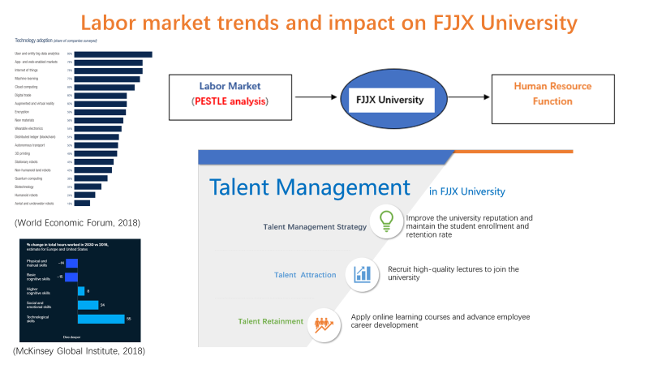
Figure 1: Infographic of labor market trends and impact on FJJX University

References
Armstrong M. (2017) Armstrong’s Handbook of Human Resource Management Practice 14th Ed. London: Kogan Page.
Bradley, A. (2016) Talent management for university. Australian Universities’ review, 58(1), pp. 13-19.
BBC. (2020) A quick guide to the US-China trade war. Available at: https://www.bbc.com/news/business-45899310 (Accessed: 19 October 2020).
CIPD. (2019) People and machines: from hype to reality. Available at: https://www.cipd.co.uk/Images/people-and-machines-exec-summary_tcm18-56971.pdf (Accessed: 14 September 2020).
Deloitte. (2017) Rewriting the Rules for the Digital Age: 2017 Deloitte Global Human Capital Trends, Deloitte University Press.
Gandy, R. Harrison, P. and Gold, J. (2017) Talent management in higher education: is turnover relevant? Talent management, 42(9), pp. 597-610.
Griffiths, D.A. Inman, M. Rojas, H. and Williams, K (2018) Transitioning student identity and sense of place: future possibilities for assessment and development of student employability skills. Studies in higher education, 43(5). pp. 891-913.
Hazelkorn, E. (2015) Rankings & the reshaping of higher education: The battle for world-class excellence. Available at https://www.researchgate.net/publication/274379817_Rankings_and_the_Reshaping_of_Higher_Education_The_Battle_for_World-Class_Excellence (Accessed: 20 October 2020).
McKinsey Global Institute. (2017) Jobs lost, jobs gained: workforce transitions in a time of automation, Available at https://www.mckinsey.com/featured-insights/future-of-work/jobs-lost-jobs-gained-what-the-future-of-work-will-mean-for-jobs-skills-and-wages (Accessed: 7 September 2020).
McKinsey Global Institute. (2018) Soft skills for the hard world, Available at https://www.mckinsey.com/featured-insights/future-of-work/five-fifty-soft-skills-for-a-hard-world (Accessed: 7 September 2020)
Morgan, J. (2016) “The 5 trends shaping the future of work”. YouTube. Available at: https://www.youtube.com/watch?v=LrhmHbDLM8o (Accessed: 20 October 2020).
The economist. (2020) China’s unemployment rate may hit 10%. Available at: http://country.eiu.com/article.aspx?articleid=359423819&Country=China&topic=Economy&subtopic=Forecast&subsubtopic=Economic+growth (Accessed: 20 October 2020).
PWC. (2020) Workforce of the future: The competing forces shaping 2030. Available at: https://www.pwc.com/gx/en/services/people-organisation/workforce-of-the-future/workforce-of-the-future-the-competing-forces-shaping-2030-pwc.pdf (Accessed: 14 September 2020).
Schwab, K. (2016) The Fourth Industrial Revolution. World Economy Forum, Available at https://www.weforum.org/about/the-fourth-industrial-revolution-by-klaus-schwab (Accessed: 7 Sep 2020).
World Economic Forum. (2018) The future of job reports. Available at: http://www3.weforum.org/docs/WEF_Future_of_Jobs_2018.pdf (Accessed: 15 September 2020).

3. Ted talk -- technology impacting on human resource planning

Link:
https://youtu.be/I5AX7rNupIw

References
Allui, A., Sahni, J. (2016) Strategic human resource management in higher education institutions: empirical evidence from Saudi. Procedia-Social behavior sciences. 235(24), pp. 361-371.
Armstrong, M. (2017) Armstrong’s Handbook of Human Resource Management Practice 14th Ed. London: Kogan Page.
Aviso, K.B., Chiu, A., Demeterio, F., Lucas, R. I., Teseng, M., Tan, R. (2019) Optimal human resource planning with P-graph for universities undergoing transition. Journal of clearner production. 24, pp. 811-822.
Bradley, A (2016) Talent management for university. Australian Universities’ review, 58(1), pp. 13-19.
CIPD. (2017) Resourcing and talent planning. Survey report, CIPD, London.
CIPD. (2019) People and machines: from hype to reality. Available at: https://www.cipd.co.uk/Images/people-and-machines-exec-summary_tcm18-56971.pdf (Accessed on 14 Sep 2020).
Curado, C. and Bontis, N. (2006) The knowledge-based view of the firm and its theoretical precursor. International journal of learning and intellectual capital, 3(4). pp. 367-381.
Deloitte. (2017) Rewriting the Rules for the Digital Age: 2017 Deloitte Global Human Capital Trends, Deloitte University Press.
Gandy, R. Harrison, P. and Gold, J. (2017) Talent management in higher education: is turnover relevant? Talent management, 42(9), pp. 597-610.
Hatch, N. W., & Dyer, J. H. (2004) Human capital and learning as a source of sustainable competitive advantage. Strategic management journal, 25, pp.1155–1178.
PWC. (2020) Workforce of the future: The competing forces shaping 2030. Available at: https://www.pwc.com/gx/en/services/people-organisation/workforce-of-the-future/workforce-of-the-future-the-competing-forces-shaping-2030-pwc.pdf (Accessed on 14 Sep 2020).
Stone, D. L. Deadrick, D. L., Lukaszeboski, K.M. Johnson, R. (2015) The influence of technology on the future of human resource management. Human resource management review, 25, pp. 216-231.
Taylor, S. (2018) Resourcing and talent management. 7th edn. Kogan Page
Publishers.
Whysall, Z. (2018) The new talent management challenges of Industry 4.0. Journal of management development, 38(2), pp. 118-129.
Workday. (2020) Take higher education to the cloud, Available at: https://www.workday.com/en-us/customer-experience/customers.html?q=&industry.name=Higher%20Education (Accessed: 20 October 2020).
World Economic Forum. (2018) The future of job reports. Available at: http://www3.weforum.org/docs/WEF_Future_of_Jobs_2018.pdf (Accessed: 15 September 2020).

4. HRM policy comparison in Liberal economy and Coordinated economy

HRM involves the application of policies and practices in relation to the organizational design and development, employee recruitment, learning and development, performance and reward so that the employee well-being could be enhanced (Armstrong & Taylor, 2014).The human resource policy is defined as the organisational approach regarding the key HRM aspects and the guidelines provides for its application (Armstrong & Taylor, 2014).
Take FJJX University in China for an example. As it would start with the cooperation with UK, the organisation would be situated from Coordinated economy market to Liberal economy market. Coordinated market economy (CME) is characterized as that organsation is easily affected by the governmental regulations and instructions and the organisational behavior is coordinated with others in a centralized system. By contrast, Liberal market economy (LME) is an economic system based on the market (Hall & Soskice, 2001). It has the following characteristics: obviously decentralized negotiations, wide and personalized employment, employment flexibility, competitive human resource management practices.
According to McLagan Wheel (1989), human resource planning and development are important, which are parts of the human resource practices. The HRM policy need to be tailored due to the international institutional context. As the government legislation and labor market is different in UK and China, human resource management need to adapt to the different perspective. How to deliver an appropriate international human resource management is important for the organizational success because both the local and global advantages are combined in the practices (Morris et al., 2016). There has been a hot debate on globalization, convergence and divergence for a long time (Farndale et al., 2017). Convergence occurs when the organisation adopts more similar practices and the implementation is ultimately universal while divergence means more and more dissimilar practices occurred in the organisation by adopting different HRM practices over time (Farndale et al., 2017; Mayrhofer, 2011). There are formal and informal institutional constraints could influence HRM practice such as employment legislationa and cultural values (Gooderham et al., 2015). Kaufman (2016) indicates lot of convergence literatures are based on the reports in relation to the consistent convergence/divergence trends identification.
Talent management is important in high education institution with the alignment with the strategic management (Armstrong, 2017; Grandy et al., 2017). “Training, talent, recruitment” are key challenges identified for the organizational competitiveness as well as the leadership element and agile capacity (BSI, 2019; Bl; Bradley, 2016). As Kooij and Boon (2018) describe training and development are high-performance human resource management practices to improve the employee engagement, the training especially onboard training could be provided for the employees in UK. As the employee relationship is relatively lower-trust and lower-commitment (Edwards & Rees, 2011) in Liberal economy market in UK compared with Coordinated economy market in China, the employee engagement is needed to be emphasized. Boon et al. (2018) point out improving employee’s motivation and skills is one of the key objectives of human resource management practice. Though the leadership is still from Chinese university, the human resource function is run by UK university, the lecturers need to be recruited in UK as it has moved to the different university. On the other hand, the lower-trust results in the employee relationship could be competitive and contract based. For example, subcontracting could be a trend based on the competitive wage offered (Edwards & Rees, 2011). It is assumed that there are 3 lecturers would come from host country (China) to join the UK University and there are not many lecturers will be hired in UK yet. For one thing, the pay in UK is higher in China. For another, there are not many students enrolled yet. According to the students enroll rate at present, it is estimated to recruit another 20 lecturers in UK. Though the high salary will be paid to the new lecturers acquired in UK, the proposal is still feasible because with the talent attraction and retainment in UK University, the reputation of the university will be improved and there will be more and more students join the university in the future.

References
Armstrong, M., & Taylor, S. (2014) Armstrong's handbook of human resource management practice. Kogan Page Publishers.
Armstrong, M. (2017) Armstrong’s Handbook of Human Resource Management Practice 14th Ed. London: Kogan Page.
Boon, C. , Eckardt, R., Lepak, D. and Boselie, P. (2018) Integrating strategic human capital and strategic human resource management. The International Journal of Human Resource Management, 29(1), pp. 34-67.
Bradley, A (2016) Talent management for university. Australian Universities’ review, 58(1), pp. 13-19.
BSI. (2019) Organizational Resilience Index: Third annual report. Available at: https://www.bsigroup.com/globalassets/localfiles/en-gb/organizational-resilience/OR-Index-2019-web-final.pdf?utm_campaign=OR-IndexReport-2019 (Accessed: 22 September 2020).
Edwards, T. and Rees, C. (2011) International Human Resource Management: globalisation, national systems and multinational companies. 2nd ed. Essex: Palgrave.C
Farndale, E., Brewster, C., Ligthart, P. and Poustsma, E. (2017) The effort of market economy type and foreign MNE subsideiaries on the convergence and divergence of HRM. Journal of international business studies, 48, pp. 1065-1086.
Gooderham, P., Morley, M., Parry, E., & Stavrou, E. (2015) National and firm-level drivers of the devolution of HRM decision making to line managers. Journal of International Business Studies, 46(6), pp. 715–723.
Gandy, R. Harrison, P. and Gold, J. (2017) Talent management in higher education: is turnover relevant? Talent management, 42(9), pp. 597-610.
Hall, P. A., & Soskice, D. (2001) ‘An Introduction to Varieties of Capitalism’ in Hall, P and Soskice, D (eds) Varieties of Capitalism: the Institutional Foundations of Comparative Advantage. New York: Oxford University Press.
Kaufman, B. E. (2016) Globalization and convergence–divergence of HRM across nations: New measures, explanatory theory, and non-standard predictions from bringing in economics. Human Resource Management Review, 26(4), pp. 338–351.
Kooij D, Boon C (2018) Perceptions of HR practices, person–or-oganization fit, and affective commitment: The moderating role of career stage. Human Resource Management Journal, 28 (1), pp.61-75.
Mayrhofer, W., Brewster, C., Morley, M. J., & Ledolter, J. (2011) Hearing a different drummer? Convergence of human resource management in Europe: A longitudinal analysis. Human Resource Management Review, 21(1), pp. 50–67.
Morris, S., Snell, S., & Bjo ¨rkman, I. (2016) An architectural framework for global talent management. Journal of International Business Studies, 47(6), pp. 723–747.
McLagan, P. A. (1989) Models for HRD practice. American Society for Training and Development, Alexandra, VA: ASTD Press.

5. Presentation -- the future of work

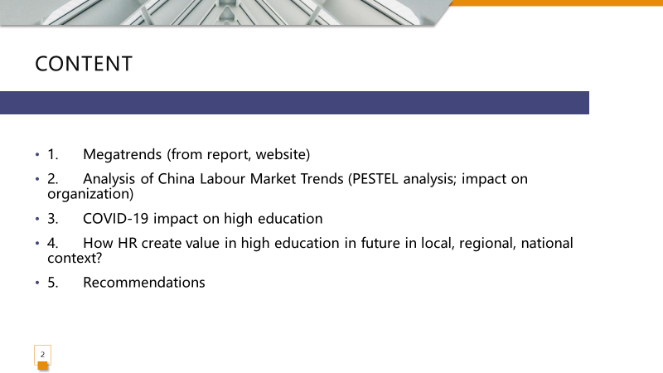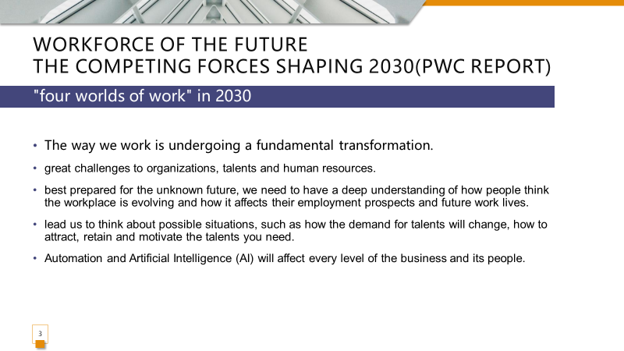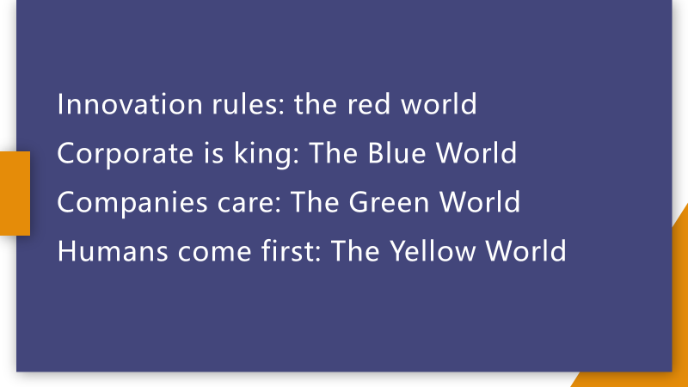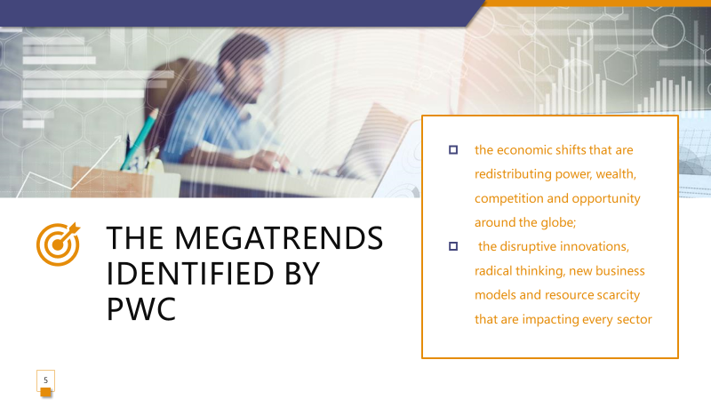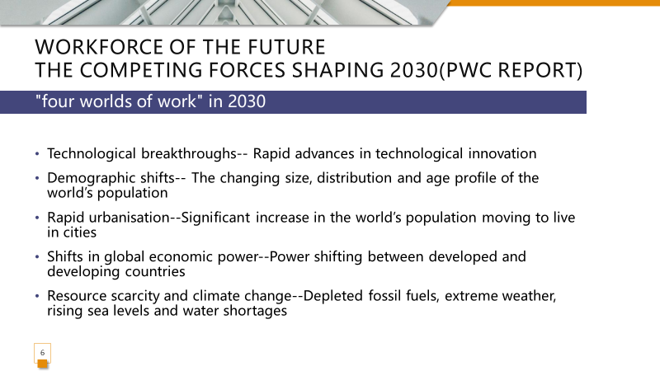

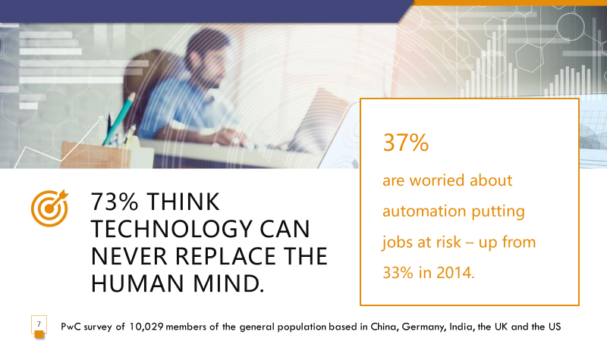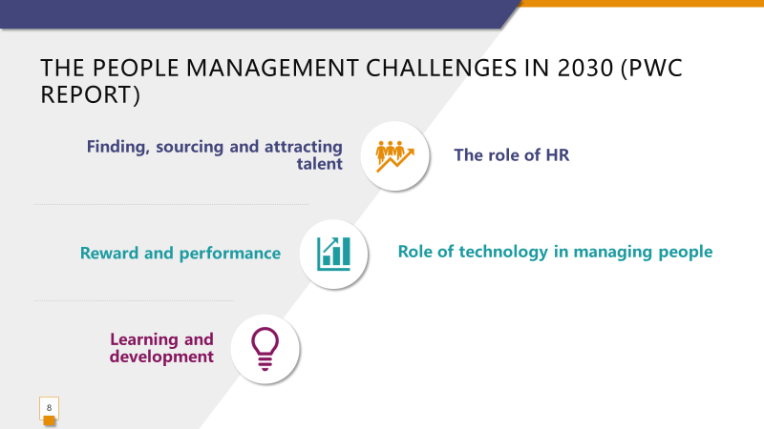

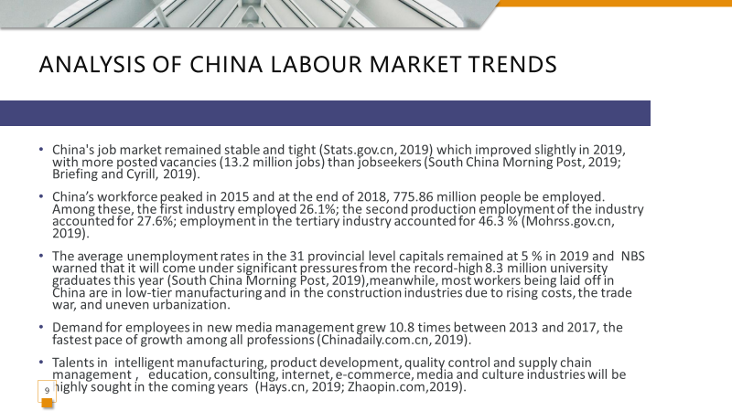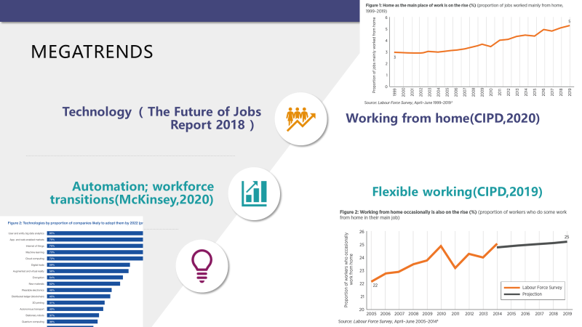

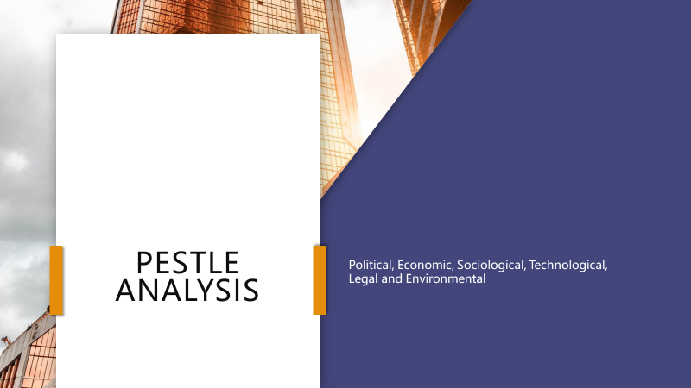

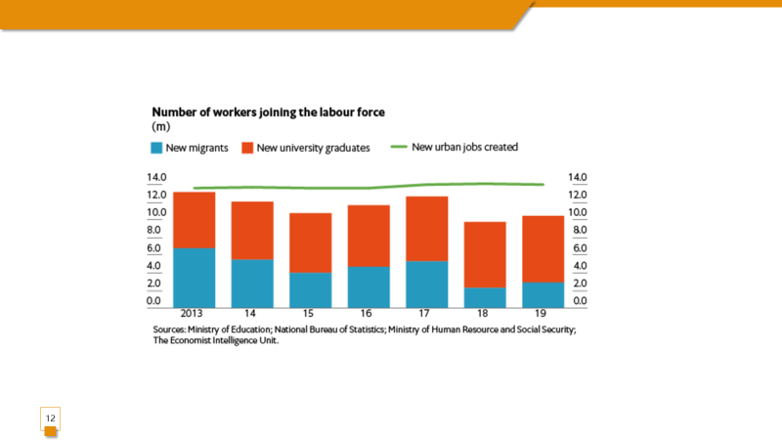

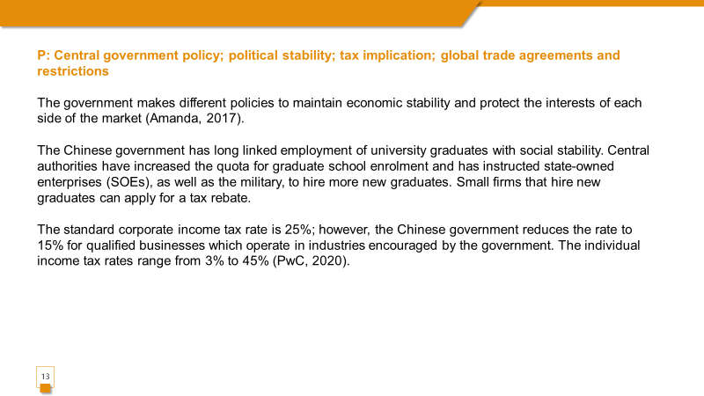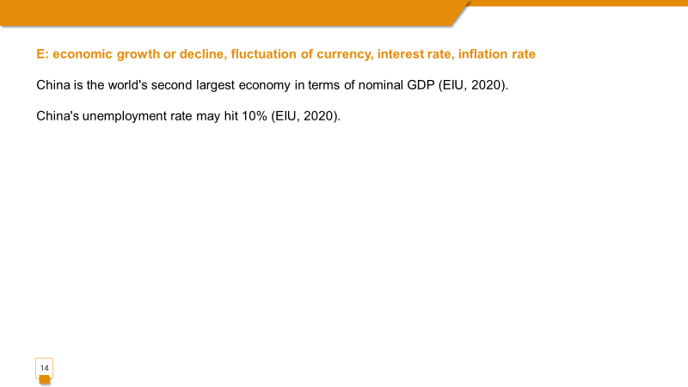

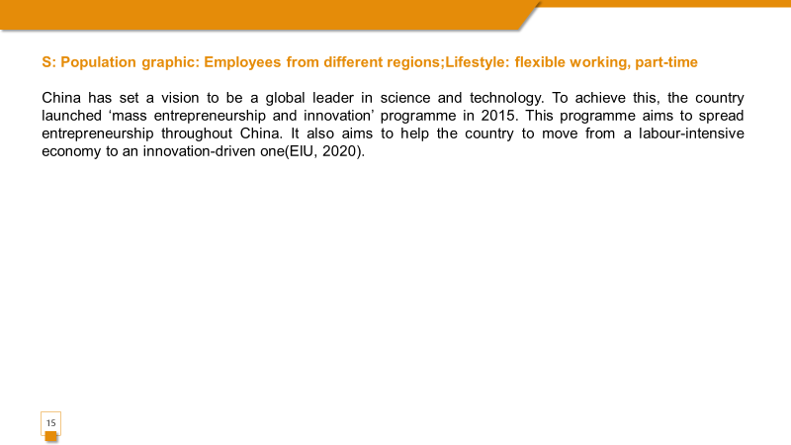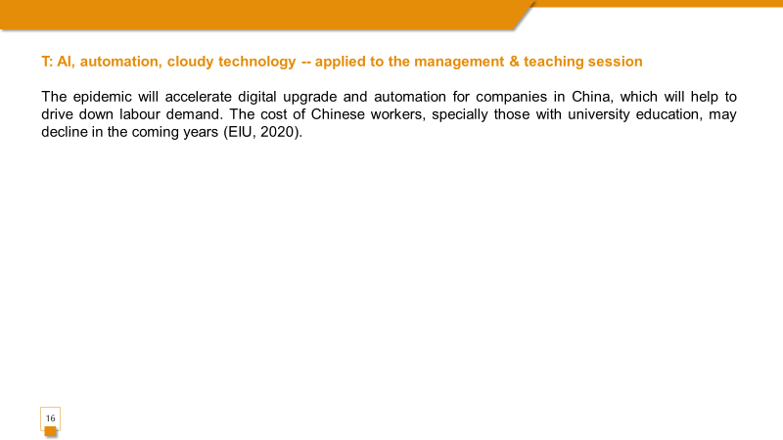

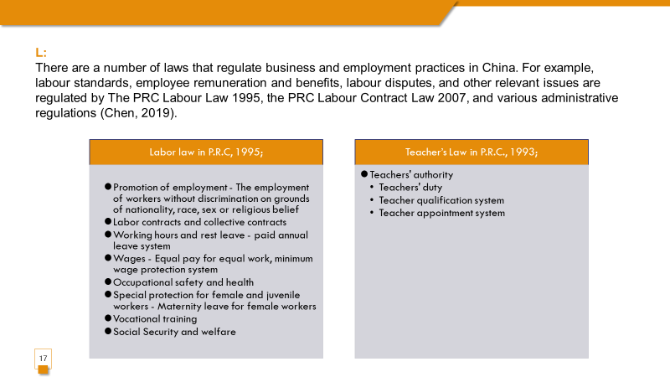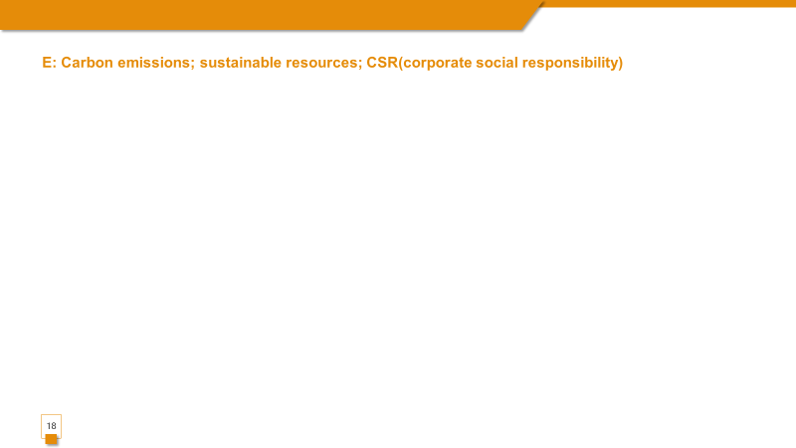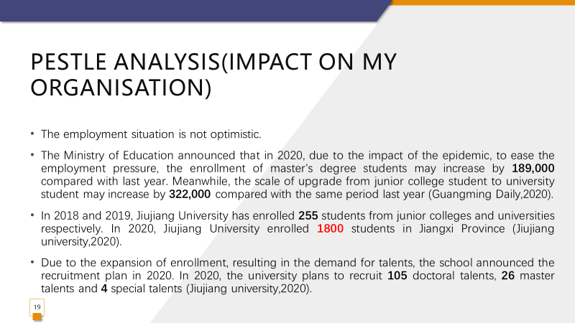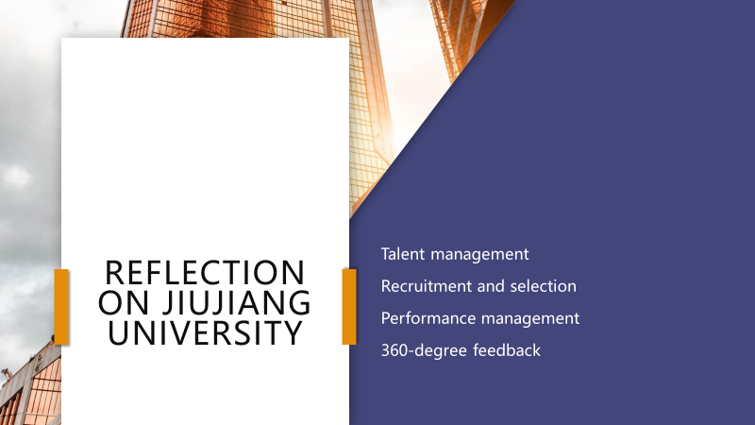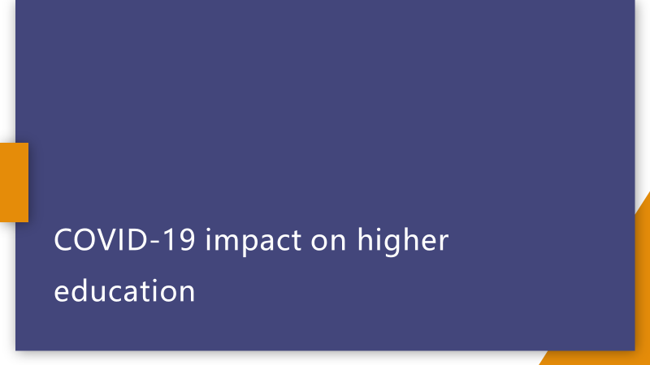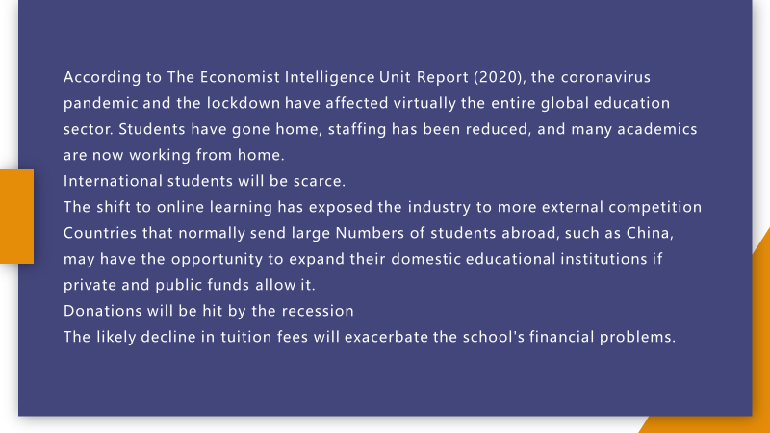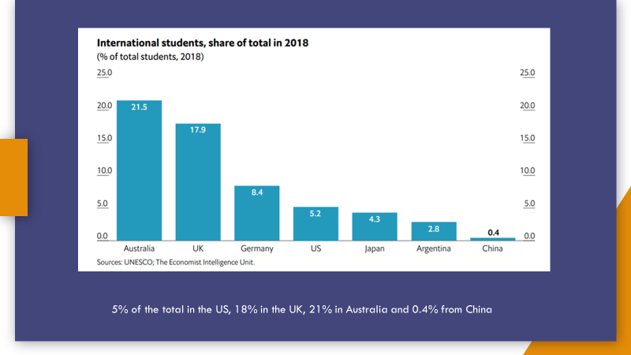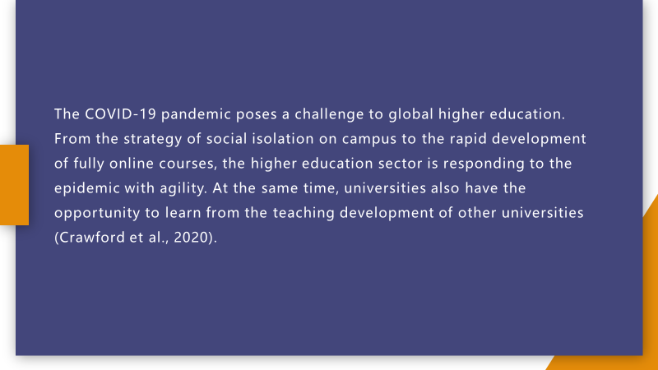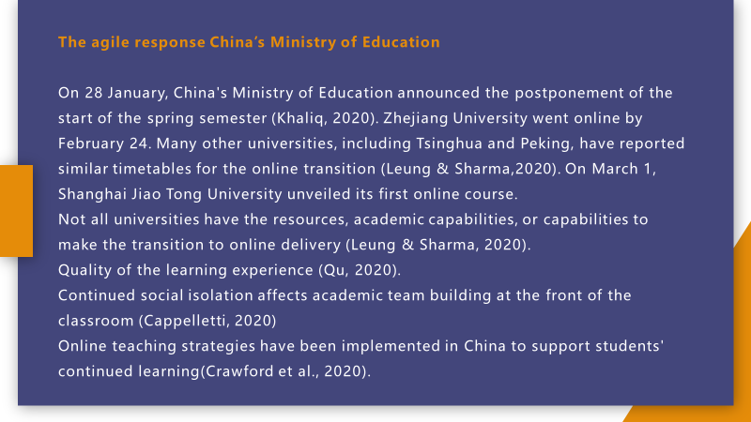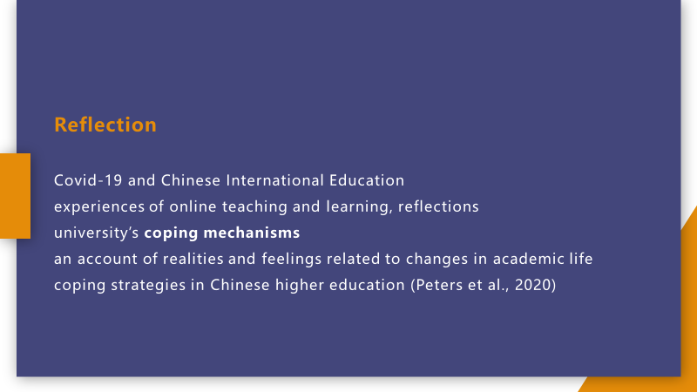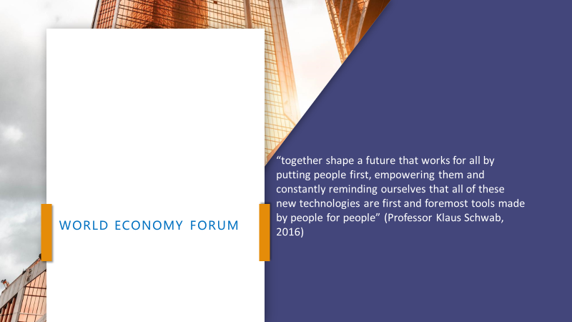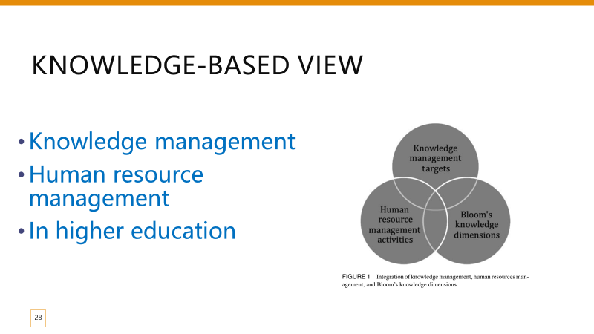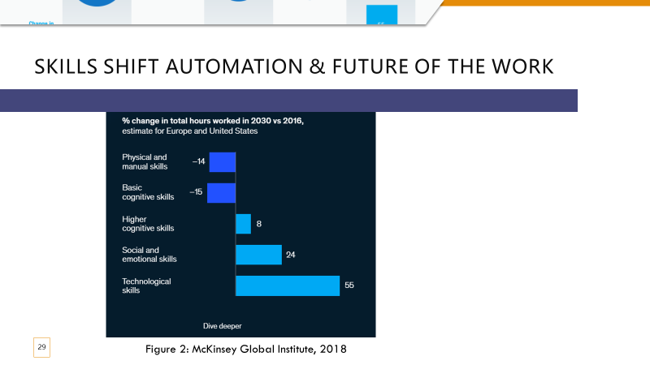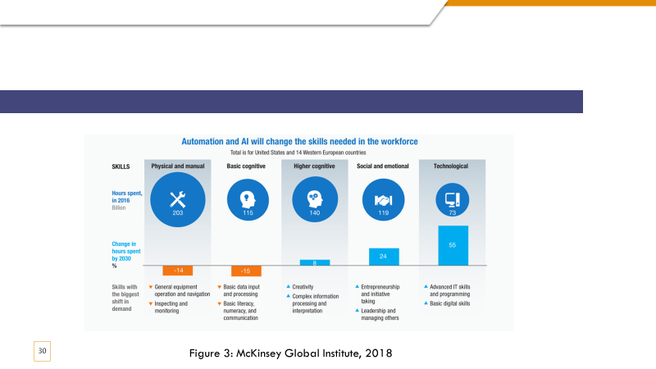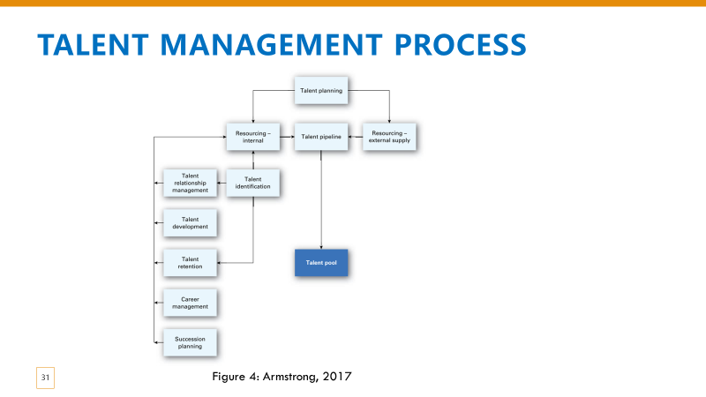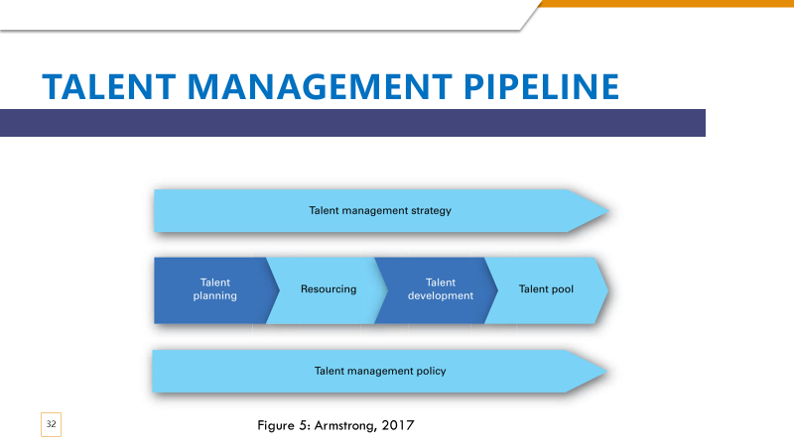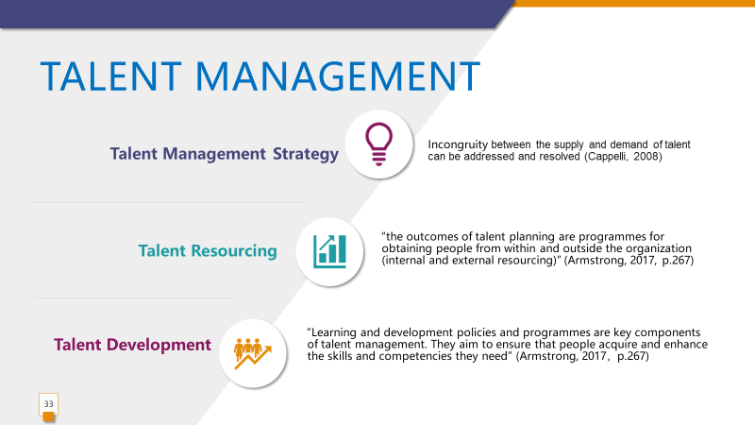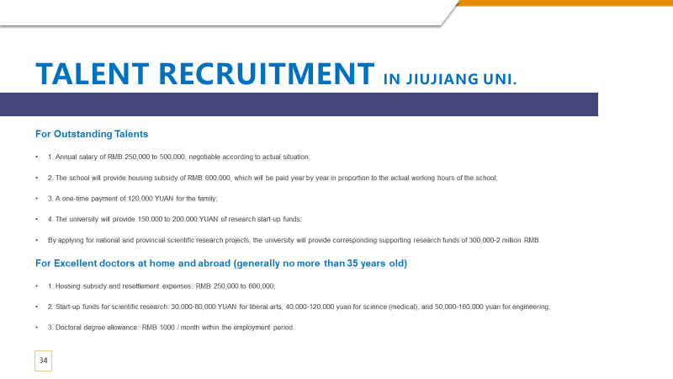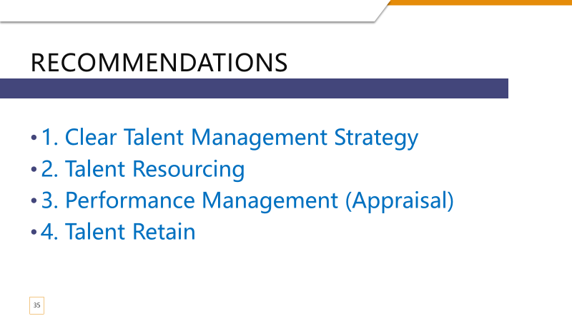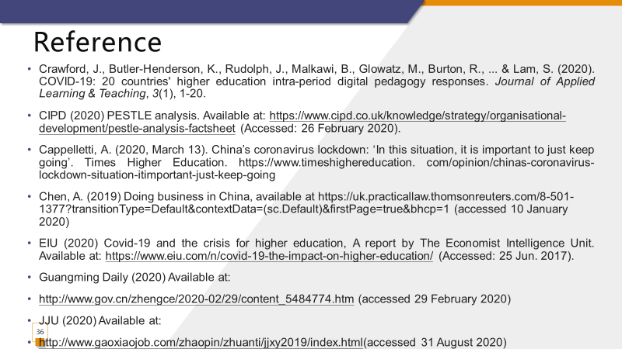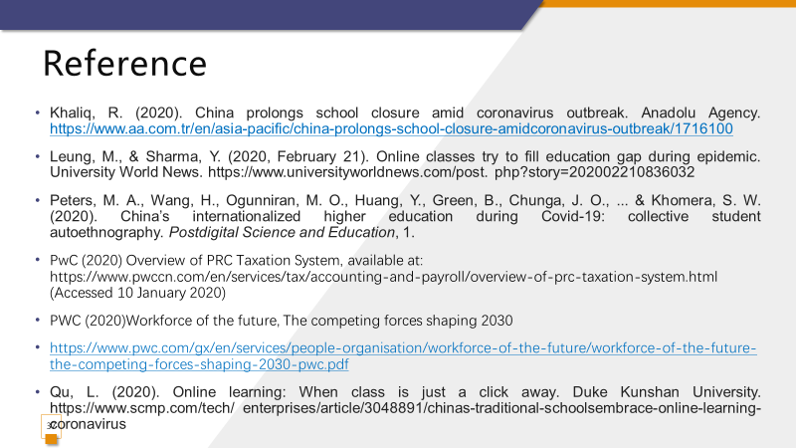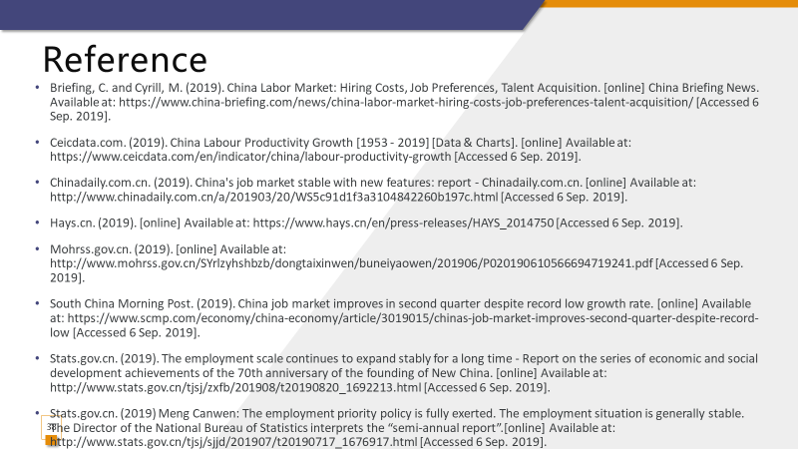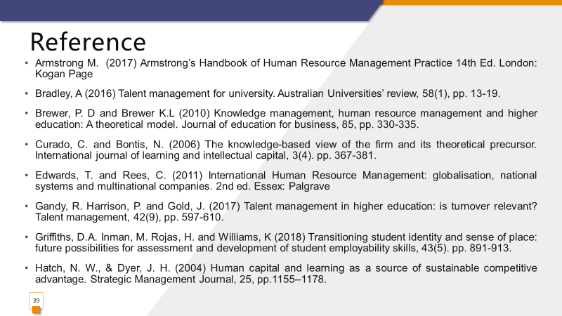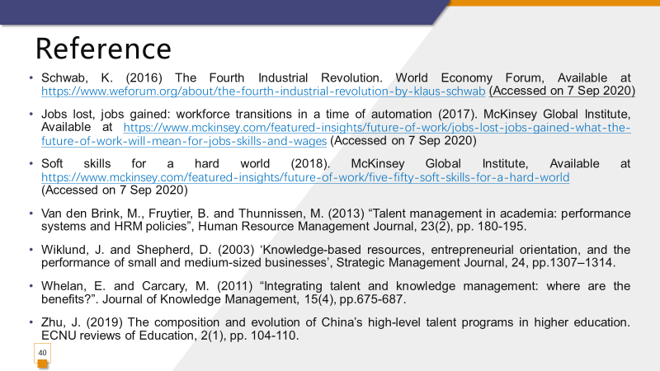

References
Armstrong M. (2017) Armstrong’s Handbook of Human Resource Management Practice.14th Ed. London: Kogan Page.
Brewer, P. D and Brewer K.L. (2010) Knowledge management, human resource management and higher education: A theoretical model. Journal of education for business, 85, pp. 330-335.
Curado, C. and Bontis, N. (2006) The knowledge-based view of the firm and its theoretical precursor. International journal of learning and intellectual capital, 3(4). pp. 367-381.
Edwards, T. and Rees, C. (2011) International Human Resource Management: globalisation, national systems and multinational companies. 2nd ed. Essex: Palgrave.
Gandy, R. Harrison, P. and Gold, J. (2017) Talent management in higher education: is turnover relevant? Talent management, 42(9), pp. 597-610.
Griffiths, D.A. Inman, M. Rojas, H. and Williams, K (2018) Transitioning student identity and sense of place: future possibilities for assessment and development of student employability skills. Studies in higher education, 43(5). pp. 891-913.
Hatch, N. W., & Dyer, J. H. (2004) Human capital and learning as a source of sustainable competitive advantage. Strategic Management Journal, 25, pp.1155–1178.
Schwab, K. (2016) The Fourth Industrial Revolution. World Economy Forum, Available at https://www.weforum.org/about/the-fourth-industrial-revolution-by-klaus-schwab (Accessed: 7 September 2020).
McKinsey Global Institute. (2017) Jobs lost, jobs gained: workforce transitions in a time of automation (20), Available at https://www.mckinsey.com/featured-insights/future-of-work/jobs-lost-jobs-gained-what-the-future-of-work-will-mean-for-jobs-skills-and-wages (Accessed: 7 September 2020).
McKinsey Global Institute. (2018) Soft skills for a hard world, Available at https://www.mckinsey.com/featured-insights/future-of-work/five-fifty-soft-skills-for-a-hard-world (Accessed: 7 September 2020).
Van den Brink, M., Fruytier, B. and Thunnissen, M. (2013) Talent management in academia: performance systems and HRM policies, Human Resource Management Journal, 23(2), pp. 180-195.
Wiklund, J. and Shepherd, D. (2003) Knowledge-based resources, entrepreneurial orientation, and the performance of small and medium-sized businesses, Strategic Management Journal, 24, pp.1307–1314.
Whelan, E. and Carcary, M. (2011) Integrating talent and knowledge management: where are the benefits? Journal of Knowledge Management, 15(4), pp.675-687.
Zhu, J. (2019) The composition and evolution of China’s high-level talent programs in higher education. ECNU reviews of Education, 2(1), pp. 104-110.

6. Critical analysis of Atkinson’s Model in open talent economy

Atkinson (1984) points out three types of flexibility which are functional, numerical and financial flexibility in the firm and the workforce is divided into a core group (primary labor market) as well as two peripheral groups and others, such as self-employment, outsourcing, sub-contracting and temporary. The model presenting the internal workforce hierarchy contributes to flexible HRM (Arjan et al.,2012). Based on the argument on political and strategic perspective, Procter et al. (1994) defense Atkinson Flexible Firm Model and suggest recasting the model due to the nature and extent of employment practice change. Flexibility is regarded as the organization ability that responding rapidly at low cost when coping with the labor market uncertainty and dynamics in the business context (Price, 2007; Arjan et al.,2012). Particularly efficiency can be increased by part-time working, alternative shift patterns, freelance and multi-skilling, which is sometimes referred to as “agile working” (CIPD, 2020).
It is argued that peripheral workers do the peripheral work and it is reasonable to figure out the peripheral workers who belong to low-skilled and who belong to high-skilled group (Bidwell, 2009; Marler et al., 2002). Meanwhile, some peripheral workers are highly- skilled and knowledge-intensive but they are not engaged in the key organization decision-making (Arjan et al.,2012). Therefore, especially in technology firm, where do high skill employee fit in the framework?
Ahard (2015) critically analyzes the advantage and disadvantage on adoption of the flexible working practice. For example, there is no training, workforce commitment or innovation due to the flexible working practice. Employees may critize that there is more task allocated with the flexibility and autonomy guise (Cartwright, 2008). CIPD (2019) points out atypical workers such as self-employment worker (CIPD, 2018), zero-hours-contract worker (CIPD, 2013) and agency worker may have difficulties in having their basic employment rights and flexibility could be one-sided. In addition, Arjan et al. (2010) argue flexible HRM can be embedded with sustainable HRM (Ehnert, 2009) from economy, society and environment perspective. For instance, the concerns could be raised in relation with whether flexible HRM facilitates or hinders ecological innovation; or what types of flexible HRM do contribution for “greener” business.
Figure 1: Atkinsons’ Flexible Firm Model
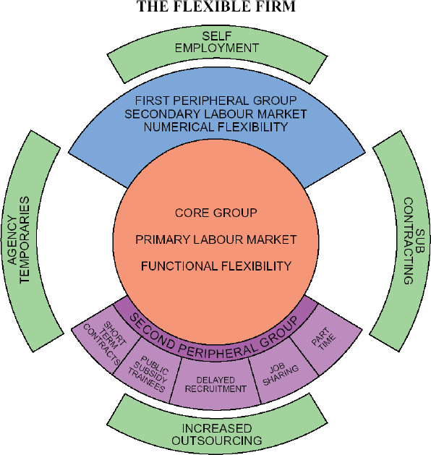
Source: Adapted from Atkinson (1984)
According to Deloitte (2013), the characteristics of ‘open talent economy’ is “collaborative, transparent, technology-enabled, rapid-cycle way of doing business” with the global talent megatrends, such as globalization, technology, mobility, social business, education and analytics. Complex ecosystem is needed to manage for leaders in the open talent economy (Deloitte, 2013). Apart from the “balance sheet” employee, the organization could access talent via contracting, outsourcing, hiring freelancers or from partnership from online in the open talent economy (HR Talents, 2017).
Figure 2: Open talent economy continuum
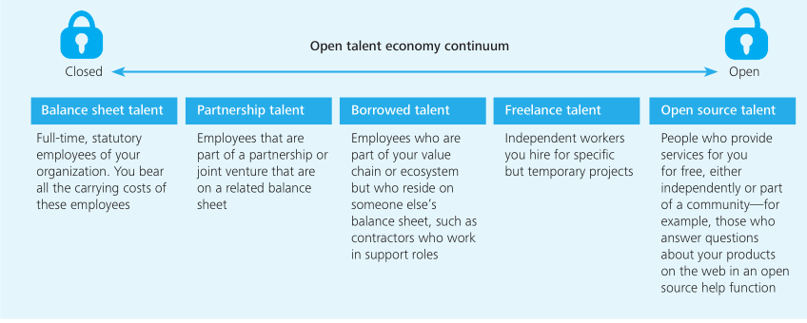
Source: Adapted from Deloitte (2013, P.6)
Pyszka and Gajda (2015) indicate the link of successful talent management with CSR, thus the talent attraction and engagement with CSR is a strategic imperative. Along with open talent economy, the organization need to adjust the HR strategy and attract and develop talent based on flexible HRM (Deloitte, 2013). Take FJJX University for an example, it is more effective and efficient to access some experts and specialists outside with no hiring and training cost; therefore the employees’ professional contribution could be beneficial for the high education in the open talent economy. Combined with Atkinson’s Model and open talent economy continuum, the core employee is balance sheet employee who are full-time staffs. There are some cooperated enterprises with the university, therefore, there are some partnership talents who are attracted to be the lecturer with rich practical experience. Meanwhile, there are some freelance talent (self-employed employee) are attracted to the university as these talents are rich in specific professional knowledge as well. Partnership talent, borrowed talent, freelance talent and open source talent are peripheral group people if referred to Atkinson’s Model. Based with the knowledge-based view (Curado & Bontis, 2006), it is important for the university to acquire the new skills for both now and in the future. As for functional flexibility, learning investment and outcome-based learning development are important in higher education (Person, 2019). However, the university need hire some more temporary staffs whose qualification is not high. In relation with CSR, the university need value the low-skilled employee and zero-hour contract employees as well.

References
Ahmad, H. (2015) A critical examination of the advantages and disadvantages of adopting flexible working practices in relation to the employer and employee. Available at: https://www.researchgate.net/publication/304038081 (Accessed: 18 October 2020).
Arjan, K. & Stephan, K. (2012) A sustainability perspective on flexible HRM: How to cope with paradoxes of contingent work. Management revenue, 23(3), pp. 239-261.
Atkinson, J. (1984) Manpower strategies for flexible organisations. Personnel
management, 16(8), pp.28-31.
Bidwell, M. (2009) Do peripheral workers do peripheral work?: Comparing the use of highly skilled contractors and regular employees. Industrial and Labor Relations Review, 62(2), pp. 200-225.
Cartwright, S. (ed.) (2008) The Oxford handbook of personnel psychology. United Kingdom: Oxford University Press.
CIPD. (2013) Zero-hours contracts: myth and reality. Available at: www.cipd.co.uk/knowledge/fundamentals/emp-law/terms-conditions/zero hours-reality-report (Accessed: 18 October 2020).
CIPD. (2018) Megatrends: More selfies? Self-employment in the UK. Available at: https://www.cipd.co.uk/knowledge/work/trends/megatrends/self-employment (Accessed: 18 October 2020).
CIPD. (2019) Atypical working: a guide to successfully implementing atypical
work in your organization. Available at: https://www.cipd.co.uk/Images/7904-atypical-working-guide-web_tcm18-61555.pdf (Accessed: 18 October 2020).
CIPD. (2020) Flexible working. Available at: https://www.cipd.co.uk/knowledge/fundamentals/relations/flexibleworking/factsheet (Accessed: 18 October 2020).
Curado, C. and Bontis, N. (2006) The knowledge-based view of the firm and its theoretical precursor. International journal of learning and intellectual capital, 3(4). pp. 367-381.
Deloitte. (2013) The open talent economy: People and work in a borderless workplace. Available at: https://www2.deloitte.com/content/dam/Deloitte/global/Documents/HumanCapital/dttl-hc-english-opentalenteconomy.pdf (Accessed: 17 October 2020).
Ehnert, I. (2009) Sustainable human resource management: A conceptual and exploratory analysis from a paradox perspective. Heidelberg: Physica-Verlag.
HR Talents. (2017) Connect with Content - Welcome to the open talent economy. Available at: https://www.hrbuilders.eu/en/blog/welcome-to-the-open-talent-economy (Accessed: 18 October 2020).
Marler, J. H., Barringer, M. W., & Milkovich, G. T. (2002) Boundaryless and traditional contingent employees: Worlds apart. Journal of organizational Behavior, 23(4), pp. 425-453.
Pearson. (2019) Opportunities for higher education in the era of the talent economy. Available at: https://www.pearson.com/content/dam/one-dot-com/one-dot-om/global/Files/news/gls/Opportunity_for_HE_Sept2019.pdf (Accessed: 18 October 2020).
Price, A. (2007) Human resource management in a business context. 3rd edn. London: Cengage Learning Business Press.
Procter, S.J., Forrester, P., Rowlinson, M., McArdle, L. and Hassard, J. (1994) Flexibility, politics & strategy: In defence of the model of the flexible firm. Work, employment & society, 8(2), pp. 221-242.
Pyszka, A. & Gajda, D. (2015) Successful talent management through positive CSR-driven transactions. Journal of positive management, 6(2), pp. 3-19.
Van der Meer, P. H., & Ringdal, K. (2009) Flexibility practices, wages and productivity: Evidence from Norway. Personnel Review, 38(5), pp. 526-543.

7. Organisational resilience model and application

“Organizational resilience is the ability of an organisation to anticipate, prepare for, respond and adapt to incremental change and sudden disruptions in order to survive and proper” (BSI, 2019, p5). The measure of organizational resilience is developed by Kantur and Say (2015) from three dimensions, which is robustness, agility and integrity. Organizational resilience is a dynamic, potential capabilities that organizations develop by coping with the unexpected changes (Ortiz-de-Mandojana and Bansal, 2016).
As organizational resilience is embedded with individual knowledge, skills and abilities level, strategic human resource systems is the appropriate instrumental to generate resilience outcomes as a collective process by developing the requisite attributes such as knowledge, skills and abilities (Lenganick-Hall et al., 2011). Strategic human resource management depends on the strategic purpose integrated with the strategic practices and it is imperative in the attainment of an institution's competitive edge (Sareen, 2018; Allui and Sahni, 2016). The SHRM influence the organizational resilience from cognitive, behavioral and contextual aspect by focusing on human resource practices, human resource analytics and high-performance work practices, which are three aspects of strategic HRM (AL-Ayed, 2019).
Many scholars have indicated that HRM process may impact organisational resilience. Cook et al. (2019) argue it is important for human resource managers to use high-performance work practices to develop the employee resilience so that the employee engagement could be further enhanced. Hence, the understanding of the “black box” (Purcell, 2003) of HRM is expanded here.
“Work engagement is a positive, fulfilling, affective-motivational state of work related well-being that can be seen as the antipode of job burnout” (Leiter and Bakker, 2010, p.1). Bardoel et al. (2014) note employee resilience may be strengthened by a coherent set of human resource practices such as employee development programmmes, reward and benefits system and flexible work arrangements. Based on organizational structures, training and education, and leadership models. Madrigano et al. (2017) build a resilience-oriented workforce for the future as a resilient workforce which is capable to respond competently and positively for future prosperity and survival (Wang et al., 2014). Blanco (2018) confirms organizational resilience is improved by training. Training, especially innovative training is a critical and important element to improve organizational and individual resilience (Flandin, et al., 2018; Siddiqui, 2017). Curado and Bontis (2016) indicate organisational learning plays a critical role in the sustainability of the competitive advantage as knowledge is a tremendous wealth to create potential. Talent management is an appropriate framework for universities to transform into strategic human resource management in high education context (Taylor, 2018; Bradley, 2016). Technology is applied in the human resource management in FJJX University, which facilitates the organisation to be resilient. For example, online learning course is encouraged to for employee personal development and e-recruiting is carried on as well. With the trend of technology, digital learning resources are more flexible than traditional classroom training as for the timing and content. The learning outcomes could be optimized by programs adjustment (McKinsey Global Institute, 2017). From the cost perspective, online learning is more advantageous and convenient than traditional learning. Especially, faced with COVID-19 now, employees in the university benefits a lot from technology by online learning. As for the dada application, it is assumed that there are 30 employees in my department. The vender charges 3,000 dollars per person for the online course. Therefore, the cost would be 90,000 dollars. The tuition fee is 8,000 dollars per student and there are 500 students in my department. If the enrollment rate is improved 5% due the university reputation improved by the talent development via the online courses applied, the income will be increase 400,000 dolloars. 400,000 is bigger than 90,000, thus the online learning courses plan is feasible due to the potential benefit based on the cost-benefit analysis. The recommendations could be that a good strategic human resource management need to be more completed based on the labor market and future work. In addition, it is important to recruit, develop and retain talents with continuously changing environment. More development opportunities could be provided for the employee to make the organisation resilient. In higher education, there is difference between “academic talent” and “teaching talent”, thus, appraisal criteria could be adjusted when conducting performance management. Feedback loop is important to help the employee make improvement and more engaged in the organization.
To sum up, human resource management has a close relationship with organizational resilience. The organisation could be more resilient and competitive via Strategic HRM, performance management, employee engagement, talent management and organasional learning.

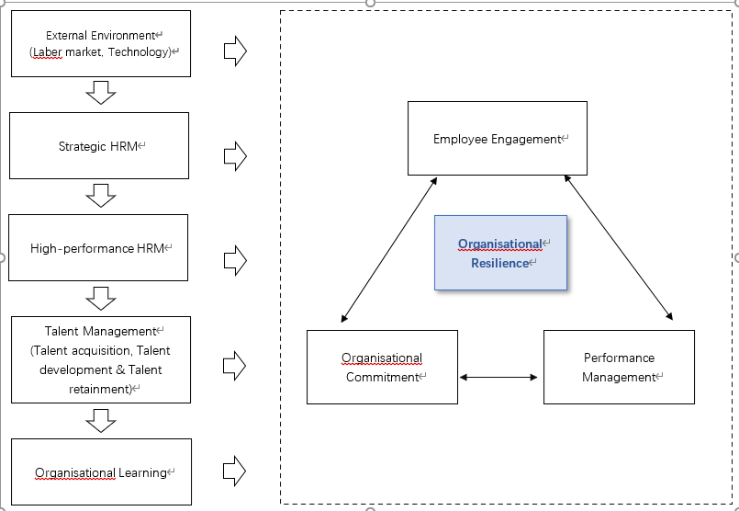
Figure 1: The model of organizational resilience

References
Al-Ayed, S. I. (2019) The impact of strategic human resource on organizational resilience: An empirical study on hospitals. Verslas: teorija ir praktika, 20(1), pp. 179-186.
Allui, A., Sahni, J. (2016) Strategic human resource management in higher education institutions: empirical evidence from Saudi. Procedia-Social behavior sciences. 235(24), pp. 361-371.
Bardoel, E. A., Pettit, T. M., De Cieri, H., and McMillan, L. (2014) Employee resilience: An emerging challenge for HRM. Asia Pacific Journal of Human Resources, 52, pp. 279–297.
Blanco, J. (2018) Organizational resilience. How learning sustains organizations in crisis, disaster, and breakdown by D Chris-topher Kayes Juan Manuel Menéndez Blanco. The learning organization, 25(2), pp.143-146.
BSI. (2019) Organizational Resilience Index: Third annual report. Available at: https://www.bsigroup.com/globalassets/localfiles/en-gb/organizational-resilience/OR-Index-2019-web-final.pdf?utm_campaign=OR-IndexReport-2019 (Accessed: 22 September 2020).
Cooke, F.L., Cooper, B., Bartram, T., Wang, J. and Mei, H. (2019) Mapping the relationship between high-performance work systems, employee resilience and engagement. The international journal of Human Resource Management, 30(8), pp. 1239-1260.
Curado, C. and Bontis, N. (2006) The knowledge-based view of the firm and its theoretical precursor. International journal of learning and intellectual capital, 3(4). pp. 367-381.
Kantur, D. and Say, A. (2015) Measuring organizational resilience: A scale development. Journal of Business Economics and Finance, 4 (3), pp. 456-472.
Flandin, S. Poizat, G. and Durand, M. (2018) Improving resilience in high-risk organizations: principles for the design of innovative training situations. Development and Learning in Organizations, 32 (2), pp. 9-12.
McKinsey Global Institute. (2017) Jobs lost, jobs gained: workforce transitions in a time of automation, Available at https://www.mckinsey.com/featured-insights/future-of-work/jobs-lost-jobs-gained-what-the-future-of-work-will-mean-for-jobs-skills-and-wages (Accessed: 7 September 2020).
Leiter, M. P., and Bakker, A. B. (2010) Work Engagement; Introduction. In A. B. Bakker & M. P. Leiter (Eds.), Work engagement: A handbook of essential theory and research (pp. 1–9). New York, NY: Psychology Press.
Lenganick-Hall, C.A., Beck, T. E. and Lenganick-Hall, M. L. (2011) Developing a capacity for organizational resilience through strategic human resource management. Human resource management review, 21, pp. 243-255.
Madrigano, J., Chandra, A. Cotigan, T. Acosta, J. D. (2017) Beyond disaster preparedness: building a resilience-oriented workforce for the future. International journal of environmental research and public health. 14, 1563.
Ortiz-de-Mandojana, N. and Bansal P. (2016) The long-term benefits of organizational resilience through sustainable business practices. Strategic Management Journal, 37, pp. 1615-1631.
Purcell, J. (2003) Understanding the people and performance link: Unlocking the black box. CIPD Publishing.
Sareen, D. (2018) Relationship between strategic human resource management and job satisfaction. International Journal of Current Research in Life Sciences, 7(3), pp. 1229-1233.
Siddiqui, S. (2017) Can employee training and development increase organizational resilience against economic crises? International Journal of Managerial Studies and Research, 5(4), pp. 78-82.
Taylor, S. (2018) Resourcing and talent management. 7th edn. Kogan Page
Publishers.
Wang, J., Cooke, F. L., and Huang, W. (2014) How resilient is the (future) workforce in China? A study of the banking sector and implications for human resource development Asia Pacific Journal of Human Resources, 52, pp. 132–154.

