
Finance For Business Managers (BMMB7005)
REPORT 1. VODAFONE FINANCIAL ANALYSIS
STUDENT NAME:Yue Zhang
NUMBER:1904670


Podcast link: https://www.youtube.com/watch?v=BbtU1Eh7rKQ
Contents
Executive Summary 1
1. Background 1
2. Limitations 1
3. Ratio Analysis 2
3.1 Profitability 2
3.2 Solvency.(Liquidity Ratio) 6
3.3 Financial Structure 7
3.4 Potential Investor Return 8
4. Summary and Recommendations 9
References 10

Executive Summary
This paper paragraph puts into perspective the financial performance of the Vodafone Group PLC through ratio analysis. The ratios analyzed included profitability ratios, liquidity ratios, gearing ratios, and investor ratios. The analysis will be based on two financial period ending 2018 and 2019. And compare these ratios with competitors China Mobile to better analyze the development of Vodafone Group. Based on the findings, recommendations have been given for the best way forward to keep the company financiallly sound into the future.

1. Background
Vodafone is one of the globe’s largest telecommunication company. It started operations in 1985 with just 50 employees but now boast of close to 100,000 personnel tasked with various operations at the giant telecommunication company. The company provides an array of telecommunication services globally which include voice and data communication. It has presence in Europe, United States, Africa, and Asia .
The company’s global network has been sustained by it subsidiaries in oversees operations. Its model is joint ventures with local companies in the local market. such a move makes it easy to penetrate the global market and improve on its market base. For instance, it operates as Vodafone Essar while in Japan it has also T-Mobile MVNO (Kiran, 2019, p.84). The key pillars that keeps the company relevant and with an edge in the competitive technology market include its investment in quality services, innovation, and partnership with local companies (Kiran, 2019, p.84). Through its operation with local companies, it is able to come up with specific products that meet the local market needs. Today, the company has its primary listing on London Stock Exchange and makes the list of FTSE 100 index. The company also has a secondary listing in NASDAQ. The market capitalization for the company is estimated at £52.5 billion which makes it the 8th largest company listed on the London Stock Exchange.

Limitations
The data in this report are all from the annual reports of Vodafone Group PLC and China Mobile in 2019 and 2018. The data unit in Vodafone ’s annual report is Euro, and the data unit in China Mobile ’s annual report is RMB. The exchange rate between RMB and the Euro has changed little over the past two years. Therefore, for convenience of comparison, I converted the data unit of China Mobile to Euro according to the current exchange rate.

Ratio Analysis

3.1 Profitability
①Return on Investment (ROI)
Net Profit after Tax/Shareholders Funds
 | 2019 | 2018
Vodafone(€m ) | -7644/63445=-12% | 2788/68607=4%
China Mobile(€m) | 13923.6691/144371.0198=9.6% | 15378.7369/137658.9328=11.1%
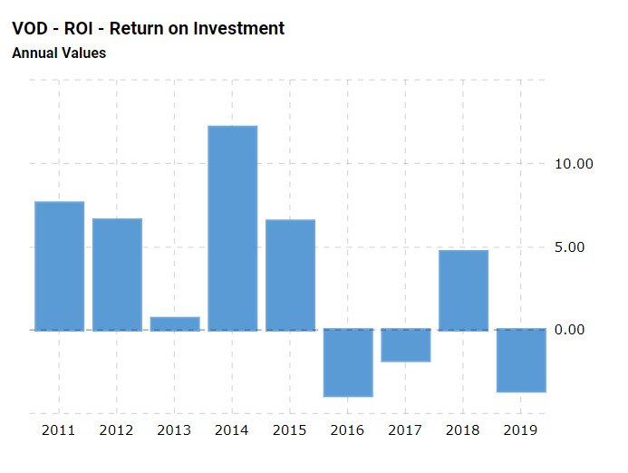
The return on investment of Vodafone Group PLC in 2019 and 2018 is -12% and 4% respectively, it can be seen that 2019 is the year of Vodafone investment failure, and the after-tax profit of the company in this year was € -7644m. Mainly due to the sale of Vodafone India business (after the completion of the merger with Idea Cellular) and asset impairments announced in November last year. Vodafone India, has posted record second quarter losses of £5.4bn(BBC, 2019).
In addition, the fierce international market competition is also the reason for Vodafone's sharp decline in performance. China Mobile's return on investment in 2019 and 2018 are 9.6% and 11.1% respectively. Compared with Vodafone, China Mobile has developed steadily and maintained strong international industry competitiveness. 2019 has entered the era of 5G systems. In the United States, companies such as AT & T and T-Mobile US launched 5G services in dozens of cities in 2019. In China, companies such as China unicom and China mobile also had started using 5G systems in a number of cities, including Beijing and Shanghai, in 2019.
Vodafone has fallen behind international competitors. Therefore, Vodafone has no choice but to buy a 5G system. Although expensive and unpredictable, he must pay for these waves. In the past year, the company spent a total of 4 billion euros in Germany and Italy, and €198 m and €378 m in Spain and the United Kingdom, respectively (Verdict,2019). Although the development of 5G has brought financial pressure to Vodafone, its long-term growth still requires investment, which will make it pay off in the next few years.

②Gross Profit margin (GPM)
Gross Profit/Sales
 | 2019 | 2018
Vodafone(€m ) | 13506/43666=30.9% | 13800/46571=29.6%
China Mobile(rmb) | 18531.6446/97254.4638=19% | 20065.2026/96068.2446=20.8%
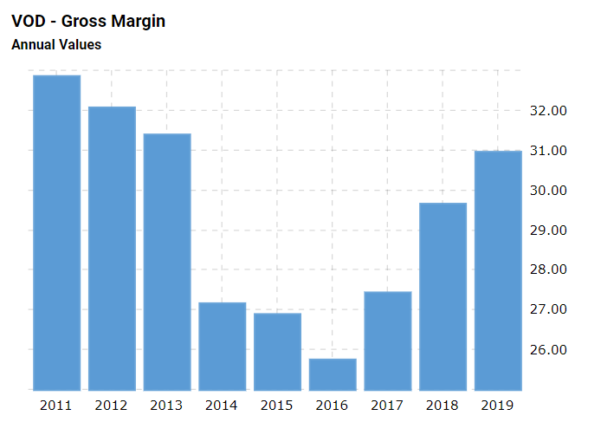
The gross profit margin (GPM) of Vodafone Group PLC in 2019 and 2018 is 30.9% and 29.6% respectively, which is nearly 10% higher than that of industry competitor China Mobile. However, it can be seen from the data that China Mobile's gross profit and total sales are much higher than Vodafone. From this, it can be seen that China Mobile is in rapid development, and its sales costs are also very high.
Although Vodafone's gross profit margin in 2019 increased by 1.3% compared with that in 2018, its gross profit and total sales declined. Gross profit is the difference between total sales and cost of sales, so the lower the cost of sales, the higher the gross profit margin. Since Vodafone's profitability has continued to decline in recent years, and even a large-scale loss occurred in 2019, the company has been working hard to reduce costs.
new chief executive Nick Read plans to axe around 1,700 jobs in service centres in Egypt, India and Romania in coming years（August,2018).In other parts of the world, Vodafone ’s operating costs have grown below local inflation, In addition, it is a medium term opportunity to improve distribution efficiency and reduce business costs through digital channel sales, companies are expected to continue to expand EBITDA. Vodafone expects to reduce European net operating expenses by at least 1.2 billion euros by fiscal year 2021 (Vodafone, 2019).

③Operating Profit Margin(OPM)
PBIT/Sales
 | 2019 | 2018
Vodafone(€m ) | -951/43666=-2.2% | 4299/46571=9.2%
China Mobile(€m) | 14752.6405/97254.4638=15% | 15826.7309/96068.2446=16%

Vodafone Group Plc Consolidated income statement 2019
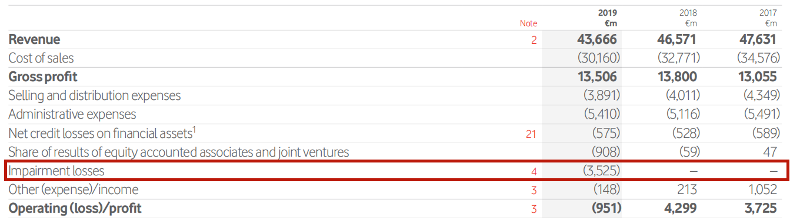
Vodafone Group PLC's operating profit margins (OPM) in 2019 and 2018 were -2.2% and 9.2% respectively, a decrease of 11.4%. Vodafone's gross profit margin has not changed much in the past three years, but operating profit in 2019 has dropped significantly, with a loss of €951m, which has a serious adverse effect on Vodafone because it will affect its credit rating (Ranjit, 2019).
According to Vodafone's financial statements, the main reason for operating profit losses is that it generated €3.525b of impairment losses in 2019, and there was no such item in the previous two years. the Group recorded impairment charges of €2.9 billion, €0.3 billion, and €0.3 billion in respect of the Group’s investments in Spain, Romania and Vodafone Idea respectively. The impairment charges with respect to Spain and Romania relate solely to goodwill and the impairment charge with respect to Vodafone Idea relates to the joint venture`s carrying value.

④Return on Capital Employed (ROCE)
PBIT/Shareholders Funds and Long time Debt
 | 2019 | 2018
Vodafone(€m ) | -951/63445+53894=-0.8% | 4299/68607+37980=4%
China Mobile(€m) | 14752.6405/144371.0198+7714.6514=9.7% | 15826.7309/137658.9328+734.6980=11.4%

ROCE considers long-term liabilities and measures how much profit is generated for every pound of capital invested, similar to ROI. The return on capital employed (ROCE) of Vodafone Group PLC in 2019 and 2018 was -0.8% and 4% respectively, a decrease of 4.8%. This is because the profit before tax and interest in 2019 was € -951 m, a decrease of €4890m from the previous year. Vodafone's Shareholders Funds has decreased, but the reduction is not large. However, the long-term liabilities in 2019 increased by €15914m from the previous year, which led to a 4.8% drop in ROCE. The reduction in ROCE means that the company's management business efficiency and profitability have decreased. The reason why Vodafone's profit before tax and interest, namely operating profit, has been greatly reduced has been analyzed in the previous paragraph and will not be repeated here.
As can be seen from the balance sheet, the main reason for Vodafone ’s long-term liabilities increased by €15914 million is that long-term borrowings increased by €15.7 billion, The commercial paper facilities were supported by €3.7 billion and €3.9 billion of syndicated committed bank facilities In addition, Vodafone Group Plc's Indian venture, reeling under $ 14 billion of net debt, mounting losses and dwindling subscribers (Sanjai, Antony, 2019).
A major concern is that the company ’s operations may not be able to maintain such a debt level because it has been reporting that the user base has been shrinking. In comparison, China Mobile ’s two-year ROCE is about 10% higher than Vodafone. China Mobile ’s BPIT is 15 times that of Vodadone, and China Mobile ’s Shareholders Funds is 2 times that of Vodadone, but China Mobile ’s long-term debt is far lower than Vodafone.

3.2 Solvency.(Liquidity Ratio)
⑤ Working Capital Ratios (Current Ratio)
Current Assets/Current Liabilities
 | 2019 | 2018
Vodafone(€m ) | 39817/25523=156% | 24131/28025=86%
China Mobile(€m) | 68134.6112/59416.4476=114.7% | 68809.7002/61000.9136=112.8%
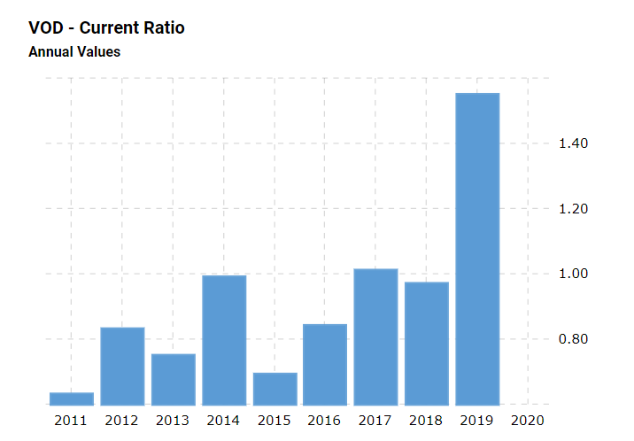
Working capital ratio is the "current ratio". It is the ratio of current assets to current liabilities. The ratio reflects the company ’s liquidity and whether the company has enough short-term assets to pay off its short-term debt (Maverick, 2019). If the ratio is lower than 1: 1, it may indicate that the company ’s solvency may have problems; If it is higher than 2: 1, it reflects that the enterprise lacks the effectiveness of working capital management.
Vodafone Group PLC's working capital ratio in 2019 and 2018 was 156% and 86%, an increase of 70%. The current working capital ratio illustrates the company ’s overall debt burden. In 2018, Vodafone `s working capital ratio was less than 100%, indicating that its solvency is insufficient and it is very likely that it will fail to repay its debts at maturity, resulting in credit damage. In 2019, Vodafone's working capital ratio has greatly increased, this is because the company's current assets all have increased from the previous year, the largest increase is Cash and cash equivalents, an increase of €8963 million from the previous year, Vodafone Need to manage idle cash more effectively to create profits for the company.
In addition, Vodafone ’s current liabilities have decreased by €25 million compared to the previous year. This is due to Vodafone ’s new CEO Nick Read said that he planed sell thousands of mobile masts to To reduce the company's debt, the telecommunications company has 110,000 towers in Europe-about 55,000 of which are directly controlled. Barclays Bank estimates that Vodafone ’s European tower may be worth €12 billion (The Irish Times, 2018). China Mobile ’s working capital ratio has remained at around 113% for the past two years, and the company ’s management of capital operations is very effective and stable.

3.3 Financial Structure
⑥Gearing Ratio
(LT Debt/Shareholders Funds + LT Debt)
 | 2019 | 2018
Vodafone(€m ) | 53894/53894+63445=46% | 37980/37980+68607=35.6%
China Mobile(€m) | 7714.6514/7714.6514+144371.0198=5% | 734.6980/734.6980+137658.9328=0.5%

Gearing refers to the means by which enterprises leverage their debt to adjust the return on equity and capital.Gearing ratios refers to the ratio of a company's debt financing. The gearing ratios of Vodafone Group PLC in 2019 and 2018 are 46% and 35.6%. A gearing ratio between 25% and 50% is typically considered optimal or normal for well-established companies(Claire, 2019). Therefore, a reasonable balance has been reached between Vodafone's long-term liabilities and Shareholders Funds in the past two years. The right investments can help companies expand their operations, add new products and services, and ultimately increase profits through debt. The gearing ratios of the company in 2019 increased by about 10% compared with the previous year, which was because the company's long-term debt increased by €15914 million compared with the previous year, and its total equity decreased by €5162 million compared with the previous year, indicating that the company relied more on borrowing and long-term financing, but less on equity financing. The increase in the company's long-term liabilities was mainly due to an increase in long-term borrowing of €15,777 million from the previous year. Long-term borrowings include bonds, Bank loans and Other long-term borrowings. Includes €1,919 million of spectrum licence payables following the completion of auctions in Italy and Spain.I also talked about this issue when analyzing the ROCE above, Vodafone Group Plc`s Indian venture, reeling under $14 billion of net debt.
In contrast, China Mobile ’s gearing ratio is very low in the past two years. As can be seen from the balance sheet, China Mobile ’s long-term liabilities include only lease liabilities, deferred income and deferred tax liabilities, and no bank loans and Loans such as bonds, this is because China Mobile is a state-owned enterprise, one of the three oligarchs in China ’s communications industry, with affluent total equity, and a strong technology in the past decade, which has developed well in the international market without too many debt.

3.4 Potential Investor Return
7 Dividend payout ratio
(Dividends Paid/Profit after tax)
years | Vodafone(€m )
2019 | (4624)/-7644
2018 | (4267)/2788
2017 | 4119/6079=67.7%
2016 | 4565/5122=89%
2015 | 4038/7477=54%

years | China Mobile(€m)
2019 | 3625.7341/13923.6691=26.4%
2018 | 4225.2670/15378.7369=27.8%

The dividend payout rate reflects the extent to which listed companies are willing to return shareholders with cash, and can help potential investors make informed decisions by gaining insight into the company's return rate and future business investment returns.
As can be seen from Vodafone's Consolidated statement of changes in equity, the 2019 dividends should be € 4624m, but because the company is in a loss state in 2019, the year-end profit is € -7644m, so it cannot pay dividends normally. The company ’s dividends in 2018 should be € 4267m, but the company ’s profitability is not good, and the year-end profit is € 2788m, which is lower than the dividends, so it can not pay dividends normally. Therefore, it is meaningless to calculate the dividend payout ratio for these two years. Vodafone chief executive Nick Read is using the money saved from dividend payments to build its 5G networks and complete its acquisition of Liberty Global (LBTYA.O) assets (Michelle 2019). From 2015 to 2017, Vodafone operates well and has good profits Ability, dividend payout rate is also very generous, it was once the UK's largest dividend payout company.
Although China Mobile's dividend payout rate is not particularly high, the stable annual dividend payout rate is very attractive to investors.

Summary and Recommendations
The company needs to focus more on increasing its revenue base while cutting down its costs as much as possible. Halting operations in India was a good move because the subsidiary was not profitable. As such, the company has sealed a potential cost elements which were adversely affecting its profitability. Going into the future, the company should consider selling off its non performing subsidiaries to allow it to free up more capital that can be invested in improving infrastructure and capacity of the company. Such a strategy will go a long way to increase the revenue base of the company while cutting down on the cost of operations.
As Vodafone grows its base, it cannot solely rely on equity finance, it needs additional injection from debt in its capital structure to sustain its growth prospects. In 2019, the company invested in 5G network rollout in the Europe market which explains the need for increased capital base to finance the project. The company is also heavily investing in automation of its operations and artificial intelligence as part of improving of reducing its costs of operations in the long run. To implement its robust growth plan, the company should seriously consider diversifying its capital structure by increasing both its equity and debt capital. Judging by the debt ratio which stands at 0.83. The company therefore has some leeway to seek debt finance to increase its expansion and other strategic ventures in the market. The company is keep to automate operations to cut costs. As such, they can exploit the debt capital.
With regards to enhancing efficiency, the company should get more value from its employees by automating operations and investing in learning development. The company should invest in automation of operations which will see it reduce number of employees by close to 30%. Besides, the company should invest in learning and development from its employees to equip them with the right skill set that will make them more valuable to the company.

References
August,G.(2018) Vodafone dips into the red as it cuts costs to reduce rising debt. Available at: https://www.cityam.com/vodafone-dips-into-red-cuts-costs-reduce-rising-debt/ (Accessed:12 May 2020)
BBC (2019) How did Vodafone lose $7bn in India in just one quarter? Available at: https://www.bbc.co.uk/news/world-asia-india-50429844 (Accessed:12 May 2020)
Claire, B,W. (2019) What Is a Good or Bad Gearing Ratio? Available at: https://www.investopedia.com/ask/answers/121814/what-good-gearing-ratio.asp (Accessed:21 May 2020)
Kiran, K., 2019. A Comparative Analysis of Financial Performance of Selected Telecom Companies Using Z Score Model. International Journal of Research in Social Sciences, 9(7), pp.631-637.
Michelle, M.(2019) Vodafone dividend cut: which stocks could be next? Available at: https://citywire.co.uk/funds-insider/news/vodafone-dividend-cut-which-stocks-could-be-next/a1229020 (Accessed:22 May 2020)
Maverick, J,B (2019) The Working Capital Ratio and a Company's Capital Management. Available at:https://www.investopedia.com/ask/answers/041015/what-does-low-working-capital-ratio-show-about-companys-working-capital-management.asp (Accessed:20 May 2020)
Ranjit, S (2019) Balance sheet of Voda Idea hit by losses. Available at: https://economictimes.indiatimes.com/industry/telecom/telecom-news/balance-sheet-of-voda-idea-hit-by-losses/articleshow/72079778.cms?from=mdr (Accessed:19 May 2020)
Sanjai,P,R and Anto Antony(2019) Vodafone Idea seeks debt revamp as losses mount, users bolt. Available at: https://economictimes.indiatimes.com/industry/telecom/telecom-news/vodafone-idea-seeks-debt-revamp-as-losses-mount-users-bolt/articleshow/71817260.cms (Accessed:19 May 2020)
The Irish Times(2018) Vodafone considers selling masts to reduce debt. Available at: https://www.irishtimes.com/business/retail-and-services/vodafone-considers-selling-masts-to-reduce-debt-1.3631765 (Accessed:12 May 2020)
Verdict(2019)Vodafone reveals bleak annual performance, blaming increased competition.Available at: https://www.verdict.co.uk/vodafone-earnings-2019/ (Accessed:12 May 2020)
Vodafone.(2019) Vodafone Group Plc Annual Report 2019 .Available at: https://www.vodafone.com/investors/investor-information/annual-report/downloads/Vodafone-full-annual-report-2019.pdf (Accessed:12 May 2020)

Finance For Business Managers (BMMB7005)


REPORT 2: Jefferson Plc investment program analysis report

STUDENT NAME:Yue Zhang

NUMBER:1904670
Contents
1, Introduction 1
2, Investment Appraisal——NPV technique 1
3, Investment Appraisal——IRR technique 3
4, Advantages of net present value 4
5, Reasons for the popularity of non-discounting methods of investment appraisal. 5
6, Factors to consider in project investment 6
7, Capital Rationing 6
8, project financing 8
References 9

1, Introduction
Jefferson Plc is a company that produces garden furniture and related accessories. Now that the company intends to expand its business scope, the company's directors have studied three project investment options.
Plan A is to open a new retail store with an initial investment of £ 750,000; Plan B is to open an online store for online sales with an initial investment of £ 1,200,000; Plan C is to produce greenhouses and conservatories with an initial investment of £ 2,000,000. And corporate tax is 20% and capital allowance is 25%. The directors estimated that in four years, the cash inflows of the three investment options are as follows:
 | Year 1 | Year 2 | Year 3 | Year 4
 | £’000 | £’000 | £’000 | £’000
(A) | 400 | 500 | 500 | 500
(B) | 500 | 600 | 800 | 1,000
(C) | 500 | 1,000 | 1,500 | 1,500

In this report, I use the net present value (NPV) technique and internal rate of return (IRR) technique to analyze the three options to find an optimal investment option. In the case of limited funds, I will split the project, make a reasonable capital ratio, select the optimal project portfolio, and maximize the profit for the company. In addition, analyzing the advantages of discounted investment evaluation and non-discounted investment evaluation, and introducing the factors that need to be considered for investment. Finally, I would make project financing suggestions for the company.

2, Investment Appraisal——NPV technique
Corporation Tax rate is 20% payable in the same year as the relevant cashflows.
capital allowances are 25% on a straight line basis.
the cost of capital to be 8%.

①Plan A
Workings:
 | Year 1 | Year 2 | Year 3 | Year 4
 | £’000 | £’000 | £’000 | £’000
(A)cash inflows | 400 | 500 | 500 | 500
(A)initial expenditure | 750

Capital allowances (CA) = Initial expenditure / 4 years = 750/4 = £187.5 per year.(£’000)
Corporation Tax (CT) = (Income - CA) x 20%
Time(years) | Calculation CT (£’000)
1 | (400-187.5) x 20%=42.5
2 | (500-187.5)x20%=62.5
3 | (500-187.5)x20%=62.5
4 | (500-187.5)x20%=62.5

time | Income-CT | Cashflow | Discount factor@8% | Present value(PV)
 | £’000 | £’000 |  | £’000
0 | -750 | -750 |  | -750
1 | 400-42.5= | 357.5 | 0.926 | 331.045
2 | 500-62.5= | 437.5 | 0.857 | 374.9375
3 | 500-62.5= | 437.5 | 0.794 | 347.375
4 | 500-62.5= | 437.5 | 0.735 | 321.5625
NPV=-750+331.045+374.9375+347.375+321.5625=624.92

②Plan B (£’000)
Workings:
 | Year 1 | Year 2 | Year 3 | Year 4
 | £’000 | £’000 | £’000 | £’000
(B)cash inflows | 500 | 600 | 800 | 1000
(B)initial expenditure | 1200

Capital allowances (CA) = Initial expenditure / 4 years = 1200/4 = £300 per year.(£’000)
Corporation Tax (CT) = (Income - CA) x 20%
Time(years) | Calculation CT (£’000)
1 | (500-300) x 20%=40
2 | (600-300)x20%=60
3 | (800-300)x20%=100
4 | (1000-300)x20%=140

time | Income-CT | Cashflow | Discount factor@8% | Present value(PV)
 | £’000 | £’000 |  | £’000
0 | -1200 | -1200 |  | -1200
1 | 500-40= | 460 | 0.926 | 425.96
2 | 600-60= | 540 | 0.857 | 462.78
3 | 800-100= | 700 | 0.794 | 555.8
4 | 1000-140= | 860 | 0.735 | 632.1
NPV=-1200+425.96+462.78+555.8+632.1=876.64

③Plan C (£’000)
Workings:
 | Year 1 | Year 2 | Year 3 | Year 4
 | £’000 | £’000 | £’000 | £’000
(B)cash inflows | 500 | 1000 | 1500 | 1500
(B)initial expenditure | 2000

Capital allowances (CA) = Initial expenditure / 4 years = 2000/4 = £500 per year.(£’000)
Corporation Tax (CT) = (Income - CA) x 20%
Time(years) | Calculation CT (£’000)
1 | (500-500) x 20%=0
2 | (1000-500)x20%=100
3 | (1500-500)x20%=200
4 | (1500-500)x20%=200

time | Income-CT | Cashflow | Discount factor@8% | Present value(PV)
 | £’000 | £’000 |  | £’000
0 | -2000 | -2000 |  | -2000
1 | 500-0= | 500 | 0.926 | 463
2 | 1000-100= | 900 | 0.857 | 771.3
3 | 1500-200= | 1300 | 0.794 | 1032.2
4 | 1500-200= | 1300 | 0.735 | 955.5
NPV=-2000+463+771.3+1032.2+955.5=1222

By calculating the net present value (NPV) of the three investment schemes: the highest NPV of scheme C is 1222,000 pounds, followed by scheme B, its NPV is 876640 pounds, and the lowest NPV is scheme A, which is 624920 pounds. Without considering the initial investment amount, only the NPV technology is used to evaluate the investment, then Plan C is the best investment plan.

3, Investment Appraisal——IRR technique
In the above, Plan C is the best investment plan through NPV technology. Now I will use another evaluation technology-IRR technology to calculate and evaluate Plan C.

time | Income-CT | Cashflow | Discount factor@8% | Present value(PV)@8%
 | £’000 | £’000 |  | £’000
0 | -2000 | -2000 |  | -2000
1 | 500-0= | 500 | 0.926 | 463
2 | 1000-100= | 900 | 0.857 | 771.3
3 | 1500-200= | 1300 | 0.794 | 1032.2
4 | 1500-200= | 1300 | 0.735 | 955.5
Plan C NPV=-2000+463+771.3+1032.2+955.5=1222

time | Discount factor@30% | Present value(PV)@30% | Discount factor@29% | Present value(PV)@29%
 |  | £’000 |  | £’000
0 |  | -2000 |  | -2000
1 | 0.769 | 384.5 | 0.7752 | 387.6
2 | 0.5917 | 532.53 | 0.6009 | 540.81
3 | 0.4552 | 591.76 | 0.4658 | 605.54
4 | 0.3501 | 455.13 | 0.3611 | 469.43
 | Plan C NPV=-2000+384.5+532.53+591.76+455.13=-36.08 |  | Plan C NPV=-2000+387.6+540.81+605.54+469.43=3.38

IRR calculation:
IRR is between 8% and 30% (22% range).
Spread is 1222 + 36.08 = 1258.08(£’000)
For 22% increase in DF, NPV reduces by 1258.08(£’000)
Therefore a 1% change in DF, NPV changes by 1258.08 / 22 = 57.185(£’000)
To reduce NPV from 1222 to 0, increase the DF by 1222 / 57.185 = 21%
Therefore new DF is 8% + 21% = 29%
Therefore IRR is 29%

Through calculation, the internal rate of return (IRR) of Project C is 29%, which is much higher than its 8% cost of capital. According to the IRR rule, projects with IRR higher than the cost of capital should be accepted (Daniel 2019). And Project C is the largest investment among the three projects. It has both a high VPN and IRR, so it can be considered a worthwhile investment.

4, Advantages of net present value
NPV is the most reasonable business decision method for investing in productive assets. (Atrill, 2014, p.388). In fact, when we talk about economic value, we are referring to the value obtained by adding all the future cash flows from the relevant assets at a discount (present value).
NPV provides a better method of evaluating investment opportunities than ARR or PP, because it fully considers each of the following factors:
First, the time of cash flow. NPV discounts the various cash flows associated with each project to predict when they will appear, thereby taking into account the time value of money. Since the discount process includes the opportunity cost of capital, the net benefit after meeting the financing cost is determined as the NPV of the project.
Second, the entire relevant cash flow. NPV includes all relevant cash flows. Depending on the date they occur, they are treated differently, but they are all taken into account. In this way, they can all influence the decision.
Finally, the corporate goals. The net present value method is the only evaluation method in which the analysis result is directly related to the wealth of the business owner. A positive net asset value increases wealth; a negative value decreases it (Hawawini, Viallet. 2015.p.194).

5, Reasons for the popularity of non-discounting methods of investment appraisal.
To make the standards used in investment evaluation consistent with corporate goals, the time value of funds must be considered. However, despite the well-known advantages of discounted evaluation methods, companies continue to use non-discounted evaluation methods. This is because in some cases, it will be very applicable, and its most obvious advantage is that the calculation is simple and the logic is easy to understand. Therefore, despite its obvious shortcomings, it is still used by decision makers.
Traditionally, as a common investment evaluation standard, accounting rate of return(ARR) has the following advantages:
⑴It's easy to calculate.
⑵It is based on accounting information that is readily available and familiar to business people.
⑶It takes into account the benefits of the project's entire life cycle.
⑷Because it is based on accounting methods that can be easily obtained from the company's financial accounting system, it contributes to post-audit capital expenditure(Open Learning World 2011).

Payback period(PP) is a widely used investment standard, which has the following advantages.
⑴It is simple in concept and application.It does not use complex concepts and tedious calculations, and has few hidden assumptions.
⑵This is a rough and ready way of dealing with risk.It favours projects that generate large cash inflows early on and discriminates against those that generate large cash inflows in later years rather than earlier.Now, if risk is going to increase with future growth -- and this may be true in general -- payback standards may help weed out risky projects.Since it highlights earlier cash inflows, this may be a wise criterion when a company faces liquidity problems (Jim 2019).

6, Factors to consider in project investment
Before Jefferson Plc invests in a project, in addition to using the NPV and IRR technology to conduct a professional assessment of project returns and project risks as described above, there are many other factors that need to be considered.
The first is Jefferson Plc's ability to raise funds. All three ABC projects require a large amount of start-up capital, Therefore, the company has to come up with the money to invest in the project, and it must be on the premise that it does not affect the normal turnover of funds required for the production and operation of the enterprise(Sally 2017). If there is a shortage of funds in the enterprise and the financing capacity is weak, there is bound to be a great risk in investing in new projects. Investing in new projects requires companies to be able to raise the required funds in full, on time, and at low cost.
The second factor to consider is the market outlook and investment environment. The business environment is complex and changes rapidly, which requires financial managers to be familiar with the internal and external environment of the investment project and predict the development of the investment environment, that is, the project's market demand and price changes in investment decision analysis(Laura 2019). For example, the current status of similar products in the market, including brand, quality, price, and product added value.
The third is the company's investment management and operational control capabilities. This involves the company's human resources management, and starting a new project requires a team of business-savvy managers and experienced staff, including executives, technical staff, sales staff, and logistics personnel. Whether the project can run smoothly, human resources are also very important factors(Anna 2016).

7, Capital Rationing
The starting capital of Jefferson Plc is £ 2,500,000. I will use the NPV technology, Profitability index and Benefit-cost ratio to find the best investment method and asset ratio.

①Using NPV technology
years | 0 | 1 | 2 | 3 | 4 | NPV@8%
Project A (£’000) | -750 | 400 | 500 | 500 | 500 | 624.92
Project B (£’000) | -1200 | 500 | 600 | 800 | 1000 | 876.64
Project C (£’000) | -2000 | 500 | 1000 | 1500 | 1500 | 1222
Relying on NPV as an indicator would give a priority order of C,B,A. With only £ 2,500,000 capital available then result would be as follows:
NPV technology | Initial outlay | NPV(£’000)
All of project C(£’000) | 2000 | 1222
5/12 project B(£’000) | 500 | 365.267
 |  | Total VPN:£1587.267
Resulting NPV(£’000)for doing Project C and 5/12 of Project B is 1222+3365.267=£1587.267
②Using the Profitability Index and Benefit-cost ratio
Project | NPV@8%(£’000) | GPV@8%(£’000) | Profitability Index | Benefit-cost ratio
A | 624.92 | 1374.92 | 1374.92/750=1.83 | 624.92/750=0.83
B | 876.64 | 2076.64 | 2076.64/1200=1.73 | 876.64/1200=0.73
C | 1222 | 3222 | 3222/2000=1.611 | 1222/2000=0.611

Arrange projects in order of the highest profitability index and Benefit-cost ratio,would give a priority order of A,B,C. With only £ 2,500,000 capital available then result would be as follows:
Benefit-cost ratio | Initial outlay | NPV(£’000)
All of project A(£’000) | 750 | 624.92
All of project B(£’000) | 1200 | 876.64
0.275 project C(£’000) | 550 | 336.05
 |  | Total VPN:1837.61
Resulting NPV(£’000)for doing Project A, Project B and 0.275 project C is 624.92+876.64+336.05=£1837.61
As can be seen from the above, through the three calculation methods of NPV technology, Profitability index and Benefit-cost ratio, the project structure using the Profitability index and Benefit-cost ratio is the most profitable, at £ 1837.61.
Compared with the project matching method of NPV technology, the Profitability index and benefit-cost ratio creates an additional ￡250.343 for shareholders.

8, project financing
The Jefferson Plc plan requires £ 2,500,000 for project investment. There are three ways companies can finance.
①Bank loan financing. Borrowing from Banks is the most common financing channel for enterprises, but Banks have their own risk control principles, which are determined by the nature of the bank's business(Atrill, McLaney 2017). For enterprises, bank borrowing compared with other financing methods, the main shortcomings are: first, the conditions are high, more restrictive, complex procedures;Second, the loan term is relatively short, less long-term loans;Third, the loan amount is relatively small, through the bank to solve the development of enterprises need all the capital is relatively difficult(Bank track,2015).

②Equity financing stock listing
Issuing stocks is a kind of capital financing.(Caroline 2019).Specifically, the advantages of issuing stocks are: there is no maturity date for the funds raised, and there is no pressure to repay the capital; the amount of capital raised is large; the restrictions on the use of funds are relatively loose; It is helpful to help enterprises establish standardized modern enterprise systems. Is conducive to improve the visibility of the enterprise, bring good reputation for the enterprise.
However, the stock listing also has disadvantages: first, the requirements for listing are higher, and most companies are difficult to meet the listing conditions; second, the long-term listing time and fierce competition cannot meet the urgent financing needs of companies(James,2008); Third, companies have to bear higher information disclosure costs, and various information disclosure requirements may expose business secrets; Fourth, the company's listing and financing must take part in the transfer of equity as a price, decentralize control of the enterprise, and transfer higher profits. From this perspective, the cost of listing a company is relatively high.

③Finance lease
The financial leasing business has opened up a new financing channel for enterprises. It adopts a new form of combination of financing and equipment to increase the speed of introduction of production equipment and technology. It can also save capital and increase capital utilization(James,2008). Many projects with low investment risk, stable cash flow, and good return on investment are the most suitable for raising funds through leasing companies to carry out project financial leasing, that is, the repayment of the rent is based on the project ’s revenue or the percentage of cash flow to reach the total rent agreed by the two parties The lessor ’s rate of return.
In this way, the lessor actually assumes a certain degree of project risk, which is a win-win investment and financing model for lessees, lessors, equipment sellers and investors (banks, institutional investments, trust investments, etc.).

References
Atrill, McLaney & McLaney, E. J., 2017. Accounting and finance for non-specialists Tenth. pp.412. (Accessed:4 May 2020)
Atrill, P. & McLaney, E. (2014), Accounting and Finance for Non-Specialists, 9th Ed.: FT Prentice Hall. pp.388. (Accessed:25 April 2020)
Anna, V,H. (2016) 4 Important Factors To Consider Before Investing. Available at: https://thenewsavvy.com/invest/important-factors-to-consider-before-investing/ (Accessed:29 April 2020)
Bank track.(2015) What is project finance? Available at: https://www.banktrack.org/download/what_is_project_finance_/what_is_project_finance.pdf (Accessed:4 May 2020)
Caroline,B.(2019) Equity Financing. Available at: https://www.investopedia.com/terms/e/equityfinancing.asp (Accessed:4 May 2020)
Daniel, J. (2019) The Formula for Calculating Internal Rate of Return in Excel. Available at: https://www.investopedia.com/ask/answers/022615/what-formula-calculating-internal-rate-return-irr-excel.asp (Accessed:26 April 2020)
Hawawini, G. and Viallet, C. (2015) Finance for Executives: Managing for Value Creation, South-Western; 5th Edition. pp.194 (Accessed:25 April 2020)
Jim, W. (2019) Advantages & Disadvantages of Payback Capital Budgeting Method. Available at: https://smallbusiness.chron.com/advantages-disadvantages-payback-capital-budgeting-method-14206.html (Accessed:26 April 2020)
James, S.(2008) Accounting and Finance - Sources of Finance.[video] Available at: https://www.youtube.com/watch?v=5ll0mKg6-yI (Accessed:5 May 2020)
James, S.(2008) Accounting and Finance - Sources of Finance Exam Technique. [video] Available at: https://www.youtube.com/watch?v=-OLb47idpqg (Accessed:5 May 2020)
Laura (2019) 5 Factors to Consider Before You Invest in Crowdfunding. Available at:https://www.relativelyinteresting.com/5-factors-consider-invest-crowdfunding/?utm_source=org (Accessed:29 April 2020)
Open Learning World. (2011) Non-discounting Methods. Available at:http://www.openlearningworld.com/books/Investment%20Appraisal/Investment%20Appraisal%20-%20Methods%20And%20Considerations/Non-discounting%20Methods.html (Accessed:26 April 2020)
Sally (2017) Factors to consider before making an investment decision. Available at: http://www.laouriscyprus.com/factors-to-consider-before-making-an-investment-decision/ (Accessed:28 April 2020)

