

CertHE Computing Skills for Workplace


ACCA4025 - Learning in the Digital Era

Assignment 1: e-Portfolio

Nafeesa Khan Begum
—
2223214
—
Teacher: Martin Svejda

Table of Contents
e-Portfolio: 3
Task 1: 4
Task 2a: 5
Task 2b: 6
Task 3: 7
Task 4: 8

e-Portfolio:
https://sites.google.com/view/nafeesakhanbegum2223214/home
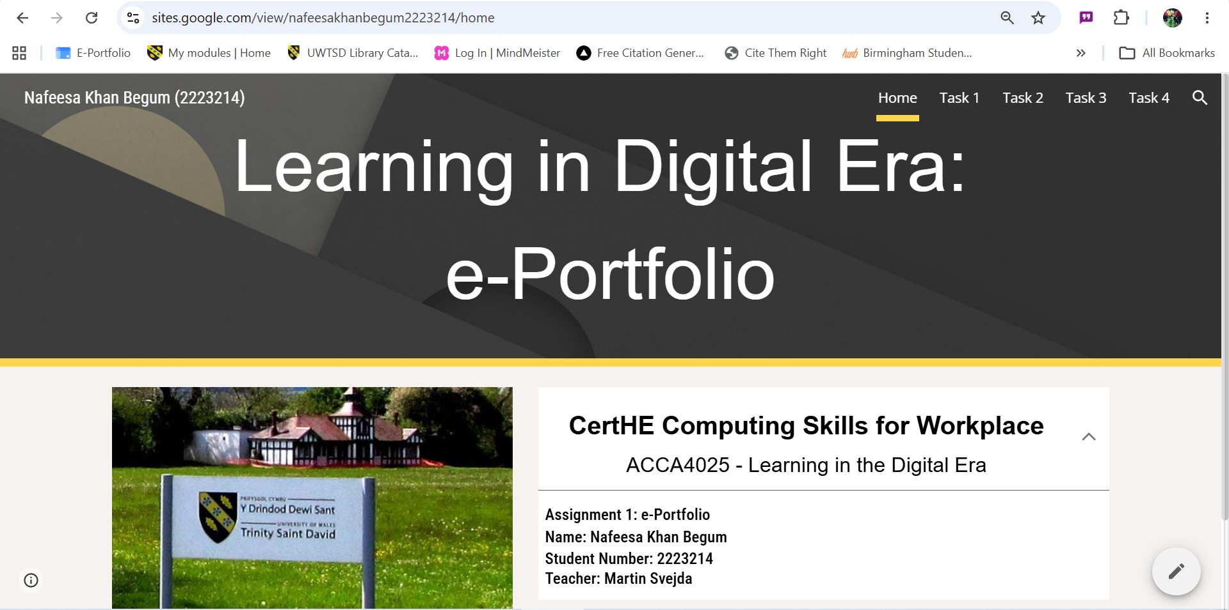

Task 1:
https://sites.google.com/view/nafeesakhanbegum2223214/task-1
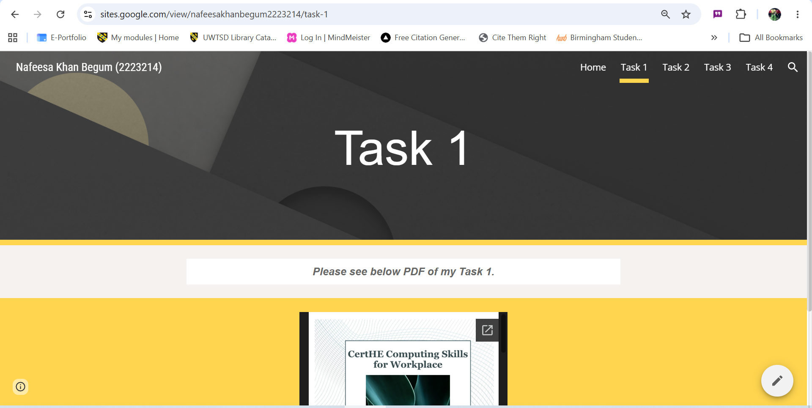

Task 2a:
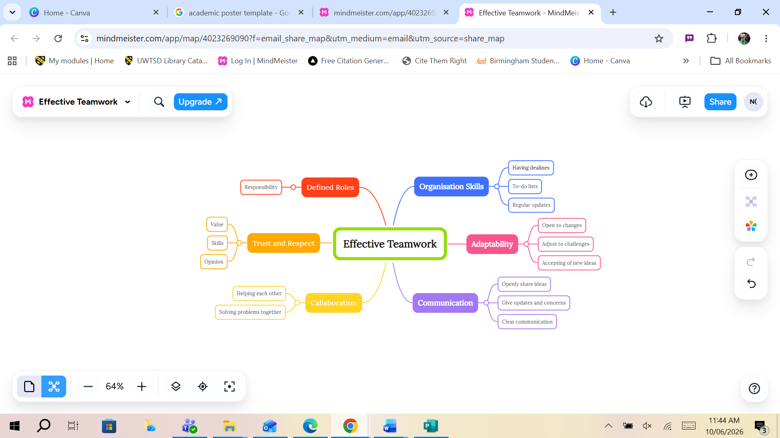
https://www.mindmeister.com/4023269090/effective-teamwork

Task 2b:
Task 2b (ACCA4025) NKB 2223214 - Image.jpg
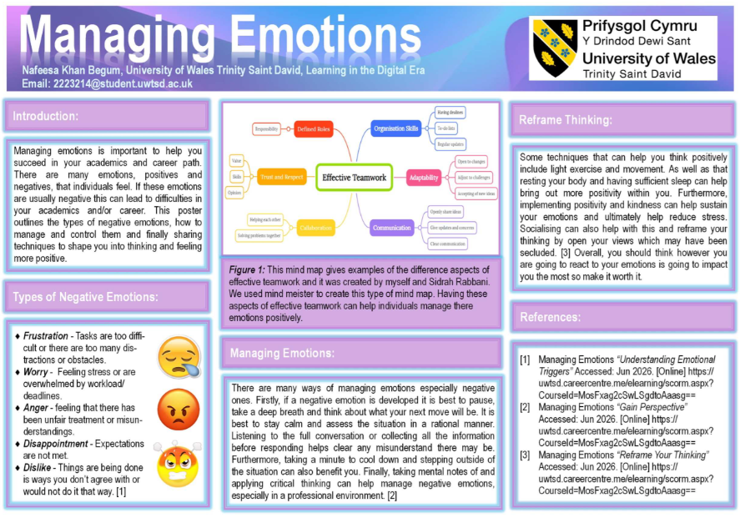

Task 3:
https://sites.google.com/view/nafeesakhanbegum2223214/task-3
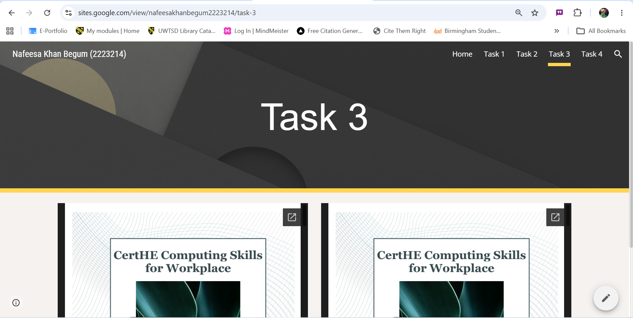

Task 4:
https://sites.google.com/view/nafeesakhanbegum2223214/home

https://sites.google.com/view/nafeesakhanbegum2223214/task-1

https://sites.google.com/view/nafeesakhanbegum2223214/task-2

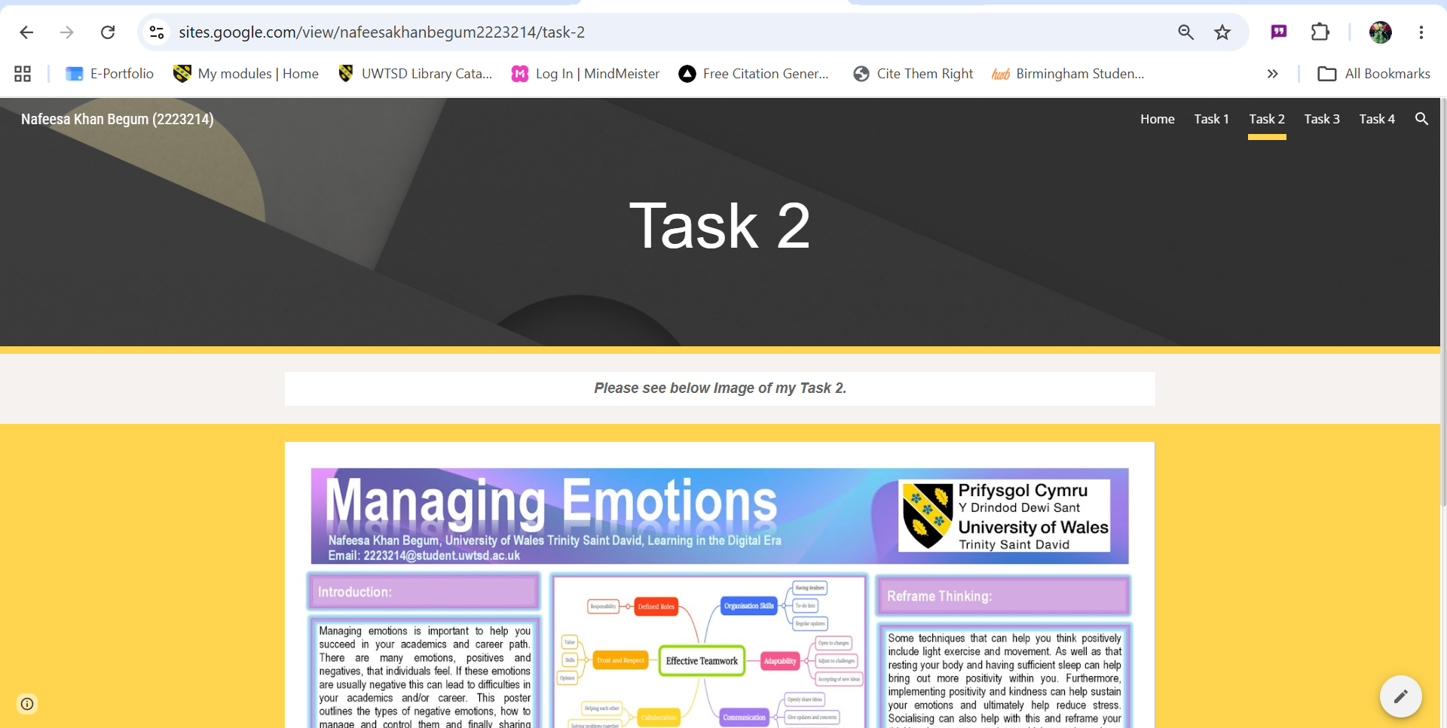

https://sites.google.com/view/nafeesakhanbegum2223214/task-3

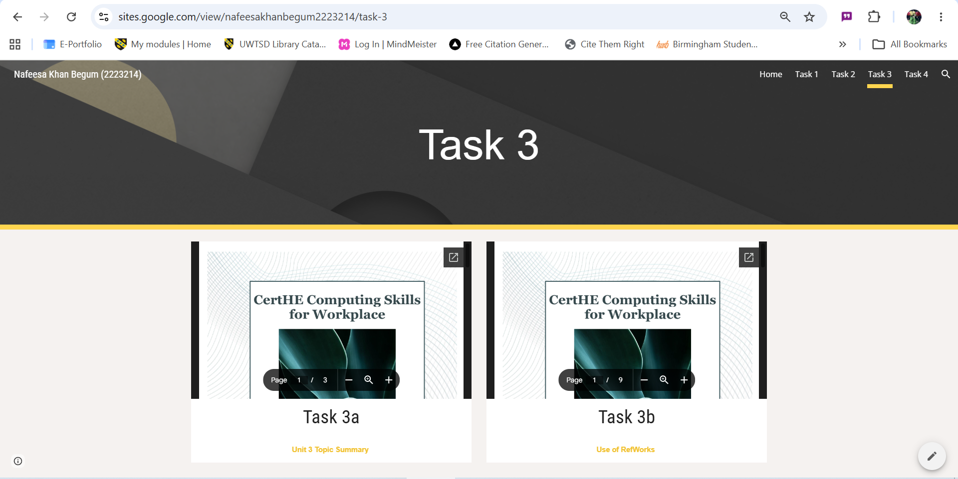

https://sites.google.com/view/nafeesakhanbegum2223214/task-4


