Physiotherapy Assistant Practitioner scientific intervention report
This report will demonstrate the science that was used from a physiotherapy assistant practitioner (PAP) through an intervention completed in the community physiotherapy team. Pseudo names used to protect the patient’s identity in accordance with the data protection act 2018 (Gov.uk, 2023)
Patient profile
Brenda Cruise
12 triangle road, Ceredigion
Date of Birth; 20/11/1951
Presenting condition
Mrs Cruise was admitted to hospital following a fall at home on 26th of February 2023 with a painful right hip. X-Ray, CT, and MRI was completed using the science of physiology. These images showed no fractures in right hip bone. Discharged home from hospital and diagnosed as bad bruising to the hip. Downstairs living due to pain and waiting for community physiotherapy.
past medical history
Hypertension
Osteoarthritis
Rheumatoid Arthritis
Depression
Drug history
Paracetamol
Oramorph
Lisinopril
Omeprazole
Sertraline
Loratadine

Social history
Mrs Cruise is a 72-year-old lady living in a house with her husband and 2 dogs, normally independent with all activities of daily living. Actively walks with her dogs. Retired shopkeeper.
Community physiotherapy assessment
Triaged and delegated to PAP in the community under Welsh government guidance (CVUHB,2011), who assessed mobility. Completed 3 metre timed up and go (CDC,2017) = 35 seconds. Elderly mobility scale (CSP,2012) = 17/20 and berg balance test (NIH,2023) = 45/56. Mrs Cruise was upset due to eviction notice. Hip strengthening exercises were practiced and issued. Mrs Cruise’s problem list was reduced mobility, High pain levels, Stairs, and financial worries, despite issues was motivated to engage with rehabilitation programme and taking pain relief at regular intervals. Therapeutic goals were to reduced pain, improve strength and balance, and walk using a stick. PAP used social science and enquired on financial support and made a telephone call advising to visit Ceredigion County Council website (2023) to access forms.
Clinical reasoning
Using the science of Anatomy and Physiology, a strength and balance programme was created to help recover from injury. The UK’s chief medical officer’s recommendation for twice-weekly strength and balance activity is important for older adults’ health including bone health (Cavill and Foster, 2018). The PAP had a duty of care under the social services and wellbeing act 2014 (Gov.UK) to provide information and support regarding financial worries and risk of homelessness.
Community physiotherapy follow up treatments
A week after assessment Mrs Cruise informed, she cannot take any more of her pain and wanted to end her life. PAP discussed suicidal thoughts using psychological science and concluded this was more feeling than attempt. PAP encouraged to call 111 service (NHS,2023) for psychological support. PAP informed senior physiotherapist and called the GP who prescribed stronger painkillers using medical science and confirmed nothing evident on MRI.
Conclusion
Mrs Cruise re-admitted herself to A+E, the MRI was re-reviewed and concluded by consultant that the hip bone was unstable and needs urgent surgery. The science of anatomy advises not to weight bear on a hip fracture (NHS,2023). Advised to cease weight bearing exercises, await surgery, follow the consultant’s lead and Physiotherapy would recommence post-surgery. PAP to learn on MRI reading.
Appendices

Appendix A
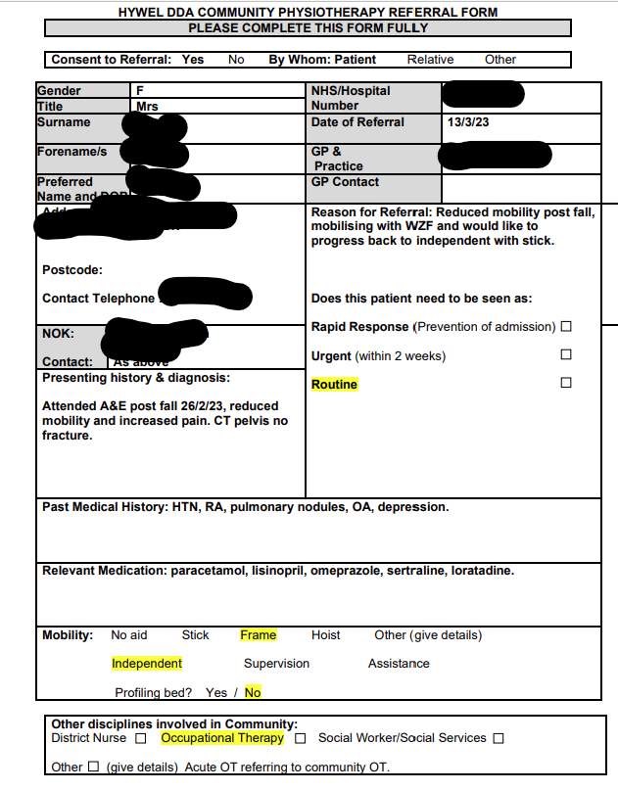
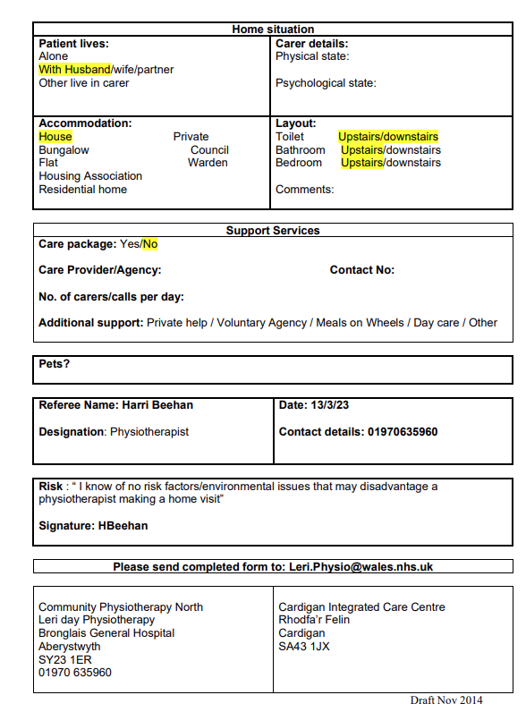

Appendix B
Action plan
S – Learn on X-ray, CT, and MRI scan reading
M – By attending training sessions
A – with training from radiography
R – Through appropriate training
T – 12 months

References
Cardiff and Vale university health board (2011) Code of conduct for healthcare support workers in Wales. Available at: https://cavuhb.nhs.wales/files/induction/code-of-conduct-1-pdf/ (Accessed 05/07/2023)
Cavill, N.A., Foster, C.E.M., (2018) ‘Enablers and barriers to older people’s participation in strength and balance activities: a review of reviews’. Journal of frailty, sarcopenia and falls, 3(2), pp. 105-113. doi: 10.22540/JFSF-03-105
Centre for disease control and prevention (2017) Timed up and go. Available at: https://www.cdc.gov/steadi/pdf/TUG_Test-print.pdf (Accessed 06/07/2023)
Ceredigion county council (2023) Cost of living. Available at: https://www.ceredigion.gov.uk/resident/cost-of-living/ (Accessed 06/07/2023)
Chartered society of physiotherapy (2012) Elderly mobility scale. Available at: https://agile.csp.org.uk/system/files/agile_outcome_measures_ems_v2.pdf (accessed 06/07/2023)
Gov.uk (2023) Data protection act 2018. Available at: https://www.gov.uk/data-protection (accessed 30/06/2023)
Legislation.gov.uk (2014) Social services and wellbeing act 2014. Available at: https://www.legislation.gov.uk/anaw/2014/4/section/19 (accessed 04/07/20230
National health service (2023) Broken Hip. Available at: https://www.nhs.uk/conditions/broken-hip/ (accessed 05/07/2023)
National Health service (2023) Mental health services. Available at: https://www.nhs.uk/nhs-services/mental-health-services/ (accessed 05/07/2023)
National library of medicine (2023) BERG balance test. Available at: https://www.ncbi.nlm.nih.gov/books/NBK574518/ (Accessed 06/07/2023)

