Programme: | BA Business Management
Module: | Marketing Fundamentals
Module code: | LCBB4004 | Contribution to Overall Module Assessment(%): | 30%
Module Coordinator/Lecturer: | Tushara Balendran | Internal Verifier: | Dr AnupamMazumdar
Assignment Title: | Assessment 1  Blogging to communicate | Word count (or equivalent): | 1500-2000

Student Name: Bogdan Alexandru Vasile
Student ID: 2114284

Table of Contents
Introduction 3
Task 1 4
Blog 1- Product 4
Blog 2- Price 6
Blog 3- Place 7
Blog 4- Promotion 9
Blog 5- Segmentation, targeting and positioning 10
Blog 6- Importance of marketing mix for the company 12
Conclusion 14
Reference List 15

Introduction
The 4Ps of marketing was introduced by Neil Borden in the 1950s it helps businesses and their marketing teams to determine the physical barrier of the business (Rust,2020). Unilever was founded in the year 1929 and is headquartered in the UK. The company sells all kinds of products for the consumers, such as beauty products and food products. It has over 400 brands and an employee count of over 149000 (Unilever, 2021). The company has stores and operates in over 190 countries. This blog post is going to explore the 4P’s of marketing mix on the company and understand its segmentation, targeting, and positioning in the market. It will also understand the importance of the marketing mix for a company.

Task 1

Blog 1- Product
The company provides a variety of products such as tea, coffee, beauty products, soups and so on. It produces products that are concerned with the comfort of the consumers. The company aims to produce healthy and high-quality products for people to use and consume (BBC, 2017). Products offered are all high quality with reasonable warranties and proper packaging. The product is made in consideration of sustainability and is environment friendly. The company has 400 brands and each sells different kinds of products for different purposes such as:
Vaseline: this brand is concerned with the selling of skincare products like body lotion the prices are low for these products.
Magnum&Walls’s- these brands are concerned with selling confectionery products such as ice cream and so on (Unilever, 2021).
Dove, Lifebuoy & Lux- these brands offer beauty products that are of high quality and low prices with different sizes of packaging.
Surf excel- this brand is concerned with selling detergents for washing clothes.
The Vegetarian Butcher: this brand is concerned with the selling of vegetable-based meat that is of high quality (Unilever, 2021).
Rexona: this brand sells deodorant for both men and women that protects from micro bacteria (Unilever, 2021)
Knorr:This brand is concerned with the selling of ready make food items that are fresh and healthy (Unilever, 2021).
Bango:the brand is famous for its soy sauce production that includes 4 natural high-quality nutrients Mallika soybean, sugar, salt and water (Unilever, 2021).
Cif:This brand provides household cleaning products and the spray bottle are reusable (Unilever, 2021).
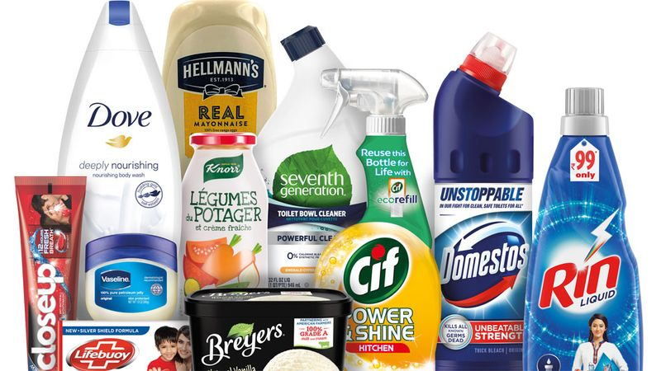
Figure 1: Unilever Products
(Source: Unilever, 2019)

Blog 2- Price
The company uses the marketing penetration strategy in which a company sells its products at low prices but the quality of the product is high. The prices of the product are comparatively lower than other company’s prices. The company uses the differentiation strategy to stand out the quality and benefits of the products in the market, which gives them competitive advantages. In the year 2020, the revenue generated by the company was 50.7 billion euros which were 2.4% lesser than the revenue generated the year earlier (Statista, 2021). However, in the year 2021 the company battle with unmet production prices and hike the prices of the products (Sillars, 2021). In 2016, the company had hiked the prices of 20 of their products by 5.7% because of the BREXIT vote (Butler, 2016).
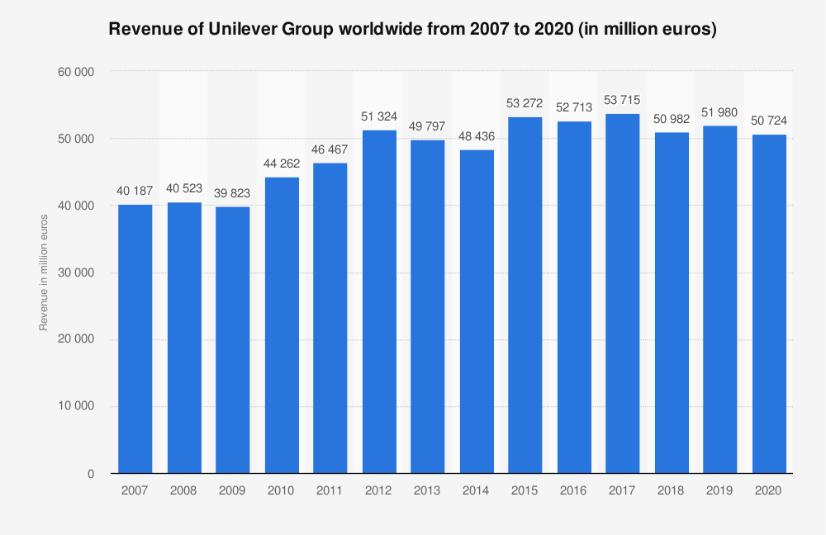
Figure 2: Revenue of Unilever Group worldwide from 2007 to 2020
(Source: Statista, 2021)

Blog 3- Place
The company operates in 190 countries in the world and own more than 400 brands including Dove and Axe (Unilever, 2021). The company has a website that has facilitates the consumers to contact the company by filling up a form. Almost every retailer in the UK sells products of the company. The retailers include Tesco, Sainsbury’s, Asda and so on that retail their product however, it is also possible to buy directly from the company’s website.

Figure 3: Countries Unilever Operates in.
(Source: Unilever, 2021)
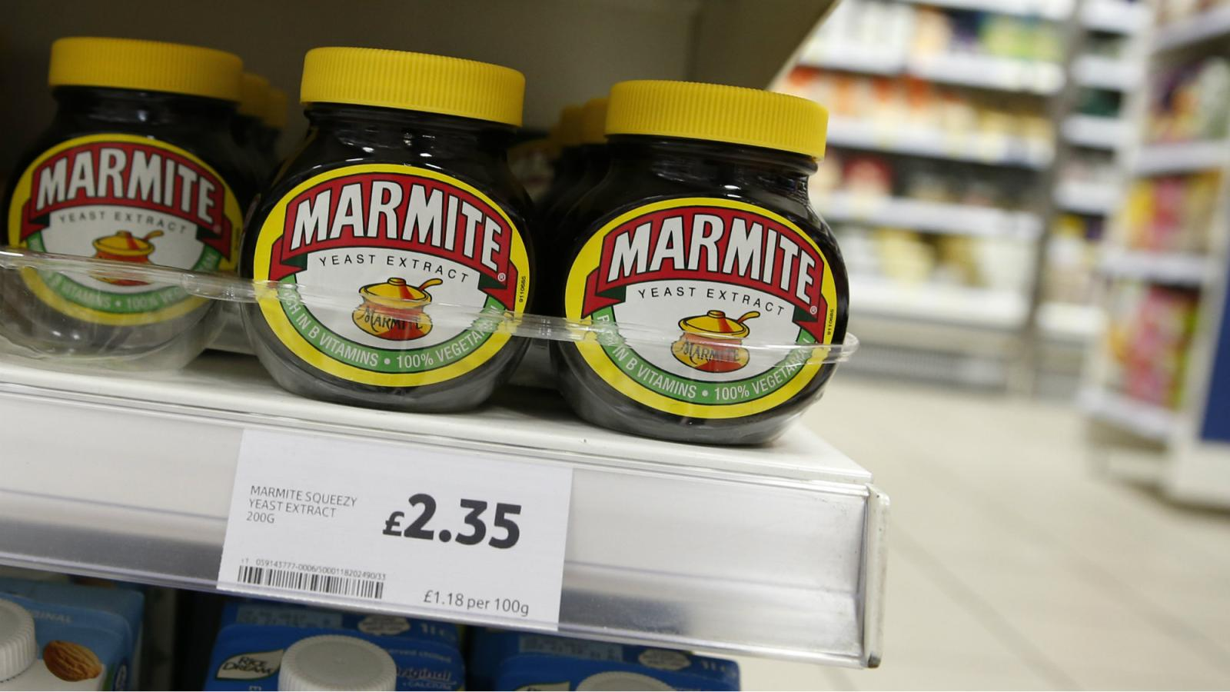
Figure 4: Tesco selling Unilever Products
(Source: Karaian, 2016)
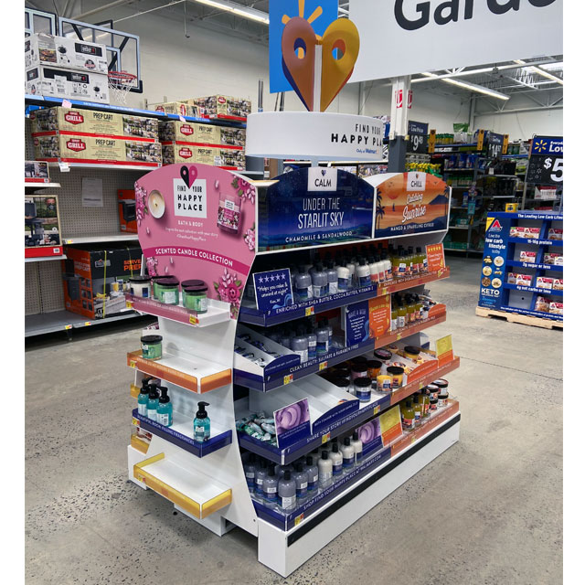
Figure 5: Walmart selling Unilever Products
(Source: POP, 2020)

Blog 4- Promotion
The company uses several ways of advertising and promotion of its product. The promotions are done sustainably and the company utilises social media in SEO to target their potential consumers. They advertised the corporate brand the right the first time on TV for the first time in the year 2014. In the advertisement, the company advertised their corporate brand as part of the Project Sunlight campaign, which was to raise awareness of sustainability (Vizard, 2014). The company has many campaigns that support certain causes such as the Dove campaign that challenges beauty stereotypes. The Omo advertising campaign was to promote that “Dirt is good” and it is all part of the children’s learning and development. Comfort advertising campaign supported the cause of saving water (Unilever, 2021).
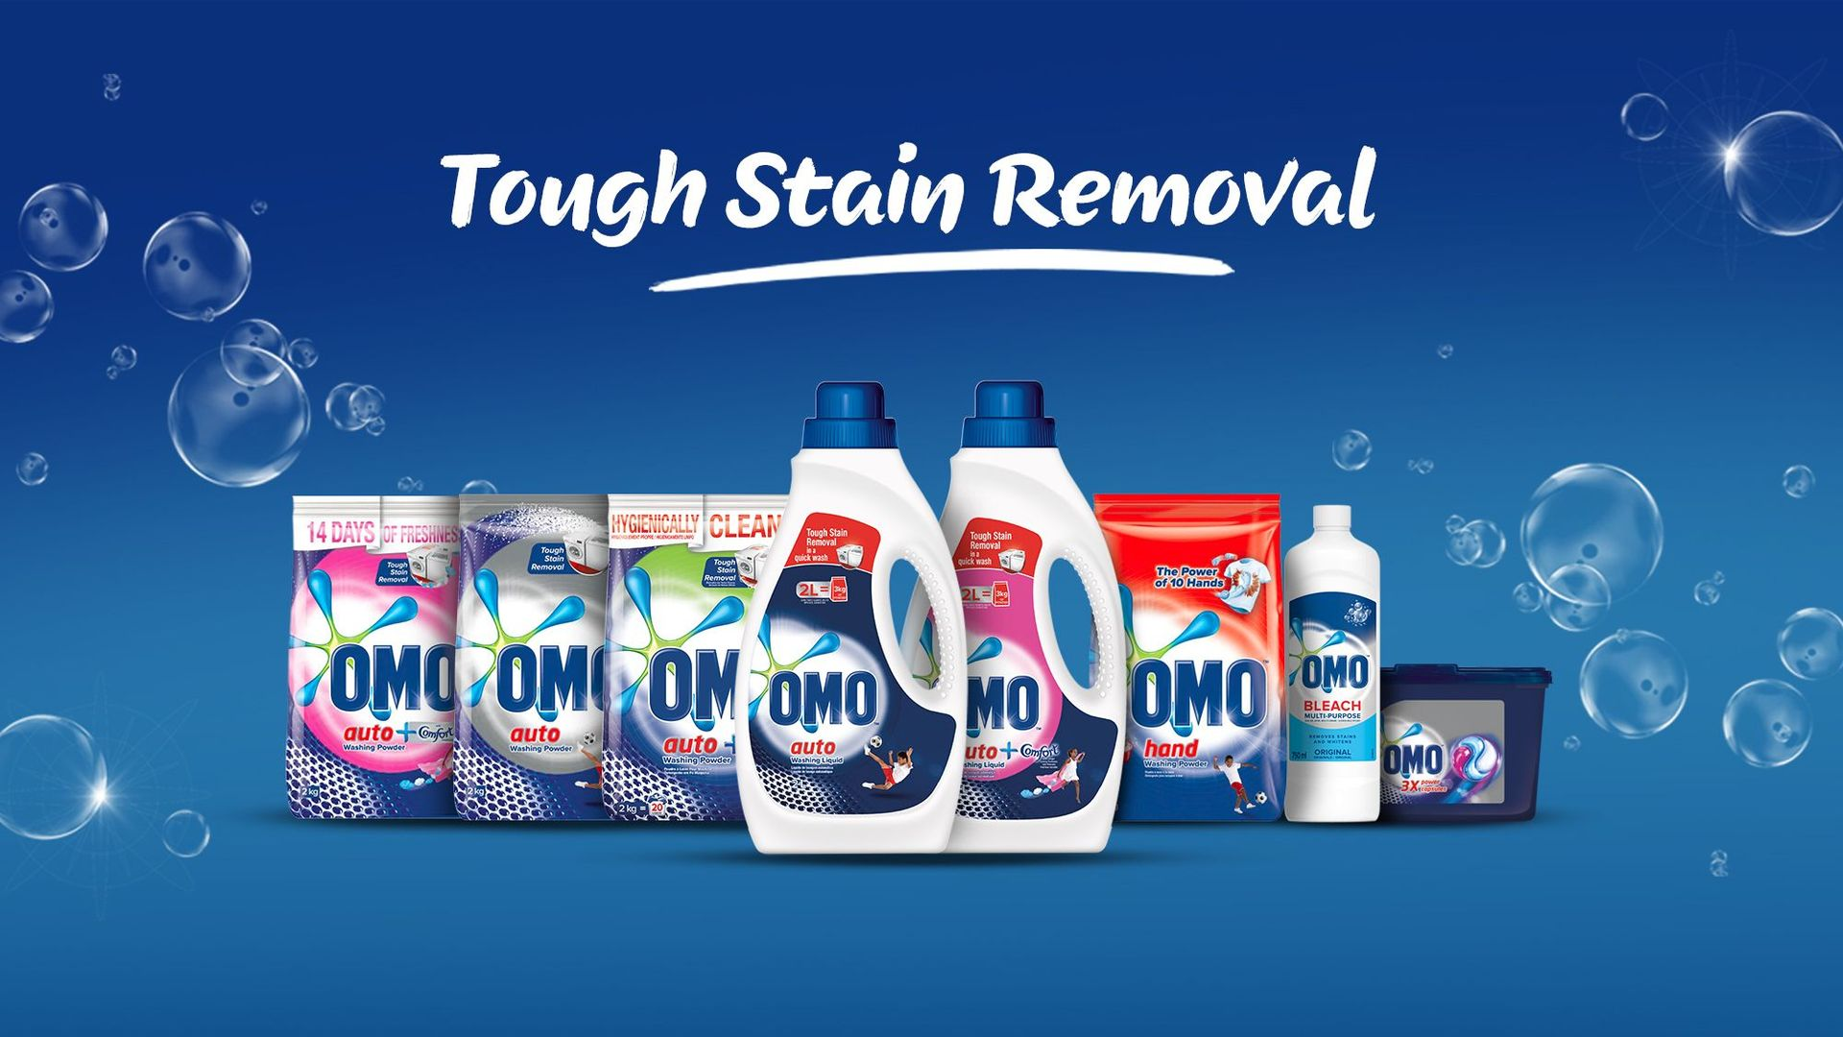
Figure 6: Unilever Ad campaign
(Source: Unilever, 2021)

Blog 5- Segmentation, targeting and positioning
Segmentation
The segmentation refers to the company’s research to identify the potential refers that would be interesting to identify (Camilleri, 2018). The companies to identify their consumer base use five types of segmentation. The segmentation types are as follows:
Demographic segmentation: This segmentation is done by taking into consideration age, gender, income, family status, occupation, marital status and religion.
Geographic Segmentation: This segmentation is based on the country or the region of the consumers
Behavioural Segmentation: it is based on the habits of the consumers
Psychographic Segmentation: it is based on personality traits, beliefs and so on.
Geo-demographic Segmentation: This segmentation is a combination of both demographic and Geographic Segmentation.
Unilever uses demographic segmentation to identify its potential consumers. It chooses the Age of consumers and sells products for all age groups. It also takes into consideration of gender products and makes products for both male and female consumers. They segment their consumers based on income and use a market penetration strategy and product quality to attract everyone.
Targeting
This is the process of identification of the niche-specific consumer or the people who might be interested in the product (Camilleri, 2018).There are four types of target marketing:
Undifferentiated marketing: this targeting strategy is based upon a company selling one kind of product.
Differentiated marketing: This targeting is also called multi-segment marketing where a company decides to offer separate kinds of products to different market segments.
Concentrated marketing: This targeting strategy involves the company in making many segments although chooses not to solve every problem except the big one of the consumers. It is mainly based on producing the product for one specific market segment.
Customised marketing: This is the newest targeting strategy in which the companies make a product for the consumer by understanding their need and producing commodities that solve every kind of problem.
Unilever follows the Customised marketing of targeting consumers. The company sells products of every kind for every age group as well as every income group. It has several brands that offer products for several different purposes of the consumers.
Targeting
Undifferentiated marketing
Differentiated marketing
Concentrated marketing
Customised marketing
Figure 7: 8 customer targeting strategies
(Inspired by Camilleri, 2018)
Positioning
Proper positioning of a company can bring it brand value, customer base and revenue generation. Unilever sells their product that is of high quality although at a very low cost that attracts consumers from every income segment. The company uses market penetration where they keep the price low and quality high of the products and remains in the same market (Alkasimet al., 2018). They also provided the consumers with sales and discount offers. It operates in 196 different countries and its products are sold by every small and big retailer in the UK (Unilever, 2021). They sell products for everyone that solves almost every problem there is with the consumers. Unilever provides high-quality products at low prices so that everyone can access them.
The company runs online campaigns and sustainably promote their business. Since the company produces products of every kind for every age group, the company has a very large customer base. The company also keeps up with the changing tastes of the consumers and keep making changes to their products for high sale (Unilever, 2020). The customer reviews of the products are high and show the satisfaction of the consumers (Glassdoor, 2021).Consumers provide with a 5star rating on the portal and satisfaction with the product they buy from the company.
High Quality
Low Quality
Low Price
High Price
Unilever
Proctor & Gamble
Colgate &Palmolive
Figure 8: Perpetual Map

Blog 6- Importance of marketing mix for the company
A marketing mix is a business tool that is used by a various number of business owners, marketing executives and operation managers. A marketing mix is a crucial tool for a company to determine the right strategy for the growth of the business. Understanding the importance of the price, product, promotion, and place is important for the business (Kotler and Armstrong, 2013). Proper determination of these aspects is important for the business as it determines the marketing strategy for the business. It helps determine the targeting and segmentation based on the products and prices. The marketing mix helps in making up a business plan and properly handling the company (The Economic Times, 2021). It needs a proper understanding, research of the market and appropriate consultation to various people.
Understanding this aspect also affects the promotion and prices of the products. Marketing mix components tend to interact or connect and affect each other (SeifpanahiShabani et al., 2018). The marketing mix helps in proper guidance in resources allotment in terms of both human and financial. This help in the allocation of the responsibilities of the marketing team member. It helps in understanding the cost elasticity of the business and be able to increase the sale personal by increasing the budget for the advertisement or increasing the sales. The marketing mix improves the communication in the marketing team. Proper utilisation of the marketing mix can help in improving the demand for the products. It also helps a loss-making company to go right on track by utilising it properly and be able to make a balanced approach.
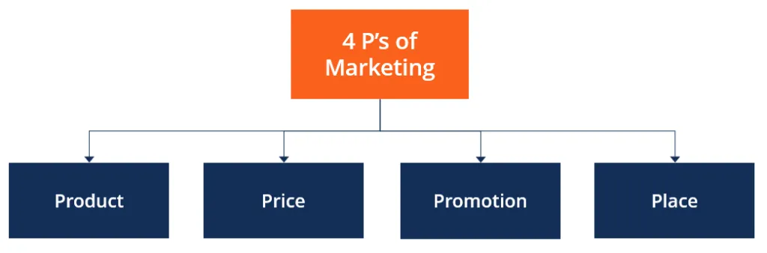
Figure 9: 4P’s Of Marketing
(Source: CFI, 2021)

Conclusion
From the above, it can be concluded that marketing mix is crucial for a business as it helps in understanding and determining the correct marketing strategy of the business. The blog also explores the price and promotion strategy of the company. It also explores the various brands, the products they sell, and their purpose of them. The blog also understood the segmentation strategies a business can use such as demographic, geographic segmentation, and so on. It also understood the targeting and segmentation strategy used by the company. Lastly, the blog also understood the importance and benefits of the marketing mix in an organisation.

Reference List
Alkasim, S.B., Abdullah, H.H., Bohari, A.M., Abdullah, S.S. and Sallehddin, M.R., 2018. The mediating effect of cost leadership on the relationship between market penetration, market development, and firm performance. Journal of Business & Retail Management Research, 12(03), pp.190-200.
BBC, 2017. Unilever: Profile of a consumer goods giant[online] Available at: https://www.bbc.com/news/business-39009072 [Accessed 22 December 2021]
Butler, S., 2016. Price of 20 Unilever products up by average of 5.7% since Brexit vote[online] Available at:https://www.theguardian.com/business/2016/nov/07/price-of-20-unilever-products-up-by-average-of-57-since-brexit-vote [Accessed 22 December 2021]
Camilleri, M.A., 2018. Market segmentation, targeting and positioning. In Travel marketing, tourism economics and the airline product (pp. 69-83). Springer, Cham.
CFI, 2021. 4 P’s of Marketing[online] Available at: https://corporatefinanceinstitute.com/resources/knowledge/other/4-ps-of-marketing/ [Accessed 22 December 2021]
Glassdoor, 2021. Unilever London, UK Reviews[online] Available at: https://www.glassdoor.co.in/Reviews/Unilever-London-Reviews-EI_IE3513.0,8_IL.9,15_IM1035_IP3.htm?filter.iso3Language=eng [Accessed 22 December 2021]
Karaian, J., 2016. Unilever is treating the UK just like a Latin American nation with a dodgy currency[online] Available at: https://qz.com/808411/in-its-marmite-spat-with-tesco-unilever-is-treating-the-uk-like-a-latin-american-country-with-a-dodgy-currency/ [Accessed 22 December 2021]
Kotler, P. and Armstrong, G., 2013. Principles of Marketing (16th Global Edition).
POP, 2020.Unilever Launches New Brand With Walmart[online] Available at:https://www.popin.net/unilever-launches-new-brand-with-walmart/[Accessed 22 December 2021]
Rust, R.T., 2020. The future of marketing. International Journal of Research in Marketing, 37(1), pp.15-26.
SeifpanahiShabani, J., Gharehkhani, H. and Naderi, F., 2018. The Role of Sport Marketing Mix in Generating Revenue for Iranian Football Clubs. Annals of Applied Sport Science, 6(1), pp.95-102.
Sillars, J., 2021. Prices of Unilever's popular brands have jumped - and the worst is yet to come[online] Available at:https://news.sky.com/story/marmite-maker-unilever-warns-worst-is-ahead-as-it-hikes-prices-to-offset-unprecedented-cost-inflation-12439899 [Accessed 22 December 2021]
Statista, 2021. Revenue of Unilever Group worldwide from 2007 to 2020[online] Available at: https://www.statista.com/statistics/269190/global-revenue-of-the-unilever-group-since-2007/ [Accessed 22 December 2021]
The Economic Times, 2021. Definition of 'Marketing Mix'[online] Available at: https://economictimes.indiatimes.com/definition/marketing-mix [Accessed 22 December 2021]
Unilever, 2019. Unilever's purpose-led brands outperform[online] Available at: https://www.unilever.com/news/press-and-media/press-releases/2019/unilevers-purpose-led-brands-outperform/ [Accessed 22 December 2021]
Unilever, 2020.How your product reviews are shaping our brands[online] Available at: https://www.unilever.com/news/news-search/2020/how-your-product-reviews-are-shaping-our-brands/ [Accessed 22 December 2021]
Unilever, 2021. Advertising and marketing[online] Available at: https://www.unilever.com/planet-and-society/responsible-business/advertising-and-marketing/ [Accessed 22 December 2021]
Unilever, 2021. Bango [online] Available at:https://www.unilever.com/brands/foods-refreshment/bango/[Accessed 22 December 2021]
Unilever, 2021. Cif[online] Available at:https://www.unilever.com/brands/home-care/cif/[Accessed 22 December 2021]
Unilever, 2021. Knorr[online] Available at:https://www.unilever.com/brands/foods-refreshment/knorr/ [Accessed 22 December 2021]
Unilever, 2021. Our Company [online] Available at: https://www.unilever.com/our-company/ [Accessed 22 December 2021]
Unilever, 2021. Rexona [online] Available at:https://www.unilever.com/brands/beauty-personal-care/rexona/[Accessed 22 December 2021]
Unilever, 2021. The Vegetarian Butcher[online] Available at:https://www.unilever.com/brands/foods-refreshment/the-vegetarian-butcher/[Accessed 22 December 2021]
Unilever, 2021. Unilever at a glance[online] Available at: https://www.unilever.com/our-company/at-a-glance/ [Accessed 22 December 2021]
Unilever, 2021. Vaseline[online] Available at: https://www.unilever.com/brands/beauty-personal-care/vaseline/ [Accessed 22 December 2021]
Unilever, 2021. Wall's[online] Available at: https://www.unilever.com/brands/foods-refreshment/walls/ [Accessed 22 December 2021]
Vizard, S., 2014. Unilever to advertise corporate brand on UK TV for first time[online] Available at: https://www.marketingweek.com/unilever-to-advertise-corporate-brand-on-uk-tv-for-first-time/[Accessed 22 December 2021]
Unilever, 2021. Advertising and marketing[online] Available at:https://www.unilever.com/planet-and-society/responsible-business/advertising-and-marketing/[Accessed 22 December 2021]
Unilever, 2021. OMO[online] Available at:https://www.unilever.co.za/brands/home-care/omo/[Accessed 22 December 2021]

