INTERNATIONAL BUSINESS SBMA - 7122D
MARKUS SCHLOTBOHM
STUDENT-NUMBER: 1603888
28.04.2018

ASSIGNMENT-PART-II
INTERNATIONAL BUSINESS PLAN
JUAN VALDEZ COMPANY
WORD COUNT TOTAL: 5.451
WORD COUNT ASSIGNMENT I (Chapter 4-5): 1.178
WORD COUNT ASSIGNMENT II 4.273

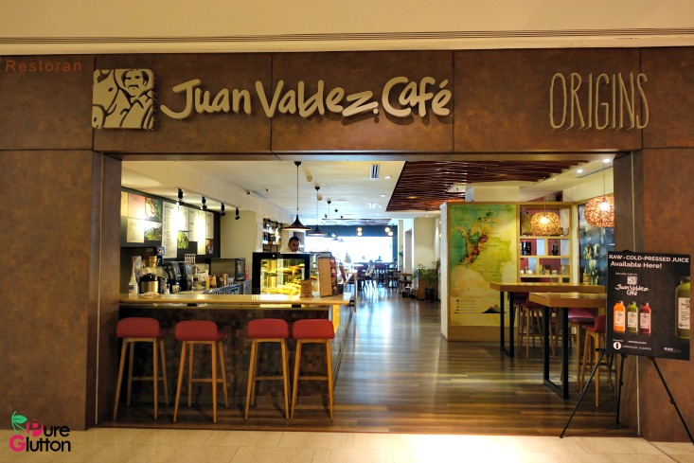

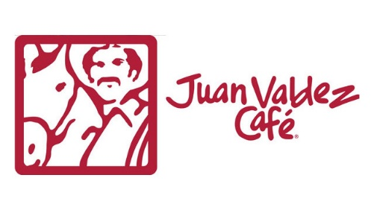

REPORT

TO: BOARD OF DIRECTORS

FROM: INTERNATIONAL BUSINESS MANAGER

DATED: 04/28/2018

SUBJECT: INTERNATIONAL BUSINESS PLAN TO EXPAND JUAN VALDEZ BUSINESS TO AUSTRIA


AUSTRIA

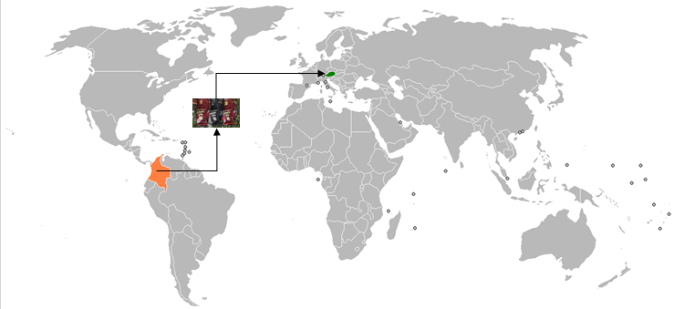

Table of Contents
EXECUTIVE SUMMARY 5
1.0 INTRODUCTION 6
2.0 CORPORATE GLOBAL VISION AND GOALS 7
3.0 INTERNATIONAL BUSINESS 7
4.0 FOREIGN MARKET RESEARCH 8
4.1 COUNTRY PROFILE 8
4.2 PESTEL ANALYSIS 9
4.3 COFFEE MARKET ANALYSIS 12
5.0 RISK ASSESSMENT 13
6.0 INTERNATIONAL BUSINESS STRATEGY 15
6.1 EXPORTING 15
6.2 LICENSING 16
6.3 FRANCHISING 16
7.0 INTERNATIONAL MARKETING PLAN 18
7.1 SEGMENTATION - TARGETING – POSITIONING 18
7.2 GLOBAL MARKETING MIX 20
7.2.1 STANDARTIZATION VS ADAPTATION 20
7.2.2 PRODUCT 21
7.2.3 PLACE 23
7.2.4 PROMOTION 24
7.2.5 PRICE 26
8.0 CONCLUSION 27
9.0 RECOMMENDATION 28
APPENDIX I TRADE FREEDOM- INVESTMENT FREEDOM INDEX 29
APPENDIX II CULTURE DIFFERENCES 30
REFERENCES: 31

TABLE OF FIGURES
Figure 1 COUNTRY PROFILE - BASIC FACTS 8
Figure 2 COUNTRY PROFILE - LANDSCAPE 8
Figure 3 POLITICAL DIMENSION 9
Figure 4 ECONOMIC DIMENSION 9
Figure 5 SOCIAL- & LEGAL DIMENSION 10
Figure 6 TECHNOLOGY- & ENVIRONMENTAL DIMENSION 11
Figure 7 COFFEE MARKET ANALYSIS 12
Figure 8 COFFEE MARKET AUSTRIA 13
Figure 9 RISK OVERVIEW 13
Figure 10 PORTER 5 FORCES - COFFEE INDUSTRY AUSTRIA 14
Figure 11 EXPORTING - ADVANTAGE / DISADVANTAGE 15
Figure 12 LICENSING - ADVANTAGE / DISADVANTAGE 16
Figure 13 FRANCHISING - ADVANTAGES / DISADVANTAGES 16
Figure 14 ENTRY STRATEGY - SUMMARY 17
Figure 15 FACTORS FAVORING STANDARDIZATION 20
Figure 16 FACTORS FAVORING ADAPTATION 20
Figure 17 MARKETING APPROACH MATRIX AUSTRIA 21
Figure 18 TYPICAL JUAN VALDEZ COFFEE PLACE COLOMBIA vs TYPICAL AUSTRIAN COFFEE PLACE 23
Figure 19 PROMOTION-INTERNET 24
Figure 20 PRICE-INFLUENCE-SENSITIVITY-FACTORS 26
Figure 21 TRADE FREEDOM INDEX 29
Figure 22 INVESTMENT FREEDOM INDEX 29
Figure 23 HOFSTEDES CULTURE DIFFERENCES 30

EXECUTIVE SUMMARY

This International Business Plan provides “Juan Valdez” a viability analysis and an international marketing plan necessary to determine if and how to expand its business to Austria. Methods of analysis include a Foreign Market Research (Country Profile, PESTEL, Hofstede’s Culture Ratios, Coffee Market Analysis), Risk Assessment, International Entry Mode Examination, Segmentation-Targeting-Positioning and Global Marketing Mix Approach. Additional information, important for the International Business Plan, is provided.
Results of the analysis show that Austria has excellent market environment condition, no trading barriers and a strong coffee culture. Furthermore, expansion in neighbouring countries like Germany, who has similar market conditions, were already executed successfully. The strongest Risks were found in Political and Cultural Risk which are manageable with the right strategies. Findings show further to expand with two entry mode strategies: Direct Exporting of its Coffee Product to Target Group I Home/Office Consumer and Target Group III Café Houses. Franchising was recommended for Target Group II Out of Home Consumers. An adaptation of the Product-, Place-, Price- and Promotion definition to each Target Group is recommended due to the results of the standardization/adaptation analysis. Logistic networks, already build during the expansion to other European countries, can be used.
This International Business Plan shows, that expansion of Juan Valdez to Austria is feasible and outlines the appropriate international marketing plan in order to succeed.
It is recommended before executing the expansion to Austria to undertake further steps: define an international HR strategy to, among others, address the cultural differences. Furthermore, develop an Accounting reconciliation strategy, create an exit strategy and also to build a Currency Exchange strategy has to be done.
Limitations for the expansion project are the missing financial reports (P&L, BS) due to non-public information-status - in order to verify if Juan Valdez is financial capable of undertaking the expansion project and also to suggest what source of finance to choose. Those reports would provide valuable insights to give an even more informed recommendation.

1.0 INTRODUCTION

In an ever-faster-globalized developing environment (WHO, 2016), international expansion opportunities arise even for companies in developing countries like Colombia. Juan Valdez, a Colombian café chain company, is one of those Colombian companies seeking to expand its business to Austria. A decision on the appropriate international business expansion is shaped by various factors. In order to expand internationally, it is necessary to understand the motivation behind its expansion strategy. Foreign Market Research and Risk Assessment are providing answers whether it’s feasible for Juan Valdez to expand internationally. Furthermore, selecting the most appropriate business strategy (e.g. exporting, licensing, franchising, etc.) is essential to succeed. Therefore, developing an international business plan needs to be created, that comprises a feasibility analysis and also an international business strategy combined with an international marketing plan that reflects the appropriate standardization and or adaption to the new foreign market.

2.0 CORPORATE GLOBAL VISION AND GOALS

Juan Valdez Café is a multinational coffeehouse chain based in Colombia that specializes in coffee retail. Its purpose is to become a member of the worldwide coffee restaurant business and promote Colombian coffee. As of 2017, Juan Valdez has 300 company locations. International expansion, which began in 2005, brought new locations to Aruba, Guayaquil, La Paz, Madrid, Miami, New York City, Costa Rica, Panama City, Santiago and Washington D.C. Despite recent closures in the United States, the company aims to continue its expansion worldwide. (COMPANY, 2018)

3.0 INTERNATIONAL BUSINESS

On December 12 2002, the first Juan Valdez Café store opened its doors at El Dorado International Airport in Bogota. This was the beginning of a process that intended to introduce more and more people to premium Colombian coffee (COMPANY, 2018). The stores are designed to bring a whole new level of the Colombian coffee experience to visitors. The stores spotlight different types of coffee, along with different preparation methods, all in the quest for the Perfect Cup. It's a delicious and educational experience. According to the corporate website (COMPANY, 2018), Juan Valdez expanded since 2011 into Aruba, Panama, Costa Rica, Mexico and Paraguay. Juan Valdez has created alliances with a number of airlines, hotels and other businesses. The customer can now enjoy Juan Valdez premium Colombian coffees on LATAM Airlines Group flights and at Marriott hotels as well as at various restaurants and businesses (COMPANY, 2018). The company is continuing with the process of international expansion, bringing its packaged coffee to Europe and Asia. Today the company also offer its Coffee in China, the United States, Spain and Germany. In its ongoing efforts to bring the best premium Colombian coffee to the world, it created its own line of packaged coffees. These coffees run the gamut from strong coffees, to balanced coffees, to coffees with flavor profiles that will satisfy even the most demanding palates. Today its Cafe Volcan has found favor with espresso aficionados, while its Cafe Cumbre is popular with younger coffee drinkers (COMPANY, 2018). In the process of international expansion, it was selected that Austria is a possible candidate to expand to. The following chapter focus on the foreign market research for Austria.

4.0 FOREIGN MARKET RESEARCH

4.1 COUNTRY PROFILE

Austria had a population of 8.74 million in the year 2016 and expected to reach 9.038 million by 2022. In 2016, Austria's unemployment rate was 6%, inflation rate was below 1% and GDP was 47.742 US$ ranking it globally on 18th place. (IMD, 2017)

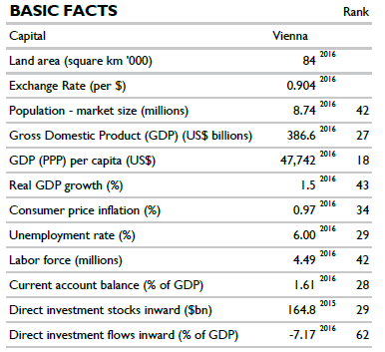
Figure 1 COUNTRY PROFILE - BASIC FACTS
Analysing the latest IMD report, it shows that in the infrastructure sector and in the business efficiency sector Austria, lays in the top ranks worldwide. Most important to outline is that International Trade performance lays in the top 20 globally supporting the demand of expanding to Austria. (IMD, 2017)

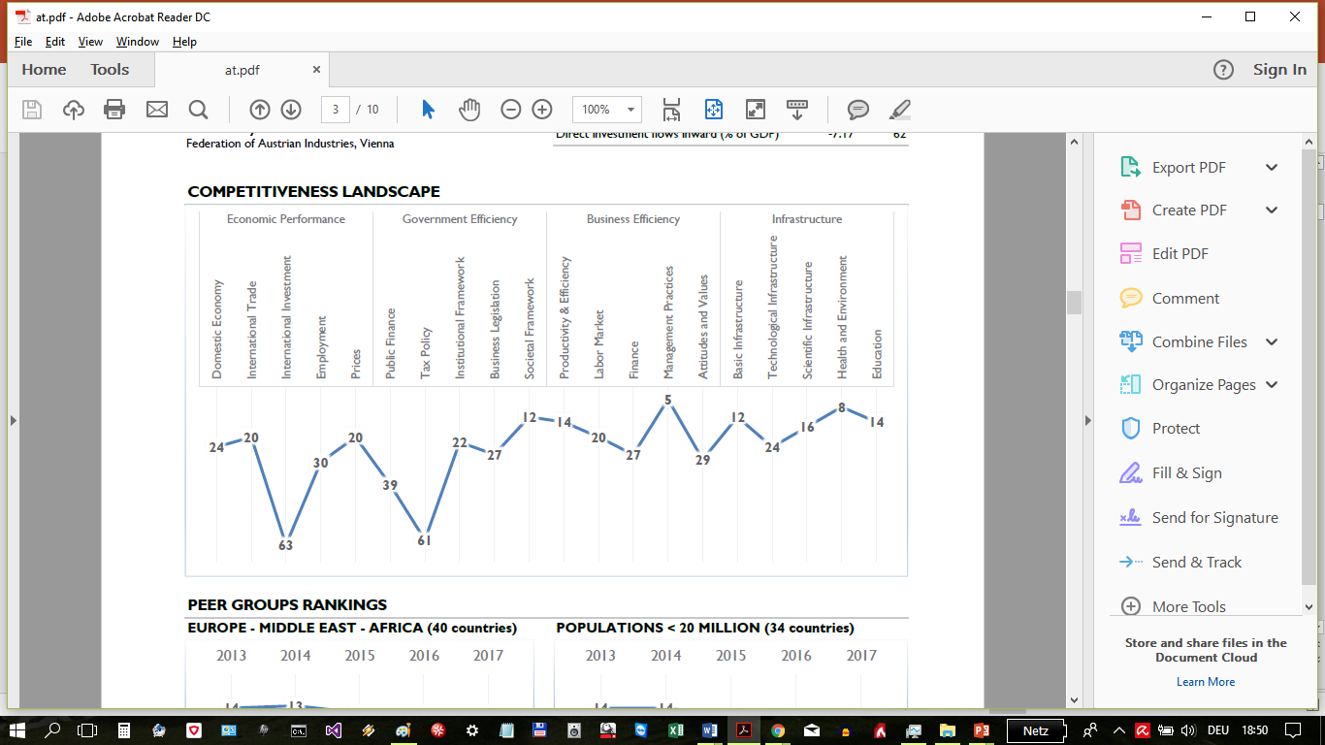
Figure 2 COUNTRY PROFILE - LANDSCAPE

4.2 PESTEL ANALYSIS

Focusing on the Political dimension, it shows that Austria is a democratic republic and had since decades a stable political environment. Austria is a member of the European Union and uses the Euro as its currency, which implies a currency exchange risk and is being analysed in Chapter 5 Risk. Currently Austria is ranked 25th among industrial countries. According to the latest Corruption Index (CORRUPTION 2017), Austria is ranked 16th out of 180 Countries and has since many years a high score, reflecting low corruption and shows a reliable framework when operating with public and private organizations.
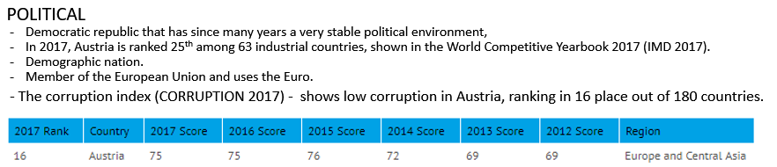
Figure 3 POLITICAL DIMENSION

Focusing on the Economic dimension, is showing Austria is a well-developed economy and highly globalized, sustained by skilled labour, competitive manufacturing and a large service sector. Openness to global trade and investment is one of the conditions findable in Austria. The legal system is transparent and reliable. It shows that GDP is after the financial crisis steady rising between 1.5-2 % annually. Trade plays an important part in its economy and was the reason which help Austria’s economy to pull out of the recession in 2009. The Economic Globalization Index for Austria shows that Austria exchanges a lot of goods, services, and investments with other countries since the beginning of the 2000, constantly scoring over 84 points.
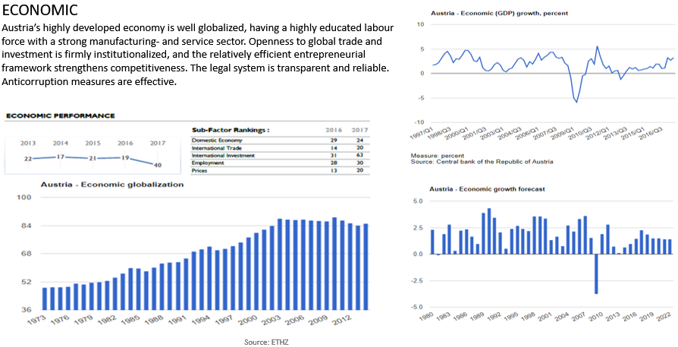
Figure 4 ECONOMIC DIMENSION

Considering the SOCIAL Dimension – The most important aspects can be seen in the following:
According to the WHO report 2017 (WHO, 2017), Educational wise Austria ranks far above the OECD average, 85 % vs 74%, Employment is at - 72 % of Austrians have a paid job above the OECD average of 67%. The Health Care system is one of the best globally, confirmed by the 4th place in the WHO ranking. The Quality of life ranking shows Austria in 3rd place underlining the high satisfaction of Austrians and also can be seen as one reason for the high life expectancy above the OECD average.
Focusing on the LEGAL dimension, Austria adopted the EU legal framework and has one of the oldest codes of civil law. (LEGAL, 2018) Labour laws are very strong in Austria and labour organisations play an important role in business. One of the important aspects is that Austria has a business-friendly tax system of 25% attractive for companies like Juan Valdez who want to expand its business. However, it should be mentioned that the latest Government is more national oriented (AUSTRIA, 2017) and could in the recent global development of protectionism (ABN, 2018) create hurdles for foreign companies wanting to do business in Austria. Due to its importance for Juan Valdez expansion, it will be further analysed in the following chapter RISK assessment (Chapter 5.4 Political Risk).
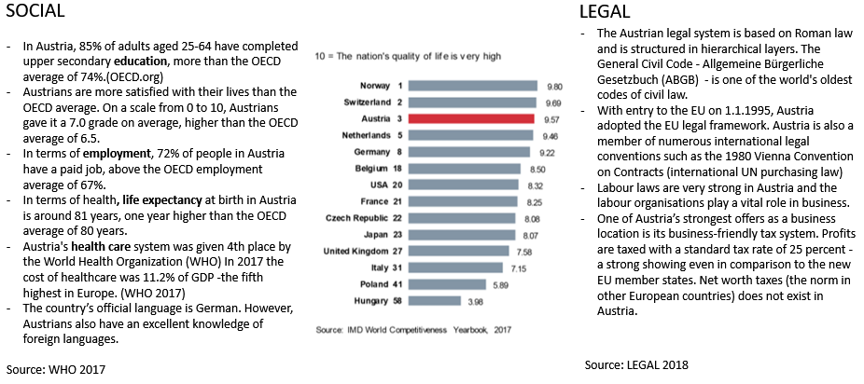
Figure 5 SOCIAL- & LEGAL DIMENSION

Regarding Technology, it is showing that Austria has a strong IT infrastructure that also supports digital public service growth offering an efficient and effective service to its inhabitants and its organizations operating in Austria. That’s important for Juan Valdez regarding internal operational processes (e.g. e-Facturing, e-Accounting, e-Commerce). Environmental aspects play a vital role in Austria although its relatively free from natural catastrophes. Austria ranks second worldwide concerning the security of energy supplies.

Of particular importance for Austria are the Alpine Conventions which deals with the protection and sustainable development of its alpine space.
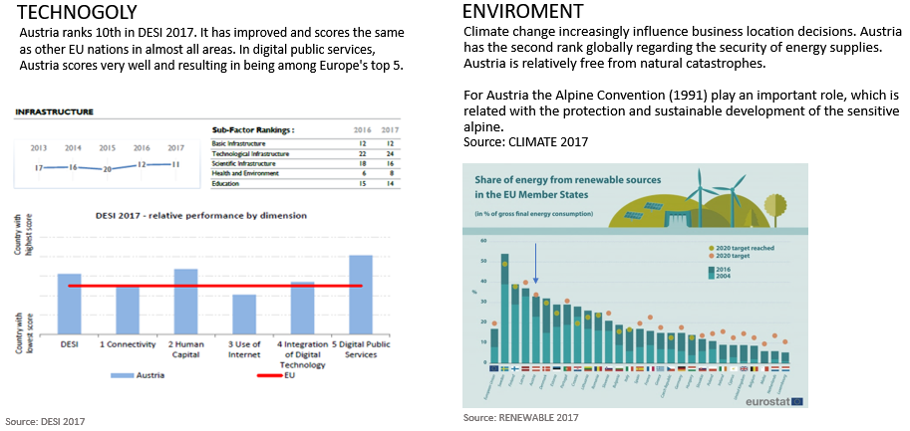
Figure 6 TECHNOLOGY- & ENVIRONMENTAL DIMENSION

The undertaken PESTEL ANALYSIS results that Austria has excellent macro conditions to operate in and by itself is favouring the expansion plan from Juan Valdez.

4.3 COFFEE MARKET ANALYSIS

Based on the 2017 Statistic report (STATISTA, 2017), the global market volume in 2018 is expected to be nearly 13 billion USD where Austria ranks 12th, however when looking at the population amount of Austria it shows that even 9 out of 10 people favour coffee for their daily favourite beverage reflecting a strong coffee culture in Austria. The latest coffee report (ICO, 2018) show also that the two segments roasted and instant coffee have a very different demand price behaviour. While instant coffee has a lower demand, it shows a higher unit price whereas roasted coffee has a stronger demand but a relatively lower unit price. It shows that roasted coffee and therefore the more traditional way of coffee consumption is favoured over fairly new instant coffee trends globally seen. Concluding it can be said Austria is a very strong coffee demand country and can be seen as a suitable market to be entered by Juan Valdez.
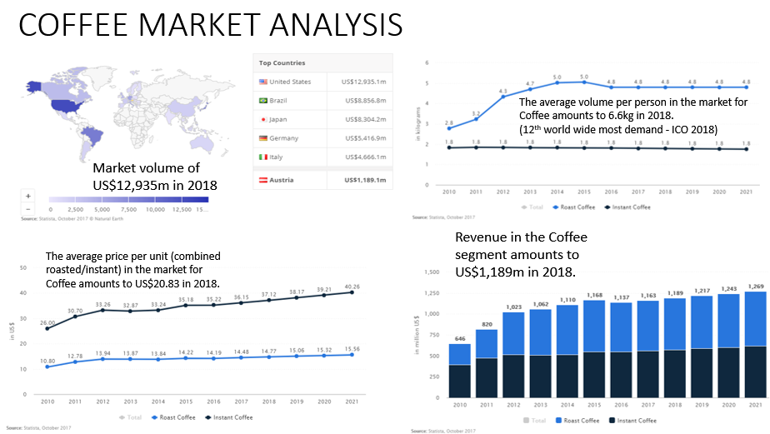
Figure 7 COFFEE MARKET ANALYSIS

The following figure 8 shows the coffee market share situation in Austria and some specific metrics about coffee consumptions. Based on the latest international coffee market report (ICO, 2018), it shows that revenue expected in Austria for coffee lays at 1.189 billion USD and has an annually growth in the next 3 years of 2.2%. The largest segment is the roasted coffee with a market Volume of 614 million $. Per person revenue for coffee in Austria is expected to be 137$ with an average consumption per person of 6.6 kg. The biggest players in the local coffee market are Jacobs, Tschibo and Nestle. To analyse further the coffee market industry, a Porter Analysis has been done in Chapter 5.

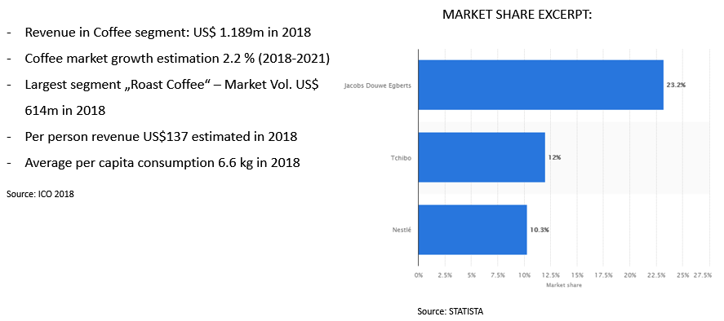
Figure 8 COFFEE MARKET AUSTRIA

5.0 RISK ASSESSMENT

The following view shows selected risks for Juan Valdez expansion to Austria.

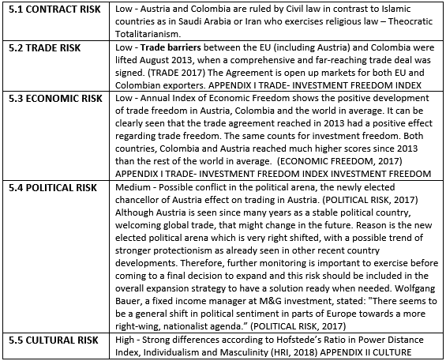
Figure 9 RISK OVERVIEW

To analyse further the coffee market industry in Austria, a porter 5 forces model has been applied:
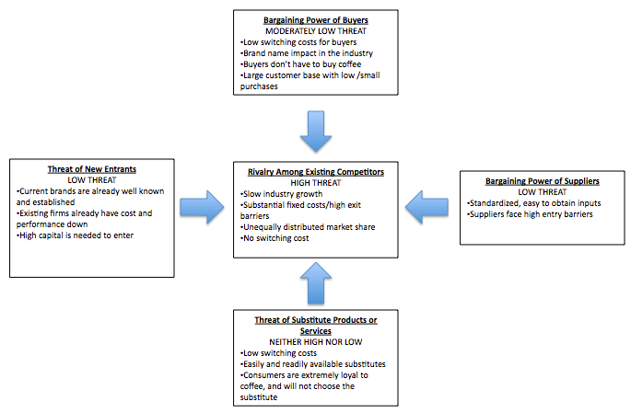
Figure 10 PORTER 5 FORCES - COFFEE INDUSTRY AUSTRIA

The analysis shows that bargaining power of buyers is a moderate low threat, which could help Juan Valdez enter the Austrian coffee market, offering its high-quality coffee products to various consumer groups (outlined in Chapter 7). Threat of new entrants is seen as low, which would be a challenge for Juan Valdez as new player in the Austrian market, according Promotion activities (chapter 7.2.4) have to be undertaken to address this aspect. The high treat of rivalry among existing competitors is seen as high, which is more like a chance for Juan Valdez than a thread. The right entry strategy needs to be performed to gain a competitive advantage, not only based on its high-quality product but also in terms of for example having a better motivated staff than the competition, who also can make a difference towards the company’s success in Austria. (FORBES, 2017)

6.0 INTERNATIONAL BUSINESS STRATEGY

Based on different publications (HILL, 2008 / DERESKY, 2014 / BALANCE.COM) there are different entry strategies available. The following overview explains different strategies available to Juan Valdez expansion to Austria.

6.1 EXPORTING
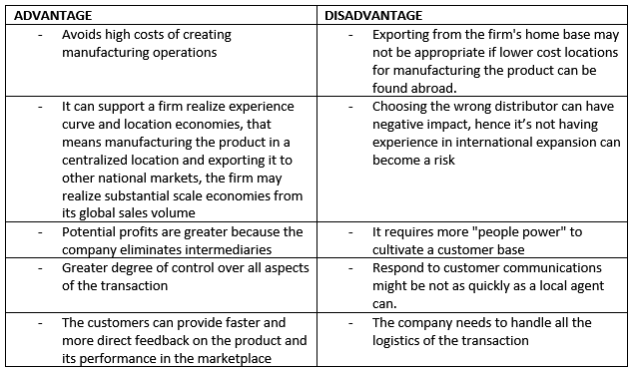
Figure 11 EXPORTING - ADVANTAGE / DISADVANTAGE
Based on the overview of advantages and disadvantages in Figure 11, it can be said that Exporting for Juan-Valdez to Austria could be a suitable strategy as the disadvantages listed above are not valid anymore to Juan-Valdez because:
- The Colombian coffee product can only be produced in Colombia due to the natural environment, therefore lower cost locations for producing is not possible.
- Due to already existing international businesses in Europe, including to Austria’s neighbouring country Germany, distributor- and logistics experience can be used and existing distributors to Germany might be utilized for Austrian expansion too.
- Due to Juan Valdez established customer service centers in Europe, a fast response to customer communication can be achieved.

6.2 LICENSING
A licensing agreement is an arrangement whereby a licensor grants the rights to intangible property to another entity (the licensee) for a specified period, and in return, the licensor receives a royalty fee from the licensee. (Hill, 2008) The license can be for a set of products or just a single product.
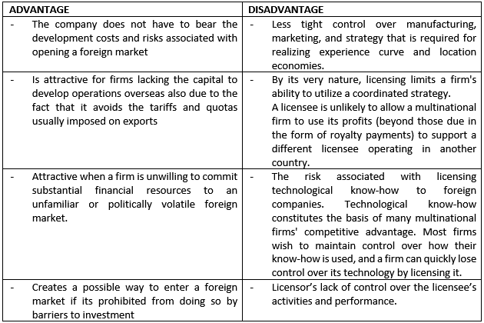
Figure 12 LICENSING - ADVANTAGE / DISADVANTAGE

6.3 FRANCHISING
Franchising is similar to licensing, although franchising tends to involve longer-term commitments than licensing. (Hill, 2008) Franchising can be seen as specialized form of licensing, where the franchiser is not only selling intangible property (trademark) to the franchisee but also requests that the franchisee agree to follow rigorous rules as to how it does business. The franchiser in many cases is supporting the franchisee to operate the business on a continues basis.
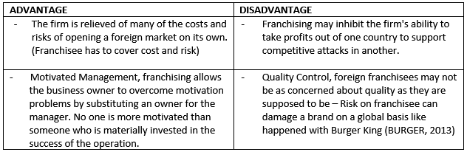
Figure 13 FRANCHISING - ADVANTAGES / DISADVANTAGES

Summarized, the following picture shows for the presented strategies its advantages and critical success factors:
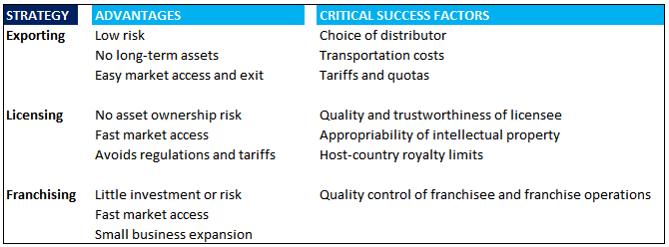
Figure 14 ENTRY STRATEGY - SUMMARY
Due to different marketing segmentations of Juan Valdez, it can be recommended to choose two strategies:
- Direct Exporting (export mode): To offer the coffee product directly to supermarkets, companies, hotels and café houses as already done in other countries (EXPORT-COFFEE, 2018), using logistics experience of expansion to Germany.
- Franchising (intermediate entry mode): To establish its Juan Valdez Stores in Austria.
In both cases, expansion experience abroad to Spain and Germany have shown success using those strategies (REUTERS, 2010). Furthermore, the Juan Valdez business model applied can be seen as non-complex repeatable business model for other countries and therefore Franchising could work well. (TRADESTART, 2018) In addition, the higher given responsibility to the Franchisee creates a good incentive for the franchisee to build a profitable operation as quickly as possible. Thus, using a franchising strategy, Juan Valdez can build a global presence quickly and at a relatively low cost and risk. It needs to be also mentioned that according to export.gov (EXPORT, 2017), the Austrian market is quite robust and friendly to franchise systems in general. There are a number of laws that govern the operation of franchises within the EU, but these laws are fairly broad and generally and do not constrain the competitive position of foreign businesses like Juan Valdez – reflecting the low legal risk as introduced in Chapter 4.2 and 5.

7.0 INTERNATIONAL MARKETING PLAN

7.1 SEGMENTATION - TARGETING – POSITIONING

The Austrian Market for Juan Valdez can be segmented in various groups:
GROUP I – HOME/OFFICE CONSUMER
Due to the strong coffee demand as outlined in the previous chapters, one segmentation group of customers are the ones who want to enjoy at home high quality coffee. Coffee is a way of life in Austria, and a distinct and essential part of local culture. (BUSINESS, 2018). Furthermore, in Austrian household’s, 49 percent prefer the high-quality filter coffee maker, followed by 26 percent whose coffee comes from capsule coffee machine. In addition, nine out of ten take their coffee in the workplace. In 36 percent of Austrian businesses, coffee is provided by the employer free of charge, according to the press release from MindTake Research. (MINDTAKE, 2014) Due to the high quality of Juan Valdez Coffee, recognized worldwide, that group of consumers would be a suitable segment. Based on this segmentation group, a suitable Target group for Juan Valdez Coffee product would be mid-high-class consumer buying their coffee in higher quality Austrian supermarket like Hofer, Billa and Merkur (SUPERMARKET, 2017) as well as organisations offering coffee to its employees, building a b-2-b relationship and using them as vehicle to reach also the fast-growing millennial work force (MILLENNIALS, 2017).
GROUP II – OUT OF HOME CONSUMER
The Austrian Coffee culture shows great demand for enjoying Coffee as an experience rather than as a simple process of drinking a hot beverage (MINDTAKE, 2014). 41 per cent of Austrian Coffee consumers like to drink their cup in café houses. Around a quarter prefer Cappuccino, while 14 percent each order a Latte Macchiato. (MINDTAKE, 2014) Juan Valdez Coffee Stores with its high-quality variation of coffee products can be a suitable experience offer for this segment of consumers. Therefore, the target group would be people in Austria who enjoy their high-quality coffee in cafes, preferable age between 25-54 as they are the biggest group (42%) according to cia.gov (AUSTRIA-AGE 2017). Positioning could be achieved by applying Marketing 3.0 (MARKETING 3.0), offering not just an exceptional coffee experience but sending also the message “we care too”, positioning its brand of containing highly values for an environmental fair coffee growing culture along with other topics that Austrians care for, e.g. the rising

breast cancer situation in Austria for woman age below 50 (CANCERINDEX, 2017), spending some of its global profits fighting that kind of disease and donating it to globally recognized research centers (CANCER.GOV).
GROUP III COFFEE HOUSES (COMPANIES)
Due to the large amount of traditional coffee houses in Austria, offering high quality coffee, Juan Valdez could offer its high-quality coffee direct from the plantation in Colombia. However, if focusing on all three GROUPS, Juan Valdez can be perceived as letting the competitor into “our café house” and therefore very difficult convincing that specific group III to order Juan Valdez Coffee. However, if the decision would be made to focus on GROUP I and not on -II, then it might be possible to succeed also with GROUP III – not being perceived as competitor.

7.2 GLOBAL MARKETING MIX

7.2.1 STANDARTIZATION VS ADAPTATION
It needs to be analysed if the 4Ps of the Marketing Mix (Price, Product, Promotion, Place) can be standardized applied or if it needs to be adapted to the Austrian Market.
FACTORS FAVORING STANDARDIZATION
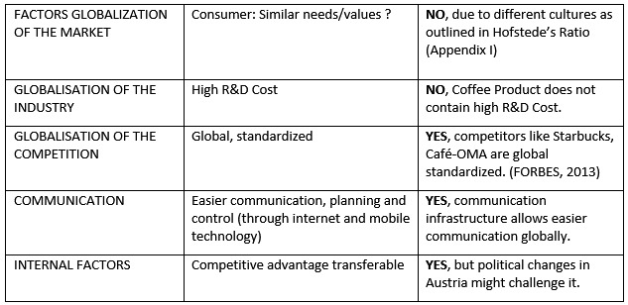
Figure 15 FACTORS FAVORING STANDARDIZATION

FACTORS FAVORING ADAPTATION
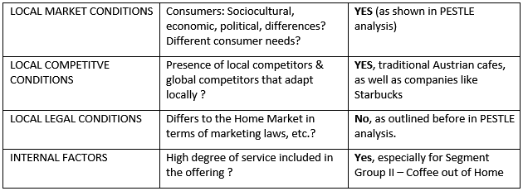
Figure 16 FACTORS FAVORING ADAPTATION

Based on the above analysis, it can be recommended to standardize the sales process using an electronic key account management system to gain a competitive advantage in Austria by being able to build close relationships with the customers and being able to react faster to market trends. Communication should be standardized through usage of internet and mobile technology. Adaptation is needed in the Product experience due to different local market condition, local competitive condition, and internal factors. The results of the analysis need to be incorporated into the application of the correct 4Ps approach in Austria.
Adapt Sales process to Juan Valdez Stores to the preferment tastes of consumer group II in Austria (TASTEAUSTRIA, 2017).

Adapt Price to reflect the high-quality product and also to match the price elasticity situation in Austria (ICO, 2018). Price level should stay high, matching the economic situation in Austria, which is by far different to the home Columbian economic situation (PESTEL, Chapter 4.2 + AUSTRIA-PRICING, 2017)
Below at Figure 17 can be seen a visual draft for a Marketing Approach how Juan Valdez can act in Austria. It shows the products and where they have the potential to be sold with what message. It will be further explained in the below 4P definition.
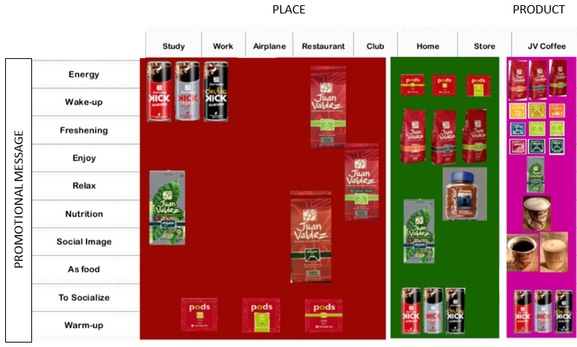
Figure 17 MARKETING APPROACH MATRIX AUSTRIA

7.2.2 PRODUCT
Global franchising is successful, in part, because it relies on recognized brand value. However, when a franchise moves across cultures, the value of its brand can diminish if the brand fails to make local modifications. (MARKETING CULTURE, 2004) For example, Starbucks has shown its Product-Adaptation well to franchising because it is offering "multi-local" beverages (light, lactose-free, goat-milk, etc.)

GROUP I - HOME/OFFICE CONSUMER
When focusing on the Home/Office consumer, there are certain products partially to be adjusted to the Austrian Market. Instant coffee and pads special combined with latest ice-coffee products (not offered in Colombia because of low demand) serving the younger millennial consumer and Start-up companies who often give coffee for free to their employees and also employ a higher number of millennials (STARTUP-AUSTRIA, 2017). Whereas to the traditional mid age consumer and traditional companies could be served with the high quality traditional coffee products.

Juan Valdez can also create an Austrian consumer panel to choose best packaging motives, apply “co-creating” with its consumer and start to create a “love affair” with them (FIRMS OF ENDEARMENT 2014)
GROUP II - OUT OF HOME
The focus to this group is not only on the various types of coffee but rather more on the presentation. Instead of serving plastic cups as in Colombia, it should be used higher quality cups and -serving dishes reflecting the demand for high quality ambient as in established coffee houses (AUSTRIA-COFFEEHOUSE, 2017). It is more the overall experience than just the coffee product that counts for this group.
In addition, Colombian cakes could be sold as Product, adjusted to the Austrian market (AUSTRIA-COFFEEHOUSE, 2017) - meaning cakes are not sold yet in Colombia’s Juan Valdez Stores but belong to an Austrian café house experience and therefore a coffee product (experience) adaption for Juan Valdez is needed.
Further products that could be sold along in the Austrian Juan Valdez store are cups, books about the coffee growing areas in Colombia and about the country in general too - creating also an educational experience and add to the competitive advantage - not offered by its Austrian rivals. In addition, it would also support Colombian tourism, which is one of the most under rated sectors in the country (TRAVEL, 2017).
GROUP III - CAFÉ HOUSE COMPANIES
The focus towards this group lays in high quality coffee beans in bulks rather than in eye-catching packaging, offering a higher-quality coffee product than the one typical café houses use today (COFFEEGUIDE, 2017).

7.2.3 PLACE

GROUP I - HOME/OFFICE CONSUMER
For the Office Consumer that would be within companies where they work, e.g. coffee corners but that could be also to provide a special mini Juan-Valdez corner/island maintained by Juan Valdez Staff inside the company. For Home consumer that prefer enjoy at home their Coffee, purchasing place would by either a distributor (supermarket) or an online e-commerce shop / mobile app and also via phone for the elderly traditional clients who are not familiar with the internet to show them “we care too for you”.
GROUP II - OUT OF HOME
That would be the Juan Valdez Stores. To adapt to Austria, those stores should be in comparison to Colombia reflect the different needs of Austrian customers. That means, using high quality dishes to present the products and high-quality furnisher. Furthermore, it should be located in city centres rather than in places with low number of inhabitants, focusing on Vienna, Salzburg, Graz, Innsbruck as being the biggest Austrian cities with rich traditional cafe house history. (AUSTRIA-COFFEEHOUSE, 2017)
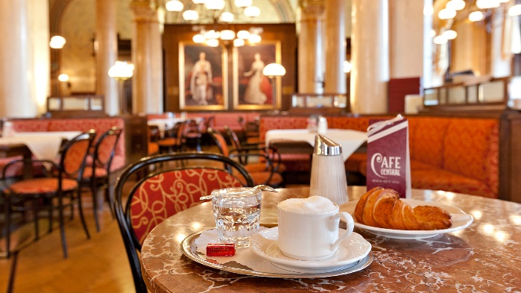
Figure 18 TYPICAL JUAN VALDEZ COFFEE PLACE COLOMBIA vs TYPICAL AUSTRIAN COFFEE PLACE

GROUP III - CAFÉ HOUSE
The place for café houses is in Austria spread over the big cities mentioned for Group II and should be able to order electronic (website, mobile, landline, mobile app) and should also have a dedicated Key Account Manager assigned from Juan Valdez to create a more personalized relationship.

7.2.4 PROMOTION
Juan-Valdez could be using its globally brand of positioning itself to the target groups I, II and III of not just offering one the highest quality of coffee worldwide but also by showing the great working conditions for the farmers where the coffee beans come from in Colombia and the difference Juan Valdez does for fair grown coffee (FAIRTRADE, 2017), showing the consumers “we care too” and by doing so applying Marketing 3.0 by Philip Kotler. (MARKETING 3.0)
GROUP I - HOME/OFFICE CONSUMER
There are different ways to promote to this group. The goal should be to create a love affair with its customer (FIRMS OF ENDEARMENT 2014), engaging with the clients for Co-Creation (Forbes, 2016).
There could be the following promotional activities:
- Online, create marketing campaigns over the internet to reach the always connected millennials (CONNECTED, 2015). Establish a presence at Facebook, Twitter, Instagram and on those platforms engage with the consumer - achieve Co-Creation, e.g. ask for feedback on coffee taste or also on packaging for example what packaging should look like to appeal to them most or ask their opinion on a possible reward program introduction. Also create a commercial campaign. Co-create with the consumer is possible like other companies as Nokia or Deutsche Bank have done successfully before. (MARKETING-JOURNAL, 2015)
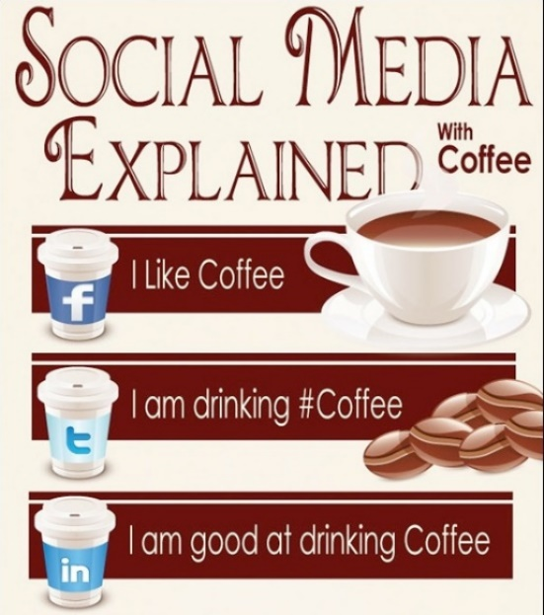
Figure 19 PROMOTION-INTERNET
Supported is that promotion channel by the excellent e-Commerce environment in Austria (AUSTRIA-ECOMMERCE, 2017)
- Create flyers and send them specific to start-up companies to reach this target group at work where they are present around 210 days a year (20 days x 12 month – 30 days’ vacation).
GROUP II - OUT OF HOME
To promote to this group, the Juan Valdez stores needs to be build first and while it’s been build the promotion activities should already start to prepare the target group that there will be a better Café House in town soon. Similar, like Apple does when its promoting its brand-new products 2-3 month before its actually gets shipped to the client. Create a pre-demand (FORBES-DEMAND, 2016).
Further Activities to this Group can be:
- Flyers different structured (incl. print on high quality paper) than for Target Group I to reflect the needs of those kind of consumer who are majority mid-age traditional value clients and directly given to them when they arrive- or leave a café house - to show them there will be soon a better option to enjoy café.
- Use agencies like JCDECAUX (JCDECAUX 2018) to book special commercial messages delivered at for example electronic modern bill boards at bus stops (at rush hour where most people are on the way), train station and traditional print media (Die Presse or Der Kurier) who the target group is reading most.
- Apply Sensory Branding (HOLLENSEN 2014) - sensory perception can have a direct impact on purchasing decision. Smell (aroma of coffee and -of the air within the store) as one sense for example should be customized towards an increase in enriching coffee experience. Adaptation is needed as Smell is perceived differently between different cultures. One example would be the car industries using a distinct smell in their cars - leather smells spread into a car for example are perceived by European as being a luxurious car whereas Indians don’t like the smell (WP 2010).
- Create a distinct TV ad to reach the traditional mid-age client at home while watching TV during the evening program.
GROUP III - CAFÉ HOUSE
- For this specific group, it can be recommended to use brochures and apps/websites with specific technic café parameters listed, showing the high global quality combined with reflecting the capability facts of being able to deliver 24/7 and having direct key account managers being able to handle all relations most professionally. Additionally, provide a reference list to whom Juan Valdez already delivers to in e.g. Germany. The goal is to create a brand image of being not just a high-quality coffee brand but also being high reliable and professional business customer oriented as those values are important to show when being a Latin American Company, who often have to fight against an image of being seen as more laid back (LATIN, 2015).

7.2.5 PRICE

According to Svend Hollensen (HOLLENSEN, 2014) there are nine factors that influence the sensitivity of customers to prices:
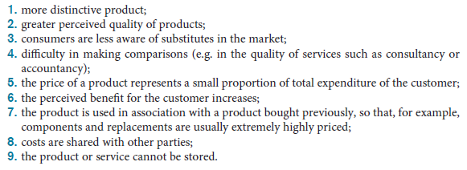
Figure 20 PRICE-INFLUENCE-SENSITIVITY-FACTORS
Juan Valdez fulfils factor 1 and 5, and needs to work towards factor 2, 3 and 6 in order to justify the premium price approach to its target groups in Austria.
GROUP I - HOME/OFFICE CONSUMER
The price should be defined based on the café price for high quality café in Austria (ICO 2018) and therefore would be different (adapted) to the price in the Colombian home market due to economic differences, outlined in PESTLE, chapter 4.2. Seasonal price offers should be applied to stimulate demand (SEASONAL PRICING, 2016).
GROUP II - OUT OF HOME
Since the focus is on a high-quality coffee experience, the price should reflect it and be in the range of café houses in Austria, applying “Market-Pricing” (HOLLENSEN, 2014). The customer would be confused to receive a high-quality café for 1 Euro. The perception would be not as high-quality brand but as low quality because quality in a product needs to be also reflected in the price, which with 1 Euro cannot be achieved. (PRICE-QUALITY-INFERENCE-THEORY, 2015)
GROUP III - CAFÉ HOUSE
The price for this group should be oriented at wholesale price and not retail price as the amount of coffee beans delivered are in kilo bulks rather than in single packages. Therefore, a volume discount scheme should be developed along with early payment discounts. Seasonal special prices should also be incorporated to offer a variety of price options to the traditional café house companies.

8.0 CONCLUSION

This international Business Plan for Juan Valdez was created to analyse the necessary steps to expand its business to Austria. For that task, it was examined first the foreign market conditions which included a country profile view, an applied PESTEL method and insights from the coffee market globally and specifically for Austria. In addition, a Risk Assessment was conducted. The result of this feasibility analysis concluded in the favourable outcome to expand business to Austria.
In further chapters, various market entry strategies were presented and concluded that a mix strategy was recommended, direct export for the coffee product and franchising for the Juan Valdez Coffee Stores.
An international Marketing Plan was subsequently developed, with the selections of three main target groups (Home/Office Consumer, Out of Home, Café House). According to those target groups, a global marketing mix was created - showing that an adaptation in Product, Place, Promotion and Price is necessary due to different target consumer needs and -situations. Applying the presented Business Plan gives Juan Valdez the possibility to expand its Business successfully to Austria.

9.0 RECOMMENDATION

Despite the detailed international business plan to expand to Austria, it is recommended that Juan Valdez should take the following steps before starting to execute its expansion to Austria:
- Human Resources (HR) Strategy: Develop an international HR strategy (HILL, 2008), which includes: Staffing Policies (ethnocentric/polycentric/geocentric), Expatriate Policy, Development Programs for its international Managers in terms to address Austrian Cultural-/Language-/Practical-/Ethical Training, International Guidelines for Performance Appraisal and also for Compensation Plans, International Talent Programs.
- Accounting reconciliation strategy: In order to comply with financial laws and therefore to harmonize Accounting standards, Juan Valdez needs to do an analysis on how to comply to Austrian local accounting standards as Colombian Accounting standards may differ (rule-based vs principle-based reflected in e.g. different consolidation of financial information).
- Exit Strategy: Although the analysis showed a prosper way for Juan Valdez to succeed in Austria, it should still have a plan in case things don’t go as intended (e.g. because if the Political Risk as introduced before, would develop an even further protectionism and cancel the free trade agreement with Colombia). A well-defined exit strategy is improving the likelihood of success, decreasing the time to exit and notably increase the ultimate exit valuation.
- Currency Exchange strategy: Due to the devaluation of Colombian Peso as home currency for Juan Valdez versus the Euro used in Austria, an appropriate exchange strategy needs to be developed. Important to access the three Vs: amount of money that is exposed (volume), how quickly the exchange rate may move (velocity) and the impact of potential rate fluctuations (volatility). Hedging possibilities need to be determined.
- Finance implication: A detailed financial analysis should be undertaken, meaning for the expansion project to Austria it should be calculated the NPV, Break-Even Analysis, P&L-, Balance Sheet- and Cash Flow impact. The result should give insights if Juan Valdez can afford (and to which extend) to expand to Austria as presented in this International Business Plan.

APPENDIX I TRADE FREEDOM- INVESTMENT FREEDOM INDEX

TRADE FREEDOM INDEX (SOURCE: ECONOMIC FREEDOM 2017)
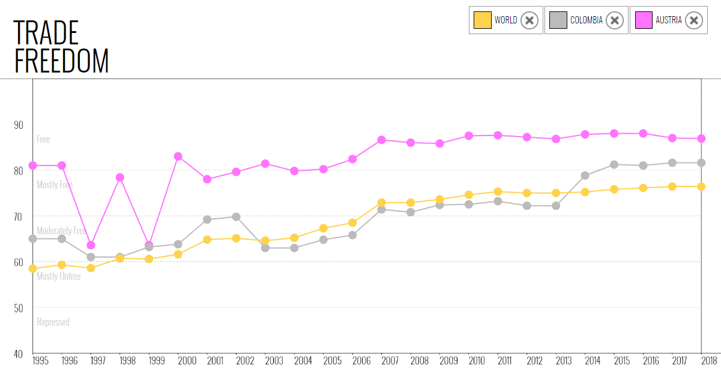
Figure 21 TRADE FREEDOM INDEX

INVESTMENT FREEDOM INDEX (SOURCE: ECONOMIC FREEDOM 2017)
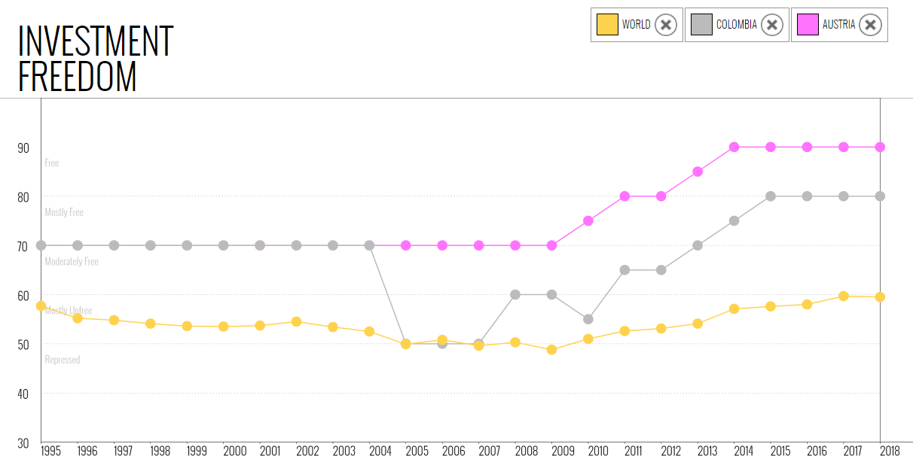
Figure 22 INVESTMENT FREEDOM INDEX

APPENDIX II CULTURE DIFFERENCES
Culture Risk – Hofstede’s Ratio (Source: HRI 2018)
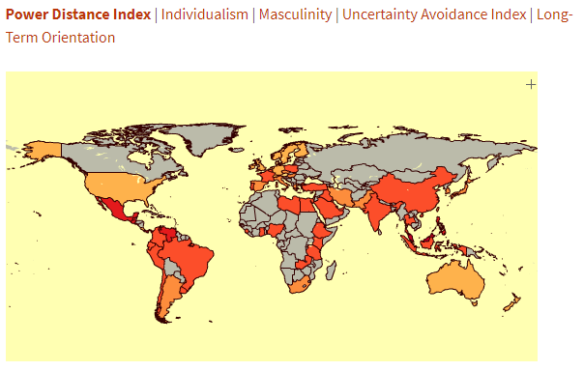
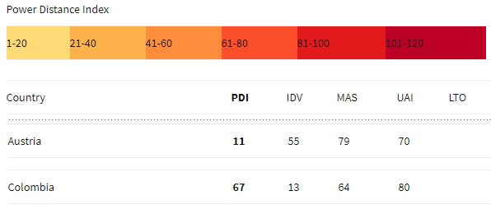

Figure 23 HOFSTEDES CULTURE DIFFERENCES

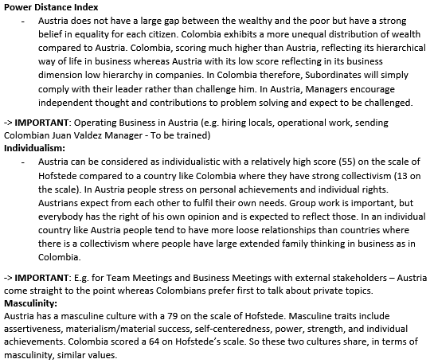

REFERENCES:

- ABN, 2018, Global Protectionism available at: https://insights.abnamro.nl/en/2018/03/global-trade-watch-global-trade-has-firmed-but-risks-are-rising/ [accessed at 02/03/2018]

- AUSTRIA, 2017, Make Austria great again, available at: http://www.dw.com/en/make-austria-great-again-the-rapid-rise-of-sebastian-kurz/a-40313720 [accessed at 02/10/2018]

- AUSTRIA-AGE 2017, Austria facts, available at: https://www.cia.gov/library/publications/resources/the-world-factbook/geos/au.html
[accessed at 02/09/2018]

- AUSTRIA-COFFEEHOUSE, 2017, Coffeehouse Culture Austria, available at: https://www.austria.info/us/activities/culture-traditions/cherrished-traditions/coffeehouse-culture-in-austria [accessed at 03/09/2018]

- AUSTRIA-ECOMMERCE, 2017, E-Commerce situation in Austria, available at: https://www.export.gov/article?id=Austria-eCommerce [accessed at 03/19/2018]

- AUSTRIA-PRICING, 2017, Pricing Situation Austria, available at: https://www.export.gov/article?id=Austria-Pricing [accessed at 03/07/2018]

- BALANCE.com, available at: https://www.thebalance.com/direct-exporting-advantages-and-disadvantages-1953310 [accessed 02.04.2018]

- BURGER, 2013, available at: https://www.theguardian.com/business/2013/jan/31/burger-king-horsemeat [accessed 03.01.2018]

- BUSINESS 2018, available at: http://www.businessinsider.com/coffee-culture-in-vienna-history-2015-10 [accessed at 02/25/2018]

- CANCER.GOV, Breast Cancer Research Centers, available at: https://www.cancer.gov/types/breast/research [accessed at 03/19/2018]

- CANCERINDEX 2017, available at: http://www.cancerindex.org/Austria [accessed at 03/04/2018]

- COFFEE GUIDE 2017, The Coffee Guide, available at: http://www.thecoffeeguide.org/coffee-guide/the-markets-for-coffee/Europe-European-Union-Summary/ [accessed at 03/28/2018]

- COMPANY 2018, available at: http://www.juanvaldezcafe.com/index.php/news/post/177
[accessed 03.10.2018]

- CONNECTED 2015, The always connected generation, available at: https://www.researchgate.net/publication/274220555_The_'always_connected'_generation
[accessed 03.19.2018]

- CORRUPTION 2017, Corruption Index, available at https://www.ris.bka.gv.at/defaultEn.aspx [accessed at 04/05/2018]

- DERESKY, Helen Deresky, International Management 8th Edition, Pearson, page 236

- ECONOMIC FREEDOM, available at: https://www.heritage.org/index/visualize?cnts=austria|colombia&src=ranking
[accessed at 04/07/2018]

- ETHZ, Swiss Institute of Technology in Zurich - Economic data, available at: https://www.ethz.ch/en.html [accessed at 04/14/2018]

- EXPORT 2017, Austria-Franchising, available at: https://www.export.gov/article?id=Austria-Franchising, [accessed at 04/02/2018]

- EXPORT-COFFEE 2018, Juan Valdez at Walmart USA, available at: https://www.walmart.com/ip/Juan-Valdez-Gourmet-Selection-Ground-Coffee-10-oz/54407801 [accessed at 03/10/2018]

- FAIRTRADE 2017, Farmer Coffee Fair Trade, available at: https://www.fairtrade.org.uk/Farmers-and-Workers/Coffee [accessed at 03/28/2018]

- FIRMS OF ENDEARMENT 2014 - Sisodia/Sheth, Firms of Endearment: How World-Class Companies Profit from Passion and Purpose 2nd Edition, Pearson FT Press; (February 19, 2014)

- FORBES 2013, Starbucks Winning Strategy, available at: https://www.forbes.com/sites/panosmourdoukoutas/2013/04/20/starbucks-and-mcdonalds-winning-strategy/#741800adb5 [accessed at 04/09/2018]

- FORBES 2016, Customer Co-Creation Is The Secret Sauce To Success, available at: https://www.forbes.com/sites/christinecrandell/2016/06/10/customer_cocreation_secret_sauce/#2c3af0e85b6d [accessed at 04/02/2018]

- FORBES 2017, Motivating Employees Should Be One of a Leaders Top Priorities, available at: https://www.forbes.com/sites/williamcraig/2017/06/20/motivating-employees-should-be-one-of-a-leaders-top-priorities/#7d2806b01d7d [accessed at 03/23/2018]

- FORBES-DEMAND 2016, Create A Demand, available at: https://www.forbes.com/sites/sujanpatel/2016/10/22/create-a-demand-for-a-new-product/#66a0723a7e2d [accessed at 04/07/2018]

- HILL, 2008 - Charles W. L. Hill International business_ competing in the global marketplace 2008, UNIVERSITY OF WASHINGTON, McGraw-Hill/Irwin, page 628-652

- HRI 2018, Hofstede’s Ratio Index, available at: www.clearlycultural.com/geert-hofstede-cultural-dimensions/power-distance-index/ [accessed at 02/10/2018]

- HOLLENSEN 2014, Svend Hollensen, Global Marketing, 6th Edition, Pearson, page 512-539

- ICO 2018, Coffee Market Report, available at: http://www.ico.org/Market-Report-17-18-e.asp [accessed at 02/09/2018]

- IMD 2017, IMD 2017 WORLD COMPETITIVE CENTER, World Competitive Yearbook 2017, available at: www.imd.com [accessed at 02/10/2018]

- JCDECAUX 2018, available at: www.jcdecaux.com [accessed at 04/08/2018]

- LATIN, 2015, What do Latin American countries think, available at: https://www.quora.com/What-do-Latin-American-countries-think-of-each-other [accessed at 04/10/2018]

- LEGAL 2018, available at: https://en.portal.santandertrade.com/establish-overseas/austria/legal-environment, [accessed at 02/25/2018]

- MARKETING 3.0, Philip Kotler, From Products to Customers to the Human Spirit, John Wiley & Sons, Mar 30, 2010, page 127-142

- MARKETING CULTURE, 2004, Marketing Across Cultures, Fons Trompenaars and Peter Woolliams, Capstone; 1 edition (September 24, 2004), page 234-247
- MARKETING-JOURNAL, 2015, Collaboration and Co-Creation, available at: http://www.marketingjournal.org/collaboration-and-co-creation-the-road-to-creating-value/
[accessed at 03/27/2018]

- MINDTAKE 2014, COFFEE IN AUSTRIAN SOCIETY, available at: https://www.thelocal.at/20141118/92-percent-of-austrians-drink-coffee [accessed at 04/02/2018]

- MILLENNIALS 2017, Millennials Are To Rule The Workforce By 2020, available at: https://magazine.startus.cc/millennials-rule-workforce-2020-infographic/
[accessed at 04/07/2018]

- POLITICAL RISK, 2017, Statement, available at: https://www.investmentweek.co.uk/investment-week/news/3019235/political-shift-in-europe-as-kurz-elected-chancellor, [accessed at 02/07/2018]

- PRICE-QUALITY-INFERENCE-THEORY, 2015, Impact of “High Quality, Low Price” Appeal on Consumer Evaluations, available at: https://www.tandfonline.com/doi/full/10.1080/10496491.2015.1088922 [accessed at 04/04/2018]

- REUTERS, 2008 Juan Valdez Spain, available at: https://www.reuters.com/article/colombia-coffee-stores-idAFN0425104120100304 [accessed at 03/30/2018]

- SEASONAL PRICING 2016, SEASONAL PRICING: A CLEVER STRATEGY, available at: https://www.americanexpress.com/us/small-business/openforum/articles/why-seasonal-pricing-may-help-bring-in-sales-during-slow-seasons/ [accessed at 03/22/2018]

- STARTUP-AUSTRIA, 2017, Start-up Companies in Austria, available at: https://investinaustria.at/en/blog/2017/05/being-a-startup-in-austria.php
[accessed at 04/02/2018]

- STATISTA 2017, Statistics, available at: https://www.statista.com/outlook/30010000/128/coffee/austria [accessed at 02/02/2018]

- SUPERMARKET 2017, Supermarkets in Austria, available at: http://www.visitingvienna.com/eatingdrinking/supermarkets/ [accessed at 04/01/2018]

- TASTEAUSTRIA 2017, Coffee Taste Austria, available at: http://www.tasteofaustria.org/coffee [accessed at 04/07/2018]

- TRADE 2017, available at: http://trade.ec.europa.eu/doclib/press/index.cfm?id=953
[accessed at 02/11/2018]

- TRADESTART, 2018, available at: http://www.tradestart.ca/market-entry-strategies
[accessed 03/05/2018]

- TRAVEL, 2017, Colombia-Underrated-Destination, available at: https://www.intrepidtravel.com/adventures/colombia-underrated-destination
[accessed at 04/09/2018]

- WHO 2016, Trends in Globalization, available at: https://www.wto.org/english/res_e/booksp_e/anrep_e/wtr16-2b_e.pdf [accessed at 04/07/2018]

- WHO 2017, available at: http://www.who.int/whr/2000/media_centre/press_release/en/ [accessed at 02/10/2018]

- WP 2010, Love the new-car smell, available at: http://www.washingtonpost.com/wp-dyn/content/article/2010/09/25/AR2010092500500.html [accessed at 04/12/2018]

