
Experimental data analysis
ACCB4002

Jake Rosser
ros19845214
2nd April 2022

Contents
Introduction 2
Frequencies 4
Mean 4
Mode 4
Median 6
Minimum 7
Maximum 8
Hypothesis 8
Null Hypothesis 8
Alternative Hypothesis 9
Proving Hypothesis – T test 9
Outliers 9
T-Test results without outliers 11
Mean, Mode, Median, Minimum and Maximum without outliers 11
Other Factors that may have changed results 12
Conclusion 12
Bibliography 13

Introduction
Class test results were taken on 40 year 5 students who are learning math concepts during primary school. They were made to take the test twice, once with just the knowledge they have and a second time with assistance of a learning app which was made to help the students learn mathematics. Analysis of this data shall be done to prove if the app in discussion actually does help students learn mathematics or is it a waste of funding.
This report shall provide a description of the data with a set of statistics, a testable hypothesis for the test, the actual testing of the hypothesis against three significance levels being 0.10, 0.5 and 0.01 and report on when the hypothesis is accepted.

student | Test score before using app | Test Score after using app
1 | 12 | 14
2 | 9 | 9
3 | 8 | 10
4 | 9 | 11
5 | 12 | 15
6 | 14 | 15
7 | 15 | 15
8 | 17 | 10
9 | 18 | 20
10 | 15 | 20
11 | 14 | 18
12 | 14 | 16
13 | 14 | 17
14 | 12 | 14
15 | 10 | 20
16 | 11 | 15
17 | 8 | 4
18 | 7 | 10
19 | 6 | 11
20 | 6 | 19
21 | 5 | 16
22 | 17 | 17
23 | 19 | 19
24 | 20 | 18
25 | 17 | 20
26 | 16 | 19
27 | 17 | 20
28 | 12 | 14
29 | 13 | 14
30 | 11 | 13
31 | 12 | 12
32 | 6 | 9
33 | 8 | 20
34 | 10 | 17
35 | 15 | 17
36 | 17 | 17
37 | 17 | 19
38 | 18 | 20
39 | 12 | 13
40 | 17 | 15

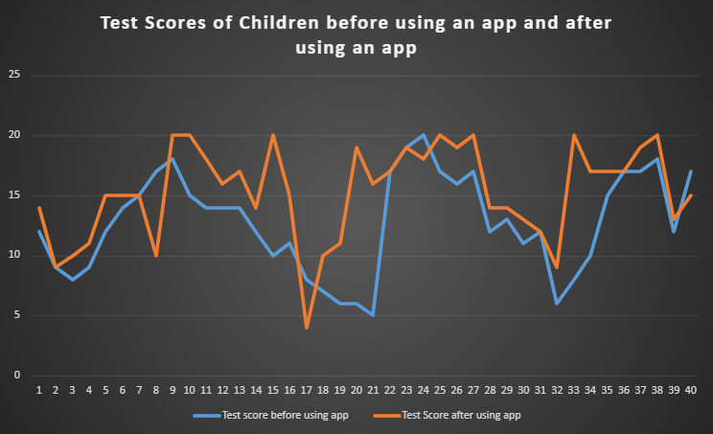

Frequencies

Mean

The mean is the average for a set of numbers, what you will do is add up all the numbers in the total set, then divide the added sum by the amount of original numbers they were. [1] Meaning that a higher mean value is better as it means the overall test scores were higher.
Comparing the mean for adding up the test scores before and then after using the app shows that there was an increase in the total mean value of 2.55. Proving that the application is working.
 | Mean
Before | 12.75
After | 15.3
Difference | 2.55

Mode

The mode is the value that appears within the data set the most in the data set, sometimes data sets have more than one mode or none at all. Having a mode will show you the most common result in a group of data, so having a large value usually determines the average result is more around that value. [2]
Comparing the results for before and after, you can see that the after results the mod value has gone up by 3. Showing that the overall most common result for the students to get has increased meaning they are improving more with the work that gets done.
 | Mode
Before | 17
After | 20
Difference | 3

Median
The median is the middle number in a data set when all the numbers are set in an ascending or descending order, medians can usually show the data average better than the mean as the mean may have outliers that can skew the values of the mean data. [3]
Comparing the median to the first attempt to the second attempt of doing the test you can see there is an increase from before and after of a value of three. This also proves that the test in question of if the application helps is currently getting proven.
 | Median
Before | 12.5
After | 15.5
Difference | 3

Minimum

The minimum means the smallest value, out of all values in the data sets you will want to find the smallest value and that is the minimum, so having a larger minimum value is better. However comparing both before the app and after the app you can see that the minimum was actually higher on before using the app by one, this is what we could assess to be an outlier and someone who may have not used the app.
 | Minimum
Before | 5
After | 4
Difference | -1

Maximum

The maximum is very similar to the minimum, but this value looks for the highest number in the data set and similar to minimum you will want it to be the higher number as the higher total number the better. Comparing the maximum in both data sets shows there is 0 difference in the maximum as they are both at the top score, being 20.
 | Maximum
Before | 20
After | 20
Difference | 0

Hypothesis
The Hypothesis is what the user predicts what will happen during a study, for this case it is either if the app does indeed help the users or if it’s just random luck and there is no significant proof that the app does indeed help. There are two types of forms, the null hypothesis and the alternative hypothesis. Both hypothesizes can be challenged and proven to either be correct or incorrect. [4]

Null Hypothesis
The null hypothesis is when the study attempts to get disproven as incorrect information, such as in this study it means that the application didn’t help the children learn during mathematics quiz, the null hypothesis is when there is no statistical relationship and significance between the two sets of data. [5] If the hypothesis is incorrect then you would list it as a H0 Hypothesis.

Alternative Hypothesis
The alternative hypothesis is when the null hypothesis gets disproven and the study and data in question has proved to follow the hypothesis that was firstly queried. The symbol that is used when the hypothesis is alternative is H1.

Proving Hypothesis – T test
Using P values and T-Testing, you can see that the value that was presented after calculating everything, the answer when you would have a one tailed answer would be 8.62016E-05, which is above the three freedom levels of 0.1, 0.05, 0.01 that means the one tailed answer is smaller than the three different p values provided meaning the null hypothesis is incorrect and the alternative hypothesis is the correct hypothesis and the children did learn with the app.
However, if you were to use two tails in your hypothesis you would get the answer 0.000172403, which is still below the three freedom levels so that means that the alternative hypothesis can be trusted while the null hypothesis cannot be trusted.

Outliers
Outliers are data points that are far from all other data points. They don’t really fit well into the data set that was provided. [6] Using interquartile range (IQR) you can exclude the first sets of numbers that are in the lower part of the data group between the Minimum and the Q1 section. And removing the ones that seem too high to be apart of the main calculations, being the ones between the Q3 and the Maximum.
IQR - Before | IQR - After
5 | 4
9.75 | 13
12.5 | 15.5
17 | 19
20 | 20

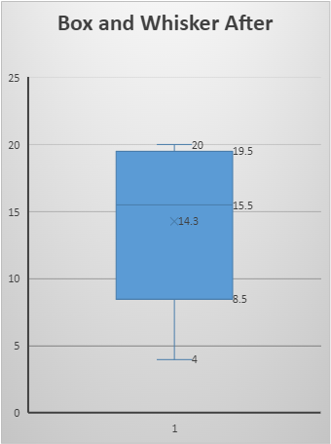
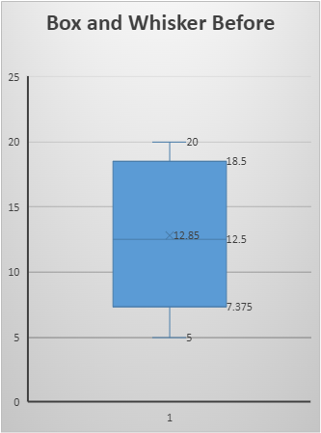
When comparing both data sets, when removing outliers if you were to remove one on one section you would have to remove it on the other section too as the data results are combined sets of data. This means that any student that scored below 11 which is the average of both first quartiles added together then divided by two and any data above 18 which is between the two numbers would be removed from the data sets too.
number | student (outliers removed) | Test score before using app | Test Score after using app
1 | 1 | 12 | 14
2 | 5 | 12 | 15
3 | 6 | 14 | 15
4 | 7 | 15 | 15
5 | 11 | 14 | 18
6 | 12 | 14 | 16
7 | 13 | 14 | 17
8 | 14 | 12 | 14
9 | 16 | 11 | 15
10 | 22 | 17 | 17
11 | 28 | 12 | 14
12 | 29 | 13 | 14
13 | 30 | 11 | 13
14 | 31 | 12 | 12
15 | 35 | 15 | 17
16 | 36 | 17 | 17
17 | 39 | 12 | 13
18 | 40 | 17 | 15

After the outliers are removed, the number of students gets put down to 18.

T-Test results without outliers
Now that the outliers have been removed, the T-Test can be done once again to see if the results are different. After calculating the results, it shows that the alternative hypothesis is still the correct set of data by a long shot as the one tailed comes to 0.000355164 which is a lot smaller than 0.01 which is the lowest P value given and the two tailed comes to 0.000710327 which again is a lot lower than the p values set of 0.1, 0.05 and 0.01 which means the alternative hypothesis can be trusted and the app has helped children learn mathematics more.
 | T-Test
One Tail | 0.000355164
Two Tailed | 0.000710327

Mean, Mode, Median, Minimum and Maximum without outliers
The mode, mean, median, minimum and maximum have also changed with these new sets of data without any outliers. The mean’s results have increased in before by around 0.7 going from 12.75 to 13.55, while it has decreased in the after results by 0.25, going from 15.3 to 15.05 respectively.
 | Mean
Before | 13.55556
After | 15.05556
Difference | 1.5

The mode has gone down a lot as a lot of the outliers within the higher ups has been removed due to their numbers being above the limits set for the outliers. Meaning the mods values have both gone down. From before being 17 down to 12 and after being 20 going down to 15.
 | Mode
Before | 12
After | 15
Difference | 3
 | Median
Before | 13.5
After | 15
Difference | 1.5
The median’s changes are one of the smallest changes as the middle ground numbers weren’t really changed when the outliers were in or out of the scenario. Both sitting around 13-15 area with the outliers before and after being 12.5 and 15.5 respectively and without the outliers it was 13.5 and 15 which isn’t a noticeable enough change.

The minimum and maximum were some of the larger changes as both the top and bottom outliers are gone which means a smaller pool for the largest and smallest numbers to be in. The minimum overall was at 11, which is the lowest number within the gap set possible and same goes for the maximum being at the highest number that was declared possible being 18.
 | Minimum
Before | 11
After | 12
Difference | 1
 | Maximum
Before | 17
After | 18
Difference | 1

Other Factors that may have changed results
There are many other factors that can affect and change the results of the test, one good example is that the test was only taken with 40 students and doing it with an entire school of around 600 people who are all doing maths would allow you to get a broader data set that can give you a set conclusion without having to rely on such as small data set. Having different teachers with different learning schemes could also vary the results as they may teach in ways that the students find it hard to grasp.

Conclusion
As a conclusion with the data set provided and the calculations done, it can be proven that using the app the school provided does indeed help with test results, with the means and average of the result is higher the students used the app. Using the T-Test as proof you can see even comparing it to all freedom levels the p value was significantly lower than all three showing that the alternative hypothesis was the correct statement and the app helped the students.

Bibliography

[1] | A. Harris, "Define Mean for Math," Sciencing, 24th April 2017. [Online]. Available: https://sciencing.com/define-mean-math-5412437.html. [Accessed 21st March 2022].
[2] | A. Hayes, "Mode," Investopedia, 21st October 2021. [Online]. Available: https://www.investopedia.com/terms/m/mode.asp. [Accessed 21st March 2022].
[3] | A. Ganti, "Median," Investopedia, 30th October 2021. [Online]. Available: https://www.investopedia.com/terms/m/median.asp#:~:text=Key%20Takeaways-,The%20median%20is%20the%20middle%20number%20in%20a%20sorted%2C%20ascending,the%20average%20of%20the%20values.. [Accessed 21st March 2022].
[4] | S. McLeod, "What is a hypothesis?," SimplyPsychology, 16th December 2021. [Online]. Available: https://www.simplypsychology.org/what-is-a-hypotheses.html. [Accessed 30th March 2022].
[5] | S. K. Haldar, "Null Hypothesis," ScienceDirect, 18th July 2018. [Online]. Available: https://www.sciencedirect.com/topics/earth-and-planetary-sciences/null-hypothesis#:~:text=The%20null%20hypothesis%20is%20a,observed%20data%20and%20measured%20phenomena.. [Accessed 30th March 2022].
[6] | J. Frost, "5 Ways to Find Outliers in Your Data," Statistics By Jim, n.d. [Online]. Available: https://statisticsbyjim.com/basics/outliers/. [Accessed 2nd April 2022].

