Develop devices for the field-testing non-engineered materials and techniques for earthquake resistant construction

HND Mechanical Engineering | 09/10/19 | Matthew permintella

Contents

1.0 Introduction……………………………………………………………Page 2

2.0 Project objectives…………………………………………………….Page 2

3.0 Team organization……………………………………………………Page 2

4.0 Project plan……………………………………………………………Page 3

5.0 Project research ………………………………………………………Page 4-18

6.0 Design specifications…………………………………………………Page 19

7.0 Concept design………………………………………………………..Page 20

8.0 Cost analysis…………………………………………………………..Page 20

9.0 Bibliography…………………………………………………………....Page 21-22

10.0 Appendix………………………………………………………………Page 23

1.0 Introduction

To design & build a device to field test non-engineered materials utilized in construction in Nepal, the devices will test compression, bending, and uniaxial loading. Research will be carried out into techniques for earthquake resistant construction.

2.0 Project objectives

- Design and build device to field test non-engineered materials, implement 1 device per region to help Nepal communities.
- Research building techniques for seismic resistant construction.

3.0 Team organization

Project manager / Design – Matthew Permintella
Infrastructure engineer – Jack Andrews
Environmental engineer – Solomon Thomas

4.0 Project plan
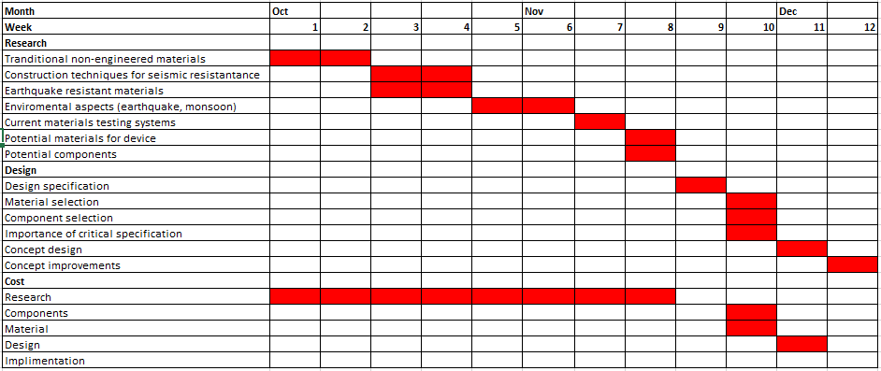

Figure (1) Project plan

5.0 Project research

5.1 Non-engineered materials used in Nepal construction

Traditional construction techniques in Nepal include building with natural non-engineered materials such as wood, earth, stone and bamboo. Emerging techniques involve incorporating recycled materials like plastic bottles, compressed plastics, car tires and earth bags. These techniques generally suffer from uncertainties attributed to material inconsistency and variable workmanship.
There is not much known about these materials as they have not been tested and results noted. (Ewb.app.box.com, 2019).
There are many types of traditionally used non-engineered materials used for construction in Nepal the important ones are listed below.
5.1.1 Superadobe
Superadobe is generally manufactured from organic and earth materials, polypropylene bags are used containing a compressed organic mixture fortified with lime. The bags are then stacked on top of each other, between each layer heavy duty barbed wire is used to hold the bags in place. This effectively forms a wall of the structure.
Superadobe homes are generally found in remote farming communities as the required materials are abundant, this type of construction to build homes are estimated to last for centuries if maintenance is carried out as required. Superadobe homes are also cost effective to construct. (Canadell, Blanco-Alvarez and Pialarissi-Cavalaro, 2019).
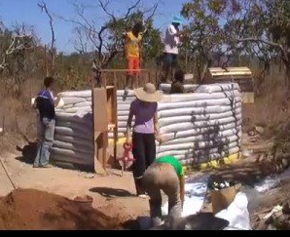
Figure (1) Superadobe construction

5.1.2 Dry Rubble Stone Masonry
Rubble stone masonry is rough, unhewn building stone set in mortar, however, is not laid in even courses. The stone walls are made with dressed stones which are shaped and sized to the required dimension. To keep the masonry in place a keystone locking mechanism is used at each interval, mud mortar is also used to enhance the mechanical properties of the construction. Stone masonry has good thermal properties, the wall generally gets finished with mud plaster to give a smooth resistant surface for the extreme seasons, repairs can be carried out when required. (Builders without borders, 2019).
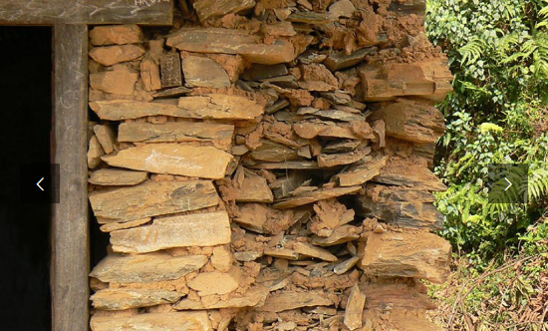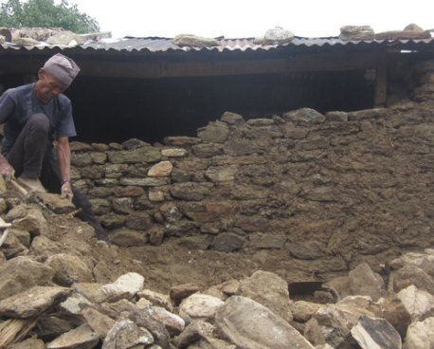
Figure (2&3) Typical dry-stone masonry construction. (Builders without borders, 2019).
5.1.3 Strawbale construction
In Nepal strawbale construction wall system consists of stacked or bundled, but not made into bundles. The straw bales are made using a compression mold and farm jack, once built the wall is then covered with plaster or other finish. (Builders without borders, 2019).

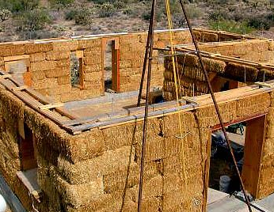

Figure (4) shows Strawbale construction (Builders without borders, 2019).

5.1.4 Wattle and daub

Wattle and daub has been used in construction for thousands of years in Nepal, the technique is used for building walls. It is made up of a woven lattice (‘wattle’) which is daubed with a variety of materials depending on location but most typical consists of mud, clay, straw, sand and animal manure, the daub provides a protective layer. The wattle is typically formed with wooden strips or thin branches woven between upright wooden bamboo stakes. (bowyer (1973)

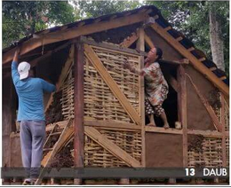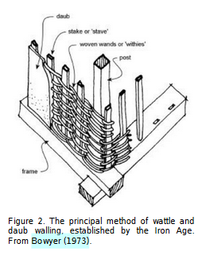

Figure (6) Wattle and daub construction. (Khatakho, 2019) (Left)
Figure (7) The method of wattle and daub walling (bowyer (1973) (Right)

5.2 Nepal geographically

In order to assess the project scope, understanding Nepal geographically is important, Nepal is a vast area of different terrain. There are 75 regions in Nepal that will benefit from a material testing device. Nepal currently has a population of 28,789,355. (Himalayan Mentor, 2019).

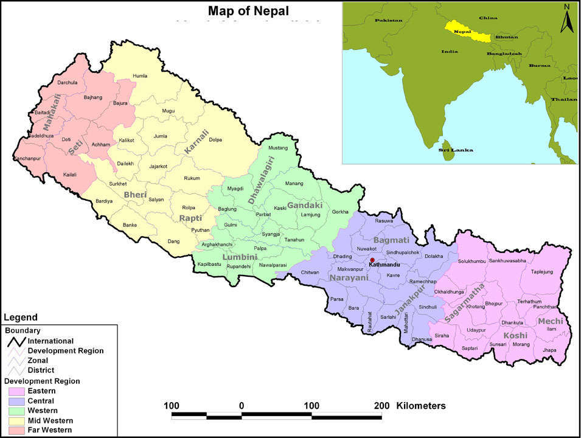

Fig (8) Nepal geographically (Himalayan Mentor, 2019).

5.3 Nepal Environment
Nepal is a landlocked country in Asia sandwiched in between China and India with the north of the country in the Himalayan mountain range. The geography of Nepal is very diverse throughout the country, as the tallest point is Mount Everest (8848m) and lowest point in Kechana Kalan (70m), because of this the conditions are very different in different parts of the country.
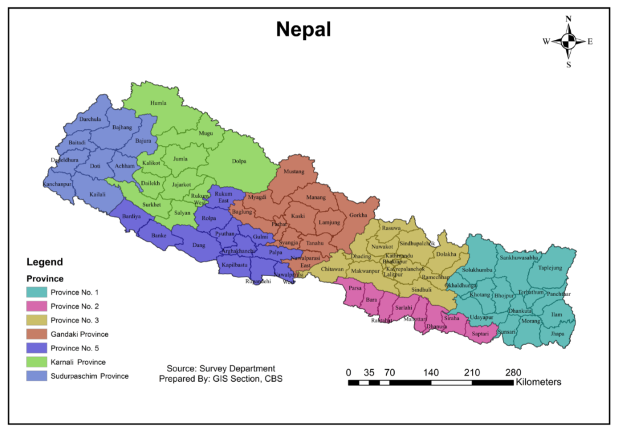
Figure (9) Government of Nepal (2019). Environmental Statistics of Nepal. Kathmandu, Nepal: Central Bureau of Statistics. 4.
Nepal can range from -40 degrees Celsius in the north of the country in the hills to + 40 degrees Celsius in the south in the summer months. Also, there are monsoons from May to August.
Being right in between the Indian and Eurasian tectonic plate, obviously Nepal is very prone to earthquakes. In 2015 there was a giant earthquake near Kathmandu. The initial shock was at the magnitude of 7.1 and over 600,000 structures in and around Kathmandu was damaged or destroyed. This is the reason for doing all the different tests to try and improve the buildings capabilities of withstanding earthquakes around Nepal in the future.
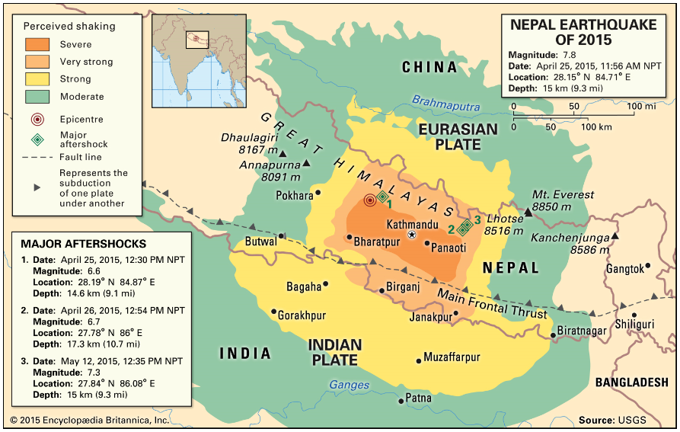
Figure (10) John P. Rafferty. (2015). Nepal Earthquake of 2015. Available: https://www.britannica.com/science/earthquake-geology. Last accessed 05/11/2019.
Although 2015 was a bigger than normal earthquake they still happen very often, and buildings need to be able to withstand several earthquakes a year. Figure.11 shows Earthquakes by Epicentre and Magnitude from 26-May-15 to 28-Jun-18.
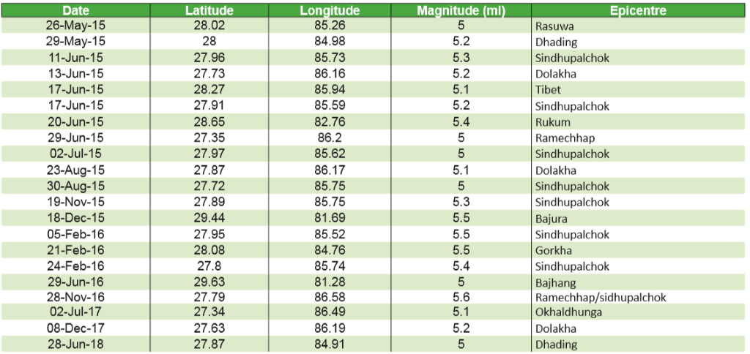
Figure (11) Government of Nepal (2019). Environmental Statistics of Nepal. Kathmandu, Nepal: Central Bureau of Statistics. 160-164.
As the table shows, earthquakes are very regular in Nepal. In 2015 there were 56 earthquakes in total from January to December. This is the reason that there needs to be a field-testing on non-engineered materials and techniques for earthquake resistant construction.

5.4 Building Techniques to withstand seismic activity

The Government UK (2012), suggest that Nepal are ranked as one of the most likely nations to suffer from an earthquake, with that being said they are very poor at creating contingency plans to reduce the impact.
Governing bodies in Nepal and outside such as the UN are working together to ensure that there are plans in place, to prepare for an earthquake and reduce the impact it has on society and the environment. One of these methods is to ensure buildings are equipped to deal with the impact, by employing structural engineers to design buildings that can withstand the impact.

5.4.1 Guidelines for earthquake resistant construction
To earthquake-proof buildings, engineers must ensure that the structures and their foundations are resistant to potential horizontal loads by employing several key design features:
Shock Absorbency
To prevent damage to buildings during an earthquake, the buildings can be fitted with shock absorbers to ensure the damage is not fatal. Shock absorbers work by converting the seismic wave energy into heat energy which is then transferred into hydraulic liquid. Various methods include devices fitted in to different sections of the walls, to ensure the buildings only sway slightly during an eruption.
Diaphragms
Diaphragms are the primary component of a building’s horizontal structure, including the floors and the roof. To earthquake-proof a building, diaphragms must be placed on their own deck and strengthened horizontally to share forces with vertical structures.
Trusses
Trusses strengthen the diaphragm where the deck is weakest. Simply put, they are diagonal structures that are inserted into the rectangular areas of the frame.
Cross-Bracing
Engineers incorporate a variety of columns, braces, and beams to transfer seismic forces back to the ground. Cross braces incorporate two diagonal sections in an X-shape to build wall trusses.
Shear Walls
To help resistance swaying forces, engineers use vertical walls, known as shear walls, to stiffen the structural frame of the building. These can be used in place of braced frames or in addition to them.
Moment-Resisting Frames
Since shear walls limit a building’s flexibility, some designers choose moment-resisting frames to allow positive movement. Although columns and beams can bend, joints and connectors stay rigid. These features also give building designers more flexibility to create exterior walls, ceilings, and arrange building contents.
A Light Roof
As a general rule, the roofs of earthquake safe structures must be as light as possible. Roofs made of thatch or metal sheet work well.

5.5 Existing devices

There are many areas and technologies relevant to the project, research into the types of existing stress testing devices and understand the force test specimens undergo. To understand the needs of the device research has been carried out into commercial material testing devices.

5.5.1 Compression tester

A compression device is used for determining the materials behavior under a compressive load. They are generally conducted by loading a specimen piece between two equal sized plates, a load is then applied to the plates. During the compression test the specimen is compressed, deformation versus the applied load is recorded. The test is used to determine limits that are useful for engineers, these are elastic limit, limit of proportionally, yield point and strength.

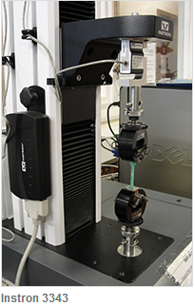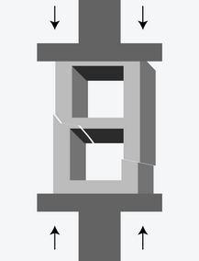

Figure (9) Instron3343 Compression material tester (Www2.le.ac.uk, 2019).
Figure (10) Free body diagram of compressive forces (Tekscan, 2019).

Useful information can be obtained by load testing specimens and allow engineers to analyze data.

5.6 Component/ material selection

5.6.1 Load cells

A load cell is a type of transducer, more typically a force transducer. They can convert forces, these forces are compression, tension, torque and pressure into electrical signals which can be measured. There are many different types and they each serve their own purpose designed to do different jobs.

Strain gauge load cells

- Bending beam – monitors the stress exerted on a spring when subject to bending forces.
- Pancake – often used for weighting in tension or compression.
- Single point shear beam load cell: spring element fixed at one end and loaded on the other.
- Double-ended shear beam: spring element fixed at both ends and loaded in the center.
- Canister load cell: Cylindrical shaped spring element; can be used in both tension and compression.
- S-type load cell: S-shaped spring element; can be used in both compression and tension.

Load cells also come in pneumatic and hydraulic alternatives. For the purpose of the built device using a load cell is ideal as accurate information is vital for later laboratory analysis. Load cells have a very accurate reading which is a must to fulfil design brief. (Pcb.com, 2019).

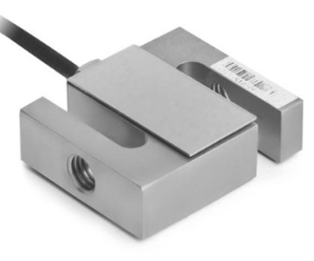

Figure (11) S-type loadcell (Omega.co.uk, 2019)
https://www.loadcells.com/products/load-cell-stc/

5.6.2 Bottle-jack

A bottle jack gets its name due to the jack being a bottle shape, it consists of 2 chambers one small and one large, pressure is applied to the smaller cylinder allowing the large cylinder to expand and raise, this happens because the liquid is incompressible and force its exerted in all directions.

“Pascal’s law describes the uniform distribution of pressure in a liquid (neglecting the hydrostatic pressure)” (tec-science, 2019).

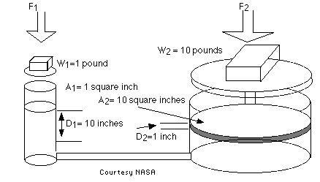

Figure (12) Free body diagram (PhysLink.com, 2019).

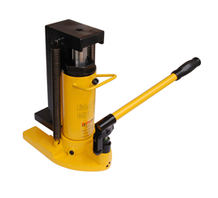

Figure (13) hydraulic bottle jack (Jack, 2019)

5.6.3 Portable load meter / logger

A portable load meter displays information from the load cell, it is batter operated. A load cell data logger records information from the strain gauge, this allows for the information to be analyzed off-field using sophisticated software. A strain gauge logger measure voltage signals from the load cell.

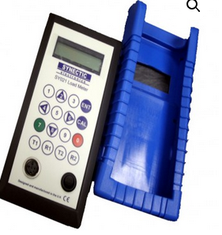

Figure (14) Portable load meter / logger (Synectic Electronics, 2019)

5.6.4 Material selection

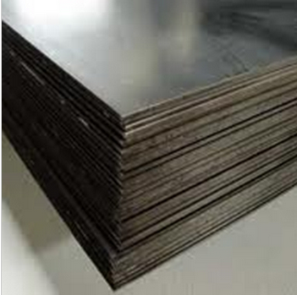

Figure (15) Steel plate (Franklinsteelplc.co.uk, 2019).

7.0 Critical design specifications

7.1 Material load tester

A device will be made to test non-engineering materials under load, there are three devices being designed these are compression, bending, and uniaxial. The main function of the device is to test material specimens under load and gather vital information for later laboratory analysis.

As these devices will be used in the remote communities, to effectively design the required devices, a comprehensive list of expectations for the final product was produced. These specifications are:

- The purpose and function – what will your product do?

The main function of the product is to test non-engineered materials in Nepal with a homemade testing device to measure material properties within specimens.

- Aesthetics

- Performance requirements

The device will need to be robust and operate correctly for at least 5 years, device must be easy to maintain and electronically operated. The device must be lightweight and easily transportable. The device must have an accurate reading for later laboratory analysis.

- What materials will product be made from?

The device will be made from casted plate steel as it has sufficient material properties, must be capable of forces up to 49050N (49KN) (20mm thickness).

- Component or systems?

Load cell will be used to measure force exerted on the test specimen; data logger will be used to capture data. A bottle jack will be used to exert force on the test specimen.

- The market or user requirements?

Must be suitable for adults to use.

- Values and issues that may influence design?

The forces the device will be under will influence design as the device must be robust enough to withstand forces, secondly the cost will be an important factor in design as it must be cheap enough to produce and maintain.

- Consideration for the manufacturing process?

Must be easy to use and maintain & low cost and easy to manufacture.

- Technology?

Research into existing material testing devices has been carried out and my design is based on those.

- Finish of product?

The material testing device will be low carbon steel finish.

- Scale of production?

There will be a batch of 75 material testing devices made.

- Quality and safety issues

The device must be safe to used as it will be under a fair amount of force so it will be over engineered to ensure it doesn’t explode whole being used, the device must cause no harm.

IP67 – waterproof, loadcell and datalogger will be used as device will be used during the wet season in Nepal.
Conform to ISO-8888.

- Ergonomic and Anthropometric dimensions?

Must be easy to use and portable.

- How long will it take to make?

An estimation of 2 weeks to make 75 devices.

- Cost restraints?

The device will cost less than £3000.00 to make.

- Lifespan?

The device must last 5 years.

- Recyclability?

Load cell and data logger could be reused in another product at end of life. The steel body and bolts could be recycled or re-used. Disassembling the product will be easy as it will be bolted together with M8 bolts.

8.0 Concept evaluation

Below are the concept matrix scores as you can see concept (1) scored the highest and will be used as the main design. Concept (1) scores 134.

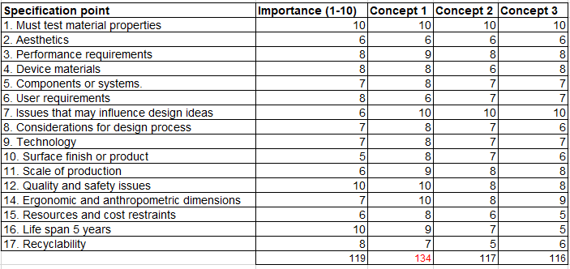
Fig (16) Shows concept matrix.

8. 1 Concept design idea’s

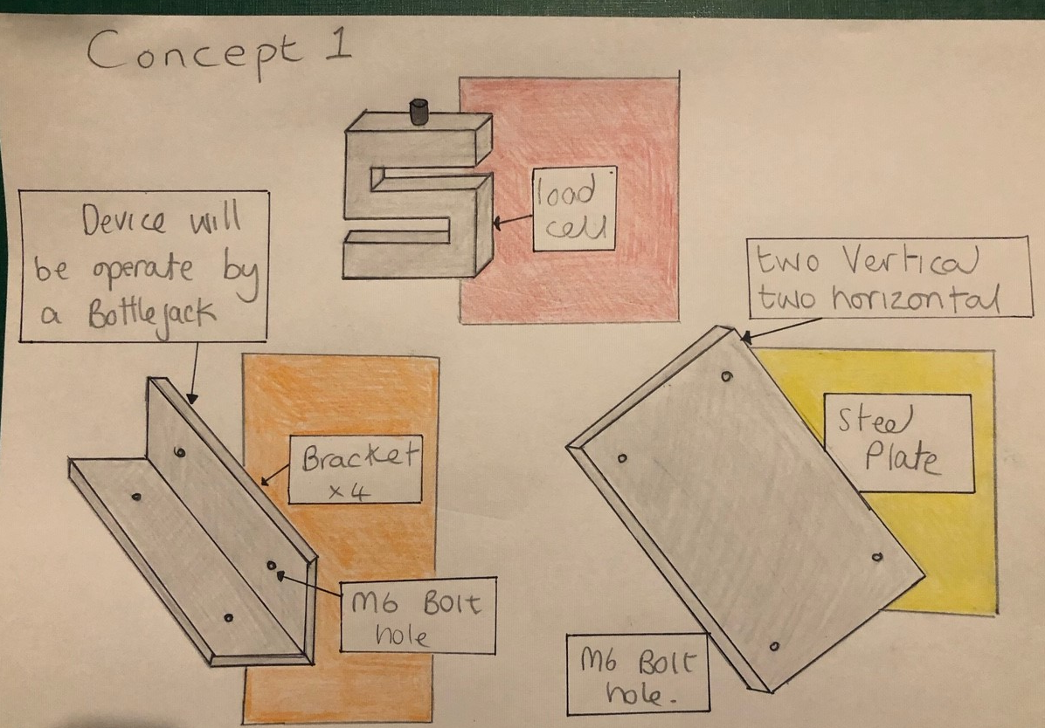

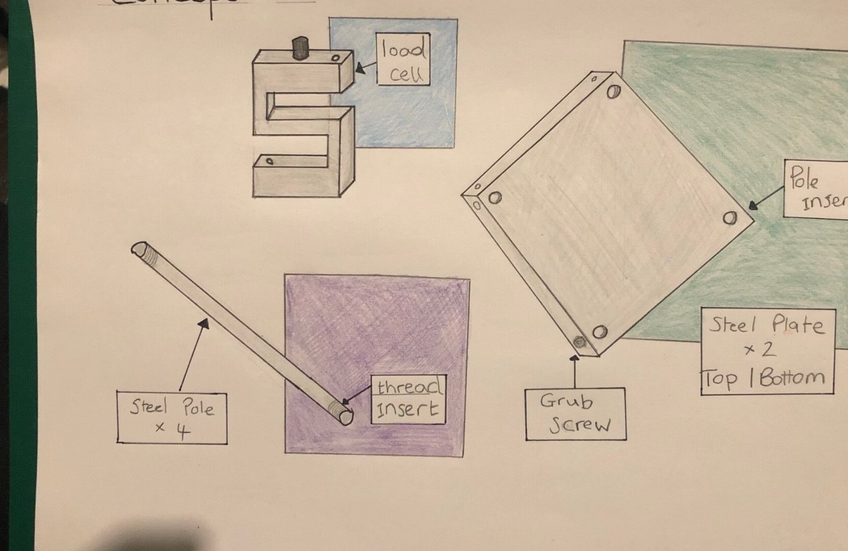

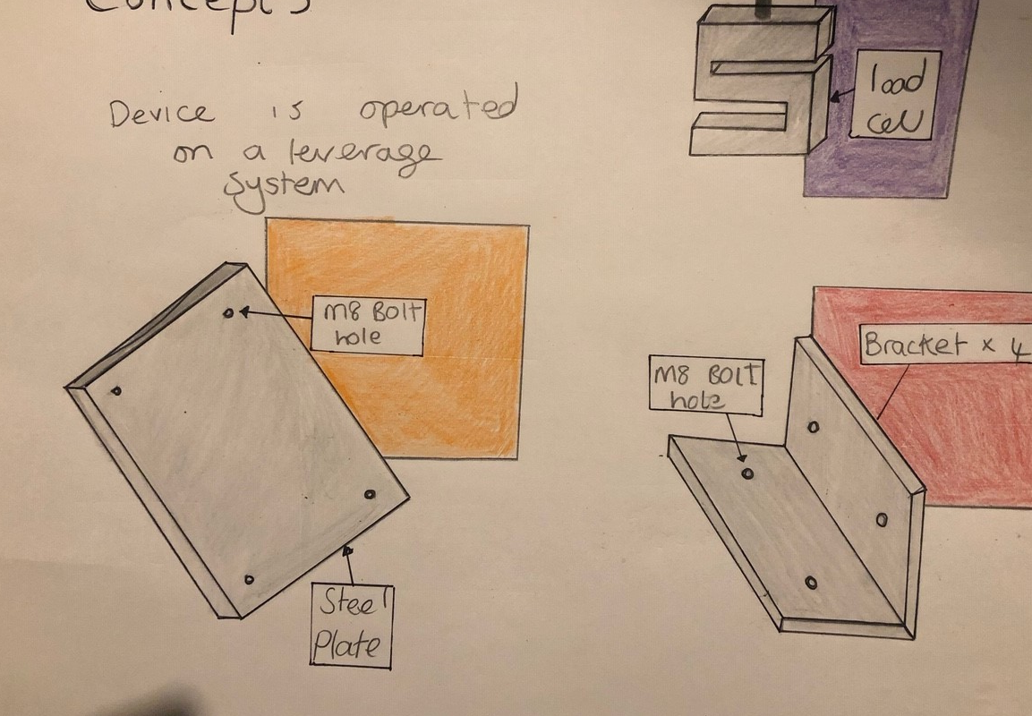

8. 2 Concept radar diagrams

Fig (17) Concept (1) Radar Diagram. Score (134)

Fig (18) Concept (2) Radar Diagram. Score (117)

Fig (19) Concept (3) Radar Diagram. Score (116)

8.3 Concept (1) 3D modelling

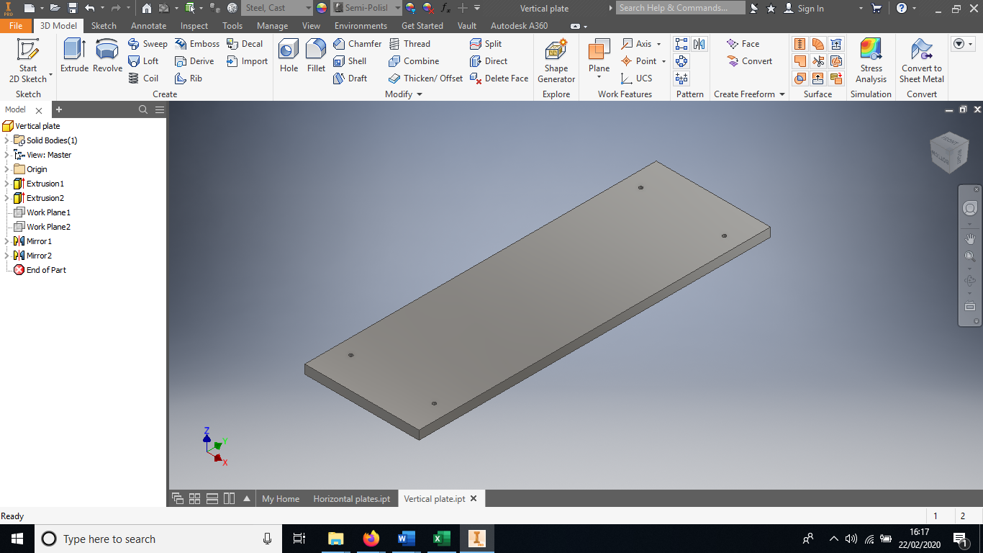
Fig (20) Vertical plate for material testing device. (Matt).

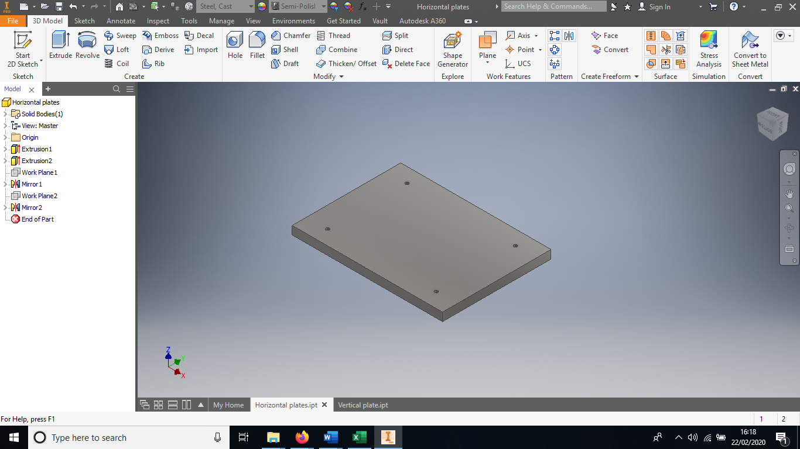
Fig (21) Horizontal base plate for material testing device. (Matt).

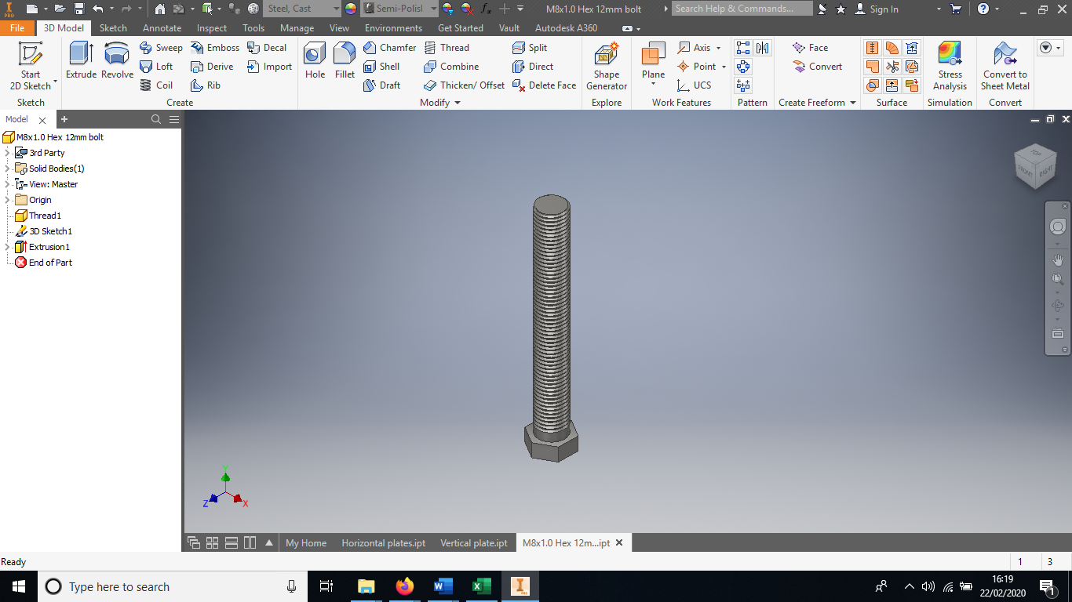
Fig (22) M8 12mm bolt for material testing device. (GrabCAD)

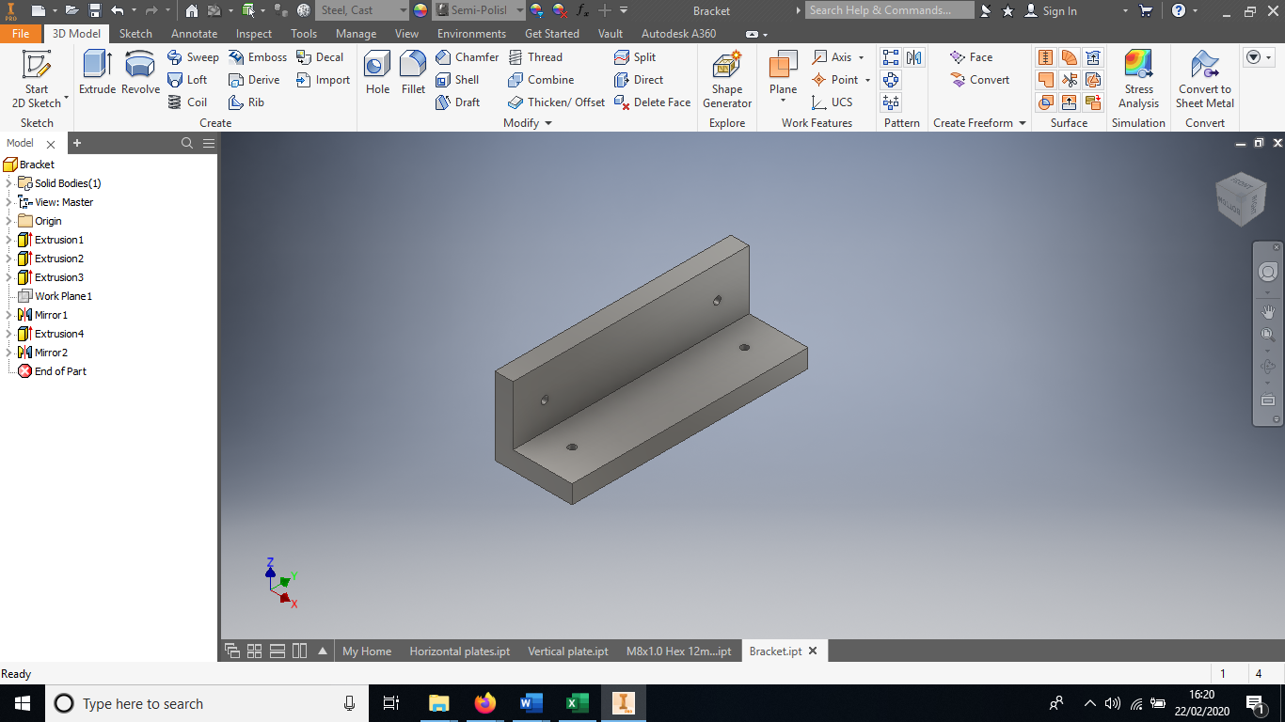
Fig (23) Bracket for material testing device. (Matt).

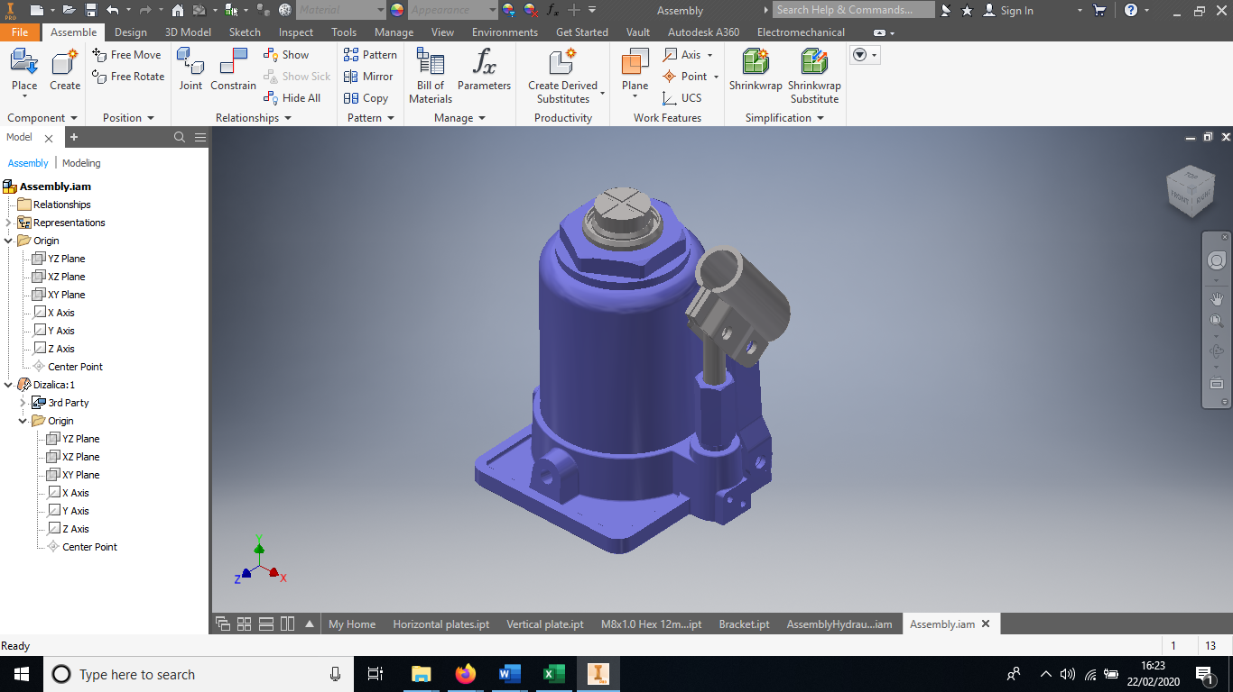
Fig (24) Bottle jack for material testing device. (GrabCAD)

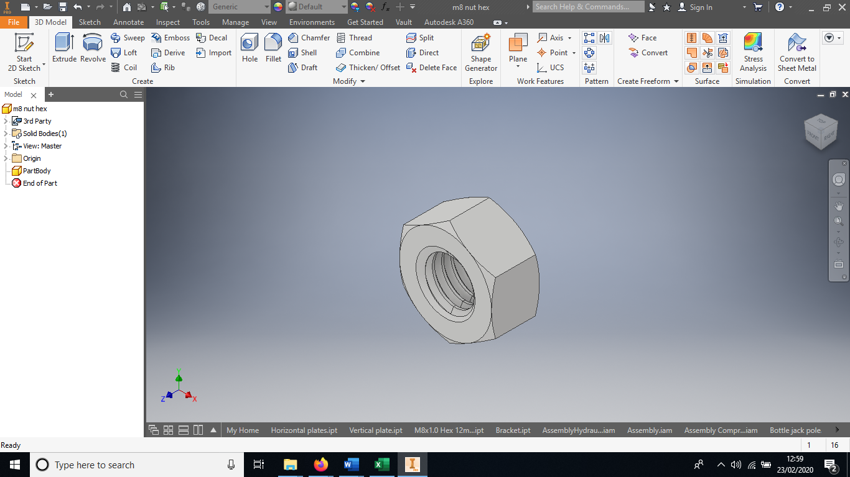
Fig (25) Hex nut M8 for material testing device. (GrabCAD).

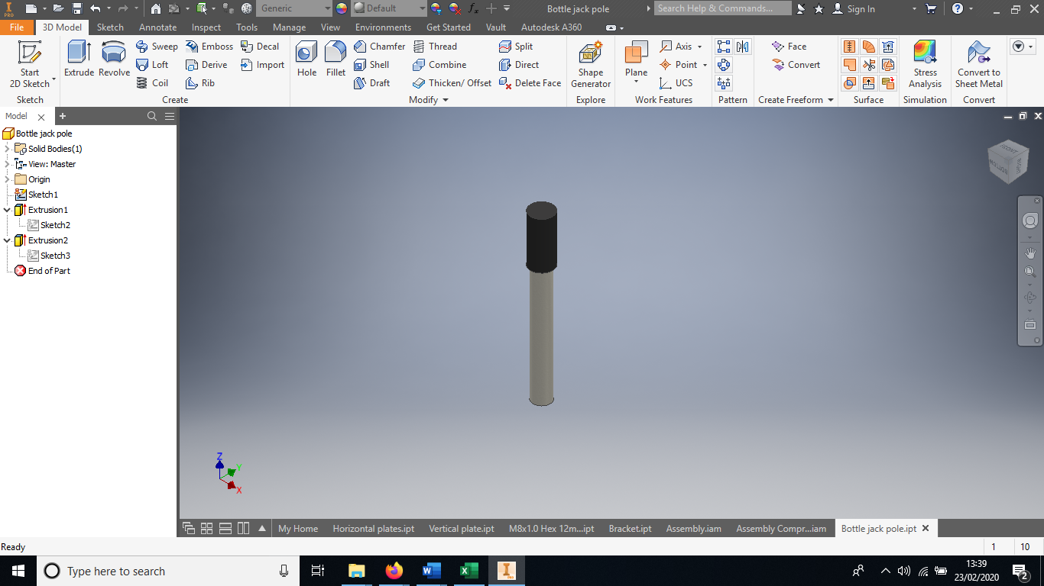
Fig (26) Lever for bottle jack. (Matt).

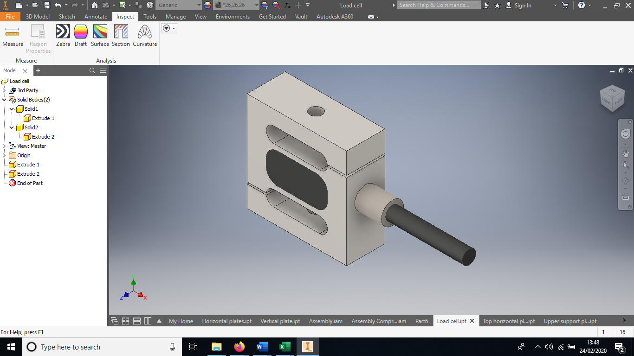
Fig (27) Load cell. (GrabCAD)

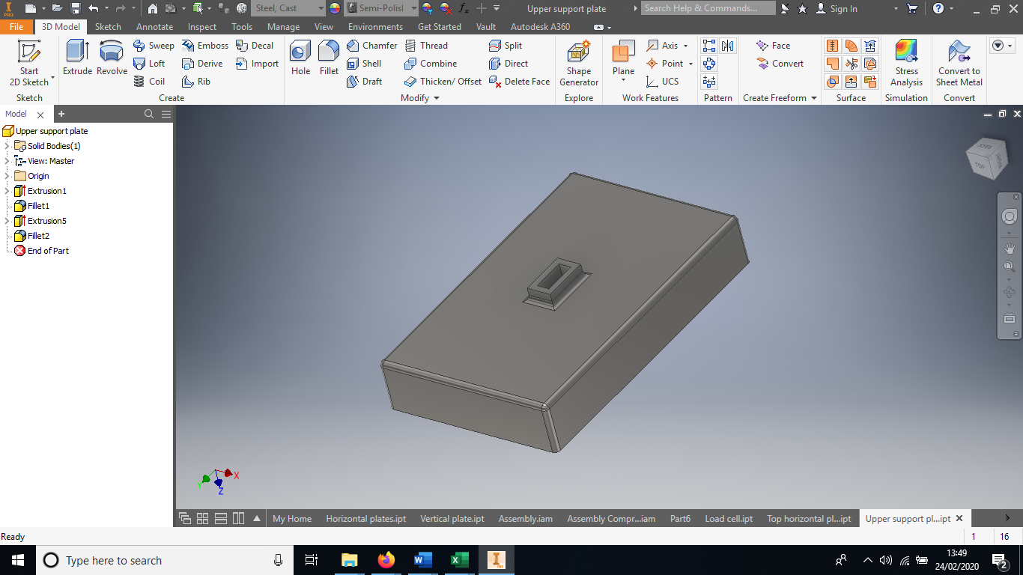
Fig (27) Upper support plate for test specimen. (Matt).

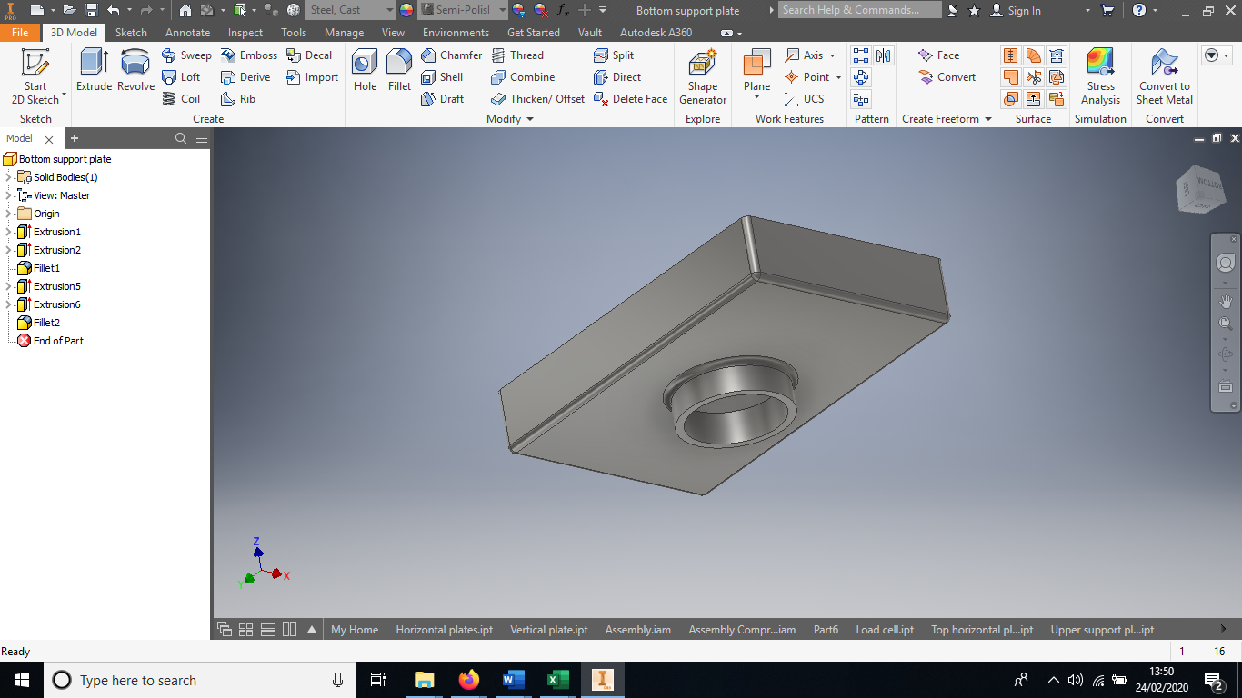
Fig (27) Lower support plate for test specimen. (Matt).

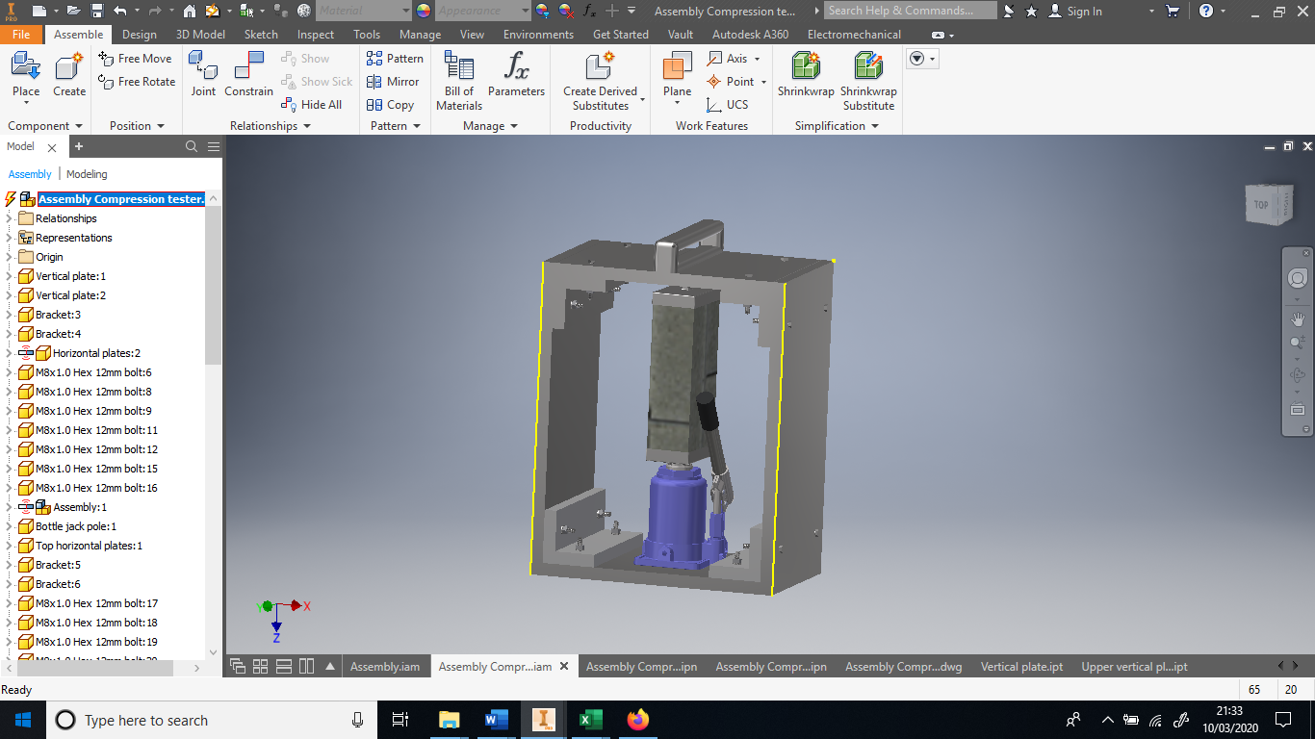
Fig (28) Fully assembled material testing device. (Matt).

8.3 Exploded view

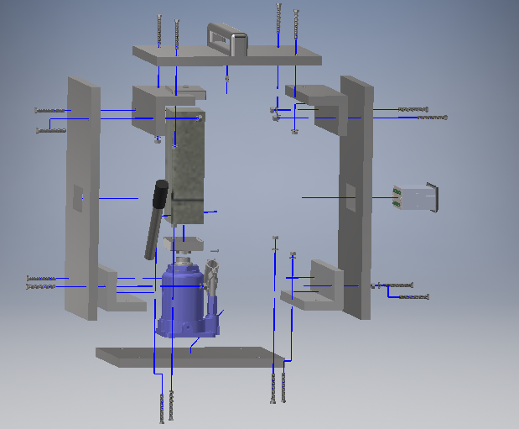
Fig (29) Fully assembled material testing device. (Matt).

Please see appendix B for full engineering drawings.

8.4 Finite element analysis

Due to the maximum stress occurring in the vertical plate, see Fig (21). Stress analysis has been carried out to ensure the specification of the plate meets the robustness needed to not fail. I’ve assumed that the plate will behave in the same way a simply supported beam would act fixed at both sides and a force applied in the middle.
8.4.1 Material properties
Below are the properties of Cast, Steel:
Name | Cast, Steel
General | Mass Density | 7.85 g/cm^³
General | Yield Strength | 250 MPa
General | Ultimate Tensile Stress | 300 MPa
Stress | Young's Modulus | 210 GPa
Stress | Poisson's Ratio | 0.3 ul
Stress | Shear Modulus | 80.7692 GPa
Fig (30) Material properties for Cast Steel. (FEA Inventor)

8.4.1 Von mises stress

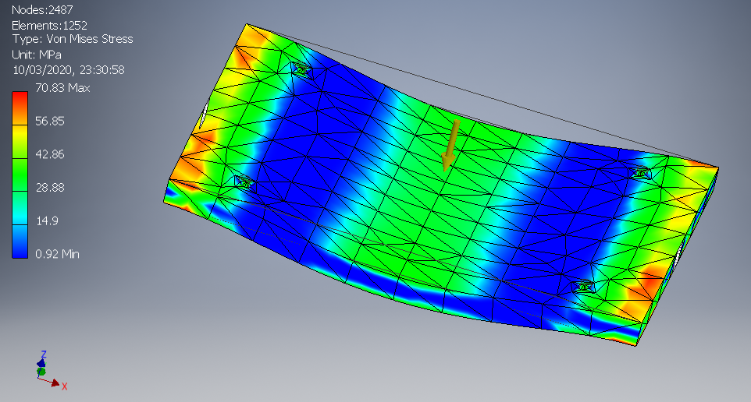
Fig (31) Top plate under a load of 50KN. (70.83MPa measured stress) (FEA Inventor).
The von mises stress is showing 70.83 MPa as the highest value which is highlighted in red Fig (31) which is under the maximum allowable yield strength of 250 MPa. This plate would be suitable for handling the load of 50KN.

8.4.2 Displacement

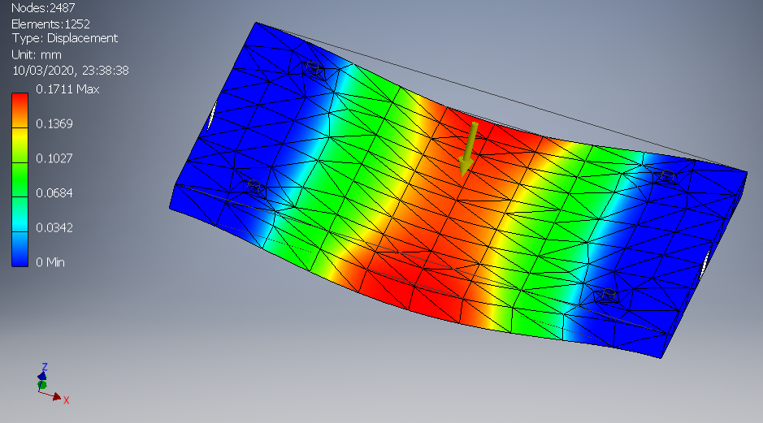
Fig (32) Top plate displacement measured (0.1711mm). (FEA Inventor).

FEA analysis showing a small amount of displacement.

8.4.2 Safety factor

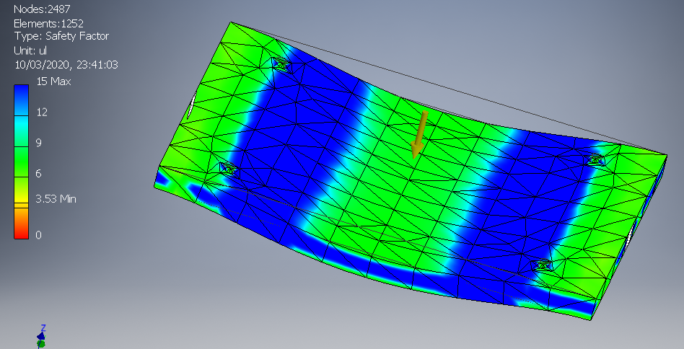
Fig (33) Top plate safety factor measured (3.53Min). (FEA Inventor).

7.2 Calculations

In order to assess materials and bolt sizes the following formulas have been used:

7.2.1 Shear on bolt

$$τ= \frac{F}{A}$$
Calculate cross-sectional area:

A $= \frac{π*d²}{4}$ = 5.06$*{10}^{-5}$

Calculation shear:
$$τ= \frac{49050N}{5.07*{10}^{-5}}= 1.07*{10}^{3}N$$

7.2.3 Determine minimum thickness of Steel plating:

Area (L*W) = 1360mm²
Density 7850 kg/m³
Weight = 2.65Kg
2065g / 7850 = Volume 263 cm³
V =263cm³ / 1360mm² = Thickness needed = 0.193mm²
7.2.4 Calculating max stress & moment
Calculating $I$ of vertical plate:
$$I= \frac{1}{12}bh³$$
b = The base or width of the rectangle
h = The height of the rectangle
$I= \frac{1}{12}(360*260³$) = 527.28$* {10}^{6}$
Maximum stress is calculated by the following formula:

$$σ_{max}= \frac{M_{max}* Y_{max}}{I_{y}}= \frac{(17658*360)(1711)}{527.28}=20.62 MPa$$

Finite element analysis showing stress (XY direction):
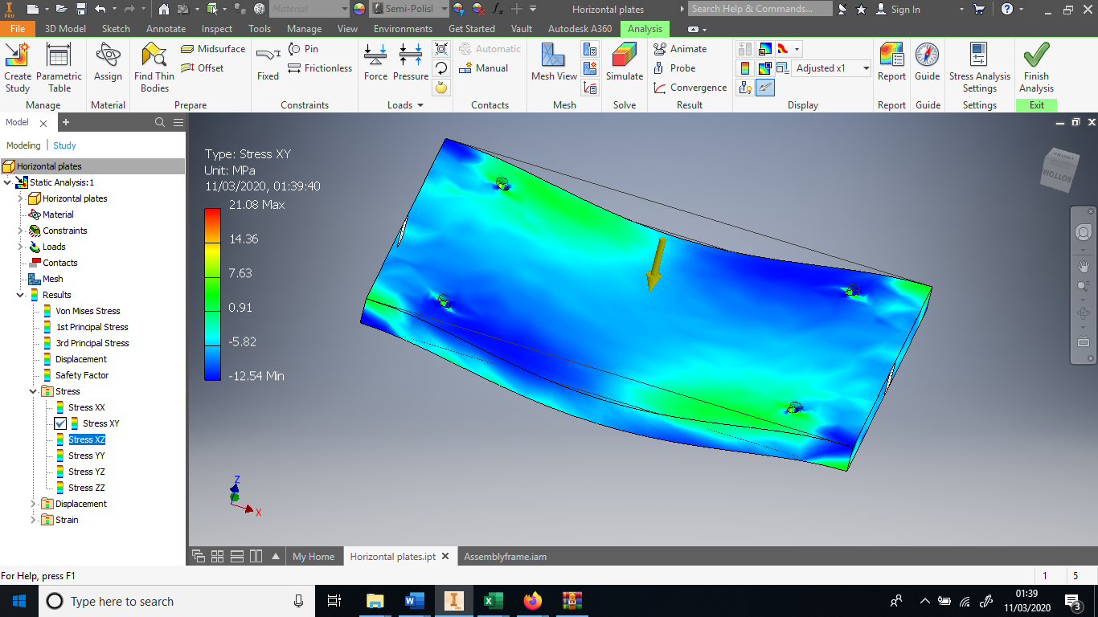
Fig (34) Top plate measure stress XY direction (21.08MPa). (FEA Inventor).

As you can see from the above analytical calculation (20.62MPa) which is close to the value displaced in FEA analysis Fig (34) valued displayed (21.08MPa).

To convert Kg into N:
$$5000Kg*9.81=49050N$$
Max moment is solved in statics by the following formula:
$M_{max}=FL$
$$49050N*0.36=17658N$$
$$M_{max}=17658N$$

9.0 Quality control

“A system of maintaining standards in manufactured products by testing a sample of the output against the specification.”
In order to assess the quality of the end product every 1 in 10 devices will be tested, this will happen once the product leaves the assembly line. Every aspect of the device will be tested to ensure it meets a high level of quality. The device will be checked against the specification that was compiled to ensure it meets what was outlined in the project.

Below is a list of what would be checked for quality.

- Spec 1 – The device fulfills its purpose / functions of testing material properties of a test specimen.
- Spec 2 – Device looks good.
- Spec 3 – Device has been constructed to ensure it is robust and is electronically operated.
- Spec 4 – The device has been constructed using Casted plated steel as outlined in the specification this will ensure the device is strong enough to operated and function correctly for 5 years.
- Spec 5 – Load cell has been used to measure force acting on test specimens as outlined in the specification.
- Spec 6 – Device is suitable for adults.
- Spec 7 – Fulfilled.
- Spec 8 – consideration had to be made when designing the device as needed to be easy to assemble and easy to use.
- Spec 9 – My research into required area played a big part in my design process.
- Spec 10 – Fulfilled.
- Spec 12 – fulfilled.
- Spec 13 – Consideration was made when deciding what standards were needed in finished product. These have been mentioned below.

9.1 Quality assurance

Training will be given within the Nepal communities to ensure the people know how to correctly operate the device safely. In-order to maintain high standard of safety the following standards have been used, ISO-9999, IP-67, ISO-8888. Off-the shelf parts have been purchased from reputable suppliers which have their own quality processes in place, these items were the load cell, load cell data logger and bottle jack.

10.0 Cost analysis

Below are the costs associated with the project:

Costs | Quantity | Price | Total price
Research | 12 weeks | 1780.78 Per week | 21,369.46
Load cell | 75.00 | 285.00 | 21,375.00
Bottle jack | 75.00 | 180.83 | 13,562.25
Load cell data logger | 75.00 | 735.00 | 55,125.00
Steel plate | 75.00 | 70.00 | 5,250.00
Labour | 2 weeks | 1,780.78 | 3,561.56
Design | 2 weeks | 3,561.56 | 3,561.56
Manufacturing | 2 weeks | 20,000.00 | 20,000.00
Assembly | 1 week | 1,780.78 | 1,780.78
Testing |  | 1,780.78 | 1,780.78
Insurance |  | 2,000.00 | 2,000.00
Training | 8 weeks | 14,246.24 | 14,246.24
Transport |  | 15,000.00 | 15,000.00
Data analysis | On-going | 15,000.00 | 15,000.00
Total cost |  |  | 193,612.63
Fig (35) Shows cost breakdown for project.

See appendix A for full breakdown of cost and explanations.

11.0 Conclusion

Below shows finite element analysis of 15mm thick cast steel plate with a safety factor of 2.08, 20mm thickness was utilized to achieve a greater safety factor (3.43) for safety reasons.

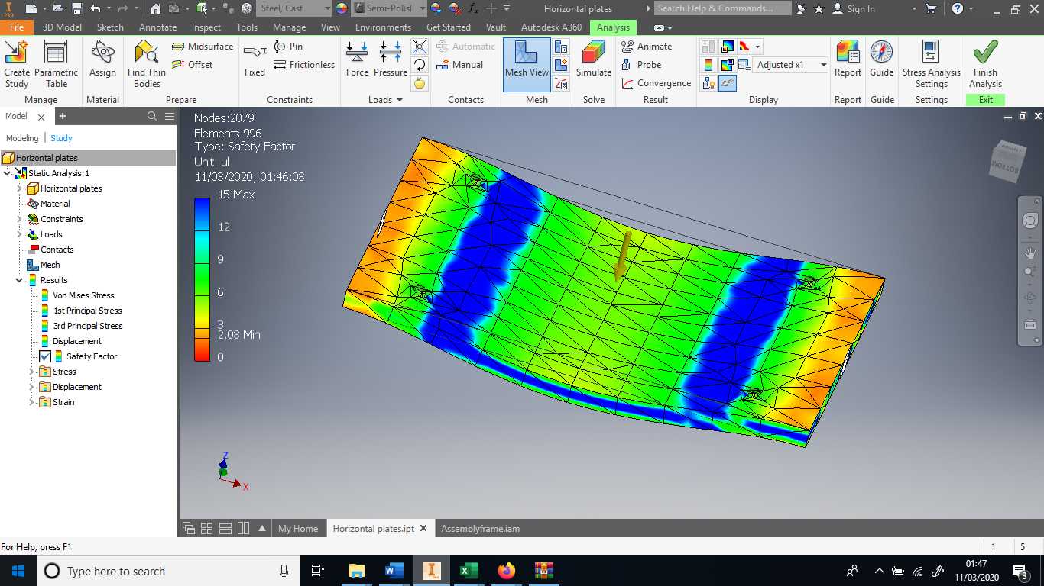

Fig (36) Finite analysis (inventor) (matt)

12.0 Recommendations

There were several aspects of the project that could have been improved.

- Timing gant chart was not always adhered by as some aspects took longer than expected and some other aspects took less than expected.
- The device costing over ran target due to high quality data logger being used due to it being more suitable for the purpose it was utilized for.
- Team meetings weren’t always possible due to people being on different shifts plans.
- Seeing the project as an individual in Nepal would have aided myself in getting a better understanding of the project as a whole.

13.0 References

Bird, J., 2015. Science for engineering. 5th ed. 2 Park Square, Milton Park, Abingdon, Oxon OX14 4RN: Routledge.
Groover, M, P., 2013. Principles of modern manufacturing. 5th ed. 111 River Street, Hoboken, NJ, 07030: John Wiley & Sons
Www2.le.ac.uk. (2019). Compression, fatigue and tensile testing — University of Leicester. [online] Available at: https://www2.le.ac.uk/colleges/scieng/research/lanser/mechanical/compression [Accessed 21 Oct. 2019].

Ewb.app.box.com. (2019). Box. [online] Available at: https://ewb.app.box.com/s/kv83rmkrergqq8rfg7dixlo3dh6kbtk9 [Accessed 23 Oct. 2019].

Bowyer, J. (1973). History of Building. London: Crosby Lockwood Staples.

https://www.actitime.com/project-management/project-cost/

14.0 Bibliography

Bird, J., 2015. Science for engineering. 5th ed. 2 Park Square, Milton Park, Abingdon, Oxon OX14 4RN: Routledge.
Groover, M, P., 2013. Principles of modern manufacturing. 5th ed. 111 River Street, Hoboken, NJ, 07030: John Wiley & Sons

Canadell, S., Blanco-Alvarez, A. and Pialarissi-Cavalaro, S. (2019). Comprehensive design method for earthbag and Superadobe structures. [online].Available at: https://repository.lboro.ac.uk/articles/Comprehensive_design_method_for_earthbag_and_superadobe_structures/9450800 [Accessed 21 Oct. 2019].

Www2.le.ac.uk. (2019). Compression, fatigue and tensile testing — University of Leicester. [online] Available at: https://www2.le.ac.uk/colleges/scieng/research/lanser/mechanical/compression [Accessed 21 Oct. 2019].

Ewb.app.box.com. (2019). Box. [online] Available at: https://ewb.app.box.com/s/kv83rmkrergqq8rfg7dixlo3dh6kbtk9 [Accessed 23 Oct. 2019].

Bowyer, J. (1973). History of Building. London: Crosby Lockwood Staples.

Patents.google.com. (2019). US3765497A - Hydraulic compression load cell - Google Patents. [online] Available at: https://patents.google.com/patent/US3765497A/en?q=hydraulic&q=load&q=cell&q=compression&oq=hydraulic+load+cell+compression [Accessed 29 Oct. 2019].

Khatakho, S. (2019). Building back cheaper and stronger. [online] Nepalitimes.com. Available at: https://www.nepalitimes.com/banner/building-back-cheaper-and-stronger/ [Accessed 23 Oct. 2019].

Builders without borders. (2019). Nepal construction. [online] Available at: http://www.builderswithoutborders.org/Nepal/SB-1.1_SBConstr_Rev2.12.15NFC.c.pdf [Accessed 23 Oct. 2019].

Himalayan Mentor. (2019). Geography of Nepal, Nepal Geography. [online] Available at: https://www.himalayanmentor.com/geography-of-nepal.html [Accessed 29 Oct. 2019].

Pcb.com. (2019). Load cell manual. [online] Available at: https://www.pcb.com/contentstore/MktgContent/LinkedDocuments/Load_Torque/LT-LoadCellHandbook_LowRes.pdf [Accessed 29 Oct. 2019].

Patents.google.com. (2019). US3765497A - Hydraulic compression load cell - Google Patents. [online] Available at: https://patents.google.com/patent/US3765497A/en?q=hydraulic&q=load&q=cell&q=compression&oq=hydraulic+load+cell+compression [Accessed 29 Oct. 2019].

tec-science. (2019). How does a hydraulic jack work? - tec-science. [online] Available at: https://www.tec-science.com/mechanics/gases-and-liquids/how-does-a-hydraulic-jack-work-pascal-law/ [Accessed 5 Nov. 2019].

PhysLink.com, A. (2019). How does a hydraulic jack work?. [online] Physlink.com. Available at: https://www.physlink.com/education/askexperts/ae526.cfm [Accessed 5 Nov. 2019].

Tekscan. (2019). What is Compression Force?. [online] Available at: https://www.tekscan.com/blog/pressure-mapping/what-compression-force [Accessed 5 Nov. 2019].

Synectic Electronics. (2019). Portable Load Meter Logger. [online] Available at: https://synectic.co.uk/product/sy021-portable-load-meter-logger/ [Accessed 5 Nov. 2019].

Jack, 1. (2019). 5 Ton Jack. [online] Safety Lifting Gear. Available at: https://www.safetyliftingear.com/products/10-tonne-toe-jack/hhqd-20?gclid=EAIaIQobChMIh4j4yazT5QIVBdTeCh2JVAoMEAQYASABEgKI5fD_Bw [Accessed 5 Nov. 2019].

Omega.co.uk. (2019). Stainless Steel S Beam Load Cell. [online] Available at: https://www.omega.co.uk/pptst/LC101.html [Accessed 5 Nov. 2019].
Sciencedirect.com. (2019). Bending Tests - an overview | ScienceDirect Topics. [online] Available at: https://www.sciencedirect.com/topics/engineering/bending-tests [Accessed 6 Nov. 2019].
https://www.sciencedirect.com/science/article/abs/pii/0263786395000577

Appendix A

Research cost

In-order to cost effectively an average weekly wage for an engineer has been used to produce the total research cost analysis. These are listed below:

£593.59 per week for 1 engineer
£1780.78 per week for 3 engineers

12 weeks of research at a cost of £21369.46

Device component cost

Bottle Jack

Bottle jack 5 tons £180.83

75 * 180.83 = £13562.25
Load cell

Individual load cell £285.00
75 * 285 = £21375.00

Load cell indicator / logger

Portable load meter logger £735.00
75 * 735 = £55125.00

Steel plate

An estimation of £75 per device has been allocated for material cost.

Labor prediction

An estimate of 2 weeks to complete 75 devices has been used.

£593.59 per week for 1 engineer
£1780.78 per week for 3 engineers

2 weeks of labor £3561.56

Design costs

An estimation of 2 weeks for the design aspect of the produce has been used.

£593.59 per week for 1 engineer
£1780.78 per week for 3 engineers
2 weeks of labor £3561.56

Manufacturing costs

The manufacturing of the device will be handled by a 3rd party company to ensure a high-end quality product. The cost will be higher as it is a batch production and not a mass production. An estimation has been used.

£20,000.00 for 75 devices to be built.

Assembly costs

An estimation of 1 weeks to assemble 75 devices

£1780.78 per week for 3 engineers

Testing costs

The device will be tested for robustness and quality for 1 week, to ensure it operates correctly and is safe to use.

£1,780.78 per week for 3 engineers

Insurance costs

£2,000.00

Training costs

The training will take several weeks to complete as there are 75 region in Nepal benefitting from material testing device. An 8-week timeline has been used. 8 weeks, 3 locations each week per engineer, 3 engineers total.

£14,246.24

Transport costs

The device will need to be shipped from the UK to Nepal, once in Nepal several vehicles will be needed to deliver one device per region. 3 vehicles, 8 weeks, 3 locations each week per engineer, 3 engineers total.

£15,000.00
Data analysis costs

The material testing device will capture data on-site every time the device is used, data collected will be send back to the UK in order to be analyzed. This will be an ongoing cost of the project. An estimate is below.

£15,000.00

16.0 Appendix B

16.1 Engineering drawings

Fig (37-49) Below.




