Effective Team Working and Communication Assignement 1
Module Code: BMSW4002
Lecturer name: Soban Sadiq
Student: Monica Andreea Stefan (2133994)
Table of Contents

Introduction 2
Models of Communication 2
The Shannon and Weaver Mathematical Model (1948/49) 2
Case Study 3
Strategies to Avoid Misunderstanding 4
Schramm Model of Communication (1954) 4
Strategies to Avoid Misunderstanding 5
Berlo’s Model of Communication (1964) 6
Types of Communication Skills 7
Verbal Communication 7
Non-Verbal Communication: 7
Listening Skills- 8
Active Listening: 8
Empathetic Listening: 8
Advantage and Disadvantages of a Communication Technology 9
Advantages of Mobile Phone: 9
Disadvantages of Mobile Phone: 9
Conclusion 10
Reference 11

Introduction
Communication is the key to various personal and professional issues. However, when it comes to professional matters it has a greater significance as it involves more people. Similarly the impact of poor communication also lies on a vast amount of the population that can risk the reputation of the company and the trust of the stakeholders (Bartosik‑Purgat, 2019). Lack of proper communication creates misunderstanding and hinders relationships among colleagues, which works as a barrier in the workplace. This report will focus on the importance of communication that will be supported by three communication models, case studies, and personal examples.

Models of Communication
There are generally three types of model communication that we will focus in this report, they are:

The Shannon and Weaver Mathematical Model (1948/49)
Back in 1948, an American mathematician, Shannon and an American scientist, Weaver, came together to write an article under the name “A Mathematical Theory of Communication”. Later on it is also popularly known as “Shannon-Weaver model of communication” (Grant, 2018). It describes the effective communication techniques between the sender and receiver. According to the model introduced by them, there are certain factors that affect the communication process, and they name it as “Noise” (Jordan, 2021).
The model was initially developed to improve technical communication but later it became beneficial for the field of Communication in general. The model is divided into separate segments, which includes- sender, encoder, channel (medium), decoder, and receiver (Kubota, 2019). The message originates from the sender, the transmitter, also known as encoder, converts it into signals. These signals are more like waves or binary data that gets easy to transmit via satellites or cables. The message gets transferred through channels, which are perfectly capable of dealing with the external noises that can affect those transmitted messages or signals. It then gets decoded to its original form before it finally reaches the receiver (Cargill, 2019).


Figure: Shannon-Weaver’s Model of Communication
(Source: Jordan, 2021)

Case Study
Just like the Maria and Pedro case, noise plays a negative role between the two people. Neither Pedro nor Maria could be blamed for this misunderstanding. It was external noise merging from the construction site that caused the misunderstanding between them. If Pedro had preferred to visit a silent place before picking up Maria’s phone, he could have avoided the misunderstanding.

Strategies to Avoid Misunderstanding
Incomplete conversation or inappropriate communication can often lead to misunderstanding. Every superior person who is in charge of running a company or a service centre expects that his or her colleagues will understand his dreams and what he is expecting from them in return. It gets more complicated if there is any external noise present between the sender and receiver (Pirandola, 2021). Thus, the best way to avoid misunderstanding in such a situation is to find a quiet place and avoid any such noise around while conveying the message.
Author Paul J. Meyer defines communication as the human key that is necessary for both career and personal success. I experienced one such communication oriented trouble back at my workplace. Our team manager, who was brilliant with software and possessed immense technical knowledge, happened to like everything in a certain way but he often failed to express himself in front and chose to convey messages via voice notes. Sometimes the voices were not clear as there were external sounds of the machines and other people talking around, which resulted in misunderstanding and disrupted the work that I had to redo again.

Schramm Model of Communication (1954)
Wilber Shramm proposed his model of communication back in 1954. The model emphasises on the idea that the sender has some goal that they wish to gain via communication (Lin and Lin, 2020). The most important factor of the Schramm model is that it contains a feedback section, which makes the communication more clear and avoids all sorts of misunderstanding.
The Schramm model is quite similar to the Shanon and Weaver model, but there are some major differences that can be spotted from the two. There is the involvement of encoding and decoding in both the models before reaching the final destination, however, unlike the Shanon and Weaver model, the Schramm model includes an interpreter to encode and decode the message. There is also a loop that can be found in the Schramm model, which is absent in the Shanon and Weaver model (Mitra, et al., 2020). This loop includes “feedback” that is being received from the last receiver and then sent back to the sender and then the sender decodes it and uses an interpreter to encode it and it sends it further in the form of a message (Anrieta, 2020).

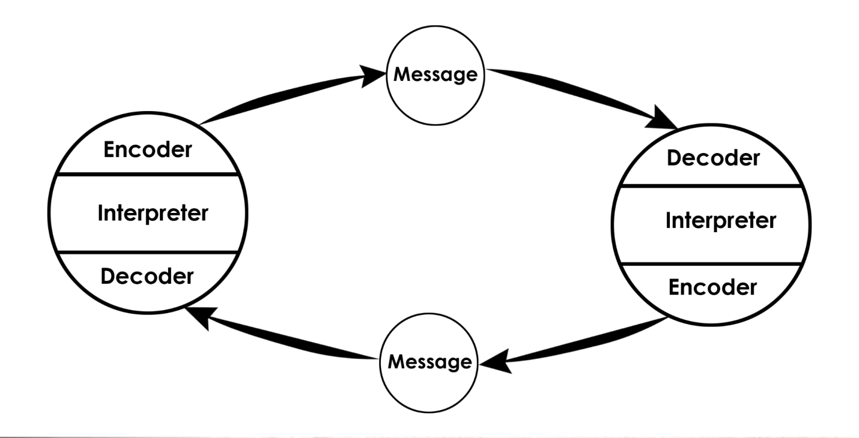
Figure: Schramm Model of Communication
(Source: Mitra, et al., 2020)

Strategies to Avoid Misunderstanding
Sometimes it is difficult to understand the message that is being sent by the sender or interpreted by the interpreter. Feedback in this case helps a lot to avoid any such misunderstanding (Lal, 2020). Just as discussed earlier in the ‘Maria and Pedro’ case, asking for feedback and then resolving them to avoid any misunderstanding. It even helps the sender to improve their way of communication by figuring out the problems the receiver faces through their feedback.
Just as mentioned earlier, the team manager who was brilliant with software and technologies failed to share and pass on it to us due to his lack of communication skill. As soon as I figured it out that if I do not clear my queries, I have to keep redoing my work over and over again and it will also make him feel that I am incompetent. I then started to raise a question, which also gave him the clue and confidence to ask us for our feedback or at least ask us if we have any queries after every discussion and announcement made by him.

Berlo’s Model of Communication (1964)
Berlo’s model of communication is divided into six categories. These stages involve- communications sources, encoding, the message, delivery of the message, decoding, and the final stage involves the receiver. It is also said that Berlo’s model of communication works on the SMCR model (Maneerutt, 2021). This means the source, message, channel, and receiver.
There is a huge difference between Berlo’s SMCR model and the Shannon and Weaver and the Schramm model. The most important difference is that there is no single type of sender, receiver, message, and channel in the SMCR model (Eke, 2020). Most importantly the sender and the receiver does not have to be an individual as it was in the earlier two models. There are no interpreters or noise management arrangements. Along with that the message does not have a particular digit or signal format and the channel can be anything including an individual’s senses. Noise in this form of model has chances to occur after the message is sent and does not impact the message as seen in the Shanon and Weaver model.
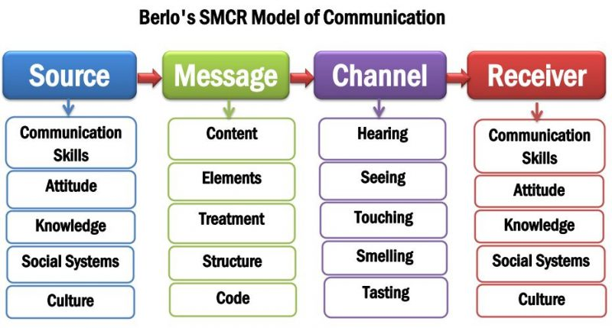
Figure: Berol’s SMCR Model of Communication
(Source: Eke, 2020 )

Types of Communication Skills

Verbal Communication
There are certain factors that need to be scrutinised and used carefully in business while using verbal communication (Ribeiro, and Ferro, 2020). These factors are the choice of words while uttering or writing a message, the tone of the voice along with the pitch also plays an important role in verbal communication. Rough tone in a pleasing situation or vice versa can disrupt the meaning of the message and send wrong ideas to the receiver, which can not only cause misunderstanding between the sender and the receiver but also hinder their relationship.

Non-Verbal Communication:
There are times when non-verbal communication also works like magic for people who find it difficult to express themselves with words (Georgiou, 2021). This type of communication includes body language, gestures, and facial expressions. However, if not used correctly, these can also become leading. For example, if somebody receives a gift and wants to express his or her gratitude but instead of smiling, that person says thank you with a frown, that can seem to be a rude gesture for the receiver.
I have faced a situation in my workplace while I opted for the interview. I was very nervous as it was my first interview and was worrying about how I must present myself just like the case, “A day with the Chief”. As I entered the room, the interviewer was very kind to me, he shook hands to welcome me and gestured to me firmly to take a seat. Just like Mrs. Brown in the case study, he too spoke gently with me and discussed my needs and expectations from the job. His selection of words and polite talking made me feel comfortable like Mark and I was able to ace the interview.

Listening Skills-

Active Listening:
Listening is also a way of becoming a better conversationalist. The communication form of the other people relies heavily on the listening form of the receiver. If a person often checks his or her phone, seems to be distracted, bite nails, overthink about the person sitting in front, while the other person is talking, it can impact the flow of the talker. But if someone is an active listener and pays full attention to the speaker and responds nicely without causing any interruption, it encourages the speaker to communicate with more interest (Jones, Bodie and Hughes, 2019).

Empathetic Listening:
Then comes empathetic listening, where people do not try to compare or create judgement about the speaker, rather they try to put themselves in the speaker’s shoes and understand from their point of view. This sort of listening skill helps to avoid arguments between the speaker and the receiver as they carry empathy for each other and understand better.
During the initial days of my job, I found my superior was not very much of an active listener whenever I shared anything with him. I felt he was always distracted and inattentive. Max in the case study, also happens to be inattentive while Tamara informs him about the changed schedule, which puts his job at risk. Just like Tamara, my boss also did not have any empathy towards my personal problems whenever I was late to my office or document submission and gradually I found it uninteresting to work there.

Advantage and Disadvantages of a Communication Technology
Telephone, now the mobile phone, is one such communication technology invented back in 1876 and 1877. Since then businesses have experienced a major change in their world (Zhu and Wang, 2020). With the upgradation of technology, it became a source of human evolution. People can now perform everything with just a click. While there are so many advantages of this type of communication technology, there are also some disadvantages.

Advantages of Mobile Phone:
- Easy Message Delivery- Communication has become a lot easier with mobile phones. People who are shy to face people and talk face-to-face, find it easier to convey their messages through the phone.
- Renders Chances for Correction- Since there is the availability of easier communication via mobile phones, the sender can recheck their messages and correct them before sending it to the receiver.
- Quick Message Delivery- Mobile phones do not need a long cable or verbal interpreter to deliver a message. It is just a matter of seconds and requires a simple click for a message to get delivered to the receiver.

Disadvantages of Mobile Phones:
- Lack of Physical Communication: People find it easier to talk over the phone, which makes them more incompetent to face people in real life. It even impacts their confidence levels and faces difficulty during mass presentations.
- Occurrence of Misunderstanding: It is difficult to understand the tone and mood of the sender from the message sent by them through mobile phones. Thus, messages can be misleading at times and can cause misunderstanding.

Conclusion
Communication might not seem to be a great deal for many people, and people often take pride about that, but for the business world it is nothing more than a curse. It is very important for anybody struggling in the corporate field or any other profession, which demands mass participation or team handling, communication is the only way to achieve success. The above models show different forms and stages of communication and how it gets improvised with the addition of different elements, like noise interruption, taking feedbacks, or using plenty of channel options.

Reference
Anrieta, K., 2020. Mass Communications: From Classics to the Virtual Models. Journal of Sociology: Bulletin of Yerevan University, 11(2 (32)), pp.59-69.
Bartosik‑Purgat, M., 2019. Digital marketing communication from the perspective of individual consumers: a cross-country comparison. Entrepreneurial Business and Economics Review, 7(3), pp.205-220.
Cargill, S.S., 2019. How do we really communicate? Challenging the assumptions behind informed consent interventions. Ethics & human research, 41(4), pp.23-30.
Eke, G.J., 2020. Effective Communication Processes: A Peanacea for Organizations’ Success. IOSR Journal of Business and Management, 22(8), pp.42-54.
Grant, M.J., 2018. The composer as communication theorist. In The Routledge Research Companion to Modernism in Music (pp. 287-306). Routledge.
Georgiou, S., 2021. Surpassing Narrative and Non-Verbal Communication: A Cross-Modal Approach to Music Composition in Nation Branding. In Handbook of Research on Future Policies and Strategies for Nation Branding (pp. 223-232). IGI Global.
Jones, S.M., Bodie, G.D. and Hughes, S.D., 2019. The impact of mindfulness on empathy, active listening, and perceived provisions of emotional support. Communication Research, 46(6), pp.838-865.
Jordan, M.F., 2021. Noise. In Information (pp. 148-161). Columbia University Press.
Kubota, M., 2019. What is “Communication”?―Beyond the Shannon & Weaver’s Model―. International Journal, 13(1), pp.54-65.
Lal, M.M., 2020. Peer feedback: a tool for growth. JONA: The Journal of Nursing Administration, 50(1), pp.3-4.
Lin, X. and Lin, C., 2020, March. Communication theories applied in mentimeter to improve educational communication and teaching effectiveness. In 4th International Conference on Culture, Education and Economic Development of Modern Society (ICCESE 2020) (pp. 870-875). Atlantis Press.
Maneerutt, G., 2021. Miscommunication at the Workplace: Causes and Ways to Improve Internal Communication. AU-GSB e-JOURNAL, 14(2), pp.155-166.
Mitra, A., Ahmed, N., Pramanik, P. and Nandi, S., 2020. Language Studies and Communication Models. International Journal of English Learning & Teaching Skills, 3(1), pp.1776-1794.
Pirandola, S., 2021. Limits and security of free-space quantum communications. Physical Review Research, 3(1), p.013279.
Ribeiro, S. and Ferro, M.J., 2020. Verbal communication: an essential factor in imternational trade. JANUS. NET, 11(1), pp.31-40.
Zhu, Y. and Wang, M., 2020. A History of Communication Technology. In Communication Technology Update and Fundamentals (pp. 9-26). Routledge.

