

GLOBAL BUSINESS MANAGEMENT

Module code: LCBB4005
Individual Essay

Student Name:Bogdan Pacuraru
Student Number: 2245496
Dr. Essa Bah
28/06/2023

Word Count: 2,668

Table of Contents
Introduction 2
Discussion 2
Conclusion 9
References 10
Appendices 14
Appendix 1: The Nature of political stability in the UK 14
Appendix 2: Estimated growth in the UK GDP 14
Appendix 3: Growth in retail sales by digital technology 15
Appendix 4: Increasing Importance of Sustainability to Consumers 15
Appendix 5: Porter’s Diamond Model 16
Appendix 6: SWOT Analysis 16

Introduction
An external business environment constantly changes in various ways beyond organisational business behaviour. The significant business behaviour of a company depends on its various external and internal components which are resources, employees, markets and customers. All of these factors contribute to an organisation's working environment and can influence its entire business functions. Hence, this essay aims to discuss the external business environment of the UK retail industry considering examples from Unilever and the process for developing its business decisions and actions to influence its ethics and wages. Hence, it will include different models to discuss the entire aspects. Most of the retail companies in the UK such as Tesco, Sainsbury, Unilever and others often reform their ethics, technology adaptation power, CSR and pay structures to influence their external environments.
Unilever is a British global retail company, which is located in London, UK (Unilever.co.uk, 2022). It offers various items such as food, beauty products, personal care and other items. Understanding the macro environment of it, Unilever can influence its global business by implementing its decision-making, competitiveness and budgeting.
Thesis statement: The theory of different external environments is used to explain business behaviour and its influences to manage external business environments. There are several theories and models such as PESTLE, Porter’s five forces and so on used to discuss the structure of external business environments.

Discussion
External market analysis
Factors | Attributes | Impacts
Political | - UK and EU trade becomes more quote free-and tariff-free (Gov.uk, 2018).  - Corporate tax legislation will be increased by 25% in 2024 (Gov.uk, 2023).  - The political stability of the UK is approximately 2.5% strong. [Refer to Appendix 1] | Highly negative
Economical | - Retail workers get an average salary of up to 57,500 pounds each year.  - Investment of UK governments is improving corporate governance.  - UK GDP has been observed with a growth of 0.2% in 2023 march (Ons.gov.uk, 2023). [Refer to Appendix 2] | Highly negative
Social | - CSR activities are affecting UK retail industries by creating new opportunities (Nyame-Asiamah and Ghulam, 2019).  - Ethical issues such as misleading marketing, and misleading sales affect retail industries in the UK.  - UK people become concerned about healthy foods. | Highly positive
Technological | - “Internet of things”, virtual reality and AR is rapidly used in UK retail sectors.  - It helps to gain rising standards of consumer experiences (Statista.com, 2022b).  - Digital technology rose retail sales by 33% in 2017 (Deloitte.com, 2017). [Refer to Appendix 3] | Highly positive
Legal | - “Consumer safety act 1978” (legislation.gov.uk, 2023).  - “Employment relations act 1999”.  - These acts govern employee and employer relationships in global trade unions. | Highly positive
Environmental | - 35% of retail sales are controlled by customers, as they prefer to buy from sustainable retailers (Consultancy.uk, 2022). [Refer to Appendix 4]  - There are no significant recycling laws in the UK.  - The risk of supply chain disruption has been increasing. | Moderate
Table 1: PESTLE analysis
(Source: Self-developed)
In the table, it can be understood that politically, UK government has taken different initiatives to help the retail market and open a few new stores and outlets. Hence, they permit UK and EU trade to become more free-and tariff-free so that other companies can perform their business in the UK. However, in the post-pandemic situation, corporate tax legislation will be increased by 25% in 2024 (Gov.uk, 2023).
Economically, the UK government has taken restrictions on spending cuts to save resources, which results in the creation of more money. It is helping to improve productivity. Investment of UK governments is improving corporate governance. However, As a result of the continued recovery of post-pandemic situations, the GDP has grown by 0.2% (Ons.gov.uk, 2023).
Socially, UK people become concerned with the practice of healthy food consumption and environmental sustainability. Hence, most of retail companies are re-arranging their CSR aspects. New CSR activities are affecting UK retail industries by creating new opportunities. However, the changes in ethical figures impact highly negatively to some organisations (Nyame-Asiamah and Ghulam, 2019). Ethical issues such as misleading marketing, and misleading sales have been observed in some companies. Hence, it needs to solve these issues with proper organisational behaviour.
Technologically, new technological aspects significantly help to raise the popularity of retail markets and it is highly positive for the retail sectors. Retail companies in the UK use various LoT, AR and VR applications in their business which can attract more customers in international markets. In 2017, the application of digital technology helped to raise retail sales by 33% (Deloitte.com, 2017).
Legally, the “Employment relations act 1999” is performing strictly in the UK trade unions and corporate areas. In the matter of global extension, the retail employer and workers have to maintain their relationships on behalf of the company. It helps to protect UK workers' rights. In addition, UK retail companies have to strictly follow the “Consumer safety act 1978” as it helps to protect the consumer's rights through buying services (legislation.gov.uk, 2023). The UK government surveys these laws to protect consumers against issues including fraud and misspelling actions.
In environmental aspects, the UK people are becoming more concerned about their suitable retail product choices. Hence, 35% of retail sales are coming from sustainable-loving consumers (Consultancy.uk, 2022). Moreover, here, the environmental impact that is reflected by using raw materials wastes is moderate. However, in the future, there can be highly negative aspects in the supply chain disruption cases.
Porter’s Five Forces
Factors | Attributes | Impact
Competition in the industry | - It becomes highly competitive as the local and organised markets are growing significantly (Upadhyay et al., 2019).  - Established retail companies such as Tesco, Sainsbury and others are already achieving a significant place in the international market. | High
The potential of new entrants | - New entrants are prominent in the market yet to continue with the competitive advantage (Reinartz, Wiegand and Imschloss, 2019). | Moderate
Power Of customers | - The powerful customers help to negotiate for lower prices and provide significant customer experiences (Nash, 2019). This makes loyal customers to be attached to their preferred organisation in a competitive atmosphere. | High
Power of suppliers | - Significant suppliers have the potential to keep the availability of inputs and control on the product supply (Schleper et al., 2021). | High
The threat of alternative products | - Alternatives for popular retail products in each segment are not prominent considering the acceptance and pricing strategies (Tolstoy et al., 2020). | Low
Table 2: Porter’s five forces
(Source: Self-developed)
Following the above table, it shows a higher competition, that changes the mindset of customers and the power of suppliers can highly impact Unilever. Hence, it needs to make a strong relationship with suppliers so that it can meet all the requirements of customers and by vast availability of inputs. Thus it can make a strong brand value in global markets.

Porter’s Diamond model
Firm strategy and structure
Unilever being one of the leading retail organisations in the market of the United Kingdom executes their business which is led by a distinct kind of organisational structure known as c-level "executives and the post of president is stated as "leadership executive". The C-level executive takes charge to regulate several organisational departments, such as finance, marketing, human resource, supply chain, resource management, and many more. This department of the organisation deals with some major products such as home care, beauty products, nutrition and many more. Unilever executes its business with five mottoes or the strategy revolving around faster and agile services, focusing on product segmentations, and concentrating on effective empowerment, and sustainability (Unilever.com, 2023). These are the strategies which are developed by the organisation to generate an impactful business in the retail industry across the United Kingdom. Apart from this, the biggest rivalry of this organisation is Tesco, which has recorded a revenue figure of around 60 billion pounds in the year 2023 (Bedford, 2022). Therefore the retail business industry in the United Kingdom seems to be crowded and highly competitive to survive for Unilever in the current situation.
Related industries
Technology and the raw material industry are directly connected with the business factor of Unilever which helps them to exchange and transfer products and knowledge to execute the business in a productive way to achieve the expected goal. In the current scenario of digital transformation, the retail industry is highly reliant on technology to execute its business through digital or e-commerce mediums and provide quality consumer services. Due to this reason, the IT industry of the United Kingdom recorded a revenue figure of around 98 billion pounds in the year 2021 (Statista.com, 2022). Apart from this, the demand f raw materials in every sector of the business in the United Kingdom has resulted in projected a revenue figure of around 351 billion pounds in the year 2020 (Statista.com, 2023). Therefore, these are the two related industries impacting the business scenario of Unilever in the contemporary business.
Demand conditions
The retail market size of the United Kingdom is around 483.0 billion pounds as per the record of 2022 (Statista.com, 2023b). The demand of the consumers and the target consumer base of Unilever is highly concentrated on urban-centric consumers which pulls a high revenue figure of around 60.7 billion pounds in the UK market (Petruzzi, 2022). This numerical data reflects the relevance and the high demand of the organisation in the business sector of the United Kingdom
Factor condition
The present state of high revenue flow in the retail market of the United Kingdom is highly influenced by the economic growth of the nation. According to the report of Clark (2023), in the year 2022, the GDP of the United Kingdom was around 2.2 trillion pounds. This factor demarks the demand increase of the business of Unilever in the nation and international trade across the globe and nation. Besides this, the revenue growth in the survival segment and growth in infrastructure is projected approx. 3.11 billion pounds in the year 2023 (Statista.com, 2023b). This revenue figure projects the major factors influencing the growth of the retail market across the nation.
Identification of the reasons that make organisations go international
Strength | Weakness
- Strong supply chain  - Effective management  - Strong employee base of around 127,000 (Unilever.com, 2023b) | - Lack of diversification of product segment (Darretta, 2021)  - Poor marketing  - Weak people management
Opportunity | Threat
- Greater economic scale  - Expanding consumer base  - Elevating productivity and innovation (Anikin, 2022)  - Increasing product segment and diversification | - High competitive market  - Low brand awareness  - Low-quality consumer services (McCarthy, 2021)
Table 3: SWOT analysis of Unilever
(Source: Self-developed)
Analysis
The above table depicts the key factors of the business infrastructure of Unilever which demarks the chances of the organisation to sustain itself in the global retail market and accrue the target consumer base. Analysing the insights of the organisation, the strength segment of this SWOT analysis depicts the huge spectrum of employees this organisation holds globally which will help them deliver innovation and productivity to expand the business and effective management will help them to sustain the employees. Besides this, there is an opportunity to increase product segmentation and the poor range of marketing can deliver huge losses due to lack of brand awareness in the global market.
Reasons to expand the business globally
There are several key reasons, which are considered as the major intentions of organisations to expand their business or trades globally. One of the key reasons is to sell a higher volume of services or products. An organisation such as Unilever has expanded their business globally to provide quality services and products to the uncracked target consumers in several other countries across the globe. These products of the organisations are getting sold by navigating the demand of the demographics. For example, Uniler is considered one of the leading beverage retail sales in the United Kingdom depicting a revenue of around 13.6 billion pounds (Petruzzi, 2023). This is one of the key reasons for Unilever to expand their business globally in different nations according to their demand.
Incorporating innovation globally
Organisations lacking in their technological aspects to provide quality consumer services in the retail business scenario usually expand their business in that notation where the organisations get new age business technologies easily and shape their business to upgrade the execution process. For example, Tesco as a well-established retail brand in Britain was lacking in quality consumer and digital services due to poor IT infrastructure in the business sector of the United Kingdom. Due to this reason, they have expanded their business to Ireland which holds an IT market revenue of around 1579.9 million pounds (Statista.com, 2023c). This has helped the organisation to incorporate new technologies such as AI, and automation in their global business segment. This is one of the main reasons to expand the business globally to avail the required business infrastructure.
Understanding of the micro economy, different market structures and their influences
Diversification of the firm is one of the key reasons for the organisation to execute or engage in international trade. Diversification of employees in retail firms such as Unilever helps them to understand the demands of several communities in different communities or regions across the globe. According to the report by Tynes (2022), the inclusion and diversification of employees in retail or any other business sectors across the globe help the organisation to develop talents and elevate productivity in the workplace. The cultural diversity which is adopted by the organisation according to their established work in a different section of the world incorporates the present innovation which eventually reflects the growth in the profit structure of the organisation. Apart from this, Organisations lacking in their technological aspects to provide quality consumer services in the retail business scenario usually expand their business in those nations where the organisations get new age business technologies easily and shape their business to upgrade the execution process.
Unilever as a leading retail brand in the UK is also an established retail name in the business sector of the United States. The high demand for beverages in the UK is measured by the consumption rate of packaged drinking water in the UK, which has recorded a rate of around 25% of bottled water of the whole beverage consumed by US customers (Ridder, 2023). Due to this reason, as mentioned in the above action of this essay, Unilever is considered one of the leading beverage retailers in the business sector of the US. This business status of Unilever in the US has been possible due to the influence made by the consumers and the American employees in the organisation, which has helped the managerial team of the organisation to navigate the target market and the demand of the consumers in the US business scenario. Therefore the strategy of the organisation has always been to understand the demand and market the brand image in different parts of the globe to build a sustainable consumer base to survive. This has helped the organisation to sustain its business in different parts of the world in the long run.
Retail business across the globe has faced huge changes in the contemporary business scenario which has contributed to the present international economy by adopting the proper usage of e-commerce as an effective source of delivering high-quality consumer satisfaction. This has helped several organisations such as Unilever to extend their business digitally. The sales of retail e-commerce in the year 2022 have recorded a worldwide figure of around 5.7 trillion pounds (Pasquali, 2023). This is the key contribution of retail business to the global economic structure.

Conclusion
This essay concludes by providing a clear insight into the global retail market which has a clear indication of its impact on the global economic structure. The clarification of global business management practices executed by several retail industries to establish diversification and technological progress has been depicted here with proper numerical data and information. All of these factors contribute to an organisation's working environment and can influence its entire business functions. Hence, this essay aims to discuss the external business environment of Unilever and how its business decisions and actions influence its ethics and wages. Hence, it will include different models to discuss the entire aspects.

References
Anikin, S. (2022) Council Post: Productivity, Innovation And Spotting The Signals Of Change, Forbes. Available at: https://www.forbes.com/sites/forbestechcouncil/2022/02/22/productivity-innovation-and-spotting-the-signals-of-change/?sh=4a31c38430ab (Accessed: 14 June 2023).
Bedford, E. (2022) Tesco financial revenue United Kingdom 2015-2018 | Statista, Statista. www.statista.com. Available at: https://www.statista.com/statistics/490931/tesco-group-finance-revenue-united-kingdom-uk/ (Accessed: 14 June 2023).
Benzaghta, M. A. et al. (2021) ‘SWOT Analysis applications: an Integrative Literature Review’, Journal of Global Business Insights, 6(1), pp. 54–72. doi: https://doi.org/10.5038/2640-6489.6.1.1148.
Clark, D. (2023) UK: GDP in pounds 2000-2018, Statista. Available at: https://www.statista.com/statistics/281744/gdp-of-the-united-kingdom/#:~:text=The%20Gross%20domestic%20product%20of (Accessed: 14 June 2023).
Consultancy.uk (2022) Sustainable consumption a £150 billion opportunity for UK retail, www.consultancy.uk. consultancy.uk. Available at: https://www.consultancy.uk/news/30531/sustainable-consumption-a-150-billion-opportunity-for-uk-retail (Accessed: 14 June 2023).
Darretta, C. (2021) Council Post: The Value Of Diversification, Forbes. Available at: https://www.forbes.com/sites/forbesbusinesscouncil/2021/10/18/the-value-of-diversification/?sh=2610ff5e221e (Accessed: 14 June 2023).
Deloitte.com (2017) Digital Influence in UK Retail, https://www2.deloitte.com/content/dam/Deloitte/uk/Documents/consumer-business/deloitte-uk-digital-influence-in-uk-retail-2014.pdf. deloitte: deloitte, p. 1/20. Available at: https://www2.deloitte.com/content/dam/Deloitte/uk/Documents/consumer-business/deloitte-uk-digital-influence-in-uk-retail-2014.pdf (Accessed: 14 June 2023).
Gov.uk (2018) UK trade policy: a guide to new trade legislation, GOV.UK. GOV.UK. Available at: https://www.gov.uk/government/publications/a-uk-trade-policy-a-guide-to-trade-legislation/preparing-for-a-uk-trade-policy-a-guide-to-trade-legislation (Accessed: 14 June 2023).
Gov.uk (2023) Spring Budget 2023 — Overview of tax legislation and rates (OOTLAR), GOV.UK. GOV.UK. Available at: https://www.gov.uk/government/publications/spring-budget-2023-overview-of-tax-legislation-and-rates-ootlar/spring-budget-2023-overview-of-tax-legislation-and-rates-ootlar#:~:text=Legislation%20will%20be%20introduced%20in (Accessed: 14 June 2023).
legislation.gov.uk (2023) Consumer Safety Act 1978, Legislation.gov.uk. legislation.gov.uk. Available at: https://www.legislation.gov.uk/ukpga/1978/38/enacted#:~:text=(1)Where%20safety%20regulations%20prohibit (Accessed: 14 June 2023).
McCarthy, B. (2021) Council Post: The Biggest Factor For Company Success: Customer Service, Forbes. Available at: https://www.forbes.com/sites/forbesfinancecouncil/2021/12/22/the-biggest-factor-for-company-success-customer-service/?sh=19a28f5c10aa (Accessed: 14 June 2023).
Nash, J. (2019) ‘Exploring How Social Media Platforms Influence Fashion Consumer Decisions in the UK Retail Sector’, Journal of Fashion Marketing and Management: An International Journal, 23(1), pp. 82–103. doi: https://doi.org/10.1108/jfmm-01-2018-0012.
Nyame-Asiamah, F. and Ghulam, S. (2019) ‘The relationship between CSR activity and sales growth in the UK retailing sector’, Social Responsibility Journal, 16(3). doi: https://doi.org/10.1108/srj-09-2018-0245.
Ons.gov.uk (2023) Gross Domestic Product (GDP) - Office for National Statistics, www.ons.gov.uk. ons.gov.uk. Available at: https://www.ons.gov.uk/economy/grossdomesticproductgdp#:~:text=GDP%20first%20quarterly%20estimate%2C%20UK%3A%20January%20to%20March%202023&text=Monthly%20estimates%20published%20today%20(12 (Accessed: 14 June 2023).
Pasquali, M. (2023) E-commerce worldwide - statistics & facts, Statista. Available at: https://www.statista.com/topics/871/online-shopping/#topicOverview (Accessed: 14 June 2023).
Petruzzi , D. (2022) Revenue of the Unilever Group worldwide 2007-2021 | Statista, Statista. www.statista.com. Available at: https://www.statista.com/statistics/269190/global-revenue-of-the-unilever-group-since-2007/ (Accessed: 14 June 2023).
Petruzzi, D. (2023) Topic: Unilever, Statista. Available at: https://www.statista.com/topics/1397/unilever/#topicOverview (Accessed: 14 June 2023).
Reinartz, W., Wiegand, N. and Imschloss, M. (2019) ‘The impact of digital transformation on the retailing value chain’, International Journal of Research in Marketing, 36(3), pp. 350–366. doi: https://doi.org/10.1016/j.ijresmar.2018.12.002.
Ridder, M. (2023) U.S. consumption share of beverages by segment, 2018, Statista. Available at: https://www.statista.com/statistics/387199/us-consumption-share-of-beverages-by-segment/ (Accessed: 14 June 2023).
Schleper, M. C. et al. (2021) ‘Pandemic-induced knowledge gaps in operations and supply chain management: COVID-19’s impacts on retailing’, International Journal of Operations & Production Management, 41(3), pp. 193–205. doi: https://doi.org/10.1108/ijopm-12-2020-0837.
Statista.com (2022a) IT market revenue in United Kingdom 2016-2021, Statista. www.statista.com. Available at: https://www.statista.com/forecasts/961413/it-revenue-in-united-kingdom (Accessed: 14 June 2023).
Statista.com (2022b) Topic: Retail technology in the UK, Statista. statista.com. Available at: https://www.statista.com/topics/5425/retail-technology-in-the-uk/#dossier-chapter5 (Accessed: 14 June 2023).
Statista.com (2023a) Import value raw building materials in UK 2019, Statista. Available at: https://www.statista.com/statistics/473728/raw-building-material-import-uk/ (Accessed: 14 June 2023).
Statista.com (2023b) Infrastructure as a Service - UK | Statista Market Forecast, Statista. Available at: https://www.statista.com/outlook/tmo/public-cloud/infrastructure-as-a-service/united-kingdom (Accessed: 14 June 2023).
Statista.com (2023c) IT services market revenue in Ireland 2016-2021, Statista. Available at: https://www.statista.com/forecasts/963825/it-services-revenue-in-ireland (Accessed: 14 June 2023).
Statista.com (2023d) Retail Trade in the UK - Industry Insights & Data Analysis, Statista. Available at: https://www.statista.com/study/42060/retail-trade-in-the-uk/#:~:text=Statista%20Industry%20Report%20%2D%20SIC%20Code%2047&text=In%202022%2C%20the%20estimated%20revenue (Accessed: 14 June 2023).
Tolstoy, D. et al. (2020) ‘The development of international e-commerce in retail SMEs: An effectuation perspective’, Journal of World Business, 56(3), p. 101165. doi: https://doi.org/10.1016/j.jwb.2020.101165.
Tsiligiris and Vangelis (2018) “An adapted Porter Diamond Model for the evaluation of transnational education host countries’, International Journal of Educational Management. 32. doi: https://doi.org/10.1108/IJEM-03-2017-0076.
Tynes, B. (2022) Council Post: The Importance Of Diversity And Inclusion For Today’s Companies, Forbes. Available at: https://www.forbes.com/sites/forbescommunicationscouncil/2022/03/03/the-importance-of-diversity-and-inclusion-for-todays-companies/?sh=17b9d0a049df (Accessed: 14 June 2023).
Unilever.co.uk (2022) Home, Unilever UK & Ireland. unilever. Available at: https://www.unilever.co.uk/ (Accessed: 14 June 2023).
Unilever.com (2023a) Strategy, Unilever. www.unilever.com. Available at: https://www.unilever.com/our-company/strategy/ (Accessed: 14 June 2023).
Unilever.com (2023b) Unilever at a Glance, Unilever. www.unilever.com. Available at: https://www.unilever.com/our-company/at-a-glance/ (Accessed: 14 June 2023).
Upadhyay, A. et al. (2019) ‘Investigating “circular business models” in the manufacturing and service sectors’, Journal of Manufacturing Technology Management, 30(3), pp. 590–606. doi: https://doi.org/10.1108/jmtm-02-2018-0063.

Appendices

Appendix 1: The nature of political stability in the UK
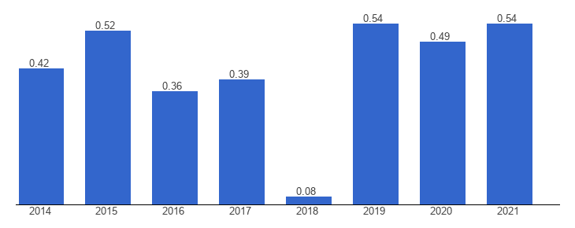
Figure 1: The nature of political stability in the UK
(Source: Gov.uk, 2023)

Appendix 2: Estimated growth in the UK GDP
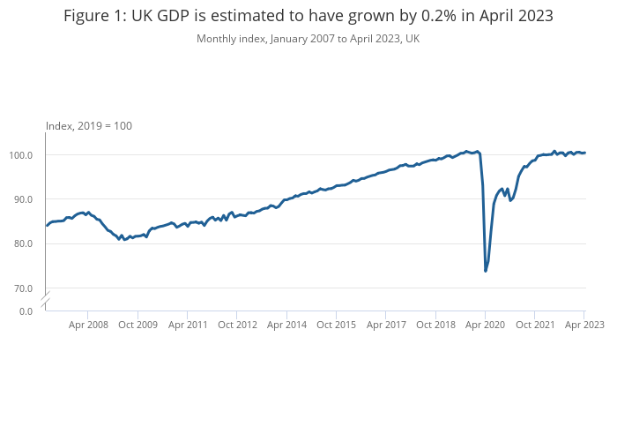
Figure 2: Estimated growth in the UK GDP
(Source: Ons.gov.uk, 2023)

Appendix 3: Growth in retail sales by digital technology
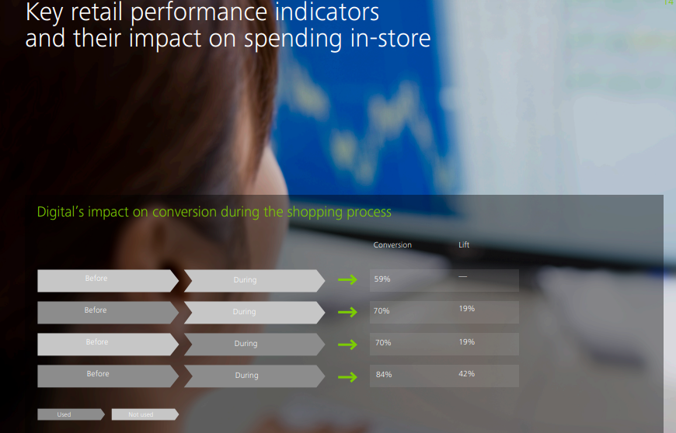
Figure 3: Growth in retail sales by digital technology
(Source: Deloitte.com, 2017)

Appendix 4: Increasing importance of sustainability to consumers
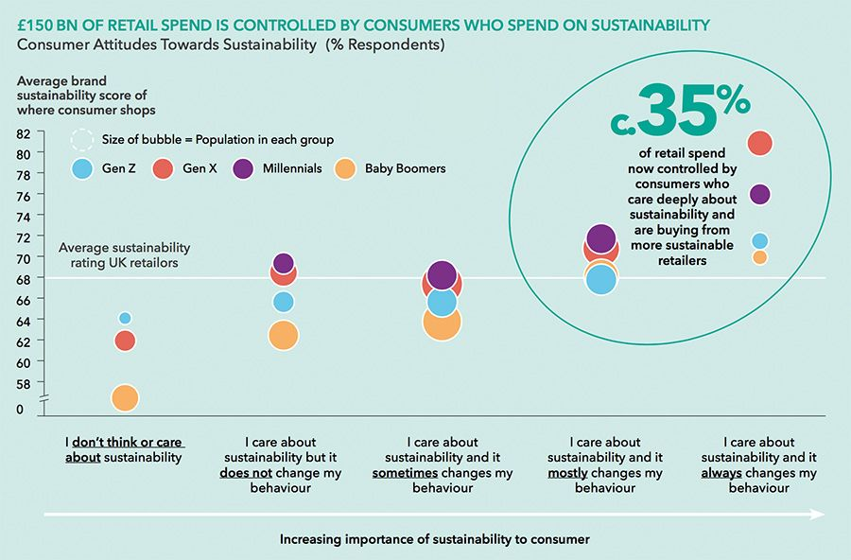
Figure 4: Increasing importance of sustainability to consumers
(Source: Consultancy.uk, 2022)

Appendix 5: Porter’s Diamond Model
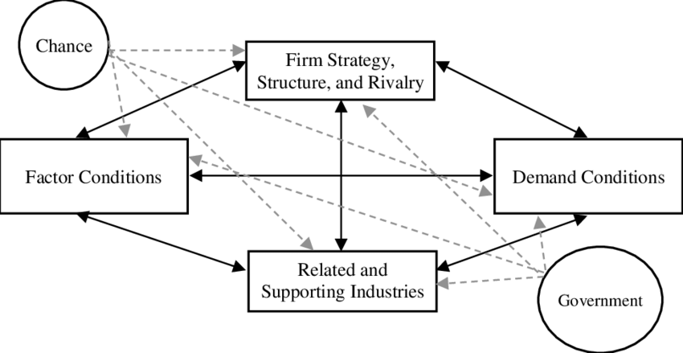
Figure 5: Porter’s Diamond Model
(Source: Tsiligiris and Vangelis, 2018)

Appendix 6: SWOT Analysis
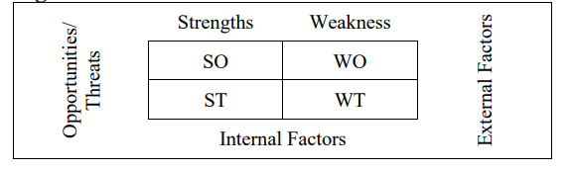
Figure 6: SWOT Analysis framework
(Source: Benzaghta et al., 2021)

