BA (Hons) Leadership and Management Skills in the Workplace
LCLM6005
Independent Project
Component 1: Portfolio
Impact of strategic changes made in University café on students’ satisfaction and business performance
Student Name: Fahad Ali
Student ID:2227918
Model Code: LCLM6005
Lecture Name: Samuel Ofori
Supervisor Name: DR Eric Osei

Acknowledgement
I am indebted and grateful to my university professor as without their guidance and support I would be unable to complete this research project. I am grateful to my Lecture Samuel Ofori the Programme Manager for, BALM also to my Supervisor Dr Eric Osei and the University authority for providing me the opportunity to conduct research on this topic. I would also like to thank my peers and parents for their constant support, which has encouraged me to carry out this particular research.
A big thank to all Students who took part in this research by completing the survey and participating in the interview. Your valuable time, honest responses, and thoughtful insights greatly contributed to the success of this study. Your participation made it possible to gather meaningful data and develop a deeper understanding of the research topic.

Abstract
Background: A well-run campus canteen provides students with healthy and affordable food items to keep them satisfied and attracted towards the products and services. It has been analysed that often students cannot get quality foods due to high prices of items, products and services. In this consideration, this research has focused on analysing the ways this research is significant and can ensure client happiness and high-quality service.
Aim: The primary purpose of this study is to investigate how strategic operational improvements improved student satisfaction in aspect of the changes brought into the University Café.
Methods: This research has chosen Positivism philosophy, Deductive approach and Descriptive design in response to engaging primary method to conduct both quantitative and qualitative research. Also, the present research has considered GDPR (General Data protection rules) to protect privacy of participants. The survey and interview have been conducted. The sample size is considered as 50 students of university for the survey and 4 for conducting the interview.
Results: It is highlighted that service quality, diversity of menu, efficiency of staff members, and accessibility to the cafe’s services play huge role in enhancing customer satisfaction. Improved service quality and better customer satisfaction can eventually help the university cafe to witness sustainable growth. The staff efficiency, service quality and individual satisfaction are closely related. The improved service quality creates positive experiences and perception of a business like university café in the present context. Besides, the overall satisfaction influences the word of mouth, repeat purchasing of individuals. This has a direct impact on the growth and development of café. Analysing the responses collected from the sample population, it has been identified that 32% of respondents visit the University Cafe twice a week. At the same time, 26% of the respondents visit the cafe thrice a week. 62% of them agreed with the view that the recent changes in these two factors have helped the University Cafe to increase its footfall. On the other hand, 22% of the respondents disagreed with this view.
Conclusion: The research demonstrated that the strategic changes in the menu variety, operational hours, pricing and service quality have successfully enhanced student satisfaction and contributed to the growth based on quality serviced, improved performance and higher productivity.

Table of contents

Chapter 1: Introduction 8
1.1 Chapter Introduction 8
1.2 Background 8
1.3 Problem Statement 8
1.4 Research Aim 9
1.5 Research Objectives 9
1.6 Research Question 10
1.7 Research Rationale 10
1.8 Chapter Summary 11
Chapter 2: Literature Review 12
2.1 Chapter Introduction 12
2.2 Relevance of service quality 12
2.3 Importance of customer satisfaction 13
2.4 Students’ perceptions on pricing strategies 13
2.5 Small business management 14
2.6 Operational improvement shaping customer loyalty 14
2.7 Operational effectiveness improving business performance 15
2.8 Theoretical underpinning 16
2.9 Literature gap 16
2.10 Chapter summary 17
Chapter 3: Methodology 18
3.1 Chapter introduction 18
3.2 Research methods 18
3.3 Research philosophy 18
3.4 Research approach 18
3.5 Research design 19
3.6 Search strategy, Inclusion/exclusion criteria 19
3.7 Sample size and techniques 19
3.8 Data collection 19
3.9 Data analysis 20
3.10 Limitations 20
3.11 Ethical considerations 20
3.12 Chapter summary 21
Chapter 4: Results and discussion 22
4.1 Chapter introduction 22
4.2 Primary Quantitative data analysis 22
4.3 Theme Table 29
4.4 Thematic Analysis: Primary Qualitative Data (Interview Transcript) 30
4.4.1 Theme 1: Menu Variety and Pricing Strategy 30
4.4.2 Theme 2: Accessibility and Café Operating Hours 30
4.4.3 Theme 3: Service Quality & Staff efficiency 31
4.4.4 Theme 4: Overall satisfaction & Business perception 31
4.5 Discussion 32
4.6 Chapter summary 36
Chapter 5: Recommendations, Conclusion and Limitations of the Research 37
5.1 Chapter Introduction 37
5.2 Recommendations 37
5.3 Conclusion 38
5.4 Limitations of the Research 39
5.5 Chapter Summary 40
References 41
Appendices 47
Appendix 1: Survey Questionnaire 47
Appendix 2: Interview Questions 50

Chapter 1: Introduction

1.1 Chapter Introduction
This chapter of the dissertation has introduced the topic, provided depth background information. Also, clear aim, objectives and research questions are highlighted in this particular section. Apart from this, the problem statement is given in order to focus on the issue and solve it through conducting this research. The answers to the study questions will be included in the findings chapter once the research is completed.

1.2 Background
Attending university for a person is a once-in-a-lifetime chance and it contributes towards the career growth opportunities in the coming years. It is also effective for social discovery and self-exploration. In between lectures and the extracurricular activities, the students gather in the college cafeteria to eat and relax. A well-managed and reasonably priced college canteen offers students with the nutritious nourishment they require to remain motivated and focused throughout the day. Providing a variety of alternatives can help the students top choose from them. This needs to be done by analysing the dietary preferences and ensuring that all kids may select meals that fit their needs. College life is tough so students must be intellectually and physically prepared (Purwadi and Manurung, 2020). Based on the present university café, common criticisms about the café were its short menu, which is viewed as a big challenge. The uncertain hours of operation and exorbitant costs also creates negative impacts on the cafe. The primary goal of this study is to assess the ways strategic café modifications effect business performance and student satisfaction. This business model will demonstrate student-run entrepreneurship on a university campus with everyday operations affecting a specific population. Some cafeterias have witnessed proper growth by promoting about healthy eating habits and allowing them to make better decisions throughout their academic careers and beyond (McDermott et al., 2020). Nonetheless, since the students are disappointed as a result of the difficulties raised with inadequate administration, this study will help the students to understand the importance of corporate management through improved decision-making and the effective implementation of necessary changes. This research topic is extremely important since the findings can throw light on the ways small businesses can be properly managed for customer satisfaction and service quality.

1.3 Problem Statement
The university café is more than just a meal choice, and it is also an important part of campus culture. It promotes environmentally beneficial behaviours that encourage people to collaborate and provides physical nutrition and emotional satisfaction. These approaches not only reduce the negative environmental impact of the café but also teach individuals the value of sustainable practices (Johannisson and Hiete, 2021). This study will give insights on strategic change management approaches that can enhance the customer experience and corporate outcomes. It can be considered as a useful tool for small businesses that are looking to improve their offerings in response to their target market regarding the changing expectations.

1.4 Research Aim
The aim of the research is to analyse the overall impact of strategic operational changes on the satisfaction and performance of the university students of the café based on the changes and improvements made

1.5 Research Objectives
The prime objectives of the research are stated as follows:
- To evaluate the impact of menu variety and pricing on student satisfaction
- To assess the effect of extended café opening times and accessibility
- To analyse the impact of service speed and worker efficiency on students

1.6 Research Question
The research questions are stated as follows:
- How have the changes made in menu variety and pricing affected student satisfaction?
- What impact do extended opening hours have on university’s café usage among students?
- To what extent have operational improvements shaped overall customer loyalty and business performance?

1.7 Research Rationale
In the fast-paced world of present times, the efficiency is essential, and diet regimens are no exception. Many individuals use cafeterias as a dining option between their busy schedules. However, issues of congestion can be identified due to the long lines, and the students have to wait for a long time. Customers become irritated as a result of the missed time. Cafeteria proprietors have to go through huge loss if guests become irritated owing to the lengthy wait and also it has a negative impact on reputation (Decker-Lange et al., 2021). In order to address this issue, the cafeteria has been mooted that would bring together all of the on-campus dining options. This is an attempt to ease some of the crowding issues while also making dining more convenient for cafeteria operators and patrons. It is always tempting to focus on labour or food costs, but it is also important to consider the intangible benefits of a healthy eating program (Mesra et al., 2021). Unplanned pop-up events with a food theme are an excellent way to keep students interested. The present research sheds light on the importance of affordable foods with high quality services so that better satisfaction can be witnessed. This can also help to bring long term growth and success of a café. The lack of variety in the café's food options has had a negative impact on sales and this has created lack of student satisfaction. High costs and the limited food options and ineffective administration all contribute to decreased sales and an inability to satisfy students (Sandberg et al., 2023). Also, an inconsistency in business hours has contributed to student dissatisfaction. All of the identified issues have a significant impact on the low sales of University Café. This study must give proper attention to resolve the current issue by adjusting the menu with more options and provide reasonable rates of each item.

1.8 Chapter Summary
This chapter of the dissertation presents the key themes of the study so that readers can comprehend the influence of strategic modifications to the university café on student satisfaction and financial success. This chapter has focused on the student-led entrepreneurship model, which has also identified the problem and this study has been considered beneficial to meet the objectives and aim. Customer satisfaction will rise as a result of the ongoing strategy and based on effective satisfaction of students, growth and effective sales can be seen.

Chapter 2: Literature Review

2.1 Chapter Introduction
The main focus of this literature review chapter is to critically analyse the existing literature studies and analyse the facts and ideas to gather insights and more knowledge. This literature review chapter has reviewed the past studies in terms of evaluating the existing information regarding customer satisfaction, service quality, small business management, and other aspects that can address the key research objectives and questions. In addition, this chapter has provided the theoretical background considering which a clear idea can be gathered regarding the research context. Furthermore, literature gaps have been identified so that the research can help in addressing those gaps and the quality of this study can be enhanced.

2.2 Relevance of service quality
According to the statement of Tannady et al. (2023), the maintenance of the quality of services becomes largely important for the businesses that are directly customer-focused such as university cafes. In order to increase client happiness and loyalty, service quality can help to provide services that either meet their expectations or fail to meet. Features including food quality, staff response, and speed of service are crucial in influencing opinions in student-focused cafes. Service quality is very crucial due to the tight budgets and hectic schedules as university students are particularly sensitive to delays and irregularities. The statement of Yunita et al. (2022) helps in evaluating that frequency of dining and customer satisfaction are positively impacted by a diverse menu and consistently high-quality service. Conversely, inadequate service quality, such as sluggish delivery or dirty surroundings, is closely associated with customer discontent and decreased business growth. It becomes largely crucial for a service providing business those consistent services with quality products is maintained as it eventually helps in enhancing the overall operational efficiency (Ahmed et al., 2023). In this regard, it can be outlined that service quality has a direct impact on cafes' long-term viability, income, and customer loyalty, making it more than just an operational issue. Therefore, the improvement of service quality through ensuring appropriate strategic approaches can also create better scopes for the businesses to enhance customer engagement and operational efficiency.

2.3 Importance of customer satisfaction
As per the views of Ali et al. (2021), customer satisfaction and experience are considered to be one of the most significant aspects that help in ensuring business growth and operational efficiency. Customer satisfaction reliably helps in understanding the level of service quality a business delivers that matches the expectations of potential customers. Food quality, cleanliness, menu variety, cost, and speed of service all affect customer satisfaction at campus cafes. Customer happiness, which in turn encourages repeat business and favourable word-of-mouth advertising, is greatly influenced by service quality. The statement of Yasir et al. (2021) argues that customer happiness predicts loyalty, which is crucial for small businesses operating in a niche industry. Students are more inclined to build faith in the cafe and contribute to long-term company success when they believe that their requirements are being satisfied, by reasonably priced meals, nutritious alternatives, and effective service. On the other hand, discontent brought on by exorbitant costs or subpar administration leads to lower sales and harm to one's reputation. Customer happiness turns into a metric for sustainability and success in small-scale businesses with limited resources, such as a campus cafe (Taufik et al., 2022). Cafes may increase customer engagement and loyalty by implementing satisfaction-driven tactics including enhanced menu variety, clear pricing, and responsiveness to feedback. Therefore, customer satisfaction works as a strong driving factor for the small businesses such as university cafes in terms of enhancing operational efficiency and business growth.

2.4 Students’ perceptions on pricing strategies
Pricing of available products plays an important role in terms of outlining the perceptions of potential customers. As per the argument of Raihen et al. (2023), fair and affordable prices have a big impact on the satisfied customers. Students are more inclined to look for alternatives off campus when costs are thought to be too high, which lowers foot traffic and income. In this situation, value-based pricing is very pertinent. This tactic ensures affordability while preserving profitability by matching pricing to the perceived worth of the item or service. On a similar note, the statement of Martinez-Perez et al. (2022) emphasises even more the ways students' intents to buy are influenced by fair pricing, which shapes their views of loyalty and trust. Furthermore, opinions of price include justice and transparency in addition to affordability. For instance, if quality, larger quantities, or healthier alternatives are offered, students might be willing to pay a little more. On the other hand, unstated fees or uneven pricing policies damage credibility and deter repeat business. Research indicates that the rivalry of university cafes in relation to adjacent off-campus establishments is directly impacted by perceptions of affordability (Ganatra et al., 2021). Hence, affordable and discounted pricing strategies attract students the most in the university cafes, which further help in enhancing their loyalty as well.

2.5 Small business management
The prospect of small business management is considered to be impacted by different internal and external aspects. Small businesses, such as university cafes, must put flexibility and cost effectiveness first, unlike larger corporations. Effective tactics include hiring qualified employees, managing cash flow well, and implementing cutting-edge procedures (Kraus et al., 2023). Results for small businesses are influenced by both internal and external influences. While consumer expectations, market competitiveness, and economic constraints are external concerns, staff competency, service performance, and leadership are crucial internal elements. Because student needs are ever-changing, flexibility is especially crucial. For instance, expanding business hours and changing the menus may both directly address the changing demands of students and spur expansion. As per the statement of Hadjielias et al. (2022), small firms sometimes lack the personnel and financial resources necessary to make significant changes. Strategic prioritising is therefore necessary to optimise the effect. According to research, managing a small firm successfully requires ongoing strategy improvement as opposed to one-time fixes. For this reason, it becomes crucial for the small businesses such as university cafes that they adapt to the lean and agile management aspects so that they can meet the changing business environments and ensure long-term sustainability.

2.6 Operational improvement shaping customer loyalty
The role of operational improvement is vital in enhancing service efficiency of firms. As mentioned by Geminarqi and Purnomo (2023), focusing on operational improvement is vital for firms to minimise waiting times for food and beverages. In order to build a positive impression among visitors in restaurants or cafes, it is vital to deliver services at a faster pace. Along with this, quality consistency is another factor which can standardise operational procedures. Moreover, consistency in product quality can be marked as highly impactful in building trust among customers. In addition, consistency in service quality allows firms to retain their valuable customers. Training and development are one of the most vital parts of firms’ operational improvement. Continuous training and development to employees enables firms to handle complaints from customers in fruitful ways. As depicted by Sutrisno et al. (2023), in order to improve the experiences of customers, it is highly important for firms to provide training and development opportunities to employees consistently. Professionalism among staff is one of the factors, which can enhance among customers to a great extent. Operational improvements support firms to build stronger connections with their target audiences and customers. Emphasising on operational improvements, firms are able to increase repeat purchases. Integration of advanced and innovative technologies is a part of firms’ operational improvements. As demonstrated by Nwabekee et al. (2025), integrating advanced technologies in operations, firms are able to reduce human errors in operations and this in turn support organisations to enhance customer loyalty. In this era, environment friendly practices support companies to enhance customer loyalty and satisfaction.

2.7 Operational effectiveness improving business performance
In order to improve business performance, it has become vital for firms to streamline their operations. As commented by Yun et al. (2022), elimination of redundancies can be marked as effective in improving firms’ business performance. Labour and energy usage must be efficiently utilised for improving business performance of organisations. Focusing on this is vital for firms to control their operational costs in an effective way. Operational effectiveness and standardised procedures have been found as impactful in maintaining consistency in service quality. It has been also found that adoption of lean inventory practices can be highly fruitful for restaurants and cafes to minimise their costs. Along with these, a high focus on process standardisation can be highly effective for firms to minimise their rework costs. As opined by Handoyo et al. (2023), operational effectiveness can allow profit earning firms to enhance their overall productivity to a great extent. Emphasising on operational effectiveness, firms are able to align the capabilities of their employees with job roles. Seamless services of firms have been found as highly fruitful for enhancing the experiences of customers. A high satisfaction among customers is considered as the key for repeat purchase among them. Focusing on operational improvement, firms are able to ensure positive word of mouth among customers.
Focusing on operational effectiveness has become highly important for profit earning firms to adopt changes in the market at a faster pace. At the same time, emphasising on operational effectiveness, firms can mitigate the risks due to disruptions in the supply chain. As stated by Garcia-Buendia et al. (2023), operational effectiveness is a factor, which supports sales and performance of organisations even in uncertain times. Furthermore, focusing on this, firms can easily introduce new products or services in markets. Operational efficiency can allow companies to optimise their supply chain operations in an effective way. In this aspect, operational effectiveness is a factor, which can be considered as the crucial for organisations to reduce employee turnover effectively.

2.8 Theoretical underpinning
Expectancy disconfirmation theory or EDT
The expectancy disconfirmation theory can be marked as effective for the firms to enhance their customer satisfaction. As illustrated by Carraher-Wolverton and Hirschheim (2023), the key components of the Expectancy disconfirmation theory are expectations, perceived performance and disconfirmation. Following this theory, firms are able to identify the gaps between customers’ expectations and the actual services provided by them. According to this theory, expectations are the anticipations of customers before their purchase. Perceived experience can be described as the actual experiences of customers of using any product or service. Disconfirmation is a factor described by this theory, which emphasises on comparing expectations and perceived experience.
SERVQUAL Model or Service quality theory
In order to evaluate satisfaction of customers, the SERVQUAL model or service quality theory has been found as very useful. As demonstrated by Naylor (2024), five key dimensions are there in the SERVQUAL model or service quality theory and those are reliability, assurance, tangibles, empathy and responsiveness. This model is widely applied in measuring customer satisfaction in the organisations engaged in the hospitality sector. Following this theory, the University Cafe will be able to make its services more reliable. Focusing on this theory, the University Cafe should ensure availability of menus. Furthermore, personalised menus can be introduced by the University Cafe to enhance satisfaction among the students.

2.9 Literature gap
Analysing the previous literature relevant to this topic, certain gaps can be identified. In the study of Tannady et al. (2023), the importance of service quality is highlighted. However, the author has missed to analyse the factors in depth. Besides, lack of numerical information can be seen as one of the major gaps in past studies. Along with this, lack of industry specific information has been found as another gap. Moreover, in the study of Ali et al. (2021), the author has highlighted the factors like customer experiences and customer satisfaction. However, the author has missed to analyse its impact on experiences and satisfaction of individual customers. Thus, the identified gaps have impacted the quality of research.

2.10 Chapter summary
From the discussions of the literature review chapter, it can be summarised that focusing on operational efficiency is vital for profit earning organisations. Following the Expectancy disconfirmation theory or EDT, the University Cafe can identify the gaps between the expectations of customers and the actual services provided by it. In order to enhance customer satisfaction, the SERVQUAL Model can be proved beneficial for the University Cafe. Profit earning firms are able to enhance their overall productivity by emphasising on operational efficiency. Operational improvement can allow organisations to adopt sustainable practices in an easier way.

Chapter 3: Methodology

3.1 Chapter introduction
This chapter has focused on analysing the research methods chosen from research onion for conducting this present research. This section has focused on analysing the research approach, philosophy, design, sample size, data collection and data analysis methods. Also, this chapter has considered ethical considerations to maintain integrity of the present study.

3.2 Research methods
Researchers consider various types of research methods like primary, secondary and mixed method to conduct particular research. This research has focused on choosing mixed method for collecting the useful data regarding the present study topic. Thus, the researcher has got the chance to collect both quantitative and qualitative data to increase the knowledge and insights related to present study topic. Quantitative method has created proper scope to add statistical data and use charts, graphs and tables to present those data (Ghanad, 2023). Based on the qualitative method, the data has helped to enhance the theoretical understanding of the chosen topic.

3.3 Research philosophy
Research philosophy is considered as the nature of belief that the researcher considers to screen, interpret and analyse the data. Researchers consider different types of philosophy to conduct research like interpretivism, realism, positivism, pragmatism. This particular research has considered the Positivism Philosophy to conduct the present study. Positivism philosophy has been chosen as it emphasises on the importance of empirical evidence in terms of focusing on objective observation and measurement of facts. This philosophy is capable of allowing researcher to analyse the relationship between research variables like operational performance, student satisfaction, and business growth. Interpretivism has not been chosen as it focuses on subjective experiences whereas, Realism is discarded because of its connection to completely novel research area.

3.4 Research approach
Researchers consider mainly two research approaches like deductive and inductive. Inductive reasoning attempts to build a theory, whereas deductive reasoning aims to test an existing hypothesis. This research has included Deductive Approach for deducing the facts by evaluating the quantitative data. This starts with testing existing theories on consumer satisfaction and business growth followed by testing those in the context of University café. Researcher will be able to form hypothesis and utilise gathered information from hands-on data to accept or reject the existing theorisation and ensure a logical and structured research approach. This can help in collecting the reliable and valid data and get positive outcomes from the study. Inductive approach is not chosen since the main purpose is not to generate new theories instead the research aims to test the effectiveness of applicability of established concept to this particular case about strategic modification within the cafe. .

3.5 Research design
The present research has included descriptive design for conducting the research. Researchers involve various types of research design. This research has considered the descriptive design as the most suitable one (DECKERT and WILSON, 2022). Exploratory design has not been included as it mainly focuses on collecting and secondary data. Also, explanatory design is not chosen as it is valid for the novel research.

3.6 Search strategy, Inclusion/exclusion criteria
Effective search strategy is considered for getting the valid resources related to the present topic. In this context, inclusion and exclusion criteria have been taken into account. Boolean operator is applied for getting effective results from this particular research. Databases that have been used include Google scholar and thus, the relevant resources have been accessed. Key words that are used include staff efficiency, customer satisfaction, price strategy. In consideration to the primary research, it is made sure that participants above 18 years old are included in the study to gather the real time data. The participants below 18 years old have been excluded from the present study to maintain academic integrity.

3.7 Sample size and techniques
Researchers include effective sampling techniques for conducting research. This involves purposive, snowball, random and convenience sampling methods. This research has considered both purposive and convenience sampling method to select the appropriate sample size and complete the study by gathering both qualitative and quantitative data (Andrade, 2021). 50 students of university have been chosen as the sample size and 4 for conducting the interview. Thus, real time data has been gathered regarding the present study topic.

3.8 Data collection
This research has conducted primary research by using the primary method. Considering this particular method, the researcher has been able to collect the data through quantitative and qualitative method based on both survey and interview methods. In aspect of the primary method, real time data has been collected from the participants by developing open and close ended questionnaires (Nieuwenhuijs et al., 2022). Thus, the reliable, valid and accurate data has been gathered regarding the present study topic. The use of graph, charts and theme table has helped to create a better insight of the collected data and increase the knowledge and understanding of the chosen topic.

3.9 Data analysis
This research has used statistical or numerical method to analyse the quantitative data collected from survey method. Besides, the text analysis has been done to analyse the qualitative data collected through interview. The participants of the interview have shared the real time information, and this has increased the understanding of the present topic. The thorough data analysis has helped to show the link between the factors, and this has provided scopes to enhance the limited knowledge and understanding of topic. Text analysis has increased theoretical knowledge based on the chosen topic and this has created better insights related to the customer satisfaction and quality of services. Themes have been developed to get better and depth idea.

3.10 Limitations
The limitation that can be highlighted regarding this present study is that the particular research has conducted primary method. This creates limitation as conducting a secondary research could have given better scopes to add theoretical idea and data regarding the chosen study topic. Conducting primary research has reduced the chance of including relevant sources and adding subjective data in the present research. Also, considering 50 as sample size can be considered as a limitation as it is very less and reduces the chance of including depth ideas from more population.

3.11 Ethical considerations
Research ethics play a crucial role to maintain integrity. This research has considered ethical aspects in order to collect the valuable data through both quantitative and qualitative methods. Besides, General Data Protection Rules (GDPR) has been taken into account to protect the privacy and safety of the individual participants associated with this particular study (Vlahou et al., 2021). It has been made sure that no personal information is misused and disclosed except using it for the academic purpose. Proper consent has been taken from the participants before including them in the study. It is also taken care of that participants get no harm during the research is conducted.

3.12 Chapter summary
This chapter has highlighted the chosen philosophy, approach, design, which has been involved to conduct the present research. Also, sampling technique has been used to select the right sample for conducting the primary research. The statistical and thematic analysis has helped to increase insights and depth idea regarding the chosen study topic of research.

Chapter 4: Results and discussion

4.1 Chapter introduction
This chapter has focused on conducting primary research and analysed the facts. The survey results have been analysed with the help of statistical analysis. Graph and charts have been used to present the real time data collected from survey method. In consideration to the interview results, text analysis has been done by developing relevant themes.

4.2 Primary Quantitative data analysis
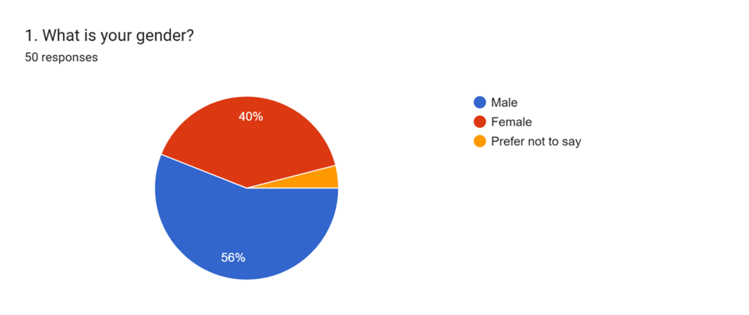
Figure 1: Gender
Source: Researcher
The above graphical presentation shows demographic information and data based on the gender of the participants. It has been found that 56% of the survey respondents are male and on the other hand, 40% of them are female.
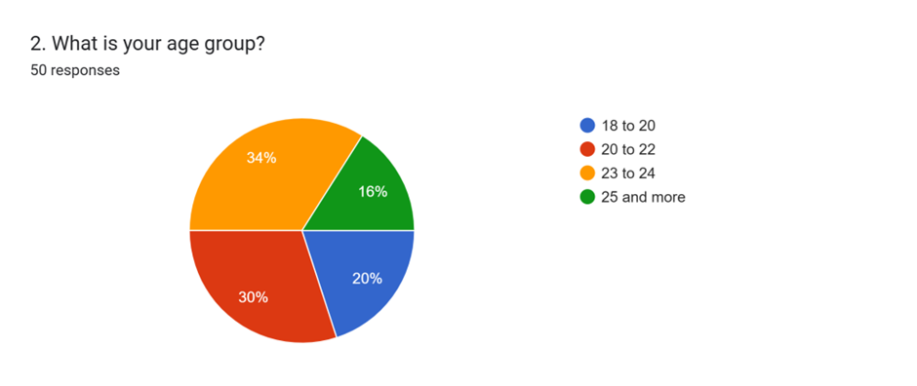
Figure 2: Age Group
Source: Researcher
The second representation is based on the age groups of survey participants. Analysing the survey responses obtained from the students, it has been found that majority of respondents 34% of them are from the age group 23 to 24 years. At the same time, very few respondents 30% of the students are from the age group 20 to 22 years.
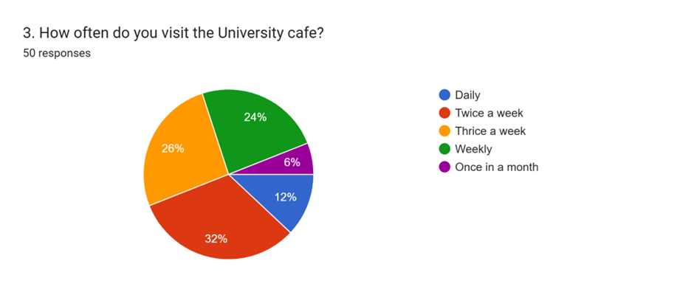
Figure 3: Frequency of Visit
Source: Researcher
The above diagram reflects the opinions of students regarding the frequency of visiting the University Cafe. Analysing the responses collected from the respondents, it has been identified that majority 32% of them visit the University Cafe twice a week. At the same time, 26% of the sample population visit the cafe thrice a week. Based on the view of Anwar and Abdullah (2021), in order to improve the experiences of customers, it has become highly important for profit earning organisations to provide continuous training and development opportunities to their employees. Very few, 24% of the students visit the University Cafe weekly. Along with these, 12% of the selected survey participants have stated that they daily visit the cafe. 6% of the survey population stated that they visit the cafe once in a month. From this result, it can be summarised that the sales performance has been improved by the University Cafe by implementing the strategic operational changes such as introducing new menu items and modifying prices.
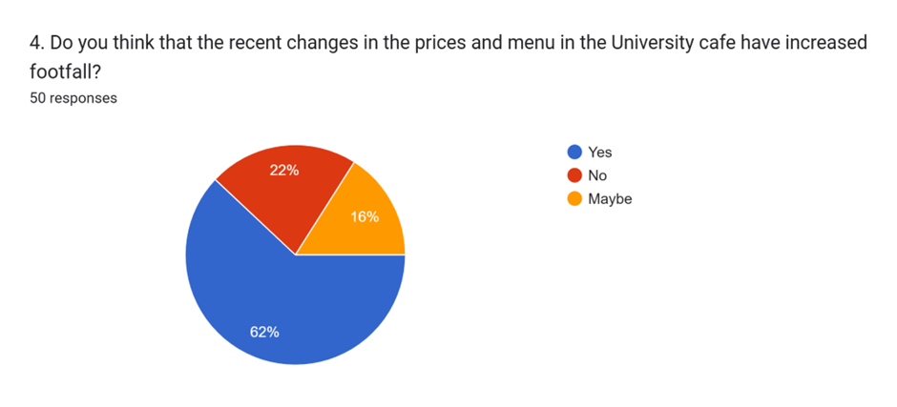
Figure 4: Changes in price and menu in the University Café
Source: Researcher
The above data and survey question is based on the opinions of students regarding the role of the recent changes brought by the University Cafe in its menu and prices in increasing customer footfall. From the results obtained from primary data collected from the sample population, it has been found that majority of respondents 62% of them agreed with the view that the recent changes in these two factors have helped the University Cafe to increase its footfall and growth. On the other hand, few respondents (22%) of the selected sample population disagreed with this view. According to Sudirjo (2023), in setting pricing strategies, a high emphasis should be given by firms on analysing the affordability of their target audiences. Along with this, in designing menus, restaurants must analyse the diverse tastes and preferences of their target audiences.
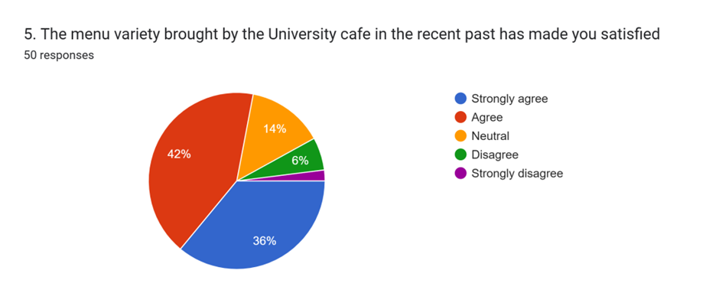
Figure 5: Menu Variety
Source: Researcher
The above data shows that the satisfaction of students regarding the menu variety brought by the University Cafe in the recent past. Analysing the responses collected from the selected sample population, it has been found that majority of respondents 42% of them are satisfied with the menu variety. 36% of the selected sample population are highly satisfied with the recently introduced menu variety. However, few respondents 6% of the sample population stated that they were not satisfied with the menu variety brought by the University Cafe. As per the view of Okeke et al. (2024), for product design, firms need to be focused on the diverse choices and preferences of their customer and target audiences. 14% of the University students stayed neutral regarding their opinion.
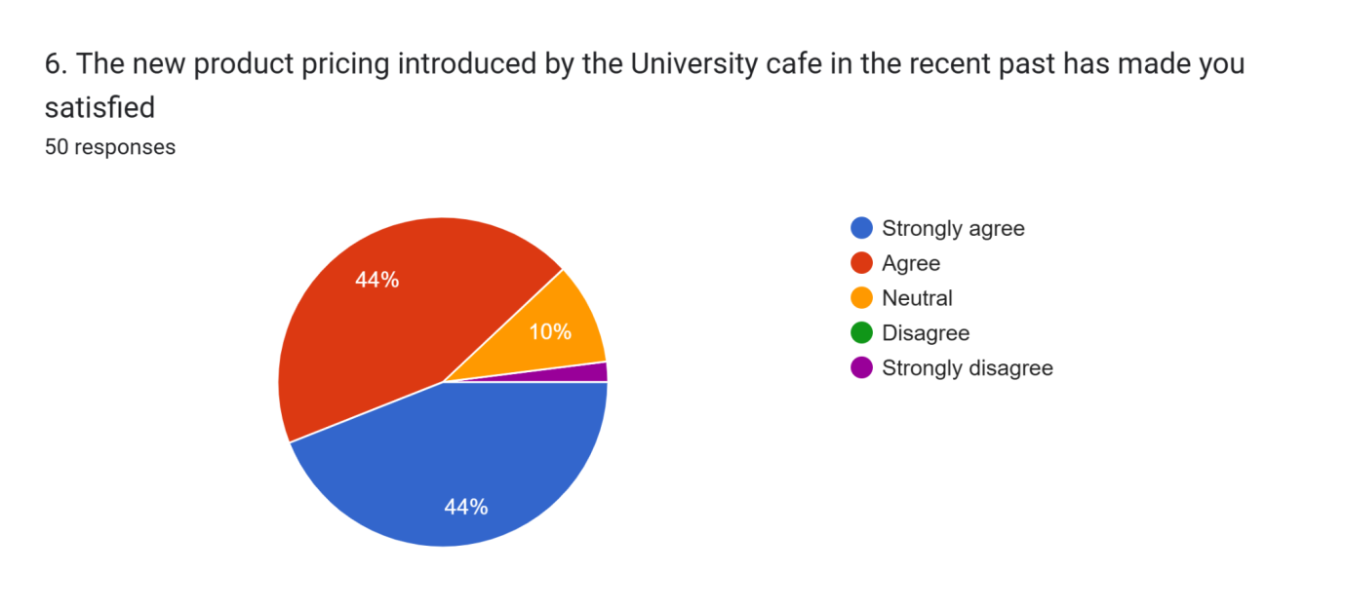
Figure 6: New Product Pricing
Source: Researcher
The above graphical analysis has helped in outlining the perceptions of the university students regarding the new pricing strategy of the cafe. The analysis helped in outlining that a large section of responding students has agreed that the updated pricing strategy of the university cafe has made them more satisfied in comparison to the past. This can be justified based on the fact that pricing strategy is largely crucial in terms of satisfying potential customers and ensuring a consistent growth trajectory (Aulia et al., 2023). In this regard, the responses of this close-ended survey question has helped in outlining that the new pricing of the university cafe’s products has effectively enhanced the satisfaction level of the students.

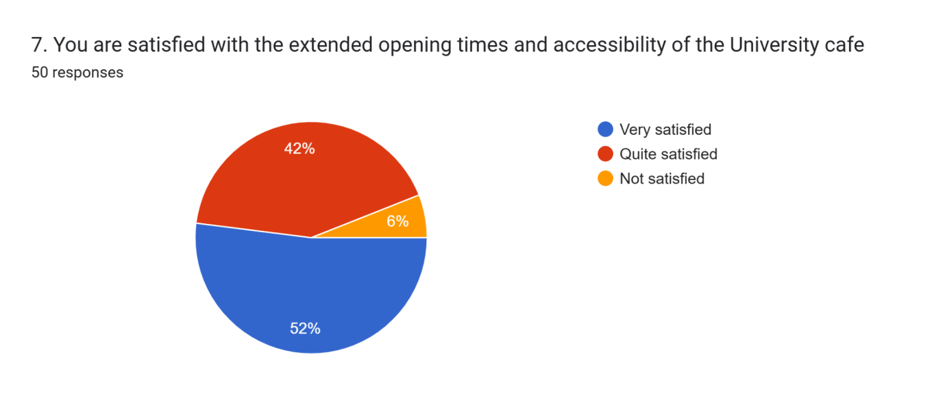
Figure 7: Extended opening times and accessibility
Source: Researcher
The figure above has evaluated the responses of the university students regarding their perceptions about the extension of the opening time of the cafe. Majority of respondents (52%) are very satisfied with the extended accessibility and opening times of university café. Students have been asked whether the extended accessibility and opening time of the cafe has satisfied them or not. The statistical analysis has outlined that more than half of responses have highlighted that the students are highly satisfied with the extended accessibility and timing of the university cafe and others are also satisfied with this change. Therefore, this helps in understanding that the extension of service quality and accessibility is largely important for the cafe in terms of ensuring that students are constantly engaged and satisfied.
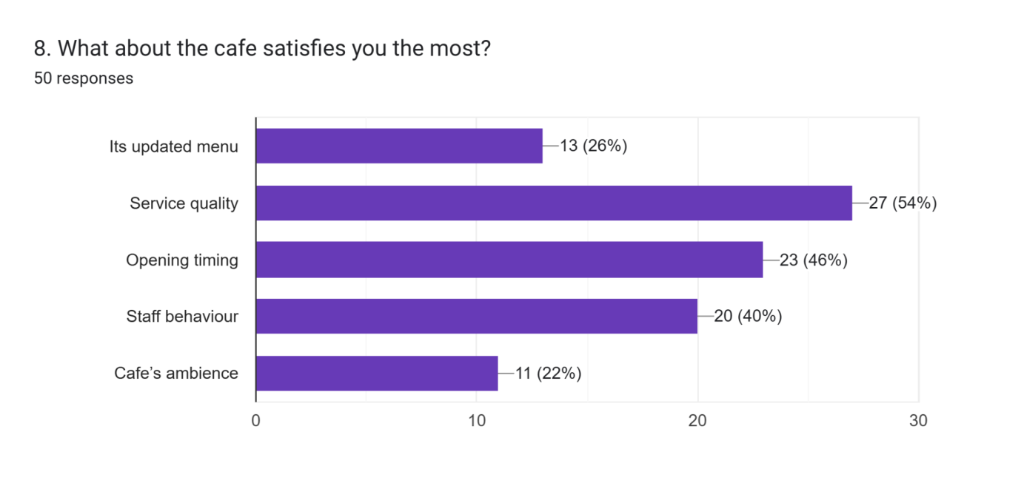
Figure 8: Satisfaction criteria
Source: Researcher
The graphical presentation above involves the close-ended question involving the options regarding which of the contexts of the university cafe satisfy the students the most. It involves the options regarding the service quality, cafe’s menu, its ambience, opening timing, and staff behaviour. The graph above highlights that a large section of students have highlighted that they are more satisfied with the improved service quality and opening timing of the cafe along with staff behaviour. This eventually helps in evaluating that customer satisfaction and business growth can be ensured with the help of maintaining consistency in service quality, accessibility, and customer engagement (Slack et al., 2021).

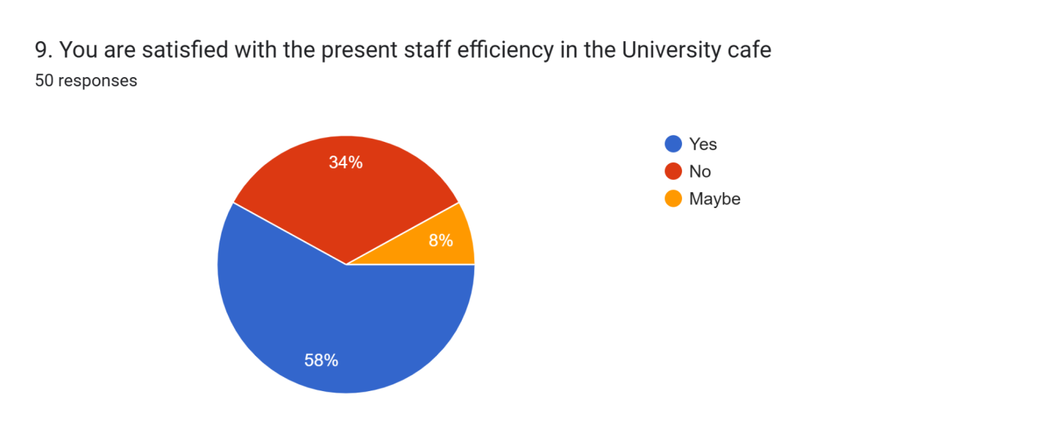
Figure 9: Staff Efficiency
Source: Researcher
The above figure highlights the responses of the participating students regarding their levels of satisfaction with the efficiency of the present staff members of the university cafe. The statistical analysis has helped in outlining that a large section of students (58%) have outlined that they are satisfied with the efficiency of the present staff of the cafe. However, a notable section of participants (34%) have outlined that they are not much satisfied presently with staff efficiency which defines that the owners must focus on this matter and employ more efficient staff members for better customer satisfaction and the cafe’s growth.

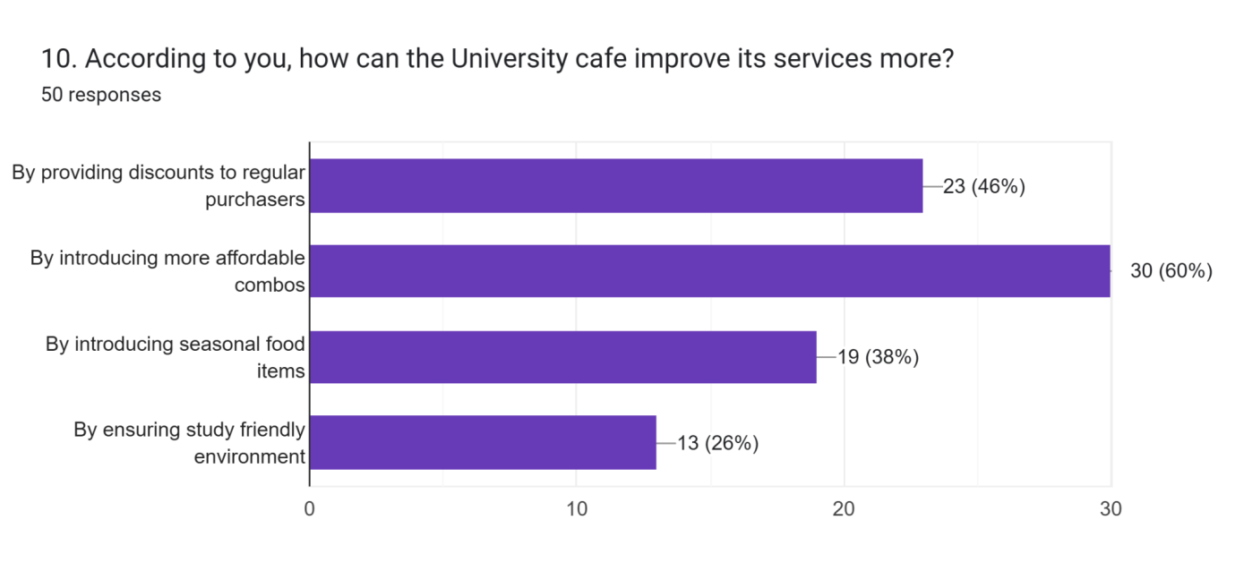
Figure 10: Service Improvement Recommendation
Source: Researcher
The above statistical analysis has helped in outlining the perceptions of the participating students regarding the strategies through which the university cafe can improve its services and ensure its growth. A large section of students (46% and 60%) have suggested that the cafe can introduce affordable combos who can help in enhancing the satisfaction level and engagement of customers. Additionally, discounts for the regular customers can be another effective strategy which can help the university cafe to ensure its growth and the improvement of its services.

4.3 Table 1: Themes
 | Themes | Responses from Students
 | Menu Variety and Pricing Strategy | “I think the café is much better now because the menu has more variety. Earlier it was just the same items every day, now I feel like there are more choices.”  “Prices are fair now, earlier I used to avoid eating here because it was too expensive.”
 | Accessibility and Café Operating Hours | “The extended hours are really helpful, especially during exam season. I don’t feel rushed anymore.”  “Sometimes I still find it hard to access when I have late classes, but it’s definitely more flexible now than before.”
Service Quality & Staff efficiency |  | ‘‘Service has become faster in the present times than experienced before. I think now I do not have to wait for long hours. The staffs stay connected and this develops the relationship’’.  ‘‘The staffs are very friendly and they also consider the feedbacks and make the required improvements’’.
Overall satisfaction & Business perception |  | ‘‘I believe that the café has improved its services a lot than before. This has attracted many individuals recently and this has made the café very busy based on their quality of services’’.  ‘‘However, I would like to say that it can also bring certain improvements in the coming years’’.

4.4 Thematic Analysis: Primary Qualitative Data (Interview Transcript)

4.4.1 Theme 1: Menu Variety and Pricing Strategy
Among the most consistent patterns across the interviews conducted with the students was recognition of improvements in the menu variety and affordability of the café products. Previously, students showed frustration over the limited offerings of the café and high prices of the items, which often pushed them to dine outside the campus. Following the strategic changes, many students have shown greater sense of satisfaction with the availability of diverse food items in the café.
According to respondent 1, “I think the café is much better now because the menu has more variety. Earlier it was just the same items every day, now I feel like there are more choices.”
This aligns with Chaand Seo (2019), who has stated that cafeteria menu variety and pricing directly influence students’ satisfaction and frequency of dining there. Another participant, respondent 3 highlighted affordability, “Prices are fair now, earlier I used to avoid eating here because it was too expensive.” This shows the importance of the principle of value based pricing, where affordability enhances the perception of fairness among the customers and also encourages repeat purchase (Rady et al., 2023). Therefore, through the analysis, it could be suggested that both the expansion on menu variety and reduced prices of the food items, have contributed towards a more positive perception of the café, thereby increasing the likelihood of frequent use and customer loyalty.

4.4.2 Theme 2: Accessibility and Café Operating Hours
Accessibility through extended operating hours also plays a crucial role in enhancing the customer satisfaction with cafeterias. Students have expressed through the interview that extended operational hours of the café made it more convenient for them, especially during the exam periods, or for the ones attending evening classes.
As according to respondent 2, “The extended hours are really helpful, especially during exam season. I don’t feel rushed anymore.”
The importance of operational flexibility reflects through this, as discussed by Alshebami (2025), where adaptability towards consumer needs is the major key for sustaining small business success. Although most of the students have appreciated the change, some of the respondents still noted areas of improvements, as stated by respondent 4, “Sometimes I still find it hard to access when I have late classes, but it’s definitely more flexible now than before.”This shows that the café still needs some ongoing refinements, along with the progress that has been made. This is necessary for balancing the operating costs with that of the demand of the customers (Zemlina et al., 2023). Extended operating hours are perceived to increase café footfall, from a business performance perspective, thereby supporting the objective of high accessibility and revenue.

4.4.3 Theme 3: Service Quality & Staff efficiency
It is analysed that service quality plays a big role in creating better satisfaction. As per the views of respondent 3, Service has become faster in the present times than experienced before. I think now I do not have to wait for long hours. The staffs stay connected, which develops the relationship’’. This can be further justified with the fact that quality services result in quality management (Borysova et al., 2024). This brings better productivity. Cafes play a major role in creating unique experiences related to the individuals. This can be analysed further based on the factors like good food, hygiene and nutrition; that service quality is the key to get success and witness overall growth. It is analysed that staffs also plays an effective role to make sure that expectations of individuals are met.
In the present consideration, based on the response of respondent 4, ‘‘The staffs are very friendly and they also considers the feedbacks and make the required improvements’’ It has been thus evaluated that quality of services of items within the café can influence the spending power of individuals. Service quality results in improved customer satisfaction. The efficiency and skills of staffs are required in order to meet the needs and enhance growth. It can be further highlighted that service quality and efficiency are very closely related (Gibbs and Kharouf, (2022). Skilled and professional staffs try to meet the needs demands of individuals by staying connected and understanding their perceptions. It is analysed that the behaviours of individual staff also influence the process of getting satisfied through a particular service. The friendlier nature of the individual staffs highly influences the students to stay loyal towards the café and this increases the chances of repeat purchases.

4.4.4 Theme 4: Overall satisfaction & Business perception
The affordability of food items has a significant impact on the perceptions of individuals. Students prefer quality food items at a very reasonable rate. As per the opinions of respondent 3, ‘‘I believe that the café has improved its services a lot than before. This has attracted many individuals recently and this has made the café very busy based on their quality of services’’.
It is analysed that improving the services through considering the pricing needs have brought many changes in the café and the ways individual student buy the products from the café. The affordability can be seen in the present food items, and this motivates the students to buy food items from the campus cafeteria. This can be justified through the statement of Bernarto et al. (2022) that perceived risk, perceived prices and brand image has significant impacts on the satisfaction of individual customers.
Besides, according to respondent 2, ‘‘However, I would like to say that it can also bring certain improvements in the coming years’’.
Thus, overall satisfaction further influences word of mouth and repurchasing intentions of individuals (Blut et al., 2024). In the present context, this is clearly evident from the fact that affordable price ranges of food items in café have increased the sales and demands in past days.

4.5 Discussion
Comparing the findings of this research with that of the previous literature, it has been found that focusing on operational improvement, firms are able to enhance customer loyalty and satisfaction to a great extent. Findings of the previous literature have depicted that minimising waiting times should be a top priority factor to restaurants or cafes to enhance loyalty among their customers (Geminarqi and Purnomo, 2023). Moreover, to enhance customer loyalty and satisfaction, it is highly important for firms to maintain consistency in their product or service quality. At the same time, the findings obtained from the quantitative data analysis in this research have reflected that by implementing the strategic operational changes, the University Cafe is able to increase repeat purchase among students. It has been found that 26% of the selected sample population visit the cafe thrice a week, 32% of the students visit the cafe twice a week and 24 of them visit the cafe regularly. This indicates an increasing popularity of the University Cafe among the students. From the findings of previous literature relevant to this topic, it has been identified that continuous training and development of employees can support firms to enhance customer satisfaction through improving service quality (Sutrisno et al., 2023).
The findings of the previous research have highlighted that streamlining operations should be a priority factor to firms to enhance their operational effectiveness. From the research of Yun et al. (2022), it has been found that overall business performance of organisations can be improved through elimination of redundancies. In order to minimise rework costs, organisations must focus on process standardisation. From the responses obtained from the survey participants, it has been observed that the majority of them agree with the view that changes in menu and prices have increased the footfall in the University Cafe. From the qualitative data obtained from the interviewees, it has been observed that varieties in the menu introduced by the cafe have played an important role in satisfying students. Moreover, the findings obtained from the qualitative data collected from the interviewees have highlighted that cheaper prices designed by the cafe are playing an important role in attracting students. 44% of the students are highly satisfied with the new pricing introduced by the University Cafe. Along with these, extended hours have played an effective role in improving the experiences of students. From the findings of the previous literature, it has been observed that seamless services are highly effective in improving the customers of firms (Handoyo et al., 2023).
A high emphasis of firms on enhancing operational efficiency can enable them to prevent disruptions in their supply chain. Moreover, emphasising on operational effectiveness, firms are able to introduce new products or services in an easier way (Garcia-Buendia et al., 2023). Findings obtained by analysing the qualitative data have indicated that faster pace in service delivery has played an important role in satisfying the University students. Similarly, the findings obtained from the results of the sample survey have indicated that the students are highly satisfied with the extended opening times of the University Cafe. The findings highlight the results from the primary responses that have been aligned with the existing literature section. The primary survey analysis has helped in highlighting that students at the university have become more satisfied and attracted towards the cafe due to the introduction of the new pricing strategy. The affordable and accessible product pricing at the university cafe has eventually helped in enhancing satisfaction of potential customers which can reliably help in the sustainable growth of the cafe. The comparative analysis of the quantitative findings with the literature review has helped in identifying a similar note. The literature review has also outlined that affordable and discounted pricing strategy is largely effective in terms of enhancing satisfaction of potential customers. The literature section has highlighted that fair and affordable pricing reliably helps in shaping the perceptions of students regarding purchasing products from the university cafes (Martinez-Perez et al., 2022). This highlights the analyses of the findings that the current pricing strategy that the university cafe has considered is defining a reliable performance in terms of satisfying students and enhancing their experiences. In addition to this, the findings have also helped in outlining that the extended accessibility of the cafe’s services and its opening timing has reliably helped in enhancing the satisfaction of the students. It has defined that enhanced accessibility of the services, menu, and other amenities, along with the extended timing of the cafe has positively influenced students to get engaged with its services. On a similar note, the literature review has highlighted that improved accessibility and longer visit timings are largely crucial for university cafes in terms of meeting the requirements of customers and ensuring their satisfaction (Ganatra et al., 2021). This eventually helps in ensuring the growth of the cafe along with long-term sustainability.
Along with this, the quantitative finding has also evaluated the perceptions of students regarding the services of the university cafe in enhancing their satisfaction and experiences. This has helped in finding that the enhanced service quality as well as the extended opening timing of the cafe has eventually helped in enhancing the satisfaction of university students. In addition to this, the literature review has similarly outlined that service quality plays a huge role in shaping customer satisfaction and growth trajectory of a cafe. It highlights that high-quality services and diversity in menu are the key aspects of enhancing service efficiency of a cafe that eventually helps in enhancing customer satisfaction and business growth (Yunita et al. 2022). Additionally, the finding represents that staff behaviour is a huge context in terms of ensuring customer satisfaction in the business of a cafe. It has outlined that the university cafe needs to improve its staff efficiency through appropriate training and hiring of more efficient employees. On the contrary, the literature review has outlined that the lack of politeness in the staff behaviour and attitude can eventually impact the overall business performance. Responses have been gathered regarding enhanced affordability and diversity of menu which can enhance customer satisfaction and growth potential for the university cafe. This highlights the existing literature finding that diversity and improved service quality is the key to business growth.
The interview responses have highlighted that greater variety in the menu and improved affordability was among the most significant improvements in the café for the students. These findings are consistent with the literature where positive relationship between the customer satisfaction and menu diversity is well established, as stated by Yunita et al. (2022) who noted that satisfaction and frequent dining in campus criteria are greatly influenced by a steady service quality and broader menu options. The importance of affordability and value based pricing for retaining student customers; is further confirmed by Raihen et al. (2023) and Martinez-Perez et al. (2022). The findings of the study have been consistent with previous studies, which have shown that higher prices tend to drive students off campus, while fair and transparent pricing helps in fostering loyalty. The analysis has also shown how fair pricing has encouraged dining in café, reflecting a more positive perception and greater willingness of the students to revisit. This aligns with the study by Ahmed et al. (2023) which states that satisfaction derived from fair pricing and menu variety results in higher footfall and repeat purchases, thereby reinforcing the primary findings that strategic changes to the menu and pricing have direct impact on business benefits.
Analysis of the findings have clearly shown that participants value the extended operating hours, and increased convenience during the high demand periods. This is consistent with the study by Hadjielias et al. (2022) which has emphasised on flexibility in operating hours is vital for small businesses in dynamic and student centered environments. According to the study, this also helps in adapting to shift demand and maximise the relevance. The findings also aligns with Ganatra et al. (2021) affirming the necessity for extended and accessible café hours as a means to increase customer footfall and compete with the off campus alternatives.
Moreover, it can be discussed that improved service quality has been seen and it has created positive experiences. The staff efficiency is closely linked with the quality of services. In addition, the friendly nature of staffs attracts the individuals to become loyal customers of university café. This is closely linked with the long term growth and success of the café. Service quality has a significant impact on the satisfaction of individuals (Singh et al., 2023). In this consideration, it can be stated that staff efficiency is one of the reasons behind improved services and this has a positive impact on the sales and profits related to the university café. The professional behaviour, skills and knowledge have helped the cafe to bring new changes, which has met the student preferences. The loyalty of individual student has increased the chances of repeat purchase. Proper discussion has been made in literature review, which also justifies the fact that quality of services and food items of café has an impact on the long term viability. The staff efficiency is also linked with better operational management and this creates customer loyalty. Operational efficiency also brings certain improvements on the performance and productivity of businesses. The quality of foods, hygiene creates attraction among the students to use a product.
Also, the overall satisfaction is influenced by many factors. This further brings positive impacts on the growth of a business. In the present consideration, prices also play a vital role to attract the potential customers towards the quality services. Considering this, it is evaluated that affordable price ranges of products of café highly influence the choices of students. The affordability, accessibility has a proper influence on creating a particular perception among the customers or individuals. Students try to get quality meals at a very affordable range. The price affordability and easier accessibility are the influential factors, which can create significant influence on the demands and choices of individuals. Overall satisfaction regarding the service quality, staff efficiency, prices, accessibility, effective chances of repurchasing can be seen. It is evident that creating positive experiences and preferences of individuals positive impact the growth of a business like university café. The aforementioned factors are closely linked with each other (Fared et al., 2021). The discussion from literature review focuses on the aspect of effective pricing strategies to make sure that buyers can stay satisfied and come back. This creates loyal customer base and influences the growth of a business in the long run. Affordable and reasonable prices of products help the students to get positive perception of brand and this influences their buying behaviour. This further creates better satisfaction and trust and loyalty.

4.6 Chapter summary
The analysis of the findings through survey and interview has shown that strategic changes in the university café including pricing adjustment, menu diversification, improved service quality and extended operational hours has collectively enhanced student satisfaction as customers. The analysis also shown how such overall satisfaction of the students with the changes made in the café’s operational activities has positively influenced perceptions of the business performance.

Chapter 5: Recommendations, Conclusion and Limitations of the Research

5.1 Chapter Introduction
This chapter presents the conclusion, recommendations and limitations of the study. This chapter integrates insights from the perspective of the students to highlight the ways in which strategic changes in the university café have influenced both the satisfaction and perceived business performance. This has been done by building upon the thematic analysis of the primary qualitative data and the survey findings. While the recommendations focus on practical actions for enhancing improvements in the café operations, the conclusion evaluates the ways in which research objectives were achieved, and lastly, the limitations acknowledge constraints faced by the researcher during the research process.

5.2 Recommendations
The findings from the thematic analysis reveal that strategic changes in the university café have significantly improved customer satisfaction and the perceptions of business performance. However, there are still some areas, which require attention for sustaining and maximising growth. Some of the recommendations include:
- Dynamic pricing and continuous menu innovation
Although the students have acknowledged improvements in the menu variety and affordability, for sustaining this satisfaction, the café should adopt a dynamic menu strategy. This can include seasonal offerings, culturally diverse items and healthier options for the health conscious customers (Yoon et al., 2020). This would not only help in keeping an attractive menu but would also appeal to a wider range of student preferences. Apart from this, dynamic pricing strategies like that of loyalty discounts and affordable meal deals, would also help in ensuring continued perceptions of value for money (Ali et al., 2024). Such strategies could help in strengthening loyalty, encourage repeat purchases and sustain growth in revenue.
- Further Optimisation of Operating Hours
Extended operational hours were welcomed by most of the students, especially during the peak academic sessions. However, some of the respondents still felt excluded, especially the ones with late schedules, therefore, the café could introduce flexible operating hours during exam weeks or could also consider a staggered shift system for balancing the cost with demand. Moreover, limited after hour’s takeaway counters or digital ordering system could also be implemented for extending access of the café services for the students, without requiring full operational costs (Sikder and Anae, 2023).
- Leveraging Data Analytics for Business Growth
As the footfall and sales data were identified as a part of research methodology, data analytics should be integrated for decision making as a part of the café management. Tracking the peak hours, purchase patterns and student preferences could help in informing smarter menu design, staffing allocation and targeted discounts (Sari et al., 2020).

5.3 Conclusion
It can be concluded that the study has achieved its objectives through a mixed method approach including surveys, interviews and analysis of the operational data. The findings have shown clear evidence that fairer pricing and menu diversification have enhanced student’s perceptions of value, reduced the need for dining outside the campus and encouraged frequent use. The first objective of evaluating the impact of menu variety and pricing on student satisfaction has been achieved. The principle of value based pricing was validated, thereby showing that affordability remains the key driver of loyalty and satisfaction. The study has focused to evaluate the impact of strategic changes in the university café on student satisfaction and business performance.
According to the thematic analysis of the interview transcript and survey analysis, extended hours of café’s operational activities have significantly increased the convenience, especially for the students with exam preparations or evening schedules. However, some gaps remain, suggesting the need for further optimisation, which shows that while the café has made improvements in its accessibility, it should focus on its continuous refinements in order to balance student demands and costs. Therefore, the second objective has been achieved by assessing the effect of extended café opening times and accessibility.
The third objective of analysing the impact of service speed and worker efficient on students has been achieved, as students reported marked improvements in service speed and staff interactions, thereby highlighting the friendliness and responsiveness as major drivers of satisfaction for the business. The findings confirm the Expectancy Disconfirmation Theory, as student’s expectations of menu variety, convenience and affordability were met. Along with this, the SERVQUAL model dimensions, especially empathy and responsiveness were also evident in shaping the loyalty. Such improvements have reinforced the idea that staff engagement and operational efficiency directly influence customer retention.
The findings from the study have also confirmed that students perceived the café and more vibrant and busier as compared to before, indicating positive growth in sales and footfall. The researcher has therefore achieved the objective of evaluating the extent to which operational improvements shaped the overall customer loyalty and business performance. Study has shown that improvements in service, affordability and accessibility translated into stronger loyalty, higher satisfaction and word of mouth for promotion. Student perceptions thus suggested that the café had entered a trajectory of sustainable growth.

5.4 Limitations of the Research
Although the study has achieved its aims, while also providing valuable insights, there are several limitations of the research process that should be acknowledged.
- Sample size and scope
The study has relied on a relatively small sample of 50 students for the survey and 4 students for gaining in-depth insights through interview. While this sample size might have provided rich qualitative and quantitative data, it might not fully represent the broader student population of the campus where the café operates. Future research on this could involve larger and more diverse sample, including external customers and staff for enhancing the generalisability (Lakens, 2022).
- Time Constraints
The research has been undertaken within a limited period of time, thereby restricting longitudinal analysis. The findings of this study have captured perceptions shortly after when the changes were introduced, but unable to assess long term impacts on the satisfaction of the student customers or business performance. Therefore, a longitudinal study could better evaluate the sustained profitability and customer loyalty over time (Akanle et al., 2020).
- Reliance on Self Reported Data
The findings were based on the subjective perception of the students, which although is valuable, might be influenced by bias, temporary experiences or personal expectations. Triangulating the data with more extensive financial and sales records would help in strengthening the reliability of conclusions regarding the business performance (Quinio and Lam, 2021).

5.5 Chapter Summary
The research demonstrated that the strategic changes in the menu variety, operational hours, pricing and service quality have successfully enhanced student satisfaction and contributed to the perceptions of improved business performance. The findings have thus highlighted the importance of student-centered decision making in campus based enterprises, thereby providing a roadmap for similar small business contexts.

References
Ahmed, S., Al Asheq, A., Ahmed, E., Chowdhury, U.Y., Sufi, T. and Mostofa, M.G., (2023). The intricate relationships of consumers’ loyalty and their perceptions of service quality, price and satisfaction in restaurant service. The TQM Journal, 35(2), pp.519-539.
Akanle, O., Ademuson, A.O. and Shittu, O.S., (2020). Scope and limitation of study in social research. Contemporary issues in social research, 105(114), pp.10-1108.
Ali, D., Alam, M. and Bilal, H., (2021). The influence of service quality, price, and environment on customer loyalty in the restaurant's industry: The mediating role of customer satisfaction. Journal of Accounting and Finance in Emerging Economies, 7(1), pp.143-154.
Ali, S.M., Shaikh, S., Izhar, F., Seereddi, S. and Umesh, C., (2024). Investigating how different pricing strategies impact consumer perception and purchase behavior in online markets with special reference to discounts, bundling. emergence, 4(3).
Alshebami, A.S., (2025). Crisis Management and Customer Adaptation: Pathways to Adaptive Capacity and Resilience in Micro-and Small-Sized Enterprises. Sustainability, 17(9), p.3759.
Andrade, C., (2021). The inconvenient truth about convenience and purposive samples. Indian journal of psychological medicine, 43(1), pp.86-88.
Anwar, G. and Abdullah, N.N., (2021). The impact of Human resource management practice on Organizational performance. International journal of Engineering, Business and Management (IJEBM), 5.
Aulia, M.R., Rudy, R., Ismail, A., Indriyani, S. and Arief, I., (2023). The Influence of Social Media, Location, Service Quality and Store Atmosphere on Purchase Decision of Coffee Café Customers. Innovative: Journal Of Social Science Research, 3(3), pp.11111-11118.
Bernarto, I., Purwanto, A. and Masman, R.R., (2022). The effect of perceived risk, brand image and perceived price fairness on customer satisfaction. JurnalManajemen, 26(1), pp.35-50.
Blut, M., Chaney, D., Lunardo, R., Mencarelli, R. and Grewal, D., (2024). Customer perceived value: a comprehensive meta-analysis. Journal of service Research, 27(4), pp.501-524.
Borysova, E., Fefelov, D., Kravchenko, A., Kuzmenko, R., Kuzmin, O., Maksymiuk, A., Osadcha, V., Vozniuk, S. and Omelchenko, M., (2024). Improving operational efficiency: quality management in cafe operations.
Carraher-Wolverton, C. and Hirschheim, R., (2023). Utilizing expectation disconfirmation theory to develop a higher-order model of outsourcing success factors. Journal of Systems and Information Technology, 25(1), pp.1-29.
Cha, S.S. and Seo, B.K., (2019). Cafeteria use by students and effect of selection attributes on satisfaction. The Journal of Asian Finance, Economics and Business, 6(1), pp.187-194.
Decker-Lange, C., Lange, K., Dhaliwal, S., and Walmsley, A. (2021). Exploring entrepreneurship education effectiveness at British universities–an application of the World Café method. Entrepreneurship Education and Pedagogy, 5(1), 113-136.
DECKERT, J. and WILSON, M., (2022). Descriptive Research Methods. Research Methods in the Dance Sciences. https://doi. org/10.2307/j. ctv33jb41z, 17.
Fared, M.A., Darmawan, D. and Khairi, M., (2021). Contribution of e-service quality to repurchase intention with mediation of customer satisfaction: Study of online shopping through marketplace. Journal of Marketing and Business Research (MARK), 1(2), pp.93-106.
Ganatra, V., Kaakandikar, R., Izzuddin, M., Kee, D.M.H., Zainuddin, N.B., Bukhari, M.A.Z., Nurhakim, M.A. and Panwar, V., (2021). The impact of food delivery apps on customer perceived value among university students. Journal of The Community Development in Asia, 4(3), pp.68-78.
Garcia-Buendia, N., Moyano-Fuentes, J., Maqueira, J.M. and Avella, L., (2023). The lean supply chain management response to technology uncertainty: consequences for operational performance and competitiveness. Journal of Manufacturing Technology Management, 34(1), pp.67-86.
Geminarqi, E.R. and Purnomo, H., (2023). Improving operational management efficiency in the food and beverage industry: A systematic literature review. Open Access Indonesia Journal of Social Sciences, 6(5), pp.1143-1149.
Ghanad, A., (2023). An overview of quantitative research methods. International journal of multidisciplinary research and analysis, 6(08), pp.3794-3803.
Gibbs, T. and Kharouf, H., (2022). The value of co-operation: an examination of the work relationships of university professional services staff and consequences for service quality. Studies in Higher Education, 47(1), pp.38-52.
Hadjielias, E., Christofi, M. and Tarba, S., (2022). Contextualizing small business resilience during the COVID-19 pandemic: evidence from small business owner-managers. Small business economics, 59(4), pp.1351-1380.
Handoyo, S., Suharman, H., Ghani, E.K. and Soedarsono, S., (2023). A business strategy, operational efficiency, ownership structure, and manufacturing performance: The moderating role of market uncertainty and competition intensity and its implication on open innovation. Journal of Open Innovation: Technology, Market, and Complexity, 9(2), pp.100039.
Johannisson, J., andHiete, M. (2021). Environmental service-learning approach in higher education–a descriptive case study on student-led life cycle assessments of university cafeteria meals. International journal of sustainability in higher education, 22(7), pp.1728-1752.
Kraus, S., Mahto, R.V. and Walsh, S.T., (2023). The importance of literature reviews in small business and entrepreneurship research. Journal of small business management, 61(3), pp.1095-1106.
Lakens, D., (2022). Sample size justification. Collabra: psychology, 8(1), pp.33267.
Martinez-Perez, N., Torheim, L.E., Castro-Díaz, N. and Arroyo-Izaga, M., (2022). On-campus food environment, purchase behaviours, preferences and opinions in a Norwegian university community. Public Health Nutrition, 25(6), pp.1619-1630.
McDermott, M., Simmons, M., Lock, J., and Kenny, N. (2020). A World Café Discussion on Well-Being: Considerations for Life in the University. Canadian Journal for the Scholarship of Teaching and Learning, 11(2), n2.
Mesra, R., Hasrin, A., Fathimah, S., Rahman, R., andSidik, S. P. (2021). The Phenomenon of Student Life Who is Studying While Working in the City of Padang. In International Joined Conference on Social Science (ICSS 2021) (pp. 319-325). Atlantis Press.
Naylor, G.S., (2024). A half-century of SERVQUAL: Exploring its impact and future directions in service quality research. Journal of Consumer Satisfaction, Dissatisfaction and Complaining Behavior, 37(2), pp.43-68.
Nieuwenhuijs, R., Houben, L. and Snijkers, G., (2022), October. A new vision on primary data collection from businesses:“naturally relevant”. In UNECE Expert meeting on Statistical Data Collection, Rome (pp. 26-28).
Nwabekee, U.S., Okpeke, F. and Onalaja, A.E., (2025). Technology in operations: A systematic review of its role in enhancing efficiency and customer satisfaction. Unpublished manuscript.
Okeke, N.I., Alabi, O.A., Igwe, A.N., Ofodile, O.C. and Ewim, C.P.M., (2024). Customer journey mapping framework for SMEs: Enhancing customer satisfaction and business growth. World Journal of Advanced Research and Reviews, 24(1), pp.2004-2018.
Purwadi, Y. S., andManurung, E. M. (2020). Cafes: New learning and knowledge production space for millennial students. Journal of Economics and Business, 3(1), pp.247-253.
Quinio, A.E. and Lam, T.C., (2021). Methods and biases in measuring change with self-reports. Basic elements of survey research in education: Addressing the problems your advisor never told you about, pp.193-217.
Rady, A., Abdelaziz, M. and Touni, R.D., (2023). The impact of price fairness on the perceived value and customer satisfaction under the exchange rate change in hotels in Egypt. Journal of Association of Arab Universities for Tourism and Hospitality, 25(2), pp.68-104.
Raihen, M.N., Akter, S. and Sardar, M.N., (2023). Food satisfaction among students: A study of present public university students in Bangladesh. Journal of Mathematics and Statistics Studies, 4(1), pp.01-18.
Sandberg, H., Alnoor, A., and Tiberius, V. (2023). Environmental, social, and governance ratings and financial performance: Evidence from the European food industry. Business Strategy and the Environment, 32(4), pp. 2471-2489.
Sari, W.M., Fitria, F., Suharto, E., Ikhwani, Y., Wagino, W., Alamsyah, N. and Windarto, A.P., (2020). Improving the Quality of Management with the Concept of Decision Support Systems in Determining Factors for Choosing a Cafe based on Consumers. In Journal of Physics: Conference Series (Vol. 1471, No. 1, pp. 012009). IOP Publishing.
Sikder, A.S. and Anae, N., (2023). Transforming Takeaway Management: Enhancing Efficiency and Customer Experience through an Online Ordering System for Sydney's Takeaway Shops.: Online Takeaway Shops in Sydney. International Journal of Imminent Science & Technology., 1(1), pp.64-78.
Singh, V., Sharma, M.P., Jayapriya, K., Kumar, B.K., Chander, M.A.R.N. and Kumar, B.R., (2023). Service quality, customer satisfaction and customer loyalty: A comprehensive literature review. Journal of Survey in Fisheries Sciences, 10(4S), pp.3457-3464.
Slack, N.J., Singh, G., Ali, J., Lata, R., Mudaliar, K. and Swamy, Y., (2021). Influence of fast-food restaurant service quality and its dimensions on customer perceived value, satisfaction and behavioural intentions. British Food Journal, 123(4), pp.1324-1344.
Sudirjo, F., (2023). Marketing strategy in improving product competitiveness in the global market. Journal of Contemporary Administration and Management (ADMAN), 1(2), pp.63-69.
Sutrisno, S., Kuraesin, A.D., Siminto, S., Irawansyah, I. and Ausat, A.M.A., (2023). The role of information technology in driving innovation and entrepreneurial business growth. JurnalMinfoPolgan, 12(1), pp.586-597.
Tannady, H., Aditia, A., Bhadra, B. and Cung, C., (2023). Analysis of Service Quality to Increase Customer Satisfaction of Libro Café. Journal of Applied Business, Taxation and Economics Research, 2(3), pp.311-318.
Taufik, A., Santoso, S., Fahmi, M.I., Restuanto, F. and Yamin, S., (2022). The role of service and product quality on customer loyalty. Journal of Consumer Sciences, 7(1), pp.68-82.
Vlahou, A., Hallinan, D., Apweiler, R., Argiles, A., Beige, J., Benigni, A., Bischoff, R., Black, P.C., Boehm, F., Céraline, J. and Chrousos, G.P., (2021). Data sharing under the General Data Protection Regulation: time to harmonize law and research ethics?. Hypertension, 77(4), pp.1029-1035.
Yasir, A., Abid, G., Afridi, J.H., Elahi, N.S. and Asif, M.F., (2021). Social media communication and behavioral intention of customers in hospitality industry: The mediating role of customer satisfaction. Int. J. Entrep, 25, pp.1-14.
Yoon, B., Chung, Y. and Jun, K., (2020). Restaurant industry practices to promote healthy sustainable eating: A content analysis of restaurant websites using the value chain approach. Sustainability, 12(17), pp.7127.
Yun, L., Yao, X., Zhu, W. and Zhang, Z., (2022). Evaluating the effect of redundant resources on corporate entrepreneurial performance. Sustainability, 14(12), pp.7101.
Yunita, R., Shihab, M.S., Jonas, D., Haryani, H. and Terah, Y.A., (2022). Analysis of the effect of servicescape and service quality on customer satisfaction at post shop coffee tofee in bogor city. Aptisi Transactions on Technopreneurship (ATT), 4(1), pp.68-76.
Zemlina, Y., Peresichna, S.V.I.T.L.A.N.A., Oliinyk, O.K.S.A.N.A., Krasovskyi, S. and Vasylenko, O., (2023). Ensuring the efficiency of service, technology, and management processes in the hotel and restaurant business. WSEAS Transactions on Environment and Development, 19, pp.1132-1144.

Appendices

Appendix 1: Survey Questionnaire
1. What is your gender?
- Male
- Female
- Prefer not to say
2. What is your age group?
- 18 to 20
- 20 to 22
- 23 to 24
- 25 and more
3. How often do you visit the University Cafe?
- Daily
- Thrice a week
- Twice a week
- Weekly
- Once in a month
4. Do you think that the recent changes in the prices and menu in the University Cafe have increased footfall?
- Yes
- No
- Maybe
5. The menu variety brought by the University Cafe in the recent past has made you satisfied
- Strongly agree
- Agree
- Neutral
- Disagree
- Strongly disagree
6. The new product pricing introduced by the University Cafe in the recent past has made you satisfied
- Strongly agree
- Agree
- Neutral
- Disagree
- Strongly disagree
7. You are satisfied with the extended opening times and accessibility of the University Cafe
- Very satisfied
- Quite satisfied
- Not satisfied
8. What about the cafe satisfies you the most?
- Its updated menu
- Service quality
- Opening timing
- Staff behaviour
- Cafe’s ambience
9. You are satisfied with the present worker efficiency in the University Cafe
- Yes
- No
- Maybe
10. According to you, how can the University Cafe improve its services more?
- By providing discounts to regular purchasers
- By introducing more affordable combos
- By introducing seasonal food items
- By ensuring study friendly environment

Appendix 2: Interview Questions
- How have the changes in menu variety and pricing influenced your decision to purchase food or drinks at the university café?
- To what extent have the extended opening hours affected your usage of the café, and how convenient do you find the new schedule?
- Can you describe your experience with the café’s service speed and staff interactions since the changes were introduced?
- Looking at the café now compared to before the changes, what do you feel has improved the most, and what areas still need further improvement to enhance your satisfaction?

