Results from General Mental Survey

I have conducted a survey which has included 16 questions, which I disseminated through Gwent Police’s intranet. These questions have been answered by 100 employees of Gwent police, either as a serving police officer, police staff or a civilian. I will present my findings in varying displays, with using numerous visual aids such as pie charts and bar charts to help showcase the data I have received. All questions were optional as was the questionnaire was, therefore there are not 100 responses to each question as can be seen within the results.

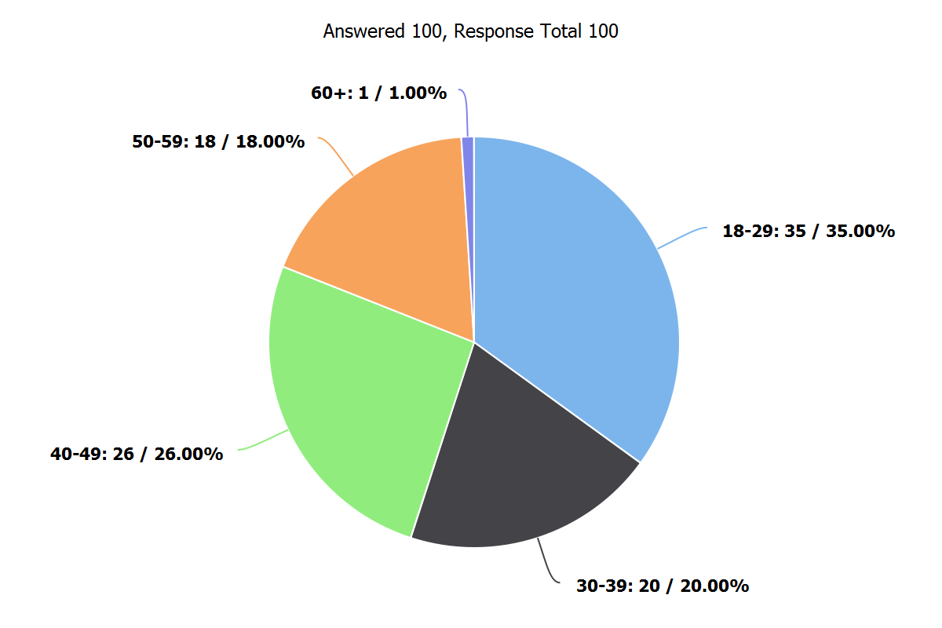

Question 1: How old are you?

My findings show that over one third (35%) of all employee’s who has undertaken my survey where between the ages of 18-29. It shows that over 50 % (55%) of all participants were 39 years old or under.

Question 2: How would you rate your current mental health from a scale of 0-10? ( 0 being the worst, 10 the best)

My results show that the most frequently selected answer (Mode) was 8. However, the average score (Mean) which was slightly lower which was 6.4. This is because I had a full range of answers from 0 to 10, which meant the mean was less then the mode. This question had a standard deviation of 2.47 which on average tells me how far each score lies from the mean.

Question 3: What Gender are you?

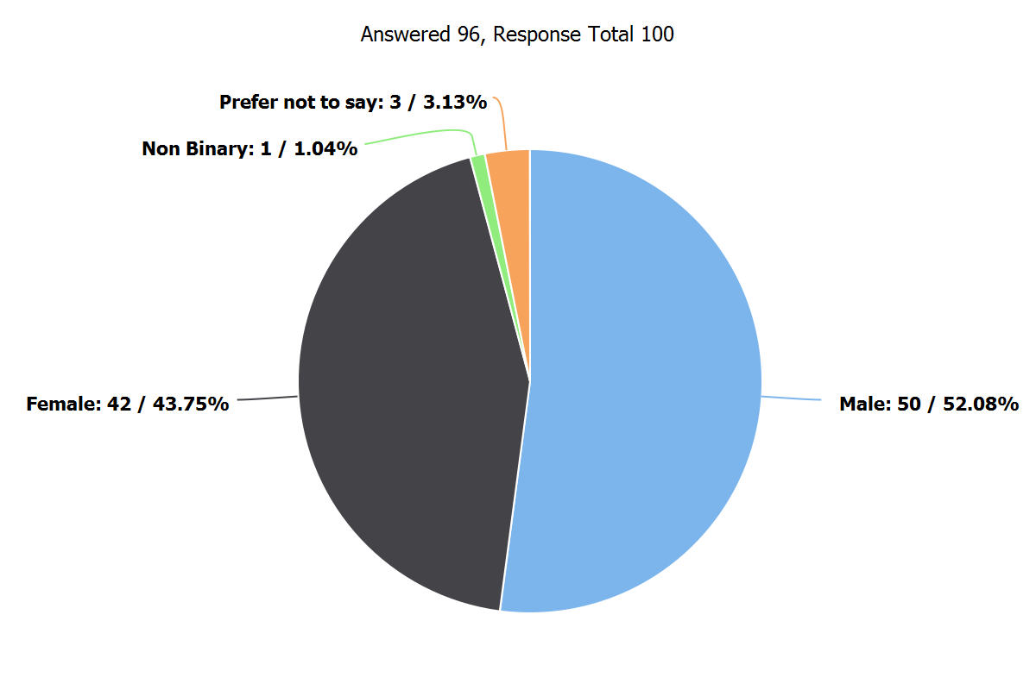

The majority which was over half ( 52.08%) of all my answers within my survey were males.

Question 4: Are you a police officer or a police staff member?

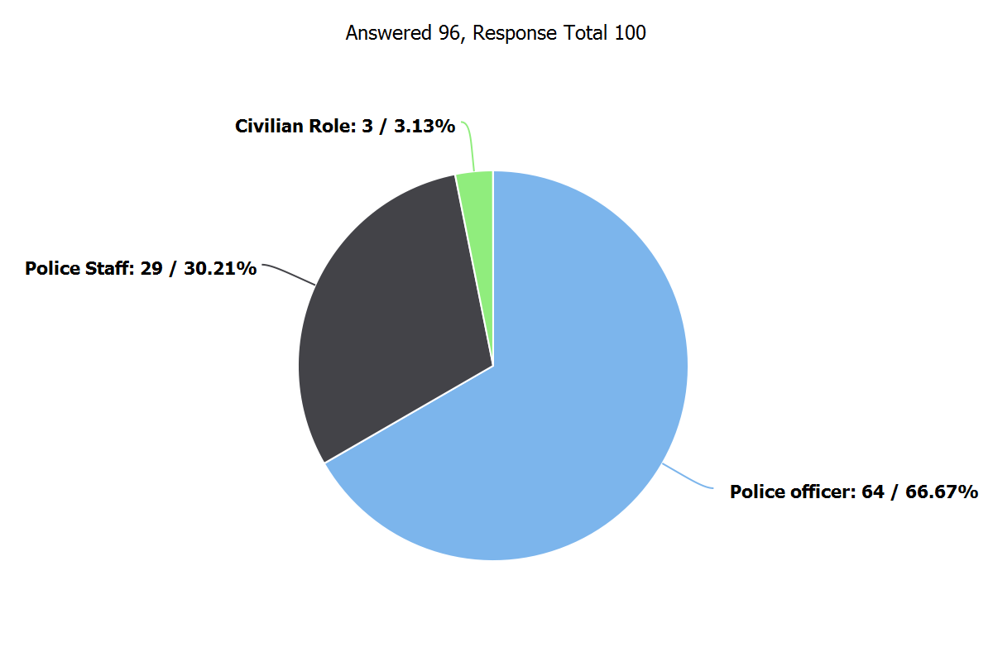

This shows that over two thirds ( 66.67%) of all answers from my survey were conducted by serving police officers. I did include a civilian role answer box which was not stipulated within the question. I have acknowledged this and have considered its potential impact within my findings; however I do not believe this to have a big impact and believe the results from this question a valuable source.

Question 5: How often do you feel stressed within your current role?

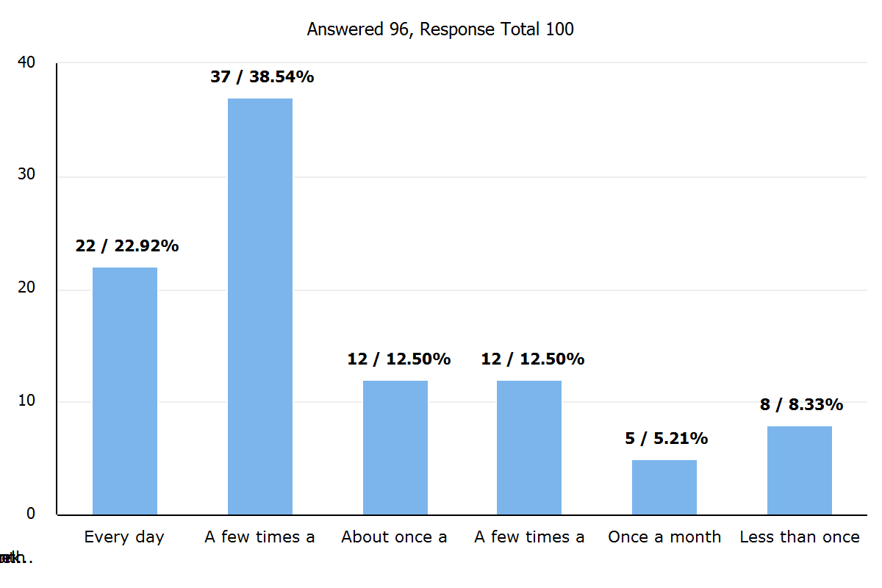

As seen from the column chart above, the two most frequent answers from this question was a few times a week and every day they feel stressed within there current role, this equates to 61.46% of all answers to this question.

Question 6: Do you feel your workload is currently affecting your mental health?
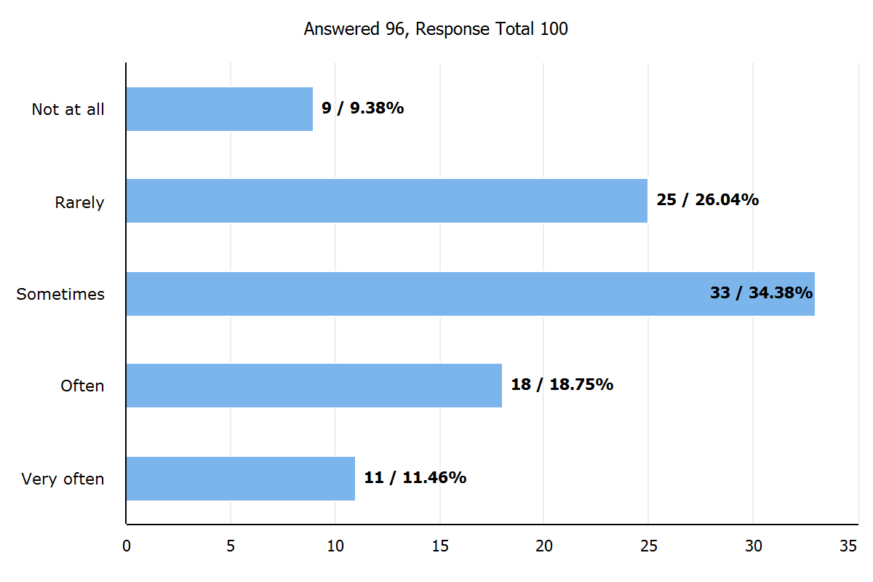

This bar chart shows over a third of all participants (35.42%) find that there workload rarely or never affects their mental health. This leaves the further 64.58% of the respondents feeling stressed sometimes, often and very often regarding there personal workload within their role.

Question 7: Does your shift/work hours negatively affect your work/life balance?
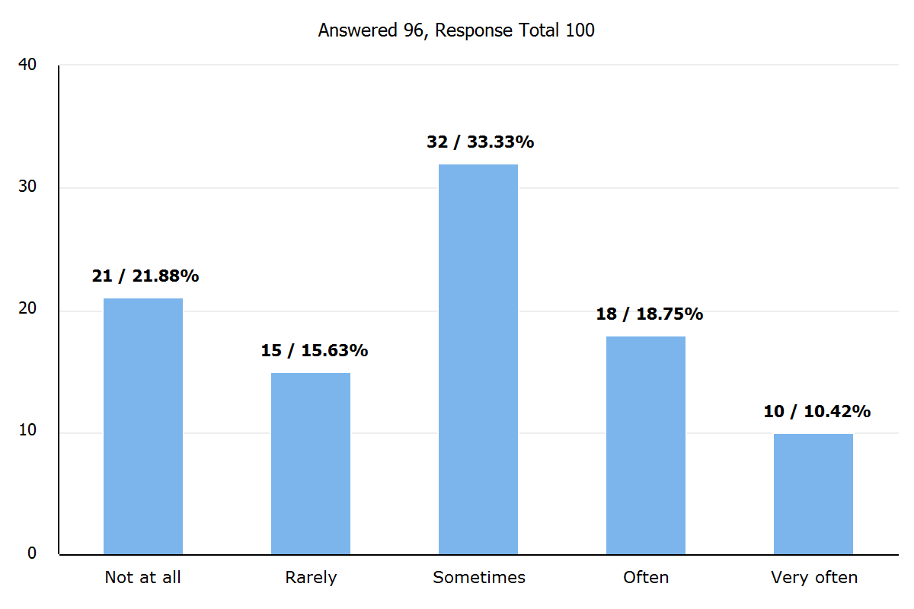

The results show the most frequent answer ( Mode) to this question was sometimes at exactly a third of all responses at 33.33%. Over a fifth (21.88%) believed their shift/work hours had no effect whatsoever on their work life balance.

Question 8: Do you feel supported by your supervisor/colleagues?
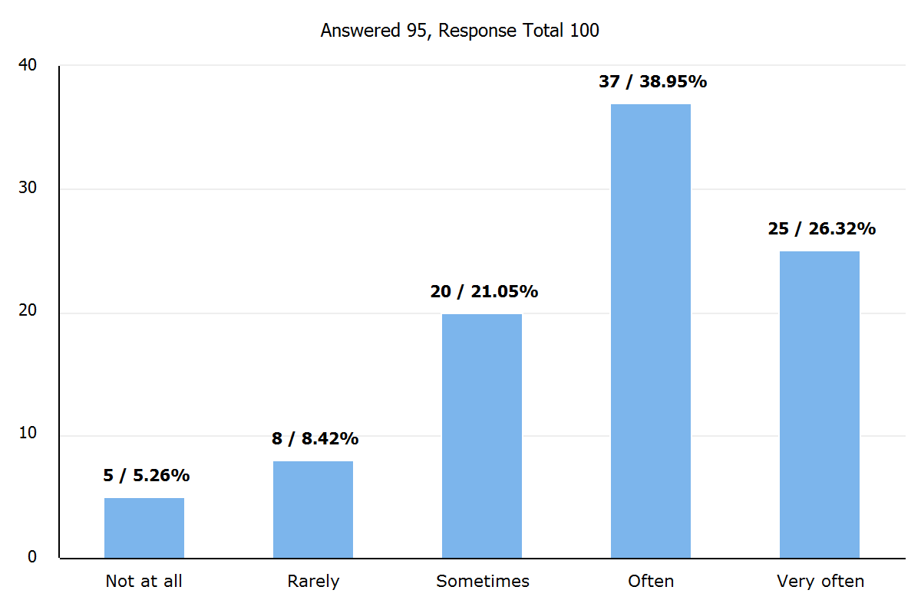
A significant proportion of the workforce within Gwent police with 62 people out of 95 responses, feel as if they are supported often or very often by their colleagues/supervisor. Only a small minority of 5.26% of the workforce did not feel supported at all.

Question 9: How often do you feel the physical symptoms (Headache, fatigue, ect) from work related stress?
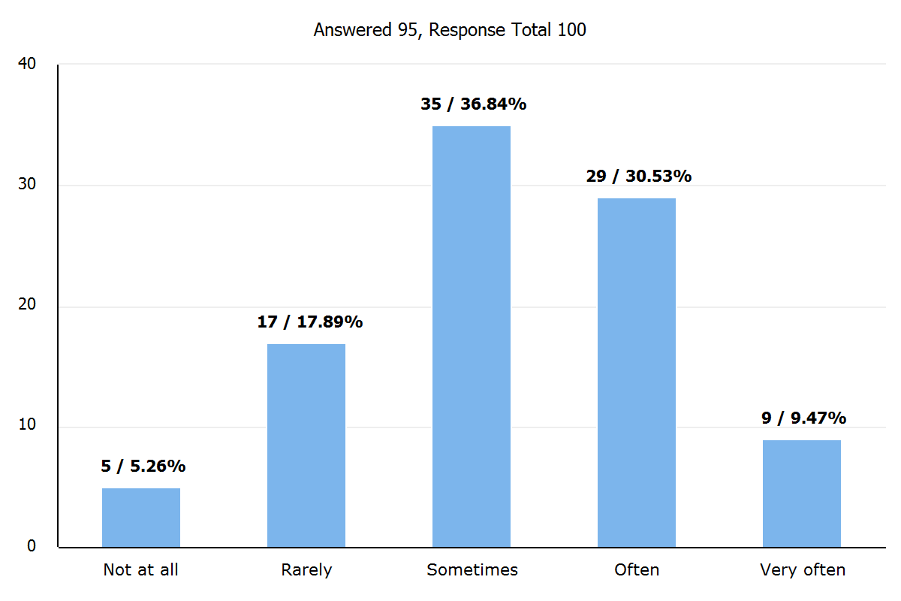
Results show that physical symptoms of stress which are perceived by the participant to be caused by stress from their job role, are presenting in over ¾’s ( 76.84%) of all respondents at least sometimes, often or very often.

Question 10: Rank below in order of what causes you the most stress within work?

There were 6 different apparent stress factors listed, in which the participants had to rank what they perceived to cause them the most stress within their role, compared to the least stress factor. To accurately reflect the results of this ranked question within my survey, I have used the mean order in which they were ranked. Using this I have found that High workload was ranked number 1 with 35.16% stating this causes the most stress within their role. From looking at the mean result, it shows that organisation challenges with a mean score of 2.61, rank at number 2 in causing stress within work. I have found that on average the cause of stress in which was ranked the lowest was inherent danger, which scored a mean score of 4.36.

Question 11: Have you ever taken time from work in the need to help support your mental health?
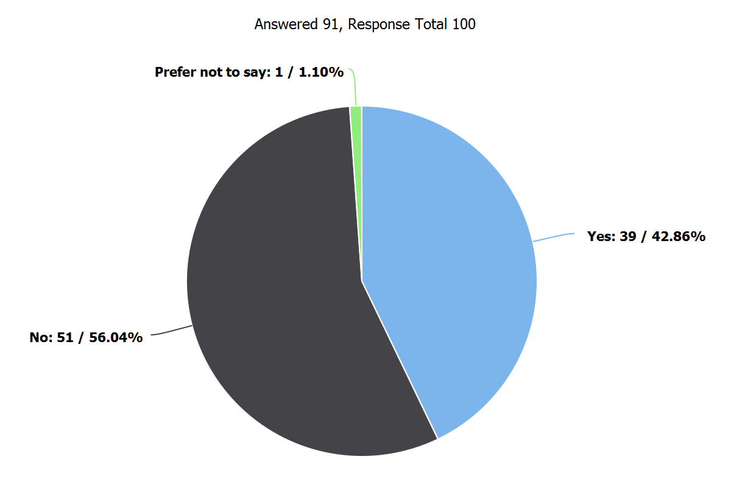
Results show a significant proportion of the workforce at some point in time at 42.86% had to take time off work due to mental health factors.

Question 12: Are you allowed to take annual leave when you request it for days you want off?
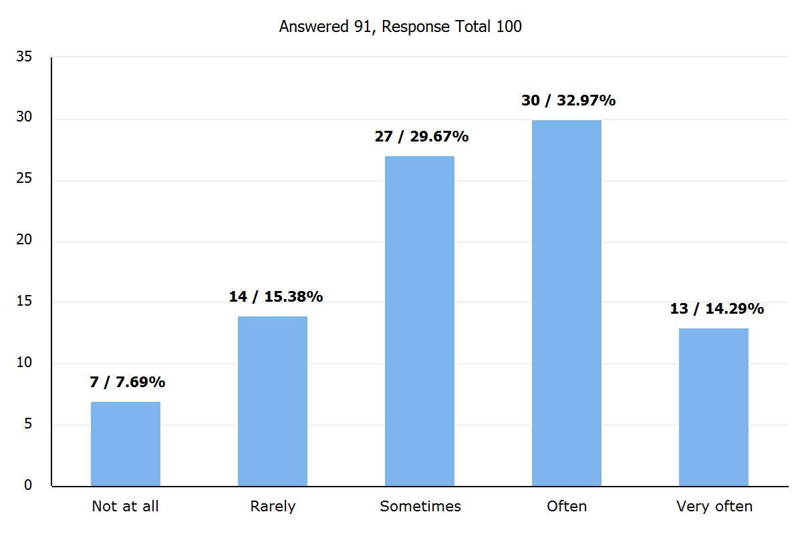

Out of 91 people who answered this question, less then half of the participants at 47.26% felt as if they could get annual leave when wanted very often or often. The rest 52.74% of respondents felt as if they only sometimes, rarely or couldn’t get annual leave when wanted.

Question 13: Rate on a scale of 1-10 how much stress is caused from your role organisationally ( Bureaucratic challenges, lack of support, poor management)? ( 1 being the least, 10 being the most)

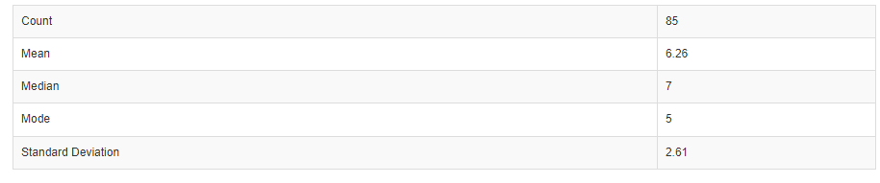

The table above shows the quantitative data which has been assembled into the mean, median and mode while also showing the standard deviation. I can see from the mode that the most often answer out of 85 replies was 5, showing that respondents feels neither strongly or negatively regarding how much stress the above causes them.

Question 14: Rate on a scale of 1-10 how much stress is caused from your role operationally (High workload, working hours, exposure to trauma, interpersonal conflicts) ( 1 being the least, 10 being the most)

For the above answers, my mean, median and mode were all at 6 from the scale of 1-10. My standard deviation came out to be 2.77. Using this information, coupled with the number of respondents and the normal distribution, I can calculate a 95% confidence interval (as below), to show that the mean lies within the interval.

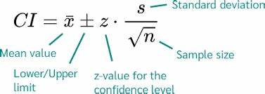

Mean = 6.02
SD = 2.77
n = 86
Z = 1.96

[ 6.02 – 1.96*2.77/9.274, 6.02 + 1.96*2.77/9.274] = [ 5.435, 6.605]

Question 15: Do you feel your workplace put in places measures to help protect your mental health? ( On a scale of 1-10 ) ( 1 being not at all, 10 being all the time)

The average response for this question was 5.23 (Mean), showing that people neither felt strongly or negatively towards Gwent police putting measures in place to help protect mental health.

Question 16: What is your best coping strategies which you have learnt over the years within your role to help cope with stress?

This question was an open narrative response box question. This it to allow qualitative analysis to help identify patterns, themes and trends. It also allows me to have a more comprehensive view of other data presented which helps complement quantitative data. The three main responses presented within the open narrative writing was seen as in no order:
- Physical activity / exercise
- Talking to family, friends and colleagues
- Don’t bring work home with themselves

Word count: 1233

